Radio Regulations Board  Geneva, 11 – 15 October 2021 | 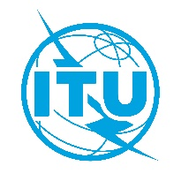
Corrigendum 1 to
Document RRB21-3/12-E
 | 20 October 2021
 | English only
summary of decisions
of the
88th meeting of the radio regulations board
11 – 15 October – Hybrid meeting
This corrigendum applies only to the English version of the Summary of Decisions and pertains only to the column ‘Decisions’ of agenda item 3f), as indicated below:
- indicate to the Administration of the Republic of Korea that it was in direct contravention of RR Nos. 15.1, 15.2, 15.21 and 23.3, and No. 97 (Article 45) of the ITU Constitution;
to be replaced with:
- indicate to the Administration of the Republic of Korea that it was in direct contravention of RR Nos. 15.1, 15.2, 15.21 and 23.3, and No. 197 (Article 45) of the ITU Constitution;

____________________

