 | World Radiocommunication Conference (WRC-23)  Dubai, 20 November - 15 December 2023 |  | 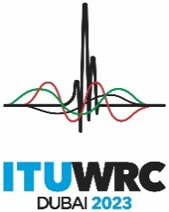
PLENARY MEETING |  | Document 3-E
 |  | 17 May 2023
 |  | Original: English
Note by the Secretary-General
Report OF the Conference Preparatory Meeting to the
World Radiocommunication Conference 2023
At the request of the Director of the Radiocommunication Bureau, I have the honour to submit to the Conference the Report of the Conference Preparatory Meeting (CPM), prepared in response to ITU Council Resolution 1399 and as approved by the second session of the CPM for WRC-23 (Geneva, 27 March to 6 April 2023). The document is available electronically at: https://www.itu.int/md/R19-CPM23.2-R-0001/en.
Doreen Bogdan-Martin
Secretary-General

