 | World Radiocommunication Conference (WRC-23)  Dubai, 20 November - 15 December 2023 |  | 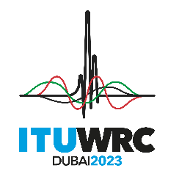
PLENARY MEETING |  | Document 61-E
 |  | 19 September 2023
 |  | Original: English
Bulgaria (Republic of)
PROPOSALS FOR THE WORK OF THE CONFERENCE
Agenda item 8
8 to consider and take appropriate action on requests from administrations to delete their country footnotes or to have their country name deleted from footnotes, if no longer required, taking into account Resolution 26 (Rev.WRC-19);
In connection with the amendment of the National Radio Frequency Allocation Plan, we propose to amend footnote RR No. 5.312 under WRC-23 agenda item 8.

ARTICLE 5
Frequency allocations
Section IV – Table of Frequency Allocations
(See No. 2.1)
MOD BUL/61/1
5.312 Additional allocation: in Armenia, Azerbaijan, Belarus, the Russian Federation, Georgia, Kazakhstan, Uzbekistan, Kyrgyzstan, Tajikistan, Turkmenistan and Ukraine, the frequency band 645-862 MHz, and in Bulgaria the frequency bands 726-753 MHz, 778-811 MHz and 822-852 MHz, are also allocated to the aeronautical radionavigation service on a primary basis. (WRC-23)
Reasons: With the amendment of the National Radio Spectrum Allocation Plan in 2021, the radio frequency band 646-694 MHz, which contains the band 646-686 MHz, is no longer allocated for the aeronautical radionavigation service. In this regard, we propose dropping the 646-686 MHz band from No. 5.312 of the Radio Regulations.
____________

