 | World Radiocommunication Conference (WRC-23)  Dubai, 20 November - 15 December 2023 |  | 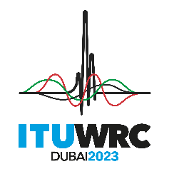
PLENARY MEETING |  | Addendum 4 to  Document 87(Add.24)-E
 |  | 23 October 2023
 |  | Original: English
African Common Proposals
PROPOSALS FOR THE WORK OF THE CONFERENCE
Agenda item 9.1(9.1-d)
9 to consider and approve the Report of the Director of the Radiocommunication Bureau, in accordance with Article 7 of the ITU Convention;
9.1 on the activities of the ITU Radiocommunication Sector since WRC-19:
(9.1-d) Protection of EESS (passive) in the frequency band 36-37 GHz from non-GSO FSS space stations

NOC AFCP/87A24A4/1
ARTICLES

NOC AFCP/87A24A4/2
APPENDICES
Reasons: The topic could be resolved via ITU-R studies related to the protection of EESS (passive) sensors operating in the frequency band 36-37 GHz against non-GSO FSS systems in the frequency band 37.5-38 GHz, with due regard to the operational aspects of the non-GSO FSS systems, and development of recommendations and/or reports, as appropriate.
___________

