 | World Radiocommunication Conference (WRC-23)  Dubai, 20 November - 15 December 2023 |  | 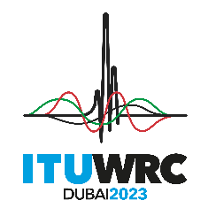
PLENARY MEETING |  | Addendum 10 to  Document 149-E
 |  | 30 October 2023
 |  | Original: English
Thailand
PROPOSALS FOR THE WORK OF THE CONFERENCE
Agenda item 1.10
1.10 to conduct studies on spectrum needs, coexistence with radiocommunication services and regulatory measures for possible new allocations for the aeronautical mobile service for the use of non-safety aeronautical mobile applications, in accordance with Resolution 430 (WRC-19);

NOC THA/149A10/1
ARTICLES

NOC THA/149A10/2
APPENDICES

SUP THA/149A10/3
RESOLUTION 430 (WRC-19)
Studies on frequency-related matters, including possible additional allocations, for the possible introduction of new non-safety aeronautical mobile applications

_______________

