 | World Radiocommunication Conference (WRC-23)  Dubai, 20 November - 15 December 2023 |  | 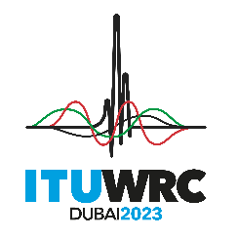
PLENARY MEETING |  | Addendum 11 to  Document 149-E
 |  | 30 October 2023
 |  | Original: English
Thailand
PROPOSALS FOR THE WORK OF THE CONFERENCE
Agenda item 1.11
1.11 to consider possible regulatory actions to support the modernization of the Global Maritime Distress and Safety System (GMDSS) and the implementation of e-navigation, in accordance with Resolution 361 (Rev.WRC-19);
Proposals
Issue C

NOC THA/149A11/1
ARTICLES

NOC THA/149A11/2
APPENDICES

SUP THA/149A11/3
RESOLUTION 361 (REV.WRC-19)
Consideration of possible regulatory actions to support modernization of the Global Maritime Distress and Safety System and
the implementation of e-navigation
Reasons: The selected method reflects concerns in uncertainty on the frequency range for new GMDSS satellite systems. Coordination and notification of the new proposed safety services of GMDSS system, in accordance with Articles 9 and 11 of the Radio Regulations, should be completed to ensure sharing and compatibility between the new and the existing systems.
_______________

