 | World Radiocommunication Conference (WRC-23)  Dubai, 20 November - 15 December 2023 |  | 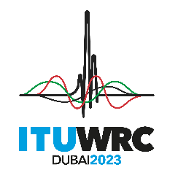
PLENARY MEETING |  | Addendum 13 to  Document 157-E
 |  | 30 October 2023
 |  | Original: English
India (Republic of)
PROPOSALS FOR THE WORK OF THE CONFERENCE
Agenda item 1.13
1.13 to consider a possible upgrade of the allocation of the frequency band 14.8-15.35 GHz to the space research service, in accordance with Resolution 661 (WRC-19);
Proposal
This document presents India’s proposal under WRC-23 agenda item 1.13. In order to satisfy the WRC-23 agenda item 1.13 as per Resolution 661 (WRC-19), the upgrading to primary status of the allocation of the frequency band 14.8-15.35 GHz for the SRS should not impose constraints on existing systems of primary services in the frequency band 14.8-15.35 GHz. Since the ITU-R studies have not fully demonstrated protection of the incumbent primary services, India supports Method A, as detailed in CPM Report, which proposes “No Change” to the Radio Regulations.

NOC IND/157A13/1
ARTICLES
Reasons: Since the ITU-R studies have not demonstrated that the upgrading SRS to primary status in the frequency band 14.8-15.35 GHz will not impose constraints on existing systems of primary services in the frequency band 14.8-15.35 GHz.
NOC IND/157A13/2
APPENDICES
Reasons: See the reasons in proposal No. 1 above.
SUP IND/157A13/3
RESOLUTION 661 (WRC-19)
Examination of a possible upgrade to primary status of the secondary allocation to the space research service in the frequency band 14.8-15.35 GHz
Reasons: This Resolution is no longer necessary
______________

