 | World Radiocommunication Conference (WRC-23)  Dubai, 20 November - 15 December 2023 |  | 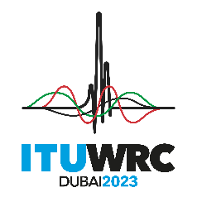
PLENARY MEETING |  | Document 189-E
 |  | 30 October 2023
 |  | Original: French
Morocco (Kingdom of)
PROPOSALS FOR THE WORK OF THE CONFERENCE
Agenda item 8
8 to consider and take appropriate action on requests from administrations to delete their country footnotes or to have their country name deleted from footnotes, if no longer required, taking into account Resolution 26 (Rev.WRC-19);

Introduction
In accordance with Resolution 26 (Rev.WRC-19), the Administration of the Kingdom of Morocco has considered the footnotes to the Table of Frequency Allocations of the Radio Regulations and proposes to delete footnote No. 5.229.

ARTICLE 5
Frequency allocations
Section IV – Table of Frequency Allocations
(See No. 2.1)
SUP MRC/189/1
5.229 Alternative allocation: in Morocco, the band 162-174 MHz is allocated to the broadcasting service on a primary basis. The use of this band shall be subject to agreement with administrations having services, operating or planned, in accordance with the Table which are likely to be affected. Stations in existence on 1 January 1981, with their technical characteristics as of that date, are not affected by such agreement.
Reasons: The broadcasting service is not used in the band 162-174 MHz in Morocco. It is therefore no longer necessary to refer to Morocco in this footnote.
_______________

