Report ITU-R BO.2497-1
(05/2024)
BO Series: Satellite delivery
Characteristics and effectiveness of frequency sharing criteria for the broadcasting-satellite service in Regions 1 and 3 subject to RR Appendix 30

Foreword
The role of the Radiocommunication Sector is to ensure the rational, equitable, efficient and economical use of the radio-frequency spectrum by all radiocommunication services, including satellite services, and carry out studies without limit of frequency range on the basis of which Recommendations are adopted.
The regulatory and policy functions of the Radiocommunication Sector are performed by World and Regional Radiocommunication Conferences and Radiocommunication Assemblies supported by Study Groups.

Policy on Intellectual Property Right (IPR)
ITU-R policy on IPR is described in the Common Patent Policy for ITU-T/ITU-R/ISO/IEC referenced in Resolution ITU-R 1. Forms to be used for the submission of patent statements and licensing declarations by patent holders are available from http://www.itu.int/ITU-R/go/patents/en where the Guidelines for Implementation of the Common Patent Policy for ITU-T/ITU-R/ISO/IEC and the ITU-R patent information database can also be found.

Series of ITU-R Reports
(Also available online at https://www.itu.int/publ/R-REP/en)
Series | Title
BO | Satellite delivery
BR | Recording for production, archival and play-out; film for television
BS | Broadcasting service (sound)
BT | Broadcasting service (television)
F | Fixed service
M | Mobile, radiodetermination, amateur and related satellite services
P | Radiowave propagation
RA | Radio astronomy
RS | Remote sensing systems
S | Fixed-satellite service
SA | Space applications and meteorology
SF | Frequency sharing and coordination between fixed-satellite and fixed service systems
SM | Spectrum management
TF | Time signals and frequency standards emissions

Note: This ITU-R Report was approved in English by the Study Group under the procedure detailed in Resolution ITU-R 1.

Electronic Publication
Geneva, 2024
© ITU 2024
All rights reserved. No part of this publication may be reproduced, by any means whatsoever, without written permission of ITU.

REPORT ITU-R BO.2497-1
Characteristics and effectiveness of frequency sharing criteria for the broadcasting-satellite service in Regions 1 and 3 subject to RR Appendix 30
(Question ITU-R 283/4)
(2021-2024)

TABLE OF CONTENTS
Page
Policy on Intellectual Property Right (IPR) ii
1 Abbreviations/Glossary 1
2 Introduction 2
3 Pfd criterion 3
4 EPM criterion 6
5 Applicability and effectiveness of pfd and EPM criteria 10
6 Summary for information purposes only 15

NOTE 1 ‒ The agreement given to this Report is on the understanding that it is merely used to increase the understanding on how the sharing mechanisms of RR Appendix 30 function. This Report therefore should in no way impact the process and functioning of notices under RR Appendix 30 by administrations and the BR and in no way should be subject to any use partially or totally for any future Recommendation.
NOTE 2 ‒ This Report merely analyses the characteristics of the two sharing criteria among broadcasting-satellite service (BSS) assignments in Regions 1 and 3 as contained in the current version of RR Appendix 30. In no way, does this Report propose to modify the current sharing criteria as contained in RR Appendix 30.
NOTE 3 ‒ In view of the above, this Report should be considered as for information purposes only.

1 Abbreviations/Glossary
Ae Effective antenna area
BSS Broadcasting-satellite service
C_{e.i.r.p.} e.i.r.p. of the wanted satellite
C/I Carrier to interference ratio
C/I_{aggr} Carrier to aggregate interference ratio
C/N Carrier to noise ratio
D Antenna discrimination
ΔC/N Degradation of C/N
ΔT/T The increase of noise temperature caused by the interference and the system noise temperature ratio
e.i.r.p. Equivalent isotropically radiated power
EPM Equivalent protection margin
I Interference
I_{aggr} Aggregate interference
I/N Interference to noise ratio
M Value of EPM
N Noise
pfd Power flux-density
PR Protection ratio
Ref. EPM The current EPM value
RR Radio Regulations
WRC World Radiocommunication Conference

2 Introduction
This Report provides useful information on the two frequency sharing criteria between BSS (broadcasting-satellite service) networks. In Section 1 of Annex 1 to Appendix 30 of the Radio Regulations (RR), two types of threshold value triggering coordination within a coordination arc of 9 degrees are given: a) pfd (power flux-density), and b) EPM (Equivalent Protection Margin). According to the provision in RR as cited below, a proposed satellite network does not need to coordinate with others if either the pfd criterion or the EPM criterion is met within a coordination arc of 9 degrees.
..., an administration in Region 1 or 3 is considered as not being affected if either of the following two conditions is met:
a) ..., the power flux-density at any test point within the service area..., does not exceed the following values: (WRC-15)
b) … the equivalent downlink protection margin corresponding to a test point of its assignment … does not fall more than 0.45 dB below 0 dB or, if already negative, more than 0.45 dB.
The pfd criterion was introduced in addition to the EPM criterion by WRC-2000 (World Radiocommunication Conference in 2000) for BSS only in Region 1 and Region 3, but not for BSS in Region 2. In Regions 1 and 3, a new satellite only needs to meet one of the two criteria. In this Report, the comparison between the two criteria and their characteristics are studied thus focusing only on Regions 1 and 3.
This study is useful for satellite broadcasting system designs including the selection of an orbital position, in which the possible impact of interference on the BSS satellite networks can be taken into account. Concerning the selection of an orbital position, this study also explains which criterion should be used by a proposed new network so that the proposed new network can transmit higher power and at the same time other BSS networks will not be considered as being affected by the proposed new network.

3 Pfd criterion
This section explains the pfd criterion and its features. The pfd value is derived as e.i.r.p. (equivalent isotropically radiated power) divided by 4 * π * d², where d is the distance between the satellite and the receiving point on the Earth where the pfd value will be calculated. The pfd criterion is easy to be calculated and understood.
The threshold pfd value triggering coordination is shown below in italics (cited from RR), as a function of orbital separation angle θ between two BSS satellites.
−147 dB(W/(m² ･ 27 MHz)) for 0° ≤ θ < 0.23°
−135.7 + 17.74 log(θ) dB(W/(m² ･ 27 MHz)) for 0.23° ≤ θ < 2.0°
−136.7 + 1.66 θ² dB(W/(m² ･ 27 MHz)) for 2.0° ≤ θ < 3.59°
−129.2 + 25 log(θ) dB(W/(m² ･ 27 MHz)) for 3.59°≤ θ < 9.0° (1)
where:
θ minimum geocentric orbital separation in degrees between the wanted and interfering space stations, taking into account the respective East-West station-keeping accuracies.
Regarding the satellite station-keeping above, RR requires that space stations in BSS must be maintained in position with an accuracy equal to or better than ±0.1 degrees in the East – West directions.
The threshold pfd value above is depicted in Fig. 1 (WRC-03, Blue line). Note that the pfd value in Fig. 1 is expressed per 1 MHz bandwidth, instead of 27 MHz, in order to be consistent with other sharing cases. The threshold pfd value is the single-entry interference level as indicated “I” of an interfering satellite (new comer) in Fig. 1. It is an absolute value regardless of the wanted level as indicated “C” of an interfered-with satellite (existing) in Fig. 1.
The threshold pfd value was derived based on the antenna discrimination of 60 cm to 2.4 m diameters. The reference receiving earth station antenna pattern is given in Fig. 7bis in Section 3.7.2, Annex 5 of RR Appendix 30. Figure 2 overwrites the pfd value (WRC-03) with the antenna discrimination of 60 cm diameter. Note that the angles in the abscissa for the 60 cm antenna is transformed from a geocentric angle to a topocentric angle under the assumption that the earth station antenna locates at a latitude of 33 degrees North and the difference between its longitude and the satellite orbital position is 13 degrees. The location of the earth station is the same throughout this Report.
For the purpose of comparison, the threshold pfd value developed in WRC-2000 is also shown in Fig. 1 (WRC-2000, red line). The pfd value was reduced by 1.7 dB between 2° and 9° (see Fig. 3) in WRC-03 in order to reflect the reduction of PR (protection ratio) by 3 dB (24 dB to 21 dB). In effect, this reduction of the threshold pfd value plays a role to protect a smaller antenna.
Since the threshold pfd value is an absolute interference power expressed in terms of pfd, it can be converted to ΔT/T (the increase of noise temperature caused by the interference and the system noise temperature ratio), ΔC/N (the degradation of C/N, Carrier to Noise ratio) defined as (C/N) – (C/(N+I)), where C/(N+I) = −10 log(10^{−(C/N)/10} + 10^{−(C/I)/10}), and I/N (Interference to Noise ratio). Note that the ΔT/T, I/N and ΔC/N are equivalent and can be converted from one to another.
In the conversion of the pfd value to ΔT/T, etc., the total link noise temperature of the earth station is assumed to be 174 K (Section 2, Annex 6, Appendix 30). Then the system noise N is given as follows.
N = kTB = −228.6 (dBW/Hz/K) + 10log(174) (dBK) + 10log(10⁶) (dB) = −146.2 (dBW/MHz) (2)
The interference power I to the receiver of the earth station is derived by using the antenna discrimination D (dB) and the effective antenna area Ae (m²) as follows.
I = pfd + D + 10log(Ae) (dBW/MHz) (3)
FIGURE 1
Comparison of WRC-2000 and WRC-03 pfd masks in Section 1, Annex 1, Appendix 30
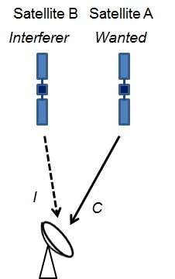
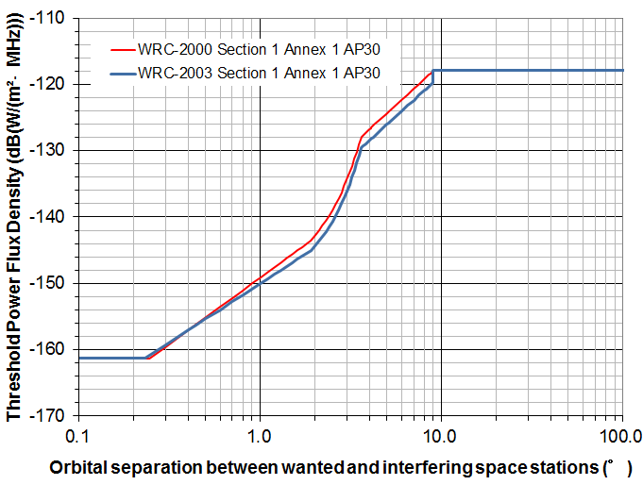
FIGURE 2
Comparison of WRC-03 pfd masks and the antenna discrimination (60 cm)
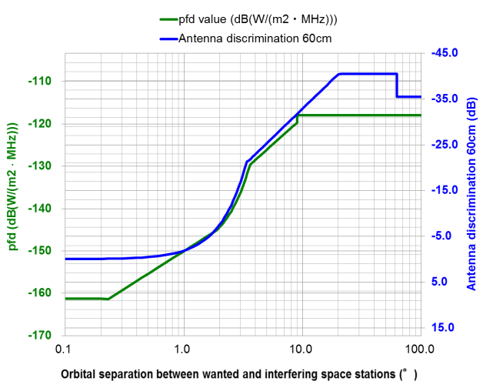
FIGURE 3
Difference in pfd masks by WRC-2000 and WRC-03
The antenna efficiency is assumed to be 61.4%, which gives the absolute maximum antenna gain of 35.5 dBi at 12.1 GHz (see Fig. 7bis, Section 3.7.2, Annex 5, Appendix 30). The ΔT/T, ΔC/N and I/N converted from the pfd mask are shown in Fig. 4. The specific example values for 3.59°≤ θ < 9.0° are shown in Table 1.
FIGURE 4
ΔT/T, ΔC/N and I/N corresponding to the pfd mask (WRC-03)
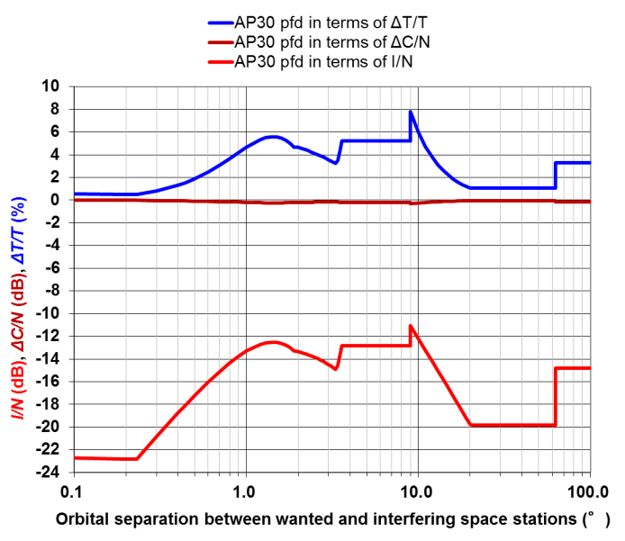
TABLE 1
Example of ΔT/T, ΔC/N and I/N corresponding to the pfd values
θ | pfd | ΔT/T | ΔC/N | I/N
3.59°≤ θ < 9.0° | −129.60 to −119.7 dB(W/(m² ･ MHz)) | 5.24% | −0.22 dB | −12.81 dB

TABLE 2
Example of C/I corresponding to the pfd values
θ | pfd | 57 dBW | 54.3 dBW | 51.5 dBW
3.59°≤ θ < 9.0° | −129.60 to −119.7 dB(W/(m² ･ MHz)) | 31.7 dB | 29.0 dB | 26.2 dB

FIGURE 5
C/I corresponding to pfd mask (WRC-03)
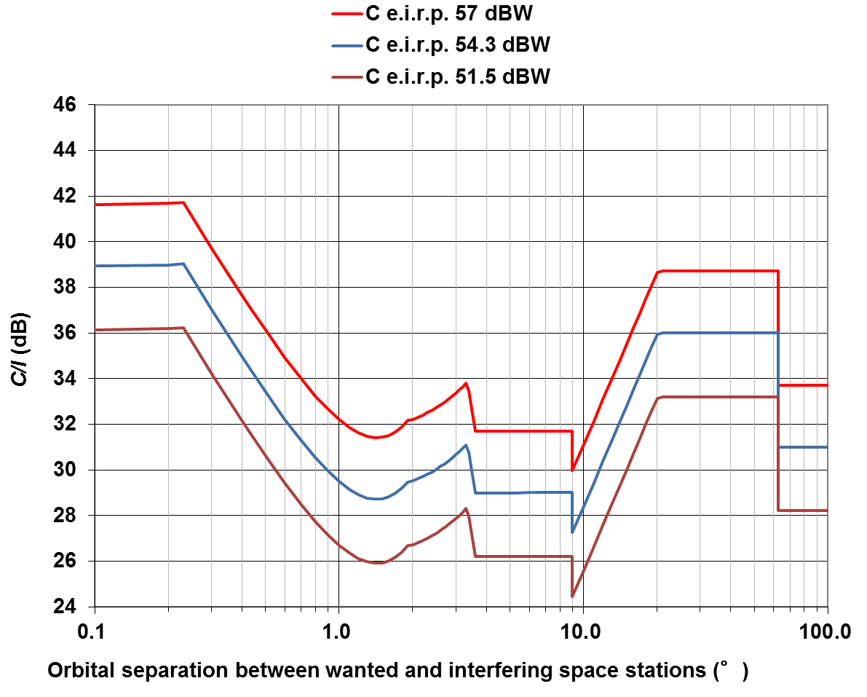
The C/I (Carrier to Interference ratio) values corresponding to the pfd value is a function of the wanted level (C) (see Fig. 5). The specific example values of C/I for 3.59°≤ θ < 9.0° are shown in Table 2. Note that the C/I value corresponds to a single-entry interference.

4 EPM criterion
This section explains the EPM criterion and its features. The EPM, referred to as M in this Report, is defined in Section 3.4 of Annex 5 to Appendix 30 to RR, as follows.
$M = -10log⁡({10}^{\frac{-M_{1}}{10}}+ {10}^{\frac{-M_{2}}{10}}+ {10}^{\frac{-M_{3}}{10}})$ (4)
where:
M₁ : value (dB) of the protection margin for the same channel (co-channel). This is defined in the following expression where the powers are evaluated at the receiver input:
$M_{1} = \frac{wanted power}{\begin{aligned}sum of the co-channel \\ interfering powers\end{aligned}} \left(dB\right)-$ (co-channel protection ratio) (dB) (5)
where:
co-channel protection ratio is the required value of the aggregate C/I used in the BSS Plan and is given in Annex 5 to Appendix 30 to RR
M₂ and M₃ are the values (dB) of the upper and lower adjacent-channel protection margins respectively.
The co-channel protection ratios (PR) in Regions 1 and 3 are as follows:
31 dB for 1977 BSS Plan.
24 dB for WRC-97 revision of BSS Plan for downlink.
21 dB for WRC-2000 digital BSS Plan.
While the EPM in equation (4) is expressed from the view point of frequency assignments, it is expressed as the ratio of carrier to aggregate interference by the next equation (see also Fig. 6).
$M = \frac{C}{I_{aggr}}-PR= \frac{C}{\sum_{i=1}^{n}{I_{i}}}-PR$ (6)
A certain amount of spectrum in the BSS band is assigned equally to all countries for future use in order to guarantee equitable access to the geostationary orbit and spectrum among countries, which constitutes a BSS Plan. For example, in the Regions 1 and 3 BSS Plan, 12 channels in the 11.7-12.2 GHz band are assigned to all Region 3 countries. In addition, the BSS band in Regions 1 and 3 is used through the coordination procedure and such spectrum is registered in the List, which are additional uses of satellites beyond the Plan (i.e. use of assignments with characteristics different from those appearing in the Regions 1 and 3 Plan and which are capable of causing more interference than the corresponding entries in the Plan or use of assignments in addition to those appearing in the Plan). For an assignment, Reference EPM (Ref. EPM) is defined in ITU-R to be the EPM when all the interfering assignments in the Plan and the List located within 9 degrees coordination arc of that assignment are considered. Note that the Ref. EPM is updated by ITU-R every time a new assignment is entered in the Plan or the List or an assignment in the List is cancelled.
FIGURE 6
Mechanism of EPM
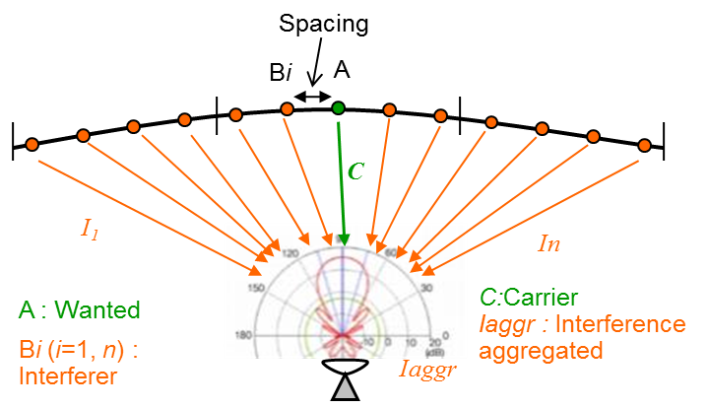
The EPM criterion is hard to be calculated and understood, but it considers all interference sources coming from other BSS networks. In Regions 1 and 3, according to RR, only other BSS networks located within ±9 degrees are taken into account in calculating EPM. It is useful to recognize the total amount of interference in terms of aggregate interference because the BSS Plan is for future use. The EPM criterion was adopted since the development of the BSS Plan back in 1977 and in WRC-2000 the EPM criterion was kept despite proposals to suppress it.
The EPM criterion giving the threshold value for coordination is described in Section 1, Annex 1 of Appendix 30 to RR (see § 2 of this Report). Table 3 shows an example of the relation among transmitting power, Ref. EPM, threshold C/I_{new}, etc., in particular it shows how much interference is allowed for a new comer depending on the Ref. EPM of an existing network so that the existing network is not considered as being affected by the new comer. The colours of the numbers in Table 3 correspond to Fig. 7 and Fig. 8, respectively.
In Table 3, the items are as follows:
C_{e.i.r.p.} is e.i.r.p. of the wanted satellite.
Ref. EPM is the current EPM value without taking into account the interference from the new comer.
C/I_{aggr} is the current value and derived by PR + Ref. EPM. The C as well as I_{aggr} should be, by definition, wanted and aggregate interference powers, respectively, at the output of the interfered-with receiving earth station antenna. However, in this Report, C is expressed as the same as C_{e.i.r.p.} and I_{aggr} is expressed as the sum of (interfering e.i.r.p. + the discrimination (≤ 0) of the interfered-with receiving earth station antenna). This expression does not change the conclusion of this study.
I_{aggr} is derived by C_{e.i.r.p.} – C/I_{aggr}. As mentioned above, the value of I_{aggr} (equivalent interfering e.i.r.p value) has been taken into account the discrimination of the interfered-with receiving earth station antenna between the wanted and the interfering satellites.
C/I_{new} shown in Fig. 8 is mathematically derived by −10log(10^{−(C/(Iaggr+Inew))/10} − 10^{−(C/Iaggr)/10}). For calculation of C/I_{new}, in Table 3, I_{new} is derived to meet the EPM criterion (see b) in § 2 of this Report). This is the lowest C/I_{new} of the existing network due to interference from the new comer so that the existing network is not considered as being affected by the new comer.
I_{new} is derived by C_{e.i.r.p.} – C/I_{new}. It indicates the maximum allowable interference power. I_{new} should be, by definition, interference power at the output of interfered-with earth station antenna. However, in this Report, I_{new} is expressed as the interfering e.i.r.p + the discrimination of the interfered-with earth station receiving earth station antenna. This expression does not change the conclusion of this study.
C/(I_{aggr} + I_{new}) is the resulting value and derived by −10log(10^{−(C/Iaggr)/10}+10^{−(C/Inew)/10}) or PR + EPM (I_{aggr} + I_{new}).
EPM (I_{aggr} + I_{new}) is the new EPM value taking into account the maximum allowable interference from the new comer. According to RR, an existing network is not considered as affected by the new comer if the Ref. EPM is not degraded more than 0.45 dB below zero if the Ref. EPM value is not negative or more than 0.45 dB if the Ref. EPM value is already negative (see Fig. 7). Thus, it is derived:
– If Ref. EPM >= 0, EPM (I_{aggr} + I_{new}) = –0.45
– If Ref. EPM <0, EPM (I_{aggr} + I_{new}) = Ref. EPM –0.45.
Degradation is the difference between Ref. EPM and EPM (I_{aggr} + I_{new}).
As same as above with the pfd criterion, it is assumed that the antenna is 60 cm in diameter, the earth station antenna locates at a latitude of 33 degrees North and the difference between its longitude and the satellite orbital position is 13 degrees.
The EPM criterion in terms of EPM degradation is depicted in Fig. 7. It shows the resulting EPM (New EPM) when the 0.45 dB degradation principle is applied.
TABLE 3
Example of the relation among transmitting power, Ref. EPM, threshold C/I_{new}, etc.
C_{e.i.r.p.} (dBW) | 54.30 | 54.30 | 54.30 | 54.30 | 54.30
PR (dB) | 21.0 | 21.0 | 21.0 | 21.0 | 21.0
C/I_{aggr} (dB) | 36.0 | 26.0 | 21.0 | 16.0 | 6.0
I_{aggr} (dBW) | 18.3 | 28.3 | 33.3 | 38.3 | 48.3
Ref. EPM (dB) | 15.0 | 5.0 | 0.0 | ‒5.0 | ‒15.0
C/I_{new} (dB) | 20.7 | 22.0 | 30.6 | 25.6 | 15.6
I_{new} (dBW) | 33.6 | 32.3 | 23.7 | 28.7 | 38.7
TABLE 3 (end)
C/(I_{aggr} + I_{new}) (dB) | 20.55 | 20.55 | 20.55 | 15.55 | 5.55
EPM (I_{aggr} + I_{new}) (dB) | −0.45 | −0.45 | −0.45 | −5.45 | −15.45
Degradation (dB) | −15.45 | −5.45 | −0.45 | −0.45 | −0.45
FIGURE 7
EPM criterion in terms of EPM degradation
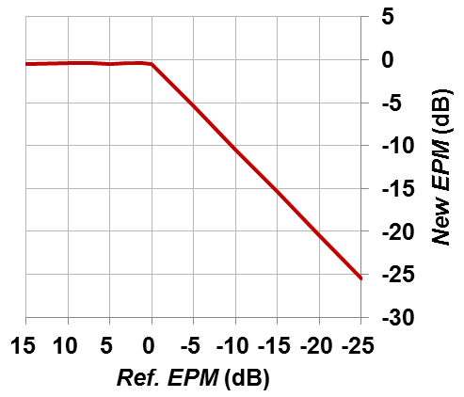
The EPM criterion in terms of C/I_{new} is shown in Fig. 8. The C/I_{new} gives a threshold value, or a permissible value of the interference I_{new} when the 0.45 dB degradation principle is applied. Note that the C/I_{new} is independent of the value of C_{e.i.r.p.}.
Table 4 below indicates minimum orbital separations for a new network to co-exist with an existing network based on the EPM criterion assuming both networks have the same characteristics (60 cm diameter of receiving antenna, same transmitting power, etc.). The earth station antenna is assumed to locate at a latitude of 33 degrees North and the difference between the longitude and the satellite orbital position is 13 degrees.
FIGURE 8
EPM criterion in terms of C/I_{new}
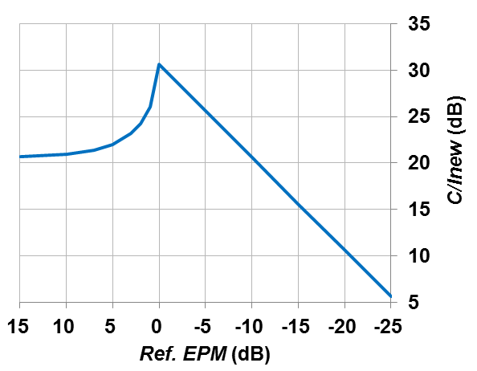
TABLE 4
Example of the relation among transmitting power,
Ref. EPM, threshold C/I_{new}, etc.
Ref. EPM  (dB) | C/I_{new}  (dB) | Minimum orbital separation  (degree) | Minimum topocentric angle  (degree)
10 | 20.96 | 3.33 | 3.78
5 | 22.01 | 3.68 | 4.18
0 | 30.62 | 8.10 | 9.22
−2 | 28.62 | 6.75 | 7.67
−4 | 26.62 | 5.61 | 6.38
−6 | 24.62 | 4.67 | 5.31
−8 | 22.62 | 3.88 | 4.11
−10 | 20.62 | 3.30 | 3.75
−15 | 15.62 | 2.88 | 3.27
−20 | 10.62 | 2.37 | 2.69
−25 | 5.62 | 1.73 | 1.96
−30 | 0.62 | 0.57 | 0.65
−30.6 | 0 | 0 | 0

From Tables 3 and 4, and Figs 7 and 8, the following items are observed:
1) For an assignment with a high (positive) Ref. EPM, it allows relatively high interference caused by the new comer, while ensuring a good level of protection to the existing assignment, up to such a level corresponding to the EPM of −0.45 dB. For example, when the Ref. EPM is 15 dB, the I_{new} (maximum allowable interference) is 33.6 dBW, which is higher than 23.7 dBW of I_{new} when the Ref. EPM is 0 dB.
2) For an assignment with a Ref. EPM around 0 dB, it allows relatively low interference to give a further degradation of EPM by −0.45 dB. Note that at 0 dB of Ref. EPM, the C/I_{new} is maximum and I_{new} is minimum (23.7 dBW in Table 3), which means the assignment is most sensitive when the Ref. EPM is 0 dB.
3) For an assignment with a very low Ref. EPM less than −10 dB, it allows relatively high interference caused by the new comer to give a further degradation of EPM by −0.45 dB, which means that the assignment will not be identified by ITU-R as being affected if a new comer does not produce up to such a high interference. In other words, it is easier for a new comer to meet the sharing criterion. For example, when the Ref. EPM is −15 dB, the I_{new} is 38.7 dBW, which is higher than 23.7 dBW of I_{new} when the Ref. EPM is 0 dB.

5 Applicability and effectiveness of pfd and EPM criteria
In this section, the relation, applicability and effectiveness of pfd and EPM criteria are investigated. In order to compare the EPM criterion with the pfd criterion, the EPM criterion is converted into the threshold pfd values. Figure 9 shows an example of the characteristics of Ref. EPM vs threshold pfd values for the pfd and EPM criteria in order to clarify the applicability and effectiveness of the two criteria. In other words, it clarifies which criterion should be used so that a new comer can transmit more power and at the same time does not affect an existing network.
In Fig. 9, the I_{new} values in Table 3 derived under the EPM criterion are converted into the threshold pfd values at the receiving earth station. Note that the I_{new} values in terms of pfd shall not exceed the hard limit of −103.6 dB(W/(m² ･ 27 MHz)) or −117.9 dB(W/(m² ･ MHz)).
The following explains how the conversion of I_{new} to threshold pfd (dB(W/(m² ･ MHz))) was done for a case of C_{e.i.r.p.} of 54.3 dBW, Ref. EPM of 0 dB and orbital separation of 0 degree, 1 degree, 3 degrees, 6 degrees and 9 degrees.
I_{new} in 27 MHz: 23.7 dB(W/27 MHz)
I_{new} in 1 MHz: 9.4 dB(W/MHz) i.e. (23.7 – 10log(27))
pfd toward boresight: −153.8 dB(W/(m² ･ MHz)) i.e. (9.4 – 162.4 (d = 37 187 km)).
Off axis angle of the receiving earth station antenna on the Earth (topo-centric angle toward the interfering satellite) and discrimination of 60 cm receiving earth station antenna on the Earth are shown in Table 5.
pfd produced by the new comer (see Table 5): −153.8 dB(W/(m² ･ MHz)) (−153.8 + 0) for 1 degree spacing, −152.0 dB(W/(m² ･ MHz)) (−153.8 + 1.8) for 1 degree spacing, −136.0 dB(W/(m² ･ MHz)) (−153.8 + 17) for 3 degree spacing, −126.5 dB(W/(m² ･ MHz)) (−153.8 + 27.3) for 6 degree spacing, −122.1 dB(W/(m² ･ MHz)) (−153.8 + 31.7) for 9 degree spacing.
It is interesting to know that, in this case, the threshold pfd value (−136.1 dB(W/(m² ･ MHz))) derived from the EPM criterion with 0 dB of Ref. EPM for C_{e.i.r.p.} of 54.3 dBW coincides to the one derived from the pfd criterion for the 3 degrees spacing between the wanted and interfering satellites.
It can be seen from Fig. 9 that in a range of Ref. EPM about from 0 dB to −5 dB, the pfd criterion is effective for low C_{e.i.r.p.} like 51.5 dBW and the orbital separation above 1 degree. The pfd criterion is effective in this region to accommodate a new comer if the existing satellites has a low C_{e.i.r.p.}.
It is also interesting to know that, when the Ref. EPM is very low (less than about −5 dB to −25 dB), the EPM criterion is effective, and it allows relatively high interference caused by the new comer. The BSS Plan is developed generally assuming a peak C_{e.i.r.p.} of 59 dBW in a 27 MHz bandwidth at the peak and 56 dBW at the edge of coverage. The assignment with a low transmitting power, e.g. C_{e.i.r.p.} of 51.5 dBW, is possible, but if there are Plan assignments and/or List assignments near such a satellite with co-coverage/co-frequency, the low power satellite suffers from high interference and results in a very low Ref. EPM (Part “C” in Fig. 9), then it can never get a value of about 0 dB of Ref. EPM (Part “B” in Fig. 9).
In the above discussion, the frequency is assumed to be fully overlapped. For the case of partial frequency overlapping, the threshold pfd values in Fig. 9 derived from the EPM criterion increase by an amount of overlapping frequency bandwidth. For the BSS Plan, bandwidth is 27 MHz, channel spacing is 19.18 MHz, the threshold pfd value increases by 2.37 dB (= 10log(27/(2 × (27-19.18)))), when the interference comes from both upper and lower adjacent channels. Note that in this case the protection of interfered-with satellite network is unchanged to meet the EPM criterion.
TABLE 5
Conversion of I_{new} to threshold pfd (dB(W/(m² ･ MHz)))
for a case of Ce.i.r.p. of 54.3 dBW, Ref. EPM of 0 dB
Orbital separation  (degree) | Topo-centric angle  (degree) | Discrimination of receiving antenna  (dB) | pfd produced  by the new comer: (dB(W/(m² ･ MHz)))
0 | 0 | 0 | –153.8
1 | 1.1 | –1.8 | –152.0
3 | 3.4 | –17.0 | –136.0
6 | 6.7 | –27.3 | –126.5
9 | 10.2 | –31.7 | –122.1

FIGURE 9
Example of EPM and pfd criteria in terms of threshold pfd
(a) 0 degree spacing
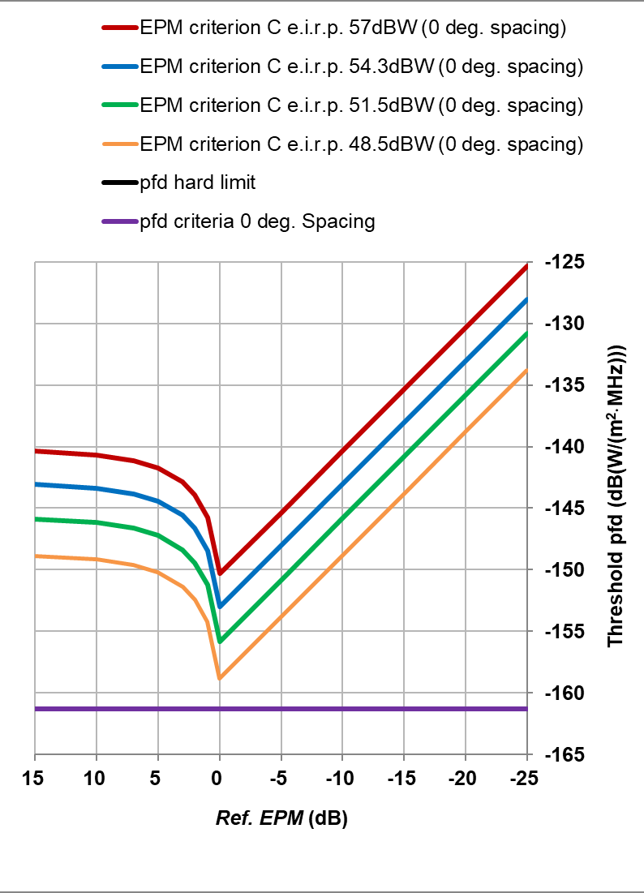
(b) 1 degree spacing
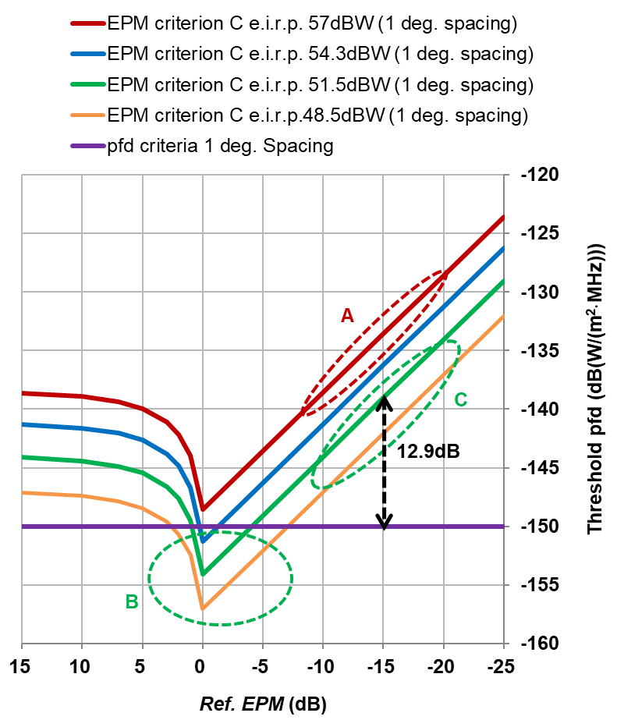
(c) 3 degree spacing
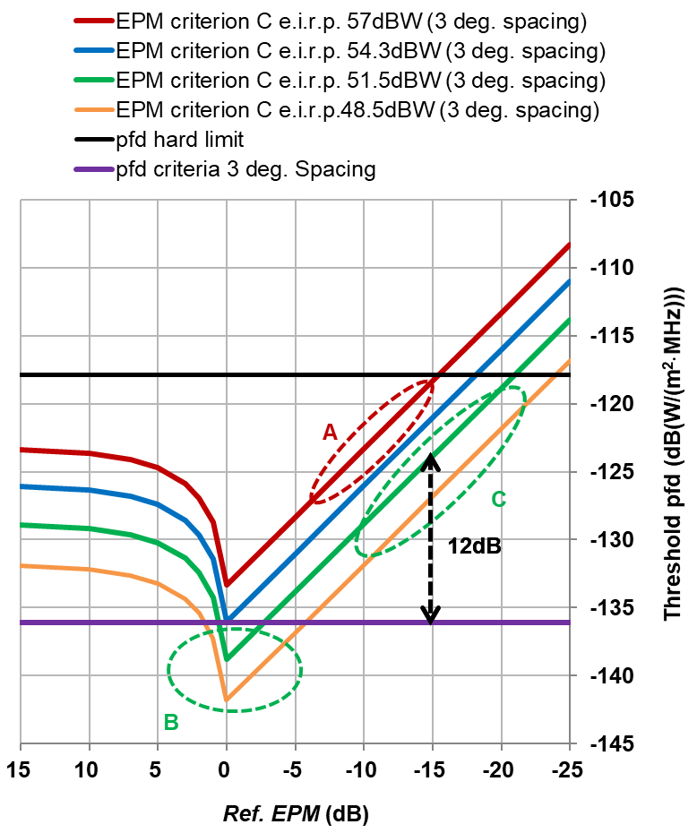

(d) 6 degree spacing
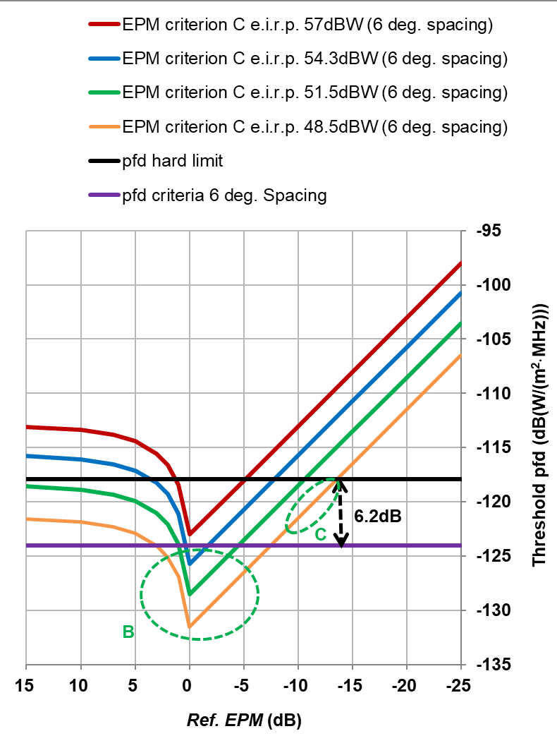
(e) 9 degree spacing
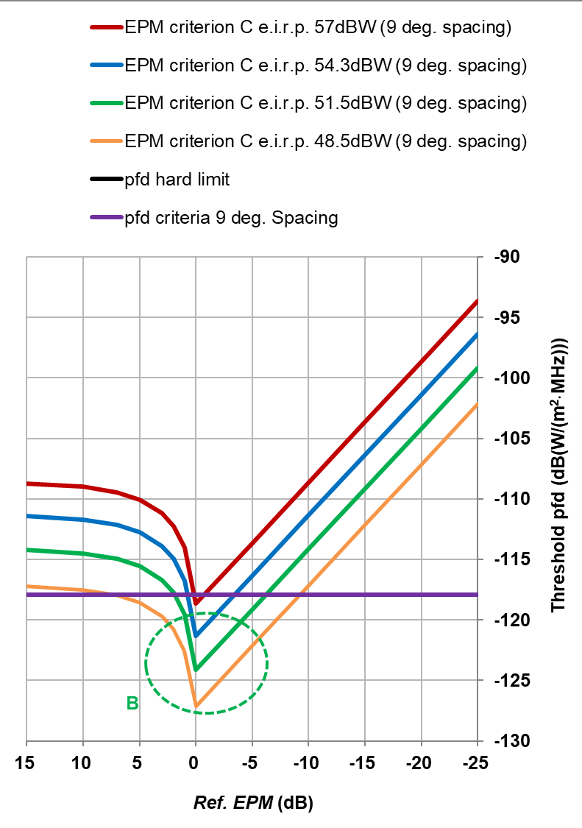
For example, for the Ref. EPM of −15 dB, the difference between the threshold pfd of the EPM criterion (−124.1 dB(W/(m² · MHz))) and the pfd criterion with 3-degree separation (−136.1 dB(W/(m² · Hz))) is about 12 dB. The relaxation of 12 dB under the EPM criterion makes the coordination much easier for a new comer than under the pfd criterion. In other words, by using the EPM criterion, a new comer can transmit 12 dB more power than using the pfd criterion while that sensitive network is not affected. The more negative the Ref. EPM is, the larger difference between the two criteria becomes.
The pfd criterion was introduced in addition to the EPM criterion by WRC-2000 to remove the possibility of artificial, speculative parameters in filings unduly blocking new comers. That is because the pfd criterion is expressed by absolute values of pfd regardless of the satellite parameters.
On the contrary, in Part (A) in Fig. 9, both of the interfered-with satellite and the interfering satellite have a high C_{e.i.r.p.}. In this case, the two satellites severely interfere with each other resulting in a very low EPM value. This situation, if it happens, should be avoided, to the extent practicable, since the operation of the assignments of both satellites could become incompatible.

6 Summary for information purposes only
In this Report, two frequency sharing criteria (pfd and EPM) for BSS in Regions 1 and 3 are compared and studied from the viewpoint of applicability and effectiveness to the sharing cases between BSS and BSS, which was not clear before. This study is useful for satellite broadcasting system designs including the selection of an orbital position. From the aspect of regulations, the mechanism for the alleviation of a problem of “sensitive satellite network” is clarified.
It was assumed in this Report that the receiving earth station antenna is 60 cm in diameter and locates at a latitude of 33 degrees North and the difference between its longitude and the satellite orbital position is 13 degrees.
The following conclusions are obtained.
1) The threshold pfd value given by the pfd criterion is an absolute interference power. The threshold pfd value in the area of 3.59°≤ θ < 9.0° (orbital separation angle) is converted and corresponds to ΔT/T of 5.24%, ΔC/N of −0.22 dB and I/N of −12.81 dB, which are all equivalent. In the same area, the pfd value corresponds to 29 dB of C/I for the C_{e.i.r.p.} of 54.3 dB(W/27 MHz).
2) For an assignment with a high (positive) Ref. EPM, it allows relatively high interference levels from a new comer while maintaining a high level of aggregate C/I.
3) For an assignment with a Ref. EPM around 0 dB, it allows relatively low interference. At 0 dB of Ref. EPM, the C/I_{new} is maximum therefore I_{new} is minimum, which means the assignment is most protective (most sensitive).
4) For an assignment with a very low Ref. EPM less than −10 dB, it allows relatively high interference, and the assignment will not be identified by ITU-R as being affected if a new comer does not produce up to such a high interference. In other words, it is easier for a new comer to meet the sharing criteria.
5) It is shown the applicability and effectiveness of the pfd and EPM criteria with respect to the Ref. EPM. The EPM criterion is mostly dominant, and the pfd criterion is dominant in a range of Ref. EPM about from 0 dB to −5 dB for low C_{e.i.r.p.}.
6) In a congested part of the GSO orbit, an incoming assignment with unrealistic parameters (e.g. very low output power) would normally have very high negative Ref. EPM.

