|  |
| --- |
| **Report ITU-R BS.2340-0**  **(12/2014)** |
| **Sharing between the mobile service and the broadcasting service in the 1 452-1 492 MHz frequency band** |
| **BS Series**  **Broadcasting service (sound)** |

Foreword

The role of the Radiocommunication Sector is to ensure the rational, equitable, efficient and economical use of the radio-frequency spectrum by all radiocommunication services, including satellite services, and carry out studies without limit of frequency range on the basis of which Recommendations are adopted.

The regulatory and policy functions of the Radiocommunication Sector are performed by World and Regional Radiocommunication Conferences and Radiocommunication Assemblies supported by Study Groups.

# Policy on Intellectual Property Right (IPR)

ITU-R policy on IPR is described in the Common Patent Policy for ITU-T/ITU-R/ISO/IEC referenced in Annex 1 of Resolution ITU-R 1. Forms to be used for the submission of patent statements and licensing declarations by patent holders are available from <http://www.itu.int/ITU-R/go/patents/en> where the Guidelines for Implementation of the Common Patent Policy for ITU‑T/ITU‑R/ISO/IEC and the ITU-R patent information database can also be found.

|  |  |
| --- | --- |
| Series of ITU-R Reports  (Also available online at <http://www.itu.int/publ/R-REP/en>) | |
| **Series** | Title |
| **BO** | Satellite delivery |
| **BR** | Recording for production, archival and play-out; film for television |
| **BS** | Broadcasting service (sound) |
| **BT** | Broadcasting service (television) |
| **F** | Fixed service |
| **M** | Mobile, radiodetermination, amateur and related satellite services |
| **P** | Radiowave propagation |
| **RA** | Radio astronomy |
| **RS** | Remote sensing systems |
| **S** | Fixed-satellite service |
| **SA** | Space applications and meteorology |
| **SF** | Frequency sharing and coordination between fixed-satellite and fixed service systems |
| **SM** | Spectrum management |

|  |
| --- |
|  |

|  |
| --- |
| ***Note****: This ITU-R Report was approved in English by the Study Group under the procedure detailed in Resolution ITU-R 1.* |

*Electronic Publication*

Geneva, 2015

© ITU 2015

All rights reserved. No part of this publication may be reproduced, by any means whatsoever, without written permission of ITU.

REPORT ITU-R BS.2340-0[1]

Sharing between the mobile service and the broadcasting service in the 1 452‑1 492 MHz frequency band

(2014)

# 1 Introduction

This Report provides a sharing study between potential international mobile telecommunication (IMT) systems and the broadcasting service (BS) in the frequency band 1 452-1 492 MHz conducted as preparatory work for WRC-15 agenda item 1.1. This Report aims at analysing the feasibility of sharing between BS and the mobile service (MS) through comparison of sharing between digital audio broadcasting networks and IMT networks with the case of sharing between networks within broadcasting service. Only the case of IMT downlink is considered.

# 2 Background

The band 1 452-1 492 MHz is allocated to BS on a primary basis globally, subject to the provisions of Resolution **528** **(Rev.WRC-03)**. The BS in this band has not been widely deployed, but digital audio broadcasting frequency planning had been performed for a large number of CEPT countries. The Maastricht, 2002, Special Arrangement, as revised in Constanţa, 2007 (MA02revCO07) governs the frequency band 1 452-1 479.5 MHz. It has been adopted by CEPT multilateral meeting on 04 July 2007 and has come into force on 01 September 2007. This Special Arrangement enables the implementation of Terrestrial-Digital Audio Broadcasting (T-DAB) stations in the frequency band 1 452-1 479.5 MHz under specified technical conditions such as interfering field strengths levels limits (in regard to any other administrations whose other radiocommunication services may be applied within the same band).

The MA02revCO07 procedure for cross-border coordination assumes that sharing and compatibility criteria for the services involved are known. Annex II of MA02revCO07 provides such criteria for T‑DAB and a set of other services.

# 3 Sharing study between terrestrial digital audio broadcasting and the mobile service

Since there are no specific limits between T-DAB and mobile systems (IMT) within this band in MA02revCO07 procedure, a comparative analysis of interference criteria for the case of broadcasting networks sharing and for the case of sharing between a broadcasting network and an IMT network is performed, specifically for the situation of adjacent geographical area sharing. Specifically, maximum permissible interfering field strength levels for T-DAB and for IMT base stations are derived and compared to evaluate sharing possibilities.

## 3.1 Calculation of the required allowable interfering field strength limits

As referred in § 3.1 from the Maastricht Special Arrangement MA02revCO07, the minimum equivalent field strength is given for a 1 470 MHz frequency emission.

a) System parameters

When deriving appropriate maximum allowable field strength limits, receiver features for each equipment intended to be protected are given in the following table. Technical characteristics and the protection criterion for T-DAB systems are extracted from the Maastricht Special Arrangement MA02revCO07. Technical characteristics and protection criteria for IMT system receivers are extracted from Report ITU-R M.2292 on IMT-Advanced systems for receiver antenna gain as well as feeder loss. The choice of the protection criterion is set for two different values *I/N* = –6 dB and *I/N*= 0 dB.

|  |  |  |
| --- | --- | --- |
| Victim application/Service | T-DAB System | IMT Base Station system |
| Interference criterion | C/I = 10 dB | *I/N*= 0, *I/N*= –6 dB |
| Additional information related to the interference criterion | C = –95.1 dBm | Noise Figure NF = 9 dB |
| Receiver bandwidth (MHz) | 1.536 | 5 |
| Antenna receiver gain Gr (dBi) | –1 | –3 |
| Receiver feeder loss (dB) | 0 | 0 |

b) Calculation of the minimum wanted field strength limit

From the previous parameters, the calculation of the field strength is performed with the following formula:

*E* (dB(μV/m)) = *C*(dBm) – *Gr*(dBi) + *FeederLoss*(dB) + 20log10(*fTx* MHz) + 77.2

leads to the following result: *Emin*(T-*DAB*) = 46.3 dB(μV/m).

Since the protection criterion for the protection of the SDL receiver does not involve any wanted signal C, it is not derived.

c) Derivation of the maximum permissible interfering field strength limit into BS

When Tx (IMT) interferes with Rx (T-DAB/) within the 1 452-1 492 MHz frequency band, the wanted signal, *E*, at a reception point must equal or exceed the interfering field strength *I* by the relevant protection ratio, PR:

*E* ≥ *I* + *PR*

From these assumptions (b., c.), the maximum is then derived (see Annex 1 for details on the formula):

*Imed* max = *Emin* + µ(99%)σ(1 – ) – *PR*

where:

– PR is the protection ratio for the wanted signal with respect to the interferer;

– μ(X%) depicts the statistical distribution factor (for X% of the locations); μ(99%) = 2.33;

– σ = 5.5 dB represents the standard deviation corresponding to the location variation of the wanted field strength.

Assuming *Emin* = 46.3 dB(μV/m), *PR* = *C*/*I* =10 dB, this formula is applied and gives:

*Imed* max = 31 dB(μV/m) for h = 1.5 m

= 41 dB(μV/m) for h = 10 m, (see footnote[2])

This is the coordination threshold included in the Maastricht special Arrangement MA02revCO07.

d) Derivation of the maximum permissible interfering field strength limit into IMT

When T-DAB interferes with IMT user equipment (UE) within the 1 452-1 492 MHz frequency band, the unwanted signal, *I*, at a reception point must be equal or lower than the UE Rx noise power level subtracted by the relevant protection criteria, *I*/*N*:

*N* ≥ *I* – *I/N*

From these assumptions (b., c.), the maximum is then derived (see Annex 1 for details on the formula):

*Imed* max = *I*/*N* +*N* – µ(99%)σ

Assuming *I/N* = –6dB, *Imed* max = 26.7 dB(μV/m) for h = 1.5 m (antenna receiving height)  
 = 36.7 dB(μV/m) for h = 10 m (see footnote[3]2).

Assuming *I/N* = 0 dB, *Imed* max = 32.7 dB(µV/m) for h = 1.5 m (antenna receiving height)  
 = 42.7 dB(µV/m) for h = 10 m (see footnote[4]3).

It can be observed that the coordination threshold within 1 452-1 492 MHz in Maastricht Special Arrangement for T‑DAB stations (41 dB(µV/m) for h = 10 m) is close to the value which was derived for the protection of IMT UEs with the following parameters *I/N* = 0 dB and location probability99%. This is due to the similarities of the devices for both T‑DAB and IMT.

However, cross border coordination of mobile systems is usually based on 50% location probability, and it is therefore not necessary to take into account the location probability factor when conducting bilateral coordination for the protection of UE receivers. Such assumption would lead to the following coordination value at 10 metres: *Imed* max = 55.6 dB(µV/m).

As an example, such a result could be compared with the current coordination threshold[5]4 used in CEPT countries for mobile networks: 75 dB(µV/m) for h = 10 metres, showing that the current protection of UE receivers is still more relaxed than *I/N* = 0 dB, favouring the overall system performance with respect to a dedicated cell.

## 3.2 Single-entry interference vs aggregated interference

The case of single interferer illustrates the similarity of sharing between MS and BS within the 1 452‑1 492 MHz frequency band. The single entry protection criterion derived above could be used to coordinate broadcasting networks and IMT networks, if agreed by administrations, although it does not take into account cumulative interference. Such a situation exists for example in the MA02revCO07 Special Arrangement.

IMT may cause a higher cumulative interference level compared to digital audio broadcasting networks, even though digital audio broadcasting networks may also operate in SFN mode. This could be taken into account by the introduction of an aggregated interference margin.

The results in Annex 2 show that the excess of the cumulative interference from IMT network over the single interferer can be up to 23 dB for the scenario analysed. This study shows that when conducting compatibility studies, cumulative interference of signals from the IMT base stations should be considered.

# 4 Conclusion

Sharing between BS and MS (IMT) in 1 452-1 492 MHz is not feasible in the same geographical area. Nevertheless, in the case of one administration implementing IMT and a neighbouring administration implementing a broadcast service, the maximum field strength value produced at the border of the neighbouring administration by a single IMT base station, together with the relevant coordination procedure, could be used in order to avoid interference from the IMT network to the T-DAB network. The administrations concerned could agree to use the above-mentioned value, as for example 41 dB(µV/m) or 21 dB(µV/m) at the border at 10 m height, depending on whether aggregated interference from IMT network is to be considered or not.

Annex 1  
  
Detailed calculation of maximum permissible interfering  
field strength limit

**1 When supplemental downlink (SDL) interferes with T-DAB Receiver (*C*/*I* criteria)**: In the simplest case, with no interfering sources present, the wanted signal, ***E***, at a reception point must equal or exceed the minimum field strength (that field strength which exceeds the noise level by the relevant *C*/*I* ratio), *Emin*:

*E* = *Emin*

In order that an area can be considered as covered, the wanted field strength *E*must exceed *Emin* for X% probability. X% *Location probability* corresponds to the probability that within a given (small) area a field strength level is exceeded at a required percentage of points.

Assuming a location probability of 99%, an area will be covered when the median wanted field strength, *Emed*, exceed the value:

*Emed* = *Emin* + µ(99%)σ = *Emin* + 2.3σ = *Emin* + 12.8

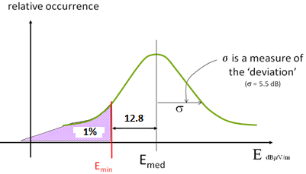

It also means that the location probability is given by:

*P*(*E* ≥ *Emin*) = 99% (1)

In compatibility calculations, the wanted *E* and interfering *I* field strengths are statistical values varying around a median value *Emed* and *Imed*, assumed to follow a ‘log-normal’ distribution with σ = 5.5 dB standard deviation for location variation.

Thus *E* and *I* can be modelled as independent random variables following Gaussian (*Emed*, σ*E*) and (*Imed*, σ*I*) distributions.

Consequently,

*E*/*I*(dB) = *E*(dB) – *I*(dB) follows a lognormal distribution (*Emed* – *Imed*,).

From the following equation:

*P*(*E*/*I* > *PR*(dB))>99% (2)

As referred to (1): *P*(*E*/*I* ≥ *Emed* – *Imed* – µ(99%) $\sqrt{σ_{E}^{2}+σ_{I}^{2}}$) = 99%

Thus: *Emed* ≥ *Imed* + *PR* + µ(99%) $\sqrt{σ_{E}^{2}+σ_{I}^{2}}$ where *PR* is the protection ratio for the wanted signal with respect to the interferer.

Assuming that $σ_{E}^{2}≈σ_{I}^{2}$ ≈ σ given that both interferer and victim transmitters operates at the same frequency, the following result is derived:

*Imed* ≤ *Emed* – *PR* – µ(99%) $\sqrt{2}σ$

*Imed* max = *Emed* – *PR* – µ99%) $\sqrt{2}σ$

From (2), it can be concluded that: *Imed* max = *Emin* + µ(99%)σ(1 – $\sqrt{2}$) – *PR*.

**2 When T-DAB system interferes with an SDL receiver (*I/N* criteria)**: The condition of protection of UE Rx is set by the following probability condition:

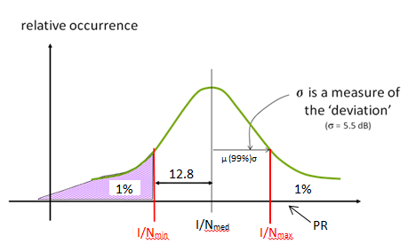

*P*(*I*/*N*≤ *I*/*N*max) = 99%

*P*(*I/N*≤ *I/Nmed*+ (99%) $\sqrt{σ_{N}^{2}+σ_{I}^{2}}$) = 99%

*P*(*I*/*N*≤ *Imed* – *N*+ $μ$ (99%) $\sqrt{σ_{N}^{2}+σ_{I}^{2}}$) = 99% (3)

and *P*(*I*/*N*≤*PR*) ≥ 9% (4)

From equations (3) and (4), we get: *PR* ≥ *Imed* – *N* + $μ$ (99%) $\sqrt{σ_{N}^{2}+σ_{I}^{2}}$

Given that *σN* = 0, the maximum is then derived: *Imed* max = *N* – $μ$ (99%)σI+ *PR*.

Annex 2  
  
The derivation of aggregated interference margin

When assessing the interference from IMT networks to BS it is necessary to evaluate the interference field strength of IMT base stations in the test points at the territory of other country. One study has assessed the change of the interference field strength taking into account the aggregate interference from base stations in the IMT network compared to the single-interference source for typical implementation of IMT network in the border areas.

The calculation of the increment of the cumulative interference field strength from the IMT network in relation to a field strength from a single interference source carried out in the following order:

1) Select country A and country B.

2) Model a network of IMT base stations with typical parameters (see Table 1) within the territory of the country A along the border with country B at a distance up to X km from the border.

3) Create test points in the territory of country B at the border and inland in increments of, for example 10 km, up to a total distance of Dt km.

4) In each test point calculate the following variables:

*a* = the highest interference field strength from a single base station;

*b* = cumulative interference field strength from all base stations in IMT network.

5) Plot on the same graph the distributions of the variables a and b as observed in respective test points (expressed as a percentage of test points).

6) Plot the distribution of the variable (*b – a*) as observed in respective test points, by the number of test points (expressed as a percentage of test points).

Perform such calculation the following parameters of IMT base stations have been used.

TABLE 1

Parameters for IMT base stations

|  |  |  |
| --- | --- | --- |
| Parameter | Units | Value |
| Maximum e.i.r.p. per sector for 10 MHz | dBm | 61.00 |
| Average base station activity | % | 50 |
| Average e.i.r.p. per sector for 10 MHz | dBm | 58.00 |
| Antenna gain (Giso) | dBi | 15.00* |
| Polarization discrimination | dB | 3 |
| Antenna height above ground | m | 30.00 |
| Antenna down tilt | Degrees | 3 |
| Main beam by 3 dB loss in H plane | Degrees | 65 |
| Main beam by 3 dB loss in V plane | Degrees | Based on Rec. ITU-R F.1336 |
| MS network type |  | Rural |
| Frequency | MHz | 1452 |
| Inter-site distance | km | 7.5 |

* – the antenna gain is 3 dB lower than the value in Report ITU-R M.2290.

Figure 1 shows an example IMT network, located along the border of the neighbouring state (blue dots indicate the location of base station sites) and covering the part of the country adjacent to the border. Evaluation of the increase of cumulative interference field strength from the IMT network over maximum interference field strength from one base station was carried out at the test points established in the territory of the neighbouring country (black dots). Figure 2 shows an example of the reverse situation – when the IMT network is located in the opposite country.

Figure 1

Example 1 – IMT base station sites (blue circles) within the borders of one country and the test points   
(black circles) on the territory of another country



Figure 2

Example 2 – IMT base station sites (blue circles) within the borders of second country and the test points   
(black circles) on the territory of first country

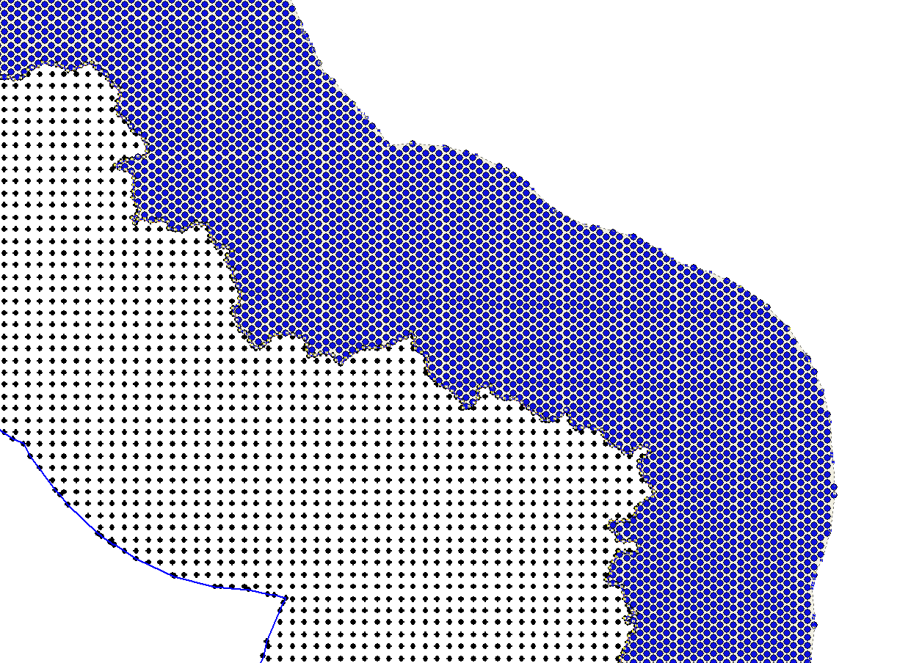

The distribution of the interfering fields in the test points of Example 1 is shown in Fig. 3, and for Example 2 is shown in Fig. 4.

Figure 3

Distribution of the interfering field strength at the test points of Example 1  
for single interferer and cumulative interference

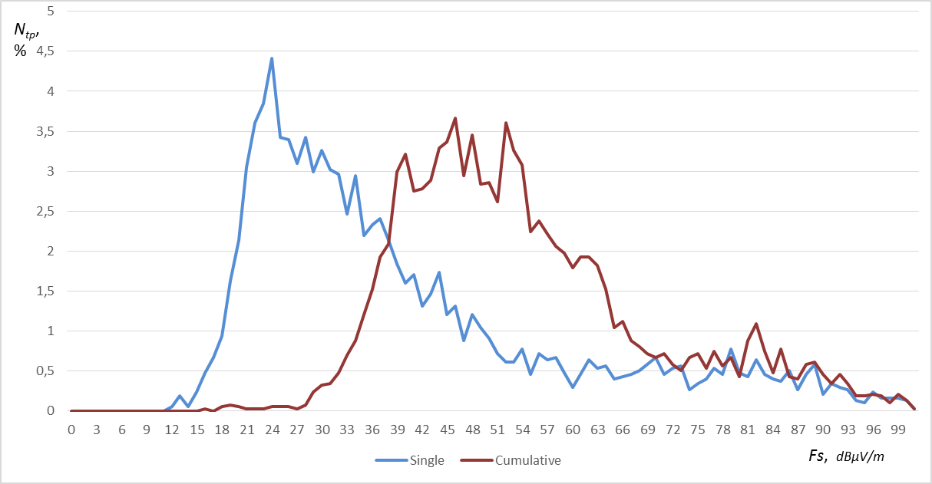

Figure 4

Distribution of the interfering field strength at the test points of Example 2  
for single interferer and cumulative interference

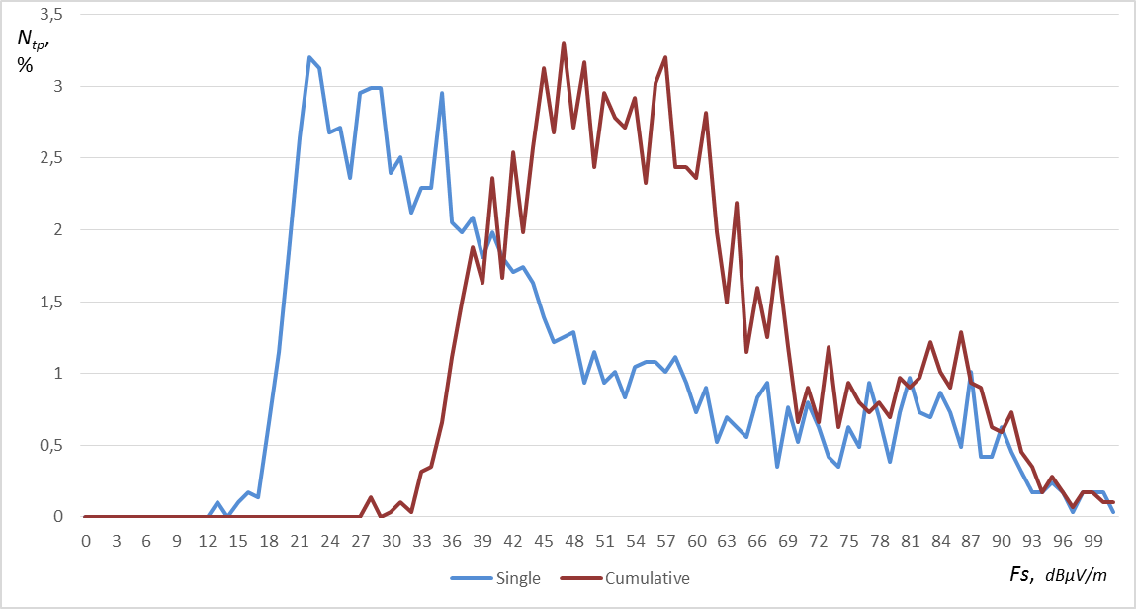

The resulting distribution of the increments of the total strength of the interfering field with respect to the maximum field strength of the interfering signal from one station is shown in Figs 5 and 6. Figures 5 and 6 show the results for the case of using an omnidirectional receiving antenna.

Figure 5

Distribution of difference in interfering field strength from IMT base stations when comparing single interference with cumulative interference in Example 1

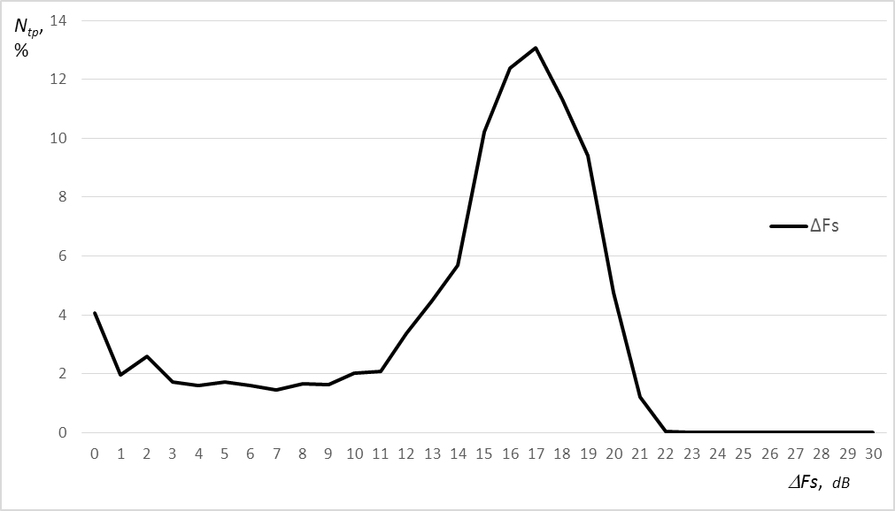

Figure 6

Distribution of difference in interfering field strength from IMT base stations when comparing single interference with cumulative interference in Example 2

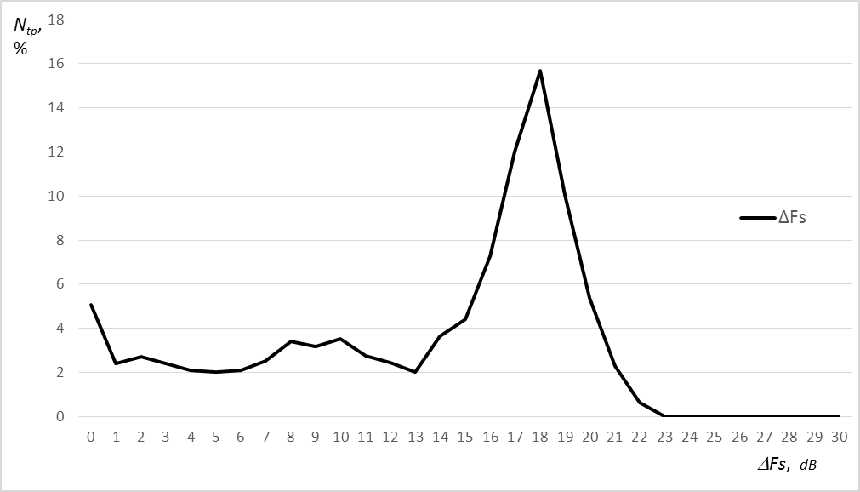

1. This Report was approved jointly by Radiocommunication Study Groups 5 and 6, and any future revision should also be undertaken jointly.
2. 1 Using an antenna height gain correction = 10 dB assumption from MA02revCO07 Annex 2 § 2.2.3.
3. 2 Using an antenna height gain correction = 10 dB assumption from MA02revCO07 Annex 2 § 2.2.3.
4. 3 Using an antenna height gain correction = 10 dB assumption from MA02revCO07 Annex 2 § 2.2.3.
5. 4 [ECC PT1(14)077_A13](http://www.cept.org/Documents/ecc-pt1/18432/ECC-PT1(14)077_Annexes-Final): Trigger values for cross border coordination.