Report ITU-R BS.2433-0
(10/2018)
Assessment of modulation depth for AM sound broadcasting transmissions

BS Series
Broadcasting service (sound)

Foreword
The role of the Radiocommunication Sector is to ensure the rational, equitable, efficient and economical use of the radio-frequency spectrum by all radiocommunication services, including satellite services, and carry out studies without limit of frequency range on the basis of which Recommendations are adopted.
The regulatory and policy functions of the Radiocommunication Sector are performed by World and Regional Radiocommunication Conferences and Radiocommunication Assemblies supported by Study Groups.

Policy on Intellectual Property Right (IPR)
ITU-R policy on IPR is described in the Common Patent Policy for ITU-T/ITU-R/ISO/IEC referenced in Resolution ITU-R 1. Forms to be used for the submission of patent statements and licensing declarations by patent holders are available from http://www.itu.int/ITU-R/go/patents/en where the Guidelines for Implementation of the Common Patent Policy for ITU-T/ITU-R/ISO/IEC and the ITU-R patent information database can also be found.

Series of ITU-R Reports
(Also available online at http://www.itu.int/publ/R-REP/en)
Series | Title
BO | Satellite delivery
BR | Recording for production, archival and play-out; film for television
BS | Broadcasting service (sound)
BT | Broadcasting service (television)
F | Fixed service
M | Mobile, radiodetermination, amateur and related satellite services
P | Radiowave propagation
RA | Radio astronomy
RS | Remote sensing systems
S | Fixed-satellite service
SA | Space applications and meteorology
SF | Frequency sharing and coordination between fixed-satellite and fixed service systems
SM | Spectrum management

Note: This ITU-R Report was approved in English by the Study Group under the procedure detailed in Resolution ITU-R 1.

Electronic Publication
Geneva, 2018
© ITU 2018
All rights reserved. No part of this publication may be reproduced, by any means whatsoever, without written permission of ITU.

REPORT ITU-R BS.2433-0
Assessment of modulation depth for AM sound broadcasting transmissions
(2018)

1 Summary
The work described in this Report was carried out in support of efforts to ensure that analogue and digital transmissions in the bands below 30 MHz could successfully co-exist. The main part of the work was carried out using the facilities and transmissions of the BBC and this is reflected in the text. Some further work was carried out with transmissions of a UK commercial broadcaster.
Measurements to assess typical modulation depths encountered on real AM (HF and MF) transmissions are described. The majority of the measurements were carried out ‘off line’ using recordings representing the demodulated transmitter output with various types of real, broadcast, programme material and typical service compression levels. A computer programme was used to find the peak to mean (rms) ratio. As a cross check, some measurements were also made of the sideband energy at the output of an operational 300 kW HF broadcast transmitter.
Modulation depths in the range 20% to 40% rms were encountered depending on the ‘genre’ of the programme material. The lower values were found with speech-based material, which is simultaneously the most vulnerable to interference. These results suggest that it may be preferable to use the low end figure (20%) when assessing protection ratios where the analogue AM broadcast service is suffering interference from a source other than an analogue AM transmission in the broadcast service

2 Background
This Report primarily describes measurements made by BBC World Service on some of its own transmissions. The study was extended to include: longer continuous samples (circa 1 hour), a greater proportion of music and samples from other broadcasters which had not been included in the original programme of measurements. The BBC was fortunate in securing the co-operation of the UK transmission service providers and one of their commercial customers. Samples of the transmissions of this commercial station were recorded at the input to a transmitter – after the transmission processor – for off line statistical analysis. The results of these supplementary measurements are presented in Annex 5.

3 Overall measurement strategy
A quantitative overview of AM modulation is given in Annex 6. From this it can be seen that the modulation depth of an AM signal can quite simply be expressed as the mean (rms) to peak ratio of the demodulated signal (the demodulated transmitter output). In the case of sine wave, which fully modulates the carrier, this is 0.7 or 70% (see equation (1) and Annex 6 below) and for a fully modulated square wave it is 1 or 100%. For a random signal, like an audio signal, the mean to peak ratio has to be established by means of a statistical analysis of the demodulated output over a period of time. For speech measurements the time period was chosen to give a representative sample while for music the time period typically covered a complete ‘track’.
Figure 1
Simplified transmission chain
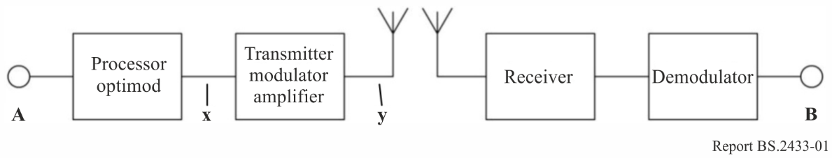
The diagram shows the important elements of the transmission chain in a simplified form. An audio input signal is applied at point A. Before transmission this is processed in order to enhance the audibility of the overall system output at B. The signal is modulated on to a carrier, transmitted, received and demodulated. It is assumed that the transmitter/antenna combination is ‘transparent’ and, when properly aligned, the demodulated signal at B should be very little different from the output of the processor.
For convenience, therefore, the analysis was performed on the output of the audio processor. The output from the audio processor was recorded onto a Compact Disc for analysis off line. The high sampling rate of a CD is more than adequate for accurate representation of the audio processor output and care was taken to keep well within the ‘digital headroom’ of the recorder.
Audio samples were converted to .wav files and these were analysed using a software package. The software package has a facility to normalise the level of the audio sample to any given reference and to find the average (rms) level of the signal. Therefore if the signal is normalised with its maximum excursion set to a value of 100 (%), the indicated rms level gives the rms modulation depth (%) directly.
Figure 2
Measurement configuration (processor only)
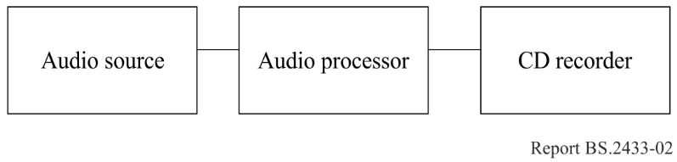
Figure 3
Measurement configuration (complete chain)
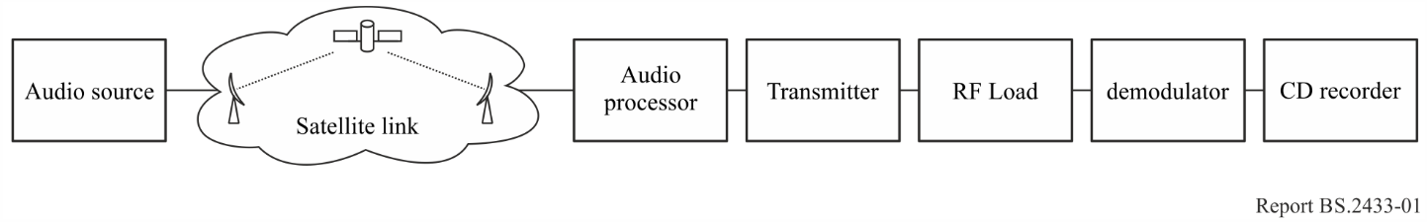

Programme samples
Different types of programme were analysed; speech, pop music, etc. The study concentrated, however, on speech. There are three related reasons for this:
– Importance: Along with many other ‘AM’ broadcasters, BBC World Service output is predominantly speech based; typically news and current affairs. This material is by far the most important part of the output.
– Vulnerability: The study supports the intuitive idea that speech is more vulnerable to interference than other types of programme. Not only does it have a lower average modulation depth, it is also characterised by frequent gaps and silences. Protection criteria should be set to protect the quietest and (therefore) most vulnerable signals and not the loudest and least vulnerable.
The different types of material analysed are listed along with the numerical results in Annexes 1 and 2. Wherever possible, samples were taken live off the network using the whole of the distribution chain including satellite up and down links. It was not, however, always possible to do this and so programme was sometimes fed directly to the audio processor input. All directly fed samples are identified in the Tables. Like the transmitter, the network distribution should be completely transparent and so the effect of directly feeding the audio processor should be insignificant. Some samples were recorded simultaneously at different points in the distribution chain to test this assertion and the relevant results are given in Annex 3.
Some sine wave samples were also used as a basic check on the method and on system calibration. The rms level of a clean (unclipped) sine wave can be calculated as:
$V_{rms}= \sqrt{\left(V_{pk} \int_{0}^{2π}{\frac{1}{2π \sin^{2}θ}dθ}\right)}$ (1)
For V_{pk} equal to unity, this yields the familiar result that V_{rms} is equal to 0.707 (1/√2). Clearly, if V_{pk} is 100% (modulation) the rms value is 70.7%.
It should be noted that modulation depth for sine waves is conventionally expressed in terms of the peak excursion and not the rms level. A sine wave that just reaches the clipping point is seen as modulated to 100%. As shown above, such modulation has an rms depth of 70.7%. The level of random signals – speech, music, noise, etc.– is best expressed as an rms value for direct comparison with the potential sideband level of a noise like interfering signal. For consistency, therefore, rms levels are used throughout this analysis. It would be possible to use ‘equivalent peak sine wave’ levels by multiplying all rms values for ‘random’ signals by √2. A more thorough quantitative overview of AM modulation and the assessment of modulation depth is given in Annex 6.
Sine wave examples are included with the audio processor input taken either from an audio test CD or from a broadcast network; actually a section from a time signal pip. It will be seen from samples 1, 17 and 18 in Annexes 1 and 2 that the measured result is close agreement with theory in both cases. In the case of the test disc it is virtually identical while the time signal shows slight.
A note about real high power transmitters
Few high power AM transmitters are capable of carrying sine wave modulation at 70% rms (100% peak) on a continuous basis. The BBC’s specifications state that a transmitter should be able to carry this level of modulation with a duty cycle of 1 to 6. It is actually specified as 10 minutes in every hour. The specified continuous rating for BBC transmitters is 56% rms (80% peak) modulation.

4 System calibration – Sources of error
At the simplest level, the test system did not need any calibration. The computer programme analysed the incoming audio file to find the maximum voltage excursion and normalised to this as 100% modulation. The actual voltage did not matter and no attempt was made to set it to any particular level save to keep comfortably within the overall system headroom. The first column of results in Annexes 1 and 2 (“No Clip”) shows rms modulation depths normalised with the absolute maximum excursion of the input signal set to 100%.
Closer examination of the waveforms showed that the bulk of the audio signal was contained well below the 100% point set in the above manner. Excursions to the 100% point were rare and brief; rarer and briefer than might be expected on a real transmitter. One reason for this could be that the audio processor allowed a small amount of ‘overshoot’. While the overshoot was insignificant in practical terms, the software programme was taking it into account where an engineer aligning a transmitter might very well ignore it. An alternative reference for the peak level was therefore sought.
Results are presented for 3% clipping and 6% clipping, designated “3% Clip” and “6% Clip” in the Tables in Annexes 1 and 2. By 3% clipping it is meant that the normalised signal is first amplified by 3% (+0.25 dB) – so that the peaks are now 103% – and then ‘clipped’ back to 100% simulating the transmitter running out of dynamic range at this level. This is shown in Fig. 4. Assuming the transmitter to be otherwise linear up to the clipping point, clipping by 3% would introduce non-linear (harmonic) distortion of slightly more than 2% to a sine wave. Clipping by 6% would introduce slightly less than 5% distortion. If a sine wave is clipped at 3% and 6%, the calculated rms values are 72.5% and 73.9% respectively.
Figure 4
3% clipping
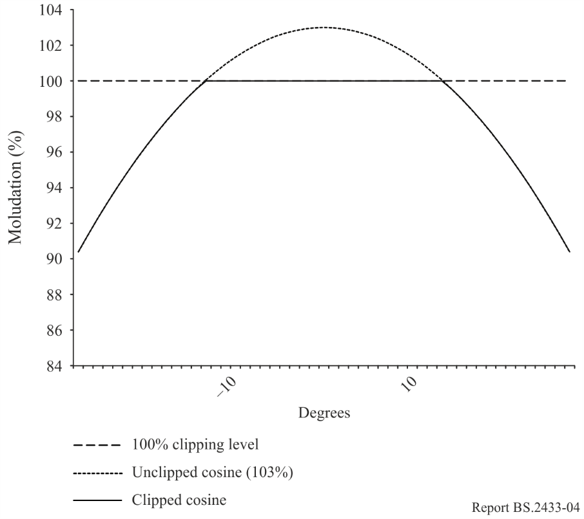
Careful analysis of a 45 second sample of English language male speech originated in a studio showed that with 3% clipping there were, on average, approximately 1.2 instances per second of negative peaks being clipped and 2.2 instances per second of positive peaks being clipped. This aligned well with the authors’ own (subjective) experience of aligning modern, audio processor-driven AM transmitters. With 6% clipping there were 2.2 instances per second of negative going peaks being clipped and 5.7 instances per second of positive going peaks being clipped; slightly more than would normally be expected.

5 Dynamic Carrier Control
Most broadcasters now use some kind of Dynamic Carrier Control (DCC) on their AM transmissions. The BBC uses its own AMC (Amplitude Modulation Companding) system. In this system, the presence of modulation has the effect of reducing the overall gain of the transmitter and hence the sideband energy. The reduction in sideband energy can be regarded as an effective reduction in the modulation depth. The greater the modulation the further the gain is reduced. Different characteristics are used for HF and MF. A purely static assessment gives the following result:
Original modulation % | 20 | 25 | 30 | 35 | 40
HF – with AMC
Equivalent modulation % | 19.0 | 22.8 | 26.8 | 30.1 | 33.4
MF – with AMC
Equivalent modulation % | 19.5 | 23.7 | 27.9 | 32.3 | 36.0

Other systems of DCC (which reduce carrier level during periods when the audio level is low) are likely to have a more severe effect, particularly with speech.
In practice the effect of DCC is likely to be far more pronounced than this table suggests because the dynamic characteristics – fast attack and slow release – dominate. This is borne out by the results presented in the next section and Annex 4.

6 Reality check
As a check on the credibility of the method a few measurements were made using the output of a real transmitter. Rather than carry out an analysis of the statistical properties of the signal, a simple test was carried out to measure the sideband power. The transmitter output power was measured using a metered test load first with no modulation and then with modulation applied. The difference gave the sideband power which could easily be converted to modulation depth. The test was repeated with DCC applied. While this method gave a useful reality check, operational constraints prevented a thorough investigation being carried out in a realistic time frame. The programme material was of the same ‘genre’ as the samples but had to be what was available on the network at the time. Additionally, this method did not give the same resolution as the computer analysis. The results are given in Annex 4 along with a discussion of the associated calibration (and other) errors.
In general there was close agreement between the measurements made on the transmitter and the statistical analysis.

7 Commentary on the results
The results in Annex 1 in the column headed “3% clip” are used as this is thought to be the best representation of the line-up of a real transmitter. It will be seen, however, that the difference between the three columns, 6%, 3% and no clipping, is anyway quite small; less than the difference between audio samples of the same genre. It is felt therefore, that this choice is of little overall significance.
Degree of compression
It can be seen that the compression effect of the audio processing varies quite considerably with programme genre. Comparing samples 5 and 15 for example shows that the audio processor increases the rms modulation depth of male speech from 11.2% to 26.9% or by 7.6 dB. The same comparison using the pop music samples 14 and 16 and the same audio processor, shows an increase from 24.0% to 35.2%, only 3.3 dB. It was clear that the audio processor was more aggressive as a compressor than the audio processors used by the BBC.
This serves to demonstrate the difficulty in making generalisations about the compressive effect of a signal processor (and probably a simple compressor as well). It is the intent of the audio processor to introduce sufficient compression to optimise audibility without undue deterioration of the sound quality, and to make the programme pleasant to hear by smoothing out loudness variations between various programme elements. The fact that the audio processor changes the rms modulation depth by different amounts for different programme elements is a side-effect of its creating loudness consistency between these elements. Pop music sources are usually more highly compressed than speech sources, so pop music requires less audio processor compression than speech to achieve loudness parity. The relationship between the degree of compression and the ultimate peak to mean ratio is complicated and depends heavily on factors such as the release time of the compressor and the precise dynamics of the input signal. Given that audio quality tends to be preserved by having fairly slow release time, this can become a dominant factor meaning that increasing levels of compression will have a diminishing effect. The source material in samples 14 and 16 was probably compressed fairly heavily when it was originated and so further compression would be expected to have a smaller effect.
The 7.6 dB difference between samples 5 and 15 suggests that the audio processor is fairly aggressive as a compressor and the resulting signal can probably be considered as being highly compressed.
Levels encountered
It is clear from the results that the modulation depth depends on the programme material. It will be seen that there is a general tendency for the results obtained with the digital audio processor (Type 2) to give a higher rms modulation depth and the digital audio processor (Type 3) higher still. With a few exceptions the range of modulation depth for speech is 20% (BBC) to 31% (commercial station) with the majority of samples giving results near to the bottom of this range. The sample of 1960s pop gave the highest level at about 35% – sample 14. On this basis it is suggested that 20% represents a realistic minimum rms modulation depth and 40% a realistic maximum. Subjectively, the commercial station offered a much more continuous sound with few gaps (silences), music underneath speech and many of the music tracks running into each other.
A small amount of analysis was carried out on samples of languages other than English. Results suggest that any differences there may be are not significant but this should not be regarded as a rigorous result. The reason for the very low level encountered with speech coming from a telephone balance unit is unclear and needs to be investigated further.
The modulation depth of uncompressed/unprocessed speech is around 10%, roundly 6.5 dB lower than the value for compressed speech.
Reality Check
The tabulated results in Annex 4 are broadly in line with those in Annexes 1 and 2; if anything they are a little lower. This serves to demonstrate that the overall method is sound and the results can be regarded as credible. Observations of the output of the particular service transmitter used for the tests suggested that it was, in practice, unable to produce modulation peaks much in excess of 95% without introducing severe distortion. Service alignment levels are adjusted accordingly.

8 Conclusions
While the speech based material gave rms modulation depths broadly in the range 20-30%, the loudest samples, pop music, approached 40%. It is suggested that realistically, with modulation depths in the range 20-40%, a difference of 6 dB can be expected from AM transmitters. There seemed to be little difference between MF band and HF band transmissions.
These results suggest that it may be preferable to use the low end figure (20%) when assessing protection ratios where the analogue AM broadcast service is suffering interference from a source other than an analogue AM transmission in the broadcast service. This would allow the most vulnerable signals – speech and other low modulation depth items – to be adequately protected. Where the analogue AM transmission is itself the interferer, the higher value (40%) may be used to offer similar protection to another service. The large, 6 dB, difference between the maximum and minimum modulation depth should be noted and, ideally, taken into account when assessing criteria for protecting one analogue transmission from another.
These modulation depths, 20% and 40%, correspond roundly to sideband powers of 4% of carrier and 16% of carrier respectively; 30 dB and 15 dB down on carrier.
It should be recognised that many broadcasters use Dynamic Carrier Control (DCC) on their transmissions improve efficiency. This does not appear to have been taken into account in the formulation of protection criteria and the limited amount of testing with DCC applied suggests that it could reduce the carrier power and hence the effective modulation depth by a further 4 dB; from about 20% to about 12%. The effect of noise like interference on DCC transmissions depends upon the actual system used. The AMC system is specifically designed with this in mind but it must be recognised that any form of DCC will make the transmission more vulnerable to interference.
However, the effect of interference on DCC transmissions requires further full quantitative and subjective analysis in its own right.

Annex 1
RMS modulation depths
Audio processor Type 2 – MF digital processing
 |  | Notes | Length | Modulation Depth  (% rms)
 | Sample (name/type) |  | secs | No clip | 3%  Clip | 6%  Clip
1 | Sine wave (440 Hz – test disc) | 1, 6 | 30.0 | 70.7 | 72.4 | 73.9
2 | Male Speech English (No. 1) |  | 46.0 | 22.3 | 22.9 | 23.7
3 | Male Speech English (No. 2) |  | 25.5 | 21.7 | 22.4 | 23.1
4 | Male Speech English (No. 3) |  | 40.0 | 22.7 | 23.4 | 24.2
5 | Male Speech English (No. 4) | 1 | 20.5 | 26.1 | 26.9 | 27.8
6 | Female Speech English (No. 1) |  | 32.0 | 23.4 | 24.7 | 24.9
7 | Female Speech English (No. 2) |  | 47.0 | 25.4 | 26.1 | 27.0
8 | Female Speech English (No. 3) |  | 184.0 | 24.1 | 24.9 | 25.7
9 | Female Speech English (No. 4) | 1 | 21.6 | 22.8 | 23.5 | 24.2
10 | Male Speech Pashto | 1 | 119.0 | 24.0 | 24.7 | 25.5
11 | Male Speech English – telephone | 1 | 54.0 | 9.1 | 9.3 | 9.7
12 | Female Speech English – telephone | 1 | 58.0 | 18.5 | 19.1 | 19.7
13 | Speech + Music (jingle) | 1 | 28.5 | 30.0 | 30.9 | 31.9
14 | Pop Music – 1966  (Herman’s Hermits – No Milk Today) | 1 | 173.0 | 34.1 | 35.2 | 36.3
15 | Male Speech English  (uncompressed – no audio processor) | 2 | 20.5 | 10.8 | 11.2 | 11.5
16 | Pop Music – 1966  (uncompressed – no audio processor) | 3 | 173.0 | 23.3 | 24.0 | 24.8
Note 1 – Audio sample fed directly to audio processor without passing through a distribution channel.
Note 2 – Same audio sample as “Male Speech No. 4”.
Note 3 – Same audio sample as “Pop Music – 1966” compressed.
Note 4 – Same audio sample as “Pop Music – 2006” compressed.
Note 6 – See Annex 3.

Annex 2
RMS modulation depths
Audio processor Type 1 – HF analogue processing
 |  | Notes | Length | Modulation Depth  (% rms)
 | Sample (name/type) |  | secs | No clip | 3%  Clip | 6%  Clip
17 | Sine wave (440 Hz – test disc) | 1, 6 | 64 | 71.2
18 | Sine wave (440 Hz – time signal) | 6 | 0.07 | 69.6
19 | Male Speech English (No. 1) |  | 90.0 | 21.4 | 22.0 | 22.7
20 | Male Speech English (No. 2) |  | 40.0 | 18.3 | 18.9 | 19.5
21 | Male Speech English (No. 3) | 5 | 118.0 | 19.5 | 20.1 | 20.8
22 | Male Speech English (No. 4) |  | 76.0 | 20.3 | 21.0 | 21.6
23 | Female Speech English (No. 1) |  | 53.0 | 22.5 | 23.2 | 24.0
24 | Female Speech English (No. 2) |  | 43.0 | 21.6 | 22.3 | 23.0
25 | Female Speech English (No. 3) |  | 53.0 | 20.0 | 20.6 | 21.3
26 | Female Speech English (No. 4) |  | 75.0 | 19.6 | 20.2 | 20.8
27 | Male Speech Urdu | 1 | 57.0 | 23.9 | 24.6 | 25.4
28 | Male Speech English – telephone |  | 150.0 | 19.3 | 19.7 | 20.5
29 | Female Speech English – telephone |  | 160.0 | 18.2 | 18.7 | 19.3
30 | Interview |  | 176 | 18.1 | 18.6 | 19.2
31 | Speech + Music (jingle) |  | 12.0 | 23.1 | 23.8 | 24.6
32 | Pop Music – 1966  (Herman’s Hermits – No Milk Today) | 1 | 173.0 | 32.6 | 33.6 | 34.7
33 | Pop Music – 2006  (Corinne Bailey Rae – Like a Star) |  | 236.0 | 26.3 | 27.1 | 28.0
34 | Male Speech English  (uncompressed – no audio processor) | 2 | 90.0 | 8.9 | 9.1 | 9.4
35 | Pop Music – 1966  (uncompressed – no audio processor) | 3 | 173.0 | 23.3 | 24.0 | 24.8
36 | Pop Music – 2006  (uncompressed – no audio processor) | 4 | 236.0 | 21.1 | 21.8 | 22.5
Note 1 – Audio sample fed directly to audio processor without passing through GDS channel.
Note 2 – Same audio sample as “Male Speech No. 4”.
Note 3 – Same audio sample as “Pop Music – 1966” compressed.
Note 4 – Same audio sample as “Pop Music – 2006” compressed.
Note 5 – News headlines with gaps – removing gaps raised level by circa 1%.
Note 6 – See Annex 3.

Annex 3
RMS modulation depths
Comparison of output of network switcher with audio processor input – effect of satellite distribution system
 |  | Note | Length | Modulation Depth  (% rms)
 | Sample (name/type) |  | secs | Before Satellite distribution | After Satellite distribution
37 | Sine Wave (time signal – 3rd pip) | 6, 7 | 0.07 | 70.7 | 70.6
38 | Male Speech English (No. 1) |  | 66.0 | 8.0 | 8.2
39 | Male Speech English (No. 2) |  | 42.0 | 9.6 | 9.9
Note 6 – Results from sine wave samples actually represent the peak to mean (rms) ratio and are not representative of actual transmitter modulation depth. Sine wave signals which fully modulate the transmitter (70% rms, 100% peak) are only ever transmitted for engineering tests. Studio and transmitter line up practice means that time signal pips are arranged to modulate the transmitter to 21% rms (40% peak).
Note 7 – Result for 3rd ‘pip’ of time signal.

Annex 4
Measurements made with a real transmitter reality check
Audio processor Type 2 – MF digital processing
 | Carrier Power (kW) | Carrier + Sideband | Modulation (rms %) | Note
Sample 1 – General programme | 245 | 263 | 27
Sample 2 – News (male and female speech) | 245 | 253 | 19
Sample 3 – Arabic (male speech) | 245 | 253 | 19
Sample 4 – News (male and female speech) | 272 | 283 | 20
Sample 5 – Dynamic Carrier Control | 278 | 147 | 12 | 1
Note 1 – This is the effective modulation depth – an equivalent figure based on the sideband power. It is, however, representative of the signal’s vulnerability to interference.
Transmitter/Test Load Calibration Errors
As stressed in this Report, measurements were made ‘live’ off the network wherever possible. While this had the disadvantage that it was difficult precisely to repeat any actual test run, it did mean that the results gave a good indication of the real situation. The ‘reality check’ measurements were similarly made with a real, service transmitter in service condition with no attempt made at exceptional ‘alignment’. It was, after all only intended as a check on the credibility of results obtained through computer analysis of audio samples.
Further to this, the test load, while metered, was not specifically calibrated. The test load is usually used as simply a power sink and would only normally be calibrated only if a particular test demanded it. A 300 kW transmitter was being used and in this instance, calibration with its attendant cost in terms of manpower, time, energy, etc. was not considered necessary. High accuracy was not needed and results were deduced from relative rather than absolute measurements.

RMS modulation depth (%) measurement with sine wave
From modulation analyser | 67 | 20 | 24 | 30
equivalent peak | 95 ⁽¹⁾ | 28 | 34 | 42
From test load | 60 | 18 | 22 | 28
absolute error (% full mod) | 7 | 2 | 2 | 2
⁽¹⁾ The actual figures were 97% negative and 93% positive – the transmitter was beginning to show signs of severe distortion at this level.

It can be seen that in the area of interest, modulation depths between 20 and 30% rms, there was a constant measurement error of around 2% (6-10% of the modulation depth value itself) which reduced to 1% when corrected by subtracting the power offset. Values corrected in this way are therefore used.
Variation in transmitter output power: It was observed that the plain carrier output power varied by about 6% during the test programme. The complete programme of tests took about 3 1/2 hours and the transmitter was running continuously. In general it appeared that the output power increased as time went by. To minimise the impact on the results, the plain carrier power was itself measured immediately before or immediately after each sideband measurement and used at the reference. Without correction this variation would give rise to an additional error of around ±2% for modulation depths in the region of 25%.
Settling time: While the thermal inertia of the test load allowed rms measurements to be made with reasonable confidence, it took a finite time for the measured power in the test load to settle and, with speech modulation, ongoing variations in the measured power were noted. To counteract this, measurements were not made until the power in the test load was subjectively judged to have settled – typically at least four minutes – and then several measurements were made at 15 second intervals. The final value was taken as the average of the measurements. The length of time taken to carry out a measurement run sometimes prevented the run from being made with a consistent input signal. It must be born in mind that the audio input was being taken from a live network and so could include a mixture of male and female speech and the occasional few bars of music.

Annex 5
Supplementary measurements
The foregoing report was presented to the European Broadcasting Union (EBU). The EBU asked if the data presented in the report could be supplemented with further measurements made with:
– longer samples (circa 1 hour)
– different genres (more music based samples)
– different broadcasters.
The authors were fortunate to be able to gather samples from a UK national commercial station, commercial radio, with a mix of popular music, news and advertisements. The Commercial radio transmitter used an audio processor from another manufacturer. The results of these supplementary measurements are presented here.
 |  | Note | Length | Modulation depth  (% rms)
 | Sample (name/type) |  | mins | No clip | 3%  Clip | 6%  Clip
 | BBC WS Samples
 | Type 1 – analogue
40 | General speech based | 8 | 44’ 17” | 18.3 | 18.9 | 19.5
41 | World music programme | 9 | 27’ 26” | 22.2 | 22.9 | 23.6
42 | Band 1 – Stargazer’s Band | 10 | 2’ 47” | 20.2 | 20.8 | 21.5
43 | Band 2 – African Jazz | 10 | 5’ 07” | 24.0 | 24.7 | 25.6
44 | Band 3 – The Dominos | 10 | 3’ 13” | 26.7 | 27.5 | 28.4
45 | Band 4 – Haruna Ishola | 10 | 2’ 48” | 25.1 | 25.8 | 26.7
 | Commercial Radio Samples
 | Type 3 – digital
46 | General music based | 11 | 67’ 48” | 33.5 | 34.6 | 35.7
47 | Pop music (3 tracks) | 12 | 10’ 17” | 33.6 | 34.6 | 35.7
48 | Advertisement sequence | 13 | 2’ 6” | 30.1 | 31.0 | 32.0
49 | Advertisement sequence | 13 | 1’ 50” | 26.5 | 27.3 | 28.2
50 | News bulletin | 14 | 1’ 30” | 29.6 | 30.5 | 31.4
Note 8 – The majority of the samples made with the audio processor HF 9501 (samples 19 to 31) were extracted from a much longer continuous sample. The whole of this is analysed as No. 40.
Note 9 – This programme, “Charlie Gillett’s World of Music” is the only programme on the BBC’s European stream that specifically deals with contemporary music. The particular episode analysed was concerned specifically with music from Africa.
Note 10 – Extract from sample 41.
Note 11 – Includes news bulletin and advertisements.
Note 12 – Music tracks are run together.
Note 13 – Extract from sample 46.
Note 14 – Extract from sample 46. News bulletin had music backing.

It will be noted that the result for sample No. 40 is close to that from the Skelton transmitter described in Annex 4.
Looking at samples 40 and 41, there appear to be two main reasons for the ' whole being less than the sum of the parts'. First, within a long sample there are numerous with short gaps and silences which will be ignored when individual components or extracts (individual speakers etc.) are analysed. Obviously this will reduce the overall mean modulation depth. Second, the Audio processor appears to equalise the loudness (rather than the peak level) of a set of otherwise different signals. In practice this probably means that the overall (mean) level tends to be reduced to that of the quietest component (the one with the largest peak to mean ratio) rather than increased to match the loudest. To realign everything (up) to the level of the loudest component would cause the transmitter to over modulate on peaks. It can be concluded that where a long sequence consists of components of the same programme genre, the long term average is likely to be smaller than that of the individual components. The long commercial radio sample gave a much more continuous sound level than the BBC sample. There were fewer gaps (silences) and where there was speech, advertisements and news, this was itself often backed with music.

Annex 6
Quantitative Overview – RMS Modulation Depth
A normalised AM broadcast signal can be expressed mathematically as:
$X_{am}\left(t\right)= Y_{rf}\left(t\right).(1+ Z_{audio} \left(t\right))$ (2)
where:
X_{am}(t): resultant AM signal
Y_{rf}(t): radio frequency carrier (sine wave)
Z_{audio}(t): audio signal – modulation.
Substituting a sinewave for the carrier component gives:
$X_{am}\left(t\right)= Cos 2 π f_{c} t.(1+Z_{audio}\left(t\right))$ (3)
where:
f_{c}: carrier frequency in Hz.
The amplitude of the carrier when un-modulated (with no audio) will have a constant, normalised peak value of 1. For everything to work properly, the audio signal, Z, has to be constrained (using careful manual control or some kind of limiter) to have a maximum excursion of ±1 such that the peak amplitude of the AM signal will vary between 0 and 2.
Considering a the case of sine wave audio modulation the AM signal becomes:
$X_{am}\left(t\right)= Cos 2 π f_{c} t .\left(1+M Cos 2 π f_{a} t \right)$ (4)
where:
f_{a}: audio frequency in Hz
M: Modulation Index – usually less than 1 (or 100%).
Setting the Modulation Index to 1 or 100% gives the waveform shown in Fig. 5 while setting it to 0.5 or 50% gives the waveform in Fig. 6.

Figure 5 | Figure 6
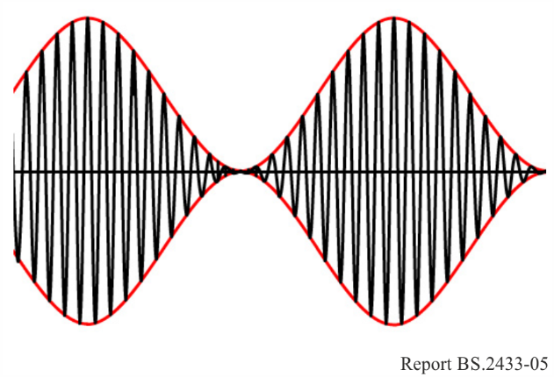 | 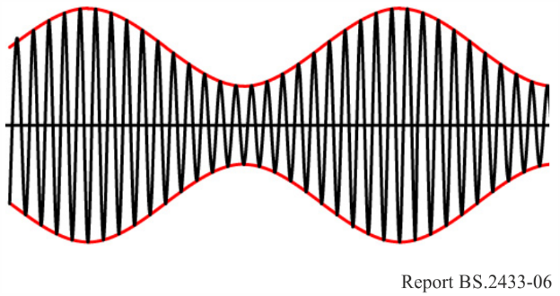
The red line is not part of the waveform but shows the consequential envelope of the modulation. Clearly, a Modulation Index of zero, or no modulation signal will result in a continuous sine wave at the carrier frequency (the carrier is shown by the black line in Figs 5 and 6) at half the peak amplitude in Fig. 5. Figure 5 is generally considered as 100% modulation because the modulation peaks occupy 100% of the available range.
The AM equation can be re-written as:
$X_{am}\left(t\right)+ Cos 2 π f_{c}t+\frac{M}{2}(Cos 2 π \left(f_{c}+f_{a}\right) t+$ Cos 2 π $\left(f_{c}-f_{a}\right) t)$ (5)
In the case of sine wave modulation, this yields three spectral components. One lies on the carrier frequency – f_{c} – and does not vary with either the Modulation Index or the size, or frequency of the modulation. The other two, which are called sidebands, are situated either side of the carrier and separated from it by plus and minus f_{a} – i.e. at (f_{c} + f_{a}) and at (f_{c} – f_{a}) – each with an amplitude of M/2. Where M is 1 or 100%, the amplitude of each sideband is 0.5 so that the power in each sideband is a quarter of the power in the carrier and the total power in the modulation is half the power in the carrier. Where M is 0.5 or 50%, the sideband amplitudes are 0.25 and the total modulation power is one eighth of the carrier (one sixteenth in each sideband).
When dealing with real modulation signals, a modulation index based on the characteristics of a sine wave is not particularly useful except as an equivalent to reference everything back to. Consider the AM waveforms in Figs 7 and 8. Figure 7 shows square wave modulation and Fig. 8 random modulation, representative of a real audio signal. Clearly both of these use the whole of the available range and so could be considered as 100% modulation. However, the sideband power in these cases will be quite different from those in the sine wave case. Taking the square wave; for one half cycle, the carrier amplitude is doubled and so the output power is four times that of the un-modulated carrier. In the other half cycle the output is zero. Averaging over a complete cycle, the overall power is double that of the un-modulated carrier; the modulation power is the same as the carrier power and the power in each sideband half of the carrier power. The modulation power for the square wave is twice that for the sine wave of the same amplitude.
Figure 7 | Figure 8
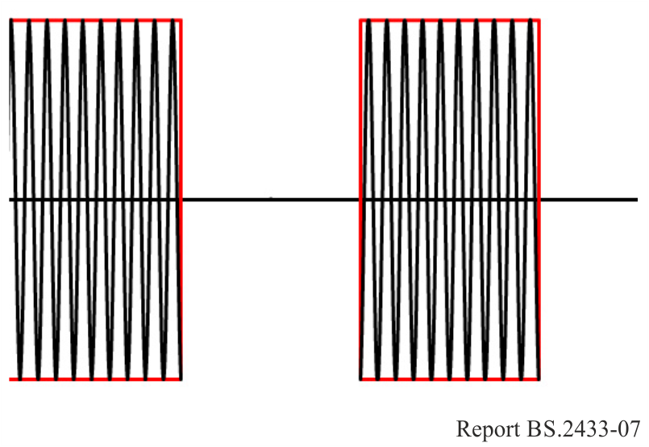 | 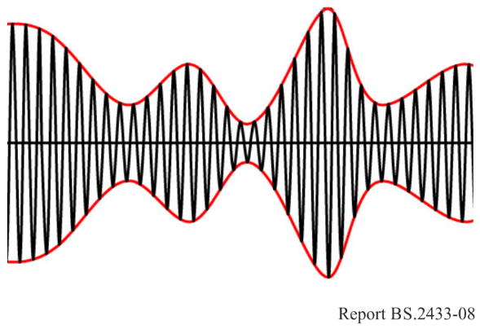
A perhaps more useful way to specify the modulation depth is to through the rms level. The rms amplitude allows the level of different wave shapes to be compared and, if necessary, referenced back to an equivalent sine wave. The rms amplitude for any waveform (f(t)) and any units over a time period T is defined by the well know formula
$f_{rms}= \sqrt{ ( \frac{1}{T} } \int_{0}^{T}{{\left(f\left(t\right)\right)}^{2} dt)}$ (6)
Equally well know are the rms values for a ± unity (peak) sine wave which is 1/√2 = 0.707 and for a ± unity square wave which is 1. This means that the rms modulation depth for the sine wave situation in Fig. 5 (Modulation Index = 1) is 0.707 or 70.7% and for the square wave in Fig. 7 it is 1 or 100%. The rms modulation depth for the sine wave in Fig. 6 (Modulation Index = 0.5) is 0.354 or 35.4%.
Conveniently, the total sideband power (both sidebands) as a proportion of the carrier power for any given rms modulation depth can simply be calculated as the square of the rms modulation depth. So for Fig. 5 it is 0.707² = 0.5, for Fig. 6 it is 0.354² = 0.125 and for Fig. 7 it is 1² = 1. The power in each sideband is half of the total because the waveform is spectrally symmetrical about the carrier.

______________

This is discussed more fully under “System Calibration – Sources of Error”.
While it is likely that there have been specific studies looking at the intrusive effects of noise and interference on different types of programme material, this has not been taken into account here.
For an even (1:1) mark space ratio square wave the peak and rms modulation depths would be the same.
The audio processor is deliberately less aggressive in controlling positive going peaks than negative; AM transmitters will typically allow some positive over-modulation while negative over-modulation is physically not possible.
Samples which fall below 20% rms are probably not significant but the reason should be investigated as a future project.

