Report ITU-R BS.2494-0
(11/2021)
Sound test materials for
advanced sound systems

BS Series
Broadcasting service (sound)

Foreword
The role of the Radiocommunication Sector is to ensure the rational, equitable, efficient and economical use of the radio-frequency spectrum by all radiocommunication services, including satellite services, and carry out studies without limit of frequency range on the basis of which Recommendations are adopted.
The regulatory and policy functions of the Radiocommunication Sector are performed by World and Regional Radiocommunication Conferences and Radiocommunication Assemblies supported by Study Groups.

Policy on Intellectual Property Right (IPR)
ITU-R policy on IPR is described in the Common Patent Policy for ITU-T/ITU-R/ISO/IEC referenced in Resolution ITU-R 1. Forms to be used for the submission of patent statements and licensing declarations by patent holders are available from http://www.itu.int/ITU-R/go/patents/en where the Guidelines for Implementation of the Common Patent Policy for ITU-T/ITU-R/ISO/IEC and the ITU-R patent information database can also be found.

Series of ITU-R Reports
(Also available online at http://www.itu.int/publ/R-REP/en)
Series | Title
BO | Satellite delivery
BR | Recording for production, archival and play-out; film for television
BS | Broadcasting service (sound)
BT | Broadcasting service (television)
F | Fixed service
M | Mobile, radiodetermination, amateur and related satellite services
P | Radiowave propagation
RA | Radio astronomy
RS | Remote sensing systems
S | Fixed-satellite service
SA | Space applications and meteorology
SF | Frequency sharing and coordination between fixed-satellite and fixed service systems
SM | Spectrum management

Note: This ITU-R Report was approved in English by the Study Group under the procedure detailed in Resolution ITU-R 1.

Electronic Publication
Geneva, 2021
© ITU 2021
All rights reserved. No part of this publication may be reproduced, by any means whatsoever, without written permission of ITU.

REPORT ITU-R BS.2494-0
Sound test materials for advanced sound systems
(2021)
Introduction
This Report contains lists of sound test materials for advanced sound systems and related information for assessment of sound quality.
TABLE OF CONTENTS
Page
Policy on Intellectual Property Right (IPR) ii
Annex 1 Channel-based sound test materials for sound system H specified in Recommendation ITU-R BS.2051 2
1 Standard test materials for three-dimensional multichannel stereophonic sound systems – Series A (provided by the Institute of Image Information and Television Engineers (ITE)) 2
1.1 Overview of standard test materials for three-dimensional multichannel stereophonic sound systems – Series A 2
1.2 Details of test materials 4
Annex 2 Status for use of test materials 18

Annex 1
Channel-based sound test materials for sound system H
specified in Recommendation ITU-R BS.2051

1 Standard test materials for three-dimensional multichannel stereophonic sound systems – Series A (provided by the Institute of Image Information and Television Engineers (ITE))

1.1 Overview of standard test materials for three-dimensional multichannel stereophonic sound systems – Series A
The test materials are matched with the channel allocations for the 22.2 multichannel sound system (sound system H (9+10+3) specified in Recommendation ITU-R BS.2051, Table 1). The test signals are provided in two file formats, a multi-mono format with signals for the 24 channels in 24 individual files and an interleaved format with signals for all 24 channels stored in a single file.
The file formats are as follows.
Signal format: Linear PCM
Sampling frequency: 48 kHz
Quantization bits: 24 bits
Number of channels: 1 channel for 24 files (multi-mono format)
24 channels for 1 file (interleaved format)
TABLE 1
Sound channel allocations for 22.2 multichannel sound
Channel  No. | Channel  label | Channel name | Speaker  label | Speaker position range
 |  |  |  | Azimuth (degree) |  | Elevation (degree)
1 | FL | Front left | M+060 | +45 | +60 | 0 | +5
2 | FR | Front right | M-060 | −45 | −60 | 0 | +5
3 | FC | Front centre | M+000 | 0 |  | 0 | +5
4 | LFE1 | Low-frequency effects −1 | LFE1 | +30 | +90 | −15 | −30
5 | BL | Back left | M+135 | +110 | +135 | 0 | +15
6 | BR | Back right | M-135 | −110 | −135 | 0 | +15
7 | FLc | Front left centre | M+030 | +22.5 | +30 | 0 | +5
8 | FRc | Front right centre | M-030 | −22.5 | −30 | 0 | +5
9 | BC | Back centre | M+180 | +180 |  | 0 | +15
10 | LFE2 | Low-frequency effects −2 | LFE2 | −30 | −90 | −15 | −30
11 | SiL | Side left | M+090 | +90 |  | 0 | +15
12 | SiR | Side right | M-090 | −90 |  | 0 | +15
13 | TpFL | Top front left | U+045 | +45 | +60 | +30 | +45
14 | TpFR | Top front right | U-045 | −45 | −60 | +30 | +45
15 | TpFC | Top front centre | U+000 | 0 |  | +30 | +45
16 | TpC | Top centre | T+000 | 0 |  | +90
17 | TpBL | Top back left | U+135 | +110 | +135 | +30 | +45
18 | TpBR | Top back right | U-135 | −110 | −135 | +30 | +45
19 | TpSiL | Top side left | U+090 | +90 |  | +30 | +45
20 | TpSiR | Top side right | U-090 | −90 |  | +30 | +45
21 | TpBC | Top back centre | U+180 | +180 |  | +30 | +45
22 | BtFC | Bottom front centre | B+000 | 0 |  | −15 | −30
23 | BtFL | Bottom front left | B+045 | +45 | +60 | −15 | −30
24 | BtFR | Bottom front right | B-045 | −45 | −60 | −15 | −30

The test materials used to assess test items are shown in Table 2.
TABLE 2
Major test items for each test material
Test signal |  | Test item
No. | Name | Overall impression | Gradation | Tone | Signal processing degradation | Sound image localisation | Stereo image | Surround sense | Vertical sense | Sense of presence
1 | Channel check |  |  | ○ | ○ | ◎
2 | Sound image localisation |  |  |  |  | ◎ | ◎ | ◎ | ◎
3 | Soundscape (Amusement park) | ◎ |  |  | ○ | ◎ | ○ | ○ | ◎ | ◎
4 | Soundscape (Train) | ◎ | ○ |  |  | ○ | ◎ |  |  | ◎
5 | Soundscape (Volleyball) |  |  |  | ◎ | ○ |  | ○ | ◎ | ○
6 | Octet | ◎ | ○ | ◎ | ◎ | ○ | ◎ | ◎ |  | ◎
7 | Song (Kagome) |  |  | ○ |  | ○ |  | ◎
8 | Drama | ◎ |  |  | ○ | ○ |  | ○
9 | Tempura |  |  | ○ | ◎
10 | Sound resources |  |  |  | ◎ | ○ |  | ○ | ◎
◎ Especially suitable
○ Suitable

1.2 Details of test materials

1.2.1 Channel check
A. Channel check, 124 s
B. Loudspeaker position check, 155 s
In ‘A. Channel check’, the loudspeaker positions are read out by a female voice in the recorded channel order. In ‘B. Loudspeaker position check’, the loudspeaker positions are read out by a male voice, clockwise starting from the front left of the middle layer, then the top layer, the top centre, and the bottom layer (see Fig. 1). The detailed recording condition is shown in Table 3.
These test signals are for checking whether the loudspeakers are connected to the playback equipment correctly. The adjustment of acoustics from loudspeakers requires pink noise to be played from each loudspeaker, which is adjusted so that all loudspeakers yield the same sound levels, arrival times and frequency characteristics (a flat response over a broad range is preferred) at the listening position. They are also suitable for checking sound quality, such as whether female and male voices sound natural and can be used to evaluate the accuracy of sound image localisation when converting the number of channels or using a pseudo surround sound.
TABLE 3
Recording data
Recording location | Soundproof room
Microphone | Omni-directional microphone
Notes | Channels are read out at 5 s intervals.  2 s of silence between channels.
Figure 1
Reading order for channel check (A, red) and loudspeaker position check (B, blue)
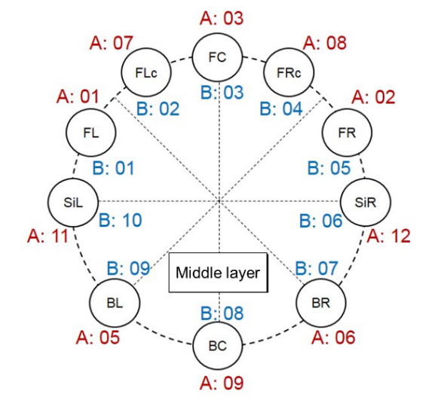
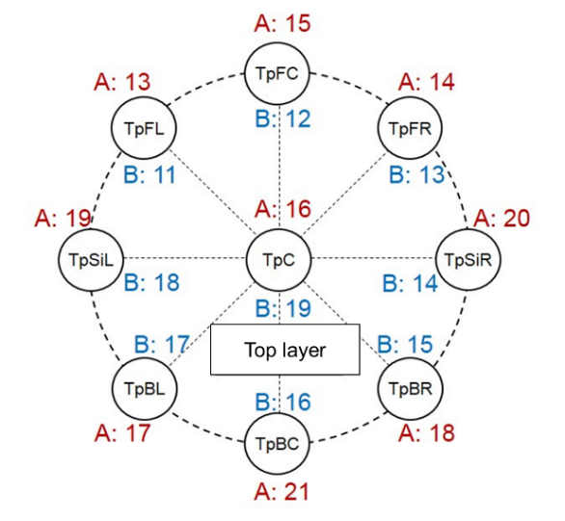
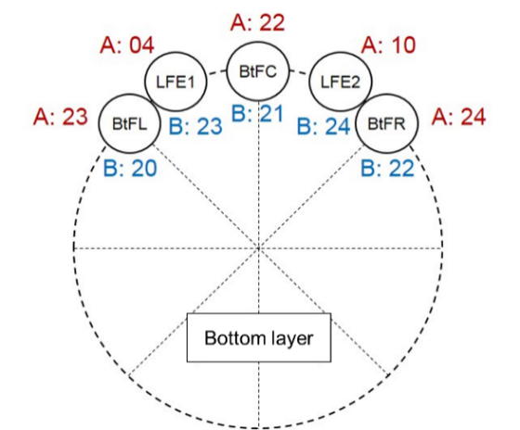

1.2.2 Sound image localisation
A. Left-to-right motion for 45 degrees or 60 degrees, 90 s
This test signal facilitates evaluation of sound image localisation accuracy by listening to white noise (sound image positions are indicated by the red circles in Fig. 2). The white noise makes a round trip, starting from 45 degrees to the left, above and to the front, and moving to 45 degrees to the right, above and to the front, and returning. This motion is repeated five times at various heights and a uniform speed. At the middle layer of the 45-degree system (the third repetition) and when the sound image is at the end of the sweep, the sound only plays from the loudspeaker at that position. However, in a 60-degree system when the sound image is at the end of the sweep in the middle layer, the same level is output from the inner and outer left or right loudspeakers. This setup is used so that, an assuming there is accompanying video, the sound image moves through the same range of ±45 degrees in the front direction, regardless of whether in a 45-degree or 60-degree system.
This is suitable for evaluating the sense of motion of sound images on the screen, particularly in the horizontal direction.
Figure 2
Left-to-right motion sound image positions
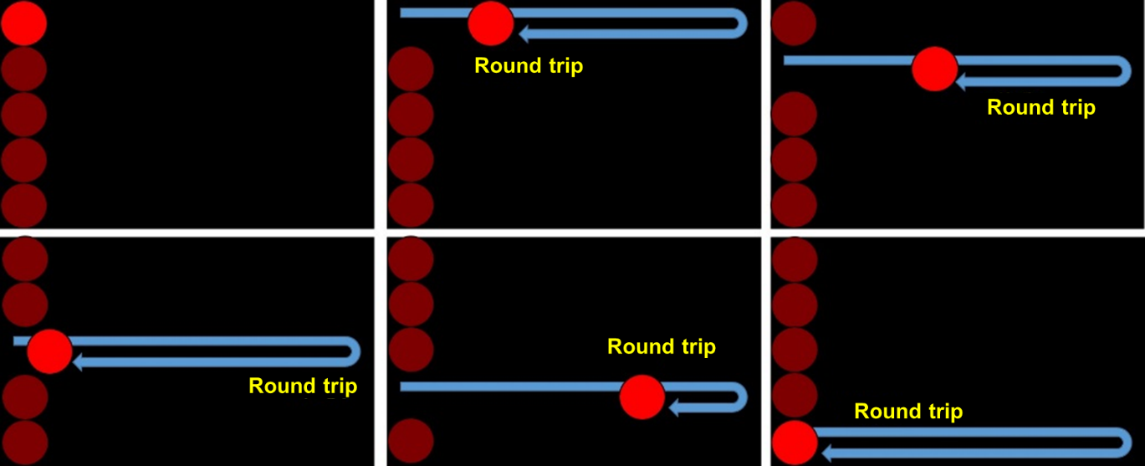
B. Up-to-down motion for 45 degrees or 60 degrees, 120 s
White noise (sound image positions indicated by the red circles in Fig. 3) makes a round trip, starting from 45 degrees to the left, above and to the front, and moving to 45 degrees to the left, below and to the front, then returns. This motion is repeated nine times at various position from left to right and at a uniform speed. At the middle layer of the 45-degree system and when the sound image is on the left (1st sweep) and right (9th sweep), the sound only plays from the loudspeaker at that position. However, in the 60-degree system when the sound image is on the left or right at the middle layer, the same level is output from the inner and outer left or right loudspeakers. This setup is used so that, assuming there is accompanying video, the sound image moves through the same range of ±45 degrees in the front direction, regardless of whether in a 45-degree or 60-degree system.
This is suitable for evaluating the sense of motion of sound images on the screen, particularly in the vertical direction.
Figure 3
Up-to-down motion sound image positions
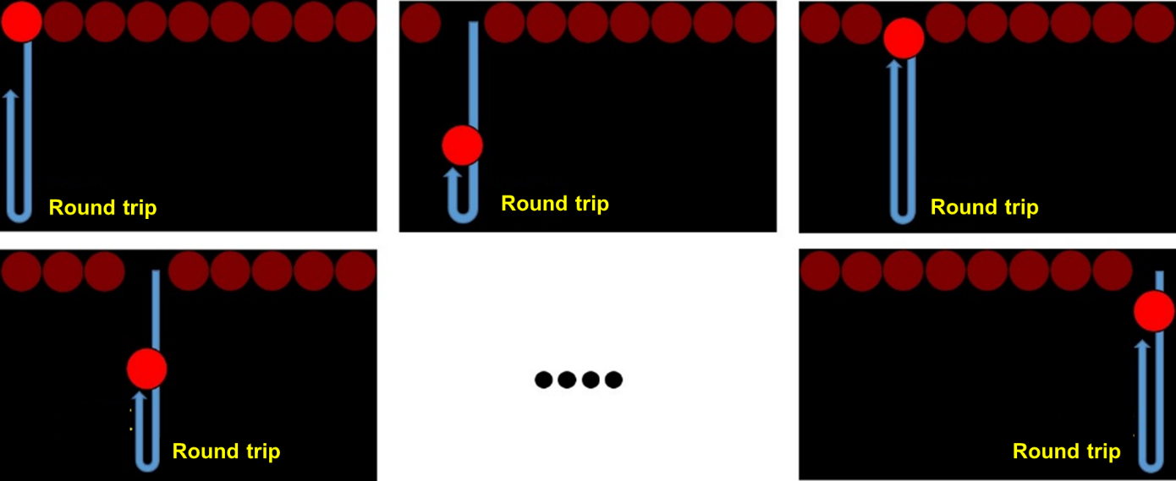
C. Horizontal rotation for 45 degrees or 60 degrees, 30 s
White noise (sound image positions indicated by the red circles in Fig. 4) rotates counter clockwise from the front in the middle layer, once around the listener, and then returns in the clockwise direction. The sound image is adjusted to move at a uniform speed.
The sound rotates around the listener, so it is suitable for evaluating the sense of motion of sound images in the horizontal plane.
Figure 4
Horizontal rotation sound image positions
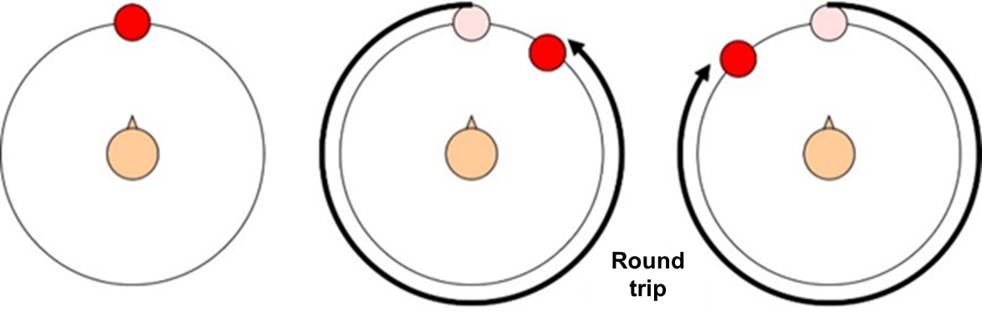
D. Flying overhead for 45 degrees or 60 degrees, 129 s
White noise (sound image positions indicated by the red circles in Fig. 5) moves from centre-front in the middle layer to the rear, through the top-centre position, and then returns to the front via the same path. This is repeated. Similarly, it makes return trips from left to right through the top-centre position, from the front-left to the back-right, and from the front-right to the back-left.
It is suitable for evaluating the motion of sound images in vertical planes (front, cross-sectional planes).
Figure 5
Flying overhead sound image positions
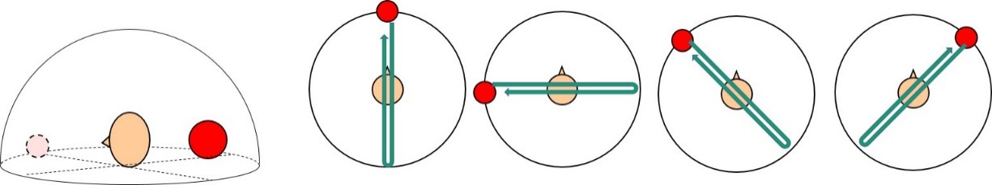
E. Vertical helix for 45 degrees or 60 degrees, 30 s
White noise (sound image positions indicated by the red circles in Fig. 6) rotates once counter-clockwise from the top-front position, once in the middle layer, and then descends while rotating around the listener’s position in the clockwise direction starting from the centre-top. The sound image is adjusted to move at a uniform speed.
This signal is suitable for evaluating the motion of sound images in the horizontal plane while moving up and down.
Figure 6
Vertical helix sound image positions
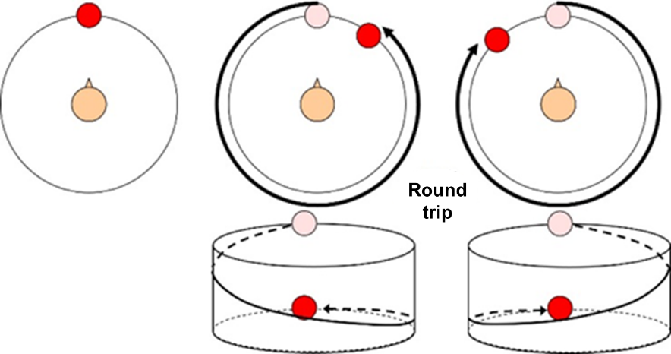

1.2.3 Soundscape (Amusement park)
A. One-point and multipoint recording at amusement park, 15 s or 31 s
The test signals are a soundscape from an amusement park recorded using a one-point microphone consisting of 22 directional microphones, and 24 omni-directional microphones placed at 22.2 multichannel sound loudspeaker positions (see Figs 7 and 8). It includes sounds of a roller coaster overhead and an empty drink can rolling below the listener. There are two test materials of lengths 15 s and 31 s, and each was obtained by single-point and multipoint recordings for a total of four recordings. The detailed recording condition is shown in Table 4.
This setup is suitable for evaluating the motion of sound images, including the movement of the roller coaster and screams overhead, and that of the empty can below. Since the audio signals from the directional and omni-directional microphones as recording devices are different, it is also useful for evaluating sound degradation due to signal processing.
TABLE 4
Recording data
Recording location | Urban amusement park
Recording equipment | Single-point recording
 |  | Microphone | Sanken CSR-2 (highly directional)
 |  | Microphone amp. | DirectOut technologies  Andiamo.MC
 | Multipoint recording
 |  | Microphones | Schoeps MK2H (Omni-directional)  Schoeps CMC6xt (Preamp)
 |  | Microphone amp. | StageTec NEXUS
Edit history

Figure 7
Recording scenes
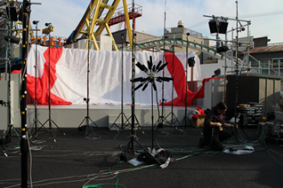 | 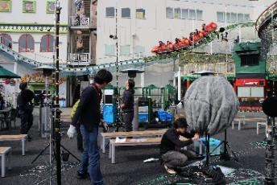
Figure 8
Multipoint recording microphone positions for Soundscape (Amusement park)
Plan view
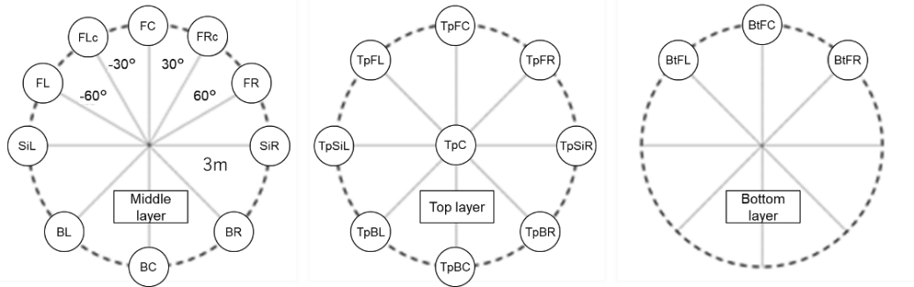
Elevation view
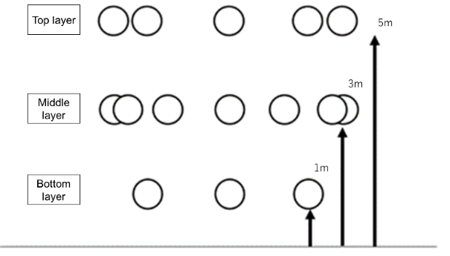

1.2.4 Soundscape (Train)
A. One point and multipoint recording of train passing, 22 s
B. One point and multipoint recording of train in roundtrip, 44 s
The scenario is a railway toward the front and overhead, and on the rail a train passes from left to right. In the case of a short, 22 s test signal, the train passes once, and in the case of a longer, 44 s test signal, trains pass in both directions (see Figs 9 and 10). Both single-point and multipoint recordings were carried out. The detailed recording condition is shown in Table 5.
This setup is suitable for evaluating sound image localisation effects with multiple microphones, which is different from evaluation with panning. It is also useful for evaluating the natural sense of distance from the train sound as it gradually approaches and its volume increases.
TABLE 5
Recording data
Recording location | Tama River, riverbed
Recording equipment | Single-point recording
 |  | Microphone | Sanken CSR-2 (highly directional)
 |  | Microphone amp. | DirectOut technologies  Andiamo.MC
 | Multipoint recording
 |  | Microphones | Schoeps MK2H (Omni-directional)  Schoeps CMC6xt (Preamp)
 |  | Microphone amp. | StageTec NEXUS
Edit history

Figure 9
Recording scenes
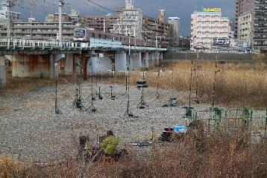 | 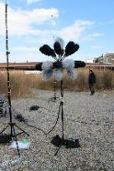
Figure 10
Multipoint recording microphone arrangement for Soundscape (Train)
Plan view
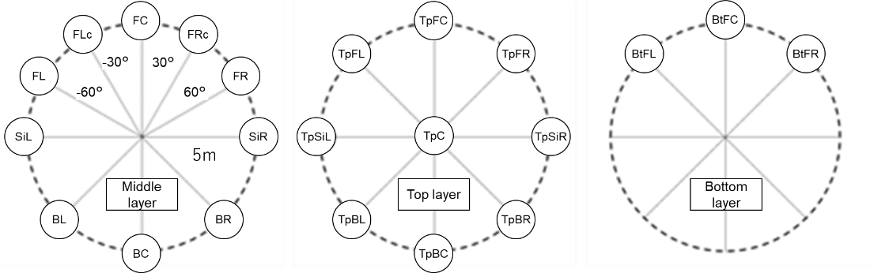

Elevation view
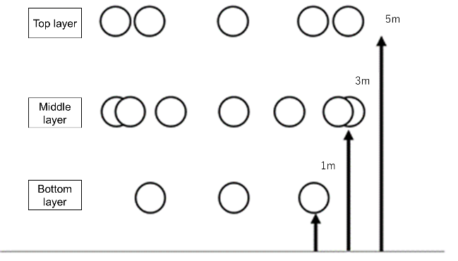

1.2.5 Soundscape (Volleyball)
A. Volleyball facing sideline in one point and multipoint recording, 15 s
B. Volleyball facing end line in one point and multipoint recording, 15 s
The test signal is a recording of a volleyball practice scenario. Single-point and multipoint recordings were carried out. The ‘22.2 one-point microphone’ for single-point recording was positioned directly under the net, and the 24 omni-directional microphones for multipoint recording were positioned in a rectangle around the perimeter of the court. Two types of test signal were recorded, one with the front of the 22.2 multichannel sound facing the sideline (spectator view), and one facing the end line (player view), for a total of four test signals (see Figs 11, 12 and 13). The detailed recording condition is shown in Table 6.
These signals are useful for evaluating the localisation of the overhead sound image of a spike, and also signal processing degradation from using sound coding with distortion. They can also be used to evaluate the immersiveness from reverberation in a gymnasium, the intensity of the players’ movements, and the sense of space.
TABLE 6
Recording data
Recording location | Gymnasium in Ibaraki Prefecture
Recording equipment | Single-point recording
 |  | Microphone | Sanken CSR-2 (highly directional)
 |  | Microphone amp. | DirectOut technologies  Andiamo.MC
 | Multipoint recording
 |  | Microphones | Schoeps MK2H (Omni-directional)  Schoeps CMC6xt(Preamp)
 |  | Microphone amp. | StageTec NEXUS
Edit history

Figure 11
Recording scenes
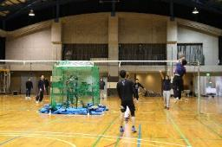 | 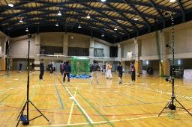
Figure 12
Multipoint recording microphone arrangement for Soundscape (Volleyball) (facing sideline)
Plan view
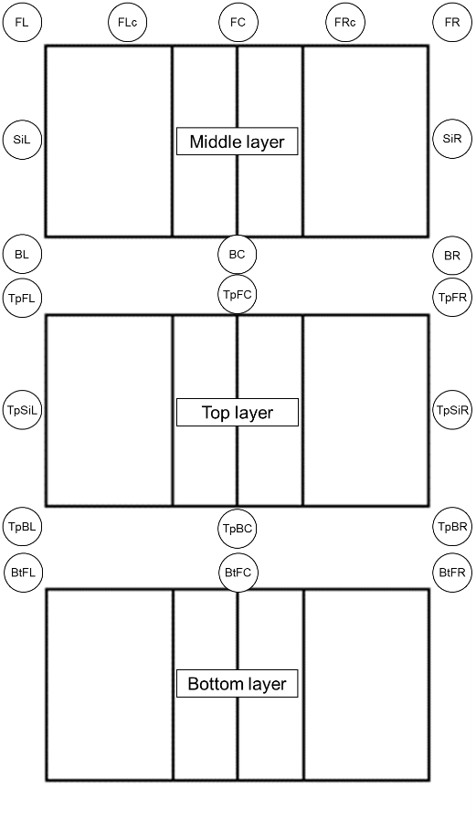
Elevation view
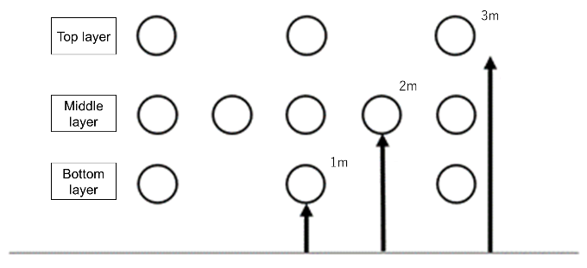
Figure 13
Multipoint recording microphone arrangement for Soundscape (Volleyball) (facing end line)
Plan view
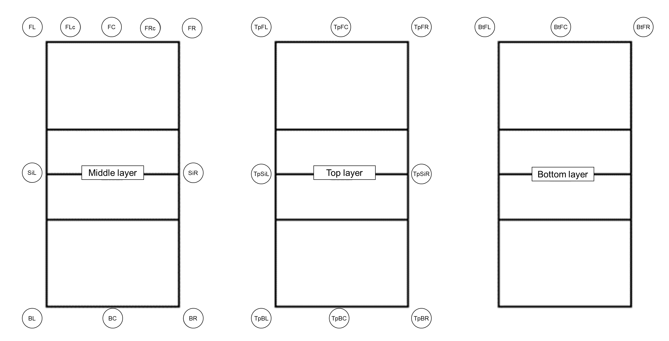
Elevation view
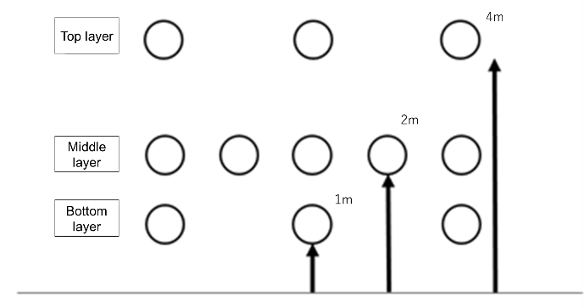

1.2.6 Octet (music)
A. Octet Strings, 16 s
B. Octet Winds, 13 s
C. Octet, 13 s, 70 s, and 291 s
D. Octet unprocessed, 291 s
In this situation, an octet of performers surrounds a one-point microphone (see Fig. 14). Recording D is the unprocessed recording of the entire performance, and recording E is the same recording with the reverberation inside a large hall added. Recording C-2 is a 70 s clip taken from C-3, whereas A to C-1 are approximately 15 s segments featuring mainly strings, mainly winds, and all instruments respectively.
These test signals are suitable for evaluating the sound direction of each instrument (position of sound image), tone and immersiveness.
These are single-point recordings, but omni-directional microphones were also used for the LFE channels, and signals from all 24 channels were recorded. The detailed recording condition is shown in Table 7. These can be used for demonstrations or for checking operation over longer periods of time.
TABLE 7
Recording data
Recording location | Urban auditorium
Recording equipment | Single-point recording
 |  | Microphone | Schoeps MK41 (Highly directional)  Schoeps CMC6xt (Preamp)
 |  | Microphone amp. | StageTec NEXUS
 | For LFE channel
 |  | Microphone | Sanken CO-100K (Omni-directional)
 |  | Microphone amp. | StageTec NEXUS
Edit history | Large-hall sound reverberation added using 3D reverb equipment

Figure 14
Recording scenes
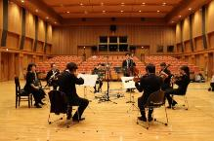

1.2.7 Song for children (in Japanese)
A. Song sang at rest, 26 s
B. Song sang while moving, 26 s
These are single-point recordings in which participants stand or walk around the one-point microphone while singing the song (see Fig. 15). The detailed recording condition is shown in Table 8.
Recordings at rest are suitable for evaluating spatial resolution, and those done with participants moving around are suitable for comparing spatial resolution and other aspects, such as differences in the tone of the voices. The participants move slowly, so this can be used for evaluating the localisation in a different situation from the train or roller coaster signals.
TABLE 8
Recording data
Recording location | Urban testing studio
Recording equipment | Single-point recording
 |  | Microphone | Schoeps MK41 (Highly directional)  Schoeps CMC6xt (Preamp)
 |  | Microphone amp. | DirectOut technologies  Andiamo.MC

Figure 15
Recording scenes
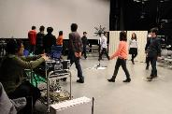

1.2.8 Drama
A. Drama “meeting”, 13 s
B. Drama “rehearsal”, 12 s
These are single-point recordings. A one-point microphone was positioned at the centre of the meeting room. The meeting and drama rehearsal were carried out in the meeting room (see Fig. 16). The detailed recording condition is shown in Table 9.
The voices of participants coming from various directions are suitable for evaluating spatial resolution. The sound of applause and that from dishes are useful for evaluating signal processing degradation. After the applause, flutter echoes also occur owing to reflections from the walls and glass windows. This effect was also audible in the environment, so we recorded it.
TABLE 9
Recording data
Recording location | Urban meeting room
Recording equipment | Single-point recording
 |  | Microphone | Schoeps MK41 (highly directional)  Schoeps CMC6xt (Preamp)
 |  | Microphone amp. | DirectOut technologies  Andiamo.MC

Figure 16
Recording scenes
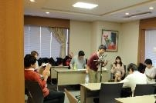

Annex 2
Status for use of test materials
Use of the test materials described in § 1 of Annex 1 is restricted to the following purposes.
a) Technical evaluations, including:
– research and development of equipment and systems;
– testing of equipment during development and production processes;
– testing of transmission conditions for broadcasting and telecommunication;
– maintenance of equipment.
b) Technical demonstrations, including:
– presentations at technical conferences and workshops;
– presentation of performance and functionality of equipment at exhibitions.
Inclusion in commercial products and promotional demonstration of commercial products are not permitted.
NOTE 1 – Usage restrictions as proposed above can be considered as falling under the following category:
Commercial restricted
The test materials may be used for research projects, to verify equipment specifications, and public demonstrations of commercial products. Inclusion in commercial products is not allowed. Reproductions for distribution may only be made by the copyright holder or authorized distributor.

Distributor: ITE, https://www.ite.or.jp/content/test-materials/. ITE: The Institute of Image Information and Television Engineers, Kikai-Shinko-Kaikan, 3-5-8 Shibakoen, Minato-ku, Tokyo 105-0011, Japan, Phone: +81 3 3432 4677, E-mail: ite@ite.or.jp.
It is recognized that white noise might not be ideal for localization. Readers are invited to propose better test signals or trajectories through their own administration.

