Report ITU-R BT.2253
(06/2012)
GPS timing receivers for DVB-T SFN application: 10 MHz phase recovery
BT Series
Broadcasting service
(television)

Foreword
The role of the Radiocommunication Sector is to ensure the rational, equitable, efficient and economical use of the radio-frequency spectrum by all radiocommunication services, including satellite services, and carry out studies without limit of frequency range on the basis of which Recommendations are adopted.
The regulatory and policy functions of the Radiocommunication Sector are performed by World and Regional Radiocommunication Conferences and Radiocommunication Assemblies supported by Study Groups.

Policy on Intellectual Property Right (IPR)
ITU-R policy on IPR is described in the Common Patent Policy for ITU-T/ITU-R/ISO/IEC referenced in Annex 1 of Resolution ITU-R 1. Forms to be used for the submission of patent statements and licensing declarations by patent holders are available from http://www.itu.int/ITU-R/go/patents/en where the Guidelines for Implementation of the Common Patent Policy for ITU-T/ITU-R/ISO/IEC and the ITU-R patent information database can also be found.

Series of ITU-R Reports
(Also available online at http://www.itu.int/publ/R-REP/en)
Series | Title
BO | Satellite delivery
BR | Recording for production, archival and play-out; film for television
BS | Broadcasting service (sound)
BT | Broadcasting service (television)
F | Fixed service
M | Mobile, radiodetermination, amateur and related satellite services
P | Radiowave propagation
RA | Radio astronomy
RS | Remote sensing systems
S | Fixed-satellite service
SA | Space applications and meteorology
SF | Frequency sharing and coordination between fixed-satellite and fixed service systems
SM | Spectrum management

Note: This ITU-R Report was approved in English by the Study Group under the procedure detailed in Resolution ITU-R 1.

Electronic Publication
Geneva, 2012
© ITU 2012
All rights reserved. No part of this publication may be reproduced, by any means whatsoever, without written permission of ITU.

REPORT ITU-R BT.2253
GPS timing receivers for DVB-T SFN application: 10 MHz phase recovery
(2012)

TABLE OF CONTENTS
Page
1 Purpose of this work 2
2 The analysis system 3
3 The long-term tests 4
4 The long-term test results 6
5 RF blockage tests 6
6 RF blockage tests results 7
7 Basic criteria for GPS equipment for broadcasting applications 9
Annex 1 – Tentative procedure to test GPS-based equipment for 10 MHz absolute phase recovery 10

Introduction
As known, a single-frequency digital terrestrial television network (SFN, DVB-T, in particular), relies on the availability of a common time and frequency reference, at the generation site and at each transmitting site.
This is due to the fact that every transmitter must emit the same signal – generated upon digital modulation of the same bits – on the same RF frequency, at the same time. Some tolerance on time and frequency is allowed by the OFDM modulation itself.
In facts, the OFDM receiver itself is able to accommodate, to some extent, the skew on received signals resulting from transmitters placed at different distances; also, a limited amount of frequency offset between the signals is allowed, having the same effect as the Doppler effect.
The time and frequency reference usually adopted by the DVB-T broadcaster is the GPS satellite system: specialized, professional receivers, the so-called “GPS Timing Receivers”, or “GPS Disciplined oscillators”, GPSDO, provide a timing signal, 1 Hz (or “1pps” – one pulse per second), and a frequency reference, 10 MHz, from an internal quartz oscillator controlled by an algorithm relying on the timing of the GPS system. Such timing receivers are thus used in every DVB-T SFN site.
The digital stream, containing audio/video/data services, is generated in a centralized site (Head-End), at a bit-rate value defined by the intended OFDM modulation. The clock for such bit-rate is derived from the 10 MHz reference coming from the local (Head-End site) GPS receiver. The stream is then distributed to all the transmitters in the SFN; in each transmitting site, the modulation (and thus emission) rate is derived in the same way from the 10 MHz reference, coming from the local (transmitting site) GPS receiver. Thus, the data-source clock and the data-sink clock are nominally the same, and actually, on the medium/long term, they have the same value, since both “sons” of the same GPS satellite system.
However, in the short timescale, the frequency fluctuations of a 10 MHz GPS receiver in a transmitting site, relative to the one on the Head-End site, can be non-negligible. In each DVB-T modulator, in SFN mode, a data buffer is present. The main purpose of such block is to implement a programmable delay that allows the transmitter to emit the signal exactly at the required moment: the value of such delay is then depending on (and complementing) the individual distribution network path delay. But a secondary – yet important – purpose of the said buffer is to absorb the short-term relative fluctuations of source and sink clocks. Since the buffer should implement up to 1 s delay, the required memory is quite big; however, some transmitter designers could decide to cascade two FIFOs: a large synchronous one, the exact depth of which is resized upon “resynchronization” (a sort of reset) of the modulator and then kept constant, and a small asynchronous one, used to absorb relative clock fluctuations. It is clear that if the latter FIFO is too little and the short-term fluctuations are too big, this FIFO can go overflow or underflow. In such cases, there is data loss, and the modulator must “resynchronize”, with a loss of service that can last several seconds. Since similar failures are not uncommon in the DVB-T SFN operation, questions arise on the extent of the 10 MHz fluctuations in available GPS timing receivers.

1 Purpose of this work
The RAI Group decided to investigate the behaviour of some quartz-based GPS timing receivers, from the standpoint of the data-buffer utilization. Unfortunately, the modulator’s data-buffer utilization percentage is usually not shown on the equipment front panel display or via equipment monitoring facilities.
To work around the problem, the RAI Group decided to implement a special analyser on a general-purpose FPGA board (see next section), able to log the equivalent data-buffer utilization versus time. The hardware has been extended to perform simultaneously measurements on up to seven clocks under test versus a reference one, in order to make a screening on several GPS receivers in parallel. In this way, it is easy to compare the behaviour of such receivers in presence of various troubles, namely, interference and low number of satellites in visibility. A further follow-up of this job has been to develop a test procedure for broadcaster application, suitable to check GPS-based equipment before to purchase them and to put them into service.

2 The analysis system
A FIFO buffer can be seen as a dual-port memory, in which the port #1 is written by incoming data (at clock #1) and the port #2 is read (at clock #2) to produce output data. At port #1 a counter is used as write address generator; its value is the write pointer. At port #2, a second counter is used as read address generator; its value is the read pointer. The difference of the read pointer value minus the write pointer value is the pointer distance, or margin.
Instead of implementing a whole FIFO buffer, the two counters and a subtractor can just give the required margin information. As a further simplification, it was decided to use a single up/down counter with a control logic driving it, that does the same function. Once this counter has been reset upon the start of the test, the counter value has the meaning of “buffer margin loss”. In fact, in a data buffer, the nominal buffer utilization is usually set at 50%, in order to have balanced room in positive and negative filling direction; the margin loss measured has positive/negative values, meaning that the test clock (of that channel) has run faster/slower than the reference clock, respectively. The units of the margin loss are clock cycles at 10 MHz (hence 100 ns/unit).
Each of the seven test channels of the analyser receives an analog signal at 10 MHz, digitizes it (oversampled), performs finite impulse response (FIR) filtering to remove noise (if any), feeds it to a threshold crossing detection, and the resulting pulse is fed to the aforementioned up/down counter (clock#1).
A further input channel is used to provide a reference clock, common for all seven test channels: after the same signal filtering/conditioning as above, it feeds the clock#2 of all seven test counters. Timing violation detectors have been implemented for each channel, as monitoring tool. The value of each counter (margin loss) is then sampled at a rate of one per second and logged to a file with a timestamp (date and time) on a host PC.
At the end of the test session, the file obtained is processed in software to filter data (if required), delete a linear drift (if desired), and finally plot the margin loss as a function of time.

figure 1
Analysis system block diagram
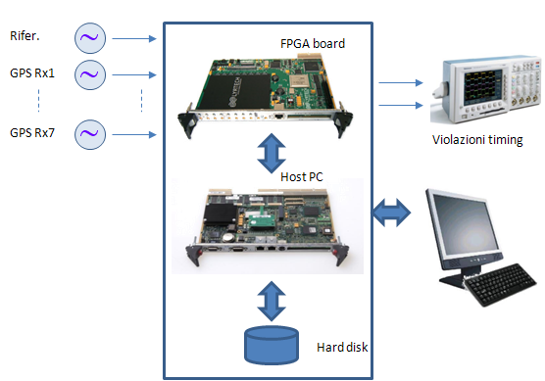

3 The long-term tests
Preliminary test
A preliminary long-term test was scheduled, to get feeling of possible problems arising from this type of test, and thus be able to tailor the following tests in an optimum way. Only two equipment were used, one acting as reference for the other. Obviously, in case of fluctuations, it is impossible to know which of the two is having troubles, but this was unimportant at this stage. In order to render more critical the reception of the GPS satellites, the GPS antennas were placed outside of a window, with limited sky visibility.
The preliminary long-term test lasted from September 14, 2011 to October 4, 2011. Several events were visible from the log: while the margin is normally expected to be on average constant (zero) with some zero-mean, short-term fluctuations, the actual behaviour showed some large steps, leading to a cumulative value that can build-up in the same direction. This, of course is a danger bell for applications where, as DVB-T SFN, a data buffer can go over/underflow. In Fig. 2, a group of such events is visible.
figure 2
Events recorded on September 21, 2011, time 05:28
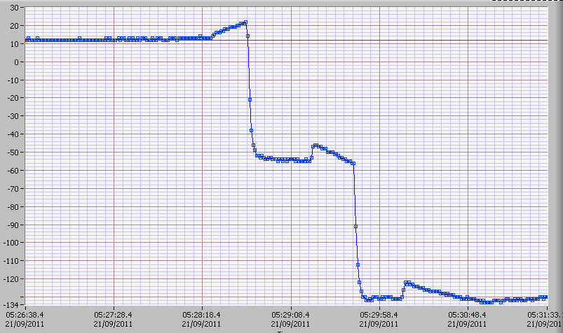
Most likely, these “steps” are due to the fact that for some reason the quartz oscillator of the GPS timing receiver is left in hold-over (no control) for some time, for lack of fresh information from the satellites. The actual reason is unknown: it could be for lack of sufficient number of satellites in visibility (very likely in this preliminary tests session), or due to RF interference corrupting the received signal. The identification of the actual reason was beyond the aim of the tests: the test purpose was only to evaluate the clocks behaviour in case of GPS reception troubles.
Long-term test
The effective long-term test was then scheduled and held in the period from November 11, 2011 to December 5, 2011, thus lasting 25 days.
The test conditions were the following:
– Five GPS timing receivers were tested in parallel.
– A free running rubidium clock was used as reference.
– Antennas were placed on the building roof (see Fig. 3), with most sky in visibility.
– A four days warm-up period was allowed for GPS receivers (rubidium was operated far more early).
figure 3
The five antennas of the GPS receivers under test placed on the building roof
The passive helical antenna used for local interference test is visible on the floor
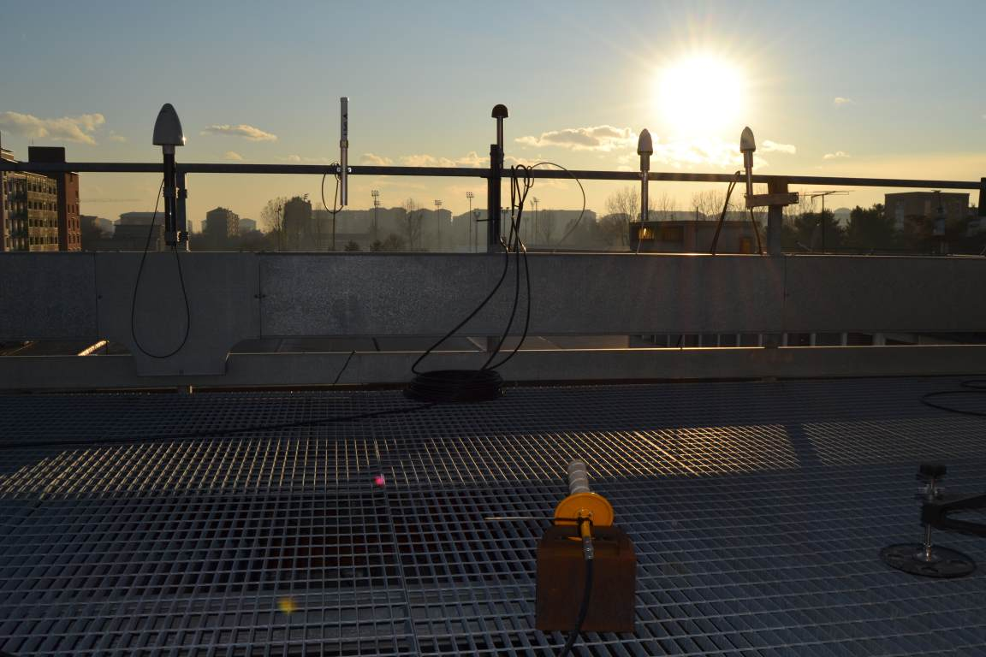

4 The long-term test results
The log files of the long-term test were analysed. Since the rubidium reference is not locked to the GPS system, a slow drift is seen on the raw data of all tested equipment, as expected. The analysis software allows to compensate (subtract) a linear drift of a given value. This has been found empirically to be –3.412E-11 (sec/sec). Once compensated for the rubidium drift, the five curves showed their net trend; in summary:
– Three equipments showed very good behaviour in the 25 days observation period.
– One equipment had one moderate step event.
– One equipment showed a continuous build-up of small steps, leading it to accumulate a margin loss of –440 clock cycles, or –44 μs, in the 25 days of observation.
The results indicate that, provided that most of the sky is in good visibility, and no interference is present – in our case the latter can be just speculated – a good GPS timing receiver should give a fairly steady 10 MHz, with no margin build-up.

5 RF blockage tests
The electromagnetic environment in a typical transmitting site is very often a very harsh one. The GPS receiving antenna can be affected by spectral components coming from harmonics of local high power transmitters. For instance, the 3rd harmonic of TV channel 27 in UHF band could hit GPS frequency 1575.42 MHz. So could the 2nd harmonic of channel 60.
Moreover, in principle, inter-modulation components arising from non-linear elements could also be a problem, but a careful analysis is not easy.
Consequently, in a typical transmitting site, it is possible that interferences could disturb normal GPS receiver operations.
To evaluate, in a controlled way, the GPS receiver’s behaviour in case of severe interferences, a further L-band passive antenna has been placed near the receiving ones, on the roof floor (see Fig. 3). The cable coming from the indoor laboratory fed the antenna with an interfering signal (2 MHz bandwidth digital modulated carrier at 1 575.42 MHz) generated by an RF vector signal generator. The RF power was kept just above the minimum level needed to completely block the receivers, in order not to disturb other distant GPS receivers.
The blockage tests were done turning on the RF interfering signal for a given time interval, and observing the margin variation during this time interval and after it.
As an alternative, it has been verified that simply disconnecting the GPS receiver’s antennas is a worthwhile method that can be used as well.
A total of thirteen blockage tests have been performed, with different blockage duration, lasting from one hour up to about one day.

6 RF blockage tests results
For each of the blockage tests, a multi-trace plot has been generated. In Fig. 4, for instance, the blockage test #3 result is provided.
figure 4
Blockage test #3 results. The blockage begins on 6/12/2011 at 1500 hours and ends on 7/12/2012 at 0930 hours
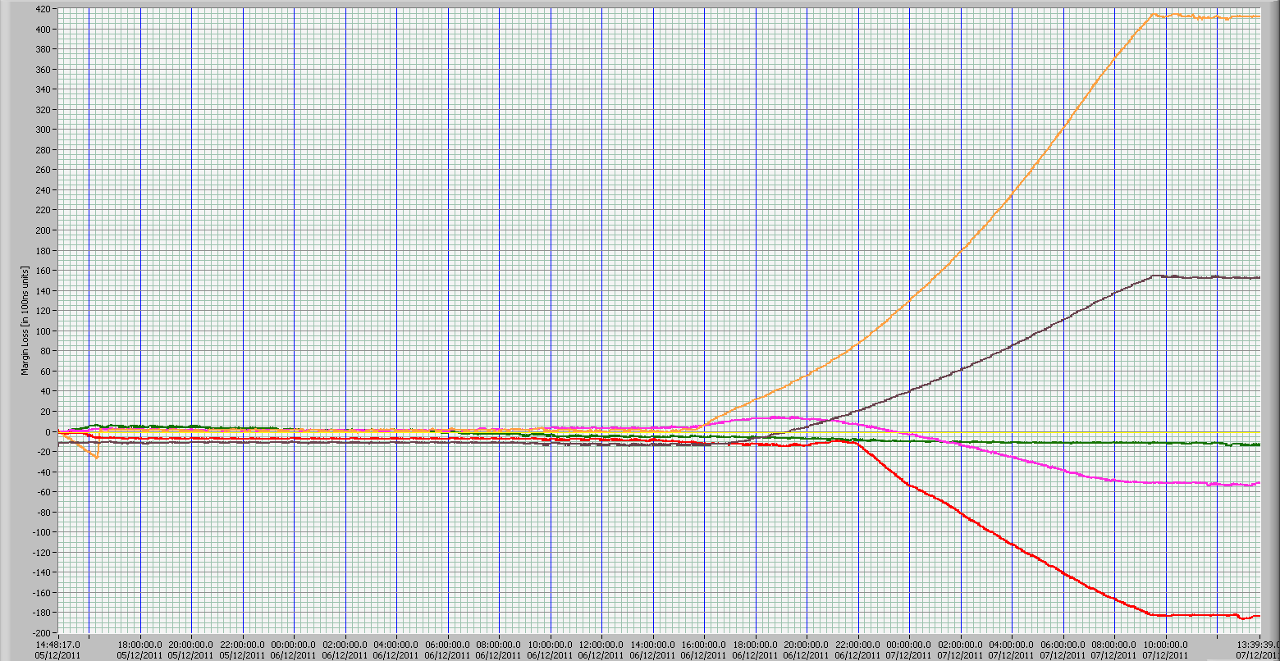
The shapes of the plots are quite reasonable: without reliable information from the GPS radio section, the quartz control system opens the control loop and the oscillator is left in holdover.
So the actual frequency is free to drift in whatever direction, depending on temperature, individual quartz characteristics, etc. Consequently, the margin of each GPS clock deviates in different fashion. As it can be seen, the margin loss accumulated during the blockage is not recovered after the event. However, after the holdover ends, the traces become flat again. This means that the frequency of the GPS receivers is set back on the right frequency, as expected.
As a general rule, short blockages result in limited margin loss and vice versa; however, the drift behaviour depends on individual quartz conditions: the quartz control voltage during the holdover is probably the most important factor.
After discussion with equipment designers, it turned out that the criterion of the recovery of the phase of the 10 MHz clock was not widely known. Some GPSDO manufacturers are not aware that this is required for broadcasting applications. Some manufacturers, instead, were aware of that, and they had already implemented this feature in their equipment. But the desirable behaviour could be not visible in some (longer) tests, because, usually, there is a configuration parameter that sets a timeout, overcoming the equipment which is supposed to have drifted too much and the DVB-T transmitter is turned off for safety. In this case, of course, it would not be needed to bring back the 10 MHz margin to zero: the transmitter must be restarted.
In Fig. 5 (brown and green traces), it is evident that after the end of the blockage two equipments managed to actively recover the margin loss.
figure 5
Blockage test #10 results. The blockage begins on 20/2/2011 at 0910 hours and ends on 20/2/2011 at 1650 hours
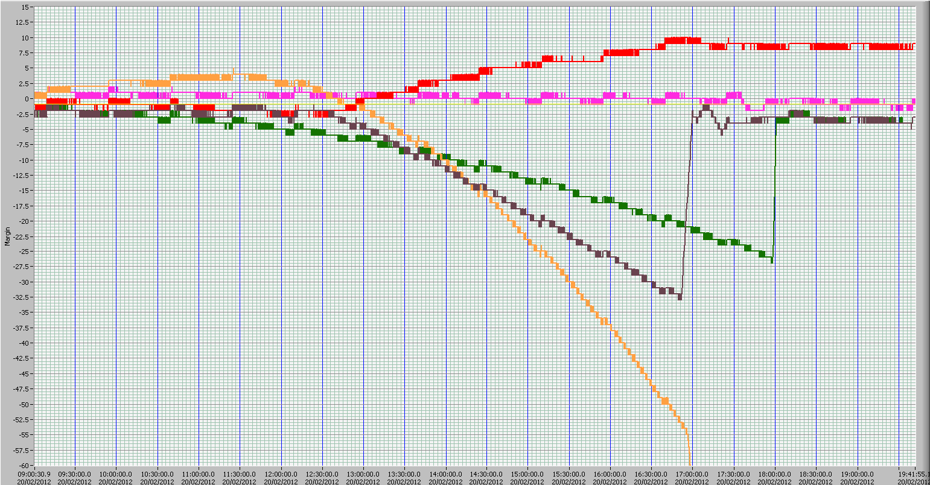
The red trace shows a GPSDO that did not recover. Nothing can be said, in this test, on “purple” GPSDO, since its natural drift was very small. Strange enough, one equipment (orange trace) diverged upon satellite signal return. This equipment had a strange behaviour in various occasions, suggesting a software bug or some kind of failure. The “brown” curve shows a re-phasing rise with a slow-rate of 30 units in 466 s. The frequency deviation is then 30/466 = 0.064 cycles/s or 0.064 Hz. In the “green” curve, instead, the slew-rate is 23/230 = 0.15 Hz. The amount of frequency deviation used can affect the correct operation of the SFN network, since the RF carrier frequency is obtained by frequency synthesis from the 10 MHz reference. For instance, at 800 MHz RF frequency, a deviation of less than 1 Hz would require one part in 10⁹ or 10 ppb. At 10 MHz, the deviation should be less than 10⁷ Hz × 10^{–9} = 0.01 Hz [1].
Fig.4:
Blockage test #3 result. Blockage started 6/12/2011 at 14:12 and lasted until 7/12/2011 at 09:22

7 Basic criteria for GPS equipment for broadcasting applications
The analysis instrument that was developed, the long-term tests and the blockage tests, allowed us to highlight different behaviours of various GPS timing receivers after each hold-over event.
Following discussions with the designers of several GPS timing receivers, the RAI Group noticed that everyone is focused on recovering the 10 MHz frequency as soon as possible, but the awareness that additional requirements are mandatory for broadcasting applications is not widespread.
A GPSDO suited for SFN DVB-T applications, upon holdover end, must recover the 10 MHz phase, so the DVB-T SFN transmitter could restore the margin of the data buffer to the original (zero) point. This statement is equivalent to require that the phase of the 1 pps signal produced by the equipment after the holdover is (gradually) driven back to the right one.
In other words, after the holdover,
– it must:
– keep the 1 pps deviation during the whole holdover period less than the maximum margin loss permitted (e.g., ±5 μs for 8 K and GI = ¼ – see ETSI 101 190, § 5.2.4);
– (gradually) drive back the phase of the 1 pps signal produced by the equipment to the right one. To do that, the frequency of the 10 MHz voltage-controlled quartz oscillator must be deviated in the suitable direction. This deviation must be such that the induced deviation at RF carrier is lower than 1/1 000 of the carrier frequency spacing, see ETSI 101 190, § 8.3.1 (e.g., 1.116 Hz for 8 K system). This will ensure that the worst-case RF carrier, generated by the transmitter, would not undergo a frequency deviation more than allowed for a fairly safe SFN operation. The above re-phasing operation can last several minutes, as needed. The maximum allowable 10 MHz deviation defines the aforementioned “graduality” of re-phasing operation. Hereafter, it will be referred to as Recovery deviation (R_{d}) expressed in terms of sec/s;
– switch off 1 pps exit when maximum margin loss is overcome;
– it must not:
– restore the 1 pps correct position using a reset of the digital counter that generates it;
– restore the 10 MHz correct frequency value using a deviation too big, as explained above. These two operations are usually done in some equipment.
As an exception, of course, the GPSDO can abruptly reset the 1 pps position and the 10 MHz value to the correct one, if the holdover duration has lasted so long that the correct transmitter timing is definitely lost (duration of the hold over for the required margin loss should be found in GPSDO manufacturer data sheet); in this case the transmitter must be resynchronized, so a short service interruption is unavoidable.
On the basis of the above guidelines, a tentative procedure to qualify GPSDO can be proposed as given in Annex 1.
Bibliography
[1] ETSI 101 190 –“Digital Video Broadcasting (DVB); Implementation guidelines for DVB Terrestrial services; Transmission aspects”.
Acronyms
CF Correction factor
DDS Direct digital synthesis
DSO Digital storage oscilloscope
DUT Device under test
FIR Finite impulse response
GPSDO GPS disciplined oscillators
HOR Hold-over recovery
TTM Timing test machine

Annex 1
Tentative procedure to test GPS-based equipment for 10 MHz
absolute phase recovery
Scope
The main objective of this procedure is to give a method to evaluate and validate GPS based equipment suitable to operate in a DVB-T/T2 single frequency network. To this purpose, it is mandatory to avoid that the phase relationships between time and frequency references at head-end and transmitting sites could accumulate significant drift during normal and hold-over operation conditions.
Test set-up
1) for Frequency Reference, use as a Rubidium or Cesium oscillator operating in free run mode. It is assumed that a 1 Hz signal is available on the adopted Frequency Reference. Otherwise, a DDS-based signal generator, configured for 1 Hz square wave generation and locked to the same 10 MHz Reference, can be used. Said signal will be referred to as “1 Hz” hereafter. Before operating in free run, the Reference should be aligned to a primary Reference Standard in order to guarantee a traceability (through a primary frequency institute or high quality GPS);
2) free-run Reference drift calibration:
connect said Frequency Reference in free run mode and compare its frequency with one of a high quality GPS timing receiver for a one day long session. Check the resulting timing difference. This information will be used to correct the final results (Correction Factor – CF);
3) the identification of the CF has limited time validity: step 2 should be repeated every month or more frequently depending on the kind of Frequency Reference used, and when necessary;
4) from technical specification of each device under test (DUT) should be noted the maximum hold over duration, t_{max}, before the 1 pps should be switched off;
5) in case of multiple hold-overs without complete recovery between them, t_{max} after each iteration should be given by:
where:
t_{r} : recovery time
t_{h} : hold over duration
R_{d} : recovery deviation
MML: Maximum margin loss
Test execution
6) connect all DUTs 10 MHz and 1 pps output signals to the Timing test machine (TTM) test inputs; connect the 10 MHz and 1 pps Frequency Reference to the TTM reference input;
7) switch on all DUTs at least one day before test starts, to allow a suitable warm-up period. The Frequency Reference should be always up since its purchase or, at least, one month before the starts of test execution. It should be kept in a controlled environment;
8) ensure that GPS receiving antennas should be able to see enough satellites during the test time in order to guarantee continuous lock to GPS time reference;
9) connect 1 pps output of all DUTs to a digital storage oscilloscope (DSO) triggered to the 1 Hz signal coming from Frequency Reference. Save a frozen picture of the signals timing relationships at this step;
10) reset TTM and start a long-term test and acquisition. A three-week test gives a good compromise between test duration and coverage of possible events;
11) reset TTM and start hold-over recovery (HOR) 1 and acquisition: disconnect GPS receiving antenna according to the following duty cycle: t_{h} < t_{max} disconnected and t_{r} > MML × 10^{–7} / R_{d} connected, repeated for 3 times;
12) reset TTM and start HOR 2 and acquisition: disconnect GPS receiving antenna according to the following duty cycle: t_{h} < t_{max} disconnected and t_{r} < MML × t_{h} / t_{max} × 10^{–7} / R_{d} connected then t_{h} < disconnected and t_{r} > MML × 10^{–7} / R_{d} connected, repeated for 3 times;
13) reset TTM and start HOR 3 and acquisition: disconnect GPS receiving antenna according to the following duty cycle: t_{h} > t_{max} disconnected and verification for the 1 pps switch off, connected for 2 hours, repeated for 3 times with reset of TTM;
14) on the DSO, save frozen pictures of final signal timing.
Pass test conditions
15) long test time: counter value at the test end < ±2 units (i.e., 0.2 μs);
16) HOR 1 and HOR 2: counter value after every recovery must be < ±2 units (i.e., 0.2 μs), with maximum deviation during the whole test of ±50 units (i.e., 5 μs);
17) HOR 3: the 1 pps switched off for t > t_{max};
18) In every HOR tests, the re-phasing frequency deviation on the 10 MHz signal (as calculated from the curve as the absolute value of the time derivative of the counter values) must not exceed 0.01 Hz at 10 MHz (< 1 × 10^{–9});
19) 1 pps displacement between frozen pictures < ±200 ns.

Rubidium GPS timing receivers are also commercially available.
Clock#1 strobe increments counter; clock#2 strobe decrements it. In case of simultaneous clock#1 and clock#2 strobes, the counter value is not modified. The count value has been defined as a signed fixed-point variable, so it can go negative.
No timing violations have been detected on tested receivers.
Oxidized bolts have been reported to behave as non-linear electric components and to generate inter-modulation components, especially in sites where radiating mechanical structures are used (MW antennas).

