Report ITU-R BT.2301-1
(07/2015)
National field reports on the introduction
of IMT in the bands with co-primary allocation to the broadcasting
and the mobile services

BT Series
Broadcasting service
(television)

Foreword
The role of the Radiocommunication Sector is to ensure the rational, equitable, efficient and economical use of the radio-frequency spectrum by all radiocommunication services, including satellite services, and carry out studies without limit of frequency range on the basis of which Recommendations are adopted.
The regulatory and policy functions of the Radiocommunication Sector are performed by World and Regional Radiocommunication Conferences and Radiocommunication Assemblies supported by Study Groups.

Policy on Intellectual Property Right (IPR)
ITU-R policy on IPR is described in the Common Patent Policy for ITU-T/ITU-R/ISO/IEC referenced in Annex 1 of Resolution ITU-R 1. Forms to be used for the submission of patent statements and licensing declarations by patent holders are available from http://www.itu.int/ITU-R/go/patents/en where the Guidelines for Implementation of the Common Patent Policy for ITU-T/ITU-R/ISO/IEC and the ITU-R patent information database can also be found.

Series of ITU-R Reports
(Also available online at http://www.itu.int/publ/R-REP/en)
Series | Title
BO | Satellite delivery
BR | Recording for production, archival and play-out; film for television
BS | Broadcasting service (sound)
BT | Broadcasting service (television)
F | Fixed service
M | Mobile, radiodetermination, amateur and related satellite services
P | Radiowave propagation
RA | Radio astronomy
RS | Remote sensing systems
S | Fixed-satellite service
SA | Space applications and meteorology
SF | Frequency sharing and coordination between fixed-satellite and fixed service systems
SM | Spectrum management

Note: This ITU-R Report was approved in English by the Study Group under the procedure detailed in Resolution ITU-R 1.

Electronic Publication
Geneva, 2015
© ITU 2015
All rights reserved. No part of this publication may be reproduced, by any means whatsoever, without written permission of ITU.

REPORT ITU-R BT.2301-1
National field reports on the introduction of IMT in the bands with co-primary allocation to the broadcasting and the mobile services
(2014-2015)
Introduction
A number of countries have recently introduced new mobile services in the parts of the UHF band in which they have a co-primary allocation to the broadcasting and the mobile services, in particular international mobile telecommunications (IMT) systems utilizing long-term evolution (LTE) technology.
The annexes in this Report provide a compilation of national approaches/best practices and their experiences so far in the protection of DTTB Services in conjunction with the introduction of LTE.
The national field reports (initial or final) in Annexes 1, 2 and 3 hereafter are related to the introduction of LTE in the 800 MHz Band using the reverse duplex arrangement. They are based on data available at the date of their inclusion.
When new data becomes available these reports could be updated, if appropriate.
It is intended to include further national approaches/best practices as they are made available by members.

Annex 1 – Field Report from Germany with regard to the 800 MHz band
Annex 2 – Preliminary Field Report from France with regard to the 800 MHz band
Annex 3 – Interim Field Report from Netherlands with regard to the 800 MHz band
Annex 4 – Field report on interference to 800 MHz band IMT base stations in Portugal from DTTB transmissions in Spain

Annex 1
Field report on the applied methodology used by Germany
to protect the broadcast service when implementing
the IMT service in the 800 MHz band

1.1 Background
Germany has implemented IMT services in the 800 MHz band. In order to protect the broadcasting service operating in the 700 MHz band adjacent to the frequencies used by the IMT service, the Federal Network Agency has set up a process to set the site-related frequency usage parameters of each individual mobile base station before such base station is put into operation.
The frequencies gained at auction can only be used after assignment subject to “their compatibility with other frequency usages”. The applicant must prove for an efficient and interference-free use of the frequencies. In planning their network build and rollout, frequency assignees must therefore apply for the site-related frequency usage parameters to be set before the individual frequencies can actually be used.
Applications for site-related frequency usage parameters to be set can only be granted if they meet the relevant requirements. In particular, applications for the use of frequencies in the 800 MHz band must take account both of the frequency usage conditions and of usage provision 36 of the national frequency band allocation Ordinance, which states that the mobile service in the 790-862 MHz frequency band must not cause any interference into the broadcasting service. These regulations constitute fundamental framework conditions which must be taken into account by applicants.

1.2 Frequency engineering and regulatory framework and key assumptions
One of the tasks and aims of the procedure for setting site-related frequency usage parameters is to guarantee protection for the broadcasting service in all relevant application situations. This is particularly relevant if there is a residential area within a certain radius of a mobile service base station in the broadcast coverage area.
Preventive studies aimed at avoiding interference to terrestrial digital television reception can be restricted to a certain radius around a base station. It can be assumed that the probability of interference to DVB-T reception outside this radius is extremely low. If, nevertheless, interference occurs in a particular case, contrary to expectations, the notice setting the parameters can be revoked by exercising the right provided for in the notice, and further safeguards can be put in place accordingly.
In cases where interference could be caused to DVB-T reception within the radius referred to above, the applicants must show which appropriate measures they will take in order to take account of the protection requirements of the broadcasting service. The applicant must show how the requirement for frequency assignment – and hence for setting the site-related frequency usage parameters – is met. In this connection, the network operators are required to take account of broadcasting interests starting at the planning stage and to take any necessary preventive measures (e.g. radiation characteristics, orientation of sectors, antenna height).
The probability of interference below DVB-T channel 52 in individual cases has not been looked at separately because, as matters stand at present, the current interference studies cover the interference potential at these frequencies.
Taking account of the limit on LTE out of block emissions below 790 MHz (max 0 dBm per 8 MHz given a planned maximum LTE radiated power) and broadcasting coverage with the lowest minimum median wanted field strength of 41 dBμV/m (exactly 41.9 dBμV/m for fixed terrestrial broadcasting coverage with DVB-T system variant A1 on channel 52 in accordance with the regulations in the Geneva 2006 Agreement), a maximum (protection) radius of approximately 1.1 km is considered sufficient. This (maximum) radius is assumed for all system variants in operation.
The probability of interference then depends on:
1) whether or not there is actually any DVB-T coverage within the (interfering) radius of the base station; and
2) whether or not there are actually any relevant digital terrestrial television broadcasting application situations within the (protection) radius.
If both these factors apply, it is necessary to see in each particular case if the DVB-T field strength available seems high enough in order to make interference to broadcasting reception from the LTE base station improbable. In this case, the applicant must explain how he will protect the broadcasting service (further remedies may be required) or why interference to broadcasting reception is improbable.
This procedure for setting site-related frequency usage parameters takes account of the fact that such parameters in the 800 MHz band at the interface with broadcasting are being, or have been, set for the first time and may need to be refined, depending on the actual effects the operational mobile networks have.

1.3 Steps for a computer-assisted standard procedure for determining compatibility between LTE and broadcasting in specific cases before setting the site-related usage parameters for an LTE base station
The following flow chart illustrates the individual steps in the procedure to provide protection for DVB-T broadcasting. Other necessary coordination steps (such as international coordination) are not included in the chart but must also be taken before site-related usage parameters can be set.
Figure A1.1
Flowchart
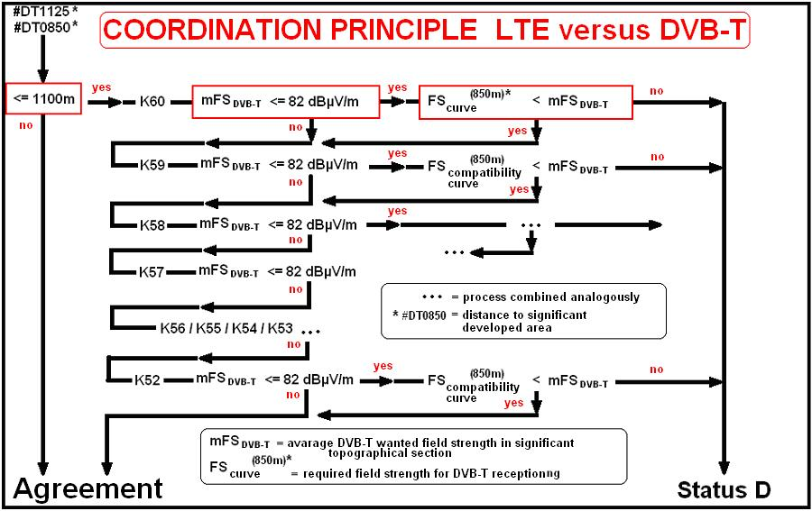

NOTE 1 – If the distance between the LTE base station and the residential area is more than 1 100 m, the application for parameters to be set can be granted.
NOTE 2 – If the distance between the LTE base station and the residential area is less than 1 100 m, a DVB-T coverage map calculated for each of the channels from 60 to (currently) 52 is used. The calculations are made using internationally recognized propagation models for DVB-T television broadcasting emissions. The coverage map is used to allocate field strengths for DVB-T coverage on each channel to grid points spaced at intervals of one arc second, following the recognized assumptions for location and time percentages for broadcasting reception.
NOTE 3 – First, the average DVB-T field strength available per channel is calculated as the arithmetic mean of all the grid point field strengths greater than 41 dBμV/m, for a 600 m by 600 m square around the LTE base station.
NOTE 4 – If the average available DVB-T field strength calculated is at least 82 dBμV/m, the application for site-related frequency usage parameters for an LTE base station can be granted, on the assumption that the base station radiated power is 59 dBm.
If the planned base station radiated power is lower than the maximum radiated power of 59 dBm, the average minimum available DVB-T field strength of 82 dBμV/m can be reduced by the difference between a radiated power of 59 dBm and the planned lower radiated power, since the LTE out of block emissions will also be correspondingly lower.
NOTE 5 – All other cases:
The necessary field strength for DVB-T reception, corresponding to the distance between the LTE base station and the nearest residential area (up to 1 100 m), can be read from the graph below (compatibility curve).
If the average available DVB-T field strength calculated in step 3 is higher, the application can be granted.
Figure A1.2
Distance as a function of the available DVB-T field strength
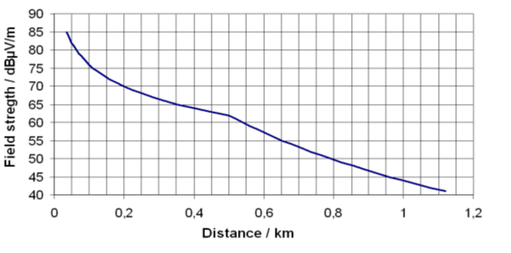
NOTE 6 – If the average available DVB-T field strength calculated is less than 41 dBμV/m on each DVB-T channel considered, the application can also be granted, since the field strength is lower than the minimum required for DVB-T coverage, i.e. absence of broadcast coverage.
NOTE 7 – If, having followed steps 1 to 5, an application cannot be granted, further information must be provided by the mobile network operator in order for a decision to be taken on the application.

1.4 Compatibility with broadcast service in neighboring countries
Compatibility with broadcast service still in operation in neighboring countries has been achieved successfully by bilateral agreements which are based on the principles outlined in the Geneva 06 Agreement, i.e. on the use of a maximum interfering field strengths at the border.
Depending on the specific situation, values in the range from 25 up to 44 dBµV/m
(8 MHz, 10 m height) were used in such agreements.

1.5 Conclusion
By the end of 2012 about 6 000 mobile base stations have been in operation in the 800 MHz band in Germany.
For 4 000 additional base stations the parameters had been assigned, which is the prerequisite for starting operation. By October 2013 most of them are in operation, too.
Only 10 (ten) of the complaints raised until October 2013 in respect of interference into the broadcasting service were identified as caused by LTE. Most of them were easily solved by simple adjustments of the DVB-T reception antenna system (e.g. antenna directivity, antenna amplifier level, additional low cost filter, etc.).
This illustrates that the implemented methodology provides a very high protection level of the broadcasting service.
Annex 2
Preliminary national field report on the introduction of IMT downlinks
in the 800 MHz band with co-primary allocation to the
broadcasting and the mobile services in France
Introduction
The aim of this document is to share experience on the deployment of mobile service LTE networks, and the impact of LTE downlinks on fixed roof-top DTT reception below 790 MHz in France. Note that the fixed DTT reception “chain” means a roof-top antenna, an amplifier system (in some cases), a passive cable and a TV receiver. Portable and mobile DTT receptions are not under consideration in this paper.
Based on the work carried out in CEPT and in ITU-R, a mechanism to address the potential interference from IMT base station to fixed DTT reception has been put in place:
– Mobile operators have the obligation to implement on all base stations filtering characteristics called “Case A/channel 60” of BS BEM out-of-block EIRP limits over frequencies below 790 MHz (see Annex, part B, table 4 of European Commission decision 2010/267/EU).
– In addition, mobile operators in the 800 MHz have the obligation:
– to solve interference of TV installation receiving broadcasting stations assigned before the LTE deployment;
– to provide the French TV viewers a common interface to complain in case of interference, and to help mobile operators to identify quickly where and which operator should intervene, ANFR is managing a call centre for interference to DTT reception and also collects the information provided by mobile operators in the 800 MHz band (e.g. BS deployment and BS putting into service information).
Moreover, information is provided (i.e. the phone number of the call centre mentioned above) through different means to local professional aerial installers, apartment block administrators, local authority and TV viewers before base stations are put into service.
Analysis of the cause of interference
The vast majority of reported interference cases that have been observed so far on fixed DTT reception were caused by LTE base station provoking DTT saturation (active systems like amplifiers or DTT television/set-top box). Saturation means that usually all TV channels are interfered.
Summary of interference situation
During the period from 1st November 2012 to 31st December 2013, 2605 LTE Base Stations have been put into service in the 800 MHz band, in particular in urban areas, and there have been 7 570 reported cases of interference to fixed DTT receiving installations, domestic or community aerial (some interference may not have resulted in claims from TV viewers).
The number of interference cases per base station is very dependent on the local conditions of TV reception. In areas where the TV signal is weak, TV viewers are likely to have installed an amplifier and have a higher risk of being interfered with.
It has been observed that the median interference distance between the base station and the TV reception installation is about 330 m with an interference distance in 99% of cases below 1.3 km, with one case reported at 3.5 km (hilly terrain).
Mitigation measures taken to resolve interference situations
Every interference case due to the deployment of LTE BS in the 800 MHz band onto the fixed roof-top DTT reception has been resolved by the introduction of a LTE 800 filter, either head-end filters (if active systems like amplifiers are present between the roof-top antenna and the television/set-top box) or user filters. The specifications of these filters have been defined by the administration, taking into account studies conducted with the help of stakeholders (broadcasters and the 800 MHz mobile operators). An industrial label could help consumers and professional aerial installers to identify efficient filters.
Preliminary conclusions
In view of the information detailed above, the following can be concluded about the interference situation between LTE BS downlinks and fixed roof-top DTT reception in adjacent band:
– for the 800 MHz band, the distance between the interfering IMT base station and the fixed roof-top DTT receiving location is in 99% of cases below 1.3 km, with one case reported at 3.5 km (hilly terrain). This interfering situation is essentially a national matter and does not require any provision in the RR;
– for the 800 MHz band, almost all reported interference cases that have been observed so far on fixed roof-top DTT reception were caused by LTE base station provoking DTT saturation (active systems like amplifiers or DTT television / set-top box) and all had been resolved by the introduction of an LTE 800 filter (either head-end filters or user filters). Administration and operators have been able to manage successfully this kind of interference;
– at 700 MHz, although a greater frequency separation between the mobile downlinks and the highest DTT channel 48 (cf. 700 MHz channelling options under consideration) may have a limited beneficial impact on DTT saturation effects, administration and stakeholders will have better knowledge of fixed roof-top TV receiving installations which could be interfered, based on the 800 MHz experience. The 800 MHz experience does not provide relevant information about the interference from mobile uplink to DTT reception.

Annex 3
Interim national field report on the LTE rollout in the 800 MHz band
in the Netherlands
Introduction
On the 31st of October 2012 the multiband auction for LTE started in the Netherlands and came to a conclusion on the 14th of December 2012. As a result licenses to three companies were granted on the 2nd of January 2013 in the 800 MHz band:
• Tele2 mobiel B.V.: 791-801 MHz paired with 832-842 MHz
• Vodafone Libertel B.V.: 801-811 MHz paired with 842-852 MHz
• KPN B.V.: 811-821 MHz paired with 852-862 MHz
Since then about 5 200 LTE antennas came in to service in the 800 MHz band. Vodafone Libertel rolled out about 775 LTE antennas in the cities Amsterdam, The Hague, Utrecht and Maastricht. All other antennas were rolled out by KPN mainly in the Randstad area (roughly the triangle between Amsterdam, Rotterdam and Utrecht).
Precautionary measures
In order to prevent interference with existing users of the radio spectrum, especially the DVB-T usage below 790 MHz, only general precautionary measures were taken. In the granted licenses the follow wording was added (for convenience translated from Dutch):
• “The usage of frequencies is such that adequate measures are taken to protect systems in adjacent frequency bands.”
• “The licensee causes no unacceptable barriers with the desired signal of radio transmitters into radio transmitters and receivers of electronic or electric facilities”
In the annex of the license additional technical requirements were defined for in band (64 dBm EIRP) and out of band emissions. For emissions in the band below 790 MHz additional requirements were defined: 0 dBm/8 MHz or less and if the base station causes no interference to the primary service below 790 MHz this level may be increased to a maximum of 22 dBm/8 MHz.
Network rollout
The picture below shows the LTE network rollout in the 800 MHz band on the 19th of November 2013. At that time only KPN and Vodafone Libertel had started to use the 800 MHz band. Vodafone Libertel rolled out about 775 LTE antennas in the cities Amsterdam, The Hague, Utrecht and Maastricht. All other antennas were rolled out by KPN mainly in the Randstad area.

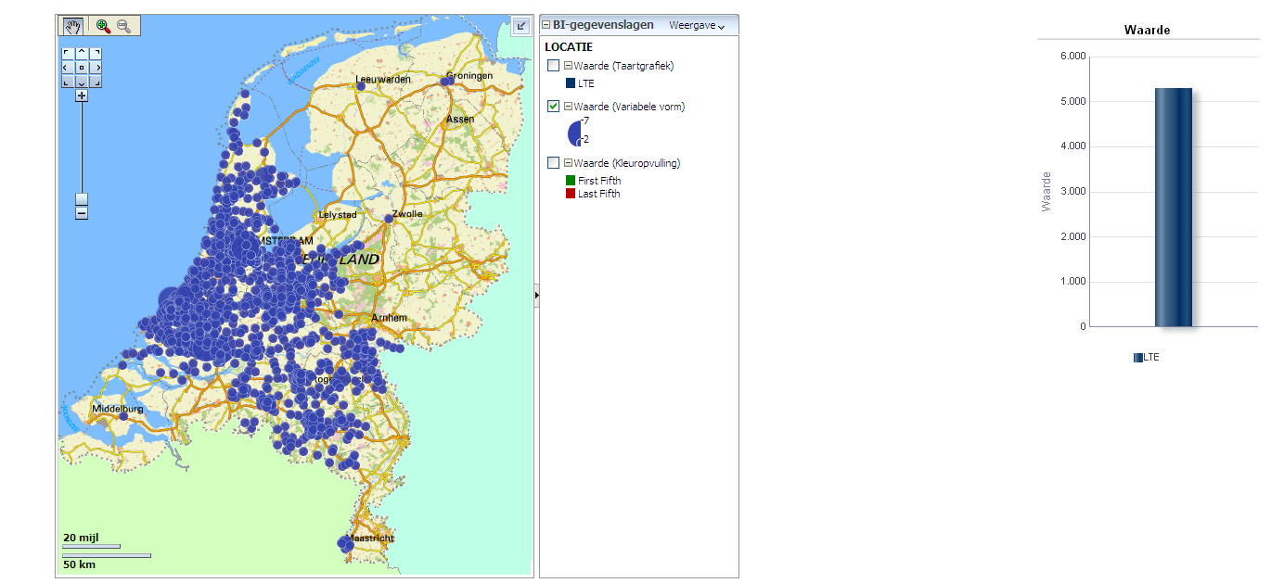

Interference cases
In the Netherlands DVB-T is operated by Digitenne which is a subsidiary of KPN. This eases the coordination of the LTE rollout in the 800 MHz band with DVB-T usage for KPN if necessary. However coordination within KPN with respect to the placing of LTE antennas did not take place. Digitenne reported no interference even when specifically asked. Nearly all DVB-T receivers put in to service by KPN are able to receive up to 862 MHz.
As of the 19th of November 2013 no interference cases were reported to the Radiocommunications Agency. Since Tele2 did not rollout any LTE antennas in the 800 MHz the most stringent sharing conditions between LTE and DVB-T still have to come.

Annex 4
Field report on interference to 800 MHz band IMT base stations in Portugal from DTTB transmissions in Spain
During the process of freeing up the 800 MHz band in Spain there were interferences to several Base Stations operating LTE on the 800 MHz band in Portugal. The interferences were caused by the Spanish DTTB emissions in the same band.
In Spain, among others, 3 nationwide SFN were in operation on channels 67-68-69, on the same frequency range as the 800 MHz LTE uplink, as shown in Fig. A4.1.
Figure A4.1
Overlap between DTTB channels 67, 68 & 69 and 800 MHz LTE
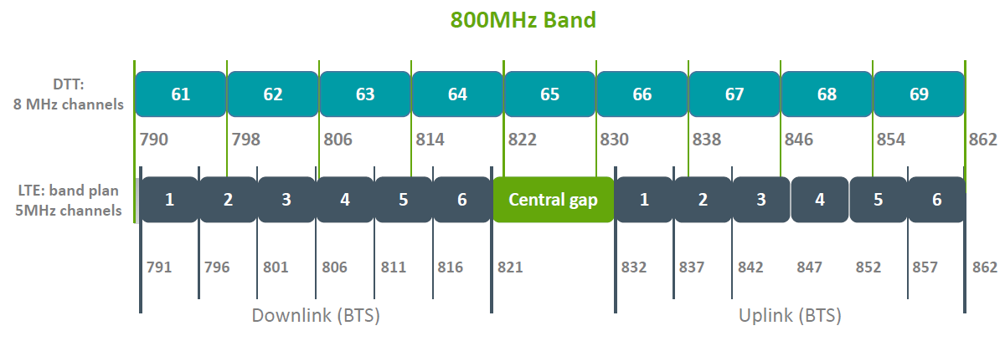
Although Spain fully cleared the 800 MHz band on March the 31st 2015, in order to avoid or minimise the interferences on the cross border zones, the Spanish administration has asked the DTTB network operator for an early change of frequencies in several border DTTB sites. Figure A4.2 shows the DTT transmitters in Spain impacting LTE800 in Portugal and which were switched off. Calculations showing the extent of the interference from Spain to Portugal are provided in Report ITU-R BT.2247.
Figure A4.2
DTTB transmitters in Spain impacting LTE800 in Portugal
_____________

This interim report reflects the national situation in the Netherlands and will be updated when appropriate.

