Report ITU-R BT.2301-4
(09/2022)
National field reports on the introduction
of IMT in the bands with co-primary allocation to the broadcasting
and the mobile services

BT Series
Broadcasting service
(television)

Foreword
The role of the Radiocommunication Sector is to ensure the rational, equitable, efficient and economical use of the radio-frequency spectrum by all radiocommunication services, including satellite services, and carry out studies without limit of frequency range on the basis of which Recommendations are adopted.
The regulatory and policy functions of the Radiocommunication Sector are performed by World and Regional Radiocommunication Conferences and Radiocommunication Assemblies supported by Study Groups.

Policy on Intellectual Property Right (IPR)
ITU-R policy on IPR is described in the Common Patent Policy for ITU-T/ITU-R/ISO/IEC referenced in Resolution ITU-R 1. Forms to be used for the submission of patent statements and licensing declarations by patent holders are available from http://www.itu.int/ITU-R/go/patents/en where the Guidelines for Implementation of the Common Patent Policy for ITU-T/ITU-R/ISO/IEC and the ITU-R patent information database can also be found.

Series of ITU-R Reports
(Also available online at http://www.itu.int/publ/R-REP/en)
Series | Title
BO | Satellite delivery
BR | Recording for production, archival and play-out; film for television
BS | Broadcasting service (sound)
BT | Broadcasting service (television)
F | Fixed service
M | Mobile, radiodetermination, amateur and related satellite services
P | Radiowave propagation
RA | Radio astronomy
RS | Remote sensing systems
S | Fixed-satellite service
SA | Space applications and meteorology
SF | Frequency sharing and coordination between fixed-satellite and fixed service systems
SM | Spectrum management

Note: This ITU-R Report was approved in English by the Study Group under the procedure detailed in Resolution ITU-R 1.

Electronic Publication
Geneva, 2022
© ITU 2022
All rights reserved. No part of this publication may be reproduced, by any means whatsoever, without written permission of ITU.

REPORT ITU-R BT.2301-4*
National field reports on the introduction of IMT in the bands with co-primary allocation to the broadcasting and the mobile services
(2014-2015-2016-2021-2022)

1 Introduction
A number of countries have introduced new mobile services in the parts of the UHF band in which they have a co-primary allocation to the broadcasting and the mobile services, in particular international mobile telecommunications (IMT) systems utilizing long-term evolution (LTE) technology.
The Annexes to this Report provide a compilation of national approaches, best practices and their experiences about the introduction of LTE in the 800 MHz band using the reverse duplex arrangement or in the 700 MHz band using the regular one, and compatibility between DTTB and IMT. The concerned situations can include cases in the 800 MHz band (790-862 MHz) and the 700 MHz band (694-790 MHz). They can relate to adjacent channel and co-channel cases, and impact in both directions, between DTTB and IMT.
This Report includes contributions from 22 administrations and 2 sector members. It is intended to include further national approaches and best practices as they are made available by members.
Section 2 summarizes the reported cases of interferences from ITU Administrations and Sector Members, the details of which are provided in the Annexes as follows:
Annex 1 – Field report from Germany with regard to the 800 MHz band
Annex 2 – Interim national field report on the introduction of IMT downlinks in the 700 and 800 MHz bands with co-primary allocations to the broadcasting and the mobile services in France
Annex 3 – Interim Field Report from Netherlands with regard to the 800 MHz band
Annex 4 – Field report on interference to 800 MHz band IMT base stations in Portugal from DTTB transmissions in Spain
Annex 5 – Collection of responses to the Request for Information to update ITU-R BT.2301, towards WRC-23 agenda item 1.5, November 2020

2 Summary of reported interference cases and corresponding solutions
In November 2020, Working Party 6A authorised a Request for Information to be sent to Administrations and Sector Members in Region 1, asking for information on experiences of introducing mobile networks in bands with co-primary allocations to the Broadcasting and Mobile services.
Responses received are presented in Annex 5. Several administrations report that no interference has been experienced to date, while others replied with details of interference experiences and the mitigation they undertook.
The reported interference cases show distances from few kilometres up to hundreds of kilometres.

2.1 Adjacent channel interference cases
There were different responses reported on whether, or not, interference was observed from the mobile service into the broadcasting service operating in the adjacent bands.
Some responses reported adjacent channel interference in both the 700 and 800 MHz bands from the mobile service into the broadcasting service, where the downlink of base stations located close to DTT receiving locations interferes with DTT reception. The following Table includes these reports, giving where possible additional information about the interference distances and number of cases.
Some other responses reported no cases of adjacent channel interference between the mobile service and the broadcasting service in either the 700 or 800 MHz bands.
TABLE 1
Reported situations of adjacent channels interference
Administration | 800 MHz band |  | 700 MHz band |  | Source
 | Interference cases | Mitigation | Interference cases | Mitigation
Croatia | MS to BS  190 interference cases over mixed paths | Filter and/or DTT receiver installation upgrade |  |  | Annex 5, A5.5
Denmark | MS to BS | Filter and/or DTT receiver installation upgrade |  |  | Annex 5, A5.6
Russia | MS to BS | Filter and/or DTT receiver installation upgrade, modification of the LTE BS |  |  | Annex 5, A5.7

TABLE 1 (end)
Administration | 800 MHz band |  | 700 MHz band |  | Source
 | Interference cases | Mitigation | Interference cases | Mitigation
Finland | MS to BS | Filter and/or DTT receiver installation upgrade | MS to BS | Filter and/or DTT receiver installation upgrade | Annex 5, A5.8
More than 54000 interference cases reported
Typically 0-5 km interference distance
France | MS to BS, average interfering distance 750 m, 99% < 2.4 km  Over 138 000 interference cases | Filter and/or DTT receiver installation upgrade | MS to BS, average interfering distance 800 m, 99% < 2.4 km  Over 18 500 interference cases | Filter and / or DTT receiver installation upgrade | Annex 2 and Annex 5, A5.9
Kyrgyzstan | MS to BS | Filter and/or DTT receiver installation upgrade, modification of the LTE BS |  |  | Annex 5, A5.12
United Kingdom of Great Britain and Northern Ireland | MS to BS, interfering distance up to 2 km  Projected up to 36000 interference cases | Filter and/or DTT receiver installation upgrade |  |  | Annex 5, A5.17

Additional information:
̶ Denmark has suffered a very limited number of interference cases; where channel 60 coverage was weak, very restrictive conditions have been applied to IMT base stations in 791-801 MHz.
̶ Germany has set up a very detailed methodology when implementing the IMT service in the 800 MHz so as to protect the broadcast service in the adjacent band. In this methodology, a distance of 1.1 km is considered as the tipping point when deciding for a potential impact from MS to BS. Below this threshold, the transmission characteristics of IMT base stations are driven by the local DTT reception conditions around the IMT base station.
In France and in the United Kingdom a low-pass filter is inserted on the DTT reception installation to circumvent the overloading situation and to sufficiently reduce the interfering input level from the IMT base station. In Finland, in some cases, two filters in series have been required in order to remove the interference. If several reception antennas are used, each antenna may need a separate filter installation. There is an ETSI Harmonised Standard for domestic TV amplifiers (ETSI EN 303 354) which has been in force since 2017 and improves resilience of DTT receivers against IMT emissions in adjacent bands (both the 700 and 800 MHz bands).
In Finland, mobile network licences include responsibility to remove TV reception interference. MNOs have formed a joint project with the TV operator to handle possible interference cases.
In France, the French administration monitors the occurrence of interference in relation with MNOs and TV network operators. MNOs also support the cost of the necessary equipment to remove the interferences.
Saudi Arabia reported no adjacent interference cases from mobile to DTT.

2.2 Co-channel interference cases

2.2.1 Interference from DTT to LTE uplink
Co-channel interference from DTT to LTE uplink is an interference situation reported by some Member States and Sector Members.
Over a warm sea path, with propagation conditions favourable to UHF frequencies, DTT transmitters can be a source of LTE performance degradation over great distances: several hundreds of kilometres.
EBU reported an interference case of 540 km over a warm sea path from Cyprus, and France reported two cases of 260 km over a warm sea path.
Saudi Arabia reported few interference cases, over shorter distances, and for limited period of time due to varying propagation conditions. They were resolved through bilateral coordination with neighbouring countries.
Portugal and Spain reported interference situations for distances up to 190 km for land path and 212 km for mixed land-sea propagation path.
In France, where the transfer of 700 MHz band was phased in 14 successive steps over three years, some MNOs reported difficulties with early deployed LTE base stations, disturbed by DTT transmitters in neighbouring areas still to be modified below 700 MHz. Similar cases occurred involving stations located in different countries. Most reported interference situations were temporary and lasted until the use of frequency bands was harmonized between different territories. The EU framework and decision to transfer the 700 MHz band and, in some cases, synchronized migration operations between countries, helped limiting the number and duration of such cases of interference.

2.2.2 Interference from LTE downlink to DTT
Only one case of DTT receivers interfered with by a co channel LTE base station is mentioned in this Report, by France. The situation was improved by cross-border coordination, and some modifications of the LTE Base Station in line with the cross-border agreement between the two countries. Distance in that case was around 11 km.

2.2.3 Summary of reported co-channel interference situations
TABLE 2
Reported cases of co-channel interference
Administration or Sector Member | 800 MHz |  | 700 MHz |  | Source
 | Interference cases | Mitigation | Interference cases | Mitigation
Saudi Arabia | BS to MS, two cases, some tens of kilometres.  Interference varies with propagation conditions, and can be observed within limited period of time. | Interference cases between countries are resolved through bilateral coordination and proper sites configurations near the borders. | BS to MS, 2 cases, some tens of kilometres.  Interference varies with propagation conditions, and can be observed within limited period of time. | Interference cases between countries are resolved through bilateral coordination and proper sites configurations near the borders. | Annex 5, A5.1
Denmark | BS to MS | Releasing the band by one of the two services | BS to MS | Releasing the band by one of the two services | Annex 5, A5.6
Finland |  |  | BS to MS, 150 km | Releasing the band by one of the two services | Annex 5, A5.8
France | BS to MS | Releasing the band by one of the two services | BS to MS, 160 km (mixed path), 260 km (warm sea path) | Releasing the band by one of the two services | Annex 2 and Annex 5, A5.9
France |  |  | MS to BS, 1 case, 11 km (mixed / sea path) | Cross-border coordination and modification of the LTE station | Annex 2 and Annex 5, A5.9
Ireland |  |  | BS to MS | Releasing the band by one of the two services | Annex 5, A5.10
Luxembourg |  |  | BS to MS, 8 km, land path | Releasing the band by one of the two services | Annex 5, A5.13
Montenegro | BS to MS, 170 km (warm sea path), 40 km (mixed path) | Releasing the band by one of the two services |  |  | Annex 5, A5.15

TABLE 2 (end)
Administration or Sector Member | 800 MHz |  | 700 MHz |  | Source
 | Interference cases | Mitigation | Interference cases | Mitigation
Uzbekistan | BS to MS | Releasing the band by one of the two services |  |  | Annex 5, A5.16
Portugal | BS to MS,  129-190 km land path and 181-212 km for mixed land/sea path, multiple cases along the entire border | Releasing the band by one of the two services |  |  | Annex 4
EBU (concerning Cyprus) |  |  | BS to MS, 500 km, warm sea path | Releasing the band by one of the two services | Annex 5, A5.19

Annex 1
Field report on the applied methodology used by Germany
to protect the broadcast service when implementing
the IMT service in the 800 MHz band

A1.1 Background
Germany has implemented IMT services in the 800 MHz band. In order to protect the broadcasting service operating in the 700 MHz band adjacent to the frequencies used by the IMT service, the Federal Network Agency has set up a process to set the site-related frequency usage parameters of each individual mobile base station before such base station is put into operation.
The frequencies gained at auction can only be used after assignment subject to “their compatibility with other frequency usages”. The applicant must prove for an efficient and interference-free use of the frequencies. In planning their network build and rollout, frequency assignees must therefore apply for the site-related frequency usage parameters to be set before the individual frequencies can actually be used.
Applications for site-related frequency usage parameters to be set can only be granted if they meet the relevant requirements. In particular, applications for the use of frequencies in the 800 MHz band must take account both of the frequency usage conditions and of usage provision 36 of the national frequency band allocation Ordinance, which states that the mobile service in the 790-862 MHz frequency band must not cause any interference into the broadcasting service. These regulations constitute fundamental framework conditions which must be taken into account by applicants.

A1.2 Frequency engineering and regulatory framework and key assumptions
One of the tasks and aims of the procedure for setting site-related frequency usage parameters is to guarantee protection for the broadcasting service in all relevant application situations. This is particularly relevant if there is a residential area within a certain radius of a mobile service base station in the broadcast coverage area.
Preventive studies aimed at avoiding interference to terrestrial digital television reception can be restricted to a certain radius around a base station. It can be assumed that the probability of interference to DVB-T reception outside this radius is extremely low. If, nevertheless, interference occurs in a particular case, contrary to expectations, the notice setting the parameters can be revoked by exercising the right provided for in the notice, and further safeguards can be put in place accordingly.
In cases where interference could be caused to DVB-T reception within the radius referred to above, the applicants must show which appropriate measures they will take in order to take account of the protection requirements of the broadcasting service. The applicant must show how the requirement for frequency assignment – and hence for setting the site-related frequency usage parameters – is met. In this connection, the network operators are required to take account of broadcasting interests starting at the planning stage and to take any necessary preventive measures (e.g. radiation characteristics, orientation of sectors, antenna height).
The probability of interference below DVB-T channel 52 in individual cases has not been looked at separately because, as matters stand at present, the current interference studies cover the interference potential at these frequencies.
Taking account of the limit on LTE out of block emissions below 790 MHz (max 0 dBm per 8 MHz given a planned maximum LTE radiated power) and broadcasting coverage with the lowest minimum median wanted field strength of 41 dBμV/m (exactly 41.9 dBμV/m for fixed terrestrial broadcasting coverage with DVB-T system variant A1 on channel 52 in accordance with the regulations in the Geneva 2006 Agreement), a maximum (protection) radius of approximately 1.1 km is considered sufficient. This (maximum) radius is assumed for all system variants in operation.
The probability of interference then depends on:
1) whether or not there is actually any DVB-T coverage within the (interfering) radius of the base station; and
2) whether or not there are actually any relevant digital terrestrial television broadcasting application situations within the (protection) radius.
If both these factors apply, it is necessary to see in each particular case if the DVB-T field strength available seems high enough in order to make interference to broadcasting reception from the LTE base station improbable. In this case, the applicant must explain how he will protect the broadcasting service (further remedies may be required) or why interference to broadcasting reception is improbable.
This procedure for setting site-related frequency usage parameters takes account of the fact that such parameters in the 800 MHz band at the interface with broadcasting are being, or have been, set for the first time and may need to be refined, depending on the actual effects the operational mobile networks have.

A1.3 Steps for a computer-assisted standard procedure for determining compatibility between LTE and broadcasting in specific cases before setting the site-related usage parameters for an LTE base station
The following flow chart illustrates the individual steps in the procedure to provide protection for DVB-T broadcasting. Other necessary coordination steps (such as international coordination) are not included in the chart but must also be taken before site-related usage parameters can be set.
Figure A1.1
Flowchart
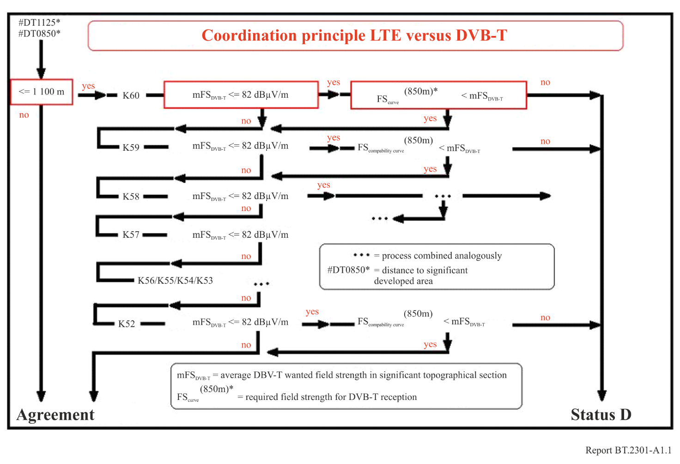

NOTE 1 – If the distance between the LTE base station and the residential area is more than 1 100 m, the application for parameters to be set can be granted.
NOTE 2 – If the distance between the LTE base station and the residential area is less than 1 100 m, a DVB-T coverage map calculated for each of the channels from 60 to (currently) 52 is used. The calculations are made using internationally recognized propagation models for DVB-T television broadcasting emissions. The coverage map is used to allocate field strengths for DVB-T coverage on each channel to grid points spaced at intervals of one arc second, following the recognized assumptions for location and time percentages for broadcasting reception.
NOTE 3 – First, the average DVB-T field strength available per channel is calculated as the arithmetic mean of all the grid point field strengths greater than 41 dBμV/m, for a 600 m by 600 m square around the LTE base station.
NOTE 4 – If the average available DVB-T field strength calculated is at least 82 dBμV/m, the application for site-related frequency usage parameters for an LTE base station can be granted, on the assumption that the base station radiated power is 59 dBm.
If the planned base station radiated power is lower than the maximum radiated power of 59 dBm, the average minimum available DVB-T field strength of 82 dBμV/m can be reduced by the difference between a radiated power of 59 dBm and the planned lower radiated power, since the LTE out of block emissions will also be correspondingly lower.
NOTE 5 – All other cases:
The necessary field strength for DVB-T reception, corresponding to the distance between the LTE base station and the nearest residential area (up to 1 100 m), can be read from the graph below (compatibility curve).
If the average available DVB-T field strength calculated in step 3 is higher, the application can be granted.
Figure A1.2
Distance as a function of the available DVB-T field strength
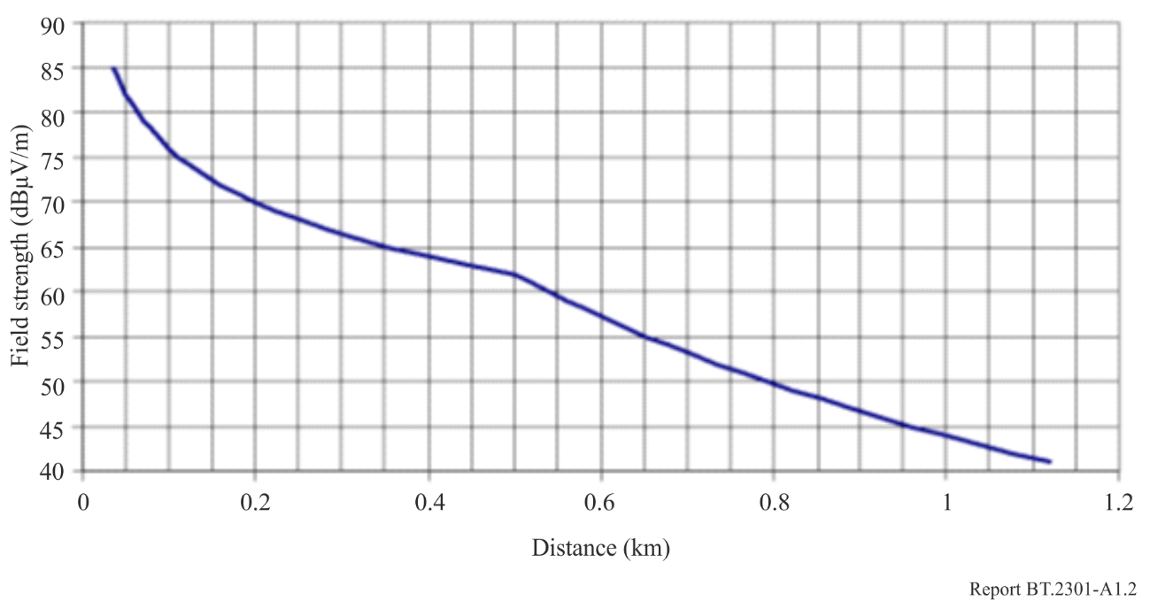
NOTE 6 – If the average available DVB-T field strength calculated is less than 41 dBμV/m on each DVB-T channel considered, the application can also be granted, since the field strength is lower than the minimum required for DVB-T coverage, i.e. absence of broadcast coverage.
NOTE 7 – If, having followed steps 1 to 5, an application cannot be granted, further information must be provided by the mobile network operator in order for a decision to be taken on the application.

A1.4 Compatibility with broadcast service in neighboring countries
Compatibility with broadcast service still in operation in neighboring countries has been achieved successfully by bilateral agreements which are based on the principles outlined in the Geneva 06 Agreement, i.e. on the use of a maximum interfering field strengths at the border.
Depending on the specific situation, values in the range from 25 up to 44 dBµV/m (8 MHz, 10 m height) were used in such agreements.

A1.5 Conclusion
By the end of 2012 about 6 000 mobile base stations have been in operation in the 800 MHz band in Germany.
For 4 000 additional base stations the parameters had been assigned, which is the prerequisite for starting operation. By October 2013 most of them are in operation, too.
Only ten of the complaints raised until October 2013 in respect of interference into the broadcasting service were identified as caused by LTE. Most of them were easily solved by simple adjustments of the DVB-T reception antenna system (e.g. antenna directivity, antenna amplifier level, additional low cost filter, etc.).
This illustrates that the implemented methodology provides a very high protection level of the broadcasting service.

Annex 2
Interim national field report on the introduction of IMT downlinks
in the 700 and 800 MHz bands with co-primary allocation to the
broadcasting and the mobile services in France

A2.1 Introduction
LTE 800 MHz rollout is underway in France since March 2013, and LTE 700 MHz deployment started on April 2016. The LTE rollout has been carried out by all four French mobile network operators and was urban predominated during the first years. In August 2020 it includes 21 183 LTE 700 MHz and 59 080 LTE 800 MHz base stations (BS).
The aim of this document is to share experience on the rollout of LTE networks, and on the impact of the LTE downlink on fixed roof-top DVB-T reception in the adjacent band. Note that the fixed DVB-T reception “chain” means a roof-top antenna, in some cases an amplifier system, a passive cable and a TV receiver. Portable and mobile DVB-T receptions are not under consideration in this document. The status presented in this Annex is dated 31 August 2020.
Furthermore, this Annex includes some elements describing co-channel interference cases from DTT to LTE uplink. These cases, both inland and cross-border, occurred during the period of transfer of the 700 MHz and 800 MHz and lasted until the spectrum use was harmonized in all concerned territories.

A2.2 Adjacent channel interference situation

A2.2.1 Background
Based on the work carried out in CEPT and in ITU-R, a mechanism has been put in place to address the potential interference from IMT base station to fixed DVB-T reception:
– For LTE 800 MHz: Mobile operators have the obligation to implement on all base stations filtering characteristics called “Case A/channel 60” of Base Station (BS) BEM out-of-block EIRP limits over frequencies below 790 MHz (see Annex, part B, table 4 of European Commission decision 2010/267/EU).
– For LTE 700 MHz: Mobile operators have the obligation to comply with the base station baseline power limits for spectrum below 694 MHz, as mentioned in Table 8 of the Commission implementing decision (EU) 2016/687.
• In addition, mobile operators have the obligation to solve interference of TV installation receiving broadcasting stations assigned before the LTE deployment.
– Agence Nationale des Fréquences (ANFR) supports the process by:
• managing a call centre dedicated to interference to DVB-T reception;
• managing a website (https://www.recevoirlatnt.fr/) about DTTB addressed to viewers and professionals;
• collecting information provided by mobile operators in the 700 and 800 MHz bands on the BS rollout progress;
• providing information through different means to local aerial professionals, property managers, local authorities and TV viewers before base stations are put into operation.

A2.2.2 Summary of adjacent channel interference situation
In the 800 MHz band, from November 2012 to February 2020, 59 080 LTE Base Stations have been put into operation, mostly in urban areas, and there have been 138 202 reported cases of interference to fixed DVB-T receiving installations, domestic or community aerials (some interference may not have resulted in claims from TV viewers), which represents interference to 270 561 households.
In the 700 MHz band, from April 2016 to February 2020, 21 183 LTE Base Stations have been put into operation, and there have been 18 579 reported cases of interference to fixed DVB-T receiving installations, domestic or community aerials, which represents interference to 31 173 households. Some interference may have not resulted in claims from TV viewers.
The number of interference cases per base station depends heavily on the local conditions of DVB-T reception. In areas where the DVB-T signal is weak or the households have several TV sets, TV viewers are likely to have installed an amplifier and have a higher risk of being interfered with.
The vast majority of interference cases that have been observed so far on fixed DVB-T reception were caused by LTE base station overloading DVB-T active systems (like amplifiers or DVB-T television/set-top box). Overloading often means that all TV channels suffer from interference.
It has been observed that the median interference distance between the IMT base station and the DVB-T fixed reception installation is in the range between 750 and 800 m. In 99% of cases the distance to the LTE BS is below 2.4 km.
Cases of interference with gap fillers (repeaters), although not documented in this Annex, have also been a matter of concerns in France.
The following Tables summarize the interference situation from LTE networks to DVB-T reception.
TABLE A2.1a
Number of interference
Mitigated interference cases from LTE 800 to DVB-T reception in France
Information dated from 31 August 2020
Number of interference cases
DVB-T reception mode | Number of active base stations (BS) | Number of households per communal aerial reception (on average) | DVB-T penetration rate (%)
 | 59 080 | 11 | 53.5
 | Number of interferences to DVB-T reception | Estimated raw number of interferences to households | Estimated weighted number of interferences  to households
Individual aerial reception ⁽¹⁾ | 111 107 | 111 107 | 111 107
Communal aerial reception ⁽²⁾ | 27 095 | 298 045 ⁽³⁾ | 159 454 ⁽⁴⁾

TABLE A2.1a (end)
Mitigated interference cases from LTE 800 to DVB-T reception in France
Information dated from 31 August 2020
Total number of interferences | 138 202 | 409 152 | 270 561
Average number of interferences per BS | 2.3 | 6.9 | 4.6
⁽¹⁾ An individual aerial reception is when a single TV aerial feeds a single household.
⁽²⁾ A common aerial reception is when a single TV aerial feeds several households.
⁽³⁾ = 27 095× 11
⁽⁴⁾ = 27 095× 11 × 0.535
TABLE A2.1b
Number of interferences
Mitigated interference cases from LTE 700 to DVB-T reception in France
Information dated from 31 August 2020
Number of interference cases
DVB-T reception mode | Number of active base stations (BS) | Number of households per communal aerial reception (on average) | DVB-T penetration rate (%)
 | 21 183 | 11 | 53.5
 | Number of interference cases to DVB-T reception | Estimated raw number of interference cases to households | Estimated weighted number of interference cases to households
Individual aerial reception ⁽¹⁾ | 16 001 | 16 001 | 16 001
Communal aerial reception ⁽²⁾ | 2 578 | 28 358 ⁽³⁾ | 15 172 ⁽⁴⁾
Total number of interference | 18 579 | 44 359 | 31 173
Average number of interference per BS | 0.9 | 2.1 | 1.5
⁽¹⁾ An individual aerial reception is when a single TV aerial feeds a single household.
⁽²⁾ A common aerial reception is when a single TV aerial feeds several households.
⁽³⁾ = 2 578 × 11.
⁽⁴⁾ = 2 578 × 11 × 0.535.

TABLE A2.2
Number of mitigation filters used (LTE 700 and 800 MHz)
Number of mitigation filters ⁽¹⁾⁽²⁾ used
Number of active base stations = 80 263
Total number of interference cases = 156 781
For resolution of interference | 156 781 ⁽¹⁾
For prevention of interference | 14 000
Total number of filters | 170 781
⁽¹⁾ Filters are installed at the DVB-T receiving antenna (either head-end filters or user filters).
⁽²⁾ More than one filter may be needed to mitigate the interference for some individual aerial receptions.

TABLE A2.3a
Interference ranges (LTE 800 MHz)
Real-life interference from LTE 800 MHz to DVB-T reception in France
Number of active base stations = 59 080
Total number of interference cases = 138 202
Estimated interference distance ⁽¹⁾
Max distance (m) | ≈ 7 354 ⁽²⁾
Average distance (m) | ≈ 743
Median distance (m) | ≈ 632
Standard deviation (m) | ≈ 552
⁽¹⁾ Distance between the victim DVB-T receiver and the interfering BS transmitter.
⁽²⁾ In 99% of cases the interference distance is below 2.4 km.

TABLE A2.3b
Interference ranges (LTE 700 MHz)
Real-life interference from LTE 700 MHz to DVB-T reception in France
Number of active base stations = 21 183
Total number of interference cases =18 579
Estimated interference distance ⁽¹⁾
Max distance (m) | ≈ 6 844 ⁽²⁾
Average distance (m) | ≈ 777
Median distance (m) | ≈ 669
Standard deviation (m) | ≈ 562
⁽¹⁾ Distance between the victim DVB-T receiver and the interfering BS transmitter.
⁽²⁾ In 99% of cases the interference distance is below 2.4 km.

TABLE A2.4
Interference rate per on air base station (LTE 700 and 800 MHz)
Number of mitigated interference cases per on air LTE BS (700 and 800 MHz)
Number of active base stations = 21 183 (700 MHz) 59 080 (800 MHz)
Total number of interference cases =18 579 (700 MHz) 138 202 (800 MHz)
 | LTE 700 MHz |  | LTE 800 MHz
Year | Communal aerial | Individual aerial | Communal aerial | Individual aerial
2013 | - | - | 1.3 | 1.9
2014 | - | - | 1.4 | 5.2
2015 | - | - | 0.8 | 2.9
2016 | 0.2 | 0.2 | 0.4 | 1.6
2017 | 0.1 | 0.3 | 0.3 | 1.6
2018 | 0.1 | 0.6 | 0.2 | 1.3
2019 | 0.1 | 0.7 | 0.2 | 1.5
2020  (Jan.-Aug.) | 0.1 | 0.9 | 0.1 | 0.6
Average | 0.1 | 0.8 | 0.5 | 1.9
Average per band | 0.9 |  | 2.3

A2.2.3 Interference mitigation
Every interference case due to the deployment of LTE BS in the 700 and 800 MHz band onto the fixed roof-top DVB-T reception has been resolved by the introduction of an LTE 700 or 800 filter, either head-end filters (if active systems like amplifiers are present between the roof-top antenna and the television/set-top box) or user filters. A total of 170 781 filters were used to resolve or prevent the interference from LTE BS to DVB-T reception. The specifications of these filters have been defined by the French administration, taking into account studies conducted with the help of stakeholders (broadcasters and mobile operators).

A2.2.4 Other considerations
Over the years, the number of interference cases per BS have decreased significantly. The main reason for this trend seems to be that the first LTE BS appearing in one area, is triggering almost all possible interference cases at once. And latter-appearing BS would not have the same effect, because the surrounding receivers are already filter-equipped. Other contributing factors are diverse, and several hypotheses exist. TV receivers may have improved since the beginning of the LTE rollout in 2012. Also, roll-out often begins in densely populated areas, and therefore may have the potential to create more interference cases than base stations implemented latter in rural areas. So, the evolution of this indicator seems to be the result of many different factors, and the contribution of each one is difficult to assess. Finally, in the past two or three years, the curve seems to flatten. Therefore, further improvements are unsettled.
The number of interference cases seems lower for 700 MHz base stations than for 800 MHz base stations. There are probably several reasons for that. First, the frequency separation is greater between the LTE downlink in 700 MHz and the upper TV channel, compared to the situation of the first 800 MHz digital dividend. Furthermore, the most likely source of interference is designated by an algorithm and no in-depth on-site analysis is performed to verify whether the designated BS is the real cause. This algorithm may bias the 700 to 800 MHz ratios. Also, some preventive mitigation operations may have occurred during the 700 MHz transfer, when possible, with the installation of a 700 MHz filter even if the designated source of interference was an LTE 800 MHz BS. Last, it can be noted that over time, more and more interference cases are addressed outside of the call centre procedure, and therefore not accounted in this Annex.
The average distance to the LTE BS did not change significantly since the beginning of the LTE rollout.

A2.2.5 Limits to the analysis
The Figures in this Annex do not provide relevant information about interference from mobile uplink to DVB-T reception.
To address an interference case, the call centre uses an algorithm to select the most likely source of interference. This algorithm has been defined and approved with the participation of mobile operators. In the end, the mitigation of interference with a filter confirms that an LTE BS was the source of interference. But there is no in-depth on-site analysis to verify that the BS, designated by the algorithm, was effectively the one causing interference. This algorithm proves to be more than 80% accurate. Which means that for less than 20% of operations, the problem finally appears no to be related to the mobile service. In this annex, only confirmed cases of LTE interference are taken into account.
The communication to the audience has a huge impact on the activity of the call centre and the number of reported interference cases. For that reason, it is difficult to draw definitive conclusions on the evolution of the situation over time.

A2.3 Summary of co-channel interference situations

A2.3.1 Preventive actions taken to avoid or minimize co-channel interference situations
In France, the 700 MHz band clearance, finalised in 2019, was organised in 14 successive phases. The IMT roll-out was scheduled, and separation distances set, in order to protect the DTTB reception from co-channel interference in adjacent geographic areas of different phases:
– to protect DTTB stations of channels 50 to 53: a 13.5 km separation distance from the BS to the border of the DTTB service area;
– to protect DTTB stations of channels 57 to 60, a threshold was evaluated on multiple test points using a 31 dB protection ratio and the receiving antenna discrimination diagram of Recommendation ITU-R BT.419:
$$E_{maxint}≤E_{med}-31 dB+D_{dir}$$
With neighbouring countries, whenever possible, coordination of the migrations schedules was sought. But not all countries released the band at the same time. Therefore, temporary difficulties arose, leading to performance degradation for newly implemented mobile networks in the 700 MHz band. Before the release of the band, the French administration published the characteristics of coordinated stations of foreign countries, in order to inform the MNOs of the availability of the 700 MHz band in areas close to the borders.
Also, in accordance with bilateral or multilateral cross-border coordination agreements, some base stations authorisations were delayed in order to protect DTTB reception in some foreign countries.

A2.3.2 Interference from DTT to LTE uplink
Some interference situations were brought to the attention of the administration by several MNOs. Reported cases involved LTE uplink interfered with by co-channel DTTB transmitters (channels 50 to 53).
Figure A2.1
Example of interference with LTE uplink (Marseille) by a co-channel DTTB transmitter (Montpellier)
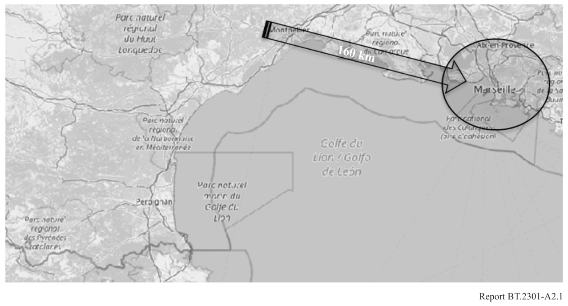
Similar cases were also reported that involved DTTB stations in neighbouring countries. In these cases, theoretical studies were undertaken by the French administration, to identify whether a foreign DTTB station could be responsible for the performance degradation. For all reported cases, these studies designated a previously coordinated foreign station. Therefore, it was not possible to improve the situation before the end of the transition period, corresponding to the release of the band in the foreign country.
Figure A2.2
Example of interference with LTE uplink (Nice) by a co-channel DTTB transmitter (Italy)
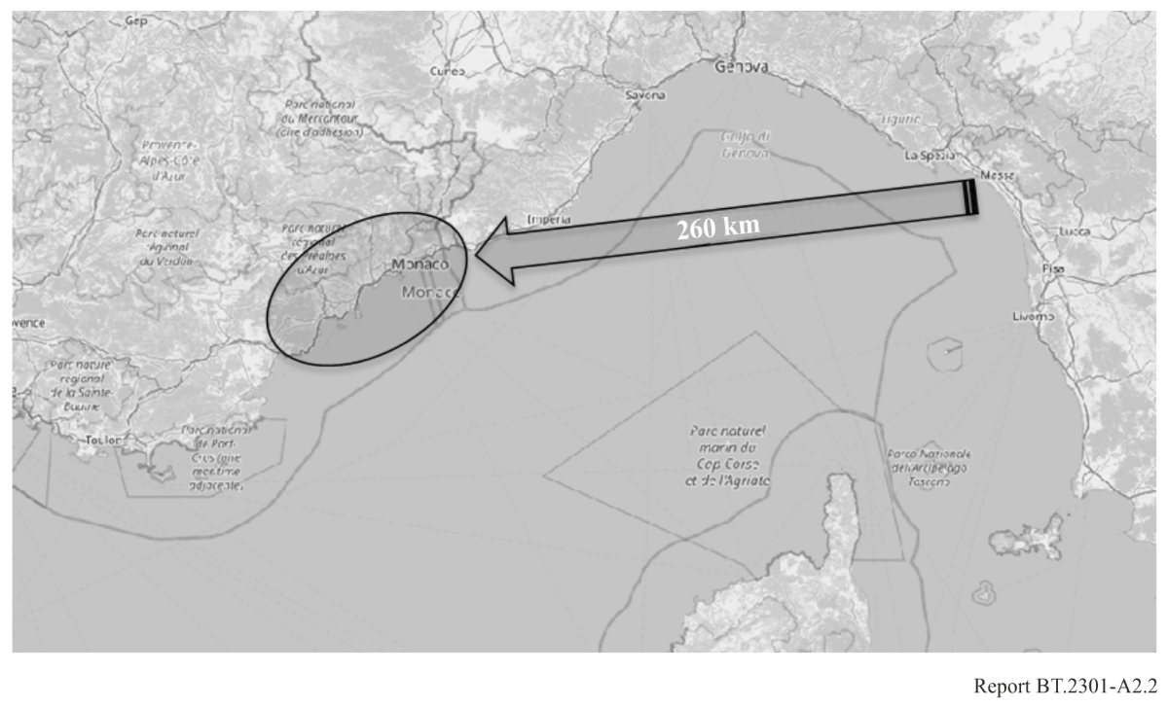
Figure A2.3
Example of interference with LTE uplink (France) by a co-channel DTTB transmitter (UK)
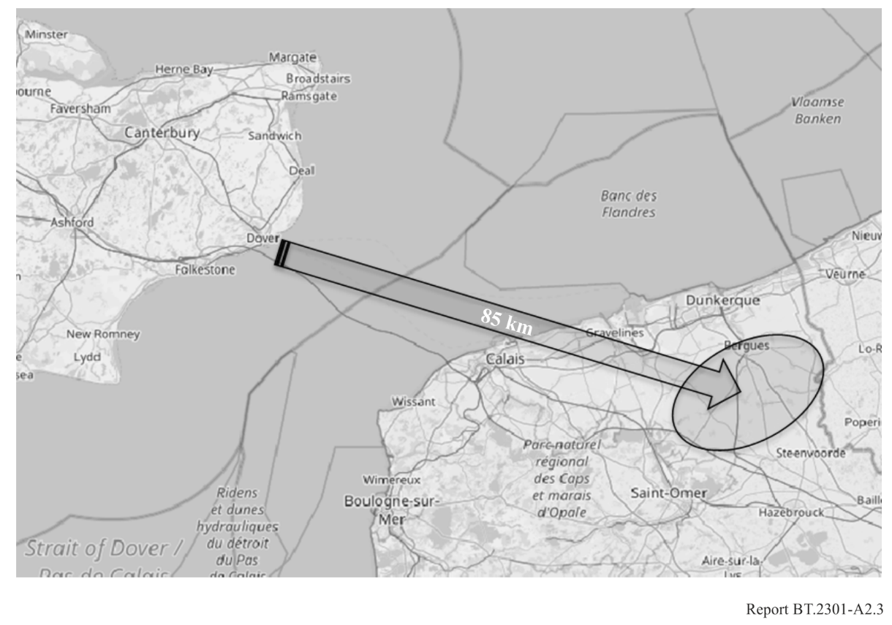

A2.3.3 Interference from LTE downlink to DTT
Only one case is reported for co-channel and cross-border interference with DTT reception in a neighbouring country by a French LTE base station. The situation was improved with some modifications of antenna tilt and EIRP, in line with the cross-border coordination agreement.
Figure a2.4
Example of interference with DTT (Italy) by a co-channel LTE base station transmitter (France)
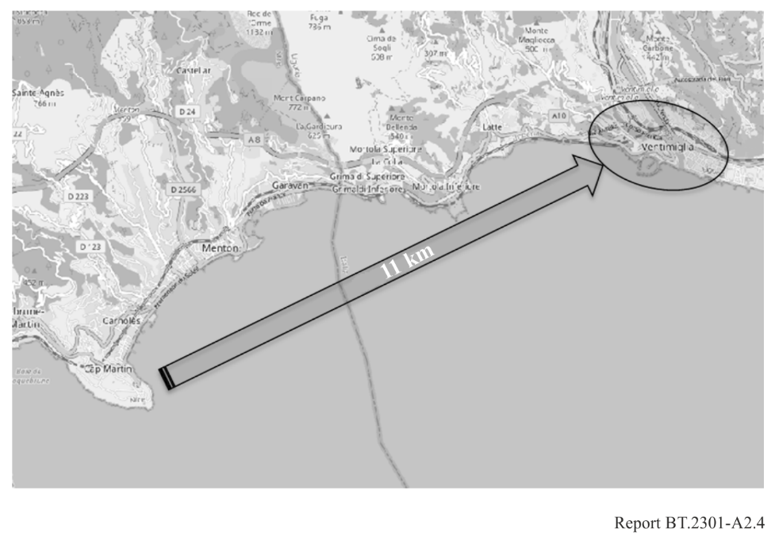

A2.4 Conclusions
Real-life experience of the rollout of LTE 700 and 800 MHz networks in France shows that LTE base stations, operating in adjacent bands to DVB-T reception, cause harmful interference to the latter. This has been observed since the beginning of the rollout in France. Indeed, this interference is limited and can be resolved, case by case, by mitigation techniques; mainly by filtering out the interfering LTE signal by an external filter connected to the DVB-T receiver antenna output.
The median interference distance between the interfering IMT base station and the fixed roof-top DTT reception installation is approximately 650 m and the maximum interference distance reported is about 7.3 km. In 99% of cases, the interference distance is below 2.4 km. Consequently, the interference from LTE BS to fixed roof-top DVB-T reception in the adjacent band is essentially a national matter and does not require any provision in the RR.
Almost all reported interferences were caused by LTE base stations provoking overloading of DTT receivers (active systems like amplifiers feeding DTT televisions / set-top boxes) and all had been resolved by the introduction of an LTE filter. The filter is installed at the DVB-T receiving antenna of the household (either head-end or user filters). Administration and operators have been able to successfully manage this kind of interference.
Co-channel interference, where the LTE uplink is being interfered with by a co-channel DTT transmitter, has been found to occur for separation distances up to 260 km for a propagation path over a warm sea. These situations last until the spectrum use is harmonised between countries. This emphasizes the need for regional coordination and synchronisation in cases where the spectrum use is being modified and which would otherwise result in co-channel operation between the Broadcasting and Mobile Services.

Annex 3
Interim national field report on the LTE rollout in the 800 MHz band
in the Netherlands
Introduction
On the 31st of October 2012 the multiband auction for LTE started in the Netherlands and came to a conclusion on the 14th of December 2012. As a result, licenses to three companies were granted on the 2nd of January 2013 in the 800 MHz band:
• Tele2 mobiel B.V.: 791-801 MHz paired with 832-842 MHz
• Vodafone Libertel B.V.: 801-811 MHz paired with 842-852 MHz
• KPN B.V.: 811-821 MHz paired with 852-862 MHz
Since then, about 5 200 LTE antennas came into service in the 800 MHz band. Vodafone Libertel rolled out about 775 LTE antennas in the cities Amsterdam, The Hague, Utrecht and Maastricht. All other antennas were rolled out by KPN mainly in the Randstad area (roughly the triangle between Amsterdam, Rotterdam and Utrecht).
Precautionary measures
In order to prevent interference with existing users of the radio spectrum, especially the DVB-T usage below 790 MHz, only general precautionary measures were taken. In the granted licenses the follow wording was added (for convenience translated from Dutch):
• “The usage of frequencies is such that adequate measures are taken to protect systems in adjacent frequency bands.”
• “The licensee causes no unacceptable barriers with the desired signal of radio transmitters into radio transmitters and receivers of electronic or electric facilities”
In the Annex of the license, additional technical requirements were defined for in band (64 dBm EIRP) and out of band emissions. For emissions in the band below 790 MHz additional requirements were defined: 0 dBm/8 MHz or less and if the base station causes no interference to the primary service below 790 MHz this level may be increased to a maximum of 22 dBm/8 MHz.
Network rollout
The picture below shows the LTE network rollout in the 800 MHz band on the 19th of November 2013. At that time only KPN and Vodafone Libertel had started to use the 800 MHz band. Vodafone Libertel rolled out about 775 LTE antennas in the cities Amsterdam, The Hague, Utrecht and Maastricht. All other antennas were rolled out by KPN mainly in the Randstad area.

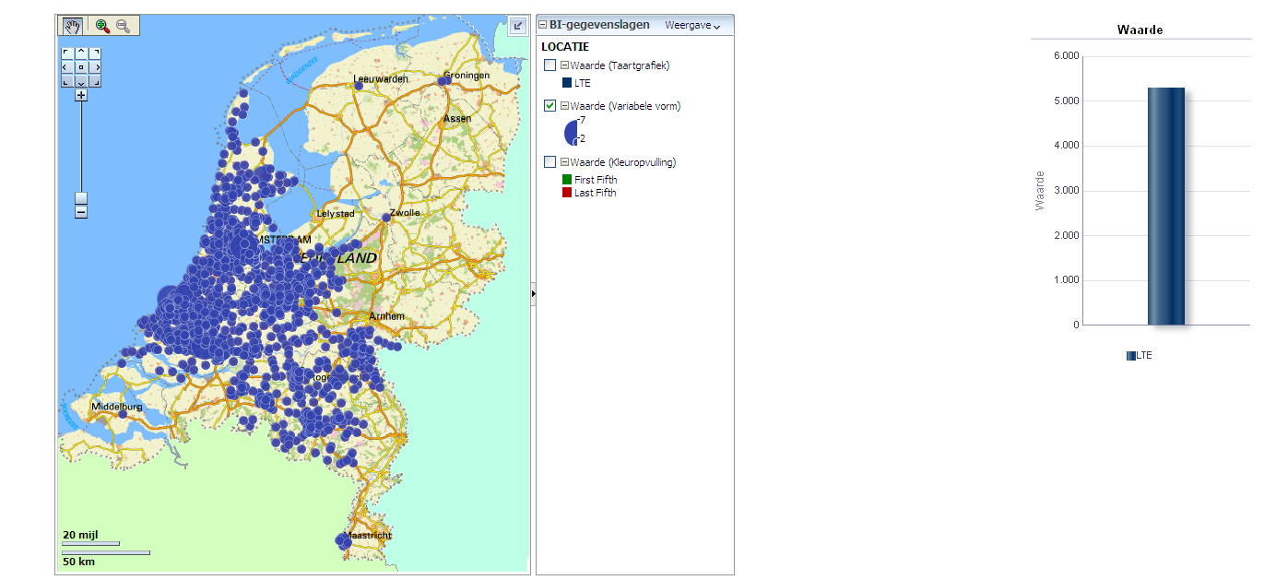

Interference cases
In the Netherlands, DVB-T is operated by Digitenne which is a subsidiary of KPN. This eases the coordination of the LTE rollout in the 800 MHz band with DVB-T usage for KPN if necessary. However, coordination within KPN with respect to the placing of LTE antennas did not take place. Digitenne reported no interference even when specifically asked. Nearly all DVB-T receivers put into service by KPN are able to receive up to 862 MHz.
As of the 19th of November 2013 no interference cases were reported to the Radiocommunications Agency. Since Tele2 did not rollout any LTE antennas in the 800 MHz the most stringent sharing conditions between LTE and DVB-T still have to come.

Annex 4
Field report on interference to 800 MHz band IMT base stations in Portugal from DTTB transmissions in Spain
During the process of freeing up the 800 MHz band in Spain there were interferences to several Base Stations operating LTE on the 800 MHz band in Portugal. The interferences were caused by the Spanish DTTB emissions in the same band.
In Spain, among others, three nationwide SFN were in operation on channels 67-68-69, on the same frequency range as the 800 MHz LTE uplink, as shown in Fig. A4.1.
Figure A4.1
Overlap between DTTB channels 67, 68 and 69 and 800 MHz LTE
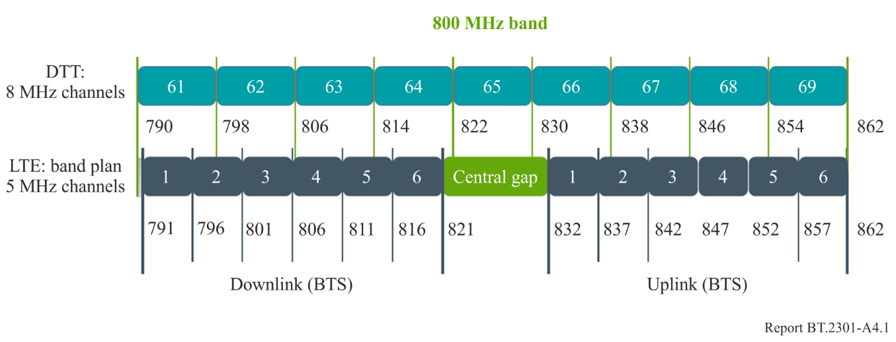
Although Spain fully cleared the 800 MHz band on March the 31st 2015, in order to avoid or minimise the interferences on the cross-border zones, the Spanish administration has asked the DTTB network operator for an early change of frequencies in several border DTTB sites. Figure A4.2 shows the DTT transmitters in Spain impacting LTE800 in Portugal and which were switched off. Calculations showing the extent of the interference from Spain to Portugal are provided in Report ITU-R BT.2247.
Figure A4.2
DTTB transmitters in Spain impacting LTE800 in Portugal
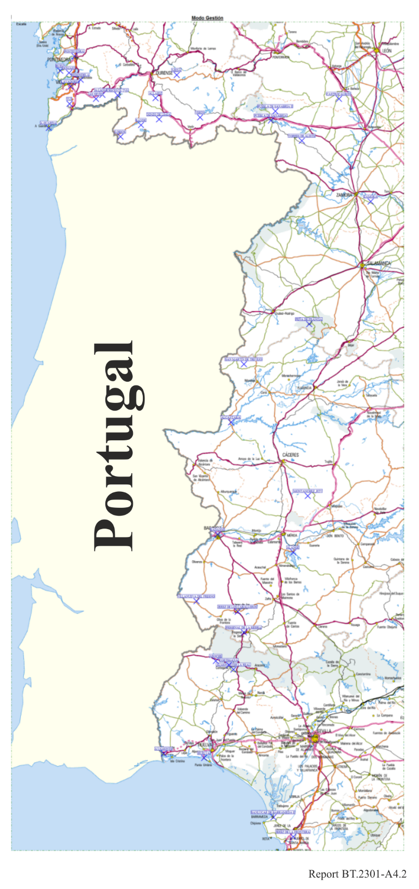

Clearing of 800 MHz band in Spain: prior studies and interferences produced to Portugal.
Part C of Report ITU-R BT.2247-3 shows separation distances between DTTB and IMT base stations ranging from 268 km for HPHT to 46 km for LPLH. Given the actual position of DTT Spanish stations, these correspond to interference distances within the Portuguese territory of 214 km and 35 km from the border, respectively.
In July 2014, while the switching process of the 800 MHz band was taking place, Portugal reported interferences from DTTB Spanish stations in some areas: in the South (Lagos, Ajustrel and Quateira), and in the centre of the country (Arraiolos), hindering the deployment of 4G services.
Based on the information provided by Portugal (azimuth and channels interfered) the interfering DTTB stations were identified, confirming in general the validity of the prior calculations, as shown in Table A4.1.
TABLE A4.1
Interfering and interfered stations
Interference location  (Portugal) | Distance to border  (km) | Interfering station  (Spain) | Distance to interference  (km) | Path | Field strength  (1% time)  (dBμV/m)
 |  |  |  |  | 1 546 | 1 812
Lagos  (37º06’N,08º40’W) | 110 | Almonaster Real (2.1 kW) | 190 | Land | 22.5 | 49.8
Ajustrel  (37°52'N 8°09'W) | 78 | Almonaster Real (2.1 kW) | 123 | Land | 32.0 | 51.6
Arraiolos  (38°43'N 7°59’W) | 62 | Almonaster Real (2.1 kW) | 141 | Land | 18.7 | 48.8
 |  | Frejenal Sierra (160 W) | 129 | Land | 16.9 | 49.6
Quarteira  (37°04'N 8°06’W) | 62 | Jerez Frontera (2.63 kW) | 181 | Sea | 33.2 | 52.4
 |  | Bornos (0.8 kW) | 212 | Sea | 18.0 | 18.1

Attachment
to Annex 4
Interference locations
Figure A4.3
Interference locations
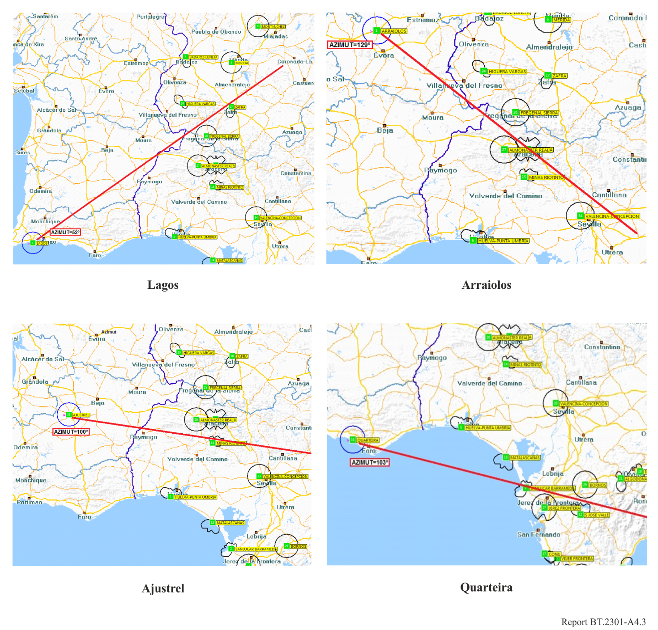

Annex 5
Collection of answers to the Request for Information to update
Report ITU-R BT.2301, towards WRC-23 agenda item 1.5, November 2020
In October 2020, WP 6A tasked its Rapporteur Group on WRC-23 agenda item 1.5 to conduct a survey in view of updating Report ITU-R BT.2301. Eighteen administrations and two Sector Members responded.
Responses are attached to this Annex and summarized in § 2 of this Report.

Attachment to Annex 5
Answers of Member States and Sector Members

A5.1 Answer of Saudi Arabia (ARS)
The answer of the administration of Saudi Arabia is as follows:

A5.2 Answer of Armenia (ARM)
The answer of the administration of Armenia, included in the contribution of the RCC, as transmitted by the Russian Federation, is as follows:

A5.3 Answer of Azerbaijan (AZE)
The answer of the administration of Azerbaijan, included in the contribution of the RCC, as transmitted by the Russian Federation, is as follows:

A5.4 Answer of Belarus (BLR)
The answer of the administration of Belarus, included in the contribution of the RCC, as transmitted by the Russian Federation, is as follows:

A5.5 Answer of Croatia (HRV)
The answer of the administration of Croatia is as follows:

A5.6 Answer of Denmark (DNK)
The answer of the administration of Denmark is as follows:

A5.7 Answer of the Russian Federation (RUS)
The answer of the administration of the Russian Federation is as follows:

A5.8 Answer of Finland (FIN)
The answer of the administration of Finland is as follows:

A5.9 Answer of France (F)
The answer of the administration of France is as follows:

A5.10 Answer of Ireland (IRL)
The answer of the administration of Ireland is as follows:

A5.11 Answer of Kazakhstan (KAZ)
The answer of the administration of Kazakhstan, included in the contribution of the RCC, as transmitted by the Russian Federation, is as follows:

A5.12 Answer of Kyrgyzstan (KGZ)
The answer of the administration of Kyrgyzstan, included in the contribution of the RCC, as transmitted by the Russian Federation, is as follows:

A5.13 Answer of Luxembourg (LUX)
The answer of the administration of Luxembourg is as follows:

A5.14 Answer of Malta (MLT)
The answer of the administration of Malta is as follows:

A5.15 Answer of Montenegro (MNE)
The answer of the administration of Montenegro is as follows:

A5.16 Answer of Uzbekistan (UZB)
The answer of the administration of Uzbekistan, included in the contribution of the RCC, as transmitted by the Russian Federation, is as follows:

A5.17 Answer of the United Kingdom of Great Britain and Northern Ireland (G)
The answer of the administration of United Kingdom of Great Britain and Northern Ireland is as follows:

A5.18 Answer of Switzerland (SUI)
The answer of the administration of Switzerland is as follows:

A5.19 Answer of EBU
The answer of EBU is as follows:

A5.20 Answer of ETSI
The answer of ETSI is as follows:

* The Administrations of Egypt (Arab Republic of), Saudi Arabia (Kingdom of) and United Arab Emirates do not support the approval of this Report. The Report in its current form is containing many errors in the summary provided in this document with conclusions supporting only one view as clarified in details during the WP 6A and SG 6 meetings. Several modifications proposed to correct many mistakes by membership, supporting the other views, were not considered. Also, the information related to Saudi Arabia (Kingdom of) is not correct and the requested corrections by the concerned Administration were also not considered. For the procedural concerns on approval of this Report and the official rejections by Administrations; see also the detail in Annex 2 to the summary record (Doc 6/130 rev)). Therefore, these Administrations do not believe this Report should share a place along with other technical ITU-R Reports.
Armenia, Belarus, Kazakhstan, Luxembourg, Malta and Switzerland report no interference so far, be it in the 800 MHz or 700 MHz band. Azerbaijan has not yet rolled out any MS network in the bands and thus reports no interference. In addition, several countries, with reported 800 MHz interference cases, are in the early stages of 700 MHz band rollout and report no interference cases for this band for the time being (see corresponding answers in Annex 5).
Each reported case may correspond to a large number of affected DTT receivers or affected LTE base stations
ANFR is a French public agency in charge of spectrum management: https://www.anfr.fr/accueil/.
Statistics in this Annex regarding adjacent channels interference cases are provided by the call centre of ANFR.
https://www.recevoirlatnt.fr/professionnels/antennistes-et-distributeurs/deploiement-de-la-4g-et-reception-tnt/caracteristiques-techniques-des-filtres-de-remediation/
This interim report reflects the national situation in the Netherlands and will be updated when appropriate.
114 kW, 18.0 dBμV/m threshold (I/N of –6 dB), 1% time.
100 W, 35.8 dBμV/m threshold (cross polarization and I/N of 0 dB), 10% time.

