|  |
| --- |
| **Report ITU-R BT.2338-0**  **(03/2015)** |
| **Services ancillary to broadcasting/services ancillary to programme making spectrum use in Region 1 and the implication of a co‑primary allocation  for the mobile service in the frequency band 694-790 MHz** |
| **BT Series**  **Broadcasting service**  **(television)** |

Foreword

The role of the Radiocommunication Sector is to ensure the rational, equitable, efficient and economical use of the radio-frequency spectrum by all radiocommunication services, including satellite services, and carry out studies without limit of frequency range on the basis of which Recommendations are adopted.

The regulatory and policy functions of the Radiocommunication Sector are performed by World and Regional Radiocommunication Conferences and Radiocommunication Assemblies supported by Study Groups.

# Policy on Intellectual Property Right (IPR)

ITU-R policy on IPR is described in the Common Patent Policy for ITU-T/ITU-R/ISO/IEC referenced in Annex 1 of Resolution ITU-R 1. Forms to be used for the submission of patent statements and licensing declarations by patent holders are available from <http://www.itu.int/ITU-R/go/patents/en> where the Guidelines for Implementation of the Common Patent Policy for ITU‑T/ITU‑R/ISO/IEC and the ITU-R patent information database can also be found.

|  |  |
| --- | --- |
| Series of ITU-R Reports  (Also available online at <http://www.itu.int/publ/R-REP/en>) | |
| **Series** | Title |
| **BO** | Satellite delivery |
| **BR** | Recording for production, archival and play-out; film for television |
| **BS** | Broadcasting service (sound) |
| **BT** | Broadcasting service (television) |
| **F** | Fixed service |
| **M** | Mobile, radiodetermination, amateur and related satellite services |
| **P** | Radiowave propagation |
| **RA** | Radio astronomy |
| **RS** | Remote sensing systems |
| **S** | Fixed-satellite service |
| **SA** | Space applications and meteorology |
| **SF** | Frequency sharing and coordination between fixed-satellite and fixed service systems |
| **SM** | Spectrum management |

|  |
| --- |
|  |

|  |
| --- |
| ***Note****: This ITU-R Report was approved in English by the Study Group under the procedure detailed in Resolution ITU-R 1.* |

*Electronic Publication*

Geneva, 2015

© ITU 2015

All rights reserved. No part of this publication may be reproduced, by any means whatsoever, without written permission of ITU.

REPORT ITU-R BT.2338-0

Services ancillary to broadcasting/services ancillary to programme making spectrum use in Region 1 and the implication of a co-primary allocation   
for the mobile service in the frequency band 694-790 MHz[1]

(2014)

TABLE OF CONTENTS

Page

1 Scope 5

2 General overview 5

2.1 Background 5

2.2 Quality and reliability of SAB/SAP in relation to spectrum demand 7

2.3 Future developments 7

3 Technical aspects of audio SAB/SAP 7

3.1 Descriptions: Analogue, digital and cognitive audio SAB/SAP 7

3.2 Operating conditions for audio links including wireless microphones and in ear monitor systems 11

3.3 Control links 14

4 Current use of SAB/SAP equipment and spectrum requirements 14

4.1 Events requiring support of various SAB/SAP devices 15

4.2 SAB/SAP usage in the 700 MHz band between 2007 and 2013 in Germany 17

5 Further developments and future requirements for audio SAB/SAP 19

5.1 Considerations on future perspectives for audio SAB/SAP 19

5.2 Future challenges 19

5.3 Future technologies 20

6 Future spectrum for audio SAB/SAP 21

6.1 Use of IMT duplex gaps and guard bands 21

6.2 Other frequency bands below 2 GHz 21

7 Conclusion 21

Page

Annex 1 – Glossary of Terms 23

Annex 2 – Technical SAB/SAP characteristics 25

2.1 Parameters for wireless microphones, in ear monitors (IEM) and audio links 25

2.2 Technical aspects for transmitters 26

2.3 Technical aspects for receivers 29

2.4 Propagation issues 30

2.5 Interference in to the audio receiver unit of a SAB/SAP system 33

2.6 A method to measure the radio microphone receiver C/I 36

2.7 Intermodulation, reverse intermodulation, WSD and SAB/SAP 38

2.8 Benefit of digital audio SAB/SAP: Possibility to adapt the characteristics to application requirements 46

2.9 Discussion and summary of the properties of the new technologies 47

Annex 3 – Study on the influence of OoB emission of an IMT duplex gap 55

Annex 4 – SAB/SAP spectrum requirements 57

4.1 General demand considerations 57

4.2 Demand for different kinds of broadcasting applications 58

4.3 Demand for places of worship 60

4.4 Demand for film and advertisement production 61

4.5 Demand for recording production 61

4.6 Demand for corporate events 61

4.7 Demand for social use 62

4.8 Demand for conferences/political events 62

4.9 Snapshots of daily SAB/SAP use 63

Annex 5 – Information on the usage of the 700 MHz band by SAB/SAP in Region 1 73

5.1 Introduction 73

5.2 Set up of measurements 73

5.3 Coordination of SAB/SAP frequencies 74

5.4 Explanation of presented diagrams 74

5.5 Measurement results 74

5.6 Summary 81

5.7 Conclusion 82

Page

Annex 6 – SAB/SAP spectrum requirements in the 470-790 MHz band at the Eurovision Song Contest 2011 82

6.1 Introduction 82

6.2 Requirements at the ESC 2011 83

6.3 Issues with frequency coordination 86

6.4 Actual spectrum use at ESC 88

6.5 Alternative coordination 91

6.6 Other events 93

6.7 Conclusion 94

6.8 List of References 95

Page

8 Conclusion 20

Annex 1 Glossary of Terms 22

Annex 2 Technical SAB/SAP characteristics 24

2.1 Parameters for wireless microphones, in ear monitors (IEM) and audio links 24

2.2 Technical aspects for transmitters 25

2.3 Technical aspects for receivers 28

2.4 Propagation issues 29

2.5 Interference in to the audio receiver unit of a SAB/SAP system 32

2.6 A method to measure the radio microphone receiver C/I 35

2.6.4.1 Analogue microphones 36

2.7 Intermodulation, reverse intermodulation, WSD and SAB/SAP 37

2.8 Benefit of digital audio SAB/SAP: Possibility to adapt the characteristics to application requirements 45

2.9 Discussion and summary of the properties of the new technologies 46

Annex 3 Study on the influence of OoB emission of an IMT duplex gap 54

Annex 4 SAB/SAP spectrum requirements 56

4.1 General demand considerations 56

4.2 Demand for different kinds of broadcasting applications 57

4.3 Demand for places of worship 59

4.4 Demand for film and advertisement production 60

4.5 Demand for recording production 60

4.6 Demand for corporate events 60

4.7 Demand for social use 61

4.8 Demand for conferences / political events 61

4.9 Snapshots of daily SAB/SAP use 62

ANNEX 5 Information on the usage of the 700 MHz band by SAB/SAP in Region 1 72

5.1 Introduction 72

5.2 Set up of measurements 72

5.3 Coordination of SAB/SAP frequencies 73

5.4 Explanation of presented diagrams 73

Page

5.5 Measurement results 73

5.6 Summary 80

5.7 Conclusion 81

Annex 6 SAB/SAP spectrum requirements in the 470-790 MHz band at the Eurovision Song Contest 2011 81

6.1 Introduction 81

6.2 Requirements at the ESC 2011 82

6.3 Issues with frequency coordination 85

6.4 Actual spectrum use at ESC 87

6.5 Alternative coordination 90

6.6 Other events 92

6.7 Conclusion 92

6.8 List of References 94

# 1 Scope

The purpose of this Report is to provide relevant information on audio SAB/SAP, including technical characteristics, quality requirements, current spectrum use, and the impact of the loss of the 700 MHz band. In addition, the Report provides an outlook on future technological developments, as well as the future service and spectrum requirements. This information has been developed to facilitate discussions at the WRC-15 under agenda item 1.2, in particular concerning SAB/SAP spectrum use.

# 2 General overview

## 2.1 Background

In Region 1 the frequency band 470-862 MHz has been traditionally a core spectrum for audio SAB/SAP applications that operate in the interleaved spectrum on a secondary basis with regard to the primary users such as terrestrial broadcasting.

At WRC-07 the upper part of the frequency band (790-862 MHz) was allocated in Region 1 on a co‑primary basis with the broadcasting service to the mobile service (MS) and identified for IMT. Resolution **749 (Rev.WRC-12)**[2] envisaged in considering (d) that applications ancillary to broadcasting to continue their operation in the range 470-862 MHz. However co-channel and co‑location sharing of IMT and SAB/SAP is not possible.

The change of the use of the 800 MHz[3] band for IMT only leaves SAB/SAP with less frequency range available. In addition a number of broadcast service systems had to migrate to the spectrum below 790 MHz, thus increasing the density of digital terrestrial television (DTT) transmitters and reducing the available interleaved spectrum below 790 MHz for SAB/SAP.

At the WRC-12 a decision was taken to allocate for Region 1 the frequency band 694[4]-790 MHz to MS on a co-primary basis with broadcasting with an identification to IMT and IMT-Advanced which will come into force by the end of WRC-15. Following Resolution **232 (Rev.WRC-12)** the conditions of use of this allocation will be discussed at WRC-15 under agenda item 1.2. In addition, solutions for accommodating SAB/SAP requirements will be considered. SAB/SAP currently is operated under RR No. **5.296** in 60 countries in the range 470-790 MHz and in 12 countries in the range 470‑698 MHz. As a consequence, the amount of spectrum available for SAB/SAP applications will be further reduced. At the same time, requirements for SAB/SAP continue to grow both for professional and community applications.

Whilst improvements in spectrum efficiency have taken place in SAB/SAP equipment they cannot fully compensate for this loss of available spectrum. Therefore, a major threat to SAB/SAP is that demand for spectrum enabling an operation with the required quality of service (QoS) will outstrip supply.

The current SAB/SAP use and spectrum requirements are described in § 5.

Definition of SAB/SAP

SAB/SAP are defined as follows:

SAB:Services ancillary to broadcasting support the activities of broadcasting industry carried out in the production of their program material.

SAP:Services ancillary to programme making support the activities carried out in the making of “programmes”, such as film making, advertisements, corporate videos, concerts, theatre and similar activities not initially meant for broadcasting to general public.

The definitions of SAB and SAP are not necessarily mutually exclusive. Therefore they are often used together as “SAB/SAP” to refer generally to the whole variety of services to transmit sound and video material over radio links.

The SAB/SAP applications include both ENG[5]/OB[6] and SNG[7]/OB applications and also the communication links that may be used in the production of programmes, such as talk-back or personal monitoring of sound-track, telecommand, telecontrol and similar applications.

## 2.2 Quality and reliability of SAB/SAP in relation to spectrum demand

Audio SAB/SAP applications, such as wireless microphones, in ear monitoring systems are used in a broad number of contexts. The operating requirements, including quality and reliability requirements as well as the number of deployed systems vary significantly. It is of importance to consider that the regular demand for spectrum for SAB/SAP should be distinguished from that, which is known as “peak demand”. “Peak demand” may be temporary and it may be geographically limited. However providing the required quality and reliability of the service in “peak demand” situations is a much complex issue, because it sets higher demand for spectrum amount and for spectrum planning. The required protection inherently puts constraints on the amount of spectrum required to guarantee the QoS.

SAB/SAP technical characteristics and quality requirements are described in detail in Annex 2 of the Report.

## 2.3 Future developments

As the available spectrum is becoming more and more congested, a development process towards more spectrum efficient audio SAB/SAP systems can be observed in recent years. Semi-cognitive analogue systems are already commercially available. These systems are able to sense the RF environment they are operating in and decide on which channels to operate depending on the information they have available. In order to benefit from such capabilities, wider frequency blocks should be available to SAB/SAP systems. These blocks are currently not available in all countries, in part because the licensing regime in some countries restricts the SAB/SAP use to only specific channels in a frequency block.

SAB/SAP systems using digital modulation schemes are also commercially available. As digital modulation involves some specific operating conditions and digital systems generally exhibit higher latency than the analogue ones, they are not suitable for use in all applications. These systems currently cannot replace analogue systems in all fields and applications. Furthermore, the use of digital technology alone does not eliminate the need for SAB/SAP to have access to spectrum that allows operation with the required QoS. A complete transition from analogue to digital SAB/SAP technology will take a number of years.

Further information about future SAB/SAP developments, including service and spectrum requirements is provided in Annex 4.

# 3 Technical aspects of audio SAB/SAP

## 3.1 Descriptions: Analogue, digital and cognitive audio SAB/SAP

### 3.1.1 Analogue

Most current audio SAB/SAP products are based on analogue modulation, e.g. frequency modulation (FM). An analogue transmission chain involves the conversion of the acoustic signal into an electric signal, which directly drives the radiofrequency signal transmitted over the air (see the following figure).

Figure 1

Typical frequency-synthesised analogue transmitter

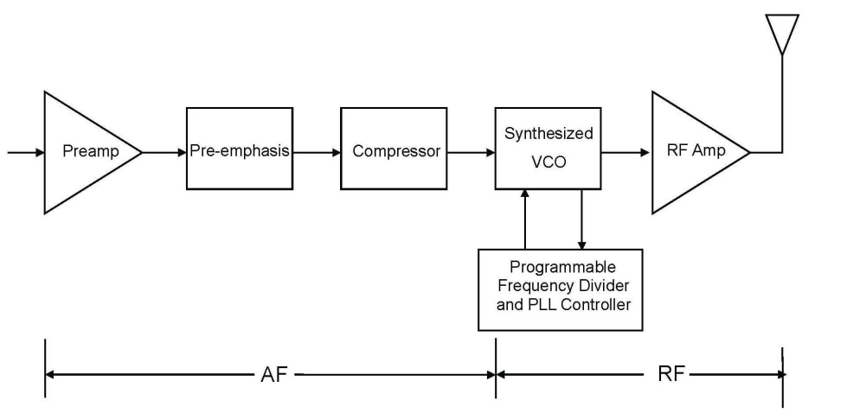

At the receiver end, the received radiofrequency signal is directly converted to an electric signal, which is then assumed to be representative of the input audio signal. Such analogue transmission chain introduces minimum latency for the end-to-end transmission of the signal. However, as the signal is not encoded, any radiofrequency interference or loss of the radiofrequency signal directly degrades the transmitted audio signal. In such a case, no interference is acceptable.

Figure 2

Typical frequency-synthesised analogue receiver

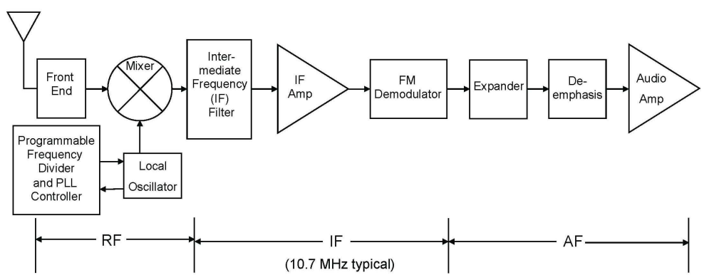

In the presence of man-made noise “simple” FM can be the most advantageous modulation. A typical FM receiver operates co-channel from a level of 10-15 dB over man-made noise; digital systems often requires a 10-15 dB higher level above man-made noise.

### 3.1.2 Digital

Digital transmission chains are used in many applications, including SAB/SAP video links. In a digital transmission chain, the acoustic signal is converted into an electric signal which is then transformed through an analogue to digital converter. Typically, the conversion into the digital domain and subsequent source encoding will be selected to obtain the desired trade-off between the transmitted signal quality and the amount of information to be transmitted. Once the signal has been digitised, it can be transmitted as any digital information through a transmission chain that potentially includes channel/forward error coding, mapping of the channel encoded information to a modulation scheme, digital to analogue conversion of the modulated signal, transmission of the radio-frequency signal, analogue to digital conversion of the received signal followed by demodulation and finally decoding of the channel/forward error correcting code.

Such a digital transmission chain may or may not involve a retransmission mechanism in case the packet is not error free at reception.

Typical transmission and reception chains are illustrated in the figures below.

Figure 3

Typical frequency-synthesised digital transmitter

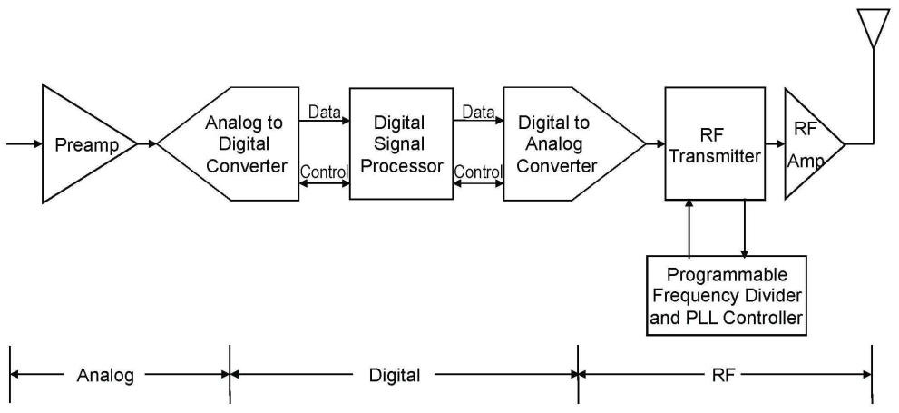

Figure 4

Typical frequency-synthesised digital receiver

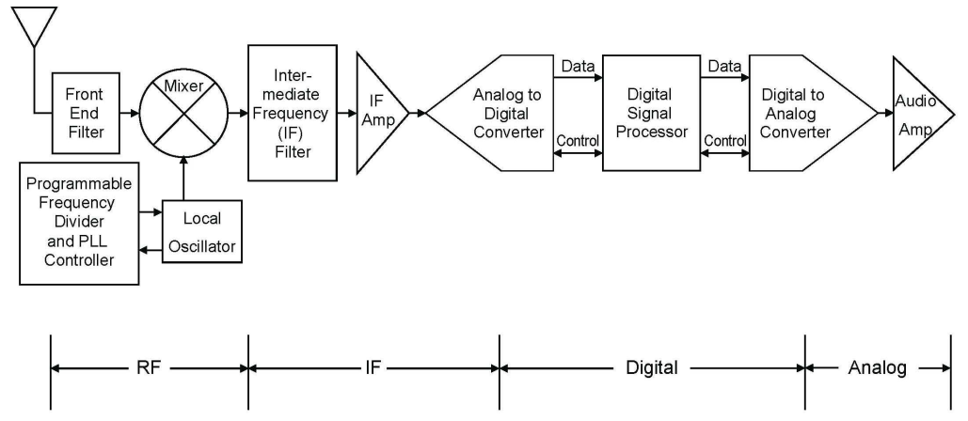

### 3.1.3 Cognitive systems

Interference mitigation in SAB/SAP by cognitive behaviour is being currently studied both in ETSI STF386 and in a German research project funded by BMWI (German Federal Ministry of Economics and Technology) called cognitive programme making and special events (C-PMSE). Both activities are aligned as some of the experts are working in both activities.

On 29th May 2013 a practical demo on cognitive behaviour was given at Berlin Trade Fair Centre. Initial frequency assignments to SAB/SAP links are calculated; frequency handovers due to raising interference and power control to accommodate a varying link quality were shown to the public. Furthermore it was shown that link quality supervision can be done on analogue FM links in situ.

Presentations of demo Workshop are available from:

Figure 5

Overview of SAB/SAP cognitive system as considered by the C-PMSE project

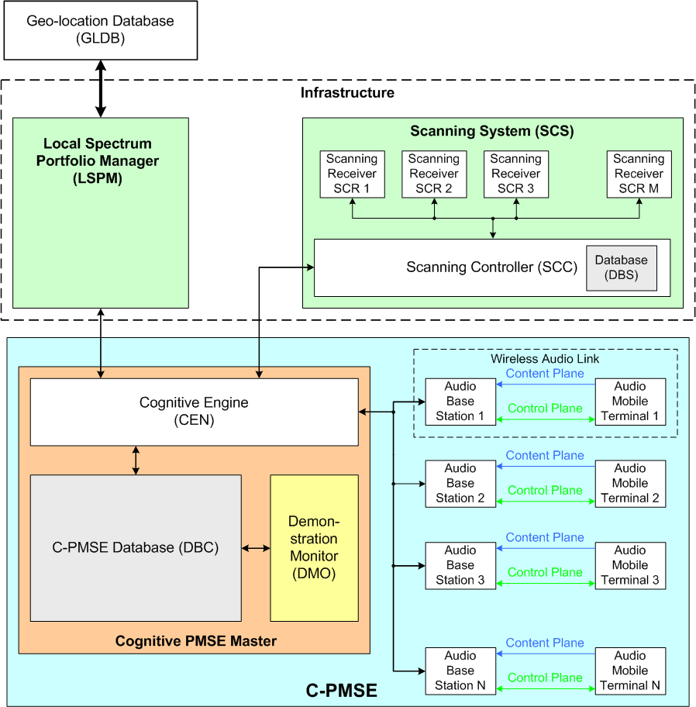

The system demonstrated in Berlin and laid out in the output documents of ETSI STF386 is composed of three large subsystems: The Local Spectrum Portfolio Manager, the Scanning system, together reflecting the infrastructure, which may be permanently installed at an event location. Then there is the entire C-PMSE, which is composed out of the two subsystems plus the cognitive engine, which is the intelligence in the system, comprising of a database and the wireless audio links.

Signalling with the demo was mapped onto existing short range device air interface standards, which operated in unlicensed bands. This is not an option for real SAB/SAP use as protection is not only needed on the content plane but also on the signalling plane. It also became clear that signalling requires additional spectrum in addition to the spectrum need for the content plane.

At Berlin Trade Fair Centre five halls are equipped with a total of 30 scanning receivers forming a large scanning grid. The scanning gird is permanently installed and is still in use thus gaining more experience with operating it. It can be accessed remotely by the project partners. For this and other purpose the German research project has been extended till end of 2013. Further findings and research results will be incorporated in phase C of ETSI STF 386 activity.

Cognitive SAB/SAP require additional clean and high reliable radio spectrum to operate their control links.

## **3.2 Operating conditions for audio links including w**ireless microphones and in ear monitor systems

### 3.2.1 Quality of service requirements

No degradation in the quality in the audio signal should be perceived during the transmission period. SAB/SAP is unusual in that large numbers of transmitters are in physical close proximity with a 100% duty cycle for the duration of the performance. Use of SAB/SAP will vary from a few hours for a news conference to many weeks for a large event such as the G8 conference and. permanently for use at studios and theatres. Details on SAB/SAP operation and the technical requirements for SAB/SAP use are given in Annex 2.

In all cases the radio microphone equipment is the first link in a transmission chain, which may end in a broadcast transmission, recording or an amplified output. As such any perceived interference of any form will impact the whole transmission chain. Irrespective if the chain is recorded or broadcast live, interference is likely to mean that the performance will be abandoned and in most cases will be unrepeatable. Therefore interference must not occur in order to keep a high quality of the service during the transmission.

The repercussions of interference to say a political broadcast could be severe for the program engineers.

### 3.2.2 General requirements regarding audio SAB/SAP operation

Wireless microphone and in ear monitor systems must fulfil the highest demands for audio quality on a consistent and repeatable basis. Audio SAB/SAP, which shares some requirements, however may also differ from application to application. Additional details are given in the table provided in Annex 2.

The following focuses on the requirements of high quality SAB/SAP.

Even in non-professional SAB/SAP use the users are acutely aware of the performance of the system and do not accept reduction in performance or interference.

The key requirements for a state of the art wireless system are:

– providing an audio quality similar to an equivalent wired system;

– low latency; in order to achieve an acceptable latency in the complete audio chain, the latency in the radio microphone has to be as low as possible especially for in-ear monitors (IEM) applications or lip sync is observable. For details see Report ITU-R BS.2161-0 (2009). For certain applications, delay is permissible for example, where the speaker is not seen by the audience;

– no interruptions: all radio microphones and IEM have a 100% audio duty cycle. In all applications users do not tolerate any corruption or interruptions in audio output. Where radio microphones are connected to large amplifiers (theatres, rock concerts etc.) any interference may generate peaks of sound, which can hurt or damage audience hearing. In the case of IEM (whose audio output is received in the ear canal of the user), damage to the user’s hearing can occur if interference is generated to the transmission.

### 3.2.3 Factors that affect the performance of wireless microphones and in-ear monitors

The following factors may affect the performance of wireless microphones and IEM:

– Interference from other users:

– interference from other services that fall into the receiving frequency range of wireless microphones and IEM;

– adjacent channel interference from other systems or services operating in the channel adjacent to the operating channel itself;

– intermodulation products that are generated either by wireless microphones, IEM and tour guide or by other services that fall into the wanted receiving channel.

– Other factors:

– size of the venue, deployment density;

– properties of the venue regarding screening and antenna positioning;

– propagation aspects: multipath, fading and body loss.

#### 3.2.3.1 Effect of intermodulation on spectrum need

Intermodulation is a physical phenomenon that occurs when multiple transmitters work simultaneously in close vicinity.

Intermodulation is the amplitude modulation of signals containing two or more different frequencies in a system with non-linearity.

Non-linearity is typical for radio systems, it occurs in the transmitter, in the receiver and ancillary RF equipment[8] or in the environment, especially where amplifiers are operating outside the linear range.

The intermodulation between each frequency will form additional signals at frequencies that are not just at harmonic frequencies (integer multiples) of either, but also at the sum and difference of the original frequencies and at multiples of those sum and difference frequencies.

The multiple combination summation of two interfering signals characterizes interference products of the same order with the same power level. Intermodulation products of higher order show a lower power level.

Increasing the power of two interfering signals leads to a significant higher growth in the level of interference products, depending on their order.

Frequencies, where intermodulation products appear with significant level, are not available for wanted signals any more.

For an increasing number of frequencies for wanted signals, the additional unwanted frequencies occupied by intermodulation products are growing significantly higher exponentially.

This is why it is important to consider the non-linear significant higher need of the amount of additional spectrum for additional channels.

A more detailed description of the technical requirements is given in Annex 2.

#### 3.2.3.2 Intermodulation mitigation techniques

Intermodulation mitigation can be achieved by a number of techniques:

1) frequency planning, in order to avoid intermodulation products on the wanted signal;

2) use of output filters and/or ferrite isolators;

3) control of microphones transmitted power;

4) adoption of transmission technologies that support operation in higher interference environment;

5) use of linear transmit amplifiers.

The approaches 3 and 4 above require additional radio spectrum to operate control links.

Analogue systems support the first two mitigation techniques. Cognitive systems support the first three mitigation techniques. Digital systems, at best, support all five mitigation techniques.

Use of item five will reduce battery life.

Furthermore, it should be noted that:

– As a best case scenario, SAB/SAP could be operated in a linear grid. In reality an intermodulation-free operation is required and the spectrum demand will be much higher;

– Current IEM transmitter technology cannot be operated in a linear grid. In any observed events an intermodulation-free frequency setup was required;

– The use of audio SAB/SAP and IEM on the presenter or actor’s body requires an additional guard band – see the scenario below observed during Eurovision Song Contest 2011:

Figure 6

Microphone and IEM separation

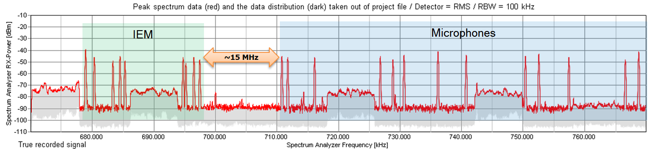

### 3.2.4 Propagation characteristics of frequency bands

The propagation characteristics for audio SAB/SAP are shown in the table taken from ECC Report 204[3] below depending on the frequency range.

TABLE 1

Propagation characteristics depending on the frequency range

| Frequency band | Propagation characteristics |
| --- | --- |
| 29.7 to 47.0 MHz | Good propagation, minimum wall absorption, no reflection or diffraction.  Shielding from metal structures is low.  Only very low or lowest body absorption in this frequency range.  Notes:  • This band may not be practicable for all types of audio SAB/SAP applications due to the high ambient noise levels.  • Due to the fact that it requires the implementation of very large antennas it is not suitable for body-worn equipment.  • Not suitable for large multi-channel systems. |
| VHF band above 174 MHz | Good propagation, minimum wall absorption, low reflection or diffraction.  Shielding from metal structures is low.  Body absorption in this frequency range is low.  NOTE – Low frequencies require large antennas. The noise floor and clock frequencies may create interference to audio SAB/SAP applications. |

TABLE 1 *(end)*

| Frequency band | Propagation characteristics |
| --- | --- |
| UHF band below 1 GHz | Good propagation, some wall absorption, depending on the surrounding structures reflection or diffraction can occur.  Shielding from metal structures occurs.  Significant body absorption.  Wall absorption and shielding effects of metal structures can be beneficial in reusing available frequencies in larger system setups.  Small antennas possible.  System performance can be optimised by the use of directional antennas. |
| UHF 1 to 1.7 GHz | Acceptable propagation, wall absorption, depending on the surrounding structures reflection or diffraction occurs.  Shielding from metal structures occurs.  Significant increased body absorption.  Wall absorption and shielding effects of metal structures can be beneficial in reusing available frequencies in larger system setups.  Small antennas possible.  System performance can be optimised by the use of directional antennas. |
| UHF 1.7 to 2.5 GHz | Acceptable propagation, wall absorption, depending on the surrounding structures reflection or diffraction occurs.  Shielding from metal structures occurs.  Critical body absorption.  Wall absorption and shielding effects of metal structures can be beneficial in reusing available frequencies in larger system setups.  Small antennas possible.  System performance can be optimised by the use of directional antennas. |

The UHF band below 1 GHz is the best band for audio SAB/SAP due to the combination of antenna size, propagation and current noise floor. The current upper limit for reliable multichannel radio microphone use has been found to be 2 GHz based on body loss and propagation. Above this figure higher power transmitters are required to overcome propagation and body loss however these then exceed the safe limits for electro magnetic field (EMF) limits exposure.

## 3.3 Control links

In many cases both radio microphones and IEM have a bidirectional control link, which enables   
a range of services such as remote battery monitoring. In the case of cognitive equipment this can include power control and changes in frequency. These control channels are currently outside the bandwidth of the device and currently 2.4 GHz is favourite operational range. However an increasing amount of other production equipment is using the 2.4 GHz range and additional spectrum may be required.

# 4 Current use of SAB/SAP equipment and spectrum requirements

The demand for spectrum for SAB/SAP applications varies depending on the use scenarios.

In many cases, an event is known in advance and detailed planning and coordination of spectrum use can take place. Currently some administrations “borrow” spectrum from other users for regular large events such as Formula 1, G8 and especially for extraordinary events such as the Olympics. Such “borrowing” will become more difficult in the future due to the form and type of new services now using the currently “borrowed” spectrum within the tuning range of SAB/SAP equipment.

The density and deployment of SAB/SAP audio equipment is high in urban areas and areas where production facilities are located (e.g. studios and media villages). In these hot spot areas, fixed deployments have a high probability of use. The actual use is dependent on the work/rehearsal/ performance schedule. During such phases, the probability of use is 100%. For the remaining time the probability of use is low.

Hot spot scenarios have a high demand for spectrum. The spectrum demand will vary depending on the time of day and other factors. For example theatres use a high number of SAB/SAP applications such as wireless microphones, IEM, and wireless audio links during rehearsals and shows, other than that, there is only low or no use.

Other scenarios have a lower demand for spectrum. The demand may vary depending on the time of day and other factors. For example houses of worship use only a small number of SAB/SAP devices such as 1-2 wireless microphones, and those only during services. Other than that, there is no SAB/SAP use at this location.

In rural scenarios where normally no SAB/SAP applications are deployed other than Houses of Worship and clubs, spectrum demand occurs in case of unexpected events, such as natural disasters, accidents and war situations that attract media coverage. This could be considered an ad hoc use of SAB/SAP equipment. For this use, a certain amount of permanent spectrum must be available as spectrum coordination based on “borrowed spectrum” is not possible in the short time scales available.

## 4.1 Events requiring support of various SAB/SAP devices

The brief list below shows a wide range of scenarios where SAB/SAP equipment is used. A detailed view on how many links are occupied in each of the scenarios below is given in § 5.2.

– theatres and rock and pop and touring shows;

– studio production, these can be single buildings or cover many hectares with multiple studios;

– news gathering for TV/radio/internet;

– sound broadcast;

– casual (sport) events and similar outside broadcasts;

– special events (i.e. large outside broadcasts);

– houses of worship;

– film and advert production;

– recording;

– corporate events;

– social use, e.g. homes for the elderly people;

– conference / political events (e.g. shareholder/board meetings/G20 summit).

### 4.1.1 Exceptional, special, large and regular events

*Special Event* is an occurrence of limited duration, typically between one day and a few weeks, which takes place at specifically defined locations.

Exceptional events like the Olympic Games occurring each two years[9] and regular large events like the Tour de France, Formula 1 competitions or football tournaments require the support of audio links, Video Links and Service Links. These will be terrestrial, waterborne, airborne or satellites.

When these events are to be organised, they result in large extra effort for spectrum management requiring detailed intervention by a band manager or the regulator. Carefully controlled reuse between indoor and outdoor links may be needed every kilometre or less.

Exceptional and large regular events will normally involve the regulator in frequency planning the event, allowing the identification of additional spectrum from other users, which can be used by SAB/SAP during these events. Exceptional events can require in excess of 7.000 assignments below 1 GHz spread over various locations as for example shown in ECC Report 204 [3].

The tables of this report show representative examples from SAB/SAP usage from around Europe.

TABLE 2

Spectrum usage for the Tour de France

|  |  |  |  |  |  |  |  |  |  |
| --- | --- | --- | --- | --- | --- | --- | --- | --- | --- |
| Event | Radiomicrophone IEM | Service Links | Video Links | | | | | | |
| 1 GHz | 2 GHz | 3 GHz | 4.5-6 GHz | 10 GHz | Above 20 GHz | Total Video Links |
| Tour de France 2007 | 365 | No information | | | | | | | |
| Tour de France 2010 | 456 | NA | 4 | 20 | 4 | 0 | 0 | 0 | 28 |
| Tour de France 2011 | 463 | NA | 3 | 23 | 9 | 0 | 0 | 0 | 35 |
| Tour de France 2012 | 452 | NA | 4 | 17 | 11 | 0 | 0 | 0 | 32(1) |
| Tour de France 2013(2) | 576 | No information | | | | | | | |
| (1) For 2012, the decrease in the number of video links is due to the fact that there was one TV operator less than in 2011.  (2) In 2013, it was the 100th Tour de France, which may explain the increase in the number of wireless microphone and IEM assignments. | | | | | | | | | |

Experience shows an increasing demand of spectrum for these events resulting from the increase in amount of data to be transmitted, an increase in the number of organisations involved in those events and a larger diffusion (see also § 3.3 on Future developments).

### 4.1.2 Studio production

Studios use radio for talkback, microphones, IEM for presenters and as appropriate cordless cameras. The reason for using SAB/SAP equipment with radio links is to give freedom of movement within the studio.

The nature of traditional studio use has changed. In some countries studios that were managed by public broadcasters have now sold off their studio complexes to private organisations. This has resulted in not only the public broadcaster using this studio but intensive use from other programme making companies. In addition, the following should be noted:

– a range of programs having permanent built studios;

– the development of Studio Villages or Media Cities with a concentration of facilities in a relatively small physical area as an example 358 audio wireless systems per 1 km2 in Media Park, Hilversum.

TABLE 3

Number of audio links for SAB/SAP in studios

|  |  | 2002 | 2009 | 2012 |
| --- | --- | --- | --- | --- |
| Single Studio | Average | 10 | 25 | 33-46 |
| Peak | 10-14 | 20-50 | 65 |
| "Studio Village" | Average | 35-70 | 80-112 | 225 |
| Peak | 50-100 | 160 | 358 |

NOTE – The average use is 50 – 70 % of installed equipment in a studio.

The complex frequency environment of these sites requires detailed frequency planning to ensure that no interference is generated between the devices on site.

## 4.2 SAB/SAP usage in the 700 MHz band between 2007 and 2013 in Germany

Over the past years the SAB/SAP use of various events in Germany was measured and the number of used links was recorded. Table 4 below shows a comparison of the coordinated and scanned links of several events.

Annex 5 "Information on the usage of the 700 MHz band by SAB/SAP", gives an overview on the use of the 690-790 MHz range by SAB/SAP. In this range between 40 and 80 links were often coordinated. On large or even exceptional events up to 147 links were coordinated.

It should be noted that in general a single scanning unit used in isolation is unable to detect all SAB/SAP carriers. The difference between coordinated and scanned carriers cannot be interpreted as coordinated unused SAB/SAP channels.

TABLE 4

Coordinated vs. scanned SAB/SAP links in the 690 to 790 MHz range

|  |  |  |  |
| --- | --- | --- | --- |
| Annex 5 Section 5.5 | Event name, location and year | Carrier in 690 to 790 MHz | |
| Coordinated | Scanned |
| 1 | Live Earth Hamburg, 2007 | – | 30 |
| 2 | UCI Road World Championships in Stuttgart, 2007 | 69 | 30 |
| 3 | Lower Saxony election Hanover, 2008 | 79 | 29 |
| 4 | Hamburg state election, 2008 | 73 | 39 |
| 5 | Bavaria state election Munich, 2008 | 65 | 28 |
| 6 | Saxony-Anhalt state election Magdeburg, 2011 | 38 | 39 |

TABLE 4 (*end*)

|  |  |  |  |
| --- | --- | --- | --- |
| Annex 5 Section 5.5 | Event name, location and year | Carrier in 690 to 790 MHz | |
| Coordinated | Scanned |
| 7 | Rhineland-Palatinate state election Mainz, 2011 | 27 | 26 |
| 8 | Bremen state election, 2011 | 67 | 25 |
| 9 | DFB Cup Final Berlin, May 2011 | 147[10] | 50 |
| 10+11 | Eurovision Song Contest Düsseldorf, 2011 | 56 | 50 |
| 12 | Mecklenburg-Vorpommern election Schwerin, 2011 | 65 | 18 |
| 13 | Berlin election, September 2011 | 127 | 37 |
| 14 | North Rhine-Westphalia state election Düsseldorf, 2012 | – | 23 |
| 15 | Schleswig Holstein state election Kiel, 2012 | 44 | 29 |
| 16 | Lower Saxony state election Hanover, 2013 | 80 | 36 |
| 17 | Oktoberfest Munich, 2012 | – | 26 |

### 4.2.1 Impact on SAB/SAP of the loss of the 694 to 790 MHz range

Annex 6 focuses on one particular event; The Eurovision Song Contest 2011 in Düsseldorf, Germany. At that event almost the entire available spectrum in the 470-790 MHz range was used for audio SAB/SAP. There were only a few spare frequencies that were at call in an emergency case such as an unexpected interferer showing up at event time. The whole event lasted about four weeks, and during that time the full range of production spectrum had to be available.

For the same event spectrum planning was carried out, without the 700 MHz band. All 6 digital terrestrial television broadcasting (DTTB) transmitters available in Düsseldorf will be reallocated to the remaining spectrum below 694 MHz. The microphones where placed in the lower part and the IEM in the upper part in the range of 470-694 MHz which led to the allocation shown in Table 5 below.

TABLE 5

Assumed channel allocation

|  |  |  |  |  |  |  |
| --- | --- | --- | --- | --- | --- | --- |
| Channel 21 | Channel 22 | Channel 23 | Channel 24 | Channel 25 | Channel 26 | Channel 27 |
| **DVB-T** | Microphone | **IM Products** | Microphone | **IM Products** | **DVB-T** | Microphone |
| Channel 28 | Channel 29 | Channel 30 | Channel 31 | Channel 32 | Channel 33 | Channel 34 |
| **IM Products** | **DVB-T** | Microphone | Microphone | **IM Products** | **IM Products** | IEM |
| Channel 35 | Channel 36 | Channel 37 | Channel 38 | Channel 39 | Channel 40 | Channel 41 |
| **DVB-T** | **IM Products** | IEM | **Radio Astronomy Channel** | **IM Products** | IEM | **IM Products** |
| Channel 42 | Channel 43 | Channel 44 | Channel 45 | Channel 46 | Channel 47 | Channel 48 |
| IEM | **DVB-T** | IEM | **IM Products** | **DVB-T** | IEM | IEM |

With keeping the same quality requirements as at the actual ESC 2011 it was possible to coordinate only 77 SAB/SAP links in the remaining spectrum (see 6 below).

TABLE 6

Comparing co-ordinated frequencies

|  |  |  |
| --- | --- | --- |
| Frequency range | Use | Total number of links |
| 470-790 MHz | Microphones/IEM/Engineering links | 175 |
| 470-694 MHz | Microphones/IEM/Engineering links | 77 |

Table 6 shows that without the range 694-790 MHz it would not have been possible to perform the event as it was planned and realized in 2011. The reduction in the number of available links is larger than the reduction in available spectrum (320 MHz to 224 MHz). This is due to the fact of the increase in the number of DTTB in the range 470-694 MHz as they had to be removed from the 694-790 MHz range. Other spectrum allowing for the accommodation of about 100 links would have had to be made available in order to achieve the same result as for the ESC 2011.

With a 100 links less available the event flow would have had to change fundamentally, longer time for stage alterations would have been needed and performances would have experienced remarkable restrictions and would have had to change dramatically to less ambitious ones. With 100 wireless links less it would be doubtful whether an event such as the ESC could still be carried out.

# 5 Further developments and future requirements for audio SAB/SAP

## 5.1 Considerations on future perspectives for audio SAB/SAP

Developments in the film, TV and theatre world are requiring ever increasing sound quality and density (i.e. additional radio microphones to pick up atmosphere/environment) from radio microphones. This is coupled with increased use of both radio microphones and IEM in all forms of multimedia platforms resulting in a conundrum of reducing spectrum availability and higher performance requirements.

24 bit, 96 kHz “Pure Audio on Blue Ray” is the new Audio Format set by production companies. This higher contribution quality on the production side is required for each recording microphone. These “Pure Audio Blue Ray” Discs are already in the market place and the music industry has set this as future standard. This process is implemented first in the classical music – classic live is one branch in the audio industry that is growing and demands higher audio quality – and other genres are following.

A range of developments from 3D films to ultra-high definition (UHD) will provide a challenge to the SAB/SAP industry since number of sources and quality will increase.

## 5.2 Future challenges

### 5.2.1 Highest quality

Compression in any form, including dynamic compression, is not desirable during the contribution phase as compression always means losses for the subsequent reproduction latter in the production train.

The demand is to produce loss-less audio with full dynamic range. This production material will be available in highest quality for the distribution via, TV SD/HD, CD, DVD; Blue Ray etc. and future formats can use this uncompressed, un-coded recording to be transferred to any future format.

This is the real challenge for wireless vocal, instrument and atmosphere/environment microphones. This leads to higher channel SAB/SAP bandwidth and increases spectrum demand in order to increase quality to adapt to industry needs and expand the listening experience.

### 5.2.2 Dynamic

The current Audio SAB/SAP equipment is limited in its dynamic range. Because of this, adjustments have to be made individually to each audio SAB/SAP link in a setup to secure the highest possible audio quality. Usually during rehearsal the sensitivity of the microphone connected to the transmitter will be manually adjusted. The settings are done in a way that headroom of about 10 dB is given before the internal limiter of the transmitter reduces the signal. If the user of the wireless microphone exceeds this headroom of 10 dB internal limiter starts working: this will be audible and reduces the perceived quality. This may happen depending on the kind of performance and the enthusiasm of the user.

Besides this, the individual adjustment of the microphones sensitivity is an obstacle of handing this microphone over to other users. If the voice of the other user is louder, the limiter will start operating as mentioned above and downgrade the quality. If the voice of the other user is weaker, then it will sound less loud – at the mixing desk more gain needs to be added which will lead to a reduced signal-to-noise performance – a downgrade in audio quality.

The problem is the limitation in the available dynamic range that current systems are able to handle. This would need to be increased in order to give the sound engineer the full dynamic range of the microphone capsule to his mixing console: at the mixing console the sound engineer will adjust the dynamics in a way that it fits to the rest of the production.

For wired operations, studios have already 24 to 48 bit audio resolution. Present wireless audio equipment in 200 kHz channel bandwidth cannot support these requirements.

### 5.2.3 Future design challenges

The radio environment for audio SAB/SAP has changed dramatically in recent years; traditional audio SAB/SAP shared the broadcast bands with high tower high power broadcast transmitters, which rarely moved. The current and proposed allocations in the UHF broadcast frequency band for Region 1 are to IMT systems and possible white space devices (WSD) both systems involve the use of mobile devices which can occur at the same location as audio SAB/SAP systems.

In addition there is a requirement to have equipment, which has a very wide tuning range; the dilemma for designers is that to provide improved immunity filtering is required. The best filters only cover a relatively small tuning range.

If improved immunity is to be achieved harmonisation of the frequency bands identified for audio SAB/SAP would greatly assist the designer in producing better equipment.

## 5.3 Future technologies

A range of new technologies have been or are currently being developed that may increase spectrum efficiency and fulfil the new demands for audio SAB/SAP. However, they will not have a deep penetration to user equipment (UE) for a number of years.

Digital wireless microphone systems have been commercially available for some years. Due to the fact that digital systems exhibit a certain amount of latency, they are not currently suitable for use in all applications. It is anticipated that future advances in digital wireless technology will bring improvements in latency, intermodulation, and robustness to interference. Evaluation of these systems show, that they can be deployed in certain application scenarios where the limitations of these systems can be accepted (e.g. latency). At the current time (2013) they cannot be considered as a common solution to questions of spectrum efficiency.

Currently semi cognitive analogue and digital systems are available. Dependant on the outcome of the C-PMSE project fully cognitive systems will be developed but given the complexity of both hardware and software the timescales for initial deployment and then significant market penetration are several years in the future.

# 6 Future spectrum for audio SAB/SAP

The increasing demand of applications of SAB/SAP in the various application fields as described in the previous sections lead to the conclusion, that the remaining band 470-694 MHz is still required but is not sufficient to accommodate the demand for SAB/SAP for many events. Recognising that non-broadcasting production teams use the same kind of equipment as broadcasting teams and many productions are conducted exclusively by external production teams or in cooperation with broadcasting teams, allowing applications to programme making to use the band on the same basis as applications ancillary to broadcasting will increase flexibility in the use of this spectrum by SAB/SAP.

Moreover additional bands outside 470-694 MHz are required.

## 6.1 Use of IMT duplex gaps and guard bands

Measurements show that a co-channel and co-location operation between SAB/SAP and IMT is not feasible[11]. Guard bands and duplex gaps within IMT band plans could be used for SAB/SAP applications. In general guard bands and duplex gaps are subject to unwanted OoB emissions from IMT devices, in particular near the band edges. Some SAB/SAP applications, which can tolerate some levels of interference, could use this spectrum. A better OoB performance of LTE devices would enable better use for SAB/SAP equipment in this spectrum. See Annex 3 for more information.

## 6.2 Other frequency bands below 2 GHz

Due to the erosion of the available spectrum for applications for SAB/SAP in the TV bands and taking into account the foreseen annual growth between 5% up to 10%, alternative spectrum must be found. These solutions for applications for SAB/SAP should be found in additional bands. Due to the propagation characteristics needed for audio applications spectrum may be found below 2 GHz. Considerations could start by studying alternatives in the band between around 1.2 and 1.6 GHz.

# 7 Conclusion

The Report provides relevant information on audio SAB/SAP, including technical characteristics, quality requirements, current spectrum use, and the impact of the allocation of the band 694‑790 MHz to the mobile service and its usage by IMT in Region 1. In addition, the Report provides an outlook on future technological developments, as well as the future service and spectrum requirements.

The allocation of 790-862 MHz to the mobile service and its usage by IMT in Region 1 has limited the spectrum available for SAB/SAP activities. Use of the 694-790 MHz band by IMT systems will further limit the available spectrum. The accompanied re-planning of the 470-694 MHz band for DTT transmitters with a higher density in frequency may further reduce the available spectrum for SAB/SAP.

The remaining frequency band 470-694 MHz is still required but is not sufficient to accommodate the demand for SAB/SAP. Recognising that non-broadcasting production teams use the same kind of equipment as broadcasting teams and many productions are conducted exclusively by external production teams or in cooperation with broadcasting teams, allowing applications ancillary to programme making to use the frequency band on the same basis as applications ancillary to broadcasting will increase flexibility in the use of this spectrum by SAB/SAP.

Measurements show that a co-channel and co-location operation between SAB/SAP and IMT is not feasible.

In general IMT guard bands and duplex gaps are subject to OoB emissions from IMT devices, in particular near the band edges. However, certain SAB/SAP applications, which can tolerate some levels of interference, could use those. An improvement of out of band performance of LTE devices increases the potential utilization for SAB/SAP.

Due to the reduction of the available spectrum for applications for SAB/SAP in the UHF TV bands IV and V, additional spectrum is necessary to satisfy the foreseen annual growth of between 5% to 10% in SAB/SAP use. These solutions for applications for SAB/SAP should be found in additional bands. Due to the propagation characteristics needed for audio applications suitable spectrum should be found below approximately 2 GHz. Considerations could start by studying the frequency range between around 1.2 and 1.6 GHz.

Annex 1  
  
Glossary of Terms

|  |  |
| --- | --- |
| **AF** | Audio frequency baseband |
| **ASI** | Asynchronous serial interface |
| **APWPT** | The Association of Professional Wireless Production Technologies |
| **BBC** | British Broadcasting Corporation |
| **BMWI** | Bundesministerium fuer Wirtschaft und Technologie (Germany) |
| **CEPT** | European Conference of Postal and Telecommunications Administrations |
| **COFDM** | Coded orthogonal frequency division multiplex |
| **CPG** | Conference preparatory group |
| **C PMSE** | Cognitive PMSE |
| **C/I** | Carrier over noise ratio |
| **DA2GCS** | Direct Air to Ground Communication System |
| **DC** | Direct current |
| **DTV** | Digital TeleVison |
| **DTTB** | Digital terrestrial television broadcasting |
| **DVB-S** | Digital video broadcasting via satellite |
| **DVB-T** | Digital video broadcast – terrestrial |
| **DVD** | Digital versatile disc |
| **EBU** | European Broadcasting Union |
| **ECC** | Electronic Communications Committee |
| **e.i.r.p.** | equivalent isotropically radiated power |
| **ECN** | Electronic Communication Network |
| **ECO** | European Communications Office |
| **EMF** | Electro magnetic field limits (human exposure) |
| **ENG** | Electronic news gathering |
| **ERC** | European Radio Communications Committee |
| **ETSI** | European Telecommunications Standardisation Institute |
| **EU** | European Union |
| **FDD** | Frequency division duplex |
| **GE06** | Geneva 2006 Regional Agreement |
| **GPS** | Global positioning system |
| **GSM** | Global System for Mobile Communications |
| **HD** | High definition |
| **IEM** | In ear monitoring |
| **IMT** | International Mobile Telecommunications |
| **ISDB-T** | Integrated Services Digital Broadcasting – Terrestrial |
| **IP** | Internet protocol |
| **LSA** | Licensed shared access |
| **LTE** | Long term evolution |
| **MCL** | Minimum coupling loss |
| **MFCN** | Mobile and fixed communication networks |
| **MIMO** | Multi-input-multi-output |
| **MPT 1327** | An industry standard for trunked radio communications networks |
| **NGH** | Next generation handheld |
| **OB** | Outside broadcasting |
| **PMR** | Private mobile radio |
| **PMSE** | Programme making and special events |
| **PT** | Project team |
| **QoS** | Quality of service |
| **RF** | Radio frequency |
| **RES** | Resolution |
| **SAB** | Services ancillary to broadcasting |
| **SAP** | Services ancillary to programme making |
| **SD** | Standard definition |
| **SNG** | Satellite news gathering |
| **SRD** | Short range device |
| **STF** | Special task force |
| **TDD** | Time division duplex |
| **TS** | Terminal station |
| **TETRA** | Terrestrial trunked radio |
| **UHF** | Ultra high frequency |
| **UHD** | Ultra high definition |
| **UMTS** | Universal Mobile Telecommunication System |
| **WGFM** | Working Group Frequency Management |
| **WGSE** | Working Group Spectrum Engineering |
| **WRC** | World Radio Conference |
| **WSD** | White space device |
| **3D** | 3-dimensional |

Annex 2  
  
Technical SAB/SAP characteristics

## 2.1 Parameters for wireless microphones, in ear monitors (IEM) and audio links

Wireless microphones normally use wide band frequency modulation to achieve the necessary audio performance for professional use. For the majority of applications the transmitted signal requires a channel bandwidth of up to 200 kHz. Wireless microphones are mono transmission.

IEM equipment is used by stage and studio performers to receive personal fold back (monitoring) of the performance. This can be just the own voice or a complex mix of sources. The bandwidth requirement of professional IEM equipment is up to 300 kHz. In-ear-monitoring use stereo transmission that requires additional bandwidth to accommodate pilot tone and twin channel.

The different specifications and operational requirements of wireless microphones, IEM and audio links is given in the table below.

TABLE 1

Wireless microphones in ear monitors and audio links

| Characteristics | Wireless microphones | IEM | Audio links |
| --- | --- | --- | --- |
| Application | Voice (Speech, Song), music instruments | Voice or mixed feedBack to stage | ENG/OB , voice |
| Transmitter | | | |
| Placement of a transmitter | Body worn or handheld | Fixed base | Body worn/vehicle mounted |
| Power source | Battery | AC mains | Battery |
| Transmitter RF‑Output power | Below 50 mW | Below 50 mW | Above 50 mW up to below 25W |
| Transmitter audio input | Microphone or line level | Line level | Microphone or line level |
| Receiver | | | |
| Placement of a receiver | Fixed/Camera mounted | Body worn | Fixed/vehicle mounted |
| Power Source | AC mains/Battery | Battery | AC mains/Battery |
| Receiver audio output | Line level | Earphone | Line level/Earphone |
| Receiver type | Single or diversity | Single or diversity | Single or diversity |
| General | | | |
| Link scheme | Unidirectional | Unidirectional | Bidirectional  Plus talk back channel |

TABLE 1 (*end*)

|  |  |  |  |
| --- | --- | --- | --- |
| Characteristics | Wireless microphones | IEM | Audio links |
| Battery/power pack operation time | > 6 – 10 h | > 6 – 10 h | > 6 – 10 h |
| Typical audio frequency response | ≤ 20 to ≥ 20.000 Hz | ≤ 80 to ≥ 15.000 Hz | Link to base: ≤ 20 to ≥ 20.000 Hz  Fold back to mobile unit: 12,5 kHz |
| Audio mode | Mono | MPX-Stereo | 2 way Mono |
| RF frequency ranges | TV bands III/IV/V, 1.8 GHz (Note 1) | TV bands III/IV/V, 1.8 GHz (Note 1) | TV Bands I/ III/IV/V, 1.8 GHz |
| Signal to noise ratio (optimal/possible) | >100/119 dB | > 60/110 dB | > 100/119 dB  Talk back link: lower |
| Dynamic range of the RF link | 117 dB | Typical 90 dB | 115 dB  Talk back link: lower |
| Modulation | FM wideband as well proprietary digital modulation | FM wideband as well proprietary digital modulation | FM wideband as well proprietary digital modulation  Talkback link: FM narrow |
| RF peak deviation (*AF* = 1 kHz) | ±50 kHz | ±50 kHz | ±50 kHz  Talkback link: voice quality |
| RF bandwidth | ≤ 200 kHz (Note 2) | ≤ 300 kHz legacy equipment  ≤ 200 kHz modern equipment (Note 2) | 2 times < 200 kHz  plus 12.5 kHz |
| Useable equipment/channel (Δ*RF* = 8 MHz) | > 12 | 6…8 | Not applicable |
| NOTE 1 – Wireless microphones and IEM may be also used in 863-865 MHz if complying with either EN 301 357 or EN 300 422 (10 mW).  NOTE 2 – Modern systems are regularly well below these figures, but legacy equipment requires a higher bandwidth identified above. | | | |

## 2.2 Technical aspects for transmitters

### 2.2.1 RF Power

< 250 mW

### 2.2.2 Spectrum mask

Audio devices to be used in Region 1 are based on two different transmitter spectrum [8] masks,   
one for analogue systems and one for digital systems.

Figure 1

Spectrum mask for analogue systems



NOTES:

– The reference power is to be measured at the unmodulated carrier centre frequency (*fc*).

– The –90 dBc point shall be at ±1 MHz from *fc* measured with an average detector. To comply, a measured value must fall below the mask limit as shown above.

Figure 2

Spectrum mask for digital systems

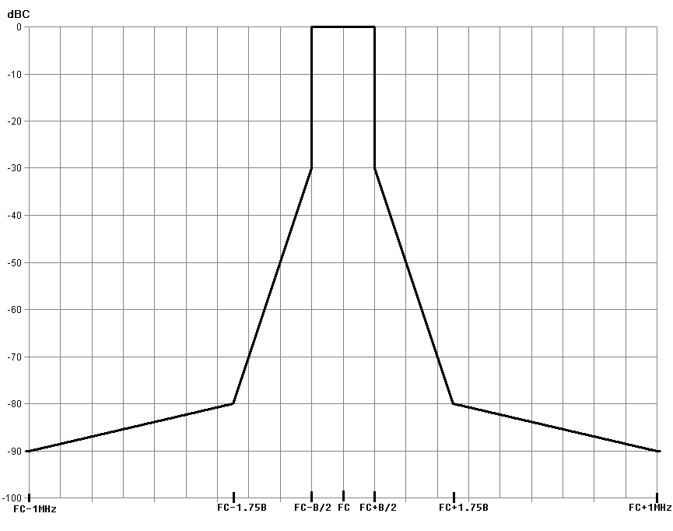

The –90 dBc point shall be ±1 MHz from *fc* measured with an average detector.

### 2.2.3 Channel bandwidth

Typical: < 200 kHz, but may be up to 600 kHz to support HD sound.

### 2.2.4 Frequency error

The frequency error shall not exceed 20 parts per million for frequencies below 1 GHz, 15 parts per million between 1 GHz and 2 GHz and 10 ppm above 2 GHz.

### 2.2.5 Spurious emissions limits at transceiver antenna port

TABLE 2

Spurious emission limits at transceiver antenna port

|  |  |  |  |
| --- | --- | --- | --- |
| State | Frequency | | |
|  | 47 MHz to 74 MHz  87.5 MHz to 137 MHz  174 MHz to 230 MHz  470 MHz to 862 MHz | Other Frequencies below 1 000 MHz | Frequencies above 1 000 MHz |
| Operation | 4 nW | 250 nW | 1 µW |
| StandBy | 2 nW | 2 nW | 20 nW |
| NOTE – Measured values for equipment in each frequency band must be below the values given in Table 2 above. | | | |

## 2.3 Technical aspects for receivers

### 2.3.1 Typical audio receiver characteristics

TABLE 3

Sensitivity for wireless microphones

|  |  |  |
| --- | --- | --- |
| Typical minimum sensitivity | –90 dBm | Depending on channel bandwidth and modulation technique |

### 2.3.2 Test arrangement and test procedure

A test procedure is described in order to place the sensitivity figures provided above into context.

The test configuration provided in Fig. 3 can be used to measure the receiver sensitivity.

Figure 3

Test configuration for receiver sensitivity

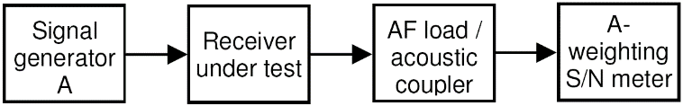

### 2.3.3 Test procedure

– Set signal generator A to receiver frequency (fc).

– Set signal generator A RF output level to –120 dBm.

– Set signal generator A to modulation FM, deviation +/–24 kHz, AF 1 000 Hz.

– Modify signal generator A RF output level until receiver S + N/N (noise and signal level divided by noise level) degrades to 80 dB(A).

NOTE − Alternative can be measured to a limit of 30 dB SINAD.

### 2.3.4 Receiver sensitivity limit

The typical receiver sensitivity must be below –90 dBm.

For miniaturized receivers and body worn receivers, a sensitivity of –85 dBm is applicable.

### 2.3.5 Sensitivity for IEM

TABLE 4

Sensitivity for IEM

|  |  |  |
| --- | --- | --- |
| Typical minimum sensitivity | –85 dBm | Depending on channel bandwidth and modulations technique |

### 2.3.6 Receiver spurious emissions at antenna port

TABLE 5

Limits for receiver spurious emissions

|  |  |
| --- | --- |
| Receivers and idle/standby transmitters | –57 dBm in 9 kHz to 1 GHz  –47 dBm above 1 GHz |

## 2.4 Propagation issues

In this section presents some information [10] to the typical transmission path from the transmitter to receiver units. Each scenario will be different, from a cluttered stage to a fast moving helicopter.

Figure 4

Body worn antenna radiation patterns

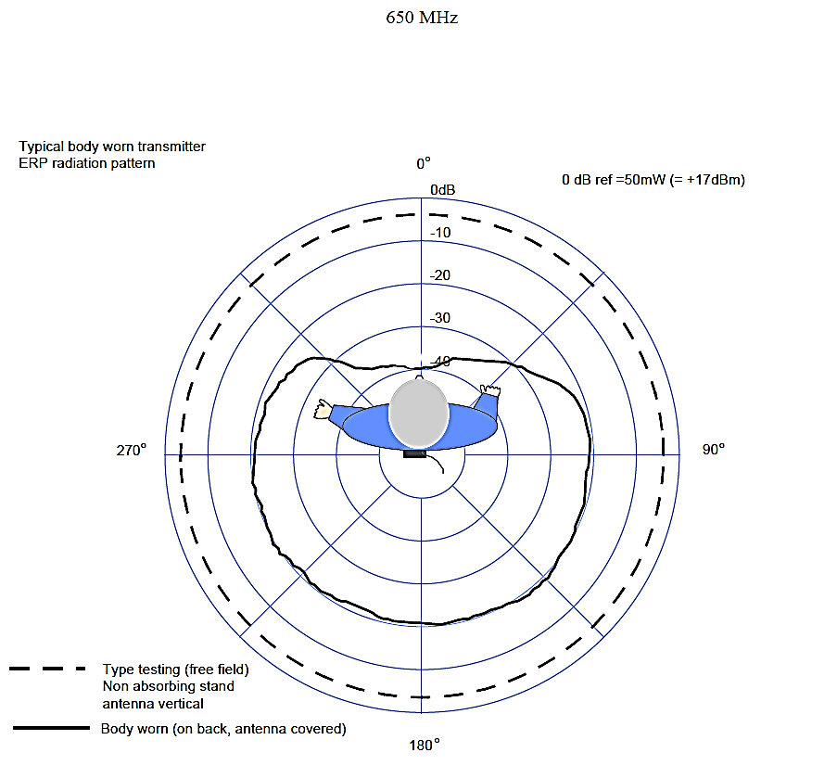

Figure 5

Hand held antenna radiation patterns

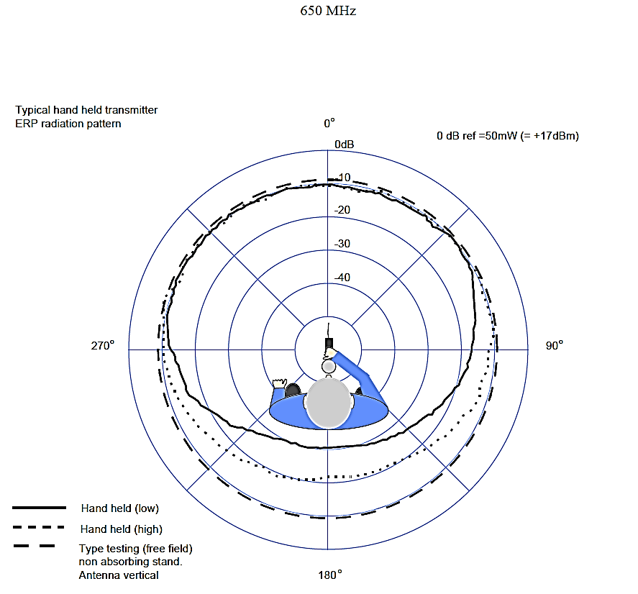

### 2.4.1 Transmission path loss: worst case scenario

Path loss for a radio microphone transmission is often interpreted as a simple line of sight scenario; however this is rarely the case as the figures below show:

Components of microphone transmission path can be described as:

• Microphone output power (e.r.p.) 17 dBm

• PLFS – Free space path loss 32.44+20*log10(D/1000)+20*log10(F)

• PLALD – Microphone antenna loss & detuning effect up to 15 dB

• PLB – Loss effected while carrying antenna on human body up to 25 dB

• PLN – Additional loss in the transmission path notches up to 30 dB

• PGDV – Gain by using antenna diversity techniques up to 7 dB

• PGA – Gain through receiver antenna typical 7 dB

The worst case in a typical non-diversity installation can described as

TotalLossWorstCaseND = PLFS + PLALD + PLB + PLN – PGA dB

### 2.4.2 Change in path loss using a diversity antenna system

Typical SAB/SAP antenna diversity systems use two antennae with the same characteristics that are physical separated (spatial diversity). In some configuration, the SAB/SAP combines pairs of antennas with orthogonal or circular polarizations. Because of the linear microphone polarization this should not be misinterpreted as polarization diversity.

The worst case in a typical installation by using diversity receiver antennas can described as:

TotalLossWorstCaseD = PLFS + PLALD + PLB + PLN – PGDV – PGA dB

Diversity receivers using two antennas and a signal switching system vary in their effectiveness depending on the spacing and type of antenna in use.

Figure 6

The complex situation on the transmission path if all parameter considered



NOTES:

– The red and blue lines represent the reception level at the antennas and the green line is the best-case signal provides by the diversity algorithm.

– The diversity cannot eliminate all path notches but can reduce their effect.

Deep fades are a major component in the use of radio microphone in any given location. Multi-path fading typically of up to 40 dB but extremes of up to 60 dB will be experienced.

### 2.4.3 Link budget

In addition to the path loss there are additional interference problems on a microphone path, which affects the system performance (e.g. Interference, manmade noise, antennas placed in actor costume or stage installations). For any production there may be a range of link budgets [11][12][13] dependant on the relative locations of the radio microphone user and the receive antenna.

Typical link budget calculation using a diversity antenna system

TABLE 6

Link budget

|  |  |  |  |  |  |  |
| --- | --- | --- | --- | --- | --- | --- |
| Input Parameter | |  |  | |  | |
| D – Distance | | 20 | m | |  | |
| F – Frequency | | 700 | MHz | |  | |
| RXCH – Microphone receiver channel bandwidth | | 140 | kHz | |  | |
| Pout – Microphone output power (e.r.p.) | | 17 | dBm | |  | |
| PLALD – Microphone antenna loss & detuning effect | | 15 | dB | |  | |
| PLB – Loss effected while carrying antenna on human body | | 25 | dB | |  | |
| PLN – Additional loss in the transmission path notches | | 30 | dB | |  | |
| PGDV – Gain by using antenna diversity techniques | | 7 | dB | |  | |
| PGA – Gain through receiver antenna | | 7 | dB | |  | |
| RNF – Receiver noise figure | | 8 | dB | |  | |
| RMINSNR – Receiver minimum SNR | | 20 | dB | |  | |
|  | |  |  | |  | |
| Constant Parameter |  | | |  | |  | |
| TNF – Thermal noise floor | 1 Hz bandwidth at 20 °C | | | –174 | | dBm | |
|  |  | | |  | |  | |
| Calculation |  | | |  | |  | |
| PLFS – Free space path loss using 0 dB dipole antennas | 32.44+20*log10(D/1000)+20*log10(F) | | | 55.4 | | dB | |
| TPF – Total path los | PLFS + PLALD + PLB + PLN - PGDV - PGA | | | 111.4 | | dB | |
| RTNF – Thermal noise floor at receiver channel bandwidth | at 20°C | | | –122.5 | | dBm | |
| TRF – Total receiver noise power | RTN + RNF | | | –114.5 | | dBm | |
| RMINRINP – Minimal needed receiver input signal | TRF + RMINSNR | | | –94.5 | | dBm | |
| RINPS – Receiver input signal | POUT – TPF | | | –94.4 | | dBm | |
|  |  | | |  | |  | |
| Link budget | RMINRIN - RINP | | | **0.2** | | **dB** | |

NOTES:

– A link budget greater than 0 shows the physical link feasibility in absence of interference.

– Any additional interference leads to a reduction in the practical link distance.

### 2.4.4 Short form presentation of signal level and path losses

TABLE 7

Link budget short form

|  |  |  |
| --- | --- | --- |
| Pout – Microphone output power (e.r.p.) | 17 | dBm |
| PLALD – Microphone antenna loss & detuning effect | –15 | dB |
| PLB – Loss effected while carrying antenna on human body | –25 | dB |
| PLN – Additional loss in the transmission path notches | –30 | dB |
| PGDV – Gain by using antenna diversity techniques | 7 | dB |
| PGA – Gain through receiver antenna | 7 | dB |
| RNF – Receiver noise figure | –8 | dB |
| RMINSNR – Receiver minimum SNR | –20 | dB |
| PLFS – Free space path loss using 0 dB dipole antennas  @ distance 20 m and 700 MHz | –55.4 | dB |
| RTNF – Thermal noise floor at receiver channel bandwidth | –122.4 | dBm |

## 2.5 Interference in to the audio receiver unit of a SAB/SAP system

### 2.5.1 Compatibility figures

#### 2.5.1.1 Minimal required *C*/*I* for microphone links in the presence of a wideband interferer

This lab test example shows a test LTE signal (2) and a SAB/SAP measuring signal (1) at a measurement bandwidth of 100 kHz. To ensure the minimum necessary production quality, the useful carrier to interference ratio (*C*/*I*) can be determined from the difference between the LTE (2) and SAB/SAP (1) signal strengths. Monitoring and control was achieved by means of a headset.

Figure 2 of Annex 5 shows the test scenario RF spectrum.

Figure 7

Required *C*/*I* in analogue systems

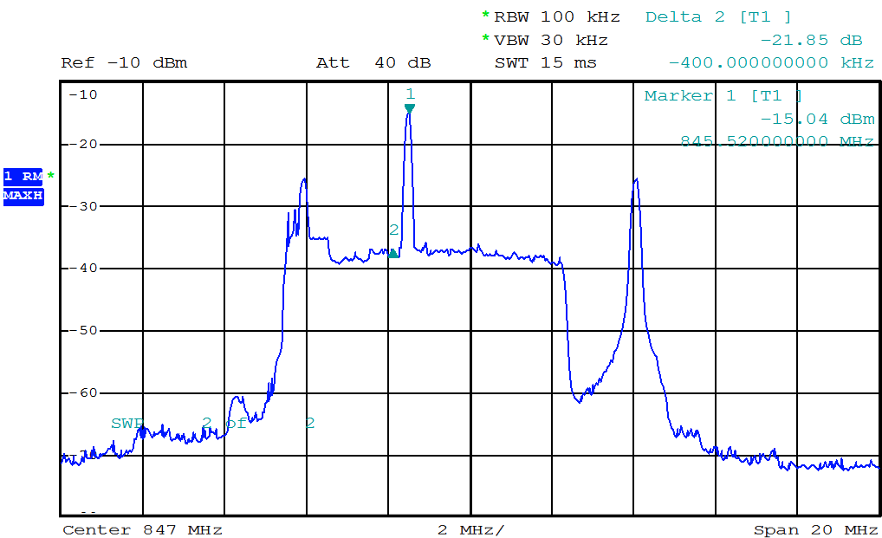

The 1 kHz audio test signal was interference free with a *C*/*I* value of ~ 22 dB. This confirms the initial hypothesis that a minimal *C*/*I* of 20 dB is needed for analogue microphone use.

#### 2.5.1.2 Wideband transmitter in adjacent spectrum

Figure 8

Six typical wireless microphone signals on receiver input

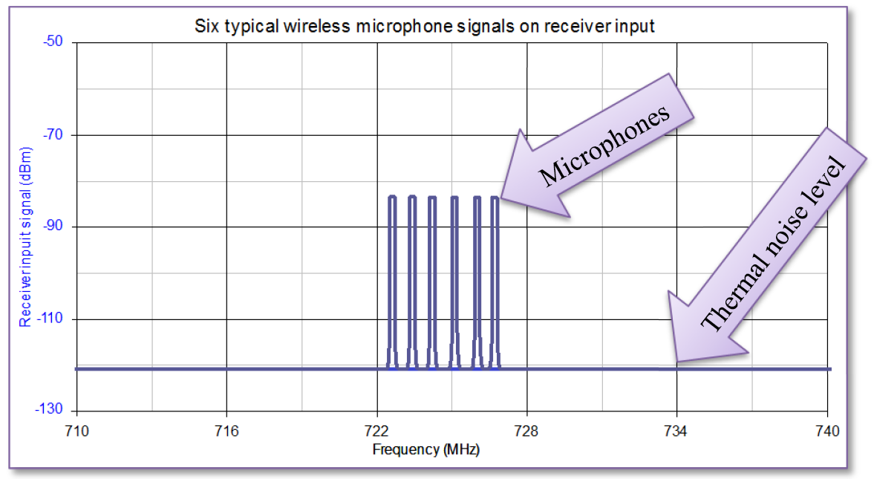

The SNR at receiver input is set according to the result of the link budget calculation.

Figure 9

Schematic illustration to show the principle of interference from a wideband interferer adjacent   
to the microphone channel



The adjacent channel transmitter noise will block all microphone links completely.

Figure 10

Schematic illustration to show the principle of interference from 2 wideband interferers adjacent   
to the microphone channel



All microphone channels are completely blocked.

NOTES:

– The signal quality of adjacent wideband transmitter defines the neighbouring risk to SAB/SAP.

– Possible blocking effects are not considered.

Figure 11

Schematic illustration to show the principle of interference from a wideband interferer adjacent to the microphone channel in a graphical format. Left) Interference free microphone scenario.   
Right) Interfered microphone links

 

NOTE − Each colour presents a different signal

## 2.6 A method to measure the radio microphone receiver C/I

### 2.6.1 Hardware test procedure

The test procedure is described in order to place in context the following sections on co-channel interference levels.

### 2.6.2 Definition

The microphone protection level can be described as the unwanted signal level which degrades the microphone receiver output audio (*S* + *N*)/*N* to 80 dB(A).

Figure 12

Test setup

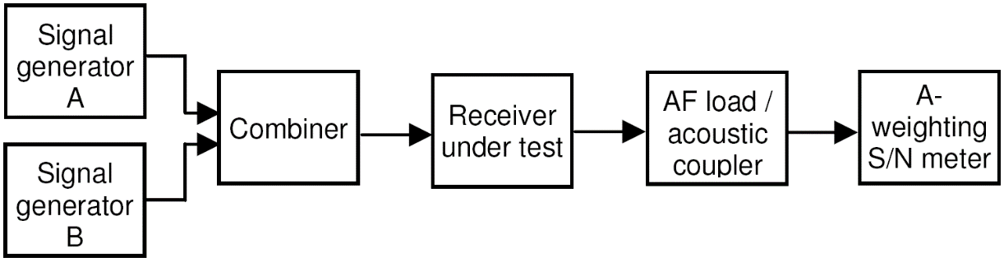

### 2.6.3 Test procedure:

– Set signal generator A to receiver frequency (fC).

– Set wanted signal generator A to the necessary modulation parameters   
(e.g. FM, Deviation +/–24 kHz, AF 1 000 Hz).

– Set signal generator A RF output level measured at microphone receiver input to –85 dBm.

– Set unwanted signal generator B on receiver frequency (fC).

– Set signal generator B RF on smallest output level (e.g. –130 dBm).

– Set signal generator B to Modulation FM, Deviation +/–24 kHz, AF 400 Hz.

– Modify signal generator B RF output level until receiver (*S* + *N*)/*N* degrades to 80 dB(A).

NOTE − If required due to the used analogue audio compander technique employed, the unwanted level can alternatively be measured on an audio quality limit of 30 dB SINAD.

– Record the generator B RF level measured at receiver input.

– Repeat the measuring on other interfering frequencies and record the generator B RF level measured at receiver input.

### 2.6.4 Results using the test procedure

#### **2.6.4.1 Analogue microphones**

Depending on the receiver construction, a co-channel interference level of less than –115 dBm will provide acceptable performance.

#### 2.6.4.2 Digital microphones

At present, systems which are available on the market differ in their behaviour substantially (also with respect to their designed behaviour), and it seems to be too early to make a definitive statement. From the few tested using spectrum efficient modulation, an unwanted interferer level of less than   
–115 dBm has been found to give acceptable performance.

#### 2.6.4.3 Derivation of interference level

a) Microphone reception quality threshold in operationThe minimal working field strength is   
–85 dBm. This level includes fading notches. With a 30 dB *C*/*I* a quality degradation of 1 dB appears.

b) Microphone receiver sensitivity  
The recent microphone receiver offers a high sensitivity. The typically RF squelch is set to –95 dBm. The minimum quality level with current equipment is given at –95 dBm with 20 dB *C*/*I*. Under these conditions a quality degradation of 3 dB appears.

Both examples calculate a maximum interference level of –115 dBm in 200 kHz channel. This can be transferred into a relative interference level of –168 dBm/Hz.

#### 2.6.4.4 Estimation of the interference level

Figure 13

Maximum interference level to microphone receiver

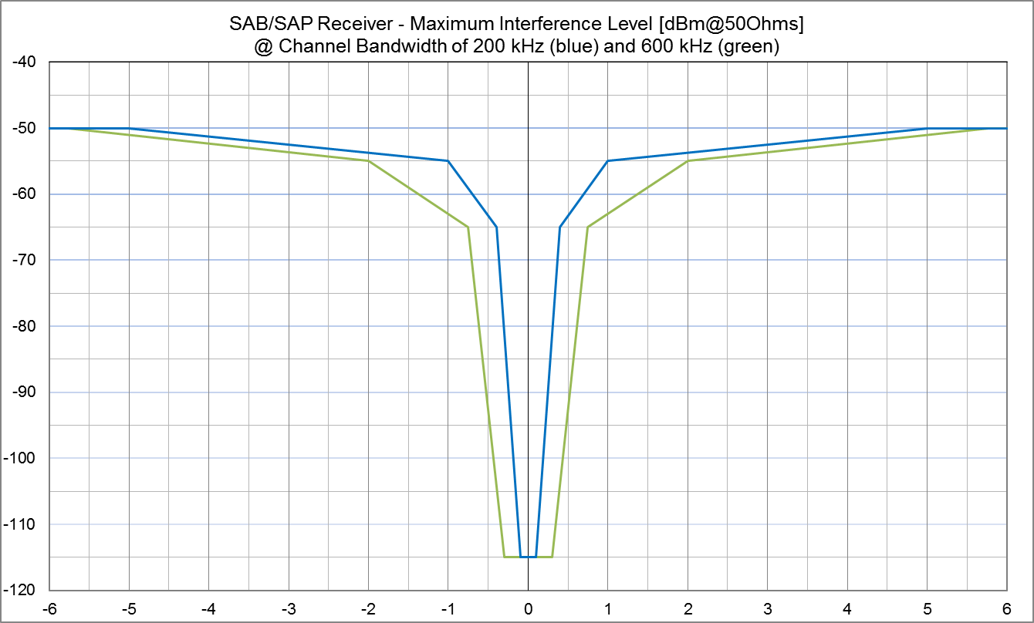

## 2.7 Intermodulation, reverse intermodulation, WSD and SAB/SAP

Wireless microphones and IEM are unusual in the radio world in that large numbers of transmitters (in excess of 80 at a large show); operate simultaneously for a number of hours and in very close proximity, in many cases within centimetres of each other.

It should be borne in mind that all wireless microphones and IEM’s will be switched on prior to the start of a performance and not switched off until the audio or recording system is shut down to prevent clicks and bangs being sent to the audio amplification or recording system.

### 2.7.1 Intermodulation

A detail description of the effects of intermodulation is in § 4.2.3.1 in the main part of the Report.

Manufacturers can control the contribution of intermodulation that each element of their equipment makes to a large extent and significant differences in performance exist between different brands and models of SAB/SAP equipment in respect of the levels of intermodulation produced and the levels of tolerance they have to intermodulation interference. However, since intermodulation can also occur elsewhere than within the radio microphone equipment it cannot be completely eliminated and therefore the best possible mitigation is to avoid the consequences of interference from any possible intermodulation wherever possible. Once an intermodulation product exists in the environment, regardless of how it originates, it is just another interference source and the effect that it will have on a receiver can be predicted to a large extent by reference to the *C*/*I* performance of the receiver.

The number of intermodulation products present rises exponentially as the number of carriers’ increases. Consequently the number of clean frequencies available within a given bandwidth declines rapidly as the number of carriers increases. The strength of the received signal from a radio microphone at the receiving antenna(s) varies widely as the transmitter moves around. Frequently the strength of the ‘wanted’ signal at the receiver will be less than that of one or more unwanted signals on adjacent frequencies, be they signals from other radio microphone transmitters which are in more favourable locations than the source of the ‘wanted’ signal, or intermodulation products.

In practice it is frequently the case that the wanted radio mix signal is one of the weakest at the receiving antennas since during many types of event at various times a single performer or group of performers may be on stage and therefore at a distance from the receiving antennas when the remainder of a shows cast are off stage and therefore their transmitters are closer to the receiving antennas.

Since intermodulation must exist at some point in all radiocommunications systems where there are multiple simultaneous transmissions many RF practitioners are often puzzled as to why it is such a major preoccupation for those involved in SAB/SAP. To understand this one needs an appreciation of the circumstances in which intermodulation becomes the problem. In the majority of communications systems either only voice quality (300-3 400 Hz) or data with check algorithms are in use. For SAB/SAP two major contributors are the wide audio bandwidth and wide audio dynamic range (or audio signal to noise ratio) of wireless microphones and IEMs. Wireless microphones typically have audio frequency responses ranging from 20 Hz up to 20 kHz and signal to noise ratios exceeding 100 dB. Consequently a low level heterodyne that might present no problem and even go completely unnoticed in other types of radio communications will be considered harmful interference in SAB/SAP applications (e.g. a 12.5 kHz heterodyne which demodulates as a whistle at –40 dB will not be apparent in a PMR system since it will be outside the audio frequency range and also close to the audio noise floor but it will be very obvious in a radio microphone system). Since wireless microphones are at the start of the audio production chain any interference at this point affects the entire downstream audience. Since in practice the likely sources of the signals which have combined to produce a particular intermodulation product will themselves be carrying modulation the intermodulation product will also carry a combination of the contributors modulation, more often than not this makes it even more audibly obtrusive. The ultimate audio output of an event, whether broadcast, recorded or live will frequently also be a combination of the audio output from more than one radio microphone summed together and so will contain the sum of any interference experienced by those wireless microphones.

The problems can be exacerbated in IEM systems by a number of factors. When operated in stereo mode – the default for live music performers – the demodulated bandwidth of the IEM receiver is necessarily considerably larger than for a mono radio microphone (or an IEM receiver operating in mono mode).

The operation of the multiplex stereo system using a 38 kHz sub carrier to carry the L-R difference information means that the receiver is susceptible to disturbance by interference that demodulates as baseband frequencies up to at least 53 kHz which are then rendered audible by the multiplex decoding process. In live music use the IEM receiver feeds high performance audio transducers inserted in to the ear canal of the artist’s ears, consequently the smallest disturbance is conducted directly to the performer’s ears which at the very least can be distracting for them and far more serious in the case of severe interference. Additionally IEM receivers are necessarily small battery powered devices and consequently are restricted in terms of antenna, space and energy resources which in turn can restrict their RF performance in comparison with what can be achieved by a top-of-the-range mains powered rack mounted radio microphone receiver. Until quite recently IEM receivers did not feature diversity reception, although newer models do now benefit from this technology.

### 2.7.2 Reverse intermodulation

The term reverse intermodulation describes the situation that occurs when RF enters the output of an RF amplifier such as the output stage of a transmitter where other signals are received via the transmitting antenna. Since the output is not designed to deal with signals being presented in this way mixing occurs between the ‘received’ signals and also the signal that the amplifier is amplifying. In general the more linear the amplifier the less reverse intermodulation will occur, up to a point. If the ‘received’ signals are sufficiently large then overload will occur. In a small battery powered device designed to output only a few tens of milliwatts this is quite a realistic proposition in the presence of higher powered transmitting devices particularly if they are operating in or near the same frequency band.

### 2.7.3 Mitigation techniques

In permanent base station installations there are a number of standard practice techniques that are commonly used which reduce intermodulation between multiple co-sited transmitters. A transmitter which is going to operate long term on a single frequency can have output filters, either internally or applied separately as part of the installation, these filters may be multi pole and have a high Q and these can contribute considerably to the reverse intermodulation performance. Ferrite isolators or circulators commonly used to combine transmitter outputs or to protect transmitters against antenna damage also produce dramatic improvements in reverse intermodulation performance at base station sites. Even antenna feeder cable loss has a beneficial effect in reducing the generation of reverse intermodulation products since it attenuates both the ‘received’ contributors travelling from the antenna to the transmitter output and also the resulting intermodulation products on their way back to the antenna.

Unfortunately most of these techniques are not suitable for small portable battery powered devices with a wide tuning range such as wireless microphones. Each contributes weight, size, reduced efficiency or a combination of all three. Highly selective filters band pass filters in radio microphone transmitter output stages were once common in high end professional devices when they operated on a single crystal controlled frequency (>20 years ago). The need for more frequency agile devices with wider tuning ranges means that modern equipment has to take a different approach with wider pass band filtering and linear output amplifiers instead. Miniature ferrite isolators do exist but have limited bandwidth thus limiting the tuning range of any equipment in to which they are incorporated and they also add size and weight which are both undesirable. A simple attenuator between the transmitter output and the antenna can deliver reverse intermodulation performance improvements without imposing significant weight or size penalties, but the effect on efficiency and therefore battery life are readily apparent and therefore not necessarily desirable.

### 2.7.4 Frequency planning

Since ultimately intermodulation cannot be completely prevented or controlled, the solution adopted by the SAB/SAP industry is to plan frequency usage so as to avoid the predictable consequences of interference which would result from intermodulation as far as is reasonably possible.

If a number of carriers are evenly spaced in frequency then mutual interference due to intermodulation can be predicted. If just three carriers are each spaced evenly then two of the three carriers will be vulnerable to interference from 3rd order two tone intermodulation products.

For ten, evenly spaced, carriers the number of two tone 3rd order products which will occur directly on the carrier frequencies is forty, evenly distributed at four per carrier frequency. If we start to look at higher order intermodulation products and higher numbers of tones, although the products will individually be predictably smaller in signal strength, they will be more numerous in quantity and the cumulative effect cannot be ignored in systems with multiple transmitters. So far we have only considered the carrier frequency and assumed zero bandwidth. Once we enter the real world then we have to consider the situation where any intermodulation products which occur within the receiver channel bandwidth can also be a source of interference. How far in frequency from the carrier frequency an intermodulation product can be before it can be ignored is a major differentiator between different brands and models of SAB/SAP equipment. For many events and locations where SAB/SAP equipment is present there may be a mixture of makes and models of equipment in use which further complicates the frequency planning. In a multiple channel system using frequency spacing which is equal to the channel spacing plus a fraction of channel spacing will still result in intermodulation products which are within the channel bandwidth. As a simple rule of thumb the spacing between any two frequencies in a system must be different to that between any other pair of frequencies.

### 2.7.5 Intermodulation products vs. required bandwidth

If the frequencies of the transmitters are equally spaced within a given bandwidth, virtually the required bandwidth for the transmitter setup is low, but the RF noise generated through the intermodulation products in the vicinity of the carriers increases significantly and makes the RF channels adjacent to the Tx carriers unusable.

Figure 14

Generated intermodulation products for 8 equally spaced transmitter carriers

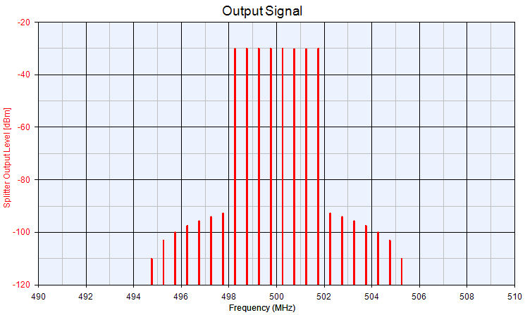

In real world situations, the maximum number of IM free channels will depend on the quality of the links as well as the equipment use. The following figure illustrates the behaviour of one typical system.

Figure 15

Required spectrum vs. number of channels in intermodulation free operation

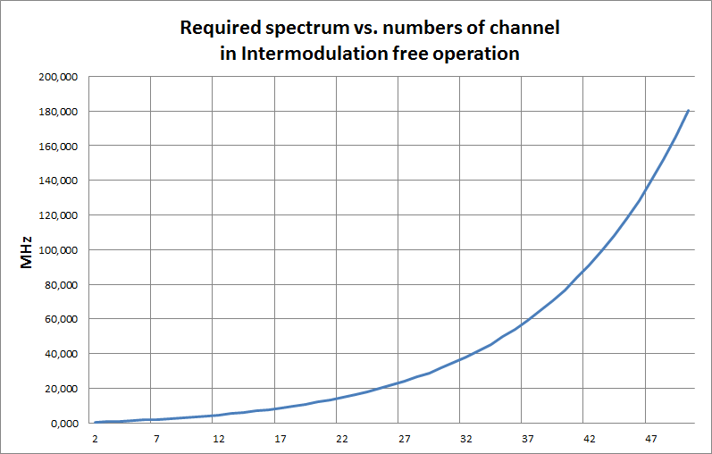

For co-located and coordinated systems, it will be possible to increase the number of links as shown in the following table.

TABLE 8

| Total number of channels | Wireless microphones | IEM | TV channels  needs to be  interference free | TV channels x 8 MHz needs to be  interference free |
| --- | --- | --- | --- | --- |
| 12 | 12 | – | 1 | 8 MHz |
| 12 | 10 | 2 | 2 | 16 MHz |
| 32 | 32 | – | 5 | 40 MHz |
| 42 | 42 | – | 7 | 56 MHz |
| 42 | 32 | 10 | 9 | 72 MHz |
| 53 | 53 | – | 9 | 72 MHz |
| 62 | 62 | – | 11 | 88 MHz |
| 62 | 52 | 10 | 13 | 104 MHz |
| 85 | 85 | – | 15 | 120 MHz |
| 98 | 98 | – | 18 | 144 MHz |
| NOTE – Frequency spectrum is one package, e.g. 11 channels = 470-558 MHz. | | | | |

### 2.7.6 Example of audio SAB/SAP in typical urban environment

This section considers the number of SAB/SAP links, which can be operated in parallel in the 470‑790 MHz band in an urban environment in best case.

The following figure provides an overview of a typical urban scenario of facilities that are using audio SAB/SAP:

Figure 16

Urban scenario of facilities using audio SAB/SAP

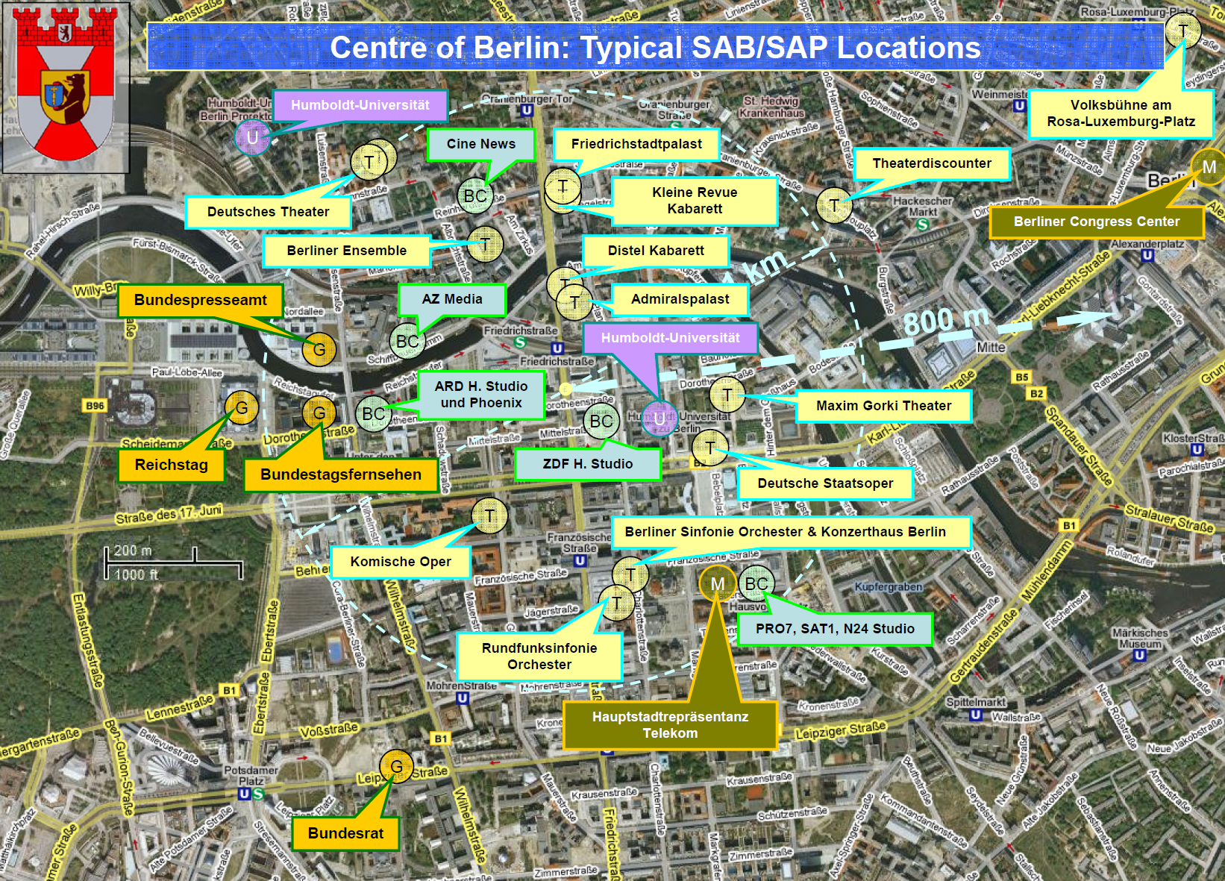

Any production has to be free of interference in order to meet the QoS expected by the listeners. One source of interference is caused by intermodulation which is generated in any wireless system when it operates in close proximity of other systems. As intermodulation can be calculated the system design takes care of the effect and uses only reliable frequencies which guarantee no unwanted noise in the audio signal.

The following graph shows a typical arrangement of carriers in a multichannel system of wireless microphones operated in three UHF TV channel (24 MHz):

Figure 17

Typical arrangement of carriers in a multichannel system of wireless microphones

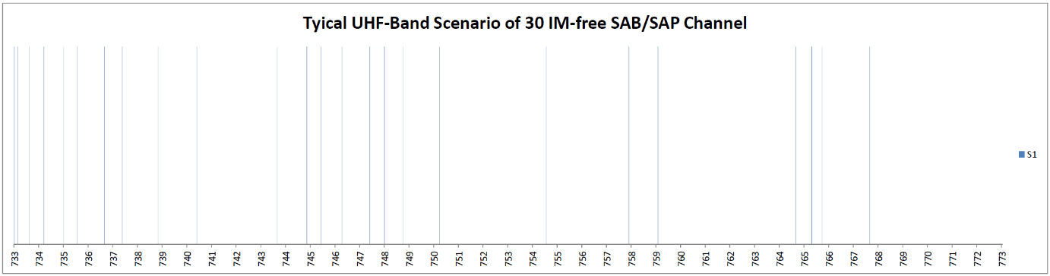

It can be seen that thirty carriers of this system are arranged in non-regular spacing.

A venue usually consists of different locations in which different events take place in parallel: in a conference centre there are different halls and rooms with different events using wireless equipment. The same situation will occur in hotels with their meeting facilities, in universities with their lecture halls, in entertainment centres with their various stages, also in exhibition halls with the booths of the exhibitors last not least at political and sport events where several ENG Teams operate in parallel in different areas.

All these events in one venue have one thing in common: they are separated by walls of by a certain distance. Separation by room, house walls or ceilings usually gives a signal attenuation of more than 15 dB in addition to the free space path loss (e.g. shielding by walls or urban installations). Taking this into account the intermodulation of the system shown above will be very low in the neighbour room or neighbour venue. This allows taking the same set of frequencies for the neighbour venue, but shifting all the frequencies by the same amount. Optimising this process will show than much more SAB/SAP can operate in parallel:

Figure 18

Scenario of SAB/SAP channel in moderately shielded locations

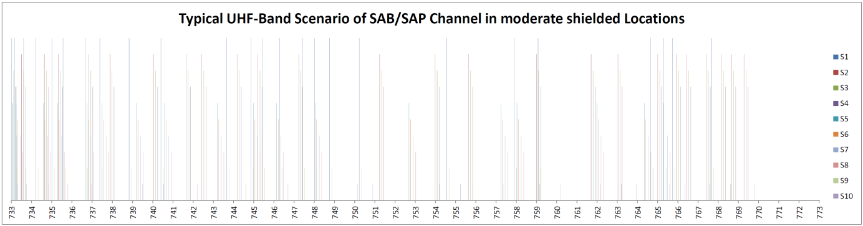

As shown in the graph above these locations are named S1, S2, and S3 etc. The colours assigned to these locations can be found in the graph that shows the used frequencies from left to right. By shifting the frequencies to higher ones there will come the point where one of these frequencies exceeds the upper limit of the three UHF TV channel. These frequencies have to be left out.

This is the reason why the 10 different venues shown on the right of the graph have a different set of frequencies for the use in that location: some venues have more, some fewer frequencies.

The carriers in the graph have different levels. The one with the highest level is the venue which is the reference, from which one can look to the signals of the neighbour venues. The difference in level of the other locations indicates the attenuation the signals experience on the way to the reference location.

Each of the venues on its own have intermodulation free frequencies, but there is a risk of interference if the wanted carrier falls below the intermodulation frequency level of one of the venues. This can only happen if one of the wireless microphones leaves its venue. For high quality productions there is no alternative than intermodulation free arrangement of a set of frequencies as shown in the first graph.

It has to be mentioned that this scenario as described above will work outdoors only if the distances between the venues delivers a signal attenuation of more than 15 dB in addition to the path loss.

The system as described above is proven by practical application in everyday operation – for the venues as named above. This is usually done by the professional frequency coordinator who takes all the important parameters into account.

It needs to be mentioned that the use of SAB/SAP with extended bandwidth, 400 kHz or 600 kHz, will reduce the maximum number of wireless links that can be used in one venue and a mixed scenario.

SAB/SAP manufactures have software tools available that can be used to calculate the number of intermodulation free channels in a given bandwidth. In these software tools, algorithms similar to the one described above are implemented.

If operation conditions cannot be considered ideal, the maximum number of available IM free channels will be lower.

A number of distinct separated spectrum blocks will give a higher number of available IM free channels than one large continuous frequency range.

### 2.7.7 Multi-venue sites

At sites where multiple venues are clustered together such as TV studio complexes, conference centres, and theatre complexes it is important to consider the effect that events in one area of the complex may have on another. Wireless microphones are portable transmitters which may travel around a venue (or beyond) outside the coverage of their receivers such as when an actor returns to the dressing room between scenes or a conference speaker leaves the room between presentations. The dressing room or the route to it may be adjacent to another studio, the conference centre bar maybe adjacent to another conference room. Taking the frequency planning for each venue on site solely in isolation exposes the receivers in each venue to the danger of intermodulation created by the proximity of a transmitter (or transmitters) from another area coming within range of the receivers. Careful planning can and does eliminate these risks allowing unhindered mobility of event participants and their wireless microphones. Similar risks exist where IEMs are used in multiple adjacent venues, but since in this case the transmitters are usually fixed in their location the situation is more controlled.

Conversely sites such as schools and universities which may have as many as forty or fifty wireless microphones distributed around a single campus need not be completely ‘intermodulation free’ allowing greater apparent spectral efficiency. Typically such institutions will have only a number of locations within them that have any concentrations of wireless microphones, such as one or two individual lecture theatres with maybe six or eight wireless microphones each. The balance of the systems will be distributed around the site in ones or twos. So long as those systems which are used together or are adjacent to each other are intermodulation free then usually all will be well since the transmitters will normally remain in or around the areas where their receivers are located.

In all of the above however the common factor is that the distribution and use of SAB/SAP radio frequencies in and around a site is known and the ‘worst case’ scenario of everything being in use at once can be assessed, calculated and allowed for.

### 2.7.8 Digital SAB/SAP

Whereas the effects of intermodulation or any form of interference may become apparent and a nuisance to analogue SAB/SAP services at even relatively low levels the onset may be gradual and the noticeable degradation in performance as levels of interference increases gives some warning of impending problems. Low levels of interference under certain circumstances such as in location news gathering may be deemed acceptable even when noticed if the alternative is no sound at all.

By comparison low levels of radio interference may not be evident in the audio output of a digital radio microphone until the *C*/*I* ratio degrades up to or very near the point at which the audio output is suddenly lost or corrupted beyond recognition; *in short, digital systems do not* fail *gracefully*. Far from being completely immune to intermodulation issues, as with most analogue or digital dilemmas, the choice is between managing the quantifiable audible intrusion of increasing interference or catastrophic loss of audio with little or no warning. Both will suffer interference as a result of intermodulation in some way. Different digital modulation schemes used by different manufacturers exhibit different levels of tolerance to interference as do different hardware architectures meaning that there is just as much variation in the effects of intermodulation in different digital systems as in different analogue systems overall.

### 2.7.9 White space devices (WSD) and SAB/SAP

White space devices (WSDs) operating within the 470-790 MHz band might have some impact on the availability of spectrum for SAB/SAP. If the operation of the WSDs is controlled by a database, the channels needed for use by SAB/SAP in a particular location can be added to the database, which would give the SAB/SAP usage priority over WSDs and remove the risk of co- or adjacent channel interference. There may still be some possibility of intermodulation occurring, if the WSD transmits within the RF operating bandwidth of the SAB/SAP device and in proximity to the SAB/SAP equipment.

## 2.8 Benefit of digital audio SAB/SAP: Possibility to adapt the characteristics to application requirements

Digital transmission chains provide significant latitude to select the appropriate audio signal quality, but also provides full freedom to select appropriate trade-offs between the following system’s characteristics:

– transmitted acoustic signal quality;

– robustness to interference and channel fading;

– required received signal strength;

– required transmitted RF power;

– spectrum efficiency.

It should be stressed that by trade-offs, it is understood that digital transmission does not allow to improve all of these characteristics at the same time, but on the contrary to adapt the transmission characteristic to a specific application by sacrificing some factors in order to improve others.

A very simple example is provided thereafter: systems can be made robust to interference through sacrifices on the achievable audio quality.

### 2.8.1 Technology limitations of digital audio SAB/SAP

Generally speaking, a digital transmission chain introduces latency compared to a similar analogue transmission chain. Latency and co-channel protection requirements may restrict the applicability of digital transmission chain for the most latency sensitive audio SAB/SAP application, most noticeably live performances involving in ear monitors.

### 2.8.2 Information on active antenna distribution systems

Many use scenarios will require additional components in the path from transmitter output to receiver input that affect the interference scenario.

#### 2.8.2.1 Receiver distribution system

In a simple environment, each receiver has its own antenna. A large production would therefore require 50 or more antennas, which is impractical. Therefore, the professional event uses antenna distribution systems. The signal of a single receiving antenna are split into many receiver paths, this unamplified antenna power division results in additional losses from antenna to receiver port. An antenna amplifier can compensate for this signal loss but the antenna amplifier is a nonlinear and broadband device. Nonlinearity in combination with high-bandwidth (e.g. 24 to 100 MHz) degrades the desired receiver performance. The receiver is affected by interference from the intermodulation generated within the amplifier.

Additional filters are used to provide protection from other radio signals.

#### 2.8.2.2 Transmitter distribution system

IEMs use a fixed transmitter mounted in 19” racks, and it is impractical to use individual antenna in a large system. The transmitter outputs are combined to a common antenna path. The power losses are compensated by the use of an amplifier. Non-linearity in combination with high bandwidth degrades the desired transceiver performance. Additional filters are used to provide protection to other radio application outside the microphone band.

An active antenna distribution system is a complex scenario, which is designed on an individual site basis.

## 2.9 Discussion and summary of the properties of the new technologies

The performance of audio SAB/SAP can be characterised by the following parameters:

– acoustic signal quality/audio quality;

– spectrum efficiency;

– system adaptability;

– range/ required TX power/required RX signal strength;

– robustness to interference;

– latency.

These parameters are in direct relation and interact with each other, they are not independent from each other and the variation of one element usually affects others. In general, the parameters cannot be varied independently from each other.

In the following diagrams, the performance of the described technologies is illustrated by using the 6 parameters as defined above. As a graphic representation, the 6 parameters were arranged in a coordinate plane. When arranged in this coordinate plane the parameters spread an envelope in this plane: “the envelope of possibilities”.

Depending on the discussed technology, some of the parameters are fixed and others can be adjusted. As a result from these dependencies the shape of the resulting envelope varies for each introduced technology. The resulting envelopes in the coordinate plane help understanding the differences of the discussed technologies and support a comparison of them with regard to the introduced parameters.

For analogue systems the shape of the envelope is fixed. For cognitive and digital systems, the corners of the envelope representing the above described parameters can be varied.

General notes for the interpretation of the diagrams:

– To make the different quantities of the parameters comparable, the axes of the diagram do not show the physical quantities of the parameters themselves but an abstract utility of them which is proportional to the suitability for the user of the system, e.g. the lower the latency of the system the higher the utility of this parameter. Using this approach, for the utility of each parameter (as used in the diagrams) the simple interpretation ‘the higher the better’ holds true.

– The higher the utility of a parameter, the further it is away from the origin of the coordinate plane. Light green and dark green colour is used, to compare different sets of feasible parameters for a given technology / system setup in the respective graphs.

### 2.9.1 Analogue systems

The current analogue systems operate with comparatively fixed parameters and characteristics that were tailored to the requirements of the users for typical usage scenarios. Analogue audio SAB/SAP systems deliver extremely low latency and very good acoustic signal quality. Analogue systems are susceptible to interference and have a fixed operating range, beyond that range the system performance will start to decrease. Due to performance reasons the adaptability to selecting the frequency of operation is limited.

Figure 19

Analogue SAB/SAP

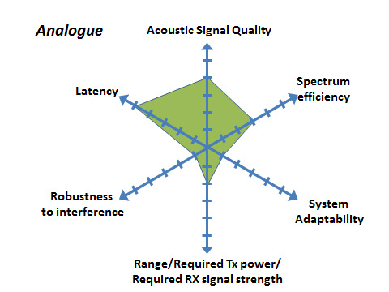

### 2.9.2 Cognitive systems with analogue audio SAB/SAP: Envelope of possibilities

In principal, cognitive audio SAB/SAP systems are not limited to a specific technology and the concept can be implemented either by analogue or digital links for the transmission of the audio signal. In the following, as an extension to current analogue devices, the focus is on systems with an analogue audio link whose parameters can be adjusted and modified through a cognitive control plane taking into account the required performance criteria as pre-selected by the user. The system can therefore modify some of the characteristics of the analogue audio link within the present parameters and is hence to some extent capable of adapting to changing conditions of the environment. However, as mentioned before, there is a trade-off between the parameters. For example, a very high spectral efficiency may correspond to a lower acoustic signal quality. On the other hand, if high acoustic signal quality is favoured this may lead to compromises with regard to robustness to interference and/or spectral efficiency.

Therefore, a cognitive audio SAB/SAP system is not defined by a fixed performance level, but would adapt its performance level with regard to various criteria depending on the requirement of the specific situation. Once the required performance level is set by the user, the system will work within this limitation In that sense, this kind of cognitive SAB/SAP systems is more adaptable than a conventional analogue SAB/SAP system.

Figure 20

Cognitive SAB/SAP envelope of possibilities

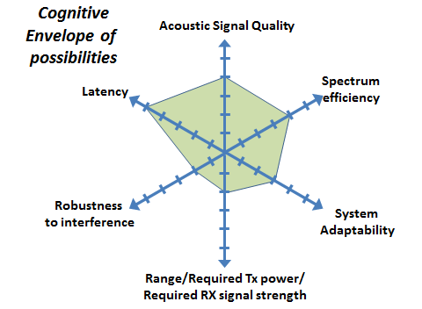

### 2.9.3 Cognitive systems Example 1

In this example, the user of the cognitive system accepts to sacrifice some robustness to interference but no compromise on the other parameters i.e. requiring maximum audio quality. This may be the case in a very controlled RF environment where a maximum number of microphones is required, while maintaining a very good audio quality.

Figure 21

Cognitive SAB/SAP – Example 1

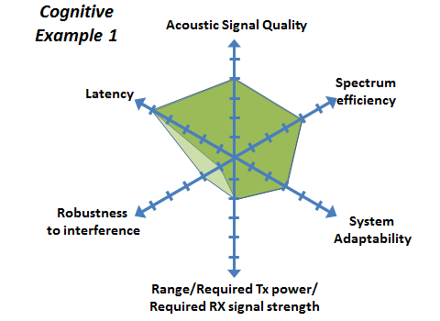

### 2.9.4 Cognitive systems: Example 2 – System providing high acoustic quality

In this example, the user of the cognitive audio SAB/SAP system would require that microphones to transmit at maximum power in order to be certain to maintain audio quality, even in case of interference.

Figure 22

Cognitive SAB/SAP – Example 2

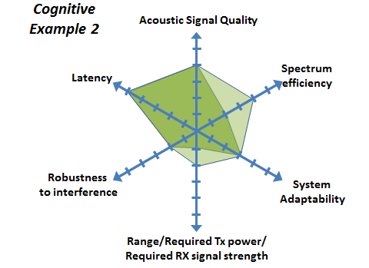

### 2.9.5 Digital systems: Envelope of possibilities

Digital audio SAB/SAP systems provide a large envelope of possibilities as various elements of the technology available in the digital communication field can be reapplied to this specific use case.

If an appropriate channel coding is applied. Digital systems are capable of correcting, to some extent, errors of the audio signal caused by added noise on the channel or by interference from other systems. This cannot be achieved by analogue systems. Thus, for digital systems the resolution of the audio signal mainly depends on the quality of the microphone itself and the resolution of the analogue to digital conversion resulting in the possibility of a very high audio quality. However, this attractive feature comes at the price of an increased latency introduced by the additional signal processing steps. Moreover, a high bandwidth is required to transmit an audio signal with a high audio resolution. By using source coding techniques the necessary bandwidth can be significantly reduced and to some extent adjusted at the price of a decreased audio quality and an additional increase of latency.

Therefore, as a compromise, low latency digital SAB/SAP systems may use tailored low latency codecs with modest coding and compression rates that accept a higher RF channel bandwidth and a higher susceptibility to interference.

If the rest of the audio chain is analogue, the received and processed digital signal must again be converted into an analogue signal resulting in additional delay. The total delay can be too high for some application scenarios in particular if in ear monitoring is used (e.g. at live performance events), as the signal from the performer must loop through the mixing console and back to the performer fast enough so that the performer does not notice the delay. In the ideal case of a completely digital audio chain these conditions are more relaxed as the additional conversion is omitted.

However, the overall delay depends on all elements of the audio chain which are potentially provided by different manufacturers hence cannot be arbitrarily controlled by the single component manufacturer.

The illustrative envelope of possibilities of digital SAB/SAP systems is provided below.

Figure 23

Digital SAB/SAP – Envelope of possibilities

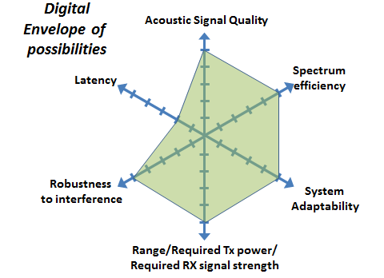

### 2.9.6 Digital systems – Example 1: High capacity system

In this example, the user of the digital audio SAB/SAP system selects a sound encoding scheme with a high compression rate, combined with a very robust channel coding scheme. In such a case, the transmission of the system can be very robust to interference and can achieve a very large range and carry a large number of audio channels in a given bandwidth. On the other hand, such a system would suffer from latency and reduced acoustic signal quality.

Figure 24

Digital SAB/SAP – High capacity system

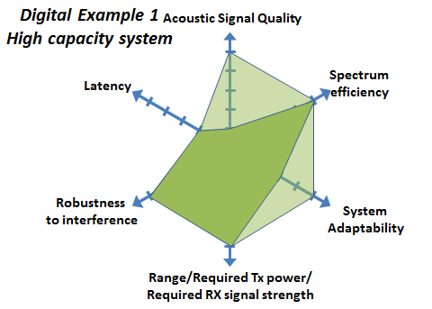

### 2.9.7 Digital systems – Example 2: System providing high voice quality

In this example, the digital systems uses a very high quality sound encoding scheme (high sampling frequency, little or no compression) together with a robust channel coding scheme. This results in large data rate on the audio link, requiring a higher order modulation scheme resulting in a higher required RF bandwidth The system does therefore support a lower number of audio channels for a given bandwidth.

Figure 25

Digital SAB/SAP – High capacity system

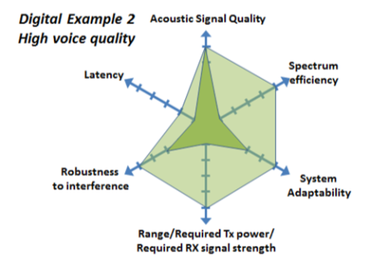

Annex 3  
  
Study on the influence of OoB emission   
of an IMT duplex gap

There has been the expectation that digital systems are more robust against interference than analogue ones. A measurement campaign conducted at IRT in Munich in June 2013 has revealed that typical analogue and digital wireless microphones start to degrade at about the same signal to interference and noise ratio (SINR).

On the right a typical test setup comprising a laptop with a built in 700 MHz LTE Modem can be seen. The interferer in this scenario was a LTE UE transmitting with the maximum power of +23 dBm. It was connected to the SAB/SAP receiver (PMSE receiver) by cable and decoupled by 47 dB.

Figure 1

LTE signal and the duplex gap position

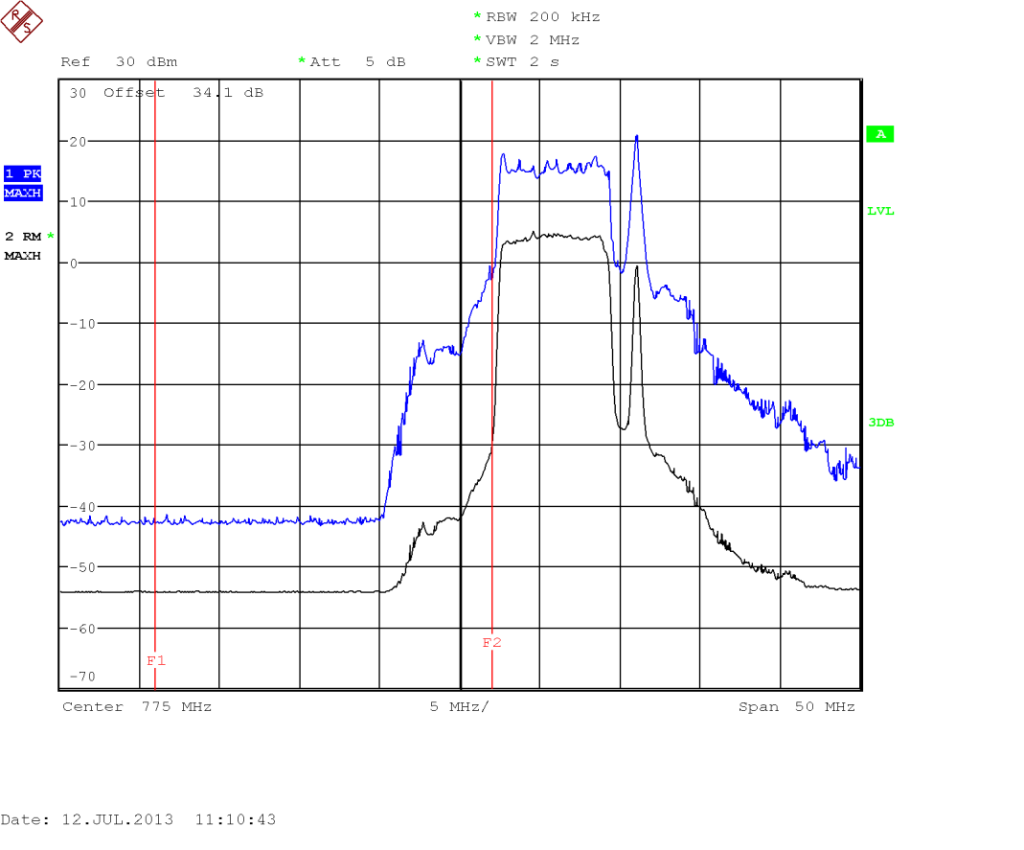

Test result

The following figures present the effect of unwanted emissions by a LTE UE to a PMSE receiver operated in the LTE Band 13 duplex gap:

Figure 2

Analogue SAB/SAP link affected by unwanted emission form a LTE UE

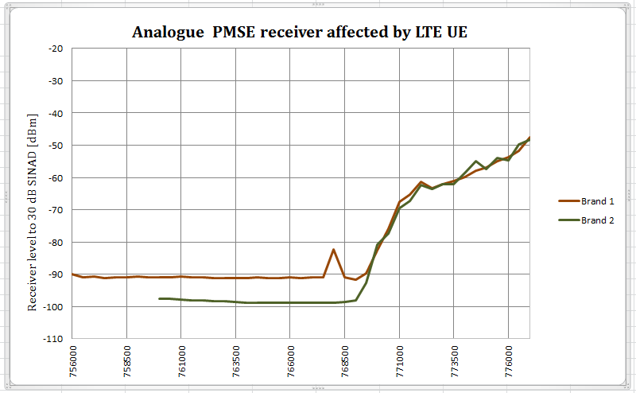

Figure 3

Digital SAB/SAP link affected by unwanted emissions from a LTE UE

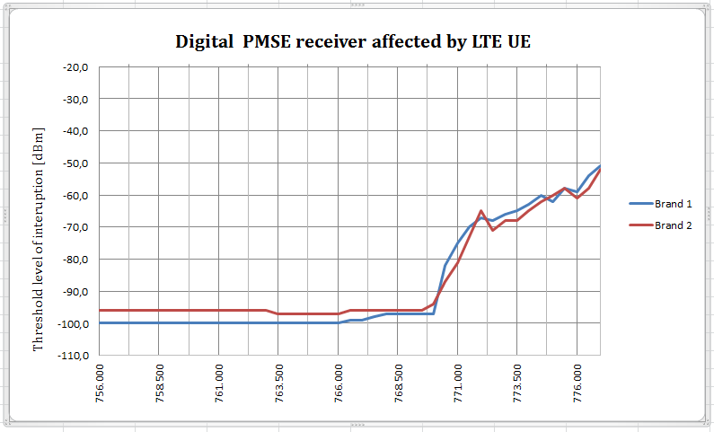

Findings

– the thresholds where both, the digital PMSE and the analogue FM PMSE links, start to degrade are at about the same order of SINR;

– audio PMSE must be operated in interference-free spectrum, i.e. interferer level less than –115 dBm in 200 kHz channel bandwidth.

Digital PMSE devices are using low-complexity or no error correction. High-complexity error correction should improve the robustness to disturbing signals but currently it is not possible to use improved error correction because the delay of digital systems would increase significantly. That is why both systems, the analogue ones and the digital ones, behave similar in the presence of interference.

Annex 4  
  
SAB/SAP spectrum requirements

## 4.1 General demand considerations

In assessing the spectrum requirement for SAB/SAP, it is important to consider that the normal regular demand for spectrum should be distinguished from the “peak demand”. “Peak demand” may be temporary or geographically limited (see CEPT Report 32 [5]).

The geographical peaks correspond to long term use within fixed sites in certain geographical areas (e.g. large urban conglomerations) where there is always a continuous heavy demand (typically multi-equipment, multi-channel users), thus most of the available SAB/SAP spectrum is needed to satisfy this demand. Every country has these in a number of locations.

The temporary peaks correspond to special events of a short term nature (big concerts, festivals etc.). When temporary events are staged at existing geographical peak locations they result in complex spectrum demand requiring detailed intervention by a band manager or the administration, as this results in a “double overload”. Spectrum planning using all available technics including building attenuation between outdoor and indoor us along with geographical shielding and borrowing spectrum must then be employed.

It should be noted that peak demand most often comes from professional users (e.g. broadcasters). Additional details are given in CEPT Report 32 Annexes 3 and 4 (see [5]). Demand for theatres and rock and pop and touring shows.

Theatres, concert venues and other auditoria of all sizes, both for amateur and professional use, they all use wireless microphones and to a lesser extent, in-ear monitoring systems, talkback and cordless cameras. Applications include drama, musical theatre, rock concerts, corporate events and amateur uses (for example for drama, concerts and shows, and in places of worship).

Spectrum demand is heaviest for large-scale, professional productions, and for touring musicals and rock concerts, and it is these areas on which the following discussion concentrates. Typically, this kind of usage will be most prominent in the locations with highest density of professional theatres, e.g. the West End in London, United Kingdom which covers some 2 square miles of central London (see Table 1 below).

Analysis of typical requirements for the touring shows, e.g. rock and pop concerts, suggests that for such touring productions channel demand may be in the order of 20-60 channels. One particular example considered in detail showed, that radiomicrophones used by performers would take around 25% of the channels, while the rest would be divided almost equally by in-ear monitors and instrument (brass, strings, guitar etc.) pick-ups.

Rock and Pop shows will use a similar infrastructure to the largest musical theatre and the maximum figures shown below can be used as representative of this genre.

TABLE 1

London West End (31 Theaters)

|  | Radio microphone | IEM |
| --- | --- | --- |
| Total | 940 | 48 |
| Average | 31 | 1.5 |
| Maximum | 64 | 10 |

## 4.2 Demand for different kinds of broadcasting applications

Broadcasting involves into a broad range of applications where all forms of SAB/SAP equipment are used.

### 4.2.1 Studio production

Studio production is covered in § 5.1.2 of the main body of the Report.

### 4.2.2 Demand for news gathering for TV/radio/Internet

Radio microphones and equipment integral to cameras including talkback systems will be present at any site. TV news providers use radio links in order to provide rapid response coverage of developing news stories. Therefore video links as well as talkback and wireless microphones are used in the production of live and recorded news reports ‘from the scene’.

Terrestrial radio links, known under the term of ENG, consist of one or more microwave links that feed video and audio signals directly from the news location to a broadcaster’s network or studio. ENG links are only one of a number of options used to transfer live or recorded material from location to the studio or network, others including:

– SNG (satellite news gathering) refers to the use of satellite links to achieve the same thing;

– fibre optic links can be used where a location has a fibre termination;

– store-and-forward over public telecommunications lines can be used for non-live inserts;

– similarly non-live inserts can be recorded digitally and carried by motorbike or otherwise to the studio.

Each ENG operator (news provider) requires its own exclusive spectrum, for which it requires round-the-clock access over the designated area; there is no scope for event by event co-ordination as the time taken to respond to a news event is too small.

ENG operators normally operate a number of trucks, which can be quickly despatched to a location where a news event is taking place. The truck contains all the facilities required to cover the story and transmit the signal back to the studio or network for (where necessary or appropriate) further production, editing and/or transmission.

It is estimated that altogether, ENG operators providing news coverage in major conurbations with a high density of news events (typically capital and other big cities, like London, Paris etc.) may require allocation on a city wide basis of up to:

– 25-50 talkback narrowband channels;

– 15-30 channels for wireless microphones;

Table 2 below provides information on the number of links available for the four main ENG/SNG companies in the United Kingdom.

TABLE 2

Number of links available for the four main ENG/SNG companies in  
the United Kingdom

| Company # | Truck | Radio microphone and IEM |
| --- | --- | --- |
| 1 | 20 | 100 |
| 2 | 2 | No information |
| 3 | 25 | 150 |
| 4 | 15 | 100 |
| Total | 62 | 350 |

Indicative numbers for events are given in the following table.

TABLE 3

Examples of links deployment for news gathering

| Event type | Number of crews | Radio microphone | IEM |
| --- | --- | --- | --- |
| Local | 1 | 2 | 1 |
| Main | 6 | 12 | 6 |
| Large | 15 | 30 | 20 |

### 4.2.3 Demand for sound broadcasters

Local and national sound broadcast stations use SAB/SAP services for newsgathering, traffic reporting (including airborne use), sports reporting, and other applications. Talkback, wireless microphones and audio links are the key services used. However not all stations make significant use of SAB/SAP; in many cases news provision is bought in from specialist news agencies or similar providers.

Therefore SAB/SAP demand for sound broadcast stations is quite modest, e.g. even for such major conurbation as London area, the total demand is some 10 audio links, 5 channels for wireless microphones and 5 narrow band channels for talk-back communications, some of which may be airborne.

TABLE 4

Examples of sound broadcast deployment (indicative numbers)

| Event type | Number of crews | Radio microphone | IEM | Audio Links |
| --- | --- | --- | --- | --- |
| Local | 1 | 2 | 1 | 1 |
| Main | 3 | 6 | 3 | 3 |

Prediction of demand over the next 10 years indicate that the number of channels for audio links and for wireless microphones may double, totalling to 15-20 audio link channels and 5-10 wireless microphone channels. These are prediction from the broadcaster community [6].

### 4.2.4 Demand for regular events such as sport and similar outside broadcasts

All forms of SAB/SAP applications are used heavily for sports and other outside broadcasts. Such events have been divided into two sectors. This section covers routine outside broadcasts; the sort of events that occur week in, week out up and down the country. Although co-ordination is needed, difficulties rarely arise and no special planning of frequencies is required. Spectrum does not have to be ‘borrowed’ from other uses to cover events in this section.

Section 5 in the main body of this Report shows some major events, which require detailed and specialised planning, sometimes on-the-ground co-ordination, and ‘borrowing’ of spectrum from other uses. The distinction should be emphasised that there are many more events of this type than major events. Therefore it would not be desirable to have to expend the same planning effort that goes into the large events on the events in this section, unless there were clear rewards in terms of spectral efficiency.

However it should be obvious that if there is more than one broadcaster covering an event or if several events occur in the same geographical area, then the above estimates should be multiplied by the number of broadcasters. Demand may also increase if it becomes necessary to duplicate some of the links, or use repeaters, etc. for topography or other reasons.

Accepting that the Olympic Games are exceptional events and Tour de France or Formula 1 are regular large events the increase in audio SAB/SAP use gives an indication of how the whole industry has expanded in a relatively short time period.

## 4.3 Demand for places of worship

Demand may vary from a few microphones to a large number of channels for microphones and IEM plus other links as well as video links and cordless cameras.

Many places of worship have a complete permanent SAB/SAP installation and can be compared to a concert hall as they provide exceptional quality to those present and often for recording and broadcasting. A number of places of worship have, since the 1960s set up international audio link for their services on a regular basis, in many cases these have now evolved to include video. Some will also provide feeds to local broadcasters and hospital radio on a regular basis

Where large choirs are involved, IEM will regularly be used to keep all sections of the choir singing in tune.

TABLE 5

Places of worship (indicative numbers)

| Event type | Radio microphone | IEM |
| --- | --- | --- |
| Average | 1 | 0 |
| Medium | 10 | 6 |
| Large | 30 | 10 |

## 4.4 Demand for film and advertisement production

Since the introduction of “talkies” in the 1940 is the quality of film sound has been under constant development, currently the introduction of 3D and HD films has generated complex sound requirements to complement the visual extravaganza

In many cases they are the equivalent of a 7:1 sound field system, with the actor speech coming direct via radio microphones and the surround sounds from a mixture of wired and radio microphones.

Consider the case where the star is speaking and a car drives away, the stars speech is the prime information and is kept at a high level whilst the car sound dies as it drives away. All sound is recorded and edited at post production.

Along with other broadcast functions the highest quality constant audio is now required (see § 6.2.1 in the main part of the Report).

Similar systems are used for sports events to give background fill in sound, events such as super bowl and football regularly use these method’s to enhance the broadcast

Adverts: can be considered the same as a film or TV show, they use the same complex SAB/SAP infrastructure and facilities

In all cases the same common problem of “hiding” radio equipment in scanty costumes is experienced

A major film will use some 40 channels of radio microphone, 20-60 IEM (used for both coordination and actor/singer feedback) a range of audio links plus talkback and video, including video assist

TABLE 6

Demand for film and advertisement production (indicative numbers)

| Event type | Radio microphone | IEM | Audio links |
| --- | --- | --- | --- |
| Small | 15 | 7 | 1 |
| Major | 40 | 20-60 | 6 |

## 4.5 Demand for recording production

This will include the recording of singers, orchestra’s and other material for CD, DVD use. It may be considered as similar in SAB/SAP use to fixed studios, but often will take place in rural or seaside locations.

## 4.6 Demand for corporate events

Corporate events are a major growth area since the early 2000s, they can be considered in the same way as a broadcast activity in that a great number of SAB/SAP applications are used to support the infrastructure of an event. Such events in the cooperate environment vary from meetings with remote participants via telephone dial-in, to large shareholder meetings in multiple locations and product presentations which may involve multiple international locations. SAB/SAP applications will include wireless microphones professional wireless conference systems and cordless video.

Professional conference systems are used to generate recordings that can be archived, and or the signal will be fed in a teleconference system that would allow remote participation to meetings. A video conference system represents an advanced solution; however a professional wireless conference system is still required to collect the sound from each speaker to the video conference facility.

In a cooperate environment, the usage and the relevance of wireless microphones and professional wireless conference systems can be considered equal: whether a delegate gives a presentation by using a wireless microphone or participates in a discussion using the table unit of the professional wireless conference system, the requirements with regard to the sound quality are the same.

A conference system may also include video and multiple channels which enable simultaneous translation of the prime speaker.

Another audio SAB/SAP application that is deployed heavily in a corporate environment is wireless tour guide systems. These systems are used in multi lingual cooperate events to provide wireless reception of multiple translated languages. These systems are also used in guided factory tours, where visitors are guided through various environments such as noisy workshops or other installations. With wireless tour guide systems the visitors can follow the guide´s comments independently from the environment.

TABLE 7

Corporate event (indicative numbers)

| Event type | Radio microphone | IEM |
| --- | --- | --- |
| Small | 10 | 4 |
| Large (per location) | 55 | 16 |
| Conference system (wired or wireless) | <600 |  |

## 4.7 Demand for social use

This covers homes for elderly people, bingo room, use in pubs, schools etc.

Social use has taken advantage of the availability to purchase SAB/SAP equipment at reasonable prices to enhance their activities, activities include, amateur music groups, schools and theatre, children’s homes and homes for the elderly, local halls where bingo and square dancing are avid users of SAB/SAP.

TABLE 8

Social use (indicative numbers)

| Event type | Radio microphone | IEM |
| --- | --- | --- |
| Small | 2 | 0 |
| Major | 15 | 2 |

## 4.8 Demand for conferences/political events

Conferences vary from events which will use a few radio microphones to extensive events such as a G8 meeting which will require the administration to clear all available spectrums at the location, not only for the infrastructure of the conference but also for the security aspects. Such events are not covered in the usage information provided in this report.

In addition to radio microphone and IEM, complex conference systems incorporating multiple translations’ with recording facilities plus spectrum used by broadcasters will be part of the frequency plan.

An example of the complex frequency plans required for a political event is provided in Table 12. This is a typical example of such events and even heavier spectrum use is required when the event is of an international nature.

In total there were 198 links and the total occupied bandwidth sums up to 37.71 MHz (without consideration of guard bands/separation distances between the applications or intermodulation effects. Note that for these reasons the number of microphone/in ear monitoring links per 8 MHz TV channel is only about 8 to 12. Hence, for most devices currently on the market the effective bandwidth per link increases to 650 kHz-1 MHz, which has a significant impact on the total bandwidth requirement.)

TABLE 9

German presidential election – Reichstag building, 18 March 2012

| Radio microphone | IEM |
| --- | --- |
| 143 | 55 |

In The Netherlands, it was reported that for the elections in The Hague 2012, about 168 microphones were used.

## 4.9 Snapshots of daily SAB/SAP use

Two “snapshots” of a typical days use are available showing very different use patterns these are:

• UK, where SAB/SAP is a licensed activity and the figures only show the licensed short term use, they do not show the UK general license use (these are used by many ENG and professional users) or the license exempt use.

Holland where the majority of spectrum is license exempt.

TABLE 10

Snapshot of daily SAB/SAP use

| Location | Radio microphone and IEM |
| --- | --- |
| UK short term licences only | 306 |
| Holland | 231.465 |

### 4.9.1 London West End hot spot

The following information refers to March 2013.

TABLE 11

Number of audio SAB/SAP used in London West End

| Name of the show | No of radio mics | No of RR/IEM |
| --- | --- | --- |
| We Will Rock You | 36 | 1 |
| Billy Elliot | 40 | 0 |
| Les Miserables | 40 | 1 |
| Jersey Boys | 40 | 4 |
| Chorus Line | 41 | 4 |
| Wicked | 36 | 0 |
| The Lion King | 40 | 0 |
| Matilda | 34 | 2 |
| Rock of Ages | 26 | 5 |
| BodyGuard | 43 | 2 |
| Warhorse | 32 | 4 |
| Singin’ in the Rain | 32 | 1 |
| Viva Forever | 48 | 0 |
| Charlie and the Chocolate Factory | 64 | 10 |
| Mamma Mia | 32 | 0 |
| One Man Two Guvs | 16 | 4 |
| Spamalot | 16 | 0 |
| Once | 68 | 0 |
| Book of Mormon | 40 | 0 |
| Trelawny of the Wells | 8 | 2 |
| Grandage Season | 8 | 0 |
| Curious Incident.. | 8 | 1 |
| Top Hat | 16 | 0 |
| King Lear | 8 | 0 |
| Stomp | 16 | 0 |
| 39 Steps | 16 | 0 |
| Woman in Black | 16 | 1 |
| Phantom Of the Opera | 40 | 3 |
| Thriller | 40 | 1 |
| The Mousetrap | 8 | 0 |
| Let It Be | 32 | 2 |

### 4.9.2 German presidential election in the Reichstag building, 18 March 2012

In total there were 198 links and the total occupied bandwidth sums up to 37.71 MHz (without consideration of guard bands/separation distances between the applications or intermodulation effects. Note that for these reasons the number of microphone/IEM links per 8 MHz TV channel is only about 8 to 12. Hence, for most devices currently on the market the effective bandwidth per link increases to 650 kHz-1 MHz, which has a significant impact on the total bandwidth requirement).

TABLE 12

Frequency coordination for the German presidential election in the Reichstag  
building, 18 March 2012

| Frequency (MHz) | Power (W) | Bandwidth (kHz) | Broadcasting Station/ Production Company | Location | Device |
| --- | --- | --- | --- | --- | --- |
| 36.640 | 0.05 | 50 | Bundestag | Reichstag | Microphone |
| 37.160 | 0.05 | 50 | Bundestag | Reichstag | Microphone |
| 37.820 | 0.05 | 50 | Bundestag | Reichstag | Microphone |
| 512.700 | 0.05 | 200 | PC 1 | Reichstag | Microphone |
| 513.250 | 0.05 | 200 | PC 1 | Reichstag | Microphone |
| 513.950 | 0.05 | 200 | PC 1 | Reichstag | Microphone |
| 514.850 | 0.05 | 200 | PC 1 | Reichstag | Microphone |
| 516.150 | 0.05 | 200 | PC 1 | Reichstag | Microphone |
| 517.550 | 0.05 | 200 | PC 1 | Reichstag | Microphone |
| 526.300 | 0.05 | 200 | BS 2 | Reichstag | Microphone |
| 527.500 | 0.05 | 200 | BS 2 | Reichstag | Microphone |
| 528.400 | 0.05 | 200 | BS 2 | Reichstag | Microphone |
| 530.350 | 0.05 | 200 | BS 2 | Reichstag | Microphone |
| 532.150 | 0.05 | 200 | BS 2 | Reichstag | Microphone |
| 534.300 | 0.05 | 200 | BS 2 | Reichstag | Microphone |
| 535.500 | 0.05 | 200 | BS 2 | Reichstag | Microphone |
| 536.400 | 0.05 | 200 | BS 2 | Reichstag | Microphone |
| 538.350 | 0.05 | 200 | BS 2 | Reichstag | Microphone |
| 540.150 | 0.05 | 200 | BS 2 | Reichstag | Microphone |
| 540.750 | 0.05 | 200 | BS 2 | Reichstag | Microphone |
| 541.000 | 0.05 | 200 | PC 1 | Reichstag | Microphone |
| 541.800 | 0.05 | 200 | PC 1 | Reichstag | Microphone |
| 542.800 | 0.05 | 200 | PC 1 | Reichstag | Microphone |
| 544.850 | 0.05 | 200 | BS 2 | Reichstag | Microphone |
| 545.200 | 0.05 | 200 | PC 1 | Reichstag | Microphone |
| 547.450 | 0.05 | 200 | PC 1 | Reichstag | Microphone |
| 549.350 | 0.05 | 200 | PC 1 | Reichstag | Microphone |
| 550.800 | 0.05 | 200 | PC 1 | Reichstag | Microphone |
| 553.350 | 0.05 | 200 | PC 1 | Reichstag | Microphone |
| 556.300 | 0.05 | 200 | PC 1 | Reichstag | Microphone |
| 558.050 | 0.05 | 200 | PC 1 | Reichstag | Microphone |
| 559.500 | 4.00 | 200 | BS 2 | Reichstag | IEM |

TABLE 12 (*continued*)

|  |  |  |  |  |  |
| --- | --- | --- | --- | --- | --- |
| Frequency (MHz) | Power (W) | Bandwidth (kHz) | Broadcasting Station/ Production Company | Location | Device |
| 560.850 | 1.00 | 20 | BS 2 | Reichstag | IEM |
| 563.100 | 1.00 | 20 | BS 2 | Reichstag | IEM |
| 564.750 | 4.00 | 200 | BS 2 | Reichstag | IEM |
| 574.150 | 0.05 | 200 | PC 1 | Reichstag | Microphone |
| 576.200 | 0.05 | 200 | PC 1 | Reichstag | Microphone |
| 579.300 | 0.05 | 200 | PC 1 | Reichstag | Microphone |
| 582.300 | 0.05 | 200 | BS 3 | Reichstag | IEM |
| 583.050 | 0.05 | 200 | PC 1 | Reichstag | Microphone |
| 583.500 | 0.05 | 200 | BS 3 | Reichstag | IEM |
| 584.400 | 0.05 | 200 | BS 3 | Reichstag | IEM |
| 584.850 | 0.05 | 200 | BS 3 | Reichstag | IEM |
| 585.350 | 0.05 | 200 | BS 3 | Reichstag | IEM |
| 586.000 | 0.05 | 200 | BS 3 | Reichstag | IEM |
| 587.050 | 0.05 | 200 | PC 1 | Reichstag | Microphone |
| 589.310 | 1.00 | 20 | BS 2 | Reichstag | IEM |
| 589.890 | 1.00 | 20 | BS 2 | Reichstag | IEM |
| 597.310 | 1.00 | 20 | BS 2 | Reichstag | IEM |
| 597.890 | 1.00 | 20 | BS 2 | Reichstag | IEM |
| 598.000 | 0.05 | 200 | PC 1 | Reichstag | Microphone |
| 600.650 | 0.05 | 200 | PC 1 | Reichstag | Microphone |
| 604.600 | 0.05 | 200 | PC 1 | Reichstag | Microphone |
| 605.310 | 1.00 | 20 | BS 2 | Reichstag | IEM |
| 605.890 | 1.00 | 20 | BS 2 | Reichstag | IEM |
| 626.775 | 0.05 | 200 | BS 3 | Reichstag | IEM |
| 628.000 | 0.05 | 200 | PC 1 | Reichstag | IEM |
| 628.700 | 0.05 | 200 | BS 3 | Reichstag | IEM |
| 630.300 | 0.05 | 200 | BS 3 | Reichstag | IEM |
| 631.500 | 0.05 | 200 | BS 2 | Reichstag | Microphone |
| 632.850 | 0.05 | 200 | BS 2 | Reichstag | Microphone |
| 634.350 | 0.05 | 200 | BS 2 | Reichstag | Microphone |
| 635.100 | 0.05 | 200 | BS 2 | Reichstag | Microphone |
| 636.150 | 0.05 | 200 | BS 2 | Reichstag | Microphone |
| 636.750 | 0.05 | 200 | BS 2 | Reichstag | Microphone |
| 637.900 | 0.05 | 200 | BS 3 | Reichstag | IEM |
| 638.350 | 0.05 | 200 | BS 3 | Reichstag | IEM |
| 638.850 | 0.05 | 200 | BS 3 | Reichstag | IEM |

TABLE 12 (*continued*)

|  |  |  |  |  |  |
| --- | --- | --- | --- | --- | --- |
| Frequency (MHz) | Power (W) | Bandwidth (kHz) | Broadcasting Station/ Production Company | Location | Device |
| 640.400 | 0.05 | 200 | PC 1 | Reichstag | IEM |
| 641.625 | 0.05 | 200 | BS 3 | Reichstag | IEM |
| 643.075 | 0.05 | 200 | BS 3 | Reichstag | IEM |
| 645.500 | 0.05 | 200 | PC 1 | Reichstag | IEM |
| 647.500 | 0.05 | 200 | BS 2 | Reichstag | Microphone |
| 648.850 | 0.05 | 200 | BS 2 | Reichstag | Microphone |
| 651.100 | 0.05 | 200 | BS 2 | Reichstag | Microphone |
| 651.100 | 0.05 | 200 | BS 2 | Reichstag | Microphone |
| 652.750 | 0.05 | 200 | BS 2 | Reichstag | Microphone |
| 665.000 | 0.05 | 200 | PC 1 | Reichstag | IEM |
| 668.300 | 0.05 | 200 | PC 1 | Reichstag | IEM |
| 674.150 | 0.05 | 200 | PC 1 | Reichstag | IEM |
| 677.300 | 0.05 | 200 | BS 4 | Reichstag | IEM |
| 677.675 | 0.05 | 200 | BS 4 | Reichstag | IEM |
| 677.800 | 0.05 | 200 | PC 1 | Reichstag | IEM |
| 688.800 | 0.05 | 200 | PC 1 | Reichstag | IEM |
| 691.800 | 0.05 | 200 | PC 1 | Reichstag | IEM |
| 693.310 | 0.05 | 200 | BS 4 | Reichstag | IEM |
| 693.310 | 4.00 | 200 | BS 2 | Reichstag | IEM |
| 693.675 | 0.05 | 200 | BS 4 | Reichstag | IEM |
| 693.875 | 0.05 | 200 | BS 4 | Reichstag | IEM |
| 694.100 | 0.05 | 200 | BS 5 | Reichstag | Microphone |
| 695.000 | 0.05 | 200 | BS 5 | Reichstag | Microphone |
| 696.300 | 0.05 | 200 | BS 5 | Reichstag | Microphone |
| 696.750 | 0.05 | 200 | PC 1 | Reichstag | IEM |
| 697.750 | 0.05 | 200 | BS 5 | Reichstag | Microphone |
| 702.200 | 0.05 | 200 | Bundestag | Reichstag | Microphone |
| 702.250 | 0.05 | 200 | BS 5 | Reichstag | Microphone |
| 705.800 | 0.05 | 200 | BS 5 | Reichstag | Microphone |
| 707.000 | 0.05 | 200 | BS 5 | Reichstag | Microphone |
| 708.400 | 0.05 | 200 | BS 5 | Reichstag | Microphone |
| 709.310 | 4.00 | 200 | BS 2 | Reichstag | IEM |
| 710.500 | 0.05 | 200 | BS 5 | Reichstag | Microphone |
| 713.200 | 0.05 | 200 | BS 5 | Reichstag | Microphone |
| 716.800 | 0.05 | 200 | BS 5 | Reichstag | Microphone |
| 717.310 | 4.00 | 200 | BS 2 | Reichstag | IEM |

TABLE 12 (*continued*)

|  |  |  |  |  |  |
| --- | --- | --- | --- | --- | --- |
| Frequency (MHz) | Power (W) | Bandwidth (kHz) | Broadcasting Station/ Production Company | Location | Device |
| 717.450 | 0.05 | 200 | BS 5 | Reichstag | Microphone |
| 719.000 | 0.05 | 200 | BS 4 | Reichstag | Microphone |
| 719.300 | 0.05 | 200 | BS 4 | Reichstag | Microphone |
| 719.675 | 0.05 | 200 | BS 4 | Reichstag | Microphone |
| 720.200 | 0.05 | 200 | BS 4 | Reichstag | Microphone |
| 720.950 | 0.05 | 200 | BS 4 | Reichstag | Microphone |
| 722.075 | 0.05 | 200 | BS 4 | Reichstag | Microphone |
| 722.675 | 0.05 | 200 | BS 4 | Reichstag | Microphone |
| 723.125 | 0.05 | 200 | BS 4 | Reichstag | Microphone |
| 724.100 | 0.05 | 200 | BS 4 | Reichstag | Microphone |
| 724.925 | 0.05 | 200 | BS 4 | Reichstag | Microphone |
| 727.500 | 0.05 | 200 | BS 3 | Reichstag | Microphone |
| 728.500 | 0.05 | 200 | BS 3 | Reichstag | Microphone |
| 729.250 | 0.05 | 200 | BS 3 | Reichstag | Microphone |
| 732.250 | 0.05 | 200 | BS 3 | Reichstag | Microphone |
| 735.750 | 0.05 | 200 | BS 3 | Reichstag | Microphone |
| 739.125 | 0.05 | 200 | BS 4 | Reichstag | Microphone |
| 744.500 | 0.05 | 200 | BS 3 | Reichstag | Microphone |
| 744.875 | 0.05 | 200 | BS 3 | Reichstag | Microphone |
| 745.375 | 0.05 | 200 | BS 3 | Reichstag | Microphone |
| 746.250 | 0.05 | 200 | BS 3 | Reichstag | Microphone |
| 746.625 | 0.05 | 200 | BS 3 | Reichstag | Microphone |
| 747.125 | 0.05 | 200 | BS 4 | Reichstag | Microphone |
| 750.100 | 0.05 | 200 | BS 5 | Reichstag | IEM |
| 750.500 | 0.05 | 200 | BS 5 | Reichstag | IEM |
| 751.600 | 0.05 | 200 | BS 5 | Reichstag | IEM |
| 753.300 | 0.05 | 200 | BS 5 | Reichstag | IEM |
| 756.200 | 0.05 | 200 | BS 5 | Reichstag | IEM |
| 758.250 | 0.05 | 200 | BS 3 | Reichstag | Microphone |
| 758.750 | 0.05 | 200 | BS 3 | Reichstag | Microphone |
| 759.300 | 0.05 | 200 | BS 5 | Reichstag | IEM |
| 760.000 | 0.05 | 200 | BS 3 | Reichstag | Microphone |
| 760.125 | 0.05 | 200 | BS 5 | Reichstag | IEM |
| 760.875 | 0.05 | 200 | BS 3 | Reichstag | Microphone |
| 761.375 | 0.05 | 200 | BS 3 | Reichstag | Microphone |
| 762.250 | 0.05 | 200 | BS 3 | Reichstag | Microphone |

TABLE 12 (*continued*)

|  |  |  |  |  |  |
| --- | --- | --- | --- | --- | --- |
| Frequency (MHz) | Power (W) | Bandwidth (kHz) | Broadcasting Station/ Production Company | Location | Device |
| 763.125 | 0.05 | 200 | BS 3 | Reichstag | Microphone |
| 764.250 | 0.05 | 200 | BS 3 | Reichstag | Microphone |
| 764.625 | 0.05 | 200 | BS 3 | Reichstag | Microphone |
| 765.175 | 0.05 | 200 | BS 5 | Reichstag | IEM |
| 766.000 | 0.05 | 200 | BS 3 | Reichstag | Microphone |
| 766.300 | 0.05 | 200 | BS 3 | Reichstag | Microphone |
| 766.625 | 0.05 | 200 | BS 3 | Reichstag | Microphone |
| 766.950 | 0.05 | 200 | BS 3 | Reichstag | Microphone |
| 769.275 | 0.05 | 200 | BS 3 | Reichstag | Microphone |
| 770.025 | 0.05 | 200 | BS 3 | Reichstag | Microphone |
| 771.575 | 0.05 | 200 | BS 5 | Reichstag | IEM |
| 771.625 | 0.05 | 200 | BS 3 | Reichstag | Microphone |
| 772.800 | 0.05 | 200 | BS 3 | Reichstag | Microphone |
| 773.925 | 0.05 | 200 | BS 5 | Reichstag | IEM |
| 782.600 | 0.05 | 200 | BS 3 | Reichstag | Microphone |
| 782.900 | 0.05 | 200 | BS 3 | Reichstag | Microphone |
| 783.585 | 0.05 | 200 | BS 3 | Reichstag | Microphone |
| 784.350 | 0.05 | 200 | BS 3 | Reichstag | Microphone |
| 786.625 | 0.05 | 200 | BS 3 | Reichstag | Microphone |
| 787.700 | 0.05 | 200 | BS 3 | Reichstag | Microphone |
| 788.700 | 0.05 | 200 | BS 3 | Reichstag | Microphone |
| 789.950 | 0.05 | 200 | BS 3 | Reichstag | Microphone |
| 790.100 | 0.05 | 200 | Bundestag | Reichstag | Microphone |
| 798.100 | 0.05 | 200 | Bundestag | Reichstag | Microphone |
| 798.300 | 0.05 | 200 | Bundestag | Reichstag | Microphone |
| 798.700 | 0.05 | 200 | Bundestag | Reichstag | Microphone |
| 799.250 | 0.05 | 200 | Bundestag | Reichstag | Microphone |
| 799.525 | 0.05 | 200 | Bundestag | Reichstag | Microphone |
| 799.950 | 0.05 | 200 | Bundestag | Reichstag | Microphone |
| 800.075 | 0.05 | 200 | Bundestag | Reichstag | Microphone |
| 800.100 | 0.05 | 200 | Bundestag | Reichstag | Microphone |
| 800.325 | 0.05 | 200 | Bundestag | Reichstag | Microphone |
| 800.375 | 0.05 | 200 | Bundestag | Reichstag | Microphone |
| 800.375 | 0.05 | 200 | Bundestag | Reichstag | Microphone |
| 801.775 | 0.05 | 200 | Bundestag | Reichstag | Microphone |
| 802.675 | 0.05 | 200 | Bundestag | Reichstag | Microphone |

TABLE 12 (*end*)

|  |  |  |  |  |  |
| --- | --- | --- | --- | --- | --- |
| Frequency (MHz) | Power (W) | Bandwidth (kHz) | Broadcasting Station/ Production Company | Location | Device |
| 804.250 | 0.05 | 200 | Bundestag | Reichstag | Microphone |
| 805.825 | 0.05 | 200 | Bundestag | Reichstag | Microphone |
| 806.650 | 0.05 | 200 | Bundestag | Reichstag | Microphone |
| 808.100 | 0.05 | 200 | Bundestag | Reichstag | Microphone |
| 809.575 | 0.05 | 200 | Bundestag | Reichstag | Microphone |
| 809.775 | 0.05 | 200 | Bundestag | Reichstag | Microphone |
| 811.225 | 0.05 | 200 | Bundestag | Reichstag | Microphone |
| 811.475 | 0.05 | 200 | Bundestag | Reichstag | Microphone |
| 817.125 | 0.05 | 200 | Bundestag | Reichstag | Microphone |
| 820.125 | 0.05 | 200 | Bundestag | Reichstag | Microphone |
| 824.525 | 0.05 | 200 | Bundestag | Reichstag | Microphone |
| 825.100 | 0.05 | 200 | Bundestag | Reichstag | Microphone |
| 838.100 | 0.05 | 200 | PC 1 | Reichstag | IEM |
| 839.900 | 0.05 | 200 | PC 1 | Reichstag | IEM |
| 845.500 | 0.05 | 200 | PC 1 | Reichstag | IEM |
| 851.525 | 0.05 | 200 | Bundestag | Reichstag | Microphone |
| 852.325 | 0.05 | 200 | Bundestag | Reichstag | Microphone |
| 858.650 | 0.05 | 200 | Bundestag | Reichstag | Microphone |
| 860.950 | 0.05 | 200 | PC 1 | Reichstag | IEM |
| 862.375 | 0.05 | 200 | Bundestag | Reichstag | Microphone |
| 863.475 | 0.05 | 200 | Bundestag | Reichstag | Microphone |
| 869.375 | 0.05 | 200 | Bundestag | Reichstag | Microphone |

The links identified as “Bundestag” are permanent equipment in the parliament building.

### 4.9.3 Snapshot of audio SAB/SAP short term allocations for 20/8/11 within the UK

The following results for the ad-hoc short term use on 20/08/11 across the UK can be seen below:

– UHF 1 & 2 – 173 Assignments;

– TV band IV/V – 306 Assignments Radio Microphones, IEM Wide Band Talkback;

– 2-4 GHz – 37 Assignments;

– 7 GHz – 2 Assignments;

– 12 GHz – 3 Assignments.

The allocations above spread across 53 different stakeholder/licensees

Please note that the figures above for short term access amounts to 521. This amount does not account for the significantly large number of annual allocations approximately at 13 000, which represents theatres with annual microphone, monitors and talkback allocations, local radio, area and regional assignments, hospital radio, point to point audio links and national news. We can say that the subtraction of the short term from annual (521 from 13 000) will exist over any weekend period. The frequency range/spread for annual allocations also runs from 48 MHz through to 12 GHz.

The map below shows the allocations geographically.

Figure 1

Snapshot of SAB/SAP use in the UK – Geographical repartition

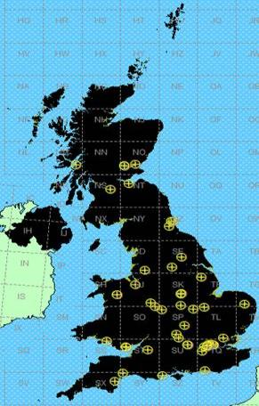

Just to re-iterate the data in the interests of this study only represents short-term allocations that took place on an ad-hoc basis.

### 4.9.4 Snapshot of audio SAB/SAP daily use in The Netherlands

Figure 2

Snapshot of daily audio SAB/SAP use in The Netherlands

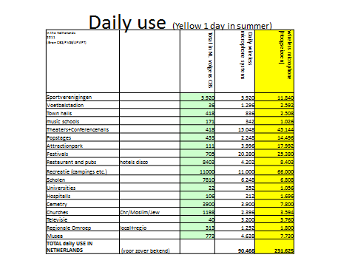

Annex 5  
  
Information on the usage of the 700 MHz band   
by SAB/SAP in Region 1

Results of measurements during a number of recent major events in Germany.

## 5.1 Introduction

This document provides information on the SAB/SAP usage during a number of recent major events in Germany in the 690 to 790 MHz tuning range, which is currently under study for WRC‑15 agenda item 1.2. The spectrum scanning and analysis of coordination information shows an average of between 32[12] and 59[13] SAB/SAP carriers being in use prior to the reallocation of 790 to 862 MHz to the mobile service.

## 5.2 Set up of measurements

The following spectrum scans are mainly derived from a single scanning station:

Figure 1

Measurement setup

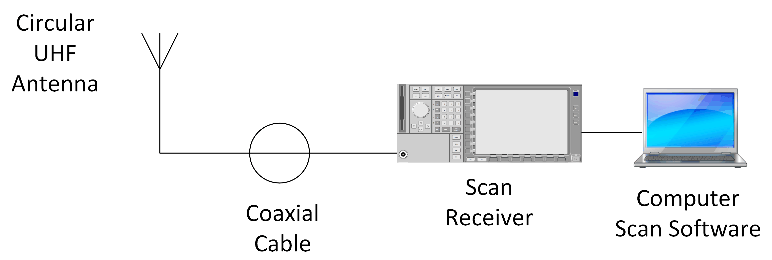

In many cases, due to the limited available positions of scanning equipment and antenna which frequently have to be erected and installed indoors, it is evident that this equipment is unable to capture consistently or comprehensively the true reflection of actual activity in the entire area[14], including analogue and digital broadcasting signals or other SAB/SAP use in adjacent facilities. Thus, some spectrum usage simultaneously taking place in surrounding facilities and rooms is not captured because the SAB/SAP signals are shielded and remain undetected by a single scanner. A variety of positions for scanning equipment would resolve this issue.

However, this document presents a few scenarios that do show an almost comprehensive use of the number of SAB/SAP used.

In addition, the local man-made noise superimposed weak microphone carriers. This makes the signal analysis difficult. The scans do not differentiate between radio microphones and IEM but in some scans the higher-powered audio links can be seen as stronger signals.

Further limitation on the measurement is given by the limited dynamics of the scanning equipment.

## 5.3 Coordination of SAB/SAP frequencies

Almost all events are professionally coordinated. This coordination takes place before the event. In addition to the event frequency coordination in some cases an additional “uncoordinated” use of spectrum has been recorded. This could be due to some other event taking place in the surrounding area.

## 5.4 Explanation of presented diagrams

The scan and analysis software used presented a combined display of scanned RF spectrum and coordination information. This combination can be used for plausibility checking.

This picture below shows, for example, the scan from the “DFB Cup Final Berlin, 2011” in the band 707.5 to 724.5 MHz. In red is shown the recorded RF spectrum. Behind the spectrum information yellow bars can be seen. These represent the information from the coordinated table of assigned frequencies.

Figure 2

Example of a spectrum recording

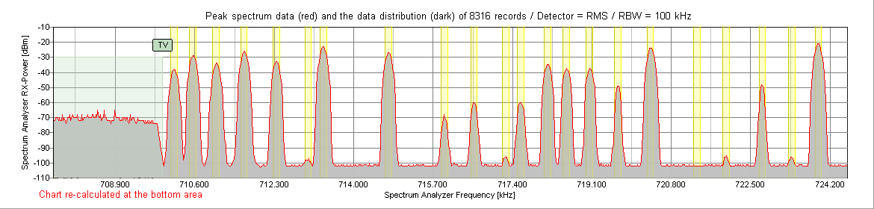

## 5.5 Measurement results

1) Live Earth Hamburg, July 2007

The spectrum plot was recorded the day before the event during the rehearsal in the football stadium. More than 30 carriers were detected in the 690 to 790 MHz band.

Figure 3

Spectrum recording Live Earth Hamburg, July 2007

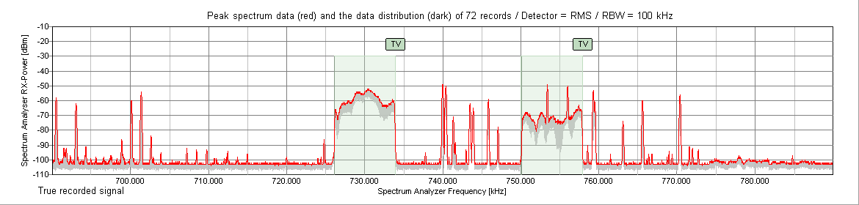

2) UCI Road World Championships in Stuttgart, September 2007

The 2007 UCI Road World Championships took place in Stuttgart, Germany, between 25 September and 30 September 2007. 69 wireless microphones and IEM were coordinated in the 690 to 790 MHz band. The scanner recorded approximately 30 carriers in the 690 to 790 MHz band.

Figure 4

Spectrum recording UCI Road World Championships in Stuttgart, September 2007

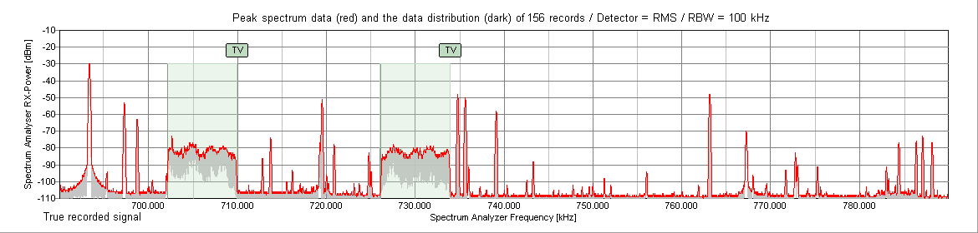

3) Lower Saxony election Hanover, January 2008

The 2008 Lower Saxony state elections were held in Lower Saxony in north-western Germany on 27 January 2008. The event was covered by all major broadcasters. The productions were based on wireless equipment due the flexibility for the organization, the temporary nature of the event, the short set-up and break down time.

79 wireless microphones, IEM and audio links were coordinated in the band 690 to 790 MHz in the surrounding town area and the parliament building.

Figure 5

Spectrum recording Lower Saxony election Hanover, January 2008

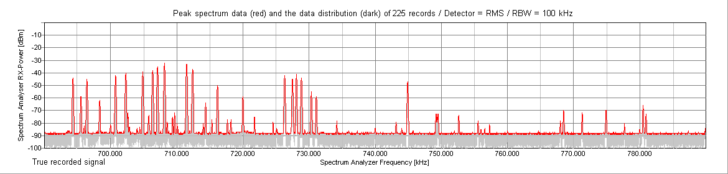

On the ground floor of the parliament building a receiver was installed. It recorded approximately 29 carriers in the 690 to 790 MHz band-as can be seen on the graph above.

4) Hamburg state election, February 2008

On 24 February 2008 state elections were held for the 19th legislative period of the parliament of the federal state of Hamburg.

Figure 6

Spectrum recording Hamburg state election, February 2008

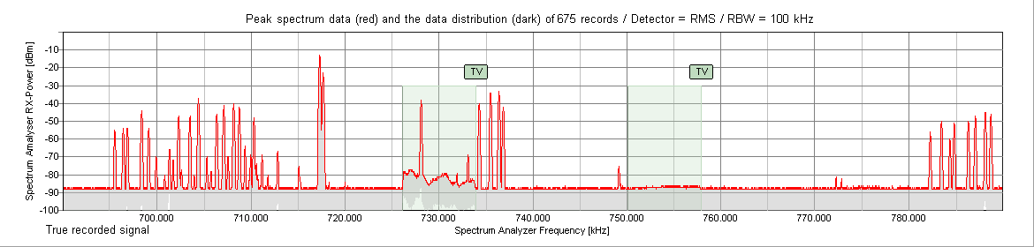

73 wireless microphones, IEM and audio links were coordinated in the 690 to 790 MHz band.   
Approximately 39 carriers were recorded in the 690 to 790 MHz band – as documented above.

5) Bavaria state election Munich, September 2008

The 2008 Bavarian state election was held on 28 September 2008.

Figure 7

Spectrum recording Bavaria state election Munich, September 2008

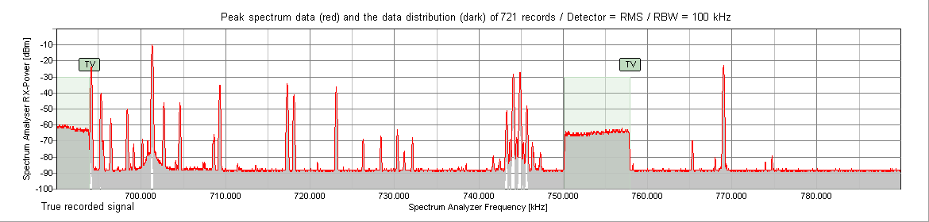

65 wireless microphones, IEM and audio links were coordinated in the 690 to 790 MHz band.   
Approximately 28 carriers were recorded in the 690 to 790 MHz band.

6) Saxony-Anhalt state election Magdeburg, March 2011

The Saxony-Anhalt state election was held on 20 March 2011 in Saxony-Anhalt for the 20thlegislative period of the parliament of Saxony-Anhalt.

Figure 8

Spectrum recording Saxony-Anhalt state election Magdeburg, March 2011

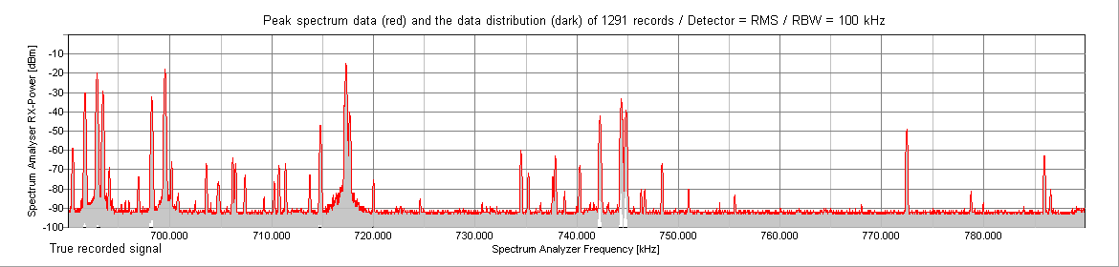

38 wireless microphones, IEM and audio links were coordinated in the 690 to 790 MHz band.   
Approximately 39 carriers were recorded in the 690 to 790 MHz band.

7) Rhineland-Palatinate state election Mainz, March 2011

The 2011 Rhineland-Palatinate state election was conducted on 27 March 2011.

Figure 9

Rhineland-Palatinate state election Mainz, March 2011

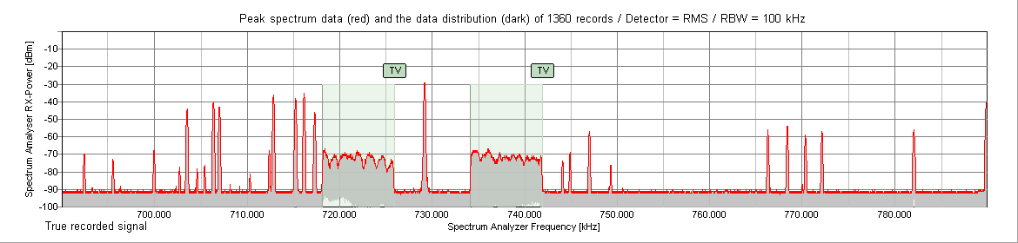

27 wireless microphones, IEM and audio links were coordinated in the 690 to 790 MHz band.  
Approximately 26 carriers were recorded in the 690 to 790 MHz band.

8) Bremen state election, May 2011

A Bremen state election was held on 22 May 2011.

Figure 10

Bremen state election, May 2011

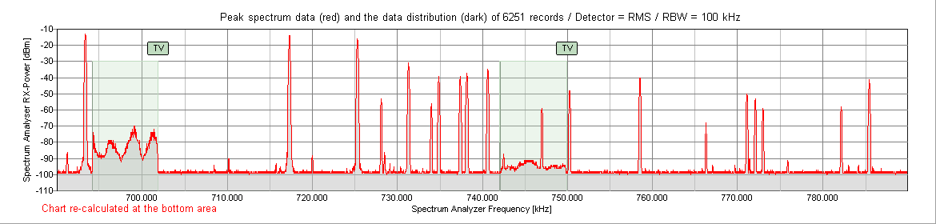

67 wireless microphones, IEM and audio links were coordinated in the 690 to 790 MHz band. Approximately 25 carriers were recorded in the 690 to 790 MHz band.

9) DFB Cup Final Berlin, May 2011

This DFB Final was the 68th season of the annual German football cup competition.

Figure 11

DFB Cup Final Berlin, May 2011

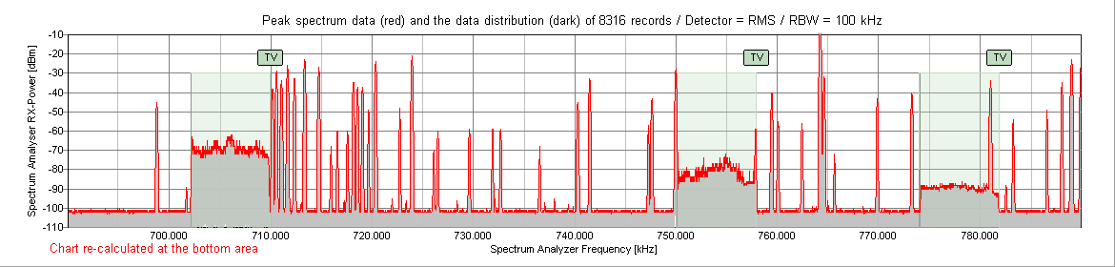

198 wireless microphones, IEM and audio links were coordinated in the 470 to 862 MHz band. Approximately 50 carriers were recorded in the 690 to 790 MHz band.

10) Eurovision Song Contest Düsseldorf, May 2011 (final event)

56 wireless microphones, IEM and audio links were coordinated in the 690 to 790 MHz band.  
Approximately 36 carriers were recorded in the 690 to 790 MHz band.

Figure 12

Eurovision Song Contest Düsseldorf, May 2011 (final event)

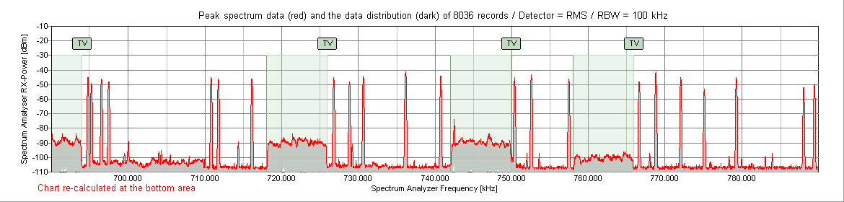

11) Eurovision Song Contest Düsseldorf, May 2011 (complete event)

Simultaneously with the Eurovision event “Interpack – Exhibition” was taking place in an adjacent Hall of the Dusseldorf exhibition centre.

56 wireless microphones, IEM and audio links were coordinated in the 690 to 790 MHz band. Approximately 50 carriers were recorded in the 690 to 790 MHz band. Additional information can be found in a separate report[15].

Figure 13

Eurovision Song Contest Düsseldorf, May 2011 (complete event)

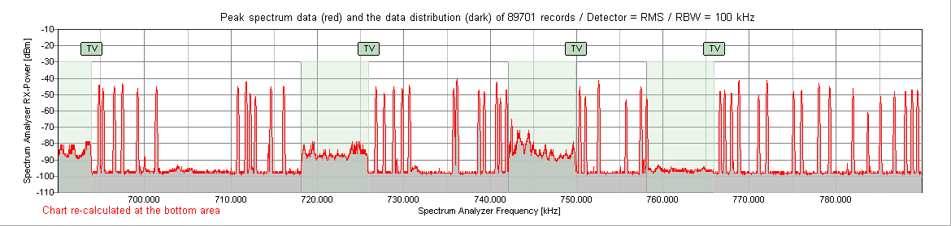

12) Mecklenburg-Vorpommern election Schwerin, September 2011

The Mecklenburg-Vorpommern state election was conducted on 4 September 2011.

Figure 14

Mecklenburg-Vorpommern election Schwerin, September 2011

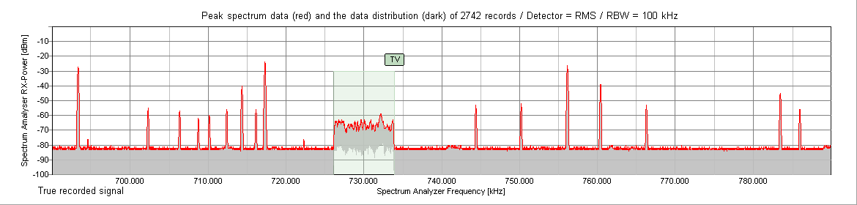

65 wireless microphones, IEM and audio links were coordinated in the 690 to 790 MHz band.  
Approximately 18 carriers were recorded in the 690 to 790 MHz band.

13) Berlin election, September 2011

The Berlin state election was held on 18 September 2011.

Figure 15

Berlin election, September 2011

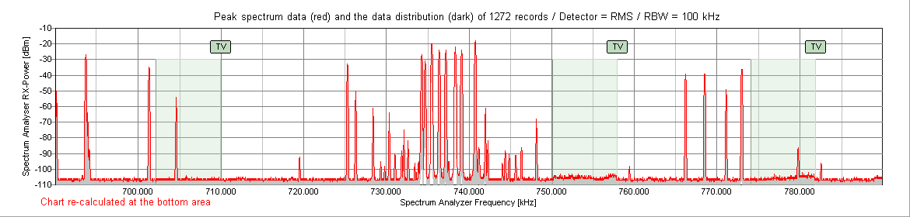

127 wireless microphones, IEM and audio links were coordinated in the 690 to 790 MHz band.  
Approximately 37 carriers were recorded in the 690 to 790 MHz band.

14) North Rhine-Westphalia state election Dusseldorf, May 2012

The North Rhine-Westphalia state election, 2012 was held on 13 May 2012, to elect members to the parliament of North Rhine-Westphalia.

Figure 16

North Rhine-Westphalia state election Dusseldorf, May 2012

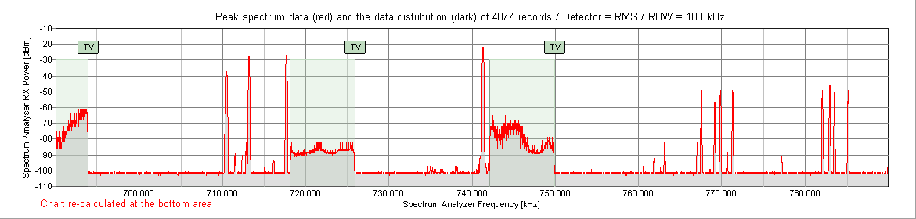

Although coordination took place before the event, no coordination data were recorded. Approximately 23 carriers were recorded in the 690 to 790 MHz band.

15) Schleswig Holstein state election Kiel, May 2012

A state election took place in Schleswig-Holstein on 6 May 2012.

Figure 17

Schleswig Holstein state election Kiel, May 2012

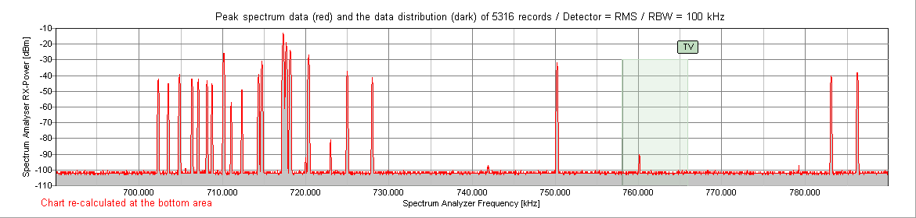

44 wireless microphones, IEM and audio links were coordinated in the 690 to 790 MHz band.  
Approximately 29 carriers were recorded in the 690 to 790 MHz band.

16) “Oktoberfest” in Munich, September 2012

Figure 18

“Oktoberfest” in Munich, September 2012

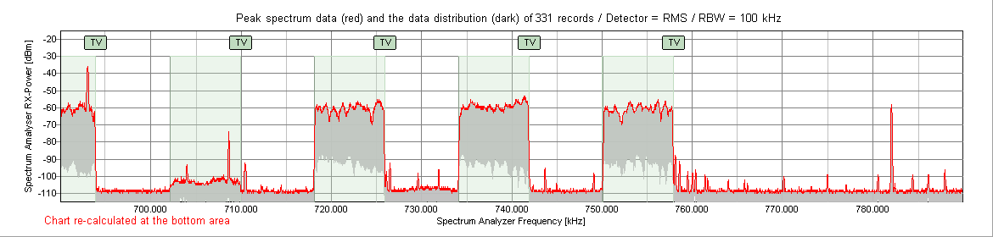

No coordination data available. Since the scanner antenna could not be positioned close enough to the stages, most of the microphone signals are recorded as weak and close to the noise floor level.

Approximately 27 carriers were recorded in the 690 to 790 MHz band.

More microphones were probably used, but due to the distance to the receiver, the signals were not picked up. An additional measurement is planned for the next “Oktoberfest” in 2013 to provide additional information.

17) Lower Saxony state election Hanover, January 2013

This event was held in Lower Saxony on 20 January 2013.

Figure 19

Lower Saxony state election Hanover, January 2013

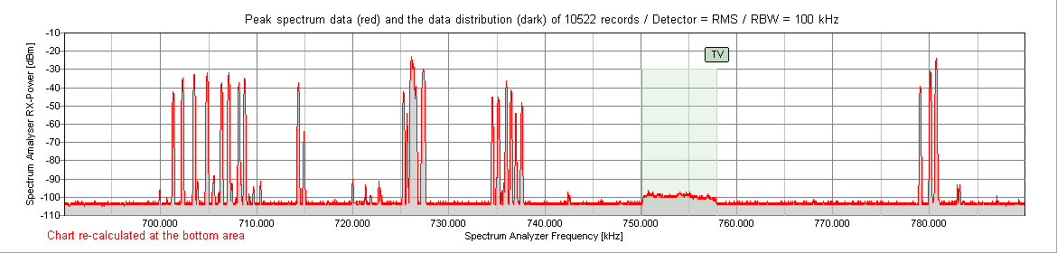

80 wireless microphones, IEM and audio links were coordinated in the 690 to 790 MHz band.  
Approximately 36 carriers were recorded in the 690 to 790 MHz band.

## 5.6 Summary

TABLE 1

Summary of the scanned events

|  |  |  |  |
| --- | --- | --- | --- |
| Annex 5 Section 5.5 | Event name, location and year | Carrier in 690 to 790 MHz | |
| Coordinated | Scanned |
| 1 | Live Earth Hamburg, 2007 | – | 30 |
| 2 | UCI Road World Championships in Stuttgart, 2007 | 69 | 30 |
| 3 | Lower Saxony election Hanover, 2008 | 79 | 29 |
| 4 | Hamburg state election, 2008 | 73 | 39 |
| 5 | Bavaria state election Munich, 2008 | 65 | 28 |

TABLE 1 (*end*)

Summary of the scanned events

|  |  |  |  |
| --- | --- | --- | --- |
| Annex 5 Section 5.5 | Event name, location and year | Carrier in 690 to 790 MHz | |
| Coordinated | Scanned |
| 6 | Saxony-Anhalt state election Magdeburg, 2011 | 38 | 39 |
| 7 | Rhineland-Palatinate state election Mainz, 2011 | 27 | 26 |
| 8 | Bremen state election, 2011 | 67 | 25 |
| 9 | DFB Cup Final Berlin, May 2011 | 147[15] | 50 |
| 10+11 | Eurovision Song Contest Düsseldorf, 2011 | 56 | 50 |
| 12 | Mecklenburg-Vorpommern election Schwerin, 2011 | 65 | 18 |
| 13 | Berlin election, September 2011 | 127 | 37 |
| 14 | North Rhine-Westphalia state election Düsseldorf, 2012 | – | 23 |
| 15 | Schleswig Holstein state election Kiel, 2012 | 44 | 29 |
| 16 | Lower Saxony state election Hanover, 2013 | 80 | 36 |
| 17 | Oktoberfest Munich, 2012 | – | 26 |

NOTE – As previously noted in § 5.2: Set up of measurements, a single scanning unit used in isolation is unable to detect all SAB/SAP carriers. The difference between coordinated and scanned carriers should not be interpreted as unused coordinated SAB/SAP channels.

## 5.7 Conclusion

Recent and current events have used the 690 to 790 MHz band as shown. The events shown above can be regarded as examples of bigger or smaller events taking place many times each year. Moreover, it can be concluded that each event is “unique” in its spectrum requirements, it has its own “spectrum footprint”.

Annex 6  
  
SAB/SAP spectrum requirements in the 470-790 MHz band   
at the Eurovision Song Contest 2011

## 6.1 Introduction

The Eurovision Song Contest (ESC, French: *Concours Eurovision de la Chanson*) is an annual competition held among many of the active member countries of the [European Broadcasting Union](http://en.wikipedia.org/wiki/European_Broadcasting_Union).

Each member country submits a song to be performed on [live television](http://en.wikipedia.org/wiki/Live_television) and radio and then votes for the other countries’ songs to determine the most popular song in the competition. The contest has been broadcast every year since its inauguration in 1956 and is one of the longest-running [television programmes](http://en.wikipedia.org/wiki/Television_programme) in the world. It is also one of the most watched non-sporting events in the world, with audience figures having been quoted in recent years as between 100 and 600 million. The Eurovision Song Contest has also been broadcast outside Europe to such countries as Argentina, Australia, Brazil, Canada, China, Colombia, Egypt, India, Japan, Jordan, Mexico, New Zealand, the Philippines, South Korea, Taiwan (China), Thailand, the United States, Uruguay and Venezuela despite the fact that they do not compete. Since 2000, the contest has also been broadcast over the [Internet](http://en.wikipedia.org/wiki/Internet) [16].

The Eurovision Song Contest 2011 took place in the [Esprit Arena](http://en.wikipedia.org/wiki/Esprit_Arena) in [Düsseldorf](http://en.wikipedia.org/wiki/D%C3%BCsseldorf) at the 14th of May. The technical setup for the event began on 20th of March, and was completed within about four weeks. This period was followed by another four weeks of actual rehearsals with the artists, semi‑finals afterwards and ended with the final on Saturday, 14th May 2011. It was one of the two largest concert venues (after the ESC in Copenhagen in 2001) so far. The [Esprit Arena](http://en.wikipedia.org/wiki/Esprit_Arena) held approximately 36 500 people. Forty-three countries participated in the contest.

The event organizer bears the responsibility for the economic impact of the event and the efficient use of the available budget. In addition, the organizer is expected to generate a wide range of secondary effects by ensuring the success of the event. These include, for example, effects on the labour market, on tourism (hotels) and numerous other activities accompanying the event (e.g. crafts or integrated trades, telecommunications and advertising). The example of ESC 2011 shows that significant investments have been undertaken in staff and infrastructure and that these rely on the event’s success – thus making its success obligatory.

## 6.2 Requirements at the ESC 2011

As well as creating a visually compelling concept, communication among all of those involved in the production had to be ensured. With considerable effort, the artists have to be transmitted over wireless microphones without interference and optimally controlled using feedback links (the so‑called in-ear monitors (IEMs)). The organizer had to ensure that participants from all countries encounter production conditions of equal quality and that the competitors are treated fairly. This includes, in particular, the quality of the live sound, live video and the accompanying interpretation. Even a partial failure of one of these three components is inevitably liable to be interpreted as unfair treatment and could have disrupted further progress of the event.

During the construction period, parts of the wireless communication network were already operational. All of the usable televisionchannels between 21 and 60 were needed by the start of the artist rehearsals approximately four weeks before the final. In parallel to the rehearsals, press conferences were held by the various countries. So enough links needed to be available, with an appropriate audio quality, for both the artist at the rehearsals and the press taking part in the conferences.

A total of approximately 215 wireless radio transmission links were co-ordinated. With this high number the limit of available intermodulation-free[17] frequencies was nearly reached. Only a few additional frequencies could have been hold available. The coordinated frequencies were located in the following frequency ranges. One link was even coordinated in the future LTE duplex gap in the 800 MHz band.

TABLE 1

Number of co-ordinated frequencies



### 6.2.1 Wireless microphones and in-ear monitoring

Wireless microphones allow performers and moderators to move around freely while using a microphone to amplify their voices. Today’s dance choreography and show performances use this freedom of movement and a return to wired microphones would not be possible without significantly restricting artistic freedom. Therefore, wired microphones are nowadays used only to a small extent (for example as ambience microphones or for background singers) and are also kept in reserve for backup reasons. At the time of the ESC 2011 digital transmitter links were not yet available and even today they are scarcely in use in a professional environment due to latency problems.

Table 2 shows the number of wired microphones used at the ESC 2011.

TABLE 2

Number of wired microphones

|  |  |
| --- | --- |
| Number of wired microphones | |
| **Type of use** | **Number** |
| Ambience microphones (5.1-spider) | 32 |
| Spare ambience microphones | 8 |
| Spare vocal microphones | 6 |
| Spare presenter microphones | 4 |

Traditionally loudspeakers placed on stage and directed towards the performers were used to monitor their audio feedback. But this system has its drawbacks. A better way is to provide each artist the audio mix he needs by the use of in-ear monitoring systems. With these systems it is possible to serve a stereo or other mixes by [panning](http://en.wikipedia.org/wiki/Panning_%28audio%29) different elements to each ear.

Almost all analogue wireless microphones and in-ear transmitters are using a frequency modulation scheme to transmit the signal to the receiver. The occupied bandwidth per audio link amounts to approximately 200 kHz.

At the ESC 2011 the links for wireless microphones, IEM, and sound engineering were located in the 470-790 MHz band. Also some intercom transmitters used this frequency range. A table with the numbers of equipment can be found below.

TABLE 3

Number of wireless audio equipment

|  |  |  |
| --- | --- | --- |
| Number of wireless audio equipment | | |
| Type of transmitters | Total number | Number of spare transmitters |
| Microphones | 113 | 12 |
| IEM | 52 | 1 |
| Intercom transmitters | 6 | – |
| **Total** | 171 | 13 |

The large number of microphones and IEM was due to different application purposes (see Table 4). 48 microphones and 8 in-ear monitors were used for the competing artists. As there were music groups from 43 countries, the microphones for voice and instruments were distributed by rotation schedules. To realize the number of required audio links the microphones that were used in the rehearsals were later additionally used for the live-acts. Twelve microphones and four in-ear monitors were assigned to the three authorized television reporting teams.

TABLE 4

Microphones and IEMs by type of use

|  |  |  |
| --- | --- | --- |
| Microphones and IEMs by type of use | | |
| Type of use | Microphones | IEM transmitters |
| Contest | 48 | 8 |
| Presentation | 12 | 4 |
| Live-acts | 20 | 10 |
| Rehearsal | 6 | 6 |
| Sound engineering | 3 | 4 |
| Reporting teams | 12 | 4 |
| Press centrum | 12 | 8 |
| Internal feedback | – | 8 |
| **Total** | **113** | **52** |

### 6.2.2 Ensuring radio coverage

Due to the size of the hall and the equipment suspended from the supporting structures, the view between the antennas of the event production and the stage was largely unobstructed. Nevertheless it was a considerable technical challenge to ensure the necessary transmission quality for a distance of approximately 90 m. To ensure the quality of sound the microphones are picked up by diversity receiver systems. The IEM systems are equipped with antenna splitters, so a reliable coverage of all stages could be guaranteed. There were 17 additional frequencies available for back up reasons, and there was additional equipment available (Table 3).

### 6.2.3 Monitoring the audio quality

Two sound engineers monitored the quality of the links. They evaluated the audio quality in a specially prepared and sound-insulated container. This monitoring was largely set up to identify and eliminate interference. Due to the limited time available, it was not tried to locate the source of an interference, but instead a different frequency was used for the interfered with signal. This made it possible to respond manually at very short notice to interference.

## 6.3 Issues with frequency coordination

### 6.3.1 Frequency coordination

The entire frequency coordination was carried out centrally and was strictly organized in order to rule out as many uncertainties as possible.

Before the frequency planning started spectrum scans were performed in the event hall. This ensured that possible sources of interference were excluded in advance.

To meet the high requirements of the organizer regarding the quality of sound the frequency planning for the wireless systems has been designed such that no intermodulation of third and fifth order may occur. Intermodulation (IM) is a major problem when operating multiple systems in one location.

Intermodulation is caused by non-linear behaviour of the signal processing being used. Intermodulation is deleterious in audio processing as it creates unwanted spurious emissions, often in the form of sidebands. For radio transmissions this increases the occupied bandwidth, leading to adjacent channel interference. To avoid such interference all possible intermodulation products are calculated and only IM3- and IM5-free frequencies are used. Due to the high number of audio links at the ESC 2011, this could only be done for devices that show similar characteristics, which eventually lead to the decision to use only devices from one manufacturer.

To eliminate interference from other sources a strict set of rules regarding the use of radio equipment was set up. Journalists who used unregistered wireless equipment immediately lost their accreditation. The usual news crews with their wireless devices were not permitted at this event. There were only three reporting teams accredited, equipped with authorized microphones and IEMs by the organizer. These measures were monitored by the security staff.

### 6.3.2 Planning constraints

The following aspects concerning the types of audio links, DVB-T spectrum occupancy and building attenuation had to be considered in the frequency planning.

#### 6.3.2.1 Microphones and IEMs

To operate wireless microphones and IEMs interference-free at the same person, spacing between the used frequencies is required. The spacing used in the ESC 2011 was about 15 MHz, see Fig. 1.

Figure 1

Channel spacing between IEM and microphones

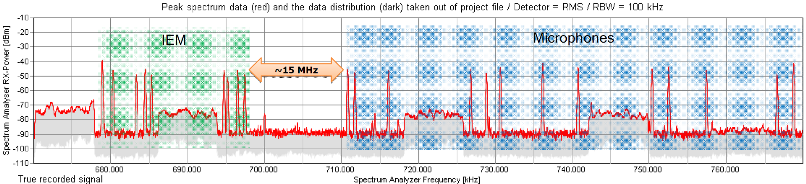

#### 6.3.2.2 Audio links and DVB-T

To avoid interference with DVB-T transmitters, a 600 kHz guard band had been used on each side of a DVB-T channel (Fig. 2). Only six DVB-T transmitters (48 MHz) were identified as strong interferers around the Esprit-Arena, a moderate number of occupied DVB-T channels for a big city like Düsseldorf. In other cities such as Berlin and Hamburg there are nine and seven DVB-T channels operational, respectively. Additionally, television channel 38 is reserved for radio astronomy in Germany and must not be used. In total 63.2 MHz[18] of the UHF Broadcast Band were not available, i.e. in principle about 257 MHz out of the TV channel 21-60 were available.

Figure 2

DVB-T channels and safety band to audio links

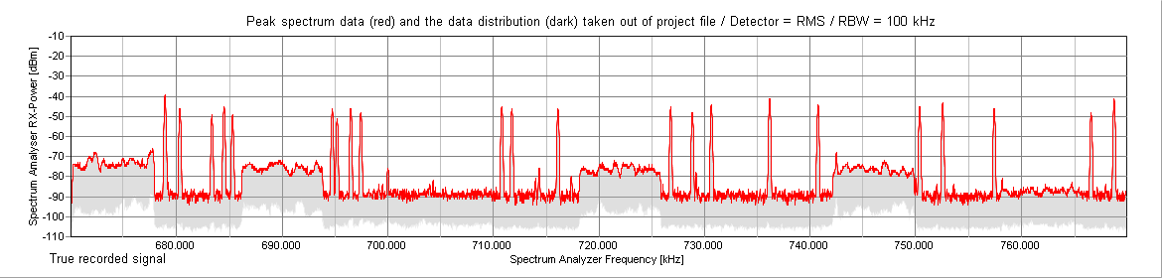

**DVB-T**

**DVB-T**

**≥ 600 kHz**

**DVB-T**

**DVB-T**

#### 6.3.2.3 Building attenuation

Additional external measurements showed that at a distance of approx. 350 m signals from the stage installation could still be clearly detected. A building attenuation of the partly roofless “ESPRIT arena” of approx. 10 dB could be derived from the received signal levels.

Such additional measurements are required in order to assess the risk of an on-going event being considerably disrupted by external signals and to take appropriate measures to avoid this.

#### 6.3.2.4 Other adjacent events

The Eurovision Song Contest 2011 was an event that took place in a metropolitan area where there was a close proximity to a neighbouring event.

In the period from 12th to 18th May 2011, at the same time as the ESC, the trade fair “Interpack - Processes and Packaging” was held. With 2703 exhibitors from 59 countries and 166 000 visitors, it is one of the largest trade fairs in Düsseldorf. The graphic below () shows its direct proximity to the “ESPRIT arena”, the venue of the ESC.

Figure 3

Esprit Arena and trade fair Interpack (all coloured halls in use by the trade fair)

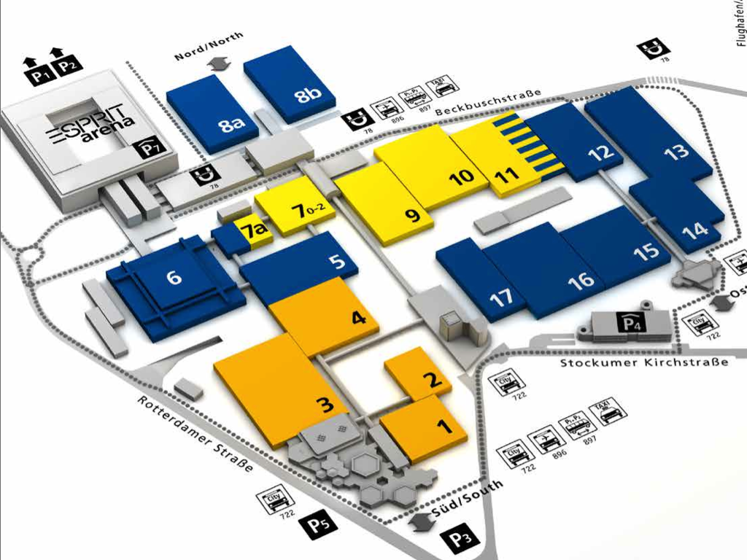

It turned out that the use of the interleaved TV spectrum by wireless systems related to the trade fair were not harmful to the ESC 2011 due to the particular, i.e. indoor, use of wireless systems by the trade fair and sufficient spatial decoupling. Possibly, links in the 800 MHz band were used by the exhibitors of the trade fair, which was feasible due to the fact that LTE-800 was not deployed yet.

## 6.4 Actual spectrum use at ESC

The spectrum was monitored by measurements. This was done by associates of the research group DKE-AK 731.0.8. They used specialized scanning and analysis software.

The accuracy of the measurements depends on the quality of the spectrum recording. To get a as realistic as possible picture of the spectrum usage the test site has to be chosen carefully.

Usually, due to event constraints, the number of possible measurement sites is restricted. In the case of the ESC 2011 a balcony opposite to the stage was chosen to place the measurement antenna. With this position not all microphones in use could be recorded but the measurements give a good picture, especially about the equipment used on stage, whereas rehearsal rooms, press centre etc. could not or only partly be observed.

In addition, as detailed information as possible on the PMSE equipment is required. Therefore the organizer provided the frequency co-ordination lists to the DKE research group in advance.

The scanning period lasted from May 1st (18:24) to May 15th (4:16 (End of event)). During the recording period it was possible to obtain a nearly complete spectrum recording of the stage. Figure 4 and Table 5 show the number of carriers that were recorded during the 15 days of production.

Figure 4

Number of recorded carriers within a time period of 15 days

TABLE 5

Recorded carriers of 15 days

|  |  |  |  |  |
| --- | --- | --- | --- | --- |
|  | Scanning period | |  |  |
| Date | from | to | Samples | Carriers |
| 01.05.2011 | 18:24 | 24:00 | 1660 | 40 |
| 02.05.2011 | 00:00 | 24:00 | 7030 | 77 |
| 03.05.2011 | 00:00 | 24:00 | 6934 | 80 |
| 04.05.2011 | 00:00 | 24:00 | 6969 | 65 |
| 05.05.2011 | 00:00 | 24:00 | 6965 | 88 |
| 06.05.2011 | 00:00 | 24:00 | 7002 | 71 |
| 07.05.2011 | 00:00 | 24:00 | 6434 | 94 |
| 08.05.2011 | 00:00 | 24:00 | 6817 | 64 |
| 09.05.2011 | 00:00 | 24:00 | 6926 | 126 |
| 10.05.2011 | 00:00 | 24:00 | 6978 | 120 |
| 11.05.2011 | 00:00 | 24:00 | 6822 | 90 |
| 12.05.2011 | 00:00 | 24:00 | 4343 | 110 |
| 13.05.2011 | 00:00 | 24:00 | 6780 | 100 |
| 14.05.2011 | 00:00 | 24:00 | 6820 | 102 |
| 15.05.2011 | 00:00 | 04:16 | 1216 | 51 |

### 6.4.1 Evaluation of spectrum recording during the main event

During the main event (duration 9.5 hours) approx. 4 500 scans were performed.

Figure 5

Maximum reception level over measurement period

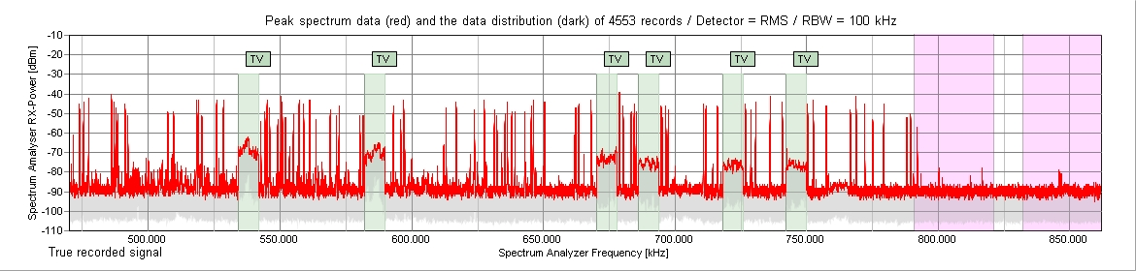

The red line in Fig. 5 with its pronounced peaks shows the maximum reception level over the measurement period. The light green blocks are the DVB-T transmitters. The two pink blocks on the right hand side are the new ranges for LTE usage. The recorded weak carries in the 800 MHz band might origin from the adjacent trade fair.

Figure 6

Time occupancy of the frequency band

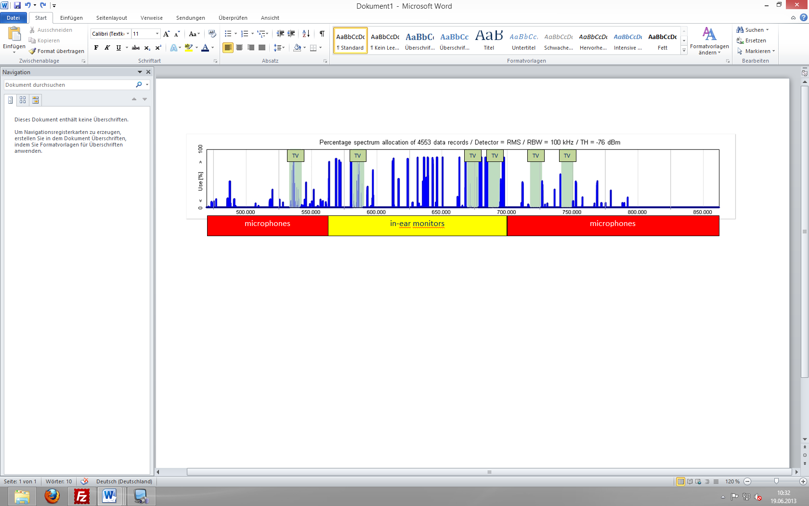

Figure 6 shows the duration of a signal that exceeds a specific evaluation threshold. 100% means constant reception on this frequency. Signals that only briefly exceed the threshold are not shown in this presentation.

The red and yellow coloured blocks in Fig. 6 indicate the use of the recorded links. In-ear transmitters were almost always in operation, while the microphones were turned on only when needed. This difference is due to the fact that, opposite to IEM transmitters, microphone transmitters can be switched on or off by the users. Even if many microphones were only active for a rather short time it is still mandatory that each microphone has its exclusive frequency assigned in order not to become accidently an interferer by switching it on at the wrong time.

Figure 7

Occupancy of unique frequency links

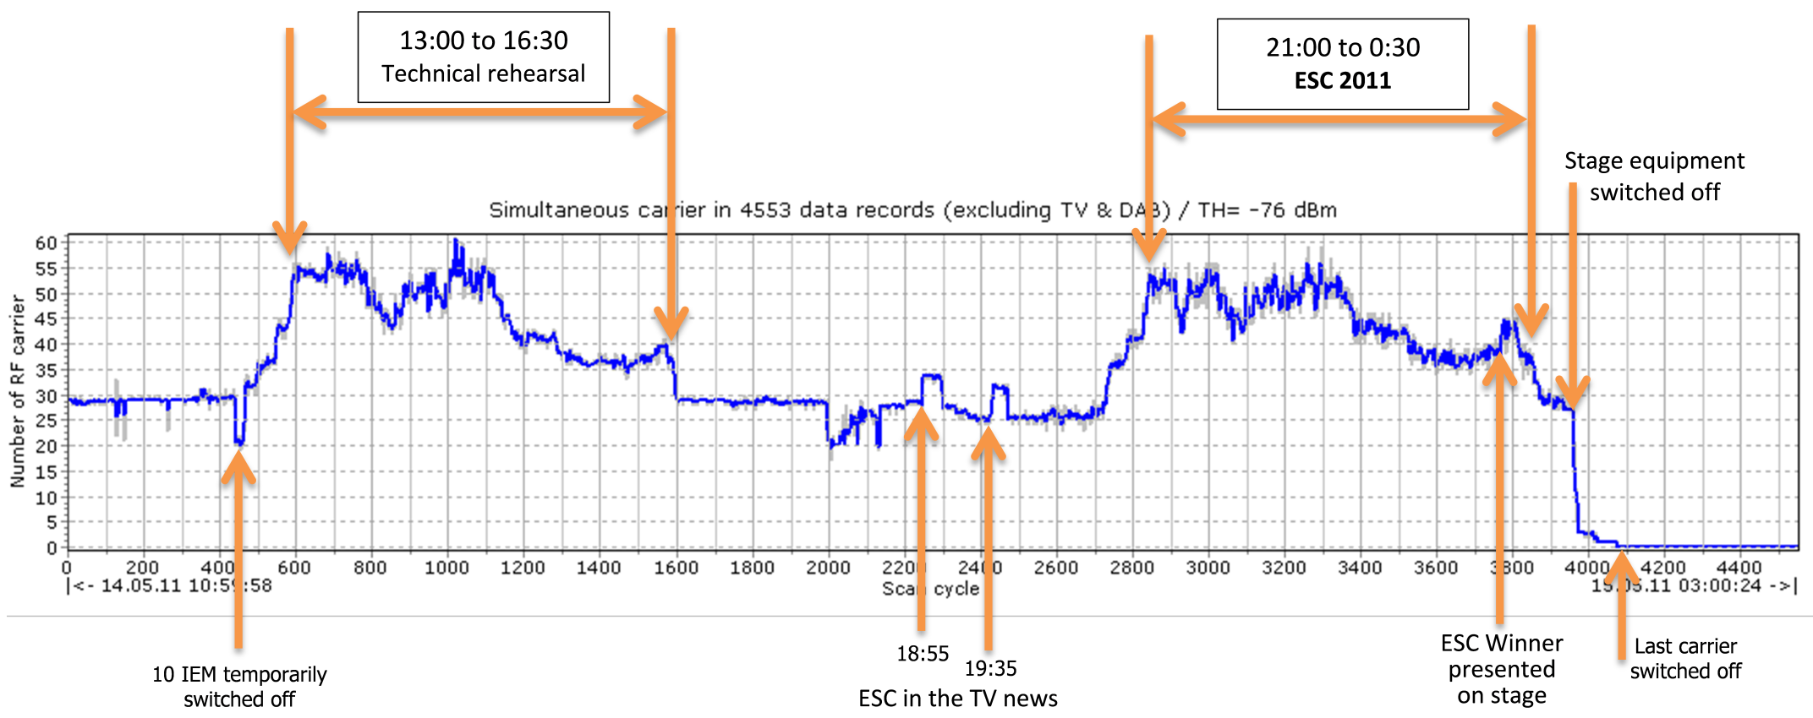

Figure 7 shows an evaluation of the measured signals over time. The blue graph represents the number of simultaneously received signals. Only narrowband signals are evaluated (< 500 kHz bandwidth), as these are signals that could represent wireless microphones and in-ear monitors. Due to an update rate of typically 13 seconds also relatively short signals could be recorded and subsequently analysed. From the perspective of signal analysis, it is irrelevant whether the microphone is switched on or off, or if the performer leaves the venue (reception area) for example. In both cases, the number of signals observed changes. In order to increase the accuracy of the measurements, all TV stations have been hidden from the spectrum analysis.

The analysis shows that the density with which the spectrum is occupied at a venue cannot be assumed to be constant, rather it follows the progress of the event. At the ESC 2011 changes were observed every minute.

The red graph in Fig. 5 shows the total number of occupied frequencies. Whenever a link triggers the threshold the first time the red line adds one up and stays at that value even if the link goes off over the measurement period. Until 12:35, only the IEM links were switched on. Until approx. 20:00, around ninety frequencies were occupied. This trend was expanded to about 100 frequencies during the main event.

## 6.5 Alternative coordination

Immediately after WRC-15, the 700 MHz band is going to be allocated to the mobile service on a co-primary basis with broadcasting and there is a risk that this band will be used by mobile services in the future. Therefore, for the present report, it was studied what would have happened if the 700 MHz band would have neither be available for DVB broadcasting nor for wireless microphones and IEMs. Thus, it was tried to coordinate the given event in the 470-694 MHz frequency range.

Then, broadcasting DVB-T transmitters, which currently use channels in the 700 MHz band would have been reallocated in the remaining 470-694 MHz band as far as possible. Such theoretical TV re‑planning was performed in advance. This new TV plan formed the boundary conditions for the PMSE planning in the 470-694 MHz band. Thus, spectrum for PMSE is reduced in a twofold way. There is less spectrum available in total, and there are less TV white spaces available in the remaining spectrum.

To ensure that the general setup for the frequency calculation remains the same as in 2011, the same planer performed the recalculation with the same requirements. As in 2011, the available spectrum is divided into two separate frequency ranges for microphones and IEMs for reasons of frequency economy.

TV channels 34 to 48 (574-694 MHz) contain the frequencies for in-ear monitors. The IEM channels are calculated in such a way that they are very robust against interference. The size of the arena and the adjoining rooms that had to be supplied with the IEM signals require a boosting of the signals. To be safe from interference by intermodulation a high channel spacing of 600 kHz is necessary. The carriers were calculated such that they were intermodulation-free up to the fifth order.

TV channels 22 to 31 (478-558 MHz) accommodate the frequencies for microphones. Up to nine microphone links are placed into one TV channel. This corresponds to the requirements of coordination of 2011. In principle, 12 links per TV channel may be possible, but not viable at the ESC due to the high number of used carriers, the amplified IEM carriers and their intermodulation products. In addition it would not have complied with the quality criteria requested by the artists and the event organizer. A channel spacing of 400 kHz is used and intermodulation products were calculated up to the third order.

Table 6 show the channel allocation that had been assumed for this study.

TABLE 6

Assumed channel allocation

|  |  |  |  |  |  |  |
| --- | --- | --- | --- | --- | --- | --- |
| Channel 21 | Channel 22 | Channel 23 | Channel 24 | Channel 25 | Channel 26 | Channel 27 |
| **DVB-T** | Microphone | **IM Products** | Microphone | **IM Products** | **DVB-T** | Microphone |
| Channel 28 | Channel 29 | Channel 30 | Channel 31 | Channel 32 | Channel 33 | Channel 34 |
| **IM Products** | **DVB-T** | Microphone | Microphone | **IM Products** | **IM Products** | IEM |
| Channel 35 | Channel 36 | Channel 37 | Channel 38 | Channel 39 | Channel 40 | Channel 41 |
| **DVB-T** | **IM Products** | IEM | **Radio Astronomy Channel** | **IM Products** | IEM | **IM Products** |
| Channel 42 | Channel 43 | Channel 44 | Channel 45 | Channel 46 | Channel 47 | Channel 48 |
| IEM | **DVB-T** | IEM | **IM Products** | **DVB-T** | IEM | IEM |

Channels 22, 24, 27 30 and 31 are used for wireless microphones and the channels 34, 37, 40, 42, 44, 47 and 48 are used for IEM. In between, there are channels that cannot be used due to the fact that the intermodulation products are placed in there. In summary a total of 39 microphones and 38 IEMs (or engineering links) could be coordinated in this spectrum.

TABLE 7

Comparing co-ordinate frequencies

|  |  |  |
| --- | --- | --- |
| Comparing co-ordinated frequencies | | |
| Frequency range | Use | Total number of links |
| 470-790 MHz | Microphones/IEM/ Engineering links | 175 |
| 470-694 MHz | Microphones/IEM/ Engineering links | 77 |

Considering only the loss of the 700 MHz band, i.e. only those links in the original PMSE plan that were located in the 700 MHz band, over 50 links would be lost which is about one third of the 2011 used capacity.

Leaving out the 700 MHz band and reallocating the DVB-T transmitters results in a loss of about 100 links as compared to the actually used links at the ESC 2011.

Without these links it would not have been possible to perform the event as it was planned and realized in 2011. Other spectrum allowing for the accommodation of about 100 links would have had to be made available in order to achieve the same result as for the ESC 2011.

With a 100 links less available the event flow would have had to change fundamentally, longer time for stage alterations would have been needed and performances would have experienced remarkable restrictions and would have had to change dramatically to less ambitious ones. With 100 wireless links less it would be doubtful whether an event such as the ESC could still be carried out.

## 6.6 Other events

Other, more regular events occur over the year with quite similar spectrum requirements. That means that the ESC is not a single outstanding event from a PMSE usage point of view but the foregoing aspects are also relevant for other events.

Good examples for these more regular events are the elections of the government of the federal states of Germany. At these events there is a high density of small reporter teams with wireless equipment. In addition, the various television broadcasters set up their TV-studios within the parliament building to produce their programme on site. Different from the ESC, these events cannot be planned with regard to PMSE in due time beforehand since reporter teams often show up only at short notice. This fact imposes an additional difficulty for the frequency coordination.

### 6.6.1 Hannover state election 2013

At the Hannover state election 2013 there were 15 different production teams on-site and 30 of the used links could only be coordinated as recently as at the event day. 213 links were coordinated in the frequency range 470-790 MHz. Actually, only 216 MHz were usable in this frequency band due to the potential interference from twelve DVB-T channels. Again also channel 38 could not be used, because it is reserved for radio astronomy in Germany. In addition the adjacent election party had to be taken into account. Links that have been used by reporting teams at the party were not usable at the parliament. As a result the frequency coordinator was forced to place up to 15 audio links into one TV channel which violates the [criterion](http://dict.leo.org/ende/index_de.html#/search=criterion&searchLoc=0&resultOrder=basic&multiwordShowSingle=on) of intermodulation-free positioning of PMSE links, as explained in § 2.7 of Annex 2, and reduced the quality.

In 2013, spectrum in the 800 MHz band with a guarantee of no interference from other services (LTE) was no longer available since the LTE roll-out already had started. Nonetheless, because of a lack of alternatives, 15 additional links had to be established in the 800 MHz band, even at the risk of LTE interference into these links.

## 6.7 Conclusion

The report shows that almost the entire available spectrum in the 470-790 MHz range was used. There were only a few spare frequencies that were at call in an emergency case such as an unexpected interferer showing up at event time. The whole event lasted about four weeks, and during that time the full range of production spectrum had to be available.

The effort that is needed to plan the frequency coordination of such a big events is immense and often takes several weeks or months. And despite of that great effort, it is not impossible that there are problems showing up during the event. To ensure a high production quality, it is important to be able to respond to these unexpected problems in an adequate way.

To achieve high sound quality of the radio links it is mandatory to avoid intermodulation. Due to the great number of required audio links at the ESC 2011 it was essential to use equipment from one manufacturer only. Otherwise, intermodulation-free frequencies could not have been found.

Additionally rotation plans for microphones and in-ear monitors and the reuse of temporally unused frequencies were necessary in order to realize all requested audio links. Finally, restrictive admission measures were required to prevent interference from non-authorized equipment. The use of PMSE equipment other than that provided by the event organizer was prohibited.

At the ESC 2011 a favourable circumstance helped to secure the production. In Düsseldorf only six DVB-T channels were in operation. If the event had taken place in another city such as Berlin or Hamburg, the free spectrum for audio links would have been even less.

The example of the ESC 2011 shows how important an interference-free environment is to achieve the necessary high quality needed for broadcasting and other high class productions. It demonstrates that there is a significant risk of failure for the event which must be controlled by the efforts of technology and personnel.

To be able to produce high quality events in the future, enough spectrum has to be available for the use of PMSE[19] equipment. This spectrum needs to have good propagation characteristics and a low interference environment. The broadcasting Bands IV and V have proven to be a good choice in all these matters.

Without frequencies in the 700 MHz band the ESC as it was would not have been possible. Other spectrum allowing for the accommodation of about 100 links would have had to be made available in order to achieve the same result as for the ESC 2011. Or the audio quality of the wireless PMSE links would have been much lower and interference would have been most likely. Alternatively, a large part of the wireless devices would have had to be exchanged with hard-wired equipment and the artistic choreographies would not have been possible in the form shown.

With a 100 links less available the event flow would have had to change fundamentally, longer time for stage alterations would have been needed and performances would have experienced remarkable restrictions and would have had to change dramatically to less ambitious ones. With 100 wireless links less it would be doubtful whether an event such as the ESC could still be carried out.

Finally, the ESC is a major event of international importance and interest. The financial, human and time resources available for this kind of production are much more extensive than those for other more daily productions of similar complexity. It is therefore all the more important to provide sufficient spectrum available for PMSE equipment.

## 6.8 List of References

[1] Recommendation ITU-R BT.1871, User requirements for wireless microphones <http://www.itu.int/dms_pubrec/itu-r/rec/bt/R-REC-BT.1871-0-201003-I!!PDF-E.pdf>

[2] Report ITU-R BT.2069-5, Tuning ranges and operational characteristics of terrestrial electronic news gathering (ENG), television outside broadcast (TVOB) and electronic field production (EFP) systems <http://www.itu.int/dms_pub/itu-r/opb/rep/R-REP-BT.2069-5-2011-PDF-E.pdf>

[3] ECC Report 204 Spectrum use and future requirements for PMSE [http://www.erodocdB.dk/doks/doccategoryECC.aspx?doccatid=4](http://www.erodocdb.dk/doks/doccategoryECC.aspx?doccatid=4)

[4] CEPT Report 50 Technical conditions regarding spectrum harmonisation options for wireless radio microphones and cordless video-cameras <http://www.erodocdB.dk/doks/filedownload.aspx?fileid=3968&fileurl=http://www.erodocdB.dk/Docs/doc98/official/pdf/CEPTREP050.PDF>

[5] CEPT Report 32 Technical considerations regarding harmonisation options for the digital dividend in the European Union [http://www.erodocdB.dk/doks/doccategory.aspx?doccatid=16](http://www.erodocdb.dk/doks/doccategory.aspx?doccatid=16)

[6] EBU Technical Report 001 Results of the EBU questionnaire on spectrum requirements for SAB/SAP & ENG/OB applications, <http://tech.ebu.ch/docs/techreports/tr001.pdf>

[7] EN 301 357, Cordless audio devices in the range 25 MHz to 2 000 MHz <http://www.etsi.org/deliver/etsi_en/301300_301399/30135701/01.04.01_60/en_30135701v010401p.pdf>

[8] EN 300 422, Wireless microphones in the 25 MHz to 3 GHz frequency range <http://www.etsi.org/deliver/etsi_en/300400_300499/30042201/01.03.02_60/en_30042201v010302p.pdf>

[9] ETSI TR 102 546, Technical characteristics for Professional Wireless Microphone Systems (PWMS), System Reference Document <http://www.etsi.org/deliver/etsi_tr/102500_102599/102546/01.01.01_60/tr_102546v010101p.pdf>

[10] ERC Report 042, HandBook on radio equipment and systems radio microphones and simple wide band audio links [http://www.erodocdB.dk/Docs/doc98/official/pdf/REP042.PDF](http://www.erodocdb.dk/Docs/doc98/official/pdf/REP042.PDF)

[11] ECC Report 159, Cognitive radio systems in the ‘white spaces’ in 470-790 MHz [http://www.erodocdB.dk/Docs/doc98/official/pdf/ECCREP159.PDF](http://www.erodocdb.dk/Docs/doc98/official/pdf/ECCREP159.PDF)

[12] ECC Report 185, Definition of technical and operational requirements for WSD in 470-790 MHz <http://www.erodocdB.dk/Docs/doc98/official/pdf/ECCREP185.PDF>

[13] ECC Report 186, Technical and operational requirements for WSD under geo-location approach <http://www.erodocdB.dk/Docs/doc98/official/pdf/ECCREP186.PDF>

[14] ECC Report 191, Adjacent band compatibility between MFCN and PMSE audio applications in 1785 to 1805 MHz [http://www.erodocdB.dk/Docs/doc98/official/pdf/ECCREP191.PDF](http://www.erodocdb.dk/Docs/doc98/official/pdf/ECCREP191.PDF)

[15] DKE Radio spectrum monitoring in the context of Eurovision Song Contest 2011  
Report main part: <http://www.apwpt.org/downloads/esc2011_20122011_english_framedoc.pdf>  
Report annex: <http://www.apwpt.org/downloads/esc2011_20122011_english_annex.pdf>

[16] IRT: LTE interference on analogue and digital PMSE devices: <http://www.irt.de/webarchiv/showdoc.php?z=NjQ5OSMxMDAzMDc3MTAxNDEwI2RvY3g=>

1. This Report was approved jointly by Radiocommunication Study Groups 5 and 6, and any future revision should also be undertaken jointly.
2. Studies on the use of the band 790-862 MHz by mobile applications and by other services.
3. Some administrations have allowed SAB/SAP in the 790-862 MHz band subject to none interference during the period of IMT network provision. Use of the duplex gap is also available in most administrations.
4. The lower edge on the allocation was provisionally decided by the WRC-12 to 694 MHz and is subject to refinement at WRC-15.
5. Electronic news gathering (ENG) is the collection of video and/or sound material by means of small, often hand-held wireless cameras and/or microphones with radio links to the news room and/or to the portable tape or other recorders.
6. Outside broadcasting (OB) is the temporary provision of programme making facilities at the location of on-going news, sport or other events, lasting from a few hours to several weeks. Mobile and/or portable radio links are required for wireless cameras or microphones at the OB location. Additionally, radio links may be required for temporary point to point connections between the OB vehicle, additional locations around it, and the studio.
7. Satellite news gathering (SNG) refers to similar applications to ENG but over the satellite radio communication channels.
8. This includes antenna distribution systems, splitters and is further discussed in Annex 2.
9. Considering both the summer and winter Olympic Games.
10. Calculated from the total number of SAB/SAP in 470 to 862 MHz.
11. IRT: LTE interference on analogue and digital PMSE devices: ECC Report 191: Adjacent band compatibility between MFCN and PMSE audio applications in CEPT Report 50 Technical conditions regarding spectrum harmonisation options for wireless radio microphones and cordless video-cameras.
12. Scanned carrier of 15 events.
13. Calculated from coordinating tables.
14. Also known as the “hidden node problem”.
15. Calculated from the total number of SAB/SAP in 470 to 862 MHz.
16. <http://en.wikipedia.org/wiki/Eurovision_Song_Contest>.
17. See § 2.7 of Annex 2.
18. 6 * 8 MHz plus 1,2 MHz guard band each and 8 MHz for channel 38.
19. Programme Making and Special Events (PMSE) is a term that refers to equipment that is used for the production of programme for broadcasting or other special events. In general it relates to wireless microphones, wireless cameras, talkback systems and IEM.