|  |
| --- |
| **Report ITU-R BT.2383-1**  **(10/2016)** |
| **Characteristics of digital terrestrial television broadcasting systems in the frequency band 470-862 MHz for frequency sharing/interference analysis** |
| **BT Series**  **Broadcasting service**  **(television)** |

Foreword

The role of the Radiocommunication Sector is to ensure the rational, equitable, efficient and economical use of the radio-frequency spectrum by all radiocommunication services, including satellite services, and carry out studies without limit of frequency range on the basis of which Recommendations are adopted.

The regulatory and policy functions of the Radiocommunication Sector are performed by World and Regional Radiocommunication Conferences and Radiocommunication Assemblies supported by Study Groups.

# Policy on Intellectual Property Right (IPR)

ITU-R policy on IPR is described in the Common Patent Policy for ITU-T/ITU-R/ISO/IEC referenced in Annex 1 of Resolution ITU-R 1. Forms to be used for the submission of patent statements and licensing declarations by patent holders are available from <http://www.itu.int/ITU-R/go/patents/en> where the Guidelines for Implementation of the Common Patent Policy for ITU‑T/ITU‑R/ISO/IEC and the ITU-R patent information database can also be found.

|  |  |
| --- | --- |
| Series of ITU-R Reports  (Also available online at <http://www.itu.int/publ/R-REP/en>) | |
| **Series** | Title |
| **BO** | Satellite delivery |
| **BR** | Recording for production, archival and play-out; film for television |
| **BS** | Broadcasting service (sound) |
| **BT** | Broadcasting service (television) |
| **F** | Fixed service |
| **M** | Mobile, radiodetermination, amateur and related satellite services |
| **P** | Radiowave propagation |
| **RA** | Radio astronomy |
| **RS** | Remote sensing systems |
| **S** | Fixed-satellite service |
| **SA** | Space applications and meteorology |
| **SF** | Frequency sharing and coordination between fixed-satellite and fixed service systems |
| **SM** | Spectrum management |

|  |
| --- |
|  |

|  |
| --- |
| ***Note****: This ITU-R Report was approved in English by the Study Group under the procedure detailed in Resolution ITU-R 1.* |

*Electronic Publication*

Geneva, 2016

© ITU 2016

All rights reserved. No part of this publication may be reproduced, by any means whatsoever, without written permission of ITU.

REPORT ITU-R BT.2383-1

Characteristics of digital terrestrial television broadcasting systems in the frequency band 470-862 MHz for frequency sharing/interference analysis

(2015-2016)

TABLE OF CONTENTS

*page*

1 Introduction 3

2 Broadcasting coverage area and service area planning 3

3 Definition of reception location probability 3

4 Broadcasting protection criteria 3

5 Quality of service requirements 4

6 Assessment of interference impact on the broadcast coverage 4

6.1 Introduction 4

6.2 Standard Broadcast Planning Practise 4

7 DVB-T and DVB-T2 reference broadcasting networks 5

7.1 Single transmitter case (assignments): 5

7.2 Single frequency networks (Allotments) (GE06) 8

8 ATSC Reference broadcasting networks 11

8.1 DTTB System A (ATSC) single transmitter 11

9 ISDB-T Reference broadcasting networks 13

9.1 DTTB System C (ISDB-T) single transmitter 13

9.2 Vertical radiation pattern 13

10 DTMB Reference broadcasting networks 14

10.1 Single transmitter case (Assignments) 14

11 DTTB reception modes 15

11.1 Fixed reception 15

11.2 Portable DTTB reception(GE06) 18

11.3 Reference planning configurations for DVB-T and DVB-T2 (GE06) 20

11.4 Interpolation of reference field strength values (GE06) 20

12 System parameters for DTTB Systems 21

*page*

12.1 System parameters related to DVB-T (8 MHz) 21

12.2 System parameters related to DVB-T2 (8 MHz) 22

12.3 System parameters related to ATSC (6 MHz) 23

12.4 System parameters and protection requirements related to ISDB-T (6 MHz/8 MHz) 24

12.5 System parameters and protection requirements related to DTMB (8 MHz) 25

12.6 Correction of protection ratio figures for different ACLR values 26

13 Propagation considerations 26

14 Aggregation of interference 26

15 Comparative evaluations 27

16 Inclusion of noise in interference assessments 27

Annex – List of relevant ITU-R Reports and Recommendations 27

# 

# 1 Introduction

This Document contains a summary of the technical and operational characteristics of digital terrestrial television broadcasting (DTTB) broadcast systems required for relevant sharing studies.

In many places in this report material was extracted from the final acts of the RRC 2006 in Geneva . For these cases the following Symbol is added to illustrate the reference: (GE06)

Quotes from existing text in ITU-R are highlighted though the use of *Italics*.

# 2 Broadcasting coverage area and service area planning

Recommendation [ITU-R V.573](http://www.itu.int/rec/R-REC-V.573/en) No. A51b defines “*coverage area*” as the “*area associated with a transmitting station for a given service and a specified frequency within which, under specified technical conditions, radiocommunications may be established with one or several receiving stations*”.

Note 4 of No. A51b explains that “*the term ’service area‘ should have the same technical basis as for ’coverage area‘, but also include administrative aspects*”.

Reference to the administrative aspects in the definition of service area is understood to mean that in that service area protection is required.

For the case of broadcast services which are usually planned with multiple overlapping transmissions from different transmitter sites, it is usual to protect only the best coverage. Furthermore, spill-over coverage into international neighbours or adjacent regions of a country do not usually form part of the intended service area and may not require protection.

# 3 Definition of reception location probability

Reception location probability is defined in Report ITU-R [BT.2265-2](http://www.itu.int/pub/R-REP-BT.2265) Section 2 as “*the percentage of locations within a small area, referred in this document as ’pixel’[1], where the wanted signal is high enough to overcome noise and interference for a given percentage of time taking into account the temporal and spatial statistical variations of the relevant fields.*”

In digital terrestrial broadcasting the coverage area is defined in Report ITU-R [BT.2265-2](http://www.itu.int/pub/R-REP-BT.2265) Annex 2 as "*the area that comprises all pixels, where a given reference reception location probability (e.g. 95%) is reached or exceeded for a predetermined percentage of the time.*"

# 4 Broadcasting protection criteria

Broadcasting protection criteria are based on local interference considerations such as reception location probability, degradation to reception location probability in the presence of additional interference, I/N limitation and degradation to C/N.

Details about the protection requirements for the broadcasting service can be found in particular in Recommendation ITU-R [BT.1895](http://www.itu.int/rec/R-REC-BT.1895/en) (“Protection criteria for terrestrial broadcasting systems”) and Report [ITU-R BT.2265](http://www.itu.int/pub/R-REP-BT.2265) (“Guidelines for the assessment of interference into the broadcasting service”). Further references are listed in the Annex.

# 5 Quality of service requirements

Planning of terrestrial television broadcasting services is required by many administrations to cover a high percentage of the population/households (e.g. 98%) or geographic regions (e.g. the entire country), in accordance with statutory requirements or commercial agreements, with all reception in the area defined by this coverage requirement essentially stipulated for continuous use to a specified time availability, within the hours of transmission. This coverage requirement (as distinct from the coverage area of the broadcast transmission) applies within the service area that is licenced and to be protected.

Within the broadcast service area, interference effects can be assessed in many ways but the overriding issue is how they may translate in terms of reducing the capacity to meet the coverage requirement of the broadcasting service. A reduction in capacity to meet the coverage requirement effectively translates to a loss of access to broadcast receiving stations at the specified time availability. Broadcast service planning methods are based on meeting a prescribed coverage requirement.

Specifically, the broadcast service delivery to the target population within the broadcast service area has been based on the expectation of a signal quality with minimum interruption[2].

# 6 Assessment of interference impact on the broadcast coverage

## 6.1 Introduction

In order to assess the impact of interference into broadcast networks, it is necessary to apply the broadcast planning criteria with the new level of interference and compare the relative change in quality of service requirement before and after the introduction of the new source of interference. The issues that arise from the combination of this process and sharing studies are highlighted in § 6.2.

## 6.2 Standard Broadcast Planning Practise

Planning of the digital terrestrial television broadcasting service is based on specified parameters and requirements. These form the basis for the protection of the existing digital terrestrial broadcast networks.

For planning terrestrial television broadcasting services it is important to take into consideration the different elements of interference and the implications of temporal variations to separately identify when interference into the broadcast service arises from protection ratio failure and blocking due to overloading.

Spectrum planners are aware that a relaxation in the value or exclusion of certain interference assessment factors would reduce the ability to meet the television broadcast coverage quality requirement. A relaxation of more than one of these parameters could result in a significant cumulative reduction in the extent to which a service area can be covered.

In the simple conceptual example below of planning the broadcasting service, it is assumed that the area covered by the broadcast transmission is circular and that up to four of the above interference assessment factors have been relaxed. Each reduction in the level of protection afforded by one of the broadcast interference assessment factors is represented by a ring identifying the potential percentage of the existing population or country that can no longer be reached under the television broadcast coverage requirement, as a result of interference arising from the relaxation in the interference assessment factor(s).

A simplification of the spectrum planning process[3] is provided for illustrative purposes in the diagram below. A service area with an existing broadcast provision that has been planned in accordance with the broadcast planning criteria and meets or exceeds the prescribed coverage requirement is represented in Fig. 1A by the dotted circle. That part of the service area in Fig. 1A, where the planned broadcast coverage has been reduced or lost due to the level of the interfering signal arising from the relaxation in one of the interference assessment factor(s) is shown in Fig. 1B.

In Fig. 1C the relaxation of multiple (in this case 4) interference assessment factors is aggregated to show the consequential impact on the planned broadcast service area , with the dotted area the only part of the planned broadcast service area in Fig. 1A, that remains covered by the planned broadcast transmission parameters. Not only is the effective broadcast service area significantly reduced but the target population within the planned service area is no longer served.

|  |  |  |
| --- | --- | --- |
| FIGURE 1A | FIGURE 1B | FIGURE 1C |
| Original area covered | Reduction in area covered (relaxation of one factor) | Resulting area covered  (relaxation of four factors) |
|  |  |  |

In practise a television broadcast service area is unlikely to be circular and the population lost to broadcast coverage will not be located in convenient rings around the edge of that service area. Both areas will be influenced by topographical factors, population distribution and the respective locations of the wanted and interfering transmitters.

Transmissions in adjacent bands /channels may also cause interference. Recommendations ITU-R BT.1368 and ITU-R BT.2033 as well as Report ITU-R BT.2215 and ITU-R BT.2248 contain additional information on this case.

# 7 DVB-T and DVB-T2 reference broadcasting networks

Reference broadcast transmitter configurations are provided that are representative of actual deployments in the case of assignments or are the reference configurations used in the GE06 Agreement for allotment planning.

## 7.1 Single transmitter case (assignments):

– High power

• ERP: 200 kW

• Effective antenna height: 300 m

• Antenna height a.g.l.: 200 m

• Antenna pattern:

– Horizontal: Omnidirectional

– Vertical antenna aperture: based on 24λ aperture with 1° beam tilt

– Medium power

• ERP: 5 kW

• Effective antenna height: 150 m

• Antenna height a.g.l.: 75 m

• Antenna pattern:

– Horizontal: Omnidirectional

– Vertical: based on 16λ aperture with 1.6° beam tilt

– Low power

• ERP: 250 W

• Effective antenna height: 75 m

• Antenna height a.g.l.: 30 m

• Antenna pattern:

– Horizontal: Directional (cardioid)

– Vertical: based on 4λ aperture with 3° beam tilt

The attenuation (Aϑ) of the horizontal radiation pattern with azimuth angle (ϑ) is given by:

$A_{}=20{Log}_{10}\left(2B-B^{2}\right)$ dB

where:

$$B= \frac{1+k+Cos\left(\right)}{2+k}$$

where:

ϑ : azimuth angle

*k* : 0.4187 for 10 dB pattern minima.

The resulting pattern is shown in Fig. 2:

Figure 2

Low power DTT

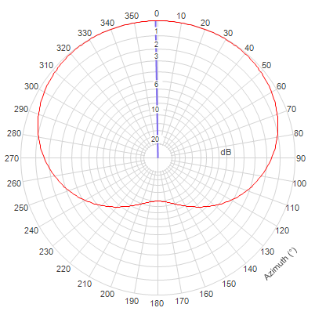

Unlike high and medium power antennas which are usually omnidirectional, very few low power DTT antenna are omnidirectional. Low power DTT antennas typically have a directional horizontal radiation pattern usually of a type cardioid (dipoles mounted on a pole) or consisting of one or more panel, Yagi or log-periodic elements. These antennas typically have minima in the HRP that are 10 dB or more below the maximum and may have lobes that occur at various azimuth angles, lobes typically being aligned with the desired service area.

As patterns of low power antenna vary considerably modelling all combinations of pattern in generic compatibility studies is usually not practical. Therefore to better represent the horizontal radiation pattern of low power DTT it is proposed to base the generic model on the pattern of a cardioid antenna with a 10 dB minimum. Depending on the compatibility study being undertaken the orientation of the pattern (angle of azimuth) can be varied as required.

The overall gain of the low power DTT antenna is unchanged given that the gain of the proposed 4 cardioid is approximately the same as that of an 8 omnidirectional antenna. The decrease in vertical aperture of a 4 cardioid relative to an 8 cardioid (reduction in gain of 3 dB) is offset by the directivity of the cardioid’s horizontal radiation pattern (nominal gain of 3 dB).

### 7.1.1 Vertical radiation patterns

The normalised field strength in the vicinity of the broadcast transmitting station is a function of the vertical radiation pattern of the transmitting antenna. The equation below is an approximation to be used for sharing studies.



where



and

*A* = the antenna vertical aperture in wavelengths

β = the beam tilt radians below the horizontal.

To allow for null fill the value of *E(*θ*)* should not go below the value shown in Table 1.

TABLE 1

Null fill values to be applied to vertical radiation patterns

|  |  |
| --- | --- |
|  | Limit on *E(*θ *)* |
| First null | 0.15 |
| Second null | 0.1 |

For the third null and at all angles of θbeyond the third null the value of *E(*θ*)* should not fall below 0.05.

*E(*θ*)* given above are linear values, to convert them to reduction values in dB the following equation is used:

$$Reduction in dB=20*log10\left\{E\left(θ\right)\right\}$$

## 7.2 Single frequency networks (Allotments) (GE06)

Three reference networks (RN) for DTT services in Region 1 will be used as described in Appendix 3.6 of Chapter 3 of the GE06 Agreement. This information is reproduced in part below.

For sharing studies within the service area of an SFN the same vertical diagrams as provided in § 7.1 above should be applied for each transmitter.

### 7.2.1 Reference network 1 (large service-area SFN)

The network consists of seven transmitters situated at the centre and at the vertices of a hexagonal lattice. An open network type has been chosen, i.e. the transmitters have non-directional antenna patterns and the service area is assumed to exceed the transmitter hexagon by about 15%. The geometry of the network is given in Fig. 3. This reference network (RN 1) is applied to different cases: fixed (RPC 1), outdoor/mobile (RPC 2) and indoor (RPC 3) reception, for Bands IV and V. RN 1 is intended for large service area SFN coverage. It is assumed that main transmitter sites with an appropriate effective antenna height are used as a backbone for this type of network. For portable and mobile reception, the size of the real service areas for this type of SFN coverage is restricted to 150 to 200 km in diameter because of self-interference degradation, unless very rugged DVB-T system variants are used or the concept of dense networks is employed.

FIGURE 3

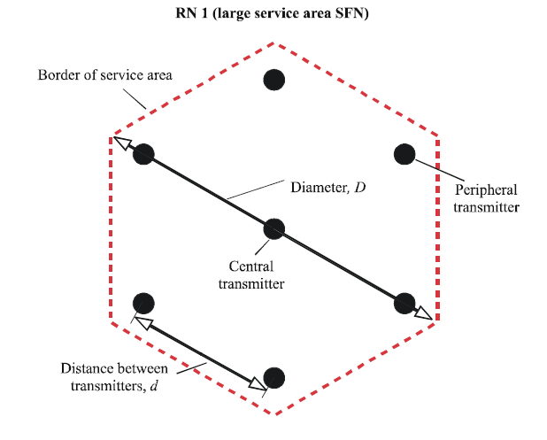

For the guard interval length, the maximum value 1/4 *Tu* of the 8k FFT mode is assumed. The distance between transmitters in an SFN should not significantly exceed the distance equivalent to the guard interval duration. In this case, the guard interval duration is 224 μs, which corresponds to a distance of 67 km. The distance between transmitters for RPC 1 is taken as 70 km. For RPC 2 and RPC 3, 70 km is too large a distance from a power budget point of view. Therefore, smaller values for the distance between transmitters have been selected, 50 km for RPC 2 and 40 km for RPC 3.

The parameters and the power budgets of RN 1 given in Table 2 shall be used.

TABLE 2

Parameters of RN 1 (large service area SFN)

|  |  |  |  |  |
| --- | --- | --- | --- | --- |
| RPC and reception type | | RPC 1 Fixed antenna | RPC 2 Portable outdoor and mobile | RPC 3 Portable indoor |
| Type of network | | Open | Open | Open |
| Geometry of service area | | Hexagon | Hexagon | Hexagon |
| Number of transmitters | | 7 | 7 | 7 |
| Geometry of transmitter lattice | | Hexagon | Hexagon | Hexagon |
| Distance between transmitters d (km) | | 70 | 50 | 40 |
| Service area diameter D (km) | | 161 | 115 | 92 |
| Tx effective antenna height (m) | | 150 | 150 | 150 |
| Tx antenna pattern | | Non-directional | Non-directional | Non-directional |
| e.r.p.* dB(W) | Band IV/V | 42.8 | 49.7 | 52.4 |
| * The e.r.p. values indicated in this table incorporate an additional power margin of 3 dB. | | | | |

The e.r.p. is given for 650 MHz in Bands IV/V; for other frequencies (*f* in MHz) the frequency correction factor added is: 20 log10(*f/650*) for RPC 1 and 30 log10(*f/650*) for RPC 2 and RPC 3.

### 7.2.2 Reference network 2 (small service area SFN, dense SFN)

The network consists of three transmitters situated at the vertices of an equilateral triangle. An open network type has been chosen, i.e. the transmitters have non-directional antenna patterns. The service area is assumed to be hexagonal, as indicated in Fig. 4.

This reference network (RN 2) is applied to different cases: fixed (RPC 1), outdoor/mobile (RPC 2) and indoor (RPC 3) reception, for both Bands IV & V.

RN 2 is intended for small service area SFN coverage. Transmitter sites with appropriate effective antenna heights are assumed to be available for this type of network and self-interference restrictions are expected to be small. Typical service area diameters may be from 30 to 50 km.

It is also possible to cover large service areas with this kind of dense SFN. However, a very large number of transmitters is then necessary. It therefore seems reasonable to have large service areas being represented by RN 1, even if a dense network structure is envisaged.

Figure 4

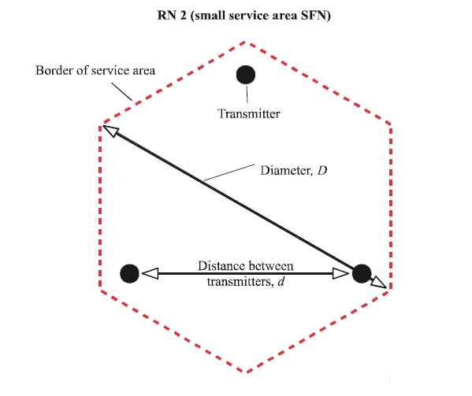

In RN 2 the inter-transmitter distance is 40 km for RPC 1 and 25 km in the case of RPCs 2 and 3.

The parameters and the power budgets of the RN 2 given in Table 3 shall be used.

TABLE 3

Parameters of RN 2 (small service area SFN)

|  |  |  |  |  |
| --- | --- | --- | --- | --- |
| RPC and reception type | | RPC 1 Fixed antenna | RPC 2 Portable outdoor and mobile | RPC 3 Portable indoor |
| Type of network | | Open | Open | Open |
| Geometry of service area | | Hexagon | Hexagon | Hexagon |
| Number of transmitters | | 3 | 3 | 3 |
| Geometry of transmitter lattice | | Triangle | Triangle | Triangle |
| Distance between transmitters d(km) | | 40 | 25 | 25 |
| Service area diameter D(km) | | 53 | 33 | 33 |
| Tx effective antenna height (m) | | 150 | 150 | 150 |
| Tx antenna pattern | | Non-directional | Non-directional | Non-directional |
| e.r.p.* (dBW) | Band IV/V | 31.8 | 39.0 | 46.3 |
| * The e.r.p. values indicated in this table incorporate an additional power margin of 3 dB. | | | | |

The e.r.p. is given for 650 MHz in Bands IV/V; for other frequencies (*f* in MHz) the frequency correction factor added is: 20 log10(*f/650*) for RPC 1 and 30 log10(*f/650*) for RPC 2 and RPC 3.

### 7.2.3 Reference network 3 (small service area SFN for urban environment)

The geometry of the transmitter lattice of reference network 3 (RN 3) and the service area are identical to those of RN 2. (See Fig. 4 above)

RN 3 is applied to different cases: fixed (RPC 1), outdoor/mobile (RPC 2) and indoor (RPC 3) reception, for both Bands IV and V.

RN 3 is intended for small service area SFN coverage in an urban environment. It is identical to RN 2, apart from the fact that urban-type height loss figures are used. This increases the required power of the SFN transmitters by about 5 dB for RPC 2 and RPC 3.

The parameters and the power budgets of the RN 3 given in Table 4 shall be used.

TABLE 4

Parameters of RN 3 (small service area SFN for urban environment)

|  |  |  |  |  |
| --- | --- | --- | --- | --- |
| RPC and reception type | | RPC 1 Fixed antenna | RPC 2 Portable outdoor and mobile | RPC 3 Portable indoor |
| Type of network | | Open | Open | Open |
| Geometry of service area | | Hexagon | Hexagon | Hexagon |
| Number of transmitters | | 3 | 3 | 3 |
| Geometry of transmitter lattice | | Triangle | Triangle | Triangle |
| Distance between transmitters d (km) | | 40 | 25 | 25 |
| Service area diameter D (km) | | 53 | 33 | 33 |
| Tx effective antenna height (m) | | 150 | 150 | 150 |
| Tx antenna pattern | | Non-directional | Non-directional | Non-directional |
| e.r.p.* (dBW) | Band IV/V | 31.8 | 44.9 | 52.2 |
| * The e.r.p. values indicated in this table incorporate an additional power margin of 3 dB. | | | | |

The e.r.p. is given for 650 MHz in Bands IV/V; for other frequencies (*f* in MHz) the frequency correction factor added is: 20 log10(*f/650*) for RPC 1 and 30 log10(*f/650*) for RPC 2 and RPC 3.

# 8 ATSC Reference broadcasting networks

Reference broadcast transmitter configurations are provided that are representative of actual deployments in the case of assignments or are the reference configurations used for allotment planning.[4]

## 8.1 DTTB System A (ATSC) single transmitter

– High power

• ERP: 1 000 kW

• Antenna Height Above Average Terrain (HAAT): 365 m

• Antenna pattern: Omnidirectional

– Medium power

• ERP: 400 kW

• Antenna Height Above Average Terrain (HAAT): 550 m

• Antenna pattern: Omnidirectional

– Low power

• ERP: 50 kW

• Antenna Height Above Average Terrain (HAAT): 1 800 m

• Antenna pattern: Omnidirectional

### 8.1.1 Vertical radiation pattern

The field strength in the vicinity of the broadcast UHF transmitting station is a function of the vertical radiation pattern of the transmitting antenna. The table below is to be used for sharing studies.[5]

TABLE 5

Vertical UHF radiation pattern

|  |  |
| --- | --- |
| Angle from horizon (degrees) | Relative Field Strength |
| 0.75 | 1.000 |
| 1.50 | 0.880 |
| 2.00 | 0.690 |
| 2.50 | 0.460 |
| 3.00 | 0.260 |
| 3.50 | 0.235 |
| 4.00 | 0.210 |
| 5.00 | 0.200 |
| 6.00 | 0.150 |
| 7.00 | 0.150 |
| 8.00 | 0.150 |
| 9.00 | 0.150 |
| 10.00 | 0.150 |

To allow for null fill the value of the relative field strength should not go below 0.150 at all angles.

*Relative Field Strength* given above are linear values, to convert them to reduction values in dB the following equations is used:

$$Reduction in dB=20*log10\left(Relative Field Strength\right)$$

# 9 ISDB-T Reference broadcasting networks

## 9.1 DTTB System C (ISDB-T) single transmitter

– Main station

• ERP: 30 kW

• Antenna Height Above Average Terrain (HAAT): 100 m

• Antenna pattern: Omnidirectional

– Relay station

• ERP: 50 W

• Antenna Height Above Average Terrain (HAAT): 20 m

• Antenna pattern: Omnidirectional

– Repeater

• ERP: 50 mW

• Antenna Height Above Average Terrain (HAAT): 10 m

• Antenna pattern: Omnidirectional

## 9.2 Vertical radiation pattern

The field strength in the vicinity of the broadcast UHF transmitting station is a function of the vertical radiation pattern of the transmitting antenna. The middle frequency antenna from Fig. 5 below is to be used for sharing studies for main and relay stations.

Figure 5

Vertical UHF radiation pattern for Main and Relay station

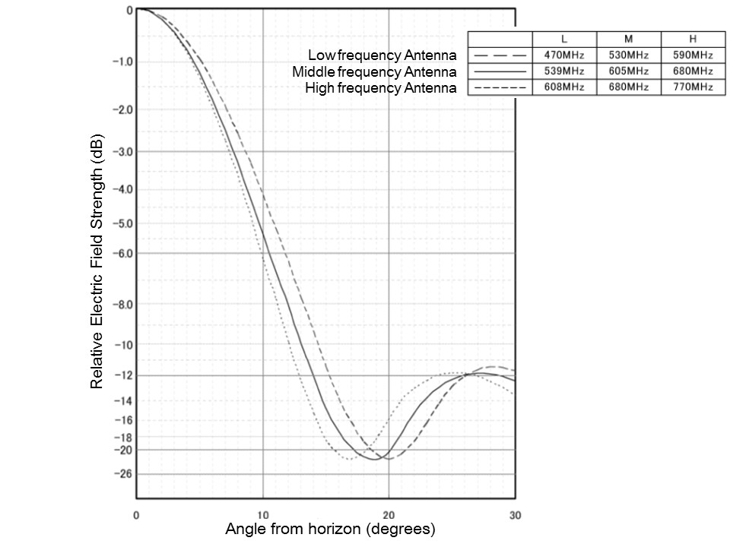

For repeater stations use the 3RG vertical pattern in Fig. 6.

Figure 6

Vertical UHF radiation pattern for Repeater

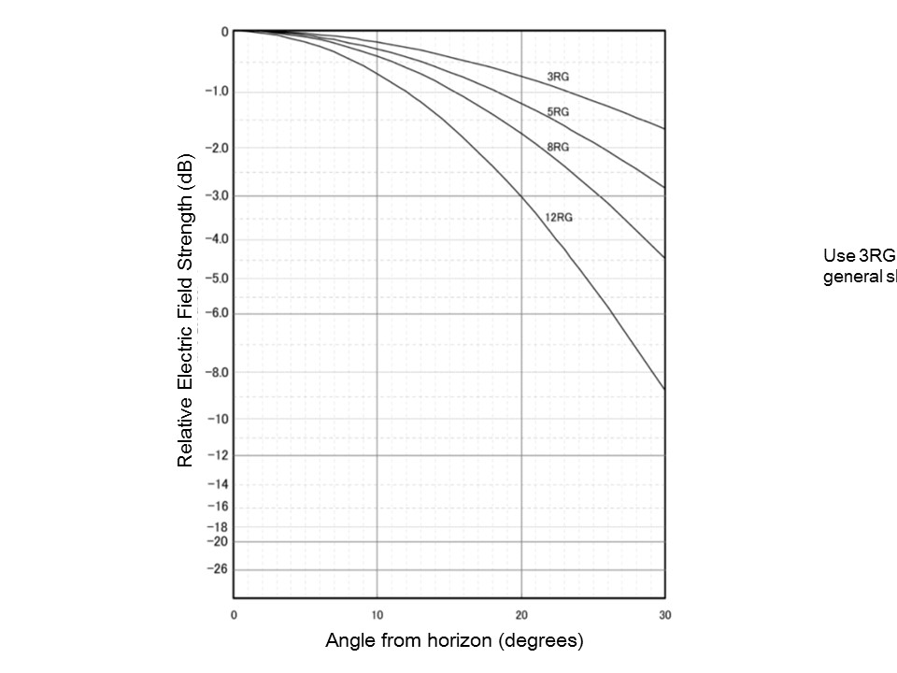

# 10 DTMB Reference broadcasting networks

Reference broadcast transmitter configurations are provided that are representative of actual deployments in the case of assignments.

## 10.1 Single transmitter case (Assignments)

– High power

• ERP: 200 kW

• Effective antenna height: 300 m

• Antenna height a.g.l.: 200 m

• Antenna pattern:

– Horizontal: Omnidirectional

– Vertical: 24λ aperture with 1° beam tilt (See formula in § 7.1.1)

– Medium power

• ERP: 5 kW

• Effective antenna height: 150 m

• Antenna height a.g.l.: 75 m

• Antenna pattern:

– Horizontal: Omnidirectional

– Vertical: 16λ aperture with 1.6° beam tilt (See formula in § 7.1.1)

– Low power

• ERP: 250 W

• Effective antenna height: 75 m

• Antenna height a.g.l.: 30 m

• Antenna pattern:

– Horizontal: Omnidirectional

– Vertical: 8λ aperture with 3° beam tilt (see formula in § 7.1.1)

# 11 DTTB reception modes

## 11.1 Fixed reception

The reference receiving antenna height considered to be representative in calculating the field strength for fixed reception is 10 m above ground level. In order to derive the minimum median field-strength levels, the receiving antenna gain and feeder-loss values are given in §§ 12.1.2 and 12.1.3 for reference frequencies. Minimum median field strength levels for other frequencies are derived by interpolation as described in § 11.4.

### 11.1.1 Fixed antenna radiation pattern

Standard radiation patterns for receiving antennas for Bands I, III, IV and V, Fig. 7, are given in Recommendation ITU-R BT.419-3.

Figure 7



Additional information on radiation pattern characteristics of UHF television receiving antennas reported in Report ITU-R BT.2138 should be considered, where applicable.

### 11.1.2 Antenna gain

#### 11.1.2.1 DVB-T / DVB-T2 /ATSC / ISDB-T

The antenna gain values (relative to a half-wave dipole) used in the derivation of the minimum median equivalent field-strength values are given in Table 6.

TABLE 6

Antenna gain (relative to a half-wave dipole) in Bands IV and V (GE06)

|  |  |  |
| --- | --- | --- |
| Frequency (MHz) | 500 | 800 |
| Antenna gain (dBd) | 10 | 12 |

The value of the antenna gain for other frequencies can be calculated by linear inter/extrapolation.

#### 11.1.2.2 DTMB

The antenna gains used in the derivation of the minimum median field strength are given in Table 7.

Antenna gain used in the derivation of the minimum median field strength.

TABLE 7

Antenna gain used in the derivation of the minimum median field strength

|  |  |  |  |  |
| --- | --- | --- | --- | --- |
| **Band** | **I/II** | **III** | **IV** | **V** |
| Reference frequency (MHz) | 65 | 200 | 500 | 700 |
| Antenna gain (dBd) | 3 | 5 | 10 | 12 |

Within any frequency band, the variation of antenna gain with other frequency may be taken into account by the addition of a correction term:



where:

Corr is the correction term

F*A* is the actual working frequency being considered

F*R* is the reference frequency quoted above.

### 11.1.3 Feeder loss

The feeder-loss values used in the derivation of the minimum median wanted signal levels are given in Table 8:

TABLE 8

Feeder loss in Bands IV and V (GE06)

|  |  |  |
| --- | --- | --- |
| Frequency (MHz) | 500 | 800 |
| Feeder loss (dB) | 3 | 5 |

The values in Table 9 only valid for DTMB systems:

TABLE 9

Feeder loss in Bands I and III

|  |  |
| --- | --- |
| 65 | 200 |
| 1 | 1 |

The value of the antenna gain for other frequencies can be calculated by linear inter/extrapolation using the values for 500 MHz and 800 MHz.

### 11.1.4 Location probability for fixed reception

For fixed reception, the location probability as given in Table 10 shall be used.

TABLE 10

Location Probability for fixed Reception

|  |  |  |  |  |
| --- | --- | --- | --- | --- |
| System | DVB-T/DVB-T2 (GE06) | ATSC | ISDB-T | DTMB |
| Location Probability  (%) | 95 | 50 | 95[6] | 95 |

### 11.1.5 Polarization discrimination for fixed reception

#### 11.1.5.1 DVB-T and DVB-T2

For calculation of interference;

– For Terminal station (UE) polarization discrimination must not be applied.

– For Base Station (BS) polarization discrimination may be applied. The combined value of polarization discrimination and discrimination offered by receive aerial directivity must not be more than 16 dB[7].

#### 11.1.5.2 ATSC

Polarization discrimination shall not be taken into account in frequency planning for fixed reception due to the possibility of multipath interference.

#### 11.1.5.3 ISDB-T

Polarization discrimination should not be taken into account in frequency planning for fixed reception due to the possibility of multipath interference.

#### 11.1.5.4 DTMB

Polarization discrimination should not be taken into account in frequency planning for fixed reception.

### 11.1.6 For fixed indoor reception (DTMB only)

Indoor fixed reception is defined as: reception where a receiving antenna mounted inside room is used.

In calculating the equivalent field strength required for indoor fixed reception, the building penetration loss should be considered.

The field strength at indoor locations will be attenuated significantly depending on the incident angle and the frequency of the radio wave, and the construction material of the house. The building penetration loss is defined as the difference (in dB) between the median field strength of a given height at indoor location and the median field strength of the same height at outdoor location. However, there is no unique formula to calculate the building penetration loss. This value has been confirmed by measurements as shown in Table 11.

TABLE 11

Building penetration loss in UHF band IV/ V

|  |  |  |
| --- | --- | --- |
| Indoor reception success rate | Average building penetration loss  dB | Mean square deviation (σb)  dB |
| High | 7 | 5 |
| Median | 11 | 6 |
| Low | 15 | 7 |

## 11.2 Portable DTTB reception(GE06)

Portable reception is defined as:

– outdoor – which means reception by a portable receiver with an attached or built-in antenna is used outdoors at no less than 1.5 m above ground level;

– indoor – which means reception by a portable receiver with an attached or built-in antenna is used indoors at no less than 1.5 m above floor level in rooms with a window in an external wall.

In both cases, it is assumed that optimal receiving conditions will be found by moving the antenna up to 0.5 m in any direction and extreme cases, such as reception in completely shielded rooms, are disregarded.

### 11.2.1 Considerations on height loss

For portable (indoor and outdoor) reception, a receiving antenna height of 1.5 m above ground level is used. The same receiving antenna height is also used for mobile reception. Since all field-strength calculations are for a receiving antenna height of 10 m, a height loss correction factor for an antenna height of 1.5 m shall be used in the calculation of minimum median field-strength levels. For planning purposes, the height-loss values for portable and for mobile reception for reference frequencies are given in Table 12. Minimum median field-strength levels for other frequencies are derived by interpolation as described in § 11.4.

TABLE 12

Suburban height loss in Bands IV and V[8]

|  |  |  |  |  |
| --- | --- | --- | --- | --- |
| Frequency (MHz) | 65 | 200 | 500 | 800 |
| Height loss (dB) | 12 | 14 | 16 | 18 |

Note: Appropriate values for the height loss for frequencies between 500 MHz and 800 MHz can be obtained by linear interpolation between the values given in the Table for 500 MHz and 800 MHz.

These values are those obtained for suburban coverage. In urban and dense-urban areas higher values are to be applied, Table 13.

TABLE 13

Urban/Dense urban height loss in Bands IV and V[9]

|  |  |  |  |  |
| --- | --- | --- | --- | --- |
| Frequency (MHz) | 65 | 200 | 500 | 800 |
| Urban height loss (dB) | 15 | 19 | 23 | 25 |
| Dense urban height loss (dB) |  |  | 26 | 28 |

Note: Appropriate values for the height loss for frequencies between 500 MHz and 800 MHz can be obtained by linear interpolation between the values given in the Table for 500 MHz and 800 MHz.

### 11.2.2 Building entry loss

Table 14 contains the mean values for building entry loss and the corresponding standard deviation at UHF taken from Table 6 in Recommendation ITU-R P.1812-2.

TABLE 14

Building entry loss in bands IV and V

|  |  |  |
| --- | --- | --- |
|  | Building entry loss | Standard deviation |
| 470 MHz | 10.4 | 5 |
| ≥600 MHz | 11 dB | 6 dB |

Note: Appropriate values for the building entry loss and the standard deviation for frequencies between 470 MHz and 600 MHz can be obtained by linear interpolation between the values given in the Table for 470 MHz and 600 MHz

### 11.2.3 Antenna gain for portable reception

Recommendation ITU-R BT.1368-12 gives in its Annex 5, § 4.1, information on antennas for portable reception. For portable reception, an omnidirectional antenna shall be applied. The antenna gain (relative to a half-wave dipole) is as given in Table 15.

TABLE 15

Antenna gain (dBd) for portable reception

|  |  |
| --- | --- |
| Band | Gain (dBd) |
| Band III | −2 |
| Band IV | 0 |
| Band V | 0 |

### 11.2.4 Location probability for portable reception

For portable indoor and outdoor reception, the location probability as given in Table 16 shall be used.

TABLE 16

Location Probability for portable Reception

|  |  |  |  |  |
| --- | --- | --- | --- | --- |
| System | DVB-T/DVB-T2 (GE06) | ATSC | ISDB-T | DTMB |
| Location Probability (%) | 95 | 50 | 95[10] | 95 |

### 11.2.5 Polarization discrimination for portable reception

Polarization discrimination shall not be taken into account in frequency planning for portable reception.[11]

## 11.3 Reference planning configurations for DVB-T and DVB-T2 (GE06)

A planning configuration describes relevant technical aspects of a broadcasting service implementation. Three planning configurations are used in assessing DTT coverage in Region 1 as described in Appendix 3.5 of Chapter 3 of the GE06 Agreement. The three reference planning configurations are:

1) RPC1 – Fixed

2) RPC2 – Portable Outdoor/Mobile

3) RPC3 – Portable Indoor.

## 11.4 Interpolation of reference field strength values (GE06)

For frequencies other than those quoted in tables, as described in Appendix 3.5 of Chapter 3 of the Final Acts of RRC06, the reference field-strength values shall be adjusted by adding the correction factor defined according to the following rule:

– (*Emed*)*ref*(*f*) = (*Emed*)*ref*(*fr*) + Corr;

– for fixed reception, Corr = 20 log10 (*f/fr*), where *f* is the actual frequency and *fr* the reference frequency in the table;

– for portable reception and mobile reception, Corr = 30 log10 (*f/fr*) where *f* is the actual frequency and *fr* the reference frequency in the table.

# 12 System parameters for DTTB Systems

## 12.1 System parameters related to DVB-T (8 MHz)

### 12.1.1 General parameters

TABLE 17

General DVB-T Parameters

|  |  |  |
| --- | --- | --- |
| Parameter | Units | Fixed reception Portable reception (outdoor/Mobile or indoor) |
| Signal band width | MHz | 7.60 |
| Thermal noise density (kT0) | dBm/Hz | −173.98 |
| Receiver noise figure[12] | dB | 7 |

The studies should consider two reception modes, one mode for fixed reception and one mode for portable reception.

### 12.1.2 Carrier-to-noise ratio (GE06)

TABLE 18

Carrier-to-noise ratio

|  |  |
| --- | --- |
| Fixed reception | Portable reception |
| 21 dB | 19 dB |

### 12.1.3 Minimum field strength at 650 MHz (GE06)

TABLE 19

Minimum field strength at *fr*=650 MHz

|  |  |
| --- | --- |
| Fixed reception at 10 m for 95% location probability | Portable outdoor reception at 1.5 m for 95% location probability |
| 56 dBµV/m | 61 dBµV/m |

Minimum median field-strength levels for other frequencies than 650 MHz are derived by the correction described in § 11.4.

### 12.1.4 Protection ratios and overload threshold for interference from other services

Recommended values for protection ratios (PR) and overloading thresholdsfor DVB-T systems to be used in sharing studies can be found Recommendation ITU-R BT.1368-12 Annex 2 § 1.5 “Protection of DVB-T from wideband signals other than terrestrial broadcasting”.

For other ACLR values than those in used in the referenced table, the PR figures should be corrected using the formula referenced in § 12.6.

## 12.2 System parameters related to DVB-T2 (8 MHz)

### 12.2.1 General parameters

TABLE 20

General DVB-T2 parameters

|  |  |  |
| --- | --- | --- |
| Parameter | Units | Fixed reception  Portable reception (outdoor/Mobile or indoor) |
| Signal bandwidth | MHz | 7.77 |
| Thermal noise density (kT0) | dBm/Hz | −173.98 |
| Receiver noise figure[13] | dB | 6 |

The studies should consider two reception modes, one mode for fixed reception and one mode for portable reception.

### 12.2.2 Carrier-to-noise ratio (GE06)

TABLE 21

Carrier-to-noise ratio

|  |  |
| --- | --- |
| Fixed reception | Portable reception |
| 21 dB | 19 dB |

### 12.2.3 Minimum field strength at 650 MHz

TABLE 22

Minimum field strength at *fr*=650 MHz

|  |  |
| --- | --- |
| Fixed reception at 10 m for 95% location probability | Portable outdoor reception at 1.5 m for 95% location probability |
| 55 dBµV/m | 60 dBµV/m |

Minimum median field-strength levels for other frequencies than 650 MHz are derived by the correction described in § 11.4.

### 12.2.4 Protection ratios and overload threshold for interference from other services

Recommended values for protection ratios and overloading threshold for DVB-T2 receiverscan be found Annex 1 of Recommendation ITU-R BT.2033-1. For other ACLR values than those in used in the referenced table, the PR figures should be corrected using the formula referenced in § 12.6.

## 12.3 System parameters related to ATSC (6 MHz)

### 12.3.1 General UHF parameters

TABLE 23

General UHF Parameters

|  |  |  |
| --- | --- | --- |
| Parameter | Units |  |
| Channel bandwidth | MHz | 6 |
| Thermal noise density (kT0) | dBm/Hz | −173.20 |
| Receiver noise figure[14] | dB | 7 |

The studies should consider two reception modes, one mode for fixed reception and one mode for portable reception.

### 12.3.2 Carrier-to-noise ratio

TABLE 24

Carrier-to-noise ratio

|  |  |
| --- | --- |
| Fixed reception | Portable reception |
| 15.0 dB | 15.0 dB |

### 12.3.3 Minimum UHF field strength

TABLE 25

Minimum field strength at *fr*=650 MHz

|  |  |
| --- | --- |
| Fixed reception at 10 m for 50% location probability | Portable outdoor reception at 1.5 m for 50% location probability |
| 41 dBµV/m | 48 dBµV/m |

Minimum median field-strength levels for other frequencies than 650 MHz are derived by the correction described in § 11.4.

### 12.3.4 Protection ratios

Co-channel, first adjacent-channel, and multiple adjacent-channel values for protection ratio to be used in sharing studies can be found Tables 3, 4 and 5 in Annex 1 of Recommendation ITU-R BT.1368-12.

## 12.4 System parameters and protection requirements related to ISDB-T (6 MHz/8 MHz)

### 12.4.1 General parameters

TABLE 26

General ISDB-T Parameters

|  |  |  |
| --- | --- | --- |
| Parameter | Units | Fixed reception Portable reception |
| Signal band width (6 MHz system / 8 MHz system) | MHz | 5.6 /7.4 |
| Thermal noise density (kT0) | dBm/Hz | −173.98 |
| Receiver noise figure | dB | 7 |

### 12.4.2 Carrier-to-noise ratio

TABLE 27

Carrier-to-noise ratio

|  |
| --- |
| Fixed reception |
| 21 dB[15] |

### 12.4.3 Minimum field strength at 600 MHz

TABLE 28

Minimum field strength at *fr*=600 MHz

|  |  |
| --- | --- |
| Bandwidth | Fixed reception at 10 m for 95% location probability[16] |
| 6 MHz system | 55.0 dBµV/m |
| 8 MHz system | 56.2 dBµV/m |

Minimum median field-strength levels for other frequencies than 600 MHz are derived by the correction described in § 11.4.

### 12.4.4 Protection ratios and overload threshold for interference from other services

Recommended values for protection ratios (PR) and overloading thresholdsfor ISDB-T systems to be used in sharing studies can be found in Annex 3 of Recommendation ITU-R BT.1368-12.

## 12.5 System parameters and protection requirements related to DTMB (8 MHz)

### 12.5.1 General parameters

TABLE 29

General DTMB Parameters

|  |  |  |
| --- | --- | --- |
| Parameter | Units | Fixed reception Portable reception (outdoor/Mobile or indoor) |
| Signal band width | MHz | 7.56 |
| Thermal noise density (kT0) | dBm/Hz | −173.98 |
| Receiver noise figure[17] | dB | 7 |

### 12.5.2 Carrier-to-noise ratio

TABLE 30

Carrier-to-noise ratio

|  |  |
| --- | --- |
| Fixed reception | Portable reception |
| 19 dB | 14 dB |

### 12.5.3 Minimum field strength at 700 MHz

TABLE 31

Minimum field strength at *fr*=700 MHz

|  |  |
| --- | --- |
| Fixed reception at 10 m for 95% location probability | Portable outdoor reception at 1.5 m for 95% location probability |
| 50 dBµV/m | 67 dBµV/m |

Minimum median field-strength levels for other frequencies than 700 MHz are derived by the correction described in § 11.4.

### 12.5.4 Protection ratios and overload threshold for interference from other services

Recommended values for protection ratios (PR) and overloading thresholdsfor DTMB systems to be used in sharing studies can be found in Annex 4 Recommendation ITU-R BT.1368-12.

## 12.6 Correction of protection ratio figures for different ACLR values

Recommendation ITU-R BT.1368-12 Attachment 3 to Annex 2 describes calculation to derive protection ratios for all DTTB systems for different ACLR values.

# 13 Propagation considerations

Broadcast planning is based on the service being subject to occasional very limited outages during the year. Indeed, many administrations have followed this and other principles established in the DTTB Handbook – *Digital terrestrial television broadcasting in the VHF/UHF bands*[18] – in achieving global harmonisation of terrestrial television broadcasting systems. The protection criteria established in Recommendations ITU-R BT.1368 and ITU-R BT.2033 for protecting DTTB services have been developed on the assumption that Recommendation ITU-R P.1546 is used in interference assessment and it is essential to take this into consideration. It should be noted that Recommendation ITU-R P.1546 has been the recommended propagation model for terrestrial television broadcast planning for many decades. Application of a different propagation model for DTTB coverage/interference assessment may not necessarily be compatible with the planning criteria and protection ratios applied by administrations towards maintaining the required quality of coverage.

Administrations which currently have planned digital terrestrial television broadcasting services are aware that, like several other radiocommunication services, interference assessment is based on an interfering signal exceeding an annual 1% of time limit based upon a methodology that includes Recommendation ITU-R P.1546.

The values in Table 32 are normally applied (standard broadcast planning practice and the GE06 Agreement):

TABLE 32

Time percentages used for planning and sharing studies

|  |  |  |
| --- | --- | --- |
| **System** | **Wanted field strength** | **Interfering field strength** |
| DVB-T / DVB-T2 | 50% | 1% |
| ATSC /ISDB-T | 90%[19] | 1% |
| DTMB | 50% | 1% |

# 14 Aggregation of interference

Appendix 3 to Annex 2 to ITU-R Report BT.2265-2 describes the methods for the aggregation of short-term interfering signals.

*Two methods for the computation of aggregate interference from multiple transmitters where individual path losses are temporally variable are recommended.*

*The first approach (“general method”) is based on a rigorous mathematical treatment of the joint variability of multiple paths, and can be used to estimate the aggregate received power at any percentage-time. The method uses Monte Carlo simulation involving multiple calculations for each path of interest, and would be appropriate for use in a situation where numerically-intensive computer simulation is already envisaged.*

*Recognizing that this approach may not always be appropriate (e.g. where a quick estimate is required without an iterative computer simulation), a simple alternative is also proposed (“simple method”). This method is currently only defined for the case where the aggregate power is to be estimated at 1% time, although it could be readily extended for use at other percentage-times.*

# 15 Comparative evaluations

When calculations are carried out with certain reference parameters and comparison calculations are to be carried out, the relevant reference parameters must be the same. For example, if single-entry field strength values are calculated at a 10 m DTTB receive antenna height, then comparison multiple-entry field values should also be calculated at the same 10 m DTTB receive antenna height.

# 16 Inclusion of noise in interference assessments

An important factor in terrestrial television broadcast service planning has been to take into consideration an allowance for the noise environment in which the television broadcast service is to be planned – these are rural, urban and suburban. It should also be noted that television broadcast services are planned based upon the calculation of C/N prior to the introduction and deployment of other services which has the potential to increase the noise allowance calculation required in many environments.

A wanted television broadcast signal must be sufficient to overcome noise for it to be receivable and in this respect thermal noise and noise figure are an essential part of any calculations. These are the fundamentals upon which the television receivers deployed globally have been designed.

Annex  
  
List of relevant ITU-R Reports and Recommendations

Additional information on the characteristics which are referred to in this Report can be found in ITU documents:

– Recommendation ITU-R [BT.419](http://www.itu.int/rec/R-REC-BT.419/en) – Directivity and polarization discrimination of antennas in the reception of television broadcasting.

– Recommendation ITU-R [BT.500](http://www.itu.int/rec/R-REC-BT.500-13-201201-I/en) – Methodology for the subjective assessment of the quality of television pictures.

– Recommendation ITU-R [BT.1368](http://www.itu.int/rec/R-REC-BT.1368/en) – Planning criteria, including protection ratios, for digital terrestrial television services in the VHF/UHF bands.

– Report ITU-R BT.2138 – Radiation pattern characteristics of UHF television receiving antennas.

– Final Acts of RRC06 – [The GE06 Agreement](http://www.itu.int/ITU-R/index.asp?category=conferences&rlink=rrc&lang=en)[20].

– ITU-R [DTTB Handbook](http://www.itu.int/pub/R-HDB-39).

Additional information on the characteristics which are not referred to in this Report can be found in ITU documents:

– Recommendation ITU-R [BT.1206](http://www.itu.int/rec/R-REC-BT.1206/en) – Spectrum limit masks for digital terrestrial television broadcasting.

– Recommendation ITU-R [BT.1877](http://www.itu.int/rec/R-REC-BT.1877/en) – Error-correction, data framing, modulation and emission methods for second generation of digital terrestrial television broadcasting systems.

– Recommendation ITU-R [BT.1306](http://www.itu.int/rec/R-REC-BT.1306/en) – Error correction, data framing, modulation and emission methods for digital terrestrial television broadcasting.

Additional information on the protection requirements which are referred to in this Report can be found in ITU documents:

– Recommendation ITU-R [BT.1368](http://www.itu.int/rec/R-REC-BT.1368/en) – Planning criteria, including protection ratios, for digital terrestrial television services in the VHF/UHF bands.

– Recommendation ITU-R [BT.1735](http://www.itu.int/rec/R-REC-BT.1735-3-201502-I/en) – Methods for objective reception quality assessment of digital terrestrial television broadcasting signals of System B specified in Recommendation ITU-R [BT.1306](http://www.itu.int/rec/R-REC-BT.1306-7-201506-I/en).

– Recommendation ITU-R [BT.1895](http://www.itu.int/rec/R-REC-BT.1895/en) – Protection criteria for terrestrial broadcasting systems.

– Final Acts of RRC06 – The GE06 Agreement.24

– Recommendation ITU-R [BT.2033](http://www.itu.int/rec/R-REC-BT.2033/en) – Planning criteria, including protection ratios, for second generation of digital terrestrial television broadcasting systems in the VHF/UHF bands.

– Report ITU-R [BT.2215](http://www.itu.int/pub/R-REP-BT.2215-4-2014) – Measurements of Protection Ratios and Overload Thresholds for Broadcast TV Receivers.

– Report [ITU-R BT.2265](http://www.itu.int/pub/R-REP-BT.2265) – Guidelines for the assessment of interference into the broadcasting service.

– Recommendation ITU-R [BT.2036](http://www.itu.int/rec/R-REC-BT.2036/en) – Characteristics of a reference receiving system for frequency planning of digital terrestrial television systems.

Additional information on the protection requirements which are not referred to in this Report can be found in ITU documents:

– Report ITU-R [BT.2254](http://www.itu.int/pub/R-REP-BT.2254) – Frequency and network planning aspects of DVB-T2.

Information on sharing and compatibility studies involving DTTB can be found in ITU documents:

– Report ITU-R [BT.2247](http://www.itu.int/pub/R-REP-BT/publications.aspx?lang=en&parent=R-REP-BT.2247) – Field measurement and analysis of compatibility between DTTB and IMT.

– Report ITU-R [BT.2248](http://www.itu.int/pub/R-REP-BT.2248-2011) – A conceptual method for the representation of loss of broadcast coverage.

– Report ITU-R [BT.2337](http://www.itu.int/pub/R-REP-BT/publications.aspx?lang=en&parent=R-REP-BT.2337) – Sharing and compatibility studies between digital terrestrial television broadcasting and terrestrial mobile broadband applications, including IMT, in the frequency band 470-694/698 MHz.

– Report ITU-R [BT.2339](http://www.itu.int/pub/R-REP-BT/publications.aspx?lang=en&parent=R-REP-BT.2339) – Co-channel sharing and compatibility studies between digital terrestrial television broadcasting and international mobile telecommunication in the frequency band 694-790 MHz in the GE06 planning area.

Information on propagation matters referred to in this Report can be found in ITU documents:

– Recommendation ITU-R [P.1546](http://www.itu.int/rec/R-REC-P.1546-5-201309-I/en) – Method for point-to-area predictions for terrestrial services in the frequency range 30 MHz to 3 000 MHz.

– Recommendation ITU-R [P.1812](http://www.itu.int/rec/R-REC-P.1812-3-201309-I/en) – A path-specific propagation prediction method for point-to-area terrestrial services in the VHF and UHF bands.

______________

1. Pixel is a small area of typically about 100 m x 100 m where the percentage of covered receiving locations is indicated.
2. Refer Recommendations ITU-R [BT.500](http://www.itu.int/rec/R-REC-BT.500/en) and ITU-R [BT.1735](http://www.itu.int/rec/R-REC-BT.1735/en).
3. Refer Report ITU-R [BT.2248](http://www.itu.int/pub/R-REP-BT.2248).
4. Values are derived from the Consolidated Data Base System (CDBS) found at:  
   <http://transition.fcc.gov/ftp/Bureaus/MB/Databases/cdbs/index.html>
5. See: <http://transition.fcc.gov/Bureaus/Engineering_Technology/Documents/bulletins/oet69/oet69.pdf>.
6. Appropriate location probability may vary by country.
7. Refer Recommendation ITU-R [BT 419](http://www.itu.int/rec/R-REC-BT.419/en)-3.
8. Refer Recommendation ITU-R P.1546. They are equivalent to the values provided in GE06.
9. Refer Recommendation ITU-R P.1546.
10. Appropriate location probability may vary by country.
11. Recommendation ITU-R BT.1368-12
12. Refer Recommendation ITU-R BT.1368-12 Annex 2.
13. Refer Recommendation ITU-R BT.2033-1.
14. Refer Recommendation ITU-R BT.1368.
15. This value is for 64QAM 3/4 which is the typical parameter used in many countries.
16. This value is calculated with adding 9 dB as the location correction factor to the minimum field strength value required for 50% location probability.
17. Refer Recommendation ITU-R BT.1368-12 Annex 2.
18. Refer <http://www.itu.int/pub/R-HDB-39>.
19.
20. For Region 1 and the Islamic republic of Iran except the territory of Mongolia the use of the band 470-694 MHz is subject to the GE06 agreement.