Report ITU-R BT.2383-5
(09/2023)
BT Series: Broadcasting service (television)
Typical frequency sharing characteristics for digital terrestrial television broadcasting systems in the frequency band 470-862 MHz

Foreword
The role of the Radiocommunication Sector is to ensure the rational, equitable, efficient and economical use of the radio-frequency spectrum by all radiocommunication services, including satellite services, and carry out studies without limit of frequency range on the basis of which Recommendations are adopted.
The regulatory and policy functions of the Radiocommunication Sector are performed by World and Regional Radiocommunication Conferences and Radiocommunication Assemblies supported by Study Groups.

Policy on Intellectual Property Right (IPR)
ITU-R policy on IPR is described in the Common Patent Policy for ITU-T/ITU-R/ISO/IEC referenced in Resolution ITU-R 1. Forms to be used for the submission of patent statements and licensing declarations by patent holders are available from http://www.itu.int/ITU-R/go/patents/en where the Guidelines for Implementation of the Common Patent Policy for ITU-T/ITU-R/ISO/IEC and the ITU-R patent information database can also be found.

Series of ITU-R Reports
(Also available online at https://www.itu.int/publ/R-REP/en)
Series | Title
BO | Satellite delivery
BR | Recording for production, archival and play-out; film for television
BS | Broadcasting service (sound)
BT | Broadcasting service (television)
F | Fixed service
M | Mobile, radiodetermination, amateur and related satellite services
P | Radiowave propagation
RA | Radio astronomy
RS | Remote sensing systems
S | Fixed-satellite service
SA | Space applications and meteorology
SF | Frequency sharing and coordination between fixed-satellite and fixed service systems
SM | Spectrum management
TF | Time signals and frequency standards emissions

Note: This ITU-R Report was approved in English by the Study Group under the procedure detailed in Resolution ITU-R 1.

Electronic Publication
Geneva, 2023
© ITU 2023
All rights reserved. No part of this publication may be reproduced, by any means whatsoever, without written permission of ITU.

REPORT ITU-R BT.2383-5
Typical frequency sharing characteristics for digital terrestrial television broadcasting systems in the frequency band 470-862 MHz
(2015-2016-2019-2021-2022-2023)

TABLE OF CONTENTS
Page
1 Introduction 3
2 Broadcasting coverage area and service area planning 3
3 Definition of reception location probability 3
4 Broadcasting protection criteria 3
5 Quality of service requirements 4
6 Assessment of interference impact on the broadcast coverage 4
6.1 Introduction 4
6.2 Standard Broadcast Planning Practise 4
7 DVB-T and DVB-T2 reference broadcasting networks 6
7.1 Single transmitter case (assignments) 6
7.2 Out of band mask 8
7.3 Single frequency networks (Allotments) (GE06) 8
8 ATSC Reference broadcasting networks 12
8.1 DTTB System A (ATSC 1.0) or System S (ATSC 3.0) single transmitter 13
9 ISDB-T reference broadcasting networks 14
9.1 DTTB System C (ISDB-T) single transmitter 14
9.2 Vertical radiation pattern 14
10 DTMB Reference broadcasting networks 16
10.1 Single transmitter case (Assignments) 16
11 DTTB reception modes 17
11.1 Fixed DTTB reception 17
11.2 Portable DTTB reception(GE06) 20
11.3 Mobile DTTB reception 22
11.4 Reference planning configurations for DVB-T and DVB-T2 (GE06) 24
11.5 Interpolation of reference field strength values (GE06) 24
12 System parameters for DTTB Systems 24
12.1 System parameters related to DVB-T (8 MHz) 24
12.2 System parameters related to DVB-T2 (8 MHz) 26
12.3 System parameters related to ATSC 1.0 and ATSC 3.0 (both 6 MHz) 27
12.4 System parameters and protection requirements related to ISDB-T (6 MHz/8 MHz) 28
12.5 System parameters and protection requirements related to DTMB (8 MHz) 29
12.6 Correction of protection ratio figures for different ACLR values 30
13 Propagation considerations 30
14 Aggregation of interference 31
15 Comparative evaluations 31
16 Inclusion of noise in interference assessments 31
Annex 1 – List of relevant ITU-R texts 32
Annex 2 – DTTB link budgets 34
A2.1 DVB-T 34
A2.2 DVB-T2 37
A2.3 ISDB-T 40
A2.4 ATSC 3.0 40
Annex 3 – List of Abbreviations 44

1 Introduction
This Report contains a summary of the frequency sharing characteristics for digital terrestrial television broadcasting (DTTB) broadcast systems, operating in the frequency range 470-862 MHz, required for relevant compatibility studies.
In many places in this Report, material was extracted from the Final Acts of the RRC 2006 in Geneva. For these cases, the following symbol is added to illustrate the reference: ^{(GE06)}
Quotes from existing text in ITU-R are highlighted though the use of Italics.
It should be noted that for Band I, II, III, IV and V systems broadcasters quote antenna gains and effective radiated power (ERP) relative to a dipole. So, for example, a DTTB receiving antenna with a quoted gain of 7 dB has a gain of 9.15 dBi when referenced to an isotropic source. Also, a broadcast station with a quoted ERP of 200 kW (53 dBW) has an e.i.r.p. of 85.15 dBm.

2 Broadcasting coverage area and service area planning
Recommendation ITU-R V.573-5 No. A51b defines coverage area as the area associated with a transmitting station for a given service and a specified frequency within which, under specified technical conditions, radiocommunications may be established with one or several receiving stations.
Note 4 of No. A51b explains that the term “service area” should have the same technical basis as for “coverage area”, but also include administrative aspects.
Reference to the administrative aspects in the definition of service area is understood to mean that in that service area protection is required.
For the case of broadcast services which are usually planned with multiple overlapping transmissions from different transmitter sites, it is usual to protect only the best coverage. Furthermore, spill-over coverage into international neighbours or adjacent regions of a country do not usually form part of the intended service area and may not require protection.

3 Definition of reception location probability
Reception location probability is defined in Report ITU-R BT.2265, § 2 as the percentage of locations within a small area, referred in this Report as “pixel”, where the wanted signal is high enough to overcome noise and interference for a given percentage of time taking into account the temporal and spatial statistical variations of the relevant fields.
In digital terrestrial broadcasting the coverage area is defined in Report ITU-R BT.2265 Annex 2 as the area that comprises all pixels, where a given reference reception location probability (e.g. 95%) is reached or exceeded for a predetermined percentage of the time.

4 Broadcasting protection criteria
Broadcasting protection criteria are based on local interference considerations such as reception location probability, degradation to reception location probability in the presence of additional interference, I/N limitation and degradation to C/N.
Details about the protection requirements for the broadcasting service can be found in particular in Recommendation ITU-R BT.1895 – Protection criteria for terrestrial broadcasting systems, and Report ITU-R BT.2265 – Guidelines for the assessment of interference into the broadcasting service. Further references are listed in Annex 1.
Interference to DTTB in sharing and compatibility studies should initially be based on an assessment of the increase in interference (I/N) as described in Recommendation ITU-R BT.1895.

5 Quality of service requirements
Planning of terrestrial television broadcasting services is required by many administrations to cover a high percentage of the population/households (e.g. 98%) or geographic regions (e.g. the entire country), in accordance with statutory requirements or commercial agreements, with all reception in the area defined by this coverage requirement essentially stipulated for continuous use to a specified time availability, within the hours of transmission. This coverage requirement (as distinct from the coverage area of the broadcast transmission) applies within the service area that is licenced and to be protected.
Within the broadcast service area, interference effects can be assessed in many ways, but the overriding issue is how they may translate in terms of reducing the capacity to meet the coverage requirement of the broadcasting service. A reduction in capacity to meet the coverage requirement effectively translates to a loss of access to broadcast receiving stations at the specified time availability. Broadcast service planning methods are based on meeting a prescribed coverage requirement.
Specifically, the broadcast service delivery to the target population within the broadcast service area has been based on the expectation of a signal quality with minimum interruption.

6 Assessment of interference impact on the broadcast coverage

6.1 Introduction
In order to assess the impact of interference into broadcast networks, it is necessary to apply the broadcast planning criteria with the new level of interference and compare the relative change in quality-of-service requirement before and after the introduction of the new source of interference. The issues that arise from the combination of this process and sharing studies are highlighted in § 6.2.

6.2 Standard Broadcast Planning Practise
Planning of the digital terrestrial television broadcasting service is based on specified parameters and requirements and providing a service that is quasi-error-free (QEF). These form the basis for the protection of the existing digital terrestrial broadcast networks.
A Quasi Error Free (QEF) condition of a digital television broadcasting signal means less than one uncorrected error event per hour and a corresponding bit error rate (BER) can be calculated for an assumed transmission bit rate. For example, for a DTTB transmission with a bit rate of about 28 Mbit/s, QEF corresponds to BER less than 10⁻¹¹ after the whole error correction process.
In the case of DVB-T, ATSC 1.0 and ISDB-T, this corresponds to BER less than 2 × 10⁻⁴ after Viterbi decoder or BER less than 10⁻¹¹ after Reed-Solomon decoder.
In the case of DVB-T2, ATSC 3.0, DTMB and DTMB-A, this corresponds to BER less than 10⁻⁷ before BCH decoder or BER less than 10⁻¹¹ after BCH decoder.
Any study of interference into a DTTB system must take account of QEF and the hour time window. Information on the use of Monte Carlo simulation to model interference to DTTB and application of a time window can be found in Recommendation ITU-R BT.2136 and Report ITU-R BT.2470.
For planning terrestrial television broadcasting services, it is important to take into consideration the different elements of interference and the implications of temporal variations to separately identify when interference into the broadcast service arises from protection ratio failure and blocking due to overloading.
Spectrum planners are aware that a relaxation in the value or exclusion of certain interference assessment factors would reduce the ability to meet the television broadcast coverage quality requirement. A relaxation of more than one of these parameters could result in a significant cumulative reduction in the extent to which a service area can be covered.
In the simple conceptual example below of planning the broadcasting service, it is assumed that the area covered by the broadcast transmission is circular and that up to four of the above interference assessment factors have been relaxed. Each reduction in the level of protection afforded by one of the broadcast interference assessment factors is represented by a ring identifying the potential percentage of the existing population or country that can no longer be reached under the television broadcast coverage requirement, as a result of interference arising from the relaxation in the interference assessment factor(s).
A simplification of the spectrum planning process is provided for illustrative purposes in the diagram below. A service area with an existing broadcast provision that has been planned in accordance with the broadcast planning criteria and meets or exceeds the prescribed coverage requirement is represented in Fig. 1A by the dotted circle. That part of the service area in Fig. 1A, where the planned broadcast coverage has been reduced or lost due to the level of the interfering signal arising from the relaxation in one of the interference assessment factor(s) is shown in Fig.1B.
In Fig. 1C the relaxation of multiple (in this case 4) interference assessment factors is aggregated to show the consequential impact on the planned broadcast service area, with the dotted area the only part of the planned broadcast service area in Fig. 1A, that remains covered by the planned broadcast transmission parameters. Not only is the effective broadcast service area significantly reduced but the target population within the planned service area is no longer served.
FIGURE 1A | FIGURE 1B | FIGURE 1C
Original area covered | Reduction in area covered  (relaxation of one factor) | Resulting area covered  (relaxation of four factors)
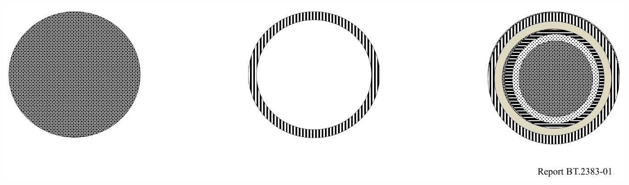
In practise, a television broadcast service area is unlikely to be circular and the population lost to broadcast coverage will not be located in convenient rings around the edge of that service area. Both areas will be influenced by topographical factors, population distribution and the respective locations of the wanted and interfering transmitters.
Transmissions in adjacent bands/channels may also cause interference. Recommendations ITU- R BT.1368 and ITU-R BT.2033, as well as Reports ITU-R BT.2215 and ITU-R BT.2248, contain additional information on this case.

7 DVB-T and DVB-T2 reference broadcasting networks
Reference broadcast transmitter configurations are provided that are representative of actual deployments in the case of assignments or are the reference configurations used in the GE06 Agreement for allotment planning.

7.1 Single transmitter case (assignments)
– High power
• ERP: 200 kW
• Effective antenna height: 300 m
• Antenna height a.g.l.: 200 m
• Antenna pattern:
– Horizontal: Omnidirectional
– Vertical antenna aperture: based on 24λ aperture with 1° beam tilt
– Medium power
• ERP: 5 kW
• Effective antenna height: 150 m
• Antenna height a.g.l.: 75 m
• Antenna pattern:
– Horizontal: Omnidirectional
– Vertical: based on 16λ aperture with 1.6° beam tilt
– Low power
• ERP: 250 W
• Effective antenna height: 75 m
• Antenna height a.g.l.: 30 m
• Antenna pattern:
– Horizontal: Directional (cardioid)
– Vertical: based on 4λ aperture with 3° beam tilt
The attenuation (A_{ϑ}) of the horizontal radiation pattern with azimuth angle (ϑ) is given by:
$A_{}=20 \log_{10}\left(2B-B^{2}\right)$ dB
where:
$B= \frac{1+k+cos\left(\right)}{2+k}$
where:
ϑ : azimuth angle
k : 0.4187 for 10 dB pattern minima.
The resulting pattern is shown in Fig. 2:
Figure 2
Low power DTTB
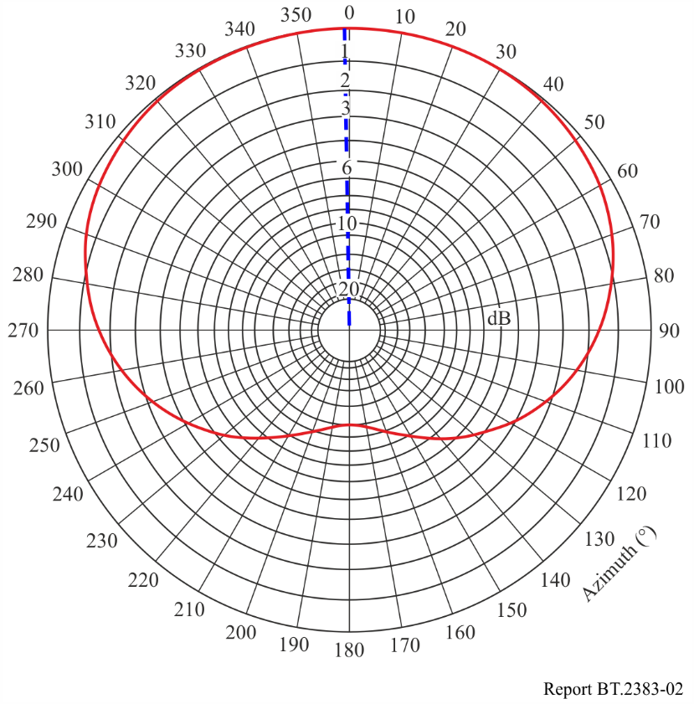
Unlike high and medium power antennas which are usually omnidirectional, very few low power DTTB antenna are omnidirectional. Low power DTTB antennas typically have a directional horizontal radiation pattern usually of a type cardioid (dipoles mounted on a pole) or consisting of one or more panel, Yagi or log-periodic elements. These antennas typically have minima in the HRP that are 10 dB or more below the maximum and may have lobes that occur at various azimuth angles, lobes typically being aligned with the desired service area.
As patterns of low power antenna vary considerably modelling all combinations of pattern in generic compatibility studies is usually not practical. Therefore, to better represent the horizontal radiation pattern of low power DTTB it is proposed to base the generic model on the pattern of a cardioid antenna with a 10 dB minimum. Depending on the compatibility study being undertaken the orientation of the pattern (angle of azimuth) can be varied as required.
The overall gain of the low power DTTB antenna is unchanged given that the gain of the proposed 4λ cardioid is approximately the same as that of an 8λ omnidirectional antenna. The decrease in vertical aperture of a 4λ cardioid relative to an 8λ cardioid (reduction in gain of 3 dB) is offset by the directivity of the cardioid’s horizontal radiation pattern (nominal gain of 3 dB).

7.1.1 Vertical radiation patterns
The normalised field strength in the vicinity of the broadcast transmitting station is a function of the vertical radiation pattern of the transmitting antenna. The equation below is an approximation to be used for sharing studies at angles of θ above and below the horizon.
$E\left(θ\right)=abs\left(\frac{\sin{ψ}}{ψ}\right)$
where:
$ψ=π A\sin{(θ-β})$
and
A : the antenna vertical aperture in wavelengths
β : the beam tilt radians below the horizontal.
To allow for null fill the value of E(θ) should not go below the value shown in Table 1.
TABLE 1
Null fill values to be applied to vertical radiation patterns
 | Limit on E(θ)
First null | 0.15
Second null | 0.1

For the third null and at all angles of θ beyond the third null the value of E(θ) should not fall below 0.05.
E(θ) given above are linear values, to convert them to reduction values in dB the following equation is used:
$Reduction in dB=20*log10\left\{E\left(θ\right)\right\}$

7.2 Out of band mask
Information on transmitter spectrum masks to be used in compatibility studies is provided in Recommendation ITU-R BT.1206.

7.3 Single frequency networks (Allotments) ^{(GE06)}
Three reference networks (RN) for DTTB services in Region 1 will be used as described in Appendix 3.6 of Chapter 3 of the GE06 Agreement. This information is reproduced in part below.
For sharing studies within the service area of an SFN the same vertical diagrams as provided in § 7.1 above should be applied for each transmitter.

7.3.1 Reference network 1 (large service-area SFN)
The network consists of seven transmitters situated at the centre and at the vertices of a hexagonal lattice. An open network type has been chosen, i.e. the transmitters have non-directional antenna patterns and the service area is assumed to exceed the transmitter hexagon by about 15%. The geometry of the network is given in Fig. 3. This reference network (RN 1) is applied to different cases: fixed (RPC 1), outdoor/mobile (RPC 2) and indoor (RPC 3) reception, for Bands IV and V. RN 1 is intended for large service area SFN coverage. It is assumed that main transmitter sites with an appropriate effective antenna height are used as a backbone for this type of network. For portable and mobile reception, the size of the real service areas for this type of SFN coverage is restricted to 150 to 200 km in diameter because of self-interference degradation, unless very rugged DVB-T system variants are used, or the concept of dense networks is employed.
FIGURE 3
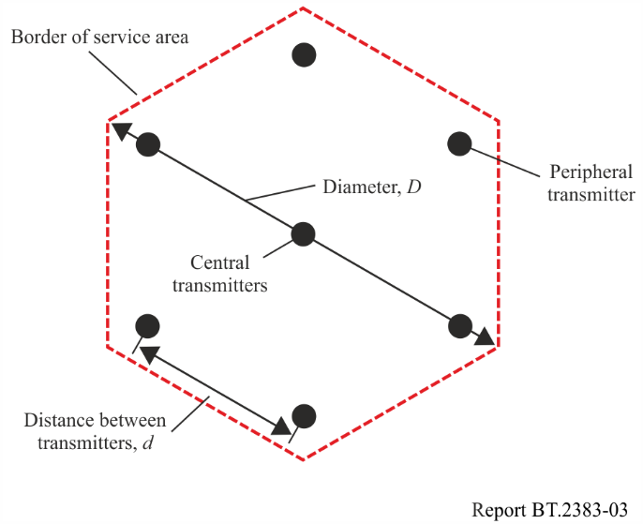
For the guard interval length, the maximum value 1/4 Tu of the 8k FFT mode is assumed. The distance between transmitters in an SFN should not significantly exceed the distance equivalent to the guard interval duration. In this case, the guard interval duration is 224 μs, which corresponds to a distance of 67 km. The distance between transmitters for RPC 1 is taken as 70 km. For RPC 2 and RPC 3, 70 km is too large a distance from a power budget point of view. Therefore, smaller values for the distance between transmitters have been selected, 50 km for RPC 2 and 40 km for RPC 3.
The parameters and the power budgets of RN 1 given in Table 2 should be used.
TABLE 2
Parameters of RN 1 (large service area SFN)
RPC and reception type |  | RPC 1 fixed antenna | RPC 2 portable outdoor and mobile | RPC 3 portable indoor
Type of network |  | Open | Open | Open
Geometry of service area |  | Hexagon | Hexagon | Hexagon
Number of transmitters |  | 7 | 7 | 7
Geometry of transmitter lattice |  | Hexagon | Hexagon | Hexagon
Distance between transmitters d (km) |  | 70 | 50 | 40
Service area diameter D (km) |  | 161 | 115 | 92
Tx effective antenna height (m) |  | 150 | 150 | 150
Tx antenna pattern |  | Non-directional | Non-directional | Non-directional
e.r.p.* dB(W) | Band IV/V | 42.8 | 49.7 | 52.4
* The e.r.p. values indicated in this Table incorporate an additional power margin of 3 dB.

The e.r.p. is given for 650 MHz in Bands IV/V; for other frequencies (f in MHz) the frequency correction factor added is: 20 log₁₀(f/650) for RPC 1 and 30 log₁₀(f/650) for RPC 2 and RPC 3.

7.3.2 Reference network 2 (small service area SFN, dense SFN)
The network consists of three transmitters situated at the vertices of an equilateral triangle. An open network type has been chosen, i.e. the transmitters have non-directional antenna patterns. The service area is assumed to be hexagonal, as indicated in Fig. 4.
This reference network 2 (RN 2) is applied to different cases: fixed (RPC 1), outdoor/mobile (RPC 2) and indoor (RPC 3) reception, for both Bands IV and V.
RN 2 is intended for small service area SFN coverage. Transmitter sites with appropriate effective antenna heights are assumed to be available for this type of network and self-interference restrictions are expected to be small. Typical service area diameters may be from 30 to 50 km.
It is also possible to cover large service areas with this kind of dense SFN. However, a very large number of transmitters is then necessary. It therefore seems reasonable to have large service areas being represented by RN 1, even if a dense network structure is envisaged.
Figure 4
RN 2 (small service area SFN)
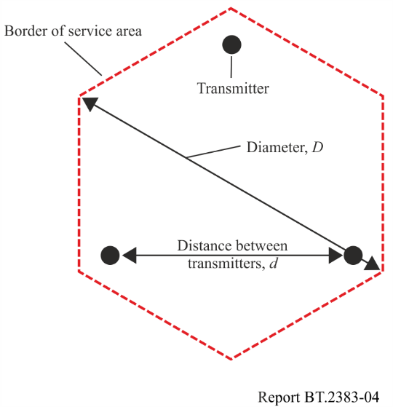
In RN 2 the inter-transmitter distance is 40 km for RPC 1 and 25 km in the case of RPCs 2 and 3.
The parameters and the power budgets of the RN 2 given in Table 3 should be used.
TABLE 3
Parameters of RN 2 (small service area SFN)
RPC and reception type |  | RPC 1 Fixed antenna | RPC 2 portable outdoor and mobile | RPC 3 portable indoor
Type of network |  | Open | Open | Open
Geometry of service area |  | Hexagon | Hexagon | Hexagon
Number of transmitters |  | 3 | 3 | 3
Geometry of transmitter lattice |  | Triangle | Triangle | Triangle
Distance between transmitters d (km) |  | 40 | 25 | 25
Service area diameter D (km) |  | 53 | 33 | 33
Tx effective antenna height (m) |  | 150 | 150 | 150
Tx antenna pattern |  | Non-directional | Non-directional | Non-directional
e.r.p.* (dBW) | Band IV/V | 31.8 | 39.0 | 46.3
* The e.r.p. values indicated in this Table incorporate an additional power margin of 3 dB.

The e.r.p. is given for 650 MHz in Bands IV/V; for other frequencies (f in MHz) the frequency correction factor added is: 20 log₁₀(f/650) for RPC 1 and 30 log₁₀(f/650) for RPC 2 and RPC 3.

7.3.3 Reference network 3 (small service area SFN for urban environment)
The geometry of the transmitter lattice of reference network 3 (RN 3) and the service area are identical to those of RN 2 (see Fig. 4 above).
RN 3 is applied to different cases: fixed (RPC 1), outdoor/mobile (RPC 2) and indoor (RPC 3) reception, for both Bands IV and V.
RN 3 is intended for small service area SFN coverage in an urban environment. It is identical to RN 2, apart from the fact that urban-type height loss figures are used. This increases the required power of the SFN transmitters by about 5 dB for RPC 2 and RPC 3.
The parameters and the power budgets of the RN 3 given in Table 4 should be used.
TABLE 4
Parameters of RN 3 (small service area SFN for urban environment)
RPC and reception type |  | RPC 1 fixed antenna | RPC 2 portable outdoor and mobile | RPC 3 portable indoor
Type of network |  | Open | Open | Open
Geometry of service area |  | Hexagon | Hexagon | Hexagon
Number of transmitters |  | 3 | 3 | 3
Geometry of transmitter lattice |  | Triangle | Triangle | Triangle
Distance between transmitters d (km) |  | 40 | 25 | 25
Service area diameter D (km) |  | 53 | 33 | 33
Tx effective antenna height (m) |  | 150 | 150 | 150
Tx antenna pattern |  | Non-directional | Non-directional | Non-directional
e.r.p.* (dBW) | Band IV/V | 31.8 | 44.9 | 52.2
* The e.r.p. values indicated in this table incorporate an additional power margin of 3 dB.

The e.r.p. is given for 650 MHz in Bands IV/V; for other frequencies (f in MHz) the frequency correction factor added is: 20 log₁₀(f/650) for RPC 1 and 30 log₁₀(f/650) for RPC 2 and RPC 3.

8 ATSC Reference broadcasting networks
Reference broadcast transmitter configurations are provided that are representative of actual deployments of DTTB System A (ATSC) or ATSC 3.0 in the cases of the assignments or the reference configurations used for allotment planning. The configurations depend on both the ‘system-independent’ planning factors and the ‘system dependent’ planning factors, that were used in regulatory allotments by those countries adopting the system. Included are such factors as the maximum power permitted in a 6 MHz channel, the maximum height (HAAT) at which that power level can be used, threshold signal levels for reception in the several television broadcast frequency bands, and so forth. There is only a single operating point with respect to the required signal-to-noise ratio for the threshold of reception at a specific bitrate.
Countries adopting DTTB System A or ATSC 3.0 should use the broadcast transmitter configurations and planning factors provided here.

8.1 DTTB System A (ATSC 1.0) or System S (ATSC 3.0) single transmitter
– High power
• ERP: 1 000 kW
• Antenna Height Above Average Terrain (HAAT): 365 m
• Antenna pattern: Omnidirectional
– Medium power
• ERP: 400 kW
• Antenna Height Above Average Terrain (HAAT): 550 m
• Antenna pattern: Omnidirectional
– Low power
• ERP: 50 kW
• Antenna Height Above Average Terrain (HAAT): 1 800 m
• Antenna pattern: Omnidirectional

8.1.1 Vertical radiation pattern
The field strength in the vicinity of the broadcast UHF transmitting station is a function of the vertical radiation pattern of the transmitting antenna. Table 5 is to be used for sharing studies.
TABLE 5
Vertical UHF radiation pattern
Angle from horizon  (degrees) | Relative field strength
0.75 | 1.000
1.50 | 0.880
2.00 | 0.690
2.50 | 0.460
3.00 | 0.260
3.50 | 0.235
4.00 | 0.210
5.00 | 0.200
6.00 | 0.150
7.00 | 0.150
8.00 | 0.150
9.00 | 0.150
10.00 | 0.150

To allow for null fill the value of the relative field strength should not go below 0.150 at all angles.
Relative Field Strength given above are linear values; to convert them to reduction values in dB the following equations is used:
$Reduction in dB=20*log10\left(Relative Field Strength\right)$

9 ISDB-T reference broadcasting networks

9.1 DTTB System C (ISDB-T) single transmitter
– Main station
• ERP: 30 kW
• Antenna Height Above Average Terrain (HAAT): 100 m
• Antenna pattern: Omnidirectional
– Relay station
• ERP: 50 W
• Antenna Height Above Average Terrain (HAAT): 20 m
• Antenna pattern: Omnidirectional
– Repeater
• ERP: 50 mW
• Antenna Height Above Average Terrain (HAAT): 10 m
• Antenna pattern: Omnidirectional

9.2 Vertical radiation pattern
The field strength in the vicinity of the broadcast UHF transmitting station is a function of the vertical radiation pattern of the transmitting antenna. The middle frequency antenna from Fig. 5 below is to be used for sharing studies for main and relay stations.
Figure 5
Vertical UHF radiation pattern for main and relay station
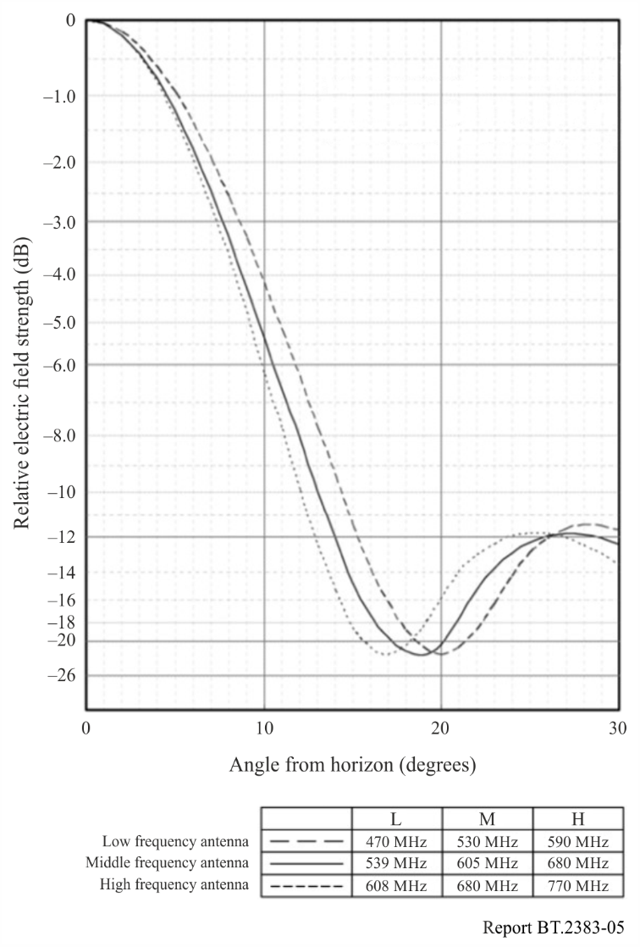
For repeater stations, the 3RG vertical pattern in Fig. 6 should be used.
Figure 6
Vertical UHF radiation pattern for repeater
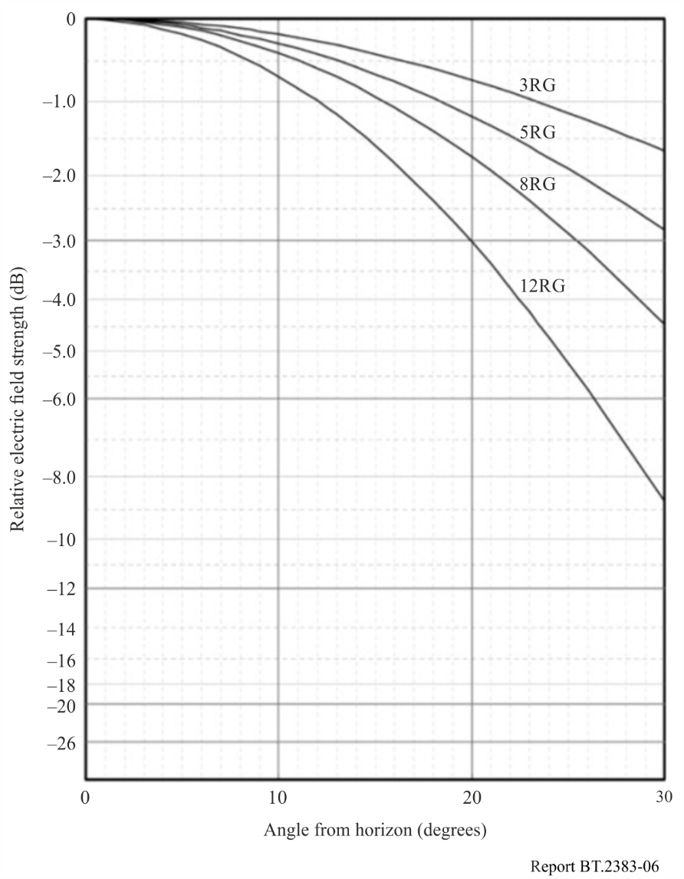

10 DTMB Reference broadcasting networks
Reference broadcast transmitter configurations are provided that are representative of actual deployments in the case of assignments.

10.1 Single transmitter case (Assignments)
– High power
• ERP: 200 kW
• Effective antenna height: 300 m
• Antenna height a.g.l.: 200 m
• Antenna pattern:
– Horizontal: Omnidirectional
– Vertical: 24λ aperture with 1° beam tilt (see formula in § 7.1.1)
– Medium power
• ERP: 5 kW
• Effective antenna height: 150 m
• Antenna height a.g.l.: 75 m
• Antenna pattern:
– Horizontal: Omnidirectional
– Vertical: 16λ aperture with 1.6° beam tilt (see formula in § 7.1.1)
– Low power
• ERP: 250 W
• Effective antenna height: 75 m
• Antenna height a.g.l.: 30 m
• Antenna pattern:
– Horizontal: Omnidirectional
– Vertical: 8λ aperture with 3° beam tilt (see formula in § 7.1.1)

11 DTTB reception modes

11.1 Fixed DTTB reception
Fixed reception is defined as reception where a directional receiving antenna mounted at roof level is used.
The reference receiving antenna height considered to be representative in calculating the field strength for fixed reception is 10 m above ground level or the height of the surrounding clutter if it is greater than 10 m, for example in an urban environment. In order to derive the minimum median field-strength levels, the receiving antenna gain and feeder-loss values are given in §§ 12.1.2 and 12.1.3 for reference frequencies. Minimum median field strength levels for other frequencies are derived by interpolation as described in § 11.5.

11.1.1 Fixed antenna radiation pattern
Standard radiation patterns for receiving antennas for Bands I, III, IV and V, Fig. 7, are given in Recommendation ITU-R BT.419. The curves in Fig. 7 are valid for signals of vertical or horizontal polarization, when both the wanted and the unwanted signals have the same polarization. In the case of orthogonal polarization the combined discrimination provided by directivity and orthogonality cannot be calculated by adding together the separate discrimination values. However, it has been found in practice that a combined discrimination value of 16 dB may be applied for all angles of azimuth in the terrestrial television Bands I to V. The tilt angle for fixed reception of terrestrial television services in hilly environments needs to be taken into account when the angle of arrival above the horizontal plane is considered.
Figure 7
Discrimination obtained by the use of directional receiving antennas in broadcasting
(The number of the broadcasting band is shown on the curve)
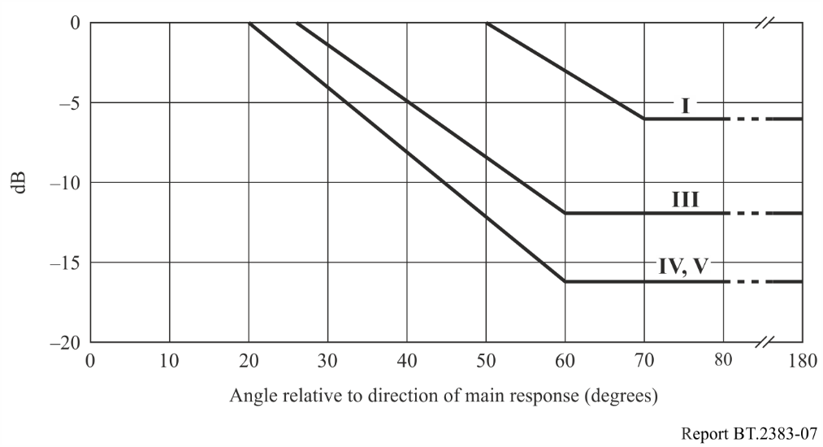
Additional information on radiation pattern characteristics of UHF television receiving antennas reported in Report ITU-R BT.2138 should be considered, where applicable.

11.1.2 Antenna gain

11.1.2.1 DVB-T / DVB-T2 / ATSC 1.0 / ATSC 3.0 / ISDB-T
The antenna gain values (relative to a half-wave dipole) used in the derivation of the minimum median equivalent field-strength values are given in Table 6.
TABLE 6
Antenna gain (relative to a half-wave dipole) in Bands IV and V ^{(GE06)}
Band | IV | V
Reference frequency (MHz) | 500 | 800
Antenna gain (dBd) | 10 | 12

The value of the antenna gain for other frequencies can be calculated by linear inter/extrapolation.

11.1.2.2 DTMB
The antenna gains used in the derivation of the minimum median field strength are given in Table 7.
Antenna gain used in the derivation of the minimum median field strength.
TABLE 7
Antenna gain used in the derivation of the minimum median field strength
Band | IV | V
Reference frequency (MHz) | 500 | 700
Antenna gain (dBd) | 10 | 12

Within any frequency band, the variation of antenna gain with other frequency may be taken into account by the addition of a correction term:
$Corr=10\log{{F_{A}}/{F_{R}}}$
where:
Corr : correction term
F_{A} : actual working frequency being considered
F_{R} : reference frequency quoted above.

11.1.3 Feeder loss
The feeder-loss values used in the derivation of the minimum median wanted signal levels are given in Table 8.
TABLE 8
Feeder loss in Bands IV and V ^{(GE06)}
Band | IV | V
Frequency (MHz) | 500 | 800
Feeder loss (dB) | 3 | 5

The value of the antenna gain for other frequencies can be calculated by linear inter/extrapolation using the values for 500 MHz and 800 MHz.

11.1.4 Location probability for fixed reception
For fixed reception, the location probability is a target value used in spectrum allocations and allotments, as well as channel assignments and facility designs. In certain cases, appropriate location probability varies due to regulatory decisions and/or use case requirements, which also can vary by country.
Table 9 presents location probabilities as mentioned in the GE06 Agreement, Recommendations ITU-R BT.1368 and ITU-R BT.2033, to be used in sharing and compatibility studies.
TABLE 9
Location probability for fixed reception
System | DVB-T/DVB-T2 ^{(GE06)} | ATSC 1.0,  ATSC 3.0 ^{(FCC)} | ISDB-T | DTMB
Location probability (%) | 95 | 50/95 | 95 | 95

11.1.5 Polarization discrimination for fixed reception

11.1.5.1 DVB-T and DVB-T2
For calculation of interference:
– For terminal station (UE) polarization discrimination must not be applied.
– For base station (BS) polarization discrimination may be applied. The combined value of polarization discrimination and discrimination offered by receive aerial directivity must not be more than 16 dB.

11.1.5.2 ATSC 1.0/ATSC 3.0
Polarization discrimination should not be taken into account in frequency planning for fixed reception due to the possibility of multipath interference.

11.1.5.3 ISDB-T
Polarization discrimination should not be taken into account in frequency planning for fixed reception due to the possibility of multipath interference.

11.1.5.4 DTMB
Polarization discrimination should not be taken into account in frequency planning for fixed reception.

11.2 Portable DTTB reception^{(GE06)}
Portable reception is defined as:
– outdoor – which means reception by a portable receiver with an attached or built-in antenna is used outdoors at no less than 1.5 m above ground level;
– indoor – which means reception by a portable receiver with an attached or built-in antenna is used indoors at no less than 1.5 m above floor level in rooms with a window in an external wall.
In both cases, it is assumed that optimal receiving conditions will be found by moving the antenna up to 0.5 m in any direction and extreme cases, such as reception in completely shielded rooms, are disregarded.

11.2.1 Considerations on height loss
For portable (indoor and outdoor) reception, a receiving antenna height of 1.5 m above ground level is used. The same receiving antenna height is also used for mobile reception.
However, in broadcasting, it is common practice for fixed reception to calculate the field strength at 10 m, or at the height of the surrounding clutter if it is greater than 10 m, for example in an urban environment. In some cases, a 10 m reference height is also used as the starting point in calculations for portable and mobile reception with an appropriate height loss taken into account to derive the required value at 1.5 m.
Hence a height loss correction factor for an antenna height of 1.5 m should be used in the calculation of signal levels. The height-loss values for portable and for mobile reception for reference frequencies are given in Tables 10 and 11. Appropriate values for the height loss for other frequencies in the UHF broadcast band can be obtained by linear interpolation/extrapolation of the values given in Tables 10 and 11 for 500 MHz and 800 MHz.
TABLE 10
Rural/suburban height loss in Bands IV and V
 | Band IV | Band V
Frequency (MHz) | 500 | 800
Height loss (dB) (10 m terminal and clutter height to 1.5 m receiver height) | 16 | 18

NOTE – These values are those obtained for rural/suburban coverage. In urban and dense-urban areas, higher values are to be applied (see Table 11).
TABLE 11
Urban/dense urban height loss in Bands IV and V
 | Band IV | Band V
Frequency (MHz) | 500 | 800
Urban height loss (dB) (20 m terminal and clutter height to 1.5 m receiver height) | 23 | 25
Dense urban height loss (dB) (30 m terminal and clutter height to 1.5 m receiver height) | 26 | 28

11.2.2 Building entry loss
The methodology described in Recommendation ITU-R P.2109 for calculating building loss should be used in sharing and compatibility studies involving broadcast systems.
Recommendation ITU-R P.2109 covers a full range of building types of traditional and thermally efficient construction. For sharing and compatibility studies involving broadcast systems using Recommendation ITU-R P.2109, whenever a single representative value is required (for example, in an MCL analysis), the parameters provided in Table 12 should be used. This is independent of coverage planning. For dynamic or statistical analysis (for example, in a Monte Carlo simulation), the full distribution function of Recommendation ITU-R P.2109 should be used.
TABLE 12
P.2109 broadcast building entry loss parameters to use in sharing and compatibility studies
Building type | Environment | Probability building entry loss not exceeded
Traditional | Suburban | 50%
Traditional | Urban | 70%

NOTE – Studies of building entry loss have meant figures have changed over time with the current version of Recommendation ITU-R P.2109 representing the latest work. The parameters specified in Table 12 provide a building entry loss aligned with values derived using parameters supplied in older documents, for example Recommendation ITU-R P.1812 and the low building class in Recommendation ITU-R BT.2033.

11.2.3 Antenna gain for portable reception
Recommendation ITU-R BT.1368 gives in its Annex 6, § 4.1, information on antennas for portable reception. For portable reception, an omnidirectional antenna should be applied. The antenna gain (relative to a half-wave dipole) is as given in Table 13.
TABLE 13
Antenna gain (dBd) for portable reception
Band | Gain (dBd)
Band IV (470-582 MHz) | 0
Band V (582-960 MHz) | 0
Note: This is equivalent to 2.15 dBi.

11.2.4 Location probability for portable reception
For portable indoor and outdoor reception, the location probability is a target value used in spectrum allocations and allotments, as well as channel assignments and facility designs. In certain cases, appropriate location probability varies due to regulatory decisions and/or use case requirements, which also can vary by country.
Table 14 presents location probabilities as mentioned in the GE06 Agreement, Recommendations ITU-R BT.1368 and ITU-R BT.2033, to be used in sharing and compatibility studies.
TABLE 14
Location probability for portable reception
System | DVB-T/DVB-T2 ^{(GE06)} | ATSC 1.0  ATSC 3.0 | ISDB-T | DTMB
Location probability (%) | 95 | 50/95 | 95 | 95

11.2.5 Polarization discrimination for portable reception
Polarization discrimination should not be taken into account in frequency planning for portable reception.

11.3 Mobile DTTB reception
Mobile reception is defined as reception by a receiver in motion with an antenna (external or integrated one) situated at no less than 1.5 m above ground level. This could for example be a car receiver or handheld equipment.
The dominant factor with regard to local reception effects is fading in a Rayleigh channel. Fade margins are intended to offset these effects. Fade margins depend on the frequency and the velocity.

11.3.1 Considerations on height loss
For mobile reception, height loss as given in Tables 10 and 11 should be used.

11.3.2 Antenna gain for Mobile DTTB reception
Recommendation ITU-R BT.1368 gives in its Annex 6, § 4.3, information on antennas for mobile reception. For mobile reception, practical standard 1/4 monopole antenna for vehicle reception, which uses the metallic roof as a ground plane, should be applied. The antenna gain for conventional incident wave angles depends on the position of the antenna on the roof. For passive antenna systems, the antenna gain (relative to a half-wave dipole) is as given in Table 15.
TABLE 15
Antenna gain (dBd) for mobile reception
Band | Gain (dBd)
Band IV | −2
Band V | −1
Note: This is equivalent to 2.15 dBi.

11.3.3 Location probability for mobile reception
For mobile reception, the location probability is a target value used in spectrum allocations and allotments, as well as channel assignments and facility designs. In certain cases, appropriate location probability varies due to regulatory decisions and/or use case requirements, which also can vary by country.
Table 16 presents location probabilities as mentioned in the GE06 Agreement, Recommendations ITU-R BT.1368 and ITU-R BT.2033, to be used in sharing and compatibility studies.
TABLE 16
Location probability for mobile reception
System | DVB-T/DVB-T2 | ATSC 1.0/  ATSC 3.0 | ISDB-T | DTMB
Location probability (%) | 99 | 50/99 | 99 | 99

11.3.4 Polarization discrimination for mobile reception
For mobile reception, the polarization discrimination is between about 4 to 10 dB depending on the roof position of the antenna when mounted on top of a vehicle. The polarization discrimination for integrated antennas, i.e. antennas within the housing of portable devices, is assumed to be 0 dB.

11.4 Reference planning configurations for DVB-T and DVB-T2 ^{(GE06)}
A planning configuration describes relevant technical aspects of a broadcasting service implementation. Three planning configurations are used in assessing DTTB coverage in Region 1 as described in Appendix 3.5 of Chapter 3 of the GE06 Agreement. The three reference planning configurations are:
1) RPC1 – Fixed
2) RPC2 – Portable Outdoor/Mobile
3) RPC3 – Portable Indoor.

11.5 Interpolation of reference field strength values ^{(GE06)}
For frequencies other than those quoted in tables, as described in Appendix 3.5 of Chapter 3 of the Final Acts of RRC06, the reference field-strength values should be adjusted by adding the correction factor defined according to the following rule:
– (Emed)ref(f) = (Emed)ref(fr) + Corr;
– for fixed reception, Corr = 20 log10 (f/fr), where f is the actual frequency and fr the reference frequency in the table;
– for portable reception and mobile reception, Corr = 30 log10 (f/fr) where f is the actual frequency and fr the reference frequency in the Table.

12 System parameters for DTTB Systems

12.1 System parameters related to DVB-T (8 MHz)

12.1.1 General parameters
TABLE 17
General DVB-T parameters
Parameter | Fixed reception  Portable reception  (outdoor/mobile or indoor)
Signal bandwidth (MHz) | 7.60
Thermal noise density (kT₀) (dBm/Hz) | −173.98
Receiver noise figure (dB) | 7

The studies should consider two reception modes, one mode for fixed reception and one mode for portable reception.

12.1.2 Carrier-to-noise ratio
Within Recommendations ITU-R BT.1368 for DVB-T and in ITU-R BT.2033 for DVB-T2, carrier to noise figures are provided. For compatibility and sharing studies the values in Table 18 should be used for both systems.
TABLE 18
Carrier-to-noise ratio
Fixed reception | Portable reception
20 dB | 18 dB

12.1.3 Minimum field strength at 650 MHz
TABLE 19
Minimum field strength at f_{r} = 650 MHz
Fixed reception at 10 m for 95%  location probability | Portable outdoor suburban reception at 1.5 m for 95% location probability
55.2 dB(µV/m) | 60.2 dB(µV/m)

Minimum median field-strength levels for other frequencies than 650 MHz are derived by the correction described in § 11.5.

12.1.4 Link budgets
Example link budgets for DVB-T for fixed rooftop, portable outdoor and portable indoor reception are provided in Annex 2.

12.1.5 Protection ratios and overload threshold for interference from other services
Recommended values for protection ratios (PR) and overloading thresholds for DVB-T systems to be used in sharing studies can be found Recommendation ITU-R BT.1368, Annex 2, § 1.5 “Protection of DVB-T from wideband signals other than terrestrial broadcasting”.
For other ACLR values than those in used in the referenced table, the PR figures should be corrected using the formula referenced in § 12.6.

12.2 System parameters related to DVB-T2 (8 MHz)

12.2.1 General parameters
TABLE 20
General DVB-T2 parameters
Parameter | Fixed reception  Portable reception  (outdoor/Mobile or indoor)
Signal bandwidth (MHz) | 7.77
Thermal noise density (kT₀) (dBm/Hz) | −173.98
Receiver noise figure (dB) | 6

The studies should consider two reception modes, one mode for fixed reception and one mode for portable reception.

12.2.2 Carrier-to-noise ratio
Within GE06, Recommendations ITU-R BT.1368 for DVB-T and in ITU-R BT.2033 for DVB-T2, carrier-to-noise figures are provided. For compatibility and sharing studies the values in Table 21 should be used for both systems.
TABLE 21
Carrier-to-noise ratio
Fixed reception | Portable reception
20 dB | 18 dB

12.2.3 Minimum field strength at 650 MHz
TABLE 22
Minimum field strength at f_{r}=650 MHz
Fixed reception  at 10 m for 95% location probability | Portable outdoor suburban reception  at 1.5 m for 95% location probability
54.3 dB(µV/m) | 59.3 dB(µV/m)

Minimum median field-strength levels for other frequencies than 650 MHz are derived by the correction described in § 11.5.

12.2.4 Link budgets
Example link budgets for DVB-T2 for fixed rooftop, portable outdoor and portable indoor reception are provided in Annex 2.

12.2.5 Protection ratios and overload threshold for interference from other services
Recommended values for protection ratios and overloading threshold for DVB-T2 receivers can be found Annex 1 of Recommendation ITU-R BT.2033. For other ACLR values than those in used in the referenced table, the PR figures should be corrected using the formula referenced in § 12.6.

12.3 System parameters related to ATSC 1.0 and ATSC 3.0 (both 6 MHz)

12.3.1 General UHF parameters
TABLE 23
General UHF parameters
Parameter
Channel bandwidth (MHz) | 6
Thermal noise density (kT₀) (dBm/Hz) | −173.20
Receiver noise figure (dB) | 7

The studies should consider two reception modes, one mode for fixed reception and one mode for portable reception.

12.3.2 Carrier-to-noise ratio
TABLE 24
Carrier-to-noise ratio
Fixed reception | Portable reception
15.0 dB | 15.0 dB

12.3.3 Minimum UHF field strength
TABLE 25
Minimum field strength at f_{r} = 650 MHz
Fixed reception  at 10 m for 50% location probability | Portable outdoor reception  at 1.5 m for 50% location probability
41 dB(µV/m) | 48 dB(µV/m)
Minimum median field-strength levels for other frequencies than 650 MHz are derived by the correction described in § 11.5.

12.3.4 Link budgets
Example link budgets for ATSC 3.0 for fixed rooftop, portable outdoor and portable indoor reception are provided in Annex 2.

12.3.5 Protection ratios
Co-channel, first adjacent-channel, and multiple adjacent-channel values for protection ratio to be used in sharing studies can be found Tables 3, 4 and 5 in Annex 1 of Recommendation ITU- R BT.1368.

12.4 System parameters and protection requirements related to ISDB-T (6 MHz/8 MHz)

12.4.1 General parameters
TABLE 26
General ISDB-T parameters
Parameter | Fixed reception /  Portable reception
Signal bandwidth (6 MHz system / 8 MHz system) (MHz) | 5.6 / 7.4
Thermal noise density (kT₀) (dBm/Hz) | −173.98
Receiver noise figure (dB) | 7

12.4.2 Carrier-to-noise ratio
TABLE 27
Carrier-to-noise ratio
Fixed reception
21 dB

12.4.3 Minimum field strength at 600 MHz
TABLE 28
Minimum field strength at f_{r} = 600 MHz
Bandwidth | Fixed reception at 10 m for 95% location probability
6 MHz system | 55.0 dB(µV/m)
8 MHz system | 56.2 dB(µV/m)

Minimum median field-strength levels for other frequencies than 600 MHz are derived by the correction described in § 11.5.

12.4.4 Link budget
An example link budget for ISDB-T for fixed rooftop reception is provided in Annex 2.

12.4.5 Protection ratios and overload threshold for interference from other services
Recommended values for protection ratios (PR) and overloading thresholds for ISDB-T systems to be used in sharing studies can be found in Annex 3 to Recommendation ITU-R BT.1368.

12.5 System parameters and protection requirements related to DTMB (8 MHz)

12.5.1 General parameters
TABLE 29
General DTMB parameters
Parameter | Fixed reception  Portable reception  (outdoor/Mobile or indoor)
Signal bandwidth (MHz) | 7.56
Thermal noise density (kT₀) (dBm/Hz) | −173.98
Receiver noise figure (dB) | 7

12.5.2 Carrier-to-noise ratio
TABLE 30
Carrier-to-noise ratio
Fixed reception | Portable reception
19 dB | 14 dB

12.5.3 Minimum field strength at 700 MHz
TABLE 31
Minimum field strength at f_{r} = 700 MHz
Fixed reception at 10 m for 95%  location probability | Portable outdoor reception at 1.5 m for 95%  location probability
50 dB(µV/m) | 67 dB(µV/m)

Minimum median field-strength levels for other frequencies than 700 MHz are derived by the correction described in § 11.5.

12.5.4 Protection ratios and overload threshold for interference from other services
Recommended values for protection ratios (PR) and overloading thresholds for DTMB systems to be used in sharing studies can be found in Annex 4 to Recommendation ITU-R BT.1368.

12.6 Correction of protection ratio figures for different ACLR values
Recommendation ITU-R BT.1368 Attachment 3 to Annex 2 describes calculation to derive protection ratios for all DTTB systems for different ACLR values.

13 Propagation considerations
Broadcast planning is based on the service being subject to occasional very limited outages during the year. Indeed, many administrations have followed this and other principles established in the DTTB Handbook – Digital terrestrial television broadcasting in the VHF/UHF bands, in achieving global harmonisation of terrestrial television broadcasting systems. The protection criteria established in Recommendations ITU-R BT.1368 and ITU-R BT.2033 for protecting DTTB services have been developed on the assumption that Recommendation ITU-R P.1546 is used in interference assessment and it is essential to take this into consideration.
As Recommendation ITU-R P.1546 is applicable where terminals are below 3 000 metres, for compatibility studies when a terminal is above 3 000 metres Recommendation ITU-R P.528 (up to 20 000 metres) or Recommendation ITU-R P.619 should be used for computation of the interfering signal strengths at the required quantile.
It should be noted that Recommendation ITU-R P.1546 has been the recommended propagation model for terrestrial television broadcast planning for many decades. Application of a different propagation model for DTTB coverage/interference assessment may not necessarily be compatible with the planning criteria and protection ratios applied by administrations towards maintaining the required quality of coverage.
Administrations which currently have planned digital terrestrial television broadcasting services are aware that, like several other radiocommunication services, interference assessment is based on an interfering signal exceeding an annual 1% of time limit based upon a methodology that includes Recommendation ITU-R P.1546.
The values in Table 32 are normally applied (standard broadcast planning practice and the GE06 Agreement):
TABLE 32
Time percentages used for planning and sharing studies
System | Wanted field strength | Interfering field strength
DVB-T / DVB-T2 | 50% | 1%
ATSC 1.0/ATSC 3.0 / ISDB-T | 90% | 1%
DTMB | 50% | 1%

14 Aggregation of interference
Attachment 3 to Annex 2 to Report ITU-R BT.2265 describes the methods for the aggregation of short-term interfering signals.
Two methods for the computation of aggregate interference from multiple transmitters where individual path losses are temporally variable are recommended.
The first approach (“general method”) is based on a rigorous mathematical treatment of the joint variability of multiple paths, and can be used to estimate the aggregate received power at any percentage-time. The method uses Monte Carlo simulation involving multiple calculations for each path of interest, and would be appropriate for use in a situation where numerically-intensive computer simulation is already envisaged.
Recognizing that this approach may not always be appropriate (e.g. where a quick estimate is required without an iterative computer simulation), a simple alternative is also proposed (“simple method”). This method is currently only defined for the case where the aggregate power is to be estimated at 1% time, although it could be readily extended for use at other percentage-times.

15 Comparative evaluations
When calculations are carried out with certain reference parameters and comparison calculations are to be carried out, the relevant reference parameters must be the same. For example, if single-entry field strength values are calculated at a 10 m DTTB receive antenna height, then comparison multiple-entry field values should also be calculated at the same 10 m DTTB receive antenna height.

16 Inclusion of noise in interference assessments
An important factor in terrestrial television broadcast service planning has been to take into consideration an allowance for the noise environment in which the television broadcast service is to be planned – these are rural, urban and suburban. It should also be noted that television broadcast services are planned based upon the calculation of C/N prior to the introduction and deployment of other services which has the potential to increase the noise allowance calculation required in many environments.
A wanted television broadcast signal must be sufficient to overcome noise for it to be receivable and in this respect thermal noise and noise figure are an essential part of any calculations. These are the fundamentals upon which the television receivers deployed globally have been designed.

Annex 1
List of relevant ITU-R texts
Additional information on the characteristics which are referred to in this Report can be found in the following ITU documents:
– Recommendation ITU-R BT.419 – Directivity and polarization discrimination of antennas in the reception of television broadcasting
– Recommendation ITU-R BT.500 – Methodology for the subjective assessment of the quality of television pictures
– Recommendation ITU-R BT.1206 – Spectrum limit masks for Digital Terrestrial Television Broadcasting
– Recommendation ITU-R BT.1306 – Error correction, data framing, modulation and emission methods for digital terrestrial television broadcasting
– Recommendation ITU-R BT.1368 – Planning criteria, including protection ratios, for digital terrestrial television services in the VHF/UHF bands
– Recommendation ITU-R BT.1877 – Error-correction, data framing, modulation and emission methods for second generation of digital terrestrial television broadcasting systems
– Report ITU-R BT.2138 – Radiation pattern characteristics of UHF television receiving antennas
– Final Acts of RRC06 – The GE06 Agreement
– ITU-R DTTB Handbook.
Additional information on the protection requirements which are referred to in this Report can be found in the following ITU documents:
– Recommendation ITU-R BT.1368 – Planning criteria, including protection ratios, for digital terrestrial television services in the VHF/UHF bands
– Recommendation ITU-R BT.1735 – Methods for objective reception quality assessment of digital terrestrial television broadcasting signals of System B specified in Recommendation ITU-R BT.1306 – Error correction, data framing, modulation and emission methods for digital terrestrial television broadcasting
– Recommendation ITU-R BT.1895 – Protection criteria for terrestrial broadcasting systems
– Final Acts of RRC06 – The GE06 Agreement²³
– Recommendation ITU-R BT.2033 – Planning criteria, including protection ratios, for second generation of digital terrestrial television broadcasting systems in the VHF/UHF bands
– Recommendation ITU-R BT.2036 – Characteristics of a reference receiving system for frequency planning of digital terrestrial television systems.
– Report ITU-R BT.2215 – Measurements of Protection Ratios and Overload Thresholds for Broadcast TV Receivers
– Report ITU-R BT.2265 – Guidelines for the assessment of interference into the broadcasting service
Information on sharing and compatibility studies involving DTTB can be found in the following ITU documents:
– Recommendation ITU-R BT.2136 – Assessing interference into digital terrestrial television broadcasting from other services by means of Monte Carlo simulation
– Report ITU-R BT.2247 – Field measurement and analysis of compatibility between DTTB and IMT
– Report ITU-R BT.2248 – A conceptual method for the representation of loss of broadcast coverage
– Report ITU-R BT.2337 – Sharing and compatibility studies between digital terrestrial television broadcasting and terrestrial mobile broadband applications, including IMT, in the frequency band 470-694/698 MHz
– Report ITU-R BT.2339 – Co-channel sharing and compatibility studies between digital terrestrial television broadcasting and international mobile telecommunication in the frequency band 694-790 MHz in the GE06 planning area
– Report ITU-R BT.2470 – Use of Monte Carlo simulation to model interference to DTTB.
Information on propagation matters referred to in this Report can be found in the following ITU documents:
– Recommendation ITU-R P.528 – A propagation prediction method for aeronautical mobile and radio navigation services using the VHF, UHF and SHF bands
– Recommendation ITU-R P.619 – Propagation data required for the evaluation of interference between stations in space and those on the surface of the earth
– Recommendation ITU-R P.1546 – Method for point-to-area predictions for terrestrial services in the frequency range 30 MHz to 3 000 MHz
– Recommendation ITU-R P.1812 – A path-specific propagation prediction method for point-to-area terrestrial services in the VHF and UHF bands
– Recommendation ITU-R P.2109 – Prediction of building entry loss.

Annex 2
DTTB link budgets

A2.1 DVB-T

A2.1.1 DVB-T fixed
DVB-T link budget for fixed roof top reception
DVB-T transmitter parameters
 | Unit | High power transmitter | Medium power transmitter | Low power transmitter | Notes
e.i.r.p. | dBm | 85.16 | 69.14 | 56.13 | For 200 kW, 5 kW and 0.25 kW ERP transmitters respectively
Tx antenna effective height | m | 300.00 | 150.00 | 75.00
DVB-T receiver parameters
Rx antenna height | m | 10.00 | 10.00 | 10.00 | ITU-R BT.2036-2
Centre frequency | MHz | 650.00 | 650.00 | 650.00 | Table 19
Channel BW | MHz | 8.00 | 8.00 | 8.00 | ITU-R BT.1368-13
Effective BW | MHz | 7.6 | 7.6 | 7.6 | ITU-R BT.2036-2
Noise figure (F) | dB | 7 | 7 | 7 | ITU-R BT.1368-13
Boltzmannʼs constant (k) | J/K | 1.38E-23 | 1.38E-23 | 1.38E-23
Absolute temperature (T) | K | 290 | 290 | 290
Allowance for man-made noise | dB | 0 | 0 | 0
Noise power (P_{n}) | dBm | −98.17 | −98.17 | −98.17 | P_{n}(dBm) = F + 10log(k * T * B * 10⁶) + 30
SNR at cell edge | dB | 20 | 20 | 20 | Table 18
Receiver sensitivity (P_{min}) | dBm | −78.17 | −78.17 | −78.17 | P_{min} = P_{n}(dBm) + SNR(dB)
DVB-T link budget for fixed roof top reception
Cell edge coverage probability | % | 95 | 95 | 95 | Table 9
Gaussian confidence factor for cell edge coverage probability of 95% (μ_{95%}) | % | 1.64 | 1.64 | 1.64
Shadowing loss standard deviation (σ) | dB | 5.50 | 5.50 | 5.50 | ITU-R P.1546-6
Loss margin (L_{m}) 95% | dB | 9.02 | 9.02 | 9.02 | L_{m} = μ_{95%} * σ
P_{mean} (95%) | dBm | −69.15 | −69.15 | −69.15 | P_{mean} = P_{min} + L_{m}
Minimum field strength at 10 m | dB(µV/m) | 55.16 | 55.16 | 55.16
Feeder loss (L_{cable}) | dB | 4.00 | 4.00 | 4.00 | Table 8
Antenna gain (G_{iso}) | dBi | 13.15 | 13.15 | 13.15 | Table 6
G_{iso-}L_{cable} | dBi | 9.15 | 9.15 | 9.15
Max allowed path loss (L_{p}) | dB | 163.43 | 147.41 | 134.40 | L_{p} = EIRP+(G_{iso}-L_{cable}) − P_{mean}

A2.1.2 DVB-T portable outdoor
DVB-T link budget for portable outdoor reception
DVB-T transmitter parameters
 | Unit | High power transmitter | Medium power transmitter | Low power transmitter | Notes
e.i.r.p. | dBm | 85.16 | 69.14 | 56.13 | For 200 kW, 5 kW and 0.25 kW ERP transmitters respectively
Tx antenna effective height | m | 300.00 | 150.00 | 75.00
DVB-T receiver parameters
Rx antenna height | m | 1.50 | 1.50 | 1.50 | ITU-R BT.2036-2
Centre frequency | MHz | 650.00 | 650.00 | 650.00 | Table 19
Channel BW | MHz | 8.00 | 8.00 | 8.00 | ITU-R BT.1368-13
Effective BW | MHz | 7.6 | 7.6 | 7.6 | ITU-R BT.2036-2
Noise figure (F) | dB | 7 | 7 | 7 | ITU-R BT.1368-13
Boltzmannʼs constant (k) | J/K | 1.38E-23 | 1.38E-23 | 1.38E-23
Absolute temperature (T) | K | 290 | 290 | 290
Allowance for man-made noise | dB | 0 | 0 | 0
Noise power (P_{n}) | dBm | −98.17 | −98.17 | −98.17 | P_{n}(dBm) = F + 10log(k * T * B * 10⁶) + 30
SNR at cell edge | dB | 18 | 18 | 18 | Table 18
Receiver sensitivity (P_{min}) | dBm | −80.17 | −80.17 | −80.17 | P_{min} = P_{n}(dBm) + SNR(dB)
DVB-T link budget for portable outdoor reception
Cell edge coverage probability | % | 95 | 95 | 95 | Table 14
Gaussian confidence factor for cell edge coverage probability of 95% (μ_{95%}) | % | 1.64 | 1.64 | 1.64
Shadowing loss  standard deviation (σ) | dB | 5.50 | 5.50 | 5.50 | ITU-R P.1546-6
Loss margin (L_{m}) 95% | dB | 9.02 | 9.02 | 9.02 | L_{m} = μ_{95%} * σ
P_{mean} (95%) | dBm | −71.15 | −71.15 | −71.15 | P_{mean} = P_{min} + L_{m}
Minimum field strength at 20 m | dB(µV/m) | 84.16 | 84.16 | 84.16 | Urban
Minimum field strength at 10 m | dB(µV/m) | 77.16 | 77.16 | 77.16 | Suburban
Feeder loss (L_{cable}) | dB | 0.00 | 0.00 | 0.00
Antenna gain (G_{iso}) | dBi | 2.15 | 2.15 | 2.15 | Table 13
G_{iso-}L_{cable} | dBi | 2.15 | 2.15 | 2.15
Urban height loss 20 m to 1.5 m (L_{height}) | dB | 24 | 24 | 24 | ITU-R P.1546-6
Suburban height loss 10 m to 1.5 m (L_{height}) | dB | 17 | 17 | 17 | ITU-R P.1546-6
Urban 20 m max path loss (L_{p}) | dB | 134 | 118 | 105 | L_{p} = EIRP + (G_{iso}-L_{cable})  − L_{height} − P_{mean}
Suburban 10 m max path loss (L_{p}) | dB | 141 | 125 | 112 | L_{p} = EIRP + (G_{iso}-L_{cable})  − L_{height} − P_{mean}

A2.1.3 DVB-T portable indoor
DVB-T link budget for portable indoor reception
DVB-T transmitter parameters
 | Unit | High power transmitter | Medium power transmitter | Low power transmitter | Notes
e.i.r.p. | dBm | 85.16 | 69.14 | 56.13 | For 200 kW, 5 kW and 0.25 kW ERP transmitters respectively
Tx antenna effective height | m | 300.00 | 150.00 | 75.00
DVB-T receiver parameters
Rx antenna height | m | 1.50 | 1.50 | 1.50 | ITU-R BT.2036-2
Centre frequency | MHz | 650.00 | 650.00 | 650.00 | Table 19
Channel BW | MHz | 8.00 | 8.00 | 8.00 | ITU-R BT.1368-13
Effective BW | MHz | 7.6 | 7.6 | 7.6 | ITU-R BT.2036-2
Noise figure (F) | dB | 7 | 7 | 7 | ITU-R BT.1368-13
Boltzmannʼs constant (k) | J/K | 1.38E-23 | 1.38E-23 | 1.38E-23
Absolute temperature (T) | K | 290 | 290 | 290
Allowance for man-made noise | dB | 0 | 0 | 0
Noise power (P_{n}) | dBm | −98.17 | −98.17 | −98.17 | P_{n}(dBm) =  F + 10log(k * T * B * 10⁶) + 30
SNR at cell edge | dB | 18 | 18 | 18 | Table 18
Receiver sensitivity (P_{min}) | dBm | −80.17 | −80.17 | −80.17 | P_{min} = P_{n}(dBm) + SNR(dB)
DVB-T link budget for portable indoor reception
Cell edge coverage probability | % | 95 | 95 | 95 | Table 14
Gaussian confidence factor for cell edge coverage probability of 95% (μ_{95%}) | % | 1.64 | 1.64 | 1.64
Shadowing loss standard  deviation (σ) | dB | 5.50 | 5.50 | 5.50 | ITU-R P.1546-6
Loss margin (L_{m}) 95% | dB | 9.02 | 9.02 | 9.02 | L_{m} = μ_{95%} * σ
P_{mean} (95%) | dBm | −71.15 | −71.15 | −71.15 | P_{mean} = P_{min} + L_{m}
Minimum field strength at 20 m | dB(µV/m) | 102.3 | 102.3 | 102.3 | Urban
Minimum field strength at 10 m | dB(µV/m) | 91.23 | 91.23 | 91.23 | Suburban
Feeder loss (L_{cable}) | dB | 0.00 | 0.00 | 0.00
Antenna gain (G_{iso}) | dBi | 2.15 | 2.15 | 2.15 | Table 13
G_{iso-}L_{cable} | dBi | 2.15 | 2.15 | 2.15
Urban height loss 20 m to 1.5 m (L_{height}) | dB | 24 | 24 | 24 | ITU-R P.1546-6
Suburban height loss 10 m to 1.5 m (L_{height}) | dB | 17 | 17 | 17 | ITU-R P.1546-6
Urban building entry loss (p=70%) (L_{wall}) | dB | 18.14 | 18.14 | 18.14 | Table 13
Suburban building entry loss (p=50%) (L_{wall}) | dB | 14.07 | 14.07 | 14.07 | Table 12
Urban 20 m max path loss (L_{p}) | dB | 116 | 100 | 87 | L_{p} = EIRP+(G_{iso} − L_{cable})  − L_{wall} – L_{height} − P_{mean}
Suburban 10 m max path loss (L_{p}) | dB | 127 | 111 | 98 | L_{p} = EIRP+(G_{iso} − L_{cable})  − L_{wall} − L_{height} − P_{mean}

A2.2 DVB-T2

A2.2.1 DVB-T2 fixed
DVB-T2 link budget for fixed roof top reception
DVB-T2 transmitter parameters
 | Unit | High power transmitter | Medium power transmitter | Low power transmitter | Notes
e.i.r.p. | dBm | 85.16 | 69.14 | 56.13 | For 200 kW, 5 kW and 0.25 kW ERP transmitters respectively
Tx antenna effective height | m | 300.00 | 150.00 | 75.00
DVB-T2 receiver parameters
Rx antenna height | m | 10.00 | 10.00 | 10.00 | ITU-R BT.2036-2
Centre frequency | MHz | 650.00 | 650.00 | 650.00 | Table 22
Channel BW | MHz | 8.00 | 8.00 | 8.00 | ITU-R BT.2033-1
Effective BW | MHz | 7.77 | 7.77 | 7.77 | ITU-R BT.2036-2
Noise figure (F) | dB | 6 | 6 | 6 | ITU-R BT.2033-1
Boltzmannʼs constant (k) | J/K | 1.38E-23 | 1.38E-23 | 1.38E-23
Absolute temperature (T) | K | 290 | 290 | 290
Allowance for man made noise | dB | 0 | 0 | 0
Noise power (P_{n}) | dBm | −99.07 | −99.07 | −99.07 | P_{n}(dBm) = F + 10log(k * T * B * 10⁶) + 30
SNR at cell edge | dB | 20 | 20 | 20 | Table 23
Receiver sensitivity (P_{min}) | dBm | −79.07 | −79.07 | −79.07 | P_{min} = P_{n}(dBm) + SNR(dB)
DVB-T link budget for fixed roof top reception
Cell edge coverage probability | % | 95 | 95 | 95 | Table 9
Gaussian confidence factor for cell edge coverage probability of 95% (μ_{95%}) | % | 1.64 | 1.64 | 1.64
Shadowing loss  standard deviation (σ) | dB | 5.50 | 5.50 | 5.50 | ITU-R P.1546-6
Building entry loss  standard deviation (σ_{w}) | dB | 0.00 | 0.00 | 0.00
Total loss  standard deviation (σ_{T}) | dB | 5.50 | 5.50 | 5.50 | s_{T} = SQRT(σ² + σ_{w}²)
Loss margin (L_{m}) 95% | dB | 9.02 | 9.02 | 9.02 | L_{m} = μ_{95%} * σ
P_{mean} (95%) | dBm | −70.05 | −70.05 | −70.05 | P_{mean} = P_{min} + L_{m}
Minimum field strength at 10 m | dB(µV/m) | 54.26 | 54.26 | 54.26
Feeder loss (L_{cable}) | dB | 4.00 | 4.00 | 4.00 | Table 8
Antenna gain (G_{iso}) | dBi | 13.15 | 13.15 | 13.15 | Table 6
G_{iso-}L_{cable} | dBi | 9.15 | 9.15 | 9.15
Max allowed path loss (L_{p}) | dB | 164 | 148 | 135 | L_{p} = EIRP + (G_{iso} − L_{cable})  − P_{mean}

A2.2.2 DVB-T2 portable outdoor
DVB-T2 link budget for portable outdoor reception
DVB-T2 transmitter parameters
 | Unit | High power transmitter | Medium power transmitter | Low power transmitter | Notes
e.i.r.p. | dBm | 85.16 | 69.14 | 56.13 | For 200 kW, 5 kW and 0.25 kW ERP transmitters respectively
Tx antenna effective height | m | 300.00 | 150.00 | 75.00
DVB-T2 receiver parameters
Rx antenna height | m | 1.50 | 1.50 | 1.50 | ITU-R BT.2036-2
Centre frequency | MHz | 650.00 | 650.00 | 650.00 | Table 22
Channel BW | MHz | 8.00 | 8.00 | 8.00 | ITU-R BT.2033-1
Effective BW | MHz | 7.77 | 7.77 | 7.77 | ITU-R BT.2036-2
Noise figure (F) | dB | 6 | 6 | 6 | ITU-R BT.2033-1
Boltzmannʼs constant (k) | J/K | 1.38E-23 | 1.38E-23 | 1.38E-23
Absolute temperature (T) | K | 290 | 290 | 290
Allowance for man made noise | dB | 0 | 0 | 0
Noise power (P_{n}) | dBm | −99.07 | −99.07 | −99.07 | P_{n}(dBm) = F + 10log(k * T * B * 10⁶)+30
SNR at cell edge | dB | 18 | 18 | 18 | Table 21
Receiver sensitivity (P_{min}) | dBm | −81.07 | −81.07 | −81.07 | P_{min} = P_{n}(dBm) + SNR(dB)
DVB-T2 link budget for portable outdoor reception
Cell edge coverage probability | % | 95 | 95 | 95 | Table 15
Gaussian confidence factor for cell edge coverage probability of 95% (μ_{95%}) | % | 1.64 | 1.64 | 1.64
Shadowing loss standard  deviation (σ) | dB | 5.50 | 5.50 | 5.50 | ITU-R P.1546-6
Loss margin (L_{m}) 95% | dB | 9.02 | 9.02 | 9.02 | L_{m} = μ_{95%} * σ
P_{mean} (95%) | dBm | −72.05 | −72.05 | −72.05 | P_{mean} = P_{min} + L_{m}
Minimum field strength at 20 m | dB(µV/m) | 83.26 | 83.26 | 83.26 | Urban
Minimum field strength at 10 m | dB(µV/m) | 76.26 | 76.26 | 76.26 | Suburban
Feeder loss (L_{cable}) | dB | 0.00 | 0.00 | 0.00
Antenna gain (G_{iso}) | dBi | 2.15 | 2.15 | 2.15 | Table 13
G_{iso-}L_{cable} | dBi | 2.15 | 2.15 | 2.15
Urban height loss 20 m to 1.5 m (L_{height}) | dB | 24 | 24 | 24 | ITU-R P.1546-6
Suburban height loss 10 m to 1.5 m (L_{height}) | dB | 17 | 17 | 17 | ITU-R P.1546-6
Urban 20 m max path loss (L_{p}) | dB | 135 | 119 | 106 | L_{p} = EIRP + (G_{iso} − L_{cable})  − L_{height} − P_{mean}
Suburban 10 m max path loss (L_{p}) | dB | 142 | 126 | 113 | L_{p} = EIRP + (G_{iso}-L_{cable})  − L_{height} − P_{mean}

A2.2.3 DVB-T2 portable indoor
DVB-T2 link budget for portable indoor reception
DVB-T2 transmitter parameters
 | Unit | High power transmitter | Medium power transmitter | Low power transmitter | Notes
e.i.r.p. | dBm | 85.16 | 69.14 | 56.13 | For 200 kW, 5 kW and 0.25 kW ERP transmitters respectively
Tx antenna effective height | m | 300.00 | 150.00 | 75.00
DVB-T2 receiver parameters
Rx antenna height | m | 1.50 | 1.50 | 1.50 | ITU-R BT.2036-2
Centre frequency | MHz | 650.00 | 650.00 | 650.00 | Table 22
Channel BW | MHz | 8.00 | 8.00 | 8.00 | ITU-R BT.2033-1
Effective BW | MHz | 7.77 | 7.77 | 7.77 | ITU-R BT.2036-2
Noise figure (F) | dB | 6 | 6 | 6 | ITU-R BT.2033-1
Boltzmannʼs constant (k) | J/K | 1.38E-23 | 1.38E-23 | 1.38E-23
Absolute temperature (T) | K | 290 | 290 | 290
Allowance for man made noise | dB | 0 | 0 | 0
Noise power (P_{n}) | dBm | −99.07 | −99.07 | −99.07 | P_{n}(dBm) = F + 10log(k * T * B * 10⁶) + 30
SNR at cell edge | dB | 18 | 18 | 18 | Table 21
Receiver sensitivity (P_{min}) | dBm | −81.07 | −81.07 | −81.07 | P_{min} = P_{n}(dBm) +SNR(dB)
DVB-T2 link budget for portable indoor reception
Cell edge coverage probability | % | 95 | 95 | 95 | Table 14
Gaussian confidence factor for cell edge coverage probability of 95% (μ_{95%}) | % | 1.64 | 1.64 | 1.64
Shadowing loss  standard deviation (σ) | dB | 5.50 | 5.50 | 5.50 | ITU-R P.1546-6
Loss margin (L_{m}) 95% | dB | 9.02 | 9.02 | 9.02 | L_{m} = μ_{95%} * σ
P_{mean} (95%) | dBm | -72.05 | -72.05 | -72.05 | P_{mean} = P_{min} + L_{m}
Minimum field strength at 20 m | dB(µV/m) | 101.4 | 101.4 | 101.4 | Urban
Minimum field strength at 10 m | dB(µV/m) | 90.33 | 90.33 | 90.33 | Suburban
Feeder loss (L_{cable}) | dB | 0.00 | 0.00 | 0.00
Antenna gain (G_{iso}) | dBi | 2.15 | 2.15 | 2.15
G_{iso-}L_{cable} | dBi | 2.15 | 2.15 | 2.15 | Table 13
Urban height loss 20 m to 1.5 m (L_{height}) | dB | 24 | 24 | 24 | ITU-R P.1546-6
Suburban height loss 10 m to 1.5 m (L_{height}) | dB | 17 | 17 | 17 | ITU-R P.1546-6
Urban building entry loss (P=70%) (L_{wall}) | dB | 18.14 | 18.14 | 18.14 | Table 12
Suburban building entry loss (P=50%) (L_{wall}) | dB | 14.07 | 14.07 | 14.07 | Table 12
Urban 20 m max path loss (L_{p}) | dB | 117 | 101 | 88 | L_{p} = EIRP+(G_{iso} − L_{cable})  − L_{wall} − L_{height}− P_{mean}
Suburban 10 m max path loss (L_{p}) | dB | 128 | 112 | 99 | L_{p} = EIRP+(G_{iso} − L_{cable})  − L_{wall} − L_{height}− P_{mean}

A2.3 ISDB-T

A2.3.1 ISDB-T fixed
ISDB-T link budget for fixed roof top reception
ISDB-T transmitter parameters
 | Unit | Main station | Relay station | Repeater | Notes
e.i.r.p. | dBm | 77 | 49 | 19 | For 30 kW, 50W and 50mW ERP transmitters respectively
Antenna height above average terrain | m | 100 | 20 | 10
ISDB-T receiver parameters
Rx antenna height | m | 10 | 10 | 10 | ITU-R BT.2036-2
Centre frequency | MHz | 600 | 600 | 600 | ITU-R BT.1368-13
Channel BW | MHz | 6 | 6 | 6 | ITU-R BT.1368-13
Effective BW | MHz | 5.6 | 5.6 | 5.6 | ITU-R BT.1368-13
Noise figure (F) | dB | 7 | 7 | 7 | ITU-R BT.1368-13
Boltzmannʼs constant (k) | J/K | 1.38E-23 | 1.38E-23 | 1.38E-23
Absolute temperature (T) | K | 290 | 290 | 290
Allowance for man made noise | dB | 0 | 0 | 0 | ITU-R BT.1368-13
Noise power (P_{n}) | dBm | −99 | −99 | −99 | P_{n}(dBm) = F + 10log(k * T * B * 10⁶) + 30
SNR at cell edge | dB | 22 | 22 | 22 | ITU-R BT.1368-13
Receiver sensitivity (P_{min}) | dBm | −77 | −77 | −77 | P_{min} = P_{n}(dBm) +SNR(dB)
ISDB-T link budget for fixed roof top reception
Cell edge coverage probability | % | 95 | 95 | 95
Gaussian confidence factor for cell edge coverage probability of 95% (μ95%) | % | 1.64 | 1.64 | 1.64
Shadowing loss  standard deviation (σ) | dB | 5.5 | 5.5 | 5.5 | ITU-R P.1546-6
Loss margin (L_{m}) 95% | dB | 9 | 9 | 9 | L_{m} = μ_{95%} * σ
P_{mean} (95%) | dBm | −68 | −68 | −68 | P_{mean} = P_{min} + L_{m}
Minimum field strength at 10 m | dB(µV/m) | 55 | 55 | 55
Feeder loss (L_{cable}) | dB | 3 | 3 | 3 | ITU-R BT.1368-13
Antenna gain (G_{iso}) | dBi | 12.15 | 12.15 | 12.15 | ITU-R BT.1368-13
G_{iso-}L_{cable} | dBi | 9.15 | 9.15 | 9.15
Max allowed path loss (L_{p}) | dB | 155 | 127 | 97 | L_{p} = EIRP + (G_{iso} − L_{cable})  − P_{mean}

A2.4 ATSC 3.0

A2.4.1 ATSC 3.0 fixed
Table 33 provides an example ATSC 3.0 link budget scenario for the use of an external outdoor antenna mounted at a height of 10 metres.
There are several relevant features for this link budget. Since the antenna has some directivity, the channel model used for this case is the Rice model. Using the parameters selected for this use case, a minimum C/N value of 16.9 dB is used. This C/N threshold includes the channel model effects as well as margin for other real-world effects such as channel estimation errors. The ATSC 3.0 parameters are as follows: 64-QAM, 11/15 LDPC code, 32K FFT, pilot mode SP8_4. The downlead is assumed to be 75 feet (22.9 m) of RG-59 coaxial cable.
TABLE 33
ATSC 3.0 link budget for fixed roof top reception
Channel centre frequency (MHz) | 69 | 195 | 605
Channel bandwidth (MHz) | 6 | 6 | 6
Antenna gain (dB) | 4.0 | 6.0 | 10.0
Downlead loss (dB) | 1.4 | 2.0 | 4.0
Receiver noise figure (dB) | 7.0 | 7.0 | 7.0
Receiver generated noise (dB) | −99.2 | −99.2 | −99.2
Sky noise (dBm) | −90.0 | −102.4 | −106.2
Equivalent noise at the antenna input (dBm) | −89.7 | −99.8 | −102.6
Channel model | Rice | Rice | Rice
Minimum C/N (dB) | 16.9 | 16.9 | 16.9
Minimum antenna input power (dBm) | −72.8 | −82.9 | −85.7
Dipole factor (dB) | 111.8 | 120.8 | 130.7
Minimum required field strength at antenna (dB(µV/m)) | 39.0 | 38.0 | 44.9
ATSC 3.0 fixed roof top coverage scenario 1
Required area coverage (%) | 70.0 | 70.0 | 70.0
Distribution factor | 0.5 | 0.5 | 0.5
Standard deviation (dB) | 5.5 | 5.5 | 5.5
Location correction factor (dB) | 2.9 | 2.9 | 2.9
Minimum required field strength at antenna with margin (dB(µV/m)) | 41.9 | 40.8 | 47.8
ATSC 3.0 fixed roof top coverage scenario 2
Required area coverage (%) | 95.0 | 95.0 | 95.0
Distribution factor | 1.6 | 1.6 | 1.6
Standard deviation (dB) | 5.5 | 5.5 | 5.5
Location correction factor (dB) | 9.0 | 9.0 | 9.0
Minimum required field strength at antenna with margin (dB(µV/m)) | 48.0 | 47.0 | 54.0

A2.4.2 ATSC 3.0 portable outdoor
Table 34 provides an example ATSC 3.0 link budget scenario for automotive reception. The antenna has no directivity so the Rayleigh channel model is used. The ATSC 3.0 parameters are as follows: 16-QAM, 5/15 LDPC code, 16K FFT, pilot mode SP4_2. The downlead loss is assumed to be that of 10 feet (3.0 m) of RG-59 coaxial cable.
TABLE 34
ATSC 3.0 link budget for portable outdoor reception
Channel centre frequency (MHz) | 69 | 195 | 605
Channel bandwidth (MHz) | 6 | 6 | 6
Antenna gain (dB) | −4.0 | −2.0 | 0.0
Downlead loss (dB) | 0.2 | 0.3 | 0.6
Receiver noise figure (dB) | 7.0 | 7.0 | 7.0
Receiver generated noise (dB) | −99.2 | −99.2 | −99.2
Sky noise (dBm) | −90.0 | −102.4 | −106.2
Equivalent noise at the antenna input (dBm) | −88.8 | −95.8 | −97.9
Channel model | Rayleigh | Rayleigh | Rayleigh
Minimum C/N (dB) | 7.8 | 7.8 | 7.8
Minimum antenna input power (dBm) | −81.0 | −88.0 | −90.1
Dipole factor (dB) | 111.8 | 120.8 | 130.7
Minimum required field strength at antenna (dB(µV/m)) | 30.8 | 32.8 | 40.6
ATSC 3.0 portable outdoor coverage Scenario 1
Required area coverage (%) | 90.0 | 90.0 | 90.0
Distribution factor | 1.3 | 1.3 | 1.3
Standard deviation (dB) | 5.9 | 5.9 | 5.9
Location correction factor (dB) | 7.7 | 7.7 | 7.7
Minimum required field strength at antenna with margin (dB(µV/m)) | 38.5 | 40.5 | 48.2
ATSC 3.0 portable outdoor coverage Scenario 2
Required area coverage (%) | 99.0 | 99.0 | 99.0
Distribution factor | 2.3 | 2.3 | 2.3
Standard deviation (dB) | 5.9 | 5.9 | 5.9
Location correction factor (dB) | 13.6 | 13.6 | 13.6
Minimum required field strength at antenna with margin (dB(µV/m)) | 44.4 | 46.4 | 54.1

A2.4.3 ATSC 3.0 portable indoor
ATSC 3.0 link budget for portable indoor reception
ATSC 3.0 transmitter parameters
ATSC 3.0 | Urban indoor | Suburban indoor | Quasi open /rural
Channel BW (MHz) | 8 | 8 | 8
Transmission BW (MHz) | 7.78 | 7.78 | 7.78
Transmitter/Base station
Transmitter antenna height (m) | 30 | 30 | 30
Frequency (MHz) | 700 | 700 | 700
Wavelength (m) | 0.43 | 0.43 | 0.43
Transmitter power (W) | 40 | 40 | 40
Transmitter power (dBm) | 46.0 | 46.0 | 46.0
Transmitter antenna gain (dBd) | 8 | 8 | 8
Cable loss (dB) | 2 | 2 | 2
Equivalent radiated power (ERP) (dBm) | 52.0 | 52.0 | 52.0
Receiver (Tablet)
Diversity | No | No | No
ATSC 3 FFT | 8k | 8k | 8k
Total capacity of mode (Mbit/s) | 3.68 | 3.68 | 3.68
Modulation | 16-QAM | 16-QAM | 16-QAM
Code rate | 2/15 | 2/15 | 2/15
C/N required (Rayleigh) static | 0.50 | 0.50 | 0.50
ATSC 3.0 Guard interval | GI1_192 | GI1_192 | GI1_192
Receiver noise bandwidth (MHz) | 7.78 | 7.78 | 7.78
Receiver noise figure (dB) | 7 | 7 | 7
Receiver noise input power (dBW) | −128.0 | −128.0 | −128.0
C/N Signal to noise ratio (dB) | 1.0 | 1.0 | 1.0
Minimum receiver input power (dBW) | −127.0 | −127.0 | −127.0
Antenna gain (dBd) [GdBi = GdBd + 2.15] | −9.2 | −9.2 | −9.2
Body loss | −2.0 | −2.0 | −2.0
Effective antenna aperture (dBm²) | −27.4 | −25.4 | −25.4
Feeder loss (dB) | 0.0 | 0.0 | 0.0
Minimum power flux-density (dBW/m²) | −99.7 | −101.7 | −101.7
Equivalent minimum field strength (dB(µV/m)) | 46.1 | 44.1 | 44.1
ATSC 3.0 Portable indoor coverage scenario
Location probability (%) | 95 | 95 | 95
Outdoor standard deviation (dB) | 5.5 | 5.5 | 5.5
Indoor standard deviation (dB) | 6.0 | 6.0 | 0.0
Combined standard deviation (dB) | 8.1 | 8.1 | 5.5
Location correction factor (dB) | 13.4 | 13.4 | 9.0
Interference Allowance (Reuse 1) | 0.0 | 0.0 | 0.0
Height loss (dB) | 0.0 | 0.0 | 0.0
Building penetration loss (dB) | 17.0 | 17.0 | 17.0
Minimum median equivalent field strength (dB(µV/m)) | 76.5 | 74.5 | 70.1
Minimum required power level at rec_antenna (dBm), no location correction | −88.0 | −97.0 | −97.0
Allowed/Planned propagation loss for cell range (dB) | 109.7 | 111.7 | 116.0
Coverage radius (km) | 0.40 | 0.84 | 2.65
Circle cell area (km²) | 0.51 | 2.24 | 22.09
Approx. SFN cell radius (km) | 0.65 | 1.30 | 3.97
SFN circle cell area (km²) | 1.34 | 5.30 | 49.54

Annex 3
List of abbreviations
Abbreviation | Description
ACLR | Adjacent channel leakage ratio
a.g.l. | Above ground level
ATSC 1.0 | Advanced Television Systems Committee standard
ATSC 3.0 | Advanced Television Systems Committee standard
BCH | Bose-Chaudhuri-Hocquenghem code
BER | Bit error rate
BS | Base station
CDBS | Consolidated data base system
C/N | Carrier to noise ratio
CRC | Cyclic redundancy check
dB | Decibel
dBd | Decibel relative to a dipole
dBi | Decibel relative to an isotropic radiator
dBm | Decibel relative to a milliwatt
dBW | Decibel relative to a watt
dB(µV/m) | Decibel relative to a micro-volt per metre
DAB | Digital audio broadcasting
DSB | Digital sound broadcasting
DTTB | Digital terrestrial television broadcasting
DTMB | Digital terrestrial multimedia broadcast
DTMB-A | Digital terrestrial multimedia broadcast – 2nd Generation
DVB-T | Digital video broadcasting – Terrestrial
DVB-T2 | Digital video broadcasting – Second generation terrestrial
ERP | Effective radiated power
FCC | U.S. Federal Communications Commission
FEC | Forward error correction
FFT | Fast Fourier transform
GE06 | Geneva 06 Radio Regional Conference
HAAT | Height above average terrain
HRP | Horizontal radiation pattern
Hz | Hertz
I/N | Interference to noise ratio
IMT | International Mobile Telecommunications
ISDB-T | Integrated Services Digital Broadcasting - Terrestrial
k | Boltzmann’s constant
km | Kilometre
kW | Kilowatt
LDPC | Low density parity check code
LMS | Licensing and management system
MBit/s | Megabits per second
MHz | Megahertz
NTIA | National Telecommunications and Information Administration
QAM | Quadrature amplitude modulation
QEF | quasi-error-free
RN | Reference network
RPC | Reference planning configuration
RRC | Regional Radio Conference
SFN | Single frequency network
SNR | Signal-to-noise ratio
T | Temperature degrees Kelvin
VHF | Very high frequency
VRP | Vertical radiation pattern
UE | User equipment
UHF | Ultra-high frequency

Characteristics of Band III broadcast systems can be found in Report ITU-R BT.2469 – Typical frequency sharing characteristics of digital terrestrial broadcasting systems in the frequency band 174-230 MHz.
Pixel is a small area of typically about 100 m × 100 m where the percentage of covered receiving locations is indicated.
Refer to Recommendations ITU-R BT.500 and ITU-R BT.1735.
For ATSC 3.0, this is achieved using 256-QAM Non-Uniform Constellation and rate 10/15, 64K-LDPC.
Refer to Report ITU-R BT.2248.
DTTB System A, also known as “ATSC 1.0,” is defined in Recommendation ITU-R BT.1306. ATSC 3.0 is defined in Recommendation ITU-R BT.1877.
Values were derived from the Consolidated Data Base System (CDBS) of the U.S. Federal Communications Commission (FCC). This system was the predecessor to the Licensing and Management System (LMS) of the FCC currently in use and available at: https://enterpriseefiling.fcc.gov/dataentry/login.html.
See: http://transition.fcc.gov/Bureaus/Engineering_Technology/Documents/bulletins/oet69/oet69.pdf.
For ATSC 1.0/ATSC 3.0, the 50% figure has been used by several administrations for allotments and assignments; the 95% figure can be used to support expanded use cases and/or service requirements.
Refer to Recommendation ITU-R BT.419.
Recommendation ITU-R P.1546, Annex 5 § 9.
Refer to Recommendation ITU-R P.1546. They are equivalent to the values provided in GE06.
Refer to Recommendation ITU-R P.1546.
For ATSC 1.0/ATSC 3.0, the 50% figure has been used by several administrations for allotments and assignments; the 95% figure can be used to support expanded use cases and/or service requirements.
Recommendation ITU-R BT.1368.
For ATSC 1.0/ATSC 3.0, the 50% figure has been used by several administrations for allotments and assignments; the 99% figure can be used to support expanded use cases and/or service requirements.
Recommendation ITU-R BT.1368.
Refer to Recommendation ITU-R BT.1368 Annex 2.
Refer to Recommendation ITU-R BT.2033.
Refer to Recommendation ITU-R BT.1368.
ATSC 3.0 can operate over a wide range of field strengths and S/N thresholds based on radiated power and particular modulation and coding parameters.
This value is for 64-QAM 3/4 which is the typical parameter used in many countries.
This value is calculated with adding 9 dB as the location correction factor to the minimum field strength value required for 50% location probability.
Refer to Recommendation ITU-R BT.1368, Annex 2.
Refer to http://www.itu.int/pub/R-HDB-39
$Field strength \left(90\%\right)=field strength \left(50\%\right)-\left\{field strength\left(10\%\right)-field strength \left(50\%\right)\right\}$
For Region 1 and the Islamic republic of Iran except the territory of Mongolia the use of the band 470-694 MHz is subject to the GE06 agreement.

