|  |
| --- |
| **Report ITU-R BT.2390-10**  **(11/2021)** |
| **High dynamic range television for production and international  programme exchange** |
| **BT Series**  **Broadcasting service**  **(television)** |

Foreword

The role of the Radiocommunication Sector is to ensure the rational, equitable, efficient and economical use of the radio-frequency spectrum by all radiocommunication services, including satellite services, and carry out studies without limit of frequency range on the basis of which Recommendations are adopted.

The regulatory and policy functions of the Radiocommunication Sector are performed by World and Regional Radiocommunication Conferences and Radiocommunication Assemblies supported by Study Groups.

# Policy on Intellectual Property Right (IPR)

ITU-R policy on IPR is described in the Common Patent Policy for ITU-T/ITU-R/ISO/IEC referenced in Resolution ITU‑R 1. Forms to be used for the submission of patent statements and licensing declarations by patent holders are available from <http://www.itu.int/ITU-R/go/patents/en> where the Guidelines for Implementation of the Common Patent Policy for ITU‑T/ITU‑R/ISO/IEC and the ITU-R patent information database can also be found.

|  |  |
| --- | --- |
| Series of ITU-R Reports  (Also available online at http://www.itu.int/publ/R-REP/en) | |
| **Series** | Title |
| **BO** | Satellite delivery |
| **BR** | Recording for production, archival and play-out; film for television |
| **BS** | Broadcasting service (sound) |
| **BT** | Broadcasting service (television) |
| **F** | Fixed service |
| **M** | Mobile, radiodetermination, amateur and related satellite services |
| **P** | Radiowave propagation |
| **RA** | Radio astronomy |
| **RS** | Remote sensing systems |
| **S** | Fixed-satellite service |
| **SA** | Space applications and meteorology |
| **SF** | Frequency sharing and coordination between fixed-satellite and fixed service systems |
| **SM** | Spectrum management |

|  |
| --- |
|  |

|  |
| --- |
| ***Note****: This ITU-R Report was approved in English by the Study Group under the procedure detailed in Resolution ITU-R 1.* |

*Electronic Publication*

Geneva, 2021

© ITU 2021

All rights reserved. No part of this publication may be reproduced, by any means whatsoever, without written permission of ITU.

REPORT ITU-R BT.2390-10

High dynamic range television for production   
and international programme exchange

(02/2016-10/2016-03/2017-10/2017-04/2018-10/2018-04/2019-07/2019-2020-03/2021-11/2021)

Summary

Recommendation ITU-R [BT.2100](https://www.itu.int/rec/R-REC-BT.2100/en) – Image parameter values for high dynamic range television for use in production and international programme exchange, specifies parameters for High Dynamic Range television (HDR-TV) signals to be used for programme production and international programme exchange. This Report provides background information on HDR in general, and for the perceptual quantization (PQ) and hybrid log‑gamma (HLG) HDR signal parameters specified in the Recommendation.

TABLE OF CONTENTS

Page

Policy on Intellectual Property Right (IPR) ii

1 Introduction and design goals for HDR television 3

1.1 Common misconceptions on HDR 3

1.2 System black level determination 4

1.3 System white and highlight level determination 6

2 Television system architecture 9

2.1 The relationship between the OETF, the EOTF and the OOTF 9

2.2 Conceptual TV system showing basic concepts 11

3 The legacy television architecture 14

3.1 HDTV as specified in Recommendations ITU-R BT.709 and BT.1886 14

4 RGB floating point HDR-TV system 16

5 PQ HDR-TV 16

5.1 PQ system architecture 16

5.2 Design of the PQ non-linearity 17

5.3 OOTF and OETF 19

5.4 Display mapping 22

6 HLG HDR-TV 22

6.1 The hybrid log-gamma opto-electronic transfer function (OETF) 23

6.2 System gamma and the opto-optical transfer function (OOTF) 26

6.3 The hybrid log-gamma electro-optical transfer function (EOTF) 30

Page

6.4 Compatibility with SDR displays 30

6.5 Traditional colour reproduction for camera signals 31

7 Colour representation for chroma sub-sampling 31

7.1 Non-constant luminance (NCL) *Y′C′BC′R* 32

7.2 Constant intensity *ICTCP* encoding 32

References 37

Glossary 38

# 1 Introduction and design goals for HDR television

HDR-TV enables more natural images that contain wider variations in brightness. While HDR-TV does allow the picture average brightness to increase, the expectation is that indoor scenes produced in HDR will generally be at a similar brightness as with legacy TV systems. The brightness range available with HDR enables outdoor sunlit scenes to appear noticeably brighter than indoor scenes, thus providing a more natural look. All scenes, especially outdoor, will be able to produce small area highlights such as specular reflections or emissive light sources at much higher brightness. There is also an improvement in the ability to show details in dark areas; this feature is dependent on the black level of the display and the viewing environment.

## 1.1 Common misconceptions on HDR

HDR for video and display is an entire ecosystem that encompasses much more than the words underlying the acronym. Before discussing system issues, there are number of frequent misconceptions about HDR video, such as: ‘It is all about brighter pictures’, ‘It is all about dynamic range’, ‘It is all about bit-depth’, ‘It is primarily an image capture issue’, ‘It is primarily a display capability issue’, ‘It makes images look like paintings’.

Of these, only the first one here will be addressed. The misconception about HDR being simply brighter[1] pictures arises from the fact that the maximum luminance *capability* is indeed much higher than standard dynamic range (SDR) television. However, this higher maximum is primarily used by the highlight regions of images. While the highlights will indeed appear brighter [1], they are nearly always small in region, and the overall image may not necessarily appear brighter. This is because the overall appearance of an image’s brightness is dominated by the average brightness, not the small regions usually occupied by highlights. One type of highlight is the specular reflection. The advantages of having more accurate specular reflections enabled by HDR include better surface material identification [2] as well as in depth perception, even with 2D imagery [3] [4].

By comparison, in the process of making the SDR content (whether colour grading in post-production or selection of the camera settings in live broadcast), human decisions are invariably made to fit the higher dynamic range of the scenes into the standard range.

In typical practice, highlights are processed through a shoulder operation or simply clipped. This loses not only the amplitudes of the highlights, but also the details within and around the highlights. Similarly, shadow detail is lost. Colour emissive highlights result in the colour component going through different portions of the shoulders such that the colour shifts towards white. These different aspects resulted in the realization that a new HDR signal format needed to be developed to allow for the HDR display to truly deliver an HDR experience.

There *is* another way to utilize the new range capabilities than to utilize it solely for highlights. This is to allow for more realistic scene-to-scene luminance variations. In current SDR, with a range of less than three log10 luminance, it was always difficult to render evening scenes, and nearly impossible to render the luminance differences of indoor and outdoor scenes. Acknowledging this limitation with SDR, some creatives like to use the increased dynamic range of HDR to have larger scene-to-scene variations in mean luminance. So, for this particularapproach, HDR may result in brighter images for some scenes.

However, despite these variations in intent for invoking increased brightness, HDR also allows for lower black levels than traditional SDR, which was typically in the range between 0.1 and 1.0 cd/m2 for cathode ray tubes (CRTs) and is now in the range of 0.1 cd/m2 for most standard SDR liquid crystal displays (LCDs). So, a key design question is how low should the black level be.

## 1.2 System black level determination

In order to determine the system black level, the state of light adaptation[2] is central. The classic psychophysical study on dark adaptation was by Hecht *et al* [5], which corresponds to the top data line of the plot in Fig. 1, which is a compilation of more recent studies [6]. The left branch of the curve corresponds to the cones, while the right branch of the curve corresponds to rod vision. While threshold values of less than 0.00001 cd/m2 can be obtained, they can take significant durations of dark adaptation, which are not likely in entertainment media. If one restricts consideration to cone vision’s left branch of the uppermost curve, visibility does not go as low, but it still can be below ~0.02 cd/m2.

However, detectability as low as 0.02 cd/m2 seems to require minutes of dark adaptation time, which in traditional entertainment media is considered unrealistic[3]. Often, the early part of the curve (< 1 minute) is used to conclude that black levels of between 0.3 and 1.0 cd/m2 are sufficient, and in previous years display capability has been limited to be greater than 0.1 cd/m2 (e.g. for fixed backlight LCD). Using data such as those presented in Fig. 1 to conclude that the human eye cannot see black level differences below 0.1 cd/m2 overlooks that the curves depend on the initial adaptation condition. The other curves shown in the figure show that as the initial adaptation level is lowered, the ability to see lower luminance levels improves. While the plotted time scale does not allow for determination of adaptation ranges on the order of video scene cuts (3-5 s), the leftmost data points are enough to show that visual detectability of black level can be close to 0.001 cd/m2 for the 25 cd/m2 initial level, close to SDR average luminance levels (i.e. average picture level (APL)). Thus from Fig. 1, one would easily conclude that the black level of video should allow levels as low as 0.001 cd/m2.

Figure 1

Black level detectability as a function of duration for different initial adaptation levels   
From Stokkerman [6]

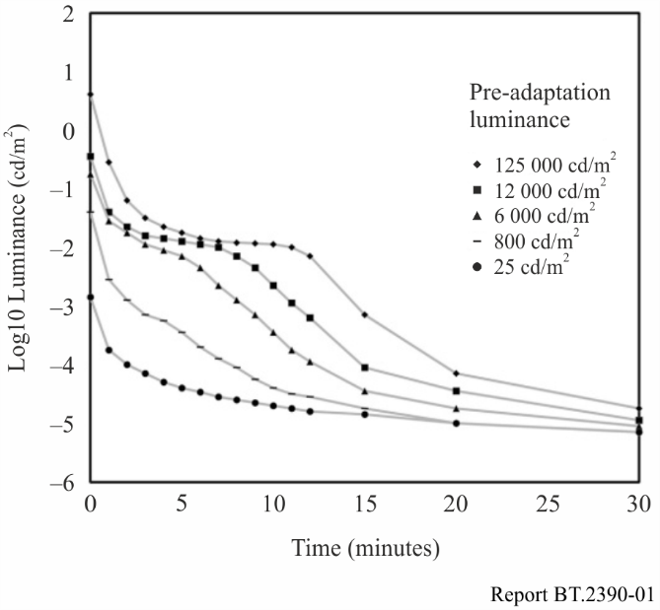

However, system design by the use of data as in Fig. 1 leans toward the most demanding cases, where the entire image may be dark. Other approaches consider that images generally do not consist of all‑dark regions; there is a mixture of different luminance levels. The general approach is to treat the image as a surround around a possible black area. Using rectangular patches with a white surround, Mantiuk *et al* [7] studied black level threshold as a function of the size of the black region. The area outside of the patch was termed the surround, and the surround serves as a surrogate for an actual image with average image luminance level. The results in Fig. 2 show the lowest black level that can be discriminated from zero luminance is ~−2.4 log10 cd/m2 (0.0039 cd/m2), at least for the darkest surround that they studied, which was 0.1 cd/m2. Lower thresholds would be expected from darker surrounds, such as might occur in home theatre, or some evening viewing situations.

Figure 2

Detectability of black level differences for a rectangular patch of either 6.1 or 1.8 visual degrees,   
both as a function of surround luminance level

Two things are clear. As the surround luminance decreases, the detectable black level decreases. That is, the expected surround luminance that results from practical imagery can determine the necessary black level to achieve a pure black perception, as well as finding the level where dark detail is no longer distinguishable. The other effect is that thresholds for the larger black region are lower than for the smaller. Thus in designing a system black level, the expected size of the black region is a key factor. Note that the largest region studied in this work was 6 degrees, whereas the image size for HDTV viewed at 3H is approximately 35 degrees (UHDTV @ 1.5 H is ~70 degrees).

Another approach for determining system black level is to not base it on psychophysical detection tasks with abstract geometric stimuli, but rather use preferences while viewing more natural imagery. Rempel at al. [8] measured preference for display black level and brightness in short video clips (a sitcom) and found all participants consistently set the black level to the lowest possible setting, which was about 0.3 cd/m2 for their display. So, the only conclusion from this was that 0.3 is not low enough. A more recent study using an experimental HDR display with very low black level capability [9] [10] [11] found levels near *its* minimum capability, which was 0.004 cd/m2. In order to meet the preferences of 90% of the viewers, a level of 0.005 cd/m2 was needed. The typical current black level LCD TVs of 0.1 cd/m2 would meet the preferences of only half of the viewers. Results are shown in Fig. 3.

The plot in Fig. 3 demonstrates the results of psychophysical experiments designed to understand the preferred dynamic range [9] [10] [11]. The experiment was based on a two-alternative forced choice paradigm using static images shown sequentially for average shot durations (2-5 s) and trial durations of around 20 s to include response times, for an experiment lasting a total of 40 minutes per participant. The stimuli were drawn from three classes of images, containing shadow detail, reflective white stimuli, and highlight stimuli. A dual modulation display was used using an LCD panel backlit by a digital cinema projector, allowing a luminance range between 0.004 and 20 000 cd/m2. Separate experimental sessions were conducted for the black level scenes vs. the white and highlight level scenes; the results of all the experiments are plotted on the same Figure but this should not be interpreted as indication that both extremes can be perceived simultaneously.

Figure 3

Cumulative distribution functions for a. black stimuli, b. reflective white stimuli and c. emissive and highlights.   
For comparison, the dynamic ranges of common displays are given

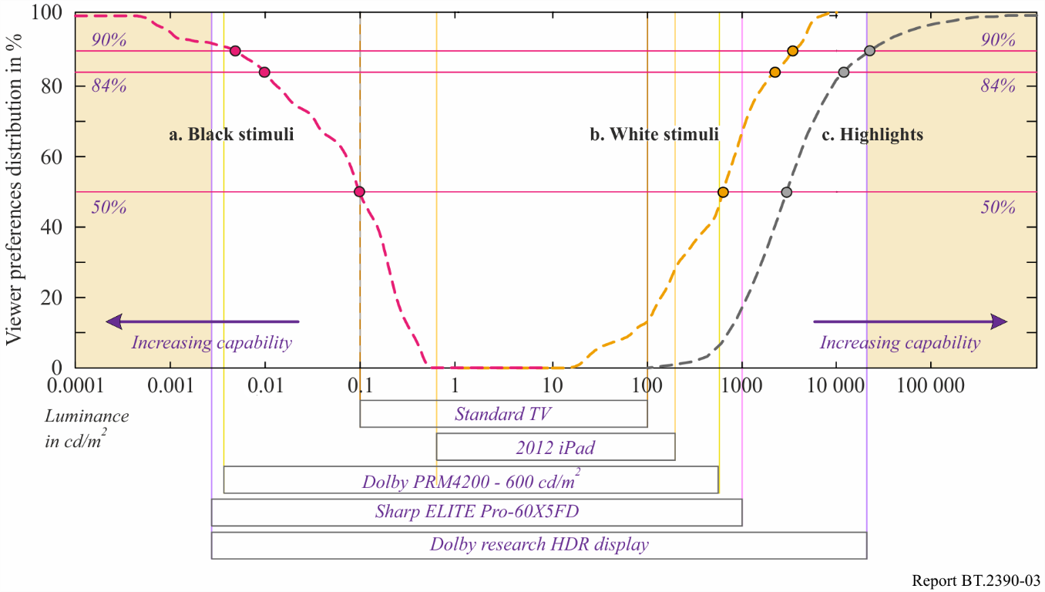

Regarding the black level, there are a number of studies that found detectability as well as preferences well below the level of 0.1 cd/m2, which was common for SDR displays. Values in the range of 0.001 to 0.005 cd/m2 could be deduced from the studies described here, and regarding preferences there may be upward biases due to the smaller field of view used in [9] than occurs with UHDTV.

## 1.3 System white and highlight level determination

In video, the system white is often referred to as reference white, and is neither the maximum white level of the signal nor that of the display. When calibration cards are used to set the reference white, it is a diffuse white (also called matte) that is placed on the card, and measured. The ideal diffuse white has a Lambertian reflection. The luminances that are higher than reference white are referred to as highlights. While there are several key quality dimensions and creative opportunities opened up by HDR (e.g. shadow detail, handling indoor and outdoor scenes simultaneously, and colour volume aspects), one of the key differentiators from SDR is the ability for more accurate rendering of highlights. These can be categorized as two major scene components: specular reflections[4] and emissives (also referred to as self-luminous). They are best considered relative to the maximum diffuse white luminance in the typical image. Most scenes can be broken down into two key ranges: object’s diffuse reflectances and the highlights. (Some scenes would defy such categorization, e.g. fireworks at night.) The object’s reflectance is important to convey its shape due to shading and other features, and the visual system has strong ability to discount the illuminant to be able to estimate the reflectance [12].

However, the human ability to perceive both types of highlights is much less accurate and less computationally sophisticated as the ability perceive reflectances [12]. Illustrations of emissives and specular highlights are shown in Fig. 4.

Figure 4

Emissive light sources, specular reflections, and diffuse white

In traditional imaging, the range allocated to these highlights was fairly low and the majority of the image range was allocated to the diffuse reflective regions of objects. For example, in hardcopy print the highlights would be 1.1x higher luminance than the diffuse white maximum. In traditional video, the highlights were generally set to be no higher than 1.25x the diffuse white. Of the various display applications, cinema allocated the highest range to the highlights, up to 2.7x the diffuse white.

Actual measurements show the specular regions can be over 1 000x higher than the underlying diffuse surface [2], which is presented in Fig. 5. This means the physical dynamic range of the specular reflections vastly exceed the range occupied by diffuse reflection. If a visual system did not have specialized processing as previously described, and saw in proportion to luminance, most objects would look very dark and the visible range would be dominated by the specular reflections. Likewise, emissive objects and their resulting luminance levels can have magnitudes much higher than the diffuse range in a scene or image. The most common emissive object, the disk of the sun, has a luminance so high (~1.6 billion cd/m2), it is damaging to the eye to look at more than briefly, and exceeding even the speculars. A more unique aspect of the emissives is that they can also be of very saturated colour (sunsets, magma, neon, lasers, etc.).

Figure 5

Measurements showing that the specular regions can be over 1 000x higher in comparison   
to the underlying diffuse surface. After Wolff (1994)

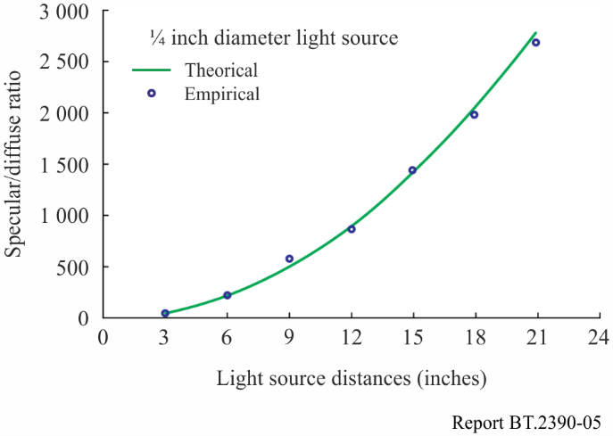

With traditional imaging’s under-representation of highlight ranges, the question arises: what happens to the luminances of highlights? Figure 6 shows example scanlines of common distortions from a specular highlight from a glossy object, (b). It exceeds the maximum luminance of the display (or the signal), indicated as the dashed line titled ‘Target Max.’. Illustration (c) shows a distortion that is seldom selected, that is, to renormalize the entire range. Another approach, (d) preserves diffuse luminances, and the highlight is simply truncated (hard-clipping). Details within the highlight region are replaced with constant values, giving rise to flat regions in the image, looking quite artificial. Typical best practices (e), have been referred to as soft-clipping, or a knee. Here the shape and internal details of the highlight are somewhat preserved, without flattened regions. HDR allows for a result closer to scanline (b). The more accurate presentation of specular highlights, (assuming the entire video pathway is also HDR), is one of the key distinctions of HDR. A number of perceptual papers have looked closely at specular reflection, as mentioned in the beginning of this section. Preferences of luminances for diffuse white and highlights are shown in Fig. 3.

Figure 6

Effects of highlight rendering, clipping and (tonescale) compression

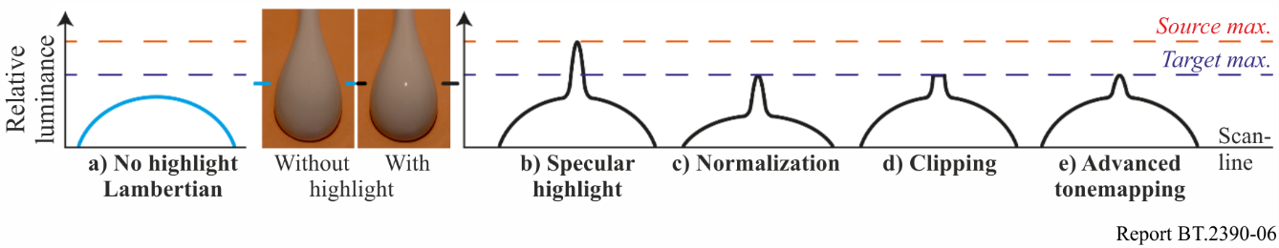

Per the results shown in Fig. 3, 16% of the viewers preferred highlights ≥10 000 cd/m2. Also shown is that 50% of the viewers preferred diffuse white levels ≥ 600 cd/m2. This suggests that if display luminances increase in the future, some PQ content (e.g. outdoor scene in bright sun) may be produced with diffuse white levels higher than the levels indicated in Report ITU-R [BT.2408](https://www.itu.int/pub/R-REP-BT.2408). Consideration would, however, need to be given to the appearance on lower peak luminance PQ displays.

# 2 Television system architecture

## 2.1 The relationship between the OETF, the EOTF and the OOTF

This Report makes extensive use of the following terms:

OETF: the opto-electronic transfer function, which converts linear scene light into the video signal, typically within a camera.

EOTF: electro-optical transfer function, which converts the video signal into the linear light output of the display.

OOTF: opto-optical transfer function, which has the role of applying the ‘rendering intent’.

These functions are related, so only two of the three are independent. Given any two of them the third one may be calculated. This section explains how they arise in television systems and how they are related.

In television systems the displayed light is not linearly related to the light captured by the camera. Instead an overall non-linearity is applied, the OOTF. The ‘reference’ OOTF compensates for difference in tonal perception between the environment of the camera and that of the display. Specification and use of a ‘reference OOTF’ allow consistent end-to-end image reproduction, which is important in TV production.

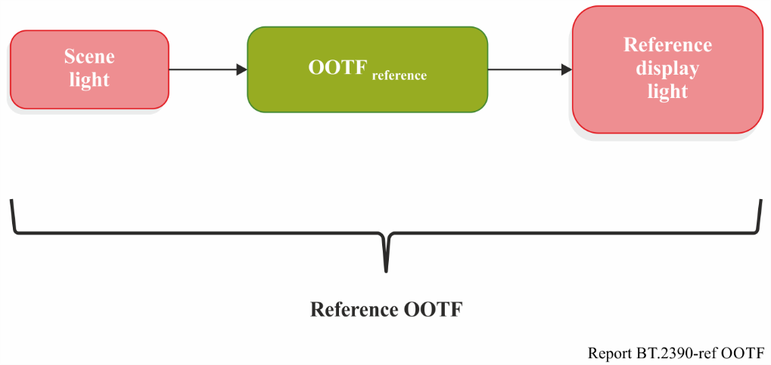

Artistic adjustment may be made to enhance the picture. These alter the OOTF, which may then be called the ‘artistic OOTF’. Artistic adjustment may be applied either before or after the reference OOTF.

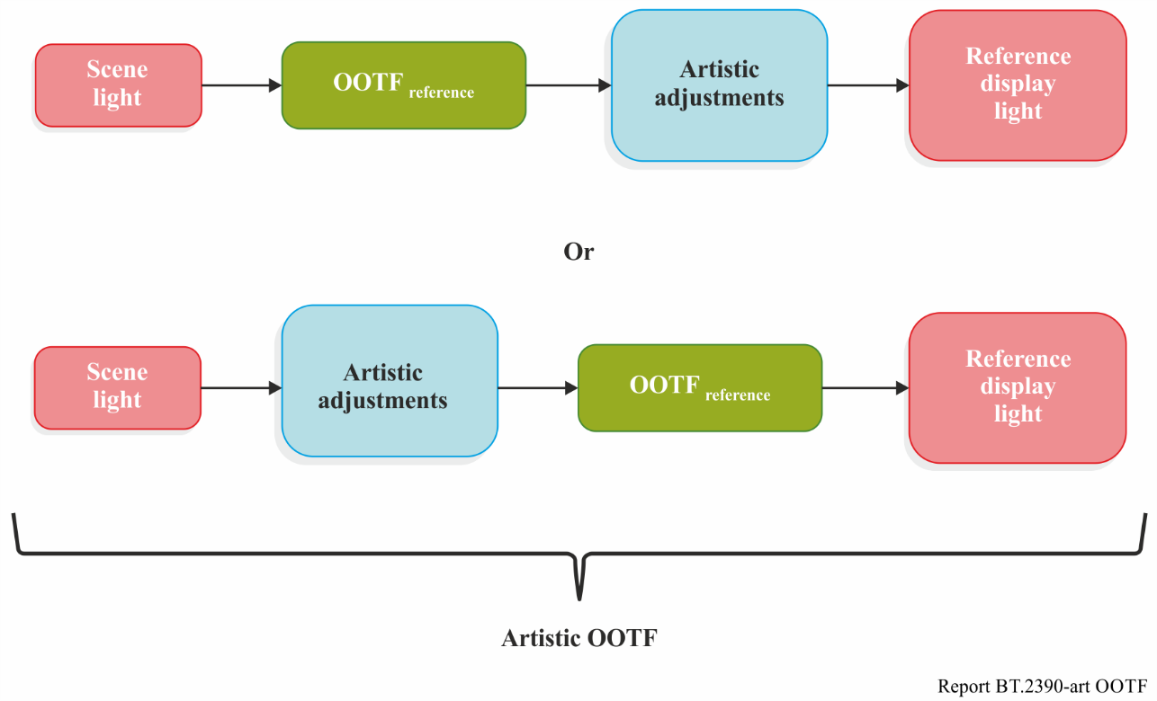

In general, the OOTF is a concatenation of the OETF, artistic adjustments, and the EOTF.

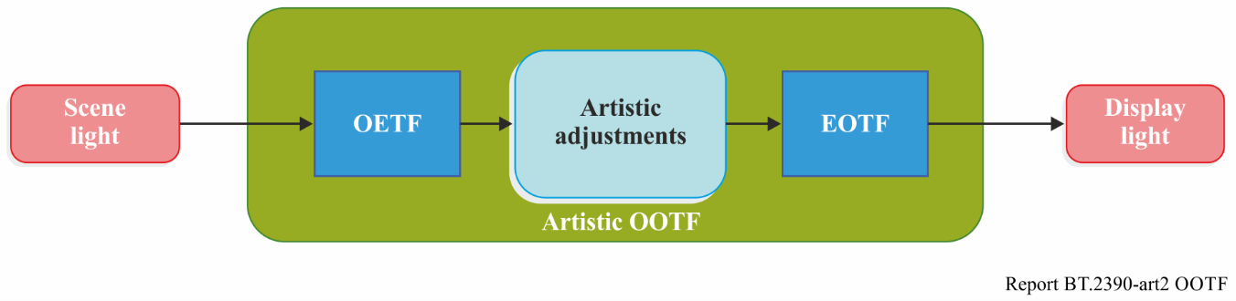

The PQ system was designed with the model shown below, where the OOTF is considered to be in the camera (or imposed in the production process):

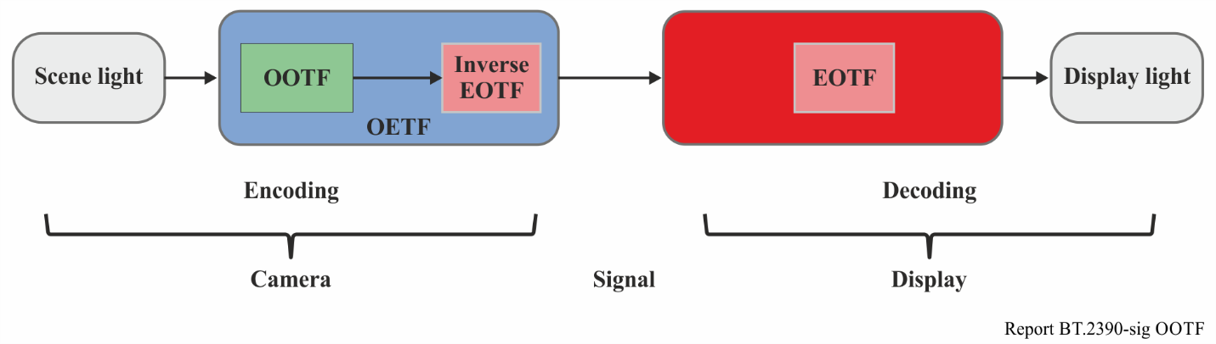

The HLG system the system was designed with the model shown below, where the OOTF is considered to be in the display:

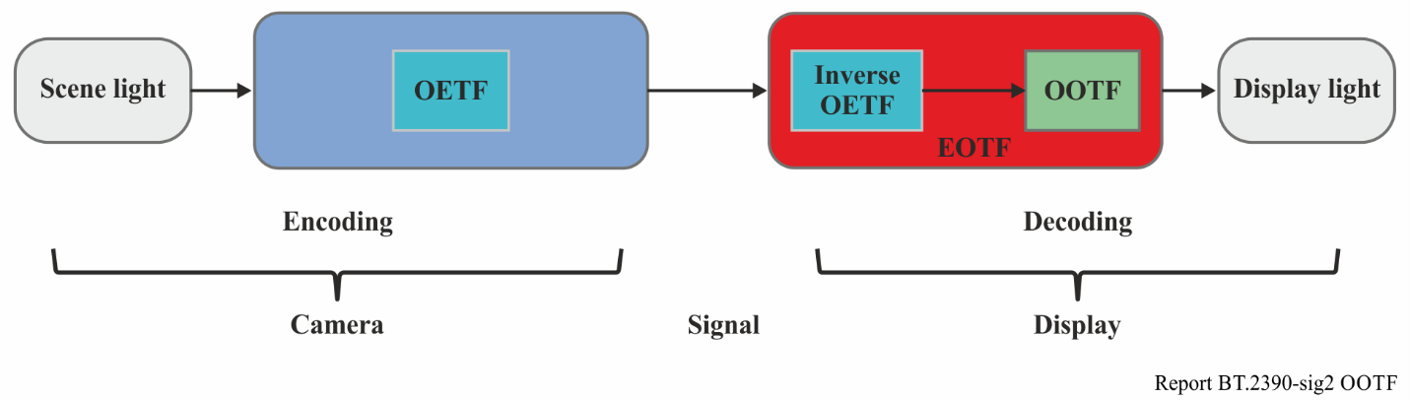

Only two of three non-linearities, the OETF, the EOTF, and the OOTF, are independent. In functional notation (where subscripts indicate the colour component):



This is clearer if the symbol ⊗ is used to represent concatenation. With this notation, the following three relationships between these three non-linearities can be obtained:



The PQ approach is defined by its EOTF. For PQ the OETF may be derived from the OOTF using the third line of the equations above. In a complementary fashion the HLG approach is defined by its OETF. For HLG the EOTF may be derived from the OOTF using the second line of the equations above.

## 2.2 Conceptual TV system showing basic concepts

Figure 7 is a high level conceptual flow of a simplified television system that does not employ a non‑linearity (such as gamma) in order to reduce the bit depth needed to represent the baseband signal; such a non-linearity is needed in signal pipelines that have limited bit depths (e.g. limitations to 8-12 bit values), but these pipelines will be considered later and the conceptual system described here is considered to have no such restrictions. In Fig. 7, the camera outputs a linear light signal, which is representative of the scene in front of the lens. Exposure controls (camera iris and filters) perform a global scaling, so the camera output is proportional to absolute scene light. The signal can be represented by high bit-depth integers, or for more efficiency, as 16-bit floating point. Non-reference viewing includes consumer viewing, as well as much TV production which often takes place in non‑reference environments.

Figure 7

The conceptual TV system

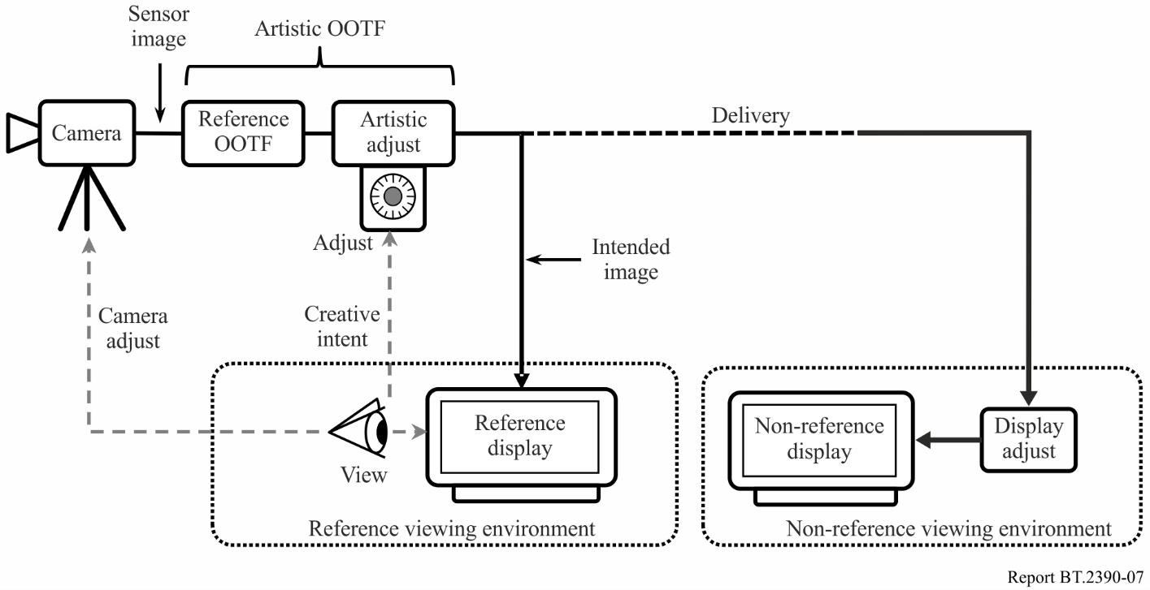

A linear display of the scene light would produce a low contrast washed out image as illustrated in Fig. 8. Therefore, the signal is altered to impose rendering intent, i.e. a Reference OOTF(opto‑optical transfer function) roughly like that shown in Fig. 9. The sigmoid curve shown increases contrast over the important mid-brightness range, and softly clips both highlights and lowlights, thus mapping the possibly extremely high dynamic range present in many real world scenes to the dynamic range capability of the TV system.

Figure 8

The left image has a system transfer function (or greyscale) of unity slope.  
The right image has a system transfer function consistent with ITU broadcast practices

A reference display in a reference viewing environment would, ideally, be used for viewing in production, and adjustments (e.g. iris) are made to the camera to optimize the image. Use of the *Reference OOTF* to produce images, with viewing done in the reference viewing environment, allows consistency of produced images across productions. If an artistic image ‘look’ different from that produced by the reference OOTF is desired for a specific programme, “Artistic adjust” may be used to further alter the image in order to create the image ‘look’ that is desired for that programme. Artistic adjustments may be made through the use of camera settings or after image capture during editing or in post-production. The combination of the reference OOTF plus artistic adjustments may be referred to as the ‘Artistic OOTF’.

Figure 9

Typical sigmoid used to map scene light to display light; extreme highlights and dark areas are compressed/clipped,   
the mid-range region employs a contrast enhancing gamma>1 characteristic

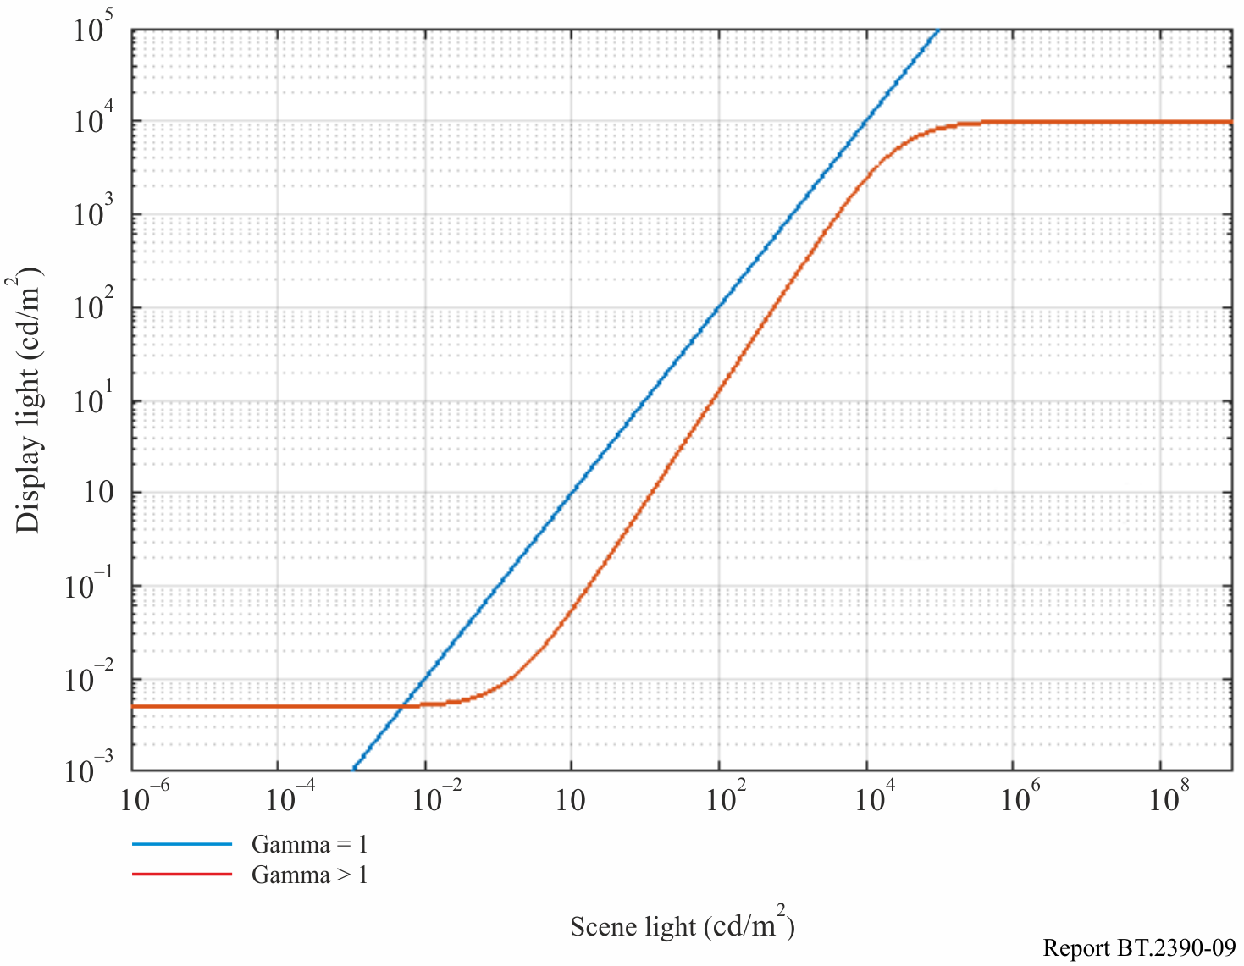

On the receive side where the consumer will view the image, if the consumer display is capable, and the consumer viewing environment is close to that of the reference viewing environment (dim room), then the consumer can view the image as intended. There may be limitations on both the viewing environment and the display itself. The viewing environment may be brighter than the reference environment, and the display may be limited in brightness, blackness, and/or colour gamut. Figure 7 shows ‘display adjust’ as an alteration made to accommodate these differences from the reference condition. To compensate for a brighter environment, display adjust may lift the black level of the signal. To accommodate limited brightness capability of the display, system gamma may be changed or a ‘knee’ may be imposed to roll off the highlights. To accommodate a limited colour gamut, gamut mapping would be performed to bring the wide gamut of colours in the delivered signal into the gamut that the display can actually show.

In practice television programmes are produced in a range of viewing environments using displays of varying capabilities. Thus, similar adjustments are often necessary in production displays to achieve consistency.

# 3 The legacy television architecture

Since its beginning, television has employed restricted signal pipelines. Limited signal-to-noise ratios in the analogue days have transitioned to limited bit depths in the digital age. A non-linearity in the basic video signal was required in order to improve the visible signal-to-noise ratio in analogue systems, and the same non-linearity helps to prevent quantization artefacts in digital systems. This is the typical ‘gamma’ curve that is the natural characteristic of the CRT, and that is documented in Recommendations ITU-R [BT.709](https://www.itu.int/rec/R-REC-BT.709), [BT.1886](https://www.itu.int/rec/R-REC-BT.1886/en) and [BT.2020](https://www.itu.int/rec/R-REC-BT.2020/en).

Until recently all displays were based on the CRT which, based on the common physics, all had a similar characteristic function converting the electrical signal to light, the so-called ‘electro-optical transfer function’ or EOTF. The camera characteristic of converting light into the electrical signal, the ‘opto-electronic transfer function’ or OETF, was adjusted to produce the desired image on the reference CRT display device. The combination of this traditional OETF and the CRT EOTF yielded the traditional OOTF. The non-linearity employed in legacy television systems (Recommendations ITU-R [BT.601](https://www.itu.int/rec/R-REC-BT.601/), [BT.709](https://www.itu.int/rec/R-REC-BT.709) and [BT.2020](https://www.itu.int/rec/R-REC-BT.2020/en)) is satisfactory in that 10-bit values are usable in production and 8-bit values are usable for delivery to consumers; this is for pictures with approximately 1 000:1 dynamic range[5], i.e. 0.1 to 100 cd/m2.

## 3.1 HDTV as specified in Recommendations ITU-R [BT.709](https://www.itu.int/rec/R-REC-BT.709) and [BT.1886](https://www.itu.int/rec/R-REC-BT.1886/en)

Recommendation ITU-R [BT.709](https://www.itu.int/rec/R-REC-BT.709) explicitly specifies a reference OETF function that in combination with a CRT display produces a good image. Creative intent to alter this default image may be imposed in either the camera, by altering the OETF, or in post-production, thus altering the OOTF to achieve an ‘artistic’ OOTF. As the CRT is no longer manufactured, it became impractical to rely on the inherent CRT characteristic in order to achieve uniformity in reference displays. In the year 2011, Recommendation ITU-R [BT.1886](https://www.itu.int/rec/R-REC-BT.1886/en) was approved; this new Recommendation specified the EOTF of the reference display to be used for HDTV production; the EOTF specification is based on the CRT characteristics so that future monitors can mimic the legacy CRT in order to maintain the same image appearance in future displays. A reference OOTF is not explicitly specified for HDTV. Nevertheless, as shown in Fig. 10, in practice it exists as the cascade of the specified OETF ([BT.709](https://www.itu.int/rec/R-REC-BT.709)) and EOTF ([BT.1886](https://www.itu.int/rec/R-REC-BT.1886/en)).

Figure 10

The BT.709 HDTV television system architecture

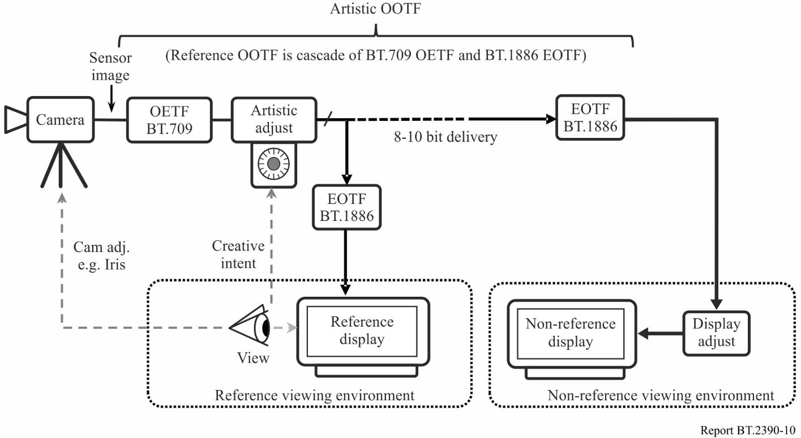

Figure 10 shows the HDTV system. The linear light is encoded into a non-linear signal using the OETF specified in Recommendation ITU-R [BT.709](https://www.itu.int/rec/R-REC-BT.709). Creative intent may be imposed by altering this encoding or in post-production by adjusting the signal itself; this can be considered as an alteration outside of the BT.709 OETF (e.g. as ‘artistic adjust’ in the diagram). Recommendation ITU‑R [BT.1886](https://www.itu.int/rec/R-REC-BT.1886/en) specifies the conversion of the non-linear signal into display light. This drives the reference display in the reference viewing environment. The image on the reference display drives adjustment of the camera iris/exposure, and if desired, artistic adjust can alter the image to produce a different artistic look. At the receiver (ideally a reference display in a reference viewing environment) the non-linear signal is converted to display light using the Recommendation ITU-R [BT.1886](https://www.itu.int/rec/R-REC-BT.1886/en) specified function. There is typically further adjustment (display adjust) to compensate for viewing environment, display limitations, and viewer preference; this alteration may lift black level, effect a change in system gamma, or impose a ‘knee’ function to soft clip highlights. (In practice the EOTF gamma and display adjust functions may be combined into a single function.)

In a typical TV system the soft clipping of the highlights (sometimes known as the ‘shoulder’), described earlier and illustrated in Fig. 3, is implemented in the camera as a camera ‘knee’. This is part of the artistic adjustment of the image. Part of the low light portion of the characteristic (sometimes known as the ‘toe’) is implemented in the display as a black level adjustment. This adjustment takes place in the display as part of the BT.1886 EOTF and implements soft clipping of the lowlights.

There is no clearly defined location of the reference OOTF in this system. The reference OOTF is the cascade of the OETF and the EOTF, and the actual OOTF is the cascade of those plus the artistic and display adjustments. Any deviation from the reference OOTF for reasons of creative intent must occur upstream of delivery. Alterations to compensate for the display environment or display characteristics must occur at the display by means of display adjust (or a modification of the EOTF away from the reference EOTF).

# 4 RGB floating point HDR-TV system

A 16-bit RGB HDR system is defined for use when 48-bit/pixel pipelines are available. This architecture is shown in Fig. 11.

Figure 11

HDR floating point system

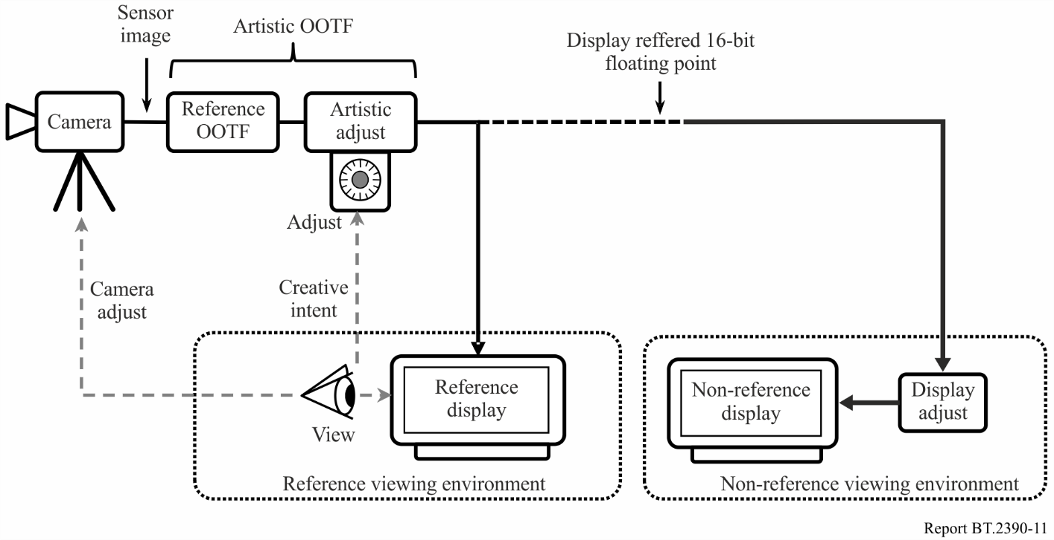

The raw output of the camera is a relative scene referred floating point signal. These floating point values may be scaled such that maximum diffuse white results in R = G = B = 1.0. The reference OOTF is implemented directly after camera capture of the scene, and an artistic adjustment may be used to make additional changes as desired for creative intent. Alternatively, the raw camera output can be used as input to a post-production process. The display referred output of the OOTF block (or post‑production) is in the 16-bit floating point format which allows for adequate precision even for large colour volumes. Display referred floating point values directly represent light values on the display, i.e. R = G = B = 1.0 means 1.0 cd/m2 of white for a pixel. As before, display adjust is used to compensate as much as possible for limitations of displays, and for environments that may differ from the reference viewing environment that was (ideally) used during programme production.

# 5 PQ HDR-TV

## 5.1 PQ system architecture

When bit-constrained pipelines are required for television production systems, then an HDR implementation very similar to the current HDTV system of Fig. 10 can be constructed. This implementation is shown in Fig. 12.

Figure 12

PQ HDR-TV system with 10-bit or 12-bit integer values

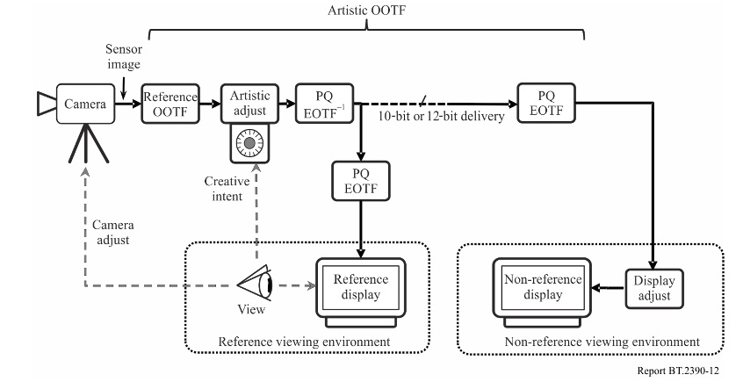

An optimized non-linear signal representation is used so that 10-bit or 12-bit depth values can accommodate the larger colour volume of HDR; otherwise this system is very similar to the HDTV system in use today. The PQ EOTF replaces the BT.1886 function of SDR HDTV, and the corresponding PQ OETF replaces the BT.709 OETF as the default camera capture curve. Once again, an artistic adjustment may be used to further modify the creative intent of the image, and a display adjustment is used to adapt the signal for different display characteristics and display environments. No use of metadata is shown or required.

## 5.2 Design of the PQ non-linearity

The traditional gamma nonlinearities of Recommendations ITU-R [BT.709](https://www.itu.int/rec/R-REC-BT.709) and [BT.1886](https://www.itu.int/rec/R-REC-BT.1886/en) are unsatisfactory when stretched to the much larger dynamic ranges desired for future television productions.

Figure 13

Contrast step size vs. display luminance for 12 bit signals

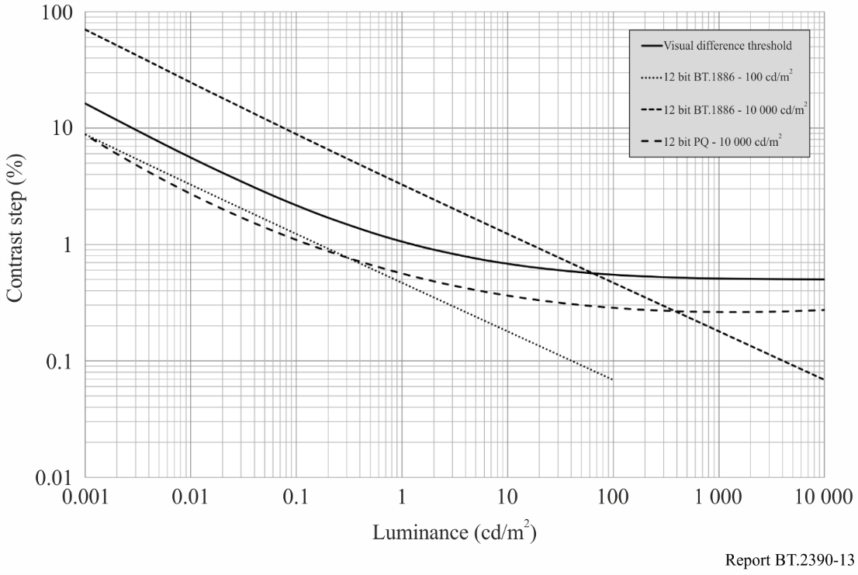

Figure 13 shows the approximate visual difference threshold as a solid black curve on a log-log plot with luminance on the x-axis and contrast step size (due to bit depth limitation) in % on the vertical axis. This threshold is based on the detailed Barten model of the human visual system. Lines which fall below this threshold curve will not exhibit any visible quantization artefacts such as image banding, while lines above the threshold curve may exhibit visual artefacts. While the legacy Recommendation ITU-R [BT.1886](https://www.itu.int/rec/R-REC-BT.1886/en) operating with a peak level of 100 cd/m2 is comfortably below the threshold curve when using 12-bit encoding, it rises substantially above the visual threshold when operating with a 10 000 cd/m2 peak. A traditional “gamma” power function is not a good approximation for human vision over an extended range of luminance values (too many code words allocated to very bright regions and not enough allocated to dark regions). This inefficiency was not a serious problem with SDR systems due to their limited dynamic range, but when trying to represent HDR luminance ranges, an improved curve is required. By using the same Barten model as the visual threshold calculation itself, an optimized nonlinear function was developed for the PQ signal, which can operate over the entire range from 10 000 cd/m2 down to less than 0.001 cd/m2 without any visible quantization artefacts using 12-bit coding precision.

Figure 14

Contrast step size vs. display luminance for 10-bit signals

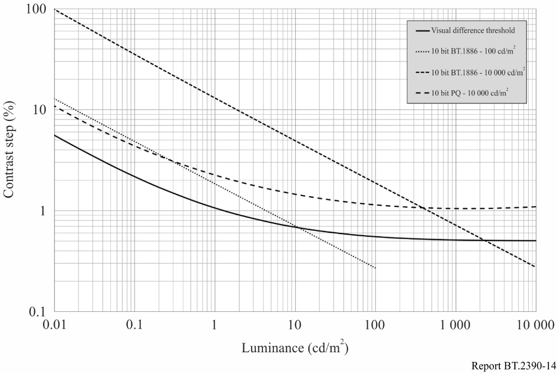

Figure 14 shows the same plots as Fig. 13 but with all three systems using 10-bit quantization. Though the signal lines all come above the threshold curve to some extent, experience has shown that with realistic camera noise levels, the slight quantization artefacts predicted for 100 cd/m2 Recommendation ITU-R [BT.1886](https://www.itu.int/rec/R-REC-BT.1886/en) or 10 000 cd/m2 PQ are masked and thus do not present real problems in television production.

## 5.3 OOTF and OETF

This subsection describes the PQ opto-optical transfer function (OOTF) and the resulting opto‑electronic transfer function (OETF). The PQ opto-optical transfer function is normatively specified in Recommendation ITU-R [BT.2100](https://www.itu.int/rec/R-REC-BT.2100/en), which is intended to be compatible with existing SDR BT.709 signal sources and BT.1886 compliant displays. This maximizes compatibility for mixed source applications wherein some sources are HDR and some are SDR. It is desired that the image from an SDR source and that from an HDR source match everywhere the HDR image brightness overlaps the range of the SDR source (the HDR OOTF extends up to the maximum PQ displayed light level of 10 000 cd/m2).

### 5.3.1 Generalized OOTF from Recommendation ITU-R [BT.1886](https://www.itu.int/rec/R-REC-BT.1886/en) in combination with Recommendation ITU-R [BT.709](https://www.itu.int/rec/R-REC-BT.709)

In order to maximize compatibility with existing SDR signals, it is desired an OOTF consistent with the effective OOTF of existing practice which is:

 (1)

It is only needed to extend the range of  and  for HDR.

The extension factor for displayed light is 10 000 / 100 = 100.

As the SDR OOTF has a roughly gamma = 1.2 characteristic at the high end, the extension relative to scene light (the input to OOTF) is approximately 100 1/1.2 = 46.42. When the exact equations for Recommendations ITU-R [BT.709](https://www.itu.int/rec/R-REC-BT.709) and ITU-R [BT.1886](https://www.itu.int/rec/R-REC-BT.1886/en) are used, the extension for HDR is 59.5208.

To expand the range of  to  for HDR the equation is therefore (HDR *E* normalized to range of 0 to 1):

 (2)

Consequently, the range of *E′* is [0, 6.813] for HDR while it remains [0,1] for SDR. To expand the range of  to for HDR no change to the equation is necessary, the argument is simply allowed to extend to 6.813 (from 1) and hence the range increases from 100 to 10 000:



These extensions satisfy the boundary conditions:

a) *E* = 1 produces a displayed luminance of 10 000 cd/m2

b) *E* = 1/(59.5208) produces a displayed luminance of 100 cd/m2

The resulting OOTF is shown in Fig. 15. The x-axis, relative scene light is the same as *E* for SDR while for HDR it is 59.5208 × *E* since the domain of *E* is [0,1]:

Figure 15

PQ and SDR OOTF

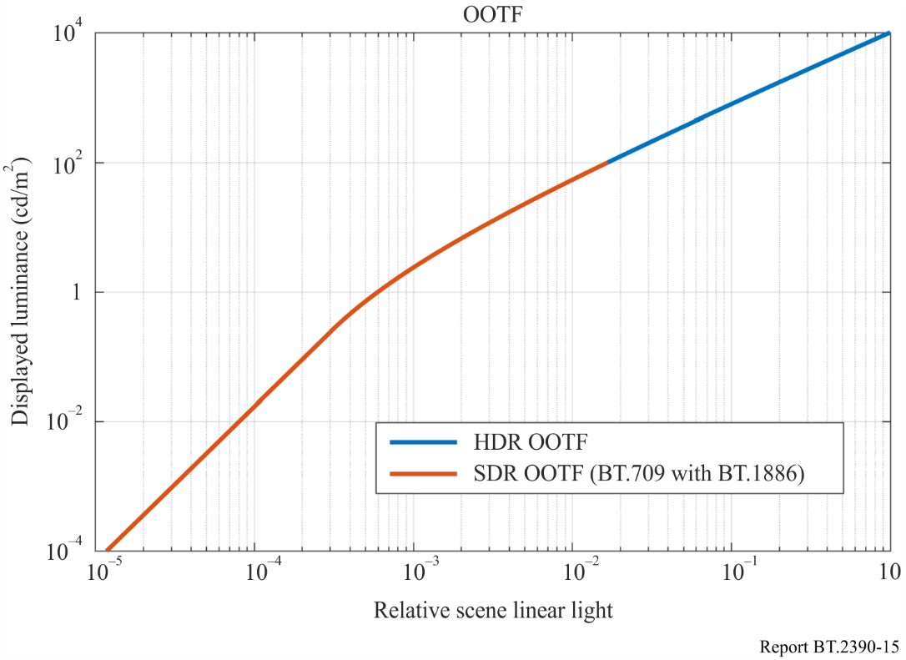

### 5.3.2 Actual OOTFs from manually graded content

It is instructive to compare this proposal with the actual OOTFs that are imposed when manually grading camera RAW output. The OOTF is the ratio of the graded linear output to the RAW linear input. Figure 16 shows several examples from the HDR sequence “Fantasy Flights”:

Figure 16

Extracted OOTFs from Fantasy Flights (3 of 3)

These Figures show scatter plots of the log of the output luminance derived from the PQ grade versus the log of the relative input luminance derived from the ARRI RAW camera output. These scatter plots are colour-coded (RGB) to match the images shown in the lower right corner of each Figure. For comparison, the OOTF from the combination of Recommendations ITU‑R [BT.1886](https://www.itu.int/rec/R-REC-BT.1886/en) and ITU-R [BT.709](https://www.itu.int/rec/R-REC-BT.709) are plotted in white. This shows that the extracted OOTFs are, as one would expect, a bit brighter than SDR. Some preliminary conclusions can be drawn from this experimental data:

1 For this manually graded content, the OOTF is not a straight line, and thus the actual OOTF does not correspond to an overall “system gamma”.

2 Darker indoor scenes tend to be noise limited at the bottom end and the OOTF exhibits a very clear toe.

3 The extracted OOTFs appear to have roughly the same curvature in the mid-tones as the proposed model.

### 5.3.3 Resultant OETF

This OOTF can be combined with the inverse of the EOTF to produce an OETF. That OETF is shown in Fig. 17.

In actual cameras there is noticeable noise at low signal levels, and in practice the OETF slope at low levels is limited so as to ‘crush’ the noise in black, thereby putting a ‘toe’ into the response. The reference OETF does not have such a ‘toe’, but one is apparent in the OOTF plot for the indoor scene of “Fantasy Flights” shown above.

Figure 17

HDR OETF

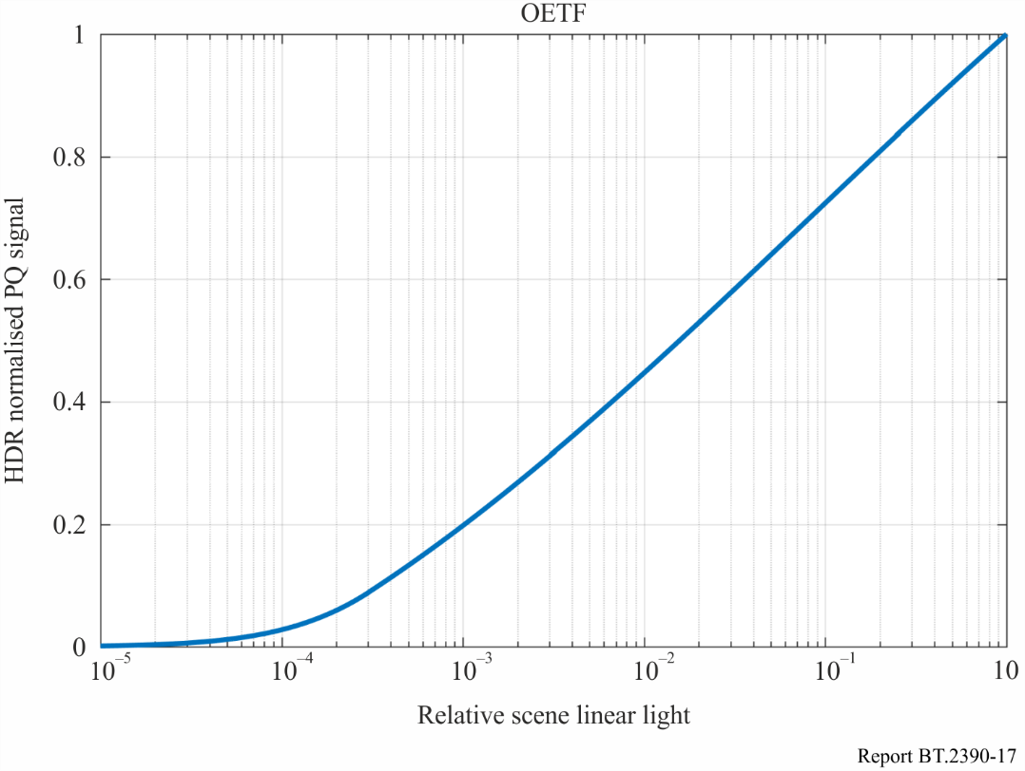

This OETF:

– emulates the ‘look’ of Recommendation ITU-R [BT.709](https://www.itu.int/rec/R-REC-BT.709) plus Recommendation ITU‑R [BT.1886](https://www.itu.int/rec/R-REC-BT.1886/en) for display light up to the limit of SDR;

– facilitates mixing of legacy BT.709 signals and PQ HDR signals;

– offers reasonable behaviour for levels above those of SDR.

## 5.4 Display mapping

The PQ HDR system generates content that is optimum for viewing on a reference monitor in a reference viewing environment. The reference monitor would ideally be capable of accurately rendering black levels down to or below 0.005 cd/m2 and highlights up to 10 000 cd/m2. Also, the ideal monitor would be capable of showing the entire colour gamut within the BT.2020 triangle. The viewing environment would ideally be dimly lit, with the area surrounding the monitor being a neutral grey (6 500 degree Kelvin) at a brightness of 5 cd/m2. However, content often must be viewed or produced in environments brighter than the reference condition, and on monitors that cannot display the deepest blacks or brightest highlights that the PQ signal can convey. In these cases, the display characteristic needs to be changed in a process often referred to as display mapping (DM). More information can be found in Recommendation ITU-R [BT.814](https://www.itu.int/rec/R-REC-BT.814/en) and Reports ITU-R [BT.2408](https://www.itu.int/pub/R-REP-BT.2408) and ITU‑R [BT.2446](https://www.itu.int/pub/R-REP-BT.2446).

# 6 HLG HDR-TV

The hybrid log-gamma (HLG) HDR-TV signal parameters were designed from the outset to offer broadcasters and programme producers an evolutionary approach to HDR production and distribution. The signal characteristic is similar to that of a traditional standard dynamic range camera with a ‘knee’ and requires no production metadata. It is therefore compatible with conventional standard dynamic range production equipment, tools and infrastructure. Furthermore, the HLG HDR‑TV signal parameters were designed to provide a significant degree of compatibility on BT.2020 colour SDR displays (see § 6.4). Thus HDR monitors are only necessary in critical monitoring areas. The design of the HLG HDR signal parameters is intended to allow distribution networks to provide a single HEVC Main 10 bitstream that can target both SDR and HDR receivers, where those SDR receivers support the BT.2020 colour container (e.g. DVB and ARIB HEVC UHD receivers).

## 6.1 The hybrid log-gamma opto-electronic transfer function (OETF)

In the brighter parts and highlights of an image the threshold for perceiving quantization is approximately constant (known as Weber’s law). This implies a logarithmic OETF would provide the maximum dynamic range for a given bit depth. Proprietary logarithmic OETFs are in widespread use. But in the low lights it becomes increasingly difficult to perceive banding. That is, the threshold of visibility for banding becomes higher as the image gets darker. This is known as the De Vries‑Rose law. The conventional gamma OETF used for SDR comes close to matching the De Vries-Rose law, which is perhaps not coincidental since gamma curves were designed for dim CRT displays. So an ideal OETF might be logarithmic in the high tones and a gamma law in the low lights, which is essentially the form of the hybrid log-gamma OETF.

The dynamic range of modern video cameras is considerably greater than can be conveyed by a video signal using a conventional OETF gamma curve (e.g. Recommendation ITU-R [BT.709](https://www.itu.int/rec/R-REC-BT.709) or Recommendation ITU-R [BT.2020](https://www.itu.int/rec/R-REC-BT.2020/en)). In order to exploit their full dynamic range conventional video cameras sometimes use a ‘knee’ characteristic to extend the dynamic range of the signal. The knee characteristic compresses the image highlights to prevent the signal from clipping or being ‘blown out’ (overexposed). Knee characteristics are discussed, for example, in “Circles of Confusion”, by Alan Roberts, published by the EBU. The ‘shoulder’ characteristic of conventional photochemical film used in movie cameras provides a similar effect. When a hybrid log gamma HDR video signal is displayed on a conventional SDR display the effect is similar to the use of a digital camera with a knee or using film. It is not surprising therefore, that the HLG video signal is highly compatible with conventional SDR displays, because what you see is very similar to the signal from an SDR camera. Indeed the ‘knee’ characteristic of the HLG OETF, defined in Table 5 of Recommendation ITU‑R [BT.2100](https://www.itu.int/rec/R-REC-BT.2100/en) (and shown in Fig. 18 below), provides an extended highlight range that is comparable to some ‘knees’ used for SDR. Note that the ‘knee’ curve in the Figure is diagrammatic for illustrative purposes only. Whilst knees are sometimes described in the literature as linear, as in this Figure, in practice they are ‘smooth’ and avoid the discontinuous gradient shown here, which can result in objectionable colour shifts.

An HLG signal is defined as:

OETF:

With *E* is normalized to the range [0:1] then the equation for the OETF is:



where:

*E*: signal for each colour component {*Rs, Gs, Bs*} proportional to scene linear light and scaled by camera exposure, normalized to the range [0:1]

*E´*: resulting non-linear signal {*R′, G′, B′*} in the range [0:1].

$a=0.17883277, b=1-4a, c=0.5-a∙\ln\left(4a\right)$

The HLG OETF is shown in Fig. 18 alongside the conventional SDR OETF and an (illustrative) knee characteristic. These plots assume that two cameras, one BT.2020 and the other BT.2100 (that is, one SDR and one HDR), are set up with the same sensitivity. For example, if both cameras were looking at the same 18% grey chart, then their sensitivities (gain, iris, and shutter time) could be adjusted so that the signal level was 42.5% of nominal full signal level for both cameras. A notional SDR ‘knee’ is shown on the same plot, with a breakpoint of 87.5% signal level, which extends the SDR dynamic capture range substantially.

Figure 18

Comparison of SDR and HLG HDR OETFs

When the two cameras’ (SDR and HDR) sensitivities are equalized then both the SDR (BT.2020) and HDR responses to light amplitude would be almost the same for signal levels at or below 50%. Above 50% signal level the HDR OETF is logarithmic, which means it can capture higher light levels (such as specular reflections and highlights) without clipping. There are small differences between the two plots below 50% of nominal signal range. This is because SDR OETFs include a linear portion near black to avoid excessive noise amplification. HLG, by contrast, uses a pure square root OETF at low levels. This allows HLG to achieve higher dynamic range “in the blacks”, but it does mean that camera manufacturers must use an alternative to the linear part of the SDR OETF to avoid excessive noise amplification in the black.

Note that the conventional ‘narrow range’ digital signal can actually support signal levels of up to 109% of nominal full scale. This is to accommodate overshoots and highlights. If this additional signal range is used (though not all equipment supports it) then even higher light levels may be captured without clipping.

Considering a nominal full scale signal (i.e. 100% signal level), and with the cameras set up as above, then the SDR camera can capture objects no brighter than 100% reflective (i.e. no highlights). The HLG camera increases the luminance that can be captured by a factor of 3. If the signal is allowed to excurse to the maximum 109% range (super-whites) then SDR can capture luminance equivalent to 120% reflectivity, whereas HLG can capture nearly a factor of 5 more luminance than 100% reflectivity. It is the limitations in the ability of SDR displays to accurately render highlights that prompts the use of camera knees.

A naïve interpretation of these plots might suggest that the dynamic range of HLG is only three times greater than SDR, but this is not the case. HDR is about more than just increasing the brightness of highlights. Creating the detail in lowlights and ‘in the black’ is also very important and HLG adds much dynamic range here. Secondly, the OETF describes the capture dynamic range. The dynamic range on the display is greater because of overall system gamma, discussed below. With a typical system gamma of 1.2, and the camera sensitivity adjusted as described, HLG supports display highlights which are a factor of 3.7 (or 6.9 with super-whites) higher than diffuse white.

However, the foregoing discussion assumes that ‘diffuse white’ produces 100% signal output for SDR cameras. Whilst this may be true for some programmes, the signal level for diffuse white is not defined for SDR signals. In practice it varies between about 90% and 115% depending on genre, geographical region, and artistic preference. Drama, in particular, tends to set diffuse white at a lower signal level. This supports more artistically pleasing pictures that can contain some highlight detail. HLG supports a much greater dynamic range than SDR, and can take advantage of this by setting diffuse white at a lower signal level to support more highlight dynamic range.

Report ITU-R [BT.2408](https://www.itu.int/pub/R-REP-BT.2408) indicates that, for HLG HDR, diffuse white should be set at a signal level of 75%. This can be configured by making the output from an 18% grey card correspond to a signal level of 38%, rather than the 42.5% stated above. The OETFs for this camera setup are illustrated in Fig. 19 below, which also include the plots above for comparison. Setting 18% grey to 42.5% and 38% results in the diffuse white signal level being 100% and 89% respectively for SDR, and 79% and 75% respectively for HLG. The traces on the plots are labelled accordingly.

FIGURE 19

Comparison of HLG OETFs with BT.2408 signal levels for diffuse white

With cameras configured to produce this slightly lower signal level for diffuse white, the dynamic range available for highlights is increased. SDR can now support scene luminance equivalent to 125% of diffuse white, and HDR can support scene luminance of 375% diffuse white. These figures increase to 150% and about 620% if super-whites are used. So, the use of super-whites is much more advantageous for HLG than it is for SDR. Note that these figures increase further to 163% and 890% at the display when a typical system gamma of 1.2 is used.

## 6.2 System gamma and the opto-optical transfer function (OOTF)

As is well known, and explained in § 2.2, the light out of a television display is not proportional to the light detected by the camera. The overall system non-linearity, or ‘rendering intent’ is defined by the opto-optical transfer function, or OOTF. The OOTF maps relative scene linear light to display linear light. Rendering intent is needed to compensate for the psychovisual effects of watching an emissive screen in a dark or dim environment, which affects the adaptation state (and hence the sensitivity) of the eye. Traditionally movies were, and often still are, shot on negative film with a gamma of about 0.6. They were then displayed from a print with a gamma of between 2.6 and 3.0. This gives movies a system gamma of between 1.6 and 1.8, which is needed because of the dark viewing environment. Conventional SDR television has an OOTF which is also a gamma curve with a system gamma of 1.2. But, for HDR, the brightness of displays and backgrounds/surround will vary widely, and the system gamma will need to vary accordingly.

Colour images consist of red, green and blue components and this affects how the OOTF should be applied. Simply applying a gamma curve to each component separately as is done for SDR television distorts the colour; in particular, it distorts saturation but also to a lesser extent the hue. As an illustration, suppose the red, green and blue components of a pixel have (normalized) values of (0.25, 0.75, 0.25). Applying a display gamma of 2, (i.e. squaring the value of the components) is obtained (0.062 5, 0.562 5, 0.062 5). In this example, the pixel has got slightly darker and the ratio of green to blue and red has increased (from 3:1 to 9:1). This means, a green pixel would have appeared as a discernibly different shade of green. This approach is far from ideal if it is wished to avoid distorting colours when they are displayed.

Instead of the current SDR practice of applying a gamma curve independently to each colour component, for HDR it should be applied to the luminance alone. The luminance of a pixel is given by a weighted sum of the colour components; the weights depend on the colour primaries and the white point. According to Recommendation ITU-R [BT.2100](https://www.itu.int/rec/R-REC-BT.2100/en), luminance is given by:



where *YS* represents normalized linear scene luminance and *RS*, *GS* and *BS*represent the normalized, linear scene light (i.e. before applying OETF) colour components. By applying rendering intent (OOTF) to the luminance component only it is possible to avoid colour changes in the display.

The HLG reference OOTF is therefore given by:

$$F_{D}=OOTF\left[E\right]=αY_{S}^{γ-1}E$$

$$R_{D}=αY_{S}^{γ-1}R_{S}$$

$$G_{D}=αY_{S}^{γ-1}G_{S}$$

$$B_{D}=αY_{S}^{γ-1}B_{S}$$

where:

*FD* : luminance of a displayed linear component {*RD*, *GD*, or *BD*}, in cd/m2

*E* : signal for each colour component {*Rs, Gs, Bs*} proportional to scene linear light and scaled by camera exposure, normalized to the range [0:1]

Α : user adjustment for the luminance of the display, commonly known in the past as a “contrast control”. It represents *LW*, the nominal peak luminance of a display for achromatic pixels in cd/m2

γ : is an exponent, which varies depending on *LW* as described below, and which is equal to 1.2 at the nominal display peak luminance of 1 000 cd/m2.

In order to determine the appropriate system gamma for a 1 000 cd/m2 reference display, NHK conducted a series of experiments with an indoor test scene. Lighting was adjusted so that the luminance level of the diffuse white was 1 200 cd/m2. The subjects were requested to adjust the system gamma and camera iris with reference to the real scene so that a tone reproduction similar to the scene could be obtained on the display. It was found that personal preference has an impact in determining the optimum system gamma for a given brightness display. But for a 1 000 cd/m2 OLED display (Sony BVM-X300) the average optimum system gamma was found to be 1.18. Similar tests were repeated using a 2 000 cd/m2 peak luminance LCD display (Canon DP-V3010), where it was found that the average preferred system gamma was 1.29.

Similarly, the BBC conducted subjective tests to determine the value of system gamma that delivers the best compatible SDR image. For those tests two Sony BVM-X300 OLED displays were used, one in its SDR mode (Recommendation ITU-R [BT.1886](https://www.itu.int/rec/R-REC-BT.1886/en), 100 cd/m2 peak luminance) and the other a running prototype HLG HDR firmware (1 000 cd/m2 peak luminance). In those tests the BBC found that the value of system gamma that delivers the best SDR compatible picture with a   
~1 000 cd/m2 display was 1.29. A value of 1.18 was found to be the best value when the peak brightness of the display was reduced to 500 cd/m2.

Notably both NHK and the BBC reported values of 1.29 and 1.18 independently, albeit at different peak brightness values.

When designing the HLG HDR system, it was considered more important to weigh the choice of gamma value in favour of HDR production, rather than backwards compatibility with SDR displays. So, a value of 1.20 was adopted for the reference 1 000 cd/m2 display.

The clear indication from both of these studies is that system gamma needs to vary according to display peak brightness. In order to establish a more precise relationship between the gamma and display brightness, the BBC conducted further subjective tests where images were viewed with different gammas at different luminances (and with a fixed background luminance of 5 cd/m2). The pictures were derived from HDR linear light images selected from Mark Fairchild’s HDR Photographic Survey. Test subjects were asked to perceptually match as closely as possible an image displayed with a reference peak brightness to the same image with a non-reference peak brightness by adjusting the system gamma applied to the non-reference brightness image. The images were displayed on a calibrated SIM2 HDR47E display using its LogLuv input. The minimum black level viewable in the test environment was determined using an HDR PLUGE test signal, and an appropriate ‘brightness’ offset added to the test images.

The initial tests varied peak brightness between 500 and 4 000 cd/m2. The results were confirmed in subsequent BBC tests for a 1 000 cd/m2 to 500 cd/m2 change using a prototype Sony BVM-X300 OLED display. These results are also consistent with the ratio of gamma values found by NHK for a 2 000 cd/m2 LCD display and a 1 000 cd/m2 OLED display, and with the ratio of values determined by the BBC for optimum SDR compatibility at 1 000 cd/m2 and 500 cd/m2. The BBC then extended these tests to lower peak luminances [13].

The results of the BBC tests are illustrated in Fig. 20. Here, test 1 corresponds to peak luminances from 1 000 to 4 000 cd/m2, and test 2 from 100 to 1 000 cd/m2. Both tests are normalised so that gamma = 1.2 at 1 000 cd/m2.

Figure 20

Gamma value to match images for different screen peak brightness

Bringing together the results of all studies, it is found that the appropriate system gamma (γ) for different brightness displays, in the reference environment, can be determined using the following equation:



where:

*LW* : nominal peak luminance of the display in cd/m2.

According to the subjective tests conducted by the BBC, displays for a range of different values of nominal peak luminance, specifically the range from 400 cd/m2 to 2 000 cd/m2, can be shown to provide a consistent look by varying the value of gamma in the HLG OOTF in accordance with the equation above. This allows programmes to be made using displays with different peak luminance. Outside this range of peak luminance, the match of this simple model to the experimental detail starts to deteriorate. An extended model, described in [14] and also illustrated in Fig. 20, is given by:

$$γ=1.2×κ^{log2(Lw/1000)}$$

where:

$κ$ = 1.111

This may be used for displays with peak luminance outside the range above. Within that range the two models are virtually identical and will provide equally good performance.

It should be noted that using a gamma adjustment to adapt to different peak luminances has its limitations. Television receivers typically apply different and more sophisticated methods. The acceptability of displays with different peak luminance values is a decision for individual producers and might differ between productions.

Many television programmes are produced in environments that differ considerably from the reference viewing environment. The luminance of the surround may be considerably higher than the recommended 5 cd/m2.

Recommendation ITU-R [BT.2100](https://www.itu.int/rec/R-REC-BT.2100/en) recognises that the HLG display gamma may need to be reduced in brighter viewing environments, to compensate for the differences in the adaptation state of the eye.

The BBC conducted subjective tests to measure the change in gamma necessary to perceptually match images displayed across a range of peak luminances in the reference and in non-reference environments. Twenty-one viewers participated in the tests. The results, from 21 viewers, that show the reduction in gamma as the surround brightness increases are presented below in Fig. 21.

Figure 21

Graph of system gamma vs. ambient lighting for a number of different screen luminances, with lines of best fit

The line of best fit, which provides an indication of how gamma should be adjusted in non-reference environments, is given by the equation below:

$$γ_{bright}=γ_{ref}-0.076\log_{10}\left(\frac{L_{amb}}{5}\right)$$

where:

γ*bright*: system gamma for display surrounds greater than 5 cd/m2

γ*ref*: system gamma for reference environment, calculated according to Recommendation ITU-R [BT.2100](https://www.itu.int/rec/R-REC-BT.2100/en) Note 5e (and above)

*Lamb* : ambient luminance level in cd/m2.

By adjusting the display gamma to compensate for non-reference viewing environments in this way more consistent results may be achieved in a wide range of production environments.

An alternative model is described in [14] which matches the form of the extended model for the variation of gamma with peak display luminance and which also includes the variation of gamma with surround luminance:

$γ= γ_{ref} ∙ Κ^{\log_{2}({L_{W}}/{L_{ref}})} ∙ μ^{\log_{2}(L_{surround} / L_{surround ref})}$

where γ*ref* is 1.2, µ*=*0.98 and the reference surround luminance *Lreference* is 5 cd/m2.

## 6.3 The hybrid log-gamma electro-optical transfer function (EOTF)

In order to specify the complete television system an EOTF is needed, as well as the OETF defined in § 6.1. The HLG EOTF maps the HLG signal representing the scene to the light emitted from the display.

The EOTF mapping should:

1) preserve the artistic intent of the programme maker (and provide a suitable rendering intent),

2) allow for the dynamic range of the display from black level to peak white, and

3) minimize quantization artefacts.

The EOTF defined in Table 5 of Recommendation ITU-R [BT.2100](https://www.itu.int/rec/R-REC-BT.2100/en) and described below is similar to the conventional display gamma curve, thereby maximizing backward compatibility, whilst also meeting the three preceding requirements.

*FD = EOTF* [max (0, (1 ̶ β) *E´* + β)]

= *OOTF* [*OETF*-1 [max (0, (1 ̶ β) *E´* + β)]]

where:

*FD*:luminance of a displayed linear component {*RD, GD, or BD*}, in cd/m2

*E´*: non-linear signal {*R′, G′, B′*} as defined for the OETF.

The inverse OETF, OETF-1, is given by:



and β, the black level lift, is given by:



*LW* nominal peak luminance of the display in cd/m2 for achromatic pixels

*LB* display luminance for black in cd/m2*.*

The black level lift, conventionally known as the “brightness” adjustment in CRT displays, adapts the EOTF to the minimum luminance that can be seen in the actual, not necessarily reference, viewing conditions. The appropriate value for β may be determined in any particular circumstance by using the PLUGE test signal specified in Recommendation ITU-R [BT.814](https://www.itu.int/rec/R-REC-BT.814/en).

## 6.4 Compatibility with SDR displays

Both PQ and HLG provide limited compatibility when directly connected to legacy SDR displays with BT.709 colorimetry. In the absence of additional processing HLG has a degree of compatibility when shown on SDR UHDTV displays that have been designed to accept signals in the BT.2020 colour space.

Concerning the degree of compatibility achieved by HLG, hue changes can be perceptible on the SDR display should images contain bright areas of highly saturated colour or very high code values. Generally, such high code values would be used for specular highlights and thus constitute a small proportion of the picture. The acceptability of the degree of compatibility of HLG might be a commercial decision by specific broadcasters or for a specific application.

When PQ or HLG HDR signals are converted for use in SDR ITU-R BT.709 facilities, the conversion process is expected to perform the colour space, HDR to SDR and any video format conversion in such a way as to minimise perceptible changes in colour for all types of HDR content, regardless of the code value ranges in use.

## 6.5 Traditional colour reproduction for camera signals

The HLG OOTF (system gamma applied on luminance) uses scene-referred camera signals that result in a display that closely preserves the chromaticity of the scene as imaged by the camera. This differs from the traditional colour reproduction provided by the HDTV and UHDTV OOTFs, which produce more saturated colours which viewers of existing SDR content have become familiar with. Should such a traditional colour reproduction be desired, a gamma of 1.2 could be applied on the RGB components of a camera signal to produce more saturated colours. This approach is illustrated in Fig. 22.

Figure 22

Block diagram of signal chain to produce more saturated colours

In this Figure (linear) light from the camera is first processed by applying a gamma curve (γ = 1.2) independently to the red, green and blue colour components. Applying gamma separately to red, green and blue components does two things. Firstly, it adjusts the overall tone curve. Secondly, because it is applied separately to the colour components, the colour saturation is increased. The second processing block undoes the modification of the tone curve by applying an inverse gamma (γ = 1/1.2) to the luminance component of the signal. Applying gamma to the luminance component only (as in the HLG OOTF) leaves the ratio of the red to green to blue components unchanged and, hence, does not change the saturation.

Overall, the effect of applying such processing is to increase colour saturation whilst leaving the overall tone curve unchanged. Conversely, it would be possible to use similar processing to modify a signal representing the traditional look to instead more closely represent the chromaticity of the scene as imaged by the camera.

# 7 Colour representation for chroma sub-sampling

The legacy *Y′C′BC′R* non-constant luminance format is a colour-opponent based encoding scheme (in which signals are interpreted based on colour differences in an opposing manner) intended to separate luma from chroma information for the purposes of chroma subsampling (i.e. 4:2:2 and 4:2:0). High dynamic range and wide colour gamut content reveal the limitations of existing colour encoding methods. Errors that were previously small with standard dynamic range can become magnified. Recommendation ITU-R [BT.2020](https://www.itu.int/rec/R-REC-BT.2020/en) provides an alternative to *Y′C′BC′R*, i.e. the *Y′CC′BCC′RC* constant luminance format. This format resolves the issue of chroma leakage into the *Y′* signal but does not solve the problem of luminance contamination of the *C′BC*and *C′RC* components. Recommendation ITU-R [BT.2100](https://www.itu.int/rec/R-REC-BT.2100/en) provides an alternative method for colour difference encoding called constant intensity, which is based on IPT colour space [15] developed by Ebner and Fairchild.

## 7.1 Non-constant luminance (NCL) *Y′C′BC′R*

*Y′C′BC′R* is widely used for standard dynamic range content and requires a specific conversion based on the primaries being encoded and decoded. Recommendation ITU-R [BT.2100](https://www.itu.int/rec/R-REC-BT.2100/en) specifies PQ as a non-linearity to be used with the BT.2020 colour primaries. While *Y′C′BC′R* performs satisfactorily in many cases, some limitations have emerged for its use in high dynamic range wide colour gamut scenarios.

Limitations of *Y′C′BC′R* with wide colour gamut and high dynamic range

– Quantization distortions due to bit depth limitations with the increased colour volume.

– Chroma subsampling distortions due to a perceptually uneven distribution of code words.

– Colour volume mapping distortions due to incorrectly predicted hue and luminance.

– Error propagation from chroma to luma channels.

The constant luminance method specified in Recommendation ITU-R [BT.2020](https://www.itu.int/rec/R-REC-BT.2020/en) helps reduce the last of these, but this solution is not being widely adopted because the benefits are considered modest and entail some additional complexity.

## 7.2 Constant intensity *ICTCP* encoding

An alternative to constant luminance (CL) *Y′CC′BCC′RC* is the constant intensity (CI) *ICTCP* colour representation. Like *Y′C′BC′R*, *ICTCP* is a colour-opponent based encoding scheme intended to separate luma from chroma information. CI offers the same benefit as CL in that the chroma channels are lacking luminance, but *ICTCP* has the advantage that the lines of constant hue are straighter, and the MacAdam’s ellipses are more circular. The CI neutral (grey) axis is encoded with the PQ or HLG non-linearity to match the human visual system, and to optimize it for high dynamic range signal encoding. The alternative 3x3 colour matrices used to generate the colour difference channels have been optimized [16] for the human visual system perception of HDR and WCG. The in-camera encoding and in-display decoding steps for *ICTCP* are identical to those for NCL *Y′C′BC′R*, so *ICTCP* is compatible with that hardware.

### 7.2.1 Constant intensity *ICTCP*encoding

Below are the conversion steps needed to get from camera linear RGB sensor signals into *Y′C′BC′R* and into *ICTCP* [17]. Note that the matrix coefficients are decimal values that differ very slightly from the values shown in Recommendation ITU-R [BT.2100](https://www.itu.int/rec/R-REC-BT.2100/en); the values shown in the Recommendation should be used in actual implementations.

Figure 23

Camera RGB conversion To *Y′C′BC′R*

Figure 24

Camera RGB conversion to *ICTCP*

### 7.2.2 Advantages of constant intensity *ICTCP*

The specific design of the constant intensity colour space provides several benefits versus the Non‑Constant Luminance colour space when used with the PQ or HLG non-linearity to provide HDR.

**Achromatic channel**: The achromatic axis of *Y′C′BC′R* (*Y′* encoded in PQ or HLG) does not fully decorrelate luminance from colour. Therefore distortions introduced into the chroma channels can propagate to luminance where they become much more noticeable. As shown in Fig. 25, the achromatic axis of *ICTCP* (*I*) corresponds very closely with luminance (where luminance is a weighted sum of linear R,G,B). This is an indicator of how well *ICTCP* separates luma from chroma information. This reduces errors that can be introduced when spatially sub-sampling the chroma components compared to conventional non-constant luminance encoding. The axes in Fig. 25 are from zero to full scale in PQ space. (The luminance errors shown for *Y′C′BC′R* are not as large for legacy systems using standard dynamic range with gamma encoding.)

Figure 25

Luminance correlation

**Quantization to limited bit-depth**: Figure 26 shows the worst case visual colour difference between chroma channel code values (using ∆*E*2000) at various luminance levels. 10-bit *ICTCP* provides an approximately 1.5-bit colour difference improvement over 10-bit *Y′C′BC′R*. At less than an average of 1.0 ∆*E* above the visual difference threshold, use of *ICTCP* significantly decreases visible distortions thus enabling excellent colour performance with 10-bit encoding.

Figure 26

Maximum colour deviation at various bit-depths

**Uniformity and hue linearity**: A colour space is hue linear when the hue remains constant as saturation or intensity are changed. Hue linearity is important during any interpolation such as colour volume mapping, chroma subsampling, and blending/fading. *Y′C′BC′R* has large deviations (see Fig. 27) that cause hue shifts with highly saturated colours. *ICTCP* was designed to minimize deviation from lines of constant hue thereby reducing hue shifts. In addition, *ICTCP* has a more uniform distribution of colours. This improves efficiency, reduces worst case quantization and interpolation errors. If the CL format specified in Recommendation ITU-R [BT.2020](https://www.itu.int/rec/R-REC-BT.2020/en) is applied to HDR, the *Y′CC′BCC′RC* representation introduces additional (over NCL) errors in skin tones. The blue is significantly improved versus NCL (but still contains errors) and CL has significantly worse errors in the red and green regions (see Fig. 28). (The BT.2020 CL coefficients were designed for use with the SDR camera characteristic, and thus were not optimized for use in HDR.)

Figure 27

Blue Hue Linearity Comparison (using PQ)

Figure 28

Constant luminance vs. constant intensity hue linearity comparison (PQ)

**Colour sub-sampling**: Figure 29 shows a practical example of a colour sub-sampling distortion due to NCL encoding. Two very similar colours with a ∆*E*2000 of 0.1 were sub-sampled to 10-bit 4:2:0 in *Y′C′BC′R* and *ICTCP* and reconstructed. Due to the poor decorrelation between *Y′* of *Y′C′BC′R* and luminance (*Y*), errors introduced in chroma during sub-sampling spread to the luminance and became more visible with a ∆*E*2000 of 4.0. Constant intensity *ICTCP* has a higher tolerance for chroma error and the colours remain indistinguishable with a ∆*E*2000 of 0.2.

Figure 29

Colour sub-sampling distortions based on correlation with luminance

References

[1] L.B. Wolf. Relative brightness of specular and diffuse reflection. Optical Engineering, 33(1), pp. 285‑293, Jan 1994.

[2] V. Interrante, H. Fuchs, and S. Pizer (1997), Conveying the 3D shape of transparent surfaces via texture. ICASE report No 97-27. NASA contractor report 201705.

[3] R. Dror, A. Willsky, and E.H. Adelson (2004), Statistical characterization of real world illumination. JOV 4, pp. 821-837.

[4] A. Blake and H. Bulthoff (1991), Shape from specularities: computation and psychophysics. Phil Trans from the Royal Society of London. Series B, 33, pp. 237-252.

[5] S. Hecht, C. Haig, A.M. Chase, The influence of light adaptation on subsequent dark adaptation of the eye, Journal of General Physiology, 20 (1937), pp. 831–850.

[6] M.G.M. Stokkermans and I. Heynderickx (2014),Temporal dark adaptation to spatially complex backgrounds: effect of an additional light source. JOSA A V31 #7, pp. 1485-1494.

[7] R. Mantiuk, S. Daly, and L. Kerofsky (2010), “The luminance of pure black: exploring the effect of surround” SPIE Electronic Imaging Conference, San Jose.

[8] Rempel, A., Heidrich, W., Li, H., and Mantiuk, R., Video viewing preferences for HDR displays under varying ambient illumination," [Proc. of the 6th Symposium on Applied Perception in Graphics and Visualization], 45{52, ACM (2009).

[9] S. Daly, T. Kunkel, X. Sun, S. Farrell, and P. Crum (2013), “Viewer Preferences for Shadow, Diffuse, Specular, and Emissive Luminance Limits of High Dynamic Range Displays”, SID Display Week, paper 41.1, Vancouver, Canada.

[10] R. De Valois and K. De Valois (1990), Spatial Vision, p 26, Ch. 2, Oxford Science Publications., Oxford University press.

[11] N. Salvaggio (2008), Basic photographic materials and processes, 3rd edition. Focal press.

[12] S. Miller, M. Nezamabadi, S. Daly, “Perceptual Signal Coding for More Efficient Usage of Bit Codes,” SMPTE Mot. Imag. J., 122(4):52-59, May-June 2013.

[13] T. Borer, A. Cotton, M. Pindoria and S. Thompson, "Approaches to high dynamic range video," 2016 Digital Media Industry & Academic Forum (DMIAF), Santorini, 2016, pp. 71-76.  
doi: 10.1109/DMIAF.2016.7574905.

[14] T. Borer, "Display of high dynamic range images under varying viewing conditions", Proc. SPIE 10396, Applications of Digital Image Processing XL, 103960H (19 September 2017); doi: 10.1117/12.2274253; <http://dx.doi.org/10.1117/12.2274253>.

[15] F. Ebner, M. Fairchild, “Derivation and Modelling of Hue Uniformity”. Rochester Institute of Technology. July 1998.

[16] “Encoding Color Difference Signals for High Dynamic Range and Wide Gamut Imagery”, Froehlich *et al*., Color and Imaging Conference, Volume 2015, Number 1, October 2015, pp. 240-247(8).

[17] J. Pytlarz, R. Atkins, T. Lu, F. Pu, P. Yin, T. Chen, W. Husak, “Overview of IPT-PQ Color Space”, Doc. m37266, October 2015, Geneva, Switzerland.

**Glossary**

Following is a list of terms within Report ITU-R BT.2390 which may not have been encountered by the reader in the context of High Dynamic Range.

**Camera RAW output**: image data produced by, or internal to, a digital camera that has not been processed, except for A/D conversion and the following optional steps: linearization, dark current/frame subtraction, shading and sensitivity (flat field) correction, flare removal, white balancing (e.g. so the adopted white produces equal RGB values or no chrominance), missing colour pixel reconstruction (without colour transformations).

**Chroma**: a term specifying that a signal represents one of the *non‑linear* two-colour difference signals related to the primary colours. The symbols used for chroma signals are denoted as *C′B* and C*′R*.

NOTE – The term chroma is used rather than the term chrominance in order to avoid the implication of the use of linear light transfer characteristics that is often associated with the term chrominance. However, in many of the ITU-R Recommendations on television systems the term “colour-difference signals” is used rather than “chroma” for *C′B* and *C′R*.

**Chroma leakage**: crosstalk inherent in the *Y′C′BC′R* non-constant luminance format from the chroma signals into the displayed luminance level and which can result in small errors in the luminance near signal transitions in highly saturated areas caused by chroma signal subsampling.

**Colour emissive highlights**: typically small areas of bright coloured light.

**HDR floating point format**: linear *R*, *G*, *B* signals each encoded in 16-bit floating point per IEEE standard 754-2008, as defined in Recommendation ITU-R [BT.2100](https://www.itu.int/rec/R-REC-BT.2100/en).

**Luma**: a term specifying that a signal represents the monochrome information related to non-linear colour signals. The symbol for luma information is denoted as *Y′*.

NOTE – The term luma is used rather than the term luminance in order to signify the use of *non‑linear* light transfer characteristics as opposed to the linear characteristics in the term luminance. However, in many of the ITU-R Recommendations on television systems, the term “luminance signal” is used rather than “luma” for *Y′* together with C*′B* and C*′R*.

**Luminance**: the photometrically weighted flow of light per unit area travelling in a given direction. It describes the amount of light that passes through, is emitted from, or is reflected from a particular area, and falls within a given solid angle. It is expressed in candelas per square metre (cd/m2).

NOTE – The relative luminance of a pixel can be approximated by a weighted sum of the *linear* colour components; the weights depend on the colour primaries and the white point.

**Rendering intent**: defined by the opto-optical transfer function (OOTF), a mapping of the relative scene light as imaged by the camera to the intended light from a display.

**Specular reflection(s)**: typically small areas of bright light reflected in a particular direction from smooth surfaces within a scene.

**Super-white**: in a narrow range signal, a video signal of greater than 100% nominal peak level extending up to 109% of nominal peak level. In the case of 10-bit digital coding this range lies above value 940 (nominal peak) extending to value 1 019, while in 12-bit digital coding this range lies above value 3 760 extending to value 4 079.

______________

1. Brightness is technically a perceptual measure, and not linear to luminance. However, in the majority of consumer TV literature, ‘brightness’ is used to convey either overall luminance, or the maximum luminance. The term will be used in that sense here.
2. Sometimes called dark adaptation when adapting toward dark.
3. Creatives in production and post have desired to allow for longer periods of dark adaptation in their content.
4. In traditional photography, the term ‘highlights’ is sometimes used to refer to any detail near white, such as bridal lace, which may entirely consist of diffuse reflective surfaces. In HDR literature, the use of ‘highlights’ is intended for the specular or emissive regions in an image since that is a key feature opened up by HDR.
5. This definition of dynamic range refers to the luminance ratio between the dimmest and brightest possible pixels presented on the display. However, quantization artefacts, known as banding, may be visible, particularly in low lights, at luminance levels substantially brighter than the dimmest pixel. Quantization artefacts may, therefore, limit the ‘effective’ dynamic range that is free from banding.