|  |
| --- |
| **Report ITU-R F.2106-1**  **(11/2010)** |
| **Fixed service applications using free‑space optical links** |
| **F Series**  **Fixed service** |

Foreword

The role of the Radiocommunication Sector is to ensure the rational, equitable, efficient and economical use of the radio-frequency spectrum by all radiocommunication services, including satellite services, and carry out studies without limit of frequency range on the basis of which Recommendations are adopted.

The regulatory and policy functions of the Radiocommunication Sector are performed by World and Regional Radiocommunication Conferences and Radiocommunication Assemblies supported by Study Groups.

# Policy on Intellectual Property Right (IPR)

ITU-R policy on IPR is described in the Common Patent Policy for ITU-T/ITU-R/ISO/IEC referenced in Annex 1 of Resolution ITU-R 1. Forms to be used for the submission of patent statements and licensing declarations by patent holders are available from <http://www.itu.int/ITU-R/go/patents/en> where the Guidelines for Implementation of the Common Patent Policy for ITU‑T/ITU‑R/ISO/IEC and the ITU-R patent information database can also be found.

|  |  |
| --- | --- |
| Series of ITU-R Reports  (Also available online at <http://www.itu.int/publ/R-REP/en>) | |
| **Series** | Title |
| **BO** | Satellite delivery |
| **BR** | Recording for production, archival and play-out; film for television |
| **BS** | Broadcasting service (sound) |
| **BT** | Broadcasting service (television) |
| **F** | **Fixed service** |
| **M** | Mobile, radiodetermination, amateur and related satellite services |
| **P** | Radiowave propagation |
| **RA** | Radio astronomy |
| **RS** | Remote sensing systems |
| **S** | Fixed-satellite service |
| **SA** | Space applications and meteorology |
| **SF** | Frequency sharing and coordination between fixed-satellite and fixed service systems |
| **SM** | Spectrum management |

|  |
| --- |
|  |

|  |
| --- |
| ***Note****: This ITU-R Report was approved in English by the Study Group under the procedure detailed   in Resolution ITU-R 1.* |

*Electronic Publication*

Geneva, 2011

© ITU 2011

All rights reserved. No part of this publication may be reproduced, by any means whatsoever, without written permission of ITU.

REPORT ITU-R F.2106-1

Fixed service applications using free-space optical links

(Question ITU-R 245/5)

(2007-2010)

TABLE OF CONTENTS

Page

1 Introduction 5

2 Description on system configuration and basic parameters 5

2.1 Explanation of parameters 5

2.1.1 Transmitter side 5

2.1.2 Receiver side 6

2.2 System configuration 7

2.3 Basic system parameters 9

3 Free-space propagation characteristics relating to the link design 10

3.1 Clear-sky propagation 10

3.2 Effect of fog 11

3.2.1 Estimation of fog attenuation using atmosphere visibility 11

3.2.2 Detailed analysis on aerosol attenuation (fog) 11

3.3 Effect of rain 13

3.4 Snow attenuation 15

3.5 Ambient light attenuation 16

3.5.1 Solar trajectory 16

3.5.2 Solar power at the receiver 17

3.6 Scintillation effects 17

3.7 Other factors 18

4 Applications in the fixed service 18

4.1 General features 18

4.2 Basic application examples 19

4.3 Real deployment examples 20

5 Link design consideration 21

5.1 Link margin 21

5.1.1 Beam diameter 22

Page

5.1.2 Geometrical attenuation 22

5.1.3 Molecular absorption 23

5.1.4 Received level 23

5.1.5 Beam wavefront errors and intensity profile homogeneity 24

5.1.6 Margin for the unit distance 24

6 Deployment of FSOL in specific climatic areas 25

7 Consideration on the operational aspect 25

7.1 Propagation times 26

7.2 Transmitted data confidentiality 26

7.3 Guidelines for implement FSOL 27

7.3.1 FSO installation process 27

7.3.2 FSO alignment process example 28

7.4 Multi FSOLs 29

8 Summary 30

Annex 1 – Examples of the link budget 31

1 Example of the link budget 31

2 Example of FSO availability prediction 32

2.1 Some link margin 32

2.2 Availability and Quality of Service 33

2.2.1 Example of minimum visibility calculation 33

2.2.2 Example of weather statistical data 34

2.2.3 Example of a link availability calculation 35

2.2.4 Example of availability according to the link distance 36

Annex 2 – Comparison between ITU-R Recommendations and “FSO prediction” QoS Software (Experimentation in France) 37

1 Introduction 37

2 FSOL field test 38

2.1 Site and equipment characteristics 38

2.2 Link design 39

2.2.1 Engineering data 39

Page

2.2.2 Field data 39

3 Simulation software 40

3.1 Capture data window 40

3.2 Report window 40

3.3 Profile window 41

4 Results comparison 41

4.1 Comparison FSO prediction versus FSO and France weather station 42

4.1.1 Aerosol attenuation (fog) 42

4.1.2 Other attenuation 44

4.2 QoS comparison and availability FSO versus ITU-R Recommendation 46

4.2.1 Comparison of QoS FSO versus Recommendation ITU-R F.1668 46

4.2.2 Comparison of FSO availability versus Recommendation ITU-R F.1703 47

4.3 Comparison of FSOL availability versus FSO prediction software 48

5 Conclusion 49

Annex 3 – Direct fibre coupling FSO terminals and their radiocommunication application 49

1 Introduction 49

2 Terminal description 50

3 RoFSOL application 52

3.1 RF-optic I/F unit 53

Objective

This Report provides a response to Question ITU-R 245/5 concerning free-space optical links for fixed service (FS) applications.

The following sections present equipment characteristics, possible FS applications as well as technical and operational aspects of the free-space optical transmission (see Notes 1 and 2).

NOTE 1 – The free-space optical transmission discussed in this Report focuses on systems for outdoor use.

NOTE 2 – Free-space optical connection between a hub station and mobile/nomadic terminals serving as wireless local area network is outside the scope of this Report; however, a fixed link between hub stations is covered by this Report.

Abbreviations

AAC Automatic attenuation control

APD Avalanche photo diode

ATM Asynchronous transfer mode

ATPC Automatic transmission power control

EAM Electrical absorption modulator

E/O Electrical to optical conversion

FDDI Fibre distributed data interface

FOV Field of view

FSO Free-space optics

FWHM Full width at half maximum

FSM Fast steering mirror

FSOL Free-space optical link

IDU Indoor unit

LD Laser diode

LAN Local area network

LoS Line of sight

LED Light emitting diode

LIDAR Light detection and ranging

ODU Outdoor unit

O/E Optical to electrical conversion

O/R Optical to radio conversion

PD Photo diode

PDH Plesiochronous digital hierarchy

QoS Quality of Service

R/O Radio to optical conversion

RoFSOL Radio on free-space optical link

RTC Réseau téléphonique commuté (Switched Telephone Network)

Rx Receiver

SDH Synchronous digital hierarchy

SMF Single mode fibre

STM-1 Synchronous transport mode level-1

Tx Transmitter

WDM Wavelength division multiplexing

References

ITU-R Recommendations

Recommendation ITU-R F.1668 – Error performance objectives for real digital fixed wireless links used in 27 500 km hypothetical reference paths and connections.

Recommendation ITU-R F.1703 – Availability objectives for real digital fixed wireless links used in 27 500 km hypothetical reference paths and connections.

Recommendation ITU-R P.1814 – Prediction methods required for the design of terrestrial free-space optical links.

Recommendation ITU-R P.1817 – Propagation data required for the design of terrestrial free-space optical links.

ITU-T Recommendations

ITU-T Recommendation G.640 – Co-location longitudinally compatible interfaces for free space optical systems.

ITU-T Recommendation G.692 – Optical interfaces for multichannel systems with optical amplifiers.

ITU-T Recommendation G.694.1 – Spectral grids for WDM applications: DWDM frequency grid.

ITU-T Recommendation G.694.2 – Spectral grids for WDM applications: CWDM wavelength grid.

ITU-T Recommendation G.984.5 – Enhancement band for gigabit capable optical access networks.

# 1 Introduction

Recently free-space optical links (FSOLs) are becoming attractive transport media for short-range fixed wireless applications. FSOL has the following advantages:

– broadband transmission is available;

– transmit/receive equipment is compact;

– there is almost no need for coordination to avoid interference between FSOLs.

Therefore, in order to expand its current and future applications, technical and operational aspects of FSOL need to be addressed through theoretical analyses as well as experimental approaches as described in this Report.

# 2 Description on system configuration and basic parameters

## 2.1 Explanation of parameters

### 2.1.1 Transmitter side

#### 2.1.1.1 Emission area, Ae

Emission area, Ae, is the surface of the transmitting window expressed in square metre (m2).

The emission area is a parameter used for the determination of a laser safety class.

#### 2.1.1.2 Emission power, Pe

Emission power, Pe, is the optical power transmitted through the Emission area, Ae, expressed either in dBm or in mW. It is one of the other parameter used for the determination of the laser safety class and used to calculate the link margin. The power measurement should be performed outside the FSO and as close as possible to the FSO emission windows. If possible, the measurement should be performed transmitting “0” and “1” with equal probabilities of occurrence. The power is the averaged value of the high level value (“1” bit) and of the low level value (“0” bit).

For safety reason, it is necessary to determine the accuracy of the power measurement, e.g., *Pe* = 10 dBm ± 1 dB.

Also for safety reasons, if the terminal has an automatic divergence adjustment, the Pe is defined for the minimum divergence value, and, for the terminal with Automatic Transmit Power Control (ATPC), the maximum Pe value is the maximum value of the emission power.

For terminals having a multibeam system, the Pe on each Ae and the total (sum of the beams – mW) should be indicated. The total is the sum of all the Pe for each emission terminal when all beams converge and this parameter is used for safety reason. The distance between two Ae with the beam divergence should also be indicated.

For terminals having a holographic optical diffuser to achieve a super-extended source, in order to provide a high level of diffusion transmission efficiency with a controlled diffusion area, and increase the transmission efficiency with a class 1 (following the IEC 60825-1 standard [4]) configuration; the Pe based on Ae should be indicated.

#### 2.1.1.3 Beam divergence, Bd or θ

The beam divergence, Bd, is the maximum value of the angles between the beam central axis corresponding to the maximum power density and the direction corresponding to a power   
density –3 dB lower.

This value is important for the determination of the laser safety class and to calculate the link margin. The value can be expressed as half angle or full angle, but should be noticed; and the unit is usually expressed in milliradian (mrad). In case of adjustment divergence, the minimum and the maximum values should be indicated.

#### 2.1.1.4 Wavelength, Wa or λ

The wavelength, Wa or λ, is the central wavelength and its full width at half maximum (FWHM). The central wavelength value is also important for laser safety class calculation. The unit should be in nanometres (e.g.: λ = 849 ± 2 nm).

If there is a wavelength division multiplexing (WDM) transmission, it could be easier to indicate the spectral range.

#### 2.1.1.5 Laser safety class

The FSO terminal safety class follows the IEC 60825 normative reference and has to be controlled by a certified laboratory. The 1 or 1M safety class for FSO terminal should be preferred.

### 2.1.2 Receiver side

#### 2.1.2.1 Receiver area, Ar

Receiver area, Ar, is the complete receiver area or surface through the receiver window and the unit can be measured in metres squared (m2).

#### 2.1.2.2 Sensitivity, Sr

Sensitivity, Sr, is the minimum optical level with a considered data quality transmission (for instance, BER should be better than 10–6; i.e., BER ≤ 10–6).

The unit should be dBm and the measurement should be achieved close to the FSO receiver window.

If the terminal has multi-receiver windows, Sr on each Ar and the total sensitivity should be indicated.

If the terminal has a reception system formed by micro-sphere doped, A, by doping element, A’, according to the resonance wavelength of the incidental beam, B, interfaced with a laser transmitter, C, with definite wavelength and adjustable power offering an energy contribution in link at the frequency of resonance of the doping elements contained in the micro-spheres; the terminal, D, sensitivity, S*r*, will be the sensitivity of such a system with the same considered data quality transmission (Fig. 1).

Figure 1

Terminal with micro-sphere

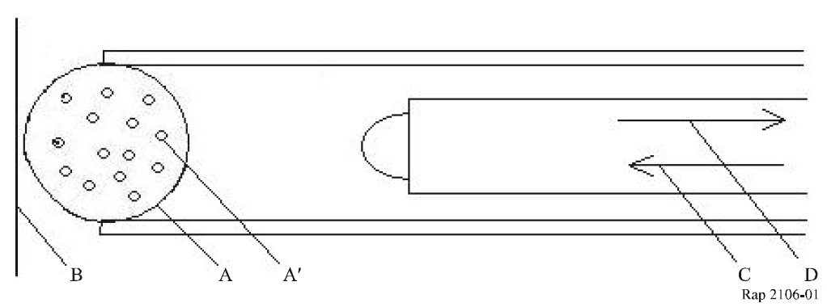

#### 2.1.2.3 Saturation sensitivity, Ss

Saturation sensitivity, Ss, is the maximum optical level with a considered data quality transmission (for instance, BER should be better than 10–6; i.e., BER ≤ 10–6); with and without automatic attenuation control (AAC).

The unit should be in dBm and the measurement should be achieved closer to the FSO receiver windows.

If the terminal has multireceiver windows, Ss on each Ar and the total saturation sensitivity should be indicated.

The difference between the saturation sensitivity (with AAC if any) and the sensitivity gives the dynamic range.

#### 2.1.2.4 Field of view, Fv

The Field of view (FOV), Fv, is the angle between the central axis and the –3 dB value angle detection. The value can be expressed as half angle or full angle, but has to be mentioned; and the unit can be expressed in milliradian (mrad).

#### 2.1.2.5 System loss, Asys

This element shall be used as an indication and it is not used for laser safety class and link margin calculation, due to the emission and receiver measurement points. The unit should be in dB.

## 2.2 System configuration

Basic configuration of a FSOL for the FS applications is illustrated in Fig. 2.

Figure 2

Basic configuration of FSOL

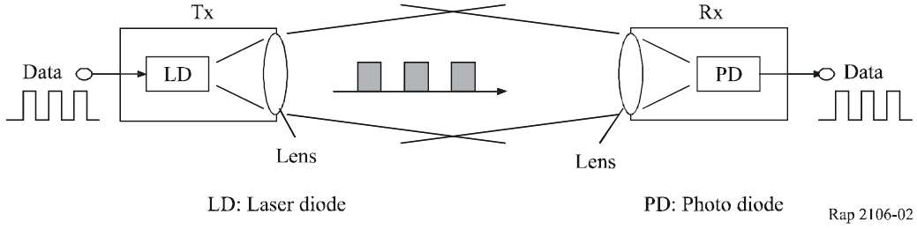

In many FSOLs, the function of electrical/optical (E/O) conversion or optical/electrical conversion (O/E) is performed using a laser diode (LD) or a light emitting diode (LED) in the transmitter (Tx) and using a photo diode (PD) or an avalanche photo diode (APD) in the receiver (Rx), respectively. Recently, some systems have implemented the WDM technique in which more than one optical carrier can be accommodated in a couple of transmitter and receiver to increase the link capacity [1], [2].

Many types of the FSO equipment use the intensity modulation of transmitting laser beam to send binary data in both directions through a transmitter/receiver couple at each end. The equipment is used for point-to-point, bilateral links and used in line of sight (LoS) conditions.

Another type of equipment to make WDM technology, such as fibre amplifiers and WDM components available in the FSOL configurations have been recently demonstrated where free-space optical beam should be coupled into a single mode fibre (SMF) with a good efficiency [3]. Since the effective aperture of the SMF is very small, about 10 μm in diameter, an accurate tracking system should be required at the both transmitting and receiving equipments. An example of the implementation of such a FSO terminal and their application of radio on free-space optical links (RoFSOLs) are described in Annex 3.

In RoFSOL, various types of radio signals, e.g., mobile and/or broadcast applications, are directly converted to light wave signals through modulation of their intensity, phase or other parameters. In such a system, WDM technology can be used to discriminate multiple services and forward/reverse link. The operating wavelength of RoFSOL may be selected based on the standardized wavelength in ITU-T Recommendations G.984.5 (Gigabit-capable Passive Optical Networks: Enhancement band), G.694.1 (Dense WDM frequency grid) or G.694.1 (Coarse WDM frequency grid).Each FSO terminal equipment consists of several modules:

– For the transmission:

a) tributary interface: electric or optics to send and receive signal;

b) O/E conversion module (in the case of fibre optic terminal interface);

c) filtering and the amplification of the electric signal;

d) optical transmission module containing the LD or LED.

– For the reception:

a) optical receiver module containing the PD;

b) filtering and amplification of the electric signal;

c) E/O conversion module (in the case of fibre optic terminal interface);

d) tributary interface: electric or optics to send and receive the signal.

Management software is sometimes provided with the equipment and allowing configuration of the link and to obtain qualitative and quantitative information from the different modules.

Additional functionalities are implemented depending on the manufacturer and the system requirements, such as:

– a tracking system, ATPC, AAC;

– a radio assistance link, with a limited rate, to prevent laser link interruption.

An example of FSO equipment structure is presented in Fig. 3.

Figure 3

FSO terminal example (according to optical access, San Diego, USA)

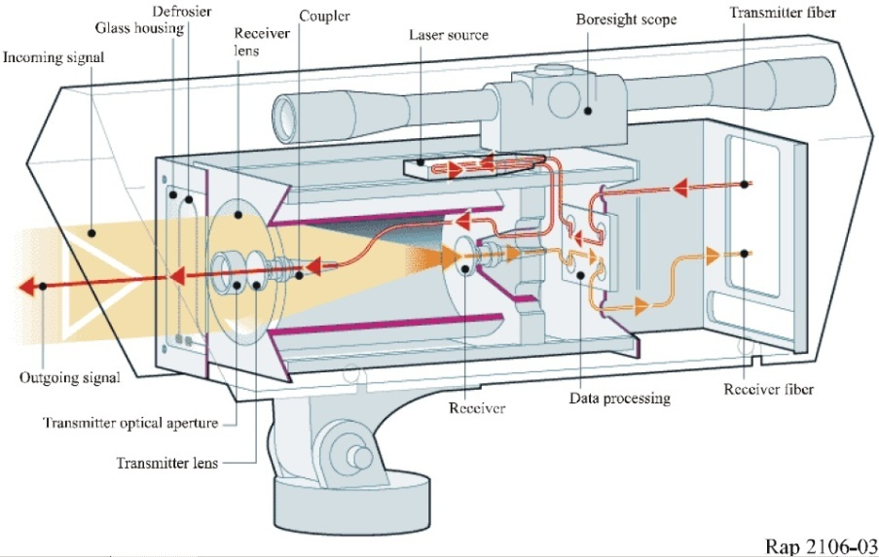

## 2.3 Basic system parameters

The main parameters to take into account in the definition of optical links are the following:

*Range:* This varies according to the equipment from a few tens of metres to several kilometres. Some manufacturers give a maximum range, others specify the typical range for various weather conditions, and others finally propose a “recommended” range, integrating a margin compared to the maximum value. These values must be taken as orders of magnitude, and not as absolute values.

*Safety:* An important factor to take into account is the laser category of the equipment, because its conditions are more or less easy methods for the installation and the maintenance of an FSO link. The parameters to be taken into account when defining laser category are the signal wavelength, the encountered powers and the beam shape. It is advised to choose a 1 or 1M class terminal based on IEC 60825-1 normative reference, otherwise, the system must follow the guidelines and requirements defined by IEC 60825-12: Safety of free space optical communication systems used for transmission of information [4].

*Data rate and type of recommended application:* Many systems are transparent to data rate and to protocol; for a data rate range, this is often relatively important. The applications then depend on the maximum capacity, which the system can transmit and are located invariably in telecommunications or in the data processing world. A transparent system up to 200 Mbit/s will be able to transmit for instance STM-1, ATM, FDDI or Fast Ethernet signals. Other terminals are specified for a data rate, an interface and thus a given use, for example the E1 (2.048 Mbit/s), or Ethernet data (10 Mbit/s).

*Frequencies/wavelengths used for FSOL:* There are two major frequency/wavelength ranges that are widely utilized for FSOL applications, i.e., 230-200 THz/1 300-1 500 nm range and 375‑385 THz/780-800 nm range. These ranges have advantages compared to other ranges, that the atmospheric absorption over the free-space is fairly small. Also, in optical fibre systems, the transmission characteristics present such good performance in these wavelength ranges that the semiconductor light devices are economically available. A precise control technology for the wavelength has been developed in particular around the 1 500 nm range, where WDM technique is currently considered. In this relation, studies on the wavelength arrangements for optical fibre transmission have been conducted by ITU-T Study Group 15. From a viewpoint of atmospheric transmittance, a wavelength range 2 000-2 200 nm is also convenient, since effects of the aerosol scattering and the molecule absorption become minimum in this range, in particular around 2 200 nm [11] [12]. This range has another advantage that it is less sensitive to optical beam bending caused by atmosphere temperature variation (see § 7.1). On the other hand, economical light devices for both signal generation and detection are not yet feasible in the 2 000-2 200 nm range. Radiocommunication Study Group 3 (Working Parties 3J and 3M) has studied free‑space optical propagation characteristics for wide range of optical frequencies including both satellite and terrestrial links (see § 3).

*Transmit power of the laser diode:* Transmit power of the laser diode (LD) used for FSOL is currently in the order of 10 mW. Therefore, the link design discussed in the later section is based on this value. However, technology development will bring about optical devices with much higher capability and this may expand scope and applications of FSOL in the near future.

The following secondary parameters are also to be taken into account for the choice of a system:

– the wavelength to which the optical link operates: this parameter influences the safety class of the terminal;

– the type and number of optical transmitters and/or receivers influence the link margin;

– a simple process of implementation and maintenance actions;

– simple, convivial supervision software, allowing a management for the two (or several) terminals (or several links) from only one site (remote control);

– and, the cost of the system.

# 3 Free-space propagation characteristics relating to the link design

This section provides free-space propagation characteristics for FSOL based on the study results in the ITU-R P-Series Recommendations. For more detailed background of the material within this section, the relevant P-Series Recommendations (Recommendations ITU-R P.1814 and ITU‑R P.1817 could be referred to.

## 3.1 Clear-sky propagation

In optical wave propagation, the atmospheric attenuation is experienced in addition to what is called the free-space loss even during clear weather. This attenuation, *Latm*, is caused by Rayleigh scattering and/or molecule absorption, the effect of which greatly depends on the wavelength.

Also, the receiving power fluctuates due to temperature gradient turbulence within the atmosphere, which produces beam-bending, spot-dancing or scintillation in the optical wave propagation path.

Usually the effect of *Latm* is not so large in the wavelength ranges mentioned in § 2.3 (frequency/wavelength for FSOL) for links shorter than about 1 km. The link outage caused by such phenomena can be easily reduced by adjusting the optical beam divergence at the transmitting side so that the diameter of the beam spot at the receiver side would become a certain size, e.g., up to several metres.

Another way to improve the link availability against the affect of the propagation is to adopt a signal retransmission scheme and/or forward-error correction in the electrical layer.

## 3.2 Effect of fog

### 3.2.1 Estimation of fog attenuation using atmosphere visibility

Attenuation due to fog is caused by Mie scattering [5], which is dependent on the number of particles (fog density). It is generally difficult to directly measure fog density or to obtain its statistical data. The effect of the attenuation due to fog, *Attfog* (dB/km), can be related to atmosphere visibility, *V* (km), defined by the maximum distance that we can recognize a black object against the sky [6], [7]. More specifically, the visibility is defined for meteorology purposes. It is characterized by the transparency of the atmosphere estimated by a human observer. It is measured according to the meteorological Optical Range and by using a transmissometer or a diffusiometer.

In current cases, measurement of visibility, *V*, is given by the distance at which the transmitted optical power drops to ε times its original value. In the literature, the two following values of ε are found ε = 0.02 or ε = 0.05.

Then the relation between *Attfog* and *V* can be expressed by the following equation, which can be applied independently of the type of fog and of the optical wavelength within the range of *V* smaller than 3 km.

*Attfog* = 10 log10(ε)/*V* (1)

Thus, the attenuation of optical waves due to fog can be estimated using visibility statistics. The above prediction method based on equation (1) has been demonstrated and taken into consideration in the link design [6], [8]. Figure 4 illustrates the relation between *Attfog* and *V* for the measured data [8].

FIGURE 4

Atmosphere attenuation due to fog

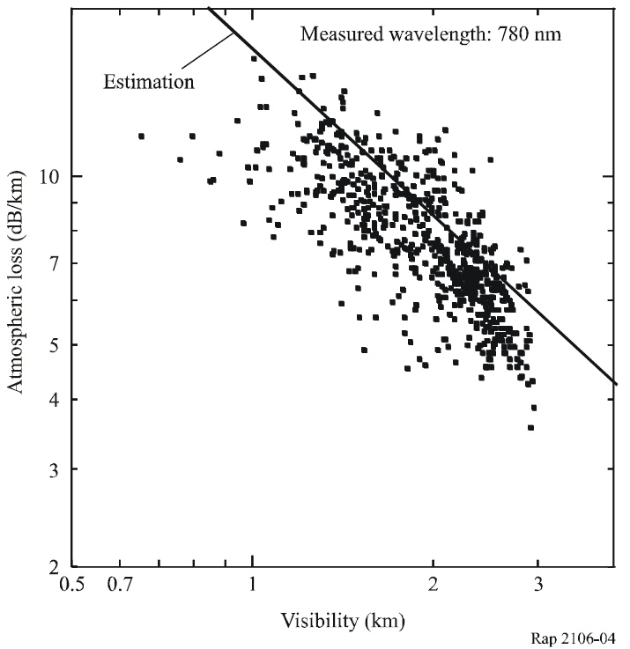

### 3.2.2 Detailed analysis on aerosol attenuation (fog)

In this sub-section, more detailed analysis is presented for cases when the type of fog is known.

Atmospheric attenuation results from an additive effect of absorption and dispersion of the infrared light by aerosols and gas molecules present in the atmosphere. Transmittance in function of the distance is given by Beer Lambert relation:

 (2)

where:

τ(λ,*d*): transmittance at the distance *d* of the transmitter;

*P*(λ,*d*): transmitted power at a distance *d*;

*P*(λ,0): transmitted power;

σ(λ): specific attenuation or extinction coefficient per unit of length.

Attenuation due to fog over a *d* (km) linkis connected to transmittance by the following expression:

                dB (3)

The extinction coefficient σ(λ) is the sum of 4 terms:

σ (λ)= α*m*(λ) + α*a*(λ) + β*m*(λ) + β*a*(λ) (4)

where:

α*m*: molecular absorption coefficient (N2, O2, H2, HO, CO2, O3, ...)

α*a*: absorption coefficient by the aerosols (small solid or liquid particles present in the atmosphere (ice, dust, smoke, …))

β*m*: Rayleigh scattering coefficient resulting from the interaction of the wave with particles of a smaller size than the wavelength

β*a*: Mie scattering coefficient. It appears when particles are of the same order of magnitude as the transmitted wavelength.

Absorption dominates in the infrared while scattering dominates in the visible and ultraviolet range. Basically, the atmospheric attenuation (function of wavelength) is inversely proportional to visibility, a parameter characterizing the atmosphere opacity in presence of fog. The low values of molecular and aerosol absorption coefficients as well as Rayleigh scattering coefficient, extinction coefficient can be written by the following Al Naboulsi & Al relations:

Advection fog generated when the warm, moist air flows over a colder surface:

 (5)

Radiation fog generated by radiative cooling of an air mass during the night radiation when meteorological conditions are favourable:

where:

 (6)

where:

λ: FSO wavelength (μm)

*V*: visibility (km).

NOTE 1 – These relations have been calculated for a wavelength located between 690 and 1 550 nm and visibility between 50 and 1 000 m, fog attenuation for a laser radiation and for two types of fog available in FASCOD, advection and radiation. These two relations are only valid for a distance between 50 m and 1 000 m and it is up to the user to choose one of the relations, which corresponds to the type of fog.

## 3.3 Effect of rain

In the case of rain, attenuation is caused by geometric scattering due to raindrops. Independent of the wavelength, this attenuation *Attrain* (dB/km) is theoretically related to the raindrop size distribution, *fI*, by the following:

*Attrain* = 27.29 ×105 **.**2 **.** *fI dr* (7)

where:

*r*: diameter of rain drops (m).

For a certain location and a link distance, *fI* can be given by the statistical data of rainfall rate (in many cases one hour rate *R* (mm/h)) as follows [9]:

*fI* = *B* exp (*C* *R* *k* *r*) (8)

Examples of the parameters used in equation (8) are as follows according to the statistics collected in Japan:

Example (based on Marshall and Palmer model); *B* = 0.16, *C* = –82, and *k* = –0.21.

Then, the effect of *Attrain* can be generally derived as a function of the precipitation intensity *R* (mm/h) using equations (7) and (8).

*Attrain =* α * *R* β (9)

Rain intensity is the fundamental parameter used to locally describe the rain. The parameters α and β will be given according to the location (see Table 1). The parameters obtained in France are consistent with those in Recommendation ITU-R P.1814.

TABLE 1

Examples of the parameters used for rain attenuation estimation

|  |  |  |
| --- | --- | --- |
| Location | α | β |
| Japan | 1.58 | 0.63 |
| France | 1.076 | 0.67 |

The above prediction method, which is basically similar to that for the millimetric range electrical wave [10], has been proven to provide good estimation in optical wave propagation [6] [8] [16].

The measurement of rain intensity is carried out either directly by means of pluviometers or weather radars. Knowing the link margin deduced from the optical power link budget, the interruption probability of the link due to rain can be deduced, by dichotomy. A calculation example using the parameters measured in France is given as follows:

*Example:*

*R* = 18 mm/h

*Attrain* = 1.076 × 180.67 = 7.46 dB/km

*AttRain* = 7 dB/km.

Figures 5a) and 5b) illustrate the relations between *Attrain* using parameters in Table 1 and *R* for the data measured in Japan [8]. It is observed that, in the heavy rainfall region, estimation based on Recommendation ITU-R P.1814 also presents good approximation to the measured data obtained in Japan.

FIGURE 5

Atmosphere attenuation due to rainfall

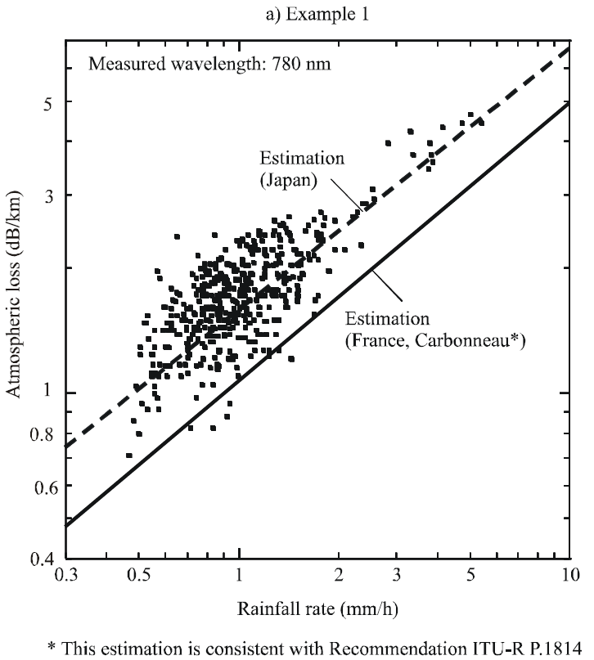

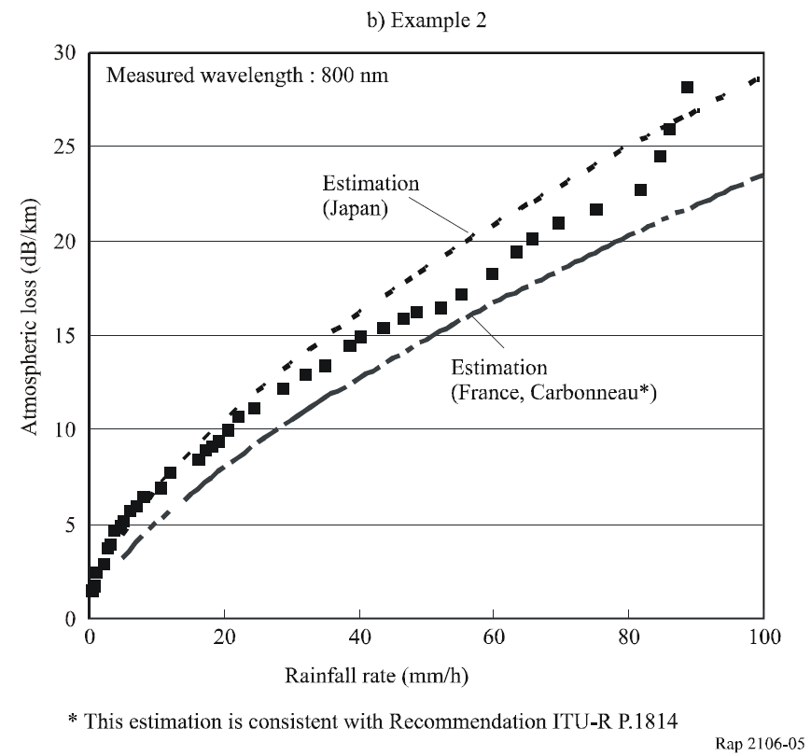

## 3.4 Snow attenuation

Attenuation due to snow is a function of the wavelength, λ*nm*, and precipitation intensity *S* (mm/h) according to the following relations:

– Wet snow (altitude <500 m):

 (10)

– Dry snow (altitude > or = 500 m)

 (11)

Snow intensity, *S*, is the fundamental parameter used to locally describe the snow. Its measurement is carried out in meteorological station.

Characteristics of snow precipitation are derived from those of rain precipitation in the altitude function system. A weighting coefficient, function of altitude (km), is applied to rain rainfall rate, *Rp*, exceeded for any given percentage, *p*, of the average year for any location (Fig. 6). Knowing the link margin deduced from the optical power link budget, we can deduce, by dichotomy, the interruption probability of the link due to snow.

Figure 6

Snow/rain weighting coefficient in function of altitude

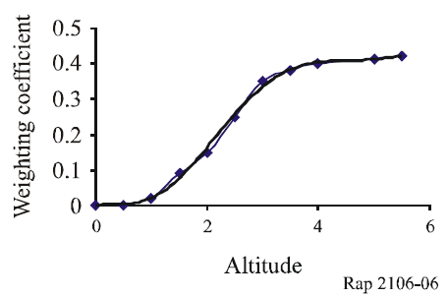

*Example:*

Altitude = 147 m, λ = 850 nm, *S* = 40 mm/h

*Attsnow* = ((0.0001023 × 850) + 3.7855466) × 400.72 = 55.14 dB/km

*Attsnow* = 55 dB/km.

## 3.5 Ambient light attenuation

Solar conjunction occurs when the sun or a reflected image of the sun is in or near the instantaneous field of view of an optical receiver, Fv. The receiver is generally at least as large as the transmit divergence. Here we will calculate the probability for which the sun position is parallel to the optical link and the sun power penetrating inside the receiver is greater than the power received from the transmitter.

### 3.5.1 Solar trajectory

The following Fig. 7 schematically represents the geometrical aspects of the sun path in the sky with regard to a FSOL (A is the receiver, B the transmitter).

Figure 7

Schematic sun path with regard to a FSOL

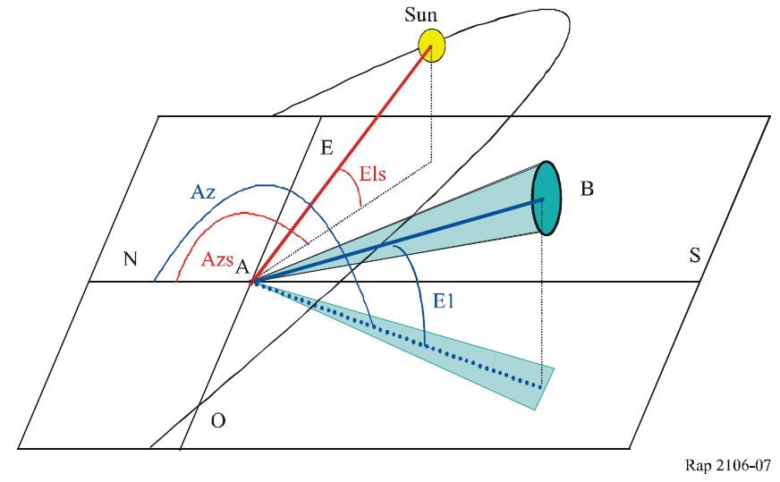

The different sun parameters (height, azimuth) are deduced for each day of the year, each hour, minute and second from its declination and its right ascension.

### 3.5.2 Solar power at the receiver

The power radiated by the sun (W/m2) is defined by the following equation:

 (12)

where:

Elevationradian: sun height.

The power penetrating inside the receiver is given by the following equation:

 (13)

where:

*Fsolar*: wavelength function characterizing the sun spectral-power

Capture_surface: capture surface receiver

Width_band receiver(nm): width band receiver.

## 3.6 Scintillation effects

Under the influence of thermal turbulence within the propagation medium one attends the formation of random, variable size (10 cm – 1 km) and of different temperature cells. These various cells have different refraction indexes thus causing scattering, multiple paths and arrival angle variations: the received signal quickly fluctuates at frequencies ranging between 0.01 and 200 Hz. The wave front varies in a similar way causing focusing and defocusing of the beam. Such signal fluctuations are called scintillations. Scintillation amplitude and frequency depend on the cells size compared to beam diameter. When heterogeneities are large compared to the beam cross section, it is deviated, when they are small, the beam is widened.

The tropospheric scintillation effect is generally studied starting from the logarithm of the amplitude χ (dB) of the observed signal (“log-amplitude”), defined as the ratio in decibels of its instantaneous amplitude and its average value. Intensity and speed of the fluctuations (frequency of scintillations) increase with the wave frequency. For a plane wave, a weak turbulence and a specific receiver, the scintillation variance σχ2(dB2) can be expressed by the following relation:

 (14)

where:

*k* (m–1): wave number

*L*: link length (m)

 (m–2/3): structural parameter of the refraction index representing the turbulence intensity. It is a function of roughness, solar radiation, humidity and terrestrial albedo.

Scintillation peak-to-peak amplitude is equal to 4σχ and attenuation related to scintillation is equal to 2σχ. For strong turbulences, one observes a saturation of the variance given by the relation above [14]. One will note that  parameter does not have the same value at millimetre and optical wavelength [15]. Millimetre waves are especially sensitive to humidity fluctuations while in optic, refraction index is a primarily function of the temperature (the water vapour contribution is negligible). One obtains in millimetre waves a value of  of about 10–13 m–2/3 what is an average turbulence (in general into millimetre we have 10–14<  <10–12) and in optics a value of  about 2 × 10–15 m–2/3 what is a light turbulence (in general in optics we have 10–16<  <10–13) [14].

## 3.7 Other factors

In outdoor propagation, FSOL scarcely incurs any background noise. However, FSOL may be interrupted by the sunray, when it comes across the receiving beam direction of the FSOL. In case that the sunray intersects the main axis of the receiving beam, the condensed thermal effect of the lens may become so significant as to destroy the receiver. Direction of the optical link should be selected to avoid the sunray intersection.

# 4 Applications in the fixed service

## 4.1 General features

FSOL has the following advantages:

– broadband or high data rate;

– small and simple equipment;

– license-free operation;

– advantageous cost;

– fast and simple deployment;

– quick link reuse and relocation.

For some specific applications, the FSOL offers several additional advantages to the ones offered by a traditional fixed link or those based on optical fibre. Below are some examples of possible applications:

– a link for a special event;

– a temporary link: a quick installation for a limited time in order to wait for a definitive traditional link;

– an emergency link: installation of an emergency link in case of a broken link;

– intersite link, independent network (PDH, SDH, ATM, Ethernet 10/100/1 000);

– optical ring close;

– backup link;

– dense network;

– mobile infrastructure, e.g., GSM or IMT-2000 nanocell or picocell link.

And FSOL has the following disadvantages:

– availability related to the distance;

– LoS condition.

On the other hand, optical wave transmission over the free space has to overcome some problems due to propagation as discussed in § 3.

## 4.2 Basic application examples

Making use of the advantages, typical FSOL applications are realized in limited distance. This paragraph presents examples of local area network (LAN) connection link between the buildings and a connection for the mobile infrastructure extension as shown in Figs 8, 9A and 9B. RoFSOL utilizes radio to optical conversion (R/O) and optical to radio conversion (O/R) instead of E/O and O/E used for the conventional FSOL of digital data transmission. This application can distribute radio signals, not only to outdoor shadow areas but also indoor shadow areas through optical fibre. In such applications, WDM grids of RoFSOL are shared by the WDM grids used by the fixed optical services, such as data and video.

FIGURE 8

FSOL connecting LANs deployed in the separate buildings

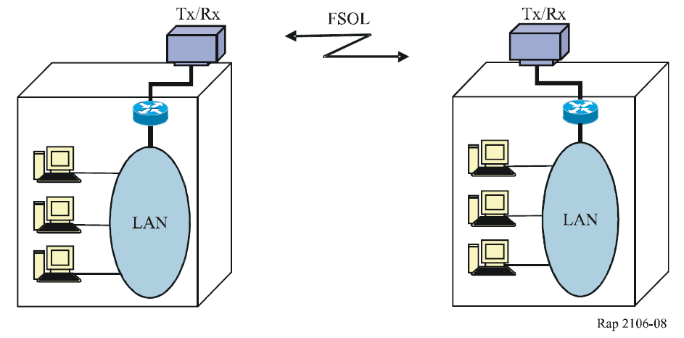

FIGURE 9A

FSOL extending mobile infrastructure

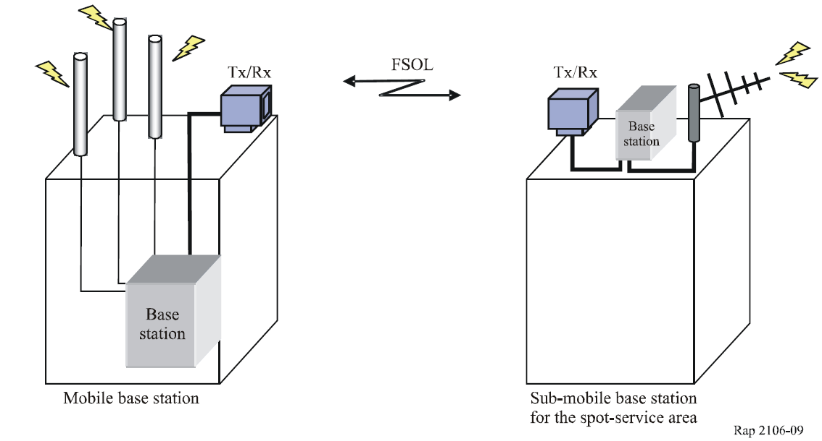

FIGURE 9B

RoFSOL extending mobile infrastructure



## 4.3 Real deployment examples

This paragraph provides a FSOL deployment example forming broadband local network solution in conjunction with optical fibre systems.

Figure 9 illustrates configuration of the school network intended for high-speed Internet access, using FSOL in combination with the fibre systems. Such broadband network infrastructure has been deployed in many schools utilizing various transmission media ranging from satellite, optical fibre, fixed wireless access to FSOLs. In Japan FSOL is used in links to more than 100 schools.

There are cases that one building is used for relay facility to provide extended links to more than one school. Such branching is easily realized using the same frequency/wavelength signal. The system parameters for the FSOL in Fig. 10 are given in Table 2.

TABLE 2

FSOL parameters

|  |  |
| --- | --- |
| Maximum link length (km) | Around 2 (1) |
| Transmission capacity (Mbit/s) | 300 |
| Margin for attenuation (dB) | 20 |
| Optic device (wavelength range) | Laser diode/Si-APD (0.8 μm band) |
| Cable interface | Optical fibre 1.3 μm |
| APD: avalanche photo diode.  (1) Link availability of above 99%. | |

The link availability of the FSOL is designed based on visibility statistics data accumulated by the local meteorological authority (see § 3.2.1).

Figure 10

Deployment example of broadband school network using

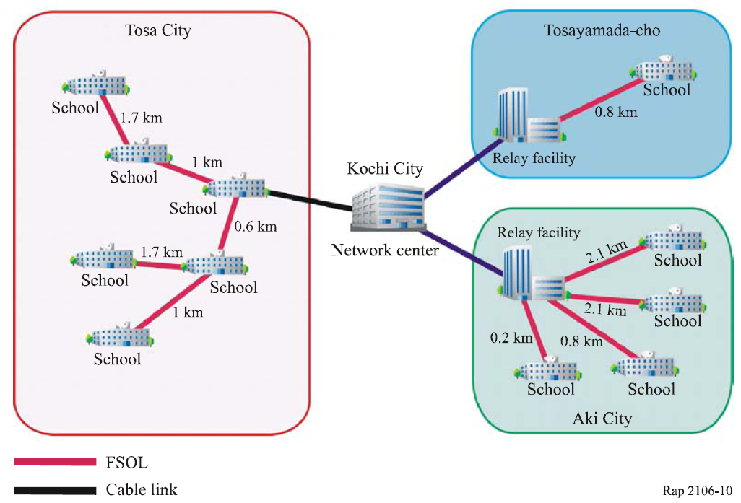

# 5 Link design consideration

## 5.1 Link margin

One of the important elements to know in FSO transmissions is the link margin of the laser beam transmission. To use the prediction models, the necessary parameters of the equipment are (non-exhaustive):

– transmit power;

– sensitivity of the receiver;

– effective aperture of the receiver;

– divergence of the transmit beam.

The optical link margin is the power available above the sensitivity of the receiver. The following relation defines it:

 (15)

where:

*Mlink*: link margin (dB)

*Pe*: power of the emission signal (dBm)

*Sr*: receiver sensitivity (dBm)

*Ageo*: geometrical attenuation of the link (dB)

*Aatm*: atmospheric attenuation including scintillation, molecular absorption and particle scattering (dB)

*Asys*: internal loss of the FSO equipment (dB) given by the manufacturer (possibly multiplied by 2, supposed to be 0 dB for an ideal case).

*Example:*

*d* = 271 m, θ = 4 mrad, *Pe* = 12 dBm, *Sr* = –50 dBm

*Ageo* = 21 dB (the calculation equation is shown in § 5.1.2)

*Aatm* = 0.11 dB

*Asys* = 0 dB

*Mlink* = +12 – (–50) – 21 – 0.11 – 0 = 40.89 dB.

In the following paragraph, the different fixed attenuations are described and have to be taken into account when calculating the link margin and some other values to be known.

If there is a WDM transmission, in order to multiply the data rate transmission on the same FSOL, it could be easier to use the equation (15) for each wavelength.

### 5.1.1 Beam diameter

The beam diameter determines the area of illumination by the transmitting beam at distance “*d*” from the transmitter according to the considered beam divergence and gives by the following relation:

 (16)

where:

θ: beam divergence (full angle) (rad)

*d*: link distance (m)

*D*: beam diameter (m).

*Example:*

*d* = 271 m, θ = 4 mrad = 0.004 rad

*D* = 271 × 2 tan(0.004/2) = 1.084 m.

### 5.1.2 Geometrical attenuation

The beam sent by the transmitter being diverging (1-3 mrad), the receiving cell will collect only a part of the transmitted energy. The following relation gives the geometrical attenuation:

 (17)

where:

*Strans*: area of illumination by the transmitting beam at the distance “*d”*

*Scapture*: effective aperture of the receiver

θ: beam divergence (full angle, rad)

*d*: link distance (m).

In dB, the attenuation is given by:

 (18)

*Example:*

*Strans*= 0.92 m2

*Scapture* = 0.00785 = 7.85 × 10–3 m2

*Ageo* = 10 log10 (0.9228 / 0.00785) = 20.70 dB.

### 5.1.3 Molecular absorption

The molecular absorption (O2, H2, CO2, O3, …) is a well known part of the atmospheric attenuation and is part of the function of the used wavelength. Some typical values (attenuation in dB for a 1 km unit link distance) are given in the Table 3:

TABLE 3

Molecular absorption typical values

|  |  |
| --- | --- |
| Wavelength (nm) | *Asp*= Specific molecular absorption (dB/km) |
| 550 | 0.13 |
| 690 | 0.01 |
| 780 | 0.41 |
| 850 | 0.41 |
| 1 550 | 0.01 |

And the following relation gives the total molecular attenuation for a considered link distance:

 (19)

where:

*Aso*: specific molecular attenuation (dB/km)

*d*: link distance (km)

*Amol*: total molecular attenuation (dB).

*Example:*

*d* = 271 m, λ = 850 nm, so, *Asp* = 0.41 dB/km

*Amol* = 0.271 × 0.41 = 0.111 dB.

### 5.1.4 Received level

The received level is the signal power received by the receiver aperture at a given distance and this value is important for the installation process. It is given by the following equation:

 (20)

where:

*Pr*: power of the received signal (dBm)

*Pe*: power of the transmit signal (dBm)

*Amol*: molecular attenuation of the link (dB)

*Asys*: internal loss of the FSO equipment (dB).

*Example:*

*d* = 271 m, θ = 4 mrad, *Pe=*12 dBm

*Ageo*= 21 dB

*Amol* = 0.11 dB

*Asys*= 0 dB

*Pr*= 12 – 21 – 0.11 – 0 = –9.11 dBm.

### 5.1.5 Beam wavefront errors and intensity profile homogeneity

One of the influences of the wavefront beam homogeneity in the transmitting beam is the quality of the sources and the optics used. These elements give on the spot projected quality and thus on the link assessment. The ideal objective is to achieve a uniform spot with a homogeneous distribution of the power (Top Hat) and the difference power on the wavelength front beam should not exceed 3 dB. Figure 11 shows various spots and homogeneities.

Figure 11

FSO various spots and homogeneities

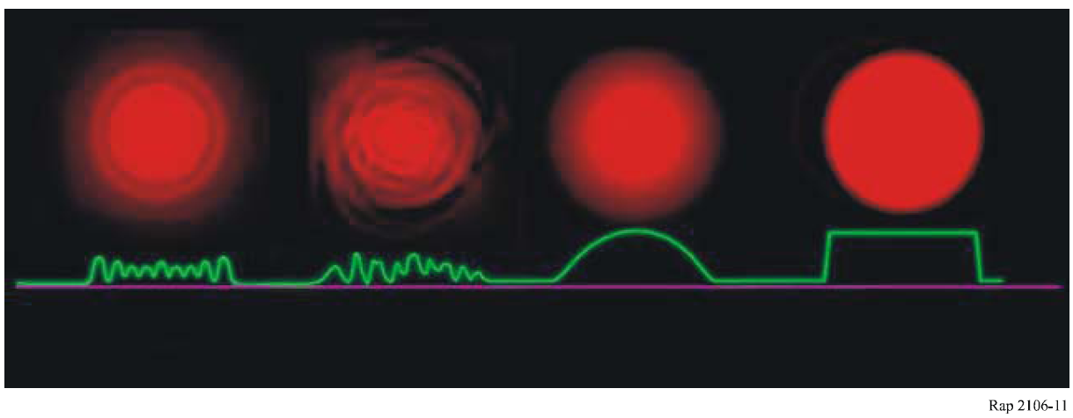

### 5.1.6 Margin for the unit distance

For a considered link with a given distance, one of the important elements (but not the only one) to know is the margin for the unit distance in order to have one of the terminal comparison elements. And the following relation defines it:

 (21)

where:

*Lmargin*: margin (dB/km) for the unit distance

*Mlink*: link margin (dB)

*d*: distance (km).

*Example:*

*d* = 0.271 km, *Mlink* = 41 dB

*Lmargin* = 41/0.271 = 151.29 dB/km

*Lmargin* = 151 dB/km.

# 6 Deployment of FSOL in specific climatic areas

As mentioned in the previous section, FSOL usually requires fairly large margin against rainfall and fog. If it is deployed in almost rain-free areas, link length will be much increased. It is assumed that, from a simple calculation, exemption of 20 dB margin will result in a 10 times longer link. In such a case, however, effects of the atmospheric attenuation *Latm* (see § 3.1) as well as impact of optical beam bending have to be taken into account. These effects mainly caused by the molecule absorption or atmosphere refraction due to the temperature variation could be observed in scintillation fading, i.e., fluctuation of the received level. The extent of the fluctuation in the dessert, which is defined by equation (14) in § 3.6, needs further study. However, for semi-arid regions, Zilbermann *et al.* [13] have developed a Middle East vertical profile model of the refractive turbulence strength  based on a large set of imaging LIDAR measurements. This model can be applied to desert areas until a more consolidated model is proposed in the future.

As a measure to overcome this type of scintillation fading, diversity reception may be effective using separate lens arrangement.

Another issue to be considered is the effects of sandstorms in the desert, which may significantly obstruct visibility condition over a hop between the transmitter and the receiver. Dust and sand blown by the wind in the desert are composed of loose and finely grained soils (e.g., calcium, silicon, aluminium and sulphur). Effect of sandstorm on the visibility of FSOL depends on the wind speed. Although there is a certain computer program available to calculate the total (absorption and scattering) transmission coefficient in a desert area, this issue has not yet been fully investigated and may also require further study.

However, for the present time the FASCOD computer program (from ONTAR) using the desert model (where aerosols are essentially suspended sand particles) can be used to calculate the total (absorption and scattering) transmission coefficient in a desert area. The necessary input data are the visibility at the ground level and the wind speed at 10 m height. The user is able to define its own climatic and aerosol model to calculate the atmospheric attenuation, or use the measurements of aerosol size distribution, volume and number concentration obtained by Zilbermann and Kopeika [13] from LIDAR measurements at different heights in the Mediterranean region (Israel).

# 7 Consideration on the operational aspect

Optical links are deployed at any time and any place. This is based on the assumption that there is no possibility requiring coordination to avoid interference between such links operated by different operators.

Theoretically, interference between FSOLs may occur under the following environments:

– when two systems are using the same frequency (wavelength), or mutually close frequencies (wavelengths);

– and at the same time, they are operating within a geographically close separation.

When the used frequencies are mutually close, transmitted spectrum of an optical wave may overlap with another FSOL spectrum, causing unacceptable interference. In that sense, choice of the frequencies (wavelengths) may be a matter of consideration by the operators to avoid effect of the interference between FSOLs (see § 2.3).

However, the interference will never have harmful effect unless two links operate under a quite limited geographical environment. As mentioned in § 3.1, light wave beam spot at the receiving side is usually adjusted so that its diameter is around several metres for a link length of about 1 km. This means that the transmitted power of FSOL is very much concentrated in the sharp beam with an aperture angle of the order of 0.1°. On the other hand, the lens aperture at the receiver side has a slightly wider angle to flexibly adapt to building rock or other factors of unstableness. It should be noted that the optical wave power will be significantly reduced, e.g., by several tens dB, outside the receiving beam spot.

It is, therefore, assumed that, there is little possibility of an interference problem between different operator’s FSOLs unless they are deployed almost in parallel using the same frequency (wavelength).

The sunray effect discussed in § 3.7 may need more attention of the operators for site selection of the FSOL stations.

## 7.1 Propagation times

Another interesting characteristic of FSO equipment is its digital data transmission speed; which possibly allows to cast off the router for a LAN link for instance.

Indeed, the majority of FSO equipment is transparent to the transmitted protocol. Generally, no treatment is carried out on the contents or the nature of the data, which offers relatively short propagation times.

The parameters to be taken into account in the calculation of the propagation time to the access are:

– electronic processing time of the FSO equipment (transmitter and receiver);

– the propagation time of the light in the atmosphere between A and B equipments (propagation time of the light in the atmosphere: about 3 × 10–9 s/m);

– the propagation time to the access is the sum of these two parameters;

– example:

– 500 m links;

– 155 Mbit/s data rate;

– example electronic processing time of FSO equipment: 3 × 10–7 × 2 = 6 × 10–7 s;

– the propagation time of the light in the atmosphere between A and B equipments: 500 m ≥ propagation time 1.5 × 10–6 s;

– the time of propagation is: 6 × 10–7 + 1.5 × 10–6 = 2.11 × 10–6 ⬄ let 2.11 μs.

## 7.2 Transmitted data confidentiality

The majority of the manufacturers use a “one-off” type amplitude modulation for data transmission by laser, the transmission protocol is generally transparent, but the possibilities of “hacking” information are rather restricted.

Apart from any direct action on the equipment or its accesses, there are only two solutions for a person “to recover” the transmitted data, with important technical skills and complex interventions criteria.

Information hacking is only possible if the person carries out the following operations:

1. Obtain the same FSO equipment from the same manufacturer, to collect and to decode data.

2. Carry out data “collecting”, a part of the beam, which is, nevertheless, very directional. And “recovers” sufficient energy toprocess them (Fig. 12):

– either between the two sites, A, to obtain the data transmitted from site X or Y only, with an additional difficulty which consists of avoiding cutting the beam;

– or, for example, behind the Y site, B, for the data transmitted from site X, knowing that the signal attenuation is very important as one moves away from the source;

– or, for example, in front of the equipment of the Y site, B, for the data transmitted from the site Y, with an additional difficulty which consists of avoiding cutting the beam.

3. Finally, the last difficulty consists of knowing the transmitted protocol, in order to understand the collected data.

Figure 12

To collect bits transmitted by sites X or Y, the hacker must collect a part of the beams

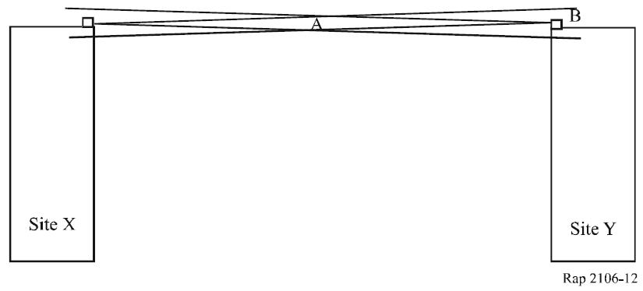

## 7.3 Guidelines for implement FSOL

### 7.3.1 FSO installation process

Generally, FSO equipment is set up in a similar way to a fixed wireless system:

* link engineering process (for instance; with the “FSO prediction” software) in order to define the link availability;
* installation on a high point (building, pylon, water tower, ...);
* in LoS with no obstacles on the actual or future trajectory;
* installation time lower than one day for a link.

But due to this specific technology, some elements and precautionary measures, are to be taken into account during the installation process (see Fig. 13).

Figure 13

FSO installation precautionary measures

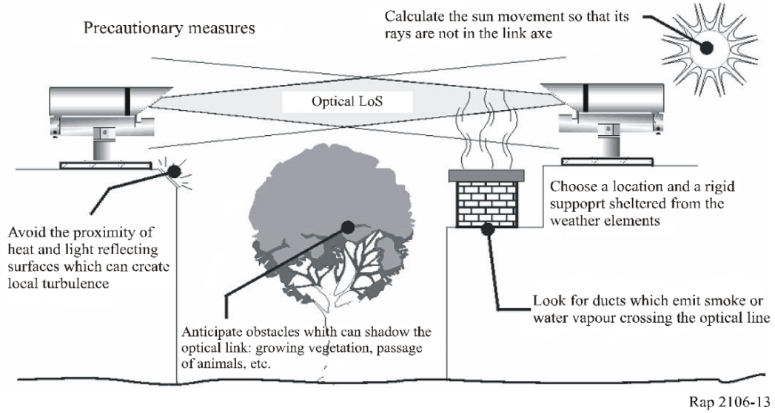

With the characteristic of the equipment (low divergence of the laser beam) being given, a very precise alignment is necessary. The alignment of the transmitter and the receiver characterizes the coupling of the optical link. These can be disturbed following mechanical vibrations. The fitter of the communication system must:

– fix the materials on a rigid support or a load-bearing wall so that it is subject to less possible vibrations or shock (edge of wall, side of wall, ...);

– avoid the direct alignment of optics with the rays of the sun;

– avoid the proximity of elements that can carry away atmospheric turbulence (chimney, reflective surface, ...).

### 7.3.2 FSO alignment process example

An FSO alignment process can be done with some preliminary calculated values, such as:

– received level;

– spot diameter.

The first alignment level is achieved by using visual rise and azimuth alignment on both sides.

And the accurate alignment should be held by camera, sound level, bip frequency, power meter indication and should follow these steps (see Figs 14 and 15).

Figure 14

Alignment process example

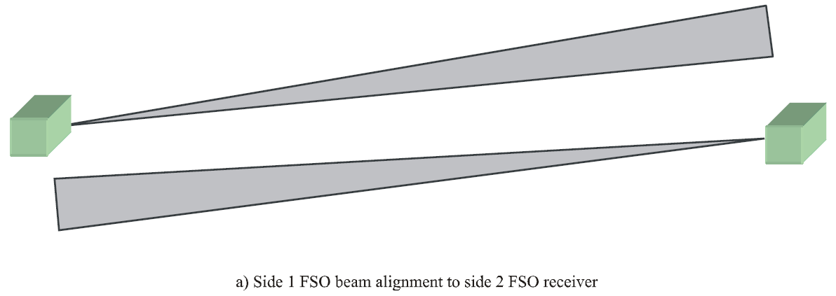

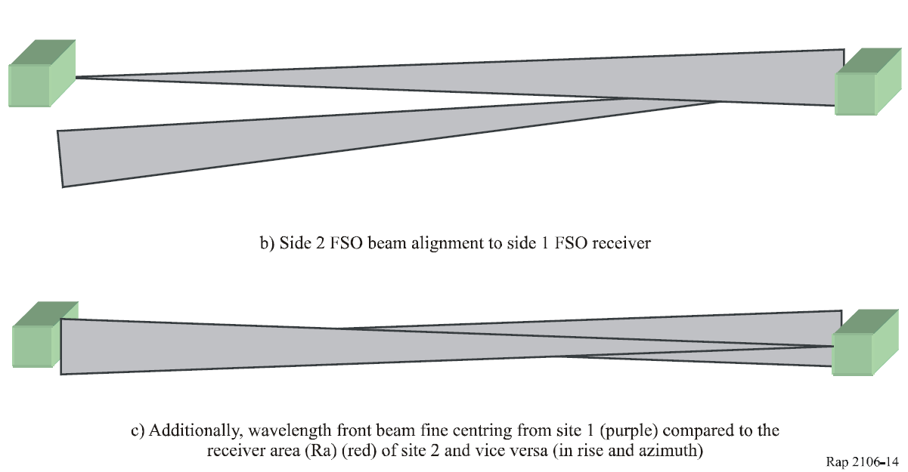

Figure 15

Fine process alignment process

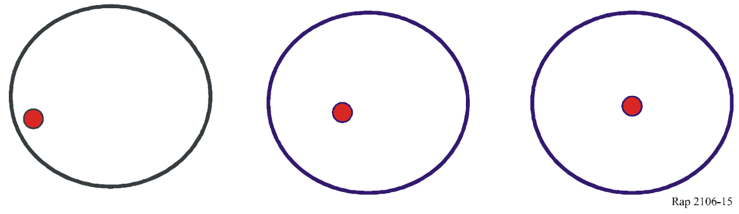

## 7.4 Multi FSOLs

In case of a multi-FSOLs implemented with the same wavelength and the same reception level, the following care should be taken to avoid the error bit:

– minimum spot diameter separation between the two parallel or nearly parallel FSOLs should be twice more important than a shorter distance spot diameter FSOL;

– minimum angular separation between two FSOLs should be twice as important as the shorter distance full angle divergence FSOL;

– it should be noted that the ITU-T SG 15 has developed ITU-T Recommendation G.640 on this item – Colocation longitudinally compatible interfaces for free-space optical systems.

# 8 Summary

This Report considers characteristics of FSOLs for FS applications as well as their technical/operational requirements. Consideration given in the previous sections focuses on FSOL for fixed service applications, and it is noted that there are other types of FSOL, e.g., belonging to the mobile service or space services. Items requiring further study or to be taken into account could be summarized as follows:

– technology development trend in the optical devices;

– expansion of FS applications;

– compatibility, if necessary, with FSOLs for other radiocommunication service applications.

Future study may extend the FSOs to multipoint FSO outdoor systems, point-to-point and point-to-multipoint FSO indoor systems, and test and measurement processes.

References

[1] G. Nykolak, *et al.*, “4 X 2.5 Gb/s 4.4 km WDM free-space optical link at 1 550 nm,” in Proc. OFC’99, PD11, 1999.

[2] Y. Aburakawa, “Dense wavelength division multiplexed optical wireless link towards terabit transmission,” in Proc. Of MWP’03, p. 135, 2003.

[3] E. Ciaramella, *et al*., “1.28 Terabit/s (32x40 Gbit/s) WDM transmission System for Free Space Optical Communications,” IEEE Journal of Selected Areas in Communications, Vol. 27, No. 9, December 2009.

[4] International Electrotechnical Commission (IEC), IEC 60825-1 Safety of laser products – Part 1: “Safety of laser products” and IEC 60825-12 Safety of laser products – Part 12: “Safety of free space optical communication systems used for transmission of information.”

[5] G. Mie, Ann. Physik., Vol. 25, p. 377-445, 1908.

[6] K. Morita, *et al.*, “Light wave attenuation in propagation through the atmosphere,” Review of Electrical Communications Labs., Vol. 19, No. 714-725, p. 798-842, 1971.

[7] Final Approach Visibility Studies, 1955, U.S. Weather Bureau.

[8] Y. Aburakawa, *et al.*, “Experimental evaluation of 800-nm band optical wireless link for radio access network,” IEICE Trans. Electron., Vol. E86-C, p. 1 175-1 183, No. 7, 2003.

[9] J.S. Marshal and W.M. Palmer, “The distribution of raindrops with size”, Journal of the Meteorology, Vol. 5, No. 6, p. 165, 1948.

[10] K. Morita, and I. Higuchi, “Statistical studies on electromagnetic wave attenuation due to rain,” Review of Electrical Communications Labs., Vol. 19, No. 7-8, p. 798-842, 1971.

[11] N. Hiromoto, “Novel detector technologies for infrared communication and sensing, CRL International Topic Workshop on Space Laser Communication Current Status and Future Perspectives, p. 90-95, 1997.

[12] M. Akiba, *et al.*, “Measurement of optical propagation characteristics for free-space optical communication during rainfall”, IEICE Trans. Commun., Vol. E87-B, No. 7 July 2004.

[13] Zilberman A., Kopeika N. S., “Aerosol and turbulence characterization at different heights in semi-arid regions”, Proc. SPIE Vol. 5891, p. 129-140.

[14] P. Bataille, “Analyse du comportement d’un système de télécommunication optique fonctionnant à 0,83 micron dans la basse troposphère”, Thèse, Université Rennes, 1992.

[15] H. Vasseur, *et al.*, “Influence de la troposphère sur les liaisons sans fil aux ondes millimétriques et optiques”, Propagation électromagnétique du décamétrique à l’angström, 3ièmes journées, Rennes 1997.

[16] T.H. Carbonneau, D.R. Wiseley, “Opportunities and challenges for optical wireless; the competitive advantage of free-space telecommunications link in today’s crowded marketplace”, SPIE Conf. on optic. Wireless Com., Boston, USA, Vol. 3232, 1998.

Annex 1  
  
Examples of the link budget

# 1 Example of the link budget

Link budget design for FSOL is derived basically from required link availability taking into account the propagation characteristics of the location where the link is deployed.

Table A1-1 indicates examples of system parameters for two different types of FSOL. For both systems, a laser diode (LD) with the same transmit power has been adopted. Also the beam spreading loss, *Lp*, is selected to be an equivalent value of 24 dB. Beam spreading loss corresponds to substantial link loss for the FSOL between the transmitter, Tx, and the receiver, Rx, i.e., free‑space loss minus the antenna gains in case of the electrical wave. *Lp* is theoretically expressed by the following formula:

*Lp* = (*Ar*/ *wr*)2 *Latm* (A-1)

where:

*wr*: beam spot diameter of the transmitted light at the distance *r* (link length)

*Ar:* effective aperture of the receiving lens.

These parameters, *wr* and *Ar*, can be adjusted by the convergence function of the optical lens installed in Tx or Rx. Atmospheric loss *Latm* is usually considered to be small as mentioned in § 3.1.

The required receiving power is derived from the calculation of *Lp* including necessary margins for fog and rainfall effects. In the examples in Table A1-1, the total margins are designed to be around 22 dB for both types.

It is recognized that two FSOLs with different link lengths can operate in an equivalent transmit power and beam spreading loss while resulting in the quite different outage objectives.

It is noted that link outage rate of 0.1% in Type 1 may not be applicable to the public network connection, e.g., PSTN or ISDN. On the other hand, Type 2 FSOL with much lower outage rate may serve as a fixed wireless access system connected to the public core networks.

TABLE A1-1

Example of link budget design for FSOL

|  |  |  |
| --- | --- | --- |
| Parameters | Type 1 | Type 2 |
| Link length (m) | 900 | 350 |
| Link capacity (Mbit/s) | 622.08 | |
| Required BER | BER = 10–9 | |
| Link outage rate | 0.1% (about 9 h/year) | 0.004% (about 20 min/year) |
| Transmit power (LD output: nominal) | 13 dBm (20 mW) | |
| Insertion loss of Tx (dB) | 3 | |
| Beam spreading loss (dB) | 24 | |
| Insertion loss of Rx (dB) | 3 | |
| Fog margin (Note 1) (dB) | 14.0 | 15.5 |
| Rainfall margin (Note 1) (dB) | 8.0 | 6.5 |
| Receiver sensitivity (dBm) | –40 | |
| NOTE 1 – Based on statistical data observed in Tokyo [8] [10]. | | |

# 2 Example of FSO availability prediction

One of the important elements to know in FSO transmissions is the margin of the FSO. In fact, following the example of radio operator equipment or radio-relay systems, it is of primary importance to know the margin of a given link. When a link is installed, mathematical models allow the calculation of the availability of the link for one year or for the most unfavourable month, for instance.

The first step consists to know the link margin. This element allows to know the capacity of the laser equipment for transmitting digital data in spite of the variations of the weather conditions.

To use the prediction models, the necessary parameters of the equipment are (non exhaustive):

– the transmitted power;

– the sensitivity of the receiver;

– the capture area of the receiver;

– the divergence of the transmitted beam.

From these data, for instance, the value of the geometrical attenuation can be known as well as the link margin and finally the availability.

## 2.1 Some link margin

In the table below, some examples of the calculation of a link margin for three typical equipment are given. Calculations are made for a distance of 500 m and the molecular attenuation is neglected. These link margins, data given as example, are basic elements to later apprehend the laser signal attenuation by climatic phenomena (fog, rain, snow, scintillation, ...).

TABLE A1-2

Example of a three link margin

|  |  |  |  |
| --- | --- | --- | --- |
| Emission power (dBm) | 10 | 13 | 26 |
| Sensitivity (dBm) | –35 | –40 | –36 |
|  | | | |
| Geometrical attenuation (dB) (*D*= 500 m) | 26 | 17 | 18 |
|  | | | |
| System loss (dB) | 1 | 2 | 0 |
|  | | | |
| Link margin (dB) | 18 | 34 | 44 |

## 2.2 Availability and Quality of Service

This part presents a concrete example of the Quality of Service (QoS) research for a given link using the characteristics of three FSO equipments.

In the example, the following elements were considered:

– link distance: 500 m;

– manufacturer: three manufacturers of different origins (A, B and C);

– equipment: a 155 Mbit/s SDH interface with optical fibre;

– model: the France Telecom models which give the attenuation by aerosols (fog) – the most disturbing attenuation for an FSOL – was applied;

– site: only one site is study, Rennes (France).

The research of QoS is a process which proceeds in three steps; thereafter, this process can be partially or completely computerized.

### 2.2.1 Example of minimum visibility calculation

A 500 m link with an interface of 155 Mbit/s is considered. From the linear link margin, by applying the France Telecom attenuation models, the value of the minimum visibility is determined.

TABLE A1-3

Example of three minimum visibility calculation

|  |  |  |  |
| --- | --- | --- | --- |
|  | Equipment A | Equipment B | Equipment C |
| Wavelength (nm) | 690 | 850 | 1 550 |
| Link distance (m) | 500 | 500 | 500 |
| Transmit power (dBm) | 10 | 13 | 26 |
| Sensitivity (dBm) | –35 | –40 | –36 |
| Geometrical attenuation (dB) | 25.94 | 17.4 | 18.59 |
| Molecular attenuation (dB) | 0.05 | 0.205 | 0.05 |
| System losses (dB) | 0 | 0 | 0 |
| Link margin (dB) | 19 | 35 | 43 |
| Lineic margin (dB/km) | 38 | 71 | 87 |
| Value of minimum visibility (m) | 470 | 250 | 210 |

### 2.2.2 Example of weather statistical data

From weather files provided by Météo France, for a city named Rennes, whose content is the percentage of hourly fog appearance, data synthesized over a long period of time; graphs presenting the cumulated percentage of fog appearance in three time periods were carried out:

– 8 a.m. to 8 p.m.;

– 8 p.m. to 8 a.m.;

– a whole day from 0 a.m. to 12 p.m.

These weather files have the following characteristics:

– hourly visibility;

– from 100 to 5 000 m;

– from 1 992 to 2 002;

– more than 73 000 observations;

– cumulated percentage of appearance;

– three hourly observation periods.

Three curves on the graph have been drowned, for which we have:

– in X-coordinate: the minimum value of visibility (m) (i.e., fog density);

– in Y-coordinate: percentage of appearances of the various minimum visibilities (%).

Figure A1-1

Percentage of appearance of fog with given visibility value

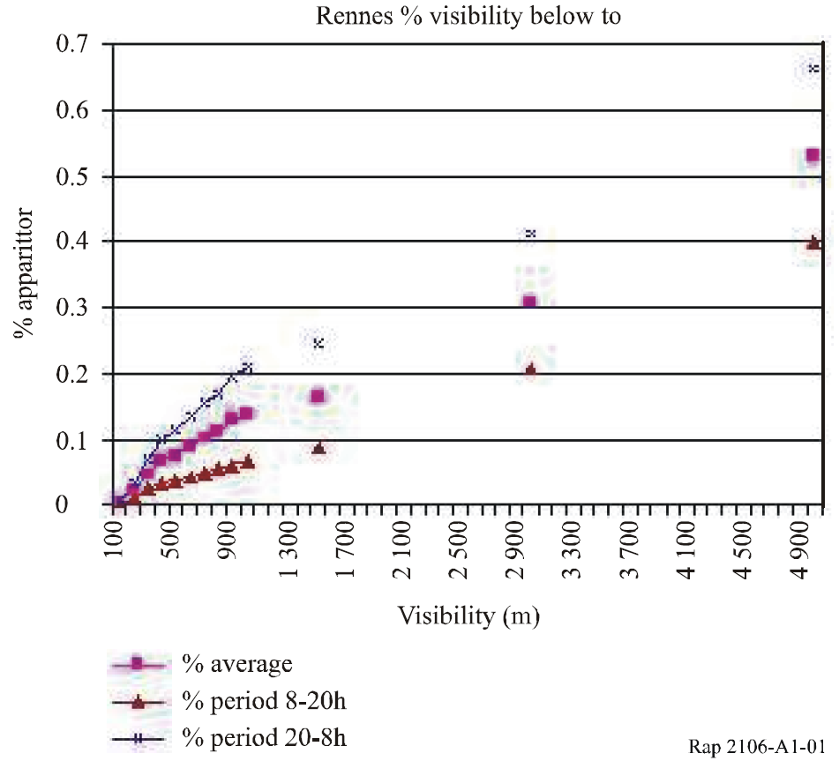

For a better legibility, the X-axis is presented in a logarithm scale.

Figure A1-2

Percentage of appearance of fog for given visibility value (logarithm scale)

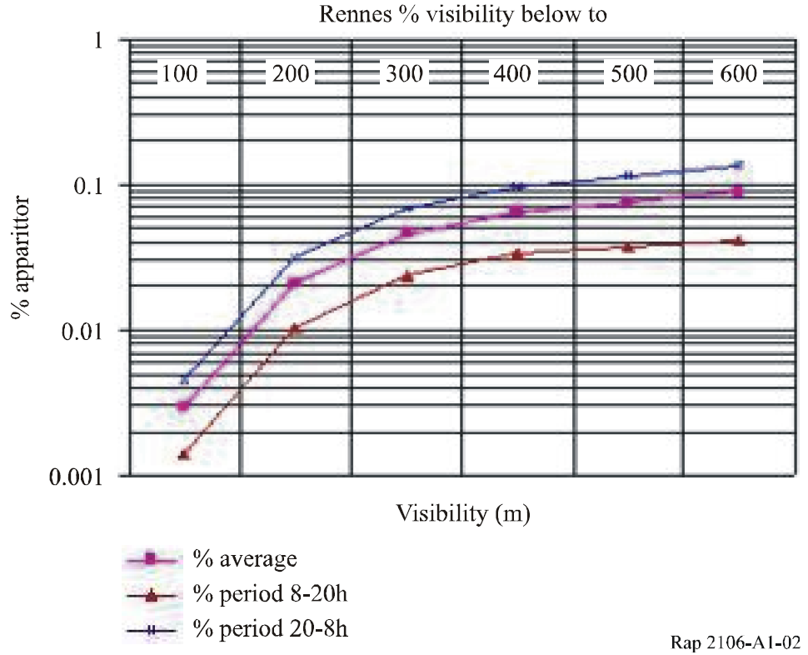

### 2.2.3 Example of a link availability calculation

An FSOL becomes unavailable when the fog density is higher than the link margin. Using meteorological graphs; thus the percentage of time for which we will have an unavailable FSOL is researched. By extension, the availability of the considered FSOL, expressed as a percentage and in a number of hours (or minutes) per year is determined. The research of the unavailability of an FSOL is carried out by taking the minimum visibility value for each equipment (in X‑coordinate) and by determining the percentage value of the appearance. Knowing this value, it estimates that the FSOL becomes unavailable beyond this value.

Tables below present the percentage values and the unavailability values for each piece of equipment.

TABLE A1-4

Comparison visibility and periods

|  |  |  |  |  |
| --- | --- | --- | --- | --- |
| % appearance |  | Equipment A | Equipment B | Equipment C |
| Minimum visibility value (m) |  | 342 | 184 | 150 |
| Model zoom | Day | 0.052 | 0.015 | 0.008 |
|  | P8-20 | 0.028 | 0.007 | 0.004 |
|  | P20-8 | 0.08 | 0.022 | 0.012 |

By extension, the availability of the considered FSOL, expressed as a percentage and in a number of hours (or minutes) per year is determined. For the considered site see Table A1-5.

TABLE A1-5

Link availability on the Rennes site for three different pieces of equipment A, B and C

|  |  |  |
| --- | --- | --- |
| Equipment A | % availability | Unavailability – Nb Hours/Year |
| Year | 99.948 | 4.56 |
| 8 a.m. to 8 p.m. period | 99.972 | 1.23 |
| 8 p.m. to 8 a.m. period | 99.920 | 3.50 |
|  |  |  |
|  |  | 8 760 hours = 1 year |
| Equipment B | % availability | Unavailability – Nb Hours/Year |
| Year | 99.985 | 1.31 |
| 8 a.m. to 8 p.m. period | 99.993 | 0.31 |
| 8 p.m. to 8 a.m. period | 99.978 | 0.96 |
|  |  |  |
|  |  | 8 760 hours = 1 year |
| Equipment C | % availability | Unavailability – Nb Hours/Year |
| Year | 99.992 | 0.70 |
| 8 a.m. to 8 p.m. period | 99.996 | 0.18 |
| 8 p.m. to 8 a.m. period | 99.988 | 0.53 |

### 2.2.4 Example of availability according to the link distance

Another approach consists of presenting QoS, according to the FSOL distance for the considered site.

Figure A1-3

Availability for the area of Rennes according to the distance

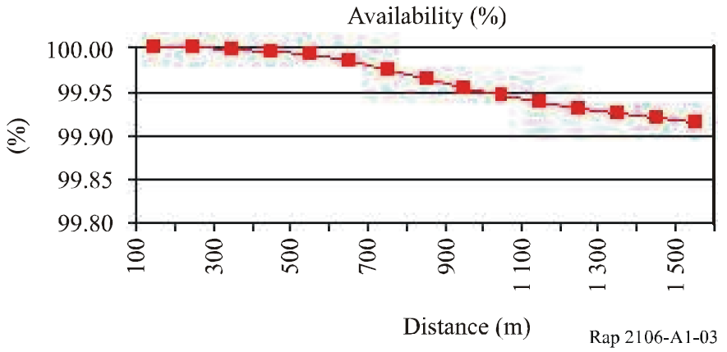

From this example, three important remarks are noted:

– QoS of an FSOL is very dependent on local weather conditions (for instance, fog) and the data-processing treatment on this climatic data becomes essential.

– QoS management is dependent on the link distance (under identical weather conditions) and a modification or an improvement on this parameter could be brought about by the equipment or the manufacturer selection. For example, from the previous graph, if a QoS higher than 99.95% in Rennes is desired; it will be necessary that the FSOL does not exceed a length of 900 m.

– This process, and other climatic parameter processes, can be computerized.

Annex 2  
  
Comparison between ITU-R Recommendations and “FSO prediction”  
QoS Software (Experimentation in France)

# 1 Introduction

An operator (FSO 04) has achieved an evaluation about FSO products capacities and developed in‑house software, “FSO prediction”. To target these objectives, it was envisaged to carry out an experimentation allowing to confront the FSO equipment capacities with weather data, the study was held on a France Telecom site around Toulouse, over an approximately six month period (12.01.2004 – 31.05.2005), during the winter season, the worst season for a product using the FSO technology to transmit numerical data.

Two objectives are defined:

– To confront the “FSO prediction” software results with the data field experimentation, over one sufficiently long period, in order to release from the relevant statistical data.

– Statistical analyse mainly directed towards the most inauspicious phenomenon of an optical link, i.e., fog attenuation or atmospheric attenuation.

– To check the results coherence with the others attenuation phenomena and from the field test data.

– To confront the FSO link results with the ITU-R Recommendation objectives, based on a microwave link:

– Recommendation ITU-R F.1703 – Availability objectives for real digital fixed wireless links used in 27 500 km hypothetical reference paths and connections.

– Recommendation ITU-R F.1668 – Error performance objectives for real digital fixed wireless links used in 27 500 km hypothetical reference paths and connections.

After a brief presentation about the experimentation site characteristics and FSO equipment, a short introduction of FSO prediction, software of quality of service simulation of an optical link, developed by France Telecom Research & Development is carried out.

The software results are then compared with the optical link data and the weather data, during the considered period, in order to achieve the two objectives.

# 2 FSOL field test

## 2.1 Site and equipment characteristics

Figure A2-1

Link characteristics

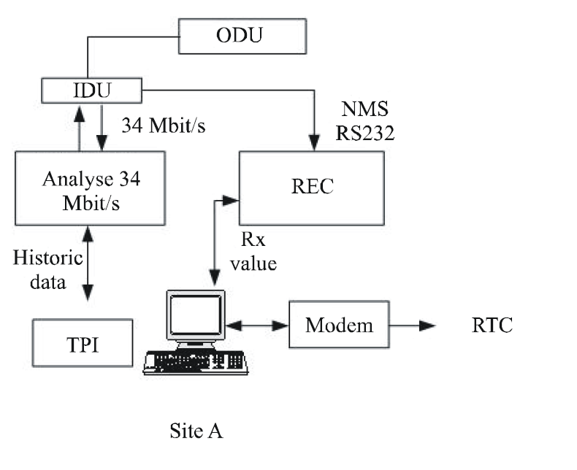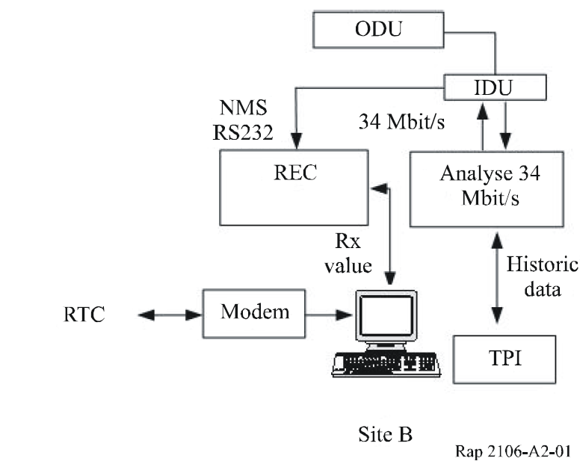

Equipments description, on each site:

– The FSO (ODU – Outdoor unit and IDU – Indoor unit) transmits PDH bilateral frame at a distance of approximately 270 m (0.2 mile) between two buildings named A and B.

– The PDH frame transmission analyser, named Victoria, records each second, the possible errors or unavailability and transmits the results to a PC every 15 min via an RS-232 connection. It is a bilateral analysis. Among the recorded data, we select and concatenate:

– ES: errored second (bit error).

– SES: severely errored second.

– Unavailability.

– The proprietary supervision software records, during each minute, the received level (sensitivity) and transmits continuously the data towards a PC.

– A RTC modem is installed for intervention, via the PC anywhere software, in case of problem.

– Weather data come from the France weather station located at the Blagnac airport (less than 500 m, around 0.4 mile, from the France Telecom experimentation site). The data are transmitted, each week, by E-mail and are defined by following measurements:

– Transmissometer, giving the visibility value (All values – frequency: each – minute – approximately 40 000 monthly values).

– Pluviometer, giving the precipitation intensity (maximum value – frequency: every 6 min).

– Snow, giving the snow intensity (maximum value).

– Pyranometer, giving the light intensity (maximum value).

## 2.2 Link design

### 2.2.1 Engineering data

The FSOL is made of two terminal equipments (each with ODU and IDU) pointing at each other and offering a PDH bilateral connection at a distance of approximately 270 m. Several information are essential [BOU 06] within the framework of the installation link, the information are:

– the link margin;

– the received level;

– the spot diameter.

### 2.2.2 Field data

After the installation process, the link measured data, in each direction, are presented in Tables A2‑1 and 2:

TABLE A2-1

Sensitivity A to B

|  |  |  |  |
| --- | --- | --- | --- |
| **Direction: From A to B** | Received level | Theoretically | –9 dBm |
| **Real** | **–11 dBm**(1) |
| Link margin | Theoretically | 41 dB |
| **Real** | **39 dB** |
| (1) The 2 dB difference can possibly be decreased by a finer pointing. | | | |

TABLE A2-2

Sensitivity B to A

|  |  |  |  |
| --- | --- | --- | --- |
| **Direction: From B to A** | Received level | Theoretically | –9 dBm |
| **Real** | **–16 dBm**(1) |
| Link margin | Theoretically | 41 dB |
| **Real** | **34 dB** |
| (1) The 5 dB difference between the two directions is voluntarily maintained, in order to study the margin sensitivity compared to the criteria of availability and quality of service. | | | |

# 3 Simulation software

Software FSO prediction V3.00 allows:

– The optical link design calculation, for any geographical place.

– The availability calculation of this link, for any place in France (in this version).

## 3.1 Capture data window

From the site data and FSO equipment measurements, we write these values in the first window of FSO prediction software; divided into six blocks of items, data sites block, equipment block, common sites data, common equipment data, environment and information. Then we launch the computing process allowing to determine various link parameters and to define the QoS and the availability from weather files.

Figure A2-2

Capture data Windows

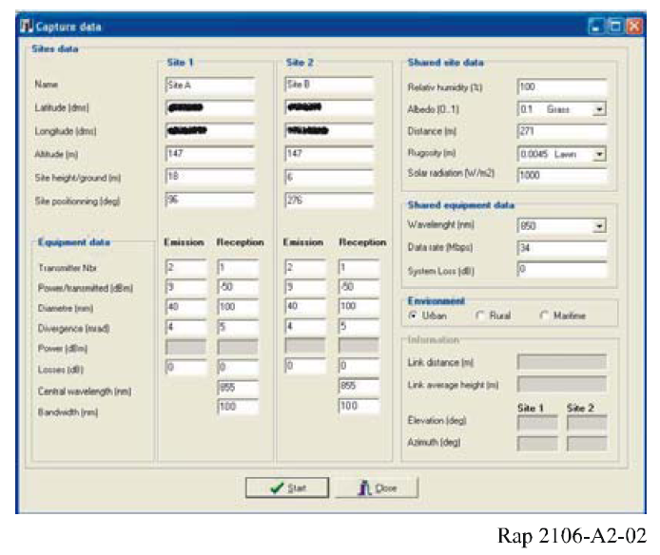

## 3.2 Report window

The report window shows us:

– Availability block item

– An availability during the year of 99.3037%, corresponding to 61 h of interruption.

– An availability during the most unfavourable month of 96.9849%, corresponding to 22 h of interruption, it is 36% of the year interruption volume.

– An availability during the day of 99.7260%, it is 20% of day interruption volume.

– An availability during the night of 98.8813%, it is 80% day interruption volume.

– Meteorological phenomena block item

– A fog influence, 0.696347%, it is 99.9982% of the phenomena volume.

– An ambient light influence, 0.000012%, it is 0.0018% of the phenomena volume.

* No scintillation, nor rain and snow influence.

Figure A2-3

Report window

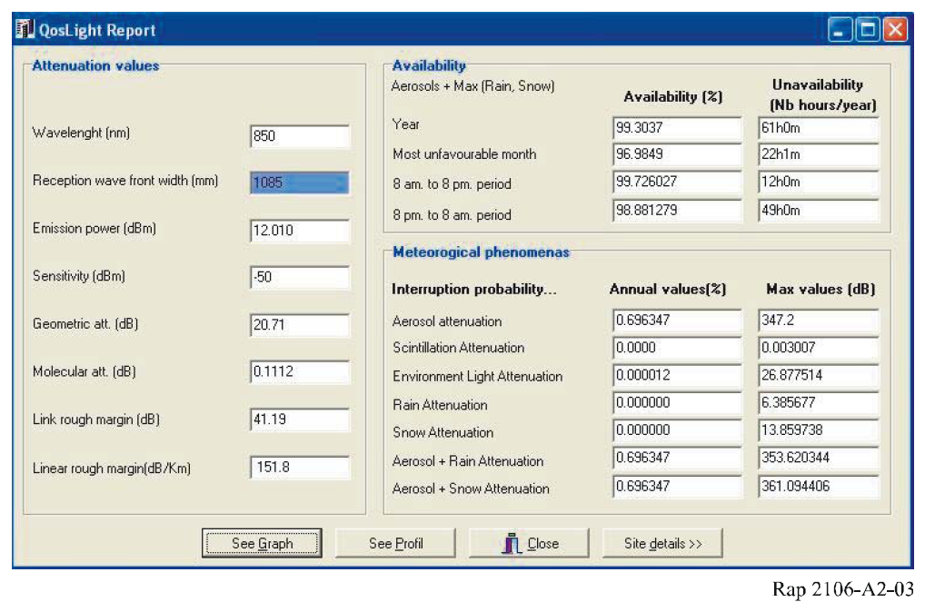

## 3.3 Profile window

This window stands for the two sites and the difference between the beam spot at the receiver and the receiver surface. The ratio is given by, beam spot at the receiver divided by receiver surface; and is equal to 1 085/100; means 10.85. This value indicates to us:

– An important proportion allowing to achieve a pointing of the bilateral link, under good condition.

– A good resistance to the vibration or dilation phenomena of the supports (buildings).

Figure A2-4

Profile window

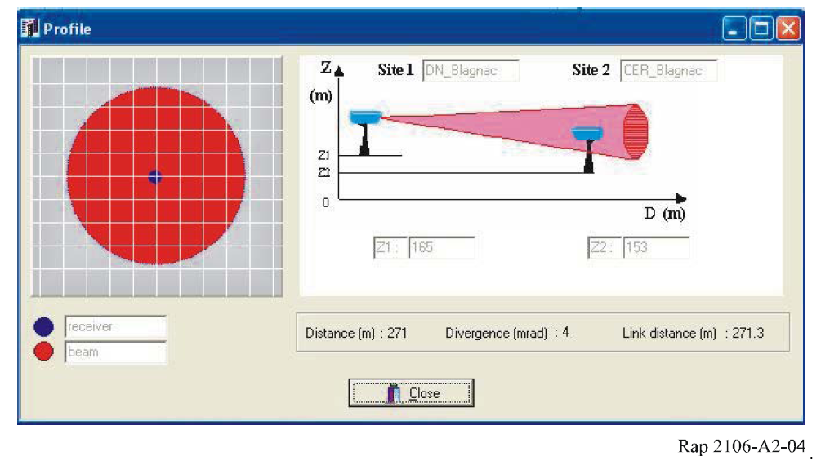

# 4 Results comparison

In this chapter, we carry out the process of comparison between the six months experimentation data, the criteria of availability and QoS and the values done by the software.

## 4.1 Comparison FSO prediction versus FSO and France weather station

### 4.1.1 Aerosol attenuation (fog)

Three formulas of aerosol attenuation or fog are analysed and compared, in order to check the models determined by Al Naboulsi & Al and are integrated in FSO prediction software.

Those three models are:

– Kim & Al model

– Advection Al Naboulsi & Al fog model for the day period, and

– radiation Al Naboulsi & Al fog model for the night period.

Fog radiation attenuation example (see equation (3) in § 3.2.2 in the main text)



Is equivalent to: 

For instance, with 80 m visibility fog, we have:  and 

#### 4.1.1.2 Process

The data are processed in order to be able to propose comparative models based on FSOL cut off. These data are selected when we have a fog (weather file – data of visibility) sufficiently intense to cut off the optical link.

For instance, a 100 m visibility fog is equivalent to an aerosol attenuation around 180 dB/km; means for the link distance, about 49 dB. This value is higher than the link margin (linear margin: 124 dB/km), we thus have, in theory, a connection cut off.

This fog cut off must be confirmed, at the same time typologies (MM:DD:YY–HH:MM) by the transmission analyser data files (link unavailability value) and the FSO supervision software data (sensitivity value – *S* < –55 dBm – cut off equivalent during the laboratory tests).

Only the data are selected for which the cut off is only due to the fog.

#### 4.1.1.3 Results

Approximately more than 400 values, answering the characteristics described above, were selected. Some incoherent data (important visibility and operational connection) were rejected. It can be explained by the relative distance of the FSOL experimentation and the site of France weather station (500 m), which involves a light temporal shift in the recordings when the fog movement is perpendicular to the two sites; or with aberrant results when the fog movement is parallel to the two sites.

The result is presented in the graph here under:

– The optical linear link margin which is 124 dB/km (blue straight);

– The Kim & Al attenuation fog formula (red dotted curve);

– The Al Naboulsi attenuation fog formulas, associated per hour of the event for the selection of the one of the two models (green curve).

All the values presented in this graph were selected because of a very low visibility, which means a strong fog attenuation value involving an obligatory cut off of the optical link.

It appears that for a configuration of link cut off, the Al Naboulsi attenuation fog formulas present a complete coherence with the link margin (100%); while the Kim & Al attenuation fog formula is not coherent in almost 50% of the cases. The Al Naboulsi attenuation fog formulas seems to be more in accordance with the reality.

Figure A2-5

Fog attenuation comparison

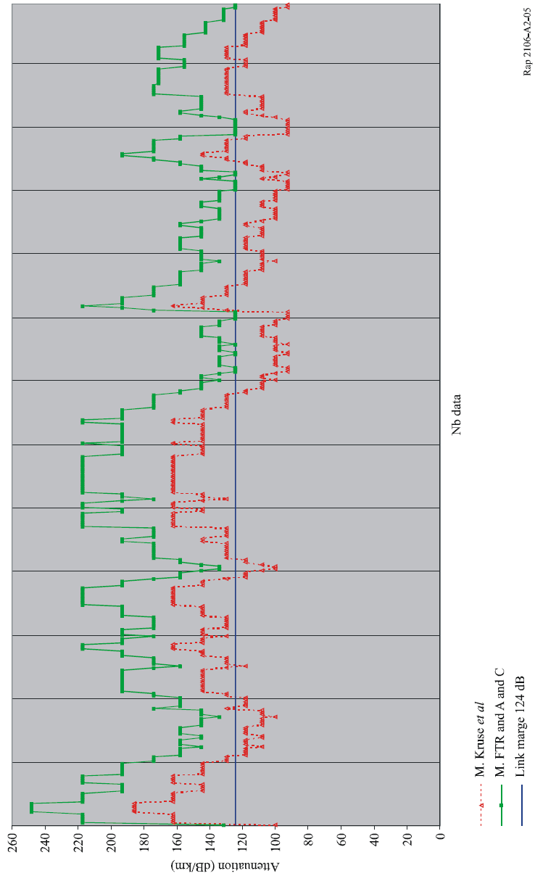

### 4.1.2 Other attenuation

#### 4.1.2.1 Rain attenuation

Attenuation due to rain is a function of the precipitation intensity *R* (mm/h) according to the following relation (A-2):

                dB/km (A-2)

where:

*R*: precipitation intensity (mm/h).

FSO prediction gives us a value of null unavailability for rain attenuation. France weather station indicates that the maximum measurement of rain, during the period considered, was *R* = 1.6 mm of rain over one 6 min period, 13 May 2005; maybe, in pessimistic projection, 16 mm/h.

Rain attenuation: *R* = 16 mm/h, *Attrain* = 1.076 × (16) 0.67 = 6.89; *Attrain* = 7 dB/km

Link rain attenuation *Attrain-link* = (271 × 7)/1000 = 1.89 dB; i.e., *Att rain-link*= 2 dB.

This value is lower than the link margin; therefore the phenomenon does not come to disturb the optical link. The FSO prediction software result is in correspondence with the climatic data of the considered period.

#### 4.1.2.2 Snow attenuation

Attenuation due to the snow is a function of the wavelength (λ*nm*) and precipitation intensity *S* (mm/h) according to the following relations (wet snow formula, altitude of the site lower than 500 m) (A-3):

 (A-3)

FSO prediction gives us a value of null unavailability for snow attenuation. France weather station indicates that snow measurements, at the station, are carried out in two forms:

– snow equivalent water level (corresponds to the quantity of precipitation),

– snow ground level.

During the considered period, the snow level, from Toulouse-Blagnac meteorological station, was not strong enough to have measurable value. We thus have a zero value for the snow climatic phenomenon.

So *Attsnow*= 0 dB.

This value is, obviously, lower than the link margin, therefore the phenomenon does not come to disturb the optical link. The FSO prediction software result is in correspondence with the climatic data of the considered period.

#### 4.1.2.3 Ambient light attenuation

Solar conjunction occurs when the sun is in the field of view (FOV) of an optical receiver. FSO prediction calculates, each minute in the year, the probability for which the sun position is parallel to the optical link and the sun power penetrating inside the receiver is greater than the power received from the emitter.

FSO prediction defines the ambient light attenuation calculation by the following formulae (Stefan Law-9):

 (A-4)

where:

λ: wavelength (m)

*C*: celerity light (3 × 108 m/s)

*T*: Temperature (K)

*K* = 1.38 × 10–23 J/K

σ = 5.67 × 10–8 Wm–2 K–4

*H* = 6.62 × 10–34 J/s.

In the spectral window of product FSO (filter in wavelength from 720 to 950 nm), we thus have:



The determination of the level received by the receiver is carried out from the FOV, with 5 mrd value and 100 mm diameter value (A-5).

where:

– Sun diameter: 1.4 million km

– Earth-Sun distance: 150 million km

 (A-5)



θ = 4.3 mrd (lower than 5 mrd), therefore FSO product receives all the light intensity, in certain configuration of position, from the sun.

France weather station indicates that the maximum sun intensity, during the period considered, was *S* = 3 500 J/cm2, and is approximately equal to 1 000 W/m2.



* Solar losses ratio (space + atmosphere)

 (A-6)



Means: filtered received flux = 180 W/m2.

It is considered that entering flux is completely focused on the receiving diode, that is to say:

, 

Therefore, the received power is equal to 1.4 W or 31.5 dBm.

This value has to be compared with the –11 dBm or –16 dBm level received value by the FSO receiver. FSO prediction indicates a 0.000012% unavailability value by the ambient light attenuation. This solar power value is, in some sun position configurations, higher than the received value; therefore the phenomenon influences and disturbs the optical link when the sun is in the direction of the FSO FOV. The result of FSO prediction simulation is in correspondence with the climatic data of the considered period.

#### 4.1.2.4 Scintillation effects

FSO prediction defines the scintillation effect calculation.

France weather station indicates a maxima solar radiation and hydrometry equal to 3 500 J/cm2 (either approximately 1 000 W/m2) and 100% respectively.

Scintillation effects: *F*1 = 8.99 × 10–14; *R*=1 000 W/m2; *F*2 = 26.6; *H* = 100; F3 = 0.19; so   
 = 4.5 × 10–13

*L* = 270 m; λ= 850 nm; *K* = 7.4 × 106; σ*X*2 = 1.23 × (7.4 × 106)7/6 × 4.5 × 10–13x(270)11/6 = 1.65

*Aff Scintillation-Link*= 2.57 dB.

This value is lower than the link margin; therefore the phenomenon does not come to disturb the optical link. The FSO prediction software result is in correspondence with the climatic data of the considered period.

## 4.2 QoS comparison and availability FSO versus ITU-R Recommendation

### 4.2.1 Comparison of QoS FSO versus Recommendation ITU-R F.1668

Recommendation ITU-R F.1668 proposes an error-performance objective for real digital fixed wireless links and it applies to the point-to-point numerical fixed links microwave. In the absence of specific Recommendation related to the FSO, this Recommendation has been used. The objectives of the Recommendation for a 34 Mbit/s access network are given in Table A2-3.

TABLE A2-3

Error performance objective

|  |  |  |
| --- | --- | --- |
|  | Monthly | Annual |
| Number of ES | < 389 | < 4668 |
| Number of SES | < 14 580 | < 174 960 |

The results of the FSOL quality of service, in the two directions and during the considered period, are given in Table A2-4.

From these results and based on the microwave link criteria, the FSOL is not in conformity compared to the quality of service criteria from the Recommendation ITU-R F.1668.

TABLE A2-4

QoS

|  |  |  |  |  |  |  |  |  |  |
| --- | --- | --- | --- | --- | --- | --- | --- | --- | --- |
|  | Direction: From A to B | | | | Direction: From B to A | | | | Results |
| Month | Nb ES | Level | Nb SES | Level | Nb ES | Level | Nb SES | Level |  |
| December 04 | 17 | OK | 16 | OK | 120 | OK | 120 | OK | 100% |
| January 05 | 104 | OK | 45 | OK | 619 | OK | **619** | **No** | 75% |
| February 05 | 1 048 | OK | **1 048** | **No** | 134 | OK | 134 | OK | 75% |
| March 05 | 157 | OK | 154 | OK | 88 | OK | 88 | OK | 100% |
| April 05 | 1 688 | OK | **1 688** | **No** | 329 | OK | 329 | OK | 75% |
| May 05 | 272 | OK | 264 | OK | 149 | OK | 149 | OK | 100% |

### 4.2.2 Comparison of FSO availability versus Recommendation ITU-R F.1703

Recommendation ITU-R F.1703 proposes an availability objective for any real digital fixed wireless link belonging to the access network and it applies to the point-to-point numerical fixed links microwave. In the absence of specific Recommendation related to the FSO, it is proposed to use this Recommendation. The objectives of the Recommendation for a 34 Mbit/s access network are given in Table A2-5.

TABLE A2-5

Availability objective

|  |  |  |
| --- | --- | --- |
|  | Most unfavourable month | Annual |
| Availability | > 99.4(1) (or 3 154 min or 189 240 s unavailability) | > 99.99 (or 53 min or 3 180 s unavailability) |
| (1) Based on 100% of availability 11 other months. | | |

The results of the FSOL availability, in the two directions and during the considered period, are given in Table A2-6.

TABLE A2-6

Availability

|  |  |  |  |  |  |
| --- | --- | --- | --- | --- | --- |
|  | Direction: From A to B | | Direction: From B to A | | Results |
| Month | Seconds | Level | Seconds | Level |  |
| December 04 | 0 | OK | 0 | OK | 100% |
| January 05 | 1 601 | OK | **38 839** | **No** | 50% |
| February 05 | 232 | OK | 0 | OK | 100% |
| March 05 | 13 | OK | 0 | OK | 100% |
| April 05 | 818 | OK | 0 | OK | 100% |
| May 05 | 0 | OK | 0 | OK | 100% |

From these results and based on the microwave link criteria, the FSOL is not in conformity compared to the availability criteria from Recommendation ITU-R F.1703.

## 4.3 Comparison of FSOL availability versus FSO prediction software

The results of FSO prediction simulation are compared with the FSOL availability recorded during six months. They are presented in Table A2-7.

TABLE A2-7

FSO prediction

|  |  |  |  |
| --- | --- | --- | --- |
|  | Most unfavourable month | Annual | Results |
| FSO prediction | 96.9849% | 99.3037% | Correct |
| Link FSO | 98.5016%(1) | 99.8768%(2) | Correct |
| (1) Annual projection.  (2) Based on the strongest unavailability. | | | |

The results from FSO prediction software are in correspondence and a little more pessimistic than the FSOL availability, during the considered period; with less than 0.58% over the year and 1.56% in the most unfavourable month.

Remarks and comments

– It should be noted that the margin difference (5 dB) between the two directions of the optical link is perfectly visible in the results of availability.

– A smoke coming from a chimney located on the roof of building A and coming from the kitchens sometimes came to obstruct the optical link, but the caused embarrassment appeared in very precise configurations (temperature, direction of the wind, speed of wind, ...) and was not quantified.

– The sunrise and the sunset also came to obstruct the optical link and software FSO prediction mentions it, but the caused embarrassment could be more frequent.

– The people located around the experimentation site have confirmed the exceptional character visibility values (fog) during the test period (important phenomenon of fog in 2005 not perceived since at least 1995). It is thus advisable to update, at regular intervals, the weather data in FSO prediction software.

# 5 Conclusion

First, the optical link experimentation made it possible to achieve the two objectives:

– To confront the results with FSO prediction software:

– The optical link statistical analysis of cut off by the fog highlighted a better precision of the models integrated in the software.

– The data test synthesis for the other attenuation phenomena are coherent with the results of the software.

– The software availability results are in correspondence and slightly more pessimistic than the reality of FSOL.

– To confront the FSOL results with the objectives of ITU-R Recommendations, based on the microwave link criteria:

– The results of optical link are not in conformity with Recommendation ITU‑R F.1703, availability objectives for real digital fixed wireless links used in 27 500 km hypothetical reference paths and connections.

– The results of optical link are not in conformity with Recommendation ITU‑R F.1668, error performance objectives for real digital fixed wireless links used in 27 500 km hypothetical reference paths and connections.

References

[BOU 06] Olivier BOUCHET *et al.* [2006] Free-space Optics: *Propagation and Communication*. ISTE Publishing Company. ISBN: 1905209029.

[FSO 04] <http://www.francetelecom.com/en/>.

Annex 3   
  
Direct fibre coupling FSO terminals and their   
radiocommunication application

# 1 Introduction

This Annex describes a newly developed FSO terminal which has a special capability to connect fibre optic links seamlessly and make WDM optical devices, such as Er-doped fibre amplifiers and radio-on-fibre equipments available in FSOLs. Using this kind of terminal, a new application of radio on free-space optical links (RoFSOLs) has been proposed and demonstrated.

# 2 Terminal description

Figure A3-1 shows the basic concept of the optics in a direct fibre coupling FSO terminal and explains how to couple the free-space optical beam into a single mode fibre (SMF). An optical antenna (telescope) is used to gather the incoming laser beam and to convert it into a smaller collimated beam. At the exit pupil of the telescope, a fast steering mirror (FSM) is placed to compensate and stabilize the angle of arrival beam fluctuation which is caused by the vibration and/or the thermal deformation of the terminal support structures as well as the atmospheric turbulence in the propagation path. The stabilized beam is finally focused into the SMF at the fibre coupler.

The following requirements should be satisfied to couple the collimated laser beam stably and efficiently into the SMF:

1. the centre of the focus image formed by the focusing lens should be the same as the centre of the mode field;

2. the direction of the focusing beam should be aligned with the SMF axis; and

3. the spot diameter at the focus should be the same as the mode field diameter of the SMF.

The last two conditions are very different from those in conventional FSO terminals which are using PDs or APDs where no coupling loss will occur if the focal spot is less than the aperture of the photo detectors. A tracking sensor should be installed in the SMF coupler to detect the position and alignment error. A tracking controller drives the FSM based on the tracking error.

FIGURE A3-1

Basic configuration of the compact FSO terminal

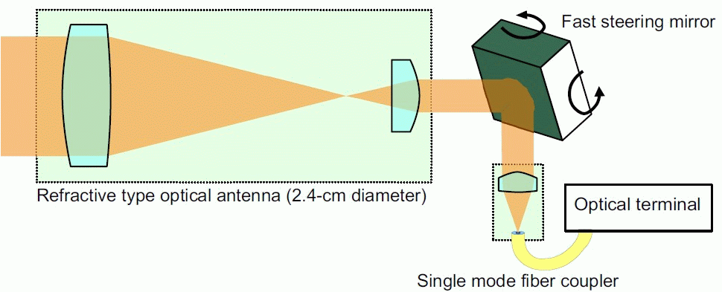

An example of the implementation of the direct fibre coupling FSO terminal is described in Fig. A3-2. The red arrows show the signal laser paths and the green arrows show the beacon laser paths, where the fibre connections are shown as the solid lines and the free-space beam paths are shown as the dotted lines. The electrical signal paths are shown in black arrows.

FIGURE A3-2

Block diagram of the compact FSO terminal

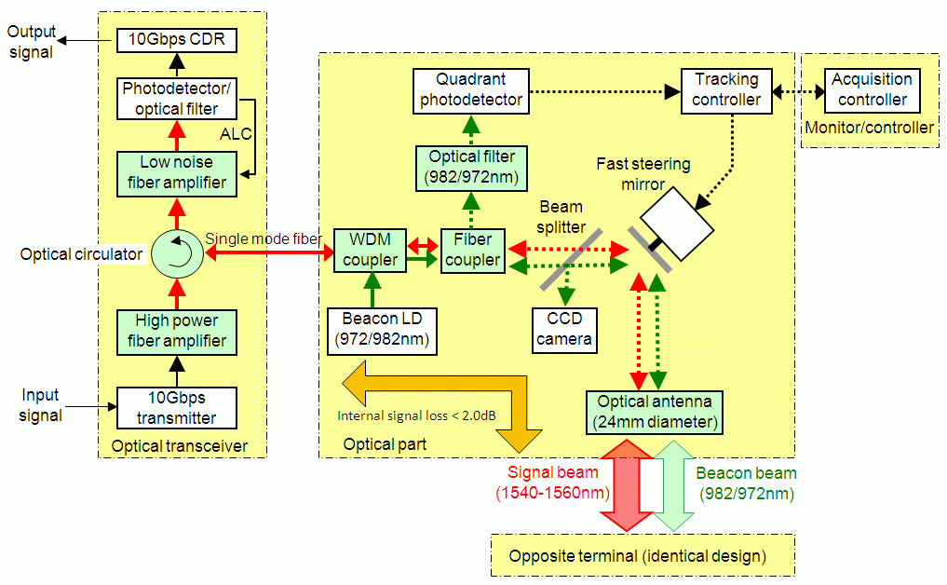

A refractive type telescope is used as an optical antenna. The typical aperture size of the telescope is 2.4 cm and the internal beam diameter is 2 mm. The overall optical signal attenuation from the aperture of the optical antenna to the SMF connection port including the telescope, fibre coupler, beam splitter and WDM coupler is about 2.0 dB. An optical circulator is used to separate the receiving signal and transmitting signal. A near infrared beacon laser is used for the purpose of bidirectional tracking. The two wavelengths, 982 nm and 972 nm, are selected within the EDFA’s pump laser wavelength band and the 10 nm difference is enough to distinguish the opposite terminal’s beacon from the background lights, including its own beacon transmission, by using a multilayer dielectric optical filter attached in front of the Si-quadrant photo detector in the tracking sensor. The transmitting signal light and the beacon laser light are multiplexed by a wave division multiplexing (WDM) coupler and then transmitted by the same optical path through the fibre coupler, the beam splitter, the FSM and the optical antenna.

An acquisition and tracking controller always watches the status of tracking controller and searches for the beacon signal by tilting the FSM within the field-of-view of the beacon divergence (about 2.0 mrad) if the link is interrupted for any reason. The CCD camera is used for the initial terminal setting. The terminal size is 12 cm × 12 cm × 20 cm and the weight is less than 1 kg. The electrical power required to operate the terminal is less than 1 W.

Figure A3-3 shows an example of theoretical calculations of the free-space link attenuation for the signal and beacon beam with the link distance from 100 m to 5 km. The geometrical attenuation due to the diffraction of the 2.4 cm diameter transmitting laser beam (with truncated Gaussian shape) is shown by a red solid line, the rain and fog attenuation assuming the location to be in Tokyo, Japan is shown by blue broken line and the signal fade due to daylight atmospheric turbulence effect (scintillation) is shown by yellow broken line, respectively. The worst-case link attenuation is the sum of the scintillation and the geometrical attenuation, because the rain/fog conditions and strong sunshine will not happen simultaneously. The beacon geometrical attenuation is also shown in the green solid line assuming the beam divergence of 2.2 mrad. The maximum transmission distance will be determined by the margin of the optical transceiver and this figure. If the transceiver has a 32 dB link margin, the FSO link distance will be extended to 1 km considering the terminal internal losses of 2.0 dB and the 28 dB geometrical attenuation. The sensitivity of the tracking sensor is about −47 dBm and the beacon transmit power is less than 1 mW.

FIGURE A3-3

Example of the link budget using the compact FSO terminal

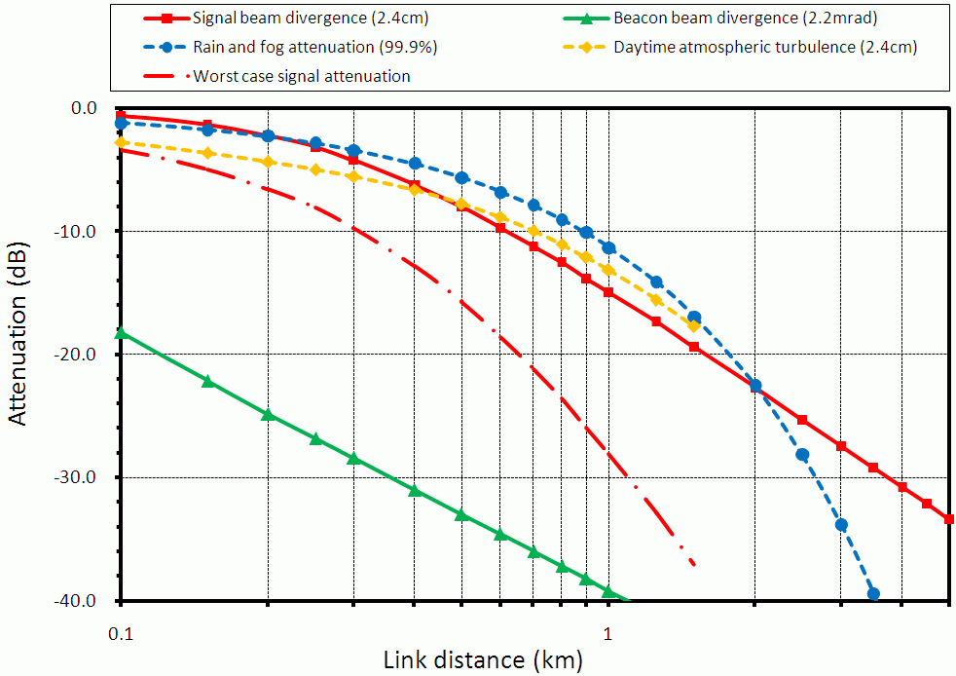

# 3 RoFSOL application

The RoFSOL consists of the following elements: RF-optic I/F units, fibre cable, FSO transceivers at BS and remote antenna sides. Figure A3-4 illustrates the configuration of RoFSOL. A radio signal is directly converted into optical intensity, phase, or other parameters as it is. In the forward direction from BS to remote antenna, radio signal is converted into optical signal at RF-optic I/F unit, and the output optical signal is transmitted on an optical fibre, and directly emitted from fibre cable to air at BS FSO transceiver.

After FSO transmission, the received optical signal is focused directly into a core of optical fibre cable, and reconverted into original radio signal at remote antenna RF-optic I/F unit. When the regenerated radio signals are transmitted from the antenna, the RoFSOL is operated as a repeater system for radio system. The backward link is the same as the forward one.

FIGURE A3-4

Configuration of RoFSOL



## 3.1 RF-optic I/F unit

In this unit, a radio signal is converted into the intensity, phase, and other parameters of an optical carrier at E/O (optical to electrical) converter, which uses a LD or an external optical modulator such as Mach-Zhender external modulator, EAM (electrical absorption modulator) and so on. When multichannel radio signals are transmitted by single E/O converter, it is able to be realized with SCM (subcarrier frequency multiplexing) techniques. Also, RoFSOL can provide optical multichannel transmission with WDM techniques. Figure A3-5 shows a configuration example for an 8-channel WDM system, where WDM is employed to realize the duplex of forward and backward links on a one-optical axis. Since the optical signal is emitted from an SMF, and focused directly into a SMF core at FSO transceivers, optical amplifiers can be easily employed at both transmitter and receiver to compensate the optical link attenuation.

FIGURE A3-5

Configuration example for an 8-channel WDM RF-optic I/F unit

RF-optic I/F unit at BS



RF-optic I/F unit at remote antenna

