|  |
| --- |
| **Report ITU-R F.2331-0**  **(11/2014)** |
| **Sharing and compatibility between international mobile telecommunication systems and fixed service systems in the 470‑694/698 MHz frequency range** |
| **F Series**  **Fixed service** |

Foreword

The role of the Radiocommunication Sector is to ensure the rational, equitable, efficient and economical use of the radio-frequency spectrum by all radiocommunication services, including satellite services, and carry out studies without limit of frequency range on the basis of which Recommendations are adopted.

The regulatory and policy functions of the Radiocommunication Sector are performed by World and Regional Radiocommunication Conferences and Radiocommunication Assemblies supported by Study Groups.

# Policy on Intellectual Property Right (IPR)

ITU-R policy on IPR is described in the Common Patent Policy for ITU-T/ITU-R/ISO/IEC referenced in Annex 1 of Resolution ITU-R 1. Forms to be used for the submission of patent statements and licensing declarations by patent holders are available from <http://www.itu.int/ITU-R/go/patents/en> where the Guidelines for Implementation of the Common Patent Policy for ITU‑T/ITU‑R/ISO/IEC and the ITU-R patent information database can also be found.

|  |  |
| --- | --- |
| Series of ITU-R Reports  (Also available online at <http://www.itu.int/publ/R-REP/en>) | |
| **Series** | Title |
| **BO** | Satellite delivery |
| **BR** | Recording for production, archival and play-out; film for television |
| **BS** | Broadcasting service (sound) |
| **BT** | Broadcasting service (television) |
| **F** | **Fixed service** |
| **M** | Mobile, radiodetermination, amateur and related satellite services |
| **P** | Radiowave propagation |
| **RA** | Radio astronomy |
| **RS** | Remote sensing systems |
| **S** | Fixed-satellite service |
| **SA** | Space applications and meteorology |
| **SF** | Frequency sharing and coordination between fixed-satellite and fixed service systems |
| **SM** | Spectrum management |

|  |
| --- |
| ***Note****: This ITU-R Report was approved in English by the Study Group under the procedure detailed in Resolution ITU-R 1.* |

*Electronic Publication*

Geneva, 2015

© ITU 2015

All rights reserved. No part of this publication may be reproduced, by any means whatsoever, without written permission of ITU.

REPORT ITU-R F.2331-0

Sharing and compatibility between international mobile  
telecommunication systems and fixed service systems  
in the 470‑694/698 MHz frequency range

(2014)

Introduction

This Report examines the compatibility of proposed international mobile telecommunication (IMT) systems and fixed service (FS) systems operating in the 470-694/698 MHz frequency range.

Methodology

This Report examines the required frequency rejection as a function of separation distance for compatible operation of IMT and FS systems. Two interference scenarios are considered: IMT base station into FS receive station and IMT user equipment (UE) into FS receive station. Three deployment environments for IMT systems are considered: macro urban, macro suburban, and macro rural. Propagation loss is calculated using Recommendation ITU-R P.452-14.

The IMT network layout is illustrated in Fig. 1. Nineteen cells are arranged in a hexagonal pattern with each cell consisting of three sectors. An IMT base station is located at the centre of each cell and operates with a 3-sector antenna. Each antenna serves a single sector covering 120 degrees of the cell.

Figure 1

IMT Network Layout



The interference calculation methodology used depends on the interference scenario considered:

IMT base station into FS receive station

Both co-channel and adjacent channel scenarios are addressed.

For the co-channel scenario, the interference from a single IMT base station or user equipment (UE) pointing in azimuth toward the FS receive station is computed over a range of azimuths and distances. The result is presented as a plot of the required separation distance around the FS receive station.

For the adjacent channel scenario, the FS receive station is positioned adjacent to the IMT network base stations. The aggregate interference into the FS station is computed assuming varying separation distances. At each distance, the required rejection is determined based on a specified protection requirement. The result is presented as a plot of the required rejection as a function of separation distance. The required frequency separation between the two systems is then determined based on the out-of-band emission characteristics of the IMT base station signal and the adjacent channel selectivity of the FS receiver.

IMT UE into FS receive station

Aggregate interference from UEs is modelled based on the Monte Carlo methodology to model IMT networks. The methodology consists of:

1) randomly positioning IMT UE throughout the IMT network area;

2) randomly assigning these UEs to an IMT base station based on the propagation loss and a specified “handover margin”;

3) randomly locating the UEs either indoors or outdoors based on a specified percentage of indoor devices; and

4) applying a power control algorithm to the UEs based on their path loss distribution.

The calculations are repeated for a number of “snapshots”, from which statistics are extracted. The network region relevant for simulations is the cluster of 19 cells illustrated in Fig. 1. Additional clusters of 19 cells are repeated around this central cluster based on a “wrap‑around” technique employed to avoid the network deployment edge effects as shown in Fig. 2.

Figure 2

IMT Network Layout with “Wrap-around” Clusters



The simulation of interference on the IMT uplink is structured as follows:

For i = 1:# of snapshots

1 Distribute sufficiently many user equipment (UE) randomly throughout the system area such that to each cell within the HO margin of 3 dB the same number KUL of users is allocated as active UE.

• Calculate the pathloss from each UE to all cells and find the smallest pathloss.

• Link the UE randomly to a cell to which the pathloss is within the smallest pathloss plus the HO margin of 3 dB.

• Select KUL UE randomly from all the UE linked to one cell as active UE. These KUL active UE will be scheduled during this snapshot.

2 Perform UL power control.

• Set UE transmit power to .

where *Pt* is the transmit power of the UE, *Pmax* is the maximum transmit power, *Rmin* is the ratio of UE minimum and maximum transmit powers *Pmin* / *Pmax* and determines the minimum power reduction ratio to prevent UE with good channel conditions to transmit at very low power level. *PL* is the path-loss for the UE from its serving BS and *PLx-ile* is the x-percentile path-loss (plus shadowing) value. With this power control scheme, the 1-x percent of UE that have a path-loss larger than *PLx-ile* will transmit at *Pmax*. Finally, 0 < γ ≤ 1 is the balancing factor for UE with bad channel and UE with good channel.

The analysis assumes that there are a sufficient number of UEs in each sector to fully occupy the bandwidth of the FS receive station receiver. The number of “snapshots” used for the Monte Carlo simulation is set to 50.

Again, both co-channel and adjacent channel scenarios are addressed.

Interference levels are calculated as follows:



where:

*I*0: Interference power density, dBW/Hz

*PDtx*: Transmit station signal power density, dBW/Hz

*FLtx*: Transmit station feeder loss, dB

*HLtx*: Transmit station head loss (applicable only to UEs), dB

*Gtx*(θ*tx*): Transmit station antenna gain in direction of receive station, dBi

*BLtx*: Building penetration loss (applicable only to indoor transmit stations), dB

*PL*: Propagation loss, dB

*BLrx*: Building penetration loss (applicable only to indoor receive stations), dB

*Grx*(θ*rx*): Receive station antenna gain in direction of transmit station, dBi

*FLrx*: Receive station feeder loss, dB

*HLrx*: Receive station head loss (applicable only to UEs), dB

*PD*: Polarization discrimination, dB.

The required rejection is determined from the interference level as follows:





where:

*N*0: Receive station noise power density, dBW/Hz

*R*: Rejection needed to meet protection requirement, dB

*I/Nreqt*: *I/N* protection requirement, dB.

System characteristics

The following tables summarize the IMT and FS characteristics considered for this analysis. IMT system characteristics are provided in Report ITU-R M.2292. FS system characteristics are provided in Recommendations ITU-R F.758 and ITU-R F.1777. Note that FS reference material does not address adjacent channel selectivity, and values similar to those for the IMT base station are assumed for this analysis.

TABLE 1

IMT base station characteristics

|  |  |  |  |
| --- | --- | --- | --- |
| Parameter | Macro urban | Macro suburban | Macro rural |
| Deployment |  |  |  |
| Number of cells | 19 | 19 | 19 |
| Number of sectors per cell | 3 | 3 | 3 |
| Cell radius | 2 km | 2 km | 8 km |
| Percent indoor | 0% | 0% | 0% |
| Base station |  |  |  |
| Antenna |  |  |  |
| Height | 30 m | 30 m | 30 m |
| Frequency range | 470-698 MHz | 470-698 MHz | 470-698 MHz |
| Peak gain | 15 dBi | 15 dBi | 15 dBi |
| Gain pattern | F.1336 (*recommends* 3.1) | F.1336 (*recommends* 3.1) | F.1336 (*recommends* 3.1) |
| ka | 0.7 | 0.7 | 0.7 |
| kp | 0.7 | 0.7 | 0.7 |
| kh | 0.7 | 0.7 | 0.7 |
| kv | 0.3 | 0.3 | 0.3 |
| k | n/a | n/a | n/a |
| Horizontal beamwidth | 65 degrees | 65 degrees | 65 degrees |
| Downtilt | –3 degrees | –3 degrees | –3 degrees |
| Transmitter |  |  |  |
| Power | 16 dBW | 16 dBW | 16 dBW |
| Activity factor | 3 dB | 3 dB | 3 dB |
| Signal bandwidth | 10.0 MHz | 10.0 MHz | 10.0 MHz |
| Channel spacing | 10.0 MHz | 10.0 MHz | 10.0 MHz |
| Feeder loss | 3 dB | 3 dB | 3 dB |
| ACLR |  |  |  |
| 1st adjacent | 45 dB | 45 dB | 45 dB |
| 2nd adjacent | 45 dB | 45 dB | 45 dB |
| Spurious | 54 dB | 54 dB | 54 dB |

TABLE 2

IMT UE characteristics

|  |  |  |  |
| --- | --- | --- | --- |
| Parameter | Macro urban | Macro suburban | Macro rural |
| Deployment |  |  |  |
| Percent indoor | 70% | 70% | 70% |
| User equipment |  |  |  |
| Antenna |  |  |  |
| Height | 1.5 m | 1.5 m | 1.5 m |
| Frequency range | 470-698 MHz | 470-698 MHz | 470-698 MHz |
| Peak gain | –3 dBi | –3 dBi | –3 dBi |
| Gain pattern | ND | ND | ND |
| Transmitter |  |  |  |
| Maximum power | –7 dBW | –7 dBW | –7 dBW |
| Minimum power | –39 dBW | –39 dBW | –28 dBW |
| Signal bandwidth | 10.0 MHz | 10.0 MHz | 10.0 MHz |
| Channel spacing | 10.0 MHz | 10.0 MHz | 10.0 MHz |
| Feeder loss | 0 dB | 0 dB | 0 dB |
| Power control |  |  |  |
| Handover margin | 3 dB | 3 dB | 3 dB |
| Balancing factor (gamma) | 1.0 | 1.0 | 1.0 |
| Percent at maximum power | 10% | 10% | 10% |
| ACLR |  |  |  |
| 1st adjacent | 30 dB | 30 dB | 30 dB |
| 2nd adjacent | 33 dB | 33 dB | 33 dB |
| Spurious | 53 dB | 53 dB | 53 dB |

TABLE 3

Fixed service station characteristics

|  |  |
| --- | --- |
| Parameter | Value |
| Fixed station |  |
| Antenna |  |
| Height | 30 m |
| Peak gain | 25 dBi |
| Gain pattern | F.699 |
| Downtilt | 0 degrees |
| Receiver |  |
| Signal bandwidth | 3.5 MHz |
| Channel spacing | 4.0 MHz |
| Feeder loss | 2 dB |
| Noise figure | 3.5 dB |
| *I/N* requirement | –6 dB |
| ACS |  |
| 1st adjacent | 45 dB |
| 2nd adjacent | 50 dB |
| > 2nd adjacent | 55 dB |

Propagation loss is based on Recommendation ITU-R P.452-14. The analysis takes a conservative approach by assuming a smooth Earth terrain profile, which may overestimate interference to fixed service systems in environments other than flat plain regions. The propagation characteristics used in this analysis are shown in Table 4.

TABLE 4

Propagation characteristics

|  |  |  |  |
| --- | --- | --- | --- |
| Parameter | Macro urban | Macro suburban | Macro rural |
| Propagation |  |  |  |
| Model | P.452-14 | P.452-14 | P.452-14 |
| Percentage of time basic loss is not exceeded | 20% | 20% | 20% |
| Average radio-refractive index lapse rate | 45 N-units/km | 45 N-units/km | 45 N-units/km |
| Sea-level surface refractivity | 330 N-units | 330 N-units | 330 N-units |
| Path center latitude | 40 N | 40 N | 40 N |
| Clutter height | 20 m | 9 m | 4 m |
| Clutter distance | 0.02 km | 0.025 km | 0.1 km |
| Polarization discrimination |  |  |  |
| IMT base station | 3 dB | 3 dB | 3 dB |
| User equipment | 0 dB | 0 dB | 0 dB |

Table 4 (*end*)

|  |  |  |  |
| --- | --- | --- | --- |
| Parameter | Macro urban | Macro suburban | Macro rural |
| Other propagation effects |  |  |  |
| Building penetration loss (indoor stations only) | 20 dB | 20 dB | 15 dB |
| UE body loss | 4 dB | 4 dB | 4 dB |

Results of interference calculations

Co-channel

The interference from a single IMT base station or UE pointing in azimuth toward the FS receive station is computed over a range of azimuths and distances. From this data, a contour is drawn at the locations around the FS receive station that meet interference protection requirement.

Figure 3

Separation Distance   
IMT base station into FS receive station

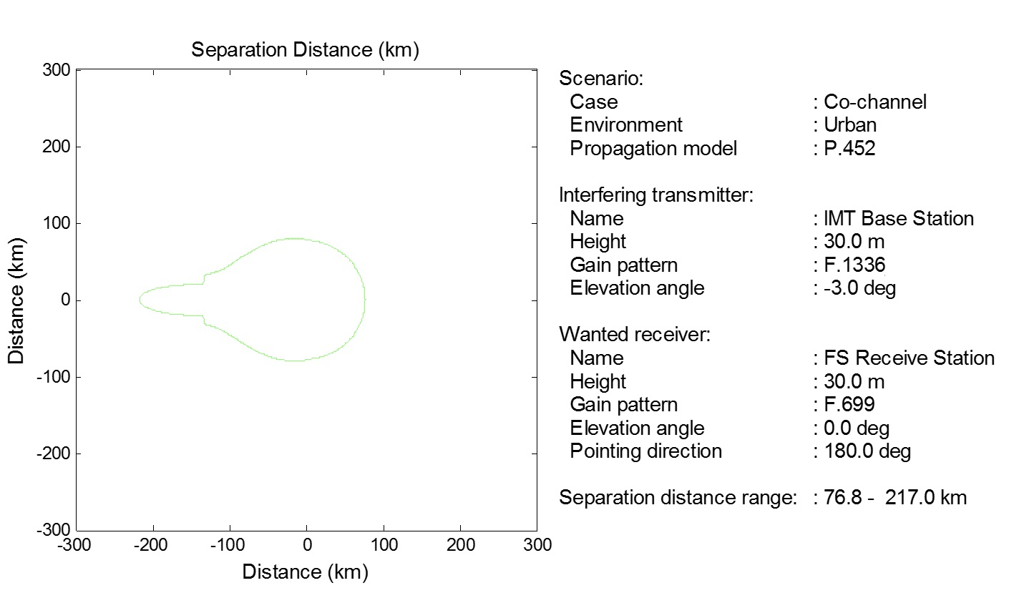

Applying this methodology to the interference scenarios and deployment environments shown in the tables above gives the following results:

TABLE 5

Co-channel separation distance

|  |  |  |
| --- | --- | --- |
| Scenario | Environment | Separation distance |
| IMT base station into FS receive station | Macro urban | 76.8-217.0 km |
| Macro suburban | 76.8-217.0 km |
| Macro rural | 76.8-217.0 km |
| User equipment into FS receive station | Macro urban | < 32.0 km |
| Macro suburban | < 27.0 km |
| Macro rural | < 27.0 km |

These results are based on worst-case assumptions including the pointing direction of the IMT station and the application of the propagation model.

Adjacent channel

Nineteen IMT base stations are positioned over the network area as illustrated in Fig. 1. The FS receive station is initially positioned at the centre of the IMT network area. The pointing angle of the FS receive antenna is along the x-axis toward the array of IMT base stations. (The pointing angles in Figs 4 and 5 are measured counter clockwise from the x-axis.) This positioning creates the worst case scenario for receiving interference from the IMT network. However, these pointing scenarios should be avoidable in practice, and as such, it could be expected that in reality interference is somewhat lower due to varying pointing direction of FS receive station with respect to IMT network. Next, the aggregate interference from the IMT base stations into the FS receive station is computed. Then the FS receive station position is moved incrementally along the x-axis and the aggregate interference is recomputed at each of these positions. This aggregate interference is compared with the FS protection requirement to determine the additional rejection needed to meet the protection requirement as a function of separation distance. The results are illustrated in Figs 4 and 5:

Figure 4

Required Rejection  
IMT base station into FS receive station  
FS receive station located within IMT deployment area



NOTE – The break in the curve shown above occurs when the FS station position coincides with the IMT base station location. Since the distance between the IMT and FS stations is zero, the propagation loss cannot be calculated resulting in no value to plot at this distance. This situation will not occur in practice.

Figure 5

Required Rejection   
IMT base station into FS receive station   
FS receive station located adjacent to IMT deployment area



For the scenario of aggregate interference from UE, a Monte Carlo simulation is used to determine the interference into the FS station receiver. The UEs are randomly positioned over each sector in sufficient numbers to ensure that the entire bandwidth of the FS receive station receiver is fully occupied by interfering signals. A specified percentage of the UEs are assumed to be located indoors. As described above, a power control algorithm is applied to assign path loss and transmit power levels to each of the UEs. Again, the FS receive station is initially positioned just to the right of the IMT network area and its antenna is pointed along the x-axis, or directly toward the IMT service area. The aggregate interference is computed for a range of separation distances and compared with the FS protection requirement to derive the needed rejection as a function of distance. This calculation is repeated 50 times.

These methodologies are applied to the deployment environments shown in the tables above, but, for brevity, plots of these results are not included here.

Results of frequency separation calculations

Frequency dependent rejection (FDR) is dependent on the characteristics of the interfering signal and the wanted receiver filter. FDR is calculated from the following equation:



where:

*FDR*: Frequency dependent rejection, dB

*S*: Power spectral density of the interfering signal, W/Hz

*F*: Frequency response of the wanted receiver, relative power fraction

*f* : Frequency, Hz

Δ*f* : Frequency offset, Hz.

The interfering signal, *S*, is modelled as a flat spectrum within the signal bandwidth and a specified adjacent channel leakage ratio (ACLR) curve outside the signal bandwidth. Similarly, the wanted receiver filter response, *F*, is modelled as a flat response within the receive signal bandwidth and a specified adjacent channel selectivity (ACS) curve outside the signal bandwidth. The following figures show the interfering signal, wanted receiver frequency response, and resulting FDR for each interference scenario considered here.

Figure 6

Frequency Dependent Rejection  
IMT base station into FS receive station

  

Figure 7

Frequency Dependent Rejection  
UE into FS receive station

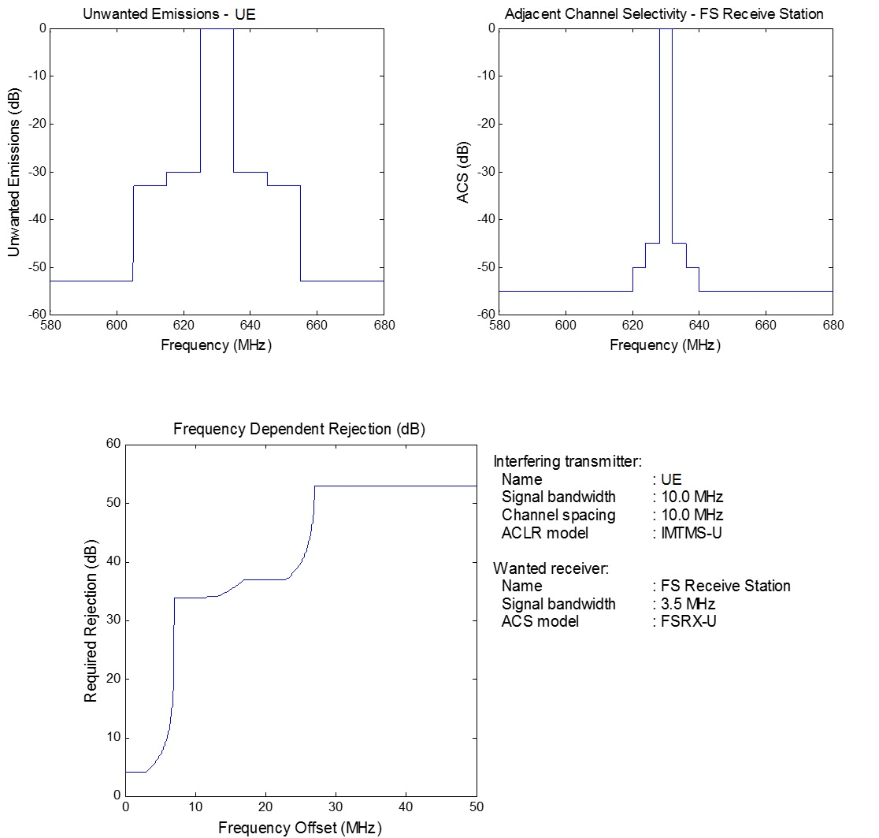

The adjacent channel interference levels and FDR curves computed above are combined to derive the frequency separation (centre-to-centre) necessary to meet the stated protection requirement at various separation distances. Table 6 provides results for selected separation distances for the various interference scenarios and deployment environments considered here.

TABLE 6

Adjacent Channel Frequency/Distance Separation  
IMT Signal Bandwidth = 10.0 MHz, FS Signal Bandwidth = 3.5 MHz

|  |  |  |  |  |  |  |  |
| --- | --- | --- | --- | --- | --- | --- | --- |
| Scenario | Environment | FS Pointing Angle | Frequency separation | | | | |
| 1.0 km | 5.0 km | 10.0 km | 20.0 km | 30.0 km |
| IMT base station into FS receive station | Macro urban | 180 deg | – | – | – | – | – |
| 90 deg | – | – | 25.9 MHz | 7.0 MHz | 7.0 MHz |
| Macro suburban | 180 deg | – | – | – | – | – |
| 90 deg | – | – | 25.9 MHz | 7.0 MHz | 7.0 MHz |
| Macro rural | 180 deg | – | – | – | – | 25.3 MHz |
| 90 deg | 26.9 MHz | 23.7 MHz | 7.0 MHz | 7.0 MHz | 7.0 MHz |
| User equipment into FS receive station | Macro urban | 180 deg | 5.6 MHz | 4.9 MHz | 3.4 MHz | 0.0 MHz | 0.0 MHz |
| 90 deg | 0.0 MHz | 0.0 MHz | 0.0 MHz | 0.0 MHz | 0.0 MHz |
| Macro suburban | 180 deg | 5.4 MHz | 3.8 MHz | 0.0 MHz | 0.0 MHz | 0.0 MHz |
| 90 deg | 0.0 MHz | 0.0 MHz | 0.0 MHz | 0.0 MHz | 0.0 MHz |
| Macro rural | 180 deg | 1.0 MHz | 0.0 MHz | 0.0 MHz | 0.0 MHz | 0.0 MHz |
| 90 deg | 0.0 MHz | 0.0 MHz | 0.0 MHz | 0.0 MHz | 0.0 MHz |

Conclusions

The co-frequency channel results show that the required separation distance can range from around 25 km to nearly 220 km, depending on the interference scenario and deployment environment. These results are based on worst-case assumptions including the pointing direction of the IMT base station and the application of the propagation model. Furthermore, mobile operators can determine which locations are suitable for the deployment of IMT base stations, which can prove advantageous in terms of meeting any required separation distances.

The adjacent channel results show that in the worst-case scenarios (FS receive station pointing directly toward a macro deployment of IMT base stations) the separation distance needed to protect the FS station exceeds 30 km. However, these pointing scenarios should be avoidable in practice, and for more realistic pointing scenarios, the interference can be mitigated through a combination of geographic separation and frequency separation. For these cases, the interference can be mitigated with a separation distance between the FS receive station and the IMT base station on the order of 10 km coupled with a frequency separation of about one to two channel bandwidths. It is important to note that the frequency separation results reflect channel centre‑to‑channel centre separations and not guardbands, which are usually expressed as channel edge‑to‑channel edge.

These results also show that the interference from the user equipment is acceptable with a geographic separation as low as one kilometre.

It should be noted that certain assumptions such as FS receive station placement and direction, use of propagation model, etc. overestimate interference from the IMT network.

______________