|  |
| --- |
| **Report ITU-R F.2471-0**  **(09/2019)** |
| **Sharing and compatibility studies of HAPS systems in the fixed service in the 21.4‑22 GHz frequency range for Region 2** |
| **F Series**  **Fixed service** |

Foreword

The role of the Radiocommunication Sector is to ensure the rational, equitable, efficient and economical use of the radio-frequency spectrum by all radiocommunication services, including satellite services, and carry out studies without limit of frequency range on the basis of which Recommendations are adopted.

The regulatory and policy functions of the Radiocommunication Sector are performed by World and Regional Radiocommunication Conferences and Radiocommunication Assemblies supported by Study Groups.

# Policy on Intellectual Property Right (IPR)

ITU-R policy on IPR is described in the Common Patent Policy for ITU-T/ITU-R/ISO/IEC referenced in Resolution ITU‑R 1. Forms to be used for the submission of patent statements and licensing declarations by patent holders are available from <http://www.itu.int/ITU-R/go/patents/en> where the Guidelines for Implementation of the Common Patent Policy for ITU‑T/ITU‑R/ISO/IEC and the ITU-R patent information database can also be found.

|  |  |
| --- | --- |
| Series of ITU-R Reports  (Also available online at <http://www.itu.int/publ/R-REP/en>) | |
| **Series** | Title |
| **BO** | Satellite delivery |
| **BR** | Recording for production, archival and play-out; film for television |
| **BS** | Broadcasting service (sound) |
| **BT** | Broadcasting service (television) |
| **F** | **Fixed service** |
| **M** | Mobile, radiodetermination, amateur and related satellite services |
| **P** | Radiowave propagation |
| **RA** | Radio astronomy |
| **RS** | Remote sensing systems |
| **S** | Fixed-satellite service |
| **SA** | Space applications and meteorology |
| **SF** | Frequency sharing and coordination between fixed-satellite and fixed service systems |
| **SM** | Spectrum management |

|  |
| --- |
|  |

|  |
| --- |
| ***Note****: This ITU-R Report was approved in English by the Study Group under the procedure detailed in Resolution ITU-R 1.* |

*Electronic Publication*

Geneva, 2019

© ITU 2019

All rights reserved. No part of this publication may be reproduced, by any means whatsoever, without written permission of ITU.

REPORT ITU-R F.2471-0

Sharing and compatibility studies of HAPS systems   
in the fixed service in the 21.4-22 GHz frequency range for Region 2

(2019)

TABLE OF CONTENTS

Page

Policy on Intellectual Property Right (IPR) ii

1 Introduction 3

2 Allocation information in the 21.4-22 GHz frequency range 3

3 Technical characteristics 3

3.1 Technical and operational characteristics of HAPS systems operating in the 21.4‑22 GHz frequency range 3

3.2 Technical and operational characteristics of fixed service operating in the 21.4‑22 GHz frequency range 4

3.3 Technical and operational characteristics of Mobile service operating in the 21.4‑22 GHz frequency range 4

3.4 Technical and operational characteristics of Earth Exploration-Satellite/Space Research (passive) service operating in the adjacent band 21.2-21.4 GHz and near adjacent band 22.21-22.5 GHz 5

3.5 Technical and operational characteristics of Radio Astronomy service operating in the 22.21-22.5 GHz frequency range 9

3.6 Propagation models for sharing and compatibility studies in the 21.4-22 GHz frequency range 10

4 Sharing and compatibility studies 10

5 Abbreviations and acronyms 11

Annex 1 (FS) Sharing and compatibility of fixed service and HAPS systems operating in the 21.4-22 GHz frequency range 11

1 Technical Analysis 11

1.1 Summary 12

1.2 Analysis 12

2 Summary and analysis of the results of studies 21

Annex 2 (MS) Sharing and compatibility of mobile service and HAPS systems operating in the 21.4-22 GHz frequency range 22

1 Technical analysis 22

1.1 Study A 23

1.2 Study B 35

2 Summary and analysis of the results of studies 38

Annex 3 (EESS (Passive) in 21.2-21.4 GHz) Compatibility of Earth exploration-satellite system (passive) in the adjacent band 21.2-21.4 GHz and HAPS systems operating in the 21.4-22 GHz frequency 39

1.1 Technical analysis 39

1.2 Study A: HAPS to HAPS ground station 39

1.3 Study B: HAPS ground CPE to HAPS 47

1.4 Study C: HAPS ground GW to HAPS 50

2 Summary and analysis of the results of studies 52

Annex 4 Compatibility of HAPS systems and EESS (passive) operating in the adjacent band 22.21-22.5 GHz 53

1 Technical analysis 53

2 Background 53

2.1 Earth exploration-satellite service (passive) protection criteria 55

2.2 Description of analysis methodology and simulation parameters 56

2.3 Uplink analysis of HAPS System 6 and EESS (passive) sensor 58

2.4 Downlink analysis of HAPS system 6 and EESS (passive) 63

2.5 Uplink and downlink analysis results for study A 70

3 Summary and analysis of the results of studies 71

3.1 HAPS station transmitting towards the HAPS GW/CPE stations 71

3.2 HAPS GW/CPE stations transmitting towards the HAPS station 71

Annex 5 Compatibility of Radio Astronomy service in the adjacent band 22.21-22.5 GHz and HAPS systems operating in the 21.4-22 GHz frequency range 72

1 Technical analysis 72

1.1 Study A 72

1.2 Study B 79

2 Summary and analysis of the results of studies 86

# 1 Introduction

This Report includes the sharing and compatibility studies of HAPS systems in the 21.4-22 GHz frequency range with services to which the bands are allocated on a primary basis.

This Report provides the sharing and compatibility studies referenced under *further resolves* 1 of Resolution **160 (WRC-15)**, to ensure the protection of the existing services allocated to the frequency range and taking into account relevant footnotes of Article **5** of the RR.

# 2 Allocation information in the 21.4-22 GHz frequency range

The Radio Regulations Table of Frequency Allocations is provided for reference in Table 1.

The 21.4-22 GHz band under study for HAPS in Region 2 is allocated to fixed and mobile services on a primary basis. The lower adjacent band 21.2-21.4 GHz and the upper near adjacent band 22.21‑22.5 GHz are allocated on a primary basis for EESS (passive) and SRS (passive) as well as fixed and mobile services.

TABLE 1

Frequency Allocation

|  |  |  |  |  |
| --- | --- | --- | --- | --- |
| Allocation to services | | | | |
| Region 1 | Region 2 | | Region 3 | |
| **21.2-21.4** EARTH EXPLORATION-SATELLITE (passive)  FIXED  MOBILE  SPACE RESEARCH (passive) | | | | |
| **21.4-22**  FIXED  MOBILE  BROADCASTING-SATELLITE 5.208B  5.530A 5.530B 5.530D | | **21.4-22**  FIXED  MOBILE  5.530A | | **21.4-22**  FIXED  MOBILE  BROADCASTING-SATELLITE 5.208B  5.530A 5.530B 5.530D 5.531 |
| **22-22.21** FIXED  MOBILE except aeronautical mobile  5.149 | | | | |
| **22.21-22.5** EARTH EXPLORATION-SATELLITE (passive)  FIXED  MOBILE except aeronautical mobile  RADIO ASTRONOMY  SPACE RESEARCH (passive)  5.149 5.532 | | | | |

# 3 Technical characteristics

## 3.1 Technical and operational characteristics of HAPS systems operating in the 21.4‑22 GHz frequency range

For technical and operational characteristics of HAPS systems, see Report ITU-R F.2439-0.

## 3.2 Technical and operational characteristics of fixed service operating in the 21.4‑22 GHz frequency range

Table 2 summarizes the technical characteristics of the FS in the band 21.4-22 GHz.

TABLE 2

FS – PP technical characteristics in the band 21.4-22 GHz

|  |  |  |
| --- | --- | --- |
| Frequency range (GHz) | 21.4-22 | |
| Modulation | FSK | 128-QAM |
| Channel spacing and receiver noise bandwidth (MHz) | 2.5, 3.5, 7, 14, **25**(3), 28, 50, 56, 112 | 2.5, 3.5, 7, 14, 28, **30**(3), 50, 56, 112 |
| Tx output power range (dBW) | −10 | −13 |
| Tx output power density range (dB(W/MHz))(1) | −24.0 | −27.8 |
| Feeder/multiplexer loss range (dB) | 0…3 | … |
| Antenna gain range (dBi) | 34.8 | … |
| e.i.r.p. range (dBW) | 21.8… 24.8 | … |
| e.i.r.p. density range (dB(W/MHz))(1) | 7.8…10.8 |  |
| Receiver noise figure typical | 11 | 6 |
| Receiver noise power density typical (dB(W/MHz)) | −133 | −138 |
| Normalized Rx input level for 1 × 10−6 BER (dB(W/MHz)) | −119.6 | −108.5 |
| Protection criterion (*I*/*N*) |  |  |
| Nominal long-term interference power density (dB(W/MHz))(2) | −133 + *I*/*N* | −138 + *I*/*N* |
| NOTE – The intended set of parameters for two reference systems for sharing/coexistence studies are presently not or only partially available; administrations are invited to contribute. On a provisional basis, the parameters reported in Annex 3 for the same bands may be used.  (1) To calculate the values for the Tx/ e.i.r.p. densities, channel spacing/bandwidth needs to be identified. In these tables, the channel spacing indicated in the **bold letter** is used. Where a modal value (Mode) is provided, it is to be taken as indicative within the range specified and further sensitivity analysis may be required on a case-by-case basis to assess a given interference potential due to the variations within the range specified.  (2) Nominal long-term interference power density is defined by “Receiver noise power density + (required *I*/*N*)” as described in § 4.13 in Annex 2 (see also § 4.1 in Annex 1).  (3) This channel spacing value is not specified in the reference Recommendation. | | |

## 3.3 Technical and operational characteristics of Mobile service operating in the 21.4‑22 GHz frequency range

The characteristics of, and protection criteria for the aeronautical mobile service (AMS) systems operating in the mobile service in the frequency range 21.2-22 GHz are contained in the Recommendation ITU-R M.2120-0. Table 3 contains the technical characteristics of the air-to-air AMS systems in 21.2-22 GHz used in the sharing study.

TABLE 3

Representative technical characteristics of the aeronautical mobile   
service systems in the frequency range 21.2-22 GHz

| Parameter | System 1 |
| --- | --- |
| Communication direction | Air-to-air |
| Transmitter tuning range (GHz) | 21.2‑21.5 |
| Transmitter power output (dBm) | 50 |
| Transmitter bandwidth (MHz)  –3 dB  –20 dB  –60 dB | 310  315  360 |
| Transmitter harmonic attenuation (dB) | >–80 |
| Transmitter modulation | FM/GMSK |
| Receiver tuning range | 21.2‑21.5 |
| Receiver IF selectivity (MHz)  –3 dB  –20 dB  –60 dB | 306  315  380 |
| Receiver RF selectivity (MHz)  –3 dB  –20 dB  –60 dB | 310  315  360 |
| Receiver noise figure (dB) | 7 |
| Receiver sensitivity (dBm) | –150 |
| Receiver image rejection (dB) | 30 |
| Receiver spurious rejection (dB) | 60 |
| Antenna gain (dBi) | 0 |
| Antenna 1st sidelobe (dB) | Not applicable |
| Antenna polarization | Vertical |
| Antenna pattern/type | Omni |

## 3.4 Technical and operational characteristics of Earth Exploration-Satellite/Space Research (passive) service operating in the adjacent band 21.2-21.4 GHz and near adjacent band 22.21-22.5 GHz

The following ITU-R Recommendations are relevant to studies between EESS (passive) and HAPS.

TABLE 4

Recommendations relating to EESS (passive) services in the   
bands 21.4–22 GHz and 22.21-22.5 GHz

| Rec. ITU-R | Title |
| --- | --- |
| RS.1813 | Passive sensor antenna patterns for use in sharing studies |
| RS.1861 | Characteristics of EESS passive systems |
| RS.2017 | Interference criteria for satellite passive sensing |

### 3.4.1 EESS (passive) characteristics

EESS (passive) and SRS (passive) have primary allocations in the 21.2-21.4 GHz and 22.21‑22.5 GHz frequency bands; the table below lists relevant EESS parameters in the 21.2‑21.4 GHz frequency band, taken from Recommendation ITU‑R RS.1861.

TABLE 5

EESS (passive) sensor characteristics in the 21.2-21.4 GHz Band

| Sensor Type | Sensor E1 | Sensor E2 |
| --- | --- | --- |
| Mechanical nadir scan | Push-broom(1) |
| **Orbit Parameters** |  | |
| Altitude (km) | 833 | 850 |
| Inclination (degree) | 98.6 | 98 |
| Eccentricity | 0 | 0 |
| Repeat period (days) | 9 |  |
| Sensor antenna parameters |  | |
| Number of beams | 1 beam; 30 Earth fields per 8 s scan period | 90 |
| Maximum beam gain (dBi) | 34.4 | 45 |
| Reflector diameter | 0.3 | 0.9 |
| Polarization | V | H,V |
| –3 dB beamwidth (degree) | 3.3 | 1.1 |
| Instantaneous field of view (km) | Nadir FOV: 48.5 Outer FOV: 149.1 × 79.4 | 16 × 2 282 |
| Main beam efficiency | 95 |  |
| Off-nadir pointing angle (degree) | ±48.33 cross-track |  |
| Beam dynamics | 8 s scan period | N/A (beams are unchanging) |
| Incidence angle at Earth (degree) |  |  |
| –3 dB beam dimensions (km) | 45 | 16 |
| Total FOV cross/along-track | Outer FOV: 149.1 × 79.4 km Nadir FOV: 48.5 km | 100/1.1° |
| Swath width (km) | 2 343 | 2 282 |

TABLE 5 (*end*)

|  |  |  |
| --- | --- | --- |
| Sensor Type | Sensor E1 | Sensor E2 |
| Sensor antenna pattern | –10 dBi back lobe gain | –12 dBi back lobe gain |
| Cold calibration antena gain (dBi) | 34.4 | 35 |
| Cold calibration angle (degrees re. satellite track) (degree) | 90° | |
| Cold calibration angle (degrees re. nadir direction) | 83 |  |
| Sensor receiver parameters |  | |
| Sensor integration time (m) | 158 | N/A |
| Channel bandwidth | 200 MHz centered at  21.3 GHz | N/A |
| Measurement spatial resolution |  | |
| Horizontal resolution (km) | 45 | 16 |
| Vertical resolution (km) | N/A | 16 |
| (1) Push-broom is a concept that has not yet been implemented at this frequency. | | |

The 22.21-22.5 GHz frequency band contains a channel for the Special Sensor Microwave Imager/Sounder (SSMI/S). The SSMI/S operates a conical scan geometry, with an orbital altitude of 833 km, and a swath width of 1 707 km. The characteristics of this sensor are shown in Table 6.

TABLE 6

EESS (passive) sensor characteristics in the 22.21-22.5 GHz band

| Parameter | Sensor R1 |
| --- | --- |
| Sensor type | Conical |
| **Orbit parameters** | |
| Altitude (km) | 854-863 |
| Inclination (degree) | 98.6-98.8 |
| Eccentricity | 0.00083564, 0.00113399, 0.00099945 |
| Repeat period (days) | 9 |
| **Sensor antenna parameters** | |
| Number of beams | 1 |
| Maximum beam gain (dBi) | 39.7 |
| Reflector diameter (m) | 0.61 |
| Polarization | V |
| –3 dB beamwidth (degree) | 2.09 (max) |
| Instantaneous field of view (km x km (for ellipse)  or km (for circle diameter at nadir)) | 46.5 x 73.6 (Footprint size due to 1x2 averaging) |
| Main beam efficiency (%) | ≥ 90 |
| Off-nadir pointing angle (degree) | 45 |
| Beam dynamics | 1.9 |
| Incidence angle at Earth (degree) | 53.1 |

TABLE 6 (*end*)

| Parameter | Sensor R1 |
| --- | --- |
| –3 dB beam dimensions | 46.5 × 73.6 (Footprint size due to 1 × 2 averaging) |
| Total FOV cross/along-track | Effective field of view (EFOV): 44.8 km (along scan) × 73.6 km (90° to scan); 1 × 2 spatial averaging |
| Swath width | 1707 |
| Sensor antenna pattern | Rec. ITU R RS.1813 |
| Cold calibration antenna gain | NA |
| Cold calibration angle re. satellite track (degree) | NA |
| Cold calibration angle re. nadir direction (degree) | NA |
| Sensor integration time (ms) | 4.22 (for a single {unaveraged} sample) |
| Channel bandwidth (MHz) | 450 MHz (max) centred at 22.235 GHz |
| Horizontal resolution (km) | 73.6 |
| Vertical resolution (km) | 46.5 |

### 3.4.2 Performance and Interference criteria for EESS (passive) systems adjacent to the 21.4‑22 GHz frequency band

Recommendation ITU-R RS.2017 provides performance and interference criteria for sharing studies between the EESS (passive) bands adjacent to 21.4-22 GHz and systems operating in the 21.4‑22 GHz band; the relevant criterion is listed in the table below for adjacent frequency bands to 21.4-22 GHz.[1]

TABLE 7

Protection Criteria for EESS (passive) in bands adjacent to 21.4-22 GHz

|  |  |  |  |
| --- | --- | --- | --- |
| Frequency band (GHz) | Reference bandwidth (MHz) | Maximum interference power  (dBW) | Percentage of area or time maximum interference may be exceeded (%) (1) |
| 21.2-21.4 | 100 | –169 | 0.1 |
| 22.21-22.5 |
| (1) For a 0.01% level, the measurement area is a square on the Earth of 2 000 000 km2, unless otherwise justified; for a 0.1% level, the measurement area is a square on the Earth of 10 000 000 km2 unless otherwise justified; for a 1% level, the measurement time is 24 h, unless otherwise justified. | | | |

## 3.5 Technical and operational characteristics of Radio Astronomy service operating in the 22.21-22.5 GHz frequency range

### 3.5.1 Relevant ITU-R Recommendations and Reports

TABLE 8

ITU-R Recommendations related to the RAS

| Rec. ITU-R | Title |
| --- | --- |
| RA.517 | Protection of the radio astronomy service from transmitters operating in adjacent bands |
| RA.769 | Protection criteria used for radio astronomical measurements *(see Table excerpts below)* |
| RA.1031 | Protection of the radio astronomy service in frequency bands shared with other services |
| RA.1513 | Levels of data loss to radio astronomy observations and percentage-of-time criteria resulting from degradation by interference for frequency bands allocated to the radio astronomy service on a primary basis |
| SM.1542 | The protection of passive services from unwanted emissions |
| SM.1633 | Compatibility analysis between a passive service and an active service allocated in adjacent and nearby bands |

TABLE 9

ITU-R Reports related to the RAS

| Rep. ITU-R | Title |
| --- | --- |
| RA.2126 | Techniques for mitigation of radio frequency interference in radio astronomy |
| RA.2131 | Supplementary information on the detrimental threshold levels of interference to radio astronomy observations in Recommendation ITU-R RA.769 |
| RA.2188 | Power flux-density and e.i.r.p. levels potentially damaging to radio astronomy receivers |

### 3.5.2 Protection criteria

Table 1 of Recommendation ITU-R RA.769 recommends that the pfd level at the RAS station with 0 dBi antenna gain towards the interferer should not exceed ‑146 dB(W/(m2 · 290 MHz)).

### 3.5.3 Percentage of data-loss (Recommendation ITU-R RA.1513)

2% exceedance of threshold levels in RA.769 when ensemble averaged over time periods of 2000 s.

### 3.5.4 Radio astronomy stations operating at 22.21-22.5 GHz in Region 2

TABLE 10

Radio astronomy stations in the 22.21-22.5 GHz band

| Country | Name | N Latitude | E Longitude | Size (m) |
| --- | --- | --- | --- | --- |
| Brasil | Itapetinga | –23° 11' 05" | –46° 33' 28" | 14 |
| Canada | Algonquin radio observatory | 45° 57' 19" | –78° 04' 23" | 46 |
| USA | Arizona radio observatory, Kitt Peak 12 Meter[2] | 31° 57' 12" | –111° 36' 53" | 12 |
| Green Bank Telescope | 38° 25' 59" | –79° 50' 23" | 100 |
| Haystack | 42° 36' 36" | –71° 28' 12" | 18 |
| Kokee Park | 22° 07' 34" | –159° 39' 54" | 20 |
| Jansky VLA | 33° 58' 22" to 34° 14' 56" | –107° 24' 40" to  –107° 48' 22" | 27 × 25 |
| VLBA Brewster, WA | 48° 07' 52" | –119° 41' 00" | 25 |
| VLBA Fort Davis, TX | 30° 38' 06" | –103° 56' 41" | 25 |
| VLBA Hancock, NH | 42° 56' 01" | –71° 59' 12" | 25 |
| VLBA Kitt Peak, AZ | 31° 57' 23" | –111° 36' 45" | 25 |
| VLBA Los Alamos, NM | 35° 46' 30" | –106° 14' 44" | 25 |
| VLBA Mauna Kea, HI | 19° 48' 05" | –155° 27' 20" | 25 |
| VLBA North Liberty, IA | 41° 46' 17" | –91° 34' 27" | 25 |
| VLBA Owens Valley, CA | 37° 13' 54" | –118° 16' 37" | 25 |
| VLBA Pie Town, NM | 34° 18' 04" | –108° 07' 09" | 25 |
|  | VLBA St. Croix, VI | 17° 45' 24" | –64° 35' 01" | 25 |
| Goldstone | 35° 25' 33" | –116° 53' 22" | 70.3, 34 |
| Owens Valley radio observatory | 37° 13' 54" | –118° 16' 35" | 10 |

## 3.6 Propagation models for sharing and compatibility studies in the 21.4-22 GHz frequency range

The sharing and compatibility studies, in accordance with Resolution **160 (WRC15)**, were conducted based on the propagation models as provided by relevant group.

# 4 Sharing and compatibility studies

Annex 1: Sharing and compatibility of fixed service and HAPS systems operating in the 21.4‑22 GHz frequency range

Annex 2: Sharing and compatibility of Mobile service and HAPS systems operating in the 21.4‑22 GHz frequency range

Annex 3: Compatibility of Earth Exploration-Satellite (passive) in the adjacent band 21.2‑21.4 GHz and HAPS systems operating in the 21.4-22 GHz frequency range

Annex 4: Compatibility of Earth Exploration-Satellite (passive) in the adjacent band 22.21‑22.5 GHz and HAPS systems operating in the 21.4-22 GHz frequency range

Annex 5: Compatibility of Radio Astronomy in the 22.21-22.5 GHz frequency range and HAPS systems operating in the 21.4‑22 GHz frequency range

# 5 Abbreviations and acronyms

AMS Aeronautical Mobile Service

CDF Cumulative distribution function

CPE Customer premise equipment

DVB-S Digital video broadcasting – satellite

EESS Earth exploration-satellite service

e.i.r.p. Equivalent isotopically radiated power

FS Fixed service

GW HAPS gateway

HAPS ground station Ground station transmitting to or receiving from HAPS

HAPS High altitude platform station

IHD Inter HAPS distance

MS Mobile service

pfd Power flux density

Ptx Transmit power

QAM Quadrature amplitude modulation

Rx Receiver

Tx Transmitter

Annex 1 (FS)  
  
Sharing and compatibility of fixed service and HAPS systems operating  
in the 21.4-22 GHz frequency range

# 1 Technical Analysis

TABLE 11

Scenario considered

|  |  |
| --- | --- |
| HAPS ground terminal to FS | Uplink is not considered in this study |
| HAPS Platform to FS | X |
| FS to HAPS ground terminal | X |
| FS to HAPS Platform | Uplink is not considered in this study |

## 1.1 Summary

This study investigates the coexistence between HAPS and FS. This study first presents a statistical study. Then the impact of the various mitigation techniques will be assessed.

The following directions are considered for HAPS in this study.

– HAPS to gateway (DL);

– HAPS to CPE (DL).

## 1.2 Analysis

### 1.2.1 Impact from transmitting HAPS into FS receiving stations

This study aims to define the maximum pfd level from HAPS versus elevation angle in order to protect FS stations’ receivers.

#### 1.2.1.1 Transmitting HAPS impact into FS receiving station: single entry

The following steps have been performed to derive such pfd mask versus elevation angle taking into account the impact of a single HAPS stations’ emission:

Step 1: compute the FS antenna gain towards the HAPS based on the following input parameters:

– 0° is taken for the elevation angle towards the HAPS;

– 0° is taken for the azimuth towards the HAPS;

– FS station antenna pointing azimuth: random variable with a uniform distribution between -180° to 180°;

– FS station antenna pointing elevation: random variable with a normal distribution (median -0.01 and standard deviation 2.07 based on Recommendation ITU-R F.2086-0);

– FS maximum antenna gain: 34.8 dBi.

Step 2: compute and store the maximum possible HAPS pfd level at the FS station using the following equation:

where:

elevation angle in degrees (angles of arrival above the horizontal plane)

*Imax* maximum interference level (-143 dB(W/MHz) clear sky/long term)

*Gr*: FS antenna gain towards the HAPS based on Recommendation ITU-R F.1245 which includes a polarisation loss of 1.7 dB in the main beam of FS (3 dB beamwidth) (see step 1)

: angle between the vector FStowards HAPS and FS antenna main beam pointing vector

*Attgas*: atmospheric attenuation (Recommendation ITU-R SF.1395, which is dependent to the elevation angle).

Figure 1

Atmospheric gaseous attenuation

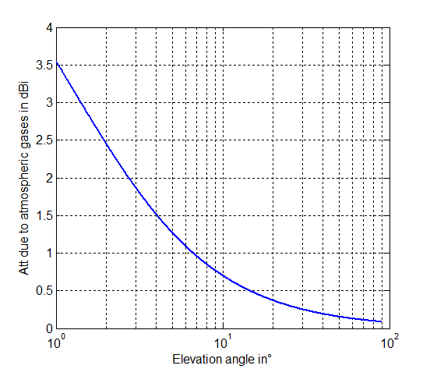

Step 3: redo step 1 and 2 sufficiently to obtain a stable pfd CDF curve and store it.

Step 4: redo step 1 to 3 with an increased elevation angle towards the HAPS of 1° until the elevation angle towards the HAPS is 90°.

Figure 2 provides the results for the clear sky conditions/long term criteria.

Figure 2

Maximum pfd level cumulative distribution function to meet the FS protection criteria

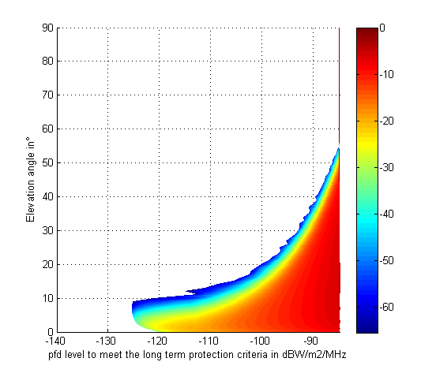

Step 5: determine the pfd mask versus elevation to protect FS station receiver.

The following pfd mask at the Earth surface should therefore be sufficient to protect FS station receivers under clear sky condition from a single HAPS emission:

where is elevation angle in degrees (angles of arrival above the horizontal plane).

Figure 3

Proposed pfd mask versus elevation angle under clear sky conditions

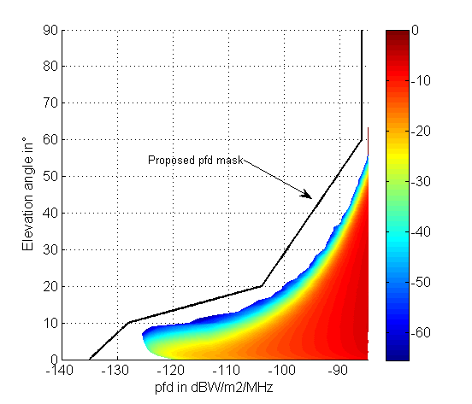

The following two approaches address the use of ATPC to compensate for rain fade.

Approach 1: In order to compensate for additional propagation impairments in the boresight of any beam of the HAPS due to rain, the HAPS can be operated so that the pfd mask can be increased in any corresponding beam (i.e. suffering the rain fade) by a value only equivalent to the level of rain fading and limited to a maximum of 20 dB. This level is the difference between long-term protection criteria of *I*/*N* = −10 dB that can be exceeded for no more than 20% of the time (i.e. clear sky) and assumed short-term protection criteria of *I*/*N* = +10 dB that is never exceeded.

Approach 2: Automatic transmit power control may be used to increase the e.i.r.p. density to compensate for rain attenuation to the extent that the power flux density at the FS station does not exceed the value resulting from use by HAPS station of an e.i.r.p. meeting the above limits in the clear sky conditions.

Since the pfd mask above has been developed taking into account attenuation due to atmospheric gases, compliance verification of a HAPS system with this mask should be conducted using the free space propagation model.

Furthermore, for the purpose of field measurements, administrations may therefore use the pfd levels provided below. These additional pfds levels, in dB(W/(m2.MHz)), do not take into account any attenuation due to atmospheric gases and are only provided for measurement purposes. This material is provided for information in this section.

0.7 θ – 135 – 6.45 / (1  0.8152 θ) for 0° ≤ θ < 10°

2.4 θ – 152 – 6.45 / (1  0.8152 θ) for 10° ≤ θ < 20°

0.45 θ – 113 – 6.45 / (1  0.8152 θ) for 20° ≤ θ < 60°

−86 – 6.45 / (1  0.8152 θ) for 60° ≤ θ ≤ 90°

where θ  is elevation angle in degrees (angle of arrival above the horizontal plane).

#### 1.2.1.2 Aggregate impact from transmitting HAPSs into FS receiving station

The following steps have been performed to define if the aggregate impact of several HAPS in visibility from the FS station is close to the one from a single HAPS station emission:

Step 1:locate N HAPS distributed on a grid over the spherical cap visible from the FS station (see Fig. 4). The distance between HAPS or Inter HAPS Distance (IHD) was set to 100 km for this study. The grid position versus FS location is randomly selected.

Figure 4

HAPS on a spherical cap

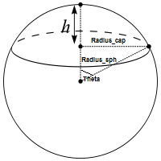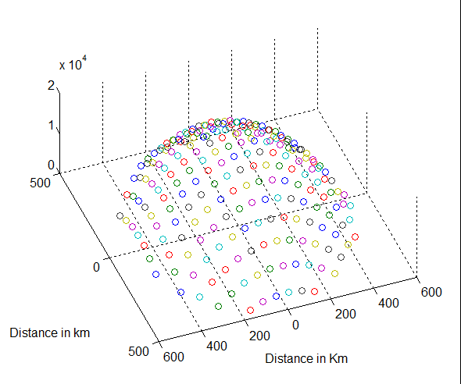

where:

*h* is the HAPS altitude (20 km)

*Radius_sph* is the Earth radius plus HAPS altitude (20 km)

*Radius_cap* is the distance between the HAPS and the FS when the HAPS is seen from the FS station with an elevation angle of 0°.

Step 2: compute, for each HAPS from step 1, the angle between the horizontal plane at the FS station location and the vector from the FS station location toward the HAPS (θ angle of arrival above the horizontal plane).

Step 3: based on step 2 and the pfd mask from the previous section, compute for each HAPS the maximum pfd level produced at the FS station location.

Step 4: compute the FS antenna gain towards the HAPS based on the following input parameters:

– the elevation angle towards the HAPS from step 2;

– azimuth 0° is taken for the azimuth towards the HAPS;

– FS station antenna pointing azimuth: random variable with a uniform distribution between -180° to 180°;

– FS station antenna pointing elevation: random variable with a normal distribution (median –0.01 and standard deviation 2.07);

– FS maximum antenna gain: 34.8 dBi.

Step 5: compute and store the level of aggregate interference in dB(W/MHz) produced by all HAPS at the FS receiver input using the following equation:

where:

*n* : index of the HAPS

*IM* : aggregate interference level in dB(W/MHz) produced by N HAPS for a given HAPS configuration

*Grn* : FS antenna gain towards the HAPS with the index *n*

φ : angle in degree between the vector FS towards HAPSn and FS antenna main beam pointing vector

*pfdn* : pfd produce at the FS station location by the HAPS with index *n* (dB(W/(m2.MHz)))

*Attngas* : atmospheric attenuation for the link with index n (Recommendation ITU-R SF.1395) which is dependent to the elevation angle θ. The mean annual global reference atmosphere is used.

Step 6: redo step 1 to 5 sufficiently to obtain a stable I cumulative distribution function curve and store it.

Figure 5 provides the results for an IHD of 100 km.

Figure 5

I aggregate in dB(W/MHz) (respectively clear sky and raining conditions)

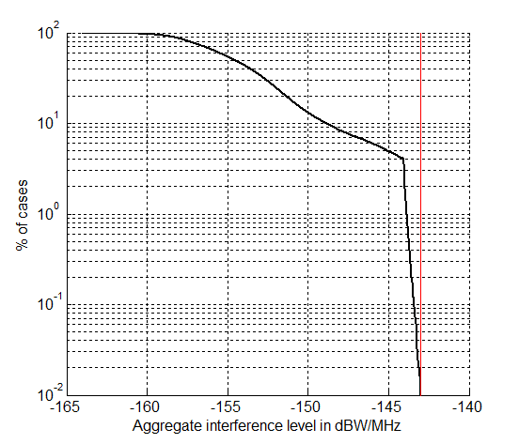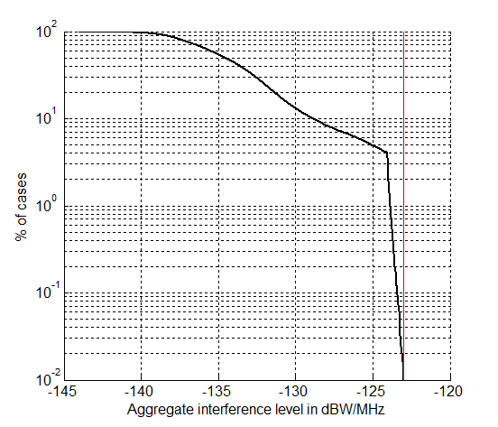

With the proposed pfd mask, the protection criteria are never exceeded. In reality, this approach is conservative as all HAPS in the visibility area of the FS station will not produce a pfd level, which is corresponding exactly to the pfd mask (assumption taken in this aggregate analysis). Most of them will produce a pfd level much lower than the pfd mask as not transmitting in the azimuth towards the FS station. Therefore, it can be concluded that the proposed pfd mask also protects FS stations receivers from aggregate HAPS transmissions.

Step 7: compare the pfd mask with systems 2 and 6 maximum pfd level versus elevation. As shown in Figs 6 and 7, systems 2 and 6 pfds meet the proposed pfd mask. It is possible to design a HAPS system that meets the proposed pfd mask and therefore protects FS receivers.

Figure 6

HAPS systems 2 compliance with the proposed pfd mask

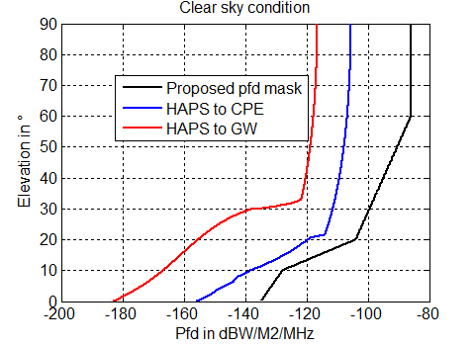 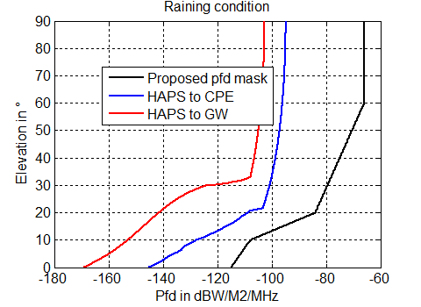

Figure 7

HAPS system 6 compliance with the proposed pfd mask (clear sky conditions)

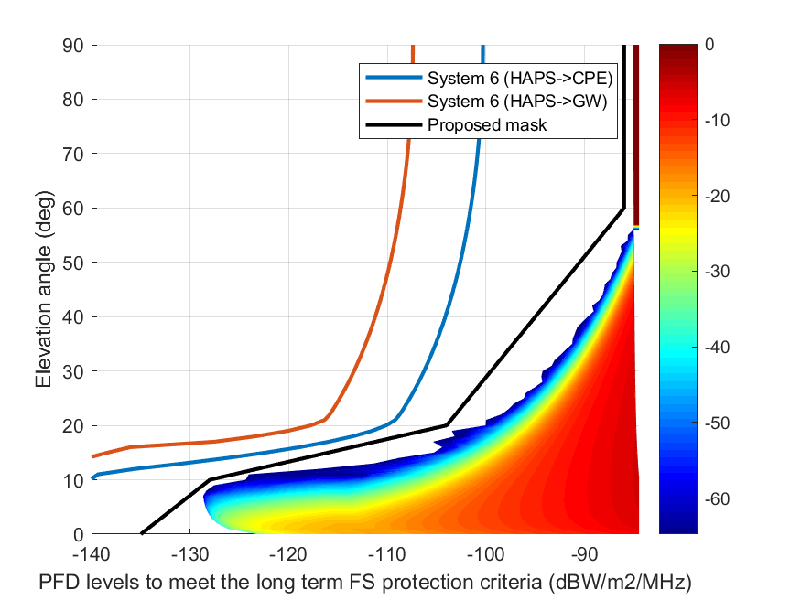

### 1.2.2 Impact from transmitting FS stations into HAPS receiving ground station and comparison with the FS to FS scenario

HAPS systems can operate as applications under the FS. The characteristics of HAPS ground stations are similar to conventional fixed stations. However, HAPS ground stations normally point at higher elevations than conventional fixed stations. The study below compares:

• the impact of a transmitting conventional fixed service station into a HAPS ground station with

• the impact of a transmitting conventional fixed service station into another conventional fixed service station.

The study is based on a statistical single-entry analysis. The purpose of the study is to provide an indication to administrations on whether sharing the band between HAPS ground stations and conventional fixed stations is more challenging than sharing the band between conventional fixed service stations.

#### 1.2.2.1 Impact from transmitting FS station into HAPS receiving ground station

The following steps have been performed to derive the minimum separation distance CDF between a single FS station (interferer) and HAPS ground station (victim).

Step 1: Compute the FS antenna gain towards the HAPS GW/CPE based on the following input parameters:

– 0° is taken for the elevation angle towards the HAPS;

– 0° is taken for the azimuth towards the HAPS;

– FS station antenna pointing azimuth: random variable with a uniform distribution between -180° to 180°;

– FS station antenna pointing elevation: random variable with a normal distribution (median -0.01 and standard deviation 2.07);

– FS maximum antenna gain (from Recommendation ITU-R F.758): 34.8 dBi;

– FS antenna pattern: ITU-R F.1245.

Step 2: Compute the HAPS GW/CPE antenna gain towards the FS based on the following input parameters:

– 0° is taken for the elevation angle towards the FS;

– 180° is taken for the azimuth towards the FS;

– HAPS station antenna pointing azimuth: random variable with a uniform distribution between −180° to 180°;

– HAPS station maximum antenna gain (from systems 2 and 6 characteristics): 51 dBi (system 2) and 51.4 dBi (system 6) for the GW and 44.8 dBi (system 2) or 46.3 dBi (system 6) for the CPE;

– HAPS station antenna pointing elevation: random variable with a distribution between 21 and 90 degrees for system 2 HAPS to CPE and between 33.3 and 90 degrees for system 2 HAPS to gateways that is shown in Fig. 8.

Figure 8

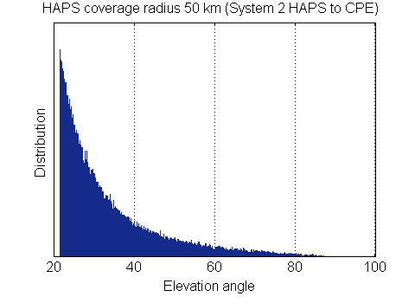

Step 3: Compute the propagation loss needed to meet the HAPS protection criteria:

where:

*EIRPmaxFS* : FS station maximum e.i.r.p. density (in the main beam):   
7.8-10.8 dB(W/MHz)

*GmaxFS* : maximum FS station antenna gain: 34.8 dBi

*GFS*→*HAPSGS* : FS station antenna gain towards the HAPS ground station in dBi

*GrHAPS* HAPS ground station antenna gain towards the FS station in dBi

*Imax* : the maximum allowable interference level: for HAPS system 2,   
−154 dB(W/MHz) (*I*/*N* of −10 dB) that should not be exceeded by more than 20% of the time and −134 dB(W/MHz) (*I*/*N* of 10 dB) that should not be exceeded by more than 0.01% of the time. For HAPS system 6, a protection criterion of *I*/*N*=−10 dB (may exceed for no more 20% of the time) and +10 dB (not to be exceeded for more than 0.01% time) was assumed for this study

*AttP*-452-16  For systems 2 and 6 is the propagation loss needed to meet the HAPS protection criteria in dB based on Recommendation ITU-R P.452-16 propagation model with *p*= 20% when *Imax/N*= −10 dB and *p* = 0.01% when *Imax*/*N*= 10 dB. The land path type is used, the typical temperature is taken at 20°, the pressure at 1013 mbar and no clutter.

Step 4:Compute the separation distance needed to meet the HAPS protection criteria based on the propagation model from recommendation ITU-R P.452

Step 5: Store the calculated separation distance and repeat steps 1 through 3 sufficiently to obtain a stable CDF.

#### 1.2.2.2 Impact from transmitting FS station into FS receiving station

The following steps have been performed to derive the minimum separation distance CDF between a single FS station (interferer) and FS receiving station (victim).

Step 1: Compute the FS transmitted station antenna gain towards the FS impacted station based on the following input parameters:

– 0° is taken for the elevation angle towards the FS impacted station;

– 0° is taken for the azimuth towards the FS impacted station;

– FS station antenna pointing azimuth: random variable with a uniform distribution between -180° to 180°;

– FS station antenna pointing elevation: random variable with a normal distribution (median -0.01 and standard deviation 2.07);

– FS maximum antenna gain (from Recommendation ITU-R F.758): 34.8 dBi;

– FS antenna pattern: ITU-R F.1245.

Step 2: Compute the FS impacted station antenna gain towards the FS transmitted station based on the following input parameters:

– 0° is taken for the elevation angle towards the FS transmitted station;

– 180° is taken for the azimuth towards the FS transmitted station;

– FS impacted station antenna pointing azimuth: random variable with a uniform distribution between -180° to 180°;

– FS impacted station antenna pointing elevation: random variable with a normal distribution (median -0.01 and standard deviation 2.07);

– FS impacted station maximum antenna gain: 34.8 dBi;

– FS antenna pattern: ITU-R F.1245

Step 3: Compute the propagation loss needed to meet the HAPS protection criteria

where:

*EIRPmaxFS* : FS station maximum e.i.r.p. density (in the main beam):7.8-10.8 dB(W/MHz)

*GmaxFS* : maximum FS station antenna gain: 34.8 dBi

*GFS*→*FS* : FS transmitted station antenna gain towards the FS impacted station in dBi

*GrFS* : FS impacted station antenna gain towards the FS transmitted station in dBi

*AttP*-452-16 : propagation loss needed to meet the FS protection criteria in dB based on Recommendation ITU-R P.452-16 propagation model with p=20% when *Imax*/*N* = −10 dB and p = 0.01% when Imax/N = 10 dB. The land path type is used, the typical temperature is taken at 20°, the pressure at 1013 mbar and no clutter

*Imax* maximum allowable interference level: −143 dB(W/MHz) (*I*/*N* of −10 dB) that should not be exceeded by more than 20% of the time and −123 dB(W/MHz) (*I*/*N* of 10 dB) that should not be exceeded by more than 0.01% of the time.

Step 4:Compute the separation distance needed to meet the FS protection criteria based on the propagation model from Recommendation ITU-R P.452.

Step 5: Store the calculated separation distance and repeat steps 1 through 3 sufficiently to obtain a stable CDF.

#### 1.2.2.3 Results

Figures 9 and 10 provide results for respectively the long-term and short-term protection criteria.

Figure 9

HAPS system 2 separation distance CDF

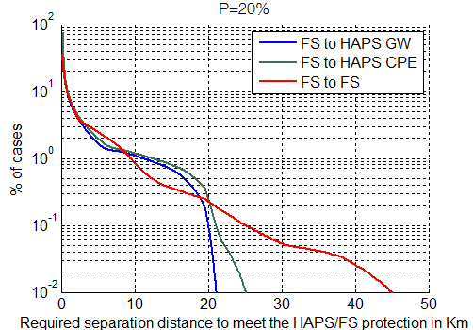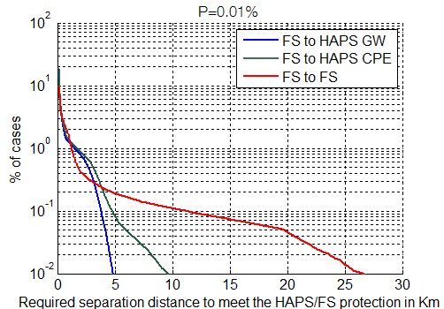

Figure 10

HAPS system 6 separation distance CDF

|  |  |
| --- | --- |
| p= 20% | p =0.01% |
|  |  |

From the above results it can be concluded that HAPS ground stations can be considered as any FS station as the result of the impact of FS station emissions into HAPS ground station receivers is less than or equivalent to the impact of an FS emitting station into another FS receiving station.

# 2 Summary and analysis of the results of studies

HAPS transmitting towards the HAPS ground stations

Several studies have shown that the following pfd mask in dB(W/(m2.MHz)), to be applied under clear sky conditions at the surface of the Earth, ensures the protection of the FS by meeting its long term protection criteria:

where is elevation angle in degrees (angles of arrival above the horizontal plane).

Note that the pfd level shown above is derived from a maximum interference level of −143 dB(W/MHz) (i.e. *I*/*N* = −10 dB not to be exceeded more than 20% of the time) for the FS long-term protection criteria. The FS parameters and deployment density are taken from Recommendations ITU-R F.758 and ITU-R F.2086, respectively. The FS antenna pattern is based on ITU-R F.1245 and gaseous atmospheric attenuation is considered (Recommendation ITU-R SF.1395).

The following two approaches address the use of ATPC to compensate for rain fade.

Approach 1: In order to compensate for additional propagation impairments in the boresight of any beam of the HAPS due to rain, the HAPS can be operated so that the pfd mask can be increased in any corresponding beam (i.e. suffering the rain fade) by a value only equivalent to the level of rain fading and limited to a maximum of 20 dB. This level is the difference between long-term protection criteria of *I*/*N* = −10 dB that can be exceeded for no more than 20% of the time (i.e. clear sky) and assumed short-term protection criteria of *I*/*N* = +10 dB that is never exceeded.

Approach 2: Automatic transmit power control may be used to increase the e.i.r.p. density to compensate for rain attenuation to the extent that the power flux density at the FS station does not exceed the value resulting from use by HAPS station of an e.i.r.p. density meeting the above limits in the clear sky conditions.

To verify that the pfd produced by HAPS does not exceed the proposed pfd mask the following equation was used:

where:

*EIRP*: nominal HAPS e.i.r.p. density level in dB(W/MHz) (dependent to the elevation angle)

*d:* distance between the HAPS and the ground (elevation angle dependent).

The impact of the gaseous attenuation in not included in the verification formula since it is already taken into account in the pfd mask.

HAPS ground stations transmitting towards the HAPS

HAPS uplink is not considered for this study.

Fixed service transmitting towards HAPS ground stations (HAPS to HAPS ground station)

HAPS uplink is not considered for this study.

Fixed service transmitting towards HAPS (HAPS ground station to HAPS)

The antennas used for both HAPS ground terminals and FS stations are directional, therefore, the required separation distance between the two systems can be reduced by appropriate site-configuration. Protection between HAPS ground stations and conventional FS stations can be managed on a case-by-case basis by coordination amongst administrations or usual link/planning method and procedures used at national level for conventional FS stations.

Annex 2 (MS)  
  
Sharing and compatibility of mobile service and HAPS systems operating  
in the 21.4-22 GHz frequency range

# 1 Technical analysis

TABLE 12

Summary of scenarios considered in study A

|  |  |  |
| --- | --- | --- |
|  | Study A | Study B |
| HAPS ground terminal to AMS | X | X |
| HAPS platform to AMS | X | X |

## 1.1 Study A

### 1.1.1 Introduction

According to the Recommendation ITU-R F.2438-0, Spectrum needs of high-altitude platform stations broadband links operating in the fixed service, HAPS systems 2 and 6 use the 21.4‑22.0 GHz frequency range, and are considered for this study. This study considers both a static single-entry case and a statistical simulation case.

### 1.1.2 Technical analysis

In these analyses, the characteristics for systems 2 and 6 are taken from Report ITU-R F.2439-0 – Deployment and technical characteristics of broadband high altitude platform stations in the fixed service in the frequency bands 6 440-6520 MHz, 21.4-22.0 GHz, 24.25-27.5 GHz, 27.9-28.2 GHz, 31.0-31.3 GHz, 38.0-39.5 GHz, 47.2-47.5 GHz and 47.9-48.2 GHz used in sharing and compatibility studies, while the characteristics for the AMS systems are taken from Recommendation ITU-R M.2120-0 – Technical characteristics and protection criteria for aeronautical mobile systems operating in the mobile service in the frequency range 21.2-22 GHz.

AMS systems operating in the 21.2-22 GHz communicate aircraft to aircraft. Since these aircrafts may fly anywhere within the service area of a HAPS deployment the maximum received interference will be within the service area and thus the dominant interfering mechanism will be a single HAPS deployment in which the aircraft flies into the main beam of a ground to HAPS/HAPS to ground link within the service area. A HAPS deployment is assumed to be a single HAPS and the associated CPEs and GW. Additionally, the AMS aircraft receivers are protected by an *I*/*N* of −6 dB.

These analyses assume that the HAPS is fixed at an altitude 20 km and does not move within the provided 5 km flight radius. It is also assumed that during each simulation this band will be used either for ground to HAPS links or for HAPS to ground links, and not both; however both gateways and CPEs will be communicating with the platform. To simulate the worst-case scenarios, operational altitudes for the AMS aircraft were chosen to be 50 000 ft (15 240 m) for HAPS to ground and 500 ft (152.4 m) for ground to HAPS. These altitudes can be found in Recommendation ITU-R M.2120-0 § 2.

The static analysis is based on a worst-case coupling scenario. The statistical simulation is based on a Monte Carlo analysis in which the locations of all HAPS ground stations are randomized within the service area for each iteration, thereby randomizing the HAPS links each iteration. The AMS location is also randomized at a fixed altitude for each iteration. The Monte Carlo analysis runs 50 000 iterations and the worst-case interference is selected for each analysis.

The relevant parameters for HAPS operations are extracted from Report ITU-R F.2439-0 and are shown in Tables 13 to 16.

TABLE 13

Gateway to HAPS (UL)

|  |  |
| --- | --- |
|  | System 6 |
| Frequency (GHz) | 21.4-22 |
| Signal bandwidth (MHz) | 571.4 (5% roll-off) |
| No. of beams | 1 |
| No of co-frequency beams | 1 |
| Coverage radius/beam (degree) | −3 dB beamwidth |
| Polarization | RHCP/LHCP |
| GW antenna diameter (m) | 2 |
| GW antenna pattern | Recommendation ITU‑R F.1245 |
| GW antenna gain (dBi) | 51.4 |
| GW antenna height above ground (m) | 10 |
| GW Tx power (W) | 39.8 |
| GW e.i.r.p. (dBW) | 65.9 |
| GW e.i.r.p. spectral density (dB(W/MHz)) | 38.3 |
| Power control range (1) (dB) |  |
| Nominal e.i.r.p. spectral density per beam (2) (dB(W/MHz)) |  |
| Platform antenna | Multi-band reflector |
| Platform antenna pattern | Recommendation ITU‑R F.1245 |
| Platform antenna diameter (m) | 0.2 |
| Platform Rx gain (dBi) | 31.4 |
| System noise temp (K) | 600 |
| Platform G/T (dB/K) | 3.62 |
| (1) This corresponds to the system capacity to operate within a range of e.i.r.p..  (2) This corresponds to the maximum power at which the system operates under clear sky conditions for the link between the HAPS and the GW and/or CPE. | |

TABLE 14

HAPS to Gateway (DL)

|  | System 6 | System 2 |
| --- | --- | --- |
| Frequency (GHz) | 21.4-22 | 21.4-22 |
| Occupied bandwidth (MHz) | 341 | 480 per beam |
| Number of beams | 1 | 2 |
| Number of co-frequency beams | 1 | 1 |
| Coverage radius/beam | −3 dB beamwidth | −3 dB beamwidth |
| Polarisation | RHCP/LHCP | RHCP/LHCP |
| Platform Tx gain (per beam) (dBi) | 32.6 | 34.3 |
| Platform antenna pattern | Rec. ITU-R F.1245 | Rec. ITU‑R S.1245 |
| Platform antenna diameter (m) | 0.2 | 0.3 |
|  |  |  |
| Platform e.i.r.p. per beam (dBW) | 29.3 | 21.3 (18.3 per polarisation) |
| Platform e.i.r.p. spectral density (dB(W/MHz)) | 4.0 | −5.5 (−8.5 per polarisation) |
| Power control range (1) (dB) |  | ≥ 14.4 |
| Nominal e.i.r.p. spectral density per beam (2) (dB(W/MHz)) |  | −19.9 (−22.9 per polarization) |
| Unwanted emissions mask |  | Rec. ITU‑R SM.1541 |
| GW antenna diameter (m) | 2 | 2 |
| GW antenna pattern | Rec. ITU‑R F.1245 | Rec. ITU‑R F.1245 |
| GW antenna height above ground (m) | 10 | 1-10 |
| GW antenna gain (dBi) | 51.4 | 51 |
| System noise temp | 350 |  |
| GW G/T (dB/K) | 27.9 | 26.2 |
| (1) This corresponds to the system capacity to operate within a range of e.i.r.p..  (2) This corresponds to the maximum power at which the system operates under clear sky conditions for the link between the HAPS and the GW and/or CPE. | | |

TABLE 15

CPE to HAPS (UL)

|  |  |  |  |
| --- | --- | --- | --- |
|  | System 6 | | |
| Frequency (GHz) | 21.4-22 | | |
| Signal bandwidth (MHz) | 117 | | |
| No. of beams | 4 | | |
| No of co-frequency beams | 4 | | |
| Coverage radius/beam (degree) | −3 dB beamwidth | | |
| Polarisation | RHCP/LHCP | | |
| CPE antenna diameter (m) | 0.35 | 0.6 | 1.2 |
| CPE antenna pattern | Recommendation ITU-R F.1245 | | |
| CPE antenna gain (dBi) | 35.6 | 40.2 | 46.3 |
| CPE antenna height above ground | 10 | | |
| CPE e.i.r.p. (dBW) | 33.2 | 37.9 | 43.9 |
| CPE density (/km²) |  | | |
| CPE e.i.r.p. spectral density (dB(W/MHz)) | 12.5 | 17.2 | 23.2 |
| Power control range+ (dB) |  |  |  |
| Nominal e.i.r.p. spectral density per beam++ (dB(W/MHz)) |  |  |  |
|  |  | | |
| Platform Rx gain (dBi) | 28.1 | 28.1 | 28.1 |
| Platform antenna pattern | Recommendation ITU-R F.1891 | | |
| System noise temperature (K) | 600 | | |
| Platform G/T (dB/K) | 0.3 | 0.3 | 0.3 |

TABLE 16

HAPS to CPE (DL)

|  |  |  |  |  |
| --- | --- | --- | --- | --- |
|  | System 6 | | | System 2 |
| Frequency | 21.4-22 | | | 21.4-22 |
| Occupied bandwidth | 600 | | | 95 per beam |
| No of beams | 4 | | | 16 |
| No of co-frequency beams | 4 | | | 4 |
| Coverage radius/beam | −3 dB beamwidth | | | −3 dB beamwidth |
| Polarization | RHCP/LHCP | | | RHCP/LHCP |
| Platform Tx gain (dBi) | 28.1 | | | 29 |
| Platform antenna pattern | Rec. ITU-R F.1891 | | | Annex 3 |
| Platform antenna diameter | N/A | | | N/A |
| Platform e.i.r.p. (dBW) | 32.2 | | | 22 (19 per polarisation) |
| Platform e.i.r.p. spectral density (dB(W/MHz)) | 4.4 | | | 2.2 (−0.8 per polarisation) |
| Power control range (1) (dB) |  | | | ≥ 10.7 |
| Nominal e.i.r.p. spectral density per beam (2) (dB(W/MHz)) |  | | | −8.5 (−11.5  per polarization) |
| Unwanted emissions mask |  | | | Rec. ITU-R SM.1541 |
| CPE antenna diameter (m) | 0.35 | 0.6 | 1.2 | 1 |
| CPE antenna pattern | Rec. ITU-R F.1245 | | | Rec. ITU-R F.1245 |
| CPE antenna gain (dBi) | 35.6 | 40.2 | 46.3 | 44.8 |
| CPE antenna height above ground (m) | 10 | | | 1-10 |
| System noise temperature (K) | 350 | | |  |
| CPE G/T (dB/K) | 12.1 | 16.7 | 22.8 | 20.2 |
| (1) This corresponds to the system capacity to operate within a range of e.i.r.p.  (2) This corresponds to the maximum power at which the system operates under clear sky conditions for the link between the HAPS and the GW and/or CPE. | | | | |

#### 1.1.2.1 Static Analysis

This static analysis is used to assess the initial impacts of interference into the AMS receiver. Since the AMS receiver is omnidirectional, the highest interference will occur at the closest separation distance between aircraft receiver and interfering transmitter. This situation occurs when the CPE or Gateway are located directly under the AMS platform and the aircraft flies directly into the link. It is assumed that for the HAPS to ground case the altitude of the aircraft is 50 000 ft (15 240 m) and for the ground to HAPS case the altitude of the aircraft is 500 ft (152.4 m). Only one CPE or gateway is considered in this static analysis. The HAPS systems are transmitting at the bottom end of the 21.4‑22 GHz band and the AMS aircraft receiver is tuned at 21.2-21.5 GHz. The free space path loss model used in these calculations can be found in Recommendation ITU-R P.525.

#### 1.1.2.2 Results of static analysis

The calculations of the static analysis are provided in Tables 17 and 18. These Tables provide link calculations to demonstrate the interference received at the AMS receiver during both HAPS to ground and ground to HAPS operations.

TABLE 17

Calculations for ground to HAPS static analysis

|  |  |  |
| --- | --- | --- |
| Parameter | System 6 GW | System 6 CPE |
| Transmit e.i.r.p. density (dB(W/MHz)) | 38.3 | 23.2 |
| Path loss at 500 ft (dB) | 102.71 | 102.71 |
| Path loss at 10 000 ft (dB) | 128.73 | 128.73 |
| Polarization loss (dB) | 3 | 3 |
| AMS receiver gain (dBi) | 0 | 0 |
| Interference power spectral density on receiver at 500 ft (dB(W/MHz)) | −67.41 | −82.51 |
| Total interference power on receiver at 500 ft (dBW) | −47.41 | −62.51 |
| Interference power spectral density on receiver at 10 000 ft (dB(W/MHz)) | −93.43 | −108.53 |
| Total interference power on receiver at 10 000 ft (dBW) | −73.43 | −88.53 |
| Noise power (dBW) | −112.06 | −112.06 |
| Protection criteria (dB) | −6 | −6 |
| Interference threshold (dBW) | −118.06 | −118.06 |
| Exceedance at 500 ft (dB) | 70.65 | 55.55 |
| Exceedance at 10 000 ft (dB) | 44.63 | 29.53 |

TABLE 18

Calculations for HAPS to ground static analysis

|  |  |  |  |  |  |
| --- | --- | --- | --- | --- | --- |
| Parameter |  | System 2 GW | System 2 CPE | System 6 GW | System 6 CPE |
| Transmit e.i.r.p. density (dB(W/MHz)) | | −5.5 | 2.2 | 4.0 | 4.4 |
| Path loss (dB) | | 132.6 | 132.6 | 132.6 | 132.6 |
| Polarization loss (dB) | | 3 | 3 | 3 | 3 |
| AMS receiver gain (dBi) | | 0 | 0 | 0 | 0 |
| Interference power spectral density on receiver (dB(W/MHz)) | | −141.1 | −133.4 | −131.6 | −131.2 |
| Total interference power on receiver (dBW) | | −121.1 | −113.4 | −111.6 | −111.2 |
| Noise power (dBW) | | −112.06 | −112.06 | −112.06 | −112.06 |
| Protection criteria (dB) | | −6 | −6 | −6 | −6 |
| Interference threshold (dBW) | | −118.06 | −118.06 | −118.06 | −118.06 |
| Exceedance (dB) | | −3.04 | 4.66 | 6.46 | 6.86 |

#### 1.1.2.3 Statistical analysis

This statistical analysis determines the impact of interference from a single HAPS deployment taking into account that the interfering links may not necessarily be deployed as described in the static analysis. This simulation considers a HAPS at 20 km altitude. A service area with a 50-km radius is then drawn around the HAPS and then divided into four quadrants. A Monte Carlo analysis was conducted by generating random locations for CPEs in each quadrant, as well as a single gateway within the entire service area. An aircraft victim receiver was also randomized within the HAPS service area. Each of these locations are randomly generated each iteration to generate data representative of all deployment scenarios. The AMS is constrained to flying within the HAPS service area and at the minimum altitude for ground to HAPS links and maximum altitude for HAPS to ground links specified in § 1.1.2.1. Additionally, for the ground to HAPS direction, an additional scenario was considered for the AMS flying at 10 000 ft (3 048 m). Each Monte Carlo analysis runs 50 000 iterations and the worst-case interference is selected for each. The HAPS systems are transmitting at the lower end of the 21.4-22 GHz band and the AMS aircraft receiver is tuned at 21.2‑21.5 GHz, producing a 100 MHz overlap. This simulation also utilizes the free space path model found in Recommendation ITU-R P.525.

#### 1.1.2.4 Results of statistical analysis

The results of the statistical analysis are shown in Tables 19 and 20. These Tables show the maximum power received by the AMS receiver, the centre tuning frequency of the receiver and transmitter, the protection required for the AMS systems and the exceedance of the protection criteria. A CDF is also provided for each direction of transmission after the corresponding table for the AMS scenarios studied.

TABLE 19

Results of ground to HAPS statistical analysis

|  |  |
| --- | --- |
| Parameter | System 6 |
| Maximum power received at 500 ft (dBW) | −97.83 |
| Maximum power received at 10 000 ft (dBW) | −80.59 |
| Centre tuning frequency for interfering transmitter (GHz) | 21.4585 |
| Centre tuning frequency for victim receiver (GHz) | 21.345 |
| Interference threshold for AMS (dBW) | −118.06 |
| Maximum exceedance at 500 ft (dB) | 20.23 |
| Maximum exceedance at 10 000 ft (dB) | 37.47 |

Figure 11

Ground to HAPS Monte Carlo interference CDF

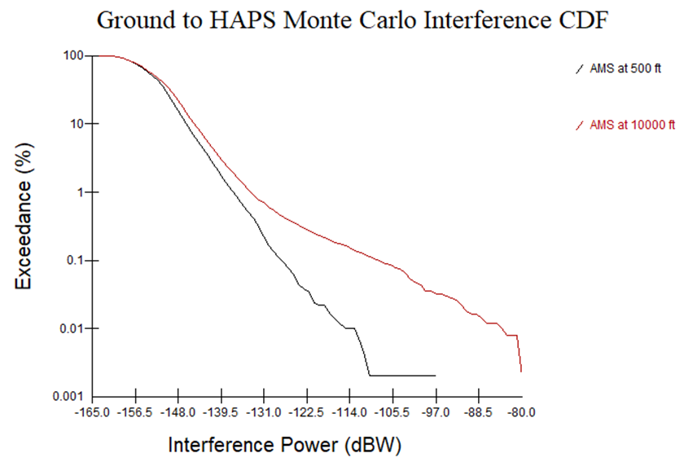

TABLE 20

Results of HAPS to ground statistical analysis

|  |  |  |
| --- | --- | --- |
| Parameter | System 2 | System 6 |
| Maximum power received at 50 000 ft (dBW) | −114.94 | −112.22 |
| Center tuning frequency for interfering transmitter (GHz) | 21.64 | 21.45 |
| Center tuning frequency for victim receiver (GHz) | 21.345 | 21.345 |
| Interference threshold for AMS (dBW) | −118.06 | −118.06 |
| Maximum exceedance at 50 000 ft (dB) | 3.12 | 5.84 |

Figure 12

HAPS to Ground Monte Carlo Interference CDF

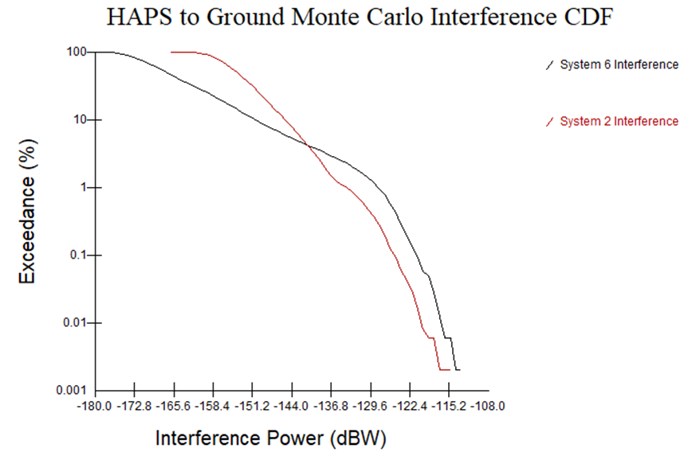

#### 1.1.2.5 Adjacent channel analysis

The statistical simulation was also conducted several more times, shifting the centre frequency of the closest channel by increments of 25 MHz up to 100 MHz to determine the frequency separation required to mitigate excessive interference. The purpose of this second analysis is to determine at which frequency, received power levels are low enough to protect AMS systems through all possible deployment scenarios.

#### 1.1.2.6 Results of adjacent channel analysis

The results of the statistical analysis are shown in tables below. These Tables show the maximum power received by the AMS receiver, the centre tuning frequency of the receiver and transmitter, the protection required for the AMS systems and the exceedance of the protection criteria. The HAPS systems are transmitting at a centre frequency that transmit at the lower end of 21.5-22 GHz band and the AMS aircraft receiver is tuned at 21.2‑21.5 GHz, producing no frequency overlap. A CDF is also provided for each direction of transmission after the corresponding table for the AMS scenarios studied.

TABLE 21

Results of System 6 ground to HAPS statistical analysis with various frequency separations

|  |  |  |  |  |
| --- | --- | --- | --- | --- |
| Parameter | System 6 | | | |
| 25 MHz | 50 MHz | 75 MHz | 100 MHz |
| Maximum power received at 500 ft (dBW) | −102.77 | −115.56 | −119.93 | −131.38 |
| Maximum power received at 10 000 ft (dBW) | −81.84 | −86.80 | −92.35 | −108.01 |
| Center tuning frequency for interfering transmitter (GHz) | 21.4835 | 21.5085 | 21.5335 | 21.5585 |
| HAPS operational frequency band edge (GHz) | 21.425 | 21.45 | 21.475 | 21.5 |
| Center tuning frequency for victim receiver (GHz) | 21.345 | 21.345 | 21.345 | 21.345 |
| Interference threshold for AMS (dBW) | −118.06 | −118.06 | −118.06 | −118.06 |
| Maximum exceedance at 500 ft (dB) | 15.29 | 2.5 | −1.87 | −13.32 |
| Maximum exceedance at 10 000 ft (dB) | 36.22 | 31.26 | 25.71 | 10.05 |

Figure 13

Ground to HAPS AMS @ 500 ft Interference CDF

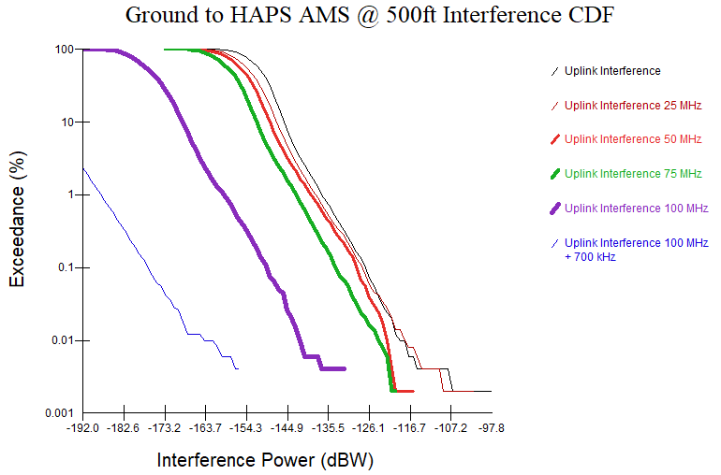

Figure 14

Ground to HAPS AMS @ 10 kft Interference CDF

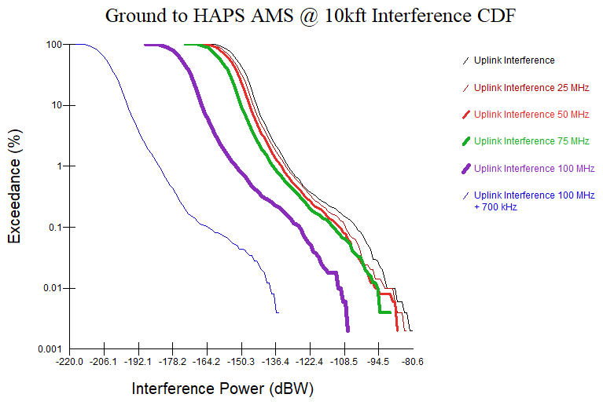

TABLE 22

Results of System 2 HAPS to ground statistical analysis with various frequency separations

|  |  |  |  |  |
| --- | --- | --- | --- | --- |
| Parameter | System 2 | | | |
| 25 MHz | 50 MHz | 75 MHz | 100 MHz |
| Maximum power received at 50 000 ft (dBW) | −115.56 | −117.88 | −120.29 | −137.95 |
| Center tuning frequency for interfering transmitter (GHz) | 21.665 | 21.69 | 21.715 | 21.74 |
| HAPS operational frequency band edge (GHz) | 21.425 | 21.45 | 21.475 | 21.5 |
| Center tuning frequency for victim receiver (GHz) | 21.345 | 21.345 | 21.345 | 21.345 |
| Interference threshold for AMS (dBW) | −118.06 | −118.06 | −118.06 | −118.06 |
| Maximum exceedance at 50 000 ft (dB) | 2.5 | 0.18 | −2.23 | −19.89 |

Figure 15

HAPS to Ground System 2 adjacent channel interference CDF

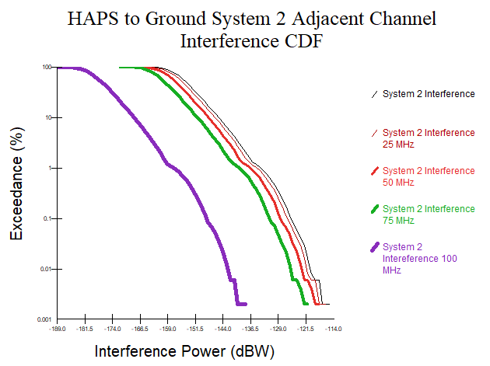

TABLE 23

Results of system 6 HAPS to ground statistical analysis with various frequency separations

|  |  |  |  |  |
| --- | --- | --- | --- | --- |
| Parameter | System 6 | | | |
| 25 MHz | 50 MHz | 75 MHz | 100 MHz |
| Maximum power received at 50 000 ft (dBW) | −113.34 | −115.53 | −117.96 | −142.43 |
| Center tuning frequency for interfering transmitter (GHz) | 21.475 | 21.5 | 21.525 | 21.55 |
| HAPS operational frequency band edge (GHz) | 21.425 | 21.45 | 21.475 | 21.5 |
| Center tuning frequency for victim receiver (GHz) | 21.345 | 21.345 | 21.345 | 21.345 |
| Interference threshold for AMS (dBW) | −118.06 | −118.06 | −118.06 | −118.06 |
| Maximum exceedance at 50 000 ft (dB) | 4.72 | 2.53 | 0.1 | −24.37 |

Figure 16

HAPS to ground System 6 adjacent channel interference CDF

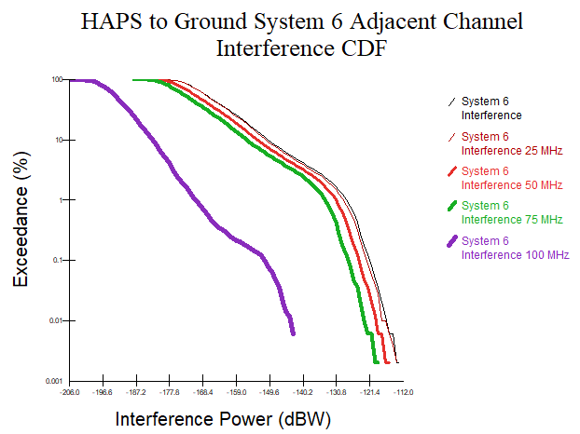

### 1.1.3 Summary and analysis of the results of study A

Study A used the characteristics of HAPS systems 2 and 6 from Report ITU-R F.2439-0 and conducted both a static and statistical analysis for a single AMS aircraft deployed into a single HAPS service area. These analyses take into account the HAPS operating at 20 km and the AMS operating at both 500 ft and 10 000 ft for the ground to HAPS case and 50 000 ft for the HAPS to ground case.

The static analysis shows that HAPS systems exceed AMS protection criterion while shifting the centre frequency of the closest channel of HAPS up to 100 MHz as the worst-case exceedance can range from 29.54 dB to 70.66 dB for the ground to HAPS case. For HAPS to ground case, HAPS as a system exceeds AMS protection criterion while shifting the centre frequency of the closest channel of HAPS up to 100 MHz. With the exception of the GW component of system 2, in the band 21.4‑21.5 GHz, the worst-case exceedance ranged from 4.66 dB to 6.86 dB.

The statistical analysis shows that after 50 000 samples that the worst case exceedance could range from 20.23 dB to 37.47 dB for the ground to HAPS case and 3.12 dB to 5.84 dB for the HAPS to ground case.

The statistical analysis CDFs in Figs 11 and 12 showed that interference to AMS systems exceeded the protection criteria of −118.06 dBW. Figures 13 to 16 also showed the amount of interference present when shifting the centre frequency of the closest HAPS channel.

While the above analysis in the ground-to-HAPS direction indicates an exceedance while shifting the centre frequency of the closest channel of HAPS by 100 MHz, it is expected that the exceedance will drop off quickly above 21.5 GHz and therefore HAPS transmissions occupying bandwidth above 21.5 GHz should not present harmful interference into AMS.

## 1.2 Study B

AMS systems operating in the 21.2-22 GHz will be deployed in groups of four spanning 100 miles across airspace using the aeronautical mobile systems to communicate between the platforms as they fly. Since these aircrafts may fly anywhere within the service area of a HAPS deployment the maximum received interference is within the HAPS service area and thus the dominant interferer is a single HAPS deployment with the aggregate of the ground to HAPS/HAPS to ground beams within the service area. A HAPS deployment is assumed to be a single HAPS and the associated CPEs and GW. Additionally, the AMS aircraft receivers are protected by an *I*/*N* of −6 dB. When using *I*/*N* criteria, the dominant interference mechanism will be the HAPS signals received; the contributions from other HAPS deployments will add negligible effect. Therefore, the aggregate impact study from multiple HAPS into an AMS receiver is therefore not required.

These analyses assume that the HAPS is fixed at an altitude 20 km and does not move within the provided 5 km flight radius. It is also assumed that this band will be used either for ground to HAPS links or for HAPS to ground links, and not both; however both gateways and CPEs will be communicating with the platform. To simulate the worst-case scenarios, operational altitudes for the AMS aircraft were chosen to be 50 000 ft (1 5240 m) for HAPS to ground and 500 ft (152.4 m) for ground to HAPS. These altitudes fall under ICAO standards for class A airspace and class G airspace, respectively.

The AMS systems in 21.2-22 GHz only operate in the frequency range of 21.2-21.5 GHz with a centre tuning frequency 21.345 GHz to accommodate the full bandwidth of the transmitters and receivers. HAPS deployment operating in 21.4-22 GHz resulted in a 100 MHz overlap of signals. To determine the impacts of this overlap, all analyses were conducted twice, accounting for a 100 MHz overlap as well as a HAPS centre frequency that would produce a signal adjacent to AMS communications.

### 1.2.1 Impact from a single HAPS transmission into AMS receiver

Since the AMS receiver is omnidirectional, the highest interference occurs at the closest separation distance between aircraft receiver and interfering transmitter. This situation occurs when the CPE or gateway are located directly under the AMS platform and the aircraft flies directly into the link. It is assumed that the altitude of the aircraft is 50 000 ft (15 240 m). The HAPS systems are transmitting at the lower end of the 21.4-22 GHz band and the AMS aircraft receiver is tuned at 21.2-21.5 GHz, producing a 100 MHz overlap. The free space path loss model used in these calculations can be found in Recommendation ITU-R P.525.

The calculation is provided in table below. This table provides link calculations to determine the maximum aggregate e.i.r.p. density per HAPS in dB(W/100 MHz) in the band 21.4-21.5 MHz in order to protect AMS receivers from interference. The calculations include the aggregate e.i.r.p. density transmitted per HAPS within the overlap band as well as a bandwidth adjustment factor that accounts for the interference across the entire AMS bandwidth.

TABLE 24

Calculations for HAPS to ground static analysis

|  |  |
| --- | --- |
| Parameter | Maximum e.i.r.p. density  (nominal e.i.r.p. density + maximum ATPC) |
| Transmit e.i.r.p. density in overlap (dB(W/100 MHz)) | 17.5 |
| Path loss (dB) | 132.6 |
| Polarization loss (dB) | 3 |
| AMS receiver gain (dBi) | 0 |
| Bandwidth adjustment factor (dB) | −4.91 |
| Transmitter signal on receiver (dB(W/100 MHz)) | −123 |
| Noise power (dB(W/100 MHz)) | −117 |
| Protection criteria (dB) | −6 |
| Interference threshold (dB(W/100 MHz)) | −123 |
| Exceedance (dB) | 0 |

The analysis shows that sharing is feasible between the HAPS downlink and AMS in the condition that the HAPS maximum aggregate e.i.r.p. per HAPS (nominal e.i.r.p. plus maximum ATPC taking into account all beams of a single HAPS) is limited to 17.5 dB(W/100 MHz) in the band 21.4‑21.5 GHz.

Considering system 2 characteristics only the HAPS to gateway links are compliant with the proposed aggregate e.i.r.p. density limit per HAPS (14.5 dB(W/100 MHz)). CPE links exceeds the proposed limit (22.2 dB(W/100 MHz)). Therefore, system 2 will have to reduce the aggregate CPE beam e.i.r.p. density by more than 4.7 dB or limit the usage of the band 21.4-21.5 GHz to gateways beams only.

### 1.2.2 Impact from a single HAPS ground station transmission into AMS receiver

Since the AMS receiver is omnidirectional, the highest interference occurs at the closest separation distance between aircraft receiver and interfering transmitter. This situation occurs when the CPE or Gateway are located directly under the AMS platform and the aircraft flies directly into the link. It is assumed that the altitude of the aircraft is 500 ft (152.4 m). The HAPS systems are transmitting at the lower end of the 21.4-22 GHz band and the AMS aircraft receiver is tuned at 21.2-21.5 GHz, producing a 100 MHz overlap. The free space path loss model used in these calculations can be found in Recommendation ITU-R P.525.

The calculation is provided in Table 25. The Table provides link calculations to determine the maximum e.i.r.p. density for a single HAPS ground station in dB(W/100 MHz) in the band 21.4‑21.5 MHz in order to protect AMS receivers from interference. The calculations include the e.i.r.p. transmitted per HAPS ground station within the overlap band as well as a bandwidth adjustment factor that accounts for the interference across the entire AMS bandwidth.

TABLE 25

Calculations for ground to HAPS static analysis

|  |  |
| --- | --- |
| Parameter |  |
| Path loss (dB) | 102.71 |
| Polarization loss (dB) | 3 |
| AMS receiver gain (dBi) | 0 |
| e.i.r.p. density in overlap (dB(W/100 MHz)) | −12.4 |
| Bandwidth adjustment factor (dB) | −4.91 |
| Transmitter signal on receiver (dB(W/100 MHz)) | −123 |
| Noise power (dB(W/100 MHz)) | −117 |
| Protection criteria (dB) | −6 |
| Interference threshold (dB(W/100 MHz)) | −123 |
| Exceedance (dB) | 0 |

The analysis shows that sharing is feasible between the HAPS uplink and AMS in the condition that the HAPS ground station maximal e.i.r.p. (nominal e.i.r.p. plus maximum ATPC) is limited to −12.4 dB(W/100 MHz) in the band 21.4-21.5 GHz. This is far below what is required by the HAPS ground station.

### 1.2.3 Summary and analysis of the results of study B

The analysis shows that AMS station can be protection from emission of HAPS in case the HAPS maximum aggregate e.i.r.p. density per HAPS is limited to 17.5 dB(W/100 MHz) in the band 21.4‑21.5 GHz. However, the risk potential of interference only arises when the AMS station is located in the beam of the HAPS, which occurs when both systems are operating in the same geographical area.

# 2 Summary and analysis of the results of studies

Impact of HAPS into AMS stations receivers

Study A shows that HAPS as a system exceeds AMS protection criteria while shifting the centre frequency of the closest HAPS channel up to 100 MHz. With the exception of the GW component of system 2, interference is present, and it ranges from 4.66 dB to 6.86 dB in the static analysis and 3.12 dB to 5.84 dB in the statistical analysis. However, it is expected that the exceedance will drop off quickly above 21.5 GHz, and therefore HAPS transmissions occupying bandwidth above 21.5 GHz should not present harmful interference into AMS.

Study B shows that AMS station can be protected from emission of HAPS in case the HAPS maximum aggregate e.i.r.p per HAPS is limited to 17.5 dB(W/100 MHz) in the band 21.4‑21.5 GHz. However, the risk potential of interference -arises when the AMS station is located in the beam of the HAPS, which occurs when both systems are operating in the same geographical area.

**HAPS ground stations into AMS stations receivers**

Study A shows that HAPS systems exceed AMS protection criterion from 29.54 dB to 70.66 dB in the static analysis and 20.23 dB to 37.47 dB in the statistical analysis while shifting the centre frequency of the closest HAPS channel up to 100 MHz. It is expected that the exceedance will drop off quickly above 21.5 GHz and therefore HAPS transmissions occupying bandwidth above 21.5 GHz should not present harmful interference into AMS.

Study B shows that sharing is not feasible between HAPS uplink and AMS in the band 21.4‑21.5 GHz.

Impact of AMS into HAPS ground stations

No studies were presented for this scenario.

Mobile service transmitting towards HAPS (HAPS GW/CPE to HAPS station)

No studies were presented for this scenario.

Annex 3   
(EESS (Passive) in 21.2-21.4 GHz)  
  
Compatibility of Earth exploration-satellite system (passive) in the adjacent band 21.2-21.4 GHz and HAPS systems operating in the 21.4-22 GHz frequency

## 1.1 Technical analysis

TABLE 26

Scenario considered

|  |  |  |  |
| --- | --- | --- | --- |
|  | Study A | Study B | Study C |
| HAPS ground terminal to EESS passive | Uplink not considered | X | X |
| HAPS to EESS passive | X |  |  |

## 1.2 Study A: HAPS to HAPS ground station

Three different and independents studies were performed to assess the impact of HAPS transmissions toward HAPS ground station into EESS (passive) receivers (21.2-21.4 GHz). All those studies provide same results and therefore, only one of them is presented in the following section.

### 1.2.1 Off-nadir angle

Figure 17 provides the link between the distance from the sub HAPS point and the off-nadir angle.

Figure 17

Off-nadir angle

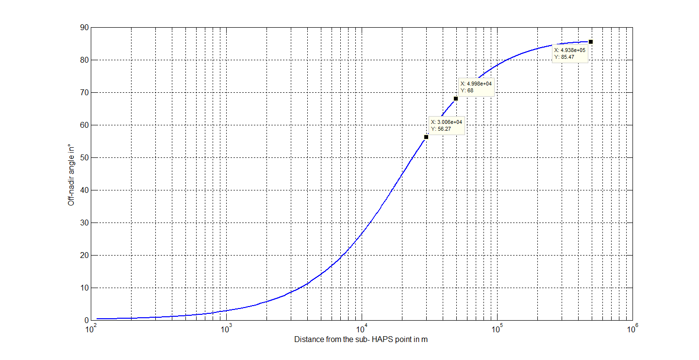

Table 27 provides the off-nadir angle corresponding to the edge of the HAPS coverage.

TABLE 27

Off nadir angle corresponding to the edge of HAPS coverage

|  |  |  |
| --- | --- | --- |
|  | System 2 GW beam | System 2 CPE beam |
| Off nadir angle at edge of the coverage (degree) | 56.3 | 68 |
| Edge of coverage (km) | 30 | 50 |

### 1.2.2 Maximum system 2 HAPS antenna gain towards EESS satellite (HAPS to GW)

The maximum HAPS antenna gain towards the EESS satellite for the HAPS to GW links is when the HAPS beam is pointing towards the edge of the HAPS coverage (30 km from the HAPS sub point). The EESS will be seen in the side lobes of the HAPS antenna with an off axis angle higher than 38.7°(95-56.3) as the EESS minimum elevation angle is −4.5°. Figure 18 shows that the maximum antenna gain for off axis higher than 29.2° is −2.3 dBi. This value is used to compute the maximum interference level that one HAPS could generate.

Figure 18

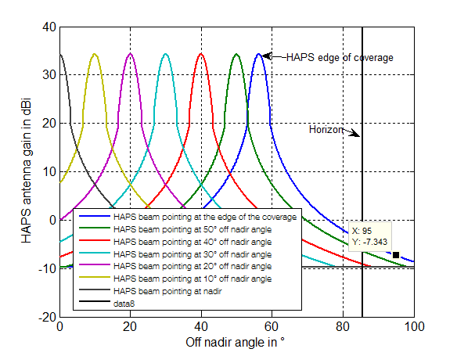

### 1.2.3 Maximum system 2 HAPS antenna gain towards EESS satellite (HAPS to CPE)

This section provides the average antenna gain as a function of the elevation angle as well as the consideration of the normalization factor on the antenna gain calculation.

There are 16 beams for the links HAPS to CPE (four per panels). Only four are co-frequency (one per panel). Their pointing directions are as follows:

Beam 1:

– Azimuth: random variable with a uniform distribution between −45° to 45°.

– Nadir: random variable between 0° and 56.4° with a distribution defined by the equation:

*Nadir*= acos(*U*\*(1-cos(56.4))+cos(56.4))

where *U* is a random variable which is uniform between 0 and 1.

Beam 2:

– Azimuth: random between 45° to 135° with a uniform distribution.

– Nadir: same as beam 1.

Beam 3:

– Azimuth: random between 135° to 225° with a uniform distribution.

– Nadir: same as beam 1.

Beam 4:

– Azimuth: random between 225° to 315° with a uniform distribution.

– Nadir: same as beam 1.

Figure 19

Example of HAPS antenna pattern

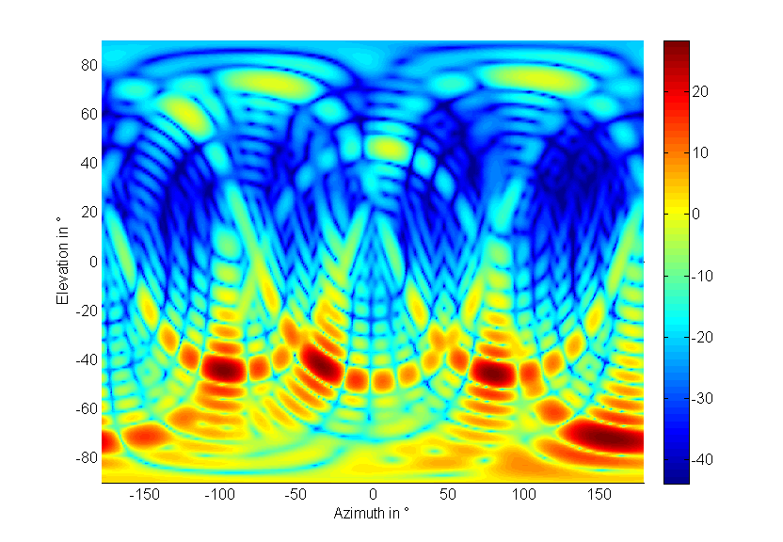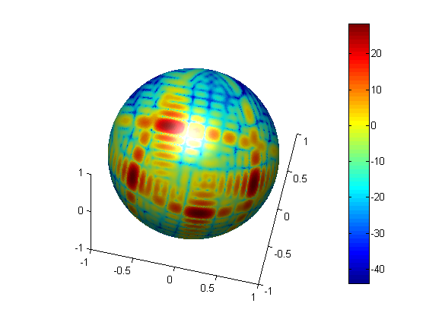

There is need to introduce a normalization factor to the calculation of the antenna directivity in each direction in order to ensure that the total array directivity is equal to 0 dB.

The expression for the composite array radiation pattern:

where:

*vm,n* called the ‘super position vector’ can be understood as the steering vector giving the phase shift due to array placement

*wm,n*depicts the weighting factor, is a function of the antenna beam pointing angles φ-scan and the electrical tilt and aims at tuning side lobe levels.

This actual array gain that has to be performed in any sharing studies should be normalised as follows:

to ensure that the total radiated power equal where is the conducted power input to the array system. Consequently, this study takes into accounts this normalization factor in the computation of the HAPS station antenna gain (HAPS to CPE). Figure 20 provides the normalization faction versus azimuth and elevation electronical tilts.

Figure 20

Normalization factor

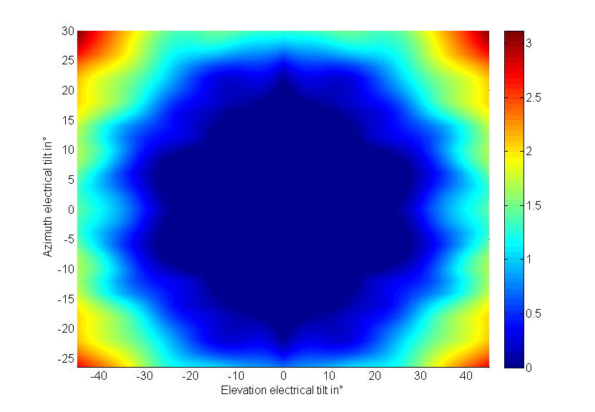

The average HAPS antenna gain towards the EESS satellites is computed as follows:

– Step 1: Each beam pointing azimuth and nadir angles are randomly set using the above distribution.

– Step 2: The gain is computed for the elevation angle −4.5° (minimum elevation angle towards FSS) in all azimuth (from −180 to 180 with a step of 1°). Store the result.

– Step 3: Redo steps 1 and 2 sufficient times.

– Step 4: Compute the average antenna gain.

– Step 5: Increase the elevation angle by 1° and redo steps 1 to 4.

– Step 6: Redo step 1 to 5 up to an elevation angle of 90°.

Figure 21 provides the results.

Figure 21

System 2 HAPS antenna gain towards EESS satellite

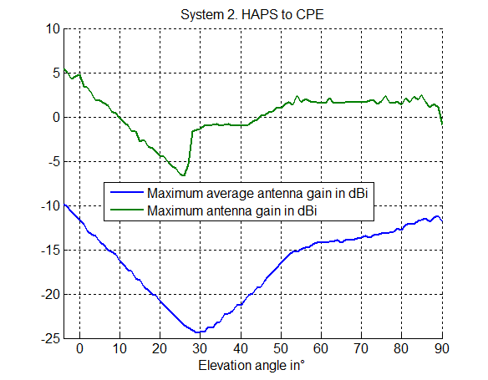

It can be noted that the normalization factor has negligible impact on the HAPS average and maximum antenna gain. The maximum antenna gain towards EESS is 5 dB above −4.5° elevation angle.

### 1.2.4 Maximum system 2 HAPS station e.i.r.p. density above −4.5° elevation

Table 28 provides the maximum HAPS e.i.r.p. density above −4.5° elevation for the link HAPS towards gateway and CPE.

TABLE 28

|  |  |  |  |
| --- | --- | --- | --- |
| Maximum e.i.r.p. density above -4.5° elevation (worst case raining condition) | HAPS-> GW (System 2) | HAPS-> CPE (System 2) |  |
| Gmax HAPS (dBi) | 34.3 | 29 |  |
| Gmax HAPS towards GSO satellite (dBi) | −2.3 | 5 |  |
| Maximum HAPS e.i.r.p. density (dB(W/MHz)) | −3.5 | 2.2 | Per polarization |
| Maximum HAPS e.i.r.p. density above -4.5° elevation (dB(W/MHz)) | −**45.1** | −**24.8** | Per polarization |

### 1.2.5 Proposed maximum HAPS e.i.r.p. density towards EESS satellite receivers

The following steps have been performed to derive an HAPS maximum e.i.r.p. density mask toward EESS satellite receivers taken into account the HAPS aggregated impact.

Step 1:Locate N HAPS distributed on a grid over the spherical cap (radius equal to Earth radius plus HAPS altitude) visible from the EESS station (minimum elevation angle towards EESS of −4.53° when HAPS altitude is 20 km). The distance between HAPS (Inter HAPS distance is 100 in km, i.e. twice the HAPS coverage radius).

Figure 22

HAPS on a spherical cap

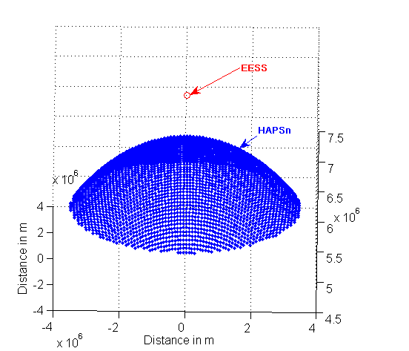

where:

*h* : HAPS altitude (20 km)

*Radius_sph* : Earth radius plus *h* in km

*Radius_cap* : 3 446 km (corresponding to an elevation angle towards EESS of −4.53°).

Step 2: Compute the attenuation towards each HAPS due to propagation.

Free space loss between the HAPS station and the satellite (Recommendation ITU-R P.525).

Figure 23

Free space loss for sensors E1 and E2

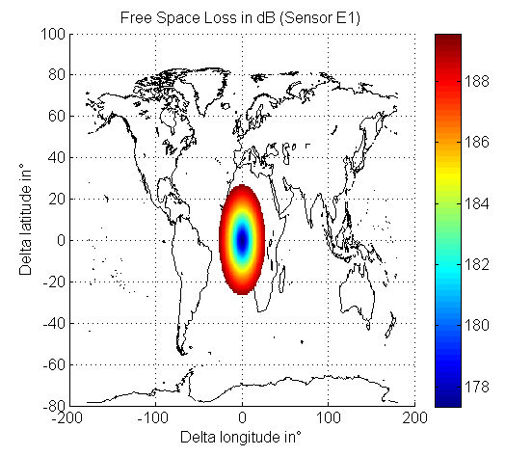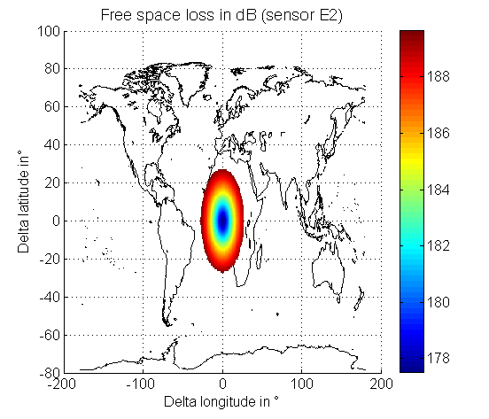

Step 3: Set the pointing direction of the satellite beam towards the ground with a minimum elevation angle of 32.4° for sensor E1 and 31.3° for sensor E2.

Step 4: Compute the satellite-beam antenna gain toward each points of the grid from step 1 and therefore toward each HAPS. As an example, Fig. 24 provides the results for an EESS antenna gain of respectively 34.4 dBi (sensor E1) and 45 dBi (sensor E2) and a pointing direction toward a point located at the Earth surface with a longitude of −10° and a latitude of −10° when the EESS satellite is located at longitude 0° and latitude 0°.

Figure 24

EESS antenna gain of EESS sensors

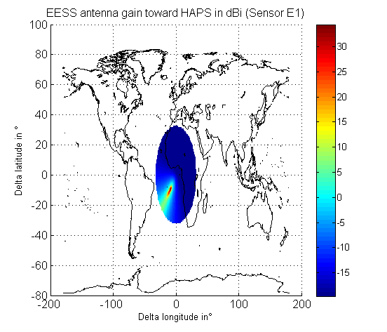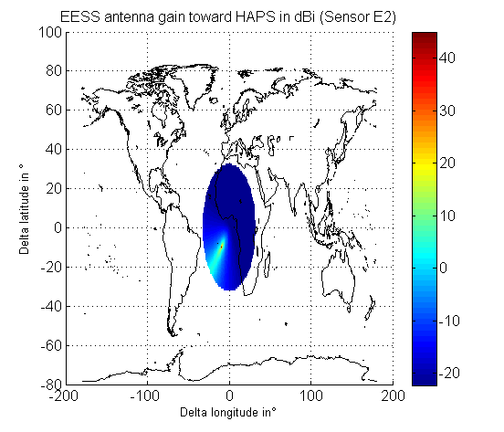

Step 5:The aggregate interference received by the EESS satellite from each HAPS of step 1 is computed.

The interference from the HAPS towards an EESS satellite receiver can be expressed as:

where:

*n* index of the HAPS (see step 1)

*EIRPn* maximum HAPS unwanted emission e.i.r.p. density in dB(W/100 MHz) with index *n* toward the EESS satellite:

θ elevation angle (degree) at the platform height

*Grn* FSS satellite receiver antenna gain towards HAPS with index n

*FSLn* free space loss in dB between the EESS satellite and HAPS with index *n* (see step 2 results).

As an example, Fig. 25 provides the interference produced by each HAPS in the case of an EESS antenna gain of respectively 34.4 dBi (sensor E1) and 45 dBi (sensor E2) and a pointing direction toward a point located at the Earth surface with a longitude of −10° and a latitude of −10°.

Figure 25

Interference level density

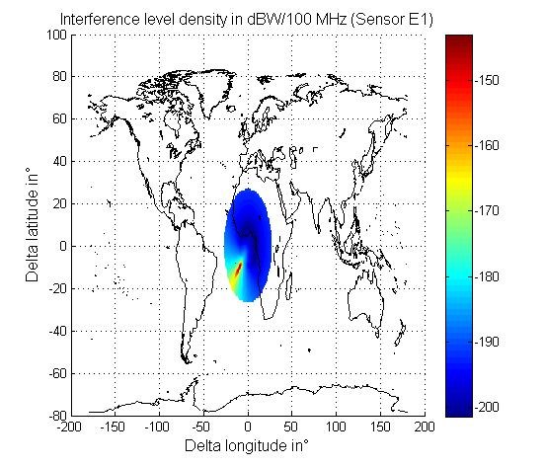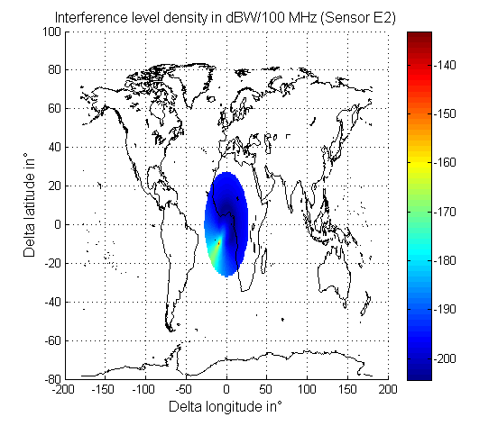

Step 6:The aggregate interference received by the satellite from all HAPS of step 1 is computed and stored. The interference from the HAPS towards an EESS satellite receiver can be expressed as:

Step 7:Redo steps 3, 4, 5 and 6 for any possible satellite pointing direction (0.2° step for longitude and latitude and with a minimum elevation angle of 32.4 for sensor E1 and 31.3° for sensor E2). Figure 26 provides the final results. It represents the aggregate interference received by the EESS satellite receiver from all HAPS versus satellite beam pointing direction. It should be noted that this analysis is worst case as it is assumed that HAPS are also located over the ocean and all over the world.

Figure 26

Aggregate interference level in the EESS sensors receiver

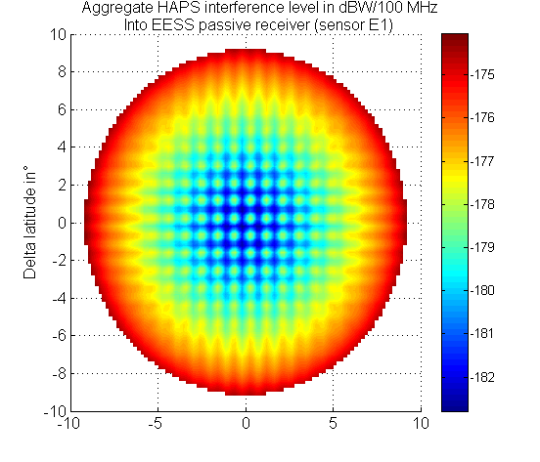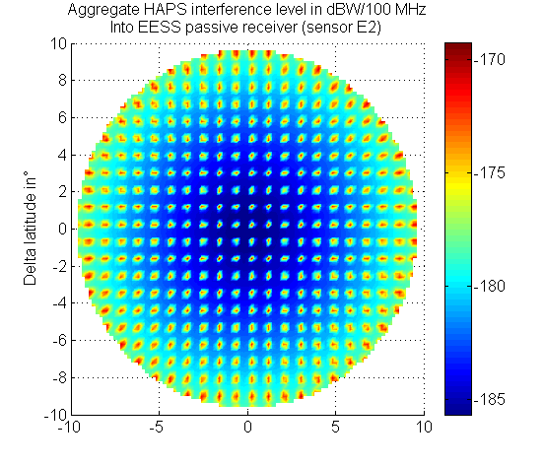

Step 8:The maximum impact corresponds to an EESS receiver antenna gain of 45 dBi (sensor E2) and is equal to −169.3 dB(W/100 MHz). The worst-case aggregate impact is 0.3 dB lower than the EESS protection criteria (−169 dB(W/100 MHz)). Therefore, in order to protect EESS receivers the unwanted emission e.i.r.p. density in dB(W/100 MHz) per HAPS transmitter should be limited to:

θ is the elevation angle (degree) at the platform height.

Step 9:Compare with HAPS systems maximum pfd level versus elevation.

**System 2**

The in band maximum system 2 e.i.r.p. density level for elevation angle higher than 5 degrees is −50.1 dB(W/MHz) per polarization for the GW beam and −27.8 dB(W/MHz) per polarization for the CPE beam.

To protect the EESS (passive) receivers the system 2 HAPS station unwanted emission towards should be attenuated compare to the in band emission level by at least 6.5 dB for GW beam and 28.8 dB for the CPE beam. With the current technology this is achievable by:

– filtering;

– spectrum shape of the modulation;

– shielding of the HAPS;

– frequency gap (e.g. by choosing the GW beam frequency band close to the EESS band and the CPE beam frequency with higher frequency gap from the EESS band).

**System 6**

Figure 27 shows the in-band maximum system 6 e.i.r.p. density level for elevation angle higher than −4.53 degrees.

Figure 27

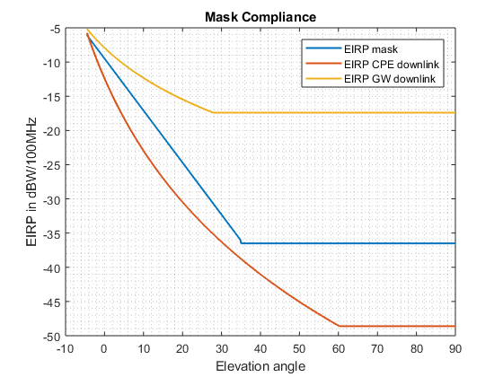

To protect the EESS (passive) receivers the system 6 HAPS station unwanted emission towards should be attenuated compare to the in-band emission level by up to 19.1 dB for the GW downlink. The following list presents possible methods to obtain the required attenuation:

– filtering;

– spectrum shape of the modulation;

– shielding of the HAPS backlobe emissions;

– power reduction;

– add frequency guardband.

It therefore is possible to design a HAPS system compliance with the above propose e.i.r.p. density mask and protect EESS satellite station receivers.

## 1.3 Study B: HAPS ground CPE to HAPS

Interference scenario:

This study addresses compatibility between HAPS CPE uplinks in the band 21.4-22 GHz and EESS (passive) in the band 21.2-21.4 GHz.

### 1.3.1 Methodology used

Only four CPEs are deployed within each HAPS coverage area and the beams are assumed to always be active. It is not expected that the results would change when considering more CPEs within the coverage area, which would be active only for a portion of time in order to share the HAPS resources.

The propagation model is free space plus gas attenuation as per Recommendation ITU-R P.676.

The sensor measurement area has been assumed to be over Europe, although the band is candidate for Region 2 only. However, the results would be the same for a measurement area in Region 2.

### 1.3.2 EESS (passive) parameters used

The protection criterion considered for the EESS (passive) is given in Recommendation ITU-R RS.2017 as a threshold of −169 dB(W/100 MHz) not to be exceeded more than 0. 1% of the time over a measurement area of 10 000 000 km².

The sensors considered are sensors E1 (Nadir mechanical scan) and E2 (push‑broom) contained within Recommendation ITU-R RS.1861.

### 1.3.3 HAPS parameters used

The HAPS system considered is system 6. The HAPS is positioned between 18 and 25 km altitude. Its coverage radius is 50 km. The HAPS have been distributed on a grid each 100 km within the measurement area, leading to 1 022 platforms in total, and 4 088 associated CPE operating co‑frequency.

### 1.3.4 Calculation results

The following cumulative distribution functions provide the interference levels produced within the passive band assuming that the unwanted emission power per 100 MHz bandwidth is 0 dBW. The difference with the protection criterion would therefore directly give the unwanted emission power level to be met in a 100 MHz bandwidth within the passive band by each CPE.

Figure 28

Level of interference for sensor E1 and CPE with different antenna gains

Une image contenant texte, carte

Description générée avec un niveau de confiance très élevé

The worst-case interference level at the sensor E1 is obtained for the 40.2 dBi CPE antenna and is −111.4 dB(W/100 MHz). There would be a need to decrease the CPE emission power by 57.6 dB leading to −57.6 dB(W/100 MHz) input power limit, or −17.4 dBW e.i.r.p. limit.

Figure 29

Level of interference for sensor E2 and CPE with a gain of 35.6 dBi

Une image contenant carte, texte

Description générée avec un niveau de confiance élevé

The worst-case interference level is obtained for the push-broom sensor (E2) and is −101.6 dB(W/100 MHz). There would be a need to decrease the CPE emission power by 67.4 dB leading to −67.4 dB(W/100 MHz) input power limit, or −31.8 dBW e.i.r.p. limit.

Figure 30

Level of interference for sensor E2 and CPE with a gain of 40.2 dBi

Une image contenant carte, texte

Description générée avec un niveau de confiance très élevé

The worst-case interference level is −100.5 dB(W/100 MHz). There would be a need to decrease the emission power by 68.5 dB leading to −68.5 dB(W/100 MHz) input power limit, or −28.3 dBW e.i.r.p. limit.

Figure 31

Level of interference for sensor E2 and CPE with a gain of 46.3 dBi

Une image contenant carte, texte

Description générée avec un niveau de confiance très élevé

The worst-case interference level is −102.7 dB(W/100 MHz). There would be a need to decrease the emission power by 66.3 dB leading to −66.3 dB(W/100 MHz) input power limit, or −20 dBW e.i.r.p. limit.

### 1.3.5 Summary and analysis of the results of study B

This study shows that in order to protect EESS (passive) in the band 21.2-21.4 GHz from harmful interference, the CPE would have to limit its unwanted emission limit within the passive band to −68.5 to −66.3 dB(W/100 MHz) depending on the antenna gain considered.

These results do not take into account any apportionment factor for the protection criterion as the EESS (passive) relevant group did not provide any value for this specific band.

Since the unwanted emission power limit does not vary a lot (2 dB range) compared to the unwanted emission e.i.r.p. limit (12 dB range), it is proposed to retain an unwanted emission input power limit of −68.5 dB(W/100 MHz).

## 1.4 Study C: HAPS ground GW to HAPS

**Interference scenario:**

This study addresses compatibility between HAPS GW uplinks in the band 21.4-22 GHz and EESS (passive) in the band 21.2-21.4 GHz.

### 1.4.1 Methodology used

One GW is deployed per HAPS within the coverage area of the platform and the beam is assumed to always be active.

The propagation model is free space plus gas attenuation as per Recommendation ITU-R P.676.

The sensor measurement area is assumed to be over Europe, although the band is candidate for Region 2 only. However, the results would be the same for a measurement area in Region 2.

### 1.4.2 EESS (passive) parameters used

The protection criterion considered for the EESS (passive) is given in Recommendation ITU-R RS.2017 as a threshold of −169 dB(W/100 MHz) not to be exceeded more than 0.1% of the time over a measurement area of 10 000 000 km².

The sensors considered are sensors E1 (Nadir mechanical scan) and E2 (push‑broom), contained within Recommendation ITU-R RS.1861.

### 1.4.3 HAPS parameters used

The HAPS system considered is system 6 in Report ITU-R F.2439-0. The HAPS is positioned between 18 and 25 km altitude. Its coverage radius is 50 km. The HAPS have been distributed on a grid with 100 km IHD within the measurement area, leading to 1022 platforms in total, and 1022 associated GW operating co-frequency.

### 1.4.4 Calculation results

The following cumulative distribution functions provide the interference levels produced within the passive band assuming that the unwanted emission power per 100 MHz bandwidth is 0 dBW. The difference with the protection criterion would therefore directly give the unwanted emission power level to be met in a 100 MHz bandwidth within the passive band by each GW.

Figure 32

Level of interference for sensor E1 assuming a 53.3 dBi antenna for the GW

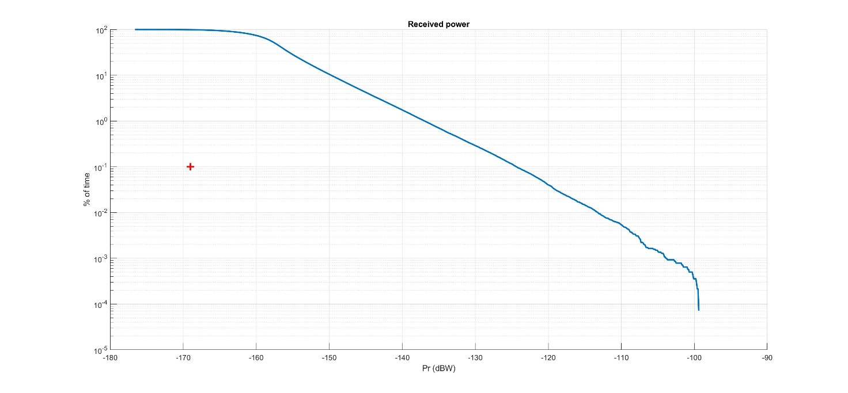

Figure 33

Level of interference for sensor E2 assuming a 53.3 dBi antenna for the GW

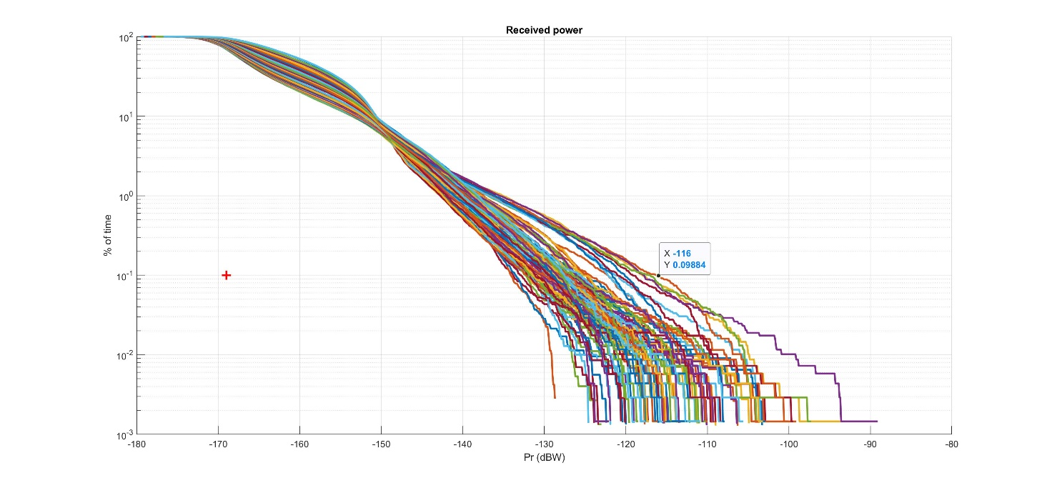

The worst-case is given by the push-broom sensor (E2). For the worst case beam, the interference level is −116 dB(W/100 MHz) and the protection criterion is exceeded by 53 dB. Hence, the level of unwanted emissions that would permit to meet the protection criterion would be −53 dB(W/100 MHz) in terms of input power and 0.3 dB(W/100 MHz) in terms of e.i.r.p. density This does not account for any apportionment.

### 1.4.5 Summary and analysis of the results of study C

This study shows that in order to protect EESS (passive) in the band 21.2-21.4 GHz from harmful interference, the GW would have to limit its unwanted emission limit within the passive band to −53 dB(W/100 MHz). Instead of input power levels, a single unwanted emission e.i.r.p. density value of 0.3 dB(W/100 MHz) to be met under clear sky conditions within the band 21.2-21.4 GHz would also protect EESS (passive).

# 2 Summary and analysis of the results of studies

HAPS transmitting towards the HAPS GW/CPE stations

Three independent studies show that compatibility between EESS (passive) sensors and HAPS downlinks is feasible provided that the unwanted emission e.i.r.p. density in dB(W/100 MHz) from the HAPS in the band 21.2-21.4 GHz is below the following values:

where:

θ : elevation angle (degree) at the platform height

e.i.r.p. :unwanted emission e.i.r.p. density limit (dB(W/100 MHz)) in the band 21.2‑21.4 GHz.

This e.i.r.p. mask would cover all the transmissions from the HAPS (i.e. towards CPE and/or gateways) that could also have emissions in the direction of the EESS satellite. No apportionment of the EESS (passive) protection criterion was considered.

It was shown that at least two of the HAPS systems can meet such e.i.r.p. limit, based on the assumptions taken.

HAPS GW/CPE stations transmitting towards the HAPS station

One study shows that the EESS (passive) sensors would be protected from HAPS CPE uplinks if the unwanted emission input power of the CPE is limited to −68.5 dB(W/100 MHz). Another study shows that the EESS (passive) sensors would be protected from HAPS GW uplinks if the unwanted emission input power of the GW is limited to −53 dB(W/100 MHz) in the band 21.2-21.4 GHz. If HAPS CPE and GW, use the same spectrum and are located within the service area, further suppression of the out-of-band emissions of both CPE and GW, would be necessary. These studies did not use any apportionment of the EESS (passive) protection criterion and used a set of CPE characteristics that are based on parameters proposed for system 6.

Annex 4  
  
Compatibility of HAPS systems and EESS (passive)   
operating in the adjacent band 22.21-22.5 GHz

# 1 Technical analysis

TABLE 29

Scenario considered

|  |  |
| --- | --- |
|  | Study A |
| Uplink: HAPS ground stations (GW & CPE) to platform | X |
| Downlink: HAPS to ground stations (GW & CPE) | X |

This Annex considers the impact of HAPS operation in the 21.4-22 GHz frequency band on EESS (passive) operations in the near-adjacent frequency band 22.21-22.5 GHz. The purpose of this assessment is to establish the out-of-band (OOB) attenuation required for HAPS in 21.4‑22 GHz to co-exist with 22.21-22.5 GHz EESS (passive).

# 2 Background

EESS (passive) has a primary allocation in the Radio Regulations from 22.21-22.5 GHz band. The bandwidth is used for tropospheric water vapour assessments from equatorial to subarctic regions, due to the water vapour resonance line at 22.235 GHz. Typical characteristics of the EESS (passive) sensors are found in § 3.4.1 in the main body of this Report; its interference protection criteria are found in Recommendation ITU‑R RS.2017.

Footnote **5.532** states, “The use of the band 22.21-22.5 GHz by the Earth exploration-satellite (passive) and space research (passive) services shall not impose constraints upon the fixed and mobile, except aeronautical mobile, services”. However, this footnote was written before the consideration for regional or global HAPS operations in this band, and this study shows that potential for interference can be caused by these HAPS operations. Therefore, in accordance with the invitation to perform sharing studies, per Resolution **160 (WRC-15)**, this study quantifies HAPS spectral limits for the 21.4-22 GHz band, for the protection of EESS (passive) allocations in 22.21-22.5 GHz.

Study A considers HAPS uplink and downlink (separately), and their impact on EESS (passive) operations near-adjacent to the 21.4-22 GHz frequency band:

a. HAPS uplink (UL) sharing studies, static and dynamic, include the aggregate effect of Gateway (GW) and Customer Premises Equipment (CPE) ground stations. GW and CPE stations transmit simultaneously. Although perhaps not co-frequency, GW and CPE out-of-band (OOB) emissions occur simultaneously. Static analysis considers one GW and four CPE stations associated with one HAPS; dynamic analysis considers the ground stations for multiple HAPS within a defined measurement area.

b. HAPS downlink (DL) sharing studies, static and dynamic, include the aggregate effect of transmissions from an elevated HAPS. One HAPS may transmit to one GW and up to four CPE stations. All DL transmissions have OOB emissions, and these are simulated to occur simultaneously. Static analysis considers one HAPS; dynamic analysis considers multiple platforms.

All HAPS characteristics for study A are found in the Report ITU-R F.2439-0. The characteristics of HAPS systems 6 were used for analysis; they are the most complete set of characteristics available. According to Report ITU-R F.2439-0, the frequency band 21.4-22 GHz may be used for UL or DL. Tables 30 and 31 contain relevant HAPS parameters for analysis of UL and DL. This Report collectively refers to CPE and GW stations as ‘ground stations’.

TABLE 30

Relevant CPE and GW UL parameters from Report ITU-R F.2439-0

| Parameters | System 6: CPE UL | | | System 6: GW UL |
| --- | --- | --- | --- | --- |
| Frequency (GHz) | 21.4-22 | | | |
| Signal bandwidth (MHz) | 117 | | | 571.4 (5% roll-off) |
| Number of beams (CPE) | 4 | | | 1 |
| Number of co-frequency beams (CPE) | 4 | | | 1 |
| Coverage radius/beam (degree) | −3 dB beamwidth | | | |
| Polarisation | RHCP/LHCP | | | |
| Antenna diameter (m) | 0.35 | 0.6 | 1.2 | 2 |
| Antenna pattern | Rec. ITU-R F.1245 | | | |
| Maximum antenna gain (dBi) | 35.6 | 40.2 | 46.3 | 51.4 |
| Antenna height above ground (m) | 10 | | | |
| e.i.r.p. (dBW) | 33.2 | 37.9 | 43.9 | 65.9 |
| e.i.r.p. spectral density (dB(W/MHz)) | 12.5 | 17.2 | 23.2 | 38.3 |

TABLE 31

Relevant HAPS DL parameters from Report ITU-R F.2439-0

| Parameters | System 6: DL to CPE | System 6: DL to GW |
| --- | --- | --- |
| Frequency (GHz) | 21.4-22 | |
| Signal bandwidth (MHz) | 600 | 341 |
| Number of beams (CPE) | 4 | 1 |
| Number of co-frequency beams (CPE) | 4 | 1 |
| Coverage radius/beam (degree) | −3 dB beamwidth | |
| Polarisation | RHCP/LHCP | |
| Antenna diameter (m) | NA | 0.2 |
| Antenna pattern | Rec. ITU-R F.1891 | Rec. ITU-R F.1245 |
| Antenna gain (dBi) | 28.1 | 32.6 |
| e.i.r.p. per beam (dBW) | 32.2 | 29.3 |
| e.i.r.p. spectral density (dB(W/MHz)) | 4.4 | 4.0 |

## 2.1 Earth exploration-satellite service (passive) protection criteria

Table 32 lists 22.21-22.5 GHz protection criteria from Recommendation ITU-R RS.2017, based on received interference power.

TABLE 32

Recommendation ITU-R RS.2017 protection criteria for 22.21-22.5 GHz EESS (passive) (1)

| Maximum interference power  (dBW) | Reference bandwidth  (MHz) | Data availability  (%) | Percentage of area or time permissible interference level may be exceeded  (%) |
| --- | --- | --- | --- |
| −169 | 100 | 99.9 | 0.1 |

(1) For a 0.01% level, the measurement area is a square on the Earth of 2 000 000 km2, unless otherwise justified; for a 0.1% level, the measurement area is a square on the Earth of 10 000 000 km2 unless otherwise justified; for a 1% level, the measurement time is 24 h, unless otherwise justified.

The data availability requirement of 99.9% requires 1 000 minimum relevant data samples, to ensure that the maximum interference does not occur for more than 0.1% of the samples. Also note that the measurement area listed in Note 1 of the table above was modified for this simulation; for measurement area, 10 000 000 km² was not used; instead, a square area of the Earth of 2 000 000 km2 was used: this represents more than 1450 samples of the R1 sensor footprint size. The 2 000 000 km2 area provides sufficient area to acquire more than 1000 data samples, in order to assess the impact of HAPS transmitters on EESS sensor R1’s data collection.

Recommendation ITU-R RS.2017 is applied to interference assessment and sharing studies to evaluate the compatibility of HAPS and adjacent or near-adjacent EESS passive sensors as shown in the following ITU-R documents:

Regarding apportionment of interference power, although ITU-R relevant group offered no explicit guidance for the 22.21-22.5 GHz band, the similarity of this band to 23.6-24 GHz the relevant group suggested that 5 dB apportionment is appropriate, resulting in a maximum interference power level of −174 dB(W/100 MHz). Further, the relevant group does confirm that “the interference criteria given in Recommendation ITU-R RS.2017 represent the total interference levels admissible by EESS (passive) sensors from all sources (aggregate interference)”.

In summary, the protection criteria applicable to EESS (passive) come from Recommendation ITU‑R RS.2017. Table 32 lists maximum interference power and its statistical exceedance limit. The use of a pfd limit is not recommended for the following reasons: (1) The distance and the angle between the HAPS transmitter and the vulnerable EESS (passive) receiver are constantly changing as the EESS satellite orbits; (2) the adjacent EESS (passive) frequency band contains multiple types of EESS sensors and antenna gain values, and each antenna gain value will yield a different interference level, again for a fixed pfd transmission; and (3) the orbital altitude of the NGSO EESS (passive) satellite sensors is not constant in Recommendation ITU-R F.1861.

## 2.2 Description of analysis methodology and simulation parameters

The goal of Study A is to quantify the HAPS OOB attenuation and the HAPS e.i.r.p. OOB limit required for the protection of EESS (passive) operation in 22.21-22.5 GHz to operate without causing harmful interference. The attenuation can be used to define the unwanted emission mask for HAPS operation in 21.4‑22 GHz. Unwanted emissions mask for any broadband HAPS transmitters have not been previously specified.

Study A static analysis description

Study A’s static analyses, UL and DL, are used to determine if dynamic analyses are necessary; each static analysis examines maximum interference from one fully-populated HAPS coverage area, which contains one elevated HAPS , one GW ground station, and four CPE ground stations.

The static analysis methodology for HAPS UL is simply a link budget, considering only the ground stations for one HAPS coverage area: one GW and four CPE stations. The GW may be positioned anywhere within the HAPS 50 km radius, and each CPE is positioned within one quadrant of the circle. The CPE and GW are positioned for maximum antenna gain coupling to the conical scanning EESS (passive) satellite; free space path loss and polarization loss are included.

Similarly, the static analysis methodology for HAPS DL considered only one elevated HAPS transmitting to one GW and four CPE stations. The off-axis gain of the HAPS antennae; free space path loss and polarization loss are included. The main beam gain, orbital altitude of passive sensor R1 and a conically-scanning sensor was used for UL and DL static analyses.

Study A dynamic analysis description

Study A’s dynamic analyses, UL and DL, use EESS satellite and sensor parameters from § 3. Sensor R1, a conical scanning sensor was modelled to include its rotational rate as well as its satellite’s orbital path. Figure 34 illustrates a conically scanning sensor.

Figure 34

Typical conical Earth scanning pattern



The HAPS CPE is understood to be a ground-based fixed link which communicates with the HAPS and redistributes its connectivity to end users by other wired or wireless means (e.g. IMT, 5.8 GHz Wireless Access Systems including radio local area networks (WAS/RLAN) frequency bands, etc.). Similarly, HAPS Gateway (GW) is an internet pipe to and from the HAPS.

Description of simulation for dynamic analysis

The protection criteria of Recommendation ITU-R RS.2017 led to the following dynamic analysis approach, for assessing both the HAPS UL and DL for 21.4-22 GHz. Table 2 of Recommendation ITU-R RS.2017 indicates that maximum allowable interference is −169 dB(W/100 MHz), not including apportionment, not to be exceeded for more than 0.1% of measured observations.

Given the protection criteria of Recommendation ITU-R RS.2017, UL and DL dynamic simulations contained the following components:

1A terrestrial grid of HAPS transmitters, spaced according to Report ITU-R F.2439-0: GW and CPE transmitters for UL analysis, and HAPS transmitters for DL analysis:

The HAPS transmitters located within the measurement area were set to random azimuth angles between -180 to +180 and elevation angles between 22 and 65 degrees, and as such, represent a realistic assessment of likely interference coupling to the scanning EESS (passive) sensor.

2A terrestrial grid of generic transmitters, each using an omnidirectional antenna: this grid’s purpose is solely to determine for each data sample, if the victim satellite beam falls within the defined measurement area. If the EESS satellite’s sensor beamwidth, hence footprint, falls within the measurement area, then the data sample is valid and received interference power is collected for that data sample.

3Five EESS (passive) satellites, each with a scanning antenna representing sensor R1. The sensor antenna is the victim receiver for the simulation. Note the five EESS satellites were located at 5° longitude intervals, each representing one orbital pass of the EESS satellite. The use of five satellites allowed more than 1 000 data samples to be collected in one orbital pass over the measurement area.

Figure 35 shows the EESS satellite’s defined measurement area for data availability of 99.9%, as well as the five satellites. The antenna beam footprints are contoured in red for ‑3 dB, and in purple for −10 dB.

Each HAPS was set to a fixed altitude of 20 km; in practice, the elevated HAPS will move within a 5 km radius of its centre location. Similarly, the GW and CPE ground stations were fixed in their positions on the terrestrial grid, although as stated above, the azimuth and elevation angles of their antennas were randomly set to simulate the variability of their location within the HAPS coverage area. The terrestrial grids used the relative spacing information from Report ITU-R.F.2439-0, which represents the maximum HAPS density permitted; the grid spacing was 50 km for CPE ground stations, and 100 km for GW ground stations and HAPS.

EESS (passive) sensor R1 has a specified integration time of 4 ms, however a step size of 11 ms was used in dynamic simulations, and Visualyse software interpolated the impact of the smaller integration time. Propagation loss used Recommendation ITU-R P.525; Visualyse software calculated the polarization loss according to ITU Radio Regulations.

Figure 35

HAPS-EESS (passive) dynamic compatibility Study: measurement grid containing HAPS transmitters  
and five conical EESS scanning satellites

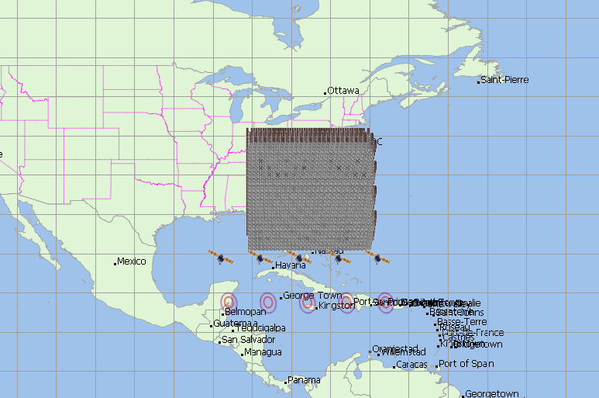

## 2.3 Uplink analysis of HAPS System 6 and EESS (passive) sensor

Uplink (UL) analysis examines the effect of HAPS ground station transmitters on EESS (passive) sensor R1 for both static analysis and dynamic assessments.

UL static analysis

UL static analysis examines the OOB attenuation required by ITU-R protection criteria: Recommendation ITU-R RS.2017 limits the maximum received interference power as described in § 1.1.2.

Table 33 lists an UL static analysis that shows the worst-case interference level between the HAPS uplink transmission band 21.4-22 GHz and the EESS (passive) frequency band 22.21‑22.5 GHz, from one HAPS coverage area. Characteristics relevant to the static analysis are as follows:

1 Two ground stations may be oriented for mainbeam-to-mainbeam coupling: one CPE and one GW, both located in the same quadrant.

2 Sensor R1 will be used as the EESS (passive) sensor for the 22.21-22.5 GHz frequency band: 39.7 dBi maximum antenna gain; conically-scanning sensor at 854 km altitude, Earth incidence angle 53.1 degrees (therefore elevation angle 36.9 degrees, and slant range 1 298 km); the other three CPE stations are ignored for this static analysis, since they are offset from boresight, and their impact on total interference power is minimal.

3 Note that each CPE must be located in a different quadrant of the HAPS coverage area, by definition.

TABLE 33

Static analysis for HAPS UL from CPE and GW, into EESS (passive)   
sensor R1 in 22.21-22.5 GHz frequency band

| ParametersUnits | Values | Source / Comment |
| --- | --- | --- |
| HAPS e.i.r.p. spectral density: CPE dB(W/MHz) | 23.2 | Report ITU-R F.2439-0 |
| e.i.r.p + 39.7 dBi max EESS antenna gain, one CPE dB(W/100 MHz) | 82.9 | Includes bandwidth correction; does not include FSPL or polarization mismatch loss |
| HAPS e.i.r.p. spectral density: GW dB(W/MHz) | 38.3 | Report ITU-R F.2439-0 |
| e.i.r.p. + 39.7 dBi max EESS antenna gain dB(W/100 MHz) | 98.0 | Includes bandwidth correction; does not include FSPL or polarization mismatch loss |
| e.i.r.p. density+EESS antenna gain:  Maximum received power, no losses considered dB(W/100 MHz) | 98.1 | Sum of CPE + GW, does not include FSPL or polarization mismatch loss |
| Distance to EESS sensor (km) | 1 298 | Slant range to conically-scanning sensor |
| Free space path loss (FSPL) (dB) | 181.6 | =20log(freqGhz) + 20log(distkm) + 92.45 |
| Polarisation mismatch loss (dB) | 1.5 dB | ITU Radio Regulations Appendix 8, § 2.2.3 |
| Total losses (dB) | 183.1 | =FSPL + polarisation mismatch |
| e.i.r.p. density at EESS satellite (dB(W/100 MHz)) | −84.9 | e.i.r.p. density of 1 CPE + 1GW, including losses |
| Interference threshold, EESS sensor (dB(W/100 MHz)) | −169 | Rec. ITU-R RS.2017 |
| Threshold exceedance (dB) | 84.1 | = max HAPS OOB attenuation required |

As listed in the Table above, 84.1 dB attenuation is required from the HAPS passband UL power 21.4‑22 GHz to meet the protection criteria in Recommendation ITU-R RS.2017.

UL dynamic analysis

The goal of this HAPS UL dynamic analysis is to determine the statistical distribution of aggregate interference power from HAPS CPE and GW ground stations, received at the EESS satellites. The aggregate interference power represents the net transfer function between a collection of HAPS coverage areas, spaced at 100 km intervals, and the EESS (passive) satellite sensor R1, gathering data in the 22.21-22.5 GHz frequency band. This is a near-adjacent sharing and compatibility assessment, so the results determine the amount of passband-to-OOB attenuation and OOB e.i.r.p. required to protect EESS (passive) services from HAPS CPE and GW OOBE.

Study A’s UL dynamic analysis models EESS (passive) sensor R1. Using the methodology and approach described in § 1.1.3, the simulation scenario depicted in Fig. 35 above was completed: the Figure shows all of the five EESS (passive) sensor footprints (−3 dB footprints are outlined in red) outside of the defined measurement area. Data was collected every 11 ms during the simulation from all five EESS (passive) satellites over the defined measurement area.

Figure 36 shows dynamic analysis results for more than 50.5 thousand valid data samples, plotted as a cumulative distribution function. At a given interference power (X-axis), the CDF (Y-axis) is the percentage of valid data whose received interference power is greater than or equal to that power. For example, consider when interference power = −120 dB(W/100 MHz), approximately 4% of data samples within the measurement area are ≥ −120 dB(W/100 MHz).

The horizontal line in the figure below shows the attenuation required to meet Recommendation ITU‑R RS.2017 protection criteria for HAPS technical and operational characteristics detailed in Report ITU-R F.2439-0, dated 24 November 2017. The leftmost red dot is the Recommendation ITU‑R RS.2017 receive power limit of -169 dB(W/100 MHz) that only occurs for ≤ 0.1% of data samples, and the rightmost red dot shows the HAPS UL interference power without OOB attenuation. Their difference is 77.5 dB, the attenuation required for HAPS to meet the Recommendation ITU-R RS.2017 protection criteria.

Analysis of 4 CPE/(100 km × 100 km) and 1 GW/(100 km × 100 km)

Figure 36

CDF of Received Interference Power from HAPS 4 CPE/(100 km × 100 km) and 1 GW/(100 km × 100 km) stations, into EESS (passive) sensor R1

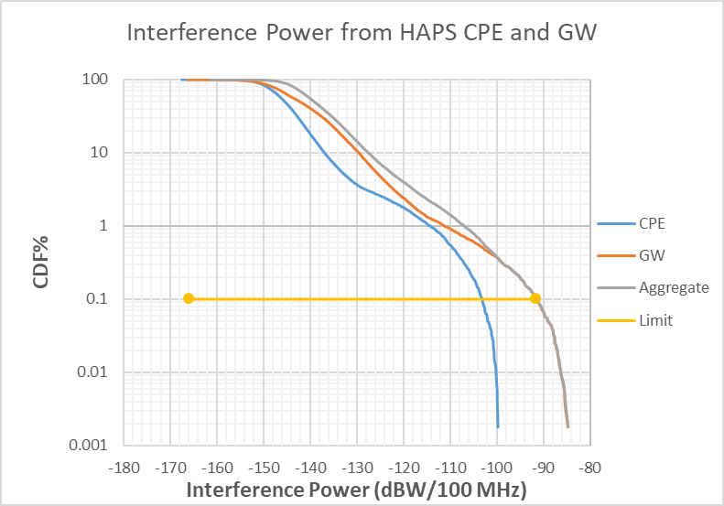

The aggregate 0.1% interference power level received during the simulation when considering the latest revision of the Report ITU-R F.2439-0 is −91.5 dB(W/100 MHz). This exceeds the RS.2017 0.1% limit of −169 dB(W/100 MHz) by 77.5 dB. When considering an apportionment factor of 5 dB, this exceeds the RS.2017 0.1% limit of −169 dB(W/100 MHz) by 82.5 dB. The 0.1% interference power level received during the simulation from CPE ground stations is −102.7 dB(W/100 MHz). This analysis considers only four CPE ground stations per 100 km × 100 km.

Analysis of 16 CPE/(100 km × 100 km) and 2 GW/(100 km × 100 km)

The same dynamic analysis methodology was used to evaluate the interference, with the following exceptions:

– The number of CPE ground stations was increased from four stations per 100 km × 100 km to 16 stations per 100 km × 100 km.

– The number of GW ground stations was increased from one station per 100 km × 100 km to two stations per 100 km × 100 km.

Figure 37

CDF of received interference power from HAPS 16 CPE/(100 km × 100 km) and 2 GW/(100 km × 100 km) stations, into EESS (passive) sensor R1

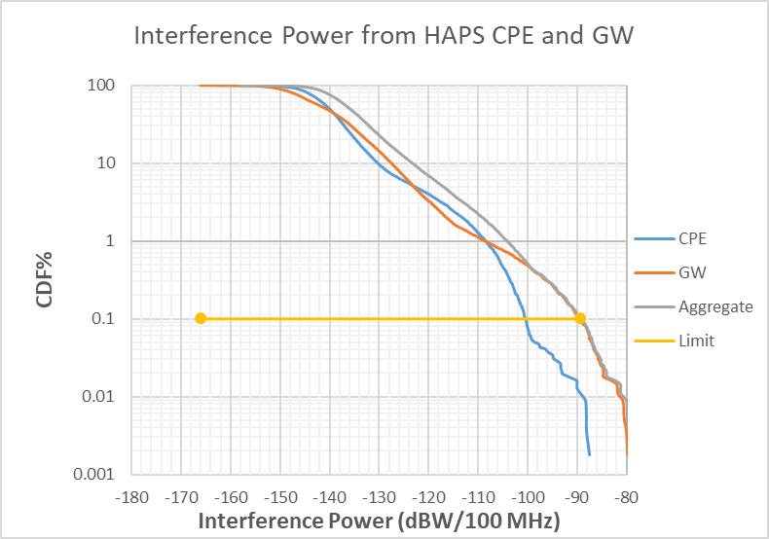

The aggregate 0.1% interference power level received during the simulation when considering the latest revision of Report ITU-R F.2439-0 is −89.2 dB(W/100 MHz). This exceeds the RS.2017 0.1% limit of −169 dB(W/100 MHz) by 79.8 dB. When considering an apportionment factor of 5 dB, this exceeds the Recommendation ITU-R RS.2017 0.1% limit of −169 dB(W/100 MHz) by 84.8 dB. The 0.1% interference power level received during the simulation from CPE ground stations is −100.4 dB(W/100 MHz).

UL analysis summary

UL static analysis, using EESS (passive) sensor R1, calculated an attenuation requirement of 84.1 dB, when using worst case (boresight) antenna alignments between two transmitters (one CPE ground station and one GW ground station) and the EESS antenna for sensor R1, not including apportionment. A 5 dB apportionment factor was applied based on guidance from ITU-R relevant group, as described in § 1.1.2; the complete result is an attenuation requirement of 89.1 dB.

The UL static analysis only considered one HAPS coverage area, and did not include statistical probability to estimate how often this coupling might occur. Its conclusion was an UL dynamic analysis was required.

UL dynamic analysis data, using EESS (passive) Sensor R1, comprised a CDF of HAPS interference power received by the EESS sensor, for data when the sensor footprint fell within the 2 000 000 km2 measurement area.

HAPS ground stations populated the measurement; their power, antenna pattern and gain, as well as relative spacing are defined by the Report ITU-R F.2439-0. To limit interference power in excess of −169 dB(W/100 MHz), to ≤0.1% of data samples, HAPS filters or shields must attenuate OOB emissions by 79.8 dB beyond propagation and polarisation losses, not including apportionment. A 5 dB apportionment factor was applied based on guidance from ITU-R relevant group, as described in § 1.1.2; the complete result is an attenuation requirement of 84.8 dB.

## 2.4 Downlink analysis of HAPS system 6 and EESS (passive)

Downlink (DL) analysis examines the effect of HAPS transmitters on EESS (passive) sensor R1.

DL static analysis

DL static analysis examines the OOB attenuation required to protect EESS (passive) sensors from HAPS transmissions, using ITU protection criteria from Recommendation ITU-R RS.2017, which is described in § 1.1.2.

The interference from HAPS transmissions on EESS sensors is primarily dependent on off-axis gain of the HAPS antenna. Two DL static analyses are shown below because two very different radiation patterns have been specified for the HAPS -to-CPE antenna for HAPS system 6:

a. Table 34 contains DL static analysis using Recommendation ITU-R F.1245 for both HAPS antenna patterns: HAPS-to-GW and HAPS-to-CPE. Recommendation ITU-R F.1245 was originally specified for both HAPS antenna patterns; its gain at 22 GHz is approximately −8.8 dBi, when the off-axis angle between the HAPS and the EESS (passive) sensor antenna exceeds 48 degrees. Recommendation ITU-R F.1245 is recommended for use from 1 to 70 GHz.

b. Table 35 contains DL static analysis using Recommendation ITU-R F.1891 for the HAPS to CPE antenna pattern, and Recommendation ITU-R F.1245 for the HAPS to GW antenna pattern. The HAPS-to-CPE radiation pattern was changed to Recommendation ITU-R F.1891; however, its phased array antenna pattern was previously specified for HAPS in 5 850-7 075 MHz, or lower frequency bands. Recommendation ITU-R F.1891 does not specify this antenna pattern for higher frequency bands. From Recommendation ITU-R F.1891, § 8 (Antenna Gain Pattern), the off-axis HAPS-CPE antenna gain at 24 GHz is −44.9 dBi, when the off-axis angle between the HAPS and EESS (passive) sensor antenna F4 exceeds 37.4 degrees.

Tables 34 and 35 show that the results vary by 11.2 dB. Table 34 shows 19.4 dB threshold exceedance when considering all transmissions from one HAPS. Because the result indicates attenuation is required, a dynamic analysis of the HAPS DL is performed below. In contrast, Table 35 indicates 8.2 dB attenuation is required. The two DL static analyses are different because the two proposed HAPS antenna patterns have very different off-axis gain. DL dynamic analyses were performed for both HAPS antennae. Further discussion on the static analyses follows Table 35.

TABLE 34

Static analysis for HAPS DL, into EESS (passive) sensor R1 in 22.21-22.5 GHz frequency band, using Rec. ITU-R F.1245 for HAPS-GW and HAPS-CPE antenna patterns

| Parameter | Value | Source |
| --- | --- | --- |
| HAPS e.i.r.p. spectral density: CPE (dB(W/MHz)) | 4.4 | Report ITU-R F.2439-0 |
| HAPS-to-CPE antenna gain (dBi) | 28.1 |
| Off-axis angle from HAPS antenna to EESS (passive) satellite (degree) | > 48 | Rec. ITU-R F.1245 |
| HAPS-CPE and HAPS-GW antenna gain in direction of EESS (passive) (dBi) | -8.8 |
| e.i.r.p. density_Off_Axis: HAPS-CPE (dB(W/100 MHz)) | −12.5 | e.i.r.p – HAPS Antenna Gain + HAPS antenna gain in direction of EESS (passive) +10log(100) |
| HAPS e.i.r.p. spectral density: GW (dB(W/MHz)) | 4.0 | Report ITU-R F.2439-0 |
| HAPS-to-GW antenna gain (dBi) | 32.6 |
| e.i.r.p. density_Off_Axis: HAPS-GW (dB(W/100 MHz)) | −17.4 | e.i.r.p – HAPS Antenna Gain + HAPS antenna gain in direction of EESS (passive) +10log(100) |
| e.i.r.p. density_Off_Axis for one GW and four CPE transmissions (dB(W/100 MHz)) | −6.2 | Does not include FSPL or polarisation mismatch loss |
| Sum of e.i.r.p. density_Off_Axis +39.7 max EESS antenna gain (dB(W/100 MHz)) | 33.5 |  |
| Distance to EESS sensor (km) | 1 298 | Slant range for 53.1° incidence angle |
| Free space path loss (dB) | 181.6 | =20log(freqGhz) + 20log(distkm) + 92.45 |
| Polarisation mismatch loss (dB) | 1.5 | ITU Radio Regulations Appendix 8, § 2.2.3 |
| *Sum of FSPL + Polarisation Loss (dB)* | *183.1* | *=FSPL + polarisation mismatch* |
| Interference at EESS satellite (dB(W/100 MHz)) | −149.6 | =Sum of (e.i.r.p. density_Off_Axis +39.7) – Losses |
| Interference threshold, EESS sensor (dB(W/100 MHz)) | −169 | Recommendation ITU-R RS.2017 |
| Threshold exceedance (dB) | 19.4 | = max HAPS stopband attenuation required |

TABLE 35

Static analysis for HAPS DL, into EESS (passive) sensor R1 in 22.21-22.5 GHz frequency band, using Rec. ITU-R F.1245 for HAPS-GW and Rec. ITU-R F.1891 for HAPS-CPE antenna patterns

| Parameter | Value | Source |
| --- | --- | --- |
| HAPS e.i.r.p. spectral density: CPE dB(W/MHz) | 4.4 | Report ITU-R F.2439-0 |
| HAPS-to-CPE max antenna gain (dBi) | 28.1 |
| Off-axis angle from HAPS-CPE antenna to EESS (passive) satellite (degrees) | > 37.4 | Rec. ITU-R F.1891 |
| HAPS-CPE antenna gain in direction of EESS (passive) (dBi) | −44.9 |
| e.i.r.p. density_Off_Axis: HAPS-CPE (dB(W/100 MHz)) | −48.6 | e.i.r.p – HAPS-CPE Max Antenna Gain + HAPS antenna gain in direction of EESS (passive) +10log(100) |
| HAPS e.i.r.p. spectral density: GW dB(W/MHz) | 4.0 | Report ITU-R F.2439-0 |
| HAPS-to-GW max antenna gain (dBi) | 32.6 |
| Off-axis angle from HAPS-GW antenna to EESS (passive) satellite (degrees) | > 48 | Rec. ITU-R F.1245 |
| HAPS-GW antenna gain in direction of EESS (passive) (dBi) | −8.8 |
| e.i.r.p. density_Off_Axis: HAPS-GW dB(W/100 MHz) | −17.4 | e.i.r.p – HAPS Antenna Gain + HAPS antenna gain in direction of EESS (passive) +10log(100) |
| e.i.r.p. density_Off_Axis for one GW and four CPE transmissions (dB(W/100 MHz)) | −17.4 | Does not include FSPL or polarisation mismatch loss |
| Sum of e.i.r.p. density_Off_Axis +39.7 max EESS antenna gain  dB(W/100 MHz) | 22.3 |  |
| Distance to EESS sensor (km) | 1 298 | Slant range for 53.1° incidence angle |
| Free space path loss (dB) | 181.6 | =20log(freqGhz) + 20log(distkm) + 92.45 |
| Polarisation mismatch loss (dB) | 1.5 | ITU Radio Regulations Appendix 8, § 2.2.3 |
| *Sum of FSPL + Polarisation Loss (dB)* | *183.1* | *=FSPL + polarisation mismatch* |
| Interference at EESS satellite dB(W/100 MHz) | −160.8 | =Sum of (e.i.r.p. density_Off_Axis +39.7) – Losses |
| Interference threshold, EESS sensor dB(W/100 MHz) | −169 | Rec. ITU-R RS.2017 |
| Threshold exceedance (dB) | 8.2 | = max HAPS stopband attenuation required |

The difference in DL static analysis results illustrates the importance of specifying an acceptable radiation pattern for the HAPS-to-CPE antenna. Recommendation ITU-R F.1245 is an acceptable ITU-R antenna pattern for this 22 GHz sharing study, and it indicates 19.4 dB OOB attenuation is required. In contrast, Recommendation ITU-R F.1891 does not have an acceptable ITU-R radiation pattern for this 22 GHz sharing study, and it indicates 8.2 dB OOB attenuation is required.

DL dynamic analysis

The goal of this HAPS DL dynamic analysis is to determine the statistical distribution of aggregate interference power from HAPS, received at the EESS (passive) satellites. The aggregate interference power represents the net transfer function between a collection of HAPS, spaced at 100 km intervals and the EESS (passive) satellite sensor R1, gathering data in the 22.21‑22.5 GHz frequency band. This is a near-adjacent sharing and compatibility assessment, so the results determine the amount of passband-to-OOB attenuation required to protect EESS (passive) services from HAPS OOB emissions.

Study A’s DL dynamic analysis models EESS (passive) sensor R1. Using the methodology and approach described in § 1.1.3, the simulation scenario depicted in Fig. 27 was completed: the Figure shows the five EESS sensor footprints (‑3 dB footprints are outlined in **red**) outside of the defined measurement area. Data was collected every 11 ms during the simulation from all five EESS satellites over the defined measurement area.

Like the DL static analysis, the DL dynamic analysis was also calculated twice:

a. One dynamic analysis with the HAPS-to-CPE and HAPS-to-GW antenna patterns both from Rec. ITU-R F.1245, Results are shown in Fig. 38.

b. One dynamic analysis with the HAPS-CPE antenna pattern from Recommendation ITU‑R F.1891, and the HAPS-to-GW antenna from Recommendation ITU-R F.1245. Results are shown in Fig. 39.

Figures 38 and 39 show the two DL dynamic analysis results, each having more than 50.5 thousand valid data samples and plotted as a cumulative distribution function. At a given interference power (X-axis), the CDF (Y-axis) is the percentage of valid data whose received interference power is greater than or equal to that power level. For example, in Fig. 38, consider when interference power = −153 dB(W/100 MHz), approximately 30% of data samples within the measurement area are ≥ −153 dB(W/100 MHz).

The only simulation difference between Fig. 38 and Fig. 39 is the specified HAPS -to-CPE antenna pattern. Table 36 compares the two results. It should be noted that Recommendation ITU-R F.1891 antenna pattern is only valid between 5 850-7 075 MHz, and at lower frequencies as specified in Resolution **221 (Rev.WRC-07)**. Therefore, Recommendation ITU-R F.1891 is not a valid antenna pattern for this sharing study.

Unlike Recommendation ITU-R F.1891, note that Recommendation ITU-R F.1245 is specified for use from 1 to 40 GHz, and provisionally from 40 GHz to about 70 GHz. Recommendation ITU-R F.1764-1 mentions its use for HAPS above 3 GHz.

Figure 38

CDF of received interference power into EESS (passive) sensor R1, from HAPS, 22 GHz DL, using Rec. ITU-R F.1245 for HAPS-to-CPE antenna pattern and HAPS-to-GW antenna pattern

Figure 39

CDF of received interference power into EESS (passive) sensor R1, from HAPS, 22 GHz DL, using Rec. ITU-R F.1891 for HAPS-to-CPE antenna pattern and Rec. ITU-R F.1891 for HAPS‑to‑GW antenna pattern

TABLE 36

Compare DL dynamic analyses: impact of two HAPS -to-CPE antenna patterns, 22 GHz

| Parameter | Rec. ITU-R F.1245 antenna pattern, CDF shown in Fig. 38 | Rec. ITU-R F.1891 antenna pattern, CDF shown in Fig. 39 | Comment(s) |
| --- | --- | --- | --- |
| Rec. ITU-R RS.2017 max interference power and max exceedance % | −169 dB(W/100 MHz) @ 0.1% exceedance | | Same protection criteria applied to both |
| OOB attenuation required to meet Rec. ITU-R RS.2017 | 19.7 | 9.1 | ITU-R F.1891 model requires 9.1 dB OOB attenuation; however, it is not specified for this band, hence, unacceptable for 22 GHz ITU sharing study |

DL dynamic e.i.r.p. density vs. elevation angle analysis

The methodology of studies done in the DL dynamic analysis section was the same for the DL dynamic assessment of e.i.r.p. density versus elevation angle, with the following exceptions:

– The e.i.r.p. density of each HAPS had the following mask:

where *El* is the elevation angle (degree) at the platform height.

– These e.i.r.p. density limits were assessed as a per-platform limit, rather than a per beam limit. If there are multiple beams then the total interference would increase by 10xlog(number of beams).

Figure 40 shows the DL dynamic analysis CDF results of interference to EESS (passive), having more than 44 000 valid data samples and plotted as a cumulative distribution function.

Figure 40

CDF of received e.i.r.p. vs. elevation angle interference power into EESS (passive) sensor R1,  
from HAPS, 22 GHz DL

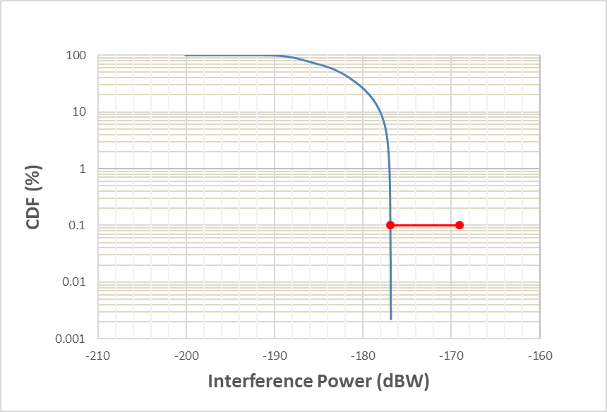

The maximum power level received at the EESS from the HAPS e.i.r.p. density vs. elevation angle mask is −176.9 dB(W/100 MHz). If a 5 dB apportionment factor is considered, the RS.2017 0.1% interference limit of −169 dB(W/100 MHz) is still met. The HAPS e.i.r.p. density vs. elevation angle mask was assessed per-platform, though each platform transmits using multiple beams. If each beam uses the maximum e.i.r.p. density versus Elevation Angle mask the received interference will increase by 10x log(number of beams).

DL analysis summary

Analysis results for static and dynamic conditions yield significantly different conclusions based on the HAPS-to-CPE antenna pattern used for simulation.

DL static analysis using Recommendation ITU-R F.1245 for all HAPS antennae required 19.4 dB OOB attenuation, compared to 8.2 dB if Recommendation ITU-R F.1891 were used for the HAPS‑to-CPE antenna pattern, not including apportionment.

However, Recommendation ITU-R F.1891 is not valid for this band, and Recommendation ITU-R F.1245 is valid. Therefore, the filter requirement is 19.4 dB to protect EESS (passive) data gathering from 22.21‑22.5 GHz, not including apportionment. A 5 dB apportionment factor was applied based on guidance from ITU-R relevant group, as described in § 1.1.2; the complete result is an attenuation requirement of 24.4 dB.

For DL dynamic analysis, use of Recommendation ITU-R F.1245 for all HAPS antennas required 19.7 dB OOB attenuation to meet EESS (passive) protection criteria, not including apportionment. A 5 dB apportionment factor was applied based on guidance from ITU-R relevant group, as described in § 1.1.2; the complete result is an attenuation requirement of 24.7 dB.

The calculated values of OOB attenuation required are dependent on all HAPS parameters remaining the same as those used for analysis. Table 36 above provides the amount of filtering required, in dB, as well as the HAPS transmitter output limits based on dynamic analysis, which remain valid even if HAPS spectral density were changed, provided the HAPS antennae information remains valid.

The following e.i.r.p. density versus elevation angle mask for HAPS OOBE the 22.21-22.5 GHz band meets the Recommendation RS.2017 Max Interference Power and Exceedance % for EESS (passive) systems from the HAPS-to-ground transmissions provided that the limit is applied on a per-platform basis, with the aggregate of all beams on a single platform being at or below the following e.i.r.p. density levels:

– e.i.r.p. density = −0.76 El – 9.5 dB(W/100 MHz) for −4.53°≤El<35.5°

– e.i.r.p. density =−36.5 dB(W/100 MHz) for 35.5°≤El<90°

– where El is the elevation angle with respect to the horizon of the HAPS

## 2.5 Uplink and downlink analysis results for study A

Table 37 summarizes the results of HAPS-EESS analyses for HAPS System 6 operating in the 21.4‑22 GHz band, and considering e.i.r.p. density levels required to meet the EESS (passive) protection criteria from Recommendation ITU-R RS.2017 for the 22.21-22.5 GHz band.

The uplink e.i.r.p. density limits are calculated by determining the exceedance of the Recommendation ITU-R RS.2017 protection criteria based on the ground-to-HAPS maximum antenna gain and input power levels for the 21.4-22 GHz band. HAPS CPE and GW 0.1% Recommendation ITU-R RS.2017 exceedances of 68.6 and 79.8 respectively, results in input transmit powers to −71.7 dB(W/100 MHz) for CPE and −72.9 dB(W/100 MHz) for GW. With the addition of the antenna gain for the respective HAPS stations, the e.i.r.p. density limit to meet the Recommendation ITU-R RS.2017 protection criteria for CPE is −25.4 dB(W/100 MHz) and for GW −21.5 dB(W/100 MHz). Assuming 5 dB of apportionment between services and 3 dB for aggregate of GW and CPE contributions, the e.i.r.p. density values to meet the Recommendation ITU-R RS.2017 limits are −33.4 dB(W/100 MHz) for CPE and −29.5 dB(W/100 MHz) for GW. These values assume 16 CPE ground stations/100 km × 100 km and 2 GW ground stations/100 km × 100 km.

TABLE 37

Study A analysis summary: HAPS 21.4-22 GHz OOB levels from both CPE and GW concurrent operations for compatibility with EESS (passive) 22.21-22.5 GHz

|  |  |  |
| --- | --- | --- |
| Analysis approach | Uplink analysis summary | Downlink analysis summary |
| Static | Rec. ITU-R RS.2017: 89.1 dB OOB attenuation required for ground stations of one HAPS coverage area | Rec. ITU-R RS.2017: Using ITU-R F.1245 for both HAPS antennas: HAPS-GW & HAPS-CPE: 24.4 dB OOB attenuation required to meet maximum power threshold, assessing one HAPS coverage area |
| Dynamic | Rec. ITU-R RS.2017: 84.6 dB OOB attenuation required to limit exceedance to 0.1%  OOB CPE e.i.r.p. density, 22.21-22.5 GHz, = −33.4 dB(W/100 MHz)  OOB GW e.i.r.p. density, 22.21‑22.5 GHz = −29.5 dB(W/100 MHz) | Rec. ITU-R RS.2017: Using Rec. ITU-R F.1245 HAPS-to-CPE antenna: 24.7 dB OOB attenuation required to limit exceedance to 0.1%;  e.i.r.p. density= −0.76 El – 9.5 dB(W/100 MHz) for −4.53°≤El<35.5°  e.i.r.p. density=−36.5 dB(W/100 MHz) for 35.5°≤El<90°  Where El is the elevation angle with respect to the horizon of the HAPS |

Limitations of study A analyses:

a. Any modification of HAPS antenna parameters, transmit power or the HAPS coverage area would require scaling analysis results or repeating the analysis.

b. HAPS “cylinder” flight radius and elevation were not simulated – this analysis used a fixed 20 km altitude for all HAPS, and fixed latitude/longitude on grid.

# 3 Summary and analysis of the results of studies

## 3.1 HAPS station transmitting towards the HAPS GW/CPE stations

Three independent studies show that compatibility between EESS (passive) sensors and HAPS downlinks is feasible provided that the unwanted emission e.i.r.p. density in dB(W/100 MHz) from the HAPS in the bands 21.2-21.4 GHz and 22.21-22.5 GHz is below the following values:

where:

θ : elevation angle (degree) at the HAPS height.

This e.i.r.p. mask would cover all the transmissions from the HAPS (i.e. towards CPE and/or gateways) that could also have emissions in the direction of the EESS satellite. No apportionment of the EESS (passive) protection criterion is considered.

It is shown that, at least two of the HAPS systems can meet such e.i.r.p. density limit, based on the assumptions taken.

## 3.2 HAPS GW/CPE stations transmitting towards the HAPS station

One study indicates that, in order to protect EESS (passive), the unwanted emission e.i.r.p. density of HAPS CPE should be below −33.4 dB(W/100 MHz), and the unwanted emission e.i.r.p. density of HAPS gateways should be below −29.6 dB(W/100 MHz). This is assuming 5 dB apportionment to account for interference from other services and 3 dB to account for interference from the CPE and GW to the EESS (passive) protection criterion.

Annex 5  
  
Compatibility of Radio Astronomy service in the adjacent band 22.21-22.5 GHz and HAPS systems operating in the 21.4-22 GHz frequency range

# 1 Technical analysis

TABLE 38

Scenario considered

|  |  |  |
| --- | --- | --- |
|  | Study A | Study B |
| HAPS ground terminal to RAS | Uplink not considered | Uplink not considered |
| HAPS to RAS | X | X |

## 1.1 Study A

Among the HAPS frequency bands under consideration, the band 21.4-22 GHz is close to the frequency band 21.21-22.5 GHz, in which the Radio Astronomy Service (RAS) has a primary allocation. This study analyses the impact of HAPS station emissions into RAS station receivers. To protect Radio Astronomy service in the band 22.21-22.5 GHz from unwanted emission of HAPS in the band 21.4-22 GHz the resulting unwanted emission pfd of a HAPS at RAS receivers listed in the table below shall not exceed -176 dB(W/(m2.290 MHz)) for more than 2% of the time level unless otherwise agreed by administrations. In MHz this corresponds to −201 dB(W/(m2.MHz)). This level is based on 30 dBi RAS antenna gain towards HAPS considered to adjust the RAS protection level specified in Recommendation ITU-R RA.769.

Figure 41

HAPS frequency plan in the band 21.4-22.0 GHz

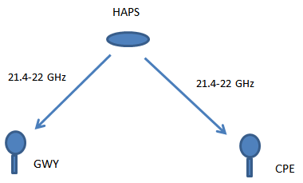

NOTE – The 30 dBi RAS antenna gain towards the HAPS relates to the time percentage of 2% associated to the RAS protection criteria. By assuming an IHD of 100 km, a total maximum of 81 HAPS can be seen by a RAS station. The RAS station while operating cannot receive interference for more than 2% of time which is the same as 2% of its field of view. This 2% field of view area divided between each HAPS amounts to:

From this area around each HAPS (in which interference can happen), the cone angle can be determined:

When applying RAS antenna pattern Recommendation ITU-R SA.509, this 1.27° corresponds to a gain of about 30 dBi (32-25l og(φ)).

### 1.1.1 The HAPS system

The parameters used in this analysis are given in Table 39.

TABLE 39

HAPS system 2 parameters in the band 21.4-22 GHz for the HAPS-to-ground direction

|  |  |  |
| --- | --- | --- |
| Frequency band | 21.4-22 GHz | |
| HAPS to | CPE station | Gateway station |
| Number of beams | 16 but 4 co-frequency | 2 |
| Antenna pattern | Beam forming (16 beams with only four beams co-frequency) | ITU R F.1245 |
| Antenna gain (dBi) | 29 | 34.3 |
| Maximum e.i.r.p. spectral density (dB(W/MHz)) under clear sky conditions | −8.5 | −19.9 |
| Maximum e.i.r.p. spectral density (dB(W/MHz)) in the band 22.21-22.5 GHz | −58.5 dB(W/MHz)  see §§ 1.2.1.1 and 1.2.1.2 | −84.9 dB(W/MHz)  see §§ 1.2.1.1 and 1.2.1.2 |
| Bandwidth per beam | 95 | 480 |
| Polarization | RHCP/LHCP | RHCP/LHCP |

TABLE 40

HAPS system 6 parameters in the band 21.4-22 GHz for the HAPS-to-ground direction

|  |  |  |
| --- | --- | --- |
| Frequency band | 21.4-22 GHz | |
| HAPS to | CPE station | Gateway (GW) station |
| Number of beams | 4 co frequency | 1 |
| Antenna pattern | ITU R F.1891 | ITU R F.1245 |
| Antenna gain (dBi) | 28.1 | 32.6 |
| Maximum e.i.r.p. spectral density (dB(W/MHz)) under clear sky conditions | −3.3 | −10.4 |
| Maximum e.i.r.p. spectral density (dB(W/MHz)) in the band 22.21-22.5 GHz | −53.3 dB(W/MHz)  see §§ 1.2.1.1 and 1.2.1.2 | −75.4 dB(W/MHz)  see §§ 1.2.1.1 and 1.2.1.2 |
| Bandwith (MHz) | 600 | 341 |
| Polarization | RHCP/LHCP | RHCP/LHCP |

#### 1.1.1.1 Out-of-band HAPS transmitter output filter

Each HAPS RF antenna system contains is a dish antenna for communication between HAPS and GW with a sharp cut-off filter with a stop-band rejection ratio for unwanted emissions from the passband.

Using current technologies for filter design, an OOB emission rejection of 25 dB is assumed for a transmission output filter in the band 21.4-22 GHz for protection of the RAS in the upper band 22.21‑22.5 (210 MHz offset).

No filter is considered for the HAPS transmitter towards CPE.

#### 1.1.1.2 HAPS transmitter baseband modulation

The envisaged digital modulation scheme is based on DVB-S waveform that conforms in the baseband with ETSI EN 301 790.



where is the Nyquist frequency and is the roll-off factor. Table 41 shows applicable roll-of factors for different DVB-S waveforms.

TABLE 41

DVB-S standards and supported roll-off factors

|  |  |  |  |
| --- | --- | --- | --- |
| Roll-off factor | DVB-S | DVB-S2 | DVB-S2X |
| 0.05 |  |  | X |
| 0.10 |  |  | X |
| 0.15 |  |  | X |
| 0.20 |  | X |  |
| 0.25 |  | X |  |
| 0.35 | X | X |  |

As an example using the modulations above and the appropriate roll-off factor, a minimum of 50 dB attenuation for the HAPS-to-CPE beam is ensured in the out-of-band domain, which would ensure compliance with Recommendation ITU-R SM.1541 applicable to digital fixed service operating above 30 MHz, which provides a 40 dB attenuation.

### 1.1.1.3 Adaptive power control

Taking into account HAPS scenario, the budget link of the communication is sensitive to rain and cloud attenuation. Therefore, in order to accommodate and to balance the budget link of the communication, adaptive power control mechanism can be implemented.

### 1.1.2 Analysis

The following steps are performed for the sharing study between HAPS emission and radio astronomy station:

Step 1: Compute the HAPS antenna gain for all possible elevation angles at the HAPS towards the Earth (−4.5° to −90°). Figure 42 provides respectively an example for the HAPS to CPE and for the HAPS to gateways.

Figure 42

|  |  |
| --- | --- |
| Antenna gain from HAPS vs elevation | |
| System 2 | |
|  |  |
| System 6 | |
|  |  |

Figure 43 is identical to Fig. 42 but the elevation angles at HAPS have been replaced by the distance from the sub HAPS point.

Figure 43

Antenna gain from HAPS vs distance

|  |  |
| --- | --- |
| System 2 | |
|  |  |
| System 6 | |
|  |  |

Step 2: Compute the attenuation from Recommendation ITU-R P.618 corresponding to *p* = 2% of the time at the radio astronomy location. Table 42 provides the results for all radio astronomy station in Region 2 operating in the band 22.21-22.5 GHz.

TABLE 42

RAS stations in Region 2 operating in 21.21-22.5 GHz

| Country | Name | N Latitude | E Longitude | Attenuation P.618 (p=2%) Elevation angle 21° | Attenuation P.618 (p=2%)  Elevation angle 33.4° |
| --- | --- | --- | --- | --- | --- |
| Brasil | Itapetinga | –23° 11' 05" | –46° 33' 28" | 0.5 | 0.4 |
| Canada | Algonquin radio observatory | 45° 57' 19" | –78° 04' 23" | 1.5 | 1.1 |
| USA | Green Bank telescope | 38° 25' 59" | –79° 50' 23" | 2.3 | 1.7 |
| Haystack | 42° 36' 36" | –71° 28' 12" | 1.7 | 1.3 |
| Kokee Park | 22° 07' 34" | –159° 39' 54" | 3.4 | 2.5 |
| Jansky VLA | 33° 58' 22" to 34° 14' 56" | –107° 24' 40" to  –107° 48' 22" | 1.4 | 1.0 |
| VLBA Brewster, WA | 48° 07' 52" | –119° 41' 00" | 1.3 | 1.0 |
| VLBA Fort Davis, TX | 30° 38' 06" | –103° 56' 41" | 0.6 | 0.4 |
| VLBA Hancock, NH | 42° 56' 01" | –71° 59' 12" | 2.0 | 1.5 |
| VLBA Kitt Peak, AZ | 31° 57' 23" | –111° 36' 45" | 1.7 | 1.3 |
| VLBA Los Alamos, NM | 35° 46' 30" | –106° 14' 44" | 1.6 | 1.2 |
| VLBA Mauna Kea, HI | 19° 48' 05" | –155° 27' 20" | 1.1 | 0.8 |
| VLBA North Liberty, IA | 41° 46' 17" | –91° 34' 27" | 3.3 | 2.4 |
| VLBA Owens Valley, CA | 37° 13' 54" | –118° 16' 37" | 2.0 | 1.5 |
| VLBA Pie Town, NM | 34° 18' 04" | –108° 07' 09" | 0.6 | 0.4 |
| VLBA St. Croix, VI | 17° 45' 24" | –64° 35' 01" | 1.2 | 0.9 |
| Goldstone | 35° 25' 33" | –116° 53' 22" | 3.9 | 2.9 |

Step 3: the pfd in dB(W/(m2.MHz)) level is computed using the following equation:

where

*Az* is the azimuth from the HAPS toward the RAS station

θ is the elevation angle at the HAPS towards the RAS station

*Att618p*=2% is the attenuation from Recommendation ITU-R P.618 corresponding to p=2% of the time at the radio astronomy location from step 2

*d* is the separation distance in m between the HAPS

EIRPmax clear sky is the maximum unwanted emission e.i.r.p. density towards the RAS station at which the HAPS station operates under clear sky condition in dB(W/MHz) in the RAS band

*GasAtt*(θ) is gaseous attenuation for elevation *El* (Recommendation ITU-R SF.1395).

Figure 44 provides respectively an example (goldstone case) of the result for the HAPS to CPE beam and the HAPS to GW beam.

Figure 44

pfd at the surface of the Earth

|  |  |
| --- | --- |
| System 2 | |
|  |  |
| System 6 | |
|  |  |

Step 3: Compare the results with the RAS protection criteria: pfd should not exceed −201 dB(W/(m2.MHz)) in the radio astronomy band. Figure 45 shows the area where it is exceeded (red area in the figure) and therefore the area where the RAS station should not be located. In this case, the HAPS and/or the CPE/GW beam locations should be modify to comply with the pfd limit to protect the RAS.

Figure 45

Compliance analysis

|  |  |
| --- | --- |
| System 2 | |
|  |  |
| System 6 | |
|  |  |

## 1.2 Study B

### 1.2.1 Introduction

Among the HAPS frequency bands under consideration, the band 21.4-22 GHz is close to the frequency band 21.21-22.5 GHz, in which the RAS has a primary allocation. Thus, this study investigates the sharing and compatibility between HAPS systems in the 21.4-22 GHz frequency band and RAS in the 22.21-22.5 GHz frequency band. In this study, the following directions are considered for HAPS.

– HAPS to CPE (DL)

– HAPS to GW (DL).

The proposed introduction of HAPS may provide diverse usage scenarios and applications with different network requirements. At the same time, it is necessary to ensure continued operation of services already allocated in the bands under consideration. Hence, sharing studies are required to understand the impact of HAPS systems on existing services.

### 1.2.2 Background

All studies consider the aggregate interference of a number of HAPS cells into the receiver of the incumbent service and were performed by means of system-level statistic simulations. The simulations concern the aggregate interference of a HAPS network consisting of several HAPS covering a large area. The results are thus probabilistic, i.e. a certain probability that the interference exceeds a given level is obtained for each scenario.

To contribute actively to ITU-R studies, the Spectrum, Orbit and Broadcasting Division of the Brazilian National Telecommunication Agency (ANATEL) is developing, in cooperation with partners in the industry and academia, an open-source simulation tool, named SHARC, to support SHARing and Compatibility studies between radio communication systems. SHARC was originally developed to study the interference to and from an IMT-2020, according to the framework proposed by Recommendation ITU-R M.2101. For this study, the simulator was adapted to model a HAPS system.

SHARC[3] is a statistic system-level simulator using the Monte-Carlo method. It has the main features required for a common system-level simulator, such as antenna beamforming, resource blocks allocation, among other.

In SHARC, the HAPS are located at fixed positions on a regular grid, and the gateways and CPEs are randomly located at each drop within the HAPS coverage area. For each link, the coupling loss is calculated between the GW/CPE and their nearest platform, including directional antennas and beamforming. The coupling losses between HAPS network elements and the interfered receiver are also calculated, enabling the interference calculation among the systems. Finally, system performance indicators are collected, and this procedure is repeated for a fixed number of snapshots.

The main key performance indicator obtained from these simulations is the aggregate interference generated by HAPS into the other system. Aggregate interference is a summation of interfering signals sourced from all active HAPS, gateways or CPEs, depending on the investigated scenario. In this contribution, a radio astronomy station is considered. The aggregate interference power is calculated and compared with protection criteria for this frequency range.

### 1.2.3 Technical characteristics

This section provides the specific parameters used in the study presented here. The following Tables list the main parameters and deployment characteristics of the HAPS (system 6) and radio astronomy stations that have been used in these studies.

TABLE 43

HAPS characteristics (system 6)

| Parameter | Value |
| --- | --- |
| Load factor | 100% |
| **HAPS to CPE link** | |
| Carrier frequency | 21.7 GHz |
| Bandwidth | 600 MHz |
| Maximum e.i.r.p. spectral density under clear sky conditions | −3.3 dB(W/MHz) |
| Maximum e.i.r.p. spectral density in the 22.21-22.5 GHz band | −53.3 dB(W/MHz) |
| Platform height | 20 km |
| Number of beams | 4 |
| 3 dB beamwidth | 3.4° |
| Antenna pattern | Rec. ITU-R F.1891 |
| Antenna peak gain | 28.1 dBi |
| Antenna near side-lobe relative level (LN) | −25 dB |
| **HAPS to GW link** | |
| Carrier frequency | 21.7 GHz |
| Bandwidth | 341 MHz |
| Maximum e.i.r.p. spectral density under clear sky conditions | −10.4 dB(W/MHz) |
| Maximum e.i.r.p. spectral density in the 22.21-22.5 GHz band | −75.4 dB(W/MHz) |
| Platform height | 20 km |
| Number of beams | 1 |
| Antenna pattern | Rec. ITU-R F.1245 |
| Peak antenna gain | 32.6 dBi |
| Antenna diameter | 0.2 m |

Each HAPS RF antenna system contains a dish antenna for communication between HAPS and GW with a sharp cut-off filter with a stop-band rejection ratio for unwanted emissions from the passband. Using current technologies for filter design, an OOB emission rejection of 25 dB is assumed for a transmission output filter in the band 21.4-22 GHz for protection of the RAS in the upper band 22.21‑22.5 (210 MHz offset). No filter is considered for the HAPS transmitter towards CPE.

According to the appropriate roll-off factor, a minimum of 40 dB attenuation for the HAPS-to- gateway beam and 50 dB attenuation for the HAPS-to-CPE beam is ensured in the out-of-band domain in order to comply with Recommendation ITU-R SM.1541, applicable to digital fixed services operating above 30 MHz.

Table below lists the parameters of the RAS station, performing continuum measurements on the 22.21-22.5 GHz frequency band. To protect Radio Astronomy Service in the band 22.21-22.5 GHz from unwanted emission of HAPS in the band 21.4-22 GHz the resulting unwanted emission pfd of a HAPS at RAS receivers listed in the table below shall not exceed −176 dB(W/m2) in 290 MHz for more than 2% of the time level unless otherwise agreed by administrations. This corresponds to −201 dB(W/m2) in 1 MHz. This level is based on 30 dBi RAS antenna gain towards HAPS considered to adjust the RAS protection level specified in Recommendation ITU-R RA.769.

TABLE 44

RAS Characteristics

| Parameter | Value |
| --- | --- |
| Centre frequency | 22.355 GHz |
| Bandwidth | 290 MHz |
| Antenna height | 50 m |
| Protection criterion pfd | −201 dB(W/m2) in 1 MHz |

The channel model used was taken from Recommendation ITU-R P.618, corresponding to *p* = 2% of the time at the radio astronomy location. The specific radio astronomy station considered was the Itapetinga station, in Brazil, and its characteristics, as well as the associated channel model parameters are listed below.

TABLE 45

Channel model

| Parameter | Value |
| --- | --- |
| HAPS to RAS Station | |
| Channel model | Rec. ITU-R P.618 + Rec. ITU-R SF.1395 |
| Propagation loss | Rec. ITU-R P.618 |
| Gaseous attenuation | Rec. ITU-R SF.1395 |
| Country | Brazil |
| Name | Itapetinga |
| N Latitude | –23° 11' 05" |
| E Longitude | –46° 33' 28" |
| Attenuation P.618 (p=2%) Elevation angle 21° | 0.5 dB |

The pfd at the RAS location in dB(W/(m2.MHz)) is computed using the following equation:

where:

maximum unwanted emission e.i.r.p. density towards the RAS station at which the HAPS station operates under clear sky condition

azimuth from the HAPS toward the RAS station

elevation angle at the HAPS towards the RAS station

attenuation from Recommendation ITU-R P.618 corresponding to p=2% of the time at the radio astronomy location

separation distance in m between the HAPS

gaseous attenuation for elevation El (Rec. ITU-R Rec. SF.1395).

### 1.2.4 Methodology

It is considered that HAPS are located on a regular hexagonal grid, with a 100 km distance between adjacent platforms. A cluster of 19 HAPS is considered.

In the case of the simulation of links between platforms and gateways, for each platform, one single gateway is randomly located within its coverage area, as seen, for example, in Fig. 46. The antennas from the gateways and the platforms are assumed to be perfectly pointed towards each other.

Figure 46

HAPS deployment scenario – Gateways

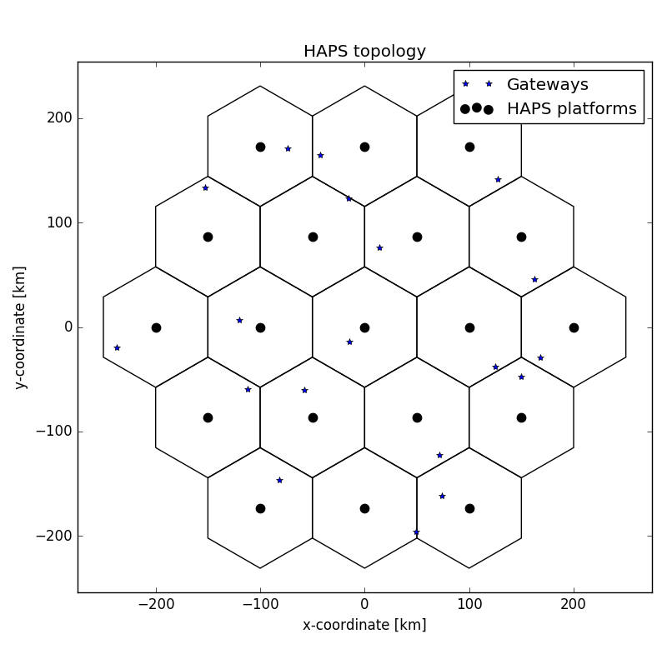

In the case of the simulation of links between platforms and CPEs, for each platform, four separate non-overlapping beams are generated for each platform at random angles, and within each beam, four different CPEs are randomly located. Such a configuration can be seen in Fig. 47. The antennas from the CPEs are assumed to be perfectly pointed towards the platform.

Figure 47

HAPS deployment scenario – CPEs

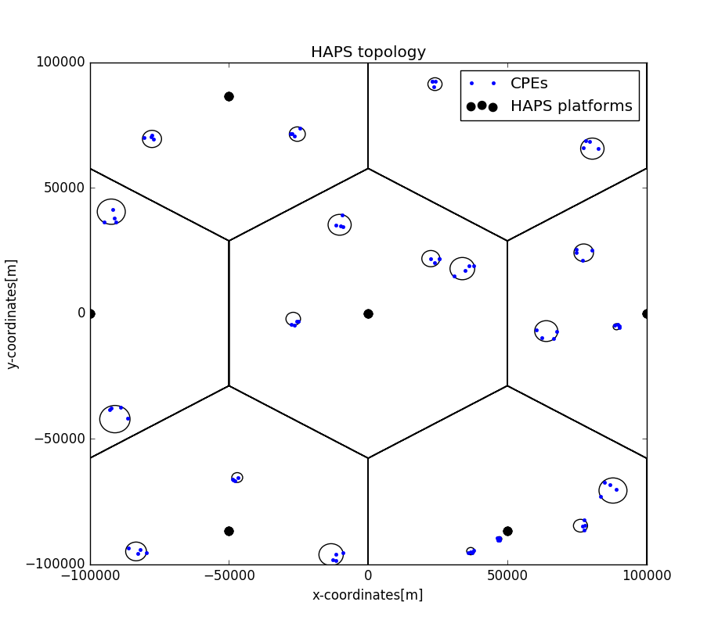

In case of simulation between HAPS and RAS, the RAS stations is assumed to be located at a fixed distance from the centre of the HAPS cluster, as shown in Fig. 48. The aggregate interference measured at the RAS station is expressed in the form of pfd and the results are compared with the protection criteria of maximum pfd of −201 dB(W/m2) in 1 MHz.

Figure 48

HAPS deployment scenario – Gateways



### 1.2.5 Results

The simulation results obtained are presented in the section below. The simulated RAS distances from the HAPS cluster were: 0 km (centre of cluster), 300 km (50 km from the edge of the cluster) and 350 km (100 km from the edge of the cluster). The distance to the edge of the cluster is the shortest distance to the closest HAPS coverage area (in this case, the coverage area of the east-most platform), and is taken based on the inter-site distance used, which is 100 km.

#### 1.2.5.1 HAPS CPE link in the 21.4-22 GHz to RAS in the 22.21-22.5 GHz band

Figure 49 shows the HAPS CPE link to RAS aggregate pfd in the 22.21‑22.5 GHz band, as well as the protection criteria. The results show that a distance of 50 km between the RAS station and the edge of the cluster is enough to ensure the protection of the RAS station. They present the percentage of cases the pfd values are exceeded for the three simulated RAS station positions: 0 km (centre of cluster), 300 km (50 km from the edge of the cluster) and 350 km (100 km from the edge of the cluster).

Figure 49

HAPS CPE link in the 21.4-22 GHz to RAS pfd

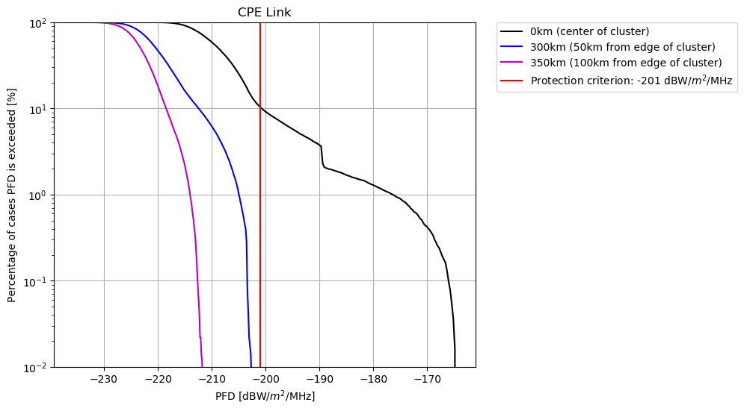

Figure 49 shows that, when the RAS station is inside the HAPS cluster, the percentage of simulation cases in which the interference of the Platform/CPE link to the RAS station is above the protection criterion of −201 dB(W/m2) in 1 MHz is approximately 10.37%. When the distance between the RAS station and the edge of the cluster is kept above 50 km, however, the aggregate interference is kept below the protection criterion for all of the simulated cases.

#### 1.2.5.2 HAPS GW link in the 21.4-22 GHz to RAS in the 22.21-22.5 GHz band

Figure 50 shows the HAPS GW link to RAS aggregate pfd in the 22.21-22.5 GHz band, as well as the protection criteria. The results show that, even when the RAS station is inside the HAPS cluster, the interference only surpasses the protection criterion for a very small percentage of the simulated cases. They present the percentage of cases where the pfd values are exceeded for three simulated RAS station positions: 0 km (centre of cluster), 300 km (50 km from the edge of the cluster) and 350 km (100 km from the edge of the cluster).

Figure 50

HAPS GW link in the 21.4-22 GHz to RAS pfd

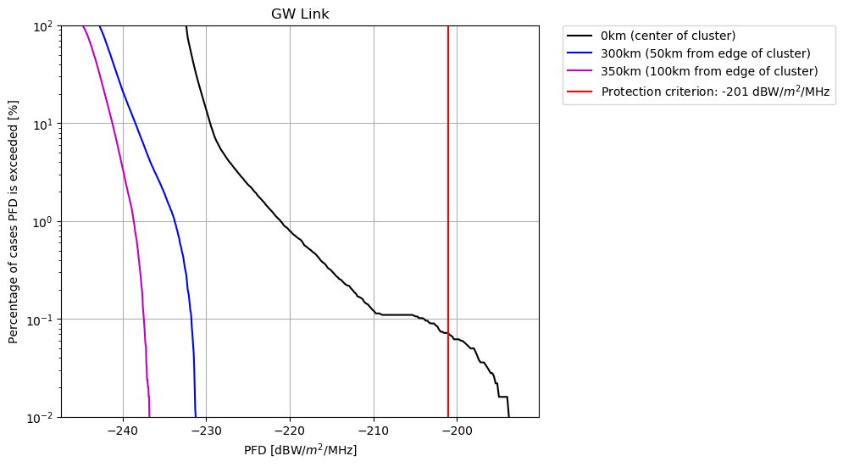

Figure 50 shows that, when the RAS station is inside the HAPS cluster, the percentage of simulation cases in which the interference of the platform to GW link to the RAS station is above the protection criterion of −201 dB(W/m2) in 1 MHz is approximately 0.07%. When the distance between the RAS station and the edge of the cluster is kept above 50 km, however, the aggregate interference is kept below the protection criterion for all of the simulated cases.

### 1.2.6 Summary and analysis of the results

Aggregated interference simulations from HAPS in the 21.4-22 GHz frequency band and Radio Astronomy Service (RAS) in the 22.21-22.5 GHz frequency band were performed. The results show that, given the assumptions and input parameters used in this study, a separation distance of 50 km is enough to keep the interference below the RAS protection criterion for the case of HAPS CPE link. For the GW link, even when the RAS station is inside the HAPS cluster, the interference exceeds the protection criterion in less than 0.1% of the simulated cases.

The fact that when the RAS station was inside the HAPS cluster the CPE link caused more interference to the RAS than the GW link can be explained by the fact that, in each HAPS coverage area, there are more CPE stations than GW station. Thus, the probability that a CPE station is located close to the RAS station (and the antennas will be pointing towards the RAS station) is higher than the probability that a GW station is located close to the RAS station. Furthermore, the GW link has a lower e.i.r.p. density when compared to the CPE link, causing less interference in the RAS station.

# 2 Summary and analysis of the results of studies

HAPS CPE and gateways uplinks

Although no study was performed for the uplinks, the RAS station performing observations in the band 22.21-22.5 GHz can be protected from HAPS CPE and gateways uplink transmissions in the band 21.4-22 GHz provided that those stations meet an unwanted emission pfd value of   
−146 dB(W/(m².290 MHz)) for continuum observations and −162 dB(W/(m².250 kHz)) for spectral line observations in the 22.21‑22.5 GHz band at the RAS station location at a height of 50 m. These pfd values shall be verified considering a percentage of time of 2% in the relevant propagation model. These pfd values can be met by the HAPS system through a combination of unwanted emission attenuation, separation distance or limitation to the uplink beam pointing direction. The possibilities for placement of HAPS ground stations may be affected by their situation with respect to the RAS station and HAPS.

HAPS downlinks

Studies have shown that the RAS station performing observations in the band 22.21-22.5 GHz can be protected from HAPS downlink transmissions in the band 21.4-22 GHz provided that such HAPS meet unwanted emission pfd values of −176 dB(W/(m².290 MHz)) for continuum observations and -192 dB(W/(m².250 kHz)) for spectral line observations in the 22.21‑22.5 GHz band at the RAS station location. This takes into account an allowable percentage of data loss of 2%. In order to avoid data loss to RAS systems, when pointing towards HAPS, RAS stations may need to implement angular cones of avoidance around HAPS by up to 1.3 degrees. These pfd values can be met by the HAPS system through a combination of unwanted emission attenuation, separation distance, or limitation of the ground station locations. These pfd values shall be verified considering a percentage of time of 2% in the relevant propagation model.

To verify the compliance, the following formula should be used:

where:

*EIRPmax* clear sky : maximum unwanted emission e.i.r.p. density towards the RAS station at which the HAPS station operates under clear sky condition in dB(W/MHz) in the RAS band

*Az* : azimuth from the HAPS toward the RAS station

θ : elevation angle at the HAPS towards the RAS station

*Att618p*=2% : attenuation from Recommendation ITU-R P.618 corresponding to p=2% of the time at the radio astronomy location from step 2

*D* : separation distance in m between the HAPS

*GasAtt(*θ*)*: gaseous attenuation for elevation θ (Rec. ITU-R SF.1395).

1. If the OOB emission level mask is symmetrical and sufficient to protect the 21.2-21.4 GHz band, it could be expected to offer equivalent protection to the 22.21-22.5 GHz band. The adequacy of this protection for this band should be further studied when emission mask parameters are set.
2. The Arizona radio observatory does not operate in this frequency range, but harmonics in this frequency range can impact observations.
3. The simulator is written in Python and the source code for the HAPS simulator is available at GitHub <https://github.com/Ektrum/SHARC_HAPS>.