REPORT ITU-R M.2109
Sharing studies between IMT-Advanced systems and geostationary
satellite networks in the fixed-satellite service in the 3 400-4 200
and 4 500-4 800 MHz frequency bands

(2007)

Executive summary
This Report provides a summary of the sharing studies between IMT-Advanced systems and geostationary satellite networks in the fixed-satellite service (FSS) in the 3 400-4 200 and 4 500-4 800 MHz frequency bands. It was conducted by ITU-R in the framework of Agenda item 1.4 of WRC-07, in accordance with resolves 5 to Resolution 228 (Rev.WRC-03), as these bands were identified as candidate bands for future development of IMT-2000 and IMT-Advanced systems, as described in the Report ITU-R M.2079.
The bands 3 400-4 200 MHz and 4 500-4 800 MHz are allocated worldwide on a primary basis to the FSS. This Report presents the results of the sharing studies performed between geostationary satellite networks in the FSS and IMT-Advanced systems.
The following areas are covered in this Report:
− Regulatory information.
− Frequency usage by satellite services in these bands, provided on a global and regional basis.
− FSS space and earth station deployments.
− Considerations on potential identification of the 3 400-4 200 MHz and 4 500-4 800 MHz bands for IMT-Advanced.
− Parameters of the systems considered in this Report.
− Sharing studies (methodologies and results) between the two services from two aspects:
− Interferences from IMT-Advanced transmitters to receiving FSS earth stations (in-band and adjacent band, and overdrive of the FSS receivers).
− Interferences from transmitting FSS space stations to IMT-Advanced receivers.
− Results from one measurement study on interference from IMT-Advanced transmitter into one television receive only (TVRO) earth station.
− Mitigation techniques and spectrum management techniques to improve the sharing possibilities.
− Sensitivity analysis with respect to certain parameters to show the effect of their variation on the sharing situation between both systems.
The main conclusions are provided in § 11.
Table of abbreviations:
3GPP 3rd generation partnership project
ACLR Adjacent channel leakage power ratio
ACS Adjacent channel selectivity
ATPC Automatic transmit power control
BER Bit error rate
C/N Carrier-to-noise power ratio
CDMA Code division multiple access
DOE Direction of earth station
EIRP Effective isotropic radiated power
FEC Forward error correction
FSS Fixed-satellite service
GSO Geostationary satellite orbit
IMT International Mobile Telecommunications
ITU International Telecommunication Union
LNA Low noise amplifier
LNB Low noise block downconverter
LoS Line-of-sight
MIFR Master International Frequency Register
MIMO Multiple input multiple output
NLoS Non line of sight
OFDM Orthogonal frequency division multiplexing
OFDMA Orthogonal frequency division multiple access
OOB Out of band
PSD Power spectrum density
PSK Phase shift keying
SDMA Space division multiple access
TDMA Time division multiple access
TT&C Tracking, telemetry and command
TVRO Television receive only
UMTS Universal mobile telecommunications System
UWB Ultra-wideband
VSAT Very small aperture terminal
WMO World Meteorological Organization

1 Introduction
During the preparatory work for WRC-07 performed within ITU-R, in accordance with Resolution 228 (Rev.WRC-03), the frequency bands 3 400-4 200 MHz and 4 400-4 990 MHz have been considered as two of the candidate bands for the future development of the terrestrial component of IMT-2000 and IMT-Advanced systems with the understanding that the use of these bands will be limited to the terrestrial component of IMT-Advanced.

2 Scope of the report
As the bands 3 400-4 200 MHz and 4 500-4 800 MHz are allocated worldwide on a primary basis to the FSS, this Report presents the results of the sharing studies performed between the FSS networks using the geostationary satellite orbit (GSO) and IMT-Advanced systems.
The sharing studies have been performed based on:
– the current band usage by GSO-FSS and the associated generalized characteristics, which could evolve during the period while IMT-Advanced is being further developed and implemented;
– assumptions on the future characteristics of IMT-Advanced.

3 Regulatory information

3.1 Table of the frequency allocations
Table 1 lists the various allocations contained in Article 5 of the Radio Regulations (RR) (Edition of 2004) together with their respective status in the frequency range 3 400-4 200 MHz, as well as in the frequency range 4 500-4 800 MHz.
TABLE 1
Table of frequency allocations in the bands 3 400-4 200 MHz and 4 500-4 800 MHz
Region 1 | Region 2 | Region 3
3 400-3 600  FIXED  FIXED-SATELLITE  (space-to-Earth)  Mobile  Radiolocation  5.431  3 600-4 200  FIXED  FIXED-SATELLITE  (space-to-Earth)  Mobile | 3 400-3 500  FIXED  FIXED-SATELLITE (space-to-Earth)  Amateur  Mobile  Radiolocation 5.433  5.432  3 500-3 700  FIXED  FIXED-SATELLITE (space-to-Earth)  MOBILE except aeronautical mobile  Radiolocation 5.433  5.435  3 700-4 200  FIXED  FIXED-SATELLITE (space-to-Earth)  MOBILE except aeronautical mobile
4 500-4 800 FIXED
FIXED-SATELLITE (space-to-Earth) 5.441
MOBILE

Note – Footnote 5.441 indicates, inter-alia, that the use of the band 4 500-4 800 MHz (space-to-Earth) by the FSS shall be in accordance with the provisions of RR Appendix 30B.

3.2 International considerations between FSS earth stations and IMT-Advanced stations
International protection of FSS earth stations and their coordination are governed by RR Nos 9.17 and 9.18 and is applicable only to specific FSS earth stations (those whose geographical coordinates are known). The thresholds/conditions to be used to trigger coordination are those specified in RR Appendix 5, together with the calculation method (contained in RR Appendix 7). This coordination procedure is a regulatory concept.
It is up to each administration to decide which stations within its own territory it wishes to protect in accordance with the RR. For Example, if an administration wishes to ensure the protection of the receiving FSS earth station located in its territory from the transmitting terrestrial station located in the adjacent countries and within the coordination area of the earth station, a set of specific earth stations located at the edge of the territory should be registered to the ITU through the coordination and notification procedure under the provisions of RR Articles 9 and 11.
Particularly, as specified in RR No 9.6, an administration intending to bring into use terrestrial services, whose territory falls within the coordination contours of the earth stations under the coordination or notification procedure or notified under RR Articles 9 and 11, shall effect coordination with other administrations having these earth stations.
The Radio Regulations do not provide any criteria or procedures for all kinds of required coordination under RR Article 9, such as between GSO FSS networks and between FSS and terrestrial network, for how this bilateral coordination is to take place.
Annex C gives examples of coordination contours at some locations.

3.3 National considerations between FSS earth stations and IMT-Advanced stations
In countries where FSS earth stations are deployed, national arrangements are likely to be required within national borders, by administrations willing also to deploy terrestrial systems in these bands.

4 FSS space stations and earth stations deployment in the 3 400-4 200 MHz and 4 500-4 800 MHz bands

4.1 Band 3 400-4 200 MHz
There is extensive utilization by the FSS of the frequency band 3 625-4 200 MHz in all ITU Regions of the world (except certain countries in Europe and in Asia) and of the frequency band 3 400-3 625 MHz in ITU Region 1 (except parts of Europe) and Region 3 (except some countries of Asia). The low atmospheric absorption in these bands enables highly reliable space-to-earth communication links with wide service coverage, particularly in, but not limited to, geographical areas with severe rain fade conditions. The wide coverage enables services to be provided to developing countries, to sparsely populated areas and over large distances.
The 3 400-4 200 MHz band has been used by the FSS for over 40 years. The technology is mature and offers equipment at low cost. This, together with the wide coverage, has lead to satellites in this band being an important part of the telecommunications infrastructure in many developing countries.
Satellite services in this band currently include very small aperture terminal (VSAT) networks, internet services, point-to-point links, satellite news gathering, TV and data broadcasting to satellite master antenna television (SMATV) and direct-to-home (DTH) receivers, feeder links for the mobile satellite service. Due to their wide coverage characteristics, satellites operating in this band have been extensively used for disaster relief operations.
The use of the band 3 400-4 200 MHz by FSS includes governmental uses and international commitments within the WMO. WMO usages of the band, which are essential for civil aviation and weather, water, climate and environmental alerts, are currently using only a few channels in the 3 600-3 800 MHz band.
The 3 400-4 200 MHz band is also utilized for tracking, telemetry and command (TT&C) purposes, under the FSS allocation, by a majority of FSS satellites operating in this band. Furthermore, there are additional satellites with service links operating in other frequency bands which have their TT&C in the 3 400-4 200 MHz band.
At the time of development of this Report, there were approximately 160 geostationary satellites operating in the band 3 400-4 200 MHz, comprising a total capacity exceeding two thousand 36 MHz transponders. The location and coverage areas of most of these satellites are provided in Table A2 of Annex A of this Report.
With regard to FSS earth stations receiving transmissions from FSS space networks, according to the ITU earth station database, there are more than 1 500 registered earth stations operating with geostationary satellites in the 3 400-4 200 MHz band. However, it should be noted that the majority of the FSS earth stations are not required to be notified to the ITU under the national regulations, and for each satellite system their characteristics are recorded in the Master International Frequency Register (MIFR) database under the “Typical earth station” category. In some rare cases, an FSS network filing with the ITU may contain few “Specific” earth stations filed in association with the satellite network.
Moreover, in many countries, the local administration does not individually license/register receive only earth stations or VSAT terminals and their number, location or detailed operating characteristics are not known. Also, even transmit stations are for the most part not registered with the ITU because their location does not raise interference issues with other countries.
FSS earth stations are deployed, in varying degrees, all around the world in the band 3 400-4 200 MHz. Some examples of such deployment are provided below.
− One major satellite operator has more than 9 900 registered earth stations, in its data base, deployed across the globe operating in the 3 400-4 200 MHz band. The location of these earth stations is shown in Fig. A4 through A6 of Annex A of this Report. The operating earth stations shown in these figures do not include all FSS earth stations dedicated to signal reception such as television receive-only (TVRO) terminals.
− In Brazil, in the band 3 700-4 200 MHz, there are more than 8 000 nationally registered earth stations pointing to one of the Brazilian satellites in and 12 000 nationally registered earth stations pointing to one of the non-Brazilian satellites that cover the country plus an equal number of earth stations in the 3 625-3 700 MHz band (see Fig. A7 of Annex A). There are also an estimated 20 million TVRO terminals deployed across the country.
− A provider of television programming in the USA provides programming via satellite directly to the general public in areas that are outside the coverage area of its terrestrial television stations. As of December 2005, there were approximately 122 000 receive-only earth stations that received programming from that provider in that country.
− Members of one Broadcasting Association utilize more than 31 000 earth stations in North America to reach over 66 million cable television households.
− In the Russian Federation, there are approximately 6 000 nationally registered earth stations that receive transmissions in the 3 400-4 200 MHz band (see Figs. A4, A5 and A6 of Annex A). This figure does not include TVRO earth stations that are deployed across the country.
− In France and Korea (Republic of), there is a limited number per country, twenty or less, of nationally registered FSS earth stations on their territories.
− In Finland and Sweden, there is a limited number per country, less than 5, of nationally registered FSS earth stations.
Different earth stations, depending on the application and traffic requirement may access different amounts of spectrum. For example, in Sweden, a particular earth station only uses a total of 2 MHz spectrum.
In other countries such as the United Kingdom, some earth station locations use a large number of antennas to communicate with different satellites and may therefore use the whole allocated band. An earth station antenna may also receive several carriers at different frequencies and may also switch between different receive frequencies (e.g. TVRO).

4.2 Band 4 500 – 4 800 MHz
The band 4 500-4 800 MHz is part of the FSS Plan, specified in RR Appendix 30B, and is therefore intended to preserve orbit/spectrum resources for future use, in particular for countries that may not have the possibility to implement satellite systems in unplanned bands in the short- and mid-terms.

5 Considerations on potential identification of the 3 400-4 200 MHz and 4 500-4 800 MHz bands for IMT-Advanced
This section provides some information about the main reasons why these bands are of interest for use by IMT-Advanced systems.
The size of these bands would accommodate IMT-Advanced systems which are envisaged with large bandwidth and would provide significant capacity, according to the ITU-R spectrum requirement estimations (see Report ITU-R M.2078).
The use of these bands may facilitate the convergence between cellular and broadband wireless access systems already deployed in the lower part of the band 3 400-4 200 MHz in some countries.
In some administrations, FSS is not deployed in the sub-band 3 400-3 600 MHz.
These frequency bands allow use of smaller antenna size for terminals and base stations, which is a favorable feature to implement multiple-antenna techniques enabling high spectrum efficiency.

6 FSS Parameters including the interference criteria
The parameters listed in § 6.1 provide key FSS parameters to be used in calculation of interference into FSS receive earth stations. Section 6.2 provides the interference criteria for FSS and § 6.3 addresses the apportionment of the interference for the FSS receivers.

6.1 System parameters
TABLE 2
Typical downlink FSS parameters in the 4 GHz band
Parameter | Typical value
Range of operating frequencies | 3 400-4 200 MHz, 4 500-4 800 MHz
Earth station off-axis gain towards the local horizon (dBi)⁽¹⁾ | Elevation Angle⁽²⁾ | 5° | 10° | 20° | 30° | 48° | >85°
 | Off-axis gain | 14.5 | 7.0 | –0.5 | –4.9 | –10 | 0
Antenna reference pattern | Recommendation ITU-R S.465 (up to 85°)
Range of emission bandwidths | 40 kHz – 72 MHz
Receiving system noise temperature | 100 K
Earth station deployment | All regions, in all locations (rural, semi-urban, urban) ⁽³⁾
⁽¹⁾ The values were derived by assuming a local horizon at 0° of elevation.
⁽²⁾ 5° is considered as the minimum operational elevation angle.
⁽³⁾ FSS antennas in this band may be deployed in a variety of environments. Smaller antennas
(1.8 m-3.8 m) are commonly deployed on the roofs of buildings or on the ground in urban, semi-urban or rural locations, whereas larger antennas are typically mounted on the ground and deployed in semi-urban or rural locations.

In order to conduct the simulations, the additional parameters were considered:
− Antenna diameter: 2.4 m and 11m (feeder link).
− Antenna height: 30 m (urban case) and 3m (rural case).
NOTE 1 − This set of parameters is representative of most of the earth stations deployed.

6.2 FSS interference criteria
Two interference criteria were identified for use when assessing the interference from IMT-Advanced to FSS.

6.2.1 Long-term interference criterion
Based on the Recommendation ITU-R S.1432, two cases have been considered, depending on the type of the scenarios studied:
− In-band sharing studies: I/N = −12.2 dB (ΔT/T = 6%) corresponding to the total interference from other systems having co-primary status, for 100% of the worst month or I/N = −10 dB (ΔT/T = 10%) corresponding to the aggregate interference from co-primary allocation for 20% of any month (Note: for typical BER-vs−C/N characteristics of PSK/FEC demodulators, the two criterion are effectively the same – i.e. if one is met the other will be met).
− Adjacent band sharing studies: I/N = −20 dB (ΔT/T = 1%) corresponding to the aggregate interference from all other sources of interference, for 100 % of the time.
where N is the clear-sky satellite system noise as described in Recommendation ITU-R S.1432.
Suitable apportionment of this criterion must be considered (see § 6.3).

6.2.2 Short-term interference criterion
The ITU-R reference for this criterion is Recommendation ITU-R SF.1006. This criterion also appears in Annex 7 (see both text and Table 8b) of RR Appendix 7:
− I/N = −1.3 dB which may be exceed by up to 0.001667% time (single entry)
It is noted that:
− the criterion above is also used to define a coordination area as defined in Annex 7 of RR Appendix 7, in conjunction with the methodology (e.g. propagation model) and other parameters described therein.
− Recommendation ITU-R SF.1006 recommends the methods that may be used for assessing interference potential between earth stations and the specific stations in the fixed service within the coordination area.

6.2.3 Guidance to use the two interference criteria
The interference potential into a FSS earth station should be evaluated taking into account both long-term and short-term interference criteria.
Studies have shown that for all types of terrain and paths, the separation distances calculated using the short-term criterion are significantly different from those calculated using the long-term.
It was noted by ITU-R that the propagation model described the Recommendation ITU-R P.452 should not be applied with a smooth earth terrain, but should use a representative terrain profile.
However, some studies have considered that the terrain profile associated with a smooth earth model is representative of areas such as coastal and flat inland plain regions. It should be noted that it is not representative of areas that have different characteristics and the use of such a model may result in the overestimation of the interference into a receiving FSS earth station.

6.3 Apportionment of the interference
As shown in § 8.1.4, two cases regarding the apportionment of the interference were investigated based on the following two assumptions.
− In one case, 100% of the interference to the FSS was allocated to IMT-Advanced systems, which corresponded to the case where both IMT-Advanced and the fixed service systems were assumed to be not deployed in the same band, in the same geographical area.
− In the other case, 50% (I/N = –15.2 dB) apportionment of the allowable interference
IMT-Advanced was evaluated, i.e., splitting the 6% allowance for other systems having a co-primary status equally between two such systems, which corresponded to the case when the FSS would share this band with the fixed service as well as IMT-Advanced systems.
Similarly, in the case of interference from other sources, including spurious emission and out-of-band (OoB) emissions from adjacent bands, it may be necessary to apportion the allotted increase in noise due to such sources of interference between various other sources of interference. No guidance has been provided by ITU-R regarding the apportionment of interference from the various other sources.

7 IMT-Advanced parameters including the interference criterion
The following values have been used to conduct the sharing studies presented in this Report.

7.1 In-band parameters
This paragraph contains the IMT-Advanced parameters assumed for the comparison of the different studies, which represent one possible scenario of an IMT-Advance deployment.
TABLE 3
IMT-Advanced base station parameters
Parameter | Value | Value considered in the simulations
EIRP density range: macro base station  scaled to 1 MHz bandwidth | 39 to 46 dBm/MHz | 46 dBm/MHz
EIRP density range: micro base station  scaled to 1 MHz bandwidth | 15 to 22 dBm/MHz | 22 dBm/MHz
Maximum EIRP⁽¹⁾  (Transmitter output power + antenna gain – feeder loss) | 59 dBm (macro base station)  35 dBm (micro base station)
Antenna type (Tx/Rx)  (the gain is assumed to be flat within one sector) | Sectored for macrocell  omni for microcell
Receiver thermal noise  (including noise figure) | –109 dBm/MHz
Protection criterion (I/N)  interference to individual base station | –6 dB or –10 dB⁽²⁾
Protection criterion (I/N)  vs satellite systems | –10 dB
⁽¹⁾ EIRP range of values assume range of frequency bandwidth between 20 and 100 MHz.
⁽²⁾ This value has to be used when assessing compatibility between a non primary allocated system and a primary allocated system (e.g. between UWB and IMT-Advanced).

TABLE 4
IMT-Advanced mobile station parameters
Parameter | Value | Value to be considered in the simulations
Maximum Tx PSD range output power⁽¹⁾ | 4 to 11 dBm/MHz | 7.5⁽²⁾ dBm/MHz
Maximum EIRP | 24 dBm
Receiver thermal noise (dBm/MHz)  (Including noise figure) | –109 to –105 dBm/MHz
Protection criterion (I/N) | –6 dB
⁽¹⁾ With reference signal bandwidth between 20 and 100 MHz.
⁽²⁾ A median value is selected considering the effect of automatic transmit power control (ATPC).

TABLE 5
IMT-Advanced network parameters
Parameter | Value
Macro cell antenna gain | 20 dBi
Micro cell antenna gain | 5 dBi
Macro cell feeder loss | 4 dB
Micro cell feeder loss | 0 dB
Antenna pattern for vertical sharing | Rec. ITU-R F.1336⁽¹⁾
Mobile station antenna gain | 0 dBi
Base station Antenna downtilt (Micro) | 0 degree
Base station Antenna downtilt (Macro) | 2 degrees
Base station antenna height (Micro) | 5 m
Base station antenna height (Macro) | 30 m
Mobile station antenna height (mobile station) | 1.5 m
Intersite distance (Micro) | 600 m
Intersite distance (Macro) | 5 km
Intersite distance (Macro) for urban case | 1,5 km
Active users density (Dense Urban/Macro) | 18/km²
Active users density (Dense Urban/Micro) | 115/km²
Active users density (Suburban/Macro) | 15/km²
Active users density (Suburban /Micro) | 19/km²
Frequency reuse pattern | 1⁽²⁾ and 6⁽³⁾
⁽¹⁾ Recommendation ITU-R F.1336 has generally been used in the studies. However, STUDY 2 of this report has used the Recommendation ITU-R F.1336-2 (see § 8.2.2).
⁽²⁾ The same frequency is used by all sectors.
⁽³⁾ Except STUDY 6 in § 8.1.2, all the other studies have only applied 1.

7.2 Out-of-band parameters
The following values were assumed to define the spectrum mask, valid for the bandwidths between 20 MHz and 100 MHz:
TABLE 6
IMT-Advanced out-of-band parameters
Offset | ACLR limit
1st adjacent channel | 45 dB
2nd adjacent channel | 50 dB
3rd adjacent channel and above | 66 dB

Regarding the spurious emissions, the document 3GPP TS 25.104, which is referred to in Recommendation ITU-R M.1457, specifies the data relating to the bandwidth of 5 MHz. The Table 6.9E in the document gives the absolute level of −30 dBm/MHz after the 2nd adjacent channel (i.e., above 2 700 MHz). For a base station transmitting a level of 43 dBm/5 MHz (i.e., 36 dBm/MHz), this leads to a relative value of 66 dB.
Some studies have been based on the spurious emission limits prescribed in RR Appendix 3. In accordance with Appendix 3 of the RR, it is assumed that the IMT-Advanced transmitters would be specified such that its spurious emission at frequency separation of 2.5 x (necessary bandwidth) from the center frequency of the IMT-Advanced carrier, measured in bandwidth of 1 MHz, would be attenuated by 43 + 10 log(P) dB or 70 dBc, whichever is less stringent, below the transmitter power level P (W). The OoB domain emission masks contained in Annex 10 of the Recommendation ITU-R SM.1541 does not present a suitable model that may be applicable to IMT-Advanced systems. As a result, the impact of OoB emission of IMT-Advanced transmitters into FSS receivers has not been evaluated in these studies.

8 Sharing study results
This paragraph provides a summary of the methodologies and assumptions incorporated by the various sharing studies and their respective results. Additionally, a number of possible mitigation techniques that may be taken into consideration to improve the sharing between FSS and
IMT-Advanced systems are described in § 8.1.5.

8.1 Interference from IMT-Advanced systems to FSS receiving earth stations
The studies presented in this Report have considered one or more of the following interference mechanisms:
− In-band interference where IMT-Advanced and FSS operate at the same frequency.
− Interference from unwanted emissions of IMT-Advanced stations (OoB and spurious emissions) operating in one portion of the 3 400-4 200 MHz band into FSS receivers operating in another portion of this band.
− Overdrive and non-linear operation of FSS receive low noise block (LNB) due to the power levels of IMT-Advanced emissions within the receive band of these, driving them outside their dynamic range.
There are some differences in the calculation methodologies, parameters and assumptions used in the different studies. Therefore:
− A description of the methodologies are given in the § 8.1.1.
− The assumptions and methodologies associated with each sharing study are summarized in Tables of § 8.1.2 and 8.1.3. These tables also indicate the extent to which each sharing study employed the common FSS and IMT-Advanced parameters that are specified in Tables 2 through 5.
The studies examined single entry and/or aggregate interference effects. A number of these studies were non-site specific (also called generic) while others were site specific and employed terrain information specific to that site and its surrounding area. The results of the generic and site specific sharing studies are summarized in the tables in § 8.1.4.1 and § 8.1.4.2, respectively.

8.1.1 Methodologies used in the simulations
This paragraph provides additional information regarding the assumptions and methodologies incorporated by the various sharing studies. The information provided herein is meant to complement that which is contained in § 8.1.2 and § 8.1.3.
The STUDY 3 analyses the single-entry interference cases only, for both short-term and long-term criteria.
The analyses are based on the propagation models described in ITU-R P.452. Due to the generic nature of the analysis, for the long-term protection cases, the propagation is calculated over a smooth earth surface, utilizing the propagation model described in § 4.3 of ITU-R P.452. Building losses and clutter effects have been assumed to represent suburban environment in these analyses.
In the case of short-term propagation, the ducting mode of propagation model described in § 4.5 of ITU-R P.452 has been utilized. In order to simplify the model, rain scatter and tropospheric scatter were not considered.
This study presents the results of analyses on impact of interference into FSS receivers from spurious emission from IMT-Advanced equipment based on the prescribed guidelines of RR Appendix 3 and the propagation models described in ITU-R P.452.
The STUDY 4 considered the following assumptions:
Single-entry
In order to generally evaluate the interference from the IMT-Advanced systems on application cases using the specific terrain profile information, in each trial of the simulation, the location of the base station of the IMT-Advanced systems is randomly changed in the area of 1 km-radius with the resolution of 50 m × 50 m, and then the interference into the FSS earth station is computed. By the sufficient number of trials, the possibility of sharing between IMT-Advanced and FSS systems is statistically evaluated.
Aggregate
In the case of the aggregated interference from the multiple IMT-Advanced base stations is evaluated, it assumed a 10-cell hexagonal deployment with specified inter-site distance scenario. The simulation methodology is the same as that of single-entry case, except that the aggregated interference from the multiple IMT-Advanced base stations is taken into account.
The STUDY 7 considered the following assumptions:
Single Entry
For each environment, results are expressed in terms of separation distance between IMT-Advanced base station and FSS earth station to meet the long term protection criterion. These separation distances are assessed regarding the FSS earth station elevation angle and additionally azimuth between earth station and single base station.
Aggregate case (without terrain data model)
For the aggregate case, the effect of all the IMT-Advanced base station is taken into account i.e. a certain number of base station equi-spaced have been uniformly located on a circle around the FSS earth station. Thus radius is the result of the required separation distance meeting the interference criterion. The number of IMT-Advanced base station is assessed according to the separation distance and the base station intersite distance range as following:
FIGURE 1

The number aggregate base station assessed is as following:
Number of aggregate base station = (2*pi* d protection) /d intersite
Aggregate IMT-Advanced base station case (with terrain data model)
Based on the consideration of a cellular network modeling and base station intersite distance, this aggregate case modeling takes into account the effect of all the IMT-Advanced base station whose interference contribution is significant is considered in the calculation. These base station are uniformly (equi-spaced) located on rings around the FSS earth station. The total sum of the interference takes into account the interference of all base station up to the farthest ring of potential interference contributors. The radius of the closest ring is the required separation distance resulting from the calculation of the total sum of the interference contribution.
FIGURE 2
Aggregate base stations scenario
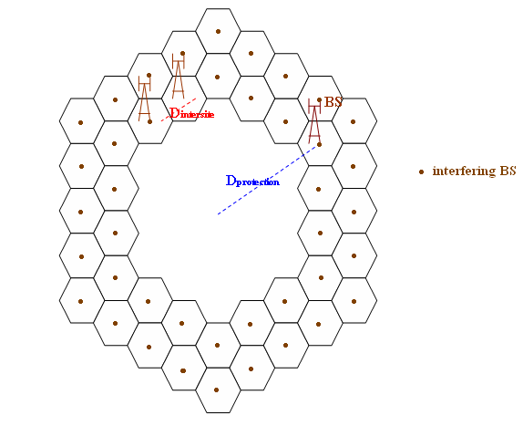
earth station
The radius of the i^{th} ring is:
D(i)= Dprotection + ( i-1)* Dintersite
The number N(i) of IMT-Advanced base station located on the i^{th} ring is assessed according to the corresponding distance D(i) and the base station intersite distance range as following:
N(i) = pi / (arc sin (Dintersite/ (2*D(i))))
Aggregate mobile station contribution
This study assumes a random distribution of agreed number of user density of mobile stations within each cell whose base station is interfering into the FSS earth station. The distance D_{mobile station} of the closest mobile station is defined as following:
D_{mobile station} = D_{protection} – D_{intersite}/2
Study 9 investigated overdrive of LNB’s and interference from unwanted emissions. It was expected that these phenomena will occur at smaller distances than in-band interference. It was therefore assumed that such interference from IMT-Advanced transmitters beyond the horizon are most unlikely. The calculations therefore have not taken trans-horizon propagation into account and are based on LoS calculations.
It is understood that multipath and focusing effects may significantly increase the received signal levels for short periods of time and increase the required separation distance. However, in these calculations, these effects have not been taken into account.
This study also only calculated required separation distances with respect to single entry interference contributions from IMT-Advanced stations and did not consider the aggregation of several IMT-Advanced base stations and/or user terminals.
Detailed description of the methodology, assumptions, calculations and results of STUDY 9 can be found in Annex E.
For LNB overdrive calculations, some additional parameters which have not yet been specified in Tables 3 to 5 are required. Amongst these are input levels that will make the LNB exhibit non-linear behaviour. For this purpose, the LNB 1 dB compression point was assumed to correspond to a level of −50 dBm at the LNB input and that the LNB would start to show non-linear behaviour at an input level about 10 dB below this level (i.e. −60 dBm). For estimation of the total received satellite power, 36 MHz satellite transponders in the full 800 MHz bandwidth, each with an EIRP of
41 dBW was assumed for this study.
In STUDY 10, the aggregate interferences have been calculated with the following assumptions:
− Base Station Case – 42 cells distributed (static distribution) within a radius of 3 km from the FSS receive station. Six-cell reuse for TDMA / single cell reuse for CDMA. Simulation assumed FSS earth station located amongst macro cells. Result was a measure of the exceedence of the required I/N protection requirement for the FSS.
− Mobile Station Case – Monte Carlo simulation, mobile stations randomly distributed within a circular area of 2.95 km about the FSS receive station. Simulation assumed FSS earth station located amongst a population of mobile IMT-Advanced stations. Result was a measure of the exceedence of the required I/N protection requirement for the FSS
The goal of the STUDY 11 is to consider the combined exclusion zone for multiple earth stations deployed in the same region. The study considers 9 existing and operational earth station receiving in the band 3 700-3 800 MHz. Aggregation over 100 MHz is based on anticipated IMT-Advanced network bandwidth. For each earth station the interference from single macro base station is evaluated for short-term and long-term interference criteria taking into account terrain, actual frequency, azimuth, elevation angle and antenna height. Other parameters have been taken from § 6 and 7 of this Report. Two extreme cases have been considered with one 100 MHz channel and with five 20 MHz channels corresponding to 39 dBm/MHz and 46 dBm/MHz EIRP accordingly. All other possible channel bandwidths and channel arrangements will be enclosed within these two cases.
During analysis macro base station has been moved from one position to another within 5 km grid, for each position short-term and long-term interference and I/N have been calculated for each earth station. Square area with approximately 5 km sides is treated as an exclusion zone if macro base station positioned in the centre of such area creates interference in earth station receiver leading to I/N higher than criterion. For long-term interference I/N is allowed to be higher than −10 dB only for 20% of time, for short-term interference I/N could exceed −1.3 dB only for 0.001667% of time. As a result aggregated exclusion zones have been drawn based on the worst value of interference among all earth station for each point of the grid.
Additional information on this study could be found in Annex B.

8.1.2 Compliance with the common parameters

 | STUDY 1 | STUDY 2 | STUDY 3 | STUDY 4 | STUDY 5 | STUDY 6 | STUDY 7 | STUDY 8 | STUDY 9 | STUDY 10 | STUDY 11
Compliance with the common set of IMT-Advanced parameters shown in Tables 3 to 5 | Fully compliant | N.A | Fully Compliant  Except the OoB parameters of IMT, which are based on Appendix 3 of the RR | Fully compliant with additional cases  Chosen parameters  − Frequency:  3.9 GHz  Additional parameters:  − Antenna  height: 20m  (rural)  − Antenna  tilt: 7° | Fully compliant, except for adjacent band analysis: the spectrum mask for OoB emissions of orthogonal frequency division multiplexing (OFDMA). Since no mask for this case was addressed, the spectrum with filtration having roll-off factor of 0.2, theoretical mask, was used | Frequency reuse pattern of 1 (CDMA) and 6 (TDMA) | Fully Compliant  OFDMA cases consider a transmitted power reduced by 5 to 7 dB compared to the maximum value of the range expressed in Table 3 | Fully compliant, except assuming base station antenna height (Micro, dense urban of Beijing) to be 20 m, not 5 m | Fully compliant except for unwanted emissions (see § 8.1.1 and Annex E for mask for unwanted emission and additional parameters not specified in Tables 3  to 5) | Fully compliant | Fully compliant
Compliance with the common set of FSS parameters shown in Table 2 | Antenna  height a.g.l  Stn-1:5 m ;  Stn-2: 25 m  Antenna Gain:  Stn-1:47.7;  Stn-2: 59.8 dBi  Locations:  Stn-1:  N51:43:44  W0:10:39  Stn-2:  N50:02:55; W5:10:46 | N.A | Fully compliant | Chosen parameters  − Frequency: 3.9 GHz  − Antenna  diameter:  2.4 m  non-compliant parameters  − Antenna  height:  10 m  (urban)  3 m (rural) | Fully compliant | Fully compliant except: Earth station off-axis gain: Appendix 7  Long-term protection criterion:  –15.2 dB | Fully compliant | Fully compliant, except assuming FSS antennas deployed in suburban and dense urban locations in Beijing:  Antenna height:  2 m (on the ground, suburban and dense urban);  10 m (on the roofs of buildings, Suburban);  30 m (on the roofs of buildings, dense urban) | Only IMT-Advanced interference allowance of 6% and 1% considered in the studies, not 3% and 0.5% | Fully compliant except with respect to  1) the height of the FSS earth station antenna, where a height of 2 m was assumed  2) for off-axis azimuth of greater than 85°, where an antenna gain of −10 dBi was assumed | Only thermal noise and antenna pattern are compliant. Other parameters are actual values for earth station under study and within following ranges:  Antenna height from 2.5 to 24 m.  Elevation angle from 3° to 22.5°.  Azimuth from 107° to 146°

8.1.3 Propagation assumptions

 | STUDY 1 | STUDY 2 | STUDY 3 | STUDY 4 | STUDY 5 | STUDY 6 | STUDY 7 | STUDY 8 | STUDY 9 | STUDY 10 | STUDY 11
Use of the Recommendation  ITU-R P.452 | Yes.  Delta N: 45  Long term  p = 20%  Short term  p = 0.00167% | N.A | Diffraction and ducting models used | − Path type: LoS with sub-path diffraction/transhorizon  − 100 m × 100 m clutter data for clutter loss (uniform average height of each clutter category) | Yes  Long term  p = 20% | − Long-term: smooth-earth, diffraction mode  − Short-term: smooth-earth, diffraction/ troposcatter/ ducting modes | Yes.  Long term  p = 20% | Diffraction over a spherical path | Path type:  LoS without sub-path diffraction, multipath or focusing effects.  Only long-term propagation conditions. | All propagation modes included, except hydrometeor scatter | Yes.  Delta N:45  Long term  p = 20%  Short term  p = 0.00167%
Use of a terrain data model | Terrain data specific to UK region is considered | N.A | Clutter losses in accordance with suburban settings given in Table 6 of Rec. ITU-R P.452 | Used with 50 m × 50 m resolution  and smoothed to 500 m × 500 m resolution by filtering | Used with  1 m × 10 m resolution real terrain data (Seoul Korea) with artificial object (buildings) | None. (Estimated 15 dB clutter losses added for aggregate base station case; 30 dB clutter/ shielding for aggregate mobile station case) | Both generic and application cases studied | Clutter losses in accordance with suburban and dense urban settings given in Rec.  ITU-R P.452 | No  (Non-specific earth station location) | Global terrain data base | Terrain data specific to Kaliningrad region (Russian exclave) is considered

8.1.4 Results
The following paragraph contains three types of study results: co-channel interferences, adjacent band interferences and saturation of the low noise amplifier (LNA) of a receiving FSS earth station. The studies have been derived for typical FSS earth station cases (generic study) as well as for specific FSS earth station cases (application case) for the three interference scenarios.
For each of the three scenarios, geographical separations between the IMT-Advanced station and the FSS earth station would be required. For these three types of study results, distances are provided. They represent the required distances to meet the interference criteria.
When performing the calculations whose results are given below, it was advised by the ITU-R that “Recommendation ITU-R P.452-12 is the appropriate propagation model for predicting interference between terrestrial stations in the frequency range from about 700 MHz up to above 6 GHz when the distance between the transmitter and receiver is longer than 1 km. Recommendation ITU-R P.1411-3 could be used for short paths up to about 1 kilometre, while Recommendation ITU-R P.1546-2 can be used for frequencies from 30 to 3 000 MHz and for time percentages down to 1%.”

8.1.4.1 Typical FSS earth station case (Generic study)
Generic studies are based on a flat terrain model.
NOTE 1 – In the case of calculations using short-term criterion, distances derived using a flat earth model are provided to assess the maximum range of distances (see § 6.2.2) and should not be applied by default to define an exclusion zone around an earth station, as it is not representative of all areas around the world.

 | STUDY 1 | STUDY 2 | STUDY 3 | STUDY 4 | STUDY 5 | STUDY 6 | STUDY 7 | STUDY 8 | STUDY 9 | STUDY 10 | STUDY 11
Co-channel Results
Long-term interference criterion / Single entry
Minimum distance  (I/N =  –12.2 dB) | N.A | N.A | Macro base station: 55 km  Mobile station: 1 km | 37-54 km (Macro urban)  15-23 km  (Micro urban)  40-59 km  (Macro rural)  with a downtilt varying from 2 to 7° | Base station:  45-58 km  (FSS earth station elevation angle: 5°-48° and bandwidth:  75 MHz) | 33-57 km  (5º elevation)  33-37 km  (15º elevation) | CDMA Macro base station: from 47 to 65.5 km  CDMA Micro base station: from 39 to 49.5 km  CDMA  Mobile station: 0 km  OFDMA Macro base Station: from 43 to 55 km  OFDMA Micro base station: from 29 to 47 km  OFDMA Mobile station: 0 km | N.A | N.A | N.A | N.A
Minimum distance  (I/N =  –15.2 dB) | N.A | N.A | Macro base Station: 70 km  Mobile station: 1.5 km | N.A | N.A | 36-60 km  (5º elevation)  36-40 km  (15º elevation) | N.A | N.A | N.A | N.A | N.A
Long-term interference criterion / aggregate case
Minimum distance  (I/N =  –12.2 dB) | N.A | N.A | N.A | N.A | Base stations:  51-60 km  (FSS earth station elevation angle: 5°-48° and bandwidth: 75 MHz)  mobile stations:  0.5-1.5 km  (base station numbers : 10) | I/N exceedence (same geographical area)  Macro base station:  51-64 dB  Mobile station:  22-65 dB | CDMA Macro base station: from 56 to  87 km  CDMA Micro base station: from 49 to  58 km  CDMA Mobile station: 0 km  OFDMA Macro base station: from 51 to 61 km  OFDMA Micro base station: from 46 to 53 km  OFDMA Mobile station: 0 km | N.A | N.A | N.A | N.A
Minimum distance  (I/N =  –15.2 dB) | N.A | N.A | N.A | N.A | NA | I/N exceedence (same geographical area)  Macro base station:  54-67 dB  Mobile station:  25-68 dB | N.A | N.A | N.A | N.A | N.A
Short-term interference criterion
Minimum distance | N.A | N.A | Macro base station:  140 km  Mobile station: 1.5 km |  | N.A | 187-430 km  (5º elevation, considering all propagation modes)  187-282 km  (15º elevation considering all propagation modes)  34-120 km  (5º elevation, considering troposcatter/ diffraction propagation modes only)  34-50 km  (15º elevation, considering troposcatter/ diffraction propagation modes only) | N.A | N.A | N.A | N.A | N.A
Adjacent band Results
Long-term interference criterion / Single entry
Minimum distance  (I/N = –20 dB) | N.A | N.A | Macro base station:  18 to 25 km  Mobile station: 300 to 450 m | N.A | CDMA Case  from 10 to  34 km  OFDMA Case  from 0.07 to 19 km | N.A | CDMA Macro base station: from 10 to 42.5 km  CDMA Micro base station:  from 2 to  14 km  OFDMA Macro base station: from 5 to 29 km  OFDMA Micro base station: from 2.4 to 8.7 km | N.A | Macro base station: from 49.5 to  80.5 km  Micro base station: from 39.5 to 51 km  User terminal: from 25 km to 32.5 km | N.A | N.A
Long-term interference criterion / aggregate case
Minimum distance  (I/N =  – 20 dB) | N.A | N.A | N.A | N.A | CDMA Macro base station: from 15 to  37 km  OFDMA Macro base station: from 0.35 to 21 km | N.A | CDMA Macro base station: from 27 to 45.5 km  CDMA Micro base station: from 11 to  35 km  OFDMA Macro base station: from 15 to 41 km  OFDMA Micro Base station: from 4 to 8.5 km | N.A |  | N.A
Saturation of LNA/LNB Results
Long-term criterion/Single entry
1 dB compression
Mobile station | N.A | N.A | N.A | N.A | N.A | N.A | N.A | N.A | 170 m | N.A | N.A
Micro cell base station | N.A | N.A | N.A | N.A | N.A | N.A | N.A | N.A | 600 m | N.A | N.A
Macro cell base station | N.A | N.A | N.A | N.A | N.A | N.A | N.A | N.A | 9.5 km | N.A | N.A
Non-linear operation
Mobile station | N.A | N.A | N.A | N.A | N.A | N.A | N.A | N.A | 550 m | N.A | N.A
Micro cell base station | N.A | N.A | N.A | N.A | N.A | N.A | N.A | N.A | 1.95 km | N.A | N.A
Macro cell base station | N.A | N.A | N.A | N.A | N.A | N.A | N.A | N.A | 30.5 km | N.A | N.A

8.1.4.2 Specific FSS earth station case (Application case)

 | STUDY 1 | STUDY 2 | STUDY 3 | STUDY 4 | STUDY 5 | STUDY 6 | STUDY 7 | STUDY 8 | STUDY 9 | STUDY 10 | STUDY 11
Co-channel Results
Long-term interference criterion / Single entry
Minimum distance  (I/N =  12.2 dB). | Stn-1:  base station-1: 90 (km)  base station-2: 40 (km)  mobile station-1: 30 (km)  Stn-2  base station-1:110 (km)  base station-2: 50 (km)  mobile station-1: 20 (km)  Note: It is assumed that there are two co-frequency interferers and an interference criterion of  I/N = -13 dB is applied with respect to each IMT-Advanced station. | N.A | N.A | 17-38 km  (Macro urban)  8-14 km  (Micro urban)  11-55 km  (Macro rural). | Urban macro (see § 4.2.1.2, Fig. 5)  20° (FSS):  1-50 km. | N.A | CDMA Macro base station: from 22.8 to 29 km  OFDMA Macro base station: from 4 to 23 km  Mobile station: 0 km. | 45.2 km – 61 km (on the roofs of buildings, macro, suburban);  23.2 km – 38.5 km (on the ground, macro, suburban);  33.9 km – 49.6 km (on the roofs of buildings, micro, dense urban);  5.3 km – 18.4 km (on the ground, micro, dense urban). | N.A | I/N ≤ –10 dB for all but 20% of time  Contours plotted around earth stations in four types of terrain – flat, moderately hilly, very hilly and offshore.  Macro base station with zero tilt – 40 km average minimum distance.  Macro base station with 120° sector and 2° tilt – 35 km average minimum distance. | For single earth station and I/N =  –10 dB  distance varies from 30 to 100 km depending on earth station configuration and azimuth.  Multiple earth station deployment causes the spread of exclusion zone compared to any single earth station.
Minimum distance  (I/N =  –15.2 dB) | N.A | N.A | N.A | N.A | N.A | N.A | N.A | N.A | N.A | N.A | N.A
Long-term interference criteria / Aggregate case
Minimum distance  (I/N =  –12.2 dB) | N.A | N.A | N.A | 21-42 km  (Macro urban)  11-18 km  (Micro urban)  15-58 km  (Macro rural) | N.A | N.A | N.A | N.A | N.A | N.A | N.A
Minimum Distance  (I/N =  –15.2 dB) | N.A | N.A | N.A | N.A | N.A | N.A | N.A | N.A | N.A | N.A | N.A
Short-term interference criterion
Minimum distance | Stn-1:  base station-1: 270 (km)  base station-2: 90 (km)  mobile station-1: 30 (km)  Stn-2  base station-1:280 (km)  base station-2: 80 (km)  mobile station-1: 20 (km) | N.A | N.A | 21 to 128 km for macro urban  8 to 17 km for micro urban  28 to 107 km for macro rural | N.A | N.A | N.A | N.A | N.A | Macro base station with zero tilt – > 150 km average minimum distance.  Macro base station with 120° sector and 2° tilt – > 125 km average minimum distance. | For single earth station and I/N =  –1.3 dB distance varies from 50 to  400 km depending on earth station configuration and azimuth, and IMT-Advanced deployment.  Multiple earth station deployment causes the spread of exclusion zone compared to any single earth station.

8.1.5 Techniques to improve the sharing
This section covers the techniques that would improve the sharing between IMT-Advanced and FSS. The use of these techniques result either in co-frequency operation of both systems or adjacent band operation of both systems.
The feasibility and practicability of implementing these techniques have not been studied in the various FSS deployment scenarios.
Furthermore, some of the techniques listed in this section would need to be further studied.
Techniques implying the use, by IMT-Advanced base stations, of frequencies different from those used by the FSS earth stations would need to ensure not causing unacceptable interference to FSS receiving earth station (including unwanted emissions and LNA overdrive).

8.1.5.1 Possible mitigation techniques
The mitigation techniques described in this section would only apply to the situation where the location of the FSS receive earth station, subject to interference (further referenced as victim FSS earth station), is known. All of them have been studied with respect to one victim FSS earth station only.

8.1.5.1.1 Sector disabling
The aim of this technique is to reduce, in the direction of the victim FSS earth station, the transmitting output power of base stations that are located at a distance smaller than the separation distance. Generally, base stations utilize tri-sectorial antennas. Accordingly, one way to reduce the transmitting output power level could be to disable the antenna sector that points towards the FSS earth station, noting that such an area would be covered through the use of other frequency bands by IMT-Advanced systems.
As shown in the following figures, when compared with normal full active sector mode, the application of this mitigation technique has shown that the separation distance ranges are reduced by between 0 and 49% in generic studies (without terrain horizon profile) and between 0 and 83% for one specific site (with terrain horizon profile) depending on the access mode (see table of § 8.1.2, STUDY 7) and on the elevation angle of FSS earth station. These results are valid for base stations employing CDMA as well as OFDMA access modes.
FIGURE 3

FIGURE 4

8.1.5.1.2 Multiple input, multiple output (MIMO)
In order to improve sharing between IMT-Advanced and FSS, an interference mitigation technology known as MIMO space division multiple access (SDMA) can be utilized.
By using this technique, a gain reduction in the base station transmit antenna diagram is generated towards the interfered FSS earth station. By using the MIMO technique, the minimum separation distance is 35 m in case of an IMT-Advanced base station and single FSS receiving earth station under the assumption of 0º direction of earth station (DOE) estimation error which implies that null beam to the FSS receiving earth station is formulated perfectly. In the case of an IMT-Advanced base station and 3 FSS receiving earth stations, the minimum separation distance increases up to 3.5 km under the same assumptions. Other results have shown that under the assumption of 8° DOE estimation error, the minimum separation distances is 22 km, but this still reduces the minimum separation distance by approximately 50% in the considered case.
As for the sector disabling technique, this approach would require the use of other frequencies to cover the area where the base transmit antenna gain is reduced.
Some detailed information about this mitigation technique is provided in Annex D.

8.1.5.1.3 Site shielding
In Recommendation ITU-R SF.1486, interference attenuation effect, in a range about 30 dB, due to the site shielding isolation obtained by providing physical or natural shielding at the FSS earth stations is described. If such shielding isolation is taken into account, the required separation distance to protect FSS earth station receivers from IMT-Advanced transmitters can be reduced.
However, the required distance separation between IMT-Advanced transmitter and a FSS receiving earth station using site shielding has to be evaluated on a site-by-site basis and is dependent on characteristics and location of each site. The possibility of applying site shielding may not be guaranteed for all sites.

8.1.5.1.4 Antenna donwtilting
A possible mitigation technique to improve sharing is antenna downtilting at the IMT-Advanced base stations. In the deployment scenarios envisaged in IMT-Advanced systems, the cell size will be reduced to support high-speed transmissions assuming a limitation of transmission power. The deployment based on the small cell size is also indispensable for IMT-Advanced systems in order to achieve high frequency efficiency. Since the degree of antenna downtilting will be increased in the case of small cell size in order to avoid inter-cell interference in IMT-Advanced systems using the frequency reuse, this will also result in the reduction of interference from an IMT-Advanced base station to FSS earth stations and the reduction of the required minimum distance.
STUDY 4 shows that, for one specific site in urban macro environment, the required separation distance is decreased by approximately 30% and 50% for the long-term and short-term interference criteria, respectively, when the antenna-downtilt at IMT-Advanced transmitter is changed from 2° to 7°. However, the impact of this technique may vary for different locations and results may be different at other locations.
By increasing the downtilt of the base station antenna, there is a potential:
– for an increase of the number of IMT-Advanced base stations required to provide service in a given area;
– for a decrease of transmission power per IMT-Advanced base station.
Accordingly, when computing aggregate interference into an FSS receives station, these two elements would have to be taken into account.

8.1.5.2 Spectrum management techniques
In areas where all the frequency resources are not fully utilized by the FSS earth station, it may be possible to introduce IMT-Advanced services. The following spectrum management techniques may be of interest to administrations wishing to introduce new services in specific geographical areas.

8.1.5.2.1 Dynamic spectrum allocation
The distribution of radio resources could either be static or dynamic depending on the local situation in a given area. For spectrum efficiency, the most favorable method would be to use the dynamic method. Local arrangements may be made to facilitate usage of both systems. In areas where not all the frequency resources are fully utilized, it may be possible to introduce additional services either of the same type or other types or a mix. The IMT-Advanced systems need then to be informed whether the FSS bands can be utilized or not. In the case when an earth station changes its frequency of operation, the IMT-advanced system may also have to change its frequency in the surrounding area.
A way for the administration to provide such information to the IMT-Advanced systems may be to have a data base where all relevant information of the current services or stations, such as FSS earth stations, using the radio resources in the area. The data base would need to be up to date and would include information such as central carrier frequency, channel bandwidth etc.

8.1.5.2.2 Usage of beacon
Broadcasting beacon or a network of beacons, or control information co-located with the FSS earth station (respectively IMT-Advanced base station) provide dynamic and active information on its spectrum usage to the IMT-Advanced system (respectively FSS earth station) to allow optimum usage of the unused spectrum to eliminate the inter-system interference.

8.1.6 Proposed methodology to be utilized with mitigation techniques

8.1.6.1 Interference area ratio methodology
This section describes a new methodology to be utilized in assessing the level of coordination difficulty on the basis of the actual terrain profile between two services for a specific site. This methodology may be used to assess the effectiveness of mitigation techniques based on the use of directional antennas, which takes into account the actual shielding effect by terrain profile and clutter losses associated with the artificial objects. In order to quantitatively evaluate this shielding effect, the methodology called “interference area ratio”, is employed in some studies, where its definition is shown in Fig. 5. When applying the interference area ratio of x%, we exclude the x% of area that has the larger separation distance over d + Δd. Then, the required separation distance becomes d + Δd. When x > 0%, the additional mitigation technique is adopted in order to protect the FSS earth stations located in the x% of the area. A possible mitigation technique is to employ directional-beam antenna, such as sectorized- or adaptive-beamforming antenna at an IMT-Advanced transmitter. The details of the methodology “interference area ratio” can be found in Annex F.
Figure 5
Definition of interference area ratio

Figure 6 shows the required minimum distance as a function of the interference area ratio. As shown in this figure, according to increase in the interference area ratio value, the required minimum separation distance can be reduced.

FIGURE 6
Required minimum distance as a function of interference area ratio
(urban area, macro-cell, single-entry)
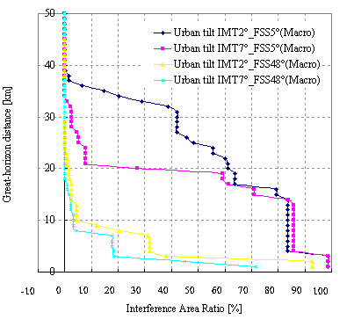
In Table 7, the required minimum distance is summarized for an assumed interference area ratio of 10%, as an example. For the comparison, the required minimum distance is also shown in the case of the interference area ratio of 0%, which is equivalent to the separation distance without considering the interference area ratio. As shown in this table, by introducing the measure “interference area ratio” associated with the mitigation technique using the directional beam antenna, the required minimum distance is reduced by about 5% to 60% depending on the scenarios in IMT-Advanced systems.
TABLE 7
Required minimum distance for interference area ratio of 10%
(urban area, single-entry, FSS earth station elevation angle = 5°)
Environment | IMT-Advanced base station antenna downtilt  (degrees) | Interference area ratio = 10%  (km) | (Reference) Without considering interference area ratio  (km)
Macro | 2 | 36 | 38
Macro | 7 | 21 | 32
Micro | 2 | 12 | 14
Micro | 7 | 5.8 | 14

8.2 Interference from FSS transmitting space station to IMT-Advanced systems
A number of sharing studies examined the impact of FSS interference upon IMT-Advanced receive stations. The assumptions and methodologies associated with each sharing study are summarized in tables of § 8.2.2 and 8.2.3. These tables also indicate the extent to which each sharing study employed the common FSS and IMT-Advance parameters that are specified in Tables 2 through 5 of this Report as well as the operational FSS scenarios recommended by the ITU-R (see § 8.2.1). The results of the studies are contained in the table in § 8.2.4.
It should be noted that only STUDIES 2, 3, 6 and 7 have provided some results for the § 8.2.

8.2.1 Methodologies used in the simulation
Two scenarios were considered:
– SCENARIO 1 was based on one GSO satellite every 10° of longitude transmitting a maximum EIRP of 11 dBW per 4 kHz at all elevation angles of 0°-90°, with all such satellites operating co-frequency and with overlapping areas of coverage.
– SCENARIO 2 was based on one GSO satellite every 4° of longitude transmitting an EIRP compliant to the RR Article 21 (11.3 dBW per 4 kHz at the 0°-5° elevation angles, {11.3 + 0.5(δ− 5)} dBW per 4 kHz for δ between 5°-25° and 20.1 dBW per 4 kHz at the 25°-90° elevation angles), with all such satellites operating co-frequency and with overlapping areas of coverage (δ is the elevation angle).
These scenarios may not be representative of the current satellite deployments but could be representative of future satellite deployments.

8.2.2 Compliance with the common parameters

 | STUDY 2 | STUDY 3 | STUDY 6 | STUDY 7
Compliance with the common set of IMT-Advanced parameters as shown in Tables 3 to 5 | Fully compliant.  (Use of Rec.  ITU-R F.1336-2) | Fully Compliant | Fully Compliant | Fully Compliant
Compliance with the common set of FSS parameters as shown in Table 2 | Fully Compliant. | Fully Compliant. | Fully Compliant. | Fully Compliant.

8.2.3 Compliance with the methodology of § 8.2.1

 | STUDY 2 | STUDY 3 | STUDY 6 | STUDY 7
Compliance with the proposed FSS scenarios | Compliant to SCENARIOS 1 and 2 | Compliant to SCENARIO 2 | Supplementary Scenario  Space station orbital separation: 10°  Maximum space station space-to-Earth PFD: 11.3-  20.1 dB(W/4 kHz)  depending on angle of arrival  Scenario 1  11.3 dB(W/4 kHz) for all angles of arrival | Compliant to SCENARIO 1

Results (co-channel only)
 | STUDY 2 | STUDY 3 | STUDY 6 | STUDY 7
I/N for the Macro-cell base station | SCENARIO 1  – Typical antenna: from –15.6 to  –14.4 dB  – Improved antenna: from –16.4 to  –14.8 dB  dB, for the 4 latitudes considered | SCENARIO 2  –3.6 | Supplementary Scenario  0.3-4.2 dB  Scenario 2  No Exceedence | SCENARIO 1  From -18.8 to  –14.9 dB, for the 4 latitudes considered
I/N for the Macro-cell base station | SCENARIO 2  – Typical antenna: from –11.3 to  –9.9 dB  – Improved antenna: from –13.6 to  –12.2 dB  (4 latitudes have been considered) | SCENARIO 2  –3.6
I/N for the Micro-cell base station | SCENARIO 1  from –10.8 to  –7.4 dB, for the 4 latitudes considered | N.A | N.A | SCENARIO 1  from –7.2 to  –6.2 dB, for the  4 latitudes considered
I/N for the Micro-cell base station | SCENARIO 2  from –2.4 to  0.9 dB, for the  4 latitudes considered | N.A | N.A
I/N for the mobile station | SCENARIO 1  from –14.4 to  –13.3 dB, for the 4 latitudes considered | SCENARIO 2  –1.4 | Supplementary Scenario  1.3-5.2 dB  Scenario 1  No Exceedence | SCENARIO 1  from –14.6 to  –13.3 dB, for the 4 latitudes considered
I/N for the mobile station | SCENARIO 2  from –4.9 to  –0.99 dB, for the 4 latitudes considered | SCENARIO 2  –1.4

9 Results from one measurement study on interference from IMT-Advanced transmitter into one TVRO earth station
As shown in § 4, in the 3 400-4 200 MHz band, TVRO is one of the FSS applications that is implemented in some parts of the world. Annex G of this report provides the results of a set of measurements carried out regarding the impact of interference into a commercial TVRO terminal using two different types of LNBs in the 3 400-4 200 MHz band, where interference is caused by an assumed IMT-Advanced transmitter.
The IMT-Advanced transmitter used in this experiment was set to transmit a carrier with an EIRP density of 35 dBm/MHz, which is 11 dB lower than a macro base station defined maximum EIRP density and 13 dB higher than a micro base station defined maximum EIRP density.
This experiment was performed at an arbitrary chosen location in Japan. The EIRP of the satellite chosen for the measurement is about 39 dBW per transponder at this location. The satellite transponder chosen for the co-channel measurement contains two carriers with a bandwidth of approximately 5 MHz each. It is not common to assign only two 5 MHz carriers in a 36 MHz wide transponder. The adjacent-channel measurements were done using a different transponder containing five 5 MHz wide carriers. This represents a more typical transponder utilization.
Summary of the measurement is given as follows:
1) When the distance between an IMT-Advanced transmitter and a TVRO terminal was in the range of 345 to 5,420 m comprising different 26 locations, no influence on the quality of the received TV picture was observed at 25 and 26 locations in the case of the co-channel and adjacent interference scenarios, respectively, with FEC coding rate of 3/4.
2) TV channel employing FEC coding rate of 3/4 was more robust against the increase in the co-channel interference power level by approximately 2 dB compared to that of 7/8 in maintaining the same quality of the received TV picture.
3) The influence on the quality of the received TV picture for adjacent-channel interference scenario was smaller compared to that for co-channel scenario. In order to maintain the same quality of the received TV picture, approximately 14 dB more power of an IMT-Advanced transmitter was permitted in the adjacent-channel interference scenario compared to the co-channel interference scenario.
This test was conducted for one arbitrarily chosen location in Japan. Moreover, only one specific satellite with the transmissions characteristics of the selected TV carriers was used in the test. The test reflects one snapshot of one case and does not take into account short-term effects, aggregation or other applications or modulation/error correction schemes. Therefore results with regard to potential interference from IMT-Advanced into TVRO or other applications cannot by default be extended to other cases.

10 Sensitivity analysis
Although the common simulation parameters for IMT-Advanced systems are summarized in § 6 and 7, in actual deployment scenarios some of the parameters will be within a range of values. In the following analyses, the influence of variation of several parameters of IMT-Advanced and FSS systems are analyzed and the impact on the required separation distance is investigated.

10.1 Interference from IMT-Advanced systems to FSS receive earth stations

10.1.1 Influence of the IMT-Advanced base station antenna downtilt
Figures 7 and 8 show the influence of the antenna downtilt angle of the IMT-Advanced base station on the minimum required separation distance with respect to a generic and a specific FSS receiving earth station, respectively. As shown in these figures, as the antenna downtilt is increased, the required minimum distance is decreased due to the reduced interference from IMT-Advanced base station.
Figure 7
Influence of down-tilt of IMT-Advanced base station transmitters
Generic study, Urban, Macro-cell
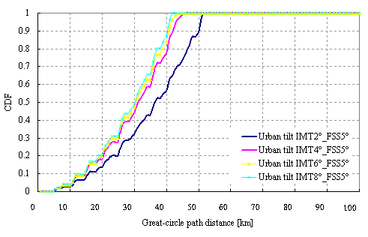
FIGURE 8
Influence of down-tilt of IMT-Advanced base station transmitters
Specific study using terrain data, Urban, Macro-cell (Kyobashi)

10.1.2 Influence of the IMT-Advanced base station antenna height
Figures 9 and 10 show the influence of the IMT-Advanced base station transmitting antenna height on the minimum required separation distance with respect to a generic and a specific FSS receiving earth station, respectively. This figure indicates that the lower antenna height brings about the reduction of the required minimum distance in urban environment, since the large shielding effect can be observed due to the clutter loss associated with the artificial objects, such as tall buildings. Meanwhile, in a rural environment, the lower antenna height is not always effective to reduce the required minimum distance, since the large clutter loss is not expected due to the lower average building height in this environment.
Figure 9
Influence of antenna-height of IMT-Advanced base station transmitters
Generic study, Macro-cell
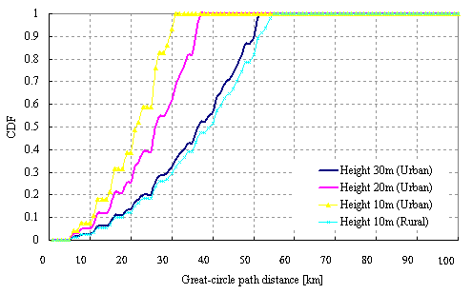
FIGURE 10
Influence of antenna-height of IMT-Advanced base station transmitters
Specific study, Macro-cell (urban: Kyobashi , rural: Kumagaya)

10.1.3 Influence of the IMT-Advanced base station EIRP
The sharing studies have been based on the maximum value of the macro and micro base stations EIRP, shown in Table 3. When deploying an IMT-Advanced network, the maximum EIRP for IMT-Advanced base station can vary from 59 to 35 dBm according to the type of the base station. The variation of this maximum EIRP would influence the sharing leading to the reduction of the size of the required separation distance between IMT-Advanced base station and FSS earth station. This is a static setting and the reduction of the distance can be derived deterministically.
Additionally, IMT-Advanced systems will implement the dynamic downlink power control (in CDMA and OFDMA networks). This feature will have the effect of reducing the EIRP of base stations, depending on the load of the cells, the distribution of the mobile stations within a cell and the time. It should be noted that:
– For a single IMT-Advanced base station to FSS earth station path, this would have no impact on the required distance separation between the IMT-Advanced transmitting base station and the FSS earth station given that the required distance separation would be based on the IMT-Advanced base station’s maximum EIRP level.
– For the aggregate case, experience to date shows that it is unlikely that all the IMT-Advanced base stations transmit at the maximum EIRP at the same time. Consequently, the use of the downlink power control could result in reducing the required distance separation. However, the statistical and temporal impact of the downlink power control has not been quantified

10.1.3.1 Influence of the IMT-Advanced base station maximum EIRP
The maximum EIRP of an IMT-Advanced base station can vary from 59 to 35 dBm for the 20 MHz minimum bandwidth, according to the Table 3 of this Report. E.i.r.p. below the maximum level of 59 dBm could reduce the required distance separation between the IMT-Advanced transmitting base station and the FSS earth station.
Figure 11 shows the impact on the required distance between an FSS earth station and an IMT-Advanced base station, taking into account the different types of aggregate base stations with a maximum EIRP value between 35 dBm and 56 dBm. The variation of the base stations deployment density and antenna type has been taken into account accordingly.
Figure 11
Protection distance reduction) versus earth station antenna elevation angles a function of EIRP
NOTE 1 – The baseline protection distance is obtained with an EIRP of 59 dBm.

10.1.3.2 IMT-Advanced down link power control analysis
Considering experience to date on terrestrial mobile networks, IMT-Advanced base stations will not always transmit at their maximum EIRP. Downlink power control is a key feature of an IMT-Advanced radio network, which has the effect to adjust the transmit power to the minimum necessary value so as to not waste power as well as to limit intra-system interference. Its use will also have the effect of reducing the inter-system interference. Depending on the cell coverage and capacity, the maximum value of an IMT-Advanced base station power will be only transmitted when the cell is 100% loaded, as follows:
Figure 12
NOTE 1 – CCH are the common channels.
Down link power control reflects the expected operational IMT-Advanced deployment conditions. The impact of the dynamic downlink power control, on the compatibility between IMT-Advanced and FSS has not been quantified, and would have to take into account:
– the statistical distribution of the mobile stations in a cell (geographical and time distributions),
– the fact that the base station power varies temporally.
However, its use has the effect of reducing the required distance separation between a FSS earth station and an IMT-Advanced base station.

10.1.4 Influence of the IMT-Advanced spurious emissions
The Table 8 provides the minimum required separation distances, as determined in STUDY 3, to protect FSS receive earth stations from the interference by the spurious emissions generated by a single IMT-advanced transmitter. The study assumed various levels of IMT-Advanced transmitter spurious emissions, with the reference being the level stipulated in RR Appendix 3. Distances are also given on the basis of assumed improved spurious levels by 10, 40 and 50 dB.
The analyses were based on the propagation models described in ITU-R P.452-12. Due to the generic nature of the analysis, for the long-term protection cases, the propagation was calculated over a smooth earth surface, utilizing the propagation model described in § 4.3 of ITU-R P.452-12. The models in ITU-R P.452-12 can include the effects of building losses and clutter where the topography of surrounding obstacles etc. is known. However, due to lack of information for these parameters, the building losses and clutter effects have been assumed to represent suburban environment in these analyses.
TABLE 8
Percentage Increase of FSS system noise | 1.0% | 0.5% |  | 1.0% | 0.5%
Additional reduction of IMT-Advanced transmitter spurious emission level (dB) | 0 | 0 |  | 10 | 10
IMT-Advanced macro base station | 18 km | 25 km |  | 5 km | 7.5 km
IMT-Advanced mobile station | 300 m | 450 m |  | 100 m | 140 m
Percentage Increase of FSS system noise | 1.0% | 0.5% |  | 1.0% | 0.5%
Additional reduction of IMT-Advanced transmitter spurious emission level (dB) | 40 | 40 |  | 50 | 50
IMT-Advanced macro base station | 115 m | 150 m |  | 35 m | 50 m
NOTE – The results corresponding to 0,5% are only given as an example, since no guidance was provided by ITU-R on the apportionment for the interference from other sources.

The results of this study showed that operation of IMT-Advanced systems and the FSS in adjacent bands in the 4 GHz frequency range would be very difficult and may not be feasible in the same geographical area if the IMT-Advanced transmitter spurious emission is defined in accordance with the limits specified in RR Appendix 3.
Additional information on this study can be found in Annex H.

10.1.5 Influence of FSS earth station elevation angle and losses from local clutter on adjacent band separation distances
From STUDY 9, it was noted that the required separation distances will depend significantly on the elevation angle of the FSS earth station. Also, if the propagation is attenuated by local clutter that blocks direct line-of-sight, this will have a significant impact on the received interference.
To ascertain the impact of elevation angle and clutter loss, STUDY 9 also calculated the required separation distance (both with respect to overdrive of LNA’s and unwanted emissions) as a function of the elevation angle, assuming two values for clutter loss; 0 dB and 20 dB.
From the results of the study, it can be noted that:
– An elevation angle of 20° will reduce the separation distance to 17.7% compared to that of 5°.
– An elevation angle of 45° will reduce the separation distance to 6.4% compared to that of 5°.
– 20 dB clutter loss will reduce the separation distance to 10% compared to that of 0 dB.

10.2 Interference from FSS transmitting space station to IMT-Advanced systems

10.2.1 Influence of the antenna downtilt and the latitude of a base station
This section provides I/N ranges according to the FSS networks parameters scenario and the IMT-Advanced downtilt parameter chosen.
Range of I/N (dB), as a function of the downtilt (from 0° to 2°) and latitude of the IMT-Advanced base station.

TABLE 9
FSS network  scenario | Macro-cell base station |  | Micro-cell base station
FSS network  scenario | Typical antenna | Improved antenna | Micro-cell base station
Scenario 1 | From –14.4 to –7.0 | From –14.8 to –7.1 | From –7.9 to –7.4
Scenario 2 | From –9.9 to –5.5 | From –12.2 to –6.2 | From 0.3 to 0.9
NOTES:
1 See § 7.2.1 for a description of FSS network scenarios 1 and 2.
2 These results have been assessed using the approved draft new Recommendation ITU-R F.1336-1, i.e., Rec. ITU-R F.1336-2.
3 It has to be noted that typical values for the antenna downtilt are as follows:
a) Macro base station IMT-Advanced (height = 30 m): between 2° and 20°.
b) Micro base station IMT-Advanced (height = 5 m): between 0° and 20°.

11 Conclusions
Sharing studies have been performed to assess the technical feasibility of deploying IMT-Advanced systems in the 3 400-4 200 MHz and 4 500-4 800 MHz bands, that are utilized by FSS (amongst other services).
To provide protection of the FSS receive earth stations, some separation distance relative to the stations of the mobile terrestrial network is required. The magnitude of this separation distance depends on the parameters of the networks and the deployment of the two services. The magnitudes of these required separation distances to protect the FSS receive earth stations have been studied, taking account of the need to meet both short-term and long-term interference criteria requirements, with respect to the three following interference mechanisms:
1. In-band, co-channel operations
The minimum required separation distances from IMT-Advanced base stations, when using the long-term interference criterion derived in the studies to date, are at least in the tens of kilometres.
The minimum separation distances associated with short-term interference criterion, generally, but not in all cases, exceed one hundred kilometres in the considered cases with similar assumptions as the ones used for the long-term.
2. Adjacent band operations
Concerning interference from unwanted emissions arising from out-of-band and spurious domains of IMT-Advanced base station transmitters and falling within the band used by the FSS receiver, the minimum required separation distances, when using the long-term interference criterion derived in the studies to date, are up to tens of kilometres (with no guard band) and decreasing as the guard band increases.
3. Overdrive of the FSS receiver
One study has shown that emissions from one IMT-Advanced station can overdrive the FSS receiver LNA, or bring it into non-linear operation, if the separation distance is less than some kilometres or some hundreds metres with respect to base stations and user terminals respectively.
An administration intending to bring into use IMT-Advanced systems, whose territory falls within the coordination contours of the earth stations under the coordination or notification procedure or notified under the Articles 9 and 11, shall effect coordination with other administrations having these earth stations.
Although the studies have differences in assumptions and methodologies, they all show that sharing between IMT-Advanced and an FSS earth station is not feasible within the area delineated by the minimum required separation distances for each azimuth to protect that specific FSS earth station, as explained above. Therefore, sharing is feasible only when the receiving earth station is specific under the condition that the required permissible interference level (which can be translated into appropriate transmission parameters for the IMT-Advanced stations such as maximum power or minimum separation distance between the stations concerned taking into account propagation environment) within individual administrations is observed, and any coordination agreements that may have been reached between the concerned administrations are observed.
If FSS is deployed in a ubiquitous manner and/or with no individual licensing of earth stations, sharing is not feasible in the same geographical area since no minimum separation distance can be guaranteed.
The effect of use of terrain information, including clutter losses, on the reduction of the separation distance has been studied. Studies have also shown that the use of local terrain information, including clutter losses, will reduce the separation distance. The degree of this reduction will depend on the specific circumstances. However, the reliability of local terrain information has not been proven for all countries.
Site shielding for FSS earth stations, where possible, would mitigate interference from IMT-Advanced systems. Other mitigation techniques for IMT-Advanced systems, such as narrow-beam transmission based on sectorized- or adaptive-beamforming antenna, sector disabling and antenna down-tilting will reduce the required minimum separation distance where they are effective. Some of these mitigation techniques could increase the deployment density of IMT-Advanced base stations in a given area. The impact of this increase in the number of IMT-Advanced cells as well as the reduction of the transmission power per IMT-Advanced base station should be taken into consideration when computing the aggregate interference.
The deployment scenarios of FSS earth stations and IMT-Advanced systems may be taken into account to take the full advantage of the mitigation techniques. The impact of the various mitigation techniques and spectrum management techniques on operation of the existing and /or planned FSS receive stations has not been fully studied.
According to the available studies, the effectiveness of the above-mentioned mitigation techniques is dependent on their application to individual site situations and can be applied only when the specific location of the FSS earth stations are known. Further studies would be necessary to determine the circumstances which would permit the effective use of such techniques, on a case-by-case basis.
With respect to interference from FSS into IMT-Advanced, studies have provided a range of margins relative to the required I/N criterion (from 9 to –11 dB) depending on the assumptions (particularly the type of IMT-Advanced base station considered and the FSS space station EIRP density). As a result, the IMT-Advanced base and mobile stations may experience interference from emissions of authorized satellite networks.

Annex A
Examples of interference exclusion plots for FSS earth stations

1 Summary of a study on the impact of the FSS protection requirements
Using the receive characteristics and protection criteria of 4/6 GHz FSS earth stations, and the transmit characteristics for IMT-advanced macro base stations given in § 6 of the main Report, protection contours were plotted for four different types of terrain found in Europe, with the earth station antenna axis at 20° elevation in each case. Each IMT-Advanced base station antenna was assumed to have 120° sector beams with 2° down-tilt. The following table gives the earth station locations selected, and the corresponding satellite longitudes.
TABLE A1
Type of terrain | Location of FSS earth station |  |  | Longitude of satellite at 20° elevation (°E)
Type of terrain | Latitude (°N) | Longitude (°E) | Country | Longitude of satellite at 20° elevation (°E)
Flat | 52.0 | 4.8 | The Netherlands | 44.7
Moderately hilly | 51.5 | –0.8 | Southern England | 39.8
Very hilly | 46.32 | 8.0 | Switzerland | –38.75
Off-shore | 57.1 | 21.3 | Latvia | 50.9

The propagation losses were computed using the methods in Recommendation ITU-R P.452 with a terrain database, and for each type of terrain separate contours were plotted to meet single-entry the long-term criterion I/N not to exceed –10 dB for more than 20% of the time, and the single-entry short-term criterion I/N not to exceed –1.3 dB for more than 0.0017% of the time. For the Southern England example these plots are given in Figs. A1 and A2. Protection contours were also plotted for locations within 13 capital cities in Europe. Thus it was shown that, although terrain causes some irregularity in contour shapes, for the majority of earth stations the long-term protection zones encompass areas of similar order to that of a circle of 35 km in radius, and the short-term protection zones encompass areas greater than that of a 125 km circle. These findings were combined with information supplied by three major satellite operators (Intelsat, Inmarsat and SES New Skies), on the locations of the 4/6 GHz earth stations in Europe indicated in their data-bases as receiving from their satellites, and C-band receiving earth stations recorded in the MIFR as of August 2006. Figure A3 gives an indication of the interference areas in which long term interference criterion might not be met.
From this study it can be observed that that sharing between IMT-Advanced base stations and the specific sites as indicated in the table above may be difficult.
Figure A1
Example of zone for long-term interference protection* in moderately hilly area
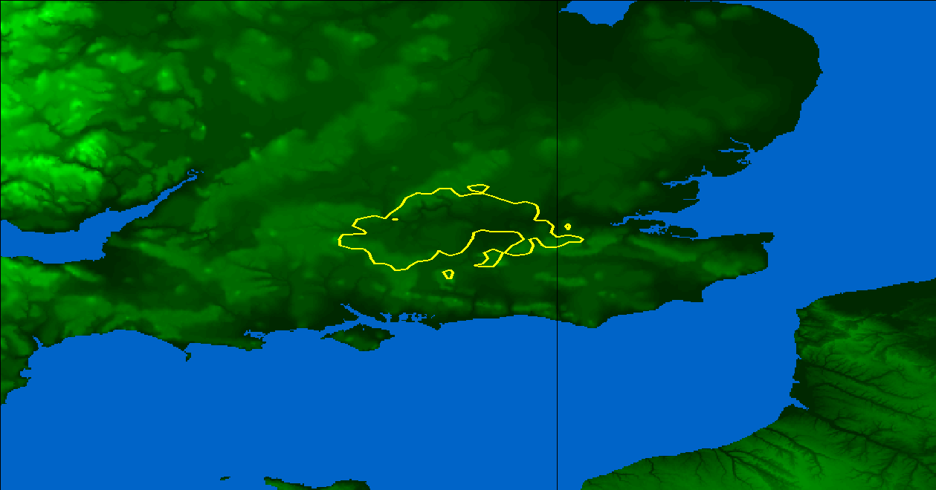
FSS earth station
Protection contour
35 km radius circle
* I/N not to exceed -10.0 dB for more than 20% of the time.
Figure A2
Example of zone for short-term interference protection* in moderately hilly area
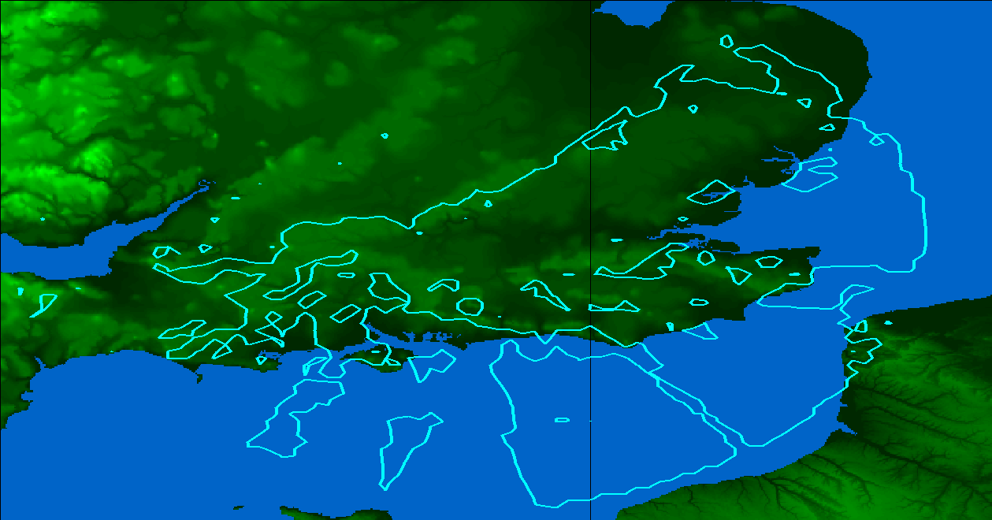
FSS earth station
Protection contour

125 km
radius
circle
* I/N not to exceed -1.3 dB for more than 0.001667% of the time.
FIGURE A3
Earth stations (except TVROs) in Europe operating to satellites within 3 400-4 200 MHz
Non-EU countries
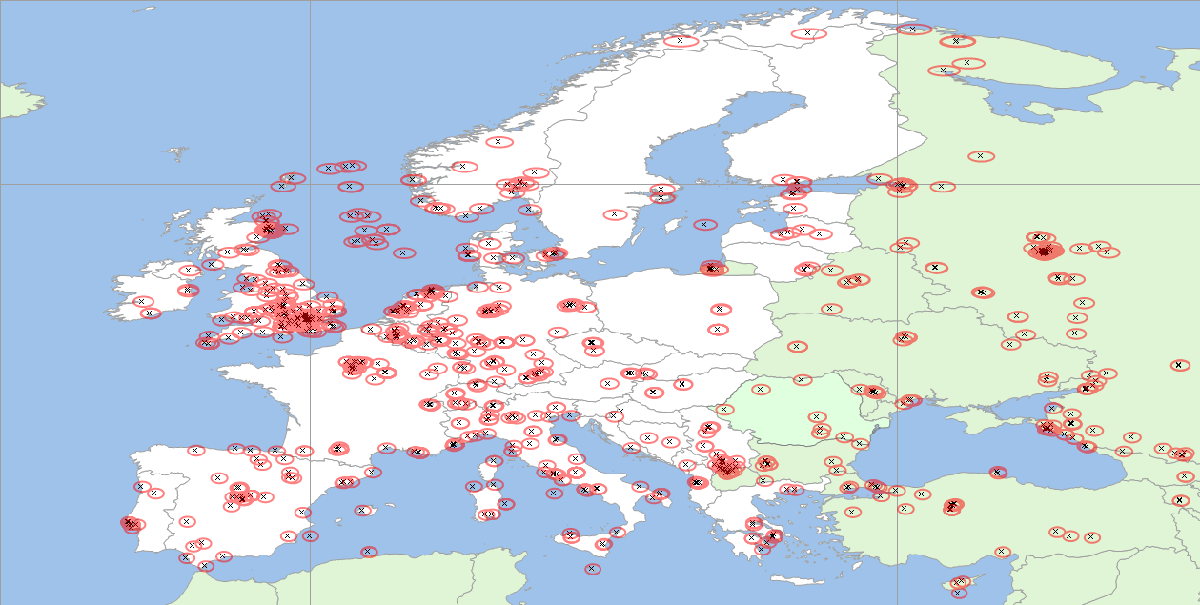
Circles of 35 km radius around earth stations

2 Locations of FSS earth stations
Figures A4, A5 and A6 show the locations of some earth stations registered with several satellite operators receiving authorised transmissions from the operating satellites of one FSS operator in the 3 700-4 200 MHz, 3 625-3 700 MHz and 3 400-3 625 MHz bands respectively. Also Fig. A7 provides information regarding the use of 3 625-4 200 MHz band by the FSS in Brazil. The earth stations shown in these figures do not include un- registered earth stations such as TVRO terminals
FIGURE A4
Locations of earth stations registered with several satellite operators and receiving in the 3 700-4 200 MHz band
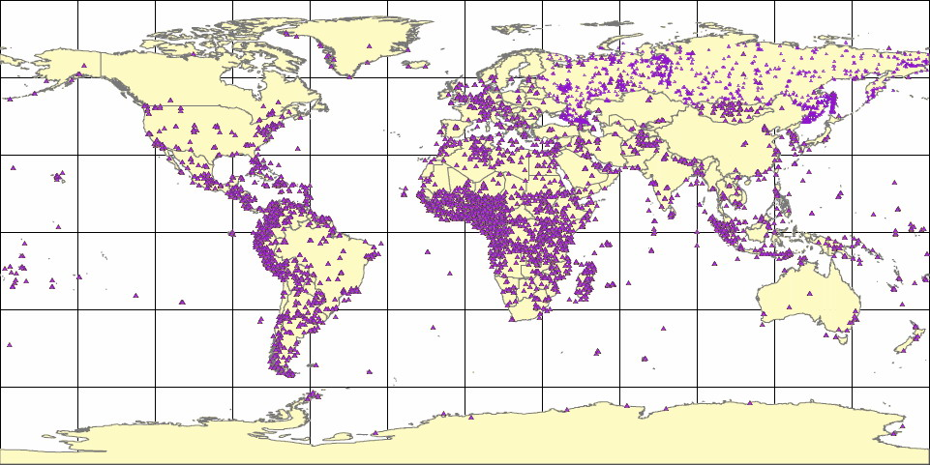
Denotes a site that may include one or more stations.
FIGURE A5
Locations of earth stations registered with several satellite operators and receiving in the 3 625-3 700 MHz band
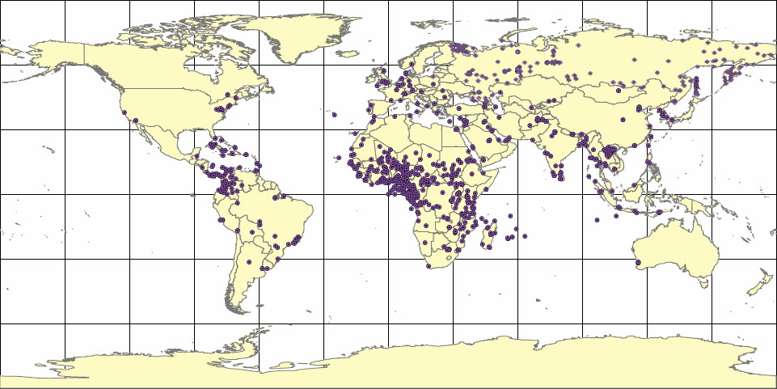
Denotes a site that may include one or more stations.
FIGURE A6
Locations of earth stations registered with several satellite operators and receiving in the 3 400-3 625 MHz band
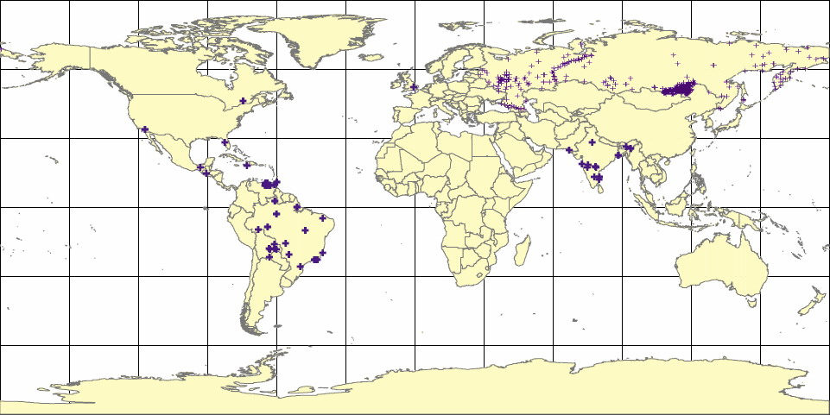
Denotes a site that may include one or more stations.
FIGURE A7
FSS earth stations in Brazil (sites using 3 625-4 200 MHz)
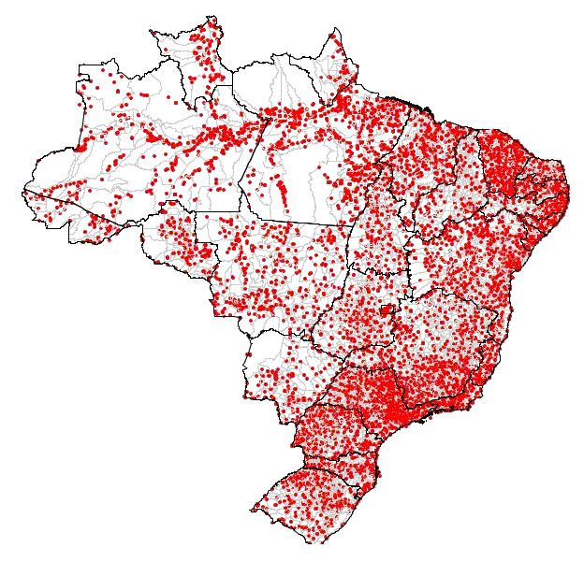

3 Locations and areas of coverage of 4/6 GHz FSS satellites
The longitudes and service areas of many, but not all, of the FSS satellites providing down-links in the 3 400-4 200 MHz band are given in Table A2.
TABLE A2
Some space stations operating in the 3 400-4 200 MHz band
Satellite Name | Orbital location (EL) | Service area
NSS 5 | –177 | East Asia /Australia / Western United States
AMC-8 | –139.0 | North America
AMC-7 | –137.0 | North America
AMC-10 | –135.0 | North America
Galaxy 15 | –133.0 | North America
AMC-11 | –131.0 | North America
Intelsat Americas 7 | –129.0 | North America
Galaxy 13 | –127.0 | North America
Galaxy 14 | –125.0 | North America
Galaxy 12 | –125.0 | North America
Galaxy 10R | –123.0 | North America
Intelsat Americas 13 | –121.0 | North America
Anik F3 | –118.7 | North America
SATMEX-5 | –116.9 | North America
Solidaridad-2 | –114.9 | North America
SATMEX-6 | –113.0 | North America
Anik F2 | –111.1 | North America
Anik F1 | –107.3 | North America
Anik F1R | –107.3 | South America
AMC-18 | –105.0 | North America
AMC-1 | –103.0 | North America
AMC-4 | –101.0 | North America
Galaxy 16 | –99.0 | North America
INMARSAT 3 | –98.0 | Global
Intelsat Americas 5 | –97.0 | North America
Galaxy 3C | –95.0 | North America
Intelsat Americas 6 | –93.0 | North America
BRASILSAT B4 | –92.0 | Brazil
Galaxy 11 | –91.0 | North America
Intelsat Americas 8 | –89.0 | North America
AMC-3 | –87.0 | North America
AMC-2 | –85.0 | North America
BRASILSAT B3 | –84.0 | Brazil
AMC-9 | –83.0 | North America
SATCOM-C3 | –79.0 | North America
Galaxy 4R | –76.8 | North America
Galaxy 9 | –74.0 | North America
AMC-6 | –72.0 | North America
BRASILSAT B1 | –70.0 | Brazil
Venesat-1 | –67.0 | South America (under construction)
BRASILSAT B2 | –65.0 | Brazil
AMAZONAS | –61.0 | North America / South America
PAS 9 | –58.0 | North America / South America / Europe
INTELSAT 805 | –55.5 | North America / South America / Europe
IS-805 | –55.5 | Global
IS-707 | –53.0 | Global
INMARSAT 4 F2 | –53.0 | Global
IS-706 | –50.25 | Global
PAS-1R | –45.0 | Global
PAS-3R | –43.0 | North America / South America/Africa/Europe
NSS 806 | –40.5 | North America / South America / Europe
INTELSAT 903 | –34.5 | North America / South America / Europe / Africa
INTELSAT 801 | –31.5 | North America / South America / Europe / Africa
INTELSAT 907 | –27.5 | North America / South America / Europe / Africa
INTELSAT 905 | –24.5 | North America / South America / Europe / Africa
NSS 7 | –22.0 | North America / South America / Europe / Africa
INTELSAT 603 | –20.0 | North America / South America / Europe / Africa
INTELSAT 901 | –18.0 | North America / South America / Europe / Africa
INMARSAT 3 F2 | –15.0 | Global
GORIZONT | –14.4 | Beam 1: Global  Beam 2: Northern Hemisphere
EXPRESS A4 | –14.0 | Europe / North Africa / Middle East / East United States
EXPRESS A3 | –11.0 | Europe / North Africa / Middle East / East United States
GORIZONT | –10.0 | Beam 1: Global (Assumed)  Beam 2: Northern Hemisphere (Assumed)
ATLANTIC BIRD 3 | –5.0 | Europe / Africa / Eastern United States / Northeast South America / Western Russia / Middle East
GORIZONT | –3.0 | Beam 1: Global (Assumed)  Beam 2: Northern Hemisphere (Assumed)
INTELSAT 10-02 | –1.0 | Global
INMARSAT 3 F5 | 25.0 | Global
PAS-5 | 26.25 | Europe/Africa/Middle East
INTELSAT 802 | 33.0 | Africa / Europe / India / East Asia
PAKSAT 1 | 38.0 | Pakistan
EXPRESS AM1 | 40.0 | Russia / Europe / Middle East
RADUGA | 44.7 | Assumed to be Russia
RADUGA | 48.4 | Assumed to be Russia
YAMAL 202 | 49.0 | Europe / Asia
IS-706 | 50.25 | Global
IS-702 | 54.85 | Global
INSAT-3E | 55.0 | India (frequency plan is unknown)
GORIZONT | 58.0 | Beam 1: Global (Assumed)  Beam 2: Northern Hemisphere (Assumed)
INTELSAT 904 | 60.0 | Africa / Europe / Asia / India / Australia
INTELSAT 902 | 62.0 | Africa / Europe / Asia / India / Australia
INTELSAT 906 | 64.0 | Africa / Europe / Asia / India / Australia
INMARSAT 4 F1 | 64.0 | Global
INMARSAT 2 | 64.0 | Global
INTELSAT 601 | 64.25 | Africa / Europe / Asia / India / Australia
IS-704 | 66.0 | Global
PAS 7 | 68.5 | Africa / Europe / India / Asia
RADUGA | 68.8 | Assumed to be Russia
RADUGA | 70.0 | Assumed to be Russia
PAS-4 | 72.0 | Africa/Europe/Asia
EDUSAT | 74.0 | Assumed to be Russia
INSAT 3C | 74.0 | India
ABS | 75.0 | Central Asia
TELSTAR 10 | 76.5 | Africa / Europe / Asia / Australia
THAICOM 5 | 78.5 | India / China / Indochina
EXPRESS AM2 | 80.0 | Russia / China / India / East Asia
INSAT 3B | 83.0 | India
INSAT 2E | 83.0 | India
RADUGA | 84.6 | Assumed to be Russia
IS-709 | 85.0 | Global
ST-1 | 88.0 | India / China / Indochina
YAMAL 101 | 89.8 | Russia
YAMAL 201 | 90.0 | Russia / Middle East / Northern China
ASIASAT 2 | 100.5 | East Asia / Australia / India / Indochina / Indonesia
EXPRESS 6 | 103.0 | Russia (Assumed)
EXPRESS A2 | 103.0 | China / Russia / Middle East / India / Japan
ASIASAT 3S | 105.5 | Asia / Australia / India
TELKOM 1 | 108.0 | Indonesia / Indochina
TELSTAR 18 | 138.0 | India / East Asia / Indochina / Australia and New Zealand
INMARSAT 3 | 109.0 | Global
SINOSAT 1 | 110.5 | China / Indochina / Indonesia / Philippines
GORIZONT | 113.0 | Beam 1: Global (Assumed)  Beam 2: Northern Hemisphere (Assumed)
PALAPA C2 | 113.0 | East Asia / Indonesia
TELKOM 2 | 118.0 | Indonesia / Indochina
ASIASAT 4 | 122.3 | India / China / Indochina /Indonesia / Philippines / Australia
RADUGA | 126.0 | Assumed to be Russia
GORIZONT | 126.0 | Beam 1: Global (Assumed)  Beam 2: Northern Hemisphere (Assumed)
APSTAR 1A | 130.0 | India / East Asia / Indochina
APSTAR 6 | 134.0 | India / East Asia / Indochina / Australia and New Zealand
TELSTAR 18 | 138.0 | India / East Asia / Indochina / Australia and New Zealand
EXPRESS AM3 | 140.0 | Beam 1: Northeast Asia  Beam 2: Steerable Global
APSTAR 1 | 142.0 | East Asia / Indochina / Indonesia
INMARSAT 2 F1 | 143.5 | Global
GORIZONT | 145.0 | Beam 1: Global  Beam 2: East Asia
AGILA 2 | 146.0 | India / East Asia / Indochina
INTELSAT 602 | 150.5 | East Asia / Australia/ India
GORIZONT | 153.8 | Beam 1: Global (Assumed)  Beam 2: Northern Hemisphere (Assumed)
PAS-8 | 166 | South East Asia/Australia/Indonesian region island
PAS-2 | 169 | East Asia/ Australia/Indonesian region/Western U.S.
INTELSAT 605 | 174.0 | East Asia / Australia/ India
INMARSAT 3 F3 | 178.0 | Global
IS-701 | 180.0 | Global

Annex B
Shape of protection zone for FSS earth station in a real environment
Figure B1 shows an example of the interference power level from the IMT-Advanced base station on the FSS earth station considering the shielding effect by terrain profile and clutter losses associated with artificial objects. In this figure, the deployment of IMT-Advanced base station is based on micro-cell using the antenna downtilt of seven degrees. The gradation of the colors white to red represents the lower to greater interference power from the IMT-Advanced base station.

Figure B1
Example of interference power level from the IMT-Advanced base station on
FSS earth station considering terrain profile and clutter losses
(Micro-cell deployment, antenna downtilt = 7°)

Below the case of multiple earth stations deployment is presented associated with the Study 11. For each channel arrangement exclusion zones for two earth stations are shown to highlight possible differences in the exclusion zones. And as a result the exclusion zone combined from nine considered earth stations is shown for two channel arrangement cases. In both cases even with dominating earth stations providing major area of exclusion zone other stations could extend it. The effect is more significant as more azimuth diversity exists corresponding to different satellites.
As shown in the figures, the interference power level is highly dependent on the locations over the 360° of area owing to the different degree of shielding effect by terrain profile and clutter losses.
These figures indicate that the required protection zones for FSS earth station will not be represented by the area of a circle. It should be also noted that the size of required protection distance depends on the deployment scenarios of IMT-Advanced systems, such as inter-site distance (i.e., micro- or macro- cell), antenna height, degree of antenna downtilt.
Figure B2
Example of interference power level from the IMT-Advanced base station
on FSS earth station considering terrain profile and without clutter losses
(Macro-cell deployment, antenna downtilt = 2°, 100 MHz channel arrangement)
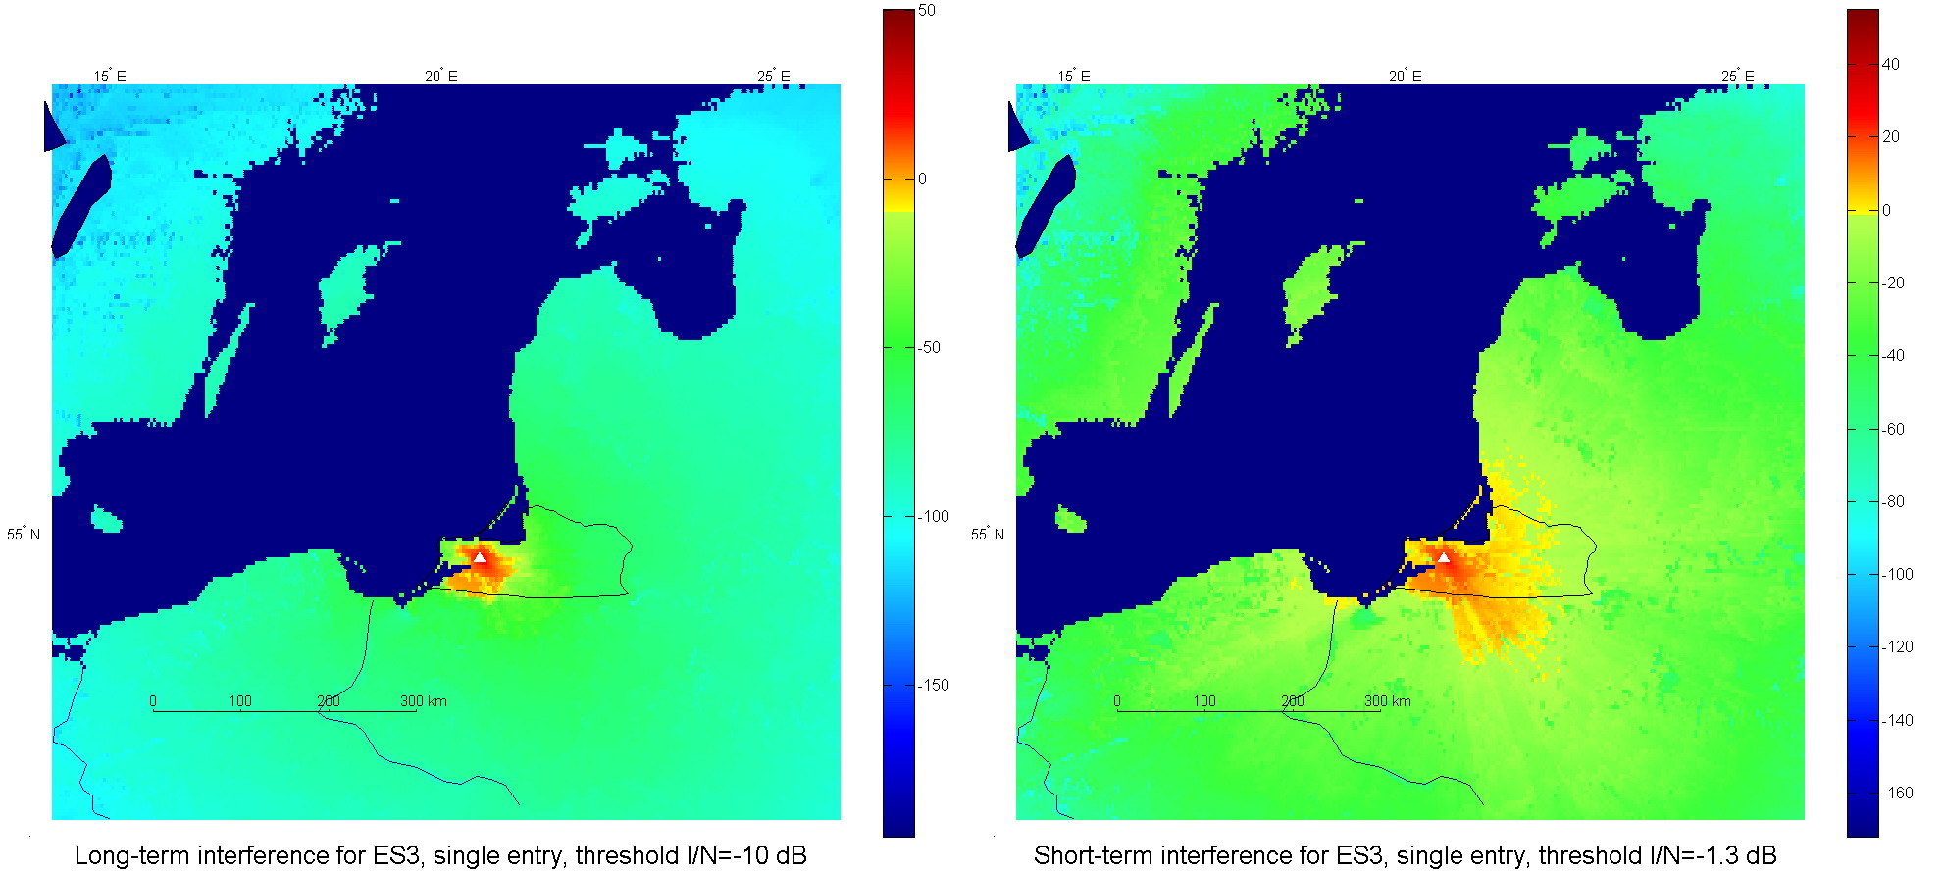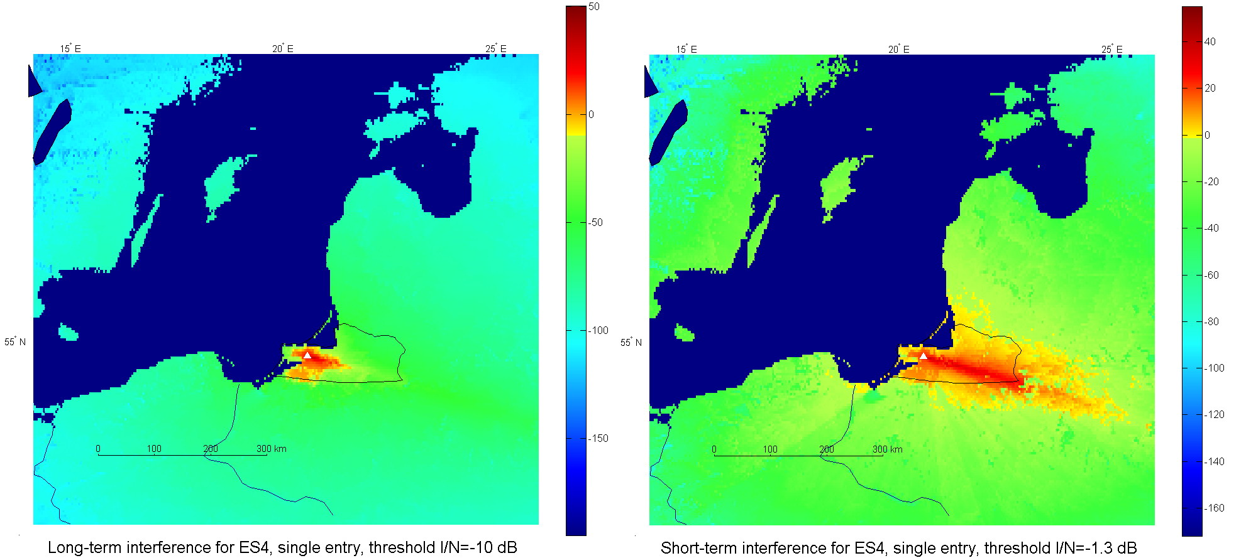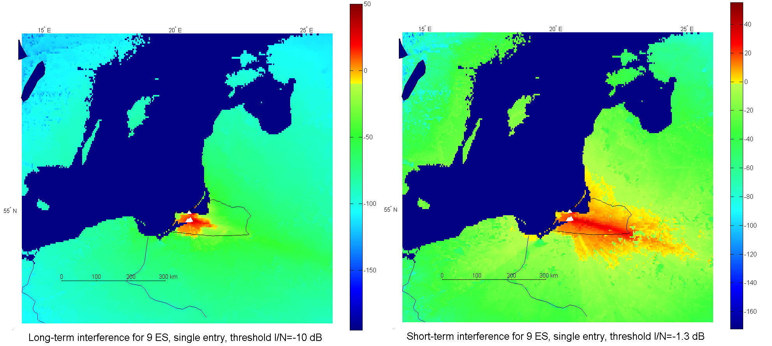
Figure B3
Example of interference power level from the IMT-Advanced base station
on FSS earth station considering terrain profile and without clutter losses
(Macro-cell deployment, antenna downtilt = 2°, five 20 MHz channels arrangement)
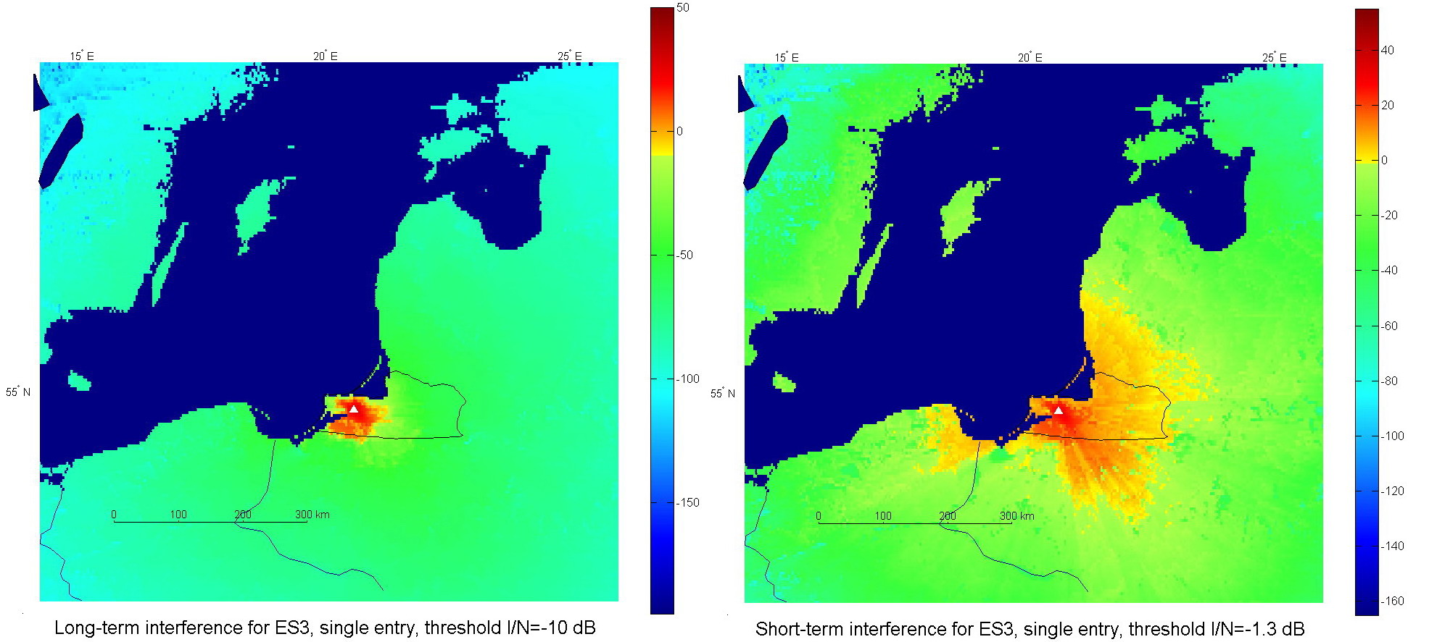
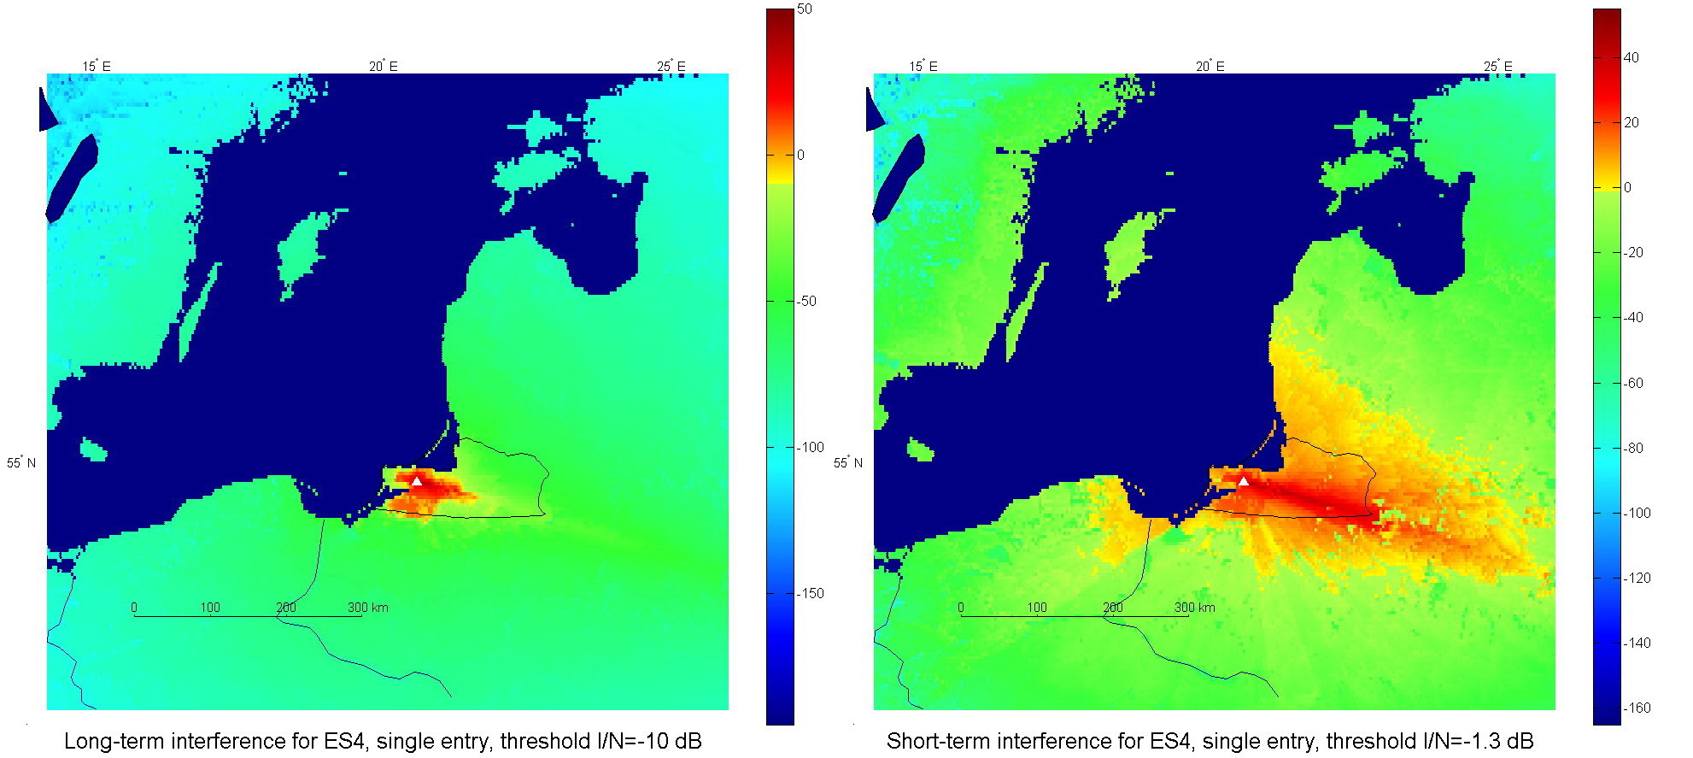
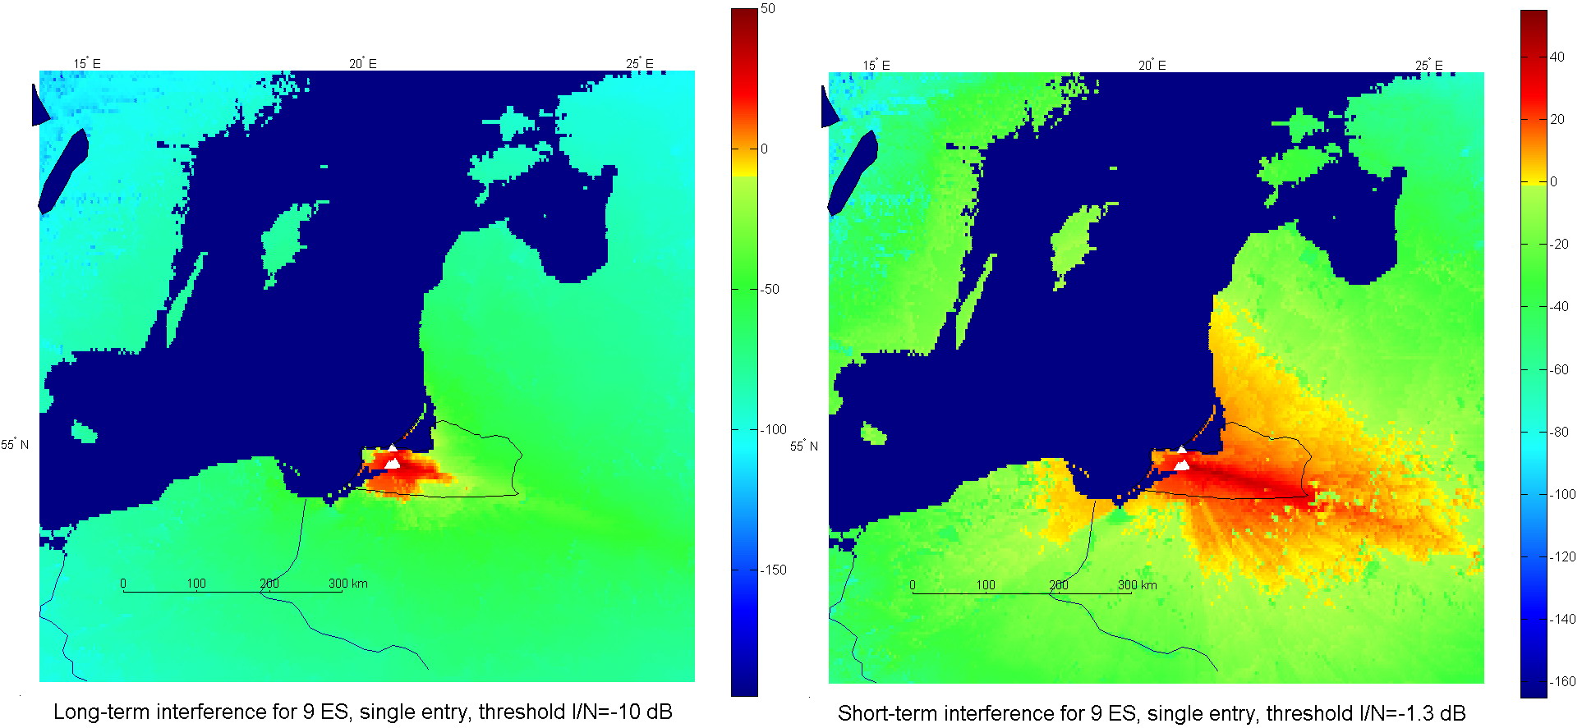
Annex C
Examples of coordination contours
The figures below provide examples of coordination contours taken from the ITU Master Register for some earth stations around the world. These contours have been derived using the ITU-R Appendix 7 methodology and criteria. The example earth stations are:

 | Earth station information |  |  | Satellite information
 | NAME | LONGITUDE | LATITUDE | SATELLITE NAME | LONGITUDE (NOMINAL)
1 | SI RACHA 2 | 100 E 56 11 | 13 N 06 02 | INTELSAT5 INDOC1 | 63
2 | AGARTALA | 91 E 16 00 | 23 N 48 00 | INSAT-1B | 74

It should be noted that RR Appendix 7 states (see § 1.1 of RR Appendix 7) that “the coordination area is not an exclusion zone within which the sharing of frequencies between the earth station and terrestrial stations or other earth stations is prohibited, but a means for determining the area within which more detailed calculations need to be performed. In most cases a more detailed analysis will show that sharing within the coordination area is possible since the procedure for the determination of the coordination area is based on unfavourable assumptions with regard to the interference potential”.
FIGURE 1a FIGURE 1b

Annex D
Sharing studies considering MIMO SDMA mitigation technique
In order to improve sharing conditions between IMT-Advanced and FSS, an interference mitigation technology such as MIMO SDMA can be utilized (see Report ITU-R M.2074 – Radio aspects for the terrestrial component of IMT-2000 and systems beyond IMT-2000 and Report ITU-R M.2038 – Technology trends). With such MIMO SDMA, IMT-Advanced base station can mitigate interference to a FSS earth station by generating null to the direction of the FSS earth station. The MIMO SDMA technique [Cheol Mun et al., 2005] which is enabled by the pre-coded multiple transmit antennas utilizes the additional degrees of freedom in a spatial domain. As such, by adjusting the coefficient of each antenna, the MIMO SDMA technique can form the desired radiation pattern which consists of main lobe and nulls.
This contribution presents a method to calculate the interference at the FSS earth station based on the MIMO SDMA technique as described earlier when the IMT-Advanced base station uses a MIMO SDMA technique and shows improvement in sharing condition between IMT-Advanced base station and FSS earth station.
With the assumptions of co-channel frequency sharing condition and free space channel environment, the interference power from an IMT-Advanced base station to a FSS earth station can be reduced smaller than the maximum permissible interference level while the distance between IMT-Advanced base station and FSS earth station is more than 35 m. In case of an IMT-Advanced base station and 3 FSS receiving earth stations, the minimum separation distance increases up to 3.5 km under the same assumptions. Moreover, up to 22° of estimation error in the direction of earth station (DOE), the minimum separation distance is reduced further by a MIMO SDMA and at the DOE estimation error of 8°, the minimum separation distance can be reduced by at least 50% compared to the separation distance without any interference mitigation scheme of 44 km.
This sharing study results indicate that the high possibility of the sharing between the IMT-Advanced and multiple FSS systems.
System modelling and interference mitigation techniques
The basic concept of the mitigation scheme is to form nulls in the spatial domain to the direction of the victim FSS earth station. For convenience, ‘DOE’ denotes the direction angles of the victim FSS earth station in this contribution.
To enable the MIMO SDMA technology, the IMT-Advance base station has to obtain DOE information and perform null steering. DOE information can be obtained by adopting a popular spatial spectrum estimation direction finding method or from the database including information about the direction from the interfering IMT-Advanced base station to the victim FSS earth station. It is assumed that the IMT-Advanced base station is already aware of DOE information for the FSS earth station.
Fig. D1 shows the interference scenario of IMT-Advanced base station with proposed interference mitigation technique, where IMT-Advanced base station constructs nulls at DOE θ₁, θ₂, and θ₃. Fig. D2 illustrates the IMT-Advanced base station null-steering beamformer structures for suppressing the interference toward FSS earth stations.

Figure D1
Interference scenario of IMT-Advanced base station with interference mitigation technique
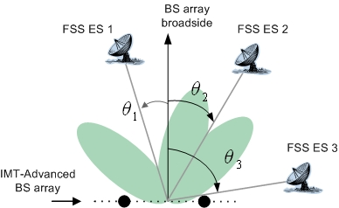
Figure D2
IMT-Advanced base station incorporating the interference mitigation technique
based on null- steering for MIMO downlinks with uniform linear array
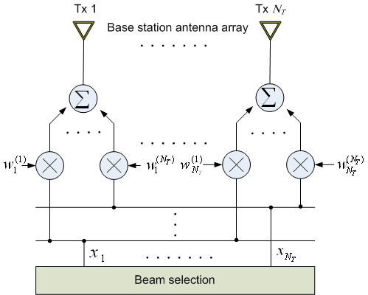
A linear array of $N_{T}$ isotropic antenna elements with uniform spacing is considered. The data signals$x_{k}$, $k=1,⋯,N_{T}$ from the beam selector are direct multiplied by a set of weights $U=\left\{w_{1},w_{2},⋯,w_{N_{T}}\right\}$ to form a null at known DOE. $w_{m}=\left[w_{1}^{\left(m\right)},w_{2}^{\left(m\right)},⋯,w_{N_{T}}^{\left(m\right)}\right]$is the m-th weight vector in row vector and is given by the following set of equations:

$\begin{aligned}w_{m}a\left(θ_{d}\right)=1 \\ w_{m}a\left(θ_{i}\right)=0; i=1,2,⋯,N_{T}−1\end{aligned}$

where a(θ) is the array propagation vector at an angle θ with respect to the array broadside and is defined by:

$a\left(θ\right)={\left[\begin{matrix}1 & e^{j2π\frac{d}{λ}\text{sin}θ} & ⋯ & e^{j2π\left(N_{T}−1\right)\frac{d}{λ}\text{sin}θ}\end{matrix}\right]}^{T}$

We can solve for the weight vector so that:

$W_{m}=A^{−1}\left[\begin{matrix}1 \\ 0 \\ ⋮ \\ 0\end{matrix}\right]$
where:

$A=\left[\begin{matrix}a\left(θ_{d}\right) & a\left(θ_{1}\right) & a\left(θ_{2}\right) & ⋯ & a\left(θ_{N_{T}−1}\right)\end{matrix}\right]$
Let us consider scenario where the spatial location of the desired user is at 0º with respect to the array broadside. There are multiple FSS earth stations at -50º, -20º, and 40º. IMT-Advanced base station is equipped with four antennas with half wavelength spacing between the antennas. Fig. D3 shows four mutually orthogonal overlapped beams generated by null-steering vectors $W_{m}$,$m=0,⋯,3$. $W_{0}$of four null-steering vectors constructs nulls at DOE -50º, -20º, and 40º as shown in Fig. D4 and thus is only used for IMT-Advance downlink service with the mitigation of interference to FSS earth station. Fig. D5 and D6 depict the IMT-Advanced base station radiation pattern regardless of whether the proposed algorithm is applied. The results confirm that, with the help of the proposed method, very little IMT-Advanced base station power is radiated to the FSS earth station.
Figure D3
Four mutually orthogonal overlapped beams generated by null-steering vectors

Figure D4
Single beam was selected from four overlapped beams, where
constructed three nulls at DOE -50º, -20º, and 40º
Figure D5
IMT-Advanced base station radiation patterns (Nt = 4, Nes = 3)

Figure D6
IMT-Advanced base station radiation patterns (Nt = 8, Nes = 6)
Results analysis
The interference received by the victim FSS earth station is depicted with various separation distances between single FSS earth station and IMT-Advanced base station in the Fig. D7. Nt and Nes denote the number of transmit antennas and FSS earth stations, respectively. The Fig. 7a) shows that the interference received by the victim FSS earth station almost approaches to the maximum permissible interference level, I_{max} without any interference mitigation schemes when the separation distance between the FSS earth station and IMT-Advanced base station is longer than 44 km. However, by using the MIMO SDMA, smaller windows are required to find the interference power that meets I_{max}, thus the interference becomes smaller than the maximum permissible interference power by the mitigation scheme at the separation distance of more than 35 m as shown in the Fig. 7b). Although the ideal case such that null beam to the FSS earth station can be formulated perfectly is assumed in the analysis, the results implies that the separation distance between IMT-Advanced and FSS earth station can be greatly reduced with the MIMO SDMA technique so that these two systems can co-exist in the same frequency with appropriate separation distance.
In addition, the imperfection in DOE estimation causes degradation in the improvement of the separation distance. The impact of the DOE estimation error to the gain of the interference mitigation technique is presented in the Fig. D8 and also in the Table D1. It is clear that the increase in the DOE estimation error causes the increase in the minimum separation distance between IMT-Advanced base station and FSS earth station. Even so, up to 22° of the DOE estimation error, the minimum separation distance with the MIMO SDMA can be still shorter than that without the interference mitigation scheme and at the DOE estimation error of 8°, the minimum separation distance can be half of the minimum distance without any interference mitigation schemes. It should be noted that the performance degradation of IMT-Advanced systems is expected when many users are around the direction of null beam of an IMT-Advanced base station.
Table D2 presents the required minimum distances for multiple FSS earth stations when proposed mitigation technique is employed. It is observed that, using the mitigation scheme, the minimum separation distances can be reduced less than 3.5 km. Our results indicate that the proposed mitigation scheme is highly efficient in terms of reducing simultaneously the required distances between single IMT-Advance base station and multiple earth stations.

Figure D7
Interference power comparison of the proposed interference mitigation
algorithm for the co-channel case (Nt = 4, Nes = 1)
a)
b)
Figure D8
Minimum separation difstance versus direction of earth
station estimation error (Nt = 4, Nes = 1)

TABLE D1
Minimum required separation distance for different (Nt = 4, Nes = 1)
Simulation environments |  | Minimum separation  distance  (km)
With interference mitigation techniques | DOE estimation error: 0° | 0.035
With interference mitigation techniques | DOE estimation error: 4° | 12
With interference mitigation techniques | DOE estimation error: 8° | 22
Without interference mitigation techniques |  | 50

TABLE D2
Required minimum distance
a) Nt = 4, Nes = 3
Minimum separation distance
(km)
 | 5° FSS earth station elevation angle | 48° FSS earth station elevation angle
Victim earth station 1 (DOE: –0º) | 1.4 | 1
Victim earth station 2 (DOE: –0º) | 3.5 | 2.5
Victim earth station 3 (DOE: 40º) | 3.3 | 2.3

b) Nt = 8, Nes = 6
Minimum separation distance
(km)
 | 5° FSS earth station elevation angle | 48° FSS earth station elevation angle
Victim earth station 1 (DOE: -60º) | 0.7 | 0.5
Victim earth station 2 (DOE: -45º) | 2.4 | 1.7
Victim earth station 3 (DOE: -10º) | 14 | 10
Victim earth station 4 (DOE: 40º) | 0.85 | 0.6
Victim earth station 5 (DOE: 50º) | 0.05 | 0.05
Victim earth station 6 (DOE: 55º) | 0.08 | 0.08

References

CHEOL MUN, et al. [15 December 2005] Space Division Multiplexing/Space Division Multiple Access Unitary Precoded MIMO. Proc. Of Wireless world research forum(WWRF).

Annex E
Assumptions and main results of Study 9

1 Assumptions

1.1 Line-of-sight
In line with equation (6) (and (5)) of Recommendation ITU-R P.452-12 for the effective radius of the earth and taking 60 as a representative annual average ΔN, the line-of-sight distance for the agreed antenna heights is calculated as follows:
TABLE E1
Line-of-sight distance
(km)
 | FSS antenna height (m) |  | Base station macro | Base station micro | User terminal
 | FSS antenna height (m) | IMT-Advanced station height (m) | 30 | 5 | 1.5
Urban | 30
Rural | 3 |  | 50 | 35 | 30
 |  |  | 33 | 18 | 13

It can be seen that the depending on the types of IMT-Advanced and FSS stations, the line-of-sight distance will range from 50 to 13 km. Using other values of ΔN will change the line-of-sight distance, but not significantly.

1.2 Far-field
Close to the antenna, the radiation pattern of an antenna will be characterized by the “near-field” pattern. As the distances to the antenna increases, the “far-field” pattern will form. Using the customary assumption for far-field conditions (a point source giving a phase variation of 22.5º over the aperture of the antenna, i.e., d = 2D²/λ, where D is the antenna diameter), the minimum distance to be in the far-field is shown in Fig. E1 (f = 3.8 GHz).

Figure E1
All calculations in this text are based upon the assumption of far-field antenna patterns of the FSS receive antenna. It can be seen that the required distance to be in the far-field ranges from some few hundred metres for small antennas to some few kilometres for large antennas. If the distance between the IMT-Advanced station and the FSS receive antenna is smaller than this, the assumed far-field antenna pattern may not give correct calculated interference levels.

1.3 Losses from local clutter
In cases where the direct line-of-sight is blocked by local obstructions, the propagation loss will increase. In the sensitivity analyses in this text, the impact of cases with such clutter losses have been addressed according to § 4.6 of Recommendation ITU-R P.452-12, using the two extreme cases; rural areas and dense urban areas. The calculated clutter losses for the different paths are shown in Table E2. It may be seen that the FSS receive antenna in many cases will stand up above the local clutter and no clutter loss will be encountered. The IMT-Advanced antennas will however in many cases be below the local clutter and clutter losses can occur. In the sensitivity analyses, clutter losses of 0 dB and 20 dB have been used as the two extreme cases. It may be noted that clutter losses in excess of about 3 dB is not predicted with respect to the base stations for this kind of rural terrain since the base stations will stand up above the local clutter. However, other types of rural surroundings, e.g. forests, could give higher losses and 20 dB has therefore been used as the upper extreme in all cases.
TABLE E2
Dense urban | 30 | 30 | 5 | 1.5 | 25 | 0.02 | -0.3 | -0.3 | 19.6 | 19.7
Rural | 3 | 30 | 5 | 1.5 | 4 | 0.1 | 3.1 | -0.3 | -0.3 | 17.3
 | FSS antenna height (m) | Macro base station | Micro base station | User term | Height of local clutter (m) (Rec. 452, Table 6) | Nominal distance from local clutter (km) (Rec. 452, Table 6) | Clutter loss FSS antenna (dB) | Clutter loss IMT-Advanced Macro base station antenna (dB) | Clutter loss IMT-Advanced Micro base station antenna (dB) | Clutter loss IMT-Advanced user terminal (dB)
 | FSS antenna height (m) | IMT-Advanced antenna height (m) | IMT-Advanced antenna height (m) | IMT-Advanced antenna height (m)

1.4 Unwanted emissions by IMT-Advanced equipment
The 3GPP TS 25.104 V7.5.0 (2006-12) standard for “band VII” (2.5 GHz) was used for determination of the expected levels of unwanted emissions from IMT-Advanced in 3 400-4 200 MHz.
This standard specifies the acceptable spurious emission levels outside the 2nd adjacent channel (Table 6.9E) and the acceptable out-of-band emission levels in the band of the 1st and 2nd adjacent channels (Tables 6.3, 6.5 and 6.6 Macro cell base station, Micro cell base station and User terminal respectively).
This 3GPP standard is based upon a 5 MHz channel bandwidth and specifies acceptable emission levels in different bandwidths for different off frequencies. Normalized to the channel bandwidth and emission levels per Hz, the requirements are as shown in Fig. E2.
FIGURE E2

It may be noted that in the spurious domain, the expected emission levels are the same for all types of stations.

2 Results
The total received RF power from one single IMT-Advanced station and the noise increase (ΔT/T) due to unwanted emissions 50, 100 and 250 MHz off the edge of the last channels from one single IMT-Advanced station were calculated as a function of distance between the FSS receiver and the IMT-Advanced transmitter. The results are presented in the Figs. E3 and E4.
FIGURE E3
Overdrive of LNB
FIGURE E4
Unwanted emissions
Annex F
Methodology “Interference Area Ratio” to be utilized with mitigation technique
Figure F1 shows the conceptual figure which indicates that the interference power level from an IMT-Advanced transmitter is non-uniformly decreased over the 360-degree area due to the shielding effect by terrain profile and clutter losses which may be observed in a real environment. Due to the feature of non-uniformly distributed interference power level over the 360-degree area, the required minimum separation distance can be reduced by using the additional mitigation technique based on directional-beam antenna.

FIgure F1
Shielding effect by terrain profile and clutter losses

In order to quantitatively evaluate this shileding effect, some studies use the methodology called “interference area ratio”. Figure F2 shows a conceptual figure to explain the definition of “interference area ratio”, where an IMT-Advanced transmitter is located at the center of the calculation area. When using the interference area ratio, at each grid of the calculation area, we calculate the interference power level caused by the IMT-Advanced transmitter and decide whether its interference power level exceeds the protection criteria of the FSS earth station based on Recommendation ITU-R SF.1006. If the interference power level exceeds the protection criteria, this grid is judged as the interfered area. Consequently, the interference area ratio as a function of distance, d, from the interferer, i.e., IMT-Advanced transmitter, is defined as the portion of the interfered area between the distance of d and d + Δd from the interferer divided by the ring-shaped area between the distance of d and d + Δd from the interferer. It should be noted that the analyses using the interference area ratio are also applicable to the aggregated interference case from multiple IMT-Advanced transmitters.
Figure F2
Definition of interference area ratio
When we derive the required separation distance for the interference area ratio of x%, we exclude the x% of area that has the larger separation distance over d + Δd. Then, the required separation distance becomes d + Δd. It should be noted that the additional mitigation technique based on directional-beam antenna, such as the sectorized-antenna and adaptive-beamforming antenna at the IMT-Advanced transmitters, is adopted in order to protect the FSS earth stations located in the x% of the area. Figure F3 shows an example employing sectorized-antenna as a mitigation technique. In this example, the transmission signal from the sector No. 6 of the IMT-Advanced transmitter No. 1 facing to the front direction of an FSS earth station antenna is stopped using a sectorized-antenna, while other base station No. 2, which is not facing to the front direction of an FSS earth station antenna, provides the services. It should be noted that the sectorized-antenna has been already implemented in the current cellular mobile communication technologies. Furthermore, the adaptive-beamforming has been also implemented in some cellular mobile communication systems. Therefore, these mitigation techniques can be applied to the IMT-Advanced systems.
Figure F3
Mitigation technique by utilizing sectorization
Annex G
Experimental evaluation on robustness against potential interference to TVRO
terminal from IMT-Advanced transmitter in the 3 400-4 200 MHz band

1 Introduction
Among a variety of application deployed FSS earth stations in the 3 400-4 200 MHz band, TVRO is one of the applications in some parts of the world, although whether to protect these TVRO earth stations from the interference caused by other stations within the own territory is a matter of each administration. Thus, it would be useful to provide the information on the robustness of TVRO terminals against potential interference from other systems in a real environment.
The following sections provide a study on the robustness against interference to a TVRO terminal in the 3 400-4 200 MHz band, where the interference is caused by an IMT-Advanced transmitter, based on the field experiment performed in one country.

2 Specification of a TVRO terminal
A commercial TVRO terminal which is typically available is used in the experiment. Tables G1 to G3 summarize the overall specifications of the TVRO terminal, TVRO antenna and LNB, respectively. As shown in Table G3, two types of LNBs having the different specifications are employed in the experiment.
TABLE G1
Specification of TVRO terminal
System capabilities | Fully DVB compliant
LNB tuner input | Connector | IEC 169-24 female
LNB tuner input | Frequency range | 950 MHz to 2 150 MHz
LNB tuner input | Signal level | –65 dBm to –25 dBm
LNB tuner input | LNB supply | 14/ 18 V, Max 400 mA
LNB tuner input | LNB switch control | 22 KHz, 0/ 12 V
LNB tuner input | DISEqC | Ver 1 2 and Ver 1.0 compatible
Demodulator | Frontend | QPSK
Demodulator | Symbol rate | 2 Msps to 45 Msps
Demodulator | SCPC and MCPC capable
Demodulator | Spectral inversion | Auto conversion
Video decoder | MPEG 2 | Main profile @ Main level
Video decoder | Data rate | Up to 15M bits/s
Video decoder | Resolution | 720 x 576, 720 x 480
Video decoder | Video format | NTSC, PAL
Video decoder | Aspect ratio | 4:3, 16:9
Teletext | DVB compliant
MPEG audio | MPEG 1 layer 1 and 2
MPEG audio | Type | Mono, Dual mono, Stereo, Joint stereo
MPEG audio | Sampling rate | 32,441 and 48 kHz

TABLE G2
Specification of TVRO terminal antenna
Antenna size | 2.4 m (96 in.)
Operating frequency | 3 625 to 4 200 MHz
Midband gain | 37.5 dBi (±0.2 dB)
3 dB beamwidth | 2.1°
Antenna noise temperature | 20° elevation 33K  30° elevation 31K
Feed interface | CPR 229F
Cross-polarization | >30 dB (on axis)
First sidelobe | –20 dB typical
Insertion loss | 0.2 dB Max
VSWR | 1.3:1 Max

TABLE G3
Specification of LNB
 | LNB (Type A) | LNB (Type B)
Input frequency | 3 400 to 4 200 MHz | 3 400 to 4 200 MHz
Output frequency | 950 to 1 750 MHz | 950 to 1 750 MHz
Noise figure | 17 K to 20 K @25° | 30 K(Max)
Gain | 65 dB typical | 60 dB(Min) to 72 dB(Max)  variation 6 dB(p-p)
Gain flatness | ±1.5 dB Max | ±1 dB/ 36 MHz
Image rejection | -- | 45 dB
RF band pass filter | Yes
Output VSWR | 2.0:1 Typical, 75 ohm
1 dB compression point | +10 dBm Min | 3 dBm
3rd order intercept point | +20 dBm Min
L0 frequency | 5 150 MHz | 5 150 MHz
L0 frequency stability | ±500 kHz Typical –40° C to +60° C | ±500 kHz(25° C)  ±1.5 MHz (–30° C to 60° C)
Phase noise | –73 dBc/Hz @ 1 kHz  –95 dBc/Hz @ 10 kHz  –110 dBc/Hz @ 100 kHz | –70 dBc/Hz @ 1 kHz  –90 dBc/Hz @ 10 kHz  –105 dBc/Hz @ 100 kHz
DC feed | +16 to +28 VDC | +12 to +20 VDC
Current | 210 mA Max | 150 mA Max
Operating temperature | –40° C to +60° C | –30° C to 60° C
Input interface | Flange, WR 229G | Flange, CPR-229G
Output interface | 75 Ohm, Type “F” Female Gold plated | 75 ohm Type “F” Female

3 Specification of an IMT-Advanced transmitter
Concrete specification of IMT-Advanced radio air-interference would be standardized after WRC-07 and is not available at the time of approval of this Report. Thus, in the experiment, the implemented transmitter having the specification shown in Table G4 is assumed to model a future envisaged IMT-Advanced transmitter.

TABLE G4
Specification of an IMT-Advanced transmitter used in experiment
Center frequency | 3.9 GHz
Frequency bandwidth | 100 MHz
Polarization | Vertical
Transmit power | 40 dBm/100 MHz
Antenna gain | 15 dBi
Antenna 3 dB width | 60°
Antenna height | 2.8 m
Modulation | OFDM
PAPR | 12 dB

4 Evaluation methodologies

4.1 Scenarios
In the experimental evaluation, three TV channels having the different frequency ranges and coding rate of forward error correction (FEC) code are selected, which are summarized in Table G5. By employing these TV channels, the scenarios of co-channel and adjacent-channel interference on a TVRO terminal from an IMT-Advanced transmitter are investigated as shown in Fig. G1.

TABLE G5
Parameters of TV channels used in experiment
Channel name | Center frequency | Intermediate frequency | Polarization | Symbol rate | Coding rate | Channel bandwidth
TV channel A | 3 904 MHz | 1 246 MHz | Vertical | 4.420 | 7/8 | 5.05 MHz
TV channel B | 3 895 MHz | 1 255 MHz | Vertical | 6.813 | 3/4 | 9.08 MHz
TV channel C | 3 834 MHz | 1 316 MHz | Vertical | 4.420 | 3/4 | 6 MHz

FIGURE G1
Frequency ranges of TV channels and interference signal from IMT-Advanced transmitter
In the experiment, the following two test scenarios are set up for the evaluation.
Static test scenario
In this scenario, the TVRO terminal receives the radio signal of TV channels from the satellite through the TVRO antenna, while the interference signal from the IMT-Advanced transmitter is given to the LNB input via the cable connection as shown in Figure G2. In this scenario, the interference signal power level does not have temporal fluctuation, but is in static condition.
FIGURE G2
Configuration of static test scenario
Dynamic test scenario
In this scenario, the TVRO terminal receives both the radio signal of TV channels from the satellite and the interference signal of the IMT-Advanced transmitter through the TVRO antenna as shown in Fig. G3. The power level of interfering signal is dynamically changed due to distance-dependent propagation loss, slow shadow-fading and fast fading phenomena caused in a real environment.
FIGURE G3
Configuration of dynamic test scenario

4.2 Evaluation criterion used in experiment
Although the employed TVRO terminal has a function to output the quality level in percentage, the technical details of this measure are not available. Meanwhile, subjective assessment methods are used to establish the performance of television systems using measurements that more directly anticipate the reactions of those who might view the systems tested. In Recommendation ITU-R BT.500-11 and ITU-T Recommendation P.800, there are similar subjective assessments so called Mean Opinion Score (MOS), which uses five-grade quality scale with Excellent (5), Good (4), Fair (3), Poor (2) and Bad (1). The numbers in the bracket represent the quality scale. This five-grade quality scale seems to be linear scale and it may be applicable for analogue and digital coding systems without bit-rate reduction. Therefore, in the experiment, the MOS quality grade having the quality grade of the received TV picture shown in Table G6 is employed.
TABLE G6
Definition of MOS quality grade in experiment
Quality grade of received TV picture | Conditions
5 | No influence
4 | Flickering or mosaic appeared once in a minute
3 | Flickering or mosaic appeared once in twenty seconds
2 | Flickering or mosaic appeared once in a second
1 | No picture

Figure G4 shows the relationship between two measures, the quality level in percentage output from the TVRO terminal and the MOS quality grade, obtained by the experiment using the static test scenario. As shown in this figure, there is correlation between these two measures. Therefore, the following results are evaluated based on the MOS quality grade as an evaluation criterion.
FIGURE G4
Relationship between “quality level output from TVRO terminal” and “MOS quality grade”

5 Experimental results

5.1 Static test scenario
In this test scenario, the TVRO terminal with the antenna diameter of 2.4 m was placed at the location of E139.40.32/ N35.13.27. The experiment was conducted under the conditions as shown in Table G7.
TABLE G7
Test location of static test scenario
TVRO antenna location | Yokosuka, E139.40.32/ N35.13.27
Antenna height (a.m.s.l) | 128.8 m
Weather | Shower

In the experiment, the measured LNB input channel power level, (C+N), was approximately using the LNB of Type A. In this case, the corresponding (C+N)/N value becomes approximately 17.5 dB assuming the noise temperature of 100 K.
Figures G5a) and b) show the quality of TV picture measured by the MOS quality grade as a function of the (C+N)/(I+N) for LNB Type A and Type B, respectively, where (C+N), N, and I represent the LNB input channel power level, thermal-noise power level, and interference power level from an IMT-Advanced transmitter, respectively. In this figure, the interference power level form an IMT-Advanced transmitter, I, is changed in the horizontal axis. As shown in the figure, the quality of TV picture is degraded in accordance with the increase in the interference power level. However, in order to maintain the same quality of TV picture, the FEC coding rate of 3/4 has more robustness against the interference power level by approximately 2 dB compared to that of 7/8. It should be noted that, according to the information on the TV channels provided by one satellite operator, among the fifty-seven TV channels, two, two, forty-seven, three, and five TV channels employ the FEC coding rate of 1/2, 2/3, 3/4, 5/6 and 7/8, respectively. Thus, in this case, approximately 80% of fifty-seven TV channels employ the FEC coding rate of 3/4.
Furthermore, when the co-channel and adjacent-channel interference scenarios are compared, the adjacent-channel interference scenario is more robust against the increase in the interference power level by approximately 14 dB, as shown in these figures.
FIGURE G5
Quality of TV picture measured by MOS quality grade as a function of (C +N)/(I +N)
a) LNB Type A
b) LNB Type B
Table G8 summarizes the required (C+N)/(I+N) level in order to maintain the MOS quality grade of 5, i.e., no influence on TV picture. Furthermore, the corresponding I/N level is derived through the calculation. According to this table, in terms of I/N value, the margin of approximately 25 dB and 42 dB is observed for co-channel and adjacent-channel interference scenarios, respectively, compared to I/N = –12.2 dB corresponding to the aggregate interference from other systems having co-primary status for 100% of the time described in Recommendation ITU-R S.1432.
TABLE G8
Required (C+N)/(I+N) to maintain MOS quality grade of 5
Channel type, Coding rate | Required (C + N)/(I + N) |  | I/N
Channel type, Coding rate | LNB Type A | LNB Type B | LNB Type A | LNB Type B
Co-channel, FEC = 7/8 | 4.5 dB | 5.5 dB | 13 dB | 12 dB
Co-channel, FEC = 3/4 | 1.5 dB | 2.5 dB | 16 dB | 15 dB
Adjacent-channel, FEC = 3/4 | –11.5 dB | –12.5 dB | 29 dB | 30 dB

5.2 Dynamic test scenario
In this test scenario, the TVRO terminal with the antenna diameter of 2.4 m was placed at the rural location of E140.41.33.6/ N36.41.88.1 as shown in Table G9. The experiment was conducted under the weather condition of clear-sky.
TABLE G9
Test location of dynamic test scenario
TVRO antenna location | Ibaraki, E140.41.33.6/ N36.41.88.1
Topographical statistics | mean 83 m / standard deviation 109 m
Antenna height (a.m.s.l) | 56 m
Antenna direction | 33.7° (elev.) / 229.7°(hor)
Weather | Clear-sky

In the experiment, different 26 locations were selected in order to place the IMT-Advanced transmitter as an interferer, where each location of the IMT-Advanced transmitter is shown in Fig. G6. Furthermore, the location of the TVRO terminal is shown at the center of this figure, where the direction of the arrow indicates the antenna-direction of TVRO terminal to receive the signal from satellite. By changing the location of the IMT-Advanced transmitter, point-to-point interference measurement between the IMT-Advanced transmitter and TVRO terminal is conducted at each location. In the measurement, averaged interference power level, its standard deviation value and delay-spread are recorded in every one second during five minutes. The interference power level to be used for the calculation of I/N is derived by the averaged value over five minutes.
FIGURE G6
Location of TVRO terminal and IMT-Advanced transmitter in dynamic test scenario
Table G10 summarizes the quality of TV picture measured by the MOS quality grade obtained by the measurement conducted at each location. As shown in the table, among 26 locations, the MOS quality grade of 5, i.e., no influence on the received TV quality, is observed at 25 and 24 locations in the case of co-channel interference scenarios with FEC coding rate of 3/4 and 7/8, respectively. Furthermore, in the case of adjacent-channel interference scenario, no influence on the received TV picture is observed at all the locations.
TABLE G10
MOS quality grade at respective locations
Location of  IMT-Advanced transmitter | MOS quality grade
Location of  IMT-Advanced transmitter | Co-channel,  FEC = 7/8 | Co-channel,  FEC = 3/4 | Adjacent-channel, FEC = 3/4
1 | 5 | 5 | 5
2 | 5 | 5 | 5
3 | 5 | 5 | 5
4 | 5 | 5 | 5
5 | 1 | 5 | 5
6 | 5 | 5 | 5
7 | 5 | 5 | 5
8 | 5 | 5 | 5
9 | 5 | 5 | 5
10 | 5 | 5 | 5
11 | 5 | 5 | 5
12 | 5 | 5 | 5
13 | 5 | 5 | 5
14 | 1 | 1 | 5
15 | 5 | 5 | 5
16 | 5 | 5 | 5
17 | 5 | 5 | 5
18 | 5 | 5 | 5
19 | 5 | 5 | 5
20 | 5 | 5 | 5
21 | 5 | 5 | 5
22 | 5 | 5 | 5
23 | 5 | 5 | 5
24 | 5 | 5 | 5
25 | 5 | 5 | 5
26 | 5 | 5 | 5

Figure G8 summarizes the relationship of the (C+N)/(I+N) value and distance between the TVRO terminal and IMT-Advanced transmitter. In the figure, the required (C+N)/(I+N) levels to maintain the MOS quality grade of 5 that are obtained by the static test scenario are also depicted in the case of FEC coding rate of 3/4 and 7/8, respectively. Furthermore, the required (C+N)/(I+N) level which corresponds to I/N = –12.2 dB is shown for reference.
FIGURE G8
Relationship of (C +N)/(I +N) value and distance between the TVRO terminal
and IMT-Advanced transmitter
Finally, in Fig. G9, the experimental results and the results which are simulated by the required protection criteria and propagation model by Recommendation ITU-R P.452 are compared. In Fig. 9a) and b), the gradation color indicates the area where the received interference power level at TVRO terminal exceeds the required protection criteria, when assuming (from ITU-R Recommendation for FSS systems carrying digital traffic) and +12 dB (from the experiment), respectively. In the figure, the white color indicates the area where the received interference power level at TVRO terminal does not exceed the protection criteria. The interference power level is calculated by assuming the propagation model shown in Recommendation ITU-R P.452 using the terrain data model and the additional clutter losses due to artificial objects. Furthermore, the location of the IMT-Advanced transmitter in the experiment is also shown in these figures, where the quality of the TV picture is damaged by the IMT-Advanced transmitter placed at the location 5 and 14 in the case of co-channel interference scenario with FEC coding rate of 7/8. As shown in Fig. 9a) assuming the criterion of I/N = –12.2 dB, most of locations of IMT-Advanced transmitter are expected to impact the quality of the TV picture in this area, however, this is not the case in the experiment in a real environment. Meanwhile, as shown in Fig. 9b) assuming the criterion of I/N = +12 dB, the location of the IMT-Advanced transmitter which is expected to impact the quality of TV picture is more accurately approximated compared with the area shown in Fig. 9a).
FIGURE 9
Comparison between experimental results and simulation results based on
Recommendation ITU-R P.452 propagation model
a) I /N = –12.2 dB
b) I /N = +12 dB

6 Summary of study
The study on the robustness against interference to a TVRO terminal in the 3 400-4 200 MHz band, where the interference is caused by an IMT-Advanced transmitter, based on the field experiment performed in one country is summarized as follows:
a) When the distance between an IMT-Advanced transmitter and a TVRO terminal is ranged from 345 to 5,420 m comprising different 26 locations, no influence on the quality of the received TV picture is observed at 25 and 26 locations in the case of the co-channel and adjacent interference scenarios, respectively, with FEC coding rate of 3/4.
b) TV channel employing FEC coding rate of 3/4 has more robustness against the increase in the co-channel interference power level by approximately 2 dB compared to that of 7/8 in order to maintain the same quality of the received TV picture.
c) The influence on the quality of the received TV picture for adjacent-channel interference scenario is smaller compared to that for co-channel scenario. In order to maintain the same quality of the received TV picture, approximately 14 dB more power of an IMT-Advanced transmitter is permitted in the adjacent-channel interference scenario compared to the co-channel interference scenario.

Annex H
Adjacent band operations: Impact of the spurious emission
of a Single IMT-Advanced transmitter into FSS receivers
In accordance with RR Appendix 3, it is assumed that the IMT-Advanced transmitters would be specified such that its spurious emission at frequency separation of 2.5x (Necessary Bandwidth) from the center frequency of the IMT-Advanced carrier, measured in bandwidth of 1 MHz, would be attenuated by 43 + 10 log(P) dB or 70 dBc, whichever is less stringent, below the transmitter power level P, where P is in watts.
The analyses presented here are based on the propagation models described in ITU-R P.452-12. Due to the generic nature of the analysis, for the long-term protection cases, the propagation is calculated over a smooth earth surface, utilizing the propagation model described in § 4.3 of ITU-R P.452-12. The models in ITU-R P.452-12 can include the effects of building losses and clutter where the topography of surrounding obstacles etc. is known. However, due to lack of information for these parameters, the building losses and clutter effects has been assumed to represent suburban environment in these analyses.
Furthermore, Recommendation ITU-R S.1432 contains the apportionment of the allowable error performance degradation to the FSS systems due to interference. This Recommendation states that for all sources of long-term interference that is neither from FSS systems, nor from systems having co-primary status, the allotted portion of the aggregate interference budget is 1%. This has been expressed in other forums as a required protection criterion of I/N = -20 dB (i.e. ΔT/T ≤ 1%). The unwanted emissions interference contribution from an adjacent band would be considered as one of these “other sources of interference”. The analysis is based on:
Case A:
– The IMT-Advanced transmitter spurious emission limit of -43 dBW/MHz per RR Appendix 3.
– For IMT-Advanced carrier bandwidths of 20 and 100 MHz, the above spurious emission limit must be met at frequency separation of 40 and 200 MHz away from the edge of the IMT-Advanced allocated band, respectively. In other words, these values represent the necessary frequency separation between these services for the computed separation distances.
– The FSS receiver antenna receives IMT-Advanced transmitter spurious emission at its 10º off-axis gain.
– The analysis is based on the impact of a single IMT-Advanced transmitter.
Figures H1 and H2 depict the required minimum separation distance for a Single IMT-Advanced transmitter from FSS receivers operating in an adjacent band to the IMT-Advanced system. The minimum separation distance resulting in ΔT/T increase of ≤ 1%, are 18 km and 300 m for IMT-Advanced Macro base station and mobile station, respectively. It should be noted that if the entire allowable 1% noise increase is used up by the spurious emission interference from a single IMT-Advanced transmitter, there would be no further allowances for any other sources of interference (in practice, there are many other sources of interference that their operation would compound and contribute to this 1% noise increase). Depending on the number of IMT-Advanced carriers and simultaneous IMT-Advanced transmissions, the required minimum separation distance due to aggregate impact of the spurious emission interference would be even larger. The ”“ markers in the figures point to the required minimum separation distances in relation to the ΔT/T increases of 1% and 0.5%.

Figure H1
Case A: Required minimum separation distance versus FSS earth station receiver ΔT/T
due to spurious emission interference from a single IMT-Advanced macro base station transmitter
(assuming LoS with diffraction path loss model)
Figure H2
Case A: Required minimum separation distance versus FSS earth station receiver ΔT/T
due to spurious emission interference from a single IMT-Advanced mobile station transmitter
(assuming LoS with diffraction path loss model)
Case B:
– The IMT-Advanced transmitter spurious emission limit of -43 dBW/MHz per RR Appendix 3.
– Assumed 10 dB additional reduction of IMT-Advanced transmitted spurious emission due to implementation of special band-edge filters, additional blocking losses, other mitigation techniques or a combination of them.
– For IMT-Advanced carrier bandwidths of 20 and 100 MHz, the above spurious emission limit must be met at frequency separation of 40 and 200 MHz away from the edge of the IMT-Advanced allocated band, respectively. In other words, these values represent the necessary frequency separation between these services for the computed separation distances.
– The FSS receiver antenna receives IMT-Advanced transmitter spurious emission at its 10º off-axis gain.
– The analysis is based on the impact of a single IMT-Advanced transmitter.
Figures H3 and H4 depict the required minimum separation distance for a single IMT-Advanced transmitter from FSS receivers operating in an adjacent band to the IMT-Advanced system. The minimum separation distance resulting in ΔT/T increase of ≤ 1.0% assuming an additional 10 dB reduction of IMT-Advanced transmitted spurious emission, are 5 km and 100 m for IMT-Advanced Macro base station and mobile station, respectively. Depending on the number of IMT-Advanced carriers and simultaneous IMT-Advanced transmissions, the required minimum separation distance due to aggregate impact of the spurious emission interference would be even larger.
Figure H3
Case B: Required minimum separation distance versus FSS earth station receiver ΔT/T
due to spurious emission interference from a single IMT-Advanced macro base station transmitter,
where spurious level is reduced by an additional 10 dB
(assuming LoS with diffraction path loss model)

Figure H4
Case B: Required minimum separation distance versus FSS earth station receiver ΔT/T
due to spurious emission interference from a single IMT-Advanced mobile station transmitter,
where spurious level is reduced by an additional 10 dB
(assuming LoS with diffraction path loss model)
Case C:
– The IMT-Advanced transmitter spurious emission limit of -43 dBW/MHz per RR Appendix 3.
– Assumed 40 dB and 50 dB additional reduction of IMT-Advanced transmitted spurious emission due to implementation of special band-edge filters, additional blocking losses, other mitigation techniques or a combination of them.
– For IMT-Advanced carrier bandwidths of 20 and 100 MHz, the above spurious emission limit must be met at frequency separation of 40 and 200 MHz away from the edge of the IMT-Advanced allocated band, respectively. In other words, these values represent the necessary frequency separation between these services for the computed separation distances.
– The FSS receiver antenna receives IMT-Advanced transmitter spurious emission at its 10º off-axis gain.
– The analysis is based on the impact of a single IMT-Advanced transmitter.
Figures H5 and H6 depict the required minimum separation distance for a single IMT-Advanced transmitter from FSS receivers operating in an adjacent band to the IMT-Advanced system assuming the IMT-Advanced transmitter spurious emission level is reduced by an additional amount of 40 dB and 50 dB. The minimum separation distance resulting in ΔT/T increase of ≤ 1.0% would be in the range of 115 m to 35 m for IMT-Advanced macro base station. It should be noted that depending on the number of IMT-Advanced carriers and simultaneous IMT-Advanced transmissions, the required minimum separation distance due to aggregate impact of the spurious emission interference would increase accordingly.
Figure H5
Case C: Required minimum separation distance versus FSS earth station receiver ΔT/T
due to spurious emission interference from a single IMT-Advanced macro base station transmitter,
where spurious level is reduced by an additional 40 dB
(assuming LoS with diffraction path loss model)
Figure H6
Case C: Required minimum separation distance versus FSS earth station receiver ΔT/T
due to spurious emission interference from a single IMT-Advanced macro base station transmitter,
where spurious level is reduced by an additional 50 dB
(assuming LoS with diffraction path loss model)
Table H1 depicts a summary of the derived required minimum separation distances to protect FSS earth stations receiver assuming Single-entry interference from IMT-Advanced transmitters operating in the adjacent band. The assumed values of 1.0%, 0.5% noise increase allotment and the 10 dB, 40 dB and 50 dB additional spurious emission levels reduction values are arbitrarily chosen and are used for illustration purposes.
TABLE H1
The minimum required separation distances to protect FSS receivers
from single-entry interference of IMT-Advanced transmitter
spurious emission operating in the adjacent band
a)
Percentage increase of FSS system noise | 1.0% | 0.5% |  | 1.0% | 0.5%
The assumed additional reduction of IMT-Advanced transmitter spurious emission level (dB) | 0 | 0 |  | 10 | 10
IMT-Advanced macro base station | 18 km | 25 km |  | 5 km | 7.5 km
IMT-Advanced mobile station | 300 m | 450 m |  | 100 m | 140 m
b)
Percentage increase of FSS system noise | 1.0% | 0.5% |  | 1.0% | 0.5%
The assumed additional reduction of IMT-Advanced transmitter spurious emission level (dB) | 40 | 40 |  | 50 | 50
IMT-Advanced macro base station | 115 m | 150 m |  | 35 m | 50 m

The results of this study show that operation of IMT-Advanced systems and the FSS in adjacent bands in the 4 GHz frequency range is very difficult and may not be feasible in the same geographical area if the IMT-Advanced transmitter spurious emission is defined in accordance with the limits specified in RR Appendix 3. As depicted in Table H1a), large separation distances would be required to satisfy the long-term protection criterion of an FSS receiver from the spurious emission of a single IMT-Advanced transmission in the adjacent band at a given frequency separation. For example, the required minimum separation distance from FSS earth stations would be 18 km for the case of transmission from only one IMT-Advanced base station transmitter, assuming that the entire allowable FSS system noise increase due to other services is allocated to IMT-Advanced equipment spurious emission. Even if the IMT-Advanced spurious emission was reduced by an additional 10 dB from the specified limits of RR Appendix 3, the required minimum separation distance from FSS earth stations would be 5 km for the case of transmission from only one IMT-Advanced base station transmitter, assuming that the entire allowable FSS system noise increase due to other services is allocated to IMT-Advanced systems. Depending on the number of IMT-Advanced carriers and simultaneous IMT-Advanced transmissions, aggregate interference from IMT-Advanced transmitters are expected to result in even larger required minimum separation distances from FSS earth stations.
However, as depicted in Table H1b), if the IMT-Advanced transmitter spurious emission level is reduced by an additional 40 to 50 dB from the specified limits in RR Appendix 3, then the required separation distances due to interference from a single IMT-Advanced transmitter become very small and it would facilitate the operation of IMT-Advanced and FSS systems in adjacent bands in the 4 GHz frequency range. The exact value of the required additional reduction of the spurious emission level would depend on the expected aggregate interference from IMT-Advanced devices. Additional information on the IMT-Advanced network design (e.g., cell size, mobile unit distribution, access schemes, protocols, etc.) is required to be able to assess the expected aggregate interference from IMT-Advanced networks into FSS receivers operating in adjacent frequency bands.

Additional band usage information on the FSS in the 3 400-4 200 MHz and 4 500-4 800 MHz bands is summarized in Table 1 of Report ITU-R M.2079.
Recommendation ITU-R P.1411 – Propagation data and prediction methods for the planning of short-range outdoor radiocommunication systems and radio local area networks in the frequency range 300 MHz to 100 GHz
Application case refers to the use of a specific terrain profile considered in all the contributions except STUDY 7 that contains results relating to a multi-carrier scheme (IMT-Advanced) with a flat terrain profil.
The number of the aggregate base stations is determined according to the methodology defined in the § 8.1.1 and the cell size values defined in the Table 3.

