|  |
| --- |
| **Report ITU-R M.2206**  **(11/2010)** |
| **Sharing between the aeronautical mobile service and the fixed service  in the band 37-38 GHz** |
| **M Series**  **Mobile, radiodetermination, amateur**  **and related satellite services** |

Foreword

The role of the Radiocommunication Sector is to ensure the rational, equitable, efficient and economical use of the radio-frequency spectrum by all radiocommunication services, including satellite services, and carry out studies without limit of frequency range on the basis of which Recommendations are adopted.

The regulatory and policy functions of the Radiocommunication Sector are performed by World and Regional Radiocommunication Conferences and Radiocommunication Assemblies supported by Study Groups.

# Policy on Intellectual Property Right (IPR)

ITU-R policy on IPR is described in the Common Patent Policy for ITU-T/ITU-R/ISO/IEC referenced in Annex 1 of Resolution ITU-R 1. Forms to be used for the submission of patent statements and licensing declarations by patent holders are available from <http://www.itu.int/ITU-R/go/patents/en> where the Guidelines for Implementation of the Common Patent Policy for ITU‑T/ITU‑R/ISO/IEC and the ITU-R patent information database can also be found.

|  |  |
| --- | --- |
| Series of ITU-R Reports  (Also available online at <http://www.itu.int/publ/R-REP/en>) | |
| **Series** | Title |
| **BO** | Satellite delivery |
| **BR** | Recording for production, archival and play-out; film for television |
| **BS** | Broadcasting service (sound) |
| **BT** | Broadcasting service (television) |
| **F** | Fixed service |
| **M** | Mobile, radiodetermination, amateur and related satellite services |
| **P** | Radiowave propagation |
| **RA** | Radio astronomy |
| **RS** | Remote sensing systems |
| **S** | Fixed-satellite service |
| **SA** | Space applications and meteorology |
| **SF** | Frequency sharing and coordination between fixed-satellite and fixed service systems |
| **SM** | Spectrum management |

|  |
| --- |
|  |

|  |
| --- |
| ***Note****: This ITU-R Report was approved in English by the Study Group under the procedure detailed   in Resolution ITU-R 1.* |

*Electronic Publication*

Geneva, 2011

© ITU 2011

All rights reserved. No part of this publication may be reproduced, by any means whatsoever, without written permission of ITU.

REPORT ITU-R M.2206

Sharing between the aeronautical mobile service  
and the fixed service in the band 37-38 GHz

(2010)

TABLE OF CONTENTS

Page

1 Introduction 2

2 P-P FS system characteristics 3

3 Deployment of FS stations in the 38 GHz band in one country 4

4 Determination of an AMS pfd mask for the protection of FS 4

4.1 Existing mask in RR Article 21 4

4.2 Dynamic analysis 6

4.3 Definition of a “combined” pfd mask FS/SRS 9

4.4 FS short-term criterion 10

4.5 Protection of point-to-multipoint FS systems 10

5 Impact of the FS on AMS receivers 11

5.1 Aeronautical mobile service parameters 11

5.2 Simulation parameters 12

6 Conclusion 14

Objective

This Report gives the results of sharing studies between the aeronautical mobile service and the fixed service in the band 37-38 GHz performed under the framework of WRC-12 Agenda item 1.12[1].

Abbreviations

AMS Aeronautical mobile service

FDMA Frequency-division multiple access

FDP Fractional degradation in performance

FS Fixed service

FSS Fixed-satellite service

GSO Geostationary satellite orbit

HDFS High density applications in the fixed service

MSS Mobile-satellite service

P-MP Point-to-multipoint

P-P Point-to-point

SRS Space research service

WAIC Wireless avionics intra-aircraft communications

References

Recommendation ITU-R F.758 – Considerations in the development of criteria for sharing between the terrestrial fixed service and other services

Recommendation ITU-R F.1245 – Mathematical model of average radiation patterns for line‑of‑sight point-to-point radio-relay system antennas for use in certain coordination studies and interference assessment in the frequency range from 1 GHz to about 70 GHz

Recommendation ITU-R F.1094 – Maximum allowable error performance and availability degradations to digital fixed wireless systems arising from radio interference from emissions and radiations from other sources

# 1 Introduction

WRC-12 Agenda item 1.12 deals with the protection of primary services in the band 37-38 GHz from interference resulting from aeronautical mobile service operations, taking into account the results of ITU‑R studies, in accordance with Resolution 754 (WRC-07).

This Resolution *resolves*

**1** to invite ITU‑R to conduct appropriate studies involving the aeronautical mobile service and the affected primary services in the band 37-38 GHz in order to determine the compatibility of the aeronautical mobile service with these other services;

**2** to invite WRC‑12 to review the results of the studies under *resolves* 1 and consider the inclusion of any appropriate compatibility criteria within the Radio Regulations (RR) or appropriate modifications to the Table of Frequency Allocations.

This Report analyses the protection of FS station receivers from interference that may occur from aircraft station transmitters operating under the mobile service primary allocation. The paper essentially addresses the case of point-to-point (P-P) FS stations. However, it is expected that the pfd mask derived for the protection of P-P systems will also cover the protection of point‑to‑multipoint (P-MP) system’s central and customer stations.

The impact of a high density of FS stations on current AMS receivers is also analyzed.

# 2 P-P FS system characteristics

The characteristics of FS systems are provided in Recommendation ITU-R F.758-4 and reproduced in Table 1.

The pfd level corresponding to the FS nominal long-term interference spectral density given in the tables of Recommendation ITU-R F.758-4 may be expressed as follows:

 (1)

where:

*I* : protection criterion of the FS station (dBW/MHz)

*L* : feeder loss (dB)

*G* : antenna gain towards the AMS station (dBi)

● : wavelength (m).

This equation may be directly used to determine the worst case in terms of susceptibility to interference between all P-P FS systems. Using Recommendation ITU-R F.1245 for the antenna pattern of the FS station, the worst cases may be determined using the long-term criterion at the horizon and at the zenith. In the first case, the antenna gain *G* is the maximum antenna gain of the FS station. In the second case the antenna gain *G* equals −13 dBi.

The worst case is taken into account in the following analyses and is reproduced in Table 1.

TABLE 1

Worst-case P-P FS characteristics

|  |  |  |  |
| --- | --- | --- | --- |
| Channel spacing (MHz) | 3.5 | 7 | 28 |
| Antenna gain (maximum) (dBi) | 47 | 47 | 47 |
| Feeder/multiplexer loss (minimum) (dB) | 0 | 0 | 0 |
| Antenna type | Dish | Dish | Dish |
| Maximum Tx output power (dBW) | −15 | −15 | −15 |
| e.i.r.p. (maximum) (dBW) | 32 | 32 | 32 |
| Receiver IF bandwidth (MHz) | 3.5 | 7 | 28 |
| Receiver noise figure (dB) | 7.5 | 7.5 | 7.5 |
| Receiver thermal noise (dBW) | −132.5 | −129.5 | −123.5 |
| Nominal long-term interference (dBW) | −142.5 | −139.5 | −133.5 |
| **Spectral density (dB(W/MHz))** | −**147.9** | −**148.0** | −**148.0** |
| Corresponding pfd at the horizon (dBW/m2/MHz) | −142.0 | −142.0 | −142.0 |
| Corresponding pfd at zenith (dBW/m2/MHz) | −82.0 | −82.0 | −82.0 |

These systems also correspond to the worst case in terms of e.i.r.p. and impact on the AMS.

In addition to the nominal long-term interference criterion given in this table, which is associated with a percentage of time of 20%, it is proposed to retain a short-term criterion based on *I*/*N* of +10 dB associated with a percentage of time of 0.013% based on Recommendation ITU‑R F.1606.

It should be noted that the corresponding pfd given in the table are not to be used as such for the definition of a pfd mask, since they are associated with a percentage of time of 20%.

# 3 Deployment of FS stations in the 38 GHz band in one country

The 38 GHz band, together with the 23 GHz band, are extensively used for the capillary network linking the mobile network base stations to the high-capacity fixed links in the lower bands or fibre optic networks. The result is a very large number of small star networks using the 23 GHz and 38 GHz bands, the former for the longer links, and the latter for the shorter links. The total number of stations deployed in the 38 GHz band is 15 792 stations (used in 7 896 links)[2], which shows the importance of the deployment. 11 864 of these stations are deployed in the 37-38 GHz band. Information was received from one single operator that about 4 200 of his stations use two different blocks of 28 MHz (56 MHz total).

Table 2 gives the distribution of elevation angles of FS stations deployed in the band 37‑39.5 GHz in one country.

TABLE 2

Elevation angle distribution for fixed service stations in the 38 GHz band in one country

|  |  |  |
| --- | --- | --- |
| Elevation angle  (degrees) | Number of stations | Percentage of stations  in the band (%) |
| 0 and below | 7 860 | 49.77 |
| 0-5 | 7 509 | 47.54 |
| 5-10 | 279 | 1.76 |
| 10-15 | 95 | 0.60 |
| 15-20 | 29 | 0.18 |
| 20-25 | 12 | 0.075 |
| 25-30 | 4 | 0.025 |
| 30-90 | 4 | 0.025 |

# 4 Determination of an AMS pfd mask for the protection of FS

## 4.1 Existing mask in RR Article 21

RR Article 21 gives, for the 37-38 GHz band, a pfd mask for the protection of the fixed service from GSO and non-GSO FSS, MSS and SRS satellites. The pfd mask related to non‑GSO satellites is reproduced in Fig. 2.

Figure 1

Distribution of FS stations elevation angles in one country at 38 GHz



Figure 2

RR Article 21 pfd mask related to non-GSO satellite in the band 37-38 GHz

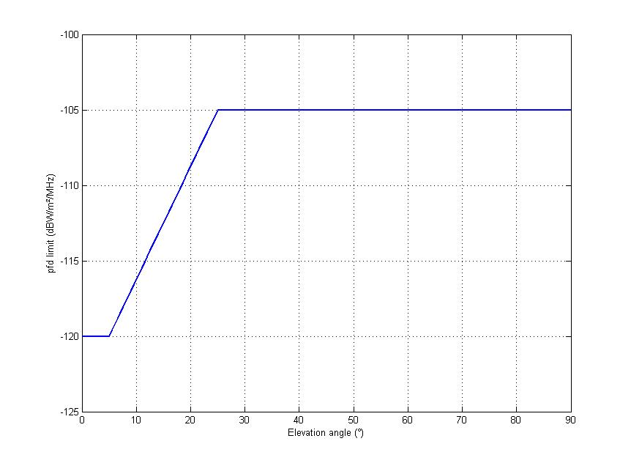

It is proposed to retain as a tentative the same pfd mask for the protection of FS from AMS. As this mask relates to the power flux-density that would be obtained assuming free-space loss, an additional attenuation due to atmospheric loss factors will be added in the dynamic simulation.

## 4.2 Dynamic analysis

It is necessary to verify that the mask defined in § 4.1 is sufficient to protect the fixed service from harmful interference from AMS, in particular for the long term through a dynamic simulation. This is done through the same kind of simulation that was used for the AMSS at 14 GHz before 2003. In particular, the air-traffic assumptions are the same as in the sharing study between AMSS and FS and between AMSS and RAS before 2003.

Fifty aircraft are deployed on air routes above the territory of France. Their altitude is either 1 000, 5 000 or 10 000 m, and their speed 800 km/h. Figure 3 shows the air routes simulated.

Figure 3

Air routes considered for simulation



Two hundred and twenty-five FS stations are then deployed for each half degree of longitude and latitude between −1° and 6° of longitude and 43° and 50° of latitude. The FS station elevation angle is fixed (either 0.5 or 10°). The azimuth pointing angle is random with a uniform distribution. The maximum antenna gain is 47 dBi and the antenna pattern used follows Recommendation ITU‑R F.1245.

The fractional degradation of performance (FDP) parameter is then calculated over one hour with a time step of one second while the aircraft are moving over the air routes. The results are given in Table 3 for the 225 stations pointing at an elevation angle of 0°, Table 4 for the 225 stations pointing at an elevation angle of 5° and in Table 5 for an elevation angle of 10°.

TABLE 3

FDP values obtained for the 64 FS stations (in percentage) for the elevation 0°

|  |  |  |  |  |  |  |  |  |  |  |  |  |  |  |
| --- | --- | --- | --- | --- | --- | --- | --- | --- | --- | --- | --- | --- | --- | --- |
| 0.00 | 0.00 | 0.03 | 0.01 | 0.02 | 0.01 | 0.00 | 0.02 | 0.02 | 0.02 | 0.02 | 0.00 | 0.00 | 0.01 | 0.00 |
| 0.01 | 0.01 | 0.00 | 0.02 | 0.01 | 0.00 | 0.01 | 0.01 | 0.01 | 0.02 | 0.03 | 0.03 | 0.01 | 0.02 | 0.00 |
| 0.03 | 0.01 | 0.01 | 0.02 | 0.03 | 0.01 | 0.00 | 0.00 | 0.00 | 0.04 | 0.04 | 0.04 | 0.01 | 0.03 | 0.00 |
| 0.00 | 0.01 | 0.01 | 0.02 | 0.01 | 0.01 | 0.01 | 0.02 | 0.02 | 0.01 | 0.02 | 0.02 | 0.01 | 0.04 | 0.02 |
| 0.01 | 0.01 | 0.01 | 0.02 | 0.01 | 0.02 | 0.03 | 0.02 | 0.02 | 0.02 | 0.04 | 0.06 | 0.03 | 0.00 | 0.02 |
| 0.01 | 0.02 | 0.02 | 0.02 | 0.01 | 0.02 | 0.01 | 0.03 | 0.02 | 0.06 | 0.03 | 0.03 | 0.04 | 0.02 | 0.03 |
| 0.00 | 0.01 | 0.01 | 0.03 | 0.02 | 0.01 | 0.01 | 0.02 | 0.03 | 0.01 | 0.03 | 0.05 | 0.03 | 0.02 | 0.02 |
| 0.00 | 0.01 | 0.03 | 0.01 | 0.02 | 0.01 | 0.02 | 0.04 | 0.02 | 0.02 | 0.04 | 0.04 | 0.02 | 0.05 | 0.19 |
| 0.00 | 0.02 | 0.01 | 0.02 | 0.02 | 0.02 | 0.04 | 0.04 | 0.04 | 0.03 | 0.03 | 0.02 | 0.05 | 0.03 | 0.04 |
| 0.00 | 0.00 | 0.00 | 0.00 | 0.02 | 0.01 | 0.02 | 0.02 | 0.02 | 0.03 | 0.02 | 0.02 | 0.03 | 0.01 | 0.04 |
| 0.01 | 0.01 | 0.01 | 0.02 | 0.03 | 0.03 | 0.01 | 0.04 | 0.03 | 0.03 | 0.02 | **0.08** | 0.04 | 0.06 | 0.04 |
| 0.01 | 0.01 | 0.00 | 0.01 | 0.02 | 0.01 | 0.04 | 0.04 | 0.03 | 0.03 | 0.04 | 0.01 | 0.01 | 0.05 | 0.00 |
| 0.00 | 0.02 | 0.00 | 0.04 | 0.00 | 0.05 | 0.03 | 0.04 | 0.03 | 0.06 | 0.02 | 0.01 | 0.01 | 0.01 | 0.00 |
| 0.02 | 0.00 | 0.02 | 0.00 | 0.04 | 0.03 | 0.04 | 0.01 | 0.01 | 0.01 | 0.02 | 0.02 | 0.02 | 0.01 | 0.00 |
| 0.00 | 0.00 | 0.02 | 0.00 | 0.02 | 0.06 | 0.01 | 0.05 | 0.04 | 0.04 | 0.03 | 0.01 | 0.01 | 0.00 | 0.00 |

TABLE 4

FDP values obtained for the 64 FS stations (in percentage) for the elevation 5°

|  |  |  |  |  |  |  |  |  |  |  |  |  |  |  |
| --- | --- | --- | --- | --- | --- | --- | --- | --- | --- | --- | --- | --- | --- | --- |
| 0.01 | 0.01 | 0.01 | 0.01 | 0.27 | 0.00 | 0.05 | 0.03 | 0.01 | 0.01 | 0.00 | 0.01 | 0.31 | 0.03 | 0.63 |
| 0.01 | 0.00 | 0.41 | 0.03 | 0.01 | 2.32 | 0.09 | 0.18 | 0.03 | 0.02 | 0.06 | 0.11 | 0.07 | 1.00 | 0.00 |
| 0.31 | 0.05 | 0.03 | 1.67 | 0.02 | 0.06 | 0.07 | 0.00 | 0.04 | 0.01 | 0.01 | 0.14 | 0.00 | 0.29 | 0.97 |
| 0.79 | 0.05 | 0.10 | 1.16 | 0.03 | 0.04 | 0.22 | 0.01 | 0.05 | 0.39 | 0.06 | 0.03 | 0.31 | 0.14 | 0.58 |
| 0.00 | 0.01 | 0.02 | 0.01 | 0.02 | 0.39 | 0.64 | 0.02 | 0.08 | 0.07 | 0.02 | 0.03 | 0.01 | 0.01 | 0.02 |
| 0.75 | 0.05 | 0.02 | 0.05 | 0.05 | 0.01 | 0.01 | 0.01 | 0.04 | 0.00 | 0.08 | 0.05 | 0.04 | 0.17 | 0.13 |
| 0.02 | 0.08 | 0.02 | 0.49 | 1.18 | 0.03 | 0.01 | 0.52 | 0.22 | 0.12 | 0.26 | 0.08 | 0.12 | 0.01 | 0.64 |
| 0.00 | 0.48 | 0.00 | 0.02 | 0.00 | 0.18 | 0.00 | 0.06 | 0.03 | 0.01 | 0.35 | 0.11 | 0.15 | 0.07 | 0.10 |
| 0.00 | 0.04 | 0.01 | 0.09 | 0.03 | 0.03 | 0.02 | 0.19 | 0.02 | 0.08 | 0.74 | 0.86 | 0.10 | 0.02 | 0.01 |
| 0.00 | 0.00 | 0.01 | 0.02 | 0.04 | 0.01 | 0.06 | 0.14 | 0.05 | 0.36 | 0.12 | 0.04 | 0.02 | 0.10 | 0.64 |
| 0.01 | 0.00 | 0.03 | 0.42 | **2.66** | 0.06 | 1.60 | 0.08 | 0.01 | 0.02 | 0.52 | 1.37 | 0.89 | 1.42 | 0.00 |
| 0.01 | 0.00 | 0.07 | 0.01 | 0.10 | 0.03 | 0.52 | 0.06 | 0.04 | 0.70 | 0.03 | 0.26 | 0.01 | 0.07 | 0.20 |
| 0.00 | 0.01 | 0.00 | 0.08 | 0.02 | 0.02 | 0.35 | 0.06 | 0.83 | 0.02 | 0.29 | 0.09 | 0.06 | 0.04 | 0.07 |
| 0.00 | 0.00 | 0.00 | 0.00 | 0.03 | 0.02 | 0.03 | 0.03 | 0.18 | 0.84 | 0.13 | 0.24 | 0.04 | 0.02 | 0.00 |
| 0.00 | 0.00 | 0.01 | 0.04 | 0.00 | 0.37 | 0.01 | 0.05 | 0.01 | 0.00 | 0.22 | 0.09 | 0.00 | 0.00 | 0.00 |

TABLE 5

FDP values obtained for the 225 FS stations (in percentage) for the elevation 10°

|  |  |  |  |  |  |  |  |  |  |  |  |  |  |  |
| --- | --- | --- | --- | --- | --- | --- | --- | --- | --- | --- | --- | --- | --- | --- |
| 0.00 | 0.01 | 0.01 | 0.05 | 0.06 | 1.29 | 0.04 | 0.00 | 0.02 | 0.01 | 0.29 | 0.17 | 0.00 | 0.00 | 0.00 |
| 0.00 | 0.02 | 0.03 | 0.01 | 0.02 | 0.01 | 0.03 | 0.00 | 0.06 | 0.05 | 0.01 | 0.22 | 0.00 | 0.09 | 0.00 |
| 0.01 | 0.03 | 0.08 | 0.02 | 2.86 | 0.02 | 0.00 | 0.01 | 0.01 | 0.00 | 0.01 | 0.01 | 0.01 | 0.01 | 0.02 |
| 0.00 | 0.02 | 0.00 | 0.03 | 0.01 | 0.01 | 0.43 | 0.01 | 0.02 | 0.12 | 0.04 | 0.04 | 0.11 | 0.02 | 0.00 |
| 0.00 | 0.03 | 0.13 | 0.34 | 0.01 | 0.03 | 0.02 | 0.03 | 0.01 | 0.02 | 0.04 | 0.05 | 1.78 | 0.21 | 0.03 |
| 0.00 | 0.00 | 0.01 | 0.01 | 0.00 | 0.02 | 0.01 | 1.81 | 0.01 | 0.08 | 0.08 | 0.67 | 0.02 | 0.06 | 0.08 |
| 0.00 | 0.01 | 0.06 | 0.04 | 0.00 | 0.01 | 0.10 | 3.22 | 0.01 | 0.31 | 0.03 | 0.10 | 0.02 | 0.05 | 0.48 |
| 0.00 | 0.01 | 0.04 | 0.05 | 0.06 | 0.01 | 0.01 | 0.03 | 0.05 | 0.08 | 0.06 | 0.03 | 0.18 | 0.03 | 0.02 |
| 0.00 | 0.00 | 0.33 | 0.01 | 0.04 | 3.70 | 0.00 | 0.44 | 0.04 | 0.05 | 0.04 | 0.01 | 0.07 | 0.05 | 0.02 |
| 0.00 | 0.00 | 0.04 | 2.35 | 0.01 | 0.03 | 0.02 | 0.01 | 0.03 | 0.10 | 0.12 | 0.02 | 0.63 | 0.09 | 0.03 |
| 0.10 | 0.00 | 0.00 | 0.00 | 0.01 | 0.03 | 0.06 | 0.06 | **4.35** | 0.01 | 0.02 | 0.07 | 0.02 | 0.02 | 0.01 |
| 0.00 | 0.00 | 0.02 | 0.00 | 0.10 | 0.07 | 0.08 | 2.23 | 0.02 | 0.05 | 0.01 | 0.33 | 0.70 | 0.01 | 0.00 |
| 0.01 | 0.01 | 0.02 | 0.01 | 1.21 | 0.03 | 0.03 | 0.03 | 0.06 | 0.04 | 0.03 | 0.59 | 0.00 | 0.11 | 0.24 |
| 0.00 | 0.00 | 0.02 | 0.54 | 0.05 | 2.25 | 0.10 | 0.09 | 0.41 | 0.33 | 0.01 | 0.07 | 2.40 | 0.19 | 0.00 |
| 0.00 | 0.02 | 0.00 | 0.00 | 0.03 | 0.05 | 0.03 | 0.03 | 0.14 | 0.05 | 0.08 | 0.15 | 0.02 | 0.00 | 0.00 |

According to Recommendation ITU-R F.1094, the maximum allowable performance degradation should be divided into 89% for the fixed service, 10% for sharing with primary services, and 1% for all other sources of interference, including secondary services and unwanted emissions. In this case, the FDP must therefore stay below the value of 10%.

Further simulations have been conducted assuming a different altitude for aircraft. With all aircraft at an altitude of 5 000 m the following results were obtained for the elevation angle of 5°.

TABLE 6

FDP values obtained for the 64 FS stations (in percentage) for the elevation 5°  
and all aircraft at 5 000 m altitude

|  |  |  |  |  |  |  |  |  |  |  |  |  |  |  |
| --- | --- | --- | --- | --- | --- | --- | --- | --- | --- | --- | --- | --- | --- | --- |
| 0.00 | 1.11 | 0.00 | 0.01 | 0.04 | 0.01 | 0.00 | 0.01 | 0.00 | 0.03 | 0.00 | 0.00 | 0.01 | 0.00 | 0.00 |
| 0.02 | 0.00 | 0.04 | 0.08 | 0.04 | 0.01 | 0.01 | 0.00 | 0.03 | 0.00 | 0.04 | 0.25 | 0.01 | 0.05 | 0.00 |
| 0.02 | 0.04 | 0.06 | 0.01 | 0.07 | 0.00 | 0.04 | 0.02 | 0.02 | 0.06 | 0.10 | 0.00 | 0.01 | 0.00 | 0.00 |
| 0.00 | 0.00 | 0.01 | 0.00 | 0.01 | 0.05 | 0.01 | 0.01 | 0.01 | 0.02 | 0.01 | 0.02 | 0.00 | 0.01 | 0.01 |
| 0.00 | 0.00 | 0.02 | 0.04 | 0.14 | 0.07 | 0.01 | 0.85 | 0.01 | 0.04 | 0.03 | 0.05 | 0.02 | 0.02 | 0.01 |
| 0.03 | 0.00 | 0.01 | 0.02 | 0.03 | 0.02 | 0.01 | 0.03 | 0.00 | 0.08 | 0.03 | 0.15 | 0.05 | 0.05 | 0.18 |
| 0.01 | 0.00 | 0.20 | 0.01 | 0.01 | 0.05 | 0.03 | 0.03 | 0.01 | 0.00 | 1.19 | 0.06 | 0.43 | 0.01 | 0.02 |
| 0.01 | 0.06 | 0.28 | 0.02 | 0.23 | 0.01 | 0.00 | 0.10 | 0.02 | 0.22 | 0.05 | 1.55 | 0.13 | 0.13 | 0.14 |
| 0.00 | 0.00 | 0.08 | 0.01 | 0.01 | 0.06 | 0.01 | 0.11 | 0.06 | 0.41 | 0.60 | 0.07 | 0.62 | 0.56 | 0.06 |
| 0.00 | 0.00 | 0.01 | 0.01 | 1.36 | 0.02 | 0.03 | 0.11 | 0.07 | 0.03 | 0.02 | 0.06 | 0.04 | 0.09 | 0.08 |
| 0.00 | 0.00 | 0.01 | 0.84 | 0.00 | 0.02 | 0.06 | 0.14 | 6.94 | 0.03 | 2.34 | 0.65 | 1.67 | 0.03 | 0.00 |
| 0.02 | 0.00 | 0.00 | 2.28 | 0.08 | 0.06 | 0.02 | 0.22 | 0.60 | 0.09 | 0.29 | 0.04 | 2.34 | 0.05 | 0.03 |
| 0.01 | 0.01 | 0.01 | 0.01 | 2.03 | 0.03 | 0.02 | 0.12 | 0.10 | **10.44** | 0.07 | 0.08 | 0.01 | 0.04 | 0.00 |
| 0.00 | 0.02 | 0.01 | 0.02 | 0.05 | 0.02 | 0.02 | 0.17 | 0.02 | 0.14 | 0.03 | 0.19 | 0.25 | 0.00 | 0.00 |
| 0.00 | 0.00 | 0.00 | 0.02 | 0.00 | 0.36 | 0.13 | 0.02 | 0.03 | 0.01 | 0.06 | 0.10 | 0.14 | 0.00 | 0.00 |

The same with all aircraft at 1 000 m.

TABLE 7

FDP values obtained for the 64 FS stations (in percentage) for the elevation 5°  
and all aircraft at 1 000 m altitude

|  |  |  |  |  |  |  |  |  |  |  |  |  |  |  |
| --- | --- | --- | --- | --- | --- | --- | --- | --- | --- | --- | --- | --- | --- | --- |
| 0.08 | 0.00 | 0.00 | 0.00 | 0.00 | 0.00 | 0.00 | 0.04 | 0.02 | 0.05 | 0.00 | 0.00 | 0.00 | 0.00 | 0.00 |
| 0.10 | 0.00 | 0.01 | 0.04 | 0.13 | 0.02 | 0.07 | 0.00 | 0.01 | 0.00 | 0.01 | 0.00 | 0.00 | 0.00 | 0.00 |
| 0.02 | 0.00 | 0.00 | 0.02 | **16.54** | 0.02 | 0.01 | 0.04 | 0.00 | 0.00 | 0.07 | 0.00 | 0.00 | 0.01 | 0.00 |
| 0.00 | 0.03 | 0.01 | 0.00 | 0.00 | 0.00 | 0.01 | 0.02 | 0.02 | 0.00 | 0.04 | 0.01 | 0.01 | 0.00 | 0.00 |
| 0.00 | 0.03 | 0.02 | 0.01 | 0.01 | 0.00 | 0.01 | 0.00 | 0.00 | 0.04 | 0.02 | 0.03 | 0.11 | 0.01 | 0.03 |
| 0.00 | 0.01 | 0.02 | 0.03 | 0.00 | 0.00 | 0.05 | 0.00 | 0.01 | 0.00 | 0.03 | 0.04 | 0.01 | 0.02 | 0.20 |
| 0.00 | 0.00 | 0.00 | 0.07 | 0.00 | 0.00 | 0.14 | 0.01 | 0.01 | 0.03 | 0.07 | 0.03 | 0.04 | 0.04 | 0.05 |
| 0.00 | 0.00 | 0.01 | 0.05 | 0.00 | 0.02 | 0.00 | 0.01 | 0.03 | 0.04 | 0.02 | 0.07 | 0.02 | 0.15 | 0.00 |
| 0.03 | 0.01 | 0.00 | 0.00 | 0.08 | 0.00 | 0.02 | 0.02 | 0.02 | 0.01 | 0.01 | 0.01 | 0.02 | 0.34 | 0.01 |
| 0.00 | 0.00 | 0.00 | 0.01 | 0.03 | 0.02 | 0.21 | 0.01 | 0.01 | 0.01 | 0.02 | 0.02 | 0.02 | 0.01 | 0.02 |
| 0.00 | 0.00 | 0.01 | 0.01 | 0.03 | 0.03 | 0.00 | 0.04 | 0.02 | 0.04 | 0.02 | 0.01 | 0.02 | 0.13 | 0.06 |
| 0.00 | 0.00 | 0.00 | 0.02 | 0.00 | 0.02 | 0.02 | 0.20 | 0.02 | 0.02 | 0.01 | 0.02 | 0.01 | 0.00 | 0.00 |
| 0.02 | 0.00 | 0.02 | 0.00 | 0.00 | 0.03 | 0.01 | 0.01 | 0.02 | 0.03 | 0.01 | 0.00 | 0.00 | 0.02 | 0.00 |
| 0.00 | 0.00 | 0.00 | 0.01 | 0.01 | 0.00 | 0.01 | 0.05 | 0.03 | 0.01 | 0.02 | 0.00 | 0.01 | 0.04 | 0.00 |
| 0.00 | 0.00 | 0.00 | 0.00 | 0.05 | 0.00 | 0.01 | 0.04 | 0.08 | 0.01 | 0.01 | 0.00 | 0.00 | 0.01 | 0.00 |

With this pfd mask, the FDP values calculated by simulation are all below the criterion of 10%, with the exception of one particular case for the altitude of 1 000 m. It has, however, to be pointed out that this does not correspond to a cruise altitude for an aircraft.

# 4.3 Definition of a “combined” pfd mask FS/SRS

The pfd mask derived from Fig. 2 for the protection of P-P fixed service stations operating in the band 37-38 GHz from interference that may occur from aircraft station transmitters operating under the mobile service in the same band may be expressed by the following:

–120 dB(W/(m2 · MHz)) for θ ≤ 5°

–120 + 0.75 · (θ − 5) dB(W/(m2 · MHz)) for 5°  θ ≤ 25°

–105 dB(W/(m2 · MHz)) for 25°  θ ≤ 90°

where θ is the angle of arrival of the radio-frequency wave (degrees above the horizontal).

However, the pfd mask defined for the protection of FS should be considered in conjunction with the pfd mask defined for the protection of the space research service that will also have to be applied worldwide. This pfd mask is defined in the Report ITU‑R SA.2190 as follows:

–174 – 10.6 · θ dB(W/(m2 · Hz)) for θ ≤ 5°

–227 dB(W/(m2 · Hz)) for 5°  θ ≤ 90°

where θ is the angle of arrival of the radio-frequency wave (degrees above the horizontal).

The combined pfd mask would be:

–180 – 9.4 · θ dB (W/(m2 · Hz)) for 0˚ ≤ θ ≤ 5˚

–227 dB (W/(m2 · Hz)) for 5˚ < θ

where θ is the angle of arrival of the incident wave above the horizontal plane at the space research service earth station, in degrees, or in a 1 MHz reference bandwidth:

–120 – 9.4 · θ dB (W/(m2 · MHz)) for 0˚ ≤ θ ≤ 5˚

–167 dB (W/(m2 · MHz)) for 5˚ < θ

## 4.4 FS short-term criterion

Using this pfd mask for an aircraft flying overhead a FS station with the characteristics given in the first column of Table 1, the maximum power that would be received by the FS station pointing at a 0° elevation angle would be, function of the elevation angle of the aircraft:

TABLE 8

*I*/*N* values received by a P-P FS station pointing at 0° elevation

|  |  |  |  |  |  |
| --- | --- | --- | --- | --- | --- |
| Elevation (degrees) | pfd  (dBW/m2) | Offset | Recommendation ITU-R F.1245 | *Pr* | *I*/*N* |
| 0 | –120 | 0 | 47.0 | –125.9 | 12.0 |
| 0.16 | –121.5 | 0.16 | 46.5 | –127.9 | 10.0 |
| 5 | –167 | 5 | 11.9 | –208.1 | –70.1 |
| 10 | –167 | 10 | 4.3 | –215.6 | –77.6 |
| 15 | –167 | 15 | –0.1 | –220.0 | –82.0 |
| 20 | –167 | 20 | –3.2 | –223.1 | –85.2 |
| 25 | –167 | 25 | –5.6 | –225.5 | –87.6 |
| 30 | –167 | 30 | –7.6 | –227.5 | –89.6 |

The *I*/*N* short-term criterion would be exceeded only for elevation angles lower than 0.16° for this specific worst-case system. However, it should be noted that the atmospheric loss has to be taken out, and is important for low elevation angles due to the distance between the aircraft and the FS station. It is therefore expected that the short-term criterion will be met all time when considering this combined pfd mask.

## 4.5 Protection of point-to-multipoint FS systems

It should be noted that the pfd mask defined in Fig. 2 would also afford protection to terminal stations in point-to-multipoint (P-MP) FS systems.

The maximum antenna gain of central or hub stations is between 14 and 20 dBi according to Recommendation ITU-R F.758-4. The noise level considering a 28 MHz bandwidth, and an 8 dB noise figure would be −121.5 dBW, or −136 dBW/MHz. With these characteristics, using the combined pfd mask defined in § 4.3, the maximum *I*/*N* level in the FS station receiver would be without any atmospheric loss:

TABLE 9

P-MP central station maximum interference

|  |  |
| --- | --- |
| pfd (dBW/m²/MHz) | –120 |
| *Gr* (dBi) | 20 |
| *f* (GHz) | 37 |
| *I* (dBW/MHz) | –152.8 |
| *N* (dBW/MHz) | –136 |
| *I*/*N* (dB) | –16.8 |

The combined pfd mask defined in § 4.3 would also provide protection to P-MP FS stations with a margin of 7 dB with regard to the long-term criterion, and 27 dB with regard to the short-term criterion.

# 5 Impact of the FS on AMS receivers

A simulation tool was used to assess the impact of FS stations deployed in one administration on an aircraft station over this administration.

## 5.1 Aeronautical mobile service parameters

No information is available on AMS systems that may use the band 37-38 GHz. The following information was tentatively retained.

TABLE 10

AMS system characteristics

|  |  |
| --- | --- |
| Parameter | Value |
| Channel bandwidth | 20 MHz |
| Antenna | Omnidirectional (0 dBi) |
| Receiver noise factor | 4 dB |
| Fuselage attenuation | 0 dB (traditional AMS system) |
| Aircraft altitude | 3 000 m and 10 000 m |
| Aircraft speed | 800 km/h |

## 5.2 Simulation parameters

It has been assumed a total of 4 200 FS transmitters per AMS channel of 20 MHz. It has also been assumed, for the purpose of simulation, that most of the links are deployed in urban areas, although such FS systems are actually used everywhere. It is not expected that there would be any change in the results if the FS stations were spread randomly over the whole area. For the purpose of the simulation, a total of 100 hot spots of 100 km2 with a density of 0.42 stations per km2 (4 200 transmitters in total) has been taken.

Figure 4

FS deployment in hot spots

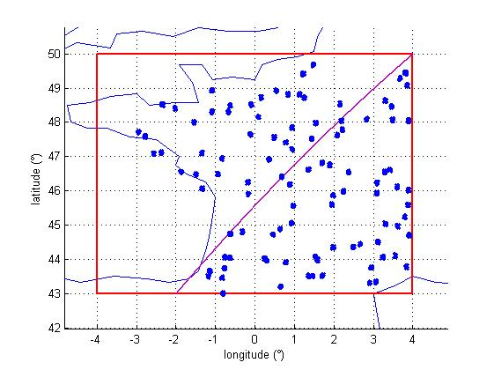

Most of the links use an elevation angle less than 10°. A Gaussian distribution was assumed, provided in Fig. 5.

The propagation model used for the interference calculation takes into account the attenuation due to atmospheric loss factors according to Recommendation ITU-R P.676. An attenuation factor of 0.11 dB/km was derived.

Results

Figure 6 shows the *I*/*N* at the aircraft receiver level as the aircraft progresses over France at an altitude of 10 000 m. Spikes of interference corresponding to *I*/*N* up to +10 dB are experienced. The *I*/*N* value of −6 dB is exceeded for 1% of the time. The *I*/*N* value of −10 dB is exceeded for 4.8% of the time.

Figure 5

FS elevation angle distribution

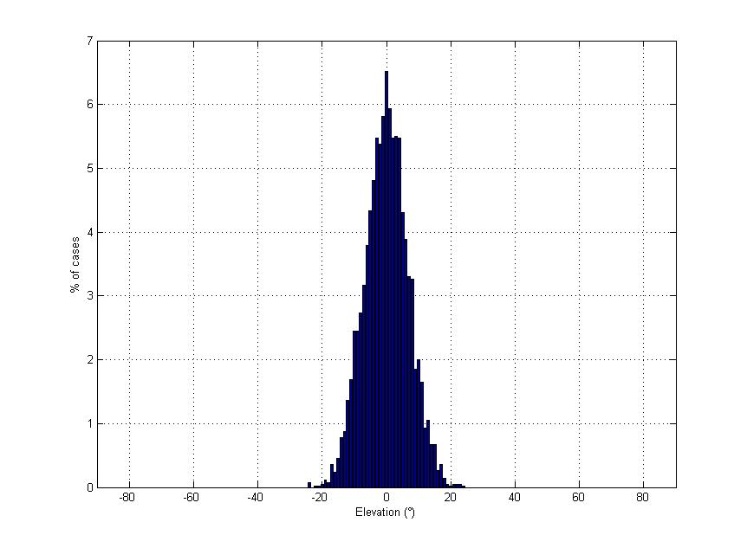

Figure 6

Results in terms of *I*/*N* for an aircraft at an altitude of 10 000 m

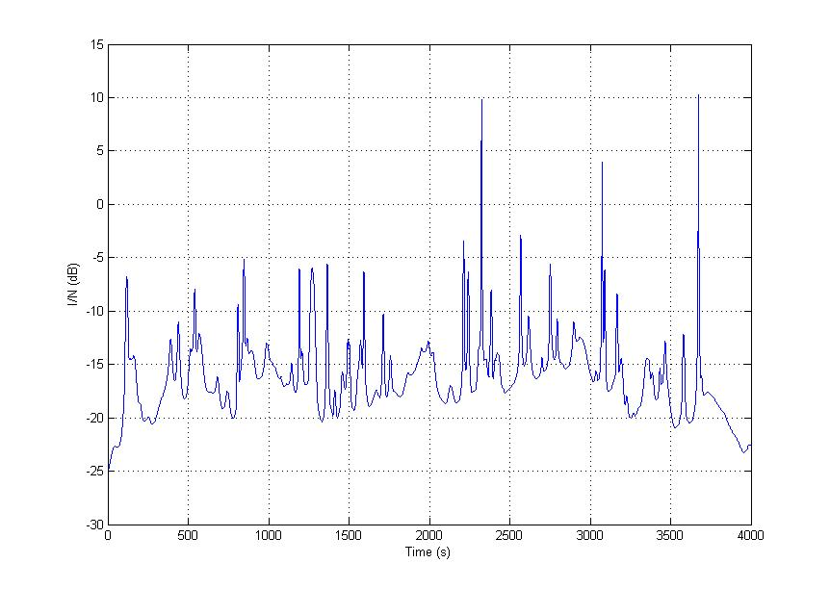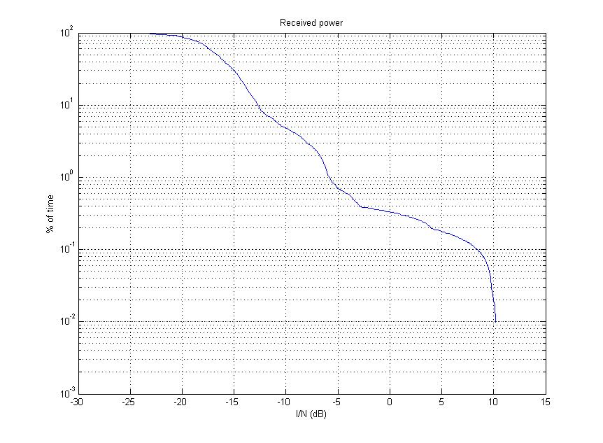

Figure 7 shows the same result for an aircraft at an altitude of 3 000 m. The situation is even worse, as *I*/*N* values up to 18 dB are experienced. The *I*/*N* value of −6 dB is exceeded 17.6% of the time, and the value of −10 dB 42.4% of the time.

Figure 7

Results in terms of *I*/*N* for an aircraft at an altitude of 3 000 m

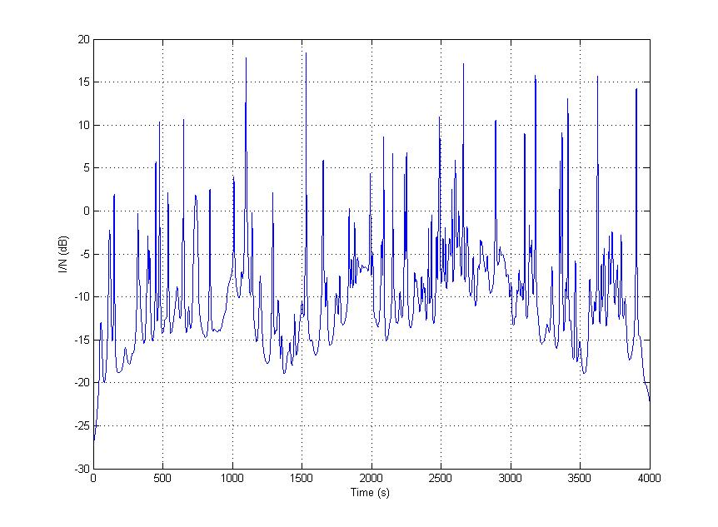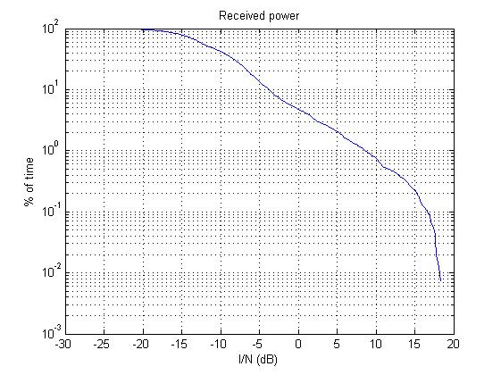

# 6 Conclusion

The existing pfd mask defined in RR Article 21 has been applied for the protection of P-P fixed service stations operating in the band 37-38 GHz from interference that may occur from aircraft station transmitters operating under the mobile service in the same band:

–120 dB(W/(m2 · MHz)) for θ ≤ 5°

–120 + 0.75 · (θ − 5) dB(W/(m2 · MHz)) for 5°  θ ≤ 25°

–105 dB(W/(m2 · MHz)) for 25°  θ ≤ 90°

where θ is the angle of arrival of the radio-frequency wave (degrees above the horizontal). This mask relates to the power flux-density that would be obtained assuming free-space loss. As shown in the analysis, it is expected that the FS protection criteria is met.

When combined with the pfd mask defined for the protection of the space research service, the pfd mask that would be applied worldwide would be:

–180 – 9.4 · θ dB (W/m2) for 0° ≤ θ ≤ 5°

–227 dB (W/m2) for 5° < θ

in any 1 Hz bandwidth, where θ is the angle of arrival of the incident wave above the horizontal plane at the space research service earth station, in degrees.

This combined pfd mask would afford protection also to P-MP FS systems operating in the band 37-38 GHz.

Any receiver associated with a current AMS system that would operate in the band for links between the ground and the aircraft or between aircraft, would suffer from harmful interference. At low altitudes of 1 000 m, such harmful interference would appear during long and frequent periods of time. The operation of AMS applications compliant with characteristics provided in Table 10 in the band 37-38 GHz is therefore not compatible with HDFS deployed in this band. However, further studies might be required with regards to wireless intra-aircraft communications (such as WAIC systems) to assess the impact of HDFS links on such applications, once the sharing characteristics are available within ITU-R.

1. This Report will be reviewed following WRC-12.
2. Similar high density deployments are typical in other countries.