|  |
| --- |
| **Report ITU-R M.2226**  **(11/2011)** |
| **Description of amateur and experimental operation between 415 and 526.5 kHz in some countries** |
| **M Series**  **Mobile, radiodetermination, amateur**  **and related satellite services** |

Foreword

The role of the Radiocommunication Sector is to ensure the rational, equitable, efficient and economical use of the radio-frequency spectrum by all radiocommunication services, including satellite services, and carry out studies without limit of frequency range on the basis of which Recommendations are adopted.

The regulatory and policy functions of the Radiocommunication Sector are performed by World and Regional Radiocommunication Conferences and Radiocommunication Assemblies supported by Study Groups.

# Policy on Intellectual Property Right (IPR)

ITU-R policy on IPR is described in the Common Patent Policy for ITU-T/ITU-R/ISO/IEC referenced in Annex 1 of Resolution ITU-R 1. Forms to be used for the submission of patent statements and licensing declarations by patent holders are available from <http://www.itu.int/ITU-R/go/patents/en> where the Guidelines for Implementation of the Common Patent Policy for ITU‑T/ITU‑R/ISO/IEC and the ITU-R patent information database can also be found.

|  |  |
| --- | --- |
| Series of ITU-R Reports  (Also available online at <http://www.itu.int/publ/R-REP/en>) | |
| **Series** | Title |
| **BO** | Satellite delivery |
| **BR** | Recording for production, archival and play-out; film for television |
| **BS** | Broadcasting service (sound) |
| **BT** | Broadcasting service (television) |
| **F** | Fixed service |
| **M** | Mobile, radiodetermination, amateur and related satellite services |
| **P** | Radiowave propagation |
| **RA** | Radio astronomy |
| **RS** | Remote sensing systems |
| **S** | Fixed-satellite service |
| **SA** | Space applications and meteorology |
| **SF** | Frequency sharing and coordination between fixed-satellite and fixed service systems |
| **SM** | Spectrum management |

|  |
| --- |
|  |

|  |
| --- |
| ***Note****: This ITU-R Report was approved in English by the Study Group under the procedure detailed in Resolution ITU-R 1.* |

*Electronic Publication*

Geneva, 2011

© ITU 2011

All rights reserved. No part of this publication may be reproduced, by any means whatsoever, without written permission of ITU.

REPORT ITU-R M.2226

Description of amateur and experimental operation between  
 415 and 526.5 kHz in some countries

(Question ITU-R 48-6/5)

(2011)

TABLE OF CONTENTS

Page

List of abbreviations 2

Recommendations and Reports cited 3

1 Introduction 3

2 Amateur and experimental observations of propagation near 500 kHz 3

3 List of administrations and conditions of operation 3

3.1 List of administrations 3

3.1.1 Secondary authorizations 4

3.1.2 Test licenses 4

3.1.3 Experimental licenses 4

3.1.4 Scientific license 4

3.1.5 Beacons (continually transmitting stations for use in propagation monitoring) 5

3.2 Conditions of operation – General remarks 5

4 Station characteristics and typical operation 5

Annex – Detailed examples of operations by administration 6

1 Australia 6

1.1 Introduction 6

1.2 Experimental operation in Australia 6

1.3 CW Beacon Transmissions 7

1.4 Very-Slow-Speed CW Transmissions 7

1.5 Weak Signal Propagation Reporter 7

1.6 Digital modes 9

1.7 Two way contacts 9

1.8 Development of transmitters, receivers, antenna systems and inference mitigation 9

1.9 Field-strength measurements 9

1.10 Conclusion 11

2 Canada 11

2.1 Framework for experiments by radio amateurs in Canada 11

2.2 Station characteristics and typical operation 12

2.3 Experimental operations in Canada 12

3 United States of America 13

4 United Kingdom 14

4.1 Background 14

4.2 Transmitting antenna design and performance 15

4.3 Receiving system design 15

4.4 Operating modes near 500 kHz 15

4.5 Equipment design 16

4.6 Conclusions 16

# List of abbreviations

CW Continuous Wave (Morse telegraphy)

DSP Digital signal processing

e.i.r.p. Effective isotropic radiated power

e.r.p. Effective radiated power

FSK-31 Frequency shift keying 31.25 Hz

MSK-31 Minimum shift keying 31.25 Hz

PSK‑31 Phase shift keying 31.25 Hz

SDR Software defined radio

SNR Signal-to-noise ratio

WSPR Weak signal propagation reporter

# Recommendations and Reports cited

Recommendation ITU‑R M.1677 International Morse Code

Recommendation ITU‑R P.368-9 Ground-wave propagation curves for frequencies between 10 kHz and 30 MHz

Report ITU‑R M.2200 Transmission characteristics of amateur radio stations in the band 415-526.5 kHz for sharing studies

# 1 Introduction

Some administrations in all three ITU Regions have authorized the use of various parts of the band 415 to 526.5 kHz by amateur service operators within their jurisdiction, either to a limited number of amateurs through temporary experimental authorizations or to the general amateur population through a national authorization subject to No. 4.4 of the Radio Regulations. Among the participating administrations temporary authorizations vary with respect to the allowed frequencies and power limits. The main body of this document identifies the administrations permitting such operations and addresses some common characteristics of these stations and their operations. The annex to this document details the conditions of and activities undertaken under a few of these temporary authorizations.

# 2 Amateur and experimental observations of propagation near 500 kHz

Amateur experience of propagation at these frequencies is that during daylight, communication by ground-wave propagation is feasible between inland stations up to a few hundred kilometres apart. After dark, sky-wave signals are comparable in strength to ground-wave at distances of the order of 100 km or greater, leading to multi-path fading with a period of the order of minutes, often with near perfect cancellation of the signal during nulls. At distances of several hundred kilometres and beyond, propagation is exclusively sky-wave, also subject to multi-path fading. This makes communication near 500 kHz challenging at distances greater than a few hundred kilometres, with signal levels frequently falling below the noise floor, even in the very narrow bandwidths generally used.

Amateurs have studied sky-wave propagation near 500 kHz through the experience of two-way communications, and also through the use of beacon transmitters. Recently, amateur beacons in several countries using the WSPR (Weak Signal Propagation Reporter) operating mode, recently developed by amateurs, have been used successfully. WSPR uses a narrow bandwidth MFSK signal that can be successfully decoded and quantified under weak signal conditions (-3 dB SNR in 6 Hz bandwidth) making it well suited for use by amateur stations with low e.r.p. Each station alternates between transmit and receive time slots, so that signals may be monitored on all paths between the active beacon stations. Received signal data from all stations is automatically logged and uploaded to a publicly accessible on-line database for further analysis.

# 3 List of administrations and conditions of operation

## 3.1 List of administrations

The International Amateur Radio Union has identified the following administrations as having authorized amateur or experimental operation between 415 and 526.5 kHz as of November 2010.

### 3.1.1 Secondary authorizations

|  |  |  |
| --- | --- | --- |
| Country | Frequency range | Comments |
| Belgium | 501-504 kHz |  |
| Norway | 493-510 kHz |  |
| New Zealand | 505-515 kHz | On a temporary basis |
| United Kingdom | 501-504 kHz | A notice of variation is required |

### 3.1.2 Test licenses

|  |  |  |
| --- | --- | --- |
| Country | Frequency range | Comments |
| Ireland | 501-504 kHz | Until mid-2011, may be renewed.  Allows communication with licensed amateur radio stations in other countries. |

### 3.1.3 Experimental licenses

|  |  |  |
| --- | --- | --- |
| Country | Frequency range | Comments |
| Croatia | 493-510 kHz | One year until June 2011 |
| Iceland | 493-510 kHz | Temporary until end 2010 |
| Denmark | 501-504 kHz | One station so far |
| Netherlands | 501-504 kHz | One year until end of 2010 (later extended until April 2011) |
| Sweden | 501-507 kHz | 2 stations until end of 2011 |
| Canada | 504-509 kHz | One year, renewable |
| United States | 461-478 kHz  495-510 kHz | Five years until August 2015 |

### 3.1.4 Scientific license

|  |  |  |
| --- | --- | --- |
| Country | Frequency range | Comments |
| Australia | 505-515 kHz | Only communication between the 6 licenses allowed, beacon allowed |

### 3.1.5 Beacons (continually transmitting stations for use in propagation monitoring)

|  |  |  |
| --- | --- | --- |
| Country | Frequency range | Comments |
| Czech Republic | 505.06 kHz | Call sign: OK0EMW |
| Germany | 505.1 kHz | Six experimental beacon stations |

## 3.2 Conditions of operation – General remarks

Although there are some variations, most of these authorizations only allow for small bandwidth modulation – mainly Morse telegraphy (CW). Power levels differ as well, both in definition (transmitter output power or e.r.p.) and level, ranging from 1 W e.r.p. to 200 W transmitter output power.

Some of the authorizations have been issued for one year only. Several of these may be renewed until WRC-12.

Many of the authorizations that are listed above as experimental or scientific licences are not allowed to have two-way contact with stations outside of their own country or territory. For large countries such as Canada, the United States and Australia this will still give valuable propagation data from short to medium range, while in other parts of the world signals from stations with an experimental licence in one country will serve as beacons for propagation experiments to radio amateurs in other countries.

# 4 Station characteristics and typical operation

Most stations are similar to those described in Report ITU‑R M.2200, “Transmission characteristics of amateur radio stations in the band 415-526.5 kHz for sharing studies”. Most stations utilize CW, PSK‑31, or another data mode as described in this Report.

**Annex  
Detailed examples of operations by administrations**

The following administrations have provided descriptions of operations they have authorized.

# 1 Australia

## 1.1 Introduction

This Report describes the experimental activities recently undertaken in Australia in the band 505‑515 kHz. Some administrations in all three ITU‑R Regions have authorized operation by amateur service operators within their jurisdiction, either to a limited number of amateurs through an experimental license, special temporary authority, or to the general amateur population through a national authorization. Such authorizations vary in the allowed frequencies and power for each station.

The 505-515 kHz band is not presently available to the amateur service in Australia; however, the Wireless Institute of Australia (WIA) was issued experimental licences that permitted transmissions in the band. The purpose of the transmissions was to allow studies to be undertaken to inform the Australian Administration’s preparations for WRC-12. Principal objectives were to demonstrate that practical and useful transmissions could be made from representative amateur service facilities without causing interference to nearby Medium Frequency (MF) broadcast receivers or to existing users of the band 415-526.5 kHz. The transmissions also permitted assessment of the achievable coverage under day-time, ground-wave and night-time, sky-wave propagation conditions. The following describes the experimental operations undertaken in Australia.

## 1.2 Experimental operation in Australia

The experimental licences that were issued to the WIA authorized transmissions with the following characteristics:

TABLE 1

Allowed transmitter characteristics

|  |  |  |  |  |  |
| --- | --- | --- | --- | --- | --- |
|  | Mode of operation | | | | |
| Morse telegraphy | PSK-31 | FSK-31 | MSK-31 | Other digital modes |
| Frequency band (MHz) | 0.505-0.515 | 0.505-0.515 | 0.505-0.515 | 0.505-0.515 | 0.505-0.515 |
| Emission designator | 150HA1A | 62H0J2B | 62H0F1B | 62H0G1D | 1K00D1D |
| Authorized e.i.r.p.(watt/dBW) | 25/14 | 25/14 | 25/14 | 25/14 | 25/14 |

During the period of the experimental activities, five stations (two in Australian Capital Territory and one in each of New South Wales (NSW), Victoria (VIC) and South Australia (SA)) operated with a variety of transmitter installations using both homemade and commercial equipment. Experimental transmissions occurred on both an ad hoc and scheduled basis. The experimental work performed under the licence conditions included:

• Normal on-off keyed Morse code (A1A modulation)

• Very slow speed on-off and frequency shift keyed Morse code

• Weak Signal Propagation Reporter (WSPR) mode

• Beacon transmissions using a variety of “sound card” digital modes

• A limited number of two-way contacts

• Development of equipment; transmitters, receivers and antenna systems

• Internet enabled receivers

• Picture transmission

• Measurement of ground wave field strength and estimating station effective radiated power

While long-distance communications were achieved during the experiments, the longer range sky‑wave signals were generally inaudible with levels below the background noise level. These signals were detected and decoded only by virtue of the intensive signal processing capability that is possible when using a personal computer to extract and decode the signals.

## 1.3 CW Beacon Transmissions

Daytime reception of normal Morse code signals extended out to several hundred kilometres, while night time reception extended to approximately 2 000 km. Station operator AX2VKW (VIC) maintained a CW beacon on 507 kHz over most weekends for the duration of the experimental activities. This beacon was very useful for the development of receiving capability as it provided a stable off-air signal for testing. Other stations operated beacons using a variety of modes on an ad hoc basis and these were useful in raising awareness of various digital modes.

## 1.4 Very-Slow-Speed CW Transmissions

Very-slow-speed on-off and frequency shift keyed Morse code and Hellschreiber are simple modes often used for weak signal communication. These modes make use of Digital Signal Processing (DSP) techniques to obtain significant processing gain. These techniques allow very weak signals with bandwidths down to 1 Hz to be extracted from below the noise level in a receiver with a nominal bandwidth of 2.7 kHz.

These modes allowed trans-Tasman reception of signals; with signals from New Zealand amateur MF beacons being regularly observed in Australia and a more limited number of reports of reception of Australian MF signals in New Zealand.

## 1.5 Weak Signal Propagation Reporter

WSPR mode uses a slow speed multi-frequency shift transmission with Forward Error Correction (FEC) coding; reception reports are automatically given in real time via the internet. Multiple stations operate in a 200 Hz frequency interval using a time division multiplex system synchronized to a two-minute time interval. Signal reports contain unambiguous transmitter identification and reliable signal-to-noise ratio measurements which are useful in assessing propagation conditions across various paths. This system allows a time series of signal reports to be created which provides useful data for ongoing analysis of propagation conditions.

A network of such stations could monitor propagation over a wide area and possibly add to knowledge of short and long term variations as well as local and regional propagation changes.

Each decoded WSPR signal produces text showing the time and measured signal to noise ratio in dB (in a 2 500 Hz reference bandwidth). The processing gain available with the WSPR software is significant and it will reliably function with a signal to noise ratio of −30 dB. Typical examples of the results obtained with such techniques are shown in Figs. 1 and 2:

Figure 1

This plot shows the changes in WSPR reported signal-to-noise ratios over a distance of 917 km (Canberra, ACT to Nairn, SA). The plot was produced from data obtained from the WSPR database

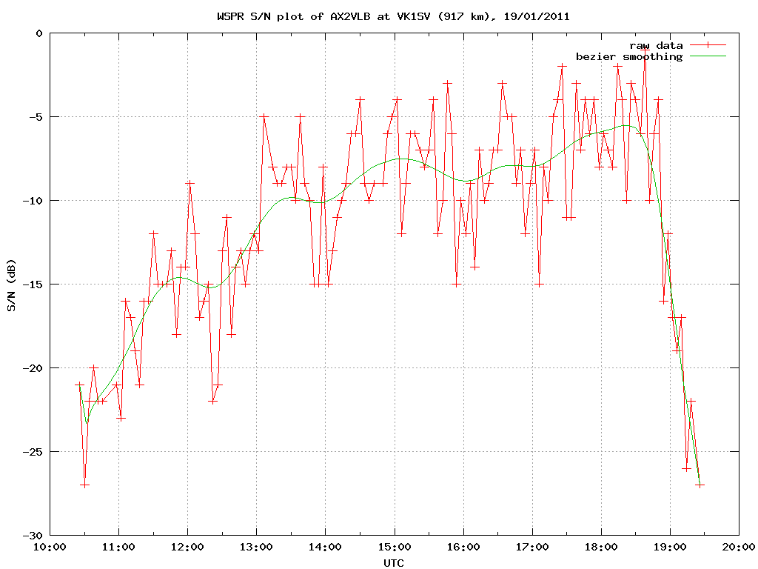

Figure 2

AX2VKY (ACT) and AX2VLA (NSW) are ground wave distance stations at about 140 km distance  
from the receiver. AX2VLB (SA) sky-wave distance is about 1 060 km

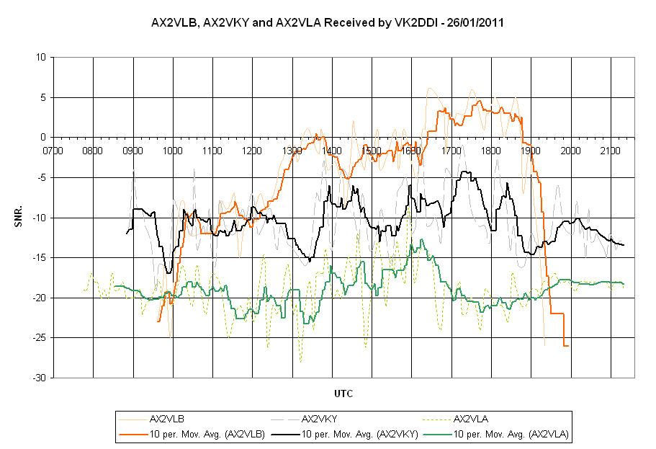

## 1.6 Digital modes

Beacon transmissions using a variety of “sound card” digital modes, with and without FEC were implemented. These beacon transmissions have shown the capability of digital modes for the reliable dissemination of text information that may be useful in disaster or emergency situations. Daytime ranges of approximately 200 km and night-time ranges up to approximately 1 000 km were achieved.

Long-distance communications were mostly achieved with a negative signal to noise ratio. This demonstrates the importance of the processing gain available by using appropriate communications application software. Often the signal was not audible, yet very few errors were observed in the received text.

## 1.7 Two way contacts

A limited number of two-way contacts using both Morse code and keyboard modes have shown that reliable two-way communications can be achieved over paths of up to at least 1 000 km at night.

Several two-way CW contacts have occurred; AX2VKW (VIC) and AV2VKZ (ACT) over a distance of about 440 km and between AX2VKW (VIC) and AX2VLB (SA) over a distance of about 650 km.

For keyboard modes, modest data rates of approximately 40 to 50 words per minute have been used with error-free performance over long-distance paths (Canberra, ACT to Nairn, SA).

## 1.8 Development of transmitters, receivers, antenna systems and inference mitigation

The experimental licences allowed a significant amount of expertise to be developed in the process of setting up and operating a MF station in a typical urban environment. Significantly, there were no known reports of interference to radio or television broadcast reception or other incumbent services.

Typical transmitter powers were in the range of 10 to 100 watts; however antenna efficiencies are low, so effective radiated power was typically much less than 1 watt. Typical transmitting antennas were some form of top-loaded vertical, generally 10 to 15 m high. Receiving antennas were usually an active whip or magnetic loop as these types of antennas appear to be less sensitive to noise pickup. Some experiments using low horizontal dipoles indicated that they perform better than might be expected at MF, so they may prove to be useful antennas for those with sufficient space.

Household electrical noise was shown to be a significant problem for reception at these frequencies. Each operator and listener had to address the issue and the problem was solved by applying one or more of the following techniques:

• Installing line filters on noisy appliances

• Installing a low impedance RF ground

• Fitting common mode chokes to antenna feed lines

• Isolated power supplies for receiver preamplifiers and active antennas

• Isolation of the radio equipment from computers which are used for signal analysis and decoding

## 1.9 Field-strength measurements

Field-strength measurements were undertaken using a loop antenna and Selective Level Meter (SLM). This was carried out in order to measure the effective radiated power from a station representative of a typical amateur station in an urban environment. A 50 watt transmitter feeding a Marconi “T” antenna was used for the signal source and a Siemens D2055 SLM with an amplified 8 turn loop antenna for reception. The results obtained from the survey are given in Table 2.

TABLE 2

Electric field-strength vs. distance

|  |  |  |
| --- | --- | --- |
| Distance (km) | *Ef* (µV/m) | dB (µV/m) |
| 2.83 | 725 | 57.2 |
| 6.07 | 351 | 50.9 |
| 9.77 | 214 | 46.6 |
| 14.21 | 145 | 43.2 |
| 22.45 | 76 | 37.6 |
| 29.76 | 59 | 35.4 |
| 43.77 | 39 | 31.9 |

Figure 3

Field-strength from Table 2 plotted in decibels referenced to 1 µV/m vs. distance in kilometres

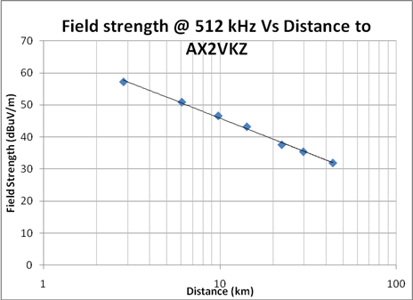

It is useful to compare the chart in Fig. 3 with Fig. 6 of Recommendation ITU‑R P.368-9, Ground‑wave propagation curves for frequencies between 10 kHz and 30 MHz. Using that chart and taking the reading at 10 km for 500 kHz gives a field strength of 87 dB above 1 µV/m, that is 41 dB above the reading shown in Fig. 3 for the same distance. Noting that the ITU charts assume 1 kW of radiated power, the effective radiated power from AX2VKZ can be calculated to be 0.08 watts. This result can be compared to other methods of calculation.

The Radio Society of Great Britain publication LF Today (2nd Edition, p101), gives a method to calculate the effective radiated power from the measured electric field strength:



where *Ef* is the field strength in volts/metre and d is distance in metres. Using the values shown in Table 2, the effective radiated power for the test installation was found to be approximately 77 ±15 mW (one standard deviation), compared to 80 mW calculated using the ITU charts. The theoretical effective radiated power can also be calculated knowing the effective height (*heff*) of the antenna and the RF current (*I*) at its base, 8.5 m and 1.7 amps in this case, which gives:



The measured value is approximately 10 dB below the value calculated above and the difference is thought to be due to the fact that the transmitting antenna was in close proximity to a house, trees and other vegetation. Rough measurements indicated that large RF currents flowed in nearby trees, plumbing and electrical cables when the transmitter was operating. This resulted in a significant amount of power being dissipated in resistive losses which are located well within the reactive near field of the antenna. Commercial MF installations avoid this problem by locating transmitting antennas in clear areas away from buildings and vegetation; they also increase efficiency by installing large low resistance ground systems to reduce losses.

Despite the low antenna efficiency (0.15 %) and small radiated power, reliable and useful communications were achieved by this station. These results show that most operators would be struggling to approach the 25 W e.i.r.p. limit allowed for the experimental licences. This fundamental limitation significantly reduces the potential for interference to other services.

## 1.10 Conclusion

The experimental work undertaken under the temporary licences in the 505-515 kHz band covered a wide range of activities and has shown the potential utility of the band for amateur communication purposes. The extensive ground wave coverage is different from that of the higher frequency amateur allocations and these characteristics could be very useful for reliable communications when other means are not available.

The availability of sophisticated application software which includes FEC and DSP enables reliable communications under circumstances that would have been previously impossible. A combination of relatively low power transmitters and inefficient antenna systems means that the potential for interference to incumbent services is very low, yet the processing gain available from such software enables reliable and useful communications that may provide a valuable service during disaster and emergency situations.

# 2 Canada

## 2.1 Framework for experiments by radio amateurs in Canada

Industry Canada has authorized some members of the Canadian amateur radio service to conduct experiments in the vicinity of 500 kHz, but requires them to do so, not as members of the amateur radio service, but as members of the Canadian “developmental service”. “Developmental service” is defined in the Canadian Radio Regulations[1] as follows: “… a radiocommunication service that provides for research and development, experimentation or demonstration of radio apparatus, or the assessment of the marketability of radio apparatus, new technology or telecommunication services.”

Experimenters in the developmental service must obtain a developmental licence that sets out the technical and regulatory terms of the experiment.

Amateur service members who obtained a developmental licence for 500 kHz experiments may communicate directly with other amateur developmental licence holders but only within Canada as no bilateral or other arrangements exist for communications with experimental stations authorized by other administrations. Amateurs holding developmental licences may not communicate with members of the amateur radio service operating in the allocated amateur radio bands. Developmental licence holders must cease operations if advised that they are causing interference to a primary user of the frequency.

## 2.2 Station characteristics and typical operation

Most stations are similar operationally to those described in Report ITU‑R M.2200, “Transmission characteristics of amateur radio stations in the band 415-526.5 kHz for sharing studies.” Most stations utilize CW (Morse telegraphy), PSK‑31, or other data modes. They also make one‑way beacon test transmissions. Transmitters typically have variable output up to 200 Watts (23 dBW) to maintain the Canadian authorized 20 Watts (13 dBW) e.r.p. limit. Antennas used are typically: 16 metre monopoles with matching unit (gain −13.8 dBi); “Tee” antennas with vertical portion 13 to 25 metres and top loading wires up to 80 metres in length (gains ranging from −9.64 dBi to −12 dBi); and Inverted “L” (Marconi) antennas, vertical portions 13 to 20 metres with horizontal portions 48 to 115 metres in length, (gains ranging from −7.6 dBi to −21.1 dBi).

## 2.3 Experimental operations in Canada

The experimental operations near 500 kHz by radio amateurs authorized by Industry Canada are defined experiments conducted under the auspices of Radio Amateurs of Canada (RAC), the International Amateur Radio Union member society for Canada.

Radio amateurs have been issued developmental licences for operation between 504 and 509 kHz, utilizing call signs in the block VX9xxx. Licences are valid for one year and are renewable. In general, the stations transmit using the following transmission characteristics:

|  |  |  |  |  |
| --- | --- | --- | --- | --- |
|  | Mode of operation | | | |
| Morse telegraphy | PSK-31 | FSK-31, WSPR | MSK-31 |
| Frequency band (kHz) | 504-509 | 504-509 | 504-509 | 504-509 |
| Necessary bandwidth and class of emission (emission designator) | 150HA1A | 62H0J2B | 62H0F1B | 62H0G1D |
| Authorized e.r.p. (dBW) | 13.0 | 13.0 | 13.0 | 13.0 |

The stations are authorized to operate at fixed locations as per developmental licence conditions. Currently there are stations on the east and west coasts of Canada, and in Central Canada (Ontario). Some of the stations have completed a number of two-way communications with each other, using protocols common to operations in the amateur service (e.g. those found in Recommendation ITU‑R M.1677 for Morse telegraphy). Canadian developmental stations may only communicate directly with other Canadian developmental stations.

Transmissions have predominantly been one-way beacon transmissions for the purposes of propagation testing over the North American land mass. Radio amateurs and short-wave listeners have been invited to submit reception reports. The experimenters also monitor the operations of experiments by radio amateurs authorized by other administrations and report signal strengths. In addition, the experimenters are also monitoring transmissions using developing technologies, such as WSPR, transmitted by stations authorized by other administrations to assess their usefulness for amateur experimentation and operations if an allocation to the amateur service is granted.

Hours of operation, two-way communications, reception reports, and interference complaints are strictly logged and documented. Since operations began in October 2009 and up to the publishing date of this Report no interference complaints have been received.

Many reception reports have come from eastern and western Canada and from the United States. Also, some reports have been received from Europe. Experimenters advise that reliable ground wave reception appears to be possible up to 200 to 500 km over land paths using the typical stations described in PDN Report ITU‑R M.2200. From experience on the amateur bands where communication at these distances is often a challenge on 3.5 MHz and unworkable on 7 MHz and higher during ionospheric storms, communication near 500 kHz often remains possible. In other words, propagation at 500 kHz is more consistently stable than at higher frequency bands.

# 3 United States of America

A number of experimental operations within the frequency range have been authorized by the United States Federal Communications Commission. Among the most active of these are operations conducted under the auspices of the American Radio Relay League (ARRL), the International Amateur Radio Union member society for the United States.

ARRL has been issued an experimental licence for operation from 461-478 kHz and 495-510 kHz, utilizing the call sign WD2XSH. Forty-two operators have been authorized to transmit with the following transmission characteristics.

|  |  |  |  |  |
| --- | --- | --- | --- | --- |
|  | Mode of operation | | | |
| Morse telegraphy | PSK-31 | FSK-31, WSPR | MSK-31 |
| Frequency band (kHz) | 461-478  495-510 | 461-478  495-510 | 461-478  495-510 | 461-478  495-510 |
| Necessary bandwidth and class of emission (emission designator) | 150HA1A | 62H0J2B | 62H0F1B | 62H0G1D |
| Authorized e.i.r.p. (dBW) | 15.1588 | 15.1588 | 15.1588 | 15.1588 |

The stations are authorized to operate at fixed locations and as mobile stations within 50 km of the fixed location. The authorized locations and current activity status (some inactive stations were active in the past) for the ARRL licence are indicated in red on the map below. The locations of other United States experimental licensees are indicated in blue, and the approximate location of observed stations in incumbent services in green.

Figure 4

Locations of experimental stations and observed incumbent stations within the United States



An operational plan has been established to minimize the potential for interference to incumbent services. Incumbent stations have been observed periodically on 500 kHz (periodic operations by legacy maritime coast stations using Morse telegraphy), 505 kHz (a beacon transmission, identifying as “NEED”, somewhere in the vicinity of Norfolk, Virginia) and 510 kHz (an aeronautical NDB, identifying as “OF”, operating in Eastern Nebraska). The operational plan restricts all users from the 499-501 kHz range to provide clearance to operations at 500 kHz. Stations near the beacon transmissions are restricted from transmitting within 2 kHz of the beacons when they are operational. In 2011, the operational plan was modified to shift operations into the range 461-478 kHz.

Transmissions have predominantly been one-way beacon transmissions for the purposes of propagation testing. Persons with capable receivers have been invited to submit reception reports via a website. Additionally, stations have completed a number of two-way communications with each other, using protocols common to operations in the amateur service (e.g. those found in Recommendation ITU‑R M.1677 for Morse telegraphy).

Operational hours, two-way communications, reception reports, and interference complaints are strictly logged and documented. From the inception of operations in 2007, 29 of the authorized 44 stations have been operational at some point, with others working to become operational. As of 31 August 2011, these stations had completed 451 two-way communications, verified 13 457 reception reports, and had combined to operate 1 061 588 station hours, with zero interference complaints.

# 4 United Kingdom

## 4.1 Background

During the past few years, the UK regulator has made available Notices of Variation (NoV) to allow UK Amateur Full Licence holders short-term access to the frequency range 501-504 kHz on a Special Research Permit (experimental) basis, with a maximum transmitted power limit of 10 W ERP. These Notices of Variation are issued subject to not causing interference to other services.

This has given amateurs an opportunity to experiment in the spectrum between the existing LF and MF allocations to the Amateur Service. Seventy-one UK Amateur Full Licence holders have been issued with NoVs and have engaged in a wide range of experimentation. This paper considers current and potential future technical development and investigations by amateurs utilizing the frequencies near 500 kHz. In addition, one propagation monitoring beacon has operated continuously for extended periods in the UK, with several others also operating on an “attended” and thus part-time basis in the UK and Europe.

## 4.2 Transmitting antenna design and performance

A major issue that UK operators have come up against, in regard to operating an amateur station near 500 kHz, is the size and efficiency of practical antennas. Amateur antennas are limited in size due to constraints of available space at domestic premises, planning restrictions and cost. At these frequencies the dimensions of amateur antennas, particularly height, can rarely be more than a few per cent of the operating wavelength. Such electrically small antennas inevitably have low radiation resistance and high losses that reduce radiation efficiency, often to less than 1%. Practical limitations on transmitter output power and antenna power handling frequently result in the maximum ERP of amateur stations being well below the permitted limits. This contrasts with the antennas deployed by professional users, which typically employ large masts to achieve much higher efficiency and power handling capability. These issues have been covered in more detail in Report ITU‑R M.2200.

The relatively low operating frequency facilitates amateur measurements with 500 kHz antennas. The long wavelength is relatively less subject to reflection, scattering and propagation losses in the area around the antenna than higher frequencies. This enables repeatable quantitative measurements to be made on the antenna in situ, rather than requiring a dedicated antenna range. The low frequency also simplifies design and calibration of measuring systems. Access to frequencies near to 500 kHz for this experimental work complements the existing 136 kHz allocation, for which similar considerations apply, and allows the investigation of frequency-dependent effects on antenna performance.

## 4.3 Receiving system design

Receiving system design is covered in detail in Report ITU‑R M.2200. With care, antennas can be designed with noise figures below the ambient noise floor, and with suitable filtering and dynamic range to operate in the presence of high-level signals in adjacent parts of the spectrum. These compact antennas can be positioned to take advantage of locally low levels of noise field strength, or combined in arrays to implement noise cancelling schemes or produce steerable directional nulls.

## 4.4 Operating modes near 500 kHz

For long-distance propagation tests, where SNR typically is much below 0 dB in normal transmission bandwidths, use has been made of narrow-band transmission techniques successfully previously employed at 136 kHz, such as extreme low speed Morse code telegraphy with fractional‑hertz bandwidths, and narrow-band, highly redundant data transmission, such as the WSPR beacon mode.

For two-way communication, a range of digital modes developed for use in the HF range and above have been tried. MFSK modulation has been favoured, since the constant-amplitude signal simultaneously enables the signal bandwidth to be closely controlled, and simplified transmitter designs to be used. The MFSK, ROS1 MF, and ROS7 MF modes[2] have been adapted specially to meet the requirements of communications at these frequencies, with modulation bandwidth of 100 Hz. The availability of powerful DSP modem software running on low cost PC hardware has been a major impetus to development of new digital transmission modes on all amateur bands, and there is much scope for development of modulation and encoding techniques specifically for MF.

## 4.5 Equipment design

For operation near to 500 kHz, there is very little commercially manufactured equipment available that is suitable for amateur use. Continuing a trend started with the 136 kHz band, class D and E switch-mode designs have been developed. Amateurs in the United Kingdom have also developed amplitude modulators for use with class D and E transmitters, permitting the full range of modulation types to be exploited when combined with SDR signal generation schemes.

Another area in which amateurs are developing equipment is instrumentation, for example for antenna impedance and field-strength measurement. This area of self-learning takes advantage of the relatively low operating frequency, meaning that it is possible for amateurs to construct and calibrate instrumentation capable of obtaining useful quantitative data without access to costly professional equipment.

## 4.6 Conclusions

It can be seen that the experimental MF authorization to the radio amateurs in the United Kingdom is being utilized to further developments in radio science and technology in numerous areas. Experimental use of these frequencies by amateurs during the past few years has demonstrated that interesting technical investigations, as well as local and international communications activities, can be conducted successfully using the relatively modest facilities available. This has been possible within the constraints of small antennas, low transmitted e.r.p., the existence of a wide range of potential sources of interference to reception, and small available bandwidth.

Bibliography

Radio Communications Handbook, 11th Edition, Chapter 10 Low Frequencies 136 kHz and 500 kHz. Radio Society of Great Britain, ISBN 9781-9050-8674-0.

______________

1. <http://laws.justice.gc.ca/PDF/Regulation/S/SOR-96-484.pdf>.
2. <http://rosmodem.wordpress.com/2010/05/14/new-ros-mf-modes-for-500-khz-band/>.