|  |
| --- |
| **Report ITU-R M.2229**  **(11/2011)** |
| **Compatibility study to support line-of-sight control and non-playload communications links for unmanned aircraft systems proposed in the frequency band 15.4-15.5 GHz** |
| **M Series**  **Mobile, radiodetermination, amateur**  **and related satellite services** |

Foreword

The role of the Radiocommunication Sector is to ensure the rational, equitable, efficient and economical use of the radio-frequency spectrum by all radiocommunication services, including satellite services, and carry out studies without limit of frequency range on the basis of which Recommendations are adopted.

The regulatory and policy functions of the Radiocommunication Sector are performed by World and Regional Radiocommunication Conferences and Radiocommunication Assemblies supported by Study Groups.

# Policy on Intellectual Property Right (IPR)

ITU-R policy on IPR is described in the Common Patent Policy for ITU-T/ITU-R/ISO/IEC referenced in Annex 1 of Resolution ITU-R 1. Forms to be used for the submission of patent statements and licensing declarations by patent holders are available from <http://www.itu.int/ITU-R/go/patents/en> where the Guidelines for Implementation of the Common Patent Policy for ITU‑T/ITU‑R/ISO/IEC and the ITU-R patent information database can also be found.

|  |  |
| --- | --- |
| Series of ITU-R Reports  (Also available online at <http://www.itu.int/publ/R-REP/en>) | |
| **Series** | Title |
| **BO** | Satellite delivery |
| **BR** | Recording for production, archival and play-out; film for television |
| **BS** | Broadcasting service (sound) |
| **BT** | Broadcasting service (television) |
| **F** | Fixed service |
| **M** | Mobile, radiodetermination, amateur and related satellite services |
| **P** | Radiowave propagation |
| **RA** | Radio astronomy |
| **RS** | Remote sensing systems |
| **S** | Fixed-satellite service |
| **SA** | Space applications and meteorology |
| **SF** | Frequency sharing and coordination between fixed-satellite and fixed service systems |
| **SM** | Spectrum management |

|  |
| --- |
|  |

|  |
| --- |
| ***Note****: This ITU-R Report was approved in English by the Study Group under the procedure detailed in Resolution ITU-R 1.* |

*Electronic Publication*

Geneva, 2012

© ITU 2012

All rights reserved. No part of this publication may be reproduced, by any means whatsoever, without written permission of ITU.

REPORT ITU-R M.2229

Compatibility study to support line-of-sight control and non-payload  
communications links for unmanned aircraft systems  
proposed in the frequency band 15.4-15.5 GHz

(2011)

# 1 Introduction

Significant growth is forecast in the unmanned aircraft (UA) systems (UAS) sector of aviation. The current state of the art in UAS design and operation is leading to the rapid development of UAS applications to fill many diverse requirements. The ability of UA to effectively support long duration and hazardous missions, are key drivers in the development and deployment of increasing numbers of UAS applications.

Though UA have traditionally been used in segregated airspace where separation from other air traffic can be assured, some administrations anticipate broad deployment of UA in non-segregated airspace shared with manned aircraft. If UA operate in non-segregated civil airspace, they must be integrated safely and adhere to operational practices that provide an acceptable level of safety comparable to that of a conventional manned aircraft. In some cases, those practices will be identical to those of manned aircraft.

It should be noted that in certain countries a wide range of frequency bands have been used for control of the UA in segregated airspace for both line of sight (LoS) and beyond line of sight (BLoS). Many of these frequency bands do not have currently the safety aspect required to enable UA flight in non-segregated airspace.

Thus it is envisioned that UA will operate alongside manned aircraft in non-segregated airspace using methods of control that could make the location of the pilot transparent to air traffic control (ATC) authorities and airspace regulators.

Because the pilot is located remotely from the UA, radio frequency (RF) communications links will be required to support, among other things, UA telemetry data, telecommand messages, and the relay of ATC communications. Since this connection will be used to ensure the safe flight of UAS, reliable communications links and associated spectrum are required. It is also expected that the characteristics of the information will necessitate user authentication, and interference resilience. As UA technology advances, it can be expected that more autonomous flight capability will be incorporated into UA. Even for autonomous UAS operations, RF communications links with the same performance characteristics will be required for emergencies as well as for selected operating conditions. If the spectrum requirements of UAS operations cannot be accommodated within existing aviation spectrum allocations, additional appropriately allocated spectrum may be necessary to support UAS operations.

The goal of airspace access for appropriately equipped UAS requires a level of safety similar to that of an aircraft with a pilot on board. The safe operation of UAS outside segregated airspace requires addressing the same issues as manned aircraft, namely integration into the air traffic control system. Because some UAS may not have the same capabilities as manned aircraft to safely and efficiently integrate into non-segregated airspace, they may require communications link performance that exceeds that which is required for manned aircraft. In the near term, one critical component of UAS safety is the communication link between the remote pilot’s unmanned aircrafts control station (UACS) and the UA.

Radiocommunication is the primary method for remote control of the unmanned aircraft. Seamless operation of unmanned and manned aircraft in non-segregated airspace requires high-availability communication links between the UA and the UACS. In addition, radio spectrum is required for various sensor applications that are integral to UAS operations including on-board radar systems used to track nearby aircraft, terrain, and obstacles to navigation.

The objective of this study is to identify potential new allocations in which the control and non‑payload communication (CNPC) links of future UAS can operate reliably without causing harmful interference to incumbent services and systems.

The technical information given in this paper is not relevant for operational purposes.

# 2 Terminology

**Unmanned aircraft:** designates all types of remotely controlled aircraft.

**UA control station:** facility from which a UA is controlled remotely.

**Sense and avoid:** corresponds to the piloting principle “see and avoid” used in all airspace volumes where thepilot is responsible for ensuring separation from nearby aircraft, terrain and obstacles.

**Unmanned aircraft system:** consists of the following subsystems:

– UA subsystem (i.e. the aircraft itself);

– UACS subsystem;

– air traffic control (ATC) communication subsystem (not necessarily relayed through the UA);

– S&A subsystem; and

– payload subsystem (e.g. video camera…)[1].

**Control and non-payload communications:** The radio links, used to exchange information between the UA and UACS, that ensure safe, reliable, and effective UA flight operation. The functions of CNPC can be related to different types of information such as telecommand messages, non-payload telemetry data, support for navigation aids, air traffic control voice relay, air traffic services data relay, S&A target track data, airborne weather radar downlink data, and non-payload video downlink data.

**Forward link:** Communication from the UACS to the UA through a satellite (see Fig. 1).

**Return link:** Communication from the UA to the UACS through a satellite (see Fig. 1).

Figure 1

Definition – forward link and return link

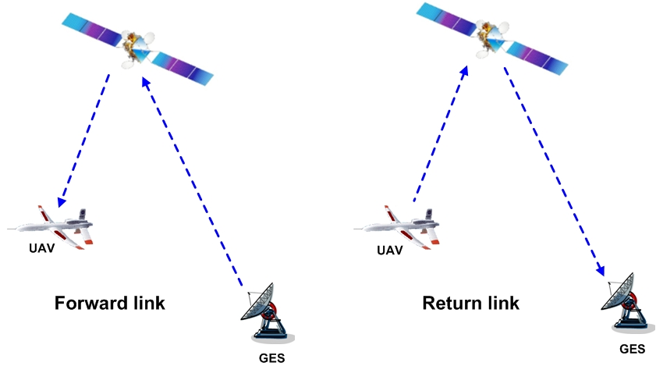

# 3 Review of radiocommunication spectrum requirements

In order to ascertain the amount of spectrum needed for UAS control links, it is necessary to estimate the non-payload UAS control link spectrum requirements for safe, reliable, and routine operation of UAS. The estimated throughput requirements of generic UA and long-term spectrum requirements for UAS non-payload control link operations through 2030 have previously been studied and can be found in Report ITU‑R M.2171.

The report provides the analyses for determining the amount of spectrum required for the operation of a projected number of UAS sharing non-segregated airspace with manned air vehicles as required by World Radiocommunication Conference (WRC) Resolution 421 (WRC-07).

The report estimates the total spectrum requirements covering both terrestrial and satellite requirements in a separate manner. Deployment of UAS will require access to both terrestrial and satellite spectrum.

The Report estimates the maximum amounts of spectrum required for UAS are:

– 34 MHz for terrestrial systems;

– 56 MHz for satellite systems.

Figure 2 illustrates the kinds of terrestrial line-of-sight links in the system.

Figure 2

Links involved in line-of-sight communications

ATC

Control Station

1. Remote Pilot to UA

2. UA to Remote Pilot

1

2

For LoS links:

– the remote pilot stations satisfy the definition RR No. 1.81 (aeronautical station);

– the UA corresponds to definition RR No. 1.83 (aircraft station).

Therefore the aeronautical-mobile (route) service (AM(R)S), the aeronautical-mobile service (AMS) and the mobile service (MS) could be considered for links 1 and 2.

Figure 3 depicts the various kinds of satellite links in the system.

Figure 3

Links involved in beyond line-of-sight communications via satellite

ATC

UA

Control Station(mobile or fixed) or Gateway station (to which remote pilots are connected)

1

4

3

2

Satellite

Forward link:

1: Remote Pilot to satellite

2: Satellite to UA

Return link:

3: UA to satellite

4: Satellite to Remote   
 Control Station

Case 1: Mobile unmanned aircraft control station

– the UA corresponds to definition RR No. 1.84 (aircraft earth station);

– the satellite corresponds to definition RR No. 1.64 (space station);

– the mobile UACS corresponds to definition RR No. 1.68 (mobile earth station).

Therefore, from the Radio Regulations point of view, AM(R)S, the aeronautical-mobile satellite service (AMSS), and the mobile-satellite service (MSS) for links 2 and 3 could be considered if the allocation is on a primary basis. MSS for links 1 and 4 could also be considered if allocated on a primary basis. In the case of mobile UACS located on the Earth’s surface, MSS except aeronautical for links 1 and 4 could be considered if the allocation is on a primary basis. Additionally for links 1, 2, 3 and 4, FSS allocations can also be considered if sharing studies with other services allocated in the frequency bands, have been successfully completed which also require appropriate modifications of the Radio Regulations taking into account ICAO requirements.

Case 2: Fixed unmanned aircraft control station

– the UA corresponds to definition RR No. 1.84 (aircraft earth station);

– the satellite corresponds to definition RR No. 1.64 (space station);

– the fixed UACS corresponds to definition RR No. 1.63 (earth station).

Therefore, from the Radio Regulations point of view, the services AM(R)S, AMSS and MSS for links 2 and 3 could be considered. For links 1 and 4, the fixed-satellite service (FSS) could be considered taking also into account ICAO requirements. Additionally for links 2 and 3, FSS allocations can also be considered if sharing studies with other services allocated in the frequency bands, have been successfully completed which also require appropriate modifications of the Radio Regulations taking also into account ICAO requirements.

Case 3: Control station providing feeder-link station functions

– the UA corresponds to definition RR No. 1.84 (aircraft earth station);

– the satellite corresponds to definition RR No. 1.64 (space station);

– the UACS corresponds to definition RR No. 1.82 (aeronautical earth station).

Therefore, from the Radio Regulations point of view, the services AM(R)S, AMSS and MSS for links 2 and 3 could be considered. The services FSS, AMSS, AM(R)S for links 1 and 4 could be considered taking also into account ICAO requirements. Additionally for links 2 and 3, FSS allocations can also be considered if sharing studies with other services allocated in the frequency bands, have been successfully completed which also require appropriate modifications of the Radio Regulations taking into account ICAO requirements.

# 4 Criteria for consideration of the possible frequency bands

The following criteria have been used for the consideration of the possible frequency bands for UAS operation:

**Controlled-access spectrum:** Each of the potential solutions should be evaluated on whether they will operate in spectrum that has some type of controlled access to enable the limitation and prediction of levels of interference.

**International Civil Aviation Organization position on AM(R)S and AMS(R)S spectrum:** the ICAO position is to ensure that allocations used, in particular for UAS command and control, ATC relay and S&A in non-segregated airspace are in the AM(R)S, AMS(R)S and/or aeronautical radionavigation service (ARNS) and do not adversely affect existing aeronautical systems.

**Worldwide spectrum allocation:** It will be advantageous if global harmonization is achieved and the equipment needed by a UA could thus be the same for operation anywhere in the world.

**Potentially available bandwidth:** Under this criterion a favourable rating is more likely to be awarded to a candidate frequency band whose incumbent RF systems currently leave a substantial amount of spectrum unoccupied, and have technical and/or operational characteristics that would facilitate coexistence with future in-band UAS control systems. Many BLoS systems share the control link and the payload return link on one common carrier, so the wide bandwidth needs of the payload return link may drive this choice more than the lower data rate needs of the control link.

**Link range:** This criterion evaluates the distance that the unmanned aircraft can fly away from its control station without the support of additional control stations.

**Link availability:** Weather-dependent availability of the link is also a very important evaluation criterion. Therefore, each candidate frequency band should be evaluated according to the approximate availability associated with the frequency of operation. Higher frequency ranges are more susceptible to signal degradation due to rainfall and therefore receive less favourable ratings.

**Satellite transmission characteristics:** In order to determine whether satellite systems can provide the integrity and reliability needed to satisfy the link availability required for communications through satellite platforms to and from the UAS certain transmission characteristics need to be defined in sufficient detail. The following is a list of such information that is needed to make this determination.

1) The frequency band to be used.

2) Minimum and maximum antenna sizes, and the corresponding transmitting and receiving antenna gains of the earth station and of the airborne station.

3) Minimum and maximum effective isotropically radiated powers (e.i.r.p.s) and e.i.r.p. densities of the earth station and of the airborne station.

4) Minimum ratio of receiving-antenna gain to receiver thermal noise temperature in kelvins (*G*/*T*) of the receiving earth station and of the airborne station.

5) The rain conditions (i.e. rain rates) in which the link must operate, and any other propagation conditions that need to be considered.

6) Minimum required availability for the total (up and down) link (both outbound and inbound); or, alternatively, the minimum required availability in the uplink and the minimum required availability in the downlink. Note should be also taken of certain double-hop links (e.g. ATC-to-UA communications relayed through a UA-to-UACS link).

7) Off-axis gain patterns of the transmitting and receiving antennas of the earth station and the airborne station.

8) Pointing accuracies of the antennas of the control station and the airborne station.

9) Geographical coverage area where the UAS requirements will have to be met.

10) Carrier characteristics

a) Information rates

b) Occupied bandwidth

c) Allocated bandwidth

d) Modulation type

e) Forward error correction rate

f) Minimum required carrier-to-(interference + noise) ratio (*C*/(*I*+ *N*))for the satellite/UA link and the satellite/control-station link

g) The minimum and maximum acceptable latency in the transmission to and from the UA and UACS.

**Co-site compatibility:** This metric evaluates the relative feasibility of operating future UAS control-link radios in the frequency band under consideration, without causing harmful interference to the collocated receivers of incumbent systems in the same UA or UACS.

**Airborne equipment size, weight, and power:** The driving factor for applying this criterion is the size of the antennas on board the unmanned aircraft. Credit should be given to frequency bands in which control links could operate using omnidirectional antennas.

# 5 Frequency bands under consideration

In this report, the frequency band and 15.4-15.5 GHz is studied for the terrestrial component.

# 6 Conclusions

## 6.1 Compatibility studies between systems operating in the aeronautical mobile (route) service and the radiolocation service in the frequency band 15.4-15.5 GHz

One study on the frequency band 15.4-15.5 GHz shows that separation distances of more than 400 km will be required to avoid harmful interference from UACS transmitter to receiver of System-6 type referred to in Recommendation ITU‑R M.1730. Moreover, airborne radars would also cause harmful interference to UAS airborne receivers within LoS distances exceeding 827 km.

In the case of operating UAS on a co-frequency basis with radiolocation in the frequency band 15.4-15.5 GHz compatibility may be difficult, without the use of appropriate operational techniques.

## 6.2 Compatibility studies between systems operating in the aeronautical mobile (route) service and the aeronautical radionavigation service in the frequency band 15.4‑15.5 GHz

Compatibility studies between UAS and ARNS systems in the frequency band 15.4-15.5 GHz have shown that protection of ARNS from interference from UAS airborne transmitters requires separation distances exceeding the line-of-sight distance (more than 903 km). Sharing would require frequency-site planning, the implementation of which would be very difficult because of the numerous UASs expected to operate simultaneously in non-segregated air-space.

## 6.3 Compatibility studies between systems operating in the aeronautical mobile (route) service and the radio astronomy service in the adjacent frequency band 15.35-15.4 GHz

One compatibility study (Study 1) using a static approach between UAS operating in the frequency band 15.4-15.5 GHz and RAS systems operating in the adjacent frequency band 15.35-15.4 GHz have shown that compatibility between UA airborne transmitters and RAS receivers is not feasible regardless of the direction of the maximum of the RAS antenna pattern.

Another study (Study 2)[2]*, using a statistical approach derived from Recommendation ITU‑R M.1583-1, shows that by taking into account multiple interfering sources that may transmit into the main lobe of the RAS station during a very short period (like UAS), the protection criterion of 2% can be met by limiting the out-of-band e.i.r.p. of UA systems to −68 dBW in a 50 MHz bandwidth. It should be noted that reaching this out of band e.i.r.p. level would be dependent upon the filters used in the UA transmitter. Obtaining this level would be difficult to achieve at this time because there is no information about the feasibility of such on-board equipment.

Further information and additional details on the results and conclusions of these studies can be found in Appendix 3 of Annex 1.

Annex 1  
  
Compatibility study between a proposed aeronautical mobile (route) service   
in the frequency band 15.4-15.5 GHz and existing services

# 1 Introduction

Annex 1 contains results of compatibility studies between AM(R)S UAS and existing and planned systems operating in RLS and ARNS in the frequency band 15.4-15.5 GHz, as well as RAS systems operating in the adjacent frequency band 15.35-15.4 GHz.

The Table of Frequency Allocations of the Radio Regulations lists the ARNS and the FSS as primary services in 15.4-15.5 GHz.

However, no systems are notified for the FSS in this frequency band and studies were not performed with regards to this service.

In addition to the sharing study with ARNS, this report assesses also the compatibility with:

• radiolocation as WRC-12 will consider the frequency band 15.4-15.7 GHz for a possible new RLS allocation;

• radio astronomy in the adjacent frequency band 15.35-15.4 GHz.

# 2 Foreseen unmanned aircraft system characteristics in the frequency band 15.4-15.5 GHz

TABLE 1

Unmanned aircraft system characteristics in the frequency band 15.4-15.5 GHz

|  |  |  |  |  |
| --- | --- | --- | --- | --- |
| Parameter | Unit | Uplink  (UACS to UA) | Downlink  (UA to UACS) | |
|  |  |  | Without video | With video |
| Transmitter power | (dBm) | 43 | 43 | 43 |
| Transmitter antenna gain | (dBi) | 38 | 3 | 3 |
| Transmitter cable loss | (dB) | 0.9 | 2.9 | 2.9 |
| e.i.r.p. | (dBm) | 80.1 | 43.1 | 43.1 |
| Receiver antenna gain | (dBi) | 3 | 38 | 38 |
| Thermal noise (290 K) | (dBm/Hz) | −174 | −174 | −174 |
| Receiver noise figure | (dB) | 4 | 4 | 4 |
| Bandwidth | (kHz) | 37.5 | 37.5 | 300 |
| Bandwidth | (dBHz) | 45.7 | 45.7 | 54.8 |
| Receiver noise power | (dBm) | −124.3 | −124.3 | −115.2 |
| Receiver cable loss | (dB) | 2.9 | 0.9 | 0.9 |
| Assumed distance | (km) | 200 | 200 | 35 |
| Free space loss | (dB) | 162 | 162 | 146.8 |
| Statistic propagation loss | (dB) | 15 | 15 | 7.4 |
| SNR ratio | (dB) | 27.5 | 23.5 | 37.2 |
| Required S/N1 | (dB) | 6 | 6 | 6 |
| Margin | (dB) | 21.5 | 17.5 | 31.2 |
| 1 QPSK with ½ rate coding | | | | |

# 3 Compatibility studies between systems operating in the aeronautical mobile (route) service and the radiolocation service in the frequency band 15.4-15.5 GHz

See Appendix 1 of this Annex.

# 4 Compatibility studies between systems operating in the aeronautical mobile (route) service and the aeronautical radionavigation service in the frequency band 15.4-15.5 GHz

See Appendix 2 of this Annex.

# 5 Compatibility studies between systems operating in the aeronautical mobile (route) service and the radio astronomy service in the adjacent frequency band 15.35-15.4 GHz

See Appendix 3 of this Annex.

Appendix 1  
to Annex 1  
  
Compatibility studies between systems operating in the aeronautical  
mobile (route) service and the radiolocation service[3]   
in the frequency band 15.4-15.5 GHz

# 1 Compatibility analysis scenario

The compatibility assessment scenario used in the studies is shown in Fig. 4 below.

Figure 4

Compatibility analysis scenario

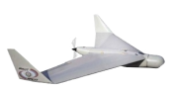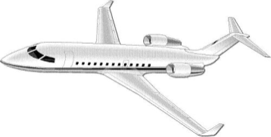

Wanted signal from

System-6



UACS

SYSTEM-6

UA

CNPC uplink

Interference from

UACS

# 2 The main assumptions and limitations

The following assumptions and limitations were used in the analysis:

1) The UACS transmitter causes harmful interference to System-6 receiver via the main lobe or the first side lobe of System-6 antenna pattern.

2) Free-space propagation model from Recommendation ITU‑R P.528 is used in the analysis.

3) Technical characteristics and protection criteria for System-6 are compliant with Recommendation ITU‑R M.1730-1.

4) The analysis assumes the worst case UAS power (UACS e.i.r.p. provides optimal UA operation near the border of UACS service area).

5) The frequency band used by System-6 receiver exceeds the emission bandwidth of UACS transmitter; both systems operate at a common carrier frequency.

# 3 The study methodology

For analysis of compatibility between System-6 airborne receiver and ground-based UACS transmitter the carrier-to-interference ratio is used.

Interference power I (W) from UACS at System-6 receiver front-end is described by the following equation:

I = e.i.r.p. • *Gsys-*6 • λ2 / (4 π *R*)2 (1)

where:

e.i.r.p.: is UACS transmitter e.i.r.p. (W)

*Gsys-*6 : is System-6 receiver antenna gain towards the interferer

λ: is wavelength (m)

*R*: is separation distance between UACS transmitter and System-6 receiver (m).

System-6 receiver protection criterion as described in Recommendation ITU‑R M.1730‑1 is:

*I*/*N* = −6 dB (2)

where *N* is system-6 receiver noise (dBW).

The value of *N* (W) is defined as:

*N* = *K* * *T* *Δ*F* (3)

where:

*K*:is Boltzmann’s constant = 1.38 × 10−23 (J/K)

*T*:is noise temperature at receiver front end (K)

Δ*F*: receiver noise bandwidth (Hz).

The value of *Т* may be derived as:

*T* = 290 × (10(*NF*/10 ) − 1), (4)

where: *NF* is system-6 receiver noise factor (dB).

Transformation of equations (1) to (4) results in the following expression for defining a minimum protection distance R (km) that would ensure compatibility between the systems under consideration with the above-specified assumptions:

 (5)

where the *Gsys*-6 is in dBi, e.i.r.p. in dBW, F is in GHz, ΔF is in MHz, and *NF* is in dB.

According to Recommendation ITU‑R M.1730-1 the following values were assumed for System-6: *Gsy*s-6 = 35 dBi (main lobe) and = 3.5 dBi (1st side lobe); *F* = 15.5 GHz; Δ*F* = 25 MHz, *NF* = 5 dB.

The calculation results based on equation (5) and the above assumptions for system-6 with various e.i.r.p. values for UACS transmitter are shown in Table 1.

TABLE 2

|  |  |  |  |  |  |  |  |  |  |  |  |  |  |  |  |  |  |
| --- | --- | --- | --- | --- | --- | --- | --- | --- | --- | --- | --- | --- | --- | --- | --- | --- | --- |
| **UACS e.i.r.p** | **(dBW)** | 2 | 4 | 6 | 10 | 12 | 14 | 16 | 18 | 20 | 22 | 24 | 26 | 28 | 30 | 32 | 34 |
| ***R* main lobe** | **(km)** | 263 | 331 | 400 * | | | | | | | | | | | | | |
| ***R* 1-t side lobe** | **(km)** | 12 | 16 | 20 | 25 | 31 | 39 | 62 | 79 | 99 | 125 | 157 | 197 | 248 | 313 | 394 | * |
| *400 km – the distance to radio horizon (for System-6 typical altitude *HSYS*6= 8 500 m and UACS antenna height *HUACS*= 30 m). | | | | | | | | | | | | | | | | | |

Then UACS transmitter e.i.r.p. that enables operation of UACS – UA radio link is defined. The e.i.r.p. level may be determined from requirements to UACS service area. The area (distance between UACS and UA) and UA receiver radio performance may be estimated using the following additional assumptions:

1) For optimization of UAS infrastructure (in order to reduce a required number of UACS) it is assumed that the UA is within line-of-sight from UACS with flight altitude of 12 000 m (*RUACS-UA*= 450 km).

2) UA uses near-omnidirectional antenna to provide a circular area of UA control from UACS location. It is assumed that UA antenna gain *GUA*= 1.5 dB.

3) Estimation of UA receiver sensitivity in the frequency band 15.4-15.7 GHz may use typical receiver noise temperature *ТUA* = 300 K.

4) It is assumed that the required pass band for UA receiver ΔFUA = 75 kHz. This value is based on the required UACS*-*UA channel capacity in the most busy stages of UA flight.

5) The estimation uses a minimum permitted (based on potential interference tolerance) carrier-to-noise ratio at the UA receiver front end (*C*/*N* = 10 dB) that corresponds to probability of a single pulse reception error *P*= 10−6 with FМ2 modulation.

Based on the above assumptions the minimum acceptable e.i.r.p. for UACS transmitter may be estimated as:

 (dBW) (6)

Using equation (6) and the above assumptions the minimum UACS transmitter e.i.r.p. = 23.73 dBW for communication with UA at the boundary of the visibility zone.

Analysis of results

Using e.i.r.p. = 23.73 dBW (as shown above) and values from Table 2 the required minimum separation distances **R** (highlighted in Table 2) between the UACS transmitter and System-6 receiver can be estimated. The estimated distances would exceed the line-of-sight distance (*R* = 400 km) when UACS causes interference to system-6 antenna main lobe and would exceed 150 km for interference from UACS to system-6 antenna 1st side lobe.

Based on the fact that system-6 uses antenna scanning within ±45° in azimuth and +5°/−45° in elevation and that UA shall be controlled within the whole line-of-sight area, the probability of interference to system-6 antenna main lobe is expected to be extremely high.

# 4 Conclusions

Unmanned aircraft are intended for operation in a non-segregated aerospace. Existing ITU‑R studies have already showed positive findings for their compatibility with different non-UAS radiocommunication systems. The studies demonstrate that separation distances of more than 400 km will be required to avoid potential interference from UACS transmitters to system-6 type radars in the frequency band 15.4-15.5 GHz.

Moreover, the airborne radars could also cause harmful interference to UAS airborne receivers. For example, system-6 transmitter e.i.r.p. is 62 dBW but UACS e.i.r.p. is only 23.7 dBW in the above‑mentioned case. At that, system-6 radars would cause interference to UA receivers via air-to-air link, and this would result in increasing the radio horizon area and hence in enlarging the required separation distances (more than 827 km). Even rare cases of affecting UAS receiver by airborne radar main lobe could result in disastrous consequences because UAS operating in non‑segregated airspace would be deemed as safety-of-life systems. Therefore, even a short-term loss of UA control is inacceptable, especially in such crucial and data traffic consumptive stages of flight as take-off and landing.

In the case of operating of UAS on co-frequency basis with radiolocation in the frequency band 15.4-15.5 GHz the compatibility may be difficult, without the use of appropriate operational techniques.

Appendix 2  
to Annex 1  
  
Compatibility studies between systems operating in the aeronautical  
mobile (route) service and the aeronautical radionavigation service  
in the frequency band 15.4-15.5 GHz

# 1 General assumptions and initial data

According to various sources four types of ARNS systems operate in the frequency band 15.4‑15.5 GHz: automatic landing system (ALS); airborne multi-purpose radar (MPR); surface-based radar (SBR); and 4) radar sensing and measurement system (RSMS).

Upon the studies it was assumed that a UAS airborne transmitter transmits a signal with a 75 kHz bandwidth and produces an e.i.r.p. of 30 dBW, and its transmitting antenna is a near-omnidirectional one. Interference to an ARNS receiver can thus be caused via either the main lobe or side lobes of the ARNS antenna pattern.

The following equation was used to estimate the protection distances for the interference-free operation of ARNS receivers:

 (7)

where:

: required protection distance (km)

: UAS e.i.r.p. in the direction to the ARNS receiver (dBW). Because of the low directivity of UAS airborne antennas, the value of  was considered to be constant for the purpose of the calculation

: ARNS receiver antenna gain in direction to UAS (dBi)

*F*:UAS signal frequency (GHz)

: permissible power of interference at the input of ARNS receiver (dBW).

The study also used the technical characteristics of ARNS systems as presented in Recommendations ITU‑R S.1340 and ITU‑R S.1341.

The maximum permissible interference-to-noise ratio of minus 6 dB (*I*/*N* = –6 dB) was used as the protection criterion for ARNS systems.

The value of the permissible power of interference at the input of ARNS receiver was then determined from its noise factor and bandwidth as follows:

 (8)

where:

*k*: Boltzmann constant

*NF:* ARNS receiver noise factor (dB)

Δ*F*: ARNS receiver bandwidth (Hz)

(*I*/*N)poss*: permissible interference-to-noise ratio at the input of ARNS receiver (dB).

The line-of-sight distance *R* (km) between the UAS transmitter and ARNS receiver, taking into account possible refraction, was estimated as follows:

  (9)

where:

: ARNS receiver antenna height (m)

: UAS transmitter antenna height (m).

The technical characteristics of the ARNS and UAS systems considered and the resulting estimates of the protection distance required are presented in Table 2.

TABLE 2

| No. | Parameter | Units | ALS | | | MPR | | SBR | | | RSMS | |
| --- | --- | --- | --- | --- | --- | --- | --- | --- | --- | --- | --- | --- |
| 1 | ARNS receiver noise factor *NF* | dB | 10 | | | 8 | | 6.5 | | | 6 | |
| 2 | ARNS receiver bandwidth Δ*F* | MHz | 3 | | | 0.5 | | 25 | | | 2 | |
| 3 | ARNS receiver noise temperature | К | 2 637 | | | 1 556 | | 1 016 | | | 873 | |
| 4 | Operating frequency *F* | GHz | 15.55 | | | | | | | | | |
| 5 | ARNS receiver antenna height | m | 3 000 | | | 12 000 | | 10 | | | 1 500 | |
| 6 | UAS transmitter antenna height | m | 12 000 | | | | | | | | | |
| 7 | − UAS transmitter e.i.r.p. | dBW | 30 | | | | | | | | | |
| 8 | − ARNS receiver antenna gain towards UAS | dBi | 8 | Antenna pattern max. | SSL* | | Antenna pattern max. | | SSL | Antenna pattern max. | | SSL |
|  | 30 | 13 | | 43 | | 24 | 13 | | −4 |
| 9 |  | dBW | −135.6 | −145.7 | | | −131 | | | −142 | | |
| 10 | Required protection distance | km | 737 | 29 572 | 4 177 | | 23 119 | | 2 594 | 2 787 | | 394 |
| 11 | Line-of-sight distance | km | 677 | 903 | | | 464 | | | 611 | | |
| * Side-lobe level. | | | | | | | | | | | | |

# 2 Unmanned aircraft systems and automatic landing systems

The studies considered a scenario in which interference caused by a UAS airborne transmitter enters the main lobe of an ALS airborne receiver antenna pattern (see Figure 5). It was assumed that the noise factor of the receiver was 10 dB, the receiver antenna gain was 8 dBi, and the receiver bandwidth was 3 MHz. With these parameter values, the protection distance for ALS would be 737 km, which is much greater than the line-of-sight distance for an aircraft at a landing-approach height (see Table 2).

Figure 5

Harmful interference from UA

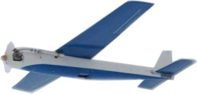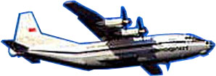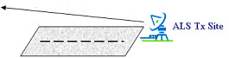

Wanted signal for ALS receiver

# 3 Unmanned aircraft systems and multi-purpose radar

Figure 6 shows the scenario where interference caused by a UAS airborne transmitter enters the main lobe or side lobes of a MPR airborne receiver antenna pattern. The antenna gain was assumed to be 30 dBi via the main lobe or 13 dBi via side lobes. The MPR receiver bandwidth was assumed to be 0.5 MHz, and the MPR receiver noise factor was assumed to be equal 8 dB. The results of calculation according to (1) show that in both cases the required protection distances 29 572 km and 4 177 km exceed the line-of-sight distance of 903 km (see Table 2).

Figure 6

**Airborne radar (МРR)**



Harmful interference from UA

Wanted signal



# 4 Unmanned aircraft systems and surface based radar

Figure 7 shows the scenario where interference caused by an airborne UAS transmitter enters the main lobe or side lobes of a SBR terrestrial antenna pattern. It was assumed that the antenna gain was 43 dBi via main the lobe or 24 dBi via side lobes. The SBR receiver bandwidth was assumed to be 25 MHz, and its noise factor was 6.5 dB. The results of calculation according to (1) show that in both cases the required protection distance of 23 119 km and 2 594 km exceed the line-of-sight distance of 464 km (see Table 2).

Figure 7



Harmful interference from UA

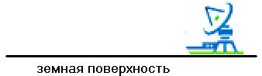

Wanted signal

Terrestrial radar (SBR)

Наземный радар (SBR)

# 5 Unmanned aircraft systems and radar sensing and measurement systems

Figure 8 shows the scenario where interference caused by a UAS airborne transmitter enters the main lobe or side lobes of a RSMS airborne receiver antenna pattern. It was assumed that the RSMS antenna gain was 13 dBi via the main lobe or minus 4 dBi via side lobes. The RSMS receiver bandwidth was assumed to be 2.0 MHz and its noise factor was 6 dB. The results of calculation according to (1) show that in the case of interference via the main lobe of the antenna pattern, the required protection distance would be 2 787 km and this value exceeds the line-of-sight distance of 611 m (see Table 2). In the case of interference via side lobes, the required protection distance would be 394 km.

Figure 8



Harmful interference from UA



Wanted signal

1500 m

Earth Surface

RSMS

# 6 Conclusions

The studies showed that compatibility between UAS and operating ARNS systems in the frequency band 15.4-15.5 GHz is possible only on the basis of frequency-site planning, which would be very difficult to implement on account of a large number of UAS expected to operate simultaneously in non-segregated airspace.

It should be noted that the studies dealt with scenarios, where one UA transmitter causes interference to ARNS receivers. Aggregate interference from multiple UAS could result by increasing the required protection distances.

Appendix 3  
to Annex 1  
  
Compatibility studies between systems operating in the aeronautical  
mobile (route) service and the radio astronomy service  
in the adjacent frequency band 15.35-15.4 GHz

# 1 Introduction

Two studies have been performed with regards to the radio astronomy service.

The first one uses a static protection criteria of −202 dBW for the RAS station (see Recommendation ITU‑R RA.769-2) whereas the second one uses the epfd methodology detailed in Recommendation ITU‑R M.1583-1, valid for multiple interfering sources that may transmit into the main lobe of the RAS station during a very short period (like UAS), and the epfd threshold derived from recommendation ITU‑R RA.769-2.

# 2 Study 1

## 2.1 General assumptions and initial data

The study considered a scenario of possible interference as illustrated in figure 1-6 below taking account of the following limitations and assumptions:

1) an unmanned aircraft (UA) transmitter may cause harmful interference to RAS station receiver via both the main lobe and side lobes of the RAS antenna pattern;

2) the free-space propagation model from Recommendation ITU‑R Р.528 was used;

3) the technical characteristics and protection criterion for RAS are in accordance with Recommendation ITU‑R RA.769-2.

Figure 9

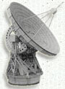

RAS receiver

Harmful interference from UA

Wanted signal received by RAS

Space object



To estimate compatibility between a RAS terrestrial receiver and a UA airborne transmitter, the criterion of maximum admissible interference level *I*max at the input of the RAS receiver was used:

*I*  = *I*max (10)

In the frequency band considered this criterion is equal to minus 202 dBW.

It should be noted that the criterion specified in Recommendation ITU‑R RA.769-2 is quite strict because of the same strict requirements to sensitivity of RAS receivers.

The power of out-of-band interference *I*(W) produced by the UA transmitter at the input of the RAS receiver is defined as follows:

 (11)

where:

*Рua*: power of out-of-band interference from the UA transmitter in the RAS receiver operating frequency band (W)

*Gras*(θ): RAS receiver antenna gain in the direction to the source of interference (where θ is the angle between the direction of the maximum of the RAS receiver antenna pattern and the direction to the source of interference)

λ: wavelength (m)

*R*: separation distance between UA transmitter and RAS receiver (m).

The value of *Рua*was estimated on the basis of following additional assumptions.

It is assumed that:

а) the baseband emission bandwidth Δ*Fua*of the UA transmitter is known;

b) the baseband emission power *Рmain* of the UA transmitter is also known;

c) the UA signal spectrum is shifted relative to the upper bound of the RAS frequency allocation so that the level of out-of-band emissions into the RAS frequency band does not exceed minus 60 dB with respect to the maximum (*Kua* = *Sua / So-o-b ua* = 60 dB);

d) RAS receiver operating bandwidth Δ*Fras* is 50 MHz (in the frequency band 15.35‑15.4 GHz).

## 2.2 Estimation of compatibility

Based on the above assumptions, the equation for *Рua* may be expressed as follows:

(12)

The following formula to determine minimum required protection distance *R* (km) can be obtained from equations (1-10) to (1-12):

 (13)

where *Gras*(θ) is in dBi, *Рmain* is in dBW, *F* is in GHz, *Kua* is in dB, Δ*F* is in kHz, Δ*Fras* is in kHz, and θ is in degrees.

The following assumptions were adopted in the calculation: *Рmain* = 30 dBW; *I*max = −202 dBW; Δ*Fua* = 75 kHz; Δ*Fras* = 50 000 kHz; *F* = 15.375 GHz. It was also assumed that UA transmitter operated at the altitude of 12 000 m, and the height if RAS receiver antenna was 10 m. Such location conditions result in the line-of-sight distance between UA and RAS station of 464 km.

Results of the calculation are presented in Table 3.

TABLE 3

|  |  |  |  |  |  |  |  |  |  |  |  |  |  |  |
| --- | --- | --- | --- | --- | --- | --- | --- | --- | --- | --- | --- | --- | --- | --- |
| θ | (deg.) | 0 | 1 | 2 | 3 | 5 | 10 | 15 | 20 | 25 | 30 | 34–80 | 80–120 | 120–180 |
| *Gras*(θ) | (dBi) | 84 | 29 | 21.5 | 17 | 11.5 | 4 | −1.3 | −5 | −8 | −10.3 | −12 | −7 | −12 |
| R – minimum protection distance | (km) | * | 449 971 | 189 751 | 113 027 | 600 045 | 25 303 | 13 746 | 8 978 | 6 356 | 4 877 | 4 010 | 7 131 | 4 010 |
| Separation distance required | (km) | 464 (line-of-sight distance) | | | | | | | | | | | | |
| * Exceeds the distance to the boundary of deep space. | | | | | | | | | | | | | | |

Table 3 shows that the required protection distances exceed the line-of-sight distance which therefore can be used as the coordination one.

# 3 Study 2

The study uses the epfd methodology detailed in Recommendation ITU‑R M.1583-1. The RAS antenna is randomly pointed in the sky, the location of UAS is randomly chosen. Then the epfd at the RAS level is calculated and integrated over a time period of 2000 seconds, taking into account the UAS movements. The epfd is then compared to the epfd threshold derived from recommendation ITU‑R RA.769-2. When the epfd is over the threshold, there is data loss in the RAS receiver. This is done for several trials (at least 20 for each of the 2 334 cells of the sky, which is more than 45 000 trials in total). The overall data loss is then calculated over the whole sky and compared to the 2% criterion for RAS.

Figure 10 gives an example of a trial where the number of UAS is following the distribution of UAS given in ITU‑R Report M.2171. The total number of UAS is 64 in a square of 1 000 km × 1 000 km. Taking into account the UAS characteristics expected in this frequency band, this study focuses on large UAS, generally flying above 6000 m. For this analysis, 54 UAS are assumed to fly above 6 000 m, while 10 UAS are assumed to be in departure or arrival phase and therefore operate below 6 000 m. The initial location and moving direction are randomly chosen, with a uniform law. The UAS speed is the same for all UAS, 300 km/h. The location of each UAS is then computed over 2 000 seconds which is the integration time for the radio astronomy station when considering the threshold levels contained in RA.769-2. The RAS station is in the middle, at altitude 0 m (coordinates 0, 0, 0).

Figure 10

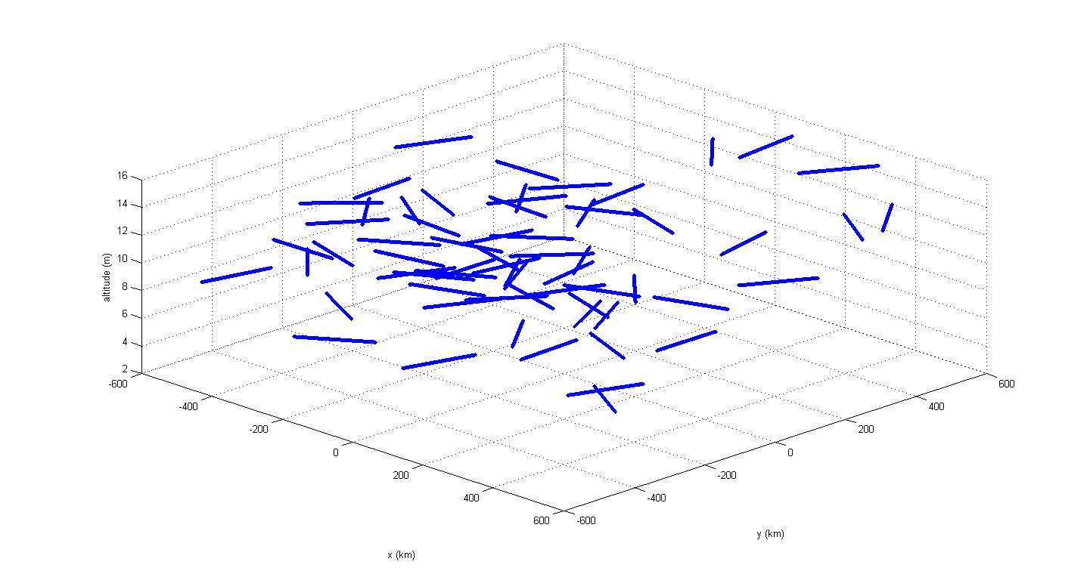

Figure 11 is an example of epfd calculation over the sky for one trial. The epfd is integrated over the 2 000 seconds, taking into account the UAS movement as shown above.

Figure 11

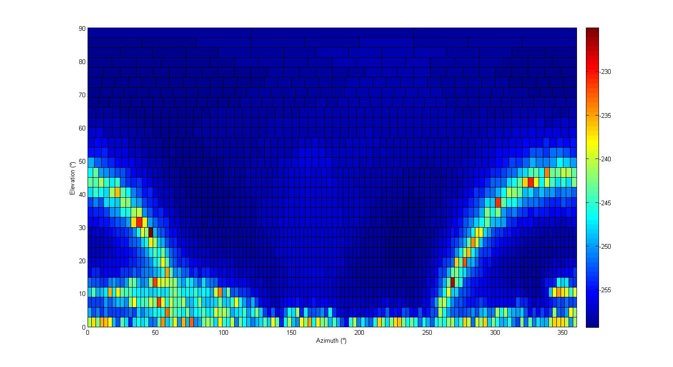

The impact of UAS is predominant at low elevation angles, below 3°. This is consistent with previous epfd simulations considering aircraft flying on air routes (see the studies performed under WRC-12 AI 1.12 with space research or studies performed prior to WRC-03 with AMS(R)S at 14 GHz).

Figures 12 and 13 give the level of data loss over the sky for 20 trials and an unwanted emission EIRP of −68 dBW in 50 MHz, noting that the epfd threshold is −240 dBW/m² in 50 MHz (continuum observations) for a 100 m diameter antenna. The overall data loss, averaged over the whole sky is 2.6%, close to the 2% criterion. This confirms that the interference occurs mainly at low elevation angles. It should be noted that not all the radio astronomy stations are able to observe below 5° elevation, and this for all azimuth angles. The data loss above 3° elevation is found to be 1.64%, i.e. below the 2% criterion.

Figure 12

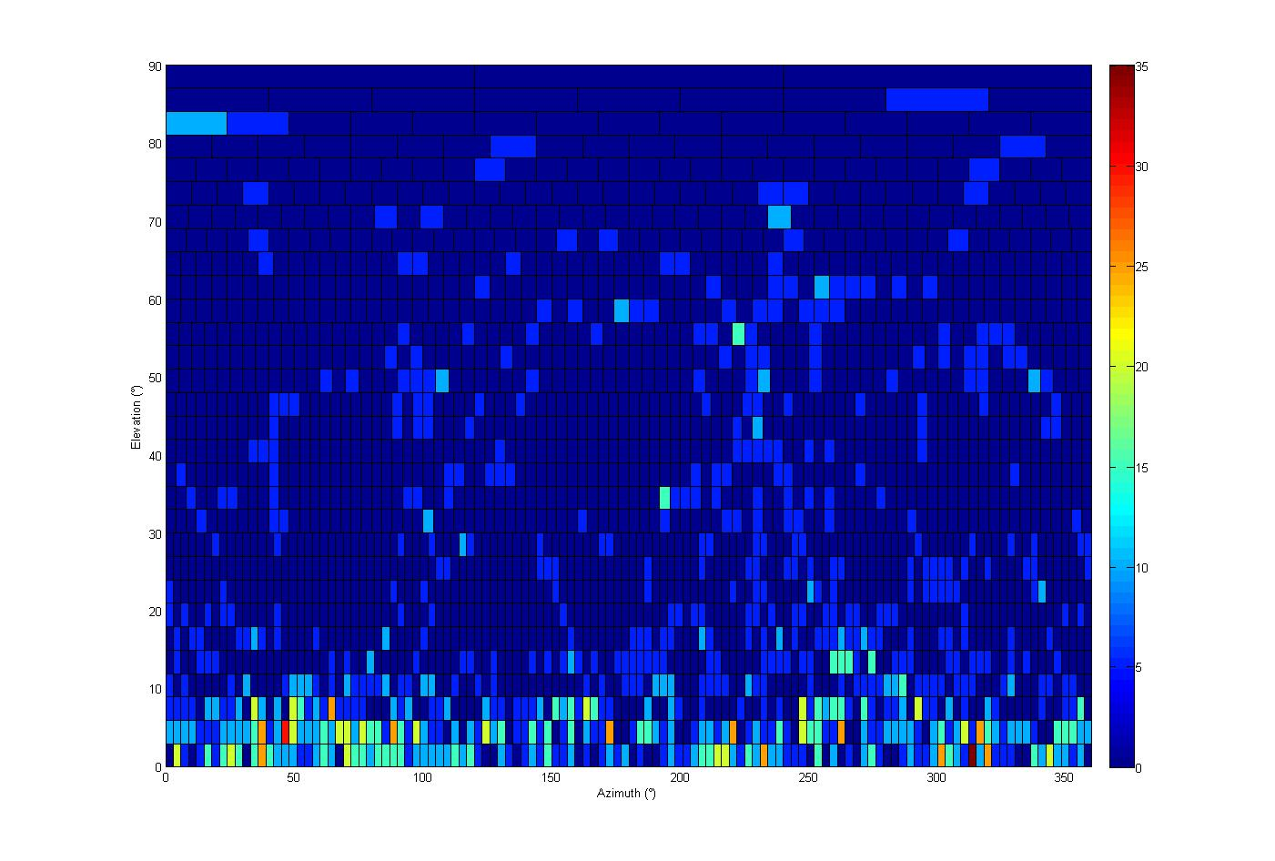

Figure 13

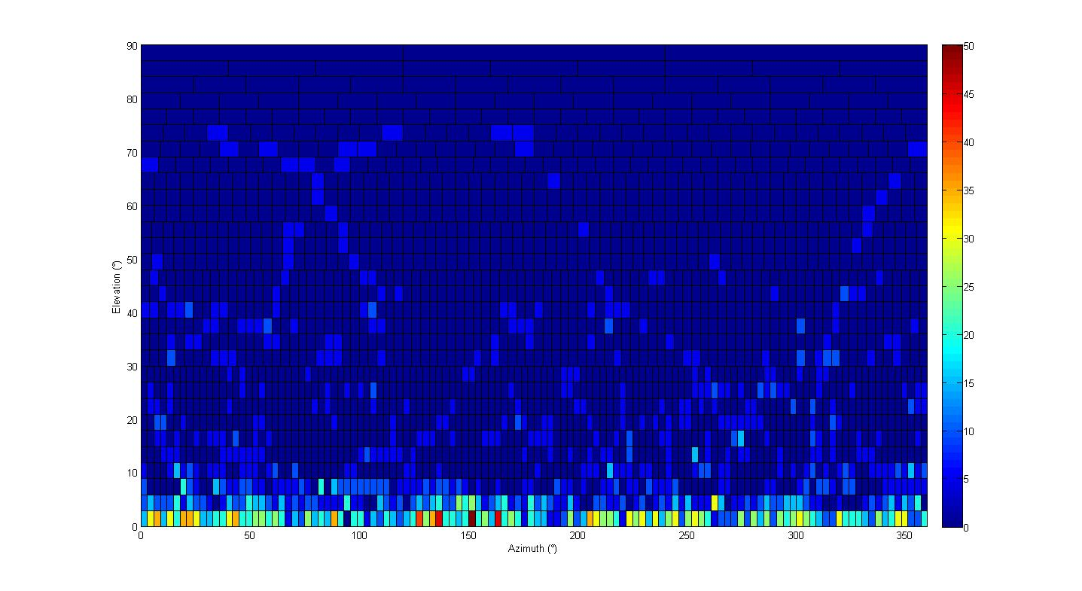

# 4 Conclusions

Analysis of the calculation results in Study 1, using a static approach, shows that compatibility between a UA transmitter and RAS receiver cannot be accomplished in any direction from the maximum level of the RAS antenna pattern at distances equal to the line-of-sight distance (464 km) due to the required level of protection contained in ITU‑R Recommendation RA.769-2. It should be noted that this result was obtained assuming an out of band rejection of 60 dB.

Study 2, using a statistical approach derived from Recommendation ITU‑R M.1583-1, shows that by taking into account multiple interfering sources that may transmit into the main lobe of the RAS station during a very short period (like UAS), the protection criterion of 2% can be met by limiting the out-of-band e.i.r.p. of UA systems to −68 dBW in a 50 MHz bandwidth. It should be noted that reaching this out of band e.i.r.p. level would be dependent upon the filters used in the UA transmitter. Obtaining this level will be difficult to achieve at this time because there is no information about the feasibility of such on-board equipment. For example, reaching the value of −68 dB/W in a 50 MHz bandwidth using the UA characteristics provided in Table 1 requires a filter rejection of 112 dB.

Annex 2  
  
Glossary

ACP Aeronautical Communications Panel

AES Airborne earth station

ALS Automatic landing system

AM(R)S Aeronautical mobile (route) service

AMS Aeronautical mobile service

AMS(R)S Aeronautical-mobile satellite (route) service

AMSS Aeronautical-mobile satellite service

ANLE Airport network and location equipment (a highly integrated, high-data-rate, wireless local-area network for airport surface areas)

ARNS Aeronautical radionavigation service

ATC Air traffic control

BLoS Beyond line-of-sight

CNPC Control and non-payload communications

dB Decibel(s)

dBc dB relative to the carrier

dBHz dB referred to one hertz

dBi dB referred to the gain of an isotropic antenna

dBm dB referred to one milliwatt

dBm/Hz dB referred to one milliwatt per hertz

dBr dB relative to a maximum value

dBW dB referred to one watt

DL Downlink

DME Distance measuring equipment

DME/N Narrow-spectrum distance measuring equipment

DME/P Precision distance measuring equipment

DQPSK Differential quadrature phase-shift keying

e.i.r.p. Equivalent isotropically radiated power

E/S Earth-to-space

EUROCAE European Organization for Civil Aviation Equipment

FDD Frequency-division duplex

FDR Frequency-dependent rejection

FL Forward link

FSS Fixed-satellite service

GES Ground earth station (for SATCOM CNPC system)

GPS Global positioning system

GS Ground station (for terrestrial CNPC system)

*G*/*T* Ratio of receiving-antenna gain to receiver thermal noise temperature in kelvins

HIBLEO-4 A non-geostationary-orbit satellite network

ICAO International Civil Aviation Organization

IEEE Institute of Electrical and Electronics Engineers

IEEE 802.16e IEEE standard (for mobile broadband wireless access systems)

ILS Instrument landing system

INR Interference-to-noise ratio

ITU International Telecommunication Union

ITU‑R ITU Radiocommunication Sector

kHz Kilohertz

LAN Local area network

LEO Low Earth orbit (or a satellite in that orbit)

LoS Line-of-sight

MHz Megahertz

MLS Microwave landing system

MPR Multipurpose radar

MS Mobile service

MSS Mobile-satellite service

OFDM Orthogonal frequency-division multiplexing

OFDMA Orthogonal frequency-division multiple access

PFD Power flux-density

QPSK Quadrature phase-shift keying

RF Radio frequency

RL Return link

RNSS Radionavigation-satellite service

RR Radio Regulations

RSMS Radar sensing and measurement system

Rx Receiver

S&A Sense and avoid

Sat. Satellite

SATCOM Satellite communications

SBR Surface-based radar

S/E Space-to-Earth

SNR Signal-to-noise ratio

SWAP Size, weight, and power

TDD Time-division duplex

Tx Transmitter

UA Unmanned aircraft

UACS UA control station

UAS UA system(s)

UL Uplink

W Watt

WiMAX Worldwide Interoperability for Microwave Access

WRC World Radiocommunication Conference

WRC-07 WRC 2007

WRC-12 WRC 2012

1. UAS payload communications are not covered in this report.
2. * Even though, due to the time constraints, the results of Study 2 (RAS) has not been reviewed by concerned ITU-R groups, nevertheless, the methodology has been taken from Recommendation ITU‑R M.1583-1 and the protection criteria for RAS from Recommendation ITU‑R RA.769-2.
3. See System-6 in Rec. ITU‑R M.1730.