|  |
| --- |
| **Report ITU-R M.2235**  **(11/2011)** |
| **Aeronautical mobile (route) service sharing studies in the frequency band 960-1 164 MHz** |
| **M Series**  **Mobile, radiodetermination, amateur**  **and related satellite services** |

Foreword

The role of the Radiocommunication Sector is to ensure the rational, equitable, efficient and economical use of the radio-frequency spectrum by all radiocommunication services, including satellite services, and carry out studies without limit of frequency range on the basis of which Recommendations are adopted.

The regulatory and policy functions of the Radiocommunication Sector are performed by World and Regional Radiocommunication Conferences and Radiocommunication Assemblies supported by Study Groups.

# Policy on Intellectual Property Right (IPR)

ITU-R policy on IPR is described in the Common Patent Policy for ITU-T/ITU-R/ISO/IEC referenced in Annex 1 of Resolution ITU-R 1. Forms to be used for the submission of patent statements and licensing declarations by patent holders are available from <http://www.itu.int/ITU-R/go/patents/en> where the Guidelines for Implementation of the Common Patent Policy for ITU‑T/ITU‑R/ISO/IEC and the ITU-R patent information database can also be found.

|  |  |
| --- | --- |
| Series of ITU-R Reports  (Also available online at <http://www.itu.int/publ/R-REP/en>) | |
| **Series** | Title |
| **BO** | Satellite delivery |
| **BR** | Recording for production, archival and play-out; film for television |
| **BS** | Broadcasting service (sound) |
| **BT** | Broadcasting service (television) |
| **F** | Fixed service |
| **M** | Mobile, radiodetermination, amateur and related satellite services |
| **P** | Radiowave propagation |
| **RA** | Radio astronomy |
| **RS** | Remote sensing systems |
| **S** | Fixed-satellite service |
| **SA** | Space applications and meteorology |
| **SF** | Frequency sharing and coordination between fixed-satellite and fixed service systems |
| **SM** | Spectrum management |

|  |
| --- |
|  |

|  |
| --- |
| ***Note****: This ITU-R Report was approved in English by the Study Group under the procedure detailed in Resolution ITU-R 1.* |

*Electronic Publication*

Geneva, 2012

© ITU 2012

All rights reserved. No part of this publication may be reproduced, by any means whatsoever, without written permission of ITU.

REPORT ITU-R M.2235

Aeronautical mobile (route) service sharing studies  
in the frequency band 960-1 164 MHz

(2011)

# 1 Introduction

This document summarizes the status of development of candidate aeronautical mobile (route) service (AM(R)S) systems intended to provide aeronautical communications in the band   
960-1 164 MHz, opened to that service by the recent WRC-07. It presents compatibility studies of AM(R)S systems operating in the aforementioned band with systems operating in-band, and in the adjacent bands, both on-board aircraft and on ground.

The civil aviation community, under the auspices of International Civil Aviation Organisation (ICAO) and notably its aeronautical communication panel (ACP) has for the last four years been studying the need to evolve its communications infrastructure in order to accommodate new functions and to provide the adequate capacity and quality of services required to support air traffic management (ATM) requirements in the years 2020 +.

This community included in the scope of its studies, the opportunity to use the frequency band   
960-1 164 MHz for data link communication, particularly suited for long-range terrestrial communications.

As new ATM concepts emerge with the advent of the single European sky ATM research (SESAR) [1] and next generation air transportation system (NEXTGEN) [2] in the USA, it is essential to converge to a single ATM concept including common standards for the future aeronautical communications infrastructure [2] being applicable on a worldwide basis to ensure interoperability. Accordingly the possibility to operate a new air/ground data-link within this band has emerged as an essential enabler for the success of both the European and US future ATM enhancement programmes.

However before significant development can start on such a data link in the frequency band   
960-1 164 MHz, studies on operational and technical means to facilitate sharing between AM(R)S systems operating in the frequency band 960-1 164 MHz and ARNS systems operating in the countries referred to in RR No. 5.312 have to be performed in the scope of WRC-12 Agenda item 1.4, namely: *“…to consider, based on the results of ITU‑R studies, any further regulatory measures to facilitate introduction of new aeronautical mobile (R) service (AM(R)S) systems in the bands 112‑117.975 MHz, 960‑1 164 MHz and 5 000-5 030 MHz in accordance with Resolutions****413 (Rev.WRC‑07)****,* ***417 (WRC‑07)*** *and* ***420 (WRC‑07)****;”*

Accordingly and as usual for band sharing feasibility investigations in aeronautical radio navigation bands, the compatibility of the future aeronautical mobile (R) system (AM(R)S) with:

i) the ICAO-standard radio navigation systems, such as distance measurement equipment (DME), secondary surveillance radar (SSR), airborne collision avoidance system (ACAS) and universal access transceiver (UAT) has been addressed within ICAO and not reported in this Report;

ii) non-ICAO systems, operating in the aeronautical radionavigation service (ARNS) in countries referred to in RR No. 5.312 and the radionavigation satellite service operating in adjacent bands above 1 164 MHz, has been addressed within ITU‑R and reported in this Report.

# 2 Status of ICAO/ACP progress in AM(R)S system design

After having elaborated a concept of operations and communication requirements (COCR) framework [3], ICAO/ACP has set itself the task to identify the suitable technologies capable to meet those requirements. In the specific band 960-1 164 MHz, with the aim of using widely available communication technologies and/or reusing systems with established ICAO standards to the greatest extent possible the candidate technologies assessed for suitability of AM(R)S operations (L-band digital aeronautical communication system (L-DACS)) fall in two options, named L-DACS1 and L‑DACS2, for digital aeronautical communications in the band 960-1 164 MHz.

Table 1 depicts the two options*.*

TABLE 1

L-DACS options key characteristics

|  |  |  |
| --- | --- | --- |
|  | Duplexing technique | Modulation type |
| **L-DACS 1** | FDD | OFDM |
| **L-DACS 2** | TDD | CPFSK/GMSK type |

# 3 Aeronautical LDACS essential characteristics

They are presented in the following Table 2 for the two options mentioned above, L-DACS 1 and L-DACS 2.

TABLE 2

Essential characteristics of the aeronautical future radio system  
operating in the frequency band 960-1 164 MHz

| Parameter | L-DACS 1 option | L-DACS 2 option | Comments/references |
| --- | --- | --- | --- |
| Polarization | linear | linear |  |
| Airborne transmit power (dBW) | 8,5 | 17 |  |
| Airborne antenna gain, min/max (dBi) | 0/5.4 | 0/5.4 |  |
| Airborne antenna cable loss (dB) | 2 | 3 |  |
| Airborne equipment necessary transmit bandwidth (kHz) | 500 | 400 |  |
| Airborne receiver noise figure, including antenna cable loss(dB) | 10 | 10 |  |
| Airborne receiver IF bandwidth (kHz) | 500 | 400 |  |

TABLE 2 (*end*)

| Parameter | L-DACS 1 option | L-DACS 2 option | Comments/references |
| --- | --- | --- | --- |
| Return link (air -> gnd) channel centre frequencies (MHz) | From 1 048.5 to 1 071.5, every 1 MHz apart | Up to 3 times 4.8 MHz (12*400 kHz) in the frequency band 960‑977 MHz | (1) |
| Uplink s/band (gnd -> air) channel centre frequencies (MHz) | From 985.5 to 1 007.5 MHz, every 1 MHz apart | Up to 3 times 4.8 MHz  (12*400 kHz) in the band 960-977 MHz | (1) |
| Gross bit-rate (Kbit/s) | 800 | 540 |  |
| Access scheme | FDD | TDD |  |
| Modulation | OFDM | GMSK | (2) |
| Internal co-channel interference ratio *C*/*Ic* (dB) | 13.2 | 12 |  |
| Other interference protection ratio, *I*/*N* (dB) | −6 | −6 | (3) |
| Signal-to-noise ratio, *S*/*N* (dB) | 15 | 15 |  |
| Safety margin (dB) | 6 | 6 |  |
| Apportionment interferences | 6 | 6 |  |
| Transmit mask, out-of-band and non‑essential radiations | See Fig. 1 | See Fig. 2 Complies with Rec. ITU-R SM.329-10 |  |
| Ground transmit power (dBW) | 18 | 20 |  |
| Ground antenna gain (dBi) | 8 | 8 | Omnidirect. In horizontal plane. In vert. Plane Rad. Pattern similar to Rec. ITU-R F.1336.1 |
| Ground necessary transmit bandwidth (kHz) | 500 | 400 |  |
| Ground antenna cable loss (dB) | 2 | 2 |  |
| Ground receiver noise figure, including antenna cable loss (dB) | 9 | 9 |  |
| Ground receiver IF bandwidth (kHz) | 500 | 400 |  |

|  |
| --- |
| *Notes relatives to Table 2:*  NOTE – Table 2 was developed with parameters available at the time of the studies.  Comments/ references:  1) L-DACS 1 is designed as inlay system, i.e. to be operated between two adjacent DME channels , each centred on a round figure frequency assignment in MHz (See Annex 10 paired VHF omni-ranging (VOR)/DME/MLS assignment table for details). For simulations, the system is extended to the 960‑1 164 MHz band with the same technical characteristics and a 7 channel reuse scheme is assumed. With L-DACS 2, uplink and downlink occur in simplex mode on the same signalling channel, using a time division duplex (TDD) scheme. A 12 channel reuse scheme is assumed. The total bandwidth required for L-DACS 2 is nominally (12 × 400 kHz) 4.8 MHz. Up to three 4.8 MHz sub-bands can be thus fitted in the 960-977 MHz band.  2) Modulation:  a) L-DACS 1 OFDM is characterized as follows:  Length of FFT (Fast Fourier Transform):  Number of used sub-carriers:  Number of cancellation carriers (side-lobe suppression):  Sub-carrier spacing:  Symbol duration with guard:  Symbol duration without guard:  Guard interval duration (incl. RC windowing):  Number of symbols per OFDM frame:  OFDM frame duration:  b) L-DACS 2 selected modulation scheme is:  – GMSK with: *h* = 0.5 and *BT* = 0.3  – Gross bit rate: ~ 540 Kbit/s  – Channel bandwidth: 400 kHz.  3) Interference protection ratio, the chosen criteria yields an acceptable 1 dB signal-to-noise ratio degradation given a minimum of 6 dB link budget margin under all circumstances except interference. |

## 3.1 L-DACS options out-of-band emissions

a) L-DACS 1 radiated out-of band emissions level is depicted in Fig. 1 below.

b) L-DACS 2 out-of-band emissions are expected to comply with Recommendation ITU‑R SM.329‑10. The spurious domain consists of frequencies separated from the centre frequency of the emission by 250% of the necessary bandwidth of the emission. A reference bandwidth is a bandwidth in which spurious domain emission levels are specified.

The following reference bandwidths are used:

– 100 kHz between 30 MHz and 1 GHz;

– 1 MHz above 1 GHz.

According to Recommendation ITU-R SM.329-10, the maximum permitted spurious domain emission power in the relevant reference bandwidth is –13 dBm. The spectrum emission mask that has been retained is in fact more efficient than this. Its specifications are given in Table 3 and Fig. 2.

TABLE 3

Spurious domain emissions used for L-DACS 2 system

|  |  |  |  |
| --- | --- | --- | --- |
| Frequency offset from the central frequency | Permitted spurious domain emission, (dBm) | Reference bandwidth, (kHz) | Comment |
| *f* >*f*0 +1 MHz or *f* <*f*0 – 1 MHz | −13 | 100 | Rec. ITU-R SM.329-10 |
| *f* >*f*0 + 2 MHz or *f* <*f*0 – 2 MHz | −27 | 100 | Additional specification |

Figure 1

Expected L-DACS 1 emission mask

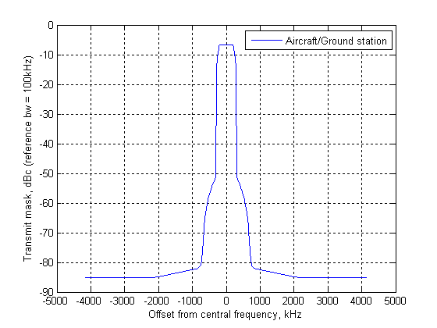

Figure 2

Expected L-DACS 2 emission mask (from Table 3)

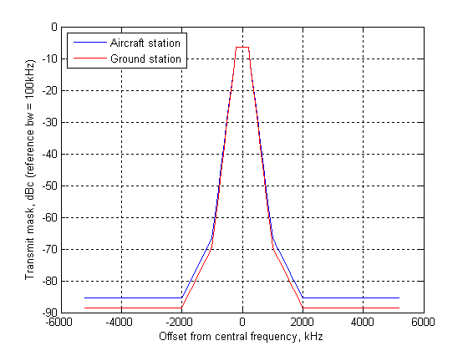

## 3.2 On-board antenna gain

Table 4 provides the antenna gain for elevation values between −90 and 90. For elevation values between two values of Table 4 a linear interpolation should be used. The *Gr*,*max* value is 5.4 dBi. It is assumed that the elevation and gain pattern is the same for all azimuth angles.

TABLE 4

| Elevation angle (degrees) | Antenna gain  *Gr*/*Gr*,*max* (dB) | Elevation angle (degrees) | Antenna gain  *Gr*/*Gr*,*max* (dB) | Elevation angle (degrees) | Antenna gain  *Gr*/*Gr*,*max* (dB) |
| --- | --- | --- | --- | --- | --- |
| –90 | –17.22 | 22 | –10.72 | 57 | –15.28 |
| –80 | –14.04 | 23 | –10.81 | 58 | –15.49 |
| –70 | –10.51 | 24 | –10.90 | 59 | –15.67 |
| –60 | –8.84 | 25 | –10.98 | 60 | –15.82 |
| –50 | –5.40 | 26 | –11.06 | 61 | –16.29 |
| –40 | –3.13 | 27 | –11.14 | 62 | –16.74 |
| –30 | –0.57 | 28 | –11.22 | 63 | –17.19 |
| –20 | –1.08 | 29 | –11.29 | 64 | –17.63 |
| –10 | 0.00 | 30 | –11.36 | 65 | –18.06 |
| –5 | –1.21 | 31 | –11.45 | 66 | –18.48 |
| –3 | –1.71 | 32 | –11.53 | 67 | –18.89 |
| –2 | –1.95 | 33 | –11.60 | 68 | –19.29 |
| –1 | –2.19 | 34 | –11.66 | 69 | –19.69 |
| 0 | –2.43 | 35 | –11.71 | 70 | –20.08 |
| 1 | –2.85 | 36 | –11.75 | 71 | –20.55 |
| 2 | –3.26 | 37 | –11.78 | 72 | –20.99 |
| 3 | –3.66 | 38 | –11.79 | 73 | –21.41 |
| 4 | –4.18 | 39 | –11.80 | 74 | –21.80 |
| 5 | –4.69 | 40 | –11.79 | 75 | –22.15 |
| 6 | –5.20 | 41 | –12.01 | 76 | –22.48 |
| 7 | –5.71 | 42 | –12.21 | 77 | –22.78 |
| 8 | –6.21 | 43 | –12.39 | 78 | –23.06 |
| 9 | –6.72 | 44 | –12.55 | 79 | –23.30 |
| 10 | –7.22 | 45 | –12.70 | 80 | –23.53 |
| 11 | –7.58 | 46 | –12.83 | 81 | –23.44 |
| 12 | –7.94 | 47 | –12.95 | 82 | –23.35 |
| 13 | –8.29 | 48 | –13.05 | 83 | –23.24 |
| 14 | –8.63 | 49 | –13.14 | 84 | –23.13 |
| 15 | –8.97 | 50 | –13.21 | 85 | –23.01 |
| 16 | –9.29 | 51 | –13.56 | 86 | –22.88 |
| 17 | –9.61 | 52 | –13.90 | 87 | –22.73 |
| 18 | –9.93 | 53 | –14.22 | 88 | –22.57 |

TABLE 4 (*end*)

| Elevation angle (degrees) | Antenna gain  *Gr*/*Gr*,*max* (dB) | Elevation angle (degrees) | Antenna gain  *Gr*/*Gr*,*max* (dB) | Elevation angle (degrees) | Antenna gain  *Gr*/*Gr*,*max* (dB) |
| --- | --- | --- | --- | --- | --- |
| 19 | –10.23 | 54 | –14.51 | 89 | –22.40 |
| 20 | –10.52 | 55 | –14.79 | 90 | –22.21 |
| 21 | –10.62 | 56 | –15.05 |  |  |

3.3 Ground antenna gain

The pattern used for the study is defined by Recommendation ITU-R F.1336-2, §§ 2.1 and 2.1.1 and is recalled below:

The *Gr, max* value is 8 dBi for both LDACS options, according to Table 2. It is assumed that the elevation and gain pattern are the same for all azimuth angles.

 for 

 for 

 for 

where:

*Gr*(θ): AM(R)S ground antenna gain relative to *Gr, max* (maximum gain)

: absolute value of the elevation angle relative to the angle of maximum gain (degrees).

## 3.4 Deployment scenario

L-DACS deployment can be modelled with a cellular network. The typical operating cell radius will be between 130 and 370 km. The proposed frequency reuse factor for L-DACS 1 system is 7 and 12 for L-DACS 2 system.

# 4 Typical characteristics of stations in the aeronautical radionavigation service

National radionavigation systems refer to non-ICAO standard ARNS systems. Two types are considered in this study i.e.:

– ARNS systems operating in the countries referred to in RR No. 5.312;

– Tactical Air Navigation system used in many other countries.

## 4.1 Stations operating in aeronautical radionavigation service in the countries referred to in RR No. 5.312

Specifically the countries referred to in RR No. 5.312 of the RR operate the ARNS systems of the following three types:

– (1) ARNS systems of the first type refer to direction-finding and ranging systems. The systems are designed for finding an azimuth and a slant range of an aircraft as well as for area surveillance and inter-aircraft navigation. They are composed of air-borne and ground‑based stations. The air-borne stations generate requesting signals transmitted via omnidirectional antennae and received at ARNS ground stations which also operate in an omnidirectional mode. The ground stations generate and transmit response signals containing azimuth/ranging information. Those signals are received and decoded at the ARNS air-borne stations. The first type stations transmit the signals requesting the azimuth/ranging data outside the 960-1 164 MHz frequency band. After receiving a requesting signal the ARNS ground stations use the 960-1 164 MHz frequency band only for transmitting the ranging data to be received at the ARNS air‑borne stations. Thus the ARNS systems of the first type use the 960-1 164 MHz frequency band only for transmitting the signals in the surface-to-air direction.

The maximum operation range for the first type ARNS systems is 400 km. It is expected that in some of the countries mentioned in RR No. 5.312 the usage of type 1 of ARNS mentioned above may be discontinued.

– (2) ARNS direction-finding and ranging systems of the second type are designed for the same missions as the first type ARNS systems. The primary difference of the second type stations refers to the fact that requesting signals are transmitted by the air-borne stations in the same frequency band as responding signals transmitted from the ground stations. Moreover the ground-based ARNS stations of the second type can operate in both directional and omnidirectional modes. Directional mode provides increased number of operational channels at the ARNS stations. The maximum operation range for the first type ARNS systems is 400 km. It is planned to use the overall frequency band 960-1 164 MHz allocated to ARNS in order to increase flexibility of operation of the second type ARNS systems. Application of the wideband tuning filter on the ARNS receiver front end is the design peculiarity of the second type ARNS systems which is stipulated by the necessity to receive signals on several channels simultaneously.

The 3 dB bandwidth of this filter is 22 MHz and it allows receiving simultaneously up to 5 channels among 30 overlapping channels of 4.3 MHz each. The simultaneous usage of a wideband filter and correlator allows an increase in the accuracy of aircraft position data measurement and *C*/*N* ratio at the receiver front end as well. Type 2 of ARNS system can operate in a limited number of countries mentioned in RR No. 5.312.

– (3) ARNS systems of the third type are designed for operating at the approach and landing stages of flight. The system provides control functions of heading, range and glide path at aircraft approach and landing. The ARNS ground stations of the third type operate in both directional and omnidirectional modes. Operation range of the third type ARNS systems does not exceed 60 km. The 960-1 164 MHz frequency band is used for operation of the channels designed for control of the glide path and range between air‑borne and ground ARNS stations. Type 3 of ARNS system can operate in a limited number of countries mentioned in RR No. 5.312.

Technical parameters as well as protection criteria are found in the Draft new Recommendation ITU-R M.2013 – Technical characteristics of, and protection criteria for non-ICAO ARNS systems, operating around 1 GHz. .Table 5A below provides brief technical description of the ARNS stations.

Thus the stations of the non-ICAO systems operate using the air-to-surface and surface-to-air links are made up of ground and airborne receivers and transmitters.

TABLE 5A

Typical characteristics of the stations operating in the aeronautical radionavigation service in the countries referred to in RR No. 5.312

|  | Type 1 | Type 2 | | Type 3 | |
| --- | --- | --- | --- | --- | --- |
| Purpose | Radio systems of short-range navigation | Radio systems of short-range navigation | | Radio systems of approach and landing | |
| Operating frequency range (MHz) | 960-1 000.5 | 960-1 164 | | | |
| Radioline direction | “Earth-aircraft” | “Earth-aircraft” | “aircraft-Earth” | “Earth-aircraft” | “aircraft-Earth” |
| Operation range (km) | up to 400 | up to 400 | up to 400 | up to 45 | up to 45 |
| Transmitted information | Transmission of azimuthal signals, range response signals and request to indication | Transmission of azimuthal signals, range response signals and request to indication | Transmission of range request signal and indication response signal | Transmission of signals in glide path and course channels and range response signals | Transmission of range request |
| **Transmitter characteristics** | | | | | |
| Station name | Airport and en-route path ground stations | Airport and en-route path ground stations | Aircraft station | Airport ground station | Aircraft station |
| Class of emission | 700KРХХ | 4M30P1N | 4M30P1D | 700KP0X; 4M30P1N | 700KP0X; 4M30P1N |
| Channel spacing (MHz) | 0.7 | 0.7 | 0.7 | 0.7 | 2 |
| Transmitter power (pulsed) dBW) | 20-45 | 29-39 | 27-33 | 3-30 | 5-33 |
| Duty factor (%) | 0.018; 0.066 | 0.064-0.3 | 0.00765 | 0.04; 0.025 | 0.009 |
| Mean output power (min/max) (dBW) | 7.6 / 13.2 | 7.1/13.8 | –14.2/−8.2 | –4/−6 | –35.5/−7.5 |
| Pulse length (μs) | 1.5; 5.5 | 1.25; 1.5; 5.5 | 1.5 | 1.7 | 1.7 |
| Antenna type | Omnidirectional | Array antenna | Omnidirectional | Array antenna | Omnidirectional |

TABLE 5A (*end*)

|  | Type 1 | Type 2 | | Type 3 | |
| --- | --- | --- | --- | --- | --- |
| Purpose | Radio systems of short-range navigation | Radio systems of short-range navigation | | Radio systems of approach and landing | |
| Max/min antenna gain (dBi) | 6/0 | 15.6 | −10/3 | 10/0 | 1.5/−3 |
| Height above the ground (m) | 10 | 10 | up to 12 000 | 10 | up to 12 000 |
| Receiving station | Aircraft station | Aircraft station | Airport and en-route path ground stations | Aircraft station | Airport ground station |
| Height above the ground (m) | up to 12 000 | up to 12 000 | 10 | up to 12 000 | 10 |
| Receiver 3dB bandwidth (MHz) | 1.5 | 22 | 22 | 7 | 7 |
| Receiver noise temperature (K) | 400 | 1 060 | 550 | 400 | 400 |
| Max/min antenna gain (dBi) | 1.5/−3 | 3/−10 | 14 | 1.5/−3 | 10/0 |
| Polarization | horizontal | horizontal | horizontal | horizontal | horizontal |
| Receiver sensitivity (dBW) | −120 | −118 | −125 | −110…−120 | −113 |
| Protection ratio *C*/*I* (dB) | 25 | 17 | 20 | 25 | 25 |
| NOTE – The protection ratios shown in Table 5A were obtained for continuous AM(R)S signals. In case of pulsed AM(R)S signals it is required to carry out additional studies. In this respect signals with a pulse length of more than 50 µs are considered non-pulsed or continuous signals. | | | | | |

## 4.2 Tactical air navigation system

TACAN is an aeronautical radio navigation system used on a national basis operating between 960 and 1 215 MHz. A TACAN system consists of an interrogator on-board an aircraft and a beacon which gives the replies. In most cases the TACAN beacons are fixed ground based installations but there are maritime mobile and aeronautical mobile beacons in use as well. Depending on the generated e.i.r.p. and design of the interrogator slant ranges up to 400 NM or 740 km can be achieved but in practice the range is limited to the maximum radio line-of-sight (RLOS). The aircraft unit transmits regular pulse pairs, so-called interrogation pulses which are received by ground based installations (beacons). The TACAN pulses have a pulse width of 3.5 μs at the 50% Amplitude points. The spacing between the pulses of an interrogation pulse pair is 12 μs (X channel) or 36 μs (Y channel). After receiving an interrogator pulse pair a ground station will test the pulse shape and spacing. If these fall within the acceptance limits, it will respond by transmitting a reply after a fixed delay with a ±63 MHz frequency offset from the interrogation frequency depending on selected channel on pulse code. The beacon has spacing between the reply pulses of 12 μs (X channel) and 30 μs (Y channel). After receipt of the reply, the interrogator will calculate the momentary slant range distance to the beacon from the time elapsed between transmitting interrogation and receiving reply pulse pairs.

The beacon will receive interrogations from many aircraft and therefore will send out many replies. Each interrogator creates a unique pattern by varying, within certain limits, the time between the pulse pairs to avoid generation of synchronic replies. By this principle each platform is able to recognize among all pulse pairs the replies that are initiated by its own interrogator.

For identification purposes, a TACAN beacon transmits a Morse ID code. The ID tone is used at the airborne interrogators to verify if the range readouts are provided by the correct beacon. Besides the pulse responses, proper reception of the ID tone is also an important condition for TACAN interrogators to properly function.

In addition to the range measurements TACAN also offers azimuth bearing information. The bearing information is provided by applying a modulation in the amplitude of the pulses transmitted by the ground beacon. This pulse amplitude modulation (PAM) is created using either a mechanically or electronically scanning beacon antenna. The rotation in the azimuth pattern in the form of 15 Hz and 135 Hz antenna lobes at the maximum allowable modulation index of 55% will reduce the signal level of the reply pulses by up to 10.7 dB below the maximum e.i.r.p. level of pulses without PAM. In order for the interrogator to decode the orientation of the antenna pattern in reference to North from the PAM, an additional 900 pulse pairs, consisting of a north-reference-pulse-group (NRPG) and additional fine reference pulse groups (RPG) are transmitted by the beacon. In order to obtain accurate bearing information and be able to reply to at least 100 aircraft with 70% reply efficiency a constant number of at least 3 600 pulse pairs have to be transmitted.

The TACAN system is used for aeronautical navigation for both state aircraft as well as civil aviation. When used by civil aviation, the TACAN equipment is functionally equivalent to the ICAO standardized DME. Technical parameters as well as protection criteria are found in the DNR ITU-R M.2013 – Technical characteristics of, and protection criteria for non-ICAO ARNS systems, operating around 1 GHz TACAN characteristics are given in Table 5B below.

TABLE 5B

Typical characteristics of TACAN stations

| Purpose | Radio systems for air navigation (960 – 1 215 MHz) | | | | |
| --- | --- | --- | --- | --- | --- |
| Radio transmission direction | Earth-aircraft | Aircraft-Earth | Earth-aircraft maritime | Aircraft-Earth maritime | Aircraft-aircraft |
| Operating frequency range (MHz) | 962-1 213 | 1 025-1 150 | 962-977 | 1 025-1 088 | 1 025-1 151 |
| Operation range  (limited to RLOS) (km) | up to 600 | up to 600 | up to 600 | up to 600 | up to 740 |
| Transmitted information | Range and bearing response signals, Identification information | Range and bearing request signal | Range and bearing response signals, Identification | Range and bearing request signal | Range and bearing response signals, Identification |
| **Transmitter characteristics** | | | | | |
| Station name | Beacon | Interrogator | Beacon | Interrogator | Beacon |
| Height above the ground (m) | 3 (10ft) | up to 18 288  (60 000ft) | 3 (10ft) | up to 18 288 (60 000ft) | up to 18 288 (60 000ft) |
| Signal type | Pulsed | pulsed | pulsed | pulsed | Pulsed |
| Channel spacing (MHz) | 1 MHz | 1 MHz | 1 MHz | 1 MHz | 1 MHz |
| Type of modulation | Pulse form and pulse pair spacing | pulse form and pulse pair spacing | pulse form and pulse pair spacing | pulse form and pulse pair spacing | pulse form and pulse pair spacing |
| Transmitter power (pulsed) (dBW) | 39 (max) | 33 (max.) | 39 (max) | 33 (max.) | 33 (max) |
| Pulse length (μs) | 3.5±0.5 (50% Amplitude) | 3.5 ±0.5 (50% Amplitude) | 3.5 ±0.5 (50% Amplitude) | 3.5 ±0.5 (50% Amplitude) | 3.5 ±0.5 (50% Amplitude) |
| Typical duty factor (%) | 2.52 | 0.105 | 2.52 | 0.105 | 0.735 |
| Antenna type | Circular array | Omnidirectional | Circular array | Omnidirectional | Circular array |
| Typical antenna gain (dBi) | 6 | 0 | 6 | 0 | 6 |

TABLE 5B (*end*)

| Purpose | Radio systems for air navigation (960 – 1 215 MHz) | | | | |
| --- | --- | --- | --- | --- | --- |
| **Receiver characteristics** | | | | | |
| Receiving station | Aircraft station | Airport and en-route ground station | Aircraft stations | Maritime station | Aircraft station |
| Operating frequency range (MHz) | 962-1 213 | 1 025-1 150 | 962-977 | 1 025-1 088 | 1 025-1 151 |
| Height above the ground (m) | up to 20 880 (60 000ft) | 3  (10ft) | up to 20 880 (60 000ft) | 3 (10ft) | up to 20 880 (60 000ft) |
| Receiver 3 dB bandwidth (MHz) | 2 | 2-4.5 | 2 | 2-4.5 | 2-4.5 |
| Max/min antenna gain (dBi) | 5.4/0 | 9.1/4.1 | 5.4/0 | 9.1/4.1 | 5.4/0 |
| Polarization | Vertical | Vertical | Vertical | Vertical | Vertical |
| Receiver sensitivity (dBW) | −122 | −122 | −122 | −122 | −122 |
| Maximum acceptable interference level based on received power (dBW) | −129 | −130 | −129 | −130 | −129 |

NOTE – The protection ratios shown in Table 5B were obtained for continuous AM(R)S signals. In case of pulsed AM(R)S signals it is required to carry out additional studies. In this respect signals with a pulse length of more than 50 µs are considered non- pulsed or continuous signals.

NOTE – The airborne antenna gain is taken from Recommendation ITU-R M.1642-1

NOTE – Measurements on some TACAN devices showed that the TACAN sensitivity for the distance and angular measurements only differ by 3 dB for the TACAN interrogator receiver (–90 dBm for distance and –87 dBm for angular measurement).

NOTE – Table 5B was developed with parameters available at the time of the studies.

# 5 Radionavigation satellite service system(s) characteristics in the frequency band 1 164-1 215 MHz

Technical parameters as well as protection criteria are found in the draft new Recommendation ITU-R M.1905 – Characteristics and protection criteria for receiving earth stations in the radionavigation-satellite service (space-to-Earth) operating in the band 1 164-1 215 MHz. Table 6 provides those technical parameters.

TABLE 6

Technical characteristics and protection criteria for radionavigation satellite service receivers (space-to-Earth)  
operating in the frequency band 1 164‑1 215 MHz

| Parameter | Air-navigation receiver #1 | Air-navigation receiver #2 (Note 9) | High precision  receivers (Note 12) | | Indoor positioning receivers | | General purpose receivers | |
| --- | --- | --- | --- | --- | --- | --- | --- | --- |
| Signal frequency range (MHz) | 1 176.45 ± 12 | 1 204.704 + 0.423*K ± 4.095, where  K= −7, …,+12 (Note 10) | 1 176.45 ± 12 | 1 204.704 + 0.423*K ± 4.095, where  K= –7, …,+12 | 1 176.45 ± 12 | 1 204.704 + 0.423*K ± 4.095, where  K= –7, …,+12 | 1 207.14 ± 12  1 176.45±12 | 1 204.704 + 0.423*K  ± 4.095, where  K= –7, …,+12 |
| Maximum receiver antenna gain in upper hemisphere (dBi) | +3 (circular)  (Note 2) | 7  (Note 11) | 3.0 circular | | 3 | | 3 | |
| Maximum receiver antenna gain in lower hemisphere (dBi) | –5 (linear) (Note 3) | −10 | –7 (linear) (elev. ≤ +10º) | | –9 | | −10 | |
| RF filter 3 dB bandwidth (MHz) | 24.0 | 17 | 24.0 or 24.9 | | 24 | | 24 | |
| Pre-correlation filter 3 dB bandwidth (MHz) | 20.46 | 17 | 20.46 | | 20.46 | 17 | 20.46 | |
| Receiver system noise temperature (K) | 727 | 400 | 513 | | 330 | | 330 | |

TABLE 6 (*end*)

| Parameter | Air-navigation receiver #1 | Air-navigation receiver #2 (Note 9) | High precision  receivers (Note 12) | Indoor positioning receivers | General purpose receivers |
| --- | --- | --- | --- | --- | --- |
| Tracking mode threshold power level of aggregate narrow-band interference at the passive antenna output (Note 1) (dBW) | –154.8  (Notes 4, 5) | −143  (Note 13) | –157.4 | –193 | −150 |
| Acquisition mode threshold power level of aggregate narrow-band interference at the passive antenna output (Note 1) (dBW) | –158.7  (Notes 4, 6) | −149  (Note 13) | –157.4 | –199 | −156 |
| Tracking mode threshold power density level of aggregate wideband interference at the passive antenna output (Note 1) (dBW/MHz) | –144.8  (Notes 4, 5) | −140 (Note 13) | –147.4 | –150 | −140 |
| Acquisition mode threshold power density level of aggregate wideband interference at passive antenna output (Note 1) (dBW/MHz) | –148.7  (Notes 4, 6) | −146 (Note 13) | –147.4 | –156 | −146 |
| Receiver input compression level (dBW) | –114 (Note 7) | −80 |  | −100 | −100 |
| Receiver survival level (dBW) | 0 (Note 8) | –1 |  | −17 | −17 |
| Overload recovery time (s) | 1 × 10−6 | (1 – 30) × 10−6 | 30 × 10−6 | 30 × 10−6 | 30 × 10−6 |

|  |
| --- |
| *Notes relatives to Table 6:*  NOTE 1 – Narrow-band continuous interference is considered to have a bandwidth less than 700 Hz. Wideband continuous interference is considered to have a bandwidth greater than 1 MHz. Thresholds for interference bandwidths between 700 Hz and 1 MHz are under study.  NOTE 2 – The maximum upper hemisphere gain applies for an elevation angle of 75º or more with respect to the antenna horizontal plane.  NOTE 3 – The maximum gain value in the lower hemisphere applies at 0º elevation. For elevation angles between 0º and –30º, the maximum gain decreases with elevation angle to −10 dBi at –30º and remains constant at –10 dBi for elevation angles between –30º and –90º.  NOTE 4 – When used in the Recommendation ITU-R M.1318-1 interference evaluation model, the threshold value is inserted in Line (a) and 6 dB (the safety margin) is inserted in Line (b) of the evaluation template.  NOTE 5  – The continuous RFI threshold value applies to airborne receiver operations above 6 096 m (20 000 feet) altitude above MSL. The tracking mode values for airborne operations below 610 m (2 000 feet) altitude above ground level are –143.0 dBW (narrow-band) and –133.0 dB(W/MHz) (wideband).  NOTE 6 – The continuous RFI threshold value applies to airborne receiver operations above 6 094 m (20 000 feet) altitude above MSL. The acquisition mode values for airborne operations below 610 m (2 000 feet) altitude above ground level are –143.1 dBW (narrow-band) and –133.1 dB(W/MHz) (wideband).  NOTE 7 – The input compression level is for power in the 20 MHz pre-correlator bandwidth.  NOTE 8 – The survival level is the peak power level for a pulsed signal with 10% maximum duty factor.  NOTE 9 – Given values represent typical characteristics of receivers. Under certain conditions more rigid values for some parameters could be required (e.g. recovery time after overload, threshold values of aggregate interference etc.).  NOTE 10 – This receiver type operates on several carrier frequencies simultaneously. The carrier frequencies (MHz) are defined by *fc*= 1 204.704 +0.423*K, where K= –7 to +12 (RNSS signals).  NOTE 11 – Minimum receiver antenna gain at 5 degrees elevation angle is –4.5 dBi.  NOTE 12 – This table column covers characteristics and thresholds for receivers that operate in the band 1 164-1 215 MHz. The characteristics and protection levels provided in this column also apply to RNSS receivers that are designed to operate in specialized RNSS applications (see § 2.2 High precision definition above). Pulse response parameters for this receiver type are subject to further study in conjunction with ITU-R work on a general pulsed RFI evaluation method.  NOTE 13 – This threshold should account for all aggregate interference. The threshold value does not include any safety margin. For FDMA signal processing, narrow-band continuous interference is considered to have a bandwidth less than 1 kHz. Wideband continuous interference is considered to have a bandwidth greater than 500 kHz. |

# 6 Sharing between aeronautical mobile (route) and non ICAO aeronautical radionavigation systems

## 6.1 Studies on the impact of emissions from stations operating in the aeronautical mobile (route) service into non ICAO systems operating in the aeronautical radionavigation service

### 6.1.1 Impact into the non ICAO aeronautical radionavigation systems operating in the countries referred to in RR No. 5.312

#### 6.1.1.1 Co-channel case

This section is based on compatibility assessment under protection ratio carrier/interference (*C*/*I*) fulfilment.

The following restrictions and assumptions are used:

– ARNS station transmitter power is maximum as it is selected on the basis of operation at maximum distance in line-of-sight area;

– airborne antenna gain is equal to its minimum value plus 3 dB as aircraft location can change with respect to ARNS terrestrial station during the flight;

– terrestrial antenna gain is maximum based on the antenna pattern directed towards service area boundary;

– the distance between ARNS receiver and transmitter is taken as maximum based on service area size, antenna heights of receiving and transmitting stations and maximum propagation losses.

The signal levels received by ARNS airborne and terrestrial receivers in case they are at the maximum distance from the transmitter (the aircraft is located at the service area boundary) are shown in Table 7.

TABLE 7

Signal levels received by aeronautical radionavigation receivers

|  |  |  |  |  |  |
| --- | --- | --- | --- | --- | --- |
|  | Type 1 | Type 2 | | Type 3 | |
| Airborne receiver | Airborne  receiver | Terrestrial receiver | Airborne receiver | Terrestrial receiver |
| *Ptrans* (dBW) | 45 | 39 | 33 | 30 | 33 |
| *Gair* (dB) | 0 | –7 | –7 | 0 | 0 |
| *Gland* (dB) | 6 | 15.6 | 14 | 10 | 10 |
| *C* (dBW) | –93.5 | –96.9 | –104.5 | –85.8 | –82.8 |
| *C*/*I* protection ratio (dB) | 25 | 17 | 20 | 25 | 25 |
| *I* threshold (dBW) | –118.5 | –113.9 | –124.5 | –110.8 | –107.8 |
| Real sensitivity (dBW) | –120 | –118 | –125 | –110…–120 | –113 |

In calculations of aggregate interference caused from AM(R)S stations to operation of ARNS stations it is supposed that the following assumptions are realized:

– AM(R)S transmitter operates with the maximum power;

– antenna gain of AM(R)S transmitter towards ARNS receiver is maximum;

– antenna gain of ARNS station receiver towards AM(R)S transmitter is maximum;

– cell radius (service area) of AM(R)S station is minimum and is equal to 130 km;

– in interference estimation in Earth-aircraft, aircraft-Earth and aircraft-aircraft links the aggregate impact from multiple AM(R)S stations was considered. The number of interfering AM(R)S stations was determined on the basis of AM(R)S station number falling into the visibility area of ARNS system stations and operating in the ARNS signal frequency band and also of the frequency reuse possibility in the AM(R)S networks;

– the height of the considered AM(R)S airborne/terrestrial transmitters is similar and is 10 m for the terrestrial transmitters and 13 600 m for airborne transmitters;

– ARNS airborne receiver height is 12 000 m;

– ARNS terrestrial receiver is 10 m;

– the calculations in earth-aircraft, aircraft-Earth and aircraft-aircraft links are based on free space propagation model;

– the calculations in Earth-Earth links (between two systems having ground stations) are based on Recommendation ITU-R P.1546-4 for 10% of time and 50% of place;

– characteristics specified in Tables 2 and 5A are taken as initial data.

The presented above assumptions meet the most possible interference impact scenario.

Table 8 presents calculation results of minimum separation distance between AM(R)S transmitters and different types of ARNS receivers operating in co-channel in order to aggregate all possible situations of harmful interference effect.

TABLE 8

Minimum separation distance in co-channel, (km)

|  |  |  |  |  |  |  |  |  |
| --- | --- | --- | --- | --- | --- | --- | --- | --- |
|  | | | ARNS receiver | | | | | |
| Earth | | | Air | | |
| Type 1 | Type 2 | Type 3 | Type 1 | Type 2 | Type 3 |
| **AM(R)S transmitter** | Earth | L-DACS 1 | – | 40 | 30 | 465 | 465 | 249 |
| L-DACS 2 | – | 50 | 35 | 465 | 465 | 268 |
| Air | L-DACS 1 | – | 495 | 124 | 302 | 523 | 124 |
| L-DACS 2 | – | 495 | 251 | 611 | 935 | 252 |

#### 6.1.1.2 Non co-frequency case

The L-DACS interference level in the ARNS receiver bandwidth is determined by subtracting the attenuation in dBc presented in Figs 3 and 4 from the L-DACS transmitted power. This attenuation is calculated in dBc with a reference bandwidth equal to the ARNS receiver bandwidth.

Figure 3

L-DACS 1 power attenuation

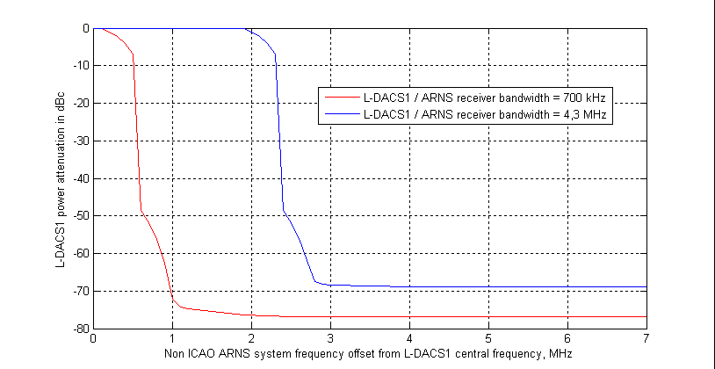

Figure 4

L-DACS 2 power attenuation

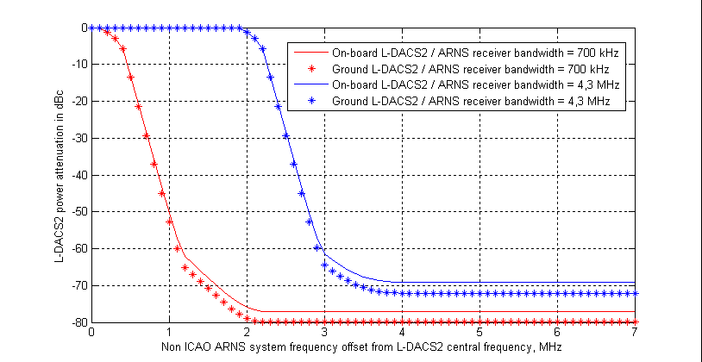

The minimum separation distance between the AM(R)S airborne station and the ARNS airborne station is therefore a function of the frequency separation between the AM(R)S centre frequency and the ARNS centre frequency. With sufficient frequency separation the separation distance is significantly low due to the power attenuation presented in Figs 3 and 4. Table 9 presents the frequency separation which is needed with all ARNS stations in line-of-sight visibility from AM(R)S station.

TABLE 9

Minimum necessary frequency offset (MHz)

|  |  |  |  |  |  |  |  |  |
| --- | --- | --- | --- | --- | --- | --- | --- | --- |
|  | | | ARNS receiver | | | | | |
| Earth | | | Air | | |
| Type 1 | Type 2 | Type 3 | Type 1 | Type 2 | Type 3 |
| **AM(R)S transmitter** | Earth | L-DACS 1 | – | 2.5 | 0.7 | 0.7 | 2.5 | 0.7 |
| L-DACS 2 | – | 2.8 | 1 | 1 | 2.8 | 1 |
| Air | L-DACS 1 | – | 2.5 | 0.7 | 0.7 | 2.5 | 0.7 |
| L-DACS 2 | – | 2.8 | 1 | 1 | 2.8 | 1 |

#### 6.1.1.3 Analysis of the results

Analysis of the obtained results shows that sharing of ARNS stations and AM(R)S stations in the absence of restrictions imposed on station characteristics in the both services requires frequency assignments planning, as their co-frequency sharing in the same geographical area is not feasible.

The maximum protection distances obtained in Table 8 can be used for identification of the affected Administrations referred to in RR No. 5.312. In frequency planning, less stringent protection distances can be used, subject to the coordination with the affected Administrations.

### 6.1.2 Impact into the non ICAO aeronautical radionavigation tactical air navigation system

#### 6.1.2.1 Co-channel case

The calculation of the minimum separation distance that is required for the protection of TACAN systems from co-channel L-DACS interference is in general the same as that described in the previous paragraph (non ICAO ARNS systems operating in the countries referred to in RR No. 5.312). The maximum acceptable level for broadband interference into TACAN receivers is however fixed, –129 dBW for the interrogator and –130 dBW for the beacon, independent of the value of the desired signal level. The minimum separation distance for air-to-ground and ground‑to‑air scenarios is calculated based on free space loss, but limited to the radio horizon. Due to the frequency planning of the L-DACS systems and the actual frequency use of TACAN the L‑DACS ground stations will not operate co-channel with TACAN ground beacons.

For the calculations the same assumptions were made as described in § 6.1.

Table 10 presents calculation results of minimum separation distance between AM(R)S transmitters and TACAN receivers operating in co-channel in order to aggregate all possible situations of harmful interference effect. In the current frequency planning methodology for L‑DACS 1 network deployment a minimum frequency offset between the L-DACS 1 channels and operational TACAN channels is foreseen. When taking this frequency planning strategy into account, a real co-channel operation of L-DACS 1 and TACAN would not occur in practice.

TABLE 10

Minimum separation distance in co-channel, (km)

|  |  |  |  |
| --- | --- | --- | --- |
| ARNS receiver | | TACAN Earth | TACAN air |
| AM(R)S transmitter | |  |  |
| Earth | L-DACS 1 | Not applicable *(Note 1)* | 572 |
| L-DACS 2 | Not applicable *(Note 1)* | 572 |
| Air | L-DACS 1 | 495 | 935 |
| L-DACS 2 | Not applicable *(Note 1)* | 935 |
| NOTE 1 – When considering the proposed up-link and down-link frequency bands for L‑DACS 1 and L-DACS 2 and relate these to the TACAN spectrum usage these interference scenarios will not occur and therefore are indicated as ‘Not applicable’ in this table. | | | |

#### 6.1.2.2 Non co-frequency case

The L-DACS interference depends, to a significant extent, on the RF-selectivity of the TACAN receivers.

Figures 5A shows the receiver selectivity curves for different TACAN/DME interrogators. What can be seen is that there is a great spread in the selectivity of the TACAN/DME interrogator receivers. In the compatibility studies the different TACAN type interrogators were taken into account in order to guarantee sufficient protection of this ARNS application including both range and azimuth determination functionality.

Figure 5B shows a receiver selectivity curve for TACAN beacon. The TACAN beacon selectivity is worse than the one of TACAN interrogator receivers.

Figure 5A

Airborne station (interrogator) receiver RF-selectivity curves

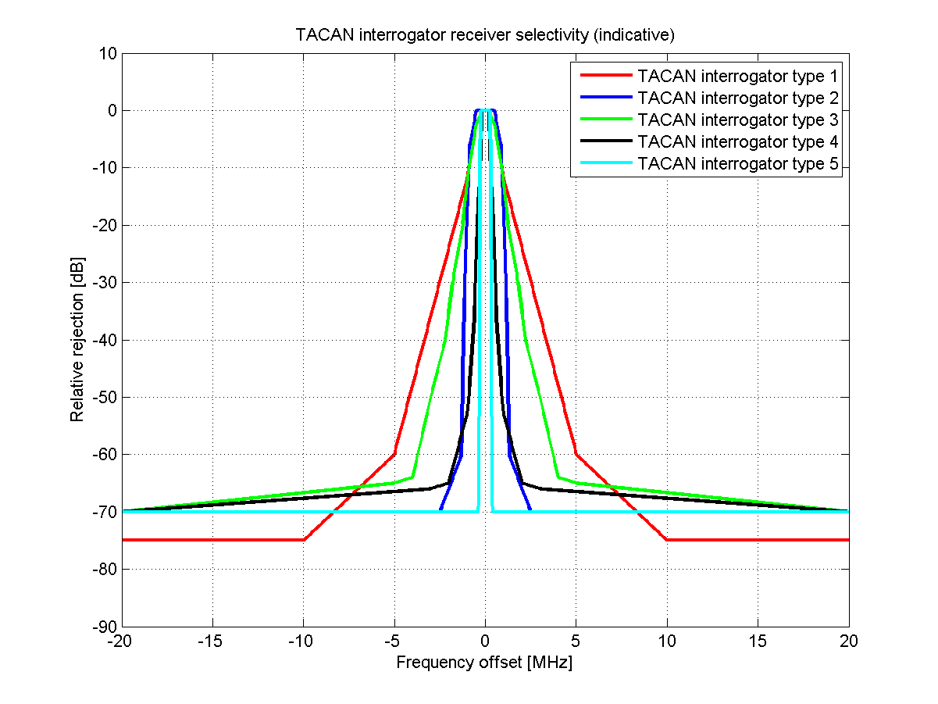

Figure 5B

Ground station (beacon) receiver RF-selectivity curve



Frequency offset between the TACAN receivers and L-DACS channels will depending on the receiver design provide a more or less large additional attenuation resulting smaller required separation distances. The minimum separation distance relative to the frequency off-set between the AM(R)S channel and the TACAN channel is shown in the following figures. The underlying assumptions are the same as for the co-channel interference analysis (§ 6.1). Also the minimum separation distances are calculated based on free-space loss and the radio horizon should be considered as a maximum.

Figure 6A

Minimum separation distance for L-DACS 1 on board and tactical air navigation airborne interrogator

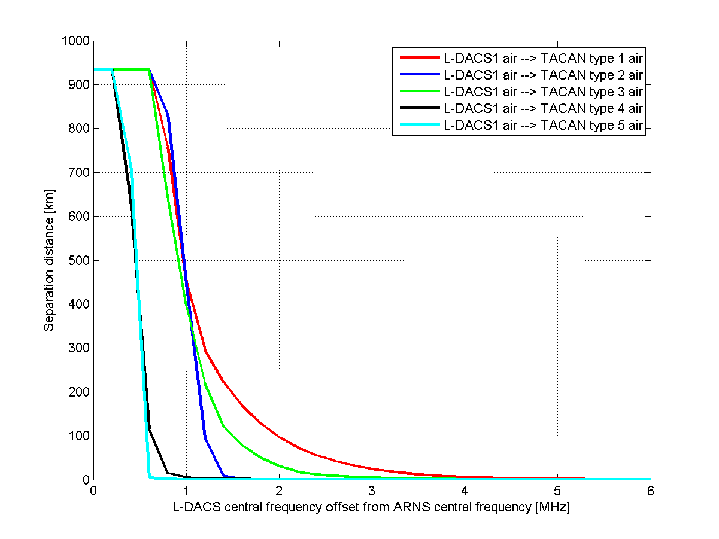

Figure 6B

Minimum separation distance for L-DACS 1 ground and the tactical air navigation airborne interrogator

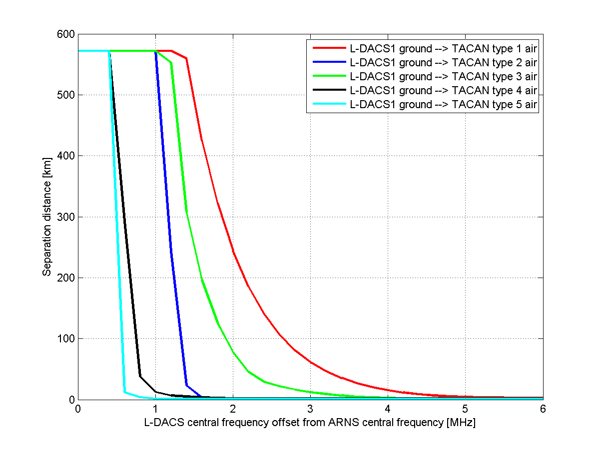

Figure 6C

Minimum separation distance for L-DACS 1 on board and tactical air navigation ground beacon

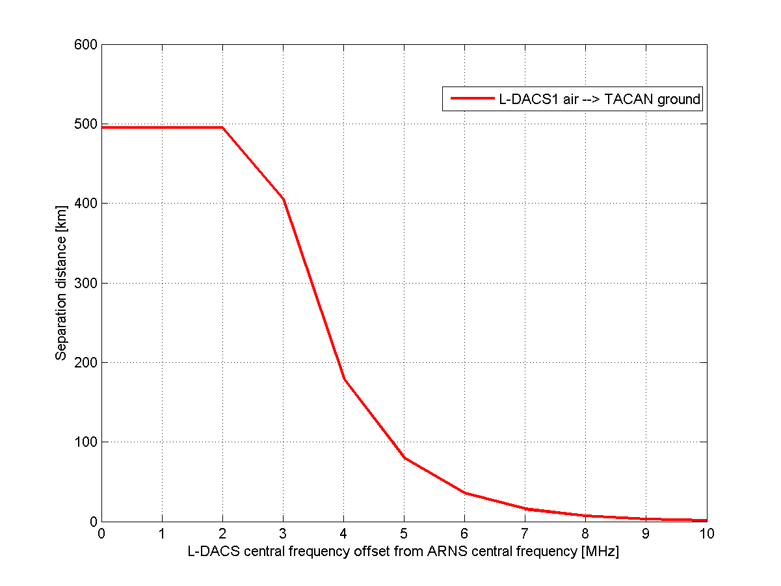

Figure 7A

Minimum separation distance for L-DACS 2 on board and tactical air navigation airborne interrogator

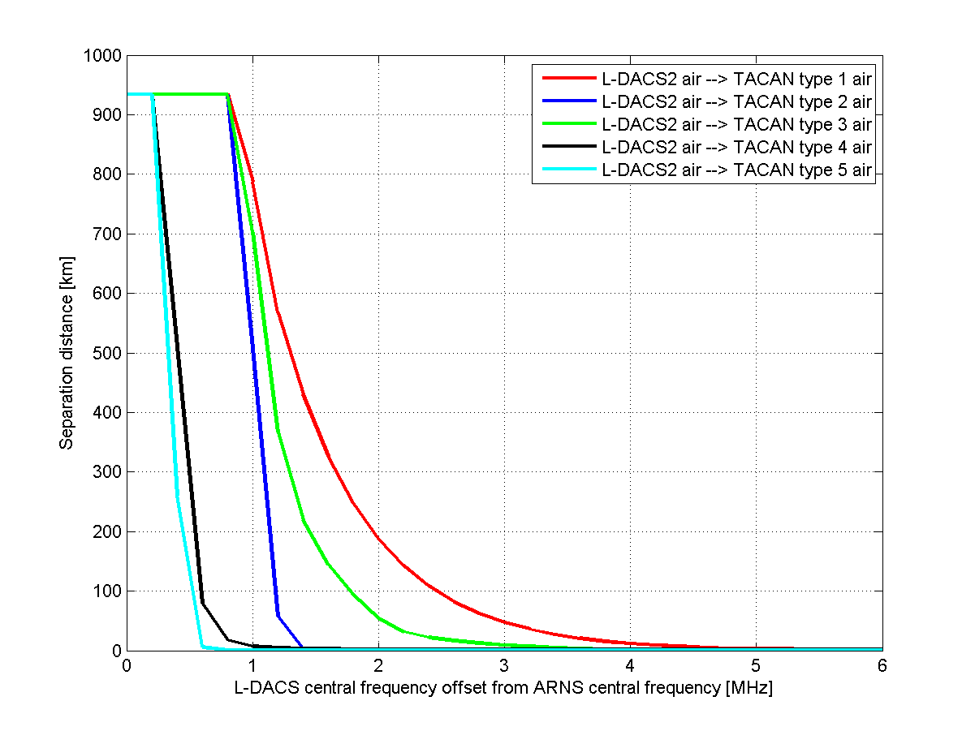

Figure 7B

Minimum separation distance for L-DACS 2 ground and tactical air navigation airborne interrogator

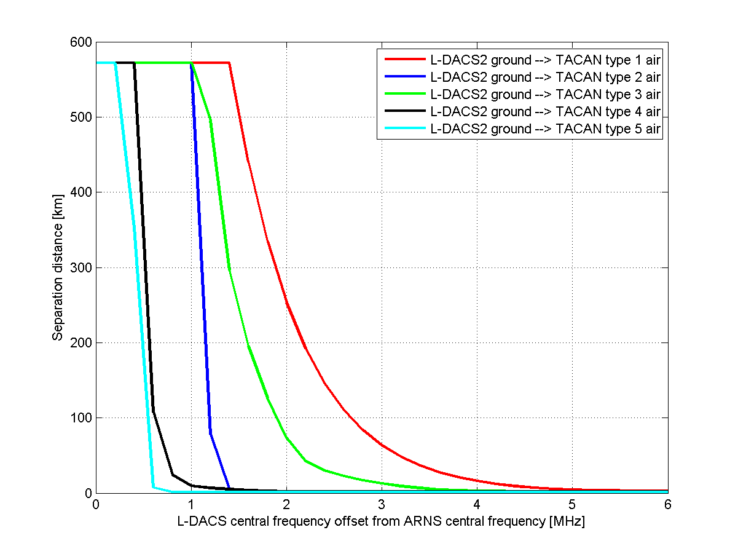

From the curves shown in Figs 6 A, B and C and Figs 7 A and B it can be seen that with an appropriate frequency separation the decoupling may be sufficient to prevent harmful interference.

If in operational scenarios it can be safeguarded that a certain minimum separation distance between both systems is kept, a lower frequency offset would be required.

#### 6.1.2.3 Analysis of the results

In the current frequency planning methodology for L‑DACS 1 network deployment a minimum frequency offset between the L-DACS 1 channels and operational TACAN channels is foreseen, because the co-channel operation is not feasible. When taking this frequency planning strategy into account, a real co-channel operation of L-DACS 1 and TACAN would not occur in practice.

Due to the fact that L‑DACS 2 will use the band 960-977 MHz it may only interfere with the airborne interrogator of the TACAN system.

The curve in Figs 5A and 5B show that there is a great spread in the selectivity of the TACAN/DME receivers. As shown in Figs 6A, 6B, 6C and Figs 7A, 7B unacceptable interference can be prevented by appropriate frequency offset and/or separation distance, taking into account the characteristics of involved TACAN systems and operational scenarios.

## 6.2 Studies on the impact of non ICAO aeronautical radionavigation systems emissions operating in the countries referred to in RR No. 5.312 into stations of the aeronautical mobile (route) service(co-channel)

Currently frequency reuse factors for some ARNS types are not known. Therefore it appears impossible to apply estimation method of aggregate interferences caused from ARNS systems to AM(R)S systems. That is why estimation of protection distances for AM(R)S systems is realized for single interference case.

In accordance with the data specified in Table 2 the permissible continuous interference threshold power *Ithreshold* of AM(R)S receiver is the following:

a) –144 dBW for L-DACS 1 terrestrial receiver;

b) –143 dBW for L-DACS 1 airborne receiver;

c) –145 dBW for L-DACS 2 terrestrial receiver;

d) –144 dBW for L-DACS 2 airborne receiver.

Table 11 presents calculation results of minimum separation distance between ARNS transmitters and different types of AM(R)S receivers in order to cover all possible situations of harmful interference effect.

TABLE 11

Minimum separation distance considering a continuous interference model, (km)

|  |  |  |  |  |  |
| --- | --- | --- | --- | --- | --- |
| AM(R)S receiver | | Earth | | Air | |
| ARNS transmitter | | L-DACS 1 | L-DACS 2 | L-DACS 1 | L-DACS 2 |
| Earth | Type 1 | 35-210 | 40-220 | 495 | 495 |
| Type 2 | 160-240 | 170-255 | 495 | 495 |
| Type 3 | 20-120 | 20-130 | 495 | 495 |
| Air | Type 1 | – | – | – | – |
| Type 2 | 465 | 465 | 934 | 934 |
| Type 3 | 465 | 465 | 934 | 934 |

## 6.3 Overall results of studies

The results of the above studies showed that the compatibility between non ICAO ARNS stations and AM(R)S stations is feasible on condition of frequency planning, e.g. sufficient frequency separation and/or distance separation.

The radio-horizon can be used for identification of the affected administrations. In frequency planning, less stringent protection distances can be used, subject to the coordination with the affected Administrations.

# 7 Studies on the impact of non-pulsed emissions from stations in the aeronautical mobile (route) service into the radionavigation satellite receivers operating in the frequency band 1 164-1 215 MHz

For the purpose of this study, the terms “out-of-band” and “in-band” are relative to the RNSS band 1 164-1 215 MHz. The performed study was based on a non-pulsed AM(R)S signal. In case of future pulsed AM(R)S signals, additional information will be required.

## 7.1 Studies of the impact of non-pulsed emissions from stations in the aeronautical mobile (route) service into radionavigation satellite receivers operating in the band 1 164-1 215 MHz

### 7.1.1 Impact on radionavigation satellite receivers from unwanted emission of ground stations in the aeronautical mobile (route) service

#### 7.1.1.1 Aeronautical radionavigation satellite receiver radio frequency interference impact analysis

The following assumptions have been used for this study:

– A single AM(R)S ground station within radio horizon in the vicinity of RNSS-equipped helicopters on CAT I precision approach, considering acquisition mode.

– A single AM(R)S ground station within radio horizon in the vicinity of RNSS-equipped aircraft on CAT I precision approach, considering tracking mode in this phase of flight.

– Single AM(R)S transmitter unwanted emission portion is 1% of the allowable total RFI to RNSS.

– 6 dB safety margin.

– A minimum separation distance of 50 m between the AM(R)S ground station and the aeronautical RNSS receiver.

Table 12A below shows that to protect an aeronautical RNSS receiver on-board a helicopter which is located at 50 m from the AM(R)S ground station, the maximum allowable AM(R)S ground station e.i.r.p. density is –94 dB(W/MHz). Table 12B below shows that to protect an aeronautical RNSS receiver on an aircraft which is located at 50 m from the AM(R)S ground station on the CAT I precision approach, the maximum allowable AM(R)S ground station e.i.r.p. density is   
–88 dBW/MHz.

Table 12A

Protection of aeronautical radionavigation-satellite receiver on-board a helicopter  
from a ground transmitter operating in the aeronautical mobile (route)  
service (acquisition mode)

|  |  |  |  |
| --- | --- | --- | --- |
|  |  | Air-navigation receiver #1 | Air-navigation receiver #2 |
|  | Frequency band (MHz) | 1 164.5-1 188.5 | 1 197.6-1 213.9 |
| a | Maximum aggregate Non-RNSS RFI threshold (dBW/MHz) | −133.1 (Wideband acquisition below 610 m alt) | −146 (Wideband acquisition) |
| b | Safety margin (dB) | 6 | 6 |
| c | Single/multiple entry factor (dB) | 20 | 20 |
| d | RNSS antenna gain (dB) | –10 | –10 |
| e | Attenuation at 50 m (dB) | 67.8 | 68 |
| **f** | **Max allowable AM(R)S ground station e.i.r.p. density  (f = a – b – c – d + e) (dBW/MHz)** | **–81.3** | **–94** |

TABLE 12B

Protection of aeronautical radionavigation-satellite receiver on CAT I approach  
from a ground transmitter operating in the aeronautical mobile (route)  
service (tracking mode)

|  |  |  |  |
| --- | --- | --- | --- |
|  |  | Air-navigation receiver #1 | Air-navigation receiver #2 |
|  | Frequency band (MHz) | 1 164.5-1 188.5 | 1 197.6-1 213.9 |
| a | Maximum aggregate Non-RNSS RFI threshold (dBW/MHz) | −133.0 (Wideband tracking below 610 m alt) | −140 (Wideband tracking) |
|  |  |  |  |
| b | Safety margin (dB) | 6 | 6 |
| c | Single/multiple entry factor (dB) | 20 | 20 |
| d | RNSS antenna gain (dBi) | –10 | –10 |
| e | Attenuation at 50 m (dB) | 67.8 | 68 |
| **f** | **Max allowable AM(R)S ground station e.i.r.p. density  (f = a – b – c – d + e) (dBW/MHz)** | **–81.2** | **–88** |

#### 7.1.1.2 Non-aeronautical radionavigation satellite receiver radio frequency interference impact analysis

The following assumptions have been used for this study:

– A single AM(R)S ground station within radio horizon in the vicinity of RNSS high precision receiver.

– Single AM(R)S transmitter unwanted emission portion is 1% of the allowable total RFI to RNSS.

– A minimum separation distance of 50 m between the AM(R)S ground station and the non‑aeronautical RNSS receiver.

– With the assumed AM(R)S height of 15 m and a 50 m separation from the RNSS receiver on the ground, the AM(R)S antenna gain at −36 degrees should be used.

Table 13 below shows that to protect a non-aeronautical RNSS receiver which is located at 50 m from the AM(R)S ground station the maximum AM(R)S ground station e.i.r.p. density is −90.8 dBW/MHz.

TABLE 13

Protection of a non-aeronautical radionavigation-satellite receiver  
from a ground transmitter in the aeronautical mobile (route) service

|  |  |  |
| --- | --- | --- |
|  |  | High precision |
|  | Frequency band (MHz) | 1 164.5-1 188.5 & 1 197.6-1 213.9 |
| a | Maximum aggregate Non-RNSS RFI threshold (dBW/MHz) | −147.4 (Wideband acquisition) |
| b | Single/multiple entry factor (dB) | 20 |
| c | RNSS antenna gain (dB) | 3 |
| d | Attenuation at 50 m (dB) | 67.8 |
| e | Ratio AM(R)S *Gmax*/*G* towards RNSS receiver (–36° elevation) (dB) | 11.8 |
| **f** | **Max AM(R)S ground station e.i.r.p. density (e = a – b – c + d + e) (dBW/MHz)** | **−90.8** |

L-DACS 2 option will be deployed in the 960-977 MHz. Thus, no harmful interference is expected from this system in the 1 164-1 215 MHz due to the frequency separation.

Using equation 3, the maximum AM(R)S ground station e.i.r.p. density is calculated as −48.9 dBW/MHz in the band 1 164.45-1 165.45 MHz with a frequency separation between the AM(R)S ground station and the 1 165.45 MHz of 1.2 MHz:

e.i.r.p.(dBW/MHz) = Pe(dBW) + Ge(dB) – Le(dB) + Att(dBc/MHz) (3)

where (see Table 2):

Pe: is the L-DACS transmit power (18 dBW for L-DACS 1)

Ge: maximum AM(R)S ground station antenna gain (8 dB for L-DACS 1)

Le: is the L-DACS cable loss (2 dB for L-DACS 1)

Att: corresponds to the attenuation due to the transmit mask in dBc (with a reference bandwidth of 1 MHz centre at 1 165.45 MHz) = −72.9 dBc/MHz.

This value (−48.9 dBW/MHz) should be compared to the value of −90.8 dBW/MHz above 1 164 MHz in order to identify an attenuation of unwanted emission to meet the interference threshold to protect all RNSS receivers. This attenuation of 41.9 dB at 1 164 MHz will likely require appropriate filtering and/or frequency separation for the AM(R)S ground station.

### 7.1.2 Impact on radionavigation satellite receiver from unwanted emission of aircraft stations in the aeronautical mobile (route) service

Two different types of RNSS receivers have also been taken into account: the aeronautical RNSS receiver and the non-aeronautical RNSS receiver.

It should be noted that a more stressful case of airborne station unwanted RFI is not presently covered in §7.1.2; namely that of airborne AM(R)S RFI to an RNSS airborne receiver on the same aircraft. Antenna-to-antenna coupling losses are less than for 300 m free space separation. This lower loss reduces the allowable AM(R)S airborne station unwanted RFI. The on-board compatibility between RNSS receivers and AM(R)S emitters will be dealt with in the aviation community (ICAO).

#### 7.1.2.1 Aeronautical radionavigation satellite receiver radio frequency interference impact analysis

The following assumptions have been used for this study:

– A single AM(R)S aircraft station within radio horizon in the vicinity of RNSS-equipped aircraft.

– Single AM(R)S transmitter unwanted emission portion is 1% of the allowable total RFI to RNSS.

– 6 dB safety margin.

– A minimum separation distance of 300 m between the AM(R)S aircraft station and the aeronautical RNSS receiver.

Table 14 below shows the maximum AM(R)S aircraft station e.i.r.p. density necessary to protect an aeronautical RNSS receiver located at 300 m.

TABLE 14

Protection of an aeronautical radionavigation-satellite receiver from an aircraft transmitter  
in the aeronautical mobile (route) service

|  |  |  |  |
| --- | --- | --- | --- |
|  |  | Air-navigation receiver #1 | Air-navigation receiver #2 |
| a | Maximum aggregate Non-RNSS RFI threshold (dBW/MHz) | −133.1 (Wideband acquisition below 610 m alt) | −146 (Wideband acquisition) |
|  | Frequency band (MHz) | 1 164.5-1 188.5 | 1 197.6-1 213.9 |
| b | Safety margin dB (dB) | 6 | 6 |
| c | Single/multiple entry factor (dB) | 20 | 20 |
| d | RNSS antenna gain (dB) | 3 | 7 |
| e | Attenuation at 300 m (dB) | 83.4 | 83.6 |
| f | Polarization discrimination (dB) | 3 | 3 |
| **g** | **Max AM(R)S aircraft station e.i.r.p. density (g = a – b – c – d + e + f) (dBW/MHz)** | **−75.7** | **−92.4** |

#### 7.1.2.2 Non-aeronautical radionavigation satellite receiver radio frequency interference impact analysis

The following assumptions have been used for this study:

– A single AM(R)S aircraft station within radio horizon in the vicinity of RNSS high precision receiver.

– Single AM(R)S transmitter unwanted emission portion is 1% of the allowable total RFI to RNSS.

– A minimum separation distance of 300 m between the AM(R)S aircraft station and the non‑aeronautical RNSS receiver.

Table 15 below show the maximum AM(R)S aircraft station e.i.r.p. density to protect non-aeronautical RNSS receiver located at 300 m.

TABLE 15

Protection of a non-aeronautical radionavigation-satellite receiver  
from an aircraft transmitter operating in the aeronautical mobile (route) service

|  |  |  |
| --- | --- | --- |
|  |  | High precision |
| a | Maximum aggregate Non-RNSS RFI threshold (dBW/MHz) | −147.4 (Wideband acquisition) |
|  | Frequency band (MHz) | 1 164.5-1 188.5 & 1 197.6-1 213.9 |
| b | Single/multiple entry factor (dB) | 20 |
| c | RNSS antenna gain (dB) | 3 |
| d | Attenuation at 300 m (dB) | 83.4 |
| e | Polarization discrimination (dB) | 3 |
| **f** | **Max AM(R)S aircraft station e.i.r.p. density (f = a – b – c + d + e)** (dBW/MHz) | −**84** |

Using equation (3), the maximum AM(R)S aircraft station e.i.r.p. density is calculated as **−**61 dBW/MHz in the band 1 164.45-1 165.45 MHz with a frequency separation between the AM(R)S ground station and the 1 165.45 MHz of 1.2 MHz.

Where (see Table 2):

Pe: is the L-DACS transmit power (8.5 dBW for L-DACS 1)

Ge: maximum AM(R)S aircraft station antenna gain (5.4 dB for L-DACS 1)

Le: is the L-DACS cable loss (2 dB for L-DACS 1)

Att: corresponds to the attenuation due to the transmit mask in dBc (with a reference bandwidth of 1 MHz centre at 1 165.45 MHz) = −72.9 dBc/MHz.

This value (−61 dBW/MHz) should be compared to the value of −84 dBW/MHz between 1 164 MHz and 1 197.6 MHz and −92.4 dBW/MHz above 1 197.6 MHz in order to identify an attenuation of unwanted emission to meet the interference threshold to protect RNSS receiver. This attenuation of 23 dB at 1 164 MHz and 31.4 dB at 1 197.6 MHz can be achieved through appropriate filtering or frequency separation.

## 7.2 Out-of-band interference impact

### 7.2.1 Typical radionavigation satellite system carrier wave out-of-band radio frequency interference susceptibility

Figure 8 represents the allowed non pulsed interference environment for typical RNSS signal tracking for an aeronautical receiver as a function of the fundamental frequency of the interfering signal. The off-frequency non pulsed interference rejection of a non-aeronautical high-precision RNSS receiver relative to attenuation at centre frequency is provided in Fig. 9.

Figure 8

Non pulsed interference levels at the aeronautical radionavigation satellite receiver antenna port



fi < 1 100 MHz 20 dBm

1 100 MHz < fi < 1 146.45 MHz Linearly decreasing from 20 dBm to 2.45 dBm

1 146.45 MHz < fi < 1 164 MHz Linearly decreasing from 2.45 dBm to −94.5 dBm

1 164 MHz < fi < 1 165 MHz Linearly decreasing from −94.5 dBm to −100 dBm.

This provides the following table which presents the relative relaxation on the interference level versus frequency offset.

Fi < 1 100 MHz 120 dB

1 100 MHz < fi < 1 146.45 MHz Linearly decreasing from 120 dB to 102.45 dB

1 146.45 MHz < fi < 1 164 MHz Linearly decreasing from 102.45 dB to 5.5 dB

Figure 9

Relative non pulsed interference attenuation referenced to the non-aeronautical high-precision   
radionavigation satellite receive antenna port

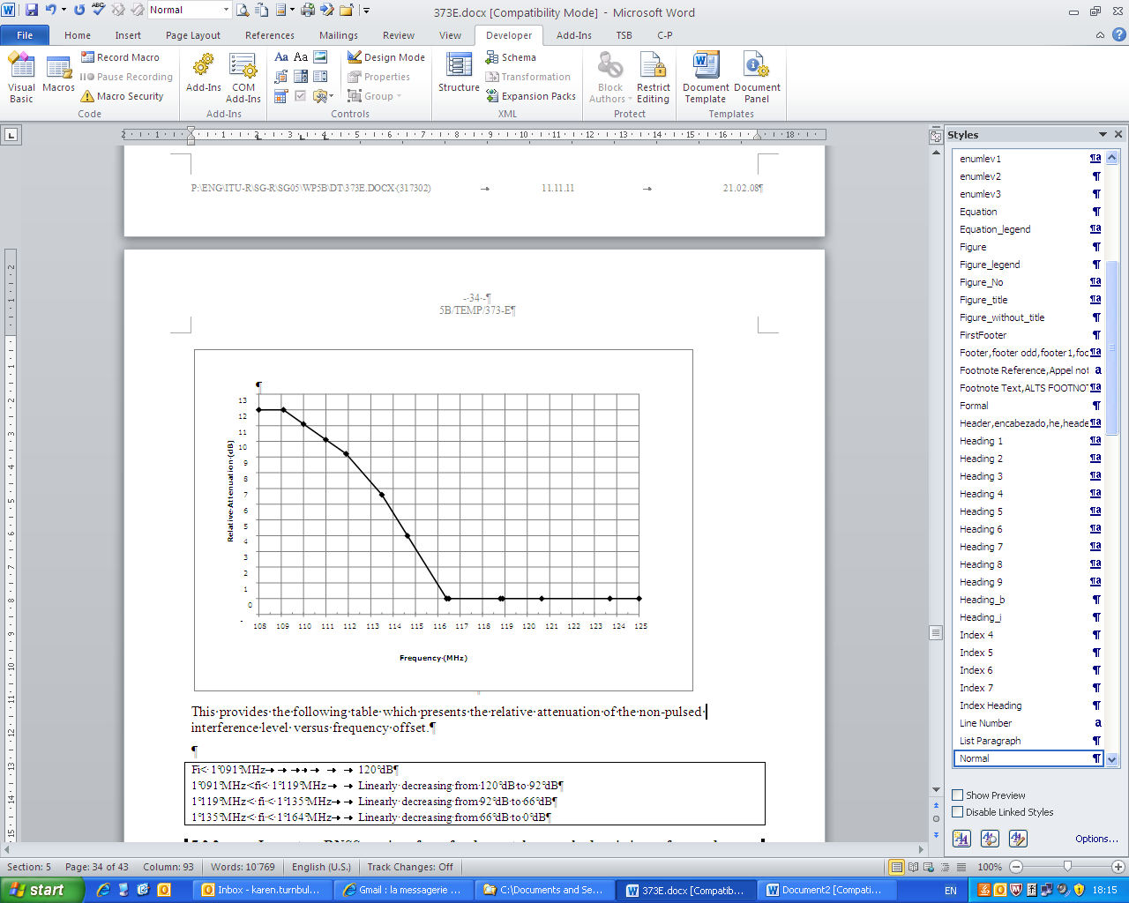

This provides the following table which presents the relative attenuation of the non-pulsed interference level versus frequency offset.

Fi< 1 091 MHz 120 dB

1 091 MHz <fi< 1 119 MHz Linearly decreasing from 120 dB to 92 dB

1 119 MHz < fi < 1 135 MHz Linearly decreasing from 92 dB to 66 dB

1 135 MHz < fi < 1 164 MHz Linearly decreasing from 66 dB to 0 dB

### 7.2.2 Impact on the radionavigation satellite receiver from fundamental non pulsed emissions of ground stations operating in the aeronautical mobile (route) service

#### 7.2.2.1 Aeronautical radionavigation satellite receiver radio frequency interference impact analysis

The following assumptions have been used for this study:

– A single AM(R)S ground station within radio horizon in the vicinity of RNSS-equipped helicopters on CAT I precision approach, considering acquisition mode.

– A single AM(R)S ground station within radio horizon in the vicinity of an RNSS-equipped aircraft on CAT I precision approach, considering tracking mode in this phase of flight.

– Single AM(R)S transmitter portion is 10% of the allowable total RFI to RNSS.

– 6 dB safety margin.

– The impact on air navigation 2 receiver is considered negligible as its frequency band starts at 1 197.6 MHz which is more than 33.6 MHz of frequency offset.

– A minimum separation distance of 50 m between the AM(R)S ground station and the aeronautical RNSS receiver.

Tables 16A and 16B below show the maximum AM(R)S ground station e.i.r.p. which will protect helicopter and aeronautical RNSS receivers, respectively, from non-pulsed AM(R)S transmissions.

TABLE 16A

Protection of aeronautical radionavigation satellite receiver on-board a helicopter  
from fundamental non pulsed emissions from ground transmitters operating  
in the aeronautical mobile (route) service (acquisition mode)

|  |  |  |  |  |
| --- | --- | --- | --- | --- |
|  |  | Air-navigation receiver #1 | | |
| a | Maximum aggregate Non-RNSS RFI threshold (dBW/MHz) | –133.1 (Wideband acquisition below 610 m alt) | | |
| b | Ratio MHz/RNSS bandwidth (dB) | 13.8 | | |
| c | Single/multiple entry factor (dB) | 10 | | |
| d | Safety margin (dB) | 6 | | |
| e | RNSS antenna gain (dBi) | −10 | | |
| f | Attenuation at 50 m (dB) | 66.4 | | |
|  | Frequency band (MHz) | fi < 1 100 | 1 100 < fi < 1 146.45 | 1 146.45 < fi < 1 164 |
| g | Relative relaxation (see Fig. 8) (dB) | 120 | Linearly decreasing from 120 to 102.45 | Linearly decreasing from 102.45 to 5.5 |
| h | Max AM(R)S ground station e.i.r.p. (h = a + b – c – d – e + f + g) (dBW) | 61.1 | Linearly decreasing from 61.1 to 43.55 | Linearly decreasing from 43.55 to –53.4 |

TABLE 16B

Protection of aeronautical radionavigation satellite receivers on CAT I approach  
from fundamental non pulsed emissions from ground transmitters operating  
in the aeronautical mobile (route) service (tracking mode)

|  |  |  |  |  |
| --- | --- | --- | --- | --- |
|  |  | Air-navigation receiver #1 | | |
| a | Maximum aggregate Non-RNSS RFI threshold (dBW/MHz) | –133.0 (Wideband tracking below 610 m alt) | | |
| b | Ratio MHz/RNSS bandwidth (dB) | 13.8 | | |
| c | Single/multiple entry factor (dB) | 10 | | |
| d | Safety margin (dB) | 6 | | |
| e | RNSS antenna gain (dBi) | −10 | | |
| f | Attenuation at 50 m (dB) | 66.4 | | |
|  | Frequency band (MHz) | fi < 1 100 | 1 100 < fi < 1 146.45 | 1 146.45 < fi < 1 164 |
| g | Relative relaxation (see Fig. 8) (dB) | 120 | Linearly decreasing from 120 to 102.45 | Linearly decreasing from 102.45 to 5.5 |
| h | Max AM(R)S ground station e.i.r.p. (h = a + b – c – d – e + f + g) (dBW) | 61.2 | Linearly decreasing from 61.2 to 43.65 | Linearly decreasing from 43.65 to –53.3 |

#### 7.2.2.2 Non-aeronautical high-precision radionavigation satellite receiver radio frequency interference impact analysis

The following assumptions have been used for this study:

– A single AM(R)S ground station within radio horizon in the vicinity of RNSS high‑precision ground-based CDMA receiver.

– A minimum separation distance of 50 m between the AM(R)S ground station and the RNSS high-precision receiver.

– Single AM(R)S transmitter portion is 10% of the allowable total RFI to RNSS.

– With the assumed AM(R)S height of 15 m and a 50 m separation from the RNSS receiver on the ground, the AM(R)S antenna gain at –36 degrees should be used.

Table 17 below shows the maximum AM(R)S ground station e.i.r.p. which will protect non‑aeronautical high-precision RNSS receivers from non-pulsed AM(R)S transmissions.

TABLE 17

Protection of non-aeronautical high-precision radionavigation satellite receiver  
from fundamental non pulsed emissions from ground transmitters operating  
in the aeronautical mobile (route) service

|  |  |  |  |  |  |
| --- | --- | --- | --- | --- | --- |
|  |  | High precision | | | |
| a | Maximum aggregate Non-RNSS RFI threshold (dBW/MHz) | −147.4 (Wideband acquisition) | | | |
| b | Ratio MHz/RNSS bandwidth (dB) | 13.8 | | | |
| c | Single/multiple entry factor (dB) | 10 | | | |
| d | RNSS antenna gain (dB) | 3 | | | |
| e | Attenuation at 50 m (dB) | 66.4 | | | |
| f | Ratio AM(R)S Gmax/G towards RNSS receiver (–36° elevation) (dB) | 11.8 | | | |
|  | Frequency band (MHz) | fi < 1 091 | 1 091< fi < 1 119 | 1 119< fi < 1 135 | 1 135 <fi<1 164 |
| g | Relative relaxation (see Fig. 9) (dB) |  | Linearly decreasing from 120 to 92 | Linearly decreasing from 92 to 66 | Linearly decreasing from  66 to 0 |
| h | Max AM(R)S ground station e.i.r.p.  (h = a + b – c – d + e + f + g) (dBW) | **51.6** | Linearly decreasing from **51.6** to **23.6** | Linearly decreasing from **23.6** to **–2.4** | Linearly decreasing from  **–2.4** to **–68.4** |

The maximum AM(R)S ground station e.i.r.p. is 24 dBW as determined by:

e.i.r.p.(dBW/MHz) = Pe(dBW) + Ge(dB) – Le(dB)

where (see Table 2):

Pe: is the L-DACS transmit power (18 dBW for L-DACS 1)

Ge: maximum AM(R)S ground station antenna gain (8 dB for L-DACS 1)

Le: is the L-DACS cable loss (2 dB for L-DACS 1).

This value (24 dBW) should be compared to the values of the above Tables. It can be shown that 24 dBW corresponds to the frequency 1 119.4 MHz. Therefore above 1 119.4 MHz, AM(R)S ground stations emitting non pulsed signals should use mitigation techniques.

### 7.2.3 Impact on radionavigation satellite receiver from fundamental non pulsed emissions of aircraft stations operating in the aeronautical mobile (route) service

#### 7.2.3.1 Aeronautical radionavigation satellite receiver radio frequency interference impact analysis

The following assumptions have been used for this study:

– A single AM(R)S aircraft station within radio horizon in the vicinity of RNSS-equipped aircraft.

– Single AM(R)S transmitter portion is 10% of the allowable total RFI to RNSS.

– 6 dB safety margin.

– The impact on air navigation 2 receiver is considered negligible as the frequency band start at 1 197.6 MHz which is more than 33.6 MHz of frequency offset.

– A minimum separation distance of 300 m between the AM(R)S aircraft station and the aeronautical RNSS receiver.

Table 18 below shows the maximum AM(RS aircraft station e.i.r.p. which will protect aeronautical RNSS receivers from non-pulsed AM(R)S transmissions.

TABLE 18

Protection of aeronautical radionavigation satellite receiver from fundamental  
non pulsed emissions from aircraft transmitters operating in the aeronautical  
mobile (route) service

|  |  |  |  |  |
| --- | --- | --- | --- | --- |
|  |  | Air-navigation receiver #1 | | |
| a | Maximum aggregate Non-RNSS RFI threshold (dBW/MHz) | −133.1 (Wideband acquisition below 610m altitude) | | |
| b | Ratio MHz/RNSS bandwidth (dB) | 13.8 | | |
|  | Single/multiple entry factor (dB) | 10 | | |
| c | Safety margin (dB) | 6 | | |
| d | RNSS antenna gain (dB) | 3 | | |
| e | Attenuation at 300 m (dB) | 81.9 | | |
| f | Frequency band (MHz) | fi < 1 100 | 1 100 < fi < 1 146.45 | 1 146.45 < fi < 1 164 |
| f | Relative relaxation (see Fig. 8) (dB) | 120 | Linearly decreasing from 120 to 102.45 | Linearly decreasing from 102.45 to 5.5 |
| g | Max AM(R)S aircraft station e.i.r.p. (g = a + b – c – d + e + f) (dBW) | 63.6 | Linearly decreasing from 63.6 to 46.05 | Linearly decreasing from 46.05 to –50.9 |

#### 7.2.3.2 Non-aeronautical high precision radionavigation satellite receiver radio frequency interference impact analysis

The following assumptions have been used for this study:

– A single AM(R)S aircraft station within radio horizon in the vicinity of non-aeronautical high-precision RNSS receiver.

– Single AM(R)S transmitter portion is 10% of the allowable total RFI to RNSS.

– A minimum separation distance of 300 m between the AM(R)S aircraft station and the non‑aeronautical high-precision RNSS receiver.

Table 19 below shows the maximum AM(R)S aircraft station e.i.r.p. which will protect non‑aeronautical high-precision RNSS receivers from non-pulsed AM(R)S transmissions.

TABLE 19

Protection of non-aeronautical high-precision radionavigation satellite receiver  
from fundamental emissions from aircraft transmitters operating  
in the aeronautical mobile (route) service

|  |  |  |  |  |  |
| --- | --- | --- | --- | --- | --- |
|  |  | High precision | | | |
| a | Maximum aggregate Non-RNSS RFI threshold (dBW/MHz) | −147.4 (Wideband acquisition) | | | |
| b | Ratio MHz/RNSS bandwidth (dB) | 13.8 | | | |
| c | Single/multiple entry factor (dB) | 10 | | | |
| d | RNSS antenna gain (dB) | 3 | | | |
| e | Attenuation at 300 m (dB) | 81.9 | | | |
|  | Frequency band (MHz) | fi < 1091 | 1 091< fi < 1 119 | 1 119< fi < 1 135 | 1 135 < fi < 1 164 |
| f | (see Fig. 9) (dB) | 120 | Linearly decreasing from 120 to 92 | Linearly decreasing from 92 to 66 | Linearly decreasing from 66 to 0 |
| g | Max AM(R)S aircraft station e.i.r.p.  (g = a + b – c – e + e + f) (dBW) | **55.3** | Linearly decreasing from **55.3** to **27.3** | Linearly decreasing from **27.3** to **–1.3** | Linearly decreasing from –1.3 to –64.7 |

The maximum AM(R)S aircraft station e.i.r.p. is 11.9 dBW as determined by:

e.i.r.p.(dB(W/MHz) = Pe(dBW) + Ge(dB) – Le                (dB)

where (see Table 2):

Pe: is the L-DACS transmit power (8.5 dBW for L-DACS 1)

Ge: maximum AM(R)S aircraft station antenna gain (5.4 dB for L-DACS 1)

Le: is the L-DACS cable loss (2 dB for L-DAC 1).

This value (11.9 dBW) should be compared to the values of the above tables. It can be shown that 11.9 dBW corresponds to the frequency 1 128.48 MHz. Therefore above 1 128.48 MHz, AM(R)S aircraft stations emitting non pulsed signals should use mitigation techniques.

# 8 Conclusion

Compatibility studies between AM(R)S in the band below 1 164 MHz and RNSS above 1 164 MHz have been completed.

The results presented in sections 4 and 7, identify the following technical means to facilitate sharing between AM(R)S systems operating in the band 960-1 164 MHz and RNSS systems operating above 1 164 MHz:

− To limit the AM(R)S ground station e.i.r.p. as follows

TABLE 20

Max e.i.r.p. (ground station)

|  |  |  |  |  |  |
| --- | --- | --- | --- | --- | --- |
| Emissions in the frequency band 960-1 164 MHz (Maximum allowable e.i.r.p. in the frequency band 960‑1 164 MHz as a function of the carrier central frequency) for non-pulsed AM(R)S transmissions | | | | Emissions in the frequency band 1 164-1 215 MHz | |
| AM(R)S centre frequency  < 1 091 MHz | AM(R)S centre frequency  1 091-1 119 MHz | AM(R)S centre frequency  1 119-1 135 MHz | AM(R)S centre frequency  1 135-1 164 MHz | 1 164-1 197.6 MHz | 1 197.6-1 215 MHz |
| **51.6** dBW | Linearly decreasing from **51.6** to **23.6** dBW | Linearly decreasing from **23.6** to **–2.4** dBW | Linearly decreasing from  **–2.4** to –**68.4** dBW | **−90.8 dBW** in any 1 MHz of the band 1 164-1 197.6 MHz | **−90.8 dBW** in any 1 MHz of the band 1 197.6-1 215 MHz |

− To limit the AM(R)S airborne station e.i.r.p. as follows

TABLE 21

Max e.i.r.p. (aircraft station)

|  |  |  |  |  |  |
| --- | --- | --- | --- | --- | --- |
| Emissions in the band 960-1164 MHz (Maximum allowable e.i.r.p. in the band 960-1 164 MHz as a function of the carrier central frequency) for non-pulsed AM(R)S transmissions | | | | Emissions in the frequency band  1 164-1 215 MHz | |
| AM(R)S centre frequency  < 1 091 MHz | AM(R)S centre frequency  1 091-1 119 MHz | AM(R)S centre frequency  1 119-1 135 MHz | AM(R)S centre frequency  1 135-1 164 MHz | 1 164-1 197.6 MHz | 1 197.6-1 215 MHz |
| **55.3** dBW | Linearly decreasing from **55.3** to **27.3** dBW | Linearly decreasing from **27.3** to −**1.3** dBW | Linearly decreasing from  **–1.3** to –**64.7** dBW | **−84 dBW** in any 1 MHz of the band 1 164‑1 197.6 MHz | **−92.4 dBW** in any 1 MHz of the band 1 197.6‑1 215 MHz |

These protection levels are based on the requirements of non-aeronautical high-precision RNSS receivers with respect to non-pulsed AM(R)S interference, and are also assumed to protect aeronautical RNSS receivers and any other non-aeronautical RNSS receivers. Future AM(R)S systems operating in the 960-1 164 MHz band with pulsed emissions will need to demonstrate that they limit AM(R)S ground and airborne station emission characteristics in order to provide protection to RNSS systems equivalent to the protection provided by non-pulsed emission AM(R)S ground and airborne stations operating in the 960-1 164 MHz band at the maximum e.i.r.p. levels in Tables 20 and 21 above.

Compatibility issues between RNSS and AM(R)S operating on the same aircraft are addressed within ICAO.

# 9 References

1) SESAR deliverable: The ATM Target Concept D3 available at <http://www.sesar-consortium.aero/>.

2) “Future Communication Study – Action Plan 17. Final Conclusions and Recommendations Report” WP 6 of ACP/WG-T, Oct. 2007 available at: <http://www.icao.int/anb/panels/acp/wgdoclist.cfm?MeetingID=201>.

3) ICAO Future Communication Infrastructure (FCI) Concept of Operations and Communications requirements (COCR_V2_0): <http://www.icao.int/anb/panels/acp/repository.cfm>.

Glossary

ACI Adjacent channel interference

ACP Aeronautical communications panel

ADS Automatic dependent surveillance

ADS-B Automatic dependent surveillance – broadcast

ADS-R Automatic dependent surveillance – rebroadcast

AGL Above ground level

AMACS All-purpose multi-channel aviation communication system

AM(R)S Aeronautical-mobile (route) service

AMS Aeronautical-mobile service

AMS(R)S Aeronautical-mobile satellite (route) service

AMSS Aeronautical-mobile satellite service

ANLE Airport network and location equipment (a highly integrated, high-data-rate, wireless local-area network for airport surface areas)

ARNS Aeronautical radionavigation service

ATC Air traffic control

ATM Air traffic management

AZ Azimuth

B-AMC Broadband aeronautical multi-carrier communications

BER Bit error ratio

BW Bandwidth

CAT I/II/III Category I/II/III instrument landing system

COCR Concept of operations and communication requirements

CPFSK Continuous-phase frequency-shift keying

CPM Conference preparatory meeting

CW Continuous wave

DME Distance measuring equipment

DME/P Precision distance measuring equipment

DME/N Narrow-spectrum distance measuring equipment

DPSK Differential phase shift keying

*Eb*/*N*0 Ratio of energy per bit to noise power spectral density

ECC Electronic Communications Committee

e.i.r.p. Equivalent isotropically radiated power

FCI Future communications infrastructure

FDD Frequency-division duplex

FDR Frequency-dependent rejection

FEC Forward error correction

FFT Fast Fourier transformation

FIS-B Flight Information Service – Broadcast

GMSK Gaussian minimum-shift keying

GNSS Global Navigation Satellite Systems

GPS Global Positioning System

*G*/*T* Ratio of receiving-antenna gain to receiver thermal noise temperature in Kelvins

ICAO International Civil Aviation Organization

IEEE Institute of Electrical and Electronics Engineers

IEEE 802.16e IEEE standard for mobile broadband wireless access systems

IF bandwidth Intermediate frequency bandwidth

I/N Interference to noise ratio

IPF Interference protection function

K Kelvin (temperature)

kbps Kilobits per second

kHz Kilohertz

L-DACS L-band digital aeronautical communications system

L-DACS1 L-band digital aeronautical communications system 1 (FDD-based)

L-DACS2 L-band digital aeronautical communications system 2 (TDD-based)

LDL L-band data link

LOS Line-of-sight

MHz Megahertz

MSL Mean sea level

NEXTGEN Next Generation air transportation system

NF Noise figure

NPR Noise power ratio

NRPG North-Reference-Pulse-Group

OFDM Orthogonal frequency-division multiplexing

OFDMA Orthogonal frequency-division multiple access

PAM Pulse amplitude modulation

pps Pulses per second

PRF Pulse repetition frequency

PW Pulse width

QAM Quadrature amplitude modulation

QPSK Quadrature phase-shift keying

RF Radio frequency

RFI Radio frequency interference

RHCP Right hand circular polarization

RLOS Radio line of sight

RNSS Radionavigation-satellite service

RPG Reference pulse groups

RR Radio Regulations

RTCA Radio Technical Commission for Aeronautics

RX Receiver

SARPs Standards and recommended practices

SESAR Single European sky ATM research

SIR Signal-to-interference ratio

SNR Signal-to-noise ratio

TACAN Tactical air navigation

TDD Time-division duplex

TIS-B Traffic information services – broadcast

TX Transmitter

UAT Universal access transceiver

VHF Very high frequency

VOR VHF omnidirectional range