|  |
| --- |
| **Report ITU-R M.2305-0**  **(07/2014)** |
| **Consideration of aggregate radio frequency interference event potentials from multiple Earth exploration-satellite service systems on radionavigation-satellite service receivers operating in the 1 215-1 300 MHz frequency band** |
| **M Series**  **Mobile, radiodetermination, amateur**  **and related satellite services** |

Foreword

The role of the Radiocommunication Sector is to ensure the rational, equitable, efficient and economical use of the radio-frequency spectrum by all radiocommunication services, including satellite services, and carry out studies without limit of frequency range on the basis of which Recommendations are adopted.

The regulatory and policy functions of the Radiocommunication Sector are performed by World and Regional Radiocommunication Conferences and Radiocommunication Assemblies supported by Study Groups.

# Policy on Intellectual Property Right (IPR)

ITU-R policy on IPR is described in the Common Patent Policy for ITU-T/ITU-R/ISO/IEC referenced in Annex 1 of Resolution ITU-R 1. Forms to be used for the submission of patent statements and licensing declarations by patent holders are available from <http://www.itu.int/ITU-R/go/patents/en> where the Guidelines for Implementation of the Common Patent Policy for ITU‑T/ITU‑R/ISO/IEC and the ITU-R patent information database can also be found.

|  |  |
| --- | --- |
| Series of ITU-R Reports  (Also available online at <http://www.itu.int/publ/R-REP/en>) | |
| **Series** | Title |
| **BO** | Satellite delivery |
| **BR** | Recording for production, archival and play-out; film for television |
| **BS** | Broadcasting service (sound) |
| **BT** | Broadcasting service (television) |
| **F** | Fixed service |
| **M** | Mobile, radiodetermination, amateur and related satellite services |
| **P** | Radiowave propagation |
| **RA** | Radio astronomy |
| **RS** | Remote sensing systems |
| **S** | Fixed-satellite service |
| **SA** | Space applications and meteorology |
| **SF** | Frequency sharing and coordination between fixed-satellite and fixed service systems |
| **SM** | Spectrum management |

|  |
| --- |
|  |

|  |
| --- |
| ***Note****: This ITU-R Report was approved in English by the Study Group under the procedure detailed in Resolution ITU-R 1.* |

*Electronic Publication*

Geneva, 2015

© ITU 2015

All rights reserved. No part of this publication may be reproduced, by any means whatsoever, without written permission of ITU.

REPORT ITU-R M.2305-0

Consideration of aggregate radio frequency interference event potentials  
from multiple Earth exploration-satellite service systems on  
radionavigation-satellite service receivers operating  
in the 1 215-1 300 MHz frequency band

(2014)

TABLE OF CONTENTS

Page

1 Introduction 2

2 Pulsed RFI effects 2

2.1 Effects of pulsed RFI from a single source 2

2.2 Aggregate RFI cases 3

3 EESS (active) sensors in the 1 215-1 300 MHz frequency band 4

3.1 General characteristics 4

3.2 Antenna characteristics 5

4 Aggregate RFI impingement analysis 8

4.1 Satellite models 8

4.2 Single sensor received isotropic power 8

4.3 Receiver models 9

4.4 Single-Sensor interference power into receivers 10

4.5 Aggregate RFI impingement statistics 11

5 Analysis results 14

5.1 Study A 14

5.2 Study B 15

5.3 Discussion 16

6 Summary 17

Annex 1 – Background on choice of time-step value for Scatterometer 2 calculations 18

# 

# 1 Introduction

The 1 215-1 300 MHz frequency band is allocated on a primary basis to the radiolocation service and radionavigation-satellite service (RNSS). This band is also allocated on a primary basis to the Earth exploration-satellite service (EESS) (active) for spaceborne active microwave sensors subject to the limitations of Radio Regulations Nos. **5.332** and **5.335A**. The ITU-R has developed a number of Reports and Recommendations useful for compatibility studies between EESS (active) and RNSS. In particular,

– Recommendation [ITU-R M.1902](http://www.itu.int/rec/R-REC-M.1902/en) – Characteristics and protection criteria for receiving earth stations in the radionavigation-satellite service (space-to-Earth) operating in the band 1 215‑1 300 MHz, specifies the characteristics and protection criteria for receiving earth stations in the RNSS operating in the 1 215-1 300 MHz frequency band. The continuous radio frequency interference (RFI) protection criteria in this Recommendation do not apply to pulsed RFI sources such as those used by EESS (active) sensors. However, certain RNSS receiver characteristics in Recommendation ITU-R M.1902 are useful for this Report.

– Recommendation [ITU-R M.2030](http://www.itu.int/rec/R-REC-M.2030/en) – Evaluation method for pulsed interference from relevant radio sources other than in the radionavigation-satellite service to the radionavigation‑satellite service systems and networks operating in the 1 164‑1 215 MHz, 1 215‑1 300 MHz and 1 559‑1 610 MHz frequency bands, provides guidance on how to assess the impact of pulsed RFI sources on RNSS receivers.

– Report [ITU-R M.2220](http://www.itu.int/pub/R-REP-M.2220) – Calculation method to determine aggregate interference parameters of pulsed RF systems operating in and near the bands 1 164-1 215 MHz and 1 215‑1 300 MHz that may impact radionavigation-satellite service airborne and ground-based receivers operating in those frequency bands, provides a method and example on how to calculate the aggregate RFI parameters used in Recommendation ITU-R M.2030.

When signals from multiple pulsed RFI sources simultaneously illuminate RNSS receivers, the degradation equations in Recommendation ITU-R M.2030, along with the companion Report ITU‑R M.2220, provide an approach to computation of the aggregate pulsed RFI impact. However, the determination of impingement statistics associated with these aggregate RFI events, i.e. how often, and for how long they occur, requires extensive satellite simulations.

The purpose of this Report is to provide results of a simultaneous illumination impingement study focusing on two EESS (active) systems. The organization of this Report is as follows: A brief description of pulsed RFI effects on RNSS receivers operating in the 1 215‑1 300 MHz frequency band is provided in § 2. The EESS (active) sensors planned for deployment in the 1 215‑1 300 MHz band are described in § 3. The analysis approach is described in § 4. The results are provided in § 5, followed by a summary in § 6.

# 2 Pulsed RFI effects

Recommendation ITU-R M.2030 provides a general method for evaluating the effect of pulsed RFI on RNSS receivers and Report ITU-R M.2220 provides a computation methodology to calculate the necessary aggregate received pulsed RFI parameters used in the evaluation. The reader is referred to these two documents for details, but a brief summary of the concepts from those documents is provided in the following sub-sections.

## 2.1 Effects of pulsed RFI from a single source

Pulses with a received peak power above a key RNSS receiver-dependent power level could cause varying degrees of gain compression up to full saturation in receiver analogue stages from the antenna input through the analogue-to-digital (A/D) converter. RNSS receiver saturation by strong pulses effectively reduces the amount of RNSS signal power that can be demodulated by the receiver. Weaker pulses with peak power below the key RNSS receiver-dependent level will act to effectively increase the receiver’s noise floor.[1]

Strong and weak received pulse effects from a single source, *i*, are characterized in Report ITU‑R M.2220 in two parameters: *PDCi* and *RI,i*. The unitless strong-pulse parameter, *PDCi*, defined for pulse streams with peak power greater than the RNSS receiver threshold power, *Pth*, is given as:

${PDC}_{i}=\left({PW}_{EFF, i}+τ_{r}\right){PRF}_{i}$ (1)

where *PRFi* is the pulse repetition frequency and τ*r* is the overload recovery time of the RNSS receiver. The effective received pulse width, *PWEFF,i*, is:

 (2)

where *PWi* is the transmitted pulse width of the i-th EESS sensor, *BWCHIRP* is the sensor total linear FM chirp bandwidth, and Δ*f* is the portion of the *BWCHIRP* that falls within the RNSS receiver pre‑correlator passband.

For the i-th EESS sensor pulse streams with peak received power, *Pi*, below the RNSS receiver threshold power, *Pth*, the unitless weak-pulse parameter, *RI,i*, is defined as:

 (3)

where *N0* is the RNSS receiver system input noise spectral density and *BW* is the receiver pre‑correlator bandwidth. The weak-pulse duty cycle, *dci*, is given as:

 (4)

where *PWEFF,i* and *PRFi* are defined the same as for strong pulses. Note that *RI,i* is essentially an average RFI power spectral density ratio.

## 2.2 Aggregate RFI cases

Given the single-source received pulse RFI parameters above, the aggregate strong and weak pulsed RFI parameters, *PDC* and *RI* are defined in general for a set of *j* sources as:

 (5)

and

. (6)

For the specific case of two EESS sources, equations (5) and (6) simplify to 0, 1 or 2 terms depending upon the received peak powers relative to the RNSS receiver threshold. Generally the strongest RFI impact occurs when both sources produce above-threshold received pulse streams.

Depending on which part of the EESS (active) sensor beam is illuminating an RNSS receiver, it could experience either strong or weak pulsed RFI effects from that sensor. When considering simultaneous illumination at a given time from two EESS (active) sensors, four cases are possible: strong-strong, strong-weak, weak-strong and weak-weak. The analyses discussed in §§ 4 and 5 focus only on the strong-strong case when the pulsed RFI from two EESS (active) sensors both exceed the RNSS receiver’s peak power threshold level. This threshold varies depending on receiver types and implementations. For these analyses this threshold level is assumed to be –129 dBW.[2]

# 3 EESS (active) sensors in the 1 215-1 300 MHz frequency band

## 3.1 General characteristics

The EESS (active) sensors in the 1 215-1 300 MHz frequency band fall in one of two categories: synthetic aperture radar (SAR) or scatterometer. The characteristics of the EESS (active) sensors used in our aggregate RFI study – SAR3, SAR6 and Scatterometer 2 – are summarized in Table 1.

The EESS (active) sensors are typically deployed in sun-synchronous orbits at various altitudes. The orientation of the orbit relative to the sun is specified by the local time of the ascending node (LAN). This parameter refers to the local time of the geographical location of the satellite ground track when the EESS (active) satellite is crossing the equator in a northward path.

The EESS (active) sensors transmit pulsed waveforms, typically using linear FM modulation. The pulse widths and pulse repetition frequencies are shown in Table 1. The transmit duty cycle values range from 5.3% to 18.7%. In some cases, the sweep bandwidth of the sensor transmitter is greater than the RNSS receiver bandwidth. In such cases, the effective pulse duty cycles described in § 2.1 are used. These parameters are also listed in Table 1.

TABLE 1

EESS assumptions for SAR3, SAR6 and Scatterometer 2

|  |  |  |  |
| --- | --- | --- | --- |
| Parameters | SAR3 | SAR6 | Scatterometer 2 |
| **Orbit Assumptions** | | | |
| Orbit type | Sun-synchronous | Sun-synchronous | Sun-synchronous |
| Orbit altitude, km | 757 | 628 | 680 |
| Orbit inclination, degrees | 98 | 97.9 | 98 |
| Local time of ascending node (LAN) | 18:00 | 12:00 (Note 1) | 18:00 |
| **Antenna Assumptions** | | | |
| Antenna type | Offset-feed parabolic 15 m diameter linear array feed | Planar array 2.9 m x 9.9 m | Offset-feed parabolic 6 m diameter |
| Transmit Antenna Peak gain, dBi | 33.4 | 36.6 | 37 |
| e.i.r.p. peak, dBW | 68.4 | 74.5 | 60 |
| Transmit Antenna elevation beamwidth, degrees | 25 | 4.6 | 2.6 |
| Parameters | SAR3 | SAR6 | Scatterometer 2 |
| Transmit Antenna azimuth beamwidth, degrees | 0.8 | 1.3 | 2.6 |

TABLE 1 (*end*)

|  |  |  |  |
| --- | --- | --- | --- |
| Parameters | SAR3 | SAR6 | Scatterometer 2 |
| **Antenna Assumptions** | | | |
| Transmit Antenna beam look angle, degrees | 30 | 7.2 to 59 | 34 |
| Transmit Antenna beam azimuth angle, degrees | 0 | 7.2 to 59 | 0 to 360 |
| RF Assumptions | | | |
| RF centre frequency, MHz | 1 215-1 300 | 1 236.5, 1 257.5, 1 278.5 | 1 215-1 300 |
| Polarization | Dual/quad, linear H and V | H,V, Circular and 45 degrees linear | Dual, linear H and V |
| Pulse modulation | Linear FM | Linear FM | Linear FM |
| RF bandwidth max, MHz | 78 | 28 | 1 x 2 |
| RF pulsewidth, µs | 78 | 18-43 | 15 |
| Pulse repetition frequency max, Hz | 2 400 | 1 550-3 640 | 3 500 |
| Transmit ave. pwr,W | 598.4 | 428.4 | 10.5 |
| e.i.r.p. ave, dBW | 61.2 | 62.9 | 47.2 |
| Transmit duty cycle, % | 18.7 | 6.81 | 10.5 |
| NOTE 1 – For SAR6, this number represents the local time of descending node. | | | |

## 3.2 Antenna characteristics

The azimuth and elevation antenna gain models for SAR3 and SAR6 are described in Table 2 and Table 3, respectively. The two-dimensional antenna patterns for SAR3 and SAR6 are shown in Figs 1(a) and 1(b). These SARs are side-looking radars that have antenna beams orthogonal to the sensor flight path and nadir. Depending on the SAR modes, the elevation look angles are selectable. For example, SAR6 beam can steer from 7.2 to 59 degrees in elevation.

TABLE 2

Standard SAR3 antenna gain model

|  |  |  |
| --- | --- | --- |
| Pattern | Gain *G*() (dBi) as a function of off-axis angle  (degrees) | Angle range |
| Vertical (elevation) | *Gv* (*v* )  35.0 – 0.18 (*v*)2  *Gv* (*v* )  32.6 – 0.05 (׀*v* ׀ – 7)2  *Gv* (*v* )  33.0 – 2.69 (׀*v* ׀ – 12)2  *Gv* (*v* )  15.0 – 20.8 log(׀*v*׀) – 0.68 (׀*v* ׀ – 16)  *Gv* (*v* )  –30 | ׀*v* ׀   4.0  4.0 ≤ ׀*v* ׀  11.3  11.3 ≤ ׀*v* ׀ 16.0  16.0 ≤ ׀*v* ׀ 35.0  ׀*v* ׀≥ 35 |
| Horizontal (azimuth) | *Gh* (*h* )  0.0 – 15.0 (*h*)2  *Gh* (*h* )  –18.0  *Gh* (*h* )  –13.55 – 23 log(׀*h*׀)  *Gh* (*h* )  –36.5 | ׀*h* ׀  1.1  1.1 ≤ ׀*h* ׀ 1.7  1.7 ≤ ׀*h* ׀ 10.0  ׀*h* ׀ ≥ 10.0 |
| Beam pattern | *G*()  *Gv* (*v* )  *Gh* (*h* ) |  |

TABLE 3

Standard SAR6 antenna gain model

|  |  |  |
| --- | --- | --- |
| Pattern | Gain *G*() (dBi) as a function of off-axis angle  (degrees) | Angle range |
| Vertical (elevation) | *Gv* (*v* )  0.0 – 0.30 (*v* )2  *Gv* (*v* )  0.0 – 0.69 *v* – 7.24  *Gv* (*v* )  –26.0 | 0  ׀*v* ׀ 6.20  6.20 ≤ ׀*v* ׀  27.00  ׀*v* ׀ ≥ 27.00 |
| Horizontal (azimuth) | *Gh* (*h* )  36.6 – 7.0 (*h*)2  *Gh* (*h* )  36.6 – 1.43 *h* – 12.83  *Gh* (*h* )  36.6 – 25.0  *Gh* (*h* )  36.6 – 25.0 – 34 log(*h*/40)  *Gh* (*h* )  36.6 – 36.98 | 0  ׀*h* ׀ 1.46  1.46 ≤ ׀*h* ׀  8.47  8.47 ≤ ׀*h* ׀ 40.0  40.0 ≤ ׀*h* ׀ 90.0  ׀*h* ׀ ≥ 90.0 |
| Beam pattern | *G*()  *Gv*(*v*)  *Gh*(*h*) |  |

FIGURE 1

Antenna gain patterns for a) SAR3 and b) SAR6

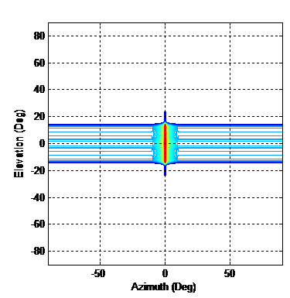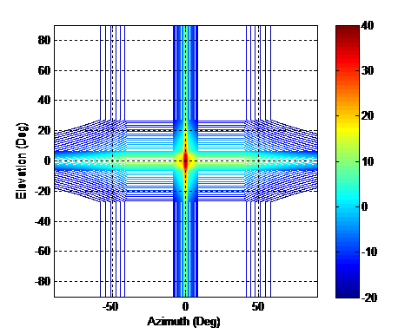

(a) (b)

The antenna gain as a function of off-axis angle for Scatterometer 2 is summarized in Table 4 while the graph of the antenna gain is shown in Fig. 2. Unlike SAR sensors with side-looking antenna beams, this scatterometer scans its antenna azimuth beam 0 to 360 degrees in azimuth at 14.6 revolutions per minute (rpm) (4.1-second rotation period).[3] As such, the antenna beam illuminates a given point on Earth for a limited period of time.

TABLE 4

Standard Scatterometer 2 antenna gain model

|  |  |  |
| --- | --- | --- |
| Pattern | **Gain *G*() (dBi) as a function of off-axis angle  (degrees)** | **Angle range** |
| Total | *G* ( )  36.933 – 0.0025 (27.935 ׀׀)2  *G* ( )  20.77 – 25 log(׀׀)  *G* ( )  –21.261 | 0  ׀׀  4   **≤**׀ ׀ 48  ׀ ׀ **≥**48 |

FIGURE 2

Scatterometer 2 antenna gain pattern as a function of off-axis angle



# 4 Aggregate RFI impingement analysis

The interference environment was simulated using the Satellite Tool Kit (STK). First STK models of the EESS (active) satellites and the ground-based RNSS receivers were created. STK was then used to simulate and record single-sensor received isotropic power (RIP) as seen by RNSS receivers. To build sufficient statistics, a simulation duration of 120 days was chosen.

These single-sensor RIP data sets were then post-processed in MATLAB to estimate aggregate RFI impingement statistics; i.e. how often and for how long aggregate RFI events occur. The details are described below.

## 4.1 Satellite models

Each EESS (active) satellite was modelled using STK’s sun-synchronous orbit satellite object with the orbit parameters given in Table 1. To model the EESS (active) sensor, a transmitter component with the appropriate RF characteristics and antenna gain pattern was added to the satellite object. For SAR3 and SAR6, the antenna beam was pointed to 90 degrees in azimuth (perpendicular to the spacecraft heading) and 30 and 59 degrees in elevation, respectively. For Scatterometer 2, the antenna was assumed pointed to 34 degrees in elevation while rotating 0 to 360 degrees in azimuth at 14.6 rpm.[4]

## 4.2 Single sensor received isotropic power

Examples of contour plots of RIP on the Earth’s surface for SAR3, SAR6 and Scatterometer 2 are shown in Figs 3(a) through (c). In each figure, the RIP contours ranging from –110 dBW to –135 dBW in 5 dB steps are displayed and the dashed circles show the coverage indicating the range to the limb of the Earth from the satellite. Any RNSS receivers in this circular area have a direct line-of-sight to the EESS (active) sensor in orbit.

Two different simulation time-steps were used, depending on the two EESS sensors under consideration. For estimating the aggregate RFI event potentials for two SARs, a 10-second time‑step was used to record the RIP data. This time-step is appropriate since the SAR emission footprint moves slowly across a given location on Earth and illuminates a RNSS receiver for periods lasting several minutes.

For estimating the aggregate RFI event potentials for scenarios involving Scatterometer 2, a 50-msec time-step[5] was used to properly model Scatterometer 2’s rotating antenna. Since it was computationally not feasible to perform a 120-day simulation using a 50-msec time-step, a two-step approach was used. First, the STK sensor access function was used to determine times when Scatterometer 2 and a SAR were simultaneously passing over a given receiver location. For each of these times, a 10-minute simulation using 50-msec time-steps was performed to estimate the RIP data.

It should be noted that the example contours in Fig. 3 are possibly skewed with respect to actual contours due to the simplified composite EESS antenna gain formulas (Tables 2 to 4 above). If improved accuracy is needed for RNSS receiver RFI impact assessment, more complete definition may be needed in the associated EESS RS series Recommendation for active sensor antenna patterns in the sidelobe regions.

FIGURE 3

Contours of received isotropic power on the Earth’s surface for SAR3, SAR6 and Scatterometer 2

(a)       (b)            (c)

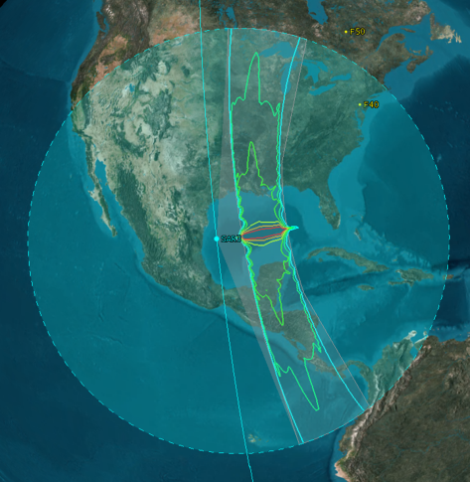 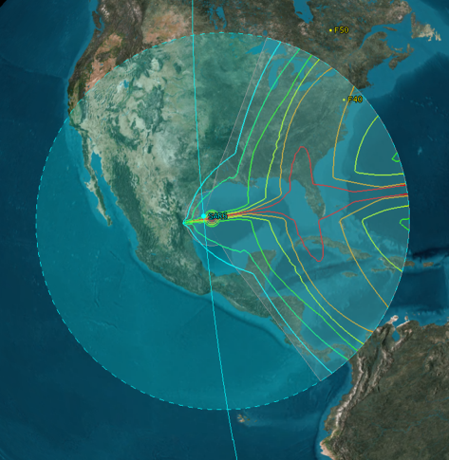 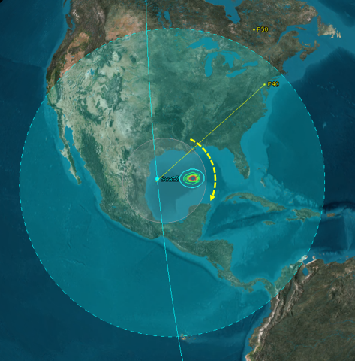

## 4.3 Receiver models

To determine times and durations of aggregate RFI events, victim RNSS receivers must be modelled. STK’s facility object simulates placing receivers at any location on Earth. Intuitively, the simultaneous illumination events should depend on the latitudes of these receiver locations and hence RNSS receivers were placed at 40, 50, 60, 70 and 80 degrees in latitude at 75 degrees West longitude.[6]

Depending on the location of the receiver, the EESS (active) sensor appears at varying elevation angles and, consequently, the receive antenna gain was taken into consideration. The receive antenna gain pattern assumed in this analysis is shown in Fig. 4. This antenna gain pattern was taken into account during the post-processing stage of the analysis.

It should be noted that this antenna pattern represents an antenna used by one particular type of receiver. Other RNSS receivers use antennas with different gain patterns and no single gain pattern represents all RNSS receivers. Additionally, the maximum antenna gain in the lower hemisphere could (under worst-case conditions) be equal to that for the upper hemisphere because the antenna in some RNSS receiver applications could potentially be pointed in almost any direction (see Table 1‑1, Note 12 in Recommendation ITU-R M.1902).

FIGURE 4

Assumed RNSS receiver antenna gain as a function of elevation angle

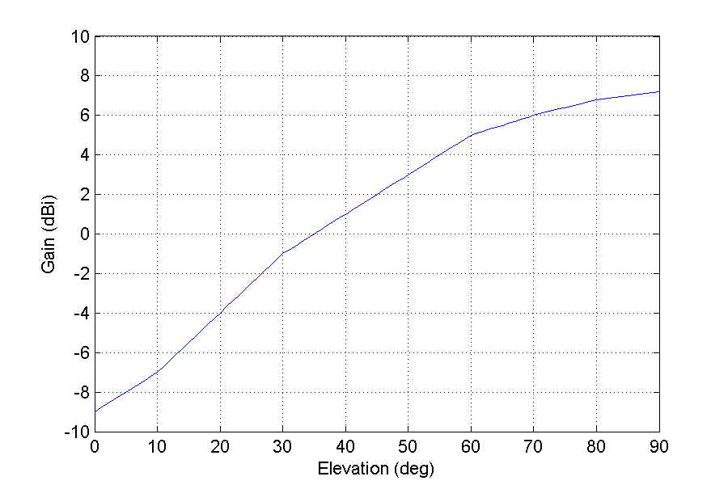

## 4.4 Single-Sensor interference power into receivers

The single-sensor RIP datasets were post-processed to estimate the interference power into the receiver. Examples of estimated interference power, as seen by a RNSS receiver at 80 degrees latitude over a 12-hour period, are shown in Fig. 5(a) for SAR3 and SAR6. The larger emission footprint of the SAR6 wide-beam antenna impinges on receivers more frequently than SAR3. The peaks repeat about every 95 minutes, the orbital period of SAR6. Similarly, the interference power into the receiver over a single-pass, 10-minute period for Scatterometer 2 and SAR6 are shown in Fig. 6(a).

In both Figs 5(a) and 6(a), the peak power threshold level of –129 dBW is indicated by a magenta dashed horizontal line. The times when the interference power exceeds this dashed line correspond to the strong-pulse RFI case, whereas at other times they correspond to weak-pulse RFI, or no interference, cases.

The aggregate pulsed RFI cases can be better described using Fig. 7, which shows a 50-second portion of Fig. 6(a). The strong-strong pulsed RFI case is illustrated in Fig. 7 beginning at about 17:18:07 GMT (at about the 187 sec mark) when the peak pulse power from both Scatterometer 2 and SAR6 exceed the –129 dBW threshold.

For this case, equation (5) can be used to estimate the aggregate strong-pulse PDC parameter. Also shown are instances of the strong-weak pulse RFI case, immediately before and after Scatterometer 2 strong-pulse RFI occurrences. For these cases the weak-pulse parameter, RI2j, for Scatterometer 2 is non-zero and may need to be taken into account when performing pulsed RFI evaluations.

Similar strong-weak cases with Scatterometer 2 causing strong-pulse RFI and SAR6 contributing to the weak-pulse RFI are seen between 17:17:30 GMT (150 sec) and 17:18:05 GMT (185 sec). Again, the weak pulse parameter *RI,j* of SAR6 may need to be taken into account when performing pulsed RFI evaluations. The weak-weak pulse RFI case is also shown immediately before and after Scatterometer 2 strong-pulse RFI occurrences.

It is worth noting that this Report only considers the potential for simultaneous illumination events for the strong-strong pulse case. This high-level statistical analysis is simpler and more general than an analysis that would seek to quantify the RFI impact of pulsed interference to RNSS receivers and fewer RNSS receiver parameters are required. It serves to indicate whether or not aggregate pulsed RFI events could occur for the assumed set of scenarios.

## 4.5 Aggregate RFI impingement statistics

The aggregate RFI impingement statistics were determined by compiling records of how often and for how long the emission footprints, corresponding to the strong-strong pulse case, overlap. This was done by processing two sets of EESS data and determining the number of EESS signals exceeding the peak power threshold at any given time. The intermediate product corresponding to the data sets in Figs 5(a) and 6(a) are shown in Figs 5(b) and 6(b), respectively. In these figures, the periods when the number of EESS signals equals 2 correspond to the strong-strong pulsed RFI case. The impingement statistics were then determined by compiling records of these peaks. These results are described in the next section.

FIGURE 5

(a) Estimated RIP for SAR3 (blue) and SAR6 (red) at 80 degrees latitude over a 12-hour period and   
(b) the number of strong pulsed signals seen by a receiver[7]

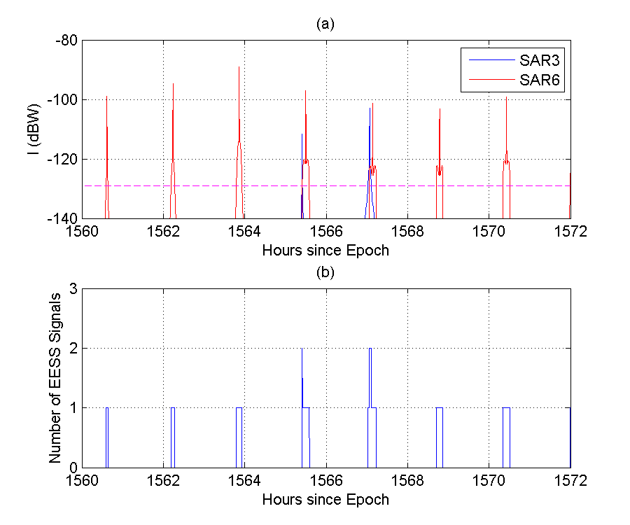

FIGURE 6

(a) Interference power into a RNSS receiver for Scatterometer 2 (blue) and SAR6 (red) at 80 degrees   
latitude over a ten-minute period and (b) the number of strong-pulsed signals seen by the receiver

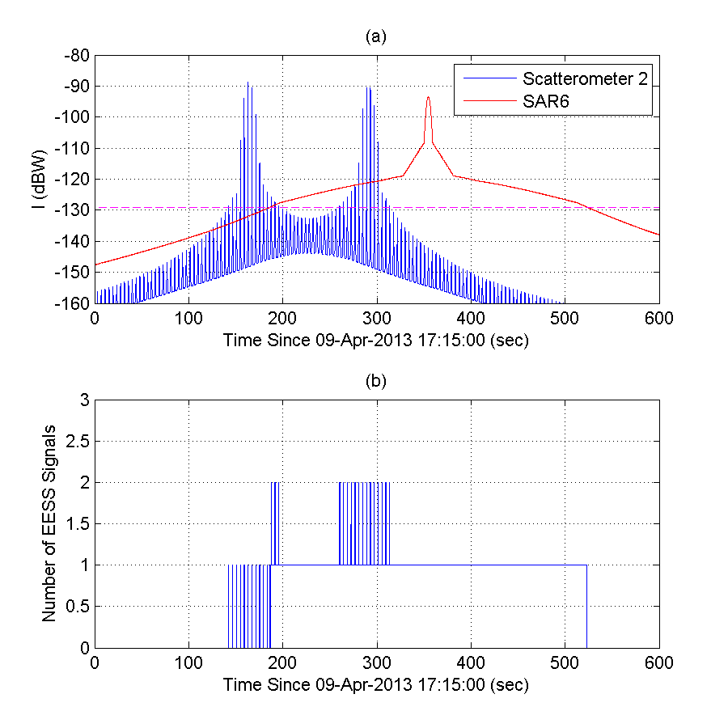

FIGURE 7

Close-up view of Fig. 6(a) showing interference power I (dBW)

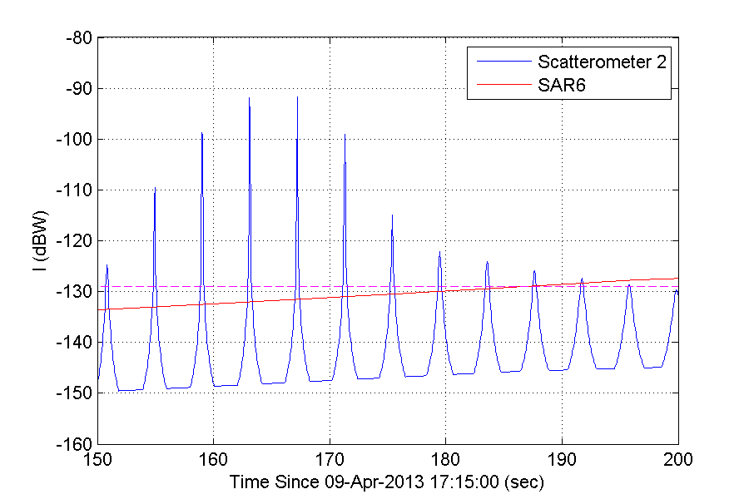

# 5 Analysis results

To investigate the potential for aggregate RFI, various scenarios were considered. The three Study A scenarios simulated combinations of planned EESS sensors. Study B simulated three hypothetical scenarios to explore what might happen with future deployment of EESS sensors. The description of these scenarios and results are provided in the next two sub-sections.

## 5.1 Study A

Study A considers planned EESS sensors and includes the following scenarios:

– SAR3 and SAR6 – a narrowbeam SAR (SAR3) and a widebeam SAR (SAR6) in orthogonal sun-synchronous orbits at different altitudes;

– SAR3 and Scatterometer 2 – a narrowbeam SAR (SAR3) and a scatterometer in the same orbit at different altitudes;

– SAR6 and Scatterometer 2 – a widebeam SAR (SAR6) and a scatterometer in orthogonal orbits at different altitudes.

The aggregate RFI impingement results for the Study A scenarios are summarized in Table 5. In all Study A scenarios, the aggregate RFI events seldom occurred during 120-day simulations. Even for the two SARs in orthogonal orbits with larger emission footprints (Scenario 1), simultaneous overlap events only occurred a total of 41 times and only at high latitude (80 degrees).

Even if the aggregate pulsed RFI for these Study A scenarios appears to be acceptable, as more EESS sensors become operational in the L2 band, the aggregate pulsed RFI will increase. This is considered in the next sub-section.

TABLE 5

Summary of Study A results over a 120-day simulation period

|  |  |  |  |  |
| --- | --- | --- | --- | --- |
| Scenarios |  | Study A | | |
|  | 1 (Note 1) | 2 (Note 2) | 3 |
| **EESS1** | LAN | 18:00 | 18:00 | 12:00 |
| Altitude | 757 km | 757 km | 628 km |
| Antenna | Narrowbeam | Narrowbeam | Widebeam |
| **EESS2** | LAN | 12:00 | 18:00 | 18:00 |
| Altitude | 628 km | 680 km | 680 km |
| Antenna | Widebeam | Rotating Spotbeam | Rotating  Spotbeam |
| **Comments** |  | SAR3/SAR6 Orthogonal orbits | SAR3 Scatterometer 2 Co-planar orbits | SAR6 Scatterometer 2 Orthogonal orbits |
| **Total Aggregate Pulsed RFI Event Occurrences (Note 3)** | 40 deg Lat | 0 | 91(5) | 0 |
| 50 deg Lat | 0 | 82(4) | 0 |
| 60 deg Lat | 0 | 87(5) | 0 |
| 70 deg Lat | 0 | 139(9) | 6(1) |
| 80 deg Lat | 41 | 409(18) | 1186(63) |
| **Duration of Aggregate RFI events (max/median)** | 40 deg Lat | NA | 0.37/0.32 (sec) | NA |
| 50 deg Lat | NA | 0.38/0.27 (sec) | NA |
| 60 deg Lat | NA | 0.38/0.28 (sec) | NA |
| 70 deg Lat | NA | 0.38/0.32 (sec) | 0.18/0.03 (sec) |
| 80 deg Lat | 6.5/1.5 (min) | 0.37/0.32 (sec) | 0.37/0.32 (sec) |
| NOTE 1 – For Study A, which includes current/planned missions, the planned SAR3 operational lifetime (2021-2024) does not overlap with the planned lifetimes of SAR6 (2013-2018) and Scatterometer 2 (2014‑2018).  NOTE 2 – The larger numbers of aggregate events at various latitudes do not account for the operational prohibition of simultaneously illuminating the same areas on the ground with both SAR3 and Scatterometer 2 due to concerns of mutual EESS interference.  NOTE 3 – These numbers reflect each time an individual scan of the Scatterometer antenna beam results in the received peak power envelope exceeding the strong-pulse threshold. The numbers in parenthesis for Scenarios 2 and 3 indicate the number of orbital passes when Scatterometer 2 and a SAR are simultaneously illuminating the RNSS receiver. | | | | |

## 5.2 Study B

Study B considers the potential for aggregate RFI from possible future EESS sensors. These additional studies were considered because there could be additional EESS (active) sensors deployed in this frequency band. The following scenarios were considered:

– two widebeam SARs in orthogonal sun-synchronous orbits at different altitudes;

– two widebeam SARs in the same orbit at different altitudes;

– a visibility study for two SARs in orthogonal sun-synchronous orbits at different altitudes.

The aggregate RFI impingement results for the Study B scenarios are summarized in Table 6. Scenario 4 considers the potential for aggregate RFI should two widebeam EESS sensors be deployed in orthogonal orbital planes. While the occurrence of beam overlap is restricted to high latitudes (> 70 degrees), the number of potential interference events is high. Scenario 5 considers the potential for aggregate RFI should two widebeam EESS sensors be deployed in the same orbit. For this particular case, the aggregate RFI events could occur at all latitudes.

Of the scenarios studied with antenna discrimination (i.e. excluding Scenario 6), Scenario 5 represents the worst configuration for two EESS sensors.[8] Finally, the visibility study for Scenario 6 indicates that, for just two EESS sensors in orthogonal orbits, the potential for significant aggregate RFI exists even at lower latitudes (> 50 degrees). Study B indicates that there is potential for harmful aggregate RFI to RNSS receivers if future EESS sensors were to be deployed with the modelled parameters.

## 5.3 Discussion

The analysis presented in this Report only considered the potential for two EESS (active) sensors to simultaneously illuminate an RNSS receiver. However, there are deployment plans for other EESS (active) sensors in this frequency band; for example, SAOCOM. The probability of aggregate RFI, due to three or more EESS sensors simultaneously illuminating RNSS receivers, is probably very small. However, the two-sensor EESS aggregate RFI events summarized in Tables 5 and 6 will occur more frequently.

The analysis also only considered EESS (active) sensors in 6 pm and 12 pm LAN sun-synchronous orbits. These two orbits are orthogonal to one another and provide maximum longitudinal separation. If future EESS sensors are planned for deployment in non-orthogonal orbits, the aggregate RFI impingement is likely to be worse.

For Table 5 (Study A), which considered currently planned missions, the operational duty cycle was not considered for the systems studied. Including this aspect of EESS sensor operation may reduce the number of aggregate RFI events. In addition, if there is a potential aggregate pulsed RFI occurrence, and the footprint of one or both of the SARs is illuminating the ocean, the SAR is probably not transmitting since the area of interest to operators is typically the land and coastal areas.

It is important to note that the antenna patterns used in this analysis were based on two principal plane cuts. The aggregate behaviour of antenna gain patterns and sidelobe levels of EESS systems in non‑principal plane antenna patterns, therefore, may not be accurately represented by this analysis. Therefore, further studies using more accurate antenna gain patterns and orbits should be considered.

Finally, the actual quantification of aggregate RFI should be assessed based on the actual EESS sensors parameters, using the methodology in Recommendation ITU-R M.2030 and its companion Report ITU-R M.2220. Whenever such quantification indicates that a specified RNSS receiver power threshold would be exceeded during any simultaneous illumination event, then a more detailed analysis of the impact of the aggregate pulsed interference may be required to determine whether or not such aggregate pulsed interference is acceptable to the victim RNSS receiver. This important information should be taken into account for a proper investigation of potential pulsed interference mitigation techniques.

TABLE 6

Summary of Study B results over a 120-day simulation period

|  |  |  |  |  |
| --- | --- | --- | --- | --- |
| Scenarios | | Study B | | |
| 4 | 5 (Note 1) | 6 (Note 2) |
| **EESS1** | LAN | 18:00 | 18:00 | 18:00 |
| Altitude | 757 km | 757 km | 757 km |
| Antenna | Widebeam | Widebeam | Line-of-sight |
| **EESS2** | LAN | 12 PM | 6 PM | 12 PM |
| Altitude | 628 km | 680 km | 628 km |
| Antenna | Widebeam | Widebeam | Line-of-sight |
| **Comments** |  | Two Widebeam EESS Orthogonal orbits | Two Widebeam EESS Co-planar orbits | Two EESS visibility study |
| **Total Aggregate Pulsed RFI Event Occurrences** | 40 deg Lat | 0 | 44 | 0 |
| 50 deg Lat | 0 | 55 | 25 |
| 60 deg Lat | 0 | 68 | 185 |
| 70 deg Lat | 32 | 116 | 296 |
| 80 deg Lat | 194 | 189 | 459 |
| **Duration of Aggregate RFI events (max/median)** | 40 deg Lat | NA | 10.2/2.1 (min) | NA |
| 50 deg Lat | NA | 10.2/2.2 (min) | 6.1/3.6 (min) |
| 60 deg Lat | NA | 10.0/2.3 (min) | 11.9/5.2 (min) |
| 70 deg Lat | 7.0/1.6 (min) | 9.8/2.3 (min) | 13.3/5.4 (min) |
| 80 deg Lat | 8.2/2.3 (min) | 10.3/3.3 (min) | 13.4/6.6 (min) |
| NOTE 1 – No particular plans for widebeam SARs operating in the same orbit are known to exist at present.  NOTE 2 – In Scenario 6, for two EESS systems within line-of-sight, not all instances of the total aggregate pulsed RFI event occurrences shown may cause RFI levels above the assumed peak power threshold level of –129 dBW. | | | | |

# 6 Summary

This Report presents results from simulations where two EESS (active) sensors are simultaneously illuminating an RNSS receiver located on the surface of the Earth. For several scenarios, the preliminary study investigated the potential for simultaneous illumination events, quantified in terms of the number and duration of instances, in which the received peak power of both of the sensors is above a specific peak power threshold (–129 dBW).

This Report identifies the potential for aggregate interference events from multiple EESS (active) sensors into RNSS receivers in terms of the number and duration of events. For a quantification of the RFI impact to an RNSS receiver, the methodology described in Report ITU-R M.2220 and Recommendation ITU-R M.2030 should be used. Such study, taking into account technical and operational characteristics of EESS (active) sensors and RNSS receivers, should be considered for future ITU-R Reports.

Annex 1  
  
Background on choice of time-step value for Scatterometer 2 calculations

A comparison of the rapid azimuth scan rate of Scatterometer 2 in this Report (87.6°/sec) to its antenna –3 dB azimuth beamwidth (2.6°) might suggest the choice of a 50-msec time-step is too coarse to properly sample the beam motion. To address this concern, a 10-msec time-step calculation was also performed for a representative situation corresponding to that shown in Fig. 6(a). Figure 8 below shows the comparison of estimated interference power (at the output of the RNSS antenna) due to Scatterometer 2 for10-msec (blue line) and 50-msec (red dots) time steps. Note that using 50‑msec time-steps will affect those antenna rotations for which the receiver is being illuminated by the peak, or very close to the peak, of the Scatterometer 2 main beam. During these scans, the interference power changes rapidly temporally because of the sharpness of the main beam. This is illustrated in Fig. 9 where the interference power estimate at the 159-second mark shows about a 3 dB difference between 10-msec and 50-msec estimates.

On the other hand, the –129 dBW interference threshold (magenta dashed line) is exceeded first during the leading edge and then later during the trailing edge of the antenna beam. For those cases, the interference power values change more slowly and under-sampling is much less likely to occur. This is illustrated in Fig. 10, which displays a close-up view between 180 to 200 seconds. In this figure, the strong pulsed event at around 196 seconds is captured using either time-step value. Thus for an initial analysis, the 50-msec time-step is believed to be adequate to sample the beam motion.

Figure 8

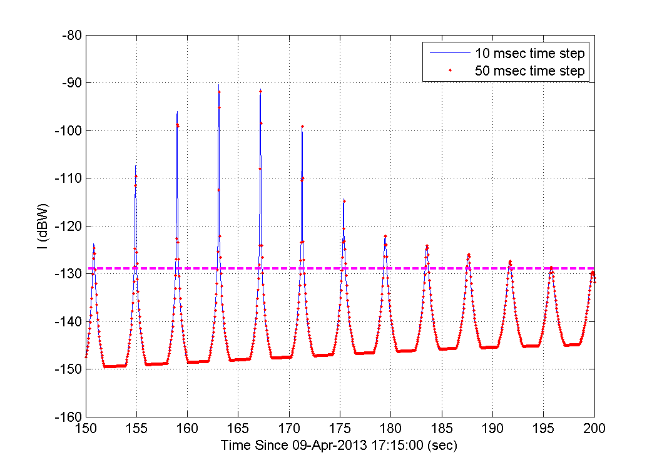

Figure 9

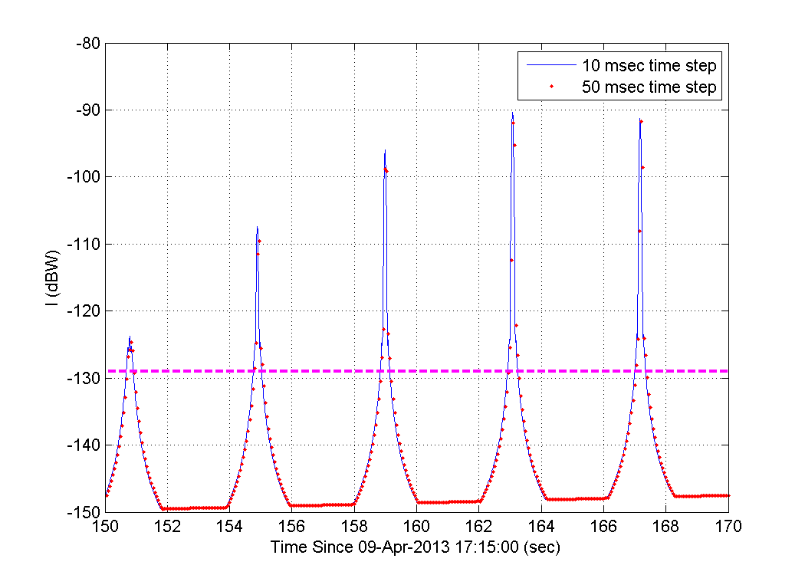

Figure 10

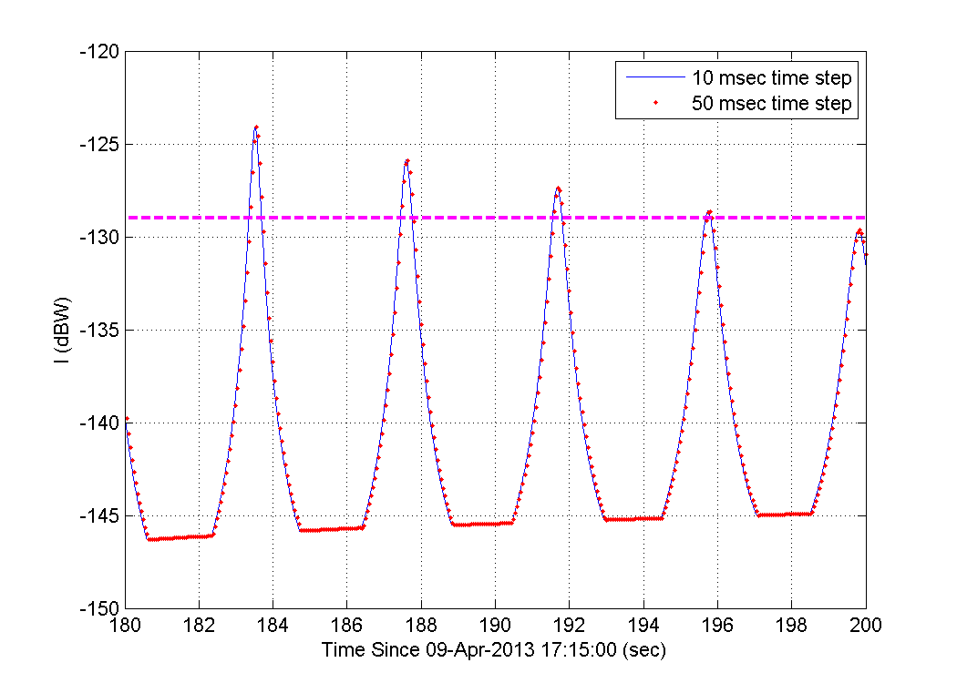

1. More details of RNSS receiver pulsed effects are found in Report ITU-R M.2220, §§ 2.2.4, 2.3, and 4.1.3.
2. The –129 dBW threshold level is based on the Scatterometer 2 pulsed RFI effect on one particular type of RNSS receiver. See Recommendation ITU-R M.1902 for other RNSS receiver types.
3. The Scatterometer 2 scan rate can be set between 13.0 and 14.6 rpm (4.1 to 4.6-second rotation period). The planned revolution rate is now 13.0 rpm.
4. Current plan is to use 13.0 rpm. This is the lower end of the 13.0 to 14.6 rpm range of selectable rates.
5. See Annex 1 for further details.
6. The simulation also looked at 165 degrees west longitude and found that the impingement statistics changed very little.
7. For Study A, which includes current/planned missions, the planned SAR3 operational lifetime (2021-2024) does not overlap with the planned lifetimes of SAR6 (2013-2018) and Scatterometer 2 (2014-2018).
8. Although the simultaneous illumination of the same point on the Earth’s surface from multiple EESS sensors could potentially be avoided through operational coordination of such sensors by EESS system operators, only the mainbeam-to-mainbeam coupling is usually considered in EESS coordination. These results indicate that sidelobe illuminations should be taken into account in such coordination processes in the future.