|  |
| --- |
| **Report ITU-R M.2324-0**  **(11/2014)** |
| **Sharing studies between potential International Mobile Telecommunication systems and aeronautical mobile  telemetry systems in the  frequency band 1 429-1 535 MHz** |
| **M Series**  **Mobile, radiodetermination, amateur**  **and related satellite services** |

Foreword

The role of the Radiocommunication Sector is to ensure the rational, equitable, efficient and economical use of the radio-frequency spectrum by all radiocommunication services, including satellite services, and carry out studies without limit of frequency range on the basis of which Recommendations are adopted.

The regulatory and policy functions of the Radiocommunication Sector are performed by World and Regional Radiocommunication Conferences and Radiocommunication Assemblies supported by Study Groups.

# Policy on Intellectual Property Right (IPR)

ITU-R policy on IPR is described in the Common Patent Policy for ITU-T/ITU-R/ISO/IEC referenced in Annex 1 of Resolution ITU-R 1. Forms to be used for the submission of patent statements and licensing declarations by patent holders are available from <http://www.itu.int/ITU-R/go/patents/en> where the Guidelines for Implementation of the Common Patent Policy for ITU‑T/ITU‑R/ISO/IEC and the ITU-R patent information database can also be found.

|  |  |
| --- | --- |
| Series of ITU-R Reports  (Also available online at <http://www.itu.int/publ/R-REP/en>) | |
| **Series** | Title |
| **BO** | Satellite delivery |
| **BR** | Recording for production, archival and play-out; film for television |
| **BS** | Broadcasting service (sound) |
| **BT** | Broadcasting service (television) |
| **F** | Fixed service |
| **M** | Mobile, radiodetermination, amateur and related satellite services |
| **P** | Radiowave propagation |
| **RA** | Radio astronomy |
| **RS** | Remote sensing systems |
| **S** | Fixed-satellite service |
| **SA** | Space applications and meteorology |
| **SF** | Frequency sharing and coordination between fixed-satellite and fixed service systems |
| **SM** | Spectrum management |

|  |
| --- |
|  |

|  |
| --- |
| ***Note****: This ITU-R Report was approved in English by the Study Group under the procedure detailed in Resolution ITU-R 1.* |

*Electronic Publication*

Geneva, 2015

© ITU 2015

All rights reserved. No part of this publication may be reproduced, by any means whatsoever, without written permission of ITU.

REPORT ITU-R M.2324-0

Sharing studies between potential International Mobile Telecommunication systems and aeronautical mobile telemetry systems   
in the frequency band 1 429-1 535 MHz

(2014)

# 1 Introduction

This Report provides sharing studies between potential International Mobile Telecommunication (IMT) systems and aeronautical mobile telemetry (AMT) systems in the frequency band 1 429‑1 535 MHz conducted as preparatory work for WRC-15 agenda item 1.1. Several technical studies are contained in the document taking into account differences in regulatory situations as well as technical and operational characteristics for the use of AMT systems in three Regions.

# 2 Related ITU-R Recommendations and Reports

Recommendation ITU-R M.1459 – Protection criteria for telemetry systems in the aeronautical mobile service and mitigation techniques to facilitate sharing with geostationary broadcasting‑satellite and mobile-satellite services in the frequency bands 1 452-1 525 MHz and 2 310-2 360 MHz.

Recommendation ITU-R P.452 – Prediction procedure for the evaluation of interference between stations on the surface of the Earth at frequencies above about 0.1 GHz.

Recommendation ITU-R P.1546 – Method for point-to-area predictions for terrestrial services in the frequency range 30 MHz to 3 000 MHz.

Report ITU-R M.2292 – Characteristics of terrestrial IMT-Advanced systems for frequency sharing/interference analyses.

# 3 Allocation information

In Region 1, the frequency band 1 429-1 525 MHz is allocated to the mobile except aeronautical mobile service on a primary basis. Radio Regulations No. **5.342** states that “*Additional allocation:* in Armenia, Azerbaijan, Belarus, the Russian Federation, Uzbekistan, Kyrgyzstan and Ukraine, the band 1 429‑1 535 MHz, and in Bulgaria the band 1 525-1 535 MHz, are also allocated to the aeronautical mobile service on a primary basis exclusively for the purposes of aeronautical telemetry within the national territory. As of 1 April 2007, the use of the band 1 452-1 492 MHz is subject to agreement between the administrations concerned.”

In Regions 2 and 3, the frequency band 1 429-1 525 MHz is allocated to the mobile service on a primary basis. Radio Regulations No. **5.343** states that “In Region 2, the use of the band 1 435‑1 535 MHz by the aeronautical mobile service for telemetry has priority over other uses by the mobile service.”

# 4 Technical characteristics used in sharing studies

## 4.1 AMT system characteristics

With regard to AMT system characteristics, the technical studies contained in the document are based on the technical characteristics as those described in Recommendation ITU-R М.1459 –Protection criteria for telemetry systems in the aeronautical mobile service and mitigation techniques to facilitate sharing with geostationary broadcasting-satellite and mobile-satellite services in the frequency bands 1 452-1 525 MHz and 2 310-2 360 MHz. Details of technical characteristics employed in the respective studies are contained in the corresponding Annexes.

## 4.2 IMT system characteristics

With regard to IMT system characteristics, the technical studies contained in the document are based on the technical characteristics as those in Report ITU-R M.2292 – Characteristics of terrestrial IMT-Advanced systems for frequency sharing/interference analyses. Details of technical characteristics employed in the respective studies are contained in the corresponding Annexes.

# 5 Overview of technical studies

This Report contains different technical studies as detailed in Annexes 1-8. An overview of each study is summarized in Table 1.

TABLE 1

Overview of each technical study in the document

|  |  |  |  |  |  |  |  |  |  |
| --- | --- | --- | --- | --- | --- | --- | --- | --- | --- |
|  | | Study 1 | Study 2 | Study 3 | Study 4 | Study 5 | Study 6 | Study 7 | Study 8 |
| Study in Region 1 associated with RR No. **5.342** | Study in Region 1 associated with RR No. **5.342** | Study in Region 1 associated with RR No. **5.342** | Study in Region 2 associated with RR No. **5.343** | Study in Region 3 | Study in Region 2 | Study in Region 1 associated with RR No. **5.342** | Study in Region 1 associated with RR No. **5.342** |
| Operating frequency band of AMT systems | | 1 429-1 535 MHz | 1 429-1 535 MHz | 1 429-1 535 MHz | 1 435-1 525 MHz | 1 429-1 518 MHz | 1 452-1 472 MHz | 1 429-1 535 MHz | 1 429-1 535 MHz |
| Interference scenarios evaluated in the studies | IMT station  🡪 AMT ground station | **YES**  (Interference from IMT base‑station) | **YES**  (Interference from IMT base‑station) | – | **YES**  (Interference from IMT base‑station and user equipment (UE)) | **YES**  (Interference from IMT base‑station) | **YES**  (Interference from IMT base‑station and UE) | – | – |
| IMT station  🡪 AMT aircraft station | **YES**  (Interference from IMT base‑station) | – | – | –  (NOTE 1) | **YES**  (Interference from IMT base‑station) | – | – | – |
| AMT aircraft station  🡪 IMT station | – | – | **YES**  (Interference into IMT base‑station) | **YES**  (Interference into IMT base‑station and UE) | – | – | **YES**  (Interference into IMT UE) | **YES**  (Interference into IMT UE) |
| AMT ground station  🡪 IMT station | – | – | – | – | – | **YES**  (Interference into IMT base‑station and UE) | – | – |
| NOTE 1 – Telecommand systems, and air-to-air telemetry relay systems, are also utilized by countries in Region 2. | | | | | | | | | |

# 6 Summary of results in each technical study

## 6.1 Interference from IMT station into AMT ground station

TABLE 2

Scenario 1: Interference from IMT station into AMT ground station

|  |  |  |  |  |  |
| --- | --- | --- | --- | --- | --- |
|  | Study 1 | Study 2 | Study 4 | Study 5 | Study 6 |
| IMT station transmitter characteristics | Macro rural base-station | Macro base-station | Macro base-station, UE | Macro rural, suburban base-station | Macro rural base-station, UE |
| Propagation model | Rec. ITU-R P.1546-4 | Rec. ITU-R P.1546-4 | Rec. ITU-R P.452-14 | – | Rec. ITU-R P.452-15, Okumura-Hata model |
| AMT ground station receiver characteristics | Antenna height: 10 m | Antenna height: 10 m | Antenna height: 30 m | – | Antenna height: 30 m |
| Protection criteria of AMT ground station | Rec. ITU-R M.1459 | Rec. ITU-R M.1459 | Rec. ITU-R M.1459 | Rec. ITU-R M.1459 | Rec. ITU-R M.1459 |
| Summary of results of studies | • Distances required for protection of AMT ground receivers from emissions produced by a single IMT station would depend on radio path features. In the case of IMT station operating in 5 MHz bandwidth the distance would be of 170 km for land path and up to 395 km for water path without accounting for tropospheric scattering. | • For 100-130 km separation distance range, the following apportionment for urban 40-50% path in the total path separating IMT base-station from telemetry terrestrial station could ensure sharing between both services. | • When beyond line of sight distances are included in propagation models, the distance at which an IMT base-station needs to be from an AMT ground station in order to comply with Recommendation ITU‑R M.1459 exceeds 100 km, even for assuming 90 meter average terrain variation. | • The isolation requirement from the IMT base-station for co-channel operation in the worst case is 200 dB (macro rural) and 198 dB (macro suburban), respectively, to prevent the harmful interference to AMT ground station. | • Adjacent channel interference was found to AMT receivers from the IMT base-station for distances about 1 km when using Okumura-Hata propagation model. |

TABLE 2 (*continued*)

|  |  |  |  |  |  |
| --- | --- | --- | --- | --- | --- |
|  | Study 1 | Study 2 | Study 4 | Study 5 | Study 6 |
|  | • With accounting for the tropospheric scattering, the required protection distances increase by 15‑20% in the average.  • Distances required for protection of AMT ground receivers from emissions produced by a network of IMT base-stations would depend on radio path features. In the case of IMT station operating in 5 MHz bandwidth the required protection distance would be of 450 km for land path and 500 km for mixed path. | • Such distances would then make the bilateral cross border coordination process possible on a case by case basis through good engineering practice (such as mitigation techniques : site engineering, reduction of output power).  • The impact of a single IMT base-station to the ground aeronautical telemetry stations that are notified in the BR IFIC when they share the same band within 1 427-1 492 MHz is (1) 42% of the notified ground telemetry stations do not require additional protection to operate properly without suffering harmful interference from a single IMT base-station, (2)the 58% remaining ground telemetry stations may require mitigation techniques (sector disabling, antenna pattern nulling, down tilting) applied to the IMT base-station to reduce the geographical distance, which would lead to tens km separation distance from the cross-border. These separation distances could be more reduced when performing mitigation techniques to the ground telemetry stations. | • For IMT UE, typical protection distances increase to 47 km and more in the absence of extreme (>20 dB) clutter loss. | • The isolation requirement from the IMT macro rural and macro suburban base-station for adjacent channel operation in the worst case is 160 dB (macro rural) & 158 dB (macro suburban) at 5 MHz OoB frequency offset and 151 dB (macro rural) & 149 dB (macro suburban) at 10 MHz OoB frequency offset to prevent the harmful interference to AMT ground station. | • No adjacent channel interference from IMT UE to AMT receiver because height differences and spectrum mask of the AMT system for the out-of-band emission results on good conditions for the IMT UE. |

## 6.2 Interference from IMT station into AMT aircraft station

TABLE 3

Scenario 2: Interference from IMT station into AMT aircraft station

|  |  |  |
| --- | --- | --- |
|  | Study 1 | Study 5 |
| IMT station transmitter characteristics | Macro rural base-station | Macro rural, suburban base-station |
| Propagation model | Free space propagation model | – |
| AMT aircraft station receiver characteristics | Flight altitude: 10 km | Antenna gain: 0 dBi |
| Protection criteria of AMT aircraft station | –140 dB(W/m2) Not exceeding in any 4 kHz band | –140 dB(W/m2) Not exceeding in any 4 kHz band |
| Summary of results of studies | • Distance required for protecting the air-borne aeronautical telemetry receivers from single IMT base-stations exceeds the air-borne receiver line-of-sight. For conventional flight altitude of 10 km the line-of-sight exceeds 412 km accounting refraction. | • The isolation requirement from the IMT base-station for co-channel operation in the worst case is 159 dB (macro rural) and 157 dB (macro suburban), respectively, to prevent the harmful interference to AMT ground station.  • The isolation requirement from the IMT macro rural and macro suburban base-station for adjacent channel operation in the worst case is 119 dB (macro rural) & 117 dB (macro suburban) at 5 MHz OoB frequency offset and 110 dB (macro rural) & 108 dB (macro suburban) at 10 MHz OoB frequency offset to prevent the harmful interference to AMT ground station. |

## 6.3 Interference from AMT aircraft station into IMT station

TABLE 4

Scenario 3: Interference from AMT aircraft station into IMT station

|  |  |  |  |  |
| --- | --- | --- | --- | --- |
|  | Study 3 | Study 4 | Study 7 | Study 8 |
| AMT aircraft station transmitter characteristics | Transmitter power:  25 Watts per 1, 3 and 5 MHz  Antenna gain: 10 dB | Transmitter power:  10 Watts per 10 MHz  Antenna gain: 2 dBi | Radiated power:  23 dBW per 21.3 MHz  Antenna gain: 0 dBi | Transmitter e.i.r.p.:  23.98 dBW per 5 MHz (maximum), 13.98 dBW (near realistic) per 5 MHz (based on Rec. ITU-R M.1459)  25.15 dBW per 21.3 MHz  (based on MIFR) |
| Propagation model | Free space propagation model | Free space propagation model | Free space propagation model | Free space propagation model |
| IMT station receiver characteristics | Macro, Micro, Pico base-station | UE, base-station | UE | UE |
| Protection criteria of IMT station | –138 dBW in 5 MHz  –135 dBW in 10 MHz  –132 dBW in 20 MHz | *I/N* = –6 dB in conjunction with IMT parameters provided in Report ITU-R M.2292 | Average long-term Throughput Loss per cell | *I/N* = –6 dB and 0 dB |
| Summary of results of studies | • Protection distance required for IMT systems operating with signals of 5 MHz, 10 MHz and 20 MHz bandwidth would exceed line-of-sight distance of 412 km for a typical flight altitude of 10 000 m for both macro-cell and micro-cell/pico-cell. | • Protection criteria required for UE will be exceeded at a 45 km distance from the aircraft to the UE.  • Exclusion zone for base‑station will be considerably larger. | • Protection criteria required for UE leads to a separation distance from the aircraft to the UE up to 25 km. (See Annex 7.) | • Significant variation of required protection distance depending on the parameters of aeronautical telemetry system and protection criteria used. (See Tables 3 and 4 for MCL analysis, Table 5 for Monte-Carlo simulations in Annex 8.) |

## 6.4 Interference from AMT ground station into IMT station

TABLE 5

Scenario 3: Interference from AMT ground station into IMT station

|  |  |
| --- | --- |
|  | Study 6 |
| AMT aircraft station transmitter characteristics | Transmitter power: 10 watts 5 MHz Antenna gain: 30 dBi |
| Propagation model | Rec. ITU-R P.452-15, Okumura-Hata propagation model |
| IMT station receiver characteristics | UE, base-station |
| Protection criteria of IMT station | *I/N*= –3 dB |
| Summary of results of studies | • No adjacent channel interference was found from AMT to IMT base-station receivers, and UEs |

# 7 Conclusions

In order to provide protection of aeronautical mobile telemetry ground receivers in Region 1 from co-frequency interference caused by IMT stations, required separation distances would generally exceed 100 km:

– For interference from a single IMT base-station, separation distances are around 225 km for a land path and up to 415 km for a sea path. For aggregate interference from an IMT network having multiple base-stations, separation distances are up to 450 km for a land path and 500 km for a mixed path (40% of land and 60% of sea).

– For interference from a single IMT base-station, separation distances are around 100‑130 km and increasing up to 200 km when assuming the apportionment for urban 40-50% path and less than 10% in the total path, respectively.

However, when applying mitigation techniques (e.g. sector antenna disabling at IMT base‑stations) separation distances may be reduced to few tens of kilometres. This will be addressed during coordination between the concerned administrations.

With respect to Region 1, Report ITU-R M.2286 indicated the operation of telemetry on-board receivers. However, some administrations who are not listed in RR No. **5.342** are considering that such airborne relay receivers cannot be considered as an assignment in conformity with RR No. **5.342** and such stations cannot be considered as a part of telemetry application and shall not be considered for protection. Providing protection for such air-borne receiver in Region 1 from co-frequency interference caused by an IMT station may require separation distances exceeding line-of-sight (460 km for typical flight altitudes). In case of airborne aeronautical receiver, necessary separation distance is equal to line of sight distance for any cases. In case of ground-based aeronautical receiver, due to finite value of telemetry receiver antenna pattern width, its main lobe may be affected by emissions from several interferers located at different distances from a given aeronautical mobile telemetry receiver.

In that case the aggregate effect of interference from IMT base-stations would be defined by density of their deployment and would result in increasing the required protection distances.

In order to provide protection for potential IMT base-stations from co-frequency interference caused by an air-borne aeronautical mobile telemetry station in Region 1, maximum required separation distances would be around 460 km. It has to be noted that the duration of interference and required separation distance is depending on the visibility of the airborne telemetry transmitter, of the scenario of the flight and of parameters such as the antenna diagram. Thus, such interference would not be permanent.

Taking into account the protection criteria of average long-term throughput loss per cell, IMT mobile stations from co-frequency interference caused by an airborne aeronautical mobile telemetry station in Region 1, required separation distances from the cross-border would be up to 25 km.

In Region 2, co-channel sharing between IMT and AMT in the sub-band 1 435-1 525 MHz has been studied by one administration. Based on that study, it is concluded that such sharing is not practical in the geographic areas located within the exclusion zones required below for all of the possible uplink/downlink combinations:

– For interference from IMT user equipment to AMT ground stations, typical protection distances are 47 km and more in the absence of extreme (>20 dB) clutter loss.

– For interference from IMT base-stations to AMT ground stations, the distance beyond which an IMT base-station needs to be from an AMT ground station exceeds 100 km, even for “typical” terrain.

– For interference from AMT equipped aircraft to IMT user equipment and IMT, the separation distances will be 45 km in the case of interference to IMT UEs, and 80 km or more in the case of interference to IMT base-stations.

Adjacent channel co-existence of IMT systems was studied by a different Region 2 administration operating AMT in the band 1 452-1 472 MHz, with IMT operating in adjacent channels. Adjacent channel operation has been determined feasible with a separation distance of one kilometre from the IMT base-station to the AMT receiver. However, this conclusion depends on certain assumptions not characteristic of flight testing as conducted in another administration (such as AMT antenna elevation angle, maximum flight distance from the AMT antenna, and maximum altitude). For this case, there would be a significant protection shortfall using a 1 kilometre separation distance for the adjacent channel case.

**Annexes:** 8

Annex 1  
  
Study 1

Interference impact caused by the possible stations of the mobile service to receivers of aeronautical telemetry in the frequency band 1 429-1 535 MHz

# 1 Introduction

This Annex presents study results of interference impact caused by the possible stations of the mobile service to receivers of aeronautical telemetry in the frequency band 1 429-1 535 MHz.

# 2 Technical characteristics

## 2.1 Protection criteria for the aeronautical telemetry stations in the frequency band 1 429‑1 535 MHz

The on-board and ground stations of the aeronautical telemetry systems can operate in the frequency band 1 429-1 535 MHz.

(1) Protection criteria for the terrestrial stations of the aeronautical telemetry systems

The protection criteria for the terrestrial aeronautical telemetry systems are given in Recommendation ITU-R M.1459. In particular for their protection in the frequency band 1 452‑1 525 MHz the power flux density (pfd) of geostationary satellites broadcasting-satellite service (BSS) or mobile-satellite service (MSS) in the reference bandwidth of 4 kHz for all methods of modulation should not exceed:

–181.0 dB(W/m2) for 0≤ α ≤ 4°

–193.0  20 log α dB(W/m2) for 4° α ≤ 20°

–213.3  35.6 log α dB(W/m2) for 20° α≤ 60°

–150.0 dB(W/m2) for 60° α ≤ 90°

where α is the angle of arrival (degrees above the horizontal plane).

Similar criteria were used for protection of the aeronautical telemetry stations in the frequency band 1 430-1 432 MHz in the studies on WRC-07 agenda item 1.17 (see CPM-07 Report section 3/1.17/2.2).

(2) Protection criteria for the aircraft stations of the aeronautical telemetry systems

For the protection of aircraft stations of the aeronautical telemetry systems operating in the countries listed in RR No. **5.342** another criterion is used: the permissible pfd value in the reference bandwidth of 4 kHz shall not exceed (−140 dB(W/m2)).

## 2.2 Technical characteristics of possible stations of the mobile service in the frequency band 1 429-1 535 MHz

Table 1 below shows IMT system technical characteristics which were used in the studies concerned.

TABLE 1

Technical characteristics of IMT base-stations between 1 GHz and 3 GHz

|  |  |  |  |
| --- | --- | --- | --- |
| Cell type | Rural macro cell | Suburban macro cell | Urban macro cell |
| Characteristics of base-stations |  |  |  |
| Cell radius / Deployment density (for frequency bands between 1 and 2 GHz) | > 3 km (typical value for sharing studies 5 km) | 0.5-3 km (typical value for sharing studies 1 km) | 0.25-1 km  (typical value for sharing studies 0.5 km) |
| Antenna height | 30 m | 30 m | 25 m |
| Number of sectors | 3 sectors | 3 | 3 |
| Tilt | 3 degrees | 6 | 10 |
| Feeder losses | 3 dB | 3 | 3 |
| Antenna pattern | see Recommendation ITU-R F.1336-3 | | |
| Antenna pattern width towards horizontal plane, deg. | 65 | | |
| Maximum base-station output power (BW*=5/10/20 MHz) | 43/46/46 dBm | 43/46/46 dBm | 43/46/46 dBm |
| Maximum base-station antenna gain | 18 dBi | 16 dBi | 16 dBi |
| Maximum e.i.r.p. | 58/61/61 dBm | 56/59/59 dBm | 56/59/59 dBm |
| Mean base-station/sector e.i.r.p. | 55/58/58 dBm | 53/56/56 dBm | 53/56/56 dBm |
| * BW – bandwidth. | | | |

# 3 Analysis

## 3.1 Assessment of the protection distances required for protection of ground stations of the aeronautical telemetry systems operating in the frequency band 1 429-1 535 MHz

The propagation model given in Recommendation ITU-R Р.1546 was used for interference assessment to the ground receivers of the aeronautical telemetry systems.

Separation distances required for protection of ground aeronautical telemetry receivers were estimated. The estimation used a propagation model in Recommendation ITU-R P.1546 for 10% of time and 50% of locations and for frequency of 1 440 MHz. The obtained results show that distances required for protection of ground aeronautical telemetry receivers from emissions produced by a single IMT station would significantly depend on radio path features. In the worst case (IMT station operates in 5 MHz bandwidth) the distance would be of 170 km for land path and up to 395 km for water path. The estimates of required protection distances as a function of IMT station frequency bandwidth are shown in Table 2.

TABLE 2

Separation distances for protecting the ground aeronautical telemetry stations from IMT   
base-stations accounting no tropospheric scattering

|  |  |  |  |  |
| --- | --- | --- | --- | --- |
| Interference from IMT base-stations | | | | |
| Frequency bandwidth, MHz | | 5 | 10 | 20 |
| Mean sector e.i.r.p., dBW | | 25 | 28 | 28 |
| e.i.r.p. /4 kHz, dBW | | –6 | –6 | –9 |
| Protection distance, km | Land path | 170 | 170 | 143 |
| Water path | 397 | 397 | 363 |

The protection distances shown in Table 2 were estimated without accounting for tropospheric scattering therefore they would not provide a complete protection for aeronautical telemetry systems from the interference concerned. Table 3 below reflects the protection distance estimates accounting the tropospheric scattering.

TABLE 3

Separation distances for protecting the ground aeronautical telemetry stations from IMT   
base-stations accounting tropospheric scattering

|  |  |  |  |  |
| --- | --- | --- | --- | --- |
| Interference from IMT base-stations | | | | |
| Frequency bandwidth, MHz | | 5 | 10 | 20 |
| Mean sector e.i.r.p., dBW | | 25 | 28 | 28 |
| e.i.r.p. /4 kHz, dBW | | –6 | –6 | –9 |
| Protection distance, km | Land path | 225 | 225 | 198 |
| Water path | 415 | 415 | 383 |

Analysis of data reflected in Table 3 shows that accounting for the tropospheric scattering results in increasing the required protection distances by 15-20% in the average. In the worst case scenario (an IMT station operates in 5 MHz bandwidth) the protection distance would be from 225 km for a land radio path to 415 km for a water path. It is to note that the results shown in Table 3 were obtained assuming a cold sea radio path. Consideration of a warm sea radio path would result in increased protection distances as compared with those shown in Table 3.

The protection distances shown in Tables 2 and 3 refer to minimal separation distances estimated assuming single-source interference. However it is to note that emissions from several IMT base‑stations could affect a main lobe of an air-borne aeronautical telemetry station antenna pattern. In that case the required protection distances would increase and would be a function of IMT base-station deployment density and an aeronautical telemetry station antenna pattern.

## 3.2 Aggregate interference impact from IMT network to ground receiver of aeronautical telemetry

In the compatibility studies two scenarios of potential IMT station deployment were considered:

– Scenario 1 is shown in Fig. 1. In this case it is assumed that IMT system transmitters are located behind the line that placed at the distance of R kilometres from the ground receiver of aeronautical telemetry. The urban area surrounded by suburban and rural areas is located in the vicinity of the receiver. The IMT transmitters are located in these areas with deployment density values and antenna heights indicated in Table 1. The ground receiver antenna height was 10 m. In the calculations the urban area of 30 km2 and the suburban area of 90 km2 (90 = 120-30, see Fig. 1) are considered.

– Scenario 2 is shown in Fig. 2. In this case it is assumed that IMT system transmitters are located behind the line that placed at the distance of R kilometres from the ground receiver of aeronautical telemetry. Unlike Scenario 1 they are located in the rural area with deployment density values corresponding to cell radius indicated in Table 1. The IMT base-station antenna height was taken as 30 m and the ground receiver antenna height was 10 m.

FIGURE 1

Scenario 1 of interference impact to ground receiver of aeronautical telemetry



FIGURE 2

Scenario 2 of interference impact to ground receiver of aeronautical telemetry



In the compatibility estimation the propagation model described in Recommendation ITU‑R Р.1546-4 was used. The estimations were carried out for the frequency of 1 460 MHz. In the estimations the impact from IMT base-station antenna tilt to its antenna gain towards horizon was taken into account. The analysis of Recommendation ITU-R F.1336 showed that using the sectoral antenna with antenna pattern beamwidth less than 120 degrees at 3 dB level in the horizontal plane the relation between antenna gain and antenna main beamwidth at 3 dB level in both planes is determined by the following:

 (1)

where:

 : maximum antenna gain

ϕ3 : antenna pattern width in the horizontal plane

θ3 : antenna pattern width in the vertical plane.

Equation (1) was used for determination of the antenna pattern beamwidth of IMT system used in different cells. The estimation results are given in Table 4.

TABLE 4

IMT base-station e.i.r.p. towards horizon

|  |  |  |  |
| --- | --- | --- | --- |
| Cell type | Rural macro cell | Suburban macro cell | Urban macro cell |
| Max. antenna gain, dB | 18 dBi | 16 dBi | 16 dBi |
| Antenna pattern width in the vertical plane, deg. | 7.6 | 12 | 12 |
| Antenna gain attenuation towards horizon, dB | 2.3 | 3 | 5 |
| e.i.r.p. towards horizon, dB | 52.7/55.7/55.7 dBm | 50/52/52 dBm | 48/51/51 dBm |

The e.i.r.p. values towards the horizon given in Table 4 were used to determine the separation distances providing interference free operation of ground receivers of aeronautical telemetry.

The estimations were carried out for land path. The antenna pattern of the ground receiver of aeronautical telemetry given in Recommendation ITU-R М.1459 was taken into account in these estimations.

The estimation results for land path obtained for IMT base-station with bandwidth of 5 MHz are given in Fig. 3.

FIGURE 3

Determination of protection distance required in case of IMT stations   
with 5 MHz bandwidth for land path

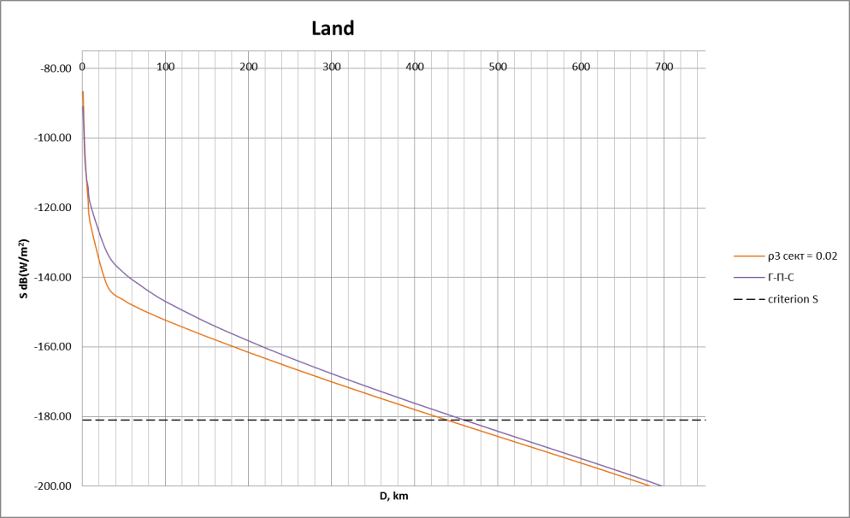

In this Figure and further the dependence of pfd from distance between IMT network and ground receiver of aeronautical telemetry for Scenario 1 is shown by violet line. The dependence of pfd from distance between IMT network and ground receiver of aeronautical telemetry for Scenario 2 is shown by orange line. The protection criterion for ground receivers of aeronautical telemetry is shown by black dotted line.

The analysis of the obtained results shows that for protection of ground receivers of aeronautical telemetry in case of interference under Scenario 1 the required protection distance is 450 km. For Scenario 2 the required protection distance is reduced up to 440 km.

The estimation results of protection distance in case of mixed path (40% land, 60% sea) are given in Fig. 4 below.

FIGURE 4

Determination of protection distance required in case of IMT stations   
with 5 MHz bandwidth for mixed path

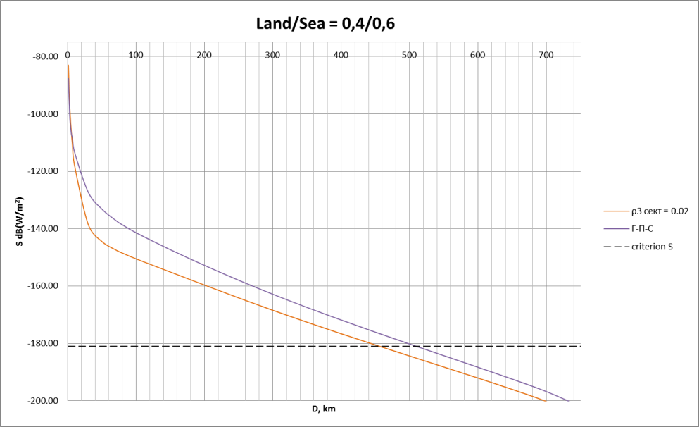

It is shown that if sea path is taken into account the required protection distance for Scenario 1 is increased up to 500 km and for Scenario 2 up to 450 km.

The results obtained for IMT base-station operating in 10 MHz bandwidth for land path are given in Fig. 5.

FIGURE 5

Determination of protection distance required in case of IMT stations   
with 10 MHz bandwidth for land path

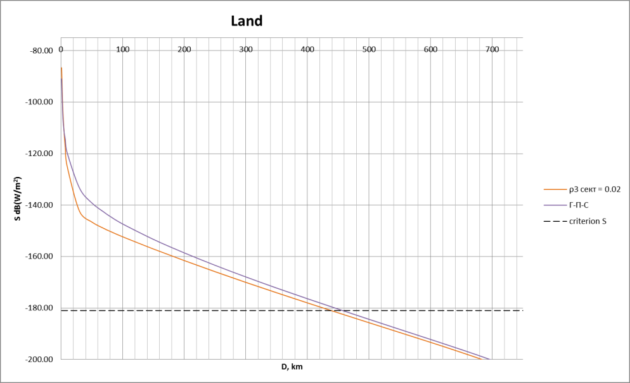

The analysis of the obtained results shows that for protection of ground receivers of aeronautical telemetry the required protection distance is 450 km for Scenario 1 and for Scenario 2 the required protection distance is to 440 km.

The estimation results for mixed path are given in Fig. 6.

FIGURE 6

Determination of protection distance required in case of IMT stations  
with 10 MHz bandwidth for mixed path

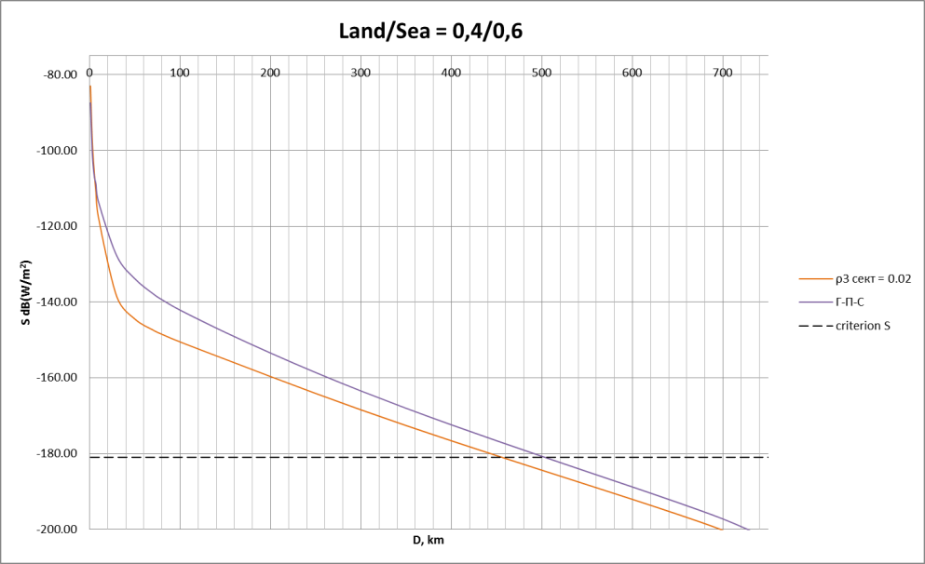

The analysis of the obtained results shows that for protection of ground receivers of aeronautical telemetry the required protection distance is 500 km for Scenario 1 and for Scenario 2 the required protection distance is to 450 km.

The results obtained for IMT base-station operating in 20 MHz bandwidth for land path are given in Fig. 7.

FIGURE 7

Determination of protection distance required in case of IMT stations   
with 20 MHz bandwidth for land path

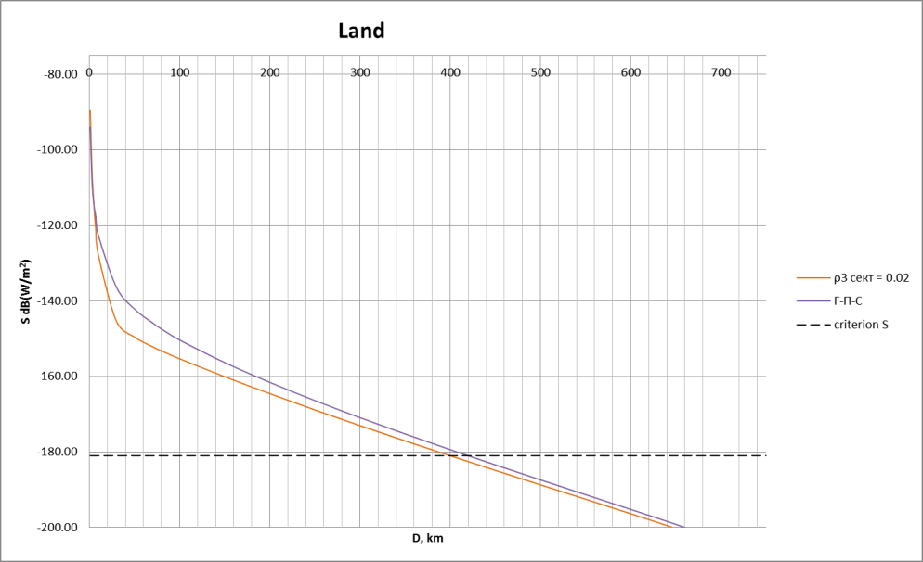

The analysis of the obtained results shows that for protection of ground receivers of aeronautical telemetry the required protection distance is 405 km for Scenario 1 and for Scenario 2 the required protection distance is to 400 km.

The estimation results for mixed path are given Fig. 8.

FIGURE 8

Determination of protection distance required in case of IMT stations   
with 20 MHz bandwidth for mixed path

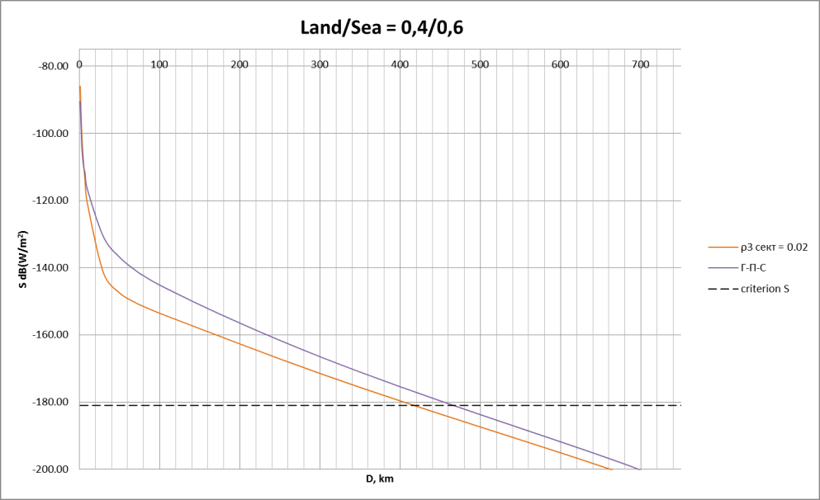

The analysis of the obtained results shows that for protection of ground receivers of aeronautical telemetry the required protection distance is 460 km for Scenario 1 and for Scenario 2 the required protection distance is to 405 km.

It is obvious that the protection distance providing interference free operation of ground receivers of aeronautical telemetry shall be maximum distance out of the obtained values. It allows to conclude that the protection distance providing interference free operation of ground receivers of aeronautical telemetry is 500 km.

## 3.3 Assessment of the protection distances required for protection of on-board stations in the aeronautical telemetry systems operating in the frequency band 1 429-1 535 MHz

The interference assessment for the on-board receivers was carried out based on the free space propagation model.

Table 5 below describes the obtained estimates of protection distances for different bandwidths used by IMT base-station transmitters.

TABLE 5

Separation distances for protecting the air-borne aeronautical telemetry   
stations from IMT base-stations emissions

|  |  |  |  |
| --- | --- | --- | --- |
| Interference from IMT base-stations | | | |
| Frequency bandwidth, MHz | 5 | 10 | 20 |
| Mean sector e.i.r.p., dBW | 25 | 28 | 28 |
| e.i.r.p. /4 kHz, dBW | –6 | –6 | –9 |
| Protection distance, km | exceeds radio line of sight (above 412 km) | | |

Analysis of obtained results shows that distance required for protecting the air-borne aeronautical telemetry receivers from single IMT base-stations exceeds the air-borne receiver line-of-sight. For conventional flight altitude of 10 km the line-of-sight exceeds 412 km accounting refraction.

It would mean that MS base-stations should be deployed at the above distances from the boundaries of air-borne aeronautical telemetry stations operation areas.

It should be noted that emissions from IMT UEs could also cause interference to air-borne aeronautical telemetry receiver. In that case protection distances would be defined by deployment density for UEs.

The presented preliminary results of analysis related to IMT station interference effect on operation of aeronautical telemetry stations provide for conclusion that dimensions of an area precluding deployment of IMT base-stations would be rather large (specifically those required for protection of air-borne aeronautical telemetry receivers) even in case of assuming interference caused by a single IMT base-station.

Figure 9 exemplifies border areas of the Russian Federation (shown in orange) where harmful interference would be caused to aeronautical telemetry stations. Figure 9 analysis shows that IMT systems would not be compatible with the aeronautical telemetry systems in the frequency band 1 429-1 535 MHz practically within a whole area of about 400 km from the country border.

Figure 9 also shows:

– a green area of an air-borne aeronautical telemetry receiver potential location;

– an orange area where operation of IMT system stations would be impossible (or restricted significantly).

FIGURE 9

Areas of potential harmful interference from IMT systems to the Russian   
aeronautical telemetry stations in the frequency band 1 429-1 535 MHz

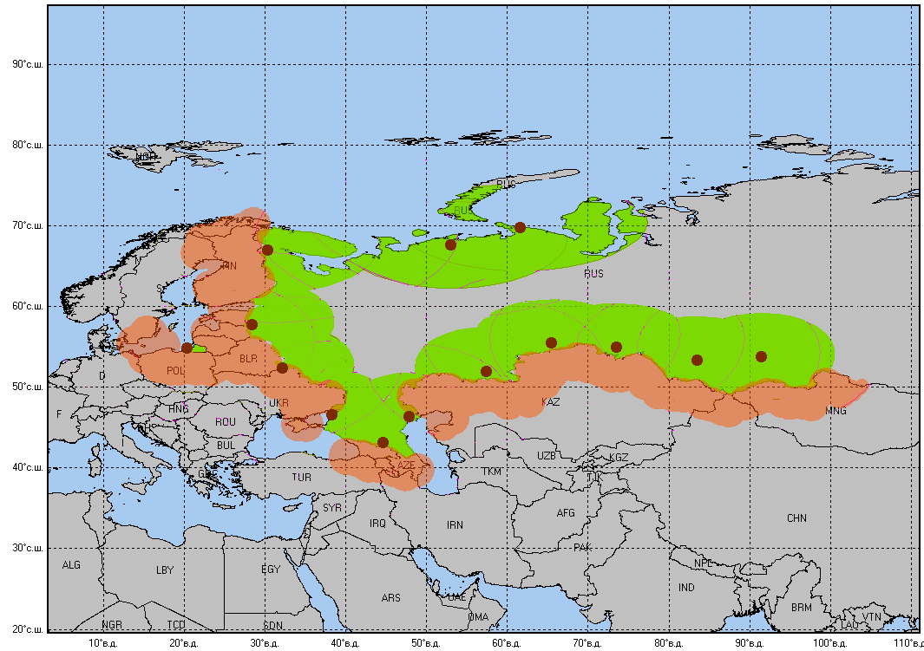

# 4 Summary

The above discussed estimates provide for conclusions that operation of IMT systems would be impractical (or restricted significantly) in areas at a distance of about 500 km from the borders of countries using aeronautical telemetry systems.

The conducted studies also show that compatibility of envisioned IMT systems and aeronautical telemetry stations would be unfeasible in the frequency band 1 429-1 535 MHz.

Annex 2  
  
Study 2  
  
Sharing studies between aeronautical telemetry terrestrial systems   
and IMT systems within 1 429-1 492 MHz band

# 1 Introduction

In Europe, the deployment of aeronautical telemetry services is limited to some CEPT countries in accordance with ITU Radio Regulations No. **5.342**.

This Annex only presents study results of interference impact caused by the possible stations of the mobile service to ground receivers of aeronautical telemetry in the frequency band 1 429‑1 492 MHz (referred to Study A, hereafter). The results also include for the results considering the ground receivers of aeronautical telemetry in the frequency band 1 427‑1 492 MHz that are notified in the BR IFIC (referred to Study B, hereafter). In terrestrial telemetry system, telemetry signals are transmitted by airborne stations (e.g. aircraft, missile) to ground stations.

# 2 Protection criteria for the aeronautical telemetry stations in the frequency band 1 429‑1 535 MHz

The protection criteria for the terrestrial aeronautical telemetry systems are given in Recommendation ITU-R M.1459.

In particular for their protection in the frequency band 1 452‑1 525 MHz the power flux-density (pfd) of geostationary satellites BSS or MSS in the reference bandwidth of 4 kHz for all methods of modulation should not exceed:

–181.0 dB(W/m2) for 0≤ α ≤ 4°

–193.0  20 log α dB(W/m2) for 4° α ≤ 20°

–213.3  35.6 log α dB(W/m2) for 20° α ≤ 60°

–150.0 dB(W/m2) for 60° α ≤ 90°

where α is the angle of arrival of the interfering signal (degrees above the horizontal plane).

These criteria were also used for the protection of the aeronautical telemetry stations in the frequency band 1 430-1 432 MHz in the studies on WRC-07 agenda item 1.17 (see CPM-07 Report section 3/1.17/2.2).

It appears relevant to extend such assumption to adjacent bands: 1 432-1 452 MHz and 1 427‑1 430 MHz, so that the same protection criteria will cover the whole 1 427-1 492 MHz frequency band for sharing studies.

# 3 Systems characteristics

a) Telemetry systems

Parameters from telemetry ground receivers for sharing studies are extracted from Recommendation ITU-R M.1459 as seen in the table below:

TABLE 1

Telemetry ground stations characteristics

|  |  |  |
| --- | --- | --- |
| Parameters | Unit | Value |
| Receiver antenna gain | dBi | 41.2 (for Study A) 20-41.2 (for Study B) |
| Ground station antenna height | m | 10 |
| Transmitter frequency range | MHz | 1 429-1 492 |

b) IMT systems

In this contribution, the considered bands for possible IMT identification on 1 427-1 452 MHz and 1 452-1 492 MHz are for supplementary down link (SDL), which impacts base-stations as IMT transmitters. Thus, features of the IMT base-stations are provided in the Table 2.

TABLE 2

Mobile systems characteristics

|  |  |  |
| --- | --- | --- |
| Parameters | Unit | Value |
| Transmitter bandwidth | MHz | 10 |
| Transmitter base-station antenna gain | dBi | 18 |
| Base-station emission power | dBm | 46 |
| Base-station downtilt | ° | 3-6 |
| Base-station feeder loss | dB | 3 |
| Base-station antenna height *he* | m | 30 |
| Transmitter frequency range | MHz | 1 427-1 492 |

c) Assumption and methodology

A minimum coupling loss approach is used, modelling only a single interferer-victim pair (as to be base-station-to-radar) and corresponding to the worst case scenario with main lobe (of the interferer transmitter antenna pattern) to main lobe (of the radar receiver antenna pattern) configuration (ML‑ML) in the horizontal plane. From this method, we derive the in-band (IB) emissions level of IMT systems when telemetry ground stations and IMT base-stations share 1 427-1 492 MHz frequency band.

Equation (8) of Recommendation ITU-R M.1459 provides a methodology to calculate the maximal acceptable interference level at the receiver, from pfd limit:

$pfd≤\frac{4π×Imax}{G_{0}λ^{2}}$

where:

*pfd*: power flux density of the interferer (W/(m2.B)

*Imax*: maximal acceptable Interference level after the antenna the receiver (dBm)

*G*o: Telemetry receiver antenna gain in the direction of the base station.

From this expression, we deduce[1] the required isolation to ensure the sharing between the telemetry receiver and base-station transmitter:

Isolation(dB) $≥$ PathLoss(dB)=pfd(dBm/4 kHz/m2)+10log10($\frac{λ^{2}}{4π}$) – e.i.r.p. base-station(dBm)

(For Study A.)

The propagation model between the telemetry ground receiver and the base-station is extracted from Recommendation ITU-R P.1546[2]. Recommendation ITU-R P.1546 is assumed over land paths and the flat terrain assumption[3] will cover the worst case as a minimization of the pathloss since no shadowing (clutter height: buildings, vegetation...) is performed, for 10% of time and 50% of locations.

The radio environment choice for the Recommendation ITU-R P.1546 model is based on the geographical topology of both telemetry ground stations and base-stations. Base-stations are deployed in rural or urban areas while Telemetry systems are deployed in rural areas. Such assumption implies to apportion path with urban/rural components. Since base-stations can also be deployed in rural radio environment, we will assume that apportionment for urban is lower or equal to the rural one.

Sharing studies with propagation model Recommendation ITU-R P.1546 sea path cover cases where telemetry ground stations and base-stations in cross borders are separated by less than 300 km and that can be kept more than 300 km away. There are only very few cases where telemetry stations would need to be protected against base-stations through sea path over distances shorter than this separation distance.

(For Study B.)

The propagation model between the telemetry ground receiver and the base-station is extracted from Recommendation ITU-R P.452-14. The selected propagation model separating the telemetry receiver from the base-station is terrestrial point-to-point propagation model which is suitable over any kind of terrestrial areas since it accounts the digital terrain model featuring the relief of the location of both transmitter and receiver. Associated parameter to the propagation model is the time for which the pathloss assessment is higher or equal is time *p* = 50%.

# 4 Results for Study A

Table 3 provides the required isolation in propagation to protect terrestrial telemetry receiver from interfering base-station transmitter, given the arrival angles range. According to the downtilt value taken by IMT base-station, the angle of arrival belongs to the 0-6° range, leading to minimum isolation value as to be 202 dB.

TABLE 3

Required isolation between ground telemetry station and IMT base-station

|  |  |  |
| --- | --- | --- |
| Arrival angle range (°) | 0-4 | 4-20 |
| Required pathloss (dB) | 202 | 202-188 |

From this value, we may derive the separation distance, in accordance with our previous assumptions on the propagation model.

Table 4 highlights the available pathloss for different rural/urban path apportionment, given fixed distance (100-130 km) and for an arrival angle of 0°:

– green colour identifies cases where the required isolation to protect terrestrial telemetry stations from base-station is met;

– yellow colour reflects urban/rural distribution of the path which does not ensure the protection of telemetry ground stations from IMT base-stations.

TABLE 4

Required isolation distance (dB) as a function of the urban/rural apportionment

|  |  |  |  |  |  |  |
| --- | --- | --- | --- | --- | --- | --- |
| Distance between telemetry system & mobile IMT system (km) | Apportionment of Urban/(Urban + Rural) in pathloss (%) | 10 | 20 | 30 | 40 | 50 |
| 100 |  | 188 | 188 | 194 | 199 | 203 |
| 110 | 190 | 190 | 196 | 201 | 205 |
| 120 | 191 | 192 | 197 | 202 | 207 |
| 130 | 192 | 193 | 198 | 204 | 208 |

It shows that for a 100-130 km separation distance range, the following apportionment for urban 40-50% path in the total path separating base-station from telemetry terrestrial station could ensure sharing between both services. Such distances would then make the bilateral cross border coordination process possible on a case by case basis through good engineering practice (such as mitigation techniques: site engineering, reduction of output power).

# 5 Results for Study B: Practical analysis of the separation distance between ground telemetry station and LTE base-station

a) Required isolation between ground telemetry station and IMT base-stations

Table 5 gives the required isolation in propagation to protect terrestrial telemetry receiver from interfering base-station transmitter, given the arrival angles range. According to the downtilt value taken by IMT base-station, the angle of arrival belongs to the 0-6° range, leading to minimum isolation value as to be 200 dB.

TABLE 5

Required isolation between ground telemetry station and IMT base-station

|  |  |  |
| --- | --- | --- |
| Arrival angle range (°) | 0-4 | 4-20 |
| Required pathloss (dB) | 200 | 200-186 |

From this value, we may derive the separation distance, in accordance with our previous assumptions on the propagation model.

## b) Declared ground telemetry stations in BR-IFIC

If the ground telemetry station is receiver, it means that the transmitter is an airborne device, which is labelled as MA (for aircraft transmitting station). The BR-IFIC lists 56 assignments for such devices over 1 427-1 525 MHz range with 4 different frequencies channels (1 439.65 MHz, 1 460.9 MHz, 1 482.15 MHz and 1 503.35 MHz) that are recorded for each geographical site. Thus, it leads to 14 different geographical terrestrial telemetry sites.

## c) Sharing results without mitigation techniques

The following table indicates for the 14 recorded assignments whether or not the ground telemetry station is protected when IMT base-stations are located in the cross-border. They are sorted by capital letter (from A to N) for the later study. The minimum pathloss (column 3) from the cross-border to the ground telemetry station is displayed in order to ease comparison with the required pathloss (200 dB) with reference to the concerned cross border country for each recorded assignments. This results in the last column if any “Required additional isolation dB” is mandatory.

The yellow rows depict the case where the declared ground telemetry station has been already protected at the cross-border without any mitigation techniques (separation distance, site shielding, sector disabling, down tilting…): in order to be protected, 4/14 sites do not require any mitigation techniques to apply on IMT base-stations.

The blue rows correspond to the notified sites which have no data related on the digital terrain model from the NASA Shuttle Radar Topography Mission (SRTM)[4]: no path loss can be calculated for such sites: 3/14 cannot be calculated. However 2/3 are at least 980 km away from the cross border which lead to the conclusion that the required isolation to protect ground telemetry station is met for 2/3 sites which have no SRTM data.

The green field indicates which ground telemetry station does not require any additional isolation to be protected from base-station interference.

TABLE 6

Preliminary conclusion: Thus, 6/14 sites do not require any additional isolation to be protected from the interfering LTE base-stations (green colour for the last column).

|  |  |  |  |  |
| --- | --- | --- | --- | --- |
| Number | Coordinates of the ground telemetry stations | D* Distance between border and ground telemetry station minimizing the pathloss | Path Loss (dB) from the frontier to the ground telemetry station | Required Additional Isolation (dB) |
| A | 91°23'00"E – 53°45'00"N | 322 km  (Kazakhstan) | 288.9 | NO |
| B | 47°52'00"E – 46°24'00"N | 54 km  (Kazakhstan) | 161 | 39 |
| C | 83°34'00"E – 53°22'00"N | 245 km (Kazakhstan) | 214.6 | NO |
| D | 38°13'00"E – 46°41'00"N | 181 km (Ukraine) | 198 | 2 |
| E | 20°24'00"E – 54°46'00"N | 45 km (Poland) 70 km (Lithuania) | 132 177 | 68 23 |
| F | 32°10'00"E – 52°20'00"N | 28 km (Ukraine) | 146.5 | 53.4 |
| G | 65°25'00"E – 55°29'00"N | 92 km (Kazakhstan) | 191.6 | 8.4 |
| H | 73°34'00"E – 54°59'00"N | 105 km (Kazakhstan) | 194 | 6 |
| I | 28°24'00"E – 57°47'00"N | 37 km (Estonia) 60 km Latvia) | 149 163 | 51 37 |
| J | 44°36'00"E – 43°13'00"N | 50 km(Georgia) | 208 | NO |
| K | 30°22'00"E – 66°58'00"N | 58 km (Finland) 239 km (Norway) | No SRTM available |  |
| L | 61°34'00"E – 69°46'00"N | 1 162 km (Finland-Norway) | No SRTM available | NO |
| M | 53°07'00"E – 67°38'00"N | 980 km (Finland-Norway) | No SRTM available | NO |
| N | 57°19'00"E – 52°02'00"N | 102 km (Kazakhstan) | 223 | NO |

There is a need to investigate for the seven[5] remaining telemetry ground stations (that have been notified in the BR IFIC) the impact of the base-station interference on them.

d) Sharing results with mitigation techniques

There are different mitigation techniques which may be applicable for co-channel operation between ground telemetry receivers and IMT base-station. In order to select the most suitable mitigation technique for each case, it is proposed to sort cases according to their required additional isolation ranges:

– Required additional isolation 0-9 dB: downtilt antenna from 3° to 6°.

|  |  |  |  |
| --- | --- | --- | --- |
| Case | Required additional isolation (dB) | Required additional isolation (dB) after additional downtilt antenna | Separation distance to the cross border (km) after mitigation techniques |
| D | 2 | 0 | 0 |
| G | 8.4 | 2.8 | 7 |
| H | 6 | 0.4 | 1.5 |

– Required additional isolation >9 dB: disabling sector and/or site antenna depointing to very local low gain value (for the base-station):

a) when disabling the sector antenna, the 2 other ones (see Fig. 10) are the main interfering components onto the telemetry ground station. The following figure depicts that any base-station in the vicinity of the cross‑border may face the radar main beam with the disabled antenna sector and thus the back-lobes of the 2 active sectors facing the Telemetry ground receiver lead to 20 dB antenna gain discrimination.

Figure 10

Overview on sector disabling

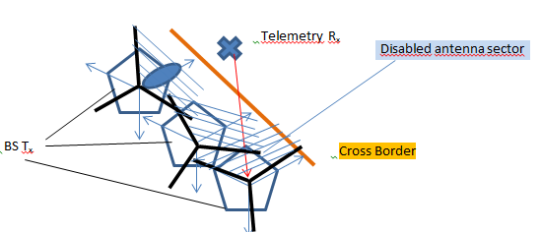

b) harmful interference is avoided if the IMT-Advanced base-station antennas can have nulling in the direction of the radar. Such nulling could be of the order of 20 dB antenna gain discrimination, as depicted by Fig. 11.

Figure 11

Nulling in horizontal main lobe of the antenna pattern

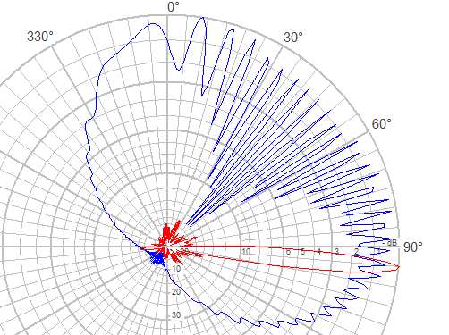

The following Figs 12, 13, 14 and 15 display the distribution of the separation distance as a function of the required isolation (dB) for the 4 (B, E, F and I) studied cases in the vicinity of the ground telemetry stations. Colour ring-shape highlight required isolation range for –50 dB, –20 dB and 0 dB values for all figures. Cross border curve is represented in yellow as well as distances scale (50 km) to give an overall view on the required separation distance from the cross border.

Figure 12

Additional isolation required pathloss to protect case B telemetry station

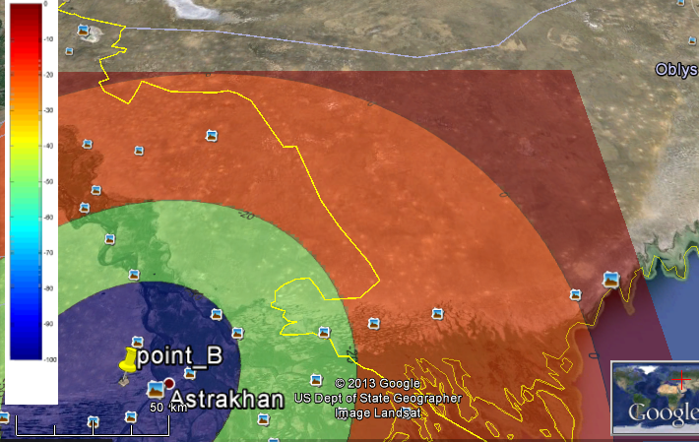

Figure 13

Additional isolation required pathloss to protect case E telemetry station (Poland cross-border)

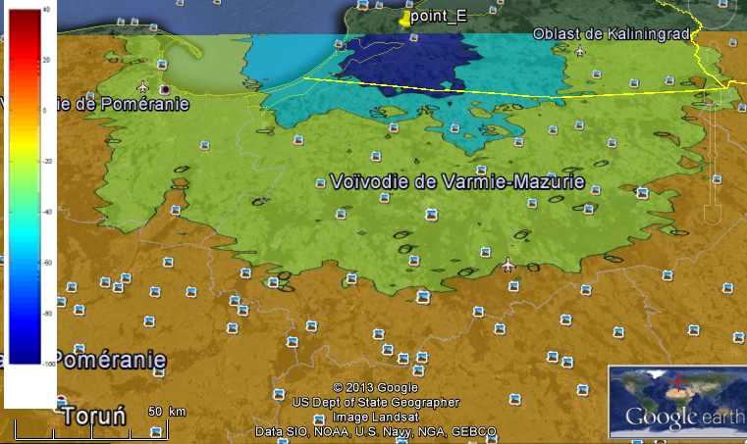

Figure 14

Additional isolation required pathloss to protect case E telemetry station (Lithuania cross-border)

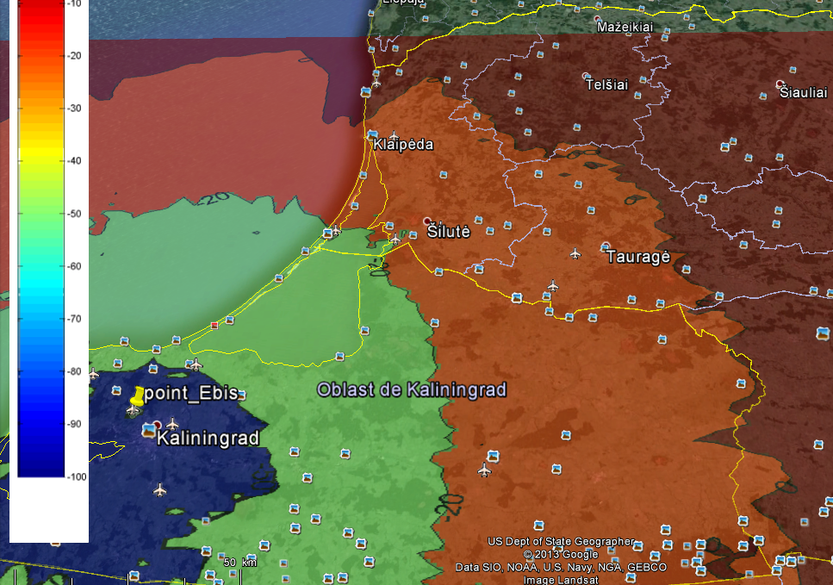

Figure 15

Additional isolation required pathloss to protect case F telemetry station

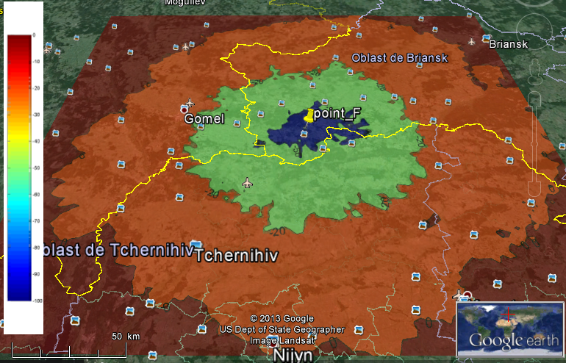

Figure 16

Additional isolation required pathloss to protect case I telemetry station (Estonia & Latvia)

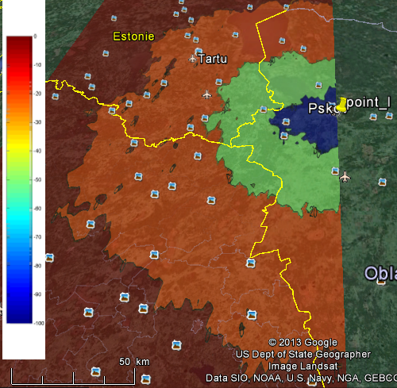

The results of the sharing studies when using mitigation techniques are summarized in the following Table 7:

TABLE 7

Separation distance from the cross border with disabling sector

|  |  |  |  |
| --- | --- | --- | --- |
| Case | Required additional isolation (dB) | Required addition isolation after disabling antenna sector or antenna pattern nulling (dB) | Separation distance from the cross border after mitigation techniques (km) |
| B | 39 | 19 | 23 |
| E | 68 (Poland) 23 (Lithuania) | 48 (Poland) 3 (Lithuania) | 30 (Poland) 7 (Lithuania) |
| F | 53.4 | 33.4 | 53 |
| I | 51 (Estonia) 37 (Latvia) | 31 (Estonia) 17 (Latvia) | 28 (Estonia) 17 (Latvia) |

Secondary conclusion: When using mitigation techniques:

– 9/14 sites would require separation distances lower than 7 km from the cross‑border;

– 4/14 sites would require some tens km separation distance from the cross‑border.

These separation distances from the cross-border (when using mitigation techniques) can be converted in separation distances between SDL base-station transmitter and Telemetry ground station receiver as depicted in the table below:

|  |  |  |
| --- | --- | --- |
| Case | Separation distance from the cross border (km) | Separation distance between IMT base-station and Telemetry ground receiver (km) |
| B | 23 | 77 |
| D | 0 | 181 |
| E | 30 (Poland) 7 (Lithuania) | 75 (Poland) 77 (Lithuania) |
| F | 53 | 81 |
| G | 7 | 99 |
| H | 1.5 | 106.5 |
| I | 28 (Estonia) 17 (Latvia) | 65 (Estonia) 67 (Latvia) |

This shows that high separation distances between the interferer and the receiver (181 km, 106.5 km) does not necessarily imply more stringent constraints on the IMT base-station deployment: in these cases, with mitigation techniques usage, the protection only requires few (1.5 km) or no separation distances from the cross-border because of the distant location of the ground telemetry receiver from the cross-border.

(Note that the missing K case with Finland is due to the lack of STRM data and does not prevent from forecasting that the expected separation distance should not overtake the maximum reached in the other cases (53 km)).

Furthermore, it has to be noted that additional mitigation techniques applied to the ground telemetry receiver such as site shielding (0-20 dB) may reduce the separation distances output in the previous table, provided:

– that operation on aircraft, missiles are not expected to be launched in the vicinity of the cross-border;

– that administrations operating telemetry have to respect the principle of equitable access to spectrum as embedded in the preamble (0.6) of the RR (and which is explicitly described in Resolution **2 (Rev.WRC-03)** in the case of satellite systems).

# 6 Summary

The presented preliminary analysis showing impact of the IMT base-station to the aeronautical telemetry stations within 1 427-1 492 MHz frequency band allows to conclude that macro base‑stations could be deployed in a coordinated manner with bilateral cross-border agreement which may ensure the sharing between both services by defining a suitable separation distance. Such conditions may be obtained by filtering and/or a frequency separation.

This Annex also analysed the impact of the IMT base-station on ground based aeronautical telemetry stations that are notified in the BR IFIC when they share the same band within 1 427‑1 492 MHz. It is shown that:

– 42% of the notified ground telemetry stations do not require additional protection to operate properly without suffering harmful interference from IMT base-stations;

– The 58% remaining ground telemetry stations may require mitigation techniques (sector disabling, antenna pattern nulling, down tilting…) applied to the IMT base‑station to reduce the geographical distance, which would lead to tens km separation distance from the cross-border. These separation distances could be more reduced when performing mitigation techniques to the ground telemetry stations.

Annex 3  
  
Study 3  
  
Interference effect caused by aeronautical telemetry systems operating in the frequency band 1 429-1 535 MHz on envisioned IMT systems

# 1 Introduction

This Annex presents study results of interference effect caused by aeronautical telemetry systems operating in the frequency band 1 429-1 535 MHz on envisioned IMT systems.

# 2 Technical characteristics of air-borne aeronautical mobile telemetry transmitters

Technical characteristics of air-borne aeronautical mobile telemetry systems are described in Recommendation ITU-R М.1459 – Protection Criteria for Telemetry Systems in the Aeronautical Mobile Service and Mitigation Techniques to Facilitate Sharing with Geostationary Broadcasting‑Satellite and Mobile-Satellite Services in the frequency bands 1 452-1 525 MHz and 2 310-2 360 MHz. Technical characteristics of air-borne aeronautical mobile telemetry transmitter are shown in Table 1 below.

TABLE 1

Technical characteristics of air-borne aeronautical mobile telemetry transmitters

|  |  |  |
| --- | --- | --- |
|  | Parameter | Value |
| 1 | Air-borne transmitter power, dBW | 25 |
| 2 | Air-borne transmitter antenna gain, dB | 10 |
| 3 | Air-borne transmitter emission bandwidth, MHz | 1/3/5 |

Technical characteristics of aeronautical mobile telemetry systems operating in the frequency band 1 429-1 452 MHz in countries listed in Radio Regulations (RR) No. **5.342** are similar to those of aeronautical mobile telemetry systems operating in the frequency band 1 452‑1 525 MHz. Therefore technical characteristics reflected in Table 1 were used for conducting the compatibility studies in the whole frequency band 1 429-1 535 MHz.

# 3 Technical characteristics of possible IMT systems in the frequency band 1 427‑1 525 MHz

Table 2 below shows IMT base-stations technical characteristics as required for estimating their compatibility with aeronautical telemetry systems

TABLE 2

Technical characteristics of IMT base-stations in the frequency range 1 800 MHz

|  |  |  |  |  |
| --- | --- | --- | --- | --- |
| Base-station | | | | |
| Cell type | | macro | micro | pico |
| Antenna gain in sector, dB | | 17 | 5 | 0 |
| Acceptable interference level, dBW in a bandwidth of: | 5 MHz | –108 dBm in 5 MHz/–138 dBW in 5 MHz | | |
| 10 MHz | –105 dBm in 10 MHz/–135 dBW in 10 MHz | | |
| 20 MHz | –102 dBm in 20 MHz/–132 dBW in 20 MHz | | |

Reflected in Table 2 above technical characteristics and protection criteria for IMT systems were used to estimate required protection distances providing for interference-free operation of IMT systems.

# 4 Estimation of protection distances required for IMT receivers operating in the frequency band 1 427-1 525 MHz

Estimation of required protection distances used free space propagation model. Distance required for protection of IMT system base-stations was estimated based on the following equation:



where:

 : separation distance required for protecting IMT system base-station receiver (m)

 : air-borne AMT system transmitter power (dBW)

 : air-borne AMT transmitter antenna gain (dB)

 : IMT base-station receiver antenna gain (dB)

λ : operation wavelength (m)

*I* :acceptable interference power threshold for IMT base-station receiver (Table 2) (dBW).

The estimation results are shown in Table 3.

TABLE 3

Protection distances for IMT systems

|  |  |  |  |
| --- | --- | --- | --- |
| G, dB  Δ*F*, MHz | 17 | 5 | 0 |
| 5 | Exceeds line-of-sight distance of 412 km for a typical flight altitude of 10 000 m | | |
| 10 |
| 15 |

Analysis of data presented in Table 3 shows that the protection distance required for IMT systems operating with signals of 5 MHz, 10 MHz and 20 MHz bandwidth would exceed line‑of‑sight distance for both macro-cell and micro-cell/pico-cell. It means that IMT systems operating in a zone of 412 km width from national boarders of countries listed in RR No. **5.342** would be affected by interference caused by aeronautical mobile telemetry system transmitters.

# 5 Summary

The above presented estimates provide for conclusions that operation of IMT systems would be impractical (or restricted significantly) in areas at a distance of about 400 km from the borders of countries using aeronautical telemetry systems.

Annex 4  
  
Study 4  
  
Sharing study regarding interference between AMT and IMT systems

# 1 Introduction

## 1.1 Aeronautical mobile telemetry systems

AMT describes a particular use of MS in Region 2 for the transmission from an aircraft station of results of measurements made on board, including those relating to the functioning of the aircraft. Examples of AMT data include engine temperature, fluid pressure, and control surface strain gauges, among many other functions.

AMT data is essential for the safety of pilots and persons on the ground during flight test activities as it is *the* critical source of real-time measurement and status information transmitted from airborne vehicles during live tests of manned and unmanned aircraft.

The frequency band 1 435-1 525 MHz is a primary band used for aeronautical mobile telemetry by some Region 2 administrations. This noise-limited band is ideal in terms of its propagation characteristics, the maturity of technology for implementing telemetry systems, and the relatively large signal wavelengths. The latter are large enough with respect to the size of aircraft structures to minimize unwanted geometrical effects, such as signal fades and destructive multipath, due to the blockage and/or reflection of the radiated telemetry signals by aircraft structures.

## 1.2 Sharing with IMT systems

The frequency band 1 435-1 525 MHz is allocated to the mobile services. RR No. **5.343** specifies that AMT applications have priority over other the mobile service uses in Region 2.

Several administrations have expressed an interest in deploying IMT systems, notably LTE-A broadband wireless “smartphones,” in this band.

This study, which considered AMT use in this band as implemented by some Region 2 administrations, shows that co-frequency sharing of IMT with AMT systems, in the absence of very large exclusion zones, is not practical. This result is consistent with others studies performed independently for Region 1[6]. Despite using Region-specific parameters, the two studies independently arrive at comparable protection distances.

## 1.3 Purpose of this study

AMT systems operate at the limits of their performance. That is, all available link margin is used to permit aircraft operation at longer range from the AMT ground station, and to permit the telemetry link to be maintained during extreme manoeuvres (e.g. flutter dives; spin recovery tests; flight under abnormal conditions, such as at unusual attitudes; etc.).

## 1.4 Study elements

The study addresses the following study elements:

1 the impact of LTE-A user equipment (i.e. handsets, or “UE”) on AMT ground stations;

2 the impact of LTE-A base-stations (i.e. eNodeBs) on AMT ground stations;

3 the impact of AMT transmissions from aircraft on LTE-A handsets;

4 the impact of AMT transmissions on base-stations.

In some administrations in Regions 1 and 2, flight test aircraft receive telemetry transmissions for relay and other purposes. In these circumstances, interference from LTE systems to flight test aircraft must also be considered[7].

# 2 Background

Several ITU-R Reports and Recommendations are relevant to the study described herein. Recommendation ITU-R M.1459 derives numerical values for angle-of-arrival dependent power flux densities. These “not-to-exceed” values take into account the statistical properties of the air‑to‑ground propagation channel. Experimental data presented in the Recommendation support the use of a Rayleigh scattering model for predicting and quantifying these effects. The protection levels in the Recommendation stipulate an acceptable aggregate interference level of –4 dB. Since the interference is measured at the aperture of the AMT ground station, it is irrelevant *how, from where, or via what propagation channel the interference arrives.* The Recommendation makes this clear when apportioning the aggregate interference budget among terrestrial and non-terrestrial interferers[8]. Likewise, LTE users have stipulated an aggregate *I/N* budget of –6 dB, independent of *how, from where, or via what propagation channel the interference arrives*.

Other relevant documents include Reports ITU-R M.2118, ITU-R M.2219, and ITU-R M.2238; Recommendations ITU-R SA.1154 and ITU-R M.1828; and CPM text from WRCs 2003, 2007, and 2012, also provide relevant data and analyses.

The possible use of the band 1 435-1 525 MHz for terrestrial mobile systems has been addressed, with respect to IMT-2000, in Reports ITU-R M.2023 and ITU-R M.2024. The latter states with regard to the use of 1 435-1 527 MHz in the United States, “telemetering, telecommand, aeronautical telemetry. Vital and extensive use for aeronautical telemetry supporting U.S. test flight and equipment. Not suitable or available for IMT-2000” (id. page 8).

Parameters of LTE-A systems can be found in various working papers. Details of LTE-A systems are captured in the Third Generation Partnership Process (3GPP) archives, which are found online at [www.3GPP.org](http://www.3GPP.org). However, for the analyses developed here, LTE parameters have been taken from available ITU-R contributions and Recommendations as well as Recommendation ITU-R F.1336 for antenna pattern information with respect to the effects of down-tilt.

For propagation analyses, Recommendation ITU-R P.528 is available for air-to-ground studies, and Recommendations ITU-R P.452 and ITU-R P.1546 for ground-to-ground studies Recommendation ITU-R P.452 has much in common with the Longley-Rice and Irregular Terrain (ITM) models), which are also widely used. The analyses that follow are consistent with Recommendations ITU‑R P.452 and ITU-R P.528.

# 3 Technical characteristics

## 3.1 Introduction

Sharing studies for LTE systems involve two distinguishing characteristics. The first is the use of dynamic power control by the LTE UE. That is, in order to maintain its communication link with a base-station while minimizing co-channel interference to other UE operating in adjacent cells, a UE can vary its transmitter power (e.i.r.p.), and hence interference to other, non-IMT systems, by two orders of magnitude.

The propagation characteristics of the channel (the free-space path) between the UE and the base-station depend upon terrain and clutter, the latter referring to the effects of foliage, buildings, other man-made structures, and so forth. Short-range clutter effects are captured in empirical models designed to predict coverage. These include the COST-231 HATA products, for example. Long term propagation characteristics that include the effects of terrain are reliably captured in Recommendation ITU-R P.452 and the Irregular Terrain Model or its predecessor, the Longley‑Rice model.

Sharing studies that involve AMT systems are complex. The location of the aircraft, its high operating speeds, and its widely varying attitudes (pitch, roll, and yaw) with respect to the ground, introduce considerable dynamics in the computation of link and interference budgets. For example, telemetry signal fades of 15-30 dB are the rule, not the exception.

It is also important to note that even a single ground multipath reflection, as captured in the widely‑used two-ray propagation model, not only introduces deep fades in the received AMT telemetry signal, but changes the path loss dependence on distance *r* from 1/*r*2 to 1/*r*4, thus reducing greatly the strength of the signal received at the AMT ground station.

An abbreviated summary of AMT and LTE system characteristics is provided in the next sections.

## 3.2 Aeronautical mobile telemetry characteristics

AMT systems operate at the limit of their performance, meaning that all of the available link margin is used to extend the range and/or complexity of aircraft operations. In addition, AMT systems are noise-limited, with noises figures of low noise amplifiers as low as 0.1 dB and   
end-to-end system noise temperatures of 25-250 kelvin.

Recommendation ITU-R M.1459, which provides the interference protection criteria for AMT systems, is nonetheless generous in its permissible aggregate *I/N* budget. An aggregate *I/N* of   
–4 dB is permitted, versus the value of –6 dB for *I/N* commonly used for protection of other systems, and protection levels as high as –10 dB for some systems, like radars.

The protection levels specified in Recommendation ITU-R M.1459 are strict because AMT antennas typically operate at elevation angles of zero degrees with respect to the horizon.

This is in contrast to satellite ground stations, which typically operate at a minimum elevation angle of 3-5 degrees. At the outset, this makes approximately a 15 dB difference in protection levels. Comparison of Recommendations ITU-R M.1459 and ITU-R SA.1154 demonstrates this.

Aircraft testing also involves considerable signal fades (15-30 dB) due to aircraft manoeuvres, signal blockage by and diffraction around aircraft structures, and ground multipath.

### 3.2.1 AMT ground station specifications

The protection criteria for AMT ground stations specified in Recommendation ITU-R M.1459 are a set of not-to-exceed power flux density (pfd) levels measured at the aperture of an AMT ground station receive antenna. The pfd levels are a function of the elevation angle of the AMT ground-station parabolic dish tracking antenna with respect to the horizon.

Flight test aircraft also typically operate at speeds from 250 knots to well over the speed of sound (which at sea level is approximately 700 knots). Thus, aircraft do not dwell for long periods of time at high elevation angles with respect to the ground station. Instead, they operate frequently at ranges up to 250 miles, and even 300 miles from the ground station for aircraft and air vehicles that operate at altitudes of over 80 000 feet. The corresponding ground station antenna elevation angles, depending on the location and placement of the AMT ground station antenna with respect to terrain, range from –2 degrees to +2 degrees with respect to the horizon. (AMT antennas are typically located on towers, at 30 meter height above terrain, and these towers are often located on hilltops or mountains.)

Thus, an AMT antenna can point for extended periods of time at 0 degrees elevation and at any azimuth angle. And, aircraft cannot instantly and randomly “jump” from one location to another. In consequence, Monte Carlo techniques for predicting the location of the aircraft are seldom accurate, and Recommendation ITU-R M.1459 makes clear that such stochastic approaches to modelling interference are not appropriate. In addition, even momentary interference can cause the AMT receive antenna tracking control loop to lose lock, or cause bit synchronization within the AMT digital receiver and bit de-commutator circuits to be lost.

As a result, interference analyses must contemplate circumstances where the interference may occur even for only a few seconds.

For interfering signals at low elevation angles of arrival at the AMT ground station, the value for protection of telemetry is –181 dBW per square meter in 4 kHz. This sensitive value is a consequence of a noise-limited system that operates with high gain (30-40 dBi) ground station tracking antennas. Furthermore, these are tracking antennas that often use servo-control loops in conjunction with a conical scan antenna feed. If the antenna control unit (ACU) loses lock, recovery of the AMT downlink can take many minutes, if it can even be accomplished without restarting the flight test segment. This is an expensive and time consuming proposition, and is not without risk to the flight crew and aircraft.

### 3.2.2 AMT aircraft transmitters and antennas

AMT aircraft typically use two omni-directional antennas, one located on top of, and one located below the fuselage, respectively. The link can be one way or two-way.

Typical aircraft transmit antenna gains are 2 dBi, and transmitter power levels range from 5‑10 watt for 1-5 MHz wide channels, and 20 watts or more for 10-20 MHz channels, with system-to-system variability between these extremes. Modulation techniques range from PCM‑FM-NRZ to advanced digital modulation techniques.

In general, the signal-to-noise ratio at the AMT ground station receiver needs to be a least 12‑15 dB in order to maintain bit synchronization.

### 3.2.3 AMT aircraft to ground propagation characteristics

Modelling of the air-to-ground path of the flight test telemetry signal is taken into account in Recommendation ITU-R M.1459 via its analysis of channel fading. Thus, the only modelling that need be done is the computation of interference from terrestrial sources. Recommendation ITU-R P.452, which models such ground-to-ground propagation, is appropriate for IMT to AMT ground station interference analyses.

However, with respect to interference from AMT aircraft transmitters to, for example, LTE base‑stations, the geometries under which interference occurs, namely from aircraft at a relatively high elevation angle with respect to a victim base-station antenna on the ground, make the use of Recommendation ITU-R P.528 more appropriate.

## 3.3 LTE characteristics

### 3.3.1 LTE UE

The LTE characteristics herein are consistent with the information in Report ITU-R M.2292. Accordingly, LTE UE transmit a maximum e.i.r.p. of 100 mW (20 dBm) across a bandwidth of 5 MHz, such that, within a 10 MHz AMT channel, two UE per base-station sector (typically 120 degrees, with 3 sectors per base-station tower) are simultaneously operational. The e.i.r.p. assumption includes 3 dB of antenna loss.

Body absorption, consistent with data published in the 3GPP specifications, is assumed to have a typical value of –4 dB. However, this is highly variable and can often be zero. And as discussed below, it is the worst-case interference from a small number of broadband transmitters, rather than the average behaviour of a large number of transmitters, that determines the impact of LTE UE on AMT operations. Thus, it is not considered in the analyses that follow, but may need to be considered in future analyses.

The height above ground for handsets is typically assumed to be 1.5 meters, although it is common for handsets to be used indoors, near windows and in the upper stories of buildings, well above the local level of terrain. There can be considerable variability with respect to LTE channel bandwidths, and handsets utilize dynamic power control.

LTE UE characteristics from the ITU Report are presented in Table 1, below.

TABLE 1

User equipment characteristics

|  |  |  |  |  |  |
| --- | --- | --- | --- | --- | --- |
| UE characteristics | Macro rural | Macro suburban | Macro urban | Small cell outdoor / Micro urban | Small cell indoor / Indoor urban |
| Indoor UE usage | 50% | 70% | 70% | 70% | 100% |
| Indoor UE penetration loss | 15 dB | 20 dB | 20 dB | 20 dB | 20 dB |
| UE density in active mode | 0.17 / 5 MHz/km2 | 2.16 / 5 MHz/km2 | 3 / 5 MHz/km2 | 3 / 5 MHz/km2 | Depending on indoor coverage/ capacity demand |
| Maximum UE output power | 23 dBm | 23 dBm | 23 dBm | 23 dBm | 23 dBm |
| Average UE output power | 2 dBm | –9 dBm | –9 dBm | –9 dBm | –9 dBm |
| Typical antenna gain for UE | –3 dBi | –3 dBi | –3 dBi | –3 dBi | –3 dBi |
| Body loss (Not considered in the analysis) | 4 dB | 4 dB | 4 dB | 4 dB | 4 dB |

The actual e.i.r.p. for a large ensemble of UE operating with the multiple base-stations that, under a sharing scenario, will be visible within the main-beam and side-lobes of an AMT antenna, will vary according to a statistical probability distribution, the *CDF*, or *cumulative distribution function*.

This is a consequence of the use of dynamic power control as well as the peak-to-average signal variations that result from the LTE modulation techniques used in both the UE and base-stations.

Table 2 shows, for the purpose of conducting Monte Carlo analyses, possible interference from UE to other systems. With respect to interference to AMT systems, it is the worst-case behaviour of an ensemble of interferers that matters, and determination of this worst-case condition does not typically require statistical analysis. This is because short term interference has long-term impact, as discussed in § 3.2.1, above.

For example, Table 2 provides worst-case power levels for UE under three different power control (PC) scenarios. But, even the conservative estimate of power control setting 2, for which 2.6% of UE are transmitting at maximum power at any given instant, describes a situation in which the likelihood of an AMT ground station encountering at least one instance of harmful interference in a multi-hour flight, in which a single device operating co-frequency produces interference that causes a long term telemetry dropout, approaches 100%. Thus, the actual distribution of UE power levels in terms of average power, or in terms of a Gaussian distribution having a well-defined standard deviation, is not relevant to most AMT analyses. Nevertheless, Table 2 provides the important statistic, namely the percentage of UEs in a geographically and/or temporally distributed ensemble that transmit at maximum power[9].

TABLE 2

Simulation results of different PC settings

|  |  |  |  |
| --- | --- | --- | --- |
|  | PC setting 1 | PC setting 2 | PC setting 3 |
| PLxile in dB | 115 | 122 | 130 |
| γ | 1 | 1 | 1 |
| Portion of UE with maximum tx power | 24.8% | 2.6% | 0.003% |
| Average IoT in dB | 14.00 | 8.81 | 0.89 |
| Average throughput (b/s/Hz) | 0.522 | 0.417 | 0.252 |
| 5% CDF throughput (b/s/Hz) | 0.167 | 0.177 | 0.141 |

### 3.3.2 LTE base-stations

LTE base-stations are assumed to have sectorized antennas with a nominal gain of ~15 dBi, including 3 dB of feeder loss, and a corresponding beamwidth per sector of approximately 120 degrees. These are typically mounted on towers above local terrain.

Details of cell size, antenna height, and power levels are shown in Table 3. However, taking into account an activity factor (e.g. network loading) of 50%, the average base-station e.i.r.p. is given as 55 dBm in 5 MHz.

In dense deployments, antenna down-tilt is used to reduce interference to adjacent LTE cells. Down-tilt is reduced when coverage, rather than capacity, is the goal. The effects of down-tilt on base-station antenna gain are described in Recommendation ITU-R F.1336. Values for down-tilt and average antenna tower height are also provided in Table 3. Note that “activity”, or “activity factor” are referred to, in some administrations, as “load factor” or “network loading”.

TABLE 3

Deployment-related parameters for frequency bands between 1 and 3 GHz

|  | Macro rural | Macro suburban | Macro urban | Small cell outdoor / Micro urban | Small cell indoor / Indoor urban |
| --- | --- | --- | --- | --- | --- |
| Base-station characteristics / Cell structure |  |  |  |  |  |
| Cell radius / Deployment density (for bands between 1 and 2 GHz) | > 3 km (typical figure to be used in sharing studies 5 km) | 0.5-3 km (typical figure to be used in sharing studies 1 km) | 0.25-1 km (typical figure to be used in sharing studies 0.5 km) | 1-3 per urban macro cell <1 per suburban macro site | depending on indoor coverage/ capacity demand |
| Cell radius / Deployment density (for bands between 2 and 3 GHz) | > 2 km (typical figure to be used in sharing studies 4 km) | 0.4-2.5 km (typical figure to be used in sharing studies 0.8 km) | 0.2-0.8 km (typical figure to be used in sharing studies 0.4 km) | 1-3 per urban macro cell4 <1 per suburban macro site | depending on indoor coverage/ capacity demand |
| Antenna height | 30 m | 30 m (1-2 GHz) 25 m (2-3 GHz) | 25 m (1-2 GHz) 20 m 2-3 GHz) | 6 m | 3 m |
| Sectorization | 3-sectors | 3-sectors | 3-sectors | single sector | single sector |
| Down-tilt | 3 degrees | 6 degrees | 10 degrees | n.a. | n.a. |
| Frequency reuse | 1 | 1 | 1 | 1 | 1 |
| Antenna pattern | Recommendation ITU-R F.1336 (*recommends* 3.1)  *ka* = 0.7  *kp* = 0.7  *kh* = 0.7  *kv* = 0.3  Horizontal 3 dB beamwidth: 65 degrees  Vertical 3 dB beamwidth: determined from the horizontal beamwidth by equations in Recommendation ITU-R F.1336. Vertical beamwidths of actual antennas may also be used when available. | | | Recommendation ITU-R F.1336  omni | |
| Antenna polarization | linear / ±45 degrees | linear / ±45 degrees | linear / ±45 degrees | linear | linear |
| Indoor base-station deployment | n.a. | n.a. | n.a. | n.a. | 100 % |

TABLE 3 (*end*)

|  | Macro rural | Macro suburban | Macro urban | Small cell outdoor / Micro urban | Small cell indoor / Indoor urban |
| --- | --- | --- | --- | --- | --- |
| Indoor base-station penetration loss | n.a. | n.a. | n.a. | n.a. | 20 dB (horizontal)  Recommendation ITU-R P.1238, Table 3 (vertical) |
| Below rooftop base-station antenna deployment | 0% | 0% | 30% (1-2 GHz) 50% (2-3 GHz) | 100% | n.a. |
| Feeder loss | 3 dB | 3 dB | 3 dB | n.a | n.a |
| Maximum base-station output power (5/10/20 MHz) | 43/46/46 dBm | 43/46/46 dBm | 43/46/46 dBm | 35 dBm | 24 dBm |
| Maximum base-station antenna gain | 18 dBi | 16 dBi | 16 dBi | 5 dBi | 0 dBi |
| Maximum base-station output power (e.i.r.p.) | 58/61/61 dBm | 56/59/59 dBm | 56/59/59 dBm | 40 dBm | 24 dBm |
| Average base-station activity  (Not considered in the analysis)[10] | 50% | 50% | 50% | 50% | 50% |
| Average base‑station power/sector10 | 55/58/58 dBm | 53/56/56 dBm | 53/56/56 dBm | 37 dBm | 21 dBm |

### 3.3.3 Applicability of LTE system characteristics to the problem of co-channel sharing between LTE and AMT

Although the data in Tables 1-3 provide information that is essential for the completion of many sharing studies, cell size, antenna down-tilt, deployment density, average UE power, assumptions about clutter and propagation, and so forth, have little impact on the final results developed herein. This is because of two key features that distinguish AMT systems from other systems:

– AMT ground station tracking antennas operate, by necessity, at elevation angles of two degrees or less. This is an unavoidable consequence of the need to track aircraft at long distances. As a result, interference from terrestrial systems arrives in the main-beam of the high gain (30-40 dBi) AMT ground station antenna, which can point in any azimuth direction for extended periods of time.

– Since the aircraft are moving at high speed, momentary signal dropouts cause loss of antenna track and bit synchronization, thus turning a short duration (fractions of a second) signal into a long term (several minutes) loss of telemetry.

#### 3.3.3.1 Cell size and down-tilt

Depending on the urban/suburban/rural nature of the deployments, the number of base-stations within the main-beam of a 30 dBi AMT ground station antenna, pointing at the horizon at 0 degrees elevation angle, will vary considerably. However, as the number of base-stations and UE in simultaneous view of an AMT ground station increases, the power per base-station and the power per handset often decreases by the same factor. Consequently, the aggregate interference at the AMT ground station becomes, to a first approximation, independent of the number of UE and of the number of base-stations in view.

#### 3.3.3.2 Statistical variation of UE power levels and load factors

As stated above in reference to Table 2, the maximum UE power levels, not the average UE power levels, are of concern. Even if only 2.6% of UEs emit at maximum power, the fact that the maximum power is so large (+20 dBm) compared to the average power (–9 dBm) in the tables reproduced above, and given that even low-duty cycle interference to AMT can be dangerous, the maximum excursions must be considered first. Because of the unique nature and safety‑related functions of AMT operations, harmful interference that occurs for 2.6% of time, or for 100% at 2.6% of locations (cf. Table 2) is not mitigated by the 97.4% of time for which a UE transmits at levels below the predicted average. If one chooses to analyse the spatial, rather than temporal case, interference to AMT is likewise not mitigated by the 97.4% of UE that transmit at average power levels all of the time, versus the 2.6% that always transmit at maximum power.

In the rural case (corresponding to the coverage, rather than capacity limit), the smaller number of UE is offset by the 26.2% that are operating at full power, presumably under conditions in which clutter and building attenuation are of significantly less importance than are the case for urban and suburban deployments.

### 3.3.3 LTE ground to ground propagation characteristics

LTE system designers strive to achieve coverage as a first criterion in system design. This is accomplished by using propagation models that ensure real-time LTE signals are powerful enough to close the UE to/from base-station link.

For modelling the effects of terrain in the absence of clutter, Recommendation ITU-R P.452 (or the Irregular Terrain Model) is appropriate. Most LTE cells will be a few km (urban) to only tens of kilometres (rural), not hundreds of kilometres, in radius. However, in accordance with Table 3, average LTE cell radii used for simulation purposes should be 5 km, 1 km, and 0.5 km, respectively for rural, suburban, and urban population zones. The resulting LTE propagation distances are short, in contrast with flight test telemetry link distances, which are several hundred kilometres.

### 3.3.4 Consideration of clutter

As shown below, the presumption that a small percentage of emitters operating under worst-case conditions dominate the LTE to AMT interference problem, which makes a detailed discussion of clutter unnecessary. This is particularly true when, as discussed above, dynamic power control and antenna down-tilt combine to offset increased numbers of LTE UE and base-stations[11].

A UE might, for example, be on the near side of a suburban cluster of buildings with respect to an AMT ground station. The presumed 20 dB of clutter caused by the buildings with respect to the line of sight path between the UE and its base-station will require the UE to use maximum power in order to close the LTE link.

Because of the omni-directional antenna used on the UE, the full brunt of the 100 mW signal will be “felt” by the victim AMT ground station antenna, which can point in the direction of the suburban area for extended periods of time while tracking a flight test aircraft operating at a typical maximum range of 320 km.

The value of path loss for which a single UE transmitting at 100 mW within the 10 MHz bandwidth of a flight test downlink channel will exceed the protection level of –181 dBW/m2 in 4 kHz is 152 dB. This value (152 dB) is approximately the log-normal mean of the predictions of the Recommendation ITU-R P.452 model and the Cost231/HATA model. This compromise number indicates that a single UE transmitting at maximum power, at a distance of 24 km, may have a measurable likelihood of exceeding the interference threshold specified in Recommendation ITU-R M.1459.

This is a concern because of the manner in which AMT links transmit packets and rely on antenna tracking loops, as well as the use of bit synchronizers and de-commutators. Due to these factors, intermittent interference can be as disruptive as continuous interference. This will depend on the time dependent component of the loading of the UE.

# 4 Summary

## 4.1 AMT and LTE protection criteria

In the summary computations below, a range of conditions is determined for which LTE signals, from UE or base-stations when received at an AMT ground station site, will exceed the pfd level of –181 dBW per square meter in 4 kHz specified in Recommendation ITU-R M.1459. An interference protection criterion of *I/N* = –6 dB from AMT systems to LTE systems is assumed. Further, it is also assumed (from previous, domestic studies in one administration) that LTE UE have a typical noise figure of 9 dB, and base-stations a noise figure of 5 dB.

Since the propagation path from an aircraft to the ground is modelled by Recommendation ITU‑R P.528, for which free space propagation dominates, it is straightforward to adjust the results presented below to a different protection level, if appropriate. For example, a change of 6 dB in protection implies a factor of two change in the protection distance, a consequence of the long range characteristics of air-to-ground propagation.

The pertinent results, presented below, are the typical distances within which the calculations show that interference will exceed the Recommendation ITU-R M.1459 levels for AMT ground stations, or the *I/N* criteria for LTE systems.

## 4.2 Study element 1: The impact of LTE-A terrestrial systems, namely UE on AMT ground stations

Considering only UEs that have a clear propagation path to the victim AMT receiver, protection distances equate to the spherical earth line of sight distance of about 24 km. If idealized line of sight is the only consideration, the protection pfd levels given by Recommendation ITU‑R M.1459 do not come into play.

However, terrain effects and refraction must also be considered. The latter increases the effective line of sight distance by a factor of $\sqrt{4/3}$, from 24 to 28 km.

And, if one performs a full E&M analysis using the pfd levels from Recommendation ITU‑R M.1459, the aggregation and statistical parameters in Tables 1-3 subject to the worst‑case UE transmit power conditions outlined above, and a terrain-based propagation model such as Recommendation ITU-R P.452, typical protection distances increase to 47 km and more in the absence of extreme (> 20 dB) clutter loss.

## 4.3 Study element 2: The impact of LTE-A base-stations on AMT ground stations

The analysis of interference from base-stations to AMT ground stations follows an approach similar to that described above for UE. However, the power levels are significantly higher, with an average e.i.r.p. of 55 dBm per 10 MHz, per Table 3, including a 3 dB reduction for antenna downtilt and including the 50% activity factor[12]. Combined with nominal base-station tower heights of 30 m, exclusion zones will be, at a minimum, the line of sight distances required for UE, as described above, but adjusted for 30 m average base-station tower height. Thus, a line of sight distance of 27 km for a UE becomes 45 km for a single base‑station tower.

However, this is a lower limit. When beyond line of sight distances are included in propagation models, the distance at which a base-station needs to be from an AMT ground station in order to comply with Recommendation ITU-R M.1459 exceeds 100 km, even for “typical” terrain[13].

This does not include aggregation, which can be significant. And, because of the scaling effects described previously, reduction of cell size and the use of larger down-tilt angles for suburban and urban deployments will typically be offset by the increased number of cells, resulting in similar levels of aggregate interference for all three deployment scenarios: rural, suburban, and urban.

This leaves clutter effects as the remaining mitigation factor. These will be of no benefit for rural scenarios. And, the 30 m tower height stipulated for use in sharing studies places base‑stations above the height for which attenuation due to clutter will be significant for suburban and urban scenarios.

## 4.4 Study element 3: The impact of AMT transmissions from aircraft on LTE-A UE

Suppose that UEs are configured to receive (FDD operation), or receive and transmit (TDD operation) in the 1 435-1 525 MHz AMT frequency band. In these cases, transmission of signals from an aircraft to a UE will cause interference.

Quantitatively, consider a UE with a noise figure of 9 dB and a corresponding noise temperature of 2 000 K operating over a bandwidth of 5 MHz. Its noise floor over this bandwidth is   
–129 dBW. If an allowable *I/N* of –6 dB for the handset and an omnidirectional UE receive antenna with a gain of –3 dBi are assumed, then a 10 watt, 10 MHz bandwidth AMT transmission through a 2 dBi gain aircraft antenna will exceed *I/N* = –6 dB at a distance of 45 km.

When body-blocking or loss associated with the handset positioning with respect to its user attenuate the AMT signal, improvement will occur. But this will only be the case when blockage does not also, simultaneously, reduce the desired base-station signal.

All UEs within this interference distance from the aircraft, which can be a very large number, will be affected.

Even if the interference criterion were to be relaxed from, for example, *I/N* = –6 dB to   
*I/N* = –3 dB, significant interference from AMT transmissions to UEs would remain.

## 4.5 Study element 4: The impact of AMT transmissions on base-stations

The above results become worse when base-stations are the victims. Even with down-tilt, their main-lobe gain in the direction of an aircraft can be high (5-15 dBi). And, because of sectorization, at least one-sector, or one third of the capacity of each base-station, will be affected by an aircraft telemetry signal when the aircraft is in sight. Furthermore, the noise figure for a base-station is 4 dB better than that of a UE. Hence, system performance levels that depend on *I/N* criteria are correspondingly more difficult to achieve than for the case where a UE is the victim receiver.

The determination of which of the four scenarios above applies to a particular LTE deployment scenario turns on whether the LTE system is operated in time division duplex (TDD) or frequency division duplex (FDD) mode. Both TDD and FDD implementations of LTE can be used in any band, subject to equipment design and network implementation, as the 3GPP specification supports both TDD and FDD.

For both TDD and FDD, when a UE transmits in the AMT band, the base-stations must receive in the AMT band. As a consequence, the large exclusion zones needed to prevent UE signals from interfering with AMT ground station receivers will be eclipsed in size by the larger exclusion zones needed to protect base-stations from AMT aircraft transmissions.

Alternatively, if base-stations transmit, rather than receive, in the AMT band, interference to AMT from UE transmitting in a different FDD band will not occur. However, the exclusion zones needed to protect AMT ground stations from base-station transmissions will be prohibitively large, and the distances required for protection of UE from AMT transmissions will be even larger.

## 4.6 Summary

The required separation distances needed in order to meet protection levels of –181 dBW/m2 in 4 kHz (interference from LTE to AMT) and *I/N* = –6 dB (interference from AMT to LTE), are significant in all cases. For interference to AMT ground stations, peak, rather than average interference levels must be considered. This is because short-term interference causes long term telemetry signal dropouts.

And, if clutter in urban and suburban deployments is found to provide significant interference mitigation, the ability of a few interference sources located at the interface between urban/suburban and suburban/rural deployments will still cause harmful interference to AMT ground stations.

Co-channel sharing between IMT and AMT in the band 1 435-1 525 MHz is not practical due to the large exclusion zones required for all of the possible uplink/downlink combinations, whether TDD or FDD is used.

Annex 5  
  
Study 5  
  
Compatibility studies of IMT systems with aeronautical telemetry   
systems in the frequency band 1 429-1 518 MHz

# 1 Introduction

This Annex analyses the compatibility of IMT systems with AMT systems in the frequency band 1 429-1 518 MHz. The analysis below mainly addresses the isolation requirement to prevent co‑band and adjacent band interference from IMT base-station into the ground station and the airborne station of AMT.

# 2 Technical parameters

## 2.1 Aeronautical telemetry system

The typical AMT system consists of the ground station and the airborne station. Some airborne stations in the AMT system transmit signals to the ground station while others do not. This study addresses the former situation. The technical parameters of AMT systems operating in the frequency band 1 429-1 518 MHz can be found in Recommendation ITU-R M.1459, as shown in Table 1. The antenna of AMT ground station is assumed to be pointed toward the aircraft at all the time.

TABLE 1

Technical parameters of AMT system in the frequency band 1 429-1 518 MHz

|  |  |
| --- | --- |
| Parameters | Values |
| Antenna gain (dBi) | 20~41 (ground station) 0 (airborne station) |
| Transmission path length (km) | Up to 320 |
| Typical emission bandwidth (MHz) | 1/3/5 |

## 2.2 Base-station of IMT system

The technical parameters of the IMT base-station can be found in Table 2. Considering the AMT systems generally could not be deployed in urban areas, this study just addresses the rural and the suburban deployment type.

TABLE 2

Technical parameters of IMT base-station for bands between 1 and 3 GHz

|  |  |  |  |  |  |  |
| --- | --- | --- | --- | --- | --- | --- |
| Parameters | Values | | | | | |
| Deployment type | Macro rural | | | Macro suburban | | |
| Bandwidth (MHz) | 5 | 10 | 20 | 5 | 10 | 20 |
| Maximum output power (dBm) | 43 | 46 | 46 | 43 | 46 | 46 |
| Maximum antenna gain (dBi) | 18 | | | 16 | | |
| Feeder loss (dB) | 3 | | | 3 | | |
| Antenna height (m) | 30 | | | 30 | | |
| Downtilt (°) | 3 | | | 6 | | |
| Antenna pattern | Recommendation ITU-R F.1336, *recommends* 3.1 | | | | | |
| Horizontal 3 dB beamwidth (°) | 65 | | | | | |
| Vertical 3 dB beamwidth (°) | Determined from the horizontal beamwidth by equations in  Recommendation ITU-R F.1336 | | | | | |
| Unwanted emissions | See 3GPP Document TS 36.104 V11.2.0, § 6.6.3 and § 6.6.4 | | | | | |

## 2.3 Protection criteria for the AMT system

### 2.3.1 Ground station

According to Recommendation ITU-R M.1459, the received interference power flux-density (pfd) in the reference bandwidth of 4 kHz should not exceed –181 dB(W/m2) when the interference’s angle of arrival is between 0° to 4°. By applying the transforming equations in Recommendation ITU-R P.525, this criterion can be converted to that the received interference power should not exceed –155 dBW, assuming that the ground station’s antenna gain is 20 dBi and the receiver’s bandwidth is 5 MHz.

### 2.3.2 Airborne station

According to § 2.8.1.1.1 of WRC-03 CPM Report, the received interference pfd into the airborne station in the reference bandwidth of 4 kHz should not exceed –140 dB(W/m2). This criterion also can be converted to that the received interference power should not exceed   
–134 dBW, assuming that the airborne station’s antenna gain is 0 dBi and the receiver’s bandwidth is 5 MHz.

# 3 Analysis

## 3.1 Interference scenarios

According to Recommendation ITU-R M.1459, the maximum air space for a telemetry receiving site is defined as a cylinder with a horizontal radius of 320 km around the site, with the lower bound determined by visibility and the upper bound determined by an altitude of 20 km. The minimum air space for a particular mission is defined as a vertical cylinder with a radius of 20 km within the maximum air space with the same lower and upper bounds as for the maximum air space, as depicted in Fig. 17.

Figure 17

Maximum and minimum air space of AMT system



It is indicated from Fig. 17 that the interference from the main lobe of the IMT base-station may enter into the airborne receivers when the AMT aircrafts fly at low altitude. Furthermore, when the AMT aircrafts fly at low altitude or at far distance, the elevation of the AMT ground station antenna will become very low and the main lobe of the AMT ground station may point toward the main lobe of the IMT base-station.

Considering that the AMT systems are related to flight safety, as the worst case, the main lobe to main lobe scenarios are mainly focused on in the following studies.

## 3.2 Methodology of analyses

The study methods are based on the deterministic link budget analysis, including the co-channel and adjacent channel analysis.

### 3.2.1 Co-channel interference

The following equation can be used to calculate the co-channel interference power from IMT base-station to the aeronautical telemetry ground station.

$P_{RX}=P_{TX}-{FL}_{TX}+G_{TX}-PL+G_{RX}-{FL}_{RX}-FDR$

where:

*PRX* : Interference power at the AMT ground receiver

*PTX* : Transmitter power of the IMT base-station

*FLTX* : Feeder loss of the IMT base-station

*GTX* : Transmitter antenna gain in the direction of the receiver

*PL* : Path loss

*GRX* : Receiver antenna gain in the direction of the transmitter

*FLRX* : Feeder loss of the AMT ground station

*FDR* : Frequency dependent rejection.

The following equation can be used to calculate the co-channel interference power from IMT base-station to the AMT airborne station.

$P_{RX}=P_{TX}-{FL}_{TX}+G_{TX}-PL+G_{RX}-{FL}_{RX}-FDR$

where:

*PRX* : Interference power at the AMT airborne receiver

*PTX* : Transmitter power of the IMT base-station

*FLTX* : Feeder loss of the IMT base-station

*GTX* : Transmitter antenna gain in the direction of the receiver

*PL* : Path loss

*GRX* : Receiver antenna gain in the direction of the transmitter

*FLRX* : Feeder loss of the AMT airborne station

*FDR* : Frequency dependent rejection.

### 3.2.2 Adjacent channel interference

The following equation can be used to calculate the adjacent channel interference power from IMT base-station to the AMT ground station.

${SP}_{RX}={SP}_{TX}-{FL}_{TX}+G_{TX}-PL+G_{RX}-{FL}_{RX}$

where:

*SPRX* : Adjacent channel interference power at the AMT ground receiver

*SPTX* : Out-of-band emission power of the IMT base-station

*FLTX* : Feeder loss of the IMT base-station

*GTX* : Transmitter antenna gain in the direction of the receiver

*PL* : Path loss

*GRX* : Receiver antenna gain in the direction of the transmitter

*FLRX* : Feeder loss of the AMT ground station.

The following equation can be used to calculate the adjacent channel interference power from IMT base-station to the AMT airborne station.



where:

*SPRX* : Adjacent channel interference power at the AMT airborne receiver

*SPTX* : Out-of-band emission power of the IMT base-station

*FLTX* : Feeder loss of the IMT base-station

*GTX* : Transmitter antenna gain in the direction of the receiver

*PL* : Path loss

*GRX* : Receiver antenna gain in the direction of the transmitter

*FLRX* : Feeder loss of the AMT airborne station.

## 3.3 Calculations

### 3.3.1 Co-channel interference

Tables 3 and 4 contain the results of co-frequency compatibility analysis between IMT systems and AMT systems in both interference scenarios from IMT base-station to AMT ground station and to AMT airborne station.

TABLE 3

Results of co-frequency compatibility analysis from IMT base-station to AMT ground station

|  |  |  |  |  |  |  |  |
| --- | --- | --- | --- | --- | --- | --- | --- |
| Deployment type | Macro rural | | | | Macro suburban | | |
| IMT bandwidth (MHz) | 5 | 10 | | 20 | 5 | 10 | 20 |
| IMT maximum base-station  output power (dBm) | 43 | 46 | | 46 | 43 | 46 | 46 |
| IMT base-station  antenna gain of main lobe (dBi) | 15-18 | | | | 13-16 | | |
| IMT feeder loss (dB) | 3 | | | | 3 | | |
| IMT base-station  antenna height(m) | 30 | | | | 30 | | |
| AMT ground receiver  feeder loss (dB) | 3 | | | | 3 | | |
| AMT ground receiver  antenna gain (dB) | 20 | | | | 20 | | |
| AMT bandwidth (MHz) | 5 | | | | 5 | | |
| FDR (dB) | 0 | | 3 | 6 | 0 | 3 | 6 |
| Maximum permissible  interference power (dBW) | –155 | | | | | | |
| Isolation requirement (dB) | 197-200 | | 197-200 | 194-197 | 195-198 | 195-198 | 192-195 |

TABLE 4

Results of co-frequency compatibility analysis from IMT base-station to AMT airborne station

|  |  |  |  |  |  |  |  |  |  |
| --- | --- | --- | --- | --- | --- | --- | --- | --- | --- |
| Deployment type | Macro rural | | | | Macro suburban | | | | |
| IMT Bandwidth (MHz) | 5 | 10 | | 20 | 5 | 10 | | | 20 |
| IMT maximum base-station  output power (dBm) | 43 | 46 | | 46 | 43 | 46 | | | 46 |
| IMT base-station  antenna gain of main lobe (dBi) | 15-18 | | | | 13-16 | | | | |
| IMT feeder loss (dB) | 3 | | | | 3 | | | | |
| AMT airborne receiver  feeder loss (dB) | 3 | | | | 3 | | | | |
| AMT airborne receiver antenna gain (dB) | 0 | | | | 0 | | | | |
| AMT Bandwidth (MHz) | 5 | | | | 5 | | | | |
| FDR (dB) | 0 | 3 | 6 | | 0 | | 3 | 6 | |
| Maximum permissible  interference power (dBW) | –134 | | | | | | | | |
| Isolation requirement (dB) | 156-159 | 156-159 | 153-156 | | 154-157 | | 154-157 | 151-154 | |

### 3.3.2 Adjacent channel interference

Report ITU-R M.2292 indicates that unwanted emission limits of IMT base-station are defined in 3GPP document TS 36.104. According to 3GPP document TS 36.104 v11.2.0 § 6.6.3.1-6 and § 6.6.4.1.1, the unwanted emission limits of IMT base-station for 5, 10 and 20 MHz channel bandwidth (E‑UTRA bands >1 GHz) are shown in Fig. 18.

FIGURE 18

IMT base-station unwanted emission limits



Based on the out-of-band (OoB) and spurious emission limits of IMT base-station shown in Fig. 18, the adjacent channel interference power in the AMT receiver from the IMT base‑station can be calculated, as shown in Fig. 19. Accordingly, the isolation requirement from the IMT base‑station to AMT receiver can be calculated based on the above adjacent channel interference power.

FIGURE 19

Out-of-Band interference from IMT base-station to AMT receiver



The isolation requirement from IMT base-station to AMT ground station and airborne station on the adjacent channel are shown in Tables 5 and 6.

TABLE 5

Results of adjacent frequency compatibility analysis from IMT base-station   
to AMT ground station

|  |  |  |  |  |  |
| --- | --- | --- | --- | --- | --- |
| Deployment type | Macro rural | | Macro suburban | | |
| OoB frequency offset* (MHz) | 5 | ≥10 | 5 | ≥10 | |
| IMT base-station OoB  emission limits (dBm/100 kHz) | –14 | –23 | –14 | –23 | |
| IMT base-station OoB emission power in 5 MHz (dBm) | 3 | -6 | 3 | –6 | |
| IMT base-station  antenna gain of main lobe (dBi) | 15-18 | | 13-16 | | |
| IMT feeder loss (dB) | 3 | | 3 | | |
| AMT ground receiver feeder loss (dB) | 3 | | 3 | | |
| AMT ground receiver antenna gain (dB) | 20 | | 20 | | |
| AMT bandwidth (MHz) | 5 | | 5 | | |
| Maximum permissible  interference power (dBW) | –155 | | | | |
| Isolation requirement (dB) | 157-160 | 148-151 | 155-158 | 146-149 | |
| * Frequency offset between the edge of AMT operating band and the edge of IMT operating band as shown in Fig. 19. | | | | |

TABLE 6

Results of adjacent frequency compatibility analysis from IMT base-station   
to AMT airborne station

|  |  |  |  |  |
| --- | --- | --- | --- | --- |
| Deployment type | Macro rural | | Macro suburban | |
| Out-of-Band frequency offset* (MHz) | 5 | ≥10 | 5 | ≥10 |
| IMT base-station OoB  emission limits (dBm/100 kHz) | –14 | –23 | –14 | –23 |
| IMT base-station OoB emission power in 5 MHz (dBm) | 3 | –6 | 3 | –6 |
| IMT base-station  antenna gain of main lobe (dBi) | 15-18 | | 13-16 | |
| IMT feeder loss (dB) | 3 | | 3 | |
| AMT airborne receiver feeder loss (dB) | 3 | | 3 | |
| AMT airborne receiver antenna gain (dB) | 0 | | 0 | |
| AMT bandwidth (MHz) | 5 | | 5 | |
| Maximum permissible  interference power (dBW) | –134 | | | |
| Isolation requirement (dB) | 116-119 | 107-110 | 114-117 | 105-108 |
| * Frequency offset between the edge of AMT operating band and the edge of IMT operating band as shown in Fig. 19. | | | | |

## 3.4 Summary

Based on the evaluations above, the following results can be concluded:

For macro rural deployment type:

– the isolation requirement from the IMT base-station for co-channel operation in the worst case is 200 dB to prevent the harmful interference to AMT ground station and 159 dB to prevent the harmful interference to AMT airborne station;

– the isolation requirement from the IMT base-station for adjacent channel operation in the worst case is 160 dB at 5 MHz OoB frequency offset and 151 dB at 10 MHz OoB frequency offset to prevent the harmful interference to AMT ground station, and 119 dB at 5 MHz OoB frequency offset and 110 dB at 10 MHz OoB frequency offset to prevent the harmful interference to AMT airborne station.

For macro suburban deployment type:

– the isolation requirement from the IMT base-station for co-channel operation in the worst case is 198 dB to prevent the harmful interference to AMT ground station and 157 dB to prevent the harmful interference to AMT airborne station;

– the isolation requirement from the IMT base-station for adjacent channel operation in the worst case is 158 dB at 5 MHz OoB frequency offset and 149 dB at 10 MHz OoB frequency offset to prevent the harmful interference to AMT ground station, and 117 dB at 5 MHz OoB frequency offset and 108 dB at 10 MHz OoB frequency offset to prevent the harmful interference to AMT airborne station.

Annex 6  
  
Study 6

Spectrum sharing between aeronautical mobile telemetry and broadband wireless system using IMT in the band 1 452-1 472 MHz

# 1 Introduction

This Annex presents sharing studies on adjacent channel operation between IMT and AMT systems operating in the band 1 452-1 472 MHz, with an aim to support the identification of one or more portions of bands in the 1 350-1 525 MHz frequency range to be used by IMT systems. The sharing possibilities between AMT and IMS systems are analysed for the following scenarios shown in Figs 20 to 22.

Figure 20

IMT Frequency band for supplemental downlink (SDL)

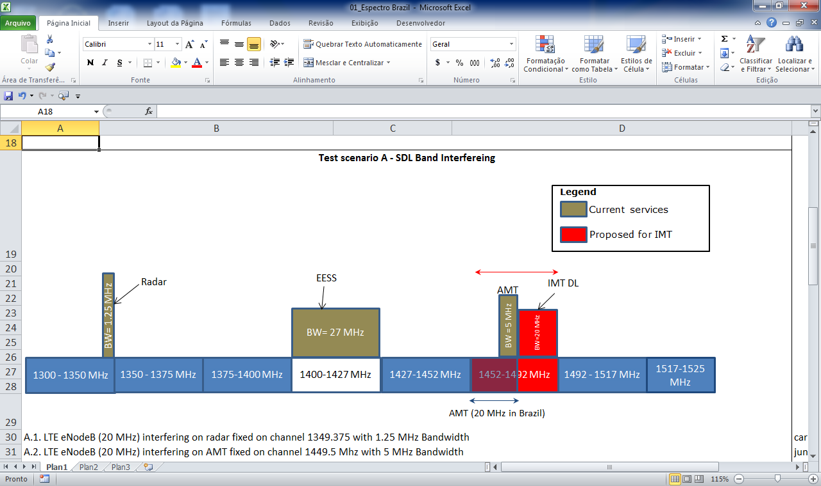

Figure 21

IMT FDD Frequency band L1

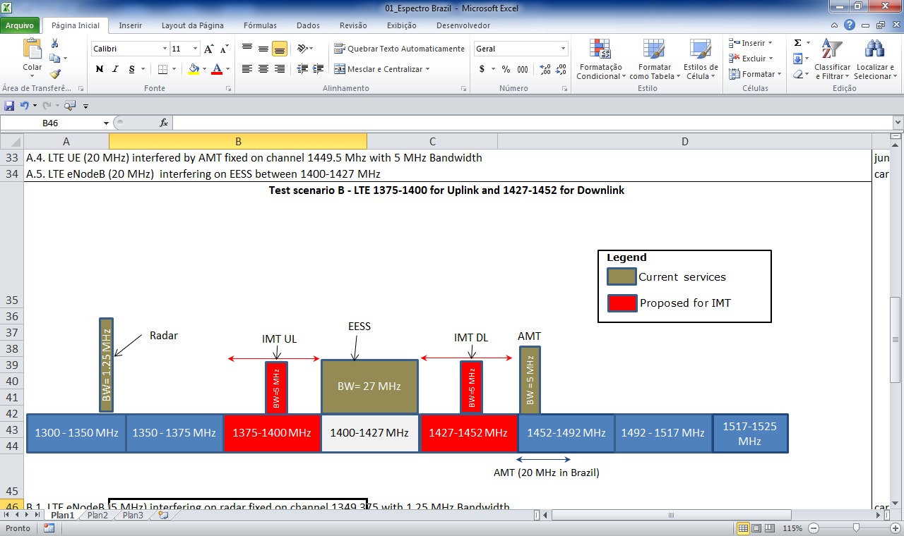

Figure 22

IMT FDD Frequency band L2

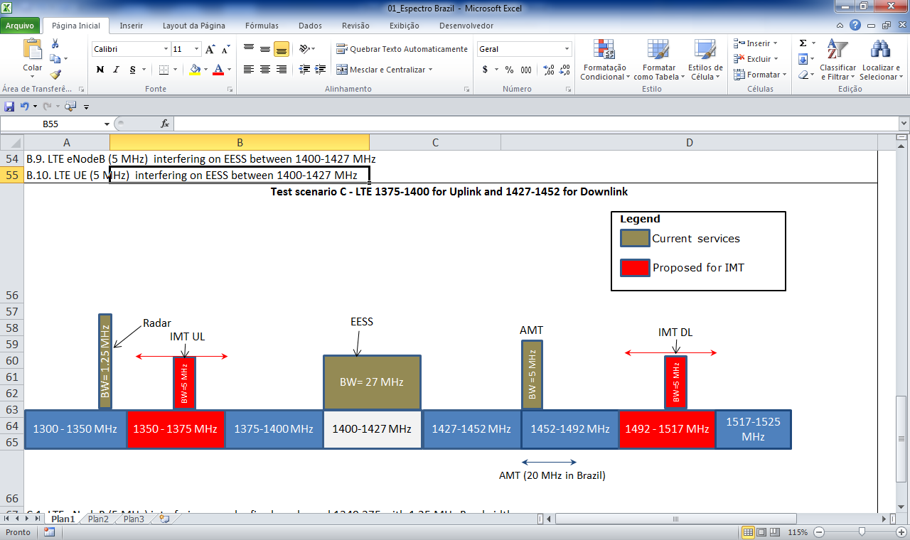

# 2 Background

The study considers technical characteristics and procedures of interference calculation from ITU‑R Recommendations.

For the IMT the equipment characteristics of the LTE-Advanced radio access technology were selected. The documents used for IMT service are:

– LTE-Advanced system characteristics are described in detail in Report ITU‑R M.2292 –Characteristics of terrestrial IMT Advanced systems for frequency sharing/interference analyses.

– Recommendation ITU-R F.1336-3 – Reference radiation patterns of omnidirectional, sectorial and other antennas in point-to-multipoint systems for use in sharing studies in the frequency range from 1 GHz to about 70 GHz, provides antenna pattern information with respect to the effects of base-station antenna down-tilt.

– Report ITU-R M.2039-2 – Characteristics of terrestrial IMT-2000 systems for frequency sharing/interference analyses.

– The unwanted emission masks were obtained from the IMT related information contained in the 3GPP standards TS 36.101 v11.6.0 and TS 36.104 v11.6.0 for IMT UE and IMT base-stations, respectively. The masks are derived from information in Table 6.6.3.2.1-6, which presents Wide Area base-station operating band unwanted emission limits for 5, 10, 15 and 20 MHz channel bandwidth (E-UTRA bands >1 GHz) for Category B.

– The values for base-station spurious emissions limits are from IMT related information contained in the For Category B, given in Table 6.6.4.1.2.1-1 of TS 36.104 v11.6.0. For services in the range 1 GHz to 12.75 GHz the maximum level is –30 dB with a measurement bandwidth of 1 MHz. These calculations also consider the value of   
–96 dBm/100 kHz (which corresponds to –86 dBm/1 MHz) from Table 6.6.4.2-1, base-station spurious emissions limits for protection of the base‑station receiver.

– Category B definition and limits are given in Recommendation ITU-R SM.329‑10 –Unwanted Emissions and Spurious Domain, in Table 3.

For the AMT service the following Recommendations were used:

– Recommendation ITU-R M.1459 – Protection criteria for telemetry systems in the aeronautical mobile service and mitigation techniques to facilitate sharing with geostationary broadcasting-satellite and mobile-satellite services in the frequency bands 1 452-1 525 MHz and 2 310-2 360 MHz, which provides the protection characteristics for AMT ground stations and the technical characteristics of AMT systems.

For the propagation models and methodology the following Recommendations were used:

– For free space loss calculation the Recommendation ITU-R P.525-2 – Calculation of free-space attenuation.

– For clear-air propagation the models in Recommendation ITU-R P.452-15 – Prediction procedure for the evaluation of interference between stations on the surface of the Earth at frequencies above about 0.1 GHz.

– Okumura-Hata model.

For out of band emission mask, the Recommendation ITU-R SM.1541 – Unwanted emissions in the out-of-band domain, Annex 11 were used for Aeronautical Telemetry.

For the simulation of interference, the worst cases will be considered with the IMT carriers adjacent with AMT systems. The results of the study will show the necessary guard band or distance of protection to IMT system coexists with actual operating telecommunication systems.

# 3 Technical characteristics

The systems considered for this Annex are the AMT and IMT based on LTE-Advanced system characteristics.

## 3.1 IMT – LTE Advanced

The IMT system to be considered on the study will be the LTE-Advanced base-station for a rural area with the followings technical specifications:

TABLE 1

LTE-Advanced base-station characteristics used for simulations

|  |  |  |
| --- | --- | --- |
| Parameter | Unit | Value |
| Bandwidth | MHz | 20 |
| Antenna gain | dBi | 18 |
| Transceiver transmission power | dBm | 46 |
| Interference criterion | dB | –3 |
| Antenna height | M | 15-25 |
| Antenna pattern |  | Rec. ITU-R F.1336-3 |

For the worst case, no activity factor was considered, and the total power was assumed as continuous in time.

The emission mask for the base-station is:

figure 23

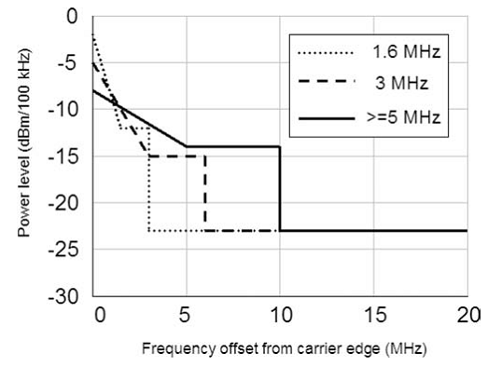

For the simulation purpose of the study, we can see that out-of-band emissions are the same for channel bandwidths above 5 MHz. The study use 20 MHz and 5 MHz of channel bandwidth.

The LTE-Advanced UE has the following technical parameters:

TABLE 2

LTE-Advanced characteristics used for simulations

|  |  |  |
| --- | --- | --- |
| Parameter | Unit | Value |
| Bandwidth | MHz | 20 |
| Antenna gain | dBi | 0 |
| Transmission power | dBm | 23 |
| Interference criterion | dB | –3 |
| Antenna height | m | 1.5 |

The emission mask for the UE is:

TABLE 3

LTE-Advanced UE emission mask

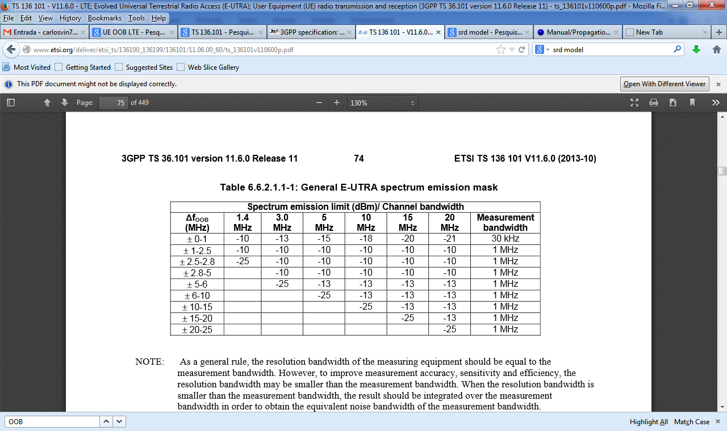

## 3.2 Aeronautical mobile telemetry systems

AMT is a subset of MS and is used for the real-time transmission of critical performance data measured on board a flight test aircraft. The data include important system parameters such as altitude, air speed, engine temperature, fluid pressure and control surface strain gauges among many other functions. Up to ten thousand parameters can be monitored during flight tests.

Although used in other ITU Regions as well, the 1 435-1 525 MHz band is the primary band used for flight test telemetry in certain Region 2 Administrations. RR No. **5.343** specifies that AMT applications have priority over other mobile service in Region 2. In Brazil the AMT service is used by channels of data and images allocated between 1 452‑1 472 MHz.

The technical characteristics of the AMT system are shown on Table 4.

TABLE 4

Technical parameters of the AMT system used on simulations

|  |  |  |
| --- | --- | --- |
| AMT | Unit | Value |
| Frequency range | MHz | 1 432-1 537 |
| Receiver bandwidth | MHz | 5 |
| Reference noise temperature | K | 290 |
| Interference criterion | dB | –3 |
| Antenna height | m | 30 |
| AMT antenna gain | dBi | 30 |
| AMT antenna azimuth (auto track) | degrees | 0 to 360 |
| Elevation (auto track) | degrees | 0 to 90 |
| Power of aircraft | watt | 10 |

Emission mask is – (55+10 log P) relative to the mean power of the AMT transmitter.

# 4 Calculation methodology

The calculation methodology is based on the comparison between the maximum interfering e.i.r.p. allowed by victim system (e.i.r.p.max_OOB) employing the e.i.r.p. out of band (e.i.r.p.interferer) from the interfering system.

The calculation procedure uses the following expressions:

e.i.r.p.max_OOB (dBm/MHz) = kTB (dBm/MHz) + NF (dB) + PathLoss (dB) +Gant_rx_vi (dBi)

e.i.r.p.interferer = PT_OOB (dBm) + Gant_int (dBi)

where:

Gant_rx_vi (dBi): antenna gain of the victim receiver

PT_OOB: transmitting power of the interfering system in the operation frequency of the victim system (ex., spurious emissions, adjacent channel leakage ratio ACLR)

Gant_int (dBi): antenna gain of the interfering system.

For the vertical antenna gain of the interferer, a typical down tilt of 5 degrees is considered in the IMT base-station, resulting in 10 dB reduction of the peak gain. For the AMT ground station with 5 degrees elevation, the gain of the AMT ground station antenna is 6 dBi. These values can be obtained with other combinations of height differences between IMT station and AMT ground station.

# 5 Analysis

## 5.1 Adjacent channel operations between AMT and IMT FDD

The methodology used establishes some scenarios of interference for adjacent channel operation.

For SDL frequency band of IMT FDD – AMT fixed on channel 1 469.5 MHz with 5 MHz of and width:

– LTE-Advanced base-station (20 MHz) interfering on AMT;

– LTE-Advanced UE (20 MHz) interfered by AMT.

For IMT FDD LTE frequency band L1 and L2 (from table I) – AMT fixed on channel 1 454.5 MHz with 5 MHz of bandwidth:

– LTE-Advanced base-station (5 MHz) interfering on AMT;

– LTE-Advanced base-station (5 MHz) interfered by AMT;

– LTE-Advanced UE (5 MHz) interfering on AMT;

– LTE-Advanced UE (5 MHz) interfered by AMT.

The methodology used includes two types of analysis. The first one based on link budget and path loss calculations using Recommendation ITU-R P.452-15 and Okumura Hata propagation models. The main equipment characteristics are the *I/N* protection criteria and OOB emission masks of the interferers. The results are for the worst-case scenario with beam-to-beam interferer to interfered antenna configurations. The second part of the analysis uses Monte Carlo simulations to evaluate the possible combinations of distance and antenna pointing between interferer and interfered systems. The resulting values are compared with the maximum OOB value permitted by the interfered receiver.

All the results are summarized in the following table:

TABLE 5

Simulation results

|  |  |  |  |  |  |
| --- | --- | --- | --- | --- | --- |
| Scenario | e.i.r.p.max_OOB  Free Space Loss (1 km) | e.i.r.p.max_OOB  Okumura-Hata (1 km) | e.i.r.p.max_OOB  Monte Carlo Simulation | e.i.r.p.interferer | Coordination conditions for interference suppression |
| **SDL Band** |  |  |  |  |  |
| LTE-Advanced base-station (20 MHz) interfering on AMT | 22.74 dBm/ 5 MHz | 38.38 dBm/ 5 MHz | 72 dBm/ 5 MHz | 21.02 dBm/ 5 MHz | No interference for Okumura-Hata model. For free space the coordination distance is 820 m. |
| LTE-Advanced UE (20 MHz) interfered by AMT | 67.92 dBm/ 20 MHz | 106.245 dBm/ 20 MHz | Without interference | –10.47 dBm/ 20 MHz |  |
| **IMT FDD frequency band L1** | | | | | |
| LTE-Advanced base-station (5 MHz) interfering on AMT | 11.54 dBm/ 5 MHz | 27.18 dBm/ 5 MHz | 21.3 dBm/ 5 MHz | 25.98 dBm/ 5 MHz | For the no interference condition, for the Okumura-Hata model, a distance of 1 km is needed to no interfere AMT on adjacent band |
| LTE-Advanced base‑station (5 MHz) interfered by AMT | 55.55 dBm/ 5 MHz | 71.22 dBm/ 5 MHz | Without interference | –16.5 dBm/ 5 MHz |  |
| LTE-Advanced UE (5 MHz) interfering on AMT | 11.42 dBm/ 5 MHz | 27.11 dBm/ 5 MHz | 34 dBm/ 5 MHz | 4.17 dBm/ 5 MHz | Interference for distance below 1 km for free space loss |
| LTE-Advanced UE (5 MHz) interfered by AMT | 52.18 dBm/ 5 MHz | 87.15 dBm/ 5 MHz | Without interference | –16.5 dBm/ 5 MHz |  |

TABLE 5 (*end*)

|  |  |  |  |  |  |
| --- | --- | --- | --- | --- | --- |
| Scenario | e.i.r.p.max_OOB  Free Space Loss (1 km) | e.i.r.p.max_OOB  Okumura-Hata (1 km) | e.i.r.p.max_OOB  Monte Carlo Simulation | e.i.r.p.interferer | Coordination conditions for interference suppression |
| **IMT FDD frequency band L2** | | | | | |
| LTE-Advanced base-station (5 MHz) interfering on AMT | 22.66 dBm/ 5 MHz | 34.79 dBm/ 5 MHz | 24.5 dBm/ 5 MHz | 10.99 dBm/ 5 MHz | Interference for distance below 1 km for free space loss |
| LTE-Advanced base-station (5 MHz) interfered by AMT | 55.89 dBm/ 5 MHz | 71.51 dBm/ 5 MHz | Without interference | –18.01 dBm/ 5 MHz |  |
| LTE-Advanced UE  (5 MHz) interfering on AMT | 11.42 dBm/ 5 MHz | 27.11 dBm/ 5 MHz | 34 dBm/ 5 MHz | 4.17 dBm/ 5 MHz | Interference for distance below 1 km for free space loss |
| LTE-Advanced UE  (5 MHz) interfered by AMT | 52.18 dBm/ 5 MHz | 87.15 dBm/ 5 MHz | Without interference | –16.5 dBm/ 5 MHz |  |

# 5 Summary

A deterministic analysis (Okumura-Hata propagation model) and Monte Carlo simulations were performed in order to model in a more realistic way the impact of interference between IMT systems and AMT.

Results were obtained in order to find a method to mitigate effects of interference on the three proposed bands for the IMT system (SDL, L1 and L2) as can be seen on Figs 20, 21 and 22.

Parameters of the systems were used form ITU-R recommendations and adapted from local use in a country in Region 2 (height of antenna and bandwidth).

Based upon the premises adopted in this study and the use of the Okumura-Hata model for the worst case distance calculation, the following results can be summarized concerning the sharing possibilities between AMT on adjacent channel coexistence with IMT FDD systems.

For the AMT systems, the following results are for adjacent channel operation:

– for SDL band, L1 band and L2 band, adjacent channel interference was found to AMT receivers from the base-station for distances around 1 km. The propagation model used for this result was Okumura-Hata;

– there is no adjacent channel interference from UE to AMT receivers. Height differences and the spectrum mask of the AMT system for the out-of-band emission results in good conditions for UE;

– no adjacent channel interference was found from AMT to the LTE-Advanced base‑station receivers.

Annex 7  
  
Study 7  
  
Sharing studies between IMT user equipment in DL and airborne telemetry transmitter within 1 429-1 518 MHz band

# 1 Introduction

This Annex presents sharing studies between IMT UE in downlink and airborne telemetry transmitter within the 1 429-1 518 MHz band.

# 2 Technical characteristics of AMT transmitters

On one hand, technical characteristics of air-borne aeronautical mobile telemetry systems are described in Recommendation ITU-R М.1459-0 – Protection Criteria for Telemetry Systems in the Aeronautical Mobile Service and Mitigation Techniques to Facilitate Sharing with Geostationary Broadcasting-Satellite and Mobile-Satellite Services in the frequency bands 1 452‑1 525 MHz and 2 310‑2 360 MHz.

On the other hand, characteristics from the assignments of the Master International Frequency Register (*MIFR*), as a *MA* class of station (airborne transmitting station), from countries listed in RR No. **5.342** could also be accounted in the following studies, given that RR No. **5.342** further describes the usage of telemetry applications within the 1 452-1 492 MHz band, stating “*As of 1 April 2007, the use of the band 1 452‑1 492 MHz is subject to agreement between the administrations concerned”.* Such statement can be understood that any technical assumption on systems which is not in line with the current declaration of the same system recorded in the MIFR is subject to agreement between the administrations concerned.

For that reason, technical characteristics of air-borne aeronautical mobile telemetry transmitters will be based on the recorded assignments in the BR-IFIC rather than from the Recommendation ITU-R M.1459[14]. The BR-IFIC lists 56 assignments for such devices in the 1 427‑1 525 MHz range with 4 different frequencies channels (1 439.65 MHz, 1 460.9 MHz, 1 482.15 MHz and 1 503.35 MHz) that are recorded for each geographical site. Thus, it leads to 14 different geographical terrestrial telemetry sites.

Figure 24

General Characteristics of a MA assignment

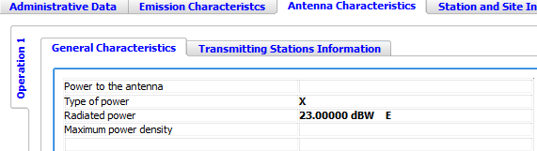

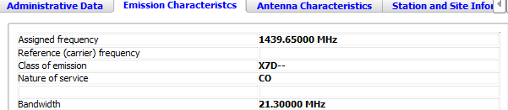

All assignments have the same declared effective radiated power (e.r.p.)[15] value, shown in Fig. 24 above and corresponding to the peak value as detailed in the *Type of power* field (filled with ***X*** information) when accessing the help command of TerraQ ITU-R software in the following Fig. 25:

FIGURE 25

Terminology for type of power featuring a class of emission

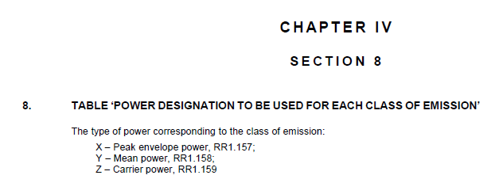

Table 1 lists the technical characteristics of an AMT airborne transmitter used for the sharing studies.

TABLE 1

Technical characteristics of air-borne aeronautical mobile telemetry transmitters

|  |  |
| --- | --- |
| Parameter | Value |
| Airborne radiated power, dBW | 23 |
| Airborne e.i.r.p., dBW | 25.15 |
| Airborne transmitter antenna height, m | 10 000 |
| Airborne transmitter emission bandwidth, MHz | 21.3 |

In addition, the telemetry transmitting antennas mounted on airborne vehicles ideally would be isotropic radiators to cover all possible radiation angles toward the telemetry receiving station. However, in practice, multiple reflections and blockage from the airborne vehicles cause large variations in the gain pattern GTx (compared to Gmax= 10 dB). For example P(G ≤ GTx= 0 dBi) = 0.96[16]. Such antenna gain mitigation would significantly reduce the percentage of time while the UE receiver is interfered with.

# 3 Technical characteristics of possible IMT systems in the frequency band 1 427‑1 525 MHz

Since 1 427-1 452 MHz and 1 452-1 492 MHz bands were proposed as a candidate for the IMT systems, both bands could be used for DL, which leads to assume UE as receivers in the sharing studies addressed in this Annex.

Technical characteristics and protection criteria for IMT system receivers are extracted from the Report ITU-R M.2292 on IMT-Advanced systems, Rec. ITU-R P.1812[17].

TABLE 2

Technical characteristics of IMT UE in the 1 427-1 518 MHz frequency range

|  |  |  |  |
| --- | --- | --- | --- |
| Noise Figure (dB) | 9 | | |
| Indoor-Outdoor UE apportionment | Rural: 50%‑50% | Suburban: 70%‑30% | Urban: 70%-30% |
| Body Loss (dB) | 4 | | |
| Building entry loss (dB) | 11 | | |
| Blocking for outdoor UE not in visibility (dB) | 10 (Urban only) | | |
| Antenna height (m) | 1.5 | | |
| Antenna gain (dBi) | –3 | | |

# 4 Estimation of protection distances required for IMT receivers operating in the frequency band 1 427-1 518 MHz

The estimation of required protection distances used the free space propagation mode for outdoor rural UE and a combination of free space with additional loss (building entry loss or/and blocking) for the remaining cases. The distance required for the protection of IMT UE was estimated based on the following equation:



where:

 : separation distance required for protecting IMT system UE receiver (m)

*e.i.r.p.Tx* : airborne AMT e.i.r.p. (dBW)

 : IMT UE receiver antenna gain (dBi)

*PL* : is the additional pathloss (dB) corresponding to a:

– 0 dB for outdoor rural UE,

– 11 dB (building entry loss) for indoor rural UE,

– 10 dB (blocking) for outdoor urban UE,

– 10 dB + 11 dB (blocking + building entry loss) for indoor urban UE

*Imax* :is themaximumacceptable interference power threshold for UE receiver (dBW)[18].

The analysis of the pathloss shows that the protection distance highly varies with the radio environment separating UE receiver from the airborne transmitter. Moreover, the path may be heterogeneous with mixed urban and rural environment which is not covered in this Report.

Table 3 gives separation distances for different protection criterion *I/N* values.

TABLE 3

Protection distance for IMT UEs (km)

|  |  |  |  |  |
| --- | --- | --- | --- | --- |
|  | Urban | | Rural | |
| *GTx*= 0 dBi | Indoor | Outdoor | Indoor | Outdoor |
| **Separation distance (km) For *I/N*= 0 dB** | 5 | 18 | 16 | 52 |
| **Separation distance (km) For *I/N*= –6 dB** | 9 | 33 | 29 | 104 |

Given that distance (UE, cross-border) = 25 km, the protection of the UE receiver is met in the urban indoor case for any protection criterion *I/N* = 6 dB or 0 dB. Thus, the three other cases need to be carried out.

When considering these results, no consideration on the duration and the likelihood of the interference coming from airborne telemetry transmitter was assumed. Such assumption would lead to address the following two aspects:

(1) The probability that both AMT transmitter and UE operate[19] in the same geographical area

When airborne transmitters operate further from the cross-border, this leads to the reduction of the dseparation as well as the interference duration. This parameter accounts for the percentage of time while telemetry measurements campaigns are launched: duration and occurrence of the campaigns. Experimental phases of a series of flight tests are sequentially distributed over different AMT ground stations available within the country operating telemetry applications.   
We have used as an example typical telemetry testing and created a model where each ground telemetry site has trials occurring up to 8 hours a day for 5 days per week. Measurement trials have a probability of occurrence which accounts for:

– the likelihood that experimental phases of a series of flight tests happen (5 days   
a week: 71%),

– the likelihood that experimental phases of a series of flight tests apply in the cross-border based on:

• the location of AMT ground receiver (with respect of the cross-border): from the current assignments of the MA stations recorded in the MIFR within 1 452‑1 518 MHz band,

• the maximum distance separating aircraft from AMT ground stations (320 km). This leads to the following value: 60.1%, assuming a uniform probability distribution.

The probability that both AMT transmitter and UE operate[20] in the same geographical area is then equal to: 71% × 60.1% = 42.6% distributed over different radio environments:

TABLE 4

Probability distribution of AMT airborne transmitter operates in cross-border

|  |  |  |  |  |
| --- | --- | --- | --- | --- |
| Urban indoor | Urban outdoor | Rural indoor | Rural outdoor | Total |
| 7.8% | 12.8% | 10.7% | 10.7% | 42% |

In spite of these assumptions, the current study cannot be served as a best case for sharing studies provided that:

– flight procedure test durations are generally shorter than 8 hours (2-3 hours),

– at lower altitudes (than 2 000 m), dseparation will be reduced for rural outdoor case.

(2) Velocity of the aircraft

This parameter leads to derive the duration while the airborne telemetry transmitter would affect the UE receiver within the same geographical area. For high altitudes (10 000 m), aircraft velocity (fighter, missile…) can easily exceed 1 000 km/h, so that 1 000 km/h is considered as a worst case velocity for flight test activities.

Different path scenarios of the aircraft are displayed in Figs 26 and 27, showing that the shape of the path followed by the aircraft (dashed brown curve) in a flight test procedure can vary. In most cases, the aircraft enters the “exclusion zone” (thick black curve) of any (indoor or outdoor) UE (e.g. 25 km from the cross-border) and leaves this area after a time length derived from the velocity of the aircraft and the distance (upper bounded by dseparation[21]) to the UE. Note that this exclusion zone depends on the protection criterion choice. For example, Fig. 28 shows that the more stringent *I/N*, the longer the exclusion zone[22]. Finally 20 km and 320 km radius values pointed out in these figures respectively correspond to the minimum and maximum transmission path length recommended in Recommendation ITU‑R M.1459-0 for the airborne transmitters to ensure the telemetry link.

The number of rounds followed by the aircraft within the flight test procedure (Scenario 1) depends on the length of the path (the shorter the path, the higher the number of rounds) and is accounted for in the calculation by the interference period.

Figure 26

Flight plan Scenario 2

dseparation



AMT Tx

AMT Rx



UE Rx

320kmm

20km

dseparation

Cross-border

25km

Figure 27

Flight plan Scenario 1

dseparation



AMT Tx

AMT Rx



UE Rx

320km

20km

dseparation

Cross-border

25km

Figure 28

Variation of the exclusion zone with respect to *I/N*

dseparation



AMT Tx

AMT Rx



UE Rx

320km

20km

dseparation

Cross-border

I/N=-6dB

I/N=0dB

The acceptable level of interference *Imax* for the UE receiver depends on both the usage and nature of the interfering service. The brief nature of the measurements campaigns of the airborne telemetry transmitters scenarios may feature scenarios for which the protection criterion over *I/N* = –6 dB could be relaxed. Prerequisites for such a relaxed protection criterion is that the average (long-term) throughput per cell should not be reduced with a significant amount (e.g. no more than 1%), and for no cell shall there be a (short-term) severe degradation of the service. In this manner, one way to measure performance of wireless technologies is to consider throughput metric. Expressed in terms of spectral efficiency (bps per Hz) in both links, this parameter can be related to[23] the protection criterion SNIR.

That means that for each user link (located in a given position within a cell), one throughput loss value is equivalent to one SNIR value.

SNIR refers to the signal to noise interference ratio within the whole cell, including the cell edge. It has to be observed that at the cell edge SNIR = *C*min/*(N+I)*, where *C*min refers to the receiver sensitivity. Since SNIR varies within the cell, throughput loss also varies within the cell. As a metric figuring out the cell performance, throughput loss per cell corresponds to the integration of the throughput loss per user for all possible locations of the user within the cell.

Throughput loss per cell is time dependent for any specific event generating a brief interference issue. For that reason, the probability of occurrence of an interfering AMT scenario into a UE receiver needs to be tackled in order to estimate the average (long-term) throughput loss per cell for IMT networks.

In addition to the probability of occurrence of such a brief interference event, when accounting for both duration of an aircraft telemetry trial (8 hours a day) and the total interference duration per day in the worst case scenario (rural outdoor) within this period, the average (long term) throughput loss per cell can be calculated based on three time periods within a trial day:

– Period 1: period of the day when there is no trial (no throughput loss per link)

– Period 2: period of the day when there is a trial and when the *I/N* protection criterion met.

– Period 3: period of the day when there is a trial and when the *I/N* is exceeded (corresponding to the exclusion zone).

The following results in Tables 5 and 6 give an overview of the impact of the airborne telemetry transmitter onto UE receivers for periods 2 and 3 on different radio environments: Rural indoor, Rural outdoor.

The average long-term throughput loss per cell is derived over the year:

TABLE 5

Distribution of the event within a trial day

|  |  |  |
| --- | --- | --- |
| Rural outdoor | within exclusion zone (period 3) | out of the exclusion zone (period 2) |
| **Protection criterion *I/N*= –6 dB** | 25.6% | 74.4% |
| **Protection criterion *I/N* = 0 dB** | 11.5% | 88.5% |
|  |  |  |
| Rural indoor | within exclusion zone (period 3) | out of the exclusion zone (period 2) |
| ***Protection criterion I/N = –6 dB*** | 4% | 96% |
| ***Protection criterion I/N = 0 dB*** | 0% | 100% |

TABLE 6

Average Throughput Loss per cell distribution during a measurements campaign

|  |  |  |  |  |
| --- | --- | --- | --- | --- |
|  |  | Average throughput loss per cell during the trial in exclusion zone (period 3) | Average throughput loss per cell during the trial out of the exclusion zone (period 2) | Average throughput loss per cell during the trial |
| Rural outdoor | Protection criterion *I/N* = –6 dB | 1.1% | 0.3% | 0.5% |
| Protection criterion *I/N* = 0 dB | 1.9% | 0.3% | 0.5% |
| Rural indoor | Protection criterion *I/N* = –6 dB | 3% | 0.4% | 0.5% |
| Protection criterion *I/N* = 0 dB | N/A[24] | 0.5% | 0.5% |

In addition to these results, the long-term average throughput loss per cell during the trial for the urban outdoor case is 0%.

It has to be observed:

– that the interference from the airborne telemetry transmitter *I* decreases when UE moves away from the cell edge closer of the cross-border while the received signal on UE *C* may increase (when UE moves closer to the IMT base-station within the cell) at the same time, leading to mitigating significantly the throughput loss (from the cell edge to the cell);

– that throughput loss results for both rural indoor and outdoor are similar due to the fact that indoor additional pathloss of the UE will reduce the received signal *C* from the IMT base-station as well as unwanted emissions *I* from the airborne telemetry interferer;

– that when considering a more stringent *I/N* protection criterion, the exclusion zone is increased but the resulting average throughput loss per cell within this exclusion zone is reduced (Table 6). This can be explained when underlining that the overall impact of the airborne telemetry transmitter on the UE receiver in the larger exclusion zone will imply longer separation distances (thus resulting in reduced average throughput loss per cell);

– that regarding the choice of the protection criterion *I/N* of –6 or 0 dB, Table 6 outlines that the average long-term throughput loss per cell within a trial (period 2 + period 3) will not vary, due to the fact that throughput loss per cell over this trial does not depend on the protection criterion *I/N*.

TABLE 7

Average throughput loss per cell

|  |  |  |  |
| --- | --- | --- | --- |
| Radio Environment | Average throughput loss per cell during the trial | Probability of occurrence | Average throughput loss per cell |
| Rural outdoor | 0.5% | 10.7% | 0.1% |
| Rural indoor | 0.5% |
| Urban outdoor | 0% | 12.8% |
| Urban indoor | 0% | 7.8% |

Since the average long-term throughput per cell exhibited by Table 7 is lower than 1%, this leads to the conclusion that the separation distance from UE to the cross‑border = 25 km is an appropriate value for the protection of the UE Rx from brief interfering airborne AMT transmitter in co-channel sharing.

Annex 8  
  
Study 8  
  
Impact of aeronautical telemetry systems on IMT UE   
in the frequency band 1 429-1 525 MHz

# 1 Introduction

Sharing studies have been initiated in the bands 1 429-1 452 MHz, 1 452-1 492 MHz, 1 492‑1 518 MHz and 1 518-1 525 MHz which were considered as potential candidate bands for IMT systems under WRC-15 agenda item 1.1. In addition to the primary services listed in the Table of Frequency Allocations, there is also an additional allocation for the band 1 429‑1 535 MHz (RR No. **5.342**):

*“Additional allocation: in Armenia, Azerbaijan, Belarus, Bulgaria, the Russian Federation, Uzbekistan, Kyrgyzstan and Ukraine, the band 1 429-1 535 MHz is also allocated to the aeronautical mobile service on a primary basis exclusively for the purposes of aeronautical telemetry within the national territory. As of 1 April 2007, the use of the band 1 452-1 492 MHz is subject to agreement between the administrations concerned.”*

Use of the frequency band for IMT downlink enables IMT systems to provide SDL capacity to carry comprehensive text, audio, images, data, sound and video content in general in a unicasting, multicasting or broadcasting mode. If the band is used for the DL component only, as it concerns the protection of IMT systems, it is sufficient to address the scenario of interference to UE receivers.

This Annex presents a co-channel compatibility study between airborne transmitters of aeronautical telemetry systems and IMT receivers in the frequency band 1 429-1 525 MHz in Region 1.

# 2 Technical characteristics used in the analysis

Aeronautical Telemetry System

There are two possible sources of the technical characteristics of telemetry airborne transmitter parameters:

– Recommendation ITU-R M.1459 – Protection criteria for telemetry systems in the aeronautical mobile service and mitigation techniques to facilitate sharing with geostationary broadcasting-satellite and mobile-satellite Services in the frequency bands 1 452-1 525 MHz and 2 310 2 360 MHz.

– Assignments of class of station “MA” (airborne transmitting station) in the Master International Frequency Register (MIFR from countries listed in RR **5.342** footnote.

Since these sources provide different characteristics of telemetry systems, the compatibility analysis was carried out for two sets of parameters as indicated in Table 1.

TABLE 1

Parameters of aeronautical telemetry airborne transmitter

|  |  |  |  |
| --- | --- | --- | --- |
|  | Rec. ITU-R M.1459 | | Master International Frequency Register (MIFR) |
| Central frequency | 1439.65 MHz; 1460.9 MHz; 1482.15 MHz; 1503.35 MHz | | |
| Channel bandwidth | 5 MHz | | 21.3 MHz |
| Antenna gain | 10 dBi (maximum) | 0 dBi (near realistic) | No information. Assumed according to Rec. ITU-R M.1459 |
| e.i.r.p. | 23.98 dBW | 13.98 dBW | 25.15 dBW |
| Maximum antenna height | 10 000 m | | 10 000 m |
| Antenna pattern | Omnidirectional | | Omnidirectional |
| Transmission path length | Up to 320 km | | Up to 600 km |

The telemetry airborne antenna ideally would be an isotropic antenna to cover all possible radiation angles toward the telemetry receiving station. However, in practice, multiple reflections and blockage form the airborne fuselage can cause large variations in the antenna gain (*GTX*) pattern (compared to *G*max = 10 dBi), e.g. the probability that *GTX* ≤ 0 dBi is equal to 0.96 (see Annex 1 of Recommendation ITU-R M.1459). Such variation of antenna gain can have a significant influence to the interference experienced by IMT UE.

Considering the above mentioned variation, different values of antenna gain of telemetry airborne transmitter were used in this analysis:

– *G* = 10 dBi, i.e. maximum antenna gain according to the Recommendation ITU‑R M.1459;

– *G* = 0 dBi, treated as near realistic in terms of interference experienced by IMT UE;

– distribution of *GTX* (CDF), as provided in Figure 1 of Annex 1 of Recommendation ITU-R M.1459, for Monte Carlo simulations only.

It was assumed that antenna type is omnidirectional in all cases.

IMT system

Technical characteristics for UE receivers were taken from Report ITU-R M.2292. For protection criteria, additional 0 dB value was used which represents relaxed protection requirement. The parameters used are provided in Table 2.

TABLE 2

IMT use equipment parameters

|  |  |
| --- | --- |
| Parameter | Value |
| Antenna height | 1.5 m |
| Antenna gain | –3 dBi |
| Antenna pattern | Omnidirectional |
| Body loss | 4 dB |
| Building penetration loss | rural: 15 dB; suburban, urban: 20 dB |
| Indoor UE usage | rural: 50%; suburban, urban: 70% |
| Building blocking for outdoor UE (only urban) | 10 dB |
| Receiver bandwidth | 5 MHz |
| Receiver noise Figure | 9 dB |
| Receiver Thermal Noise Level | –98 dBm |
| *I/N* target | 0 dB and –6 dB |

# 3 Minimum coupling loss (MCL) analysis

The co-channel impact of aeronautical telemetry airborne transmitter on IMT UE receiver was analysed to calculate required separation distances.

This section provides the calculation results using a minimum coupling loss method based on the deterministic link budget analysis. The calculated path loss was converted into a separation distance using the free space propagation model (formula (3) of Recommendation ITU‑R P.525‑2).

For the calculation of the minimum path loss required (*L*) the following formula was used:

*L = PTX + GRX –Lbody – Cenv + CBW – Imax*

where:

*PTX* : e.i.r.p. of aeronautical telemetry airborne transmitter

*GRX* : antenna gain of IMT UE receiver

*Lbody* : body loss

*Cenv* : environment correction factor combining building penetration loss and blocking

*CBW* : bandwidth correction factor

*Imax* : maximal interference level allowed.

Four different environments were analysed:

– rural outdoor;

– rural indoor (building penetration loss of 15 dB was taken into account);

– urban outdoor (building blocking of 10 dB was taken into account, UE is not in line‑of-sight);

– urban indoor (building penetration loss 15 dB and building blocking 10 dB was taken into account).

Calculation results are provided in Tables 3 and 4 below.

TABLE 3

Protection distances for IMT UE receiver when interfered with by AMT airborne transmitter,  
according to MCL analysis, *I/N* = 0 dB

|  |  |  |  |
| --- | --- | --- | --- |
| AMT characteristics from Recommendation ITU-R M.1459, GTX = 10 dBi | | | |
| Urban indoor | Urban outdoor | Rural indoor | Rural outdoor |
| 9.3 km | 93 km | 52 km | 294 km |
| AMT characteristics from Recommendation ITU-R M.1459, GTX = 0 dBi | | | |
| Urban indoor | Urban outdoor | Rural indoor | Rural outdoor |
| 2.9 km | 29 km | 17 km | 93 km |
| AMT characteristics from MIFR | | | |
| Urban indoor | Urban outdoor | Rural indoor | Rural outdoor |
| 5.1 km | 52 km | 29 km | 163 km |

TABLE 4

Protection distances for IMT UE receiver when interfered with by AMT airborne transmitter,   
according to MCL analysis, *I/N* = –6 dB

|  |  |  |  |
| --- | --- | --- | --- |
| AMT characteristics from Recommendation ITU-R M.1459, GTX = 10 dBi | | | |
| Urban indoor | Urban outdoor | Rural indoor | Rural outdoor |
| 18.5 km | 185 km | 104 km | 412 km (limited by LoS) |
| AMT characteristics from Recommendation ITU-R M.1459, GTX = 0 dBi | | | |
| Urban indoor | Urban outdoor | Rural indoor | Rural outdoor |
| 5.9 km | 59 km | 33 km | 185 km |
| AMT characteristics from MIFR | | | |
| Urban indoor | Urban outdoor | Rural indoor | Rural outdoor |
| 10.3 km | 103 km | 58 km | 325 km |

The calculation results show significant variation of required protection distance depending on the parameters of aeronautical telemetry system and protection criteria used.

MCL evaluations are based on worst case assumptions therefore lead to possibly overestimated separation distances. In practice, UE is not necessarily used in every potential occurrence of interference; additionally, the telemetry airborne transmitter is not always capable to influence UE, because a telemetry airborne transmitter normally is in motion (having velocities up to 1 000 km/h) servicing the area of radii up to 320 km (according to Recommendation ITU-R M.1459) or up to 600 km (according to MIFR). Since the interference is not of a permanent nature, Monte-Carlo simulations using SEAMCAT software tool could show more realistic picture of interference potential.

# 4 Interference scenario for Monte-Carlo simulations

The interference scenario created in SEAMCAT is shown in Fig. 29 below. The separation distance (*dsep*) is defined as the distance between the location of a victim IMT UE and the closest edge of the service area of an AMT airborne transmitter.

FIGURE 29

Interference scenario for Monte Carlo simulation



The simulations were carried out using 1 000 000 randomly generated snapshots. Separation distances for worst case (rural) of MCL evaluations were used as a starting point. A relaxed interference criterion (*I/N* = 0 dB) was used. The proportion of 50% of IMT UE used for indoor was taken into account.

The interference probability (*IP*) for different separation distances i.e. equal to and less than the largest separation distance resulted in MCL simulations are presented in Table 5.

TABLE 5

Simulations results using Monte-Carlo approach

|  |  |  |  |  |
| --- | --- | --- | --- | --- |
|  | Scenario 1 (pessimistic) | Scenario 2 (near realistic) | Scenario 3 (realistic) | Scenario 4 |
| AMT characteristics | ITU-R M.1459 | ITU-R M.1459 | ITU-R M.1459 | MIFR |
| AMT antenna gain | 10 dBi | 0 dBi | CDF from M.1459 (Fig. 2 of Ann. 1) | 10 dBi |
| *dsep* for *IP* = 0% | 294 km | 93 km | 71 km | 163 km |
| *dsep* for *IP* = 0.5% | 265 km | 56 km | 15 km | 95 km |
| *dsep* for *IP* = 1.0% | 250 km | 34 km | not required | 52 km |
| *dsep* for *IP* = 2.0% | 225 km | not required | not required | not required |
| *dsep* for *IP* = 3.0% | 204 km | not required | not required | not required |
| *dsep* for *IP* = 5.0% | 167 km | not required | not required | not required |
| *IP* for *dsep* = 1 km | 17.4% | 1.96% | 0.75% | 1.76% |

Results of a SEAMCAT simulation show that the required separation distance between an aeronautical telemetry airborne transmitter and an IMT UE receiver is significantly smaller given that a certain probability of interference to an IMT UE is considered to be acceptable.

# 5 Summary

The results of analysis using an MCL calculation method show a significant variation of the required separation distance (see Tables 3 and 4) for IMT UE depending on the parameters of the aeronautical telemetry system (Recommendation ITU-R M.1459 or MIFR) and the receiving environment.

A probabilistic approach allowed to make a quantitative assessment of the reduction of the protection distances which were obtained by using an MCL method. Monte-Carlo simulations showed that the separation distance can be significantly reduced while maintaining an acceptable interference probability for an IMT UE receiver (see Table 5). According to a realistic scenario which takes into account a measured distribution of antenna gain of an AMT airborne transmitter (provided in Recommendation ITU-R M.1459), the separation distance of 15 km is sufficient to protect an IMT UE receiver with less than 0.5% interference probability.

1. Imax(dBm)=e.i.r.p. base-station(dBm)+PathLoss(dB)+Go(dBi).
2. The adjusted Recommendation ITU-R P.1546 model is suitable for modelling propagation path loss in the broadcasting, land mobile and certain fixed services (e.g. those employing point‑to‑multipoint systems) in the frequency range 30 to 3 000 MHz and for the distance range 1 km to 1 000 km.
3. Recommendation ITU-R P.1546-4 is under revision for short paths longer than one kilometre when there is a large required correction (happening with large difference in antenna heights). dB. This is not the case here since |*Cds*|<10-3.
4. Available for download at: <http://dds.cr.usgs.gov/srtm/version2_1/SRTM3/Eurasia/>
5. There should be 8 but one of them (number K) does not have the SRTM data to calculate the required separation distance.
6. These studies use propagation models contained in Recommendation ITU-R P.1546, whereas the present study cites propagation models in Recommendations ITU-R P.452 and ITU-R P.528. In its *notings*, Recommendation ITU-R P.1546 compares the features of each model. Of relevance here, Recommendation ITU-R P.1546 uses values for important technical parameters that are specific to Region 1.
7. At this time it cannot be predicted with certainty whether the frequency band 1 435‑1 525 MHz will be used for LTE UE, or for LTE base-stations (“base-stations”), or for some combination of the two, by all administrations in all Regions. Hence, for the sake of completeness this study addresses both uplink and downlink scenarios.
8. Recommendation ITU-R M.1459 has been applied in both terrestrial and satellite cases. See, e.g. Report ITU-R M.2118 – Compatibility between proposed systems in the aeronautical mobile service and the existing fixed-satellite service in the 5 091-5 250 MHz band (see § 5.2.1: “Impact into AMS for telemetry limited to flight testing, “The compatibility between the FSS ground transmitter and the AMS for telemetry...”); and Report ITU-R M.2238 – Compatibility study to support line of sight control and non‑payload communications links for unmanned aircraft system ground tracking antennas in 5 091‑5 150 MHz.
9. Although the percentages in Table 2 refer to spatial, rather than temporal averages, individual LTE UE cannot be presumed to be actively transmitting 100% of the time on a 24 hour basis. Thus, a temporal component is implicit in the assumption that 2.6% of all UE that are active at a particular instant, are transmitting at maximum power under PC1, 2, or 3 limits. This means that the UE that comprise the 2.6% change over time within a time frame that is neither specified nor material to the analysis.
10. Average base-station power factor was not considered in the analyses here. The assumption is made in the analyses that the difference between peak and average power due to a 50% activity factor means that an individual base-station transmits at peak power 50% of the time, rather than at average power 100% of the time. Although this distinction might not matter when computing the aggregate interference due to a large number of interfering base-stations, it is important in situations where a small number of base-stations is responsible for the majority of the interference. From the AMT perspective, transmission at peak power for an even short period of time is more harmful than transmission at average power for a long period of time. This is because short term interference results in long-term telemetry dropouts. Thus, if the activity factor for a network is 50%, rather than 100%, even during peak broadband service periods, the 50% activity factor does not necessarily yield a 50% reduction in impact to AMT operations.
11. Cf. § 3.3.3.1.
12. As stated in § 3.3.2, short-term interference to AMT systems causes long-term dropouts. Hence, 50% activity factor or other time-division factors (e.g. time division multiplexing among sector antennas on a single base-station) might not provide mitigation against the inevitable worst-case maximum power situation. The exception is when aggregate effects are significant enough that the use of average power per base-station is appropriate. However, in this limit and for AMT systems, the deleterious effects of aggregation will likely outweigh the benefits to sharing that result from the use of average values.
13. E.g. 90 m average terrain variation, which is common in Region 2.
14. BR International Frequency information Circular.
15. <http://www.itu.int/ITU-R/terrestrial/docs/notice-forms/fxm/fxm-guide.pdf> (page 21).
16. Using the formula given in Recommendation ITU-R M.1459 P(G ≤ GTx)=(1-e−3.46G1)1.25.
17. For building entry loss.
18. Imax= *I/N+N*.
19. We assume that the UE Rx operates when the consumer uses the UE while interfering by the AMT transmitter.
20. We assume that the UE Rx operates when the consumer uses the UE while interfering by the AMT transmitter.
21. Corresponding to the approach and the distancing of the aircraft from the UE.
22. Orange curve in Fig. 28 shows the expansion of the exclusion zone for *I/N* = –6 dB with respect of the exclusion zone for *I/N* = 0 dB.
23. 3GPP TR 36.942 Table A.2.
24. Given that the separation distance for *I/N* = 0 dB (16 km) is met (d(UE,cross-border) = 25 km).