|  |
| --- |
| **Report ITU-R M.2372-0**  **(07/2015)** |
| **Channel usage to protect automatic identification system channels and also protect any additional channels that may be allocated to support automatic identification system technology applications** |
| **M Series**  **Mobile, radiodetermination, amateur**  **and related satellite services** |

Foreword

The role of the Radiocommunication Sector is to ensure the rational, equitable, efficient and economical use of the radio-frequency spectrum by all radiocommunication services, including satellite services, and carry out studies without limit of frequency range on the basis of which Recommendations are adopted.

The regulatory and policy functions of the Radiocommunication Sector are performed by World and Regional Radiocommunication Conferences and Radiocommunication Assemblies supported by Study Groups.

# Policy on Intellectual Property Right (IPR)

ITU-R policy on IPR is described in the Common Patent Policy for ITU-T/ITU-R/ISO/IEC referenced in Annex 1 of Resolution ITU-R 1. Forms to be used for the submission of patent statements and licensing declarations by patent holders are available from <http://www.itu.int/ITU-R/go/patents/en> where the Guidelines for Implementation of the Common Patent Policy for ITU‑T/ITU‑R/ISO/IEC and the ITU-R patent information database can also be found.

|  |  |
| --- | --- |
| Series of ITU-R Reports  (Also available online at <http://www.itu.int/publ/R-REP/en>) | |
| **Series** | Title |
| **BO** | Satellite delivery |
| **BR** | Recording for production, archival and play-out; film for television |
| **BS** | Broadcasting service (sound) |
| **BT** | Broadcasting service (television) |
| **F** | Fixed service |
| **M** | Mobile, radiodetermination, amateur and related satellite services |
| **P** | Radiowave propagation |
| **RA** | Radio astronomy |
| **RS** | Remote sensing systems |
| **S** | Fixed-satellite service |
| **SA** | Space applications and meteorology |
| **SF** | Frequency sharing and coordination between fixed-satellite and fixed service systems |
| **SM** | Spectrum management |

|  |
| --- |
|  |

|  |
| --- |
| ***Note****: This ITU-R Report was approved in English by the Study Group under the procedure detailed in Resolution ITU-R 1.* |

*Electronic Publication*

Geneva, 2015

© ITU 2015

All rights reserved. No part of this publication may be reproduced, by any means whatsoever, without written permission of ITU.

REPORT ITU-R M.2372-0

Technical assessment of RR Appendix 18  
  
Channel usage to protect automatic identification system channels and also protect any additional channels that may be allocated to support automatic identification system technology applications

(2015)

# 1 Introduction

During WRC-12, the revision of Appendix **18** introduced new configuration of channels to allow enhanced applications in those bands. The revision also allowed simplex shipborne use of the upper legs of four duplex channels 2078, 2019, 2079 and 2020.

# 2 Technical analysis

Subsequent study in support of Resolution **360 (WRC-12)** has investigated new terrestrial and satellite applications using automatic identification system (AIS) technology. These potential new applications and technologies identified unacceptable effects to both the current AIS channels and limitations on introduction of new applications from the current shipborne use of channels 2078, 2019, 2079 and 2020 as designated by WRC-12 in RR Appendix **18**. Since the additional channels identified for new AIS applications are positioned in close proximity to AIS 1 and AIS 2, they would be subject to the same blocking effects.

Note from Table 1 (taken from Appendix **18**) that AIS 1 and AIS 2 (yellow highlights) are very close in frequency to channels 2078, 2019, 2079 and 2020 (green highlights), the use of these channels for radio communications by a ship will block that ship’s AIS receiver, consequentially causing that ship’s AIS to be unable to update the location of other ships nearby, resulting in a navigation safety hazard and possible collision.

# 3 General observation

Further note from Table 1 that RR Appendix **18** (Rev. WRC-12) is structured in two sections with a 4.6 MHz separation between the lower section (156.025 MHz to 157.425 MHz) and the upper section (160.625 MHz to 162.025 MHz). This arrangement permits the implementation of duplex channels in which ships stations transmit on the lower section and shore stations transmit on the upper section. Because of this arrangement, prior to WRC-12, ships voice radios have been designed to transmit only in the lower section of the RR Appendix **18** band, which provides sufficient frequency separation to provide protection (by filtering) for AIS receivers.

TABLE 1

| Channel designator | Notes | Transmitting frequencies  (MHz) | | Inter-ship | Port operations  and ship movement | | Public corres-pondence |
| --- | --- | --- | --- | --- | --- | --- | --- |
| From ship stations | From coast stations | Single frequency | Two frequency |
| 15 | *g)* | 156.750 | 156.750 | x | x |  |  |
| 75 | *n), s)* | 156.775 | 156.775 |  | x |  |  |
| 16 | *f)* | 156.800 | 156.800 | DISTRESS, SAFETY AND CALLING | | | |
| 76 | *n), s)* | 156.825 | 156.825 |  | x |  |  |
| 17 | *g)* | 156.850 | 156.850 | x | x |  |  |
| 77 |  | 156.875 |  | x |  |  |  |
| 18 | *m)* | 156.900 | 161.500 |  | x | x | x |
| 78 | *t), u), v)* | 156.925 | 161.525 |  | x | x | x |
| 1078 |  | 156.925 | 156.925 |  | x |  |  |
| 2078 |  | 161.525 | 161.525 |  | x |  |  |
| 19 | *t), u), v)* | 156.950 | 161.550 |  | x | x | x |
| 1019 |  | 156.950 | 156.950 |  | x |  |  |
| 2019 |  | 161.550 | 161.550 |  | x |  |  |
| 79 | *t), u), v)* | 156.975 | 161.575 |  | x | x | x |
| 1079 |  | 156.975 | 156.975 |  | x |  |  |
| 2079 |  | 161.575 | 161.575 |  | x |  |  |
| 20 | *t), u), v)* | 157.000 | 161.600 |  | x | x | x |
| 1020 |  | 157.000 | 157.000 |  | x |  |  |
| 2020 |  | 161.600 | 161.600 |  | x |  |  |
| 80 | *w), y)* | 157.025 | 161.625 |  | x | x | x |
| 21 | *w), y)* | 157.050 | 161.650 |  | x | x | x |
| 81 | *w), y)* | 157.075 | 161.675 |  | x | x | x |
| 22 | *w), y)* | 157.100 | 161.700 |  | x | x | x |
| 82 | *w), x), y)* | 157.125 | 161.725 |  | x | x | x |
| 23 | *w), x), y)* | 157.150 | 161.750 |  | x | x | x |
| 83 | *w), x), y)* | 157.175 | 161.775 |  | x | x | x |
| 24 | *w), ww), x), y)* | 157.200 | 161.800 |  | x | x | x |
| 84 | *w), ww), x), y)* | 157.225 | 161.825 |  | x | x | x |
| 25 | *w), ww), x), y)* | 157.250 | 161.850 |  | x | x | x |
| 85 | *w), ww), x), y)* | 157.275 | 161.875 |  | x | x | x |

TABLE 1 (*end*)

| Channel designator | Notes | Transmitting frequencies  (MHz) | | Inter-ship | Port operations  and ship movement | | Public corres-pondence |
| --- | --- | --- | --- | --- | --- | --- | --- |
| From ship stations | From coast stations | Single frequency | Two frequency |
| 26 | *w), ww), x), y)* | 157.300 | 161.900 |  | x | x | x |
| 86 | *w), ww), x), y)* | 157.325 | 161.925 |  | x | x | x |
| 27 | *z)* | 157.350 | 161.950 |  |  | x | x |
| 87 | *z)* | 157.375 | 157.375 |  | x |  |  |
| 28 | *z)* | 157.400 | 162.000 |  |  | x | x |
| 88 | *z)* | 157.425 | 157.425 |  | x |  |  |
| AIS 1 | *f), l), p)* | 161.975 | 161.975 |  |  |  |  |
| AIS 2 | *f), l), p)* | 162.025 | 162.025 |  |  |  |  |

In support to this problem a technical study provided by China in Annex 1 demonstrated the   
co-sight interference problem when using channels 2078, 2019, 2079 and 2020.

# 4 Suggestion

– Administrations should take appropriate technical or regulatory actions for avoiding analogue modulated voice transmission on channels 2078, 2019, 2079 and 2020 by ship stations which might bring harmful interference to AIS or other new digital modulated security and safety related applications on nearby channels.

– Administrations are encouraged to take appropriate actions to forbid any long time analogue modulated signal transmitting on channels 2078, 2019, 2079 and 2020 for protection of AIS and any other new digital modulated security and safety related applications on nearby channels.

– Administrations are encouraged to study and propose on highly effective and efficient usage of channels in Appendix **18** for enhancing ship movement and port operation.

Annex 1  
  
Experiments from China for justifying channel usage to protect automatic identification system and new applications channels

# 1 Experiment

## 1.1 Experiment platform

The experiment was conducted in a research base near Meilin Port, Shenhu bay, Fujian Province, China. The coordinating position is 24º41.220' N, 118º41.906' E. The antennas were installed on the roof of the laboratory building, with elevation of approx. 20 m above sea level.

Experiment date: 1 Sep. 2014 and 3 Sep. 2014

The structure of the experiment platform is shown in Fig. A1-1.

VHF radio telephone: Feitong FT-805, being consistent with Recommendation [ITU-R M.489-2](http://www.itu.int/rec/R-REC-M.489/en).

AIS: Feitong FT-8700, being consistent with Recommendation [ITU-R M.1371-4](http://www.itu.int/rec/R-REC-M.1371/en), Class B shipborne equipment.

Spectrum analyser: Agilent E4402B.

Ship antenna:

– Length: 1.2 m

– Gain: 3 dB

– Standing-wave ratio (SWR): < 1.5

– Central frequency: 158 MHz (for VHF radio telephone), 162 MHz (for AIS).

Figure A1-1

Configuration of testing environment

VHF Telephone

antenna

AIS

antenna

Spectrum analyser

Power metre

## 1.2 Experiment procedure

For simulating the real condition on the bridge of a ship, the test was done for two antenna installation conditions which were both typical positions. In Condition 1, the horizontal distance of the antennas is 2 m, and the vertical distance of the antennas is 2.3 m, which is shown as in Fig. A1-2. In Condition 2, the horizontal distance of the antennas is 4 m, and the vertical distance of the antennas is 0 m, which is shown as in Fig. A1-3.

|  |  |
| --- | --- |
| Figure A1-2  Condition 1 | Figure A1-3  Condition 2 |
|  |  |

During the experiments, the average number of received targets by AIS in normal condition is about 267, and the typical distance between the AIS terminal and the furthest target is about 100 NM, as shown in Figs A1-4 and A1-5.

|  |  |
| --- | --- |
| Figure A1-4  Maximum automatic identification system target range | Figure A1-5  Maximum automatic identification system target range |
|  |  |

For the purpose of testing the blocking of AIS signal reception by transmission on channels 2078, 2019, 2079 and 2020, in the experiments, the VHF radio telephone was set transmitting manually on 161.525 MHz (CH 2078) and 161.600 MHz (CH 2020) respectively. Taking consideration that the longest reporting interval in AIS is 3 minutes, and the longest screen update of the FT-8700 is 4 minutes, each testing period was set to 10 minutes. Modulated carrier was transmitted in two modes. One of them was continuously transmitting, to simulate an abnormally long occupation of the channel, referred to as Mode A.

The other transmitting mode was discontinuous, alternating between 10 s transmission followed by 10 s of silence, to simulate a typical voice communication, referred to as Mode B. Figure A1-6 gives an example of spectrum of VHF telephone transmission. As the VHF telephone transmitting power is adjustable, the modulated carrier was transmitted by two power levels, separately 25 W and 1 W.

Figure A1-6

Spectrum of radiotelephone transmitter

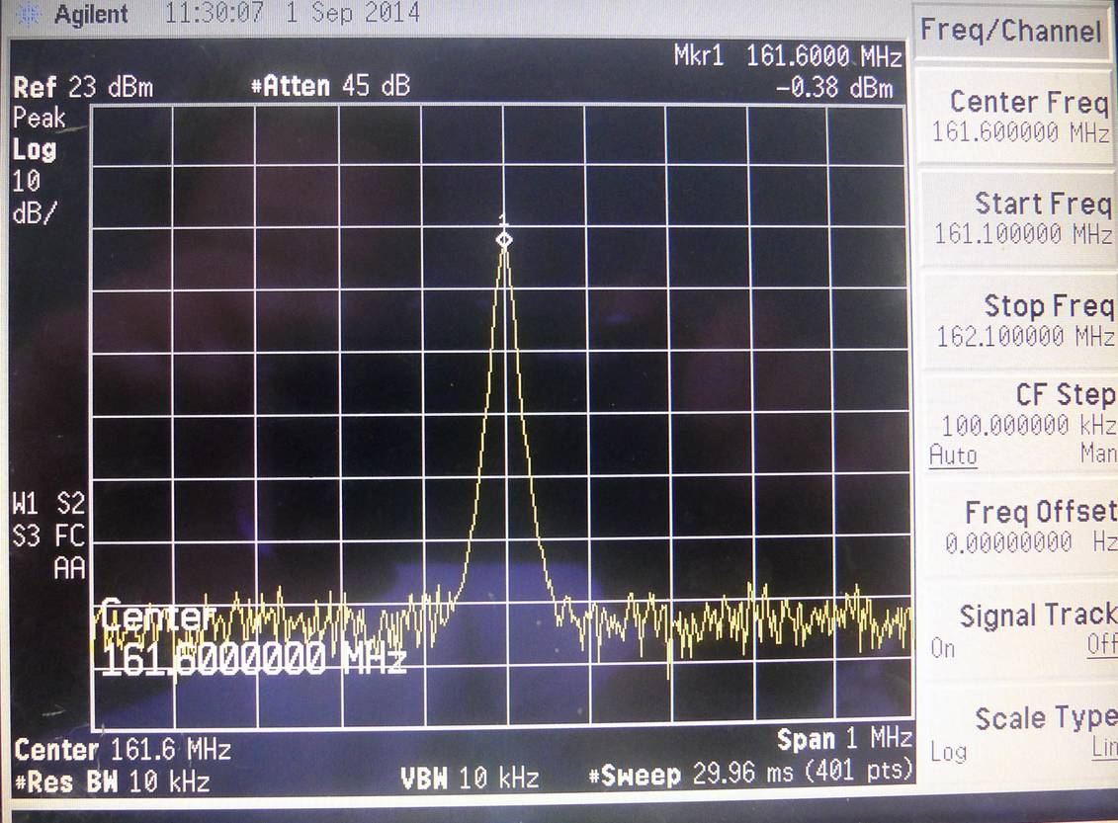

Generally, except to justify the possible blocking to AIS signal, the experiments would test the effect of different antenna position, different voice transmitting frequency, power, and channel occupancy mode.

## 1.3 Test results

The following Tables give the typical data from the experiments.

TABLE A1-1

Antennas installed as per condition 1

|  |  |  |  |  |  |
| --- | --- | --- | --- | --- | --- |
| Transmitting frequency | Transmitter power | Receive level | Transmitting mode | Number of received targets | Distance to the furthest target |
| **(MHz)** | **(W)** | **(dBm)** |  |  | km (NM)[1] |
| 161.525 | 25 | –9 | A | 27 | 28.34 (15.3) |
| B | 227 | 184.46 (99.6) |
| 1 | –22 | A | 135 | 92.23 (49.8) |
| B | 238 | 208.35 (112.5) |
| 161.600 | 25 | –8 | A | 12 | 16.67 (9.0) |
| B | 228 | 157.23 (84.9) |
| 1 | –21 | A | 143 | 137.42 (74.2) |
| B | 234 | 142.42 (76.9) |

TABLE A1-2

Antennas installed as per condition 2

|  |  |  |  |  |  |
| --- | --- | --- | --- | --- | --- |
| Transmitting frequency) | Transmitter power | Receiver level | Transmitting mode | Number of received targets | Distance to the furthest target |
| **(MHz)** | **(W)** | **(dBm)** |  |  | km (NM)[2] |
| 161.525 | 25 | 13 | A | 12 | 14.08 (7.6) |
| B | 233 | 274.10 (148) |
| 1 | –0.4 | A | 40 | 14.816 (8.0) |
| B | 239 | 320.40 (173) |
| 161.600 | 25 | 13 | A | 2 | 7.96 (4.3) |
| B | 206 | 253.17 (136.7) |
| 1 | –0.4 | A | 19 | 16.11 (8.7) |
| B | 226 | 412.63 (222.8) |

Figures A1-7 and A1-8 give some examples of screen displays of the AIS testing terminal in the experiments.

|  |  |
| --- | --- |
| Figure A1-7  AIS testing in transmitting mode A | Figure A1-8  AIS testing in transmitting mode B |
|  |  |

# 2 Analysis

The results of the experiments indicate that:

– Voice transmission on channels 2078, 2019, 2079 and 2020 (irrespective of whether long occupation to the channels or normal voice communication was in use) do block AIS signal reception, and would have an adverse impact to other digital modulated applications using AIS technology on the nearby channels. The less the frequency interval between the voice channel and the digital channel, the greater is the impact.

– Apparently, using some certain type of antennas, the installation position scheme will determine the extent receiver signal blocking to a great extent. In these experiments, the receiving level of the modulated carrier from voice communication measured at AIS testing terminal in antenna installation in Condition 2 was higher about 21 dB than that in antenna installed as per Condition 1.

– Reducing the transmission power of voice communication could relieve the harmful impact of digital modulated signal receiving to some extent. In these experiments, the difference of receiving level in the same other conditions was about 13 dB between transmission power 25 W and 1 W. Anyway, as AIS is used for safety of navigation purposes, the loss of signal being blocked by 1 W continuing voice transmission is not acceptable.

– The most influential fact is the voice modulated carrier transmission mode. Discontinuing carrier transmitting brought far less impact to the AIS signal receiving, as most of the AIS message is a kind of repeated position report. Furthermore, by observing the result display of AIS testing terminal, when operating in discontinuous transmission mode, the further the target is away from the tester, the greater is the effect. In other words, those nearby targets, especially those within 55.56 km (30 NM) from the tester have barely been impacted.

1. 1 Nautical mile = 1 852 m
2. 1 nautical mile = 1 852 m