Report ITU-R M.2378-0
(07/2015)
Operational guidelines for the deployment of broadband wireless access systems
for local coverage operating below 6 GHz

M Series
Mobile, radiodetermination, amateur
and related satellite services

Foreword
The role of the Radiocommunication Sector is to ensure the rational, equitable, efficient and economical use of the radio-frequency spectrum by all radiocommunication services, including satellite services, and carry out studies without limit of frequency range on the basis of which Recommendations are adopted.
The regulatory and policy functions of the Radiocommunication Sector are performed by World and Regional Radiocommunication Conferences and Radiocommunication Assemblies supported by Study Groups.

Policy on Intellectual Property Right (IPR)
ITU-R policy on IPR is described in the Common Patent Policy for ITU-T/ITU-R/ISO/IEC referenced in Annex 1 of Resolution ITU-R 1. Forms to be used for the submission of patent statements and licensing declarations by patent holders are available from http://www.itu.int/ITU-R/go/patents/en where the Guidelines for Implementation of the Common Patent Policy for ITU-T/ITU-R/ISO/IEC and the ITU-R patent information database can also be found.

Series of ITU-R Reports
(Also available online at http://www.itu.int/publ/R-REP/en)
Series | Title
BO | Satellite delivery
BR | Recording for production, archival and play-out; film for television
BS | Broadcasting service (sound)
BT | Broadcasting service (television)
F | Fixed service
M | Mobile, radiodetermination, amateur and related satellite services
P | Radiowave propagation
RA | Radio astronomy
RS | Remote sensing systems
S | Fixed-satellite service
SA | Space applications and meteorology
SF | Frequency sharing and coordination between fixed-satellite and fixed service systems
SM | Spectrum management

Note: This ITU-R Report was approved in English by the Study Group under the procedure detailed in Resolution ITU-R 1.

Electronic Publication
Geneva, 2015
© ITU 2015
All rights reserved. No part of this publication may be reproduced, by any means whatsoever, without written permission of ITU.

REPORT ITU-R M.2378-0
Operational guidelines for the deployment of broadband wireless access systems
for local coverage operating below 6 GHz

(2015)
TABLE OF CONTENTS
Page
1 Introduction 2
2 Definition and terminology 3
2.1 Definition 3
2.2 Terminology 4
2.3 Abbreviations 4
2.4 Related ITU-R Recommendations and Reports 4
3 General concept and technical study framework 4
3.1 General concept of local coverage 4
3.2 Technical properties of local coverage 6
3.3 Deployment cases of local coverage 8
3.4 Use cases and categories 9
3.5 Scope and subjects of the studies 10
3.6 Currently available technologies 12
4 Utilization of frequency bands for local coverage 12
4.1 Operational scenarios 12
4.2 Modelling and analysis 14
4.3 Operational requirements 18
5 Functional requirements for flexible operation of local coverage. 21
5.1 Technical capabilities for network operation and management of
local coverage 21
5.2 Functional requirements for technical capabilities 21
5.2.1 Functional requirements to implement technical capability 1) 21
5.2.2 Functional requirements to implement technical capability 2) 22
5.2.3 Functional requirements to implement technical capability 3) 22
5.3 Analysis and implementation of functional requirements 22
5.3.1 Analysis of functional requirements for technical capabilities
1) and 2) 22
5.3.2 Analysis of functional requirements for technical capability 3) 24
6 Conclusion 26
References 26

Summary
This Report deals with a specific operation concept of local coverage for Broadband Wireless Access (BWA) systems in frequency bands below 6 GHz. From a technical point of view, this Report is intended to provide some operational guidelines for the deployment of BWA systems for local coverage in the frequency bands above those frequencies typically used for macro cell deployments. The study in this Report addresses technical analysis of local coverage, modelling of categorized operational scenarios and analysis to investigate possibilities of enhancing operational flexibilities, . Taking advantage of properties of local coverage, the study focuses on flexible and efficient operation of BWA systems such as multi-standard radio operation and increasing degree of freedom in operational conditions. Possibilities are presented for flexible operation of BWA systems under certain operational conditions of local coverage.

1 Introduction
This Report addresses a specific concept of local coverage, which is intended for efficient and flexible operation of broadband wireless access (BWA) systems employing radio interface standards in Recommendation ITU-R M.1801 and operating in the frequency bands below 6 GHz. The concept has not been considered in other studies of BWA systems so far. Traditionally, macro cell mobile networks have been deployed mainly in the bands below 3 GHz. In higher frequency bands, cell coverage tends to become smaller due to the propagation characteristics. Different from conventional macro-cell radio access networks, BWA systems in higher frequency bands are generally used to serve local coverage area using small cells and hot spot deployments. The study in this Report is not intended for the conventional macro cell deployments.
This Report first provides a specific definition of local coverage to characterize the operation of BWA systems in limited geographical coverage in frequency bands below 6 GHz. It should be noted that this study does not assume any specific Radio Access Technology (RAT) as the study is intended for generally applicable methodology irrespective of RATs. In section 2, the specific concept of local coverage is presented with focus on the difference from conventional macro cell operation. The objective of the analysis in this Report is to clarify technical properties of local coverage, to develop effective operational scenarios and to derive operational management guidelines which would allow more efficient and flexible use of local coverage systems.
The scope of the study is defined by the following items:
– Efficient use of frequency bands below 6 GHz for operation of BWA systems by developing flexible operational guidelines of local coverage under certain conditions
– Technical analysis of the characteristics of local coverage.
– Categorized operational scenarios and modelling for analysis of local coverage operation.
– Technical conditions and management scheme for operation of local coverage of BWA systems in categorized operational scenarios.
– Technical capabilities and functional requirements to support local coverage operation of BWA systems.
In some cases, local coverage areas may be isolated from each other while in some other cases neighbouring local coverage areas may have mutual interaction. Mutual interaction is defined in this Report as any influences from a neighbouring coverage area that impact network operation within a given coverage area. Examples of this could include signal interference from systems operating in a neighbouring coverage area or the need to coordinate transmissions with radio systems operating in a neighbouring coverage area. When mutual interaction is limited, flexible approaches may become possible for operation of local coverage as well as use of frequency bands.
In section 3, technical properties of local coverage are investigated in detail together with use cases of local coverage. Section 4 deals with operational scenarios of local coverage. Detailed modelling is presented for the categorized operation scenarios. Based on the proposed modelling, each operation scenario is analyzed to investigate to what extent operational flexibilities may be enhanced for local coverage. As an operational guideline, operational conditions and possible inter and intra-system network management scheme are also discussed. Based on the analysis in section 4, section 5 presents three technical capabilities to take full advantage of efficient and flexible operation of local coverage. Functional requirements are derived to implement the three technical capabilities along with analysis for typical operational situations.

2 Definition and terminology

2.1 Definition
Local coverage: a type of radio system deployment that provides coverage limited to small areas (e.g. pico cells, traffic hot spots). Those areas may be isolated, adjacent or overlapping each other. However, those overlapping areas are not expected to result in seamless wide area coverage.
It should be noted that the term “Coverage area” is defined in Recommendation ITU-R V.573 as “coverage area (of a terrestrial transmitting station)… Area associated with a transmitting station for a given service and a specified frequency within which, under specified technical conditions, radiocommunications may be established with one or several receiving stations.”

2.2 Terminology
– Base station (BS): The common name for all the radio equipment located at one and the same place used for serving one or several cells.
– Handover: The action of switching a call in progress from one cell to another (intercell) or between radio channels in the same cell (intracell) without interruption of the call.
NOTE 1 – Handover is used to allow established calls to continue when mobile stations move from one cell to another (or as a method to minimize co-channel interference). (Recommendation ITU-R M.1224)
– Macro cells: Cells with a large cell radius, typically several km.
– Mobility: a terminal or a subscriber to access telecommunications services from different locations and while in motion, and the capability of the network to identify and locate that terminal or the associated subscriber.
– Nomadic wireless access: Wireless access application in which the location of the end-user termination may be in different places but it must be stationary while in use.
– Pico cells: small cells with a typical cell radius of less than 50 m that are predominantly situated indoors.
NOTE 1 – Pico cells are characterized by medium to high traffic density support for mobile low speed stations and wide band services.

2.3 Abbreviations
BWA: Broadband wireless access
RAN: Radio access network
RAT: Radio access technology
RLAN: Radio local area network
TDD: Time division duplex

2.4 Related ITU-R Recommendations and Reports
Recommendation ITU-R M.1801 – Radio interface standards for broadband wireless access systems, including mobile and nomadic applications, in the mobile service operating below 6 GHz.
Recommendation ITU-R M.1652 – Dynamic frequency selection in wireless access systems including radio local area networks for the purpose of protecting the radiodetermination service in the 5 GHz band.
Report ITU-R M.2225 – Introduction to cognitive radio systems in the land mobile service.
Report ITU-R M.2330 – Cognitive radio systems (CRSs) in the land mobile service.

3 General concept and technical study framework

3.1 General concept of local coverage
The following technical characteristics of radio access coverage are taken into consideration.
– Propagation losses at higher frequencies are generally greater than at the lower frequencies typically used for macro-cell deployments.
– In such frequency bands, small area coverage is typically provided by a low transmit power and low antenna height base station (so-called low power and low tower).
– Small area coverage creates areas of limited coverage, which may be isolated from each other, adjacent to each other or overlapping with each other.
– Such limited coverage may be used for localized or confined operation of a radio access network (RAN).
Figure 1 illustrates local coverage for smaller areas consistent with the explanation above. Note, however, that lower frequencies can also be used to create small cells.
Figure 1
Smaller area coverage
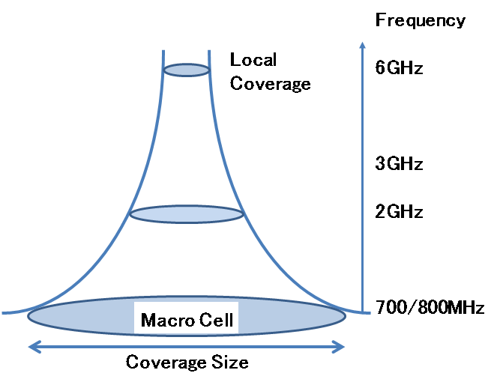
Figure 2 shows the basic concept of local coverage in comparison with conventional seamless macro coverage. Refer to section 3.2 for detailed technical properties of local coverage.
Figure 2
Basic concept of local coverage
Seamless Coverage
Three deployment cases of local coverage
Seamless macro cell
(Case 1)
Isolated coverage
(Case 3)
Overlapping coverage
(Case 2)
Adjacent coverage
Table 1 provides a comparison between seamless macro cell and local coverage.
TABLE 1
Comparison of macro cell and local coverage
 | Macro cell | Local coverage
Seamless coverage | Supported | Optional
Positioning of coverage | Adjacent or overlapping without coverage gap | Isolated/adjacent/overlapping
Mobility | Supports high mobility | Nomadic or low mobility
Handover | Supports seamless handover | Optional

3.2 Technical properties of local coverage
Broadband wireless access (BWA) systems employing radio interface standards in Recommendation ITU-R M.1801 operate in the bands below 6 GHz. Due to radio propagation characteristics, conventional macro-cell radio access networks have been deployed mainly in the bands below 3 GHz.
As discussed in section 3.1, propagation losses at higher frequencies are generally greater than at the lower frequencies typically used for macro-cell deployments. This Report addresses three categorized deployment cases of local coverage for BWA systems operating in 3 GHz to 6 GHz. Their implementation and feasibility will depend upon the resolution of technical challenges and compliance with national and ITU Radio Regulations.
The technical properties of local coverage should be analyzed for the study of effective operation of local coverage in deployment of BWA systems in bands below 6 GHz. The following properties should be taken into consideration:
(1) Characteristics of coverage
– Propagation losses at higher frequencies are generally greater than at the lower frequencies typically used for macro-cell deployments
– Local coverage may be provided by a low transmit power and low antenna height base station (so-called low power and low tower).
– Local coverage areas may be isolated in some cases such as indoor coverage with sufficiently large penetration loss by building walls.
– The size of coverage has not been rigidly defined for local coverage, which may include indoor pico cell, hot spots, access points of radio local area networks, outdoor pico cell or equivalent coverage.
– Local coverage does not assume seamless and full coverage for wide area.
– Local coverage allows coverage gap as mutual positioning of coverage may be isolated, adjacent or overlapping.
– Such isolated local coverage may be operated with minimal interference to and from other cells.
– Where macro cell coverage is already available, local coverage can provide additional localized capacity in different frequencies. This, however, does not preclude the use of local coverage without a macro cell.
(2) Usage of local coverage
– Local coverage is intended to provide broadband wireless access for a limited area which may have very high density traffic demands.
– Such local coverage is mainly deployed in urban areas or for indoor usage.
– Local coverage is used mainly for nomadic and low-mobility operation for both indoor and outdoor coverage, as local coverage is not intended for seamless wide area coverage.
– Applications of local coverage focuses on high-efficiency broadband mobile data transmission in a limited area rather than seamless coverage for wide areas. Therefore, seamless handover capabilities are optional for local coverage.
– Mobility management functions of high complexity for macro-cell mobile systems are not necessarily required.
– The operational guidelines in this Report are not intended for a specific wireless access technology.
(3) Use of frequency bands
– Local coverage may share the same frequency bands with other neighbouring local coverage. Local coverage may be deployed in licensed and/or license-exempt frequency bands.
– It is not assumed that local coverage shares the same frequency band with a macro-cell, which is overlapping with local coverage. Operation of local coverage is therefore primarily intended for frequency bands higher than macro-cell frequency bands, which does not exclude the case that lower frequency band is used for operation of local coverage.
– Sufficiently large and contiguous bandwidth, when available, could be used for such local coverage in order to provide large transmission capacity and high throughput for typical broadband mobile applications. Higher frequencies, where large and contiguous bandwidths may be available, could be especially suitable for this type of large bandwidth local coverage.

3.3 Deployment cases of local coverage
Different from macro cell for seamless coverage, local coverage may be deployed in various ways due to its technical properties. Deployment of local coverage can be categorized into the following three cases in Fig. 3.
Figure 3
Three deployment cases of local coverage
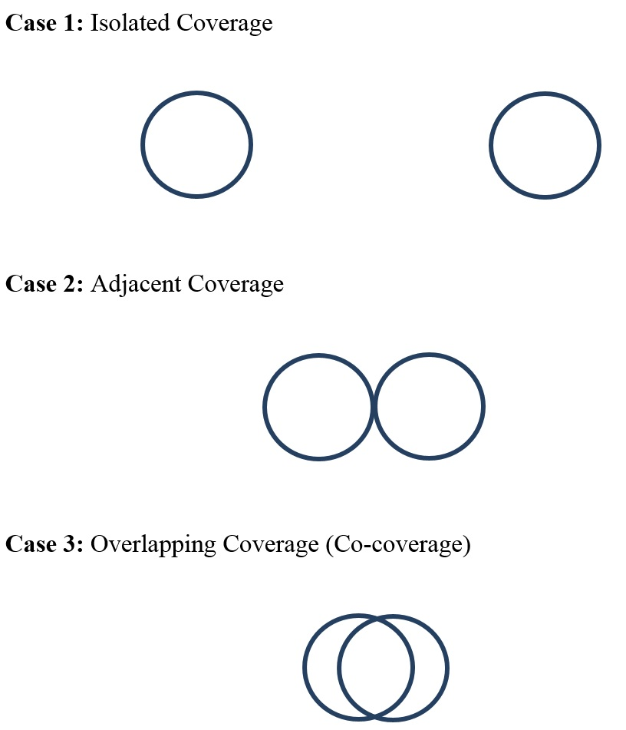
As local coverage has limited area coverage, mutual interaction between nearby local coverage areas depends on relative positioning of coverage as shown in the above three cases.
In Case 1, two local coverage areas are isolated from each other. Figure 4 illustrates examples of isolated local coverage. Isolation between them is large enough to permit the disregard of interference from other local coverage radio stations operating in neighbouring local coverage areas. This implies that each of the coverage areas may be operated independently without any limitations to protect and to coordinate with each other. This may lead to the more efficient use of a given frequency band and more flexible operation of RAN systems. For example, two different radio access technologies may be operated in adjacent sub-bands without any guard band if the adjacent sub-bands are used in a pair of isolated local coverage areas respectively. Due to very little inter-coverage interference, the radio link design in Case 1 is generally free from transmission impairment by inter-network interference.
Figure 4
Examples of isolated local coverage
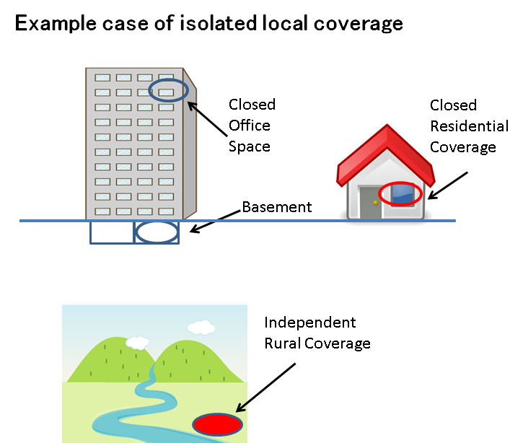
Example cases of isolated local coverage
In Case 2, two local coverage areas are adjacent to each other. There exists loose coupling between the adjacent coverage areas. As the edges of the coverage areas are in contact with each other, inter-coverage interference is observed only around the cell edge. The operation of adjacent coverage areas is not as flexible as in Case 1.
In Case 3, two local coverage areas overlap with each other. Interference is inevitable in the overlapping area. For Case 3, operational limitations would apply because of the co-coverage area. Thus, inter-network interference is a dominant transmission impairment factor in the radio link design in Case 2 and Case 3.

3.4 Use cases and categories
In general, broadband wireless access systems have been used for wide variety of applications, which include but are not limited to the following use cases.
– Local access to fixed broadband (corporate network and consumer network).
– Traffic offloading from mobile data networks.
– Outdoor hot spot.
– Public facilities (railway stations, airport, stadium, conference hall, etc.).
– Indoor local access (office LAN and home network).
– Pico-cell and hot spots.
– Occasional use for a big event.
– Emergency applications.
Local coverage may be used for both indoor and outdoor coverage. Indoor coverage may be provided for public space (e.g., airport, station), office areas, or residential areas. The use of local coverage may also be categorized into two types. The first type is closed access by limited users such as telecommunication network service subscribers and registered users for both corporate and consumer applications. The second type is open access for public users.
Local coverage may be used as a general means for use cases which may be categorized as follows:
– Gap filler for macro cell
– Traffic offloading from other mobile networks (particularly for high density traffic)
– Local access to broadband networks
– Others (e.g., emergency operation, occasional use, isolated rural area coverage, ship/aircraft).
In these general use cases, a specific radio access standard is not assumed and any BWA systems employing radio interface standards in Recommendation ITU-R M.1801 could apply. These use cases may be summarized in accordance with the above discussed categories as shown in the following Table.
TABLE 2
Use cases
Usage | Indoor | Outdoor
Gap filler for macro cell | Hot spots | Pico cell
Traffic offloading from other mobile networks | Pico cell / RLAN  for residential / enterprise / factory / public facility* | Pico cell / RLAN (low mobility)  for hotspot / public facility*  for visitor to enterprise / public Facility*
Local access to broadband networks | Pico cell / RLAN  for residential / enterprise / factory / public facility* | Pico cell / RLAN (low mobility)  for hotspot / public Facility*  for visitor to enterprise / public Facility*
Others (emergency, occasional, rural, ship/aircraft) | Pico cell / RLAN  for occasional big event  for train / ship / aircraft | Pico cell / RLAN  for occasional big event(Nomadic)  for station / port / airport
* e.g. Sports Stadium, Conference hall, others.

These use cases described in Table 2 cover a number of generic uses of local coverage, which may fall under the categories of operational scenarios defined in section 4.

3.5 Scope and subjects of the studies
In section 2.1, the definition of local coverage was first provided, for which the detailed technical characteristics were presented in section 3.2. Taking into consideration these technical characteristics of local coverage, the study in this Report intends to analyze effective use of spectrum and flexible ways of operating local coverage. The study is based on the technical characteristics of local coverage as summarized in the following Table.
TABLE 3
Technical characteristics of local coverage
Item by layer | Description
Physical transmission | – Coverage for local coverage areas rather than seamless coverage for wide areas  – Coverage for outdoor and indoor use.  – Example use cases: Cellular hot spots and RLAN.  – Type of Coverage:  • isolated;  • edge connecting to adjacent one(s);  • overlapping coverage with adjacent one(s).  – Interference from other networks is negligible in radio link design for the isolated coverage.  – Inter-network interference is dominant in radio link design for the overlapping coverage
Shared access | – Independent channel assignment control by a base station.  – Coordinated channel assignment control by multiple base stations.  – Frequency/time division multiple access for the shared use by sensing  prior to transmission on a channel.  Frequency sharing arbitrated by a sharing mechanism (e.g. database).  – Dedicated use of a frequency band or sub-band by a single network (as in licensed bands)  – Shared use of a frequency band or sub-band by multiple networks  – Shared use of a frequency band or sub-band by a single RAT  – Shared use of a frequency band or sub-band by multiple RATs  –
Network control | – Network control and management within a single RAN.  • Authentication and access admission control  • Monitoring of operational status, network performance and quality  – Coordinated network control among base stations of the same network.  – Coordinated network operation by a centralized or distributed control.  • With or without handover between local coverage areas  • With or without integrated and coordinated operation with macro coverage  • Options for heterogeneous network operation and interworking.  – Coexistence of multiple RATs under certain conditions.

Based on the given technical characteristics, the following subjects are studied for operation of local coverage in this Report.
– Technical analysis of local coverage.
– Operation models of local coverage.
– Flexibility in use of frequency bands for local coverage.
– Operational conditions and management scheme for local coverage.
– Technical and functional capabilities for flexible operation of local coverage (e.g., network functions, radio resource management functions, control and management functions).
It should be noted that the possibility of increasing the degree of freedom and efficiency of operation of frequency bands under certain operational conditions of local coverage may exist. The study considers operational conditions of local coverage to what extent operational flexibility may be enhanced. The objectives of the flexible and efficient operation of local coverage include but are not limited to
– Coexistence of multiple RATs
– Elimination of operational limitations on network timing synchronization
– Flexibility in TDD frame structure for partitioning uplink and downlink capacity
– Increase of overall transmission bandwidth of operational frequencies
– Assessment and reduction of operational limitations
Once flexible operational conditions for local coverage networks are identified, methodologies are then needed to detect such operational conditions and to make decisions to facilitate more flexible operation. These subjects are specific study items for operation and management of frequency bands by local coverage. To this end, the study may include operation control and management functions for the stable operation of broadband wireless systems. The operational guidelines in this Report are not intended for a specific wireless access technology. From a purely technical operational point of view, the study explores generic guidelines to enhance the use of local coverage by increasing operational flexibility for the existing wireless access framework.
The study subjects, which are discussed in sections 4 and 5, include fundamental elements of technologies as follows:
– Sensing of co-channel and adjacent channel interference.
– Decision criteria for shared operation of spectrum.
– Decision criteria for adjacent band compatibility.
– Radio network synchronization.
For these functionalities, some of the technologies described in section 3.6 may be applicable. In other cases, further study may be needed.

3.6 Currently available technologies
Some of the use case examples in section 3.4 have been already implemented, such as successful use of pico cells and small cells [1, 2]. Various radio access technologies in Recommendation
ITU-R M.1801 have also been widely deployed.
For the effective use of spectrum, various operational schemes have been studied. An example is dynamic frequency selection as found in Recommendation ITU-R M.1652. Cognitive radio is one of the most promising technologies for advanced and efficient use of spectrum. Recent studies on cognitive radio have been summarized in Reports ITU-R M.2225 and M.2330. It should be noted that spectrum sensing and signal detection are important technologies, for which a wide variety of study results have been published [3, 4, 5, 6].

4 Utilization of frequency bands for local coverage

4.1 Operational scenarios
The objective of this Report is to provide some operational guidelines for the deployment of BWA systems for local coverage in bands below 6 GHz. The deployment of local coverage can be categorized into the three cases presented in section 3.3: isolated, adjacent and overlapping. In some deployment cases of local coverage, the frequency band may be utilized in a more efficient and flexible manner. Operational scenarios have to be clearly described to analyze such flexible operation of the subject frequency band by a local coverage network. This subsection presents generic operational scenarios for modelling of operation of local coverage and for analysis of the flexible use of frequency bands. In this Report, operational scenarios are categorized into three basic types, however other categorization of scenarios, which may result from the combination of the basic types, may be possible.
The following aspects are taken into account to characterize the operational scenarios discussed in this Report.
– The operational guidelines in this Report are not intended for any specific wireless access technology.
– The Report explores generic guidelines to enhance the use of local coverage not by changing existing provisions nor by tightening operational conditions of wireless access but by enhancing flexible approaches under certain operational conditions.
– The Report on local coverage considers various operational scenarios such as a band shared by multiple networks in license-exempt band or licensed band (shown in the second row in Table 4) and a band exclusively used by a single network in licensed band (shown in the first row in Table 4).
– The Report includes operator control and management functions to ensure stable operation of broadband wireless access systems. However, it is assumed that protocols inherent in license-exempt devices would ensure efficient and effective spectrum use without additional control and management functions. Additional work may be required to validate this assumption in the event that multiple license-exempt technologies share a band.
– Migration by a single operator from one RAT to another RAT should be investigated because both may coexist in the same frequency band during a transition period.
From the viewpoint of technical and operational classification, operational scenarios are categorized as shown in the following Table.
TABLE 4
Categories of operational scenarios
 | License-exempt band | Licensed band
Dedicated use of a sub-band by a single network | N/A | Operation Scenario 1
Shared use of an entire frequency band by multiple networks | Operation Scenario 2 | Operation Scenario 3

In addition, a combination of basic scenarios may occur when the licensed band and the license-exempt band are both available.
In these scenarios, it is generally assumed that networks are operated with multiple RATs. In the case where those networks are operated by a single RAT, signal detection becomes relatively easy.
It should be noted that local coverage may be deployed for each of the operational scenarios by the following three cases.
– Case 1: Isolated local coverage areas
– Case 2: Adjacent local coverage areas
– Case 3: Overlapping local coverage areas.
In the various operational scenarios, the technical conditions for operation of local coverage are dependent on these three cases. For the modelling and analysis of local coverage operation, cases 1, 2 and 3 are studied for each of the three operational scenarios.

4.2 Modelling and analysis
The three operational scenarios in Table 4 are here considered for local coverage, for which the following technical conditions are assumed.
Assumptions for analysis:
– Local coverage areas are deployed in Cases 1 (isolated), 2 (adjacent) or 3 (overlapping) in section 3.3.
– All the local coverage areas commonly use the same frequency band under consideration.
– For the use of the subject frequency band, both segmentation into sub-bands and shared use of an entire band are considered.
– Recommendation ITU-R M.1801 contains radio interface standards based on various Radio Access Technologies. The analysis does not assume any specific RAT. Use of multiple RATs is here assumed in a frequency band under consideration. (Although it is often the case that series of sub-bands are operated by a single RAT, adjacent sub-bands may also be used for different RATs, where a guard band may be needed.)
Based on these assumptions, the three operational scenarios are investigated to analyze operational conditions for local coverage and possible relaxation.
(1) Operational Scenario 1: Dedicated use of a sub-band by a single network
in a licensed band
As shown in Fig. 5, a licensed frequency band is divided into several sub-bands, each of which is assigned for a single network for dedicated and exclusive use. Multiple Radio Access Technologies may be operated in these sub-bands.
Figure 5
Dedicated sub-bands
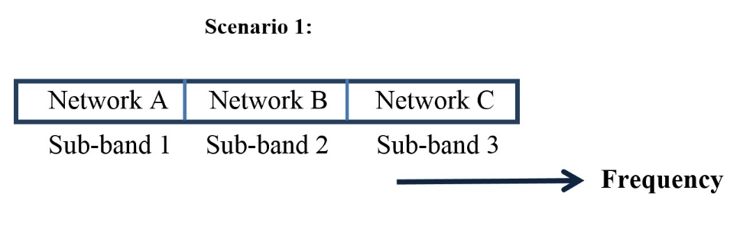
In Case 1 (isolated coverage), no mutual interaction exists. As shown in Table 5, such isolated coverage may be operated without any operational limitation for out-of-band emissions and compatibility with the adjacent sub-bands. For example (as shown in Fig. 6-1), sub-band 1 is operated by RAT X whereas sub-band 2 employs RAT Y without any need for a guard band. It should be noted that other adjacent sub-bands are left unused in this case.

Case 1: Isolated coverage
Figure 6-1
Operation Scenario 1 for case of isolated coverage
Coverage for network A
Coverage for network B

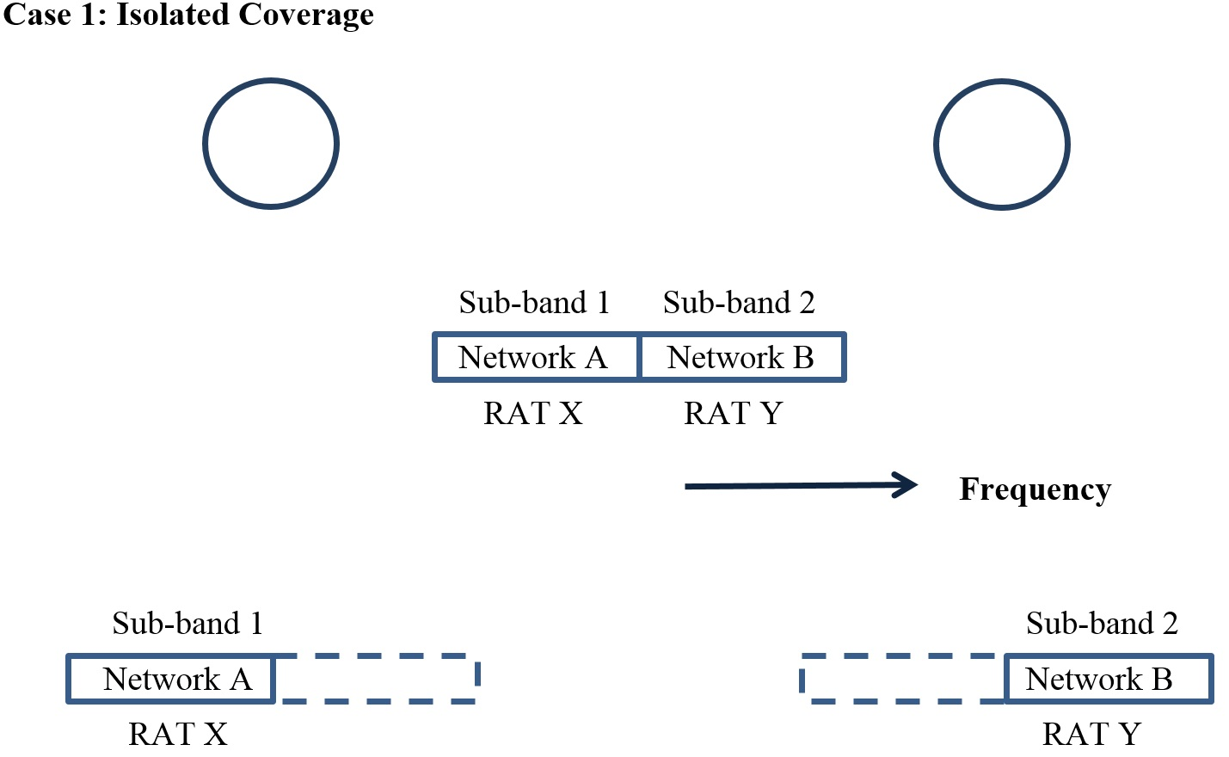
As shown in Table 5, Case 3 (overlapping coverage), some limitations on out-of-band emissions and compatibility with the adjacent sub-band are applied for operation of local coverage. In Case 2 (adjacent coverage), similar constraints may be also needed around the cell edge in contact as well. For example, as shown in Fig. 6-2, some guard band may be needed if the adjacent sub-bands are operated by two different RATs or in the event that a) unsynchronized TDD systems or b) a mix of TDD and FDD systems are present. On the other hand, it may be possible to remove such a guard band if the adjacent sub-bands are operated by the same RAT.
For the cases 2 and 3, further study may be needed as follows.
– Appropriate criteria to operate each sub-band by multiple RATs for local coverage.
– Coordination between adjacent sub-bands operated by different networks.

Case 2: Adjacent coverage or Case 3: Overlapping coverage
Figure 6-2
Operation Scenario 1 for adjacent or overlapping coverage
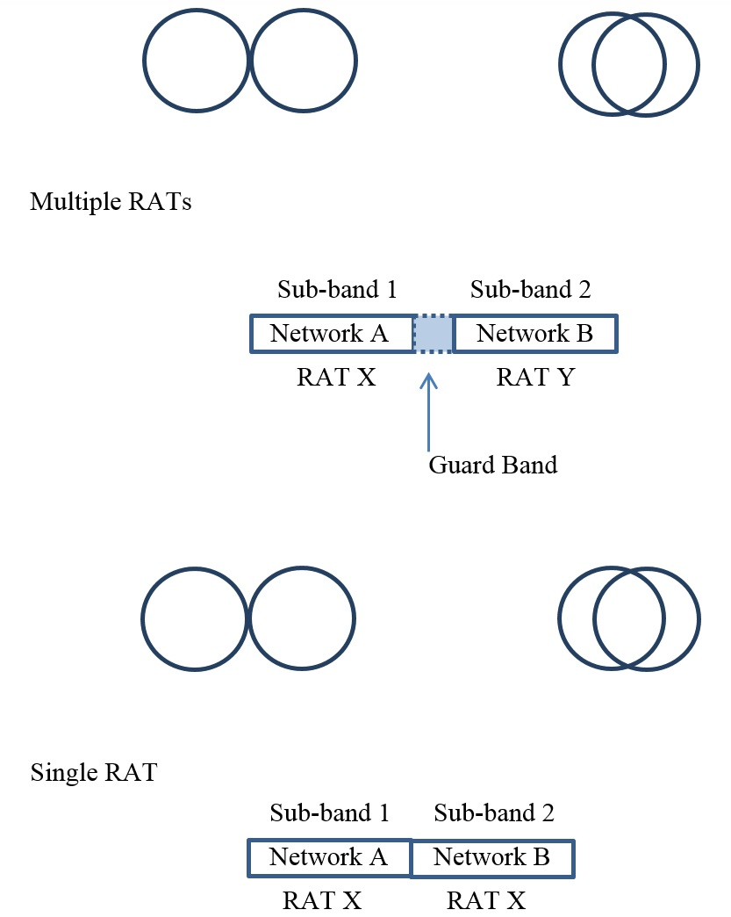
Coverage for NW-A NW-B
Coverage for NW-A NW-B
Coverage for NW-A NW-B
Coverage for NW-A NW-B
(2) Operational Scenario 2: Shared use of an entire frequency band by multiple networks in a license-exempt band
The entire band of a subject license-exempt frequency is used by multiple networks for shared operation as shown in Fig. 7. The investigation should assume not only shared operation by a single RAT but also shared operation allowing multiple RATs.
Figure 7
Shared band
Scenario 2
Networks A, B, C
Frequency
In Case 1, the entire frequency band may be operated by a single network for each instance of isolated local coverage without any other operational limitations. Operation is feasible for a pair of isolated coverage areas by either a single RAT or multiple RATs as mutual interaction can be disregarded between isolated local coverage areas. Figure 8-1 illustrates operation of multiple RATs in isolated coverage.
It should be noted that the entire frequency band is operated by a number of BWA carriers on a shared basis under certain sharing control mechanisms.

Case 1: Isolated coverage
Figure 8-1
Operation Scenario 2 for isolated local coverage
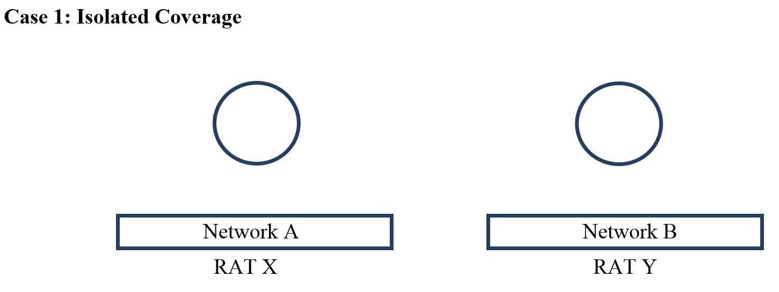
Coverage for network A
Coverage for network B

For Case 3 (overlapping coverage), the frequency band is shared by multiple networks. As shown in Table 5, a sharing control mechanism between the networks would facilitate sharing. This may also apply to Case 2 (adjacent coverage) around the contact edge of coverage. Multiple networks may employ the same RAT in some cases or may operate multiple RATs in other cases. Figure 8-2 illustrates operation in adjacent or overlapping coverage. A sharing control mechanism would facilitate sharing not only for the case of a single RAT but also among multiple RATs.
For these cases of shared operation by networks of multiple RATs for adjacent coverage or overlapping coverage in Cases 2 and 3, further study may be needed in the following areas:
– Mechanisms of frequency selection and interference avoidance not only within a single RAT but also among multiple RATs.
– Carrier sensing prior to start of transmission.

Case 2: Adjacent coverage or Case 3: Overlapping coverage
Figure 8-2
Operational Scenario 2 for adjacent and overlapping coverage
Coverage for NW-A NW-B
Coverage for NW-A NW-B
Networks A, B
RATs X, Y
Networks A, B
RAT X
In the case of shared operation of multiple networks using a single RAT (Fig. 8-2), sharing control is relatively easy as coherent signal detection may be applicable. The complexity may be higher for sharing control for operation of multiple networks using multiple RATs with heterogeneous characteristics as signal detection may have to rely on power sensing. It is assumed that when multiple license-exempt RATs share spectrum, common sharing protocols such as listen before talk would be employed, thus limiting complexity.
(3) Operational Scenario 3: Shared use of an entire frequency band by multiple networks in a licensed band
Operation of a licensed band for shared use is generally similar to the shared operation of license-exempt band in Scenario 2. Methodologies to support operation of Scenario 2 therefore may be applicable to Scenario 3 as well. It should be noted that the number of operating networks in a licensed band (Scenario 3) is limited and known whereas the number of networks sharing the license-exempt band (Scenario 2) is uncertain. Moreover, the detailed technical parameters and location of radio stations are generally known for the networks operated in a licensed band. In the case of license-exempt band operation, the existence of a common sharing mechanism allows multiple RANs to function properly for adjacent coverage in Case 2 and overlapping coverage in Case 3. As the number of RANs and their technical parameters are known for the licensed band, coordination and sharing mechanism should take advantage of such technical information.

4.3 Operational requirements
The modelling and analysis in the previous sub-section shows that technical characteristics to be considered in operation of local coverage vary significantly depending on combinations of deployment cases and operational scenarios. Operational requirements for combinations of deployment cases and operational scenarios are indicated by technical conditions for operation of local coverage in each operational situation. The following table summarizes the technical conditions for operation of local coverage. These technical conditions have been directly derived

from the results of analysis in the previous section 4.2. These technical conditions are intended for consideration as operational requirements to take full advantage of flexibility in operation of local coverage.
TABLE 5
Technical conditions for operation of local coverage in various situations
Combination of operational situations of local coverage | Scenario 1 | Scenario 3 | Scenario 2
 | Licensed frequency band |  | License-exempt frequency band
 | Dedicated Sub-bands | Shared band
Case 1  Isolated local coverage areas  (No interaction between local coverage areas) | Out-of-band emission limits not necessary for adjacent sub-band | Full use of the entire frequency band by any single RAT without sharing limitations with other networks.
Case 2  Adjacent local coverage areas  (Interaction around local coverage area boundary) | Possible limitation on out-of-band emissions and compatibility with the adjacent sub-band | Shared use of the frequency band by multiple networks (Sharing control mechanism would facilitate use by a single RAT and also multiple RATs.)
Case 3  Overlapping local coverage areas  (Interaction in the overlapping local coverage area) | Possible limitation on out-of-band emissions and compatibility with the adjacent sub-band | Shared use of the frequency band by multiple networks (Sharing control mechanism would facilitate use by a single RAT and also multiple RATs.)
Note: Each case in Scenario 1 is deployed for a single network in each sub-bands.

As summarized in the table, the analysis of operational scenarios shows some possibilities for increasing the degree of freedom in technical conditions for operation of local coverage in certain deployment cases. The following charts in Fig. 9 indicate a process of determining possible technical conditions for the operation of local coverage in various situations.

Figure 9
Process of determining possible technical conditions

(1) Operational Scenario 1: Licensed & Dedicated sub-bands
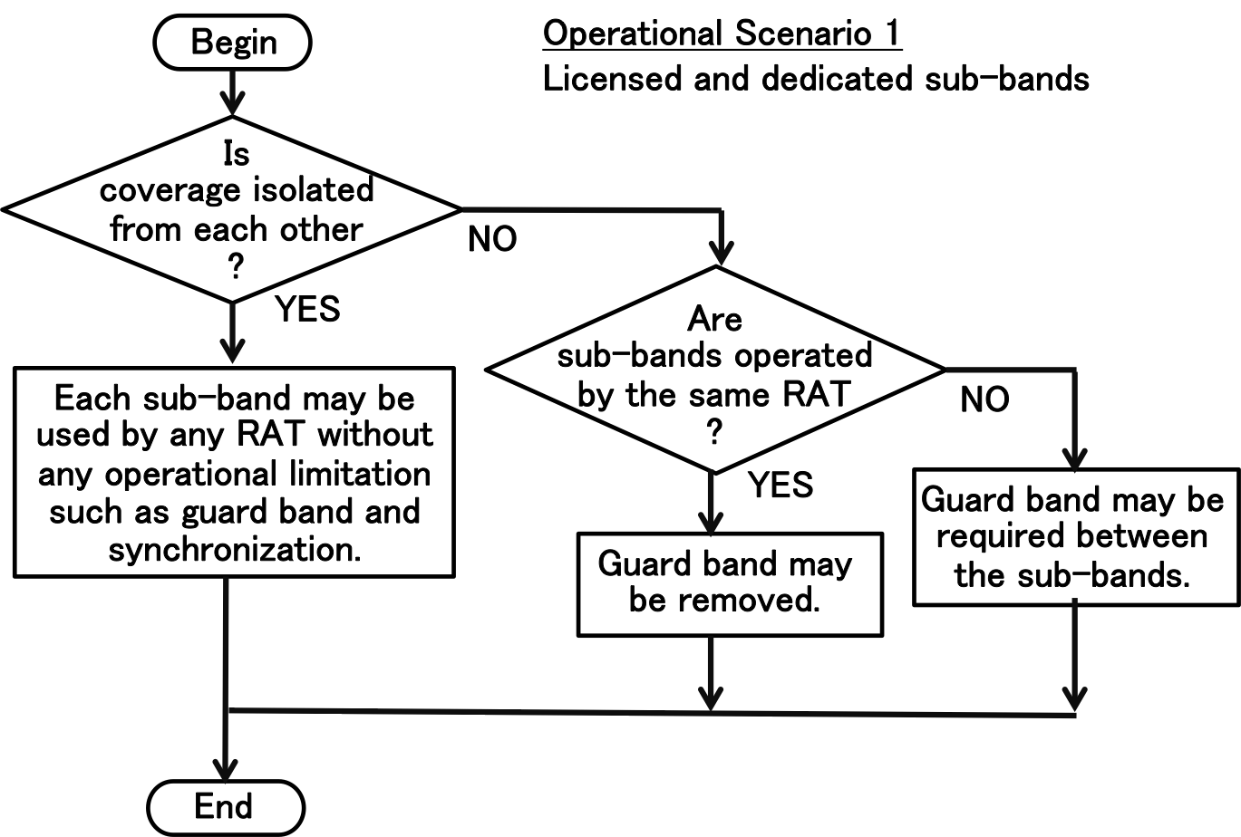

(2) Operational Scenarios 2 and 3: Shared band
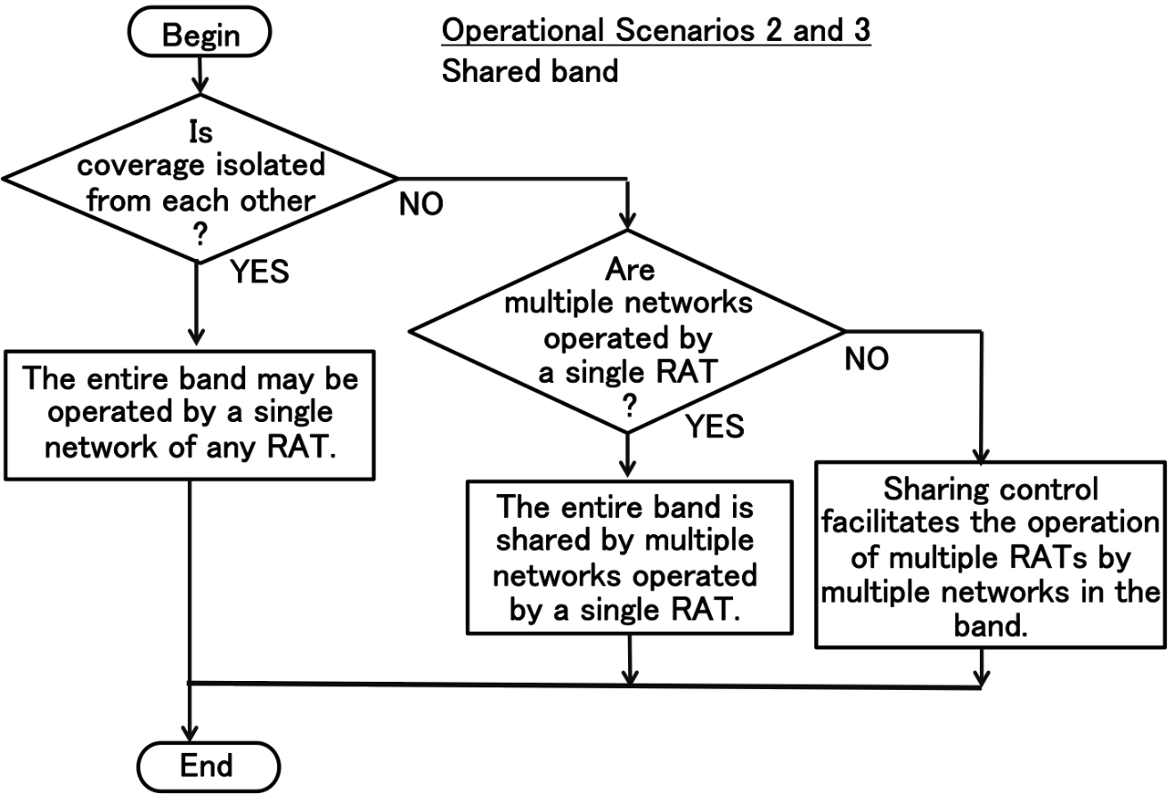

Note: RATs of TDD systems operating with different frame structures are considered as different RATs in this figure.

5 Functional requirements for flexible operation of local coverage.

5.1 Technical capabilities for network operation and management of local coverage
Technical conditions to be considered for the operation of local coverage are dependent on various combinations of operational scenarios and deployment cases of local coverage as summarized in section 4.3. In accordance with Table 5, an appropriate technical condition may be found for operation of local coverage in each combination of deployment cases and operational scenarios of local coverage. As technical conditions for the operation of local coverage vary, the possibility of increasing flexibility in operation exists, particularly when local coverage areas are isolated from each other. Such flexibility in operation will contribute to effective use of local coverage and efficient use of spectrum.
The possible advantages of flexible operation include multi-RAT operation and a larger degree of freedom in the use of frequency band, network synchronization and TDD frame structure.
An appropriate technical condition should be found for a given operational situation of local coverage to enjoy the advantages of flexible operation of local coverage in accordance with Table 5. For this purpose, the following three technical capabilities are applicable:
1) Detection of deployment cases of local coverage to determine whether the coverage is Isolated / Adjacent / Overlapping
2) Decision to identify technical conditions for operation of local coverage in accordance with Table 5. (Detailed technical conditions for operation of the BWA system may be derived accordingly for each specific situation of local coverage.)
3) Operational control and management of the BWA system in accordance with the technical conditions decided in above 2)
Technical capabilities 1) and 2) are necessary to determine the most suitable technical conditions for operation of local coverage as summarized in Table 5 for a given operational situation. Technical capability 3) supports network operation and management for each BWA system for the given operational scenarios.

5.2 Functional requirements for technical capabilities
The three technical capabilities 1), 2) and 3) described in section 5.1 can be provided by fundamental technical functions commonly used for radio resource management and network operation control. Each technical capability can be implemented by a set of basic functions. The following subsections provide more detailed information regarding each technical capability into basic elements of these functional requirements.

5.2.1 Functional requirements to implement technical capability 1)
– Radio signal sensing and detection of nearby radio stations of other RANs (for detection of co-channel interference and usage of adjacent channels) [3], [4], [5], [6].
– Monitoring of radio spectrum and radio resource usage for operation of RAN (own RAN and other RANs sharing the same frequency band)
– Monitoring of radio channel quality
The first two functional requirements are used to determine whether the coverage is Case 1 (isolated), Case 2 (adjacent) or Case 3 (overlapping). The monitoring of radio channel quality is used to improve reliability of the determination.
These functional requirements to support these technical capabilities are implemented at the base station: support of the functionality at the mobile stations would improve the accuracy and reliability of the determination, particularly around the edge of local coverage.

5.2.2 Functional requirements to implement technical capability 2)
– Monitoring of radio spectrum and radio resource usage for operation of RAN (own RAN and other RANs sharing the same frequency band)
– Control of frequency channel selection and assignment
– Monitoring of radio channel quality
It is assumed that these functional requirements are provided at each base station. As the result of functional capability 1), the most suitable technical condition for operation of BWA system is determined based upon the identified combination of deployment case and operational scenario of local coverage in Table 5. Appropriate options and parameters may then be selected for the use of the frequency band such as guard band requirements, network synchronization and TDD frame structure. The first two functional requirements then provide a means of control and management of operation satisfying the given technical condition. The third functional requirement is optional: it provides support for the first two functional requirements by increasing accuracy.

5.2.3 Functional requirements to implement technical capability 3)
(1) Radio resource management functions
– Channel assignment control
– Access admission control of mobile terminals by base station
– Collection of monitoring data for radio resource usage and quality (optional)
– Transmit power adjustment (optional)
– Priority control for radio resource assignment (optional)
(2) Network control and management functions
– General network control and management functions for operation of BWA system
– Collection of monitoring data for network operation status and health check (optional)
These functional requirements are commonly implemented in existing BWA systems. It is assumed that these functional requirements have been provided by the existing BWA systems, for which appropriate options and parameters are selected in accordance with the functions in section 5.2.2. Depending on BWA systems, some functions are optional. These functional requirements are provided mainly by base stations, with which mobile terminals operate in accordance with BWA system standards.

5.3 Analysis and implementation of functional requirements

5.3.1 Analysis of functional requirements for technical capabilities 1) and 2)
The functional requirements for technical capabilities 1) and 2) may be implemented in various ways of radio resource management, depending on operational situations of local coverage. The functional requirements and their implementation are analyzed for technical capabilities 1) and 2) as follows for typical operational situations.
For implementation of technical capability 1), special attention should be paid to the functional requirement for radio signal sensing and detection of nearby radio stations of other RANs (for detection of co-channel interference and usage of adjacent channels) [3], [4], [5], [6]. For such inter-system radio signal sensing and detection, it should be noted that two cases exist, namely single-RAT case and multi-RAT case. Radio signal sensing and detection is easier for the single-RAT case as coherent detection is applicable in many cases. For the multi-RAT case, it is generally necessary to rely on incoherent detection by power sensing, whereas coherent detection may be possible for some special cases [7], [8].
It should be noted that the requirements may differ between licensed band and license-exempt band.
Licensed frequency band
– For licensed band operation, pre-operational coordination is applicable because the detailed technical information is generally known (e.g. databases in some cases as described in Table 3) for radio stations, such as system parameters and location of radio stations.
– In the case of local coverage in licensed frequency bands, inter-system coordination between network operators could be possible by applying existing management and control functions for the technical capabilities 1) and 2).
– For technical capability 1), basic sensing and detection functions are generally applicable for a case of dedicated use of a sub-band.
– Based on the determination of applicable deployment cases (i.e. isolated/adjacent/ overlapping), appropriate options and parameters are selected for guard-band requirements, synchronization and TDD frame structure formatting for technical capability 2). Channel assignment control can then be accordingly adjusted.
– Such coordination may be carried out initially by a manual and off-line process as a pre-operation planning. This process may be supported by existing functions.
– an automatic process may be developed for such coordination to some extent. This automatic process may require new additional functions. For automatic control, advanced mechanisms such as cognitive radio may be effective.
– For a dynamic and automatic coordination process, new advanced methodologies are needed for monitoring and control, such as carrier signal sensing and frequency channel selection control. To this end, application of cognitive radio technologies is highly expected [3], [4], [5].
– Adaptive beam forming at the base station is another promising technology for interference mitigation among adjacent local coverage areas so as to create isolated coverage. For example, it is very effective if a detected deployment Case 2 may be adjusted to Case 1 by adaptive beam forming.
In the case of shared use of the frequency band, the following description for license-exempt band generally applies. It should here be noted that other RANs sharing the same frequency band are known in the case of licensed frequency band.
License-exempt band
– For operation in license-exempt bands, pre-operational coordination is applicable in a manner similar to licensed frequency band operation when the detailed technical information of widespread radio interface technologies is known. It may be possible to utilize system parameter information such as bandwidth and transmission timing for radio signal sensing and detection of nearby radio stations of other RANs.

– License-exempt equipment generally assumes shared use of frequency band with other RANs. Existing control and management functions therefore include basic carrier sensing and channel assignment control capability. In the case of local coverage by license-exempt equipment, existing control and management functions may implicitly provide the necessary capabilities without additional requirements.
Technical capability 1) may be implicitly provided by existing carrier sensing mechanisms. Technical capability 1) can be further enhanced by fully utilizing the existing control and management capabilities for radio resource management in technical capability 3).
– New additional management mechanisms may facilitate inter-system coordination for technical capabilities 1) and 2). A dynamic and automatic mechanism could facilitate the determination of whether the local coverage is isolated, for example, by signal sensing. For such explicit control, additional functions may improve management performance.
– For isolated coverage in Case 1, only one network occupies a frequency band without inter-system sharing. In this case, the frequency band may be used in the most preferable way for the network by optimizing the operation management algorithm and its parameters.
– In the case of isolated local coverage, the frequency band can be used by a single network without any sharing conditions with other networks. The technical capability 2) therefore is not necessarily required. If needed, the sharing control may be further optimized only for intra-network sharing.
– In the case of adjacent or overlapping local coverage, the existing sharing control mechanism may be applied without explicit implementation of the technical capabilities 1) and 2) as the existing sharing control mechanism may include such functionality.
– For shared use of a frequency band by local coverage, multiple networks should operate by inter-system radio signal sensing and detection for Cases 2 and 3. For a single-RAT case, coherent detection is applicable in many cases for radio signal sensing and detection. For a multi-RAT case, incoherent power sensing is generally used as coherent detection is applicable in special cases only.
Advanced spectrum usage
– As an advanced operational scenario in which a combination of operational scenarios is considered, it may be possible to utilize technical information among multiple networks. For example, a licensed band can be used by each network and the license-exempt band can be shared by multiple networks with different RATs. Signal detection and database can be used to provide detailed technical parameters and location of radio stations which can facilitate operation of multiple networks in the license-exempt band.

5.3.2 Analysis of functional requirements for technical capability 3)
With regard to network management functions, it is first assumed that existing control and management functions generally cover functional requirements for technical capability 3). For this network management, existing operation management and control functions are generally applicable without additional functional requirements or modifications. Appropriate options and parameters are selected in accordance with the outcome of technical capability 2) to operate each RAN in the most advantageous way for local coverage operation. Each RAN is operated under given operational conditions according to the operational guideline for local coverage.
Basic functions for both base stations and mobile terminals are summarized in this section for such network control and management functions. In the case of multi-RAT operation, each RAN may be operated by its own network control and management functions.
It is generally assumed that monitoring functions are implemented for both base station and mobile terminals. Control and management functions are basically implemented in each base station and mobile terminals operate under the control of the base station. In the case of distributed control, some control functions may also be implemented at each mobile terminal as well. Dynamic channel assignment is generally assumed rather than pre-assigned channels. The frequency channel selection and assignment function should be properly adjusted for shared use of a frequency band in accordance with the outcome of technical capability 2). In general, multiple RANs for shared operation may use multiple RATs as well as a single RAT.
For local coverage operation, existing RAN systems generally provide the following basic network operation and management functions. In existing RAN systems, some of them are optional. It is assumed that these functions are implemented within a single RAN.
– Monitoring of operational status for base stations and mobile stations.
– Monitoring and management of transmission performance of base station and mobile station.
– Identification and management of mobile stations under control of each base station.
– Collection of monitoring data from mobile stations for control functions of base station.
– Access admission control for mobile station by base station to maintain sufficient throughput per user.
– Authentication process for mobile station by base station.
In addition, the following management and control functions are useful for the operation of a RAN. These functions are generally optional.
– Transmit power control for base station.
– Transmit power control for mobile station by base station.
– Priority control of radio resource assignment for delay-sensitive traffic.
– Monitoring and management of traffic loading of base station and mobile station.
– Integrated implementation of radio resource management functions through capabilities of cognitive radio technologies [3], [4], [5], in conjunction with utilization of methods such as spectrum access databases and sensor devices.
For operation in licensed bands, network management control may include the following functions for some operational cases. For operation in license-exempt bands, these functions are optional.
– Monitoring of the mobile station operational conditions by the base station.
– Initiation of the mobile station operation by the base station.
– Forced termination of mobile station operation by the base station.

6 Conclusion
This Report presents the concept of local coverage for efficient and flexible operation of BWA systems.
To analyze the specific concept in detail, it was first defined and then its technical properties were presented along with use cases. Deployment cases of local coverage were categorized into three types, namely isolated, adjacent and overlapping. Use of frequency bands was grouped into three operational scenarios considering both dedicated sub-bands and shared use of spectrum. Each of the three operational scenarios was analyzed in detail to investigate the possibility of enhancing operational flexibilities. For each of the combinations of deployment cases and operational scenarios, operational conditions were clarified by identifying technical conditions for guard band requirements, multi-RAT operation, network synchronization and so forth. Some possibilities have been presented for increasing operational flexibility and efficiency of BWA systems in certain operational conditions such as isolated local coverage.
The results of the analysis were summarized in a table of operational conditions to support the operation of BWA systems in local coverage which may increase operational flexibility and efficiency of spectrum usage. These operational conditions are generally applicable irrespective of RATs.
Three technical capabilities were presented to take maximum advantage of the operational flexibility in the operational conditions. A set of functional requirements was indicated to implement each technical capability. These functional requirements were analyzed for typical operational situations. More elaborated approaches may be possible when new technologies such as those employed by Cognitive Radio Systems are made available for implementation of the functional capabilities.
It has been demonstrated that flexibility is enhanced for operation of BWA systems in local coverage in the isolated case, where local coverage areas are free from mutual interaction.
Though conventional radio resource management for frequency sharing will be still needed for overlapping cases, there will be some possibility of improving flexibility in adjacent cases by utilizing advanced technologies such as adaptive beam forming control to reduce mutual interaction.
References
[1] Vikram Chandrasekhar, et al.: “Femtocell Networks: A Survey”, IEEE Communications Magazine, pp. 59-67, September 2008.
[2] Jeffrey G. Andrews, et al.: “Femtocells, Past, Present, and Future”, IEEE J. on Selected Areas in Communications, Vol. 30, No. 3, pp. 497-508, April 2012.
[3] Tevfik Yucek and Huseyin Arslan: “A survey of spectrum sensing algorithms for cognitive radio applications”, IEEE Communications Surveys & Tutorials, Vol. 11, No. 1, pp. 116-130, First Quarter 2009.
[4] Amir Ghasemi and Elvino S. Sousa: “Spectrum sensing in cognitive radio networks: Requirements, Challenges and Design Trade-offs”, IEEE Communications Magazine, pp. 32-39, April 2008.
[5] Kanshiro Kashiki et al.: “Analytical study for performance evaluation of signal detection scheme to allow the coexistence of additional and existing radio communication systems”, IEICE Transactions on Communications, Vol. E97-B, No. 2, pp. 295-304, February 2014.
[6] Bodhisatwa Sadhu et al.: “Building an On-Chip Spectrum Sensor for Cognitive Radios”, IEEE Communications Magazine, Vol. 52, No. 4, pp. 92-100, April 2014.
[7] 3GPP TS 36.133 version 12.5.0 Release 12, LTE; Evolved Universal Terrestrial Radio Access (E-UTRA); Requirements for support of radio resource management, November 2014.
[8] N. Montavont et al.: “On the Selection of Scanning Parameters in IEEE 802.11 Networks”, Personal Indoor and Mobile Radio Communications (PIMRC), 2013 IEEE 24th International Symposium on 2013, pp. 2137-2141.
______________

In the context of this Report, Broadband wireless access (BWA) systems refers to the systems operating in the land mobile service between 30 MHz and 6 GHz. For the BWA systems including IMT, radio interface standards are defined in Recommendation ITU-R M.1801.
This Report is intended to be technology-neutral and is not intended to promote any applicable Radio Access Technology (RAT), which in this Report refers to the implementation of one of the BWA radio interface standard among those found in Recommendation ITU-R M.1801.
This Report is not intended to address any regulatory issues including the identification of suitable frequency ranges for BWA systems nor to require any changes to Recommendation ITU-R M.1801 in order to support functional requirements. Frequency sharing with other services is out of the scope of this study. Notwithstanding, sharing mechanisms may be necessary if local coverage is deployed in a license-exempt or shared-access band.
The extent to which the local coverage deployment scenarios will be implemented depends upon compliance with national and ITU Radio Regulations.

