Report ITU-R M.2414-0
(11/2017)
Performance measurements of interference into one example of a Radar operating under the aeronautical radionavigation service in the frequency
band 2 700-2 900 MHz

M Series
Mobile, radiodetermination, amateur
and related satellite services

Foreword
The role of the Radiocommunication Sector is to ensure the rational, equitable, efficient and economical use of the radio-frequency spectrum by all radiocommunication services, including satellite services, and carry out studies without limit of frequency range on the basis of which Recommendations are adopted.
The regulatory and policy functions of the Radiocommunication Sector are performed by World and Regional Radiocommunication Conferences and Radiocommunication Assemblies supported by Study Groups.

Policy on Intellectual Property Right (IPR)
ITU-R policy on IPR is described in the Common Patent Policy for ITU-T/ITU-R/ISO/IEC referenced in Annex 1 of Resolution ITU-R 1. Forms to be used for the submission of patent statements and licensing declarations by patent holders are available from http://www.itu.int/ITU-R/go/patents/en where the Guidelines for Implementation of the Common Patent Policy for ITU-T/ITU-R/ISO/IEC and the ITU-R patent information database can also be found.

Series of ITU-R Reports
(Also available online at http://www.itu.int/publ/R-REP/en)
Series | Title
BO | Satellite delivery
BR | Recording for production, archival and play-out; film for television
BS | Broadcasting service (sound)
BT | Broadcasting service (television)
F | Fixed service
M | Mobile, radiodetermination, amateur and related satellite services
P | Radiowave propagation
RA | Radio astronomy
RS | Remote sensing systems
S | Fixed-satellite service
SA | Space applications and meteorology
SF | Frequency sharing and coordination between fixed-satellite and fixed service systems
SM | Spectrum management

Note: This ITU-R Report was approved in English by the Study Group under the procedure detailed in Resolution ITU-R 1.

Electronic Publication
Geneva, 2018
© ITU 2018
All rights reserved. No part of this publication may be reproduced, by any means whatsoever, without written permission of ITU.

REPORT ITU-R M.2414-0
Performance measurements of interference into one example of a Radar operating under the aeronautical radionavigation service in the frequency
band 2 700-2 900 MHz
(2017)
Scope
This document reports the measured radar receiver performance of an example airport surveillance radar that operates in the 2 700-2 900 MHz frequency band. Tests were conducted in the presence of various pulsed interference waveforms and a generic continuous interference waveform.
Glossary
ASR Airport surveillance radar
CFAR Constant false alarm rate
IF Intermediate frequency
I/N Interference power over noise power
LFM Linear frequency modulated
P_{D} Probability of detection
PPI Plan position indicator
STC Sensitivity time control
TSG Target signal generator

1 Introduction
The purpose of this Report is to collect the results of airport surveillance radar (ASR) performance testing and the process used to determine performance degradation thresholds for pulsed-interference waveforms. Each ASR interference degradation threshold is determined as a function of the interference effective pulsed duty cycle and the pulsed interference-to-noise (I/N) ratios in dB.
This Report is organized as follows:
– ASR system description.
– Test scenarios: pulsed-interference.
– Test setup and calibration.
– Measured test results.

2 Tested airport surveillance radar system description
Airport surveillance radars operate in the 2 700-2 900 MHz frequency band allocated for the aeronautical radionavigation service. These radars are used by the air navigation service provider for the safe operation and separation of aircraft. The tested ASR has similar technical characteristics to those of radar C listed in Recommendation ITU-R M.1464 so it will be referred to in this Report as tested radar C. The technical characteristics of this radar are provided in Table 1.
TABLE 1
Technical characteristics of the tested radar C
Parameter | Units | Value
Frequency range | MHz | 2 700-2 900
Peak transmitter power | kW | 25
Transmitter type |  | Solid state
Pulse width | µs | 1 (short range, un-modulated)  89 (long range, 1-MHz chirp)
Pulse repetition frequency stagger sequence | Hz | 694/ 757/ 898/ 1 008
Antenna type |  | Modified parabolic reflector with stacked feed horns
Receiver IF bandwidth | MHz | 1.06
Receiver noise figure | dB | 2.9
Antenna gain | dBi | 34
Antenna scan rate | RPM | 12.5
Typical antenna feed point height | M | 12
Antenna beam type |  | Vertical cosecant beam
Antenna 3-dB beam width | degree | 1.45 Horizontal  4.8 Vertical

Tested radar C transmits a sequence of pulse-pairs of un-modulated and frequency-modulated (chirp) pulses. The pulse repetition frequency and frequency of the pulse-pair are changed after five pulse pairs that are transmitted as illustrated in Fig. 1. The five-pulse sequence, referred to as a coherent processing interval, is subsequently processed coherently (after range compression for the long pulse) via Doppler filtering. After a constant false alarm rate (CFAR) detection process, an M of N (2 of 4) binary integrator is employed to further reduce false alarms.
FIGURE 1
Tested Radar C waveform
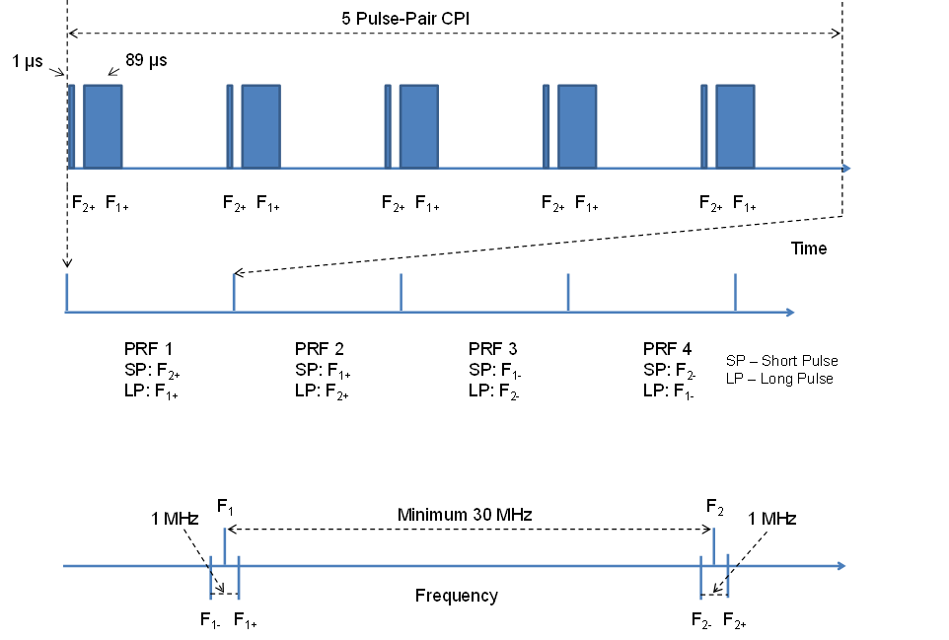
From Fig. 1, tested radar C transmits on four different frequencies arranged as two frequency pairs, F1 ± 0.5 MHz and F2 ± 0.5 MHz. The tested radar C processes dual parallel channels: target channel and weather channel. In certain implementations of radar C, the weather channel processor produces a weather map that is contoured by comparing weather returns against six calibrated level thresholds. No tests on the weather channel are detailed in this Report.
Tested radar C is a frequency diversity radar. Two pairs of frequencies are provided to compensate for atmospheric fading, distortion, and other effects on any one frequency pair; effects that degrade one frequency pair are not expected to affect the other pair. Furthermore, the frequency diversity is employed to provide increased rain-clutter visibility. Without frequency diversity, rain returns are correlated and summed in the four processing intervals (four batches or 20 pulses). This causes the rain returns to produce a high false alarm rate. By using frequency diversity, the rain returns are de-correlated and the residue of rain returns is equal to the noise.
The false alarm rate does not increase in areas of the coverage where rain returns exceed receiver noise. Frequency diversity is provided so that the radar can meet its performance requirements under all predicted conditions and is not provided in order to use one frequency pair to compensate for interference on the other frequency pair due to other radar or non-radar systems in the frequency band.

3 Interference test scenarios

3.1 Pulsed interference test scenarios
Tests were conducted with interference sources injected at the centre of each frequency pair (also referred to herein as primary frequencies) and with an interference source at the centre of a single frequency pair. In addition to the on-tune interference tests, tests were conducted with the interference source off-tuned with the primary frequencies in order to include cases where the receiver intermediate-frequency (IF) filter distorts the interference pulse resulting in significant change in duty cycle when compared with the interference waveform at the input of the receiver.
Four sets of tests were conducted on the target channel:
– Two interference sources each on-tune to one of tested radar C’s frequency pairs, i.e. each interference source tuned to the centre of the two 0.5 MHz offset frequencies.
– One interference source tuned to the centre of two 0.5 MHz offset frequencies with the other frequency pair free from interference.
– Two interference sources each off-tuned from a frequency pair.
– One interference source off-tuned from a frequency pair.
Figure 2 illustrates the interference source off-tuning for these four scenarios.
Since the tested radar employs two out of four M of N detection, the effects of a single interference source on the radar will be masked when one frequency pair is interference-free. This is not a desirable condition as the Radar requires both frequency-pairs to meet its performance requirements and masking interference negates the benefits of frequency diversity and this reduced performance may be unknown to the operator.
Frequency diversity is a technique used in Radar to improve probability of detection (P_{D}) in atmospheric fading, rain clutter, and other distortion effects when more than one pulse is transmitted. Frequency diversity is not intended as a technique to suppress the effects of interference from other radar or non-radar systems in the frequency band. To understand the true impact of interference, two interference sources equally affecting both radar frequency pairs are necessary to eliminate the masking of the interference effects. With two interferences sources, all radar pulses entering the M of N detector will be affected by interference, a condition that is identical to that produced by a single interference source in a radar not employing frequency diversity.
FIGURE 2
Pulsed-interference test scenarios
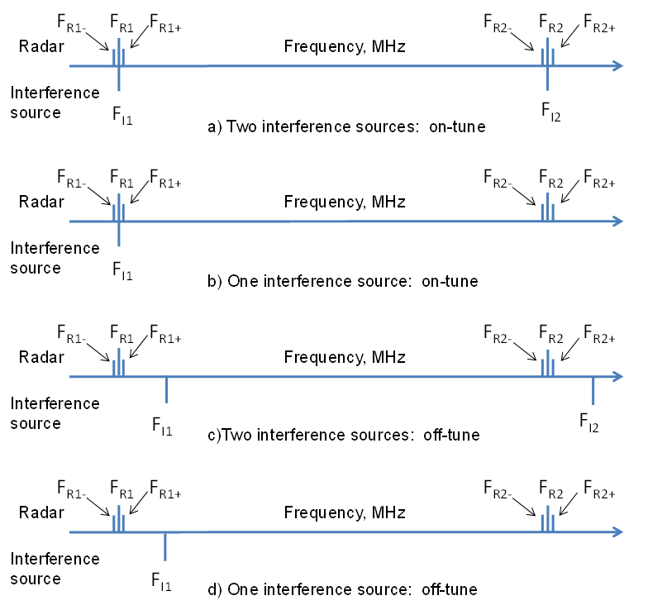

3.2 Additional pulsed waveforms
In additional tests, pulse widths, pulse-repetition frequencies, and bandwidths of linear frequency modulated (chirp) waveforms were varied for the interference sources so that the results of the tests could be applied to assess potential degradation from other interference sources that the tested radar C may encounter.

4 Test setup and calibration

4.1 Test setup
Figure 3 provides the setup for the interference testing. For both the calibration and target channel tests, the coaxial cable from the circulator to the RF filter input was disconnected from the radar (the radar transmitter continued to transmit with the antenna rotating).
The target signal generator (TSG) produced test targets on both frequency pairs for the target channel tests. Two vector signal generators, were available to inject the interference waveforms on both radar frequency pairs.
The RF down conversion is accomplished in three stages: each of the three stages includes a band-pass filter, an amplifier, and a mixer. The spectrum analyser connects to the output of the final IF stage filter, referred to as IF3, located prior to the analogue-to-digital convertor.
The radar detector stage consists of the Radar interference suppressor, pulse compressor, Doppler filters, and adaptive CFAR circuitry. The plan position indicator (PPI) display, located on the local radar display unit, shows target detections prior to the M of N detector sliding-window binary integrator. The number of target declarations made by the target processor, following the M of N sliding window block, is also shown on the PPI display.
FIGURE 3
Test setup
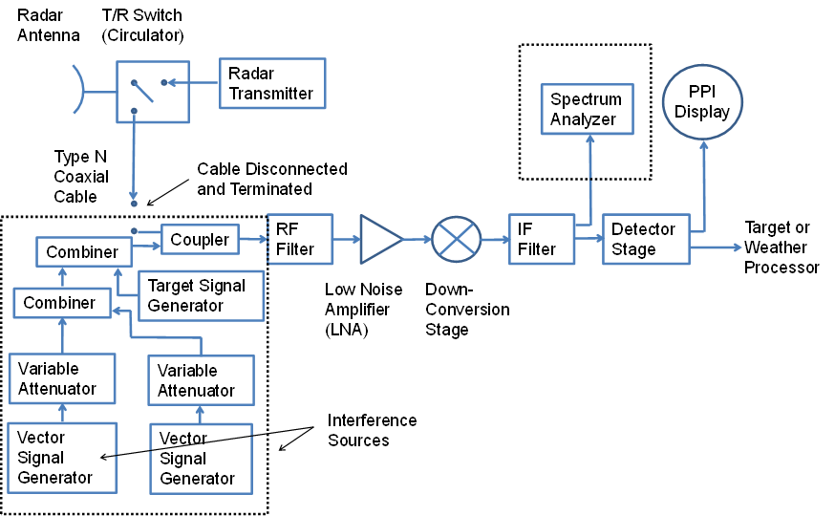

4.2 Measurement and calibration principles

4.2.1 Concept of measurement
The concept of measurement is similar of that described in Annex 2 of Recommendation ITU-R M.1464-2. The value of the threshold of an interfering waveform is determined from the values of the signal generator when the measured P_{D} on the victim radar under test shows a 1-sigma standard deviation from its baseline P_{D} obtained during the calibration process.

4.2.2 Settings
The TSG was configured to inject a ring of 100 test targets at 40 NM, which is outside the range for sensitivity time control (STC) of the radar. Limited tests were also conducted in the short-pulse range region at 6.0 NM, which is also outside of the STC range for the short pulse.
An 89 µs linear frequency modulated (LFM) waveform was used to approximate the non-linear frequency modulated long pulse employed by the radar C. The pulse-compression ratio was measured by comparing the pulse compression stage outputs for both an unmodulated 89 µs pulse and the 89 µs LFM pulse employing several chirp bandwidths.

4.2.3 Measurement of the P_{D}
Target declarations reported by the radar, over a period (75 s) that exceeded 12 scans (1 200 potential targets) were used to determine the P_{D}, which was calculated by dividing the number of counted targets by the number of expected targets (or targets generated).
To account for the radar’s CFAR processing stabilization, each measurement at different levels of interference starts after a defined time, (i.e. 10 generated targets).
This approach is valid as long as the interference does not produce significant numbers of false targets that are included in the target declaration counts. To ensure that this condition was met, another PPI scope was used to monitor all target declarations reported during the tests.
This PPI scope received the same data made available to the standard terminal automated replacement system terminals currently employed in the field. False targets on the PPI were identified as targets seen at ranges other than the 40 NM range of the test targets. Reported false targets were negligible, except for the scenario of the same Radar waveform, Radar C, as the source and Radar under test. In this case, a specific procedure for calculation of P_{D} was applied as described in § 5.2.

4.2.4 Calibration
With the ASR example Radar C transmitter on and the receiver isolated from external interference sources, the TSG power was set such that a PD between 88% and 92% for the test targets was recorded over at least 12 scans. This baseline PD was measured prior to each waveform being tested. Statistical fluctuations of the target detection were observed during the measurements. In the few cases where the baseline PD varied outside the desired range of 88% to 92%, the TSG power was readjusted and the data set restarted.
Prior to performing interference tests, the TSG baseline power was set and P_{D} data was collected for about a 10 hour period to test the stability of the power generated by the TSG. The results of this test showed it to be relatively stable over this period.

5 Measured test results

5.1 Measured results for different Radar interference waveforms
Tests were conducted using interference waveforms representative of Radars commonly operating in the frequency band 2 700-2 900 MHz, e.g. radar A, radar B, and radar G, against tested radar C. The special scenario of Radar C against tested Radar C is presented in § 5.2.
Interference thresholds measured for pulsed interference sources are shown in Table 2.
TABLE 2
Peak interference to average noise power thresholds measured for radar interfering systems
to tested Radar C receiver
Interference source | On-tune I/N Threshold (dB)
Radar A | 50
Radar B | 50
Radar G short pulse | 40
Radar G long pulse | 20

The interference mechanism being reported in the table above is a reduction in P_{D} due to the desensitization of the victim Radar receiver.

5.2 Measured results for radar C affecting the tested radar C
In the case of radar C with the same transmission characteristics affecting the tested radar C receiver on-tune, the interference mechanism results in the generation of false targets for I/N ratios down to
−20 dB. This occurs due to the interference waveform matching the waveform that the victim radar receiver expects. This results in the tested radar C receiver interpreting the interference waveform as false target returns. When I/N > −20 dB, both the injected real targets and false target returns were observed. The measurement shows impact to this radar’s ability to detect the injected real targets when the received interference signal is at I/N of −6 dB or higher. The high interference signal increases the receiver noise floor, which results in a higher probability of false alarm and a lower probability of target detection.
Due to the numerous false targets generated by radar C on tested radar C, the target declaration data for these measurements was recorded and subsequently manually processed to ensure an accurate target and false-target count to properly evaluate the level I/N which produce 1-sigma standard deviation on the P_{D} only due to the desensitization of the victim radar receiver.
Peak interference to average noise thresholds measured from a radar C with the same transmission characteristics as the tested radar C receiver affecting the tested radar C are shown in Table 3.
TABLE 3
Peak interference to average noise thresholds measured from a Radar C with the same transmission characteristics as the tested Radar C receiver affecting the tested Radar C
Interference source | On-tune I/N threshold  (dB) | Off-tune I/N threshold  (dB) | Off-tune condition*  (MHz)
Radar C | −6 | 30 | ≥ 3
* Referenced from the centre of frequency pair

5.3 Measured results for pulsed waveforms’ duty cycle study
For additional pulsed-interference waveforms shown in Table 4, tested radar C on-tune interference degradation thresholds are determined as a function of the interference effective pulsed duty cycle and the pulsed-interference I/N levels, as shown in Table 3.

TABLE 4
Tested radar C on-tune peak interference to average noise thresholds for various
duty cycles of unmodulated pulsed waveforms
Effective pulse duty cycle, DC_{EFF} (%) | I/N threshold (dB)
DC_{EFF} < 0.1 | 60
0.1 < DC_{EFF} < 0.2 | 50
0.2 < DC_{EFF} < 0.3 | 40
0.3 < DC_{EFF} < 0.4 | 30
0.4 < DC_{EFF} < 1 | 20
1 < DC_{EFF} < 2 | 10
2 < DC_{EFF} < 3 | 0
3 < DC_{EFF} < 10 | −6
10 < DC_{EFF} < 15 | −10
15 < DC_{EFF} | −13

