Report ITU-R M.2517-0
(11/2022)
Coexistence between land-mobile and
fixed service applications operating in
the frequency range 252-296 GHz

M Series
Mobile, radiodetermination, amateur
and related satellite services

Foreword
The role of the Radiocommunication Sector is to ensure the rational, equitable, efficient and economical use of the radio-frequency spectrum by all radiocommunication services, including satellite services, and carry out studies without limit of frequency range on the basis of which Recommendations are adopted.
The regulatory and policy functions of the Radiocommunication Sector are performed by World and Regional Radiocommunication Conferences and Radiocommunication Assemblies supported by Study Groups.

Policy on Intellectual Property Right (IPR)
ITU-R policy on IPR is described in the Common Patent Policy for ITU-T/ITU-R/ISO/IEC referenced in Resolution ITU-R 1. Forms to be used for the submission of patent statements and licensing declarations by patent holders are available from http://www.itu.int/ITU-R/go/patents/en where the Guidelines for Implementation of the Common Patent Policy for ITU-T/ITU-R/ISO/IEC and the ITU-R patent information database can also be found.

Series of ITU-R Reports
(Also available online at http://www.itu.int/publ/R-REP/en)
Series | Title
BO | Satellite delivery
BR | Recording for production, archival and play-out; film for television
BS | Broadcasting service (sound)
BT | Broadcasting service (television)
F | Fixed service
M | Mobile, radiodetermination, amateur and related satellite services
P | Radiowave propagation
RA | Radio astronomy
RS | Remote sensing systems
S | Fixed-satellite service
SA | Space applications and meteorology
SF | Frequency sharing and coordination between fixed-satellite and fixed service systems
SM | Spectrum management

Note: This ITU-R Report was approved in English by the Study Group under the procedure detailed in Resolution ITU-R 1.

Electronic Publication
Geneva, 2023
© ITU 2023
All rights reserved. No part of this publication may be reproduced, by any means whatsoever, without written permission of ITU.

REPORT ITU-R M.2517-0
Coexistence between land-mobile and fixed service applications
operating in the frequency range 252-296 GHz
(2022)
TABLE OF CONTENTS
Page
Policy on Intellectual Property Right (IPR) ii
1 Introduction 2
2 Scope 2
3 Related Recommendations and Reports 2
4 List of acronyms and abbreviations 2
5 Technical and operational characteristics 3
5.1 Technical and operational characteristics of LMS applications operating in the frequency range 252-296 GHz 3
5.2 Technical and operational characteristics of FS operating in the frequency range 252-296 GHz 4
6 Interference scenarios from LMS to FS applications operating in the frequency range 252-296 GHz 6
6.1 Interference scenarios from LMS to FS applications operating in the band 252-296 GHz 6
6.2 Protection criterion for coexistence studies in the frequency range
252-296 GHz 8
6.3 Propagation characteristics 9
6.4 Simulation results 9
7 Summary 16
Annex 1 – Extrapolation of building entry loss from Recommendation ITU-R P.2109 16
Annex 2 – Channel arrangement in the frequency range 252-296 GHz 17

1 Introduction
Radio Regulations (RR) No. 5.565 identifies the specific frequency bands for the radio astronomy service, the Earth exploration-satellite service (passive) and the space research service (passive) in the frequency range 275-1 000 GHz. Although the use of the frequency range 275-1 000 GHz by the passive services does not preclude the use of this range by active services, administrations wishing to make frequencies in the 275-1 000 GHz range available for active service applications are urged to take all practicable steps to protect these passive services from harmful interference.
WRC-19 modified RR Article 5 above 275 GHz in accordance with the results of WRC-19 agenda item 1.15. The new footnote RR No. 5.564A was added in the Table of Frequency Allocations to identify the frequency bands 275-296 GHz, 306-313 GHz, 318-333 GHz and 356-450 GHz for use by administrations for the implementation of land mobile service (LMS) and fixed service (FS) applications, where no specific conditions are necessary to protect Earth exploration-satellite service (passive) applications.
In the Table of Frequency Allocations, the frequency bands 252-265 GHz and 265-275 GHz have already been allocated to the mobile and fixed services. If these bands and the newly identified band 275-296 GHz are simultaneously used for mobile and fixed service applications, coexistence operation of those applications in the total frequency band of 44 GHz should be examined using the technical and operational characteristics provided by Reports ITU-R M.2417 (for land-mobile service applications) and ITU-R F.2416 (for point-to-point fixed service applications).

2 Scope
This Report provides the coexistence scenarios between LMS and FS applications operating in the frequency range 252-296 GHz, allowing to have a possible operation in co-frequency and adjacent frequency bands.

3 Related Recommendations and Reports
Recommendation ITU-R F.699 – Reference radiation patterns for fixed wireless system antennas for use in coordination studies and interference assessment in the frequency range from 100 MHz to 86 GHz
Recommendation ITU-R F.758 – System parameters and considerations in the development of criteria for sharing or compatibility between digital fixed wireless systems in the fixed service and systems in other services and other sources of interference
Recommendation ITU-R P.2109 – Prediction of building entry loss
Report ITU-R F.2239 – Coexistence between fixed service operating in 71-76 GHz, 81-86 GHz and 92-94 GHz bands and passive services
Report ITU-R F.2416 – Technical and operational characteristics and applications of the point-to-point fixed service applications operating in the frequency band 275-450 GHz
Report ITU-R M.2417 – Technical and operational characteristics of land-mobile service applications in the frequency range 275-450 GHz
Report ITU-R SM.2450 – Sharing and compatibility studies between land-mobile, fixed and passive services in the frequency range 275-450 GHz

4 List of acronyms and abbreviations
BBU Baseband unit
BEL Building entry loss
BER Bit error ratio
CPMS Close proximity mobile system
CPMS MT Close proximity mobile system – Mobile terminal
CPMS FS Close proximity mobile system – Fixed station
e.i.r.p. Equivalent isotropically radiated power (see RR No. 1.161)
FDD Frequency-division duplex
FS Fixed service
IEEE Institute of Electrical and Electronic Engineers
I/N Interference to noise ratio
LMS Land mobile service
PSD Power spectrum density
RRH Remote radio head
TDD Time-division duplex

5 Technical and operational characteristics

5.1 Technical and operational characteristics of LMS applications operating in the frequency range 252-296 GHz
TABLE 1
Technical and operational characteristics of land mobile service applications
operating in the frequency range 252-296 GHz
Parameters | Values
Frequency band (GHz) | 252-296
Tx output power density (dBm/GHz) | −4.1…6.6
Max. e.i.r.p. density (dBm/GHz) | 25.9…36.6
Duplex method | FDD/TDD
Modulation | OOK/BPSK/QPSK/16QAM/64QAM  BPSK-OFDM/QPSK-OFDM/ 16QAM-OFDM/32QAM-OFDM/64QAM-OFDM
Average distance between CPMS fixed and mobile devices (m) | 0.1
Maximum distance between CPMS fixed and mobile devices (m) | 1
Antenna height (m) | 1…2
Antenna beamwidth (degree) | 3…10
Antenna elevation (degree) | ±90
Frequency reuse | 1
Antenna type | Horn

TABLE 1 (end)
Parameters | Values
Antenna pattern | Gaussian
Antenna polarization | Linear
Indoor CPMS fixed device deployment (%) | 100
Feeder loss (dB) | 2
Maximum CPMS fixed/mobile device output power (dBm) | 10
Channel bandwidth (GHz) | 2.16/4.32/8.64/12.96/17.28/ 25.92  (see Annex 2)
Transmitter spectrum mask | Report ITU-R M.2417
Maximum CPMS fixed device antenna gain (dBi) | 30
Maximum CPMS mobile device antenna gain (dBi) | 15
Maximum CPMS fixed device output power (e.i.r.p.) (dBm) | 40
Maximum CPMS mobile device output power (e.i.r.p.) (dBm) | 25
Average activity factor (%) | 0.76
Average CPMS fixed device power (dBm (e.i.r.p)) | 20
Receiver noise figure typical (dB) | 15
Density (per km²) | 9.1

5.2 Technical and operational characteristics of FS operating in the frequency range 252-296 GHz
TABLE 2
Technical and operational characteristics of the fixed service applications planned to operate in the frquency range 252-296 GHz
Parameter | Values
Frequency band (GHz) | 252-296
Duplex Method | FDD/TDD
Modulation | BPSK/QPSK/8PSK/8APSK/16QAM/32QAM/64QAM  BPSK-OFDM/QPSK-OFDM/ 16QAM-OFDM/32QAM-OFDM/64QAM-OFDM
Channel bandwidth (GHz) | 2…25 (FDD)  2…50 (TDD)
Spectrum mask | See Table 3 below
Tx output power range (dBm) | 0…20
Tx output power density range (dBm/GHz) | −17…17
Feeder/multiplexer loss range (dB) | 0…3
Antenna gain range (dBi) | 24…50
e.i.r.p. range (dBm) | 44…70
e.i.r.p. density range (dBm/GHz) | 30…67
TABLE 2 (end)
Parameter | Values
Antenna pattern | Recs ITU-R F.699 and ITU-R F.1336
Antenna type | Parabolic reflector
Antenna height (m) | 6…25
Antenna elevation (degree) | ±20 (typical)
Receiver noise figure typical (dB) | 15
Receiver noise power density typical (dBm/GHz) | −69
Normalized Rx input level for 1 × 10⁻⁶ BER (dBm/GHz) | −61…−54
Link length (m) | 100…300
I/N protection criteria | Rec. ITU-R F.758
Density (per km²) | 8.4

FS transmitter spectrum mask
The following spectrum mask is taken from IEEE Std 802.15.3dTM-2017 as shown in Fig. 1 and Table 3.
FIGURE 1
Generic transmit spectral mask
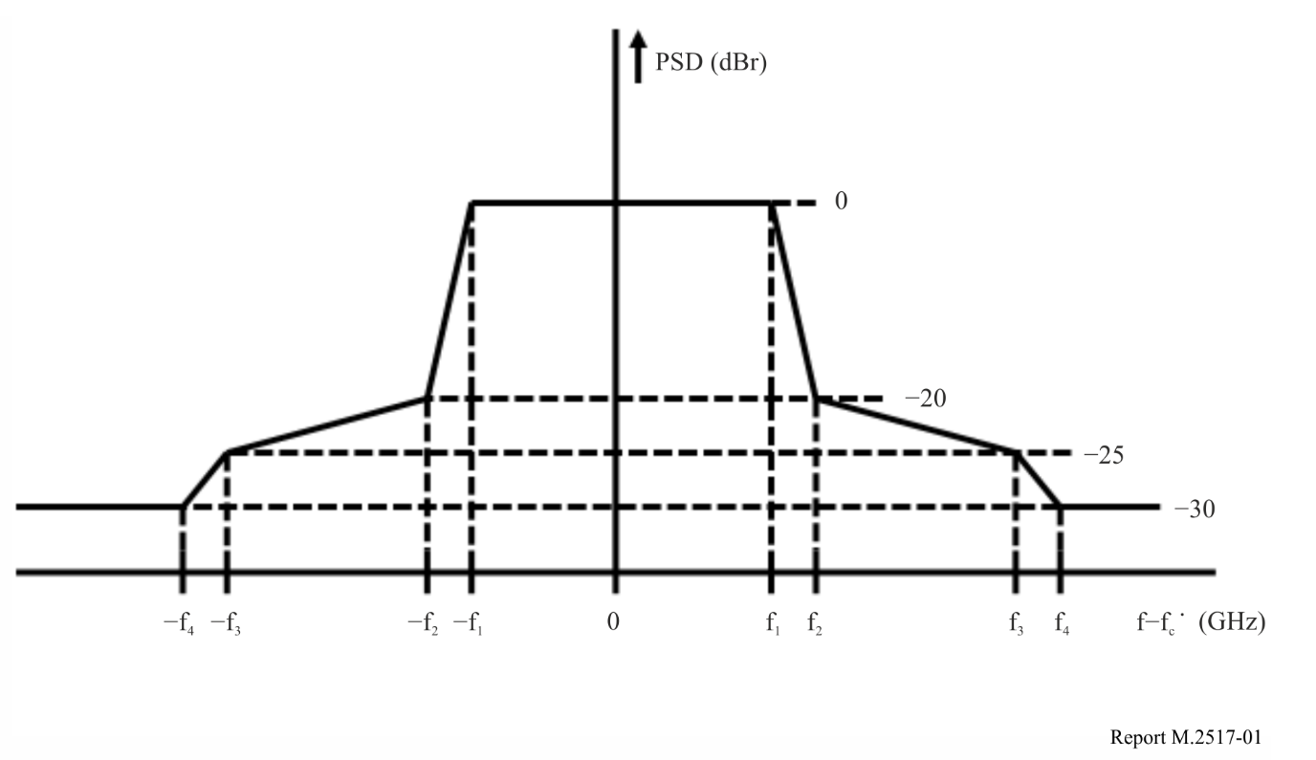
The parameters of the PSD indicated in Fig. 1 are defined in Table 3.
TABLE 3
Transmitter spectrum mask parameters
Channel bandwidth (GHz) | f₁  (GHz) | f₂  (GHz) | f₃  (GHz) | f₄  (GHz)
0.160 | 0.94 | 1.10 | 1.60 | 2.20
4.320 | 2.02 | 2.18 | 2.68 | 3.28
8.640 | 4.18 | 4.34 | 4.84 | 5.44
12.960 | 6.34 | 6.50 | 7.00 | 7.60
17.280 | 8.50 | 8.66 | 9.16 | 9.76
25.920 | 12.82 | 12.98 | 13.48 | 14.08
51.840 | 25.78 | 25.94 | 26.44 | 27.04
69.120 | 34.42 | 34.58 | 35.08 | 35.68

6 Interference scenarios from LMS to FS applications operating in the frequency range 252-296 GHz

6.1 Interference scenarios from LMS to FS applications operating in the band 252-296 GHz
The two interference scenarios between LMS and FS applications are listed in Table 4 and shown in Fig. 2. Since the close proximity mobile system is one of LMS applications indicated in Report ITU-R M.2417, this section studies the interference-to-noise ratio value of FS receivers which will be used for backhaul/fronthaul applications indicated in Report ITU-R F.2416. Table 4 summarizes interference scenarios between CPMS and fronthaul applications. The fronthaul consists of RRH covering a small cell and BBU accomplishing baseband signal processing functions of radio access networks. Since the interference to RRH from CPMS may be worse than that of BBU from CPMS due to a lower antenna height of RRH than that of BBU in general, the study focuses on the interference from CPMS to RRH.
TABLE 4
Interference scenarios
Scenario | Interfering | Interfered | Propagation model
A1 | CPMS MT | RRH | Recs ITU-R P.452, P.676, P.2108, P.2109
A2 | CPMS FS | RRH | Recs ITU-R P.452, P.676, P.2108, P.2109
B1 | RRH | CPMS MT | Recs ITU-R P.452, P.676, P.2108, P.2109
B2 | RRH | CPMS FS | Recs ITU-R P.452, P.676, P.2108, P.2109
CPMS MT: Close proximity mobile system – Mobile terminal
CPMS FS: Close proximity mobile system – Fixed station
RRH: Remote Radio Head
BBU: Base band unit

FIGURE 2
Illustration of interference scenarios between LMS and FS applications
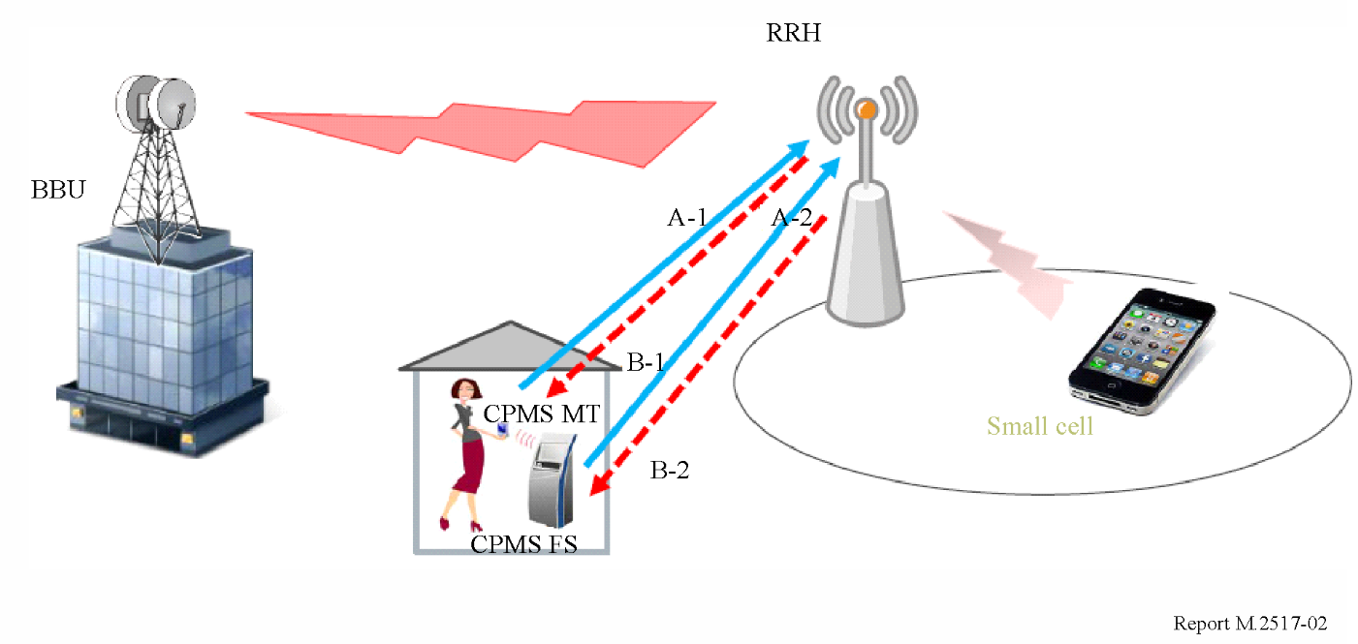

6.1.1 Aggregate interference effect to FS receivers
Report ITU-R M.2417 provides deployment density and activity factor of CPMS applications such as Kiosk downloading system. Based on the deployment scenario, CPMS link density within a circle of 300 m radius which is the maximum distance between RRH and BBU provided in Report ITU-R F.2416 is estimated to be 2.55 per 0.28 km². Figure 3 shows the schematic illustration of CPMS distribution within a circle of 300 m radius. This link density is calculated as the worst-case scenario using the total number of convenient stores within the 23 wards of Tokyo whose area is 619 km². It also becomes 15 times as large as the average link density provided in Report ITU-R M.2417. The aggregate maximum received power of RRH/BBU receivers can be calculated using the above link density when the azimuth off-axis angle of RRH antenna is set to zero degree.
FIGURE 3
Schematic illustration of CPMS link distribution within a circle of 300 m radius
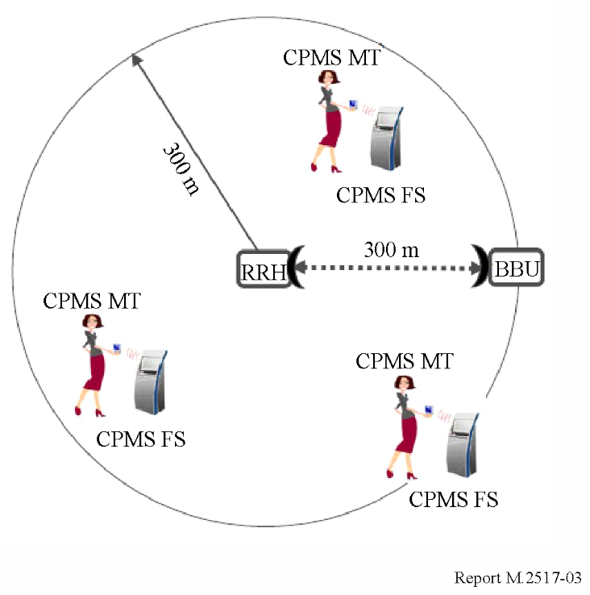

6.1.2 Aggregate interference effect to CPMS receivers
Report ITU-R F.2416 provides deployment scenario of FS applications such as fronthaul/backhaul to be used for some populated cities in Japan. The FS link density of 8.4 FS links/km² is estimated and used for sharing and compatibility studies between FS applications and EESS (passive) in Report ITU-R SM.2450. Since the above link density is estimated using some highly populated cities, the interference scenario of aggregate effect to CPMS receivers may be provided by Fig. 4. If all of FS links in the area of 1 km by 1 km square are located as closed to CPMS receivers as possible, the additional interference level can be estimated to be as large as about 9.2 dB.
FIGURE 4
Schematic illustration of FS link distribution within 1 km by 1 km square
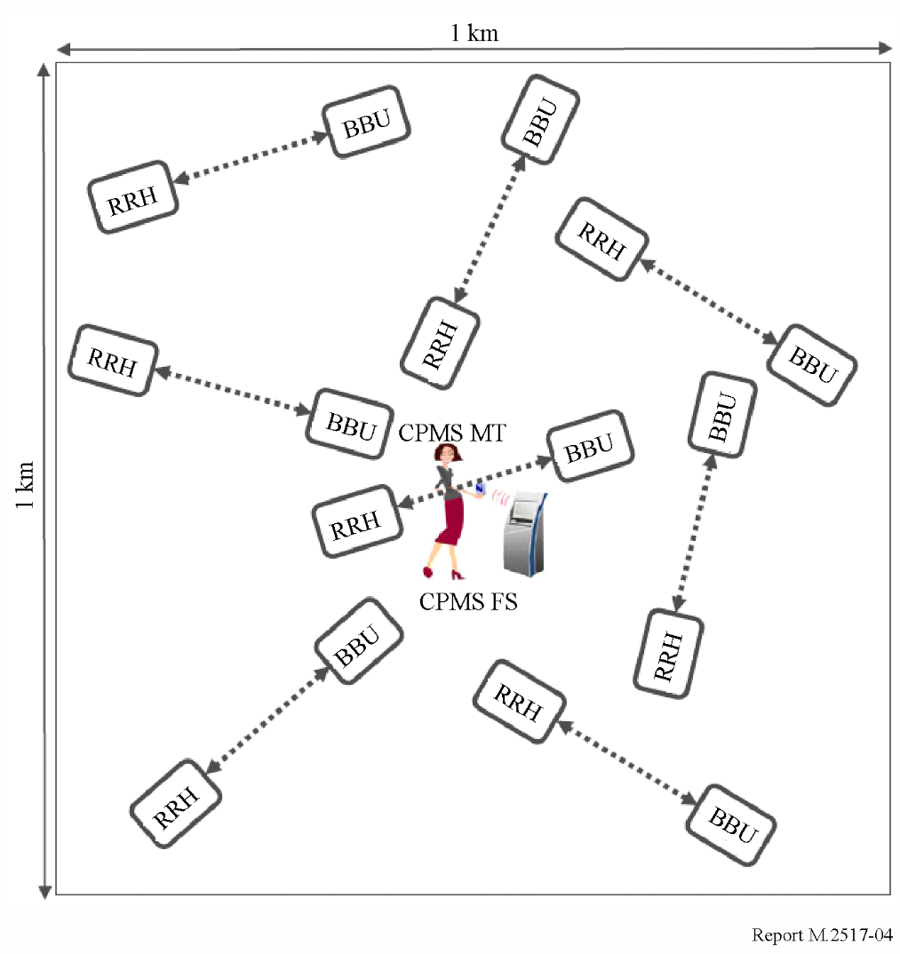

6.2 Protection criterion for coexistence studies in the frequency range 252-296 GHz

6.2.1 Protection criterion for FS applications
Recommendation ITU-R F.758 provides an interference-to-noise ratio (I/N) value of −10 dB as the long-term (no more than 20% of the time) interference protection criterion for the FS in the frequency bands of above 3 GHz.

6.2.2 Protection criterion for LMS applications
Protection criterion of I/N values of −6 dB which are widely used for mobile service devices are applied for LMS applications operating in the frequency range 252-296 GHz. The specified tolerable I/N is referenced to the mobile receiver input and requires taking into account all sources of interference.

6.2.3 Adjacent channel leakage ratio
Reports ITU-R M.2417 and ITU-R F.2416 define the spectrum mask of LMS and FS applications, respectively. Figure 5 shows two channel arrangements defined by the above Reports. If the channel bandwidth of each system is 17.28 GHz, the adjacent channel leakage ratio is 29.2 dB and then the adjacent channel leakage power −9.2 dBm.
FIGURE 5
Two channels of spectrum mask defined in Report ITU-R M.2417
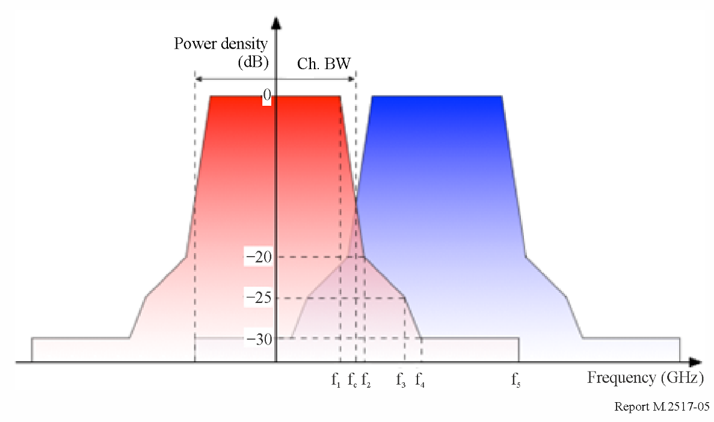

6.3 Propagation characteristics
In the frequency range 252-296 GHz, the following propagation mechanisms should be considered:
– free space basic transmission loss;
– attenuation by atmospheric gases;
– clutter loss where appropriate;
– BEL where appropriate.
For the terrain-obstructed cases, due to the very high diffraction losses at these frequencies any contribution from non-light-of-sight interferers could be neglected.
Paths with a dominant line-of-sight component are not likely to be subject to any clutter loss at these frequencies.
The extrapolated characteristics of BEL up to the frequency of 1 000 GHz are provided in Annex 1 for the future coexistence study between LMS and FS applications.

6.4 Simulation results

6.4.1 Methodology of single-entry interference calculations
The interference has been calculated using the following equations:
(a) For scenarios A1 and A2:
$I/N=P_{LMS}+{BW}_{factor}+G_{LMS→FS}+G_{FS→LMS}-PL\left(d_{0}\right)-N_{FS}$
(b) For scenarios B1 and B2:
$I/N=P_{FS}+{BW}_{factor}+G_{FS→LMS}+G_{LMS→FS}-PL\left(d_{0}\right)-N_{LMS}$
where:
P_{LMS} : power of LMS transmitter in the bandwidth of FS receiver
P_{FS} : power of FS transmitter in the bandwidth of LMS receiver
G_{LMS→FS} : gain of LMS transmitter antenna in the direction of FS receiver
G_{FS→LMS} : gain of FS receiver antenna in the direction of LMS transmitter
G_{FS→LMS} : gain of FS transmitter antenna in the direction of LMS receiver
G_{LMS→FS} : gain of LMS receiver antenna in the direction of FS transmitter
PL : basic transmission loss (see § 6.3)
N_{FS} : thermal noise power of FS receiver
N_{LMS} : thermal noise power of LMS receiver
${BW}_{factor}\left(Inter→Vic\right)=10 log10(\min{(1,BW_{Vic}/BW_{int})})$: bandwidth factor.
The polarization loss be included depending on the type of linear or circular polarized antennas to be used in transmitters and receivers.

6.4.2 Layout of RRH and CPMS transceivers
Figure 6 shows the simulation parameters of the azimuth off-axis angle θ between RRH and CPMS transceivers, and the elevation angle φ of RRH transceivers. Although Report ITU-R F.2416 specifies the elevation angle within ±20 degrees of FS stations in the urban areas where the height of FS station is in the range 6-25 m and the distance between FS stations in the range 100-300 m, as shown in Table 2, the elevation angle of ±30 degrees of FS stations is taken into account as a worst-case scenario, as proposed in Report ITU-R F.2239.
FIGURE 6
Layout of RRH and CPMS for simulation
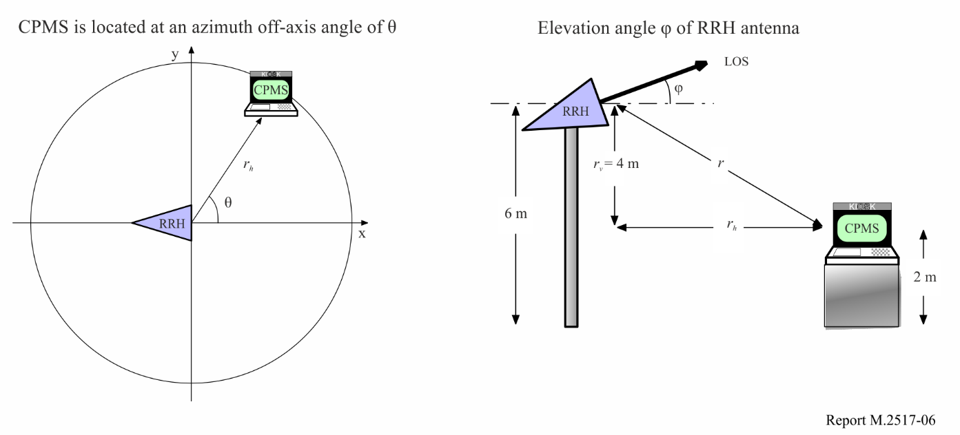

6.4.3 CPMS interfering scenario

6.4.3.1 Co-channel analysis
According to interference scenarios illustrated in Fig. 2, I/N of RRH receiver is calculated using the equations in § 6.4.1. Figure 7 shows the relationship between I/N of RRH receiver and distance between CPMS MT transmitter and RRH receiver. It is clearly indicated that the peak I/N of RRH receiver is determined from the distance between CPMS MT transmitter and RRH receiver and the height difference of CPMS MT transmitter and RRH receiver, as well as the elevation angle of RRH antenna.
FIGURE 7
I/N of RRH receiver as a function of distance between RRH and CPMS MT whose antenna heights are 6 m and 2 m, respectively, at the frequencies of 252 GHz, 275 GHz and 296 GHz
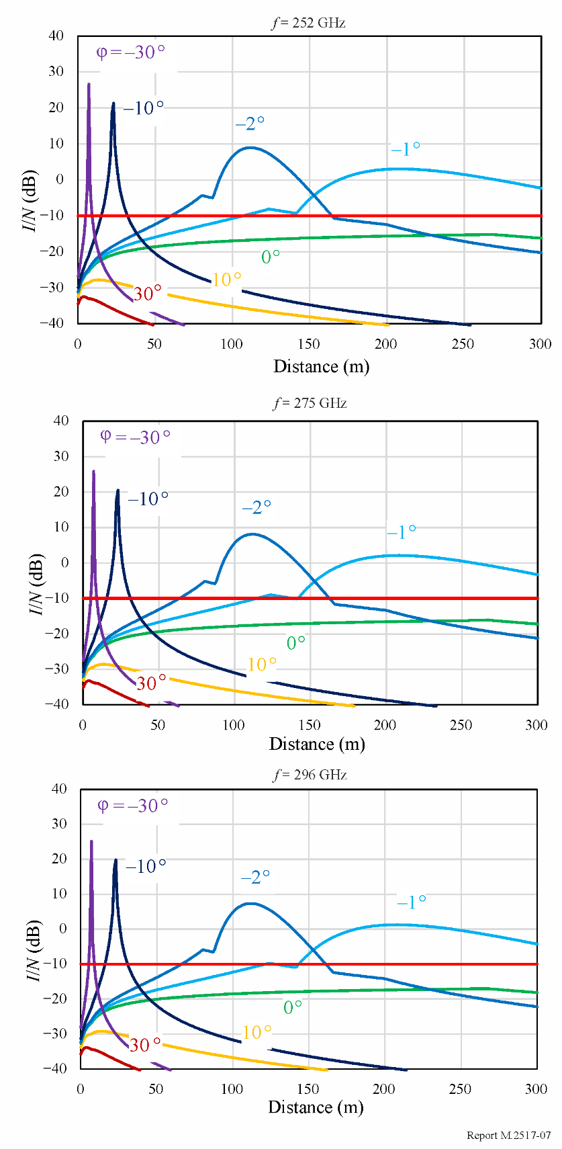

6.4.3.2 Adjacent channel analysis
I/N of RRH receiver is calculated using the adjacent channel leakage ratio given in § 6.2.3. Figure 8 shows the relationship between I/N of RRH receiver and distance between CPMS MT/FS transmitters and RRH receiver. It is clearly indicated that the peak I/N of RRH receiver is determined from the distance between CPMS MT/FS transmitters and RRH receiver and the height difference of CPMS MT/FS transmitters and RRH receiver, as well as the elevation angle of RRH antenna.
FIGURE 8
I/N of RRH receiver as a function of distance between RRH and CPMS whose antenna heights are 6 m and 2 m, respectively, at the frequency of 275 GHz
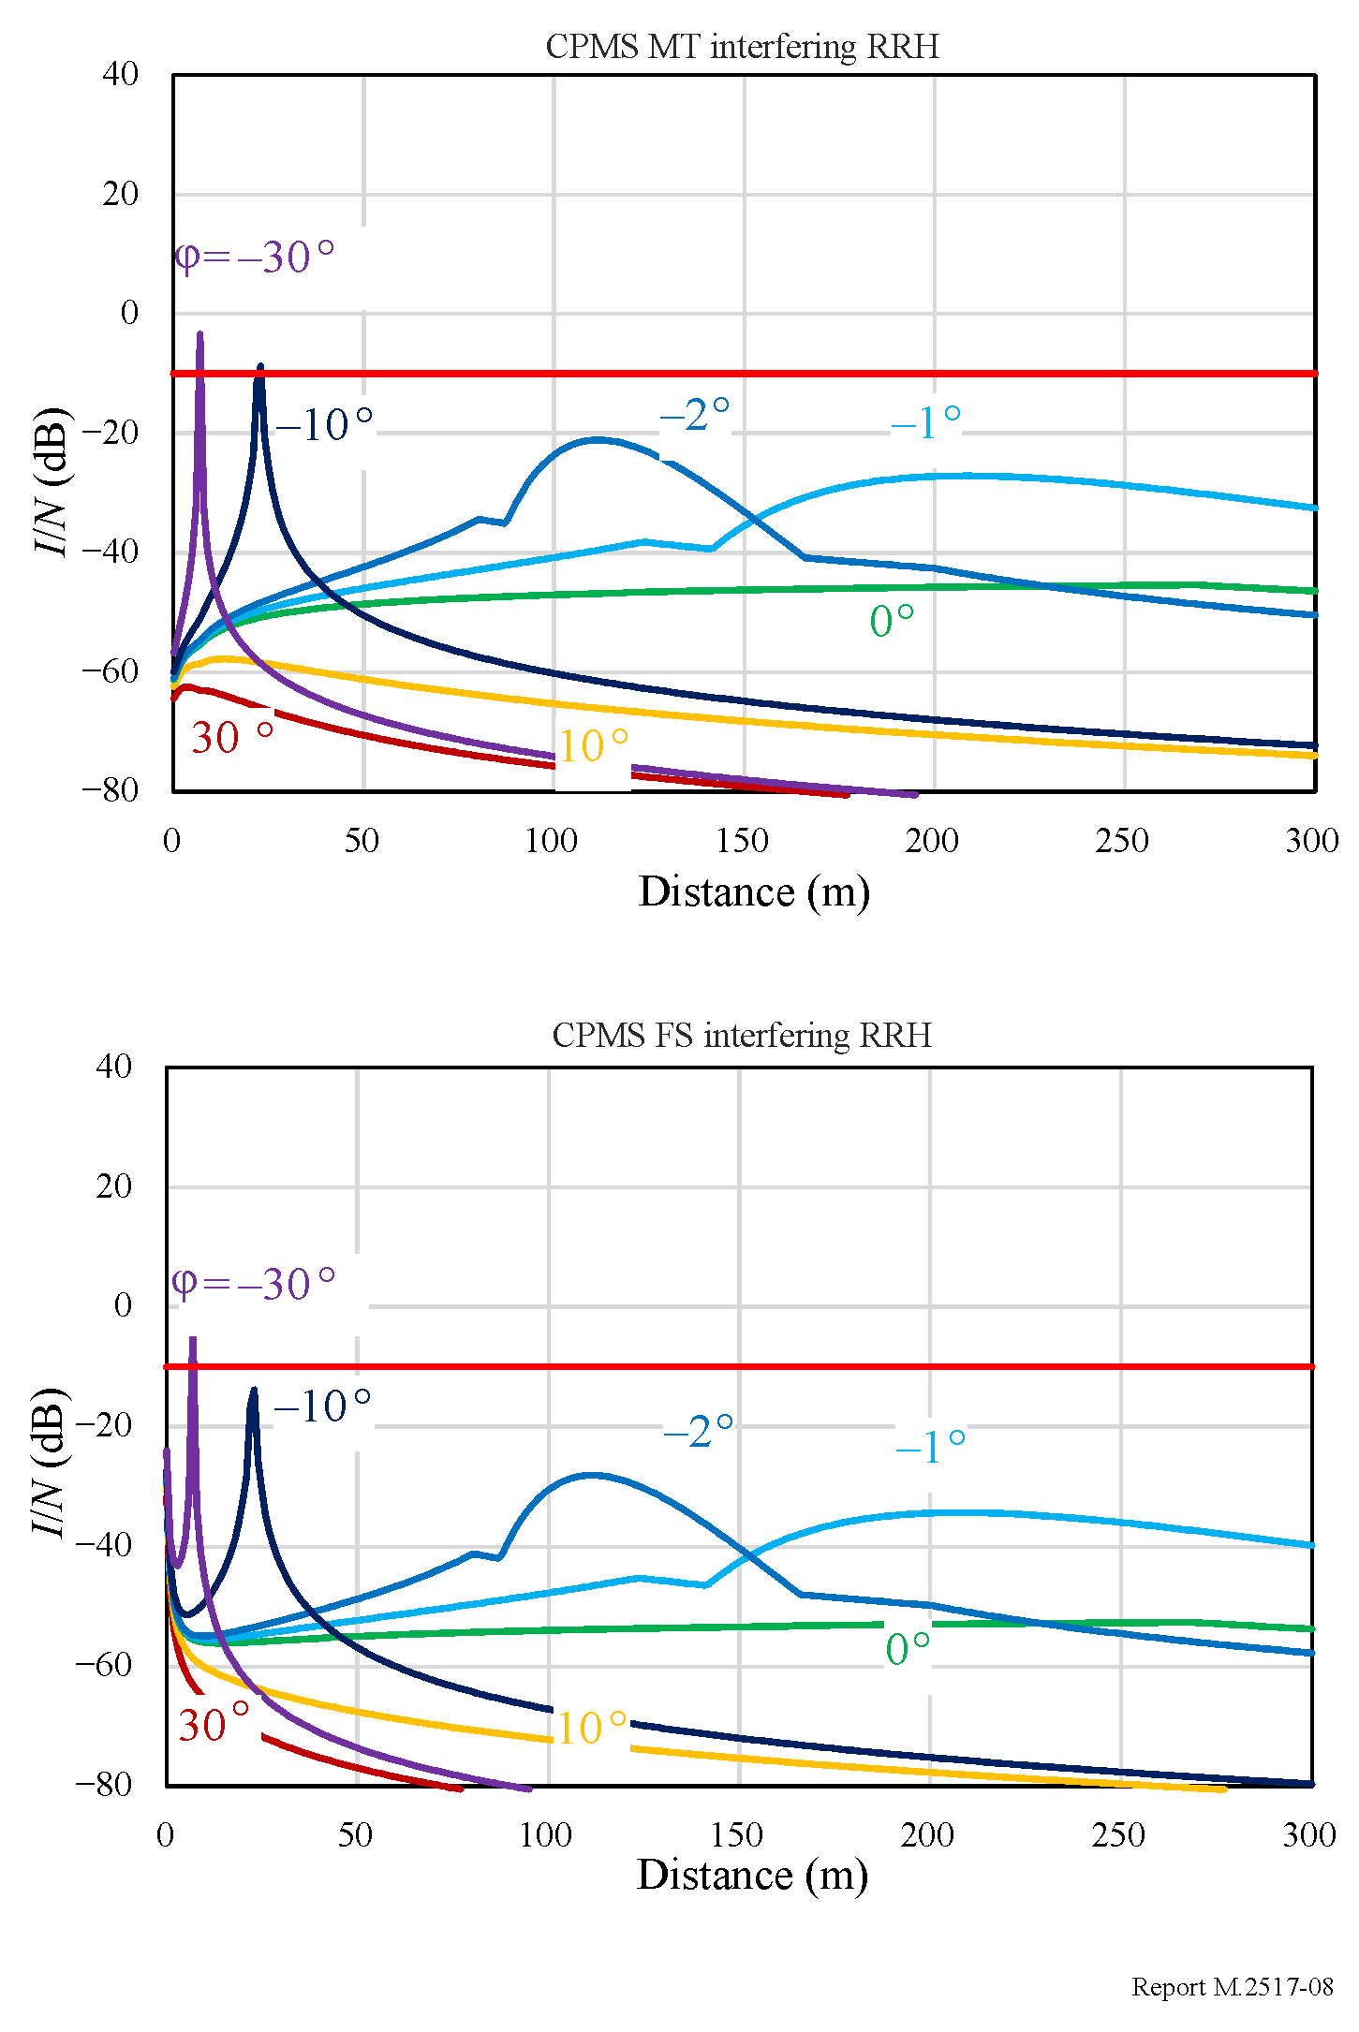

6.4.4 FS interfering scenario

6.4.4.1 Co-channel analysis
According to interference scenarios illustrated in Fig. 2, I/N of CPMS MT receiver is calculated using the equations in § 6.4.1. Figure 9 shows the relationship between I/N of CPMS MT receiver and distance between RRH transmitter and CPMS MT receiver. It is clearly indicated that the peak I/N of CPMS MT receiver is determined from the distance between RRH transmitter and CPMS MT receiver and the height difference of RRH transmitter and CPMS MT receiver, as well as the elevation angle of RRH antenna.
FIGURE 9
I/N of CPMS MT receiver as a function of distance between RRH and CPMS MT whose antenna heights are 6 m and 2 m, respectively, at the frequencies of 252 GHz, 275 GHz and 296 GHz
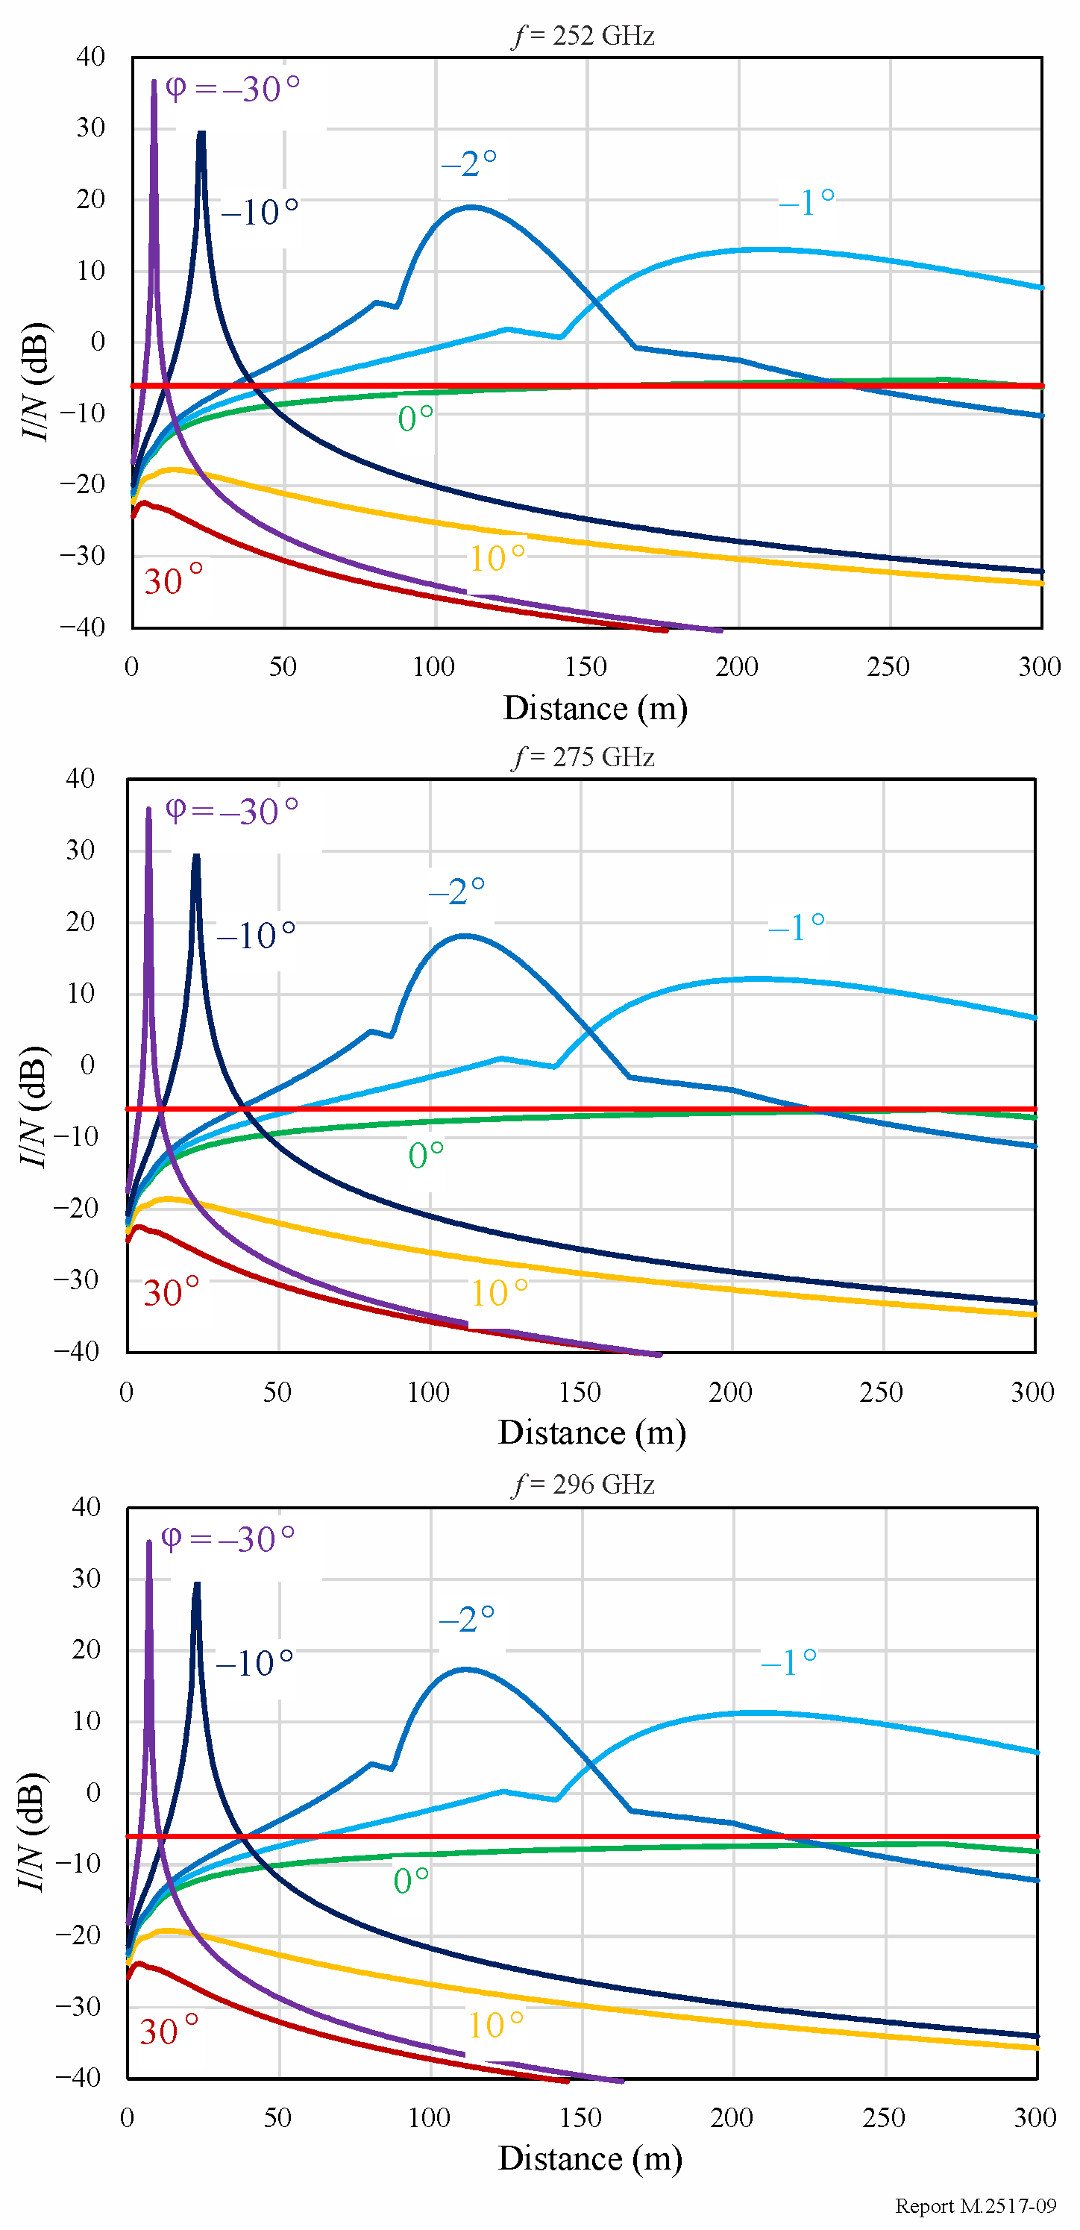

6.4.4.2 Adjacent channel analysis
I/N of CPMS MT/FS receivers is calculated using the adjacent channel leakage ratio given in § 6.2.3. Figure 10 shows the relationship between I/N of CPMS MT/FS receivers and distance between RRH transmitter and CPMS MT/FS receivers. It is clearly indicated that the peak I/N of CPMS MT/FS is determined from the distance between RRH transmitter and CPMS MT/FS receivers and the height difference of RRH transmitter and CPMS MT/FS receivers, as well as the elevation angle of RRH antenna.
FIGURE 10
I/N of CPMS MT/FS receivers as a function of distance between RRH and CPMS whose antenna heights are 6 m and 2 m, respectively, at the frequency of 275 GHz
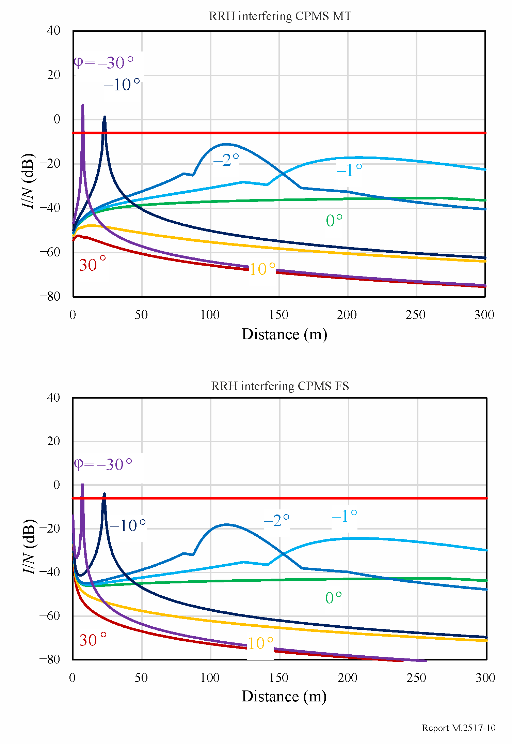

7 Summary
The interference study conducted indicates that LMS applications cannot coexist with FS applications if both applications are operated in the same channel in the same geographical area. When LMS applications and FS applications operate in adjacent channels, coexistence is feasible when considering the FS long-term protection criterion.
Although LMS and FS applications utilize a variety of channel bandwidths, this Report only provides an initial coexistence study considering a channel bandwidth of 17.28 GHz. Future updates of this Report could consider coexistence study results using combinations of different channel bandwidths and/or transmission frequencies, and further information on clutter loss and BEL, when such data is available.

Annex 1
Extrapolation of building entry loss from Recommendation ITU-R P.2109
This Annex provides extrapolated estimation of the median building entry loss (BEL) in accordance with Recommendation ITU-R P.2109 provided that the correction for the probabilities other than median should not be used. Figure 11 shows the extrapolated building loss in the frequency range 10-1 000 GHz. Those values may be used for the future coexistence studies between LMS and FS applications in the frequency range 252-296 GHz if the frequency range covered by Recommendation ITU-R P.2109 could be extended up to terahertz frequencies.
FIGURE 11
Extrapolated median building entry loss using Recommendation ITU-R P.2109
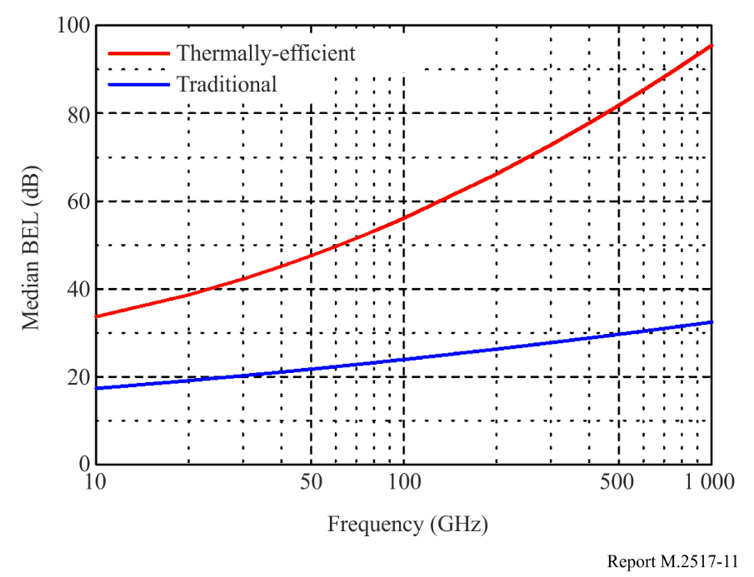

Annex 2
Channel arrangement in the frequency range 252-296 GHz
The channel arrangement whose channel bandwidth of 2.16 GHz, 4.32 GHz, 8.64 GHz, 12.96 GHz, 17.28 GHz and 25.92 GHz is shown in Fig. 12.
FIGURE 12
Channel arrangement in the frequency range 252-296 GHz based on IEEE Std. 802.15.3dTM-2017
