Report ITU-R M.2518-0
(11/2022)
Terrestrial International Mobile Telecommunications for remote sparsely populated areas providing
high data rate coverage

M Series
Mobile, radiodetermination, amateur
and related satellite services

Foreword
The role of the Radiocommunication Sector is to ensure the rational, equitable, efficient and economical use of the radio-frequency spectrum by all radiocommunication services, including satellite services, and carry out studies without limit of frequency range on the basis of which Recommendations are adopted.
The regulatory and policy functions of the Radiocommunication Sector are performed by World and Regional Radiocommunication Conferences and Radiocommunication Assemblies supported by Study Groups.

Policy on Intellectual Property Right (IPR)
ITU-R policy on IPR is described in the Common Patent Policy for ITU-T/ITU-R/ISO/IEC referenced in Resolution ITU-R 1. Forms to be used for the submission of patent statements and licensing declarations by patent holders are available from http://www.itu.int/ITU-R/go/patents/en where the Guidelines for Implementation of the Common Patent Policy for ITU-T/ITU-R/ISO/IEC and the ITU-R patent information database can also be found.

Series of ITU-R Reports
(Also available online at http://www.itu.int/publ/R-REP/en)
Series | Title
BO | Satellite delivery
BR | Recording for production, archival and play-out; film for television
BS | Broadcasting service (sound)
BT | Broadcasting service (television)
F | Fixed service
M | Mobile, radiodetermination, amateur and related satellite services
P | Radiowave propagation
RA | Radio astronomy
RS | Remote sensing systems
S | Fixed-satellite service
SA | Space applications and meteorology
SF | Frequency sharing and coordination between fixed-satellite and fixed service systems
SM | Spectrum management

Note: This ITU-R Report was approved in English by the Study Group under the procedure detailed in Resolution ITU-R 1.

Electronic Publication
Geneva, 2023
© ITU 2023
All rights reserved. No part of this publication may be reproduced, by any means whatsoever, without written permission of ITU.

REPORT ITU-R M.2518-0
Terrestrial International Mobile Telecommunications for remote sparsely populated areas providing high data rate coverage
(2022)
TABLE OF CONTENTS
Page
Policy on Intellectual Property Right (IPR) ii
1 Introduction 2
2 Background 2
3 Related ITU Recommendations and Reports 2
4 Solutions that support remote sparsely populated areas providing high data rate coverage 3
5 IMT solutions and configurations 5
5.1 Analysis of coupling loss with dual band systems 6
5.2 Analysis for isolated remote sites 8
5.3 Relays and repeaters 8
5.4 Network and terminal enhancements 9
5.5 3GPP specifications support for coverage extension 11
6 Summary 12
Annex 1 – List of acronyms and abbreviations 13

1 Introduction
The prospect of providing mobile and fixed wireless broadband services for most of the unconnected people, living in underserved rural areas, is largely related to techno-economic circumstances. As it has been indicated in the World Telecommunication/ICT Indicators Database, with 29 July 2022 data, 2.7 billion people are still unconnected.
This Report provides details on scenarios associated with the provisioning of enhanced mobile broadband services in sparsely populated and underserved remote areas with a discussion on enhancements of user and network equipment. Mobile broadband access in rural and remote areas can be done by various existing user equipment and additionally, broadband can be delivered also by fixed wireless access (FWA) type of consumer premises equipment (CPE). It offers technical solutions for certain deployment scenarios prevailing in developing countries and is meant to be used in accordance with the existing regulations in those countries.

2 Background
More than a billion people still live in areas that are not covered by mobile broadband networks and a significant portion of them (~95%) live in middle-income or low-income countries. One of the most significant challenges in providing users with mobile coverage is affordability in deploying and maintaining cell sites in regions with very low density of users and limited infrastructure.
For the purpose of this Report, rural areas are defined as low population density areas where agriculture dominates and only a basic infrastructure exists. Remote areas have even lower population densities and limited infrastructure. Much of the global population that is currently unconnected lives in remote locations with low population density and weak or non-existent enabling infrastructure (e.g. roads and/or electricity). All these characteristics negatively influence the expansion of mobile network in such areas as the investment remains the same. Providing affordable mobile broadband connectivity in such areas/regions is challenging.
In many countries, national policymakers have recognized the necessity to introduce polices and solutions to ensure connectivity in underserved and remote areas.
Further challenges that limit the reach of mobile broadband in sparsely populated areas are, for example, infrastructure requirements, backhaul connectivity, operation and maintenance, sparse distribution of population and so on. However, some of the remote areas have industrial plants, excavation units and mining with temporary human occupancy or shelters, which would benefit from broadband connectivity.
Remote coverage might in the future be driven by the need for national security and public safety connectivity, intelligent traffic systems, Internet of things, industry automation and end users need for home and commercial broadband services as an alternative to fibre connections. In order to fulfil the needs of remote coverage, it is important to identify viable solutions for mobile and fixed wireless broadband services.

3 Related ITU Recommendations and Reports
ITU-R Recommendations
ITU-R M.819 – International Mobile Telecommunications-2000 (IMT-2000) for developing countries
ITU-R M.1036 – Frequency arrangements for implementation of the terrestrial component of International Mobile Telecommunications (IMT) in the bands identified for IMT in the Radio Regulations
ITU-R M.1645 – Framework and overall objectives of the future development of IMT-2000 and systems beyond IMT-2000
ITU-R M.2012 – Detailed specifications of the terrestrial radio interfaces of International Mobile Telecommunications Advanced (IMT-Advanced)
ITU-R M.2083 – IMT Vision - Framework and overall objectives of the future development of IMT for 2020 and beyond
ITU-R M.2150 – Detailed specifications of the terrestrial radio interfaces of International Mobile Telecommunications-2020 (IMT-2020)
ITU-R P.833 – Attenuation in vegetation
ITU-R P.2001 – A general purpose wide-range terrestrial propagation model in the frequency range 30 MHz to 50 GHz
ITU-R P.2108 – Prediction of clutter loss
ITU-R P.2109 – Prediction of building entry loss
ITU-R Reports
ITU-R M.1155 – Adaptation of mobile radiocommunication technology to the needs of developing countries
ITU-D Reports
Available at https://www.itu.int/en/ITU-D/Study-Groups/2018-2021/Pages/Publications.aspx
Question 1/1: Strategies and policies for the deployment of broadband in developing countries
Question 5/1: Telecommunications/ICTs for rural and remote areas

4 Solutions that support remote sparsely populated areas providing high data rate coverage
Possible technical solutions to achieve both extended coverage as well as high capacity in remote areas could be to use dual frequency bands at the same time, one lower band for the uplink (UL) and one higher band for the downlink (DL) in aggregated configurations.
Combining spectrum bands in the mid-band range (1-6 GHz) and the low-band range (below 1 GHz) on an existing grid can provide extended capacity compared to a network only using the low-band range.
An alternative technical solution to provide extended coverage in a remote area using existing or reduced number of terrestrial base station (BS) sites requires careful selection of proper locations and technical characteristics compared to configurations of suburban networks. Realizing such extended network configuration for coverage, several considerations need to be taken into account, both at a BS site and at customer premises. Considerations of accommodating BSs on high towers in sparsely populated areas could be further studied. Performance limitations usually arise in the uplink, arising from the handset designs: higher noise figure and, (due to regulation) limited transmission power of 23 dBm. Such large cell designs therefore typically rely on the use of external CPE with large gain antennas, and high processing and computation power and stable power supply.
In order to extend broadband services to remote areas, IMT systems can benefit by employing high gain antennas. One proposed solution is to use a few high-gain (up to 29.5 dBi), narrow beam x-pole antennas on a strategically placed high ground tower, where power and backhaul exist. Each of the very high gain antennas (VEGA) can cover a 15 to 35 km range, depending on deployment parameters like frequency, antenna height, ground surface and vegetation. See also in ITU-D 2021 final Report Telecommunications/ICTs for rural and remote areas. The directive antennas improve the quality of service by increasing the signal-to-noise ratio (SNR) and E_{b}/N₀ of the downlink (DL) and uplink (UL) signals. See the following Fig. 1.
FIGURE 1
Coverage using very high gain multi beam antenna
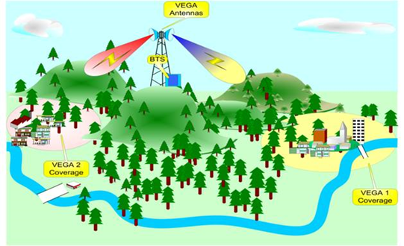
Such very high gain multi-beam antennas provide gain, wider combined beamwidth, as well as broadband with a three-fold capacity, wherever needed. One tower implementing several high-gain beam-antennas, each providing high quality service to its dedicated target area, saves the necessity of additional building, maintaining (and guarding) several towers, each with a full BS and microwave backhaul or a fibre link. For these reasons, these antennas operate in remote sites to cover those distant underserved communities at a shorter time.
With potential enhancements of base station (BS), user equipment (UE) and customer premises broadband configurations, it is deemed feasible to deploy a standalone network in the bands identified for IMT within the 1-6 GHz range (see Recommendation ITU-R M.1036) providing high capacity and coverage over tens of kilometres in remote sites. This could potentially be a promising solution for bringing IMT broadband (e.g. IMT-2020/5G) in remote sites.
Remote areas are very often characterized by limited Internet access and basic mobile service provide by a 2G network designed for voice connectivity. Some of the remote areas that are sparsely populated may have non-contiguous coverage in the area. Therefore, one of the key considerations in providing extended coverage in remote areas, aiming to bringing down the cost, is to possibly reuse the existing 2G network grid deployed for large coverage area. Alternatively, combining the coverage bands below 1 GHz for UL connectivity with a capacity band in 1-6 GHz (see footnote 2) for the DL system, through installations on high towers. The mid-band range offer access to more spectrum bandwidth and therefore capacity, and in combination with the low-band range can provide the coverage for cell edge users in a unified manner.
Aggregation of carriers from existing 4G LTE in low-band with New Radio (NR) in the bands identified for IMT within the mid-range (~1-6 GHz) can provide such extended coverage along with capacity enhancement.
Generally, at a BS site, the antenna height, the radio frequency output power and antenna gain impact the coverage and capacity performance. Effective performance solutions are also represented by a high level of antenna sectorization, high antenna beamforming gain, and the use of Multiple Input Multiple Output (MIMO) antennas, as well as the use of carrier-aggregation. Furthermore, additional spectrum bands and bandwidth, and usage of redundant signalling protocol will improve performance.
Extending cell-coverage is limited by the uplink performance. Enhancing UE transmission capabilities is key to enabling extended coverage along with the downlink coverage. For a fixed wireless broadband deployment in a ‘wireless fibre’ configuration, using an outdoor directional antenna mounted line-of-sight (LOS) to the BS antenna site extends the coverage range significantly by avoiding building penetration losses. Conventional, mobile devices are UEs with power class of maximum 23 dBm transmit power. At higher carrier frequencies in the mid-band (between 1-6 GHz), a standalone network will be limited by uplink coverage rather than the downlink coverage when deployed for extended coverage in remote areas. Hence, it is important to provide adequate extended coverage in the UL direction for the users located at the cell edge along with DL enhancements by using the dual band carriers in the deployment.
It is assumed that conventional IMT antenna arrangements are used for the UL system. For the DL, IMT-2020/5G bands identified for IMT within the 1-6 GHz range, an antenna array is assumed to have 64 dual-polarized antenna elements installed on very high television towers. The considered inter-site distance (ISD) is regarded to be representative for a conventional 2G network grid. For extended coverage, adding a new band from bands identified for IMT within the 1-6 GHz range for mobile and fixed wireless broadband connectivity, networks can clearly deliver on the promise to increase on the coverage requirements for IMT-2020/5G services, but only adequately in the DL direction. This additional band also helps distribute the UL traffic through the 4G low-band at the cell-edge.
With dual bands, a very high gain antenna covering all lower bands as well as bands in 1-6 GHz enables easy implementation of the carrier aggregation, as well as strong DL on the higher bands (and good UL using the lower bands). The solutions employing a higher BS or UE power or other parameters/values different than typical deployments, should be used in accordance with the existing regulations of those countries

5 IMT solutions and configurations
The traditional approach of deploying macro-sites that provide wide coverage and have large upfront and operating costs is not always well suited to cover some remote areas, where villages or households are sparsely distributed and have low population density.
There are various techno-commercial considerations and associated challenges like passive infrastructure requirements, backhaul connectivity, operation and maintenance, coverage solution range, link budget, maximum allowed path loss (MAPL), site density for ubiquitous coverage, etc. required in some remote areas. This section explores technical options that can help in constructing solution configurations to overcome challenges in such remote sites in applicable scenarios.
Solutions often consider the following aspects:
a) Enable IMT technology features like UL power control, and support for High Power User Equipment (HPUE) and CPE type of UEs.
b) Frequency band/spectrum
Terrestrial solution needs to be based on the optimum link budget for suitable band combinations in both UL and DL. Appropriate band aggregation is needed at such remote sites. Optimize site design for low user density and isolated cell-sites.
c) Passive infrastructure requirements
In remote areas, there are challenges in getting the required Passive Infrastructure to deploy the site solution. An optimum site location may not be feasible due to lack of infrastructure. Proposed solution to include the feasibility to use existing terrestrial infrastructure e.g. TV, radio broadcast towers, watch towers on hills, high tension lines, in these areas.
d) Backhaul requirements
Remote areas have challenge in terms connectivity, thus backhaul connectivity for terrestrial sites need to be flexible with possibility of utilizing various solutions (e.g. fibre, fixed service, satellite (VSAT) connectivity) for backhaul.

5.1 Analysis of coupling loss with dual band systems
One of the key challenges for the extended coverage is to ensure sufficient link budget for the uplink common control channels. The maximum supported coupling loss for 2G is approximately 137-144 dB to support acceptable control channel signalling, and assuming a maximum of 140 dB coupling loss is needed for basic coverage. The LTE 800 MHz, the cell-edge (5%) coupling loss of −140 dB corresponds to 4 km ISD. This is tightly connected with the propagation model assumed. For NR, the common control channels, e.g. Synchronization Signal and Physical Broadcast Channel SS/PBCH block Synchronization Signal Block (SSB) support a coupling loss of 145-150 dB and for beamformed control channels such as PDCCH and PUCCH, a beamformed coupling loss of approximately 143 dB need to be supported.
FIGURE 2
Coupling gain for LTE, NR and NR-beamformed
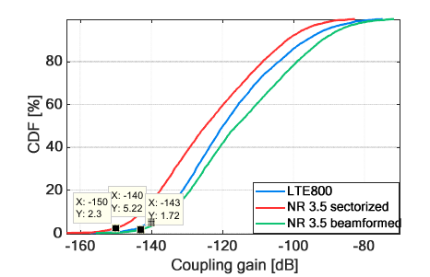
To understand the benefits of dual band (LTE 800, NR 3.5 GHz), a simple deployment scenario of ISD=4 km, with typical heights of UE =1.5 m and BS =25 m is evaluated. A seven-cell, macro sites with uniform UE distribution with 50% indoor and 50% outdoor (in-car) is analysed. It can be noted that coverage for beamformed control channels (−143 dB) is reached at the 1.72% point, and coverage for non-beamformed control channels (−150 dB) is reached at the 2.3% point.
FIGURE 3
5% DL user throughput vs traffic load
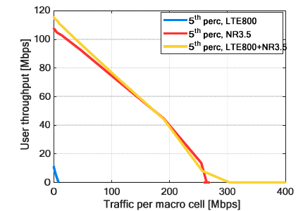
FIGURE 4
5% UL user throughput vs traffic load
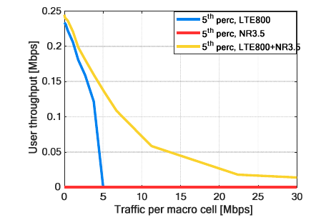
For DL, over 20 times capacity gain can be achieved by utilizing an additional IMT-2020/5G connectivity link in the band 3.5 GHz compared, to an IMT-Advanced/4G connectivity link only in the band 800 MHz This is due to the wider bandwidth of the band 3.5 GHz together with the advanced BS antenna array deployed. For users located at the cell edge, data rates of over 100 Mbit/s can be reached in the DL direction using conventional 5G UE terminals.
For UL, due to limited transmit power of conventional UE (23 dBm), the NR 3.5 GHz standalone cannot provide adequate uplink coverage (zero UE throughput for fifth percentile users for all traffic load). But when a dual-band network is deployed, the UL of LTE 800 MHz can be offloaded to NR 3.5 GHz for UEs close to the cell, and the cell-edge UEs can be served through the LTE 800 MHz grid.

5.2 Analysis for isolated remote sites
In many countries, there are small pockets of population living in remote areas. Depending on the geography, this can be at the outskirts of rural area or even in the outskirts of cities. An example case is illustrated in Fig. 5, where there are only few houses situated some 10 to 15 km away from existing sites.
FIGURE 5
Illustration of remote area
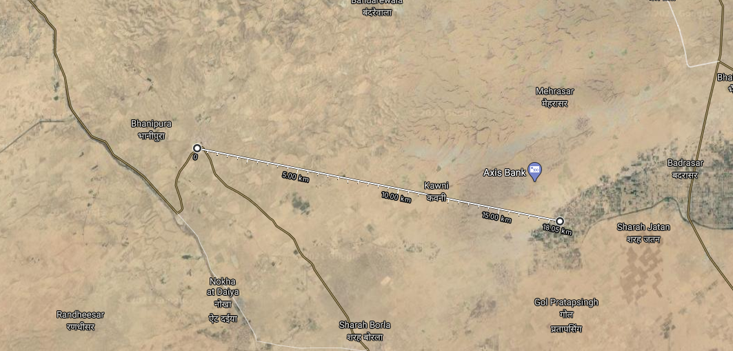
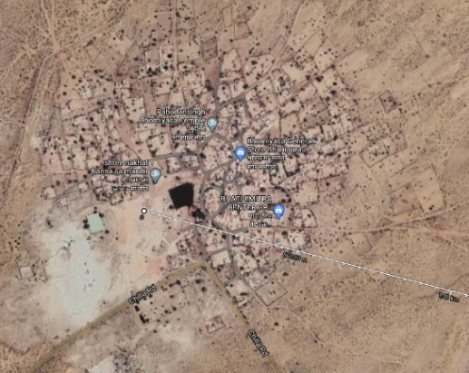
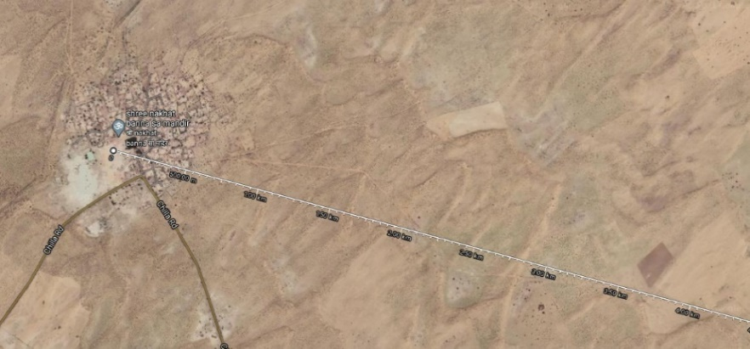
There are multiple reasons why an operator would want to enhance a particular site by extending coverage instead of deploying a BS at the remote area itself. Availability of stable power supply and leverage existing back-haul and infrastructure could be few of the reasons.

5.3 Relays and repeaters
The IMT-Advanced specifications have support for data forwarding through relays and are also known to be used for urban indoor coverages and local coverages but has not found successful adoption in rural applications. Even the usage of repeaters, which have found success in niche applications such as tunnels, have been found not suitable in rural terrains. Repeaters tend to amplify interference and they are sensitive to the location of the antennas. For remote connectivity, the solution needs to be comparatively less complex to install without additional (external) infra-dependencies (for e.g. femto-cells solutions).

5.4 Network and terminal enhancements
This section analyses the possibility of extending the coverage of existing IMT deployments to service such remote areas using a 5G NR system operating in the mid-band. Various parameters of the BS and terminal that can be enhanced to extend this coverage are considered.
For those solutions employing a higher BS or UE power or other parameters/values different than typical deployments, they should be used within the existing regulations of those countries.
The upgrades to BSs in selected remote sites and UE used in the remote sites that can be considered are:
Base-station
Higher altitude | High altitude infrastructure  Reuse high altitude towers, reuse LTE grid of sub-GHz
Higher output power | To improve the DL coverage
Higher sectorization, beamforming, carrier-aggregation, etc. | High sectorization using directional antennas can be deployed, targeted to remote area
LTE-M (coverage enhancements modes) | Cat-M2 enables regular UE to improve coverage by repetition of data in channels (PDSCH, PUSCH). Moderate repetition of 1-32 will increase coverage up to 15 dB

UE – station
Higher altitude | Over roof-tops or poles of 10 m
Higher output power | Class-1 HP-UE providing up to 1.2W compared to conventional Class-3 UE of 200 mW Transmit power
Pole mounted UE | 43 dBm transmit power for UE antenna mounted at poles

Some effective network adaptations for consideration in selected remote sites are: high sectorization (directional antennas), high beamforming gains, the use of MIMO, more spectrum and bandwidth, and usage of carrier enhancements by protocol repetitions in LTE-M2.
Enhancing the UE transmission side capabilities is also key to enable extended coverage. An upgrade from a conventional Class-3 UE with 23 dBm Tx power to Class-1 High-Power UE (HP-UE) providing 1.2 W with support of LTE-M2 will provide a noticeable improvement to the link budget. The different power classes supported in 3GPP for NR bands can be found in TS 38.101-1 (see reference in Recommendation ITU-R M.2150).
A typical enhanced Mobile Broadband eMBB application is designed to provide sufficient link-budget for indoor mobile users, which includes the compensation for building penetration losses (see Fig. 6).
FIGURE 6
Typical eMBB
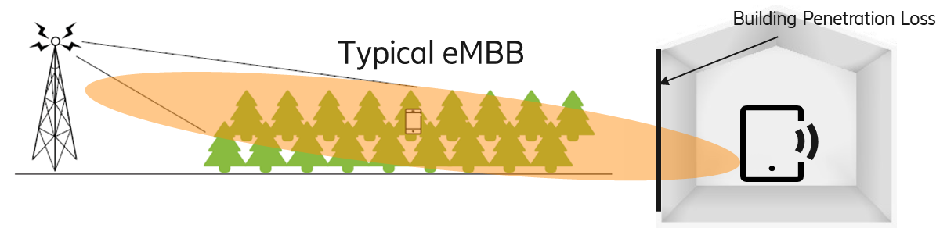
The remote users can deploy UE terminals with external outdoor directional antennas, mounted on rooftops that can help in LoS communication to the base-station, further will also extend the UL coverage significantly (by avoiding the losses due to buildings and vegetation). Such UE terminals can also have large form-factors that makes it feasible to have more antennas than the typical hand-held devices.
Improving the uplink link budget corresponds to budgeting for sufficient SNR for the uplink data (PUSCH) as well as control channels (PUCCH). With NR and Active Antenna systems it is possible to have control and data beamformed providing directional gain towards the UE terminals.
Figures 7 and 8 depicts two cases of enhanced UE terminal. The UE terminals with externally mounted antenna increases the probability of LOS conditions and improves the link budget. Alternatively, the height of the base station can also be adjusted for the same result.
FIGURE 7
User terminal close to window
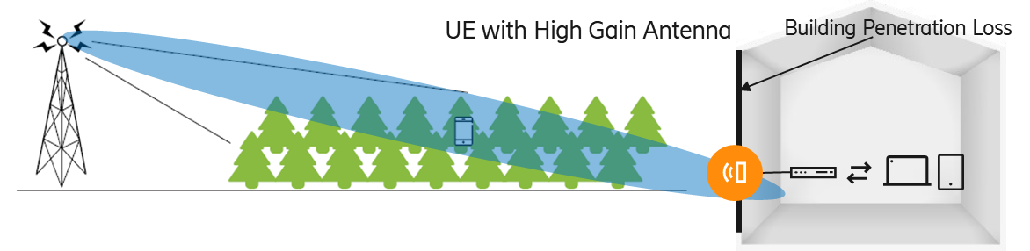
FIGURE 8
Terminal with externally mounted outdoor antenna
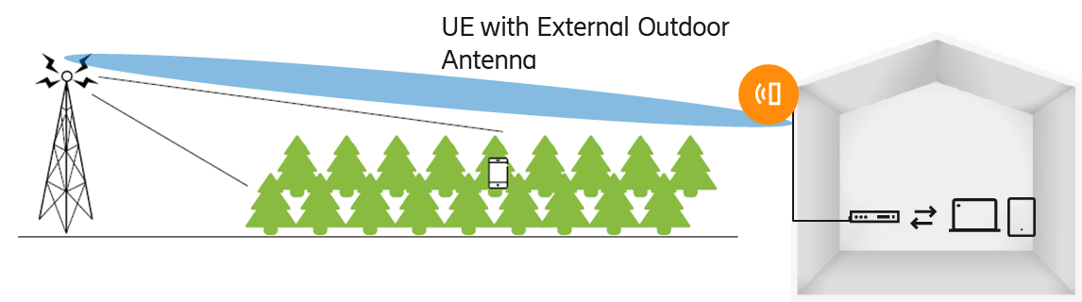
Having CPE antennas mounted outdoor and at elevated height can reduce the vegetation/foliage loss; (see Recommendation ITU-R P.833).
Various loss and potential coverage gain due to enhancements
Based on Recommendation ITU-R P.2109, building penetration loss of the order 4~33 dB can be expected for 3.5 GHz carrier whereas for the 1 800 MHz the same would be around 4~31 dB for typical BS and UE heights of 30 m and 1.5 m respectively.
Having antennas of UEs externally mounted at higher elevation in outdoor environments can also increase the probability of LOS as well as minimize the vegetation/foliage loss. The potential coverage-gain in distance due to this can be evaluated based on Recommendations ITU-R P.2001 and ITU-R P.2108.
 | 1.8 GHz  (Typical values) | 3.5 GHz  (Typical values) | Enhancements | Potential coverage gain
Building penetration loss (P.2109) | ~14.9 dB  ~30.6 dB | ~15.7 dB  ~30.6 dB ⁽¹⁾ | Reduce BEL by enabling terminals with Outdoor mounted Antenna | For 3.5 GHz  Additional ~2.5 to ~5 km link budget possible, if BEL of 4 dB to 10 dB need not be compensated.  A 15 dB of clutter loss can allow a significant link-budget improvement to extend the coverage to such terminals.
Clutter loss  (P.2108) | ~14 dB | ~15 dB | External mounted antenna at 6 m, compared to typical UE at 1.5 m
Antenna gain (UE) | −3 dBi | −3 dBi | High Gain Antenna ⁽²⁾  10 dBi ⁽³⁾
⁽¹⁾ For thermally efficient buildings.
⁽²⁾ From 5G Americas – Advanced antenna systems for 5G https://www.5gamericas.org/wp-content/uploads/2019/08/5G-Americas_Advanced-Antenna-Systems-for-5G-White-Paper.pdf
⁽³⁾ This value can be changed according to the existing regulations in the developing countries.

5.5 3GPP specifications support for coverage extension
Timing advance
Both LTE and NR support uplink timing advance. The uplink timing advance instructs the UE to advance its uplink transmissions from large distances are aligned with other UE’s uplink transmissions, when received at the base-stations.
Timing advance is a negative offset, introduced at the UE, between the start of a received downlink subframe and a transmitted uplink subframe. This offset at the UE is necessary to ensure that the downlink and uplink subframes are synchronised at the eNodeB/gNodeB. A UE far from the eNodeB/gNodeB encounter a larger propagation delay so its uplink transmission is advanced when compared to a UE closer to the eNodeB/gNodeB. The Timing Advance needed to create this alignment is equal to twice the propagation delay, assuming that the same propagation delay value applies to both the downlink and uplink directions.
If the Timing Advance is not applied, then the start of uplink transmission from a certain UE (say, UE2) closer to the eNodeB/gNodeB for a certain subframe (say, #n+1) will overlap with the end of uplink transmission from a farther UE (say, UE1) for subframe #n. Assuming that same resource blocks are assigned to UE1 in subframe #n and UE2 in subframe #n+1, this overlap creates interference which causes reception failures at the eNodeB/gNodeB. Whereas, if a proper value of Timing Advance is applied, then these subframes won’t collide.
The eNodeB/gNodeB continuously measures timing of uplink signal from each UE and adjusts the uplink transmission timing by sending the value of Timing Advance to the respective UE. As long as an UE sends some uplink data (say, PUSCH/PUCCH/SRS), the eNodeB/gNodeB can estimate the uplink signal arrival time which can then be used to calculate the required Timing Advance value for every UE in the system.
FIGURE 9
Timing advance
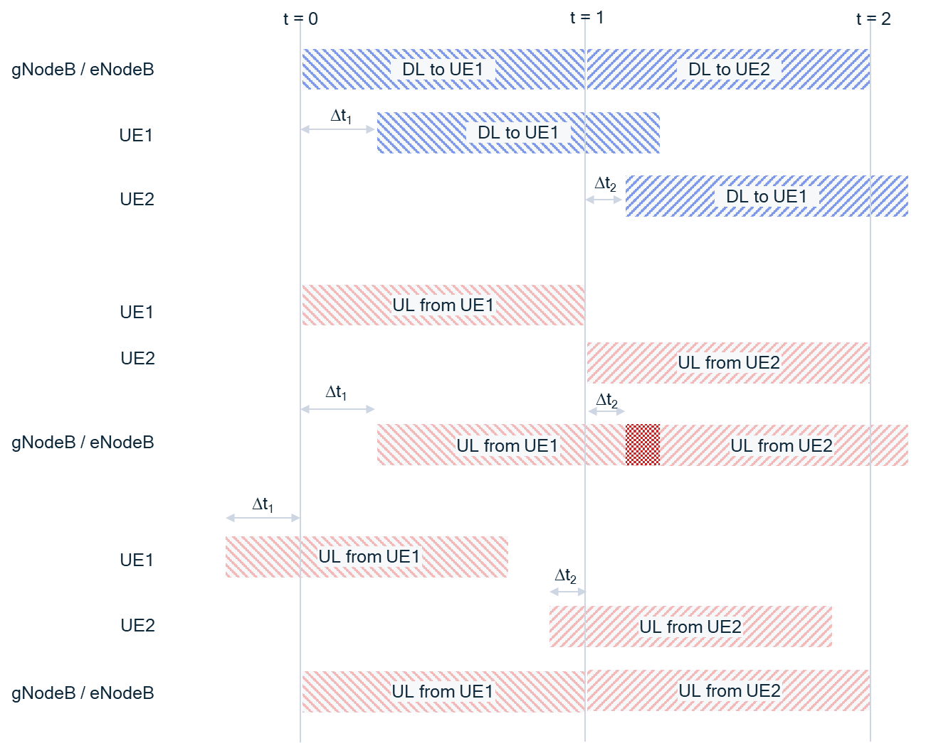
The 3GPP specifications allow timing advance parameters to accommodate UL transmissions from a distance up to 100 km.
Especially, in the bands operating in TDD mode, it is important that there is also sufficient time available to switch between DL and UL slots.
Extended Cyclic Prefix (CP)
3GPP LTE and 5G-RIT supports normal and extended CP (see 3GPP TS 38.211). The length of the normal CP and extended CP depends on the numerology – Sub Carrier Spacing. The length of the CP determines the ability to support the delay spread due to multipath propagation channel.

6 Summary
As has been indicated with 29th July 2022 data, 2.7 billion people are still unconnected. The prospect of providing affordable mobile broadband services to those living in remote and sparsely populated areas remains a challenge. In this Report, details on scenarios associated with the provisioning of enhanced mobile broadband services in sparsely populated and underserved remote areas are discussed, by considering potential enhancements of user equipment and network equipment. Mobile broadband access from remote sites can also be done for the existing user equipment through a combination of frequency bands. Additionally, for single frequency/band deployment, broadband can also be delivered through FWA type of CPEs, which can be placed appropriately to improve the link quality between BS and user terminal. This Report also demonstrates various potential gains that can be achieved if losses, including building penetration loss and clutter loss, can be overcome. Additionally, this Report provides reference to the IMT specifications from 3GPP, specifying features that can help extend coverage for large cells. IMT-based solutions for providing broadband to remote areas could therefore be considered, while adhering to the prevailing regulations in the country.

Annex 1
List of acronyms and abbreviations
3GPP Third Generation Partnership Project
BS Base station
CP Cyclic prefix
CPE Customer premises equipment
DL Downlink
E_{b}/N₀ Energy per bit to noise power spectral density ratio; SNR per bit
FWA Fixed wireless access
HPUE High power user equipment
IMT International Mobile Telecommunications
ISD Inter-site distance
LOS Line-of-Sight
LTE Long-term evolution
LTE-M Long-term evolution for machines
MIMO Multiple input multiple output
NR New radio
PDCCH Physical downlink control channel
PUCCH Physical uplink control channel
QoS Quality of service
SNR Signal-to-noise ratio
TDD Time division duplex
UE User equipment
UL Uplink

https://www.itu.int/en/ITU-D/Statistics/Pages/stat/default.aspx. The database is revised frequently.
Such opportunities rest with traditionally high tower used for analogue or digital television with an average inter-site distance (ISD) of the order of 60 km to 80 km designed to provide blanket coverage of national terrestrial television services.
3GPP R1-1809266, Ericsson, “IMT-2020 Self-Evaluation: NR Link Budgets”, https://www.3gpp.org/ftp/tsg_ran/wg1_rl1/TSGR1_94/Docs/R1-1809266.zip.

