Report ITU-R M.2519-0
(11/2022)
Protection of radio receivers
installed onboard vessels against electromagnetic interference from
light emitting diode lighting systems
and other interfering sources

M Series
Mobile, radiodetermination, amateur
and related satellite services

Foreword
The role of the Radiocommunication Sector is to ensure the rational, equitable, efficient and economical use of the radio-frequency spectrum by all radiocommunication services, including satellite services, and carry out studies without limit of frequency range on the basis of which Recommendations are adopted.
The regulatory and policy functions of the Radiocommunication Sector are performed by World and Regional Radiocommunication Conferences and Radiocommunication Assemblies supported by Study Groups.

Policy on Intellectual Property Right (IPR)
ITU-R policy on IPR is described in the Common Patent Policy for ITU-T/ITU-R/ISO/IEC referenced in Resolution ITU-R 1. Forms to be used for the submission of patent statements and licensing declarations by patent holders are available from http://www.itu.int/ITU-R/go/patents/en where the Guidelines for Implementation of the Common Patent Policy for ITU-T/ITU-R/ISO/IEC and the ITU-R patent information database can also be found.

Series of ITU-R Reports
(Also available online at http://www.itu.int/publ/R-REP/en)
Series | Title
BO | Satellite delivery
BR | Recording for production, archival and play-out; film for television
BS | Broadcasting service (sound)
BT | Broadcasting service (television)
F | Fixed service
M | Mobile, radiodetermination, amateur and related satellite services
P | Radiowave propagation
RA | Radio astronomy
RS | Remote sensing systems
S | Fixed-satellite service
SA | Space applications and meteorology
SF | Frequency sharing and coordination between fixed-satellite and fixed service systems
SM | Spectrum management

Note: This ITU-R Report was approved in English by the Study Group under the procedure detailed in Resolution ITU-R 1.

Electronic Publication
Geneva, 2023
© ITU 2023
All rights reserved. No part of this publication may be reproduced, by any means whatsoever, without written permission of ITU.

REPORT ITU-R M.2519-0
Protection of radio receivers installed onboard vessels against electromagnetic interference from light emitting diode lighting systems
and other interfering sources
(2022)

TABLE OF CONTENTS
Page
Policy on Intellectual Property Right (IPR) ii
1 Introduction 4
2 Interference protection criteria for automatic identification system and VHF marine radios from interfering radiation sources 4
2.1 For the VHF marine radio receiver and the automatic identification system receiver 5
2.2 Conclusions 10
3 Interference protection criteria for marine global navigation satellite system receivers from interfering radiation sources 11
3.1 Adjustments for standard resolution bandwidth 12
3.2 Comparing these levels to current standards 12
4 Summary of results 13
4.1 Important precautions for avoiding interference when using light emitting diode lamps 13
4.2 Separate light emitting diode lamps from sensitive antennas 13
4.3 Use vertical separation wherever possible 14
4.4 Testing for interference following installation 14
Annex 1 Protection criteria for the VHF data exchange system 15
1 VHF data exchange system satellite system characteristics 15
2 VHF data exchange system satellite downlink budget 15
3 VHF data exchange system satellite downlink power flux-density and noise plus interference levels 16
4 Protection for the VHF data exchange system satellite downlink (refer to Recommendation ITU-R M.2092) 17
5 Relating VHF data exchange system interference protection to CISPR 25 Class 5 test levels 17
6 Protection for the automatic identification system 18
7 Conclusions 19
Annex 2 VHF and automatic identification system installation electromagnetic compatibility test results 20
Annex 3 Review of emission limits in the global navigation satellite service frequency bands 26

Scope
The purpose of this Report is to:
– Identify and describe the problem of electromagnetic interference (EMI) emanating from light emitting diode (LED) lighting systems on marine vessels and the effects of EMI on maritime safety-related systems.
– Quantify the intensity of this problem in technical terms.
– Assess the insufficiency of current EMI standards to address this problem.
– Develop new technical guidance relevant to the problem and coordinate with appropriate standards groups.
– Develop installation guidelines for mariners to minimize degradation from EMI to sensitive radio communications and radio navigation equipment on their vessels.
Keywords
Electromagnetic interference (EMI), Light emitting diode (LED), Measurement bandwidth, Safety-related systems, Interfering sources
Abbreviations/Glossary
AIS Automatic identification system
AV Average
CISPR Comité International Spécial des Perturbations Radioélectriques
EMI Electromagnetic interference
GMDSS Global maritime distress and safety system
GNSS Global navigation satellite system
GPS Global positioning system
IEC International Electrotechnical Commission
LED Light emitting diode
PER Packet error rate
pfd Power flux-density
PK Peak
RBW Resolution bandwidth, used in radiation measurements
RSSI Received signal strength indication
SINAD Signal-to-interference ratio including noise and distortion
VDES VHF data exchange system
Related ITU-R Recommendations
ITU-R F.699 Reference radiation patterns for fixed wireless system antennas for use in coordination studies and interference assessment in the frequency range from 100 MHz to 86 GHz
ITU-R F.1336 Reference radiation patterns of omnidirectional, sectoral and other antennas for the fixed and mobile service for use in sharing studies in the frequency range from 400 MHz to about 70 GHz
ITU-R M.1371 Technical characteristics for an automatic identification system using time-division multiple access in the VHF maritime mobile band
ITU-R M.1581 Mathematical models for radiodetermination radar systems antenna patterns for use in interference analyses
ITU-R M.1902 Characteristics and protection criteria for receiving earth stations in the radionavigation-satellite service (space-to-Earth) operating in the band 1 215-1 300 MHz
ITU-R M.1903 Characteristics and protection criteria for receiving earth stations in the radionavigation-satellite service (space-to-Earth) and receivers in the aeronautical radionavigation service 1 operating in the band 1 559-1 610 MHz
ITU-R M.1905 Characteristics and protection criteria for receiving earth stations in the radionavigation-satellite service (space-to-Earth) operating in the band 1 164-1 215 MHz
ITU-R M.2092 Technical characteristics for a VHF data exchange system in the VHF maritime mobile band

1 Introduction
Maritime radiocommunication authorities have received many reports of electromagnetic interference (EMI) emanating from light emitting diode (LED) lighting systems on marine vessels. These reports have been primarily focused on interference to the automatic identification system (AIS) and to VHF marine radios, both of which operate in the 156-162 MHz band and are essential to safety of navigation and safety of life. It was found that most LED lighting systems on marine vessels cause significant desensitization of the receivers of both the AIS and the VHF marine radios, especially when the LED lamps are located in close proximity to the AIS antenna and/or the VHF radio antenna. The latest bulletin announces the final approval of a new maritime EMI standard RTCM 13700.0, 13 April 2022 which follows the analysis and test procedures recommended in this Report.

2 Interference protection criteria for automatic identification system and VHF marine radios from interfering radiation sources
Operational ‘Minimum sensitivity’ requirements for the AIS and for VHF marine radios are developed by ITU and International Electrotechnical Commission (IEC).
For the AIS, the minimum sensitivity is contained in Recommendation ITU-R M.1371 as −107 dBm for a maximum packet error rate (PER) of 20%, which occurs at approximately carrier-to-interference plus noise ratio = 10 dB (C/(N + I)) = 10 dB, based on the specified co-channel rejection ratio, which is 10 dB for a PER of 20%. Thresholds for protecting the VHF data exchange system (VDES), are derived in Annex 1, which indicates that the VDES threshold is approximately 1.3 dB stricter than for the AIS.
For the marine VHF radio, the ‘maximum useable sensitivity’ is contained in IEC 61097-3 edition 2 as “+6 dBµV e.m.f. for a SINAD, psophometrically weighted, of 20 dB”, which occurs at approximately C/(N + I) = 10.8 dB, based on an “FM improvement factor” (FM_{i}) of 9.2 dB, which is determined by:
FM_{i} = (S/N)_{o}/(C/(N + I)) = 3(∆F/f_{m})² = 3(5/3)² = 8.33, logarithmically, 10 log₁₀ 8.33 = 9.2 dB
Note that +6 dBµV e.m.f. is equivalent to −107 dBm in a 50-ohm system, since e.m.f. is technically defined as the open-circuit voltage of the energy source. Also note that this level is the same as 2 µV e.m.f. (the open-circuit output terminal of the 50-ohm signal source) and 1 µV at the 50-ohm input terminal of the victim equipment. Therefore, the sensitivity and interference protection criteria for both the AIS and the marine VHF radio are within 0.8 dB.

2.1 For the VHF marine radio receiver and the automatic identification system receiver
For the VHF marine radio receiver, the maximum interference plus noise (I+N) level, at the input of the receiver is (−107 dBm − 9.2 dB) = −116.2 dBm. Since thermal noise in the VHF marine radio receiver bandwidth of 16 kHz = N = kTB = −131.96 dBm, and the maximum level of I + N = −116.2 dBm, the maximum level of interference (I) can be calculated from the linear power terms and converted back to logarithmic terms. Consequentially, the maximum level of interference (I) at the VHF marine radio receiver input is −116.32 dBm.
And for the AIS receiver, the maximum interference plus noise (I + N) level, at the input of the receiver is (−107 dBm – 10 dB) = −117 dBm. Since thermal noise in the AIS receiver bandwidth of 18 kHz = N = kTB = −131.4 dBm, and the maximum level of I + N = −117 dBm, the maximum level of interference (I) can be calculated from the linear power terms and converted back to logarithmic terms. Consequentially, the maximum level of interference (I) at the AIS receiver input is −117.16 dBm. Thus, protection for the AIS will ensure protection for the VHF marine radio receiver.

2.1.1 Assessing the efficacy of the current electromagnetic interference standards for this application
The current EMI standards specify a maximum field-strength level measured at a separation distance.
Example 1: IEC 60945 specification (per 9 kHz bandwidth):
– Maximum field-strength level (quasi-peak): 24 dBµV/m = 16 µV/m
– Separation distance for measurement: 3 m
Example 2: CISPR 25 Class 5 specification (per 120 kHz bandwidth):
– Maximum field-strength level (average): 15 dBµV/m = 5.6 µV/m
– Maximum field-strength level (quasi-peak): 22 dBµV/m = 12.6 µV/m
– Separation distance for measurement: 1 m
Note that the Comité International Spécial des Perturbations Radioélectriques (CISPR) measurement bandwidths for the VHF marine frequency band (156-162 MHz) is 120 kHz and the IEC 60945 measurement resolution bandwidth (RBW) for this band is 9 kHz. Considering that the VHF marine radio receiver bandwidth is 16 kHz, and the AIS receiver bandwidth is 18 kHz, testing in a 20 kHz resolution bandwidth will more accurately assess the performance effects on both of these maritime VHF receivers. For example, it was found that changing from 120 kHz bandwidth to the IEC 60945 specified 9 kHz bandwidth, “the test level of the marine VHF band will decrease 16-20 dB for most signals” . This measurement bandwidth factor is considered in § 2.1.3 below.

2.1.2 Information needed for this application
– Separation distances between victim antennas and unintentional interference sources, e.g. for LED navigation lights:
NOTE – The separation distance, for this analysis, is the distance between the interfering device and the centre of radiation of the victim antenna. The antenna gain for this analysis may also be adjusted (see graph in Fig. 1) to account for the angular offset to the antenna radiation pattern relative to the reference elevation angle of zero degrees (0⁰).
Worst case = 1 metre; edge of antenna near field, minimum separation. In rare cases = 0.5 metre; in the antenna near field, should be avoided if possible. Characteristics of the victim equipment antennas are shown in Fig. 1.
Figure 1
Characteristics for vertical whip antennas based on Recommendation ITU-R F.1336

NOTE: Antenna gain is defined as the gain at 0⁰ elevation angle.
– For the AIS, the typical antenna is a 4-foot whip; gain = +2 dBi = 0 dBd.
– For the VHF radio, the typical antenna is an 8-foot whip; gain = +6 dBi = 3 dBd.

2.1.3 Necessary adjustments to current standards to fit this application
Adjustments to field-strength level:
– Adjustment for distance separation: 20log₁₀ D, in metres
– Adjustment for marine VHF radio is based on receiver sensitivity and antenna characteristics (gain, radiation pattern and angular offset of the position of the interfering source relative to the antenna)
– Adjustment for AIS is based on receiver sensitivity and antenna characteristics (gain, radiation pattern and angular offset of the position of the interfering source relative to the antenna).
– Consideration of the measurement resolution bandwidth compared to the bandwidth of the victim receiver, based upon the type of detector used to measure interference (e.g. average, quasi-peak and peak) and the type of interference encountered, as noted in §§ 2.1.3.2 and 2.1.3.5.
– Adjustment for reactive near field effect in partially illuminating a 2.5 m shipboard VHF marine radio antenna, for example, from an unintentional emitter separated by as little as 1 m or even 0.3 m, as noted in Annex 2. The reactive near field for such an antenna begins at 1.5 m separation.

2.1.3.1 Field-strength determination examples for the automatic identification system
Maximum interference signal level at the AIS RF input terminal = −117.16 dBm
The conversion of maximum interference power level to maximum interference field-strength level is as follows:
NOTE: Units are assumed to be rms values (average values, not quasi-peak values).
Method 1 (standard method)
E_{dBµV/m} = AF_{dB/m} + V_{dBµV}
AF_{50Ω} = 20 log₁₀ f_{MHz} − 10 log₁₀ G − 29.7707, where
G = 1.64 for the 0 dBd AIS antenna
AF_{50Ω} = 44.19 − 2.15 − 29.7707 = 12.27 dB/m
V_{dBµV} (for −117.16 dBm) = −10.17 dBµV
E_{dBµV/m} = AF_{dB/m} + V_{dBµV} = 12.27 − 10.17 = +2.1 dBµV/m
Method 2 (according to: Wikipedia, Antenna Factor)
AF_{50Ω} = 9.73/(λ√G) = 4.10/m = 12.26 dB/m
and
AF = E/V
Thus
AF_{dB/m} = E_{dBV/m} − V_{dBV} = E_{dBµV/m} − V_{dBµV}
E_{dBµV/m} = AF_{dB/m} + V_{dBµV} = 12.26 + (−10.17) = +2.1 dBµV/m
Result: The results of Method 1 and Method 2 are identical.

2.1.3.2 Adjustments for standard resolution bandwidth
Ideally, if the spectral distributions of all interference sources could be assumed to be Gaussian, a test standard with an RBW of B₁ could be adjusted to a victim receiver with effective receiver bandwidth B₂, by adjusting the test levels according to L₁/L₂ = 10 log (B₁/B₂) as shown below. Units are assumed to be average values (not peak or quasi-peak values). However, it has been found that this test bandwidth adjustment does not accurately represent the interference scenario in the VHF maritime environment, as previously noted in § 2.1.1, and as further evidenced by the test results reported in § 2.1.3.5.
Adjustments based on Gaussian interference spectrum:
For a 9 kHz resolution bandwidth, per IEC 60945
P_{dBm} = −117.16 + 10 log (9/18) = −120.16 dBm
P_{dBm} = V_{dBµV} − 107
V_{dBµV} (for −120.16 dBm) = −120.16 + 107 = −13.16 dBµV
E_{dBµV/m} = 12.27 + (−13.16) = −0.89 dBµV/m
For a 20 kHz resolution bandwidth, for VHF maritime 25 kHz channels
P_{dBm} = −117.16 + 10 log (20/18) = −116.70 dBm
P_{dBm} = V _{dB uV} − 107
V_{dBµV} (for −116.70 dBm) = −116.70 + 107 = −9.70 dBµV
E_{dBµV/m} = 12.27 + (−9.70) = +2.57 dBµV/m
For a 120 kHz resolution bandwidth, per CISPR 25 Class 5
P_{dBm} = −117.16 + 10 log (120/18) = −108.92 dBm
P_{dBm} = V _{dB uV} − 107
V_{dBµV} (for −108.92 dBm) = −108.92 + 107 = −1.92 dBµV
E_{dBµV/m} = 12.27 + (−1.92) = +10.35 dBµV/m

2.1.3.3 Comparing these levels to current standards
– CISPR 25 Class 5 (120 kHz bandwidth and 1 m):
• Maximum field-strength level (average): +15 dBµV/m
The minor difference (15 dBµV/m −10.35 dBµV/m = 4.65 dB) between the CISPR 25 Class 5 level and the level calculated for the AIS may be attributed to the higher gain (physical size) of the typical marine antenna compared to the typical automotive antenna addressed by CISPR 25 Class 5.
• Maximum field-strength level (quasi-peak): +22 dBµV/m
• Maximum field-strength level (peak): +35 dBµ
– IEC 60945 (9 kHz bandwidth and 3 m):
• Maximum field-strength level (quasi-peak): +24 dBµV/m

2.1.3.4 Measurements in a typical electromagnetic interference laboratory test chamber
For the 9 kHz resolution bandwidth, the ambient noise floor (kTB) is:
P_{dBm} (kTB for 9 kHz resolution bandwidth) = −134.43 dBm
For the test chamber:
The noise figure of the measurement system is 3.0 dB.
The antenna factor of the test antenna is 14.7 dB/m.
Therefore:
P_{dBm} = (kTB + NF) = −134.43 + 3 = −131.43 dBm
V_{dBµV} (for −131.43 dBm) = −131.43 + 107 = −24.43 dBµV
E_{dBµV/m} = 14.7 + (–24.43 dBµV) = −9.73 dBµV/m
Thus, the ambient level of the chamber, −9.73 dBµV/m, is 8.84 dB below the test level, −0.89 dBµV/m, which meets the 6 dB CISPR minimum requirement.
Test results from the test chamber (ambient level, average level measurement) shown in Fig. 2 are consistent with the calculated value (−9.73 dBµV/m) shown above. Thus, it is practical to measure the levels required to protect the AIS in a typical EMI test laboratory, e.g. footnote 6.
Figure 2
Measurement of the ambient noise level (9 kHz resolution bandwidth, fast Fourier transform, average level)
of the electromagnetic interference test chamber
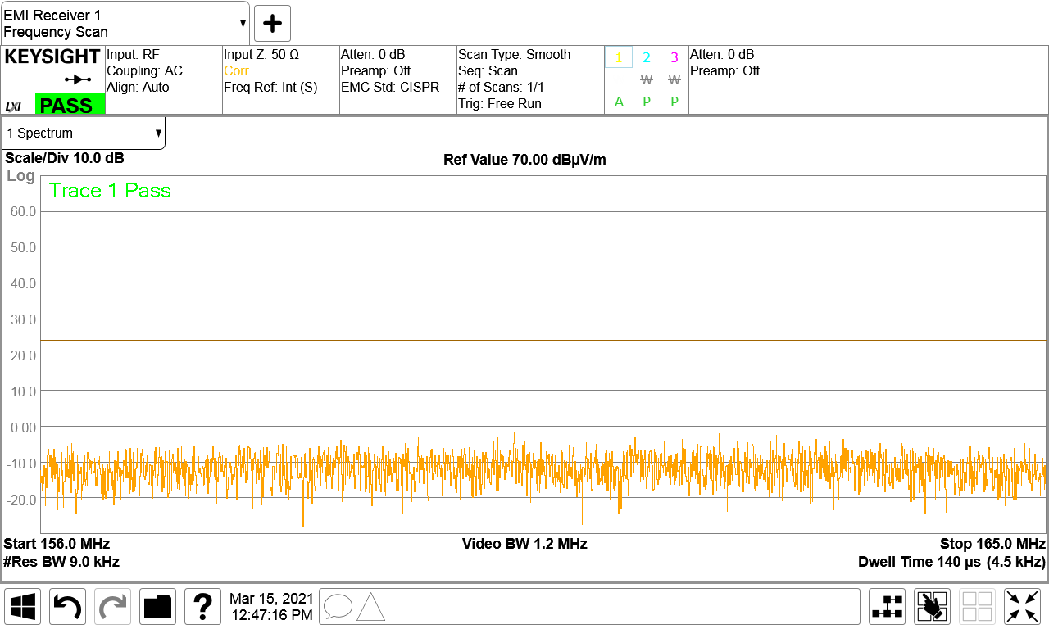

2.1.3.5 Results from testing numerous maritime light emitting diodes navigation lights in the electromagnetic interference laboratory test chamber
Annex 2 provides measured effects of radiation from the “active” sample LED lights on the installed victim receivers, VHF marine radio, and AIS, at various installed separation distances from 0.33 m to 3 m.
Figure 3 provides a summary of test results from testing radiation from numerous samples of marine LED lights in the EMI laboratory test chamber referred to in footnote 6. The samples were tested in the resolution bandwidths of 9 kHz, 20 kHz, and 120 kHz noted in § 2.1.3.2 above, using average, peak, and quasi-peak detectors. Only the results from the “active” samples are recorded here because the others did not radiate above the ambient noise level of Fig. 2.
Figure 4 provides a comparison of measured radiation levels as a function of resolution bandwidth. Figure 4 shows the deviations for the test samples and two additional scaling factors (10 log B₁/B₂ and 20 log B₁/B₂) for comparison.

2.2 Conclusions
The conclusions from these test results represented in Fig. 3, Fig. 4 and Annex 2 are:
• Only Sample 1 passes CISPR 25 Class 5 level of +15 dBµV/m average in 120 kHz RBW.
• None of the samples pass any of the levels stated in § 2.1.3.2 above, but sample 1 comes the closest, within 5 dB.
• The relationship between measured levels and RBW is inconsistent, thus unpredictable.
• Although it is difficult to come to a precise conclusion, the tests performed in Annex 2 support the adequacy of the predicted radiated emission limit of +2.57 dB µV/m average at 20 kHz RBW and 1 m separation, calculated in § 2.1.3.2, to protect the VHF radio and AIS.
Figure 3
Test results from ‘active’ samples
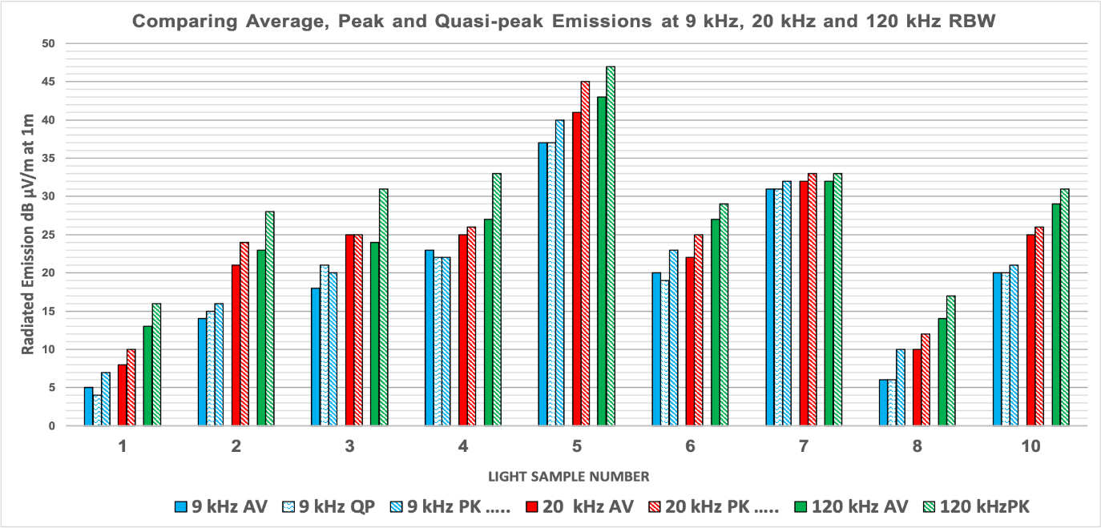
FIGURE 4
Comparison of measured radiation levels as a function of resolution bandwidth
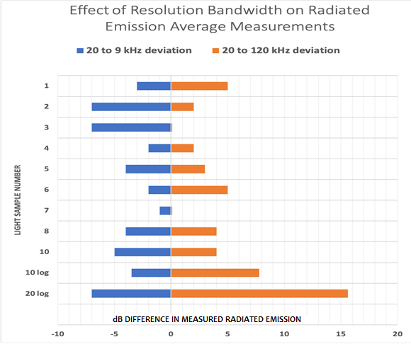

3 Interference protection criteria for marine global navigation satellite system receivers from interfering radiation sources
The interference protection threshold for global navigation satellite system (GNSS) (e.g. global positioning system (GPS)) receivers is based on Recommendation ITU-R M.1903 – Characteristics and protection criteria for receiving earth stations in the radionavigation-satellite service (space-to-Earth) and receivers in the aeronautical radionavigation service operating in the band 1 559-1 610 MHz.
Acquisition mode threshold power density level of aggregate wideband interference at the passive antenna output: −142 dB W/MHz = −112 dBm/MHz
Tracking mode threshold power density level of aggregate wideband interference at the passive antenna output: −136 dB W/MHz = −106 dBm/MHz
Acquisition mode threshold power level of aggregate narrow-band interference at the passive antenna output: −158 dBW = −128 dBm
RF filter 3 dB bandwidth: 32 MHz
Pre-correlation filter 3 dB bandwidth: 2 MHz
Noise temperature: 645ºK
AF_{50Ω} = 20 log₁₀ f_{MHz} − 10 log₁₀ G_{numeric} − 29.7707 dB/m,
= 63.945 − 29.7707 = 34.174 dB/m at 1 575 MHz
P_{dBm} = V_{dBμV} − 107
E_{dBµV/m} = AF_{50Ω} + V_{dBµV} = AF_{50Ω} + P_{dBm} + 107 = P_{dBm} + 107 + 34.174 = P_{dBm} + 141.174

3.1 Adjustments for standard resolution bandwidth
For a 1 MHz resolution bandwidth
P_{dBm (acquisition)} = −112 dBm/MHz
E_{dBµV/m (acquisition)} = −112 dBm + 141.174 = 29.2 dBµV/m
For a 120 kHz resolution bandwidth
P_{dBm (acquisition)} = −112 dBm − 10 log (1/0.120) = −112 − 9.2 = −121.2 dBm
E_{dBµV/m (120 kHz)} = −121.2 dBm + 141.174 = 20 dBµV/m
For a 9 kHz resolution bandwidth
P_{dBm (acquisition)} = −112 dBm − 10 log (1/0.009) = −112 − 20.46 = −132.46 dBm
E_{dBµV/m (9 kHz)} = −132.46 dBm + 141.174 = 8.71 dBµV/m

3.2 Comparing these levels to current standards
– IEC 60945 (120 kHz, quazi-peak, 3 meters): 54 dB µV/m
• Adjustment for 3 meters to 1 meter: 20 log (3/1) = + 9.54 dB
• Adjustment for quazi-peak to average: −10 dB
• Adjusted value: + 54 − 10 + 9.54 = 53.5 dBµV/m
• Difference to this calculation: 53.5 − 20 = 33.5 dB
– CISPR 25 Class 5 (9 kHz, 1 meter, average): 10 dBµV/m
• Difference to this calculation: 10 − 8.71 = 1.29 dB

3.2.1 Results of comparison to current standards
Recommendation ITU-R M.1903 requires the acquisition mode threshold power density level of aggregate wideband interference at the passive antenna output to be no greater than −142 dB W/MHz. This level is only 1.83 dB above kTB (kTB = −143.83 dB W/MHz), which can only be measured with specialized equipment including very high gain antenna and very low noise preamplifier, as noted below.

3.2.2 Measurements by an electromagnetic interference certification laboratory
For a typical EMI laboratory test chamber:
For the 9 kHz RBW, the ambient noise floor (kTB) is:
P_{dBm} (kTB for 9 kHz resolution bandwidth) = −134.43 dBm
The noise figure of the typical measurement system is 3.0 dB.
The antenna factor of the typical test antenna is 25.0 dB/m.
Therefore:
P_{dBm} = (kTB + NF) = −134.43 + 3 = −131.43 dBm
V_{dBµV} (for −131.43 dBm) = −131.43 + 107 = −24.43 dBµV
E_{dBµV/m} = 25.0 + (−24.43 dBµV) = +0.57 dBµV/m
Thus, the ambient level of the chamber, +0.57 dBµV/m, is only 8.14 dB below the test level, +8.71 dBµV/m, which barely meets the 6 dB CISPR minimum requirement, but it does not allow for measurement uncertainty of typically 3 dB.
Enhancements for testing to Recommendation ITU-R M.1903
Example enhancements for the EMI laboratory test chamber:
The noise figure of the special low noise preamplifier at 1575 MHz is 1.5 dB.
The antenna factor of the special high gain horn test antenna at 1575 MHz is:
AF_{50Ω} = 20 log₁₀ f_{MHz} − G_{dB} – 29.7707 dB/m; G_{dB} = 14.4_{dB}; AF_{50Ω} = 19.77 dB/m
Therefore:
P_{dBm} = (kTB + NF) = −134.43 + 1.5 = −132.93 dBm
V_{dBµV} (for -132.93 dBm) = −132.93 + 107 = −25.93 dBµV
E_{dBµV/m} = 19.77 + (−25.93 dBµV) = −6.16 dBµV/m
The ambient level of the enhanced EMI laboratory test chamber, −6.16 dBµV/m, is 14.87 dB below the test level, +8.71 dBµV/m. This meets the 6 dB CISPR minimum requirement with a comfortable margin, including measurement uncertainty of typically 3 dB.

3.2.3 Conclusion
Testing to the level prescribed by Recommendation ITU-R M.1903 by a certified EMI test laboratory may require some enhancements as noted in the example stated above.

4 Summary of results
If these lighting systems are installed on marine vessels, installers should use the following guidelines to avoid interference to safety related marine radio communications (both HF and VHF) and radio-navigation systems (both AIS and GPS).

4.1 Important precautions for avoiding interference when using light emitting diode lamps
If LED lamps are used, ensure they are proven to meet CISPR 25 Class 5 radiated emissions limits in the marine radio communications and radio-navigation frequency bands, measured at 1 meter from the LED lamps. The connecting cables should be shielded.
– HF Marine Band (RR Appendix 17) 2-30 MHz: 20 dB(µV/m) average
– VHF Marine Band (RR Appendix 18) 156-162 MHz: 15 dB(µV/m) average
– GNSS L1 Marine Band (1 559-1 610 MHz): 10 dB(µV/m) average

4.2 Separate light emitting diode lamps from sensitive antennas
To mitigate EMI from LED lamps, separate the LED lamps as far as possible from VHF marine band antennas, with a minimum distance of 1 meter wherever possible.

4.3 Use vertical separation wherever possible
If possible, separate the LED lamps from the sensitive antennas in the vertical direction, either over or under each other, in order to minimize the coupling between them. Refer to the antenna patterns on Fig. 1 for ±90 degrees elevation angle.

4.4 Testing for interference following installation

4.4.1 Test the VHF marine radio for interference
To test for the presence of EMI, switch off all lighting that could be a source of EMI. Tune the radio to a weak continually broadcasting station. Turn on the LED light(s) one at a time, and then all on. If the broadcast signal vanishes after a lamp is energized, it is generating RF interference.

4.4.2 Alternative method using received signal strength indication to test the VHF marine radio for interference
Some marine radios use received signal strength indication (RSSI) displays to indicate the strength of a received signal on the radiocommunications channel. The RSSI level is usually displayed in a bar graph.
When a marine radio is tuned to a communications channel that displays an RSSI level but has no discernible output signal, the RSSI level may be an indication of RF interference. To confirm this, the user may lower the squelch control to its minimum setting to determine whether the displayed RSSI level is due to a weak communication signal. This test should be performed on a channel in which there is currently no radio traffic, i.e. a channel that is ‘quiet’ at the time of the test. This condition may occur at night when navigation lights are switched ON. LED lights are a common source of radio interference, and if they are the suspected source of interference, they should momentarily be switched OFF to determine whether the interference ceases.

4.4.3 Test the automatic identification system for interference
If the AIS antenna is closer to an LED lamp than the VHF marine radio antenna, disconnect the AIS antenna from the AIS and connect it to the marine VHF radio and rerun the test in § 4.4 above to verify that the AIS antenna is not degraded. If that is impractical, performing these tests using a VHF handheld in the vicinity of an AIS antenna is a reasonable substitute.

4.4.4 Test the global navigation satellite system for interference
Turn off the LED lamps and note the indicated GNSS S/N values on the various satellites. Turn on the LED lamps, wait ten minutes and then observe whether the GNSS S/N values on the satellites have degraded significantly.

Annex 1
Protection criteria for the VHF data exchange system

1 VHF data exchange system satellite system characteristics
Interference protection threshold for the VHF data exchange system (VDES) satellite system is based on the technical characteristics described in Recommendation ITU-R M.2092 as follows. The maximum satellite e.i.r.p as a function of elevation angle PFD on ground at 0 degree elevation (S) is −149 dBW/m²/4 kHz. Note that this is a maximum value and that the actual value based on the VDES satellite’s antenna pattern (8 dB circularly polarized Yagi antenna) is 3.4 dB lower as shown in Table 1 below. Thus, the protection criteria should be based on −152.4 dBW/m²/4 kHz.
TABLE 1
Satellite e.i.r.p. and margin to the power flux-density mask as a function of elevation angle
Ship elevation angle  (degree) | Satellite antenna gain  (dBi) | Nadir offset angle  (degree) | Boresight offset angle  (degree) | Satellite e.i.r.p. in circular polarization  (dBW per 50 kHz) | Margin to maximum satellite e.i.r.p, i.e margin to the pfd-mask  (dB)
0 | 8 | 66.1 | 0 | −1.4 | 3.4
10 | 8 | 64.2 | 1.9 | −1.4 | 1.7
20 | 8 | 59.2 | 6.9 | −1.4 | 0.4
30 | 7.8 | 52.3 | 13.8 | −1.6 | 0.0
40 | 6.9 | 44.4 | 21.7 | −2.5 | 0.8
50 | 5.5 | 36 | 30.1 | −3.9 | 4.1
60 | 3.6 | 27.2 | 38.9 | −5.8 | 10.5
70 | 0.7 | 18.2 | 47.9 | −8.7 | 13.7
80 | −2.2 | 9.1 | 57 | −11.6 | 17.2
90 | −5.5 | 0 | 66.1 | −14.9 | 21.4

2 VHF data exchange system satellite downlink budget
The nominal signal level C/N₀ and C/(N₀+I₀) for the VHF data exchange – satellite downlink as a function of elevation angle for a 50 kHz channel are provided in Table 2. In a 50 kHz channel a signal bandwidth of 42 kHz can be used, which allow a satellite transmitter RF output power of −10.2 dBW. A transmission frequency of 161.9125 MHz is used in the calculation of path loss. The ship antenna gain is 3 dBi at zero degrees elevation angle and the system noise temperature is 30.2 dBK. The noise density level (N₀) will then be −168.4 dBm/Hz. The link budget shown in Table 2 assumes a maximum noise plus interference density level (N₀+I₀) of −161 dBm/Hz, based on IEC 61993-2 performance requirements for maritime VHF equipment. Propagation effects, e.g. multi-path fading, are addressed in § 3.1 of Report ITU-R M.2435-0.
TABLE 2
VHF data exchange satellite downlink budget as a function of elevation angle
Ship elevation angle  (degrees) | Satellite e.i.r.p. in circular polarization  (dBW) | Satellite range  (km) | Path loss  (dB) | Polarization loss  (dB) | Ship antenna gain  (dBi) | Carrier level at LNA  (dBm in 50 kHz) | C/N₀  (dBHz) | C/(N₀+I₀)  (dBHz)
0 | −2.2 | 2 829 | 145.7 | 3 | 3 | −117.8 | 50.5 | 43.2
10 | −2.2 | 1 932 | 142.4 | 3 | 3 | −114.5 | 53.8 | 46.5
20 | −2.2 | 1 392 | 139.5 | 3 | 2.5 | −112.2 | 56.2 | 48.8
30 | −2.4 | 1 075 | 137.3 | 3 | 1 | −111.6 | 56.7 | 49.4
40 | −3.3 | 882 | 135.5 | 3 | 0 | −111.8 | 56.5 | 49.2
50 | −4.7 | 761 | 134.3 | 3 | −1.5 | −113.4 | 54.9 | 47.6
60 | −6.6 | 683 | 133.3 | 3 | −3 | −115.9 | 52.5 | 45.1
70 | −9.5 | 635 | 132.7 | 3 | −4 | −119.1 | 49.2 | 41.8
80 | −12.4 | 608 | 132.3 | 3 | −10 | −127.7 | 40.7 | 33.3
90 | −15.7 | 600 | 132.2 | 3 | −20 | −140.9 | 27.5 | 20.1

3 VHF data exchange system satellite downlink power flux-density and noise plus interference levels
Satellite PFD and signal power density levels on ground in standard EMI test bandwidths assuming Gaussian noise distribution:
P_{dBm/m}2/kHz = −152.4 dBW/m²/4 kHz = −122.4 dBm/m²/4 kHz −10 log 4
= −128.4 dBm/m²/kHz
P_{dBm/m}2 (9 kHz) = −128.4 dBm/m²/kHz + 10 log 9 = −128.4 + 9.5 = −118.9 dBm/m²
P_{dBm/m}2 (20 kHz) = −128.4 dBm/m²/kHz + 10 log 20 = −128.4 + 13 = −115.4 dBm/m²
P_{dBm/m}2 (120 kHz) = −128.4 dBm/m²/kHz +10 log 120 = −128.4 + 20.8 = −107.6 dBm/m²
Antenna effective area A_{e} for ½ wave dipole = 0.1305 λ² = 0.448 m² = −3.5 dB (m²)
Carrier level C_{dBm} = P_{dBm/m}2 + A_{e} _{dB (m}2₎
C_{dBm} (9 kHz) = −118.9 dBm/m² − 3.5 dBm(m²) = −122.4 dBm
C_{dBm} (20 kHz) = −115.4 dBm/m² − 3.5 dBm(m²) = −118.9 dBm
C_{dBm} (120 kHz) = −107.6 dBm/m² − 3.5 dBm(m²) = −111.1 dBm
Maximum noise plus interference density (N₀ + I₀) levels based on (N₀ + I₀) = −161 dBm/Hz:
N₀ + I_{0 dBm} (9 kHz) = −161 dBm/Hz + 10 log 9 kHz = −161 + 39.5 = −121.5 dBm
N₀ + I_{0 dBm} (20 kHz) = −161 dBm/Hz + 10 log 20 kHz = −161 + 43 = −118 dBm
N₀ + I_{0 dBm} (120 kHz) = −161 dBm/Hz + 10 log 120 kHz = −161 + 50.8 = −110.2 dBm
Carrier to noise plus interference C/(N₀ + I₀) levels in standard EMI test bandwidths:
C/(N₀ + I₀) (9 kHz) = −122.4 − (−121.5) = −0.9 dB
C/(N₀ + I₀) (20 kHz) = −118.9 − (−118) = −0.9 dB
C/(N₀ + I₀) (120 kHz) = −111.1 − (−110.2) = −0.9 dB
Note that the VDES satellite downlink waveform is designed to operate with the prescribed pfd mask in a controlled interference environment.
The conversion of maximum interference power level to maximum interference field-strength level can be determined from the following formulae:
NOTE: Units are assumed to be rms values (average values, not quasi-peak values).
Field strength E_{dBµV/m} = AF_{dB/m} + V_{dBµV}
Antenna factor AF_{50Ω} = 20 log₁₀ f_{MHz} − 10 log₁₀ G − 29.7707, where
Antenna gain G = 1.64 (for the 0 dBd AIS antenna)
Therefore AF_{50Ω} = 44.19 − 2.15 − 29.7707 = 12.27 dB/m
And thus E_{dBµV/m} = AF_{dB/m} + V_{dBµV}

4 Protection for the VHF data exchange system satellite downlink (refer to Recommendation ITU-R M.2092)
For standard EMI test bandwidths 9 kHz and 120 kHz, 20 kHz is added for comparison to the AIS protection criteria:
For a 9 kHz RBW, per IEC 60945
P_{dBm} = −121.5 dBm
P_{dBm} = V_{dBµV} – 107
V_{dBµV} (for −121.5 dBm) = −121.5 + 107 = −14.5 dBµV
E_{dBµV/m} = 12.27 + (−14.5) = −2.23 dBµV/m
For a 20 kHz RBW, for VHF maritime 25 kHz channels (RR Appendix 18)
P_{dBm} = −118 dBm
P_{dBm} = V_{dBµV} − 107
V_{dBµV} (for −118 dBm) = −118 + 107 = −11 dBµV
E_{dBµV/m} = 12.27 + (−11) = +1.27 dBµV/m
For a 120 kHz RBW, per CISPR 25 Class 5
P_{dBm} = −110.2 dBm
P_{dBm} = V_{dBµV} −107
V_{dBµV} (for −110.2 dBm) = −110.2 + 107 = −3.2 dBµV
E_{dBµV/m} = 12.27 + (−3.2) = +9.07 dBµV/m

5 Relating VHF data exchange system interference protection to CISPR 25 Class 5 test levels
When relating CISPR 25 Class 5 test levels to VDES interference protection, it is important to consider how test measurements are made and how compliance is determined. Figure 5 below shows a sample with a mean value of +5 dBµV/m. The highest measured value of +12 dBµV/m passes the CISPR 25 Class 5 limit of +15 dBµV/m. Note that the EMI receiver is set to a resolution BW of 120 kHz and a video BW of 1.2 MHz, and it uses FFT in 60 kHz steps with 12.7 µs dwell time per step. When computing the equivalent noise plus interference density level (N₀ + I₀) against the VDES requirement of −161 dBm/Hz, it is necessary to determine the mean value of the samples in the scan of Fig. 5 below, which is approximately +5 dBµV/m, with a maximum deviation of approximately ±7 dBµV/m. Since the VDES satellite downlink uses a spread spectrum signal format, it will integrate the N₀+I₀ to a value that approximates the mean value. The CISPR 25 Class 5 limit of +15 dBµV/m represents a mean value of +8 dBµV/m (7 dB lower), which provides a 1 dB margin against the VDES threshold of +9 dBµV/m calculated in § 4 above.
On this basis, application of the CISPR 25 Class 5 test to its specified limit as demonstrated in Fig. 5 would provide adequate protection for the VDES satellite downlink.
Figure 5
Scan of radiated emissions, vertical polarity, of a sample LED navigation light in the VHF marine band
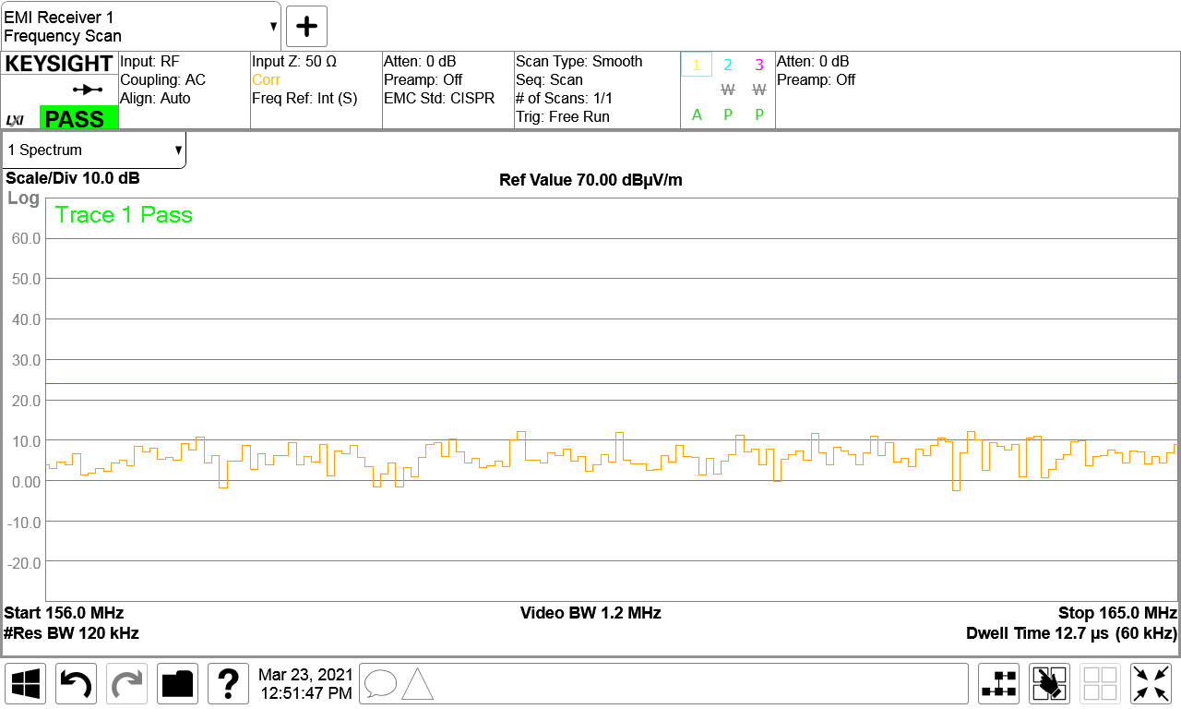

6 Protection for the automatic identification system
Standard resolution bandwidths for EMI testing are 9 kHz and 120 kHz. The 20 kHz resolution bandwidth and the associated level used for the AIS are based on the AIS test standard, IEC 61993-2, since AIS is a 25 kHz channelized maritime VHF safety system. The levels for the 9 kHz and the 120 kHz resolution bandwidths, are calculated from the 20 kHz level, assuming a Gaussian power flux-density for the interference, which typically is not the case since the highest levels of interference on ships are typically from switch-mode power supplies with various non-Gaussian waveforms.
For a 9 kHz RBW, per IEC 60945
P_{dBm} = −120.16 dBm
P_{dBm} = V_{dBµV} − 107
V_{dBµV} (for −120.16 dBm) = −120.16 + 107 = −13.16 dBµV
E_{dBµV/m} = 12.27 + (−13.16) = −0.89 dBµV/m (see footnote 17)
For a 20 kHz RBW, for VHF maritime 25 kHz channels (RR Appendix 18)
P_{dBm} = −116.70 dBm
P_{dBm} = V_{dBµV} − 107
V_{dBµV} (for −116.70 dBm) = −116.70 + 107 = −9.70 dBµV
E_{dBµV/m} = 12.27 + (−9.70) = +2.57 dBµV/m
For a 120 kHz RBW, per CISPR 25 Class 5
P_{dBm} = −108.92 dBm
P_{dBm} = V_{dBµV} − 107
V_{dBµV} (for −108.92 dBm) = −108.92 + 107 = −1.92 dBµV
E_{dBµV/m} = 12.27 + (−1.92) = +10.35 dBµV/m (see footnote 17)

7 Conclusions
• In summary, as shown below, the protection criteria for the VDES Satellite downlink are nearly the same, approximately 1.3 dB stricter than for the AIS.
For protection of the AIS:
For a 9 kHz bandwidth: E_{dBµV/m} = 12.27 + (−13.16) = -0.89 dBµV/m
For a 20 kHz bandwidth: E_{dBµV/m} = 12.27 + (−9.70) = +2.57 dBµV/m
For a 120 kHz bandwidth: E_{dBµV/m} = 12.27 + (−1.92) = +10.35 dBµV/m
For protection of the VDES satellite downlink:
For a 9 kHz bandwidth: E_{dBµV/m} = 12.27 + (−14.5) = −2.23 dBµV/m
For a 20 kHz bandwidth: E_{dBµV/m} = 12.27 + (−11) = +1.27 dBµV/m
For a 120 kHz bandwidth: E_{dBµV/m} = 12.27 + (−3.2) = +9.07 dBµV/m
• As noted in § 5 above, application of the CISPR 25 Class 5 test to its specified limit as demonstrated in Fig. 5 would provide adequate protection for the VDES satellite downlink.
• Further, since the AIS signal is a digital system (digitally modulated waveform) with a probability-based performance requirement (packet error rate), § 5 also provides a valid basis for application of the CISPR 25 Class 5 to ensure protection of the AIS as well as the VDES.

Annex 2
VHF and automatic identification system installation electromagnetic compatibility test results
VHF and AIS installation tests were undertaken with two purposes:
1) to measure the radio systems’ required interference protection criteria, what level of interfering field strength degrades the performance of installed VHF radio and AIS systems. This measurement could be used to validate predicted protection criteria with measured results, and
2) to measure the affect placement of an interfering source has at various distances from a victim antenna, within its near field.
To accomplish this, the radiated emission from 9 light test samples were measured at 1 m distance at the operating frequency of both the VHF radio (156.75 MHz) and AIS (161.975 and 161.025 MHz), using an average detector and a resolution bandwidth of both 20 kHz and 120 kHz. The receiver sensitivity of a VHF radio using a 4’ and then an 8’ whip, and an AIS using a 4’ whip, installed in the test chamber was then measured. Receiver sensitivity was measured in accordance with the relevant IEC receiver test standard, with each of the light test samples activated, at distances of 3 m, 2 m, 1 m, 0.66 m and 0.33 m from the receiver whip antenna.
TABLE 3
VHF radio installation signal-to-noise and distortion ratio test
Light sample number | No LED |  | 3 metre antenna setback |  | 2 metre antenna setback |  | 1 metre antenna setback |  | 0.66 metre antenna setback |  | 0.33 metre antenna setback
 | Power in dBm
 | 4' whip | 8' whip | 4- whip | 8' whip | 4- whip | 8' whip | 4- whip | 8' whip | 4- whip | 8' whip | 4' whip | 8' whip
1 | −116.5 | −116.5 | −114.5 | −116.5 | −115.5 | −116.5 | −116.5 | −116.5 | −116.5 | −116.5 | −115.5 | −116.5
2 | −116.5 | −116.5 | −114.5 | −115.5 | −114.5 | −114.5 | −112.5 | −114.5 | −111.5 | −113.5 | −108.5 | −113.5
3 | −116.5 | −116.5 | −110 | −114.5 | −109.5 | −113.5 | −106.5 | −111.5 | −105.5 | −110.5 | −104.5 | −110.5
4 | −116.5 | −116.5 | −109.5 | −112.5 | −113.5 | −115.5 | −113.5 | −113.5 | −109.5 | −114.5 | −105.5 | −114.5
5 | −116.5 | −116.5 | −80 | −91.0 | −84 | −78.0 | −73 | −77.0 | −71 | −82.0 | −68 | −86.0
6 | −116.5 | −116.5 | −107.5 | −111.5 | −110.5 | −115.5 | −109.5 | −115.5 | −104.5 | −114.5 | −100.5 | −114.5
7 | −116.5 | −116.5 | −107 | −108.0 | −108 | −109.0 | −108 | −109.0 | −106 | −108.0 | −106 | −108.0
8 | −116.5 | −116.5 | −114.5 | −114.5 | −114.5 | −115.5 | −113.5 | −115.5 | −113.5 | −112.5 | −112.5 | −112.5
9 | −116.5 | −116.5 |  | −115.5 |  | −116.0 |  | −116.0 |  | −116.0 |  | −116.0
10 | −116.5 | −116.5 | −109.5 | −106.5 | −110.5 | −115.5 | −112.5 | −106.5 | −105.5 | −103.5 | −97.5 | −102.5

It is immediately apparent from Table 3 that interference increases as a noisy LED is placed closer to a 4-foot (1.5 m) whip antenna, even as close as a foot (0.33 m) from the antenna. In light sample #5 for example, interference from that light increases by 2 dB when the light is moved from a metre to 0.66 m from the antenna, and then increases another 3 dB when moved from 0.66 m to 0.33 m from the antenna. The same is not true for an 8-foot (2.5 m) antenna. Maximum susceptibility appears to occur 1 m from the antenna. Interference from light sample #5 actually decreases by 5 dB when the light is moved within 0.66 m of the antenna and decreases further by another 4 dB when moved to within 0.33 m of the antenna.
TABLE 4
Automatic identification system − radio installation test
Light sample number | AIS Radio Test (4' WHIP ANTENNA) Power in dBm
 | No LED | 3 metre antenna set back | 2 metre antenna setback | 1 metre antenna setback | 0.66 metre antenna setback | 0.33 metre antenna setback
1 | −112 | −108 | −110 | −110 | −109 | −109
2 | −112 | −109 | −109 | −107 | −108 | −107
3 | −112 | −110 | −111 | −110 | −108 | −108
4 | −112 | −111 | −112 | −110 | −109 | −109
5 | −112 | −95 | −94 | −89 | −89 | −91
6 | −112 | −108 | −110 | −111 | −111 | −107
7 | −112 | −108 | −109 | −109 | −108 | −108
8 | −112 | −111 | −110 | −110 | −110 | −110
9 | −112 | −109 | −109 | −112 | −112 | −110
10 | −112 | −110 | −110 | −107 | −106 | −102

The VHF radio and AIS loss of receiver sensitivity shown in Tables 3 and 4 can be compared with the forward-facing radiated emission values measured from these same lights. The emission levels have to be measured at the frequencies the radios are tuned to during testing. AIS operates on both 161.975 and 162.025 MHz. The VHF radio was tested on channel 15 or 156.750 MHz, 50 kHz from the distress channel 16. Table 5 shows the radiated emission levels at 156.750 and 162 MHz. Note that radiated emission levels, VHF 4’ tests, VHF 8’ tests, and AIS tests were each performed and measured at different times, so variations in results will occur as interfering emissions shift and drift in frequency and intensity.
TABLE 5
Radiated emission results
Light sample number | 20 kHz average, dB µV/m at 1 m |  |  | 120 kHz average, dB µV/m at 1 m |  |  | Polarization
 | Highest value | Value at 156.75 MHz | Value at 162 MHz | Highest value | Value at 156.75 MHz | Value at 162 MHz
1 | 7 | 0 | 0 | 13 | 8 | 8 | Vertical
2 | 21 | 12 | 10 | 23 | 13 | 12 | Horizontal
3 | 25 | 16 | 18 | 24 | 22 | 10 | Vertical
4 | 25 | 24 | 14 | 27 | 23 | 10 | Horizontal
5 | 41 | 32 | 38 | 43 | 41 | 41 | Horizontal
6 | 22 | 18 | 19 | 27 | 23 | 23 | Horizontal
7 | 32 | 12 | 12 | 32 | 15 | 12 | Vertical
8 | 9 | 4 | 7 | 14 | 11 | 10 | Horizontal
10 | 25 | 20 | 13 | 29 | 21 | 18 | Vertical

Test results are shown in Tables 6 (VHF receiver sensitivity) and 7 (AIS sensitivity), and plotted in Figs 6 and 7 respectively. Note the anomaly shown in the 20 kHz and 120 kHz RBW values shown for light sample #3 in Table 7, in which the 20 kHz RBW emission is 8 dB higher than the 120 kHz emission. That anomaly is better seen in the noise blip at 162 MHz in Fig. 8, the original 20 kHz RBW emission plot. The 10 dBµV/m value shown at 162 MHz in Fig. 9 is likely the actual value for both bandwidths. This anomaly illustrates the limits in making precise measurements in tests such as these.
TABLE 6
Radiated emission effect on VHF receiver sensitivity
Light sample number | Measured field strength at 1 m at VHF channel 15  (dBµV/m) |  | Receiver sensitivity degradation  (dB)
 |  |  | 4’ (1.5 m) whip |  | 8’ (2.5 m) whip
 |  |  | At 1 m | At 0.33 m | At 1 m | At 0.33 m
 | 20 kHz RBW | 120 kHz RBW
1 | 0 | 8 | 0 | 1 | 0 | 0
2 | 12 | 13 | 4 | 8 | 2 | 3
3 | 16 | 22 | 10 | 12 | 5 | 6
4 | 24 | 23 | 3 | 11 | 3 | 2
5 | 32 | 41 | 43.5 | 48.5 | 39.5 | 30.5
6 | 18 | 23 | 7 | 6 | 1 | 2
7 | 12 | 15 | 8.5 | 10.5 | 7.5 | 8.5
8 | 4 | 11 | 3 | 4 | 1 | 4
10 | 20 | 21 | 4 | 19 | 10 | 14

TABLE 7
Radiated emission effect on automatic identification system receiver sensitivity
Light sample number | Measured field strength at 1 m  at 162 MHz (dBµV/m) |  | Receiver sensitivity degradation  (dB)
 | 20 kHz RBW | 120 kHz RBW | At 1 m | At 0.33 m
1 | 0 | 8 | 2 | 3
2 | 10 | 12 | 5 | 5
3 | 18 | 10 | 2 | 4
4 | 14 | 10 | 3 | 3
5 | 38 | 41 | 23 | 21
6 | 19 | 23 | 1 | 5
7 | 12 | 12 | 3 | 4
8 | 7 | 10 | 2 | 2
10 | 13 | 18 | 5 | 10
Figure 6
VHF signal-to-noise and distortion ratio test results using a 4’ (1.5 m) whip at 1 m
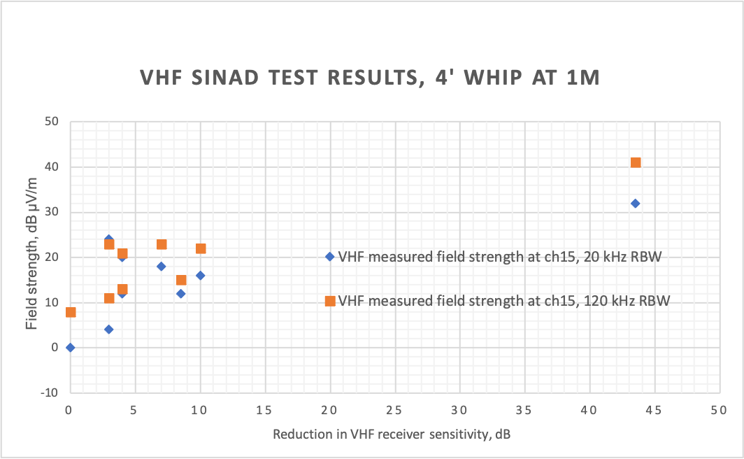
Figure 7
Automatic identification system test results using a 4’ (1.5 m) whip at 1 m
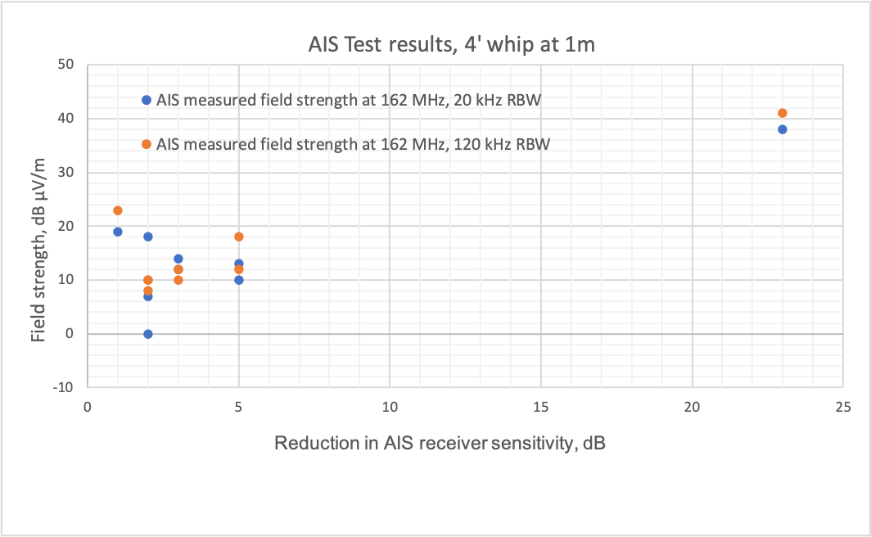
Figure 8
Light sample #3, 20 kHz resolution bandwidth average, vertical
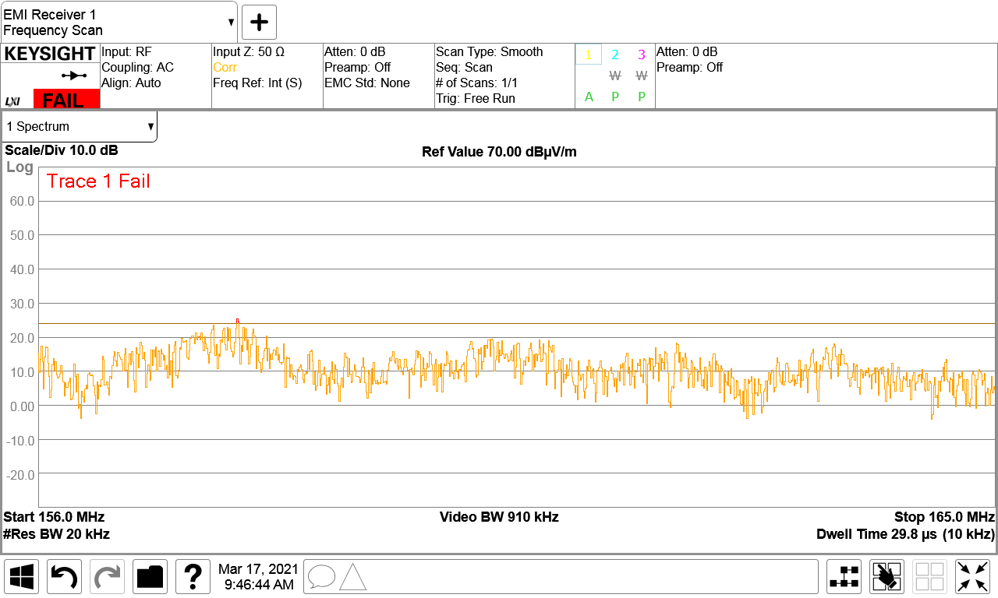
162 MHz
Figure 9
Light sample #3, 120 kHz resolution bandwidth average, vertical
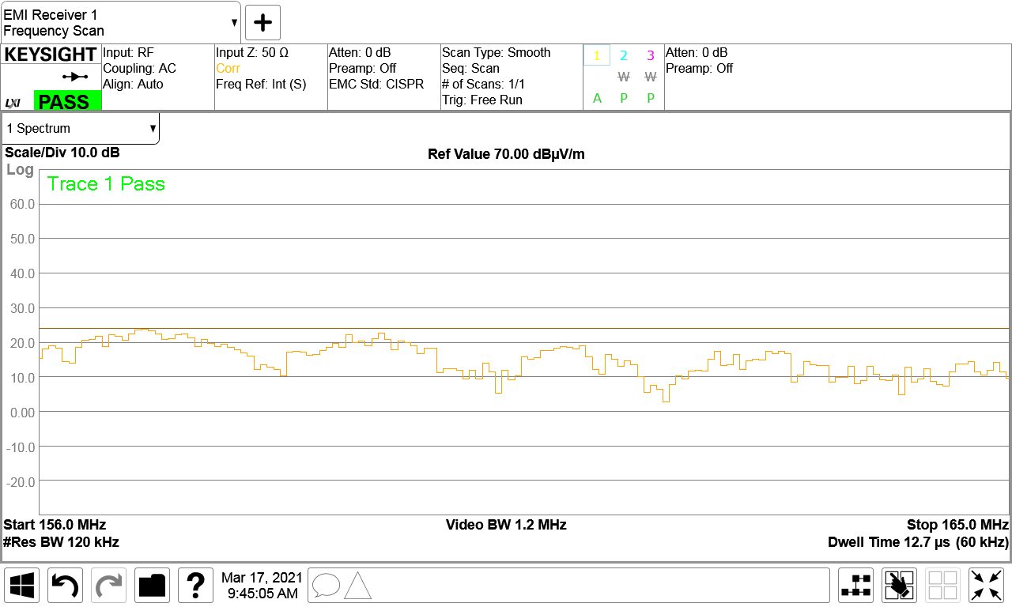
162 MHz
Conclusion from test results
Although it is difficult to come to a precise conclusion, these tests appear to confirm the predicted radiated emission limit of +2.57 dBµV/m average at 20 kHz RBW, necessary to protect a VHF radio and AIS, as calculated in § 2.1.3.2. It also shows that based upon the lights tested, a radiated emission limit of about 10 dBµV/m average at 120 kHz RBW should provide equivalent protection.
However, a review of the emission limit and test method necessary to protect the VHF Data Exchange System (VDES) satellite downlink as well as the AIS described in Annex 1 should also be considered.

Annex 3
Review of emission limits in the global navigation satellite service
frequency bands
IEC 60945 Annex C states “Above 1 GHz the ship may be carrying receivers in the bands 1 525-1 544 MHz for Inmarsat, 1 575,42 MHz ± 1 023 MHz for GPS and 1 602-1 615 MHz for GLONASS. The band 1 525-1 544 MHz is used for GMDSS distress and safety. Similarly, Global Navigation Satellite Systems (GNSS) is becoming an IMO carriage requirement and the bands around 1 575.42 MHz and 1 602-1 615 MHz require protection. In this edition limits are therefore given in 9.3 extending to 2 GHz.” IEC 60945 existing radiated emission limits were simply extended in its last edition from 1 GHz to 2 GHz to include GMDSS ship earth stations and GNSS shipboard receivers. New emission limits based upon Recommendations ITU-R M.1903-1, ITU-R M.1905-1, ITU-R M.1902-1 and RTCA DO-160G are considered.
TABLE 8
Current relevant electromagnetic compatibility standards
Standard | Frequency  band | Bandwidth | Distance  (m) | Emission limit
 |  |  |  | Quasi peak  (dBµV/m) | Average  (dBµV/m) | Peak  (dBµV/m)
IEC 60945 | 1 to 2 GHz | 120 kHz | 3 | 54 | - | -
FCC Part 15 Class B | - | 1 MHz | 3 | - | 54 | 74
CISPR 15 | 1 to 6 GHz | 1 MHz | 3 | - | 50 | 70
CISPR 25 Class 5 | BDS 1553-1569 MHz | 9 kHz | 1 | - | 5.5 | -
 | GPS 1567-1583 MHz | 9 kHz | 1 | - | 10 | -
 | GLONASS  1590-1617 MHz | 9 kHz | 1 | - | 10 | -
 | GPS L5 1 156.45-1 196.45 MHz | 9 kHz | 1 | - | 20 | -
RTCA DO-160G | 1 559-1 610 MHz | 1 MHz | 1 | - | - | 40

Recommendation ITU-R M.1903-1 at upper L-band
Radiated emissions limits (EMI requirements) to protect GNSS (e.g. GPS) receivers are based on Recommendation ITU-R M.1903-1 – Characteristics and protection criteria for receiving earth stations in the radionavigation-satellite service (space-to-Earth) and receivers in the aeronautical radionavigation service operating in the band 1 559-1 610 MHz.
Table 9 is a comparison of receiver types based upon Recommendation ITU-R M.1903 Table 2 receiver type, General purpose No. 1, aggregate wideband interference power density. Wideband continuous interference is considered to have a bandwidth greater than 1 MHz.
TABLE 9
Recommendation ITU-R M.1903 Table 2 receiver type
GNSS receiver parameter | GPS | Galileo | GLONASS | BDS (Beidou)
Rec. ITU-R M,1903 Table 2 receiver type | General purpose No. 1 | General purpose No. 1 | General purpose No. 1 | General purpose No. 2
Frequency | 1 575.42 ±  12 MHz | 1 575.42 ± 12 MHz | 1 602 + 0.5625 K  ± 5.11, where  K = −7, …, +6 | 1 561.098  ± 2.046  1 589.742  ± 2.046
Acquisition mode threshold power density level of aggregate wideband interference at the passive antenna output | −142 dBW/MHz =  −112 dBm/MHz | −142 dBW/MHz =  −112 dBm/MHz | −142 dBW/MHz =  −112 dBm/MHz | −146 dBW/MHz =  −116 dBm/MHz
Acquisition mode threshold power level of aggregate narrow-band interference at the passive antenna output | −158 dBW = −128 dBm | −158 dBW = −128 dBm | −158 dBW = −128 dBm | −156 dBW = −126 dBm
Antenna gain | 6 dBi | 6 dBi | 6 dBi | 3 dBi
RF filter 3 dB bandwidth | 32 MHz | 32 MHz | 32 MHz | 4.196 MHz
Pre-correlation filter 3 dB bandwidth | 2 MHz | 2 MHz | 22 MHz | 4.096 MHz

Figure 10
GPS, GLONASS, Galileo and BDS navigational frequency bands
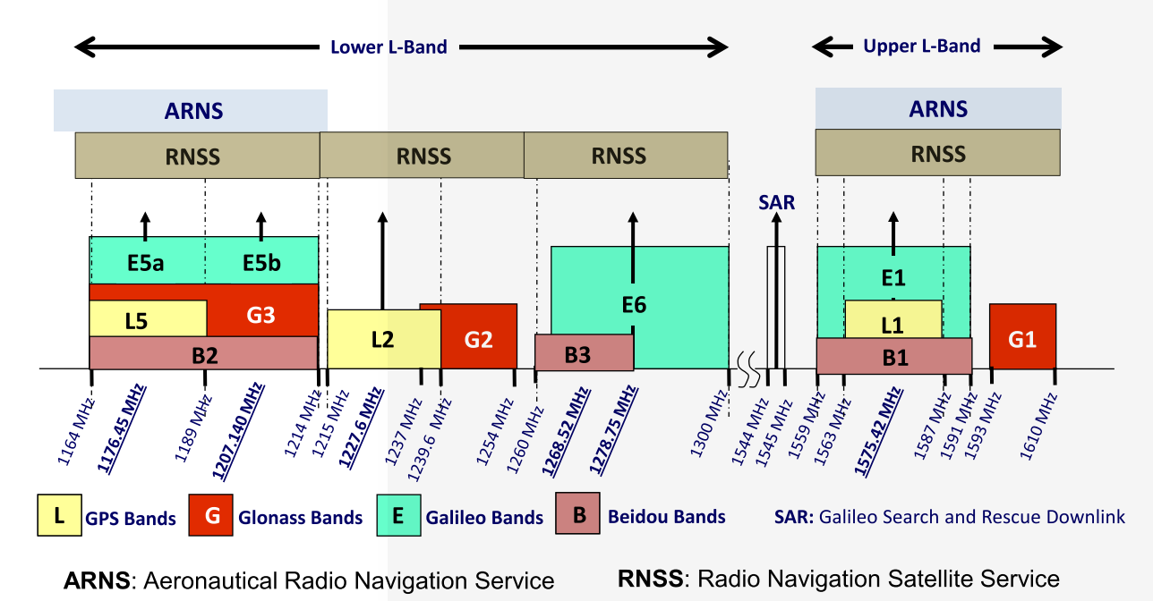
ITU-R M.1903
ITU-R M.1902
ITU-R M.1905
Calculation of global navigation satellite service protection limits based upon Recommendation ITU-R M.1903-1 at upper L-band
Antenna factor at 50 ohms
AF_{50Ω} = 20 log₁₀ f_{MHz} − 10 log₁₀ G_{numeric} – 29.7707 dB/m, G_{numeric} = 1.0 for 0 dBi
= 63.945 – 29.7707 = 34.174 dB/m at 1 575 MHz (GPS and Galileo)
= 64.093 – 29.7707 = 34.322 dB/m at 1 602 MHz (GLONASS)
= 63.868 – 29.7707 = 34.097 dB/m at 1 561 MHz (BDS)
P_{dBm} = V _{dB µV} – 107 (power at the receiver input)
E_{dBµV/m} = AF_{50Ω} + V _{dB µV} = AF_{50Ω} + P_{dBm} + 107 (field strength 1 m from the antenna)
E_{dBµV/m} = P_{dBm} + 107 + 34.175 = P_{dBm} + 141.175 (GPS and Galileo)
E_{dBµV/m} = P_{dBm} + 107 + 34.322 = P_{dBm} + 141.323 (GLONAS)
E_{dBµV/m} = P_{dBm} + 107 + 34.097 = P_{dBm} + 141.097 (BDS)
Global navigation satellite service protection criteria at 1 m based upon Recommendation ITU-R M.1903-1 wideband interference
P_{dBm (WBacquisition)} = −112 dBm/MHz + 10 log (2) = −109 dBm (GPS and Galileo)
P_{dBm (1 MHz RBW)} = −112 dBm/MHz − 10 log (1/1) = −112 dBm (GPS and Galileo)
P_{dBm (9 kHz RBW)} = −112 dBm/MHz − 10 log (1/.009) = −132.46 dBm (GPS and Galileo)
P_{dBm (WBacquisition)} = −112 dBm/MHz + 10 log (22) = −98.6 dBm (GLONASS)
P_{dBm (1 MHz RBW)} = −112 dBm/MHz − 10 log (1/1) = −112 dBm (GLONASS)
P_{dBm (9 kHz RBW)} = −112 dBm/MHz − 10 log (1/.009) = −132.46 dBm (GLONASS)
P_{dBm} _{(WBacquisition)} = −116 dBm/MHz + 10 log (4.096) = −109.9 dBm (BDS)
P_{dBm (1 MHz RBW)} = −116 dBm/MHz − 10 log (1/1) = −116 dBm (GLONASS)
P_{dBm (9 kHz RBW)} = −116 dBm/MHz − 10 log (1/.009) = −136.46 dBm (GLONASS)
GPS and Galileo
E_{dBµV/m (1 MHz)} = −112 dBm + 141.175 = 29.2 dBµV/m
E_{dBµV/m (9 kHz)} = −132.46 dBm + 141.175 = 8.7 dBµV/m
GLONASS
E_{dBµV/m (1 MHz)} = −112 dBm + 141.323 = 29.3 dBµV/m
E_{dBµV/m (9 kHz)} = −132.46 dBm + 141.323 = 8.9 dBµV/m
BDS
E_{dBµV/m (1 MHz)} = −116 dBm + 141.097 = 25.1 dBµV/m (BDS)
E_{dBµV/m (9 kHz)} = −136.46 dBm + 141.097 = 4.6 dBµV/m (BDS)
Electromagnetic compatibility protection criteria based upon Recommendation ITU-R M.1903 narrowband interference
E_{dBµV/m} = AF_{50Ω} + V _{dB µV} = AF_{50Ω} + P_{dBm} + 107 (field strength 1 m from the antenna)
E_{dBµV/m} = P_{dBm} + 107 + 34.175 = P_{dBm} + 141.175 (GPS and Galileo)
E_{dBµV/m} = P_{dBm} + 107 + 34.322 = P_{dBm} + 141.323 (GLONAS)
E_{dBµV/m} = P_{dBm} + 107 + 34.097 = P_{dBm} + 141.097 (BDS)
P_{dBm (NBacquisition)} = −128 dBm (GPS and Galileo)
P_{dBm (NBacquisition)} = −128 dBm (GLONASS)
P_{dBm (NBacquisition)} = −126 dBm (BDS)
E_{dBµV/m (NBacquisition)} = −128 dBm + 141.175 = 13.2 dBµV/m (GPS and Galileo)
E_{dBµV/m (NBacquisition)} = −128 dBm + 141.323 = 13.3 dBµV/m (GLONASS)
E_{dBµV/m (NBacquisition)} = −126 dBm + 141.097 = 15.1 dBµV/m (BDS)

TABLE 10
Comparison of Recommendation ITU-R M.1903-1 based calculated emission limits
with existing standards, normalized to 1 m
EMC standard | Resolution bandwidth | EMC standard emission limit | ITU-R M.1903 wideband |  | ITU-R M.1903 narrowband |  | GNSS receiver distortion distance
 |  |  | Emission requirement | Difference | Emission requirement | Difference
IEC 60945 | 120 kHz | 63.5 dBµV/m QP | 20 dBµV/m  15.9 dBµV/m (BDS) | +43.5 dB  +44.5 dB (BDS) | 13.2 dBµV/m  15.1 dBµV/m (BDS) | +50.3 dB  +48.4 dB (BDS) | 100 m+
FCC Part 15 Class B | 1 MHz | 63.5 dBµV/m AV | 29.2 dBµV/m  25.1 dBµV/m (BDS) | +34.3 dB  +38.4 dB (BDS) | 13.2 dBµV/m  15.1 dBµV/m (BDS) | +50.3 dB  +48.4 dB (BDS) | 50 m  (100 m+ NB)
CISPR 15 (not yet adopted) | 1 MHz | 59.5 dBµV/m AV | 29.2 dBµV/m  25.1 dBµV/m (BDS) | +30.3 dB  +34.4 dB (BDS) | 13.2 dBµV/m  15.1 dBµV/m (BDS) | +46.3 dB  +44.4 dB (BDS) | 30 m  (100 m+ NB)
CISPR 25 Class 5 GNSS | 9 kHz | 10 dBµV/m AV  5.5 dB µV/m (BDS) | 8.7 dBµV/m  4.6 dBµV/m (BDS) | +1.3 dB  −0.9 dB (BDS) | 13.2 dBµV/m  15.1 dBµV/m (BDS) | -3.2 dB  -9.6 dB (BDS) | 1 m
RTCA  DO-160G | 1 MHz | 40 dBµV/m  PK | 29.2 dBµV/m  25.1 dBµV/m (BDS) | + 10.8 dB  + 14.9 dB (BDS) | 13.2 dBµV/m  15.1 dB µV/m (BDS) | +26.8 dB  +24.9 dB (BDS) | 3 m  (20 m NB)

Recommendations ITU-R M.1902-1 and M.1905-1 at lower L-band
Recommendation ITU-R M.1902-1 – Characteristics and protection criteria for receiving earth stations in the radionavigation-satellite service (space-to-Earth) operating in the band 1 215-1 300 MHz, addresses lower L-band GNSS system signals including GPS L2 and GLONASS G2. Recommendation ITU-R M.1905-1 – Characteristics and protection criteria for receiving earth stations in the radionavigation-satellite service (space-to-Earth) operating in the band 1 164-1 215 MHz, addresses lower L-band GNSS system signals including GPS L5 and Galileo E5.
TABLE 11
Recommendation ITU-R M.1902-1 GPS L2 and GLONASS G2 receiver types
GNSS receiver parameter | GPS L2 | GLONASS G2
Rec. ITU-R M.1902 Table 1 receiver type | General purpose | General purpose
Frequency | 1 227.6 ± 12 MHz | 1 246 + 0.4375 K  ±5.11, where  K = −7, …, +6
Acquisition mode threshold power density level of aggregate wideband interference at the passive antenna output | −145 dBW/MHz =  −115 dBm/MHz | −145 dBW/MHz =  −115 dBm/MHz
Acquisition mode threshold power level of aggregate narrow-band interference at the passive antenna output | −164 dBW = −134 dBm | −164 dBW = −134 dBm
Antenna gain | 6 dBi | 6 dBi
RF filter 3 dB bandwidth | 32 MHz | 30 MHz
Pre-correlation filter 3 dB bandwidth | 2 MHz | 20 MHz

TABLE 12
Recommendation ITU-R M.1905-1 GPS L5 and Galileo E5 receiver types
GNSS receiver parameter | GPS L5 and Galileo E5
Rec. ITU-R M.1905 Table 1 receiver type | General purpose
Frequency | 1 207.14 ± 12  1 176.45 ± 12 MHz
Acquisition mode threshold power density level of aggregate wideband interference at the passive antenna output | −146 dBW/MHz =  −116 dBm/MHz
Acquisition mode threshold power level of aggregate narrow-band interference at the passive antenna output | −156 dBW =  −126 dBm
Antenna gain | 3 dBi
RF filter 3 dB bandwidth | 24 MHz
Pre-correlation filter 3 dB bandwidth | 20.46 MHz

The parameters described in Recommendations ITU-R M.1902-1 and ITU-R M.1905-1 are similar and comparable to those in Table 2 of Recommendation ITU-R M.1903-1.
AF_{50Ω} = 20 log₁₀ f_{MHz} – 29.7707 dB/m = 32.01 dB/m (GPS L2)
= 32.14 dB/m (GLONASS G2)
= 31.86 dB/m (GPS L5 1207 MHz)
= 31.64 dB/m (GPS L5 1176 MHz)
$≈$ 32 dB/m
TABLE 13
Wideband and narrowband interference performance requirements
Recommendation ITU-R | Wideband interference  (dBm/MHz) | Narrowband interference  (dBm) | Antenna factor  (dBm)
M.1903 | −112 | −128 | 34
M.1902 GPS L2/GLONASS G2 | −115 | −134 | 32
M.1905 | −116 | −126 | 32
E_{dBµV/m} = AF_{50Ω} + P_{dBm} + 107
Electromagnetic compatibility protection criteria for GPS L2 and GLONASS G2 (Recommendation ITU-R M.1902)
E_{dBµV/m (1 MHz)(WB)} = 24 dBµV/m
E_{dBµV/m (9 kHz)(WB)} = 4 dBµV/m
E_{dBµV/m (NB)} = 5 dBµV/m
Electromagnetic compatibility protection criteria for GPS L5 and Galileo E5 (Recommendation ITU-R M.1905)
E_{dBµV/m (1 MHz)} = 23 dBµV/m
E_{dBµV/m (9 kHz)} = 3 dBµV/m
E_{dBµV/m (NB)} = 13 dBµV/m
Ambient. The EMI test laboratory ambient level at 9 kHz RBW using an average detector was about −2 to −1 dB µV/m.
Conclusions
Only CISPR 25 Class 5 and RTCA DO-160G appear designed to protect GNSS receivers from unintentional electromagnetic interference close to GNSS antennas.
Radiated emission average (AV) limits: Proposed that maritime applications adopt radiated emission limits based upon Recommendations ITU-R M.1903-1, ITU-R M.1902-1 and ITU-R M.1905-1 based upon receiver acquisition mode, aligned with those of CISPR 25 Class 5, in the relevant bands used by shipboard GNSS receivers.
Radiated emission peak (PK) limits: Proposed that maritime applications consider peak radiated emission limits based upon RTCA DO-160G.
Radiated emission bandwidth: Proposed that maritime applications adopt 9 kHz Resolution bandwidth to ensure Recommendations ITU-R M.1902, ITU-R M.1903 and ITU-R M.1905 narrowband emission limits are met and aligned with CISPR 25.
TABLE 14
L-band global navigation satellite service emission limits with source
Frequency band (MHz) | Rec. ITU-R | CISPR 25 Class 5 limits  (dBµV/m) | ITU-R WB limits  (9 kHz)  (dBµV/m) | ITU-R NB limits  (dBµV/m) | RTCA DO-160G PK limits  (1 MHz)  (dBµV/m) | Maritime applications proposed AV limits  (dBµV/m)
1 559-1 591 | M.1903 | 10 | 9 | 13 | 40 | 10
1 593-1 610 | M.1903 BDS | 5.5 | 5 | 15 | 40 | 5.5
1 260-1 300 | M.1902 | - | 4 | 5 | - | 10
1 164-1 214 | M.1905 | 20 | 3 | 13 | 38 | 20

These reports were received in response to US Coast Guard Marine Safety Alert, Bulletins. Links to these bulletins are in the footnotes at the bottom of the next page Marine Safety Information Bulletin MSIB13-18 (see https://www.dco.uscg.mil/Portals/9/DCO%20Documents/5p/CG-5PC/INV/Alerts/1318.pdf?ver=2018-08-16-091109-630).
US Coast Guard Marine Safety Bulletin MSIB-03-22 https://www.dco.uscg.mil/Portals/9/DCO%20Documents/5p/MSIB/2022/USCG-MSIB-03-22-EMC-RTCM-13700.pdf?ver=bfEmAvRnl8nyr0K-6SR9nA%3d%3d&timestamp=1650662305308
“Reference Data for Radio Engineers,” Fifth Edition, March 1970, Sections 21-11 to 21-12.
H. Jin, W. Yang, F. Yu and Z. Wang, “A novel EBG structure with spiral line bridges for radiation suppression in marine VHF band,” in IEEE Electromagnetic Compatibility Magazine, vol. 8, no. 4, pp. 56-61, 4th Quarter 2019.
Based on equations for average sidelobe levels for omnidirectional antennas in Recommendation ITU-R F.1336-5, recommends 2.2. These patterns are for use in the far field, beyond the reactive near field.
RR Appendix 18.
Sponsored by the United States Coast Guard at IMANNA Laboratory, Inc. www.imanna.com
‘Active’ means that a switch-mode power supply is used to drive the LED light.
Refer to Annex 1 for an analysis of the possible application of the CISPR 25 Class 5 test levels and test method for protection of the AIS as well as the VDES.
Annex 3 provides an analysis of both wideband and narrowband interference requirements. Note that the CISPR 25 Class 5 test standard could be used to address both requirements.
A more comprehensive review of emissions limits in the GNSS bands is provided in Annex 3.
Note that quasi-peak above 1 GHz is undefined and not recognized by CISPR.
Com-Power Corporation, Model PAM-6000, ASSEMBLY PROCEDURE (com-power.com)
Amplifier Research Corporation, Model ATH800M6G, Manual Text Template (arworld.us)
These tests are included in the US Federal Communications Commission Ship Inspection Checklists available at https://www.fcc.gov/eb-ship-inspection-checklists and are also planned for inclusion in the next edition of NMEA 0400 Installation Standard.
This analysis pertains mainly to protection of the VDES satellite downlink, the most vulnerable VDES component. It further shows that this protection, if applied, would also protect the AIS.
Test levels for the 9 kHz and the 120 kHz resolution bandwidths, are calculated from the 20 kHz level, assuming a Gaussian power flux-density for the interference, which typically is not the case since the highest levels of interference on ships are typically from switch-mode power supplies with various non-Gaussian waveforms. Thus the 20 kHz resolution bandwidth is best suited for AIS protection criteria.
ibid.
The VDES satellite downlink is a spread spectrum waveform. Thus the 120 kHz resolution bandwidth is best suited for VDES satellite downlink protection criteria.
This annex provides test results from the EMI test laboratory (refer to Footnote 6) that apply to shipborne installations of the AIS and VHF GMDSS marine radios.
CISPR 16-1-1 does not recognize quasi-peak measurements above 1 GHz.
CISPR 15 Ed.9 currently has no emissions limits above 1 GHz. However, CIS/F/801/CD Amd.1 would raise emission limits to 6 GHz. Emission limits from 3 to 6 GHz would be 54 dBµV/m AV and 74 dBµV/m PK.
Assume 0 dBi since in worst case, gain equally affects both signal and interference.
10 log is appropriate in this case, since ITU-R specified protection requirements as pfd (dBW/MHz).
Peak, quasi-peak and average measurements are considered equivalent for this purpose.
The receiver distortion distance is the minimum separation distance between the victim receiver’s antenna and the unit capable of causing interference that is required in order to ensure that harmful interference is not caused to the receiver, assuming free space propagation loss.

