Report ITU-R P.2402-0
(03/2017)
A method to predict the statistics of clutter loss for earth-space and aeronautical paths

P Series
Radiowave propagation

Foreword
The role of the Radiocommunication Sector is to ensure the rational, equitable, efficient and economical use of the radio-frequency spectrum by all radiocommunication services, including satellite services, and carry out studies without limit of frequency range on the basis of which Recommendations are adopted.
The regulatory and policy functions of the Radiocommunication Sector are performed by World and Regional Radiocommunication Conferences and Radiocommunication Assemblies supported by Study Groups.

Policy on Intellectual Property Right (IPR)
ITU-R policy on IPR is described in the Common Patent Policy for ITU-T/ITU-R/ISO/IEC referenced in Annex 1 of Resolution ITU-R 1. Forms to be used for the submission of patent statements and licensing declarations by patent holders are available from http://www.itu.int/ITU-R/go/patents/en where the Guidelines for Implementation of the Common Patent Policy for ITU-T/ITU-R/ISO/IEC and the ITU-R patent information database can also be found.

Series of ITU-R Reports
(Also available online at http://www.itu.int/publ/R-REP/en)
Series | Title
BO | Satellite delivery
BR | Recording for production, archival and play-out; film for television
BS | Broadcasting service (sound)
BT | Broadcasting service (television)
F | Fixed service
M | Mobile, radiodetermination, amateur and related satellite services
P | Radiowave propagation
RA | Radio astronomy
RS | Remote sensing systems
S | Fixed-satellite service
SA | Space applications and meteorology
SF | Frequency sharing and coordination between fixed-satellite and fixed service systems
SM | Spectrum management

Note: This ITU-R Report was approved in English by the Study Group under the procedure detailed in Resolution ITU-R 1.

Electronic Publication
Geneva, 2017
© ITU 2017
All rights reserved. No part of this publication may be reproduced, by any means whatsoever, without written permission of ITU.

REPORT ITU-R P.2402-0
A method to predict the statistics of clutter loss
for earth-space and aeronautical paths
(2017)
Scope
This Report will be used as background material for Recommendation ITU-R P.2108-0, section 3.3.
This Report describes the method used to generate the clutter loss equations within Recommendation ITU-R P.2108-0, section 3.3.

1 Introduction
This Report describes methods for predicting what is often called "clutter loss". In the context of radio the term "clutter" may have originated with the development of radar, since unwanted returns on a radar screen are also termed clutter. In general propagation modelling, clutter loss means losses due to objects which are on the ground but which are not the ground itself. In this context "clutter" most often means buildings or vegetation.
This Report covers only losses due to urban or suburban clutter. Within this classification, any man-made objects can be included, particularly those of sizes comparable to buildings, such as bridges.
The term clutter loss also implies a certain type of radio path, characterised by having:
a) one station embedded within clutter, such as below roof level in an urban area;
b) the radio path extends beyond the influence of clutter.
This concept can apply to:
i) a path to an aeronautical or high-altitude platform station;
ii) a path to a station in space.
In all these cases the clutter loss at the station embedded within the clutter can be evaluated as an end-correction, to be added to losses calculated using other models applying to the whole length of the path.
The building statistics used to create the clutter loss cumulative distribution are given in § 7.
The method used to combine the London and Melbourne curves and fit the model described in § 3.3 of Recommendation ITU-R P.2108-0 is detailed in § 8.

2 Urban clutter
Urban clutter varies greatly in its materials and geometry, and thus its propensity for causing obstruction losses. Another characteristic of urban clutter is that many buildings have reflective surfaces which in some cases can support specula reflection with low loss. It is possible for clutter loss to be negative when multiple rays are taken into account.
A long-term difficulty in modelling variability of clutter loss concerns the classification of urbanisation. Reliance has often been placed on qualitative descriptions such as "dense urban", with quantitative metrics often limited to typical building heights. Such classification fails to capture details relevant to propagation, such as the difference between street canyons with fairly continuous lines of buildings, and more open areas with perhaps taller but more separated buildings.
The sketches in Fig. 1 illustrate these cases. Paths from antennas within the street canyons in a) are obstructed except in the directions nearly parallel to the streets. In b), more paths exist between buildings, and even when a building causes obstruction the diffraction loss to one side might be lower than diffraction over the roof. Thus even if the buildings in b) are higher than in a), diffraction losses will not necessarily be greater, and reflections may have more effect in reducing overall losses. It is thus to be expected that the statistics of urban clutter loss can differ substantially between these two types of urban area.
FIGURE 1
Urban areas formed of street canyons or separate building blocks
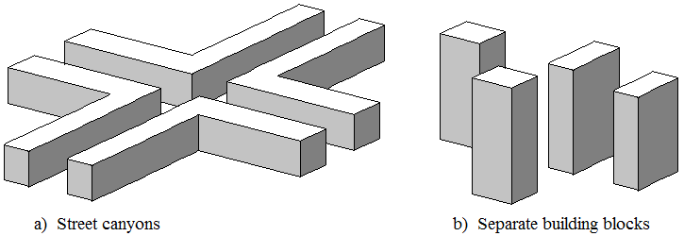
While the Report refers to urban clutter it is believed that it is equally applicable to any built up area e.g. suburban clutter. The model in section 3.3 of Recommendation ITU-R P.2108-0 is appropriate for environments that have similar cumulative distributions of horizontal distance and building heights to those given in § 7.

3 General form of a statistical urban clutter-loss model
A statistical model for clutter loss in urban environments is most suitable for scenarios with an area deployment of stations within a particular type of urban area. The model described here has the following general form:
a) A specific example of a general type of urban environment is characterised by compiling cumulative distributions of horizontal distance and building heights. These distributions capture the characteristics of the area with respect to street width, fraction of ground covered, building heights, and changes in ground level. Collectively these statistics are referred to as the template for the area actually surveyed, and can be representative of other urban areas judged to be sufficiently similar.
b) The statistics comprising a template are collected for a number of survey points within the specific example of urbanisation. The horizontal positions of these survey points should be typical of the locations of the expected area deployment of station within the clutter. Assuming that an area-coverage system is in view, stations might be on building faces, above the kerbs along the edges of pavements (sidewalks), etc. Another distinction is whether each station to be deployed is intended to have the largest practicable coverage area, or to cover a smaller area in order to maximise traffic density. If different deployment strategies are expected in different cases, correspondingly different templates are required for the same type of urbanisation.
c) The location of survey points has no connection with the expected height at which stations will be deployed. Different templates do not have to be compiled for different station heights.
d) A stochastic process evaluates diffraction and reflection losses based on distances and heights generated randomly from the template statistics. The resulting clutter loss is thus also random, but all such results for the same template, station height above ground, path elevation angle and frequency are equally probable. The model is run a sufficient number of times to compile a cumulative distribution of clutter loss to the required statistical certainty.
e) The stochastic process takes only horizontal distances and vertical heights into account. There is no concept of azimuth within this part of the method. The cumulative distribution of loss compiled from repeated use of the process will take into account the effect of street direction on a statistical basis for arbitrary path azimuths. The method is not able to predict the effect of street orientation relative to path direction.
f) The cumulative distributions given by the model can be used directly within a Monte Carlo simulation. Each run of the simulation should generate a new random value for percentage locations $p_{L}$ with $0\%{≤p}_{L}<100\%$ from which the model will give a corresponding value of clutter loss for the apparent path elevation angle to be added to the other losses for the path. The effect of the random but equi-probable clutter losses on the ensemble of paths will approximate to the physical paths under consideration, the approximation improving with greater number of path calculations.
g) Because building penetration is not taken into account, the method is not suitable for frequencies at which transmission through building might be significant. Up to about 1 GHz transmission losses through many building can be low. The transition range over which most buildings become effectively opaque to radio is estimated as from 1 GHz to 10 GHz. Thus the statistical method here is suitable for 10 GHz and above. It has been tested up to 100 GHz, and a limited number of comparisons with measurements have been made in the vicinity of 28 GHz.

4 Assembling a template
The urban statistics required by the propagation model consist of probability distributions of horizontal distances and building heights. The following sub-sections give details of the process of compiling them.

4.1 The use of representative survey points
Cumulative probability distributions are compiled for a number of survey points representative of the expected deployment of station locations within the area. Survey points might be placed along street centre-lines, the curb lines or edges of pavements (sidewalks), or on building faces, according to the expected deployment of stations to be represented. An appropriate choice should also be made as to whether stations will typically be installed at street intersections for maximum area coverage in several directions, or avoiding intersections to increase isolation between cells.
The plan view in Fig. 2 illustrates the general method. The altitude of ground level at each survey point above sea level $A_{gs}$ (m) is recorded. Then for each horizontal radial at 10-degree intervals, the following are recorded:
a) the horizontal distance $D_{b1}$ (m) to the first building travelling outwards from the survey point;
b) the roof altitude above sea level $A_{b}$ (m) above the point where the radial meets the building face;
c) the additional horizontal distance $D_{b12}$ (m) to the second building encountered along the same radial.
The two distances are shown on one of the radials in Fig. 2, where for clarity the two buildings involved are not shaded. The other radials are in red, and stop where the second building is encountered. Some radials do not encounter a second building within the diagram. The search distance for either a first or a second building is limited to 1 000 m. If no building is encountered within the first 1 000 m, $D_{b1}$ and $D_{b12}$ are both set to 500 m, and $A_{b1}$ is set to terrain height at 500 m distance. If one building is encountered within the first 1 km but not a second, the total distance to the second, $D_{b2}$, is set to 1 000 m. Although these limits are arbitrary, the corresponding entry for the radial concerned appropriately represents a direction with little obstruction.
FIGURE 2
Compiling urban statistics
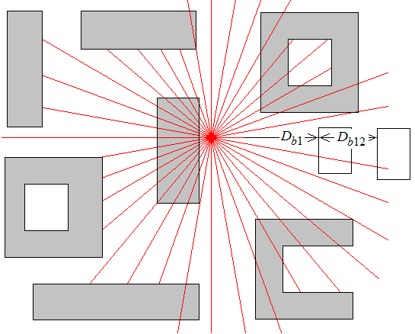
The above process should not be confused with radiowave propagation modelling, such as ray tracing. The objective is to characterise urban geometry. There is no consideration of, for instance, the width of Fresnel zones. The criterion for a radial encountering a building should be interpreted exactly, however small the margin either way.
Figure 3 illustrates the relationship between roof altitude $A_{b}$ and building height $H_{b}$ for a given radial from a survey point to building 1. The heights of ground level at the survey point $A_{s}$ , and of the building roof $A_{b}$ , are both altitudes above sea level (m asl). The building height $H_{b}$ is given by:
$H_{b}=A_{b}-A_{s}$ (m) (1)
FIGURE 3
Altitude of building roof and building height
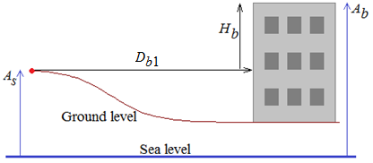
The following points apply to the above urban statistics:
1) It is intended that each roof altitude is recorded close to the roof edge above where the radial meets the external building wall. Consideration should not be given as to whether a different part of the same roof is higher, since: (i) it would introduce a subjective process; (ii) the ray elevation angle is unknown at this stage; (iii) the building height information will be used for both diffraction and reflection which require different treatments, (iv) the association which exists between a distance and a height along a given survey radial is discarded in subsequent processing.
2) The second building may be part of the first, as shown for some radials in Fig. 2. The criterion for a second building is that the ray travels over un-built-on ground before reaching it. This is, as in a), a readily interpreted objective condition intended to assist in making urban statistics reproducible.
3) The propagation part of the model could use a second height distribution for the height of the second building, but in various surveys it has been found that, with the criterion in b), a distribution of second heights is so similar to the distribution of first heights that it is not worth compiling the second-building heights.
4) The definition of building height allows changes of ground level within the urban area to be captured. This means that the two distributions characterise not only the nature of the urbanisation itself but also the extent to which the buildings stand on hilly ground.
5) Recording building heights on a per-radial basis, as opposed to one height for each building, tends to weight height probabilities according to building width. This is a desirable feature in view of how the distributions are used.

4.2 Obtaining the distance and altitude data
Any survey method can be used to compile values for $A_{gs}$, $D_{b1}$, $A_{b1}$, and $D_{b12}$ described in § 4.1 above. The two altitudes are only intermediate values; if appropriate the survey can directly compile building heights relative to ground level at the survey point, $H_{b}$. Working units do not need to be mandated, although the following descriptions assume that both distances and heights are in metres.
Examples of sources of the required urban statistics are:
a) direct surveying;
b) large-scale digital maps with building heights;
c) three-dimension model of an urban area derived from LIDAR or stereo photography.

4.3 Conversion to cumulative distributions
The values of $D_{b1}$ $D_{b12}$ $H_{b}$ collected for all radials at a number of survey points are now treated as three sets of data, with no further association with the survey points or radials from which they were derived.
The three sets of values are used to compile three cumulative distributions.
The distributions of both distances and heights are found to depart considerably from the normal distribution, with large positive skew. The statistics used to represent a typical urban area are thus specific cumulative distributions compiled from the three sets of values for $D_{b1}$ $D_{b12}$ and $H_{b}$. No use is made of the means and standard deviations of these distributions.
The statistics are also compiled as population distributions rather than sample distributions. This has the effect that a value extracted from the distribution for any probability will not be less than the lowest value or higher than the highest value.
The data are used to compile three histograms which can be in the form of:
A vector of distances or roof heights:
$\vec{X}=\left\{x_{1},x_{2},⋯x_{N}\right\}$ (m) (2a)
A corresponding vector of counts:
$\vec{C}=\left\{c_{1},c_{2},⋯c_{N}\right\}$ (2b)
The values in $\vec{X}$ are in ascending order from the lowest value to the highest value. For the sample results presented in § 4 the distance and height values were rounded to the nearest metre. For most locations it is thought that this provides sufficient resolution, although the method can readily be adopted for smaller intervals.
The counts in $\vec{C}$ are the number of occurrences of each value of x. Thus $\vec{X}$ and $\vec{C}$ constitute a histogram.
The corresponding cumulative distribution is compiled by assigning:
$\vec{P}=\left\{p_{1},p_{2},⋯\right\}=\left\{\frac{c_{1}}{C},\frac{c_{1}+c_{2}}{C},\frac{c_{1}+c_{2}+c_{3}}{C}⋯\right\}$ (3)
where:
$C=\sum_{n=1}^{N}{c_{n}}$ (3a)
The value from a vector of distances or heights $\vec{X}$ not exceeded for a given probability $p$ is given by a function $Q$ defined as:
$Q\left(\vec{X},\vec{P},P\right)=x_{n}$ (4)
where $n$ is the highest index for which $p_{n}≤P$ , unless P$≤p_{1}$ in which case $n=1$. With these conditions, function Q returns only observed values.
It is noted that with the foregoing formulation, the number of elements in $\vec{P}$ is the same as in $\vec{X}$ , not one greater. This is the effect of values in $\vec{X}$ being rounded to the nearest metre, and thus the concept of bin width being not applicable.

4.4 Distributions forming a template
Following the procedures described in § 4.3, a template consists of:
a) Vector of distance to first building $\vec{D_{b1}}$ and corresponding probabilities $\vec{P_{db1}}$.
b) Vector of distance from first to second building $\vec{D_{b12}}$ and corresponding probabilities $\vec{P_{db12}}$.
c) Vector of building height $\vec{H_{b}}$ and corresponding probabilities $\vec{P_{hb}}$.

4.5 Random value from a cumulative distribution
In the propagation model, random values of distances and heights are obtained by generating a uniformly-distributed random probability P in the range $0≤P<1$ and using function $Q$ defined by equation (4) to obtain the required value.

5 The stochastic model
The stochastic part of the method calculates the clutter loss for a ray leaving a station located below roof level in an urban area. Random numbers are used to extract building distances and heights from the template which represents the characteristics of the area. These random dimensions define the geometry in a hypothetical vertical plane. There is no concept of azimuth within the geometry.
Repeated calculations will produce different but equally-probable clutter losses. The calculation must be performed a sufficiently large number of times to obtain the statistical distribution of clutter losses for arbitrary station locations. The repetition of the calculation can be one element of a larger-scale simulation.

5.1 Inputs
A multiple run of calculations to compile clutter-loss statistics requires the following inputs:
a) the template of the representative urban area, as described in § 4 above;
b) station height above ground level $H_{s}$ (m);
c) path elevation angle $θ$(degrees);
d) frequency (GHz).
If wished, station heights above ground can be defined by a probability distribution. This would be appropriate when a range of heights is expected in a planned future deployment.
Units are not given for elevation angle $θ$ since it is used only to extract its tangent.

5.2 Model overview
Figure 4 gives an overview of the stochastic model. The blue ray leaving the station at a given elevation angle passes over or around buildings B1 and B2 with an associated diffraction loss which takes both buildings into account. This ray always exists, although it may have a high loss. A reflected ray exists if the ray leaving the station intercepts either B1 below its roof height, or if not, intercepts B2 below its roof height. If there is a reflected ray, the first reflection will be from either B1 or B2. If this ray passes over building 3 then there is a singly-reflected ray, and building 4 is not needed. Otherwise the ray reflected from building 1 or 2 undergoes a second reflection from building 3. If this ray passes over building 4 then there is a doubly-reflected ray. Otherwise it is blocked by building 4 and there is no reflected ray.
FIGURE 4
Overview of propagation model
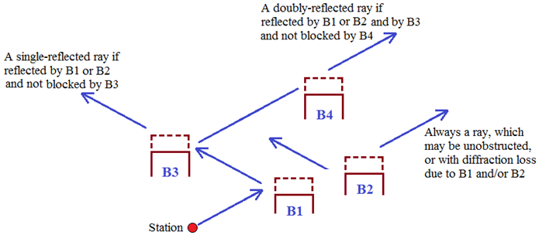

5.3 Parameters set by comparison with measurement
A number of parameters in the following calculations cannot be obtained analytically. Potentially they can be optimised by comparisons between the model and measurements. The effect of varying these values tends to be complicated but minor.
Table 1 shows the values which are currently recommended. They were all set initially on the basis of reasonable estimates, and then some small adjustments were made during comparisons with the limited number of measurements available at the time. They should not be changed without a comprehensive optimisation using a large volume of measured results, should these become available.
TABLE 1
Parameters adjusted by comparison with measurement
Symbol | Value | Description
$$K_{dr}$$ | 0.5 | Upper fraction of distance probability range for reflection distances
$$K_{dh}$$ | 1.5 | Adjusts distance/height ratio of diffraction building height
$$K_{hc}$$ | 0.3 | A probability which adjusts the critical diffraction height
$$K_{rc}$$ | 3.0 | Frequency in GHz defining regions of reflection loss
$$K_{rs}$$ | 15 | Slope in dB/decade of low-frequency reflection range
$$K_{rm}$$ | 8.0 | Reflection loss minimum in dB in high-frequency reflection range

5.4 Obtaining the propagation geometry
The horizontal distances and vertical building heights required to evaluate propagation effects are obtained from the template distributions as follows.

5.4.1 Horizontal distances
The horizontal distance from the station to building 1 is obtained as:
$D_{b1}=Q\left(\vec{D_{b1}},\vec{P_{db1}},P\right)$ (m) (5a)
The horizontal distance from the building 1 to building 2 is obtained as:
$D_{b12}=Q\left(\vec{D_{b12}},\vec{P_{db12}},P\right)$ (m) (5b)
where in both equations (5a) and (5b) $P$ is a new random number with $0≤P<1$, and function Q is defined by equation (4).
The horizontal distance from the station to building 2 is given by:
$D_{b2}=D_{b1}+D_{b12}$ (m) (6)
For the reflection model, the horizontal distance between buildings 1 and 3 is given by:
$D_{r13}=Q\left(\vec{D_{b1}},\vec{P_{db1}},P_{r}\right)$ (7a)
For the reflection model, the horizontal distance between buildings 2 and 3 is given by:
$D_{r23}=Q\left(\vec{D_{b1}},\vec{P_{db1}},P_{r}\right)$ (7b)
For the reflection model, the horizontal distance between buildings 3 and 4 is given by:
$D_{r34}=Q\left(\vec{D_{b1}},\vec{P_{db1}},P_{r}\right)$ (7c)
where in each of equations (7a) to (7c) the modified probability for reflection distances is given by:
$P_{r}=1-K_{dr}\left(1+P\right)$ (7d)
where:
$K_{dr}$ is a parameter in Table 1.
and where in each case $P$ is a new random number with $0≤P<1$.

5.4.2 Roof heights
For the reflection model the roof heights of buildings 1, 2 and 3, and if required building 4, above the station for the reflection model is obtained as:
$H_{bxs}=Q\left(\vec{H_{b}},\vec{P_{hb}},P\right)-H_{s}$ (m) (8)
where:
$x$ stands for 1, 2 3, and if required 4;
$P$ is a new random number in each case with $0≤P<1$.
For the diffraction model the roof height of buildings 1 and 2 above the station may require adjustment to take account of the possibility that a path around the side of an isolated tall building may have lower diffraction loss than over its roof. This is taken into account by reducing the roof height under certain circumstances.
For the diffraction calculation the roof heights of building 1 and 2 are given by:
$H_{bxs}=\left\{\begin{matrix}H_{c}+\frac{H_{bx}-H_{c}}{R_{dh}} if R_{dh}>1 and {H_{b}>H}_{c} \\ H_{bx}\end{matrix}\right.$ (m) (9)
where:
$x$ stands for 1, 2;
$H_{c}=Q\left(\vec{H_{b}},\vec{P_{hb}},K_{hc}\right)$ (m) (9a)
$H_{b}=Q\left(\vec{H_{b}},\vec{P_{hb}},P\right)-H_{s}$ (m) (9b)
P is a new random number in each case for $x=1$ and $x=2$ with $0≤P<1$.
$R_{dh}=K_{dh}\left(\frac{\overline{D_{b1}}}{\overline{H_{b}}}\right)$ (9c)
$K_{hc}$ and $K_{dh}$ are parameters in Table 1
and $\overline{D_{b1}}$ and $\overline{D_{hb}}$ are the medians of vectors $\vec{D_{b1}}$ and $\vec{H_{b}}$.

5.4.3 Ray heights above the station
The height above the station at which a ray arrives at building $y$ can be written as a function $H_{ray}$:
$H_{ray}\left(H_{rsx},D_{xy}\right)=H_{rsx}+D_{xy}tan\left(θ\right)$ (m) (10)
where:
$H_{rsx}$: is the height above the station at a starting point $x$ where $x=0$ to indicate the station, and 1 to 4 to indicate a building
$D_{xy}$: is the horizontal distance from $x$ to $y$.
Ray heights are calculated as needed by the diffraction and reflection models.

5.5 Diffraction loss
Diffraction losses for two building are each calculated as though the other does not exist, and the losses are then combined with a correction taking account of their separation, similar in principle to the methods for two isolated edges in Recommendation ITU-R P.526.
Each building is treated as though a knife-edge, for which diffraction loss is given as a function J of a dimensionless parameter according to:
$J\left(\right)=\left\{\begin{matrix}6.9+20log\left[\sqrt{{\left(-0.1\right)}^{2}+1}+-0.1\right] & if >-0.78 \\ 0 & otherwise\end{matrix}\right.$ (dB) (11)
For building 1 the knife-edge diffraction loss is given by:
$L_{d1}=J\left({}_{1}\right)$ (dB) (12)
where:
${}_{1}=2\sqrt{\frac{\sqrt{{d_{01}}^{2}+{h_{o1}}^{2}}-d_{o1}}{}} sign\left(h_{o1}\right)$ (12a)
$d_{o1}=\sqrt{{D_{b1}}^{2}+{H_{rs1}}^{2}}+R_{o1}H_{rs1}$ (m) (12b)
$h_{o1}=R_{o}D_{b1}$ (m) (12c)
$R_{o1}=\frac{H_{b1}-H_{s}-H_{rs1}}{\sqrt{{D_{b1}}^{2}+{H_{rs1}}^{2}}}$ (12d)
$H_{rs1}=D_{b1}\tan\left(θ\right)$ (m) (12e)
and noting that $h_{o1}$ has a negative value in the line-of-sight case.
For building 2 the knife-edge diffraction loss is given by:
$L_{d2}=J\left({}_{2}\right)$ (dB) (13)
where:
${}_{2}=2\sqrt{\frac{\sqrt{{d_{02}}^{2}+{h_{o2}}^{2}}-d_{o2}}{}} sign\left(h_{o2}\right)$ (13a)
$d_{o2}=\sqrt{{D_{b12}}^{2}+{H_{rs2}}^{2}}+R_{o2}H_{rs2}$ (m) (13b)
$h_{o2}=R_{o2}D_{b2}$ (m) (13c)
$R_{o2}=\frac{H_{b2}-H_{s}-H_{rs2}}{\sqrt{{D_{b2}}^{2}+{H_{rs2}}^{2}}}$ (13d)
$H_{rs2}=H_{rs1}+D_{b12}\tan\left(θ\right)$ (m) (13e)
$D_{b12}=D_{b1}+D_{b12}$ (m) (13f)
and is the wavelength in metres.
The separate diffraction losses for the two buildings are now combined to give the overall diffraction loss according to:
$L_{d}=10log\left[\left({10}^{0.1L_{d1}}+{10}^{0.1L_{d2}}\right)\frac{1+L_{d1}+L_{d2}}{2+L_{d1}+L_{d2}}\right]$ (dB) (14)

5.6 Reflection loss
The main part of the reflection calculation decides whether there is a reflected ray, and if it does exist, whether it is the result of one or two reflection.
Figure 5 illustrates this algorithmic process, in which:
The ovals are end points, starting at "S" and ending at one of "0", "1" or "2" giving the number of reflections. Zero reflections means there is no reflected ray, otherwise there is one reflected ray which may be the result of one or two reflections.
The process rectangles show the next ray height to calculate and the appropriate arguments for function $H_{ray}$. Horizontal distances should be obtained as given in § 4.1.
The decision diamonds indicate the point where it must be determined whether or not the ray is above the roof height of the building concerned. If the ray is below the roof height there will either be a reflection, or a previously reflected ray is blocked. This branch is labelled in all cases; the other branch is taken when the ray is above the roof height.
FIGURE 5
Flow chart for determining the number of reflections
Reflection from building 2
Blocked at building 4
Reflection from building 2
Reflection from building 1
$$H_{rs1}=H_{ray}\left(0,D_{b1}\right)$$
$$H_{rs3}=H_{ray}\left(H_{rs1},D_{b13}\right)$$
$$H_{rs2}=H_{ray}\left(H_{rs1},D_{b12}\right)$$
$$H_{rs3}=H_{ray}\left(H_{rs2},D_{b23}\right)$$
$$H_{rs4}=H_{ray}\left(H_{rs3},D_{b34}\right)$$
0
1
2
1
2
4
3
S
If there is no reflected ray, no reflection loss is calculated and the calculation should continue from § 5.7.
Otherwise the loss due to one reflection is given by:
$L_{r}=10log\left[{10}^{0.1K_{rm}}+{10}^{0.1L_{lof}}\right]$ (dB) (15)
where:
$L_{lof}=K_{rm}-K_{rs}log\left(f/{K_{rc}}\right)$ (dB) (15a)
$f$ is frequency in GHz
and parameters $K_{rc}$, $K_{rm}$ and $K_{rs}$ appear in Table 1.

5.7 Clutter loss
Each individual calculation accounts for one ray leaving the station, resulting in a single direct ray which may have diffraction loss, and possibly one reflected ray which may be the result of one or two reflections.
The clutter loss for each individual calculation is given by:
$L_{c}=\left\{\begin{matrix}-10log\left({10}^{0.1\left(-L_{d}\right)}+{10}^{0.1\left(-N_{r}L_{r}\right)}\right) & if N_{r}>0 \\ L_{d} & otherwise\end{matrix}\right.$ (dB) (16)
where $N_{r}$ is the number of reflections obtained from the process illustrated in Fig. 5.

6 Application of the statistical clutter-loss model
Results from repeated use of the stochastic calculation described in § 5 should be compiled into a cumulative distribution of clutter loss. Each calculation must use new random numbers for the probabilities; no random number should be used more than once.
For use with other propagation models and in spectrum-related studies it is convenient to compile the cumulative distribution in terms of percentage locations rather than probability.
The number of repetitions of the calculation for statistically reliable results can conveniently be judged by plotting the distribution at a scale which allows the required scale of accuracy to be visible. A smooth curve at this scale indicates that sufficient repetitions has been used.

7 Building statistics used to derive the clutter loss distribution within Recommendation ITU-R P.2108-0 § 3.3

7.1 Representative areas similar to The City, London, UK
The template used to produce the curves for areas similar to The City, London, UK was obtained from the survey points shown in Fig. 6. The City, London, is typical of a business centre with narrow streets and relatively few gaps between buildings. The survey points are on kerbs at the edge of pavements (sidewalks). To be typical of stations intended to serve small coverage areas, the locations mainly avoid street intersections.
FIGURE 6
Survey points in London
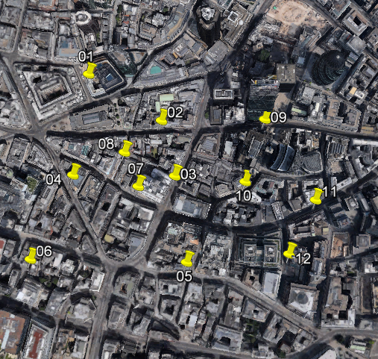
Table 2 gives the coordinates of the survey points.

TABLE 2
Coordinates of survey points in London
Point number | Latitude | Longitude
1 | 51°30'51.49"N | 0° 5'14.98"W
2 | 51°30'48.34"N | 0° 5'7.04"W
3 | 51°30'44.59"N | 0° 5'5.59"W
4 | 51°30'44.66"N | 0° 5'16.67"W
5 | 51°30'38.75"N | 0° 5'4.31"W
6 | 51°30'38.94"N | 0° 5'21.34"W
7 | 51°30'43.89"N | 0° 5'9.57"W
8 | 51°30'46.19"N | 0° 5'11.06"W
9 | 51°30'48.43"N | 0° 4'55.80"W
10 | 51°30'44.21"N | 0° 4'57.93"W
11 | 51°30'42.98"N | 0° 4'50.27"W
12 | 51°30'39.32"N | 0° 4'53.15"W

Figure 7 shows the distance and height cumulative distributions compiled from the survey points, constituting the template for central London.
FIGURE 7
Distance and height cumulative distributions for London
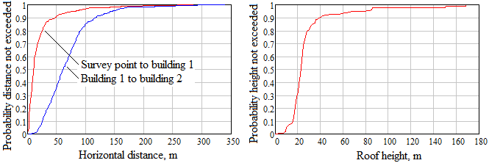

7.2 Representative areas similar to the central area of Melbourne, Australia
The template used to produce the curves for areas similar to the central area of Melbourne, Australia, was obtained from the survey points shown in Fig. 8. Central Melbourne is laid out on a rectangular grid with fairly wide main roads, but many narrow passages within the city blocks. To be typical of stations intended to serve small coverage areas, the survey point locations mainly avoid street intersections.
FIGURE 8
Survey points in Melbourne
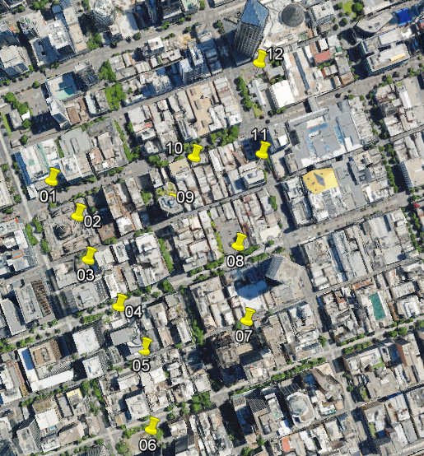
Table 3 gives the coordinates of the survey points.

TABLE 3
Coordinates of survey points in Melbourne
Point number | Latitude | Longitude
1 | 37°48'48.23"S | 144°57'28.00"E
2 | 37°48'50.46"S | 144°57'30.09"E
3 | 37°48'53.17"S | 144°57'30.93"E
4 | 37°48'56.13"S | 144°57'33.33"E
5 | 37°48'58.88"S | 144°57'35.31"E
6 | 37°49'3.95"S | 144°57'35.88"E
7 | 37°48'57.06"S | 144°57'43.55"E
8 | 37°48'52.31"S | 144°57'42.84"E
9 | 37°48'49.81"S | 144°57'37.43"E
10 | 37°48'46.72"S | 144°57'39.34"E
11 | 37°48'46.48"S | 144°57'44.78"E
12 | 37°48'40.73"S | 144°57'44.56"E

Figure 9 shows the distance and height cumulative distributions compiled from the survey points, constituting the template for central Melbourne.
FIGURE 9
Distance and height cumulative distributions for Melbourne
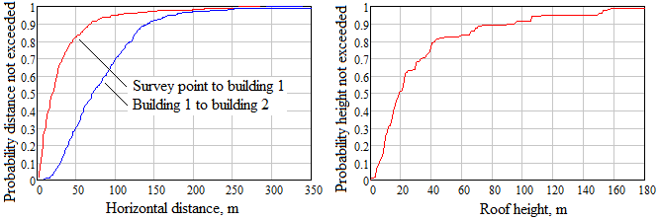

8 An expression approximating the statistical clutter-loss model
Having produced a family of cumulative distributions of clutter loss not exceeded for p% of locations for various elevation angles, as described in § 6, they may be approximated by the following expression:
$L_{ces}={\left\{-K_{1}\left[ln\left(1-\frac{p}{100}\right)\right]cot\left[A_{1}\left(1-\frac{θ}{90}\right)+\frac{πθ}{180}\right]\right\}}^{\left[{K_{2}\left(90-θ\right)}/{90}\right]}-K_{3}-K_{4}Q^{-1}\left(p/100\right)$ dB (17)
with
$K_{1}=93\left(f^{0.175}\right)$, $A_{1}=0.05$
where:
θ: elevation angle (degrees)
p: percentage locations (%) and 0 < p < 100
f: frequency (GHz)
Q⁻¹(p/100): inverse complementary normal distribution function.
A procedure of curve fitting by adjusting the constants K₁, and A₁, K₂, K₃, and K₄ in equation (17) for minimum overall RMS difference from the generated cumulative distributions is impractical in this case, due to the unusual nature of the curves, and the requirement that the fitting accuracy is most important in the low-loss low-percentage-of-locations region of the curves, and relatively unimportant in the high-loss high-percentage-of-locations region. Instead, the constants are manually adjusted for a good fit in the important regions.
Apart from simplifying the implementation of the clutter model, the other advantage of approximating the cumulative distributions with equation (17) is that in the low-loss region at mid to high percentages, smooth curves typical of those produced by true ray-tracing simulation are produced.

8.1 Description of the curve-fitting constants
An understanding of the role of the constants in equation (17) is required in order to achieve a good fit.
Constants K₃, and K₄ provide a minor adjustment only, for high elevation angles, and suggested values are K₃ = 1, and K₄ = 0.6.
The cotangent expression recognises the dominance of specular reflection in the clutter loss, but instead of cot[πθ/180], which would give infinite loss at zero elevation angle, this is modified to cot[A₁(1 – θ/90) + πθ/180], to give high loss at zero elevation angle, but a similar result to cot[πθ/180] at high θ. Thus A₁ controls the loss at low θ, relatively independently of high θ, and a low value such as A₁ = 0.05 is suggested.
The main constants adjusted for fitting the curves are then K₁ and K₂, with K₁ adjusted for the median value of (17) for θ = 0 to match the median of the distribution generated as described in § 6. Suggested value for K₂ is 0.5; however this may be varied to adjust the percentage of locations in the low-loss tail of the distribution. Reducing K₂ reduces this percentage, and vice versa.

8.2 Example of curve-fitting the cumulative distributions
Families of cumulative distributions produced as described in § 6, for both London and Melbourne were produced using terminal heights of 4 to 6 metres uniformly distributed, and a mean by percentage of locations generated, to give a single family of distributions. The curve fitting described above was then performed.
The distributions over the 10 to 100 GHz frequency range were found to be well fitted by making K₁ a function of frequency, K₁ = 93( f ^{0.175}), and K₂ = 0.5. An example of the result, for 30 GHz, is shown in Fig. 10.
FIGURE 10
Example of fitting (17) to the generated cumulated distributions, for 30 GHz
