Report ITU-R RA.2509-0
(10/2022)
Technical and operational characteristics
of radio astronomy systems operating
below 350 MHz (85 cm)
RA Series
Radio astronomy

Foreword
The role of the Radiocommunication Sector is to ensure the rational, equitable, efficient and economical use of the radio-frequency spectrum by all radiocommunication services, including satellite services, and carry out studies without limit of frequency range on the basis of which Recommendations are adopted.
The regulatory and policy functions of the Radiocommunication Sector are performed by World and Regional Radiocommunication Conferences and Radiocommunication Assemblies supported by Study Groups.

Policy on Intellectual Property Right (IPR)
ITU-R policy on IPR is described in the Common Patent Policy for ITU-T/ITU-R/ISO/IEC referenced in Resolution ITU-R 1. Forms to be used for the submission of patent statements and licensing declarations by patent holders are available from http://www.itu.int/ITU-R/go/patents/en where the Guidelines for Implementation of the Common Patent Policy for ITU-T/ITU-R/ISO/IEC and the ITU-R patent information database can also be found.

Series of ITU-R Reports
(Also available online at http://www.itu.int/publ/R-REP/en)
Series | Title
BO | Satellite delivery
BR | Recording for production, archival and play-out; film for television
BS | Broadcasting service (sound)
BT | Broadcasting service (television)
F | Fixed service
M | Mobile, radiodetermination, amateur and related satellite services
P | Radiowave propagation
RA | Radio astronomy
RS | Remote sensing systems
S | Fixed-satellite service
SA | Space applications and meteorology
SF | Frequency sharing and coordination between fixed-satellite and fixed service systems
SM | Spectrum management

Note: This ITU-R Report was approved in English by the Study Group under the procedure detailed in Resolution ITU-R 1.

Electronic Publication
Geneva, 2022
© ITU 2022
All rights reserved. No part of this publication may be reproduced, by any means whatsoever, without written permission of ITU.

REPORT ITU-R RA.2509-0
Technical and operational characteristics of radio astronomy systems
operating below 350 MHz (85 cm)
(Questions ITU-R 129-3/7, ITU-R 145-3/7, ITU-R 237/7)
(2022)
TABLE OF CONTENTS
Page
Policy on Intellectual Property Right (IPR) ii
1 Introduction 2
2 Telescopes using radio spectrum below 350 MHz 3
2.1 Compound Astronomical Low-cost Low-frequency Instrument for Spectroscopy and Transportable Observatory (CALLISTO) 3
2.2 Region 1 3
2.3 Region 2 4
2.4 Region 3 5
3 Technical and operational parameters of low frequency radio telescopes 7
4 Frequency allocations and spectrum sharing 10
5 Consequences of interference mitigation 11
5.1 Example: Impact of ionospheric signal reflections 11
6 List of acronyms and abbreviations 13
7 References 13

Scope
This Report summarizes generic technical and operational characteristics of radio telescopes working at frequencies below 350 MHz. In most cases these are arrays of dipoles; however, in a few cases these are more traditional parabolic dishes designed to work at higher frequencies but instrumented to also work below 350 MHz. To maximize collecting area for very faint cosmic signals, the use of large numbers of elements is needed, which has recently been further facilitated by advancements in digital processing.

1 Introduction
The pioneering days of radio astronomy involved observations below a few hundred MHz. However, the prediction and subsequent detection of the 21 cm line of hydrogen at 1 420 MHz, the quest for higher angular resolution, and technological advances in receiver technology and interferometry, shifted the attention to higher frequencies. Subsequent discoveries in radio astronomy were indeed dominated by these higher frequencies. In the 1980s to early 1990s, renewed interest in low frequencies grew with the realization that many cosmic sources have inverted radio spectra. In the past 20 years, an additional ambitious goal was the detection of neutral hydrogen at cosmological distances, as early as the cosmic dawn, when the first stars and galaxies lit up the Universe and which corresponds to frequencies below 100 MHz. This requires well characterized instruments with huge collecting areas at affordable cost that observe at frequencies below 350 MHz. Further topics of interest include Fast Radio Bursts (FRBs), Meteors, Pulsar and fundamental physics, exoplanets detection, galactic and extragalactic magnetism, and space weather. Many new instruments have been built or are under construction around the world. Figure 1 shows an example of one of such new instruments.
Figure 1
Aerial view of the first long wavelength array station (LWA1) with the very large array in the background
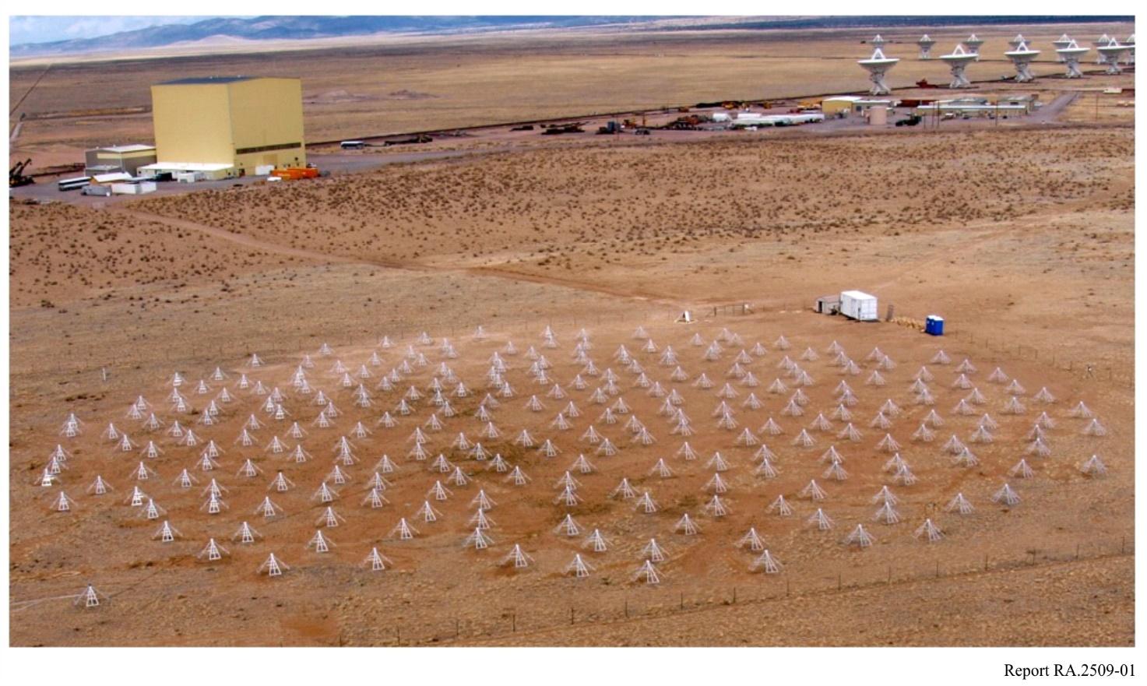
Relevant ITU-R publications are Report ITU-R RA.2195 on the transition to digital television and its impact on radio astronomy [1], Report ITU-R RA.2163 on spectrum sharing at high frequencies [2], and Report ITU-R RS.2456 on the use of space weather sensor systems that make use of the radio spectrum.
In light of the recent rapid developments in low frequency radio astronomy, it is believed appropriate to describe the characteristics of this new generation of instruments, and the frequencies employed. This Report provides this information.

2 Telescopes using radio spectrum below 350 MHz
The general characteristics for common designs of radio telescopes operating below 350 MHz are highlighted here.
Some smaller single dish telescopes, essentially solar or space weather instruments, observing in that band have not been mentioned in this Report for clarity but the full list can be found in Report ITU-R RS.2456.

2.1 Compound Astronomical Low-cost Low-frequency Instrument for Spectroscopy and Transportable Observatory (CALLISTO)
The CALLISTO instrument is a sweeping radio spectrometer operating between 45 and 870 MHz. Other frequency ranges can be observed by using either a heterodyne up- or down-converter. The CALLISTO instrument observes 825 MHz of the solar radio spectrum using individual channels which have a bandwidth of 300 kHz and can be tuned in 62.5 kHz increments. The narrow channel width and accurate positioning are essential to avoid known sources of interference. The number of channels per observing program is limited between 4 and 400, and up to 800 measurements can be made per second. For a typical number of 200 channels, the sampling time per channel is 0.25 seconds. CALLISTO instruments are easily transportable and used in many observatories.
As per March 2021, 172 instruments are already deployed worldwide. The current list of CALLISTO instruments can be found under the following link: http://www.e-callisto.org

2.2 Region 1

2.2.1 The Low Frequency ARray (LOFAR)
LOFAR (Low Frequency ARray) is a large radio telescope operating at the lowest frequencies that can be observed from Earth. Unlike single-dish telescope, LOFAR is a multipurpose sensor network, with an innovative computer and network infrastructure that can handle extremely large data volumes. The telescope contains 38 stations in the Netherlands, of which 28 are located in a central location. LOFAR is an international telescope with stations in Germany (six stations), Poland (three stations), France, Ireland, Latvia, Sweden and the United Kingdom (one station each); a station in Italy is funded to be built soon. A LOFAR station consists of Low Band Antenna (LBA, 10-80 MHz) and High Band Antenna (HBA, 110-250 MHz).
Core stations consist of 48 HBAs and 96 LBAs and a total of 48 digital Receiver Units (RCUs). The HBAs are arranged in two 24-element fields with a diameter of 30.8 m each, straddling an 87 m diameter LBA field. The two 24-element fields can be used either as individual stations or their signals can be combined to form one station.
Remote stations consist of 48 HBAs arranged in a single 41 m diameter field and 96 LBAs arranged in a single 87 m diameter field and a total of 48 digital Receiver Units (RCUs).
International stations consist of a 70 m wide LBA array with 96 elements, a 56.5 m wide HBA array consisting of 96 antenna tiles and a total of 96 digital Receiver Units (RCUs).

2.2.2 New Extension in Nançay Upgrading LOFAR (NENUFAR)
NenuFAR is a large low-frequency radio telescope, at the Nançay Radioastronomy Observatory, that provides high sensitivity observations in the 10-85 MHz range. NenuFARʼs 1938 dual polarization antennas are hierarchically distributed. They are grouped in hexagonal 25 m diameter tiles of 19 crossed-dipoles (Mini-Arrays, hereafter MA) that are analogue-phased to produce a beam smoothly steerable from horizons to zenith. Ninety-six such MA are densely distributed with a 400 m diameter core, whereas six additional MA are distributed at distances up to ~3 km. A suite of receivers allowing the instrument to operate, simultaneously if needed, in four distinct modes: as a standalone beamformer, a standalone imager, a waveform snapshots recorder, and a giant low-frequency station of the LOFAR array.

2.2.3 Nançay Decameter Array (NDA)
The NDA, located at the Nançay Radioastronomy Observatory, is an array of 144 log-periodic conical antennas with circular polarizations. The array is dedicated to routine observations of powerful radio sources typically within the 10-80 MHz range, namely Jupiter and the solar corona.

2.2.4 Nançay Radioheliograph (NRH)
The Nançay Radioheliograph consists of 47 antennas with sizes in the range 2 to 10 m, distributed along two arrays in the East West and North South directions for imaging the sun. The E-W and N-S baselines range to 3 200 m and 2 440 m respectively. The NRH observes the sun between 0830 and 1530 UT daily, at up to ten frequencies between 150 and 450 MHz, with sub-second cadence. It maps the quiet, active, and flaring solar radio emissions with an angular resolution from 6 arc-minutes at 450 MHz to 2 arc-minutes at 150 MHz (the sun is about 32 arc-minutes in diameter).

2.2.5 Small Phased Array DEmonstrator (SPADE)
SPADE is a small eight-antennas array spread over a 20×20 m grid, located in the Humain radio astronomy station, in the south of Belgium. The antennas are the ones of the NenuFAR project, which are based on the LWA antenna design. The array is devoted to solar observations in the range 20-80 MHz.

2.2.6 The Hydrogen Epoch of Reionization Array (HERA)
HERA is a cosmology experiment using new methods for higher precision calibration to make very long integrations. It is located in the Western Cape of South Africa at the site of the intermediate frequency Square Kilometre Array (SKA1-Mid). HERA consists of 350 fixed zenith pointing 14-m dishes. The dishes are packed into a 300-m wide hexagonal grid with 12 outriggers providing baselines up to 3 km long. The operating band is 50 to 250 MHz. RF signals are directly digitized at the baseband, channelized and cross correlated in real time. Analysis products are produced on site and used to monitor the operation of the telescope. HERA is a project of the U.S. National Science foundation in collaboration with South African Radio Astronomical Observatory. The HERA dishes provide high gain, however due to other cosmology design constraints, the feeds have line of sight to the horizon increasing susceptibility to terrestrial interference. Through cooperation with the South African government several analogue television stations in the HERA band have been deactivated greatly improving the quality of science possible at the site.

2.3 Region 2

2.3.1 Long Wavelength Array (LWA) Stations
Long Wavelength Array stations consist of a collection of hundreds of omni-directional cross-dipoles with a broadband response that can be combined into a phased array, which can operate singly or as a combined system for interferometry. The configuration of an individual station can range from a distribution of dipoles over a footprint of 100 m in diameter, e.g. LWA1 or LWA-SV, or up to many kilometres, e.g. OVRO-LWA. A detailed technical description of LWA1 can be found in [6].
At each station, the RF signal from each dipole is received within a single frequency range of 3-88 MHz, where analogue filters allow broad attenuation of strong signals below 30 MHz and the FM band above 88 MHz. The analogue signals are amplified, digitized, and raw voltages can be recorded individually or can be digitally added to form multiple beams that are able to capture an instantaneous bandwidth covering the entire available frequency range. The resulting data from each station are raw voltages or dynamic spectra, the former can be combined for interferometric imaging with other telescopes.

2.3.2 Karl G. Jansky Very Large Array (VLA)
The VLA consists of 28 steerable and reconfigurable 25-m diameter parabolic dishes. Among cm-wavelength receivers, it also operates on each antenna a broadband receiver system covering two bands from 56-86 MHz (4-band) and 240-470 MHz (P-band). Both bands are available for general use. The P-band RF feed consists of a cross-dipole mounted near the primary focus of a dish, in-front of an achromatically shaped sub-reflector. The 4-band RF feed consists of a modified J-pole design, mounted in a square pattern around the support structure of the sub-reflector. Both RF signals are combined through an analogue frontend and jointly digitized, channelized, and subsequently combined through real-time interferometric correlation. Complex full Stokes correlation products are recorded, which are commonly used for synthesis imaging. The VLA can be used as a stand-alone instrument or in combination with other low frequency instruments via recording of a narrow band (up to 16 MHz) raw voltage stream for joint correlation with other low frequency stations, e.g. the LWA.

2.4 Region 3

2.4.1 Murchison Widefield Array (MWA)
The Murchison Widefield Array consists of 4,096 dual-polarised ‘bowtie’ dipole antennas, arranged in 256 4×4 grids (approximately 5 m × 5 m in extent) called ‘tiles’, spread over an area of approximately 5.5 km in diameter within the Murchison Radio-astronomy Observatory (MRO). Data from the antennas are correlated onsite before being transmitted to the Pawsey Supercomputing Centre for long-term storage. The back-end of the telescope is an online platform: the MWA node of the All Sky Virtual Observatory (MWA-ASVO), through which scientists access calibrated MWA data.
The majority of the tiles are scattered across a roughly 1.5 km core region, forming an array with very high imaging quality, and a field of view of at least several hundred square degrees at a resolution of several arcminutes. The remaining tiles are placed at locations outside the core, yielding baseline distances of up to approximately 5.5 km to allow higher angular resolution. Detailed technical descriptions are contained in [7] and [8].
The MWA’s particular attributes include:
• a very wide field of view (at least hundreds of square degrees);
• high angular resolution (several arcminutes);
• wide frequency range (70-300 MHz) with flexible tuning; and
• extremely rapid re-pointing agility.

2.4.2 The Experiment to Detect the Global 21cm Signal (EDGES)
EDGES is an astrophysics and cosmology experiment that aims to observe the early Universe through observations in a 50-200 MHz band. The experiment uses multiple instruments, each is a broadband radio spectrometer consisting of a single horizontal dipole antenna and large (at least 30-metre) metal ground plane. The instruments are carefully calibrated to achieve better than 1% absolute accuracy in sky brightness temperature and better than 0.01% in-band relative accuracy. EDGES has a permanent station located at the Murchison Radio-astronomy Observatory (MRO) in Western Australia. It also operates temporary installations periodically in the U.S. at sites in Oregon, Nevada, and Maine. Additional sites in Alaska and on remote island chains in the Pacific and Atlantic Oceans are under consideration. The system is especially sensitive to FM radio and TV band transmitters and is best operated at distances greater than 1000 km from the nearest transmitter in these bands in order to limit received power from reflection of these over-the-horizon signals by micrometeorites and airplanes.
The EDGES installation at the Murchison Radio-astronomy Observatory (MRO) in Western Australia consists of two instruments: 1) a high-band instrument sensitive to 100-200 MHz, and 2) a low-band instrument sensitive to 50-100 MHz. The instruments are nearly identical except for their antennas and ground planes, which are scaled copies.
Sky radiation is collected by a wideband dipole-like ‘blade’ antenna consisting of two rectangular metal panels mounted horizontally above a metal ground plane. A receiver is installed underneath the ground plane, directly below the antenna panels. A balun is used to guide radiation from the antenna panels to the receiver. The ground plane rests directly on the physical ground and consists of a 5 × 5 metre solid metal assembly (10 × 10 metre mesh for the low-band). This ground plane provides a stable high-conductivity electric boundary to the antenna under varying environmental conditions and is critical for achieving the expected smooth wideband response of the antenna.
From the output of the receiver, the RF signal is taken along a 100-m coaxial cable into an EMI-shielded equipment rack where it is amplified and filtered by back-end electronics. The signal is then sent to a data acquisition system with 400 Mega Samples per second ADC that samples with 14-bit amplitude resolution and 6.1 kHz frequency resolution.

2.4.3 SKA-Low
The SKA-LOW telescope will be the most sensitive radio interferometer in the world operating at frequencies below 350 MHz. The array will be located within the Murchison Radio-Astronomy Observatory (MRO) of Western Australia, and is expected to come online before 2030. The design baseline consists of more than 131000 dual polarization log periodic dipole antennas operating between 50 and 350 MHz. These antennas will be grouped into stations of 256 elements each with a diameter of ~38 m, antennas are distributed randomly within a station. The maximum baseline length between stations will extend out to just beyond 70 km.
The correlator has been designed to process up to 300 MHz of bandwidth with a spectral resolution of ~5 kHz; however, higher spectral resolution observations over a narrower bandwidth will be possible using correlator ‘zoom modes’. Calibration and imaging of the correlated data stream will be performed by the Science Data Processor (SDP) located at a High Performance Computing (HPC) centre in Perth, Australia. The data will then be distributed globally to the end users through a network of Science Regional Centres (SRCs).

2.4.4 Five-hundred-metre Aperture Spherical radio Telescope (FAST)
The Five-hundred-metre Aperture Spherical radio Telescope (FAST) is the largest single-dish radio telescope in the world. The FAST site is a depression called Dawodang located in south Guizhou of China, which is large to host the 500-metre telescope and deep to allow a zenith angle of 40 degrees. The active main reflector of FAST corrects for spherical aberration on the ground to achieve a full polarisation and a wide band without involving complex feed systems. The light-weight feed cabin driven by cables and servomechanism plus a parallel robot works as a secondary adjustable system to move with high precision. Within seven sets of receivers, there are three sets of receivers covering the bands of 70-140 MHz, 140-280 MHz and 270-1 620 MHz separately.

2.4.5 21 Centimetre Array (21CMA)
The 21CMA is a ground-based radio interferometer dedicated to the detection of the EoR. The array, sited in the Ulastai valley of western China, consists of 81 pods or stations, and a total of 10,287 log-periodic antennas are deployed in two perpendicular arms along the east–west (6.1 km) and north–south (4 km) directions, respectively. Each antenna element has 16 pairs of dipoles, optimized to cover a frequency range of 50-200 MHz.

3 Technical and operational parameters of low frequency radio telescopes
The following items present some characteristics of ground based low frequency telescopes (receive only) for the purpose of radio astronomy research below 350 MHz. For completeness we have included existing facilities as well as facilities that have advanced at least to the stage of soliciting funding through federal proposals. These are marked with a ‘*’ in Table 1.
A population centre is defined as >1 000 people in a town. Populations of this size (or larger) are assumed to make use of a broad spectrum of devices and services. Al-Hourani et al. [5] have demonstrated that spectrum occupancy scales with population size. The proximity of such population centres is indicated by the three letter codes in Table 1, C, N and F, corresponding to distance ranges of close: 0-10 km, near: 10-100 km, and far: >100 km respectively.

TABLE 1
Radio astronomy facilities that operate below 350 MHz
 | Country | Name | N latitude | E longitude | Array size | Operating frequency  (MHz) | Proximity to population centre
 | Distributed worldwide | CALLISTO |  |  |  | 45-870
R1 | Distributed throughout Europe | LOFAR |  |  |  | 10-80  110-250 | C
 | France | NenuFAR | 47°22'35" | 02°11'35" | 400 m core  3 000 m array | 10-85 | N
 | France | NDA | 47°22'50" | 02°11'36" | 400 m | 10-80 | N
 | France | NRH | 47°22'53" | 02°11'43" | 3 200×2 440 m | 150-450 | N
 | Belgium | SPADE | 50°11'31" | 05°15'10" | 20 m | 20-80 | C
 | South Africa | HERA | -30°43'17.26" | 21°25'41.59" | 300m | 50-250 | N
R2 | USA | LWA1 | 34° 4'7.92" | −107°37'42.20" | 110 m | 10-88 | N
 |  | LWA-SV | 34°20'54.33" | −106°53'8.48" | 110 m | 3-88 | N
 |  | LWA-NA | 34°14'48.89" | −107°38'25.49" | 85 m | 3-88 | N
 |  | *LWA-Farr | 33°47'11" | −108°09'18" | 1000 m | 3-88 | N
 |  | OVRO-LWA | 37°14'23.02" | −118°16'56.18" | 2500 m | 10-88 | C
 |  | Jansky VLA | 33° 58' 22"to 34° 14' 56" | −107° 24' 40" to −107° 48' 22" | 27×25 m | 54-86  200-500 | N
 |  | GBT | 38°25'59" | −79°50'23" | 105 m | 290 | N
 |  | DLITE-NM | 34° 4'7.92" | −107°37'42.20" | 400 m | 30-40 | N
 |  | DLITE-Pomonkey | 38˚ 34’ | −77°03’ | 400 m | 30-40 | C
 |  | *DLITE-Florida | 28˚ 01’ | −80°41’ | 400 m | 30-40 | C
 |  | *DLITE-Alaska | 57˚ 27’ | −152°22’ | 350 m | 30-40 | N
 |  | DART | 34°37'16” | −112°26'54" | 260 m | 80-300 | C
 |  | LoFASM-PM | 26°33'19" | −97°26'31" | 163 m | 10-88 | N
TABLE 1 (end)
Radio astronomy facilities that operate below 350 MHz
 | Country | Name | N latitude | E longitude | Array size | Operating frequency  (MHz) | Proximity to population centre
 |  | LoFASM-GB | 38°25'45" | −79°50'46" | 350 m | 10-88 | N
 |  | LoFASM-Goldstone | 35°14'50" | −116°47'36" | 165 m | 10-88 | N
 |  | LoFASM-Hillsdale | 41°56'16" | −84°36'51” | 140 m | 10-88 | C
R3 | Australia | MWA | −26°42′11′′.94986 | 116°40′14′′.93485 | 256×5 m over 5.5 km | 70-300 | F
 |  | EDGES | −26°41'50" | 116°38'21” | 45 m | 50-100 | F
 |  | *SKA-Low | −27°03'35" to −26°29'49" | 116°28'44" to 117°11'46" | 512×38 m | 50-350 | F
 | China | FAST | 25°39′10″ | 106°51′20″ | 500 m | 70-140  140-280  270-1620 | N
 |  | 21CMA | 42°56′ | 86°41′ | 10287×2.2 m | 50-200 | N
* Under construction or in planning stages
Note to Table 1: Many of the listed facilities are also capable to operate above 350 MHz, which is indicated under operating frequency.

4 Frequency allocations and spectrum sharing
Frequency allocations for the radio astronomy service below 350 MHz include:
• 13.360-13.410 MHz with a primary status in all Regions
• 25.550-25.670 MHz with a primary status in all Regions
• 37.5-38.25 MHz with a secondary status in all Regions
• 73.0-74.6 MHz with a primary status in Region 2
• 150.05-153 MHz with a primary basis in Region 1 only and in Australia and India (RR No. 5.225)
• 322-328.6 MHz with a primary status in all Regions.
All the mentioned bands are included in RR No. 5.149 plus the band 73-74.6 MHz in Regions 1 and 3. Radio Regulations No. 5.149 urges administrations to take all practicable steps to protect the RAS when assigning frequencies to stations of other services in these bands. Emissions from spaceborne or airborne stations can be particularly serious sources of interference to the radio astronomy service.
The level of sensitivity of a radio telescope is defined by the system noise. An interfering signal can be tolerated if its contribution is small compared to observed noise fluctuations. A useful criterion for interference threshold calculations is the response to interference of one-tenth of the root-mean-square level of the noise in the measurement. The corresponding level of such a signal can be calculated using the effective collecting area of the antenna in the direction of the interference. However, at long wavelengths, radio astronomy antennas or arrays consisting of dipoles are sensitive to the entire sky, unlike dishes which typically see a suppression of 30-40 dB outside the main beam of the telescope. In addition, the effective collecting area is still substantial at low elevations close to the horizon. In consequence, the probability of an interfering signal being received in the main beam or nearby sidelobes is high.
The LOFAR array in the Netherlands operates from 10-80 and from 110-240 MHz. Given the high population density in the Netherlands, considerable effort has gone into understanding and mitigating the effects from other services and unintended emission from windmills [3],[4]. Interference to LOFAR observations from other radio services in bands not allocated to RAS is minimized through high spectral and temporal resolution, accurate interference detection methods, strong filtering, and high receiver linearity, combined with the proximity of antennas low to the ground.
Following the transition from analogue to digital television in June 2009 the number of full-power television stations operating on VHF channels was much reduced, especially in the southwest US where there are a number of dipole arrays. This has provided an opportunity for radio astronomers to advance scientific research at low frequencies. A concern for the future is what industries might also want to take advantage of this change, so-called ‘TV White Space’ devices, for the purpose of unlicensed, low-power, broadband wireless networking. Ideally, ways can be found to share this spectrum for everyone’s benefit.
Coordination is encouraged to minimize impact on radio astronomy operations.
Other unintended emitters can also be found below 350 MHz. These include natural sources such as lightning, the Sun, and meteors, as well as artificial sources such as power lines (including methods of power line communication), wind turbines, lighting, and myriad forms of electronic equipment. Of these power line noise is particularly a problem for the US with less buried power lines and much longer lines to maintain in the rural areas which are most conducive to radio astronomy research. Close collaboration between power line operators and radio observatories, both in the planning and operational stages, are essential for successful coexistence.
Distant signals at low frequencies can also reflect off of the ionosphere, meteor trails, airplanes or even satellites if conditions are right. The strength of the reflected signal depends on the transmitted power, geometry of the transmitter, receiver, and the densities if plasmas are involved.

5 Consequences of interference mitigation
Mitigation of harmful interference at low frequencies increases the cost of operating the instruments. This impact shows up in a number of areas including: (a) increasing the complexity and cost of the correlators, filters, and digital signal processing in general to allow sufficient headroom in the presence of strong signals; (b) additional data storage requirements since high spectral and temporal resolution is essential for post observing mitigation strategies; (c) time spent identifying RFI and working with individuals or companies (e.g. power line companies) to mitigate interfering devices; (d) cost of development of RFI detection and excision techniques.

5.1 Example: Impact of ionospheric signal reflections
At low radio frequencies, below 350 MHz especially, Earth’s ionosphere can have a significant impact on cosmic signals passing through it. These effects cause radio waves to be refracted, and linearly polarized signals undergo Faraday rotation. In addition, transmissions from the ground can be reflected off the ionosphere back to the ground. Such reflections can appear as bright features close, however appreciably above the horizon, depending on the reflection angles of such signals. An example is provided here, shown in Fig. 2. Here, a bright dominating feature is found in the lower left, slightly above the horizon, which dominates the detected emission in the field and causes compression in the digital system that limits the ability to see faint cosmic signals from other parts of the sky.
Given that receiving dipoles from low frequency arrays are sensitive to the entire sky and most commonly employ wideband receivers, special care has to be taken in order to minimize the impact of out of band emission on radio astronomy observations within RAS protected parts of the spectrum, which include not only line-of-sight emissions, but also over the horizon reflections, with the most common being off the ionosphere.
In this example, the observed signal reflected originates from transmission at around 27.25 MHz. In the United States of America, this frequency is authorized to be used by the Citizens Band Radio Service, which is the most likely source of the observed transient emission. The transmissions are seen predominantly during the day when the ionosphere is most reflective, and are likely originating from distant cities, or stretches of highway. Figure 3 shows a corresponding dynamic spectrum of this emission. In this example the strong Citizens Band Radio Service signal bleeds into the RAS RR No. 5.149 band at 25.55-25.67 MHz, due to the nature of the broad-band digital signal processing. In this case, the Citizens Band Radio Service signal is strong enough to also affect the RR No. 5.149 band at 37.5-38.25 MHz (not shown).
FIGURE 2
All-sky image recorded at 30.0 MHz by the LWA station at Sevilleta National Wildlife Refuge in New Mexico, USA
(LWA-SV), showing reflection of a citizen band radio signal off the ionosphere close to the horizon
Left: total intensity. Right: absolute intensity of corresponding circularly polarized signals
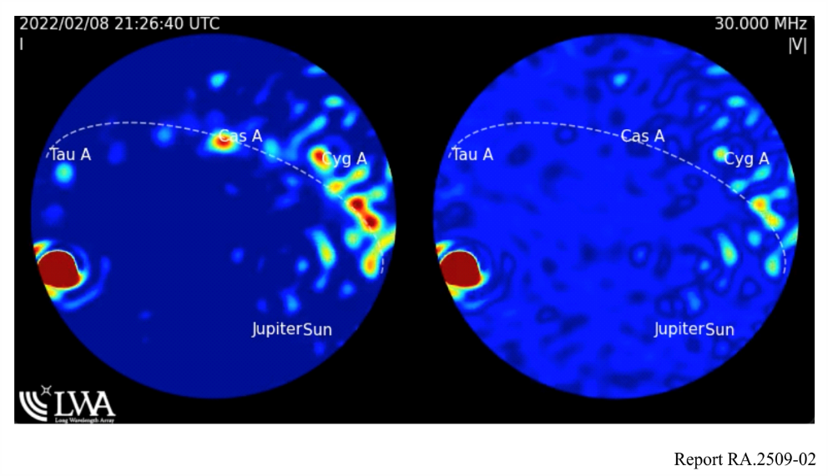
FIGURE 3
Dynamic radio spectrum recorded at LWA-SV, corresponding to the spatial representation in Fig. 2.
Left: February 2nd, 2022 dynamic spectrum with no digital filtering applied. Note the saturation caused by strong emitters. Right: February 14th, 2022 dynamic spectrum after application of a digital polyphase filter bank
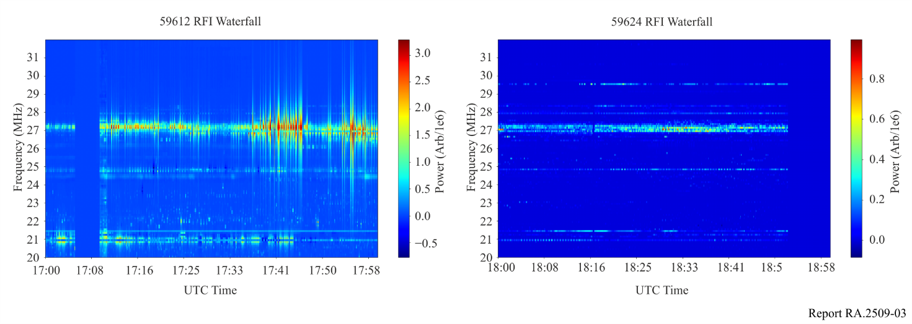
To mitigate impacts from these strong signal reflections, for 25.55-25.67 MHz the actions that can be taken are either by limiting observations to times of a less charged ionosphere, i.e. night-time, or by modifying digital filters to try to reduce the impact of this out-of-band signal, as shown in Fig. 3. In the case of 37.5-38.25 MHz, LWA-SV has the ability to attenuate signals below 35 MHz by adding an analogue shelf filter that is able to attenuate signals below 35 MHz by up to 60 dB, which serves as a last line of defence should RFI below this range become persistently linearity limiting. This example demonstrates, while it is possible for low frequency radio observatories to co-exist with other services, special precautions have to be taken in siting, analogue and digital system design, as well as in post-processing to ensure that observations in RR No. 5.149 bands are possible, while retaining the ability to passively use parts of the spectrum not allocated to radio astronomy to maximize the scientific return of investment, if possible.

6 List of acronyms and abbreviations
ADC Analogue digital converter
CALLISTO Compound Astronomical Low-cost Low-frequency Instrument for Spectroscopy and Transportable Observatory
DART The Distributed Array Telescope
DLITE The Deployable Low-band Ionosphere and Transient Experiment
EDGES The Experiment to Detect the Global EoR Signature
EMI Electromagnetic interference
EoR Epoch of Re-ionization
FAST Five-hundred-metre Aperture Spherical radio Telescope
FRB Fast Radio Burst
GBT Green Bank Telescope
GPS Global positioning system
HDTV High definition television
HERA Hydrogen Epoch of Recombination Array
LoFASM The Low Frequency All Sky Monitor
LOFAR The Low Frequency ARray
LWA1 Long Wavelength Array station 1
LWA-SV Long Wavelength Array Sevilleta NWR station
LWA-NA Long Wavelength Array North Arm station
MWA The Murchison Widefield Array
NDA Nançay Decameter Array
NRH Nançay Radioheliograph
NENUFAR New Extension in Nançay Upgrading LOFAR
OVRO-LWA Owen’s Valley Radio Observatory Long Wavelength Array station
SKA Square Kilometre Array
SKA1-MID Intermediate Frequency SKA
SPADE Small Phased Array DEmonstrator
VLA Very Large Array
21CMA 21 Centimetre Array

7 References
[1] Report ITU-R RA.2195 – The transition to digital television and its impact on the unprotected use by the radio astronomy service of bands used for terrestrial television broadcasting
[2] Report ITU-R RA.2163 – Astronomical use of frequency band 50-350 THz and coexistence with other applications
[3] A. J. Boonstra and S. v. d. Tol, “Spatial filtering of interfering signals at the initial low frequency array (LOFAR) phased array test station,” in Radio Science, vol. 40, No. 05, pp. 1-16, Oct. 2005, https://doi.org/10.1029/2004RS003135
[4] A. R. Offringa, A. G. de Bruyn, S. Zaroubi, G. van Diepen, O. Martinez-Ruby, P. Labropoulos, M. A. Brentjens, B. Ciardi, S. Daiboo, G. Harker, V. Jelić, S. Kazemi, L. V. E. Koopmans, G. Mellema, V. N. Pandey, R. F. Pizzo, J. Schaye, H. Vedantham, V. Veligatla, S. J. Wijnholds, S. Yatawatta, P. Zarka, A. Alexov, J. Anderson, A. Asgekar, M. Avruch, R. Beck, M. Bell, M. R. Bell, M. Bentum, G. Bernardi, P. Best, L. Birzan, A. Bonafede, F. Breitling, J. W. Broderick, M. Brüggen, H. Butcher, J. Conway, M. de Vos, R. J. Dettmar, J. Eisloeffel, H. Falcke, R. Fender, W. Frieswijk, M. Gerbers, J. M. Griessmeier, A. W. Gunst, T. E. Hassall, G. Heald, J. Hessels, M. Hoeft, A. Horneffer, A. Karastergiou, V. Kondratiev, Y. Koopman, M. Kuniyoshi, G. Kuper, P. Maat, G. Mann, J. McKean, H. Meulman, M. Mevius, J. D. Mol, R. Nijboer, J. Noordam, M. Norden, H. Paas, M. Pandey, R. Pizzo, A. Polatidis, D. Rafferty, S. Rawlings, W. Reich, H. J. A. Röttgering, A. P. Schoenmakers, J. Sluman, O. Smirnov, C. Sobey, B. Stappers, M. Steinmetz, J. Swinbank, M. Tagger, Y. Tang, C. Tasse, A. van Ardenne, W. van Cappellen, A. P. van Duin, M. van Haarlem, J. van Leeuwen, R. J. van Weeren, R. Vermeulen, C. Vocks, R. A. M. J. Wijers, M. Wise, O. Wucknitz A&A 549 A11 (2013) https://doi.org/10.1051/0004-6361/201220293
[5] A. Al-Hourani, V. Trajković, S. Chandrasekharan and S. Kandeepan, “Spectrum occupancy measurements for different urban environments,” 2015 European Conference on Networks and Communications (EuCNC), 2015, pp. 97-102, doi: 10.1109/EuCNC.2015.7194048 https://doi.org/10.1109/EuCNC.2015.7194048
[6] S. W. Ellingson et al., “The LWA1 Radio Telescope,” in IEEE Transactions on Antennas and Propagation, vol. 61, no. 5, pp. 2540-2549, May 2013, doi: 10.1109/TAP.2013.2242826 https://doi.org/10.1109/TAP.2013.2242826
[7] Tingay, S.J. et al., 2013, “The Murchison Widefield Array: The Square Kilometre Array Precursor at Low Radio Frequencies”, Publications of the Astronomical Society of Australia, 30, E007 https://doi.org/10.1017/pasa.2012.007
[8] Wayth, R.B. et al., 2018, “The Phase II Murchison Widefield Array: Design Overview”,
Publications of the Astronomical Society of Australia, 35, E033 https://doi.org/10.1017/pasa.2018.37

