|  |
| --- |
| **Report ITU-R RS.2273**  **(09/2013)** |
| **Potential interference from Earth exploration-satellite service (active) scatterometers into aeronautical radionavigation service systems in the frequency band 1 215‑1 300 MHz** |
| **RS Series**  **Remote sensing systems** |

Foreword

The role of the Radiocommunication Sector is to ensure the rational, equitable, efficient and economical use of the radio-frequency spectrum by all radiocommunication services, including satellite services, and carry out studies without limit of frequency range on the basis of which Recommendations are adopted.

The regulatory and policy functions of the Radiocommunication Sector are performed by World and Regional Radiocommunication Conferences and Radiocommunication Assemblies supported by Study Groups.

# Policy on Intellectual Property Right (IPR)

ITU-R policy on IPR is described in the Common Patent Policy for ITU-T/ITU-R/ISO/IEC referenced in Annex 1 of Resolution ITU-R 1. Forms to be used for the submission of patent statements and licensing declarations by patent holders are available from <http://www.itu.int/ITU-R/go/patents/en> where the Guidelines for Implementation of the Common Patent Policy for ITU‑T/ITU‑R/ISO/IEC and the ITU-R patent information database can also be found.

|  |  |
| --- | --- |
| Series of ITU-R Reports  (Also available online at <http://www.itu.int/publ/R-REP/en>) | |
| **Series** | Title |
| **BO** | Satellite delivery |
| **BR** | Recording for production, archival and play-out; film for television |
| **BS** | Broadcasting service (sound) |
| **BT** | Broadcasting service (television) |
| **F** | Fixed service |
| **M** | Mobile, radiodetermination, amateur and related satellite services |
| **P** | Radiowave propagation |
| **RA** | Radio astronomy |
| **RS** | **Remote sensing systems** |
| **S** | Fixed-satellite service |
| **SA** | Space applications and meteorology |
| **SF** | Frequency sharing and coordination between fixed-satellite and fixed service systems |
| **SM** | Spectrum management |

|  |
| --- |
|  |

|  |
| --- |
| ***Note****: This ITU-R Report was approved in English by the Study Group under the procedure detailed in Resolution ITU-R 1.* |

*Electronic Publication*

Geneva, 2013

© ITU 2013

All rights reserved. No part of this publication may be reproduced, by any means whatsoever, without written permission of ITU.

REPORT ITU-R RS.2273

Potential interference from Earth exploration-satellite service (active)  
scatterometers into aeronautical radionavigation service systems in the frequency band 1 215‑1 300 MHz

(2013)

# 1 Introduction

This Report analyses the potential interference from one Earth exploration-satellite service (EESS) (active) scatterometer system into three aeronautical radionavigation service (ARNS) systems in the 1 215‑1 300 MHz frequency band, and possible mitigation techniques to lower the interference levels.

# 2 Description of EESS (active) Scatterometer2

The Scatterometer2 is a 1.26 GHz, radar scatterometer designed to acquire radar backscatter signals to estimate surface soil moisture. The spaceborne radar is designed to operate at an altitude of 685 km and inclination of 98 degrees to provide an average revisit time of 3 days for soil moisture globally. The orbit is dawn/dusk sun-synchronous. The radar will collect dual polarimetric returns (VV, HH, and HV transmit-receive polarizations) at 3 km spatial resolution. In order to minimize range/Doppler ambiguities with the baseline antenna and viewing geometry, separate carrier frequencies are used for each polarization (e.g. 1 260 MHz for H-pol and 1 263 MHz for V-pol). The subband centre frequencies are set 3 MHz apart, and the two frequencies can be selectively set within the 80 MHz range of 1 217.5‑1 297.5 MHz to minimize RFI. The linearly FM pulses will have a pulse duration of 15 microseconds and bandwidth of 1 MHz. Table 1 summarizes the characteristics of the Scatterometer2 radar and antenna as simulated for the compatibility analysis. Figure 1a illustrates the Scatterometer2 in orbit and Fig. 1b illustrates the measurement geometry with the rotating antenna.

TABLE 1

Characteristics of Scatterometer2 radar and antenna

|  |  |
| --- | --- |
| Parameters | Scatterometer2 |
| Orbit altitude (km) | 685 |
| Orbit inclination (degrees) | 98 |
| Transmit Pk pwr (W) | 320 W maximum (230-300 W typical) per polarization |
| Antenna Pk Xmt gain (dBi) | 36 |
| e.i.r.p. peak (dBW) | 61.0 maximum |
| Antenna xmt elev. beamwidth (degrees) | 2.6 |
| Antenna xmt az. beamwidth (degrees) | 2.6 |
| RF center frequency (MHz) | Tunable from 1 217.25 MHz to 1 297.75 MHz |
| Polarization | Dual, linear H and V |
| RF bandwidth (MHz) | 1 |
| RF pulsewidth (μs) | 2 × 15 |

TABLE 1 (*end*)

|  |  |
| --- | --- |
| Parameters | Scatterometer2 |
| Pulse repetition frequency max (Hz) | 3 200 |
| Transmit Ave. pwr (W) | 15 W max per polarization |
| e.i.r.p. Ave (dBW) | 50.7 |
| Chirp rate (MHz/μs) | 0.067 |
| Transmit duty cycle (%) | 2 × 4.8 |
| Azimuth scan rate (rpm) | 14.6 |
| Antenna beam xmt look angle (degrees) | 35.5 |
| Antenna beam xmt azimuth angle (degrees) | 0-360 |

Figure 1a

Illustration of Scatterometer2 in orbit

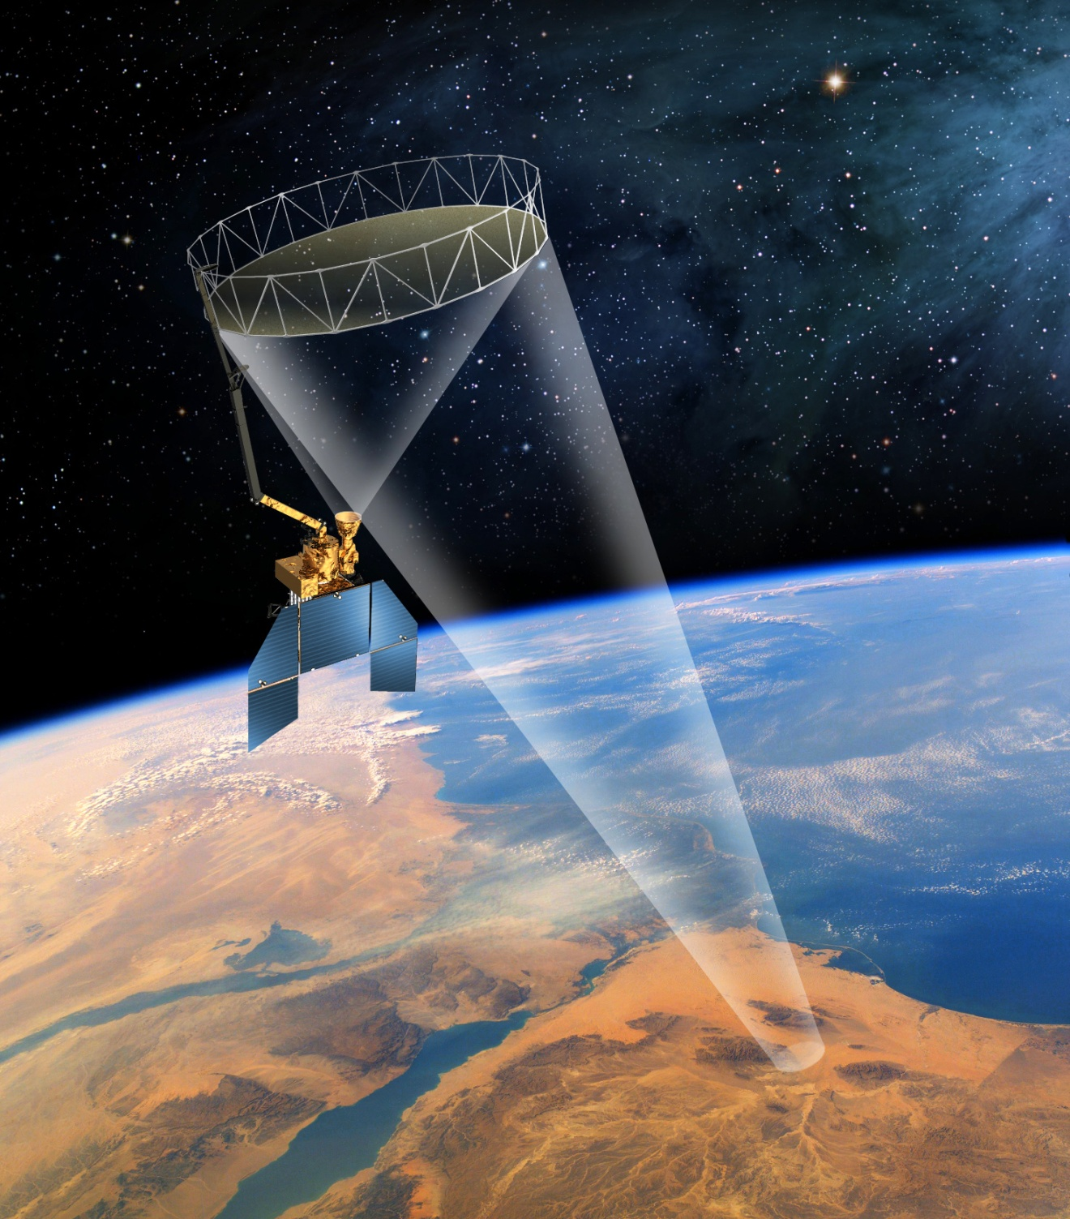

Figure 1b

Scatterometer2 measurement geometry showing the rotating antenna and the 1 000 km ground swath  
that is swept out as the spacecraft moves in a 680 km orbit. The beam footprint is shown in blue

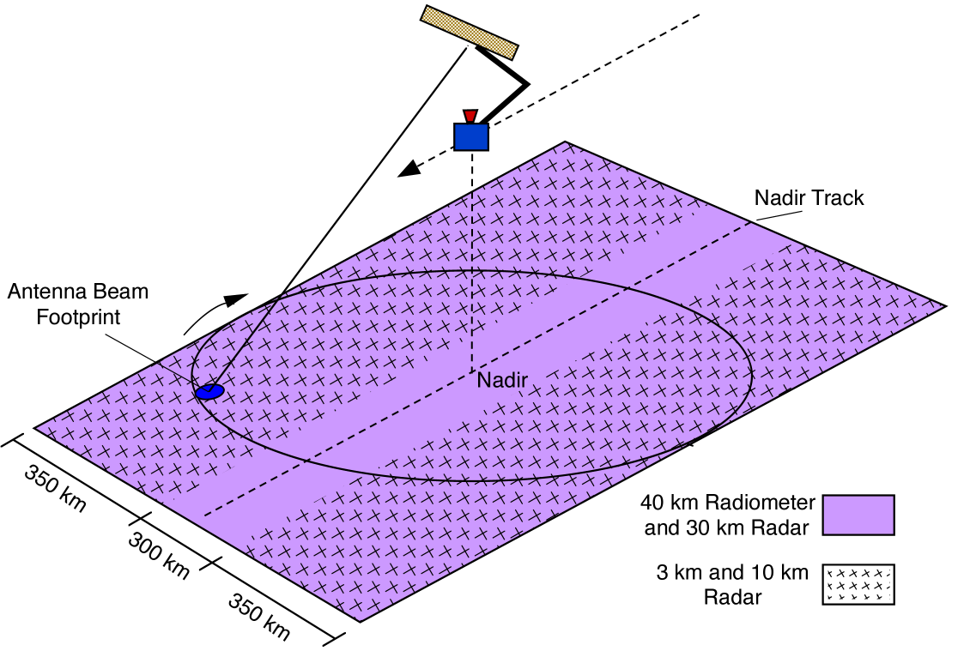

# 3 Description of the three ARNS systems

The three ARNS systems being considered in the simulations are shown in Table 2. The system characteristics of Systems 1, 2 and 8 are taken from Table 1 of preliminary draft revision of Recommendation ITU-R M.1463-2 – Characteristics of and protection criteria for radars operating in the radiodetermination service in the frequency band 1 215-1 400 MHz.

TABLE 2

1 215-1 400 MHz ARNS system characteristics of Systems 1, 2 and 8

|  |  |  |  |
| --- | --- | --- | --- |
| Parameter | System 1 | System 2 | System 8 |
| Peak power into antenna (dBm) | 97 | 80 | 78.8 |
| Frequency range (MHz) | 1 240-1 350 | 1 215-1 390 | 1 240-1 350 |
| Pulse duration (μs) | 2 | 88.8; 58.8  (Note 1) | 115.5; 17.5 (Note 4) |
| Pulse repetition rate (pps) | 310-380 staggered | 291.5 or 312.5 average | 319 average |
| Chirp bandwidth for frequency modulated (chirped) pulses | Not applicable | 770 kHz for both pulse widths | 1.2 MHz |
| Phase-coded sub‑pulse width (μs) | Not applicable | Not applicable | Not applicable |

TABLE 2 (*end*)

|  |  |  |  |
| --- | --- | --- | --- |
| Parameter | System 1 | System 2 | System 8 |
| Compression ratio | Not applicable | 68.3:1 and 45.2:1 | 150:1 and 23:1 |
| RF emission bandwidth (3 dB) (MHz) | 0.5 | 1.09 | 1.2 |
| Output device | Klystron | Transistor | Transistor |
| Antenna type | Horn-fed reflector | Stack beam reflector | Horn-fed reflector |
| Antenna polarization | Horizontal, vertical, LHCP, RHCP | Vertical, circular | Vertical; RHCP |
| Antenna maximum gain (dBi) | 34.5, transmit 33.5, receive | 32.4-34.2, transmit 31.7-38.9, receive | 34.5 |
| Antenna elevation beamwidth (degrees) | 3.6 shaped to 44 | 3.63-5.61, transmit 2.02-8.79, receive | 3.7 shaped to 44 (cosecant squared) |
| Antenna azimuthal beamwidth (degrees) | 1.2 | 1.4 | 1.2 |
| Antenna horizontal scan characteristics (rpm) | 360° mechanical at 5 rpm | 360° mechanical at 5 rpm | 360° mechanical at 5 rpm |
| Antenna vertical scan characteristics (degrees) | Not applicable | –7 to +30 in 12.8 or 13.7 ms | Not applicable |
| Receiver IF bandwidth | 780 kHz | 0.69 MHz | 1.2 MHz |
| Receiver noise figure (dB) | 2 | 2 | 3.2 |
| Platform type | Fixed | Fixed | Fixed |
| Time system operates (%) | 100 | 100 | 100 |
| LHCP: Left-hand circularly polarized.  RHCP: Right-hand circularly polarized.  NOTE 1 – The radar has 44 RF channel pairs with one of 44 RF channel pairs selected in normal mode. The transmitted waveform consists of an 88.8 μs pulse at frequency *f*1 followed by a 58.8 μs pulse at frequency *f*2. Separation of *f*1 and *f*2 is 82.854 MHz.  NOTE 4 – This radar utilizes two fundamental carriers, F1 and F2, with two sub-pulses each, one for medium range detection and one for long range detection. The carriers are tunable in 0.1 MHz increments with a minimum separation of 26 MHz between F1 (below 1 300 MHz) and F2 (above 1 300 MHz). The carrier sub-pulses are separated by a fixed value of 5.18 MHz. The pulse sequence is as follows: 115.5 µs pulse at F1 + 2.59 MHz, then a 115.5 µs pulse at F2 + 2.59 MHz, then a 17.5 µs pulse at F2 – 2.59 MHz, then a 17.5 µs pulse at F1 – 2.59 MHz. All four pulses are transmitted within a single pulse repetition interval. | | | |

# 4 *I*/*N* curves of single pass of spacecraft over ARNS sites

Short duration single pass simulations that only included orbits within the visibility circle of the ARNS radar site obtain assessments of *I*/*N* levels under conditions with different antenna beam couplings. The longitude of the ascending node of the orbits were generally selected to test “stressing” conditions, where all three coupling levels occurred in the same orbit (Scatterometer main-lobe to ARNS side-lobe, Scatterometer2 side-lobe to ARNS main-lobe, and side-lobe to side‑lobe) to assess the interference levels and how long the interference persisted during the orbit. These simulations used 20 ms time steps and 15 minutes orbit duration. The short-term single pass simulations were used mainly to optimize the interference mitigation strategy and to study the dependence of the interference on the Scatterometer2 transmission frequency.

The calculated values of the *I*/*N* level in System 2 are shown in Fig. 2 as a function of time during a single pass of Scatterometer2 satellite (with no frequency hopping) using a dynamic simulation of the systems.

Figure 2

Calculated values of the *I*/*N* level in System 2 receiver as a function of time during an overpass   
of the Scatterometer2 satellite using a dynamic simulation of the systems



# 5 EESS mitigation techniques

## 5.1 Duty cycle reduction

Standard theory coupled with quantitative measurements showed that the target detection probability of the ARNS processors depends upon the duty cycle of the interfering signal, with higher interference level tolerance for lower duty cycles. It is known that the interference caused by spaceborne active sensors into ARNS radars is directly related to the effective duty cycle, which is the product of the true transmit duty cycle and the ratio of the tracking radar detection bandwidth to the active sensor transmit bandwidth. The effective duty cycle, and hence the degree of interference, is reduced when the true transmit duty cycle is lowered or the transmit bandwidth is increased relative to the tracking radar detection bandwidth.

The Scatterometer2 lowered its effective duty cycle to minimize the potential impact on ARNS radars. The original pulse length of 40 microseconds coupled with the 3 200 Hz pulse repetition frequency yielded an effective duty cycle of approximately 8% for the ARNS. By decreasing the pulse length to 15 microseconds, the effective duty cycle was reduced by approximately 62.5%. These parameters give the lowest effective duty cycle that can be accommodated within the science and technology constraints for the active sensor.

## 5.2 Frequency band overlap reduction

There is the option of changing the operating frequency of the Scatterometer2 active sensor to not overlap the frequency band of the ARNS radars from 1 240‑1 300 MHz.

Science and technology constraints preclude transmitting in a different frequency band or with an appreciably different waveform.

## 5.3 Frequency hopping

Frequency hopping involves changing the Scatterometer2 transmission frequency fast enough that a single ARNS radar, which operates at fixed frequency, does not experience interference from Scatterometer2 a duration that could adversely impact their performance.

A significant reduction in the number of interference events and the average *I*/*N* level at a given ARNS radar site can be achieved through the implementation of a frequency hopping strategy during Scatterometer2 mission operations. In particular, the number of interference events occurring in consecutive scans of the ARNS radar is dramatically reduced through appropriate selection of the time between frequency hops and the frequency step size.

The essence of the approach would be to never operate a Scatterometer2 signal on a single frequency for as long as one scan cycle of an ARNS radar (that is, to always operate for less than 12 seconds at a time on any given frequency). Hopping from one frequency to the next for less than 12 seconds at a time, and not revisiting any given frequency in intervals of less than several ARNS scan cycles, no target could be impacted for more than one scan cycle at a time, and the affected ARNS receivers would have two or more scan cycles to then observe all targets before the Scatterometer2 could revisit their frequencies. The *I*/*N* levels over a single pass are shown in Fig. 3 below for Scatterometer2 both without and with frequency hopping.

Frequency hopping reduces interference in three ways:

1) The number of times where interference levels from the Scatterometer2 radar exceed higher levels of *I*/*N* that causes target detection degradation is significantly reduced.

2) The minimum time interval between interference events increases, so one target is never continuously subject to a loss of detection.

3) The average *I*/*N* is significantly reduced.

Frequency hopping will not reduce the maximum possible interference power seen at a given air route surveillance radar site. However, by reducing the probability that the two radars operate near the same frequency, it reduces the number of times that high interference powers will occur. For example, power levels seen once per month without frequency hopping will be seen once per year when hopping between 12 different frequencies in a cycle. The most significant effect, though, is the change in the persistence of the interference during a Scatterometer2 orbit.

The three interference mitigating effects of frequency hopping listed above are shown graphically in Fig. 3 where the *I*/*N* levels as a function of time during an orbital overpass of the Scatterometer2 satellite are plotted with and without frequency hopping. This figure clearly shows the following major mitigating effects:

1) the number of times where the *I*/*N* level exceeds –6 dB and the *I*/*N* value during the spikes are both significantly reduced; and

2) large *I*/*N* spikes are always separated by more than one ARNS radar scan unlike the case without frequency hopping where interference spikes separated by 12 seconds occurrence during a significant fraction of the time that Scatterometer2 is within the visibility circle.

The *I*/*N* level is generally much lower and the maximum *I*/*N* level during this single orbit is smaller with frequency hopping implemented.

Figure 3

*I*/*N* levels as a function of time at an ARNS receiver during a Scatterometer2 orbital overpass a) at fixed Scatterometer2 frequency and b) with frequency hopping. The red curve shows the *I*/*N* levels   
and the green curve the elevation angle of the satellite relative to the ARNS radar

**(a) Without frequency hopping**

**(b) With frequency hopping**



# 6 Frequency hopping mitigation technique and curves of *I*/*N* over single pass of spacecraft over ARNS sites

Single pass simulations at all possible Scatterometer2 transmission frequencies in sequences with 7.5 MHz frequency spacing and 1.25 MHz tuning resolution (63 orbits total) were repeated for five different ARNS frequencies (1 241.47 MHz, 1 254.42 MHz, 1 260.0 MHz, 1 272.54 MHz, 1 285.49 MHz). The ARNS site is located at 38°N, 80°W in the simulations. A typical frequency sequence for the single pass orbit is shown in Fig. 4. The single pass simulations with Systems 1, 2 and 8 are shown in Figs 5, 6 and 7, respectively.

Figure 4

Typical frequency hopping sequence during Scatterometer2 orbit simulated



Figure 5

Calculated values of the *I*/*N* level in System 1 receiver as a function of time during an overpass   
of the Scatterometer2 satellite using a dynamic simulation of the systems



Figure 6

Calculated values of the *I*/*N* level in System 2 receiver as a function of time during an overpass   
of the Scatterometer2 satellite using a dynamic simulation of the systems



Figure 7

Calculated values of the *I*/*N* level in System 8 receiver as a function of time during an overpass   
of the Scatterometer2 satellite using a dynamic simulation of the systems



Typically, the spikes where the *I*/*N* value exceeds +8 to +12 dB are separated by more than a minute. Otherwise, the *I*/*N* values are typically at levels below –6 dB.

Analysis of the potential interference from the Scatterometer2 radar sensor into ground-based ARNS surveillance and tracking radars yielded the following results:

1) The satellite geometry precludes main-beam to main-beam coupling between the two radars.

2) Given the effective duty cycle of the Scatterometer2 radar, *I*/*N* levels that exceed a high level of *I*/*N* can arise from either Scatterometer2 main-lobe to ARNS side-lobe or ARNS main-lobe to Scatterometer2 side-lobe coupling.

3) Maximum interference levels occur when both of the following conditions are met:

a) The two radars are azimuthally aligned so that the radars point at each other; and

b) the Scatterometer2 transmit frequency of either the H-polarization or V-polarization chirp is within the 3 dB processing bandwidth of the ARNS receiver.

4) Dynamic simulations of *I*/*N* levels during Scatterometer2 orbits show that with frequency hopping to mitigate interference, the Scatterometer2 interference power level is typically less than –6 dB and is very unlikely to exceed high levels of *I*/*N* on two consecutive scans of the ARNS radar.

5) Both short duration (single orbits within visibility circle of ARNS radar) and long duration (28-day ARNS operation) simulations confirm that a frequency hopping algorithm that works for the ARNS System 8 receivers, which have the lowest interference threshold, works for the Systems 1 and 2 receivers also.

6) *I*/*N* levels above +25 dB occur very infrequently (10 cases in 2 500 simulated orbits, or less than once in two weeks).

7) *I*/*N* levels that exceed the critical threshold usually occur between one and six times during the ~14 minutes of an orbit when the Scatterometer2 radar is within the visibility circle of the ARNS radar.

8) With frequency hopping implemented, six or more clean scans separate events where the Scatterometer2 interference level exceeds the critical threshold for all three ARNS radar types and for the Scatterometer frequency in the full allocated frequency band of 1 215‑1 300 MHz. Exceptional events where the Scatterometer2 interference power level exceeds the interference threshold on two consecutive scans of the ARNS radar are very rare (1 case in 2 500 simulated orbits, or less than once in six months).

9) Analysis of a contingency case where the Scatterometer2 operational frequency band is reduced by 24 MHz (for ARNS frequency band reduction) shows a potential reduction to 3 or more clean scans separating any event where the Scatterometer2 interference level exceeds high levels of *I*/*N* (+8 to +12 dB).

10) In cases of *I*/*N* exceeding –6 dB for more than 12 seconds, the effective duty cycle (combination of reduced duty cycle and frequency hops) in the radar receiver should be less than or equal to 1%.

# 7 Summary

This Report analyses the potential interference from one EESS (active) system into ARNS systems in the 1 215 1 300 MHz frequency band.

Three mitigation techniques of duty cycle reduction, ARNS frequency band reduction, and frequency hopping are discussed.

The Report presents the single pass *I*/*N* of RFI from one EESS (active) system, the Scatterometer2, into ARNS systems, in particular, ARNS Systems 1, 2 and 8 in the 1 215‑1 300 MHz frequency band. The *I*/*N* curves are presented for representative single passes of the spacecraft over three types of ARNS systems. Mitigation of the RF interference persistence is studied using a frequency hopping technique whereby the frequency of the EESS (active) system is changed on a smaller time‑scale (8.2 seconds) than the 360 degrees azimuthal scan time of the ARNS systems (12 seconds). The *I*/*N* curves with the frequency hopping show lower values of *I*/*N* over the single passes.