|  |
| --- |
| **Report ITU-R RS.2311-0**  **(09/2014)** |
| **Pulsed radio frequency signal impact measurements and possible mitigation  techniques between Earth exploration-satellite service (active) systems and radionavigation satellite service systems and networks in the band 1 215-1 300 MHz** |
| **RS Series**  **Remote sensing systems** |

Foreword

The role of the Radiocommunication Sector is to ensure the rational, equitable, efficient and economical use of the radio-frequency spectrum by all radiocommunication services, including satellite services, and carry out studies without limit of frequency range on the basis of which Recommendations are adopted.

The regulatory and policy functions of the Radiocommunication Sector are performed by World and Regional Radiocommunication Conferences and Radiocommunication Assemblies supported by Study Groups.

# Policy on Intellectual Property Right (IPR)

ITU-R policy on IPR is described in the Common Patent Policy for ITU-T/ITU-R/ISO/IEC referenced in Annex 1 of Resolution ITU-R 1. Forms to be used for the submission of patent statements and licensing declarations by patent holders are available from <http://www.itu.int/ITU-R/go/patents/en> where the Guidelines for Implementation of the Common Patent Policy for ITU‑T/ITU‑R/ISO/IEC and the ITU-R patent information database can also be found.

|  |  |
| --- | --- |
| Series of ITU-R Reports  (Also available online at <http://www.itu.int/publ/R-REP/en>) | |
| **Series** | Title |
| **BO** | Satellite delivery |
| **BR** | Recording for production, archival and play-out; film for television |
| **BS** | Broadcasting service (sound) |
| **BT** | Broadcasting service (television) |
| **F** | Fixed service |
| **M** | Mobile, radiodetermination, amateur and related satellite services |
| **P** | Radiowave propagation |
| **RA** | Radio astronomy |
| **RS** | **Remote sensing systems** |
| **S** | Fixed-satellite service |
| **SA** | Space applications and meteorology |
| **SF** | Frequency sharing and coordination between fixed-satellite and fixed service systems |
| **SM** | Spectrum management |

|  |
| --- |
|  |

|  |
| --- |
| ***Note****: This ITU-R Report was approved in English by the Study Group under the procedure detailed in Resolution ITU-R 1.* |

*Electronic Publication*

Geneva, 2015

© ITU 2015

All rights reserved. No part of this publication may be reproduced, by any means whatsoever, without written permission of ITU.

REPORT ITU-R RS.2311-0

Pulsed radio frequency signal impact measurements and possible mitigation   
techniques between Earth exploration-satellite service (active) systems and radionavigation satellite service systems and networks   
in the band 1 215-1 300 MHz

(2014)

# 1 Introduction

This Report contains the results of two independent studies of pulsed RF signal impact of several spaceborne active sensors in the Earth exploration-satellite service (EESS) (active) on certain types of radionavigation satellite service (RNSS) receivers operating in the band 1 215‑1 300 MHz.

The band 1 215 to 1 300 MHz is allocated to the radiolocation service and RNSS (space-to-Earth) on a primary basis. The 1 215‑1 300 MHz band is also allocated on a primary basis to the EESS (active) for spaceborne active microwave sensors subject to the limitations of Radio Regulations Nos. **5.332** and **5.335A**.

Based on the information in this Report, a replacement for Recommendation ITU-R RS.1347 – Feasibility of sharing between radionavigation-satellite service receivers and the Earth exploration‑satellite (active) and space research (active) services in the band 1 215-1 300 MHz, is being developed within the ITU-R.

In that replacement document Table 1 of Annex 1 lists characteristics for eight EESS (active) sensors, five of which were included in the pulsed RF signal impact tests: Scatterometer2, SAR3 for the GPS receiver tests, and SAR4, SAR5, and SAR6 for the QZSS receiver tests.

Systems and networks in the RNSS provide worldwide accurate information for many positioning, navigation and timing applications, including safety aspects for some frequency bands under certain circumstances and applications. Recommendation ITU‑R M.1902 has the characteristics for receiving earth stations in the RNSS (space-to-Earth) operating in the 1 215-1 300 MHz band. Table 1-1 of Annex 1 to Recommendation ITU-R M.1902 lists seven RNSS receivers, four of which were included in the pulsed RF signal impact tests: high-precision semi‑codeless receiver, the satellite-based augmentation system (SBAS) ground reference receiver, and two Quasi-Zenith satellite system (QZSS) receivers. Active spaceborne sensors in the EESS (active) that operate in this band include the synthetic aperture radar (SAR) systems and land observing scatterometers.

Recommendation ITU-R M.2030 provides a method to compute the impact of pulsed radio frequency interference (RFI) on RNSS receivers in terms of degradation to receiver carrier-to-noise density ratio, *C*/*N*0. Report ITU-R M.2220 provides the basic theory for received pulsed RFI impact to RNSS receivers. It also provides a methodology to compute two parameters that characterize the received pulsed RFI from non-RNSS sources which are used to calculate the resulting degradation in receiver *C*/*N*0.

# 2 Objective

The objective of this Report is to present results of pulsed EESS (active) signal impact measurements on certain RNSS receivers and illustrate possible mitigation techniques for systems in the EESS (active) to reduce RFI to RNSS receivers operating in the band 1 215-1 300 MHz.

# 3 Pulsed EESS signal impact measurement approach

Parametric measurements were conducted for several SAR and scatterometer signal characteristics, pulse widths, pulse repetition frequencies (PRFs) and chirps. The SAR and scatterometer signals were hard-coupled into the RNSS receiver and the receiver performance was monitored and the SNR or *C*/*N*0[1] was recorded as a function of the effective duty cycle at the receiver.

# 4 2010 U.S. study of EESS signal impact on GPS receivers

In 2010 the U.S. National Aeronautics and Space Administration and the Federal Aviation Administration collaborated in a joint effort to measure pulsed EESS RF signal impact and possible impact mitigation techniques on two semi-codeless GPS receivers listed in Recommendation ITU‑R M.2030. The EESS (active) waveforms for these measurements included those of Scatterometer2 with a chirp waveform contained within the RNSS receiver bandwidth and those of SAR3 with three different chirp waveforms, some of which had spectral components outside the receiver bandwidth. Further details are contained in the following subsections. Conclusions drawn from testing these two semi-codeless receivers cannot be assumed to apply to other RNSS receivers without further study.

## 4.1 Synthetic aperture radar and scatterometer descriptions

The SAR3 system is a 1.26 GHz, SAR designed to acquire interferometric radar backscatter signals to monitor the Earth’s surfaces. This spaceborne radar is designed to operate at an altitude of 757 km and an inclination of 98 degrees to provide an average revisit time of 13 to 15 days. SAR3 has several modes with corresponding waveforms. One of the waveforms consists of a split spectrum with 20 MHz at one end of its 85 MHz transmission bandwidth and 5 MHz at the opposite end in order to mitigate the effects of the ionosphere on the interferometric phase. SAR3 has a reflector fed antenna with an active array feed. The active array feed consists of a single string set of 8-24 transmit/receive, T/R modules that both transmit and receive both horizontal and vertical polarizations. Echoes received at the T/R modules are immediately digitized and digital beam‑forming techniques are employed to achieve the desired performance while reducing downlink data rate.

Scatterometer2 is a 1.26 GHz radar designed to acquire backscatter signals to estimate surface soil moisture. This spaceborne radar is designed to operate at an altitude of 685 km and an inclination of 98 degrees to provide an average revisit time of 3 days for soil moisture globally. The orbit is dawn/dusk sun-synchronous. The radar will collect dual polarimetric returns (VV, HH, and HV transmit-receive polarization pairs) with a 3-km spatial resolution. In order to minimize range/Doppler ambiguities with the baseline antenna and viewing geometry, separate carrier frequencies are used for each polarization (e.g. 1 260 MHz for H-pol and 1 263 MHz for V-pol). The sub-band centre frequencies are set 3 MHz apart, and the two frequencies can be selectively set within the 80 MHz range of 1 217.5-1 297.5 MHz to minimize RFI. The linearly FM pulses will have a pulse duration of 15 µs and bandwidth of 1 MHz.

### 4.1.1 SAR and scatterometer system parameter details

Table 1 summarizes the test characteristics of the SAR3 radar and antenna as simulated for the pulsed RFI impact tests and analysis. The mode designations such as “SAR3-3” correspond to those test modes as shown in Table 3. The SAR3 parameters used during the test are not necessarily the same as those found in relevant Recommendations.

Table 2 summarizes the characteristics of the Scatterometer2 radar and antenna as simulated for the pulsed RFI impact tests and analysis. The mode designations such as “SCAT2-1” correspond to those test modes as shown in Table 3. The test used 5.25% transmit pulse duty cycle while the current planned value is 10.5%.

TABLE 1

Test characteristics of SAR3 radar and antenna

|  |  |  |  |  |
| --- | --- | --- | --- | --- |
| Parameters | SAR3-3 | SAR3-4 | SAR3-6 | SAR3-8 |
| Orbit altitude (km) | 757 | | | |
| Orbit inclination (degrees) | 98 | | | |
| Local time of ascending node (LAN) | 18:00 | | | |
| Transmit (Xmt) pk pwr (W) | 3 200 | | | |
| Antenna pk xmt gain (dBi) | 33.4 | | | |
| e.i.r.p. pk (dBW) | 68.5 | | | |
| Antenna pk rcv gain (dBi) | 41 | | | |
| Antenna xmt elev. beamwidth (degrees) | 15 | | | |
| Antenna xmt az. beamwidth (degrees) | 0.8 | | | |
| Antenna rcv elev. beamwidth (degrees) | 16.7 | | | |
| Antenna rcv az. beamwidth (degrees) | 0.8 | | | |
| RF centre frequency (MHz) | 1 220.0 + 1 287.5 | 1 227.5 + 1 295.0 | 1 257.5 | 1 257.5 |
| Polarization | Dual/quad, linear H and V | | | |
| RF Chirp bandwidth* (MHz) | 5 + 20 (split spectrum) | 20 + 5 (split spectrum) | 40 | 78 |
| RF pulse width (µs) | 10 + 40 | 40 + 10 | 40 | 50 |
| Pulse repetition frequency max (Hz) | 3 500 | | | |
| Xmt Ave. pwr (W) | 240 | 240 | 448 | 560 |
| e.i.r.p. Ave (dBW) | 57.4 | 57.4 | 59.9 | 60.9 |
| Chirp rate (MHz/µs) | 0.5 | 0.5 | 1.0 | 1.56 |
| Xmt duty cycle (%) | 17.5 | 17.5 | 14.0 | 17.5 |
| Azimuth (Az) scan rate (rpm) | 0 | | | |
| Antenna beam xmt look angle (degrees) | 35 | | | |

TABLE 1 (*end*)

|  |  |  |  |  |
| --- | --- | --- | --- | --- |
| Parameters | SAR3-3 | SAR3-4 | SAR3-6 | SAR3-8 |
| Antenna beam rcv look angle (degrees) | 35 | | | |
| Antenna beam xmt az angle (degrees) | 0 | | | |
| Antenna beam rcv az angle (degrees) | 0 | | | |
| System noise temperature (degrees) | 420 | | | |
| * Bandwidths listed are –3 dB values. Necessary bandwidths (99%) are 7.4, 23.2, 42.7 and 84 MHz, respectively. The split-chirp waveforms have a continuous RF envelope during the very short transition time from the low to high centre frequency portion. | | | | |

TABLE 2

Test characteristics of Scatterometer2 radar and antenna

|  |  |  |
| --- | --- | --- |
| Parameters | SCAT2-1 | SCAT2-2 |
| Orbit altitude (km) | 685 | |
| Orbit inclination (degrees) | 98 | |
| Local time of ascending node (LAN) | 18:00 | |
| Xmt pk pwr (W) | 320 maximum (230-300 typical) per polarization | |
| Antenna pk xmt gain (dBi) | 36 | |
| e.i.r.p. peak (dBW) | 61.0 | |
| Antenna xmt elev. beamwidth (degrees) | 2.6 | |
| Antenna xmt az. beamwidth (degrees) | 2.6 | |
| RF centre frequency (MHz) | 1 227.6 MHz | 1 295.5 |
| Polarization | Dual, linear H and V | |
| RF bandwidth (MHz) | 2 × 1 | |
| RF pulse width (µs) | 2 × 15 | |
| Pulse repetition frequency max (Hz) | 1 750 | |
| Xmt Ave. pwr (W) | 16.8 | |
| e.i.r.p. Ave (dBW) | 48.25 | |
| Chirp rate (MHz/µs) | 0.35 | |
| Xmt duty cycle (%) | 5.25 | |

TABLE 2 (*end*)

|  |  |  |
| --- | --- | --- |
| Parameters | SCAT2-1 | SCAT2-2 |
| Azimuth (Az) scan rate (rpm) | 14.6 | |
| Antenna beam xmt look angle (degrees) | 35.5 | |
| Antenna beam xmt az angle (degrees) | 0-360 | |

### 4.1.2 SAR and scatterometer test set-up details

A SAR and scatterometer signal simulator used different combinations of the following waveform characteristics:

|  |  |
| --- | --- |
| Pulse width: | 10 µs, 15 µs, 20µs, 40µs and 50µs |
| Chirp bandwidth: | 1 MHz, 5 MHz, 20 MHz, 40 MHz and 78 MHz |
| PRF: | 1 750 Hz and 3 500 Hz |
| Signal levels: | −125 dBW, –105 dBW, –85 dBW, and –75 dBW. |

Figure 1 shows a block diagram of the equipment to generate the SAR and scatterometer waveforms. For the scatterometer waveforms, there was a gating circuit to turn the signal on for 100‑200 ms to simulate the transit of the scatterometer antenna beam rotating through the RNSS antenna beam pattern and to turn the signal off for 4 seconds to simulate the antenna rotation period of 4.1 seconds. The spaceborne SAR looks off to the side of the spacecraft at a fixed angle.

The EESS signal levels used in the tests are sufficient to fully saturate the two receivers to give the “strong” pulse interference effect. No “weak” pulse effects were tested[2].

Figure 1a

Test set-up with RNSS simulator in laboratory



Figure 1b

Test set-up with RNSS satellite transmissions on roof of building

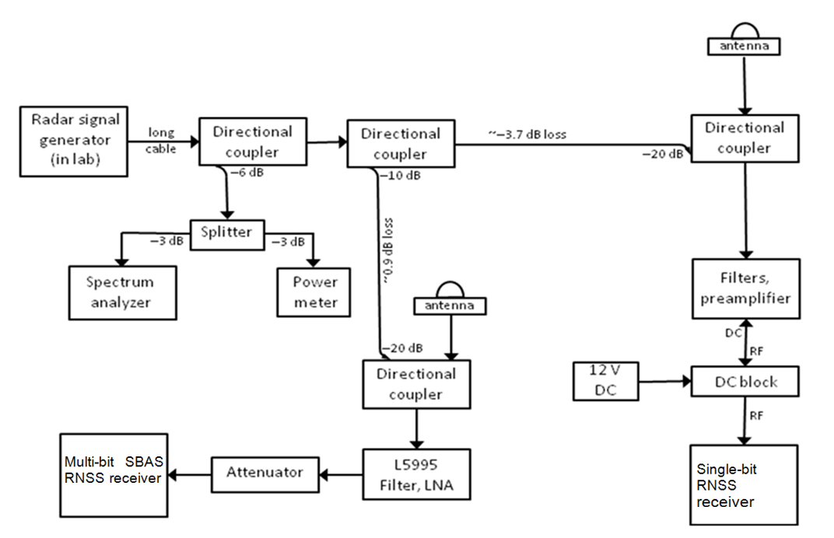

The SAR and scatterometer signals were hard-coupled into the RF front-end of the RNSS receiver just after the antenna. SAR and scatterometer waveforms were monitored with a spectrum analyzer, oscilloscope and peak power meter at the input to the RNSS receiver RF stage.

### 4.1.3 SAR and scatterometer signal simulation details

The peak interfering signal levels to the RNSS ground receiver are calculated from the Scatterometer2 at nominal altitude of 685 km. In Fig. 2a, there are “spikes” of RFI occurring every 4.1 seconds as the Scatterometer2 antenna beam rotates in azimuth toward the RNSS receiver. Figure 2a also shows below a span of 8 seconds in the orbit for two of the maximum “spikes”, and the temporal half-power width of the spikes are about 30 ms. The shapes of the spikes are the modulation by the Scatterometer2 antenna pattern in azimuth as the beam rotates at 14.6 rpm. The peak RFI levels vary from –170 dBW at the low elevation angles at the beginning and end of the pass to about –90 dBW at a 50-degree elevation angle when the Scatterometer2 antenna beam centre aligns with the RNSS receiver. The elevation angle of the spacecraft relative to the horizon as seen by the RNSS receiver is shown for the two plots of elevation angle versus relative time in orbit at the bottom of Fig. 2.

Figure 2

Scatterometer2 and SAR3 RFI levels into RNSS receiver over typical pass

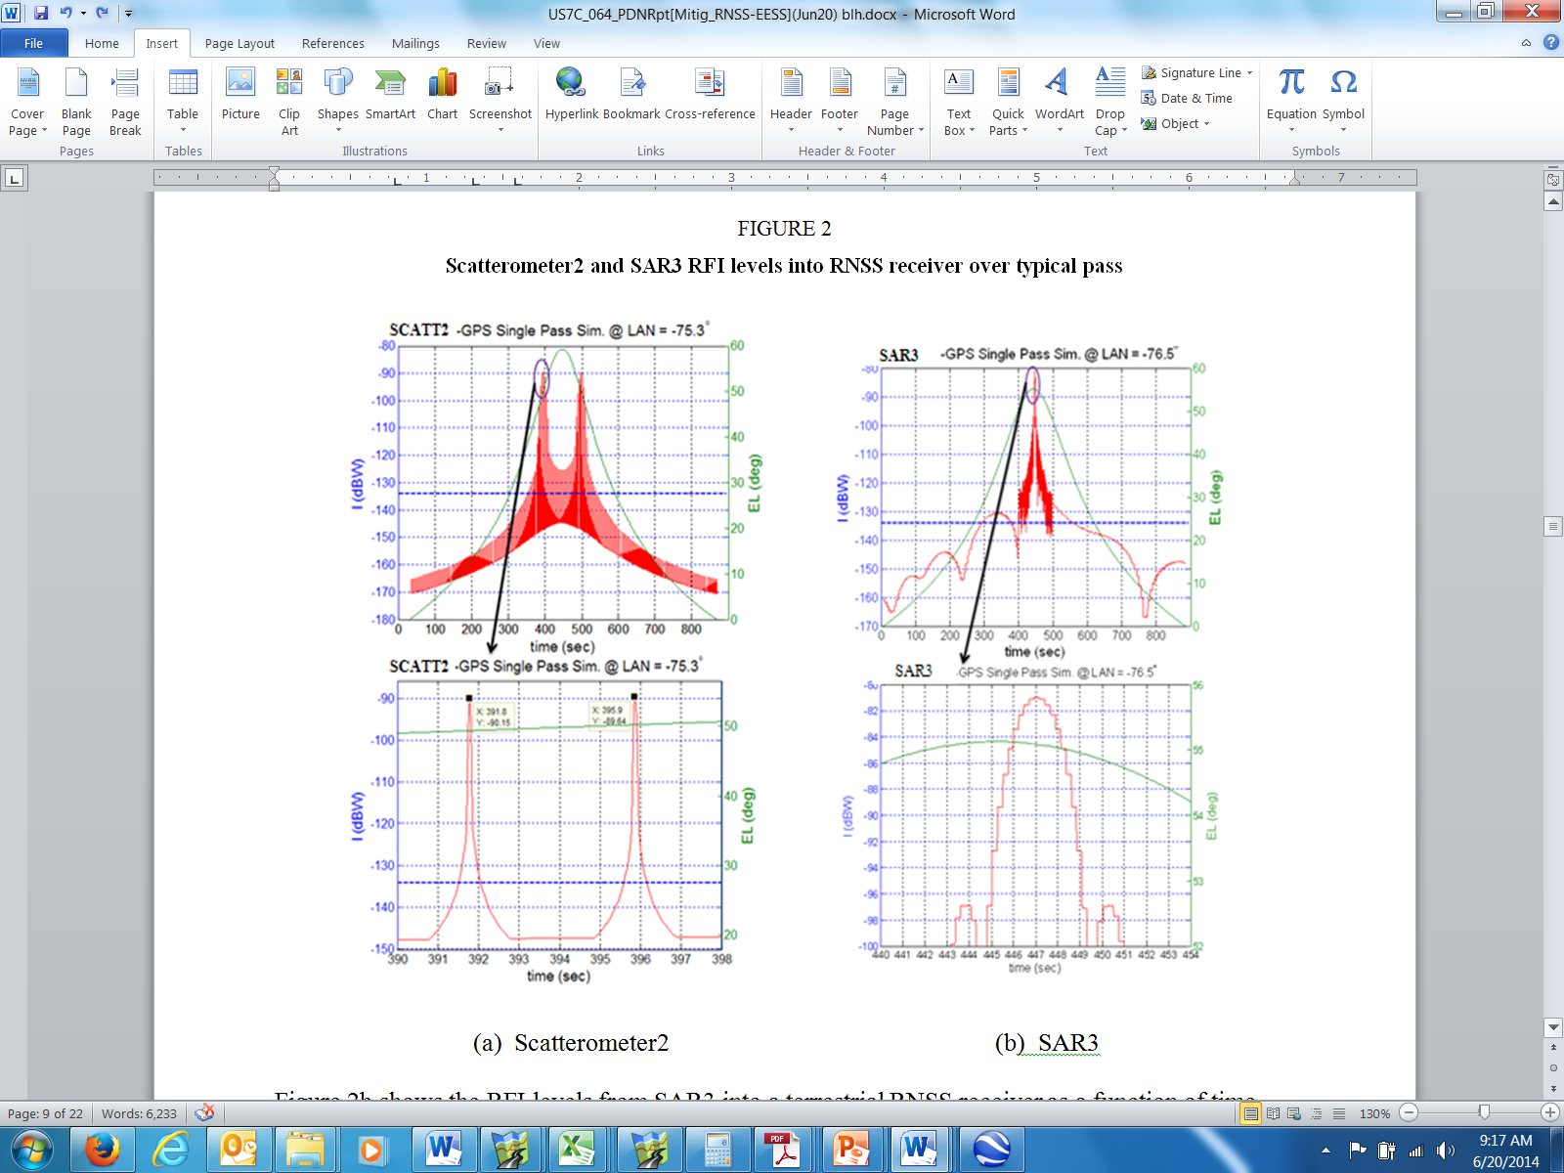

(a) Scatterometer2 (b) SAR3

Figure 2b shows the RFI levels from SAR3 into a terrestrial RNSS receiver as a function of time during a typical pass. There is a single “spike” at the maximum elevation angle when the SAR3 antenna is pointed starboard and perpendicular to the ground nadir track toward the RNSS receiver. SAR3’s antenna beamwidth in azimuth is 0.8 degree resulting in a duration of the RFI “spike” of about 2 seconds in the footprint and has a peak RFI level of –82 dBW.

RFI levels vary from –216 dBW at the low elevation angles at the beginning of the pass and increase to above –135 dBW, a typical receiver input compression level for a RNSS receiver, and sustain that level or higher for more than 250 seconds.

### 4.1.4 SAR and scatterometer signal calibration

The SAR and scatterometer signal simulator was calibrated to establish a prescribed signal level at the RNSS receiver input. The interference level of the generated waveform was measured at the input to the coupler using a peak power meter and monitored on a spectrum analyzer. Known values of attenuators were inserted to attain the desired interference level into the RNSS receiver. Interference signals were split to both RNSS receivers under test to allow parallel testing of both receivers.

## 4.2 RNSS receiver characteristics and performance criteria

Recommendation ITU-R M.1902 has the characteristics and protection criteria for RNSS receivers operating in the 1 215-1 300 MHz band. Table 1-1 of Annex 1 lists seven RNSS receivers, two of which were included in the signal impact tests: the SBAS ground reference receiver (RNSS1), and a specialized version[3] of the high-precision semi‑codeless receiver (RNSS2). Conclusions drawn from testing these two receivers should not be assumed to apply to the other receivers listed in Recommendation ITU-R M.1902 (e.g. CDMA receivers acquiring and tracking GPS L2C signals) without further study. An additional RNSS receiver to be studied is one that processes signals from multiple RNSS systems in this frequency band and therefore has a wider RF bandwidth than the types listed in Recommendation ITU-R M.1902.

The following RNSS receiver performance parameters were monitored during the measurements to evaluate the effects of active spaceborne radar pulsed emissions on the system performance:

a) decrease in *S*/*N*;

b) decrease in *C/N*0.

The objective of the data analysis was to determine the amount of degradation of the *S*/*N* or *C/N*0 observed by the RNSS receiver in the presence of the interfering EESS (active) sensor signal.

## 4.3 Measurement procedure

Several parameters of the interfering signal are varied in the different tests, including the radar type (SAR and scatterometer), power level, frequency, and gating so that the degradation varies accordingly. Each test consists of a number (ranging from two to ten) of 100-second intervals in which the interfering signal is alternately off and on.

### 4.3.1 SBAS ground reference receiver (RNSS1) measurement features

The SBAS ground reference (RNSS1) receiver provides tracking for up to 14 GPS and four SBAS satellites. GPS measurements are provided for L1 C/A (1 575.42 ± 10.23 MHz) and L2 P(Y) (1227.6 ± 10.23 MHz) signals and SBAS measurements are provided for L1 C/A only. L1 C/A code tracking uses narrow-correlator spacing and L2 P(Y) signal tracking uses semi-codeless processing. The L1 carrier loop filter has a relatively fast update rate and relatively wide loop bandwidth. The L2 carrier loop is aided by L1 and has a much narrower loop bandwidth.

Important aspects of RNSS1 processing for interference impact testing are frequency selectivity provided by the receiver front-end, receiver IF filtering, A-D sampling, and pulse interference mitigation. Multi-bit A-D sampling is used together with the AGC algorithm for gain control and with a pulse detection and suppression algorithm for pulsed RFI mitigation. The net effect of the suppression is to yield a pulse response equivalent to a receiver with unity *NLIM*. The RNSS1 receiver outputs L2 *C/N*0 estimates at a 1-Hz rate.

### 4.3.2 Specialized high-precision semi‑codeless receiver (RNSS2) measurement features

The RNSS2 receiver used in the EESS interference testing uses code tracking for the L1 C/A code signals and a semi-codeless algorithm to track the GPS P(Y) code signals at both L1 and L2 frequencies. This processing produces carrier phase, pseudorange, and *S*/*Nv* observables at a 10‑second rate.

The RNSS2 receiver combines the voltage *S*/*N* determined over each 0.018-second period during the data output interval to form a one-second Voltage *S*/*N*, denoted as *S*/*Nv*, that is reported in the receiver output data stream. The RNSS2 data interval used during the SMAP interference testing was 10 seconds of which about 9 seconds of data were used to calculate the *S*/*Nv*.

This one-second *S*/*Nv* is reported as the peak signal Voltage divided by the RMS noise Voltage, and the conversion between one-second *S*/*Nv* and *C/N*0 is:

*C/N*0 (dB-Hz) = 10 Log (½ (*S*/*Nv*)2)

The *S*/*N* calculation described above has known systematic errors at very low and very high *S*/*N*, but is accurate for the values of *S*/*Nv* experienced during these tests. The random error due to system noise of each 10-second measurement is about 0.01 dB, where this number is calculated for the nominal *C/N*0 of 48 dB-Hz used during the tests.

## 4.4 Measurement results

### 4.4.1 RNSS receiver selectivity and antenna filter model

The portion of the received interference power contained within the RNSS pre-correlator passband can be calculated by multiplying the interference waveform spectrum by the combined filter response of the receiver selectivity and the antenna filter/pre-amplifier. The combined filter measured/modeled response of the receiver selectivity and the antenna filter/pre-amplifier is shown in Fig. 3. The interference waveform spectra are shown in Fig. 4 for the nine configurations. The product of the interference waveform spectra and the combined filter response are shown in Fig. 5 for the nine configurations. Table 3 shows the pulse-width, PRF, bandwidth, and centre RF frequency for the different scatterometer and SAR configurations.

Figure 3

Total filter response for RNSS1 and RNSS2 receivers

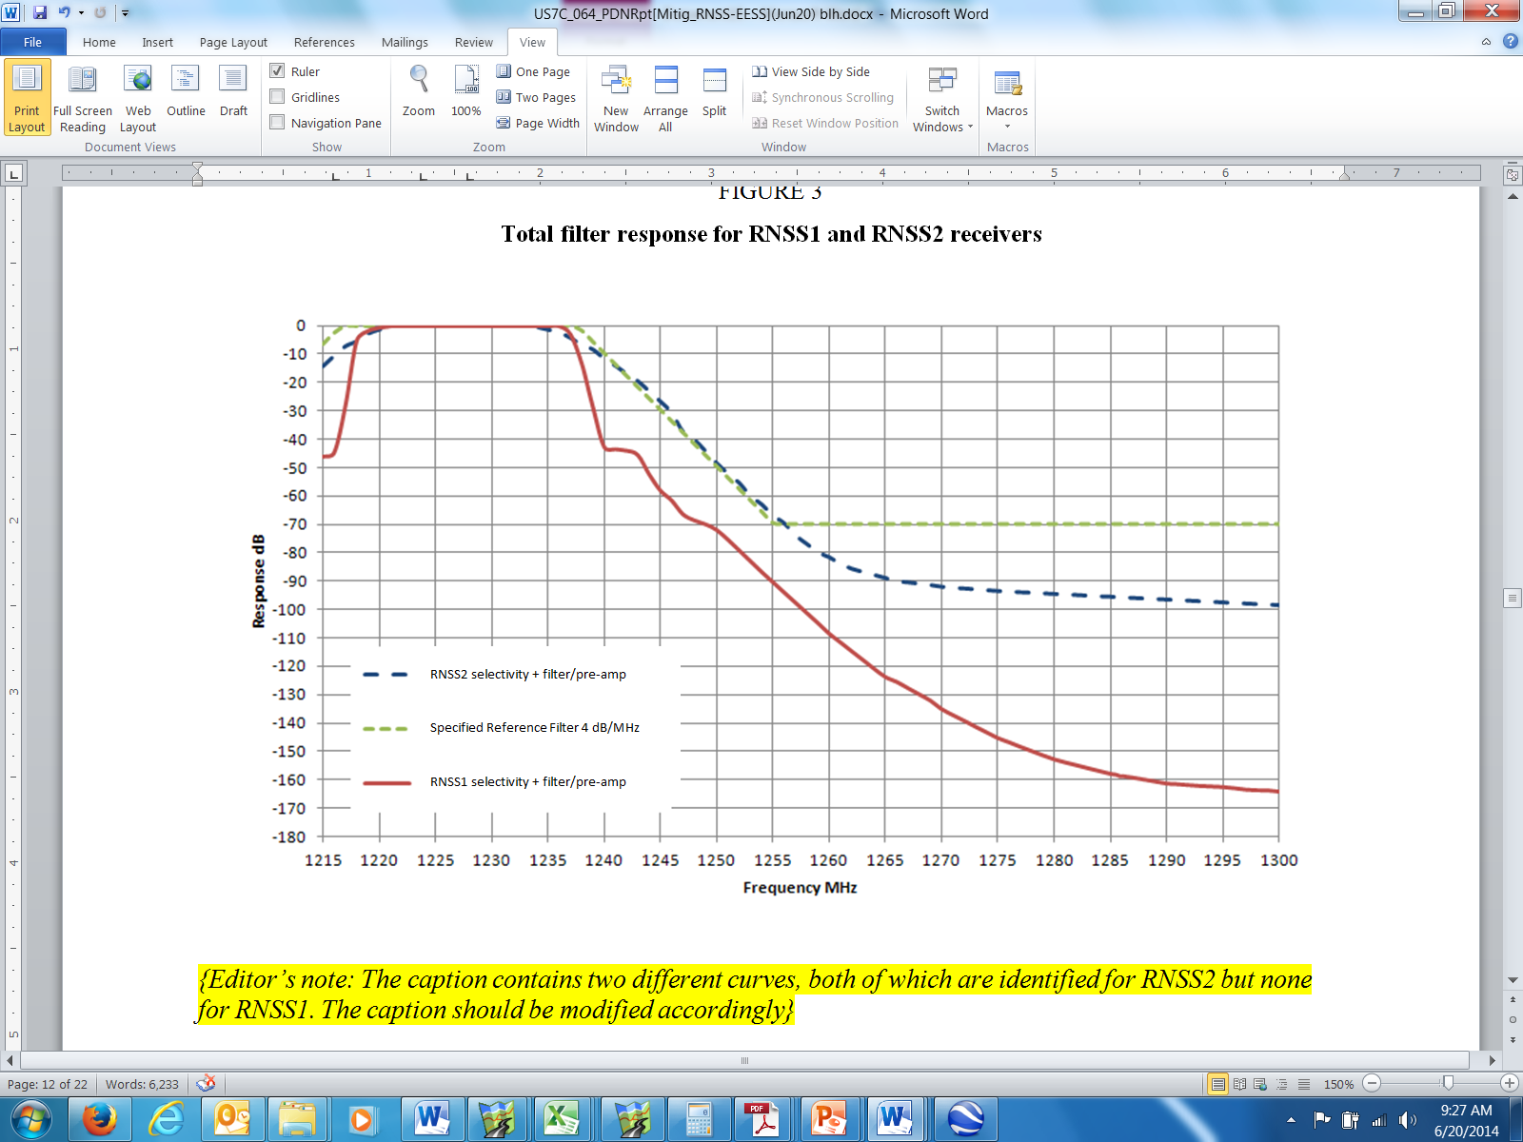

Figure 4

Relative spectral power (dB) versus frequency (MHz) over 1 215-1 300 MHz   
for interference waveforms

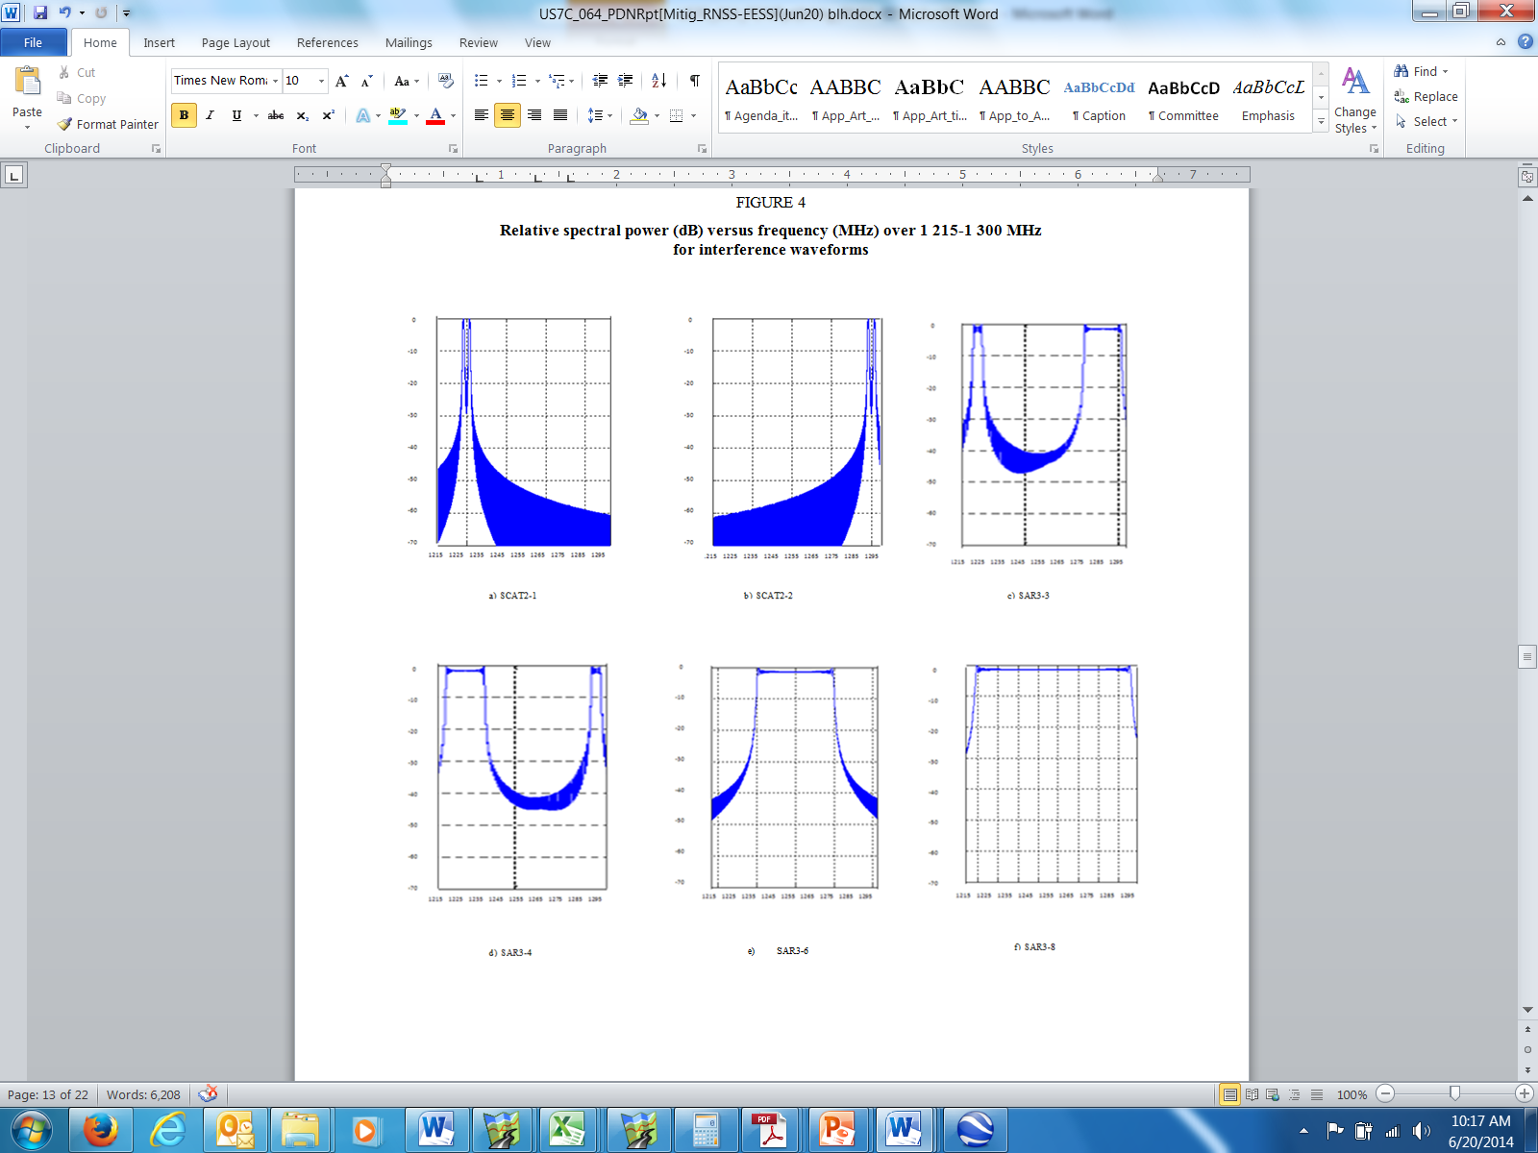

NOTE – The spectra in Figs 4c-4f do not show the additional spectral sidelobes caused by the EESS signal generator output non-linear amplifier.

Figure 5

Received spectral power (dBW) vs. frequency (MHz) over 1 215-1 300 MHz   
for interference waveforms

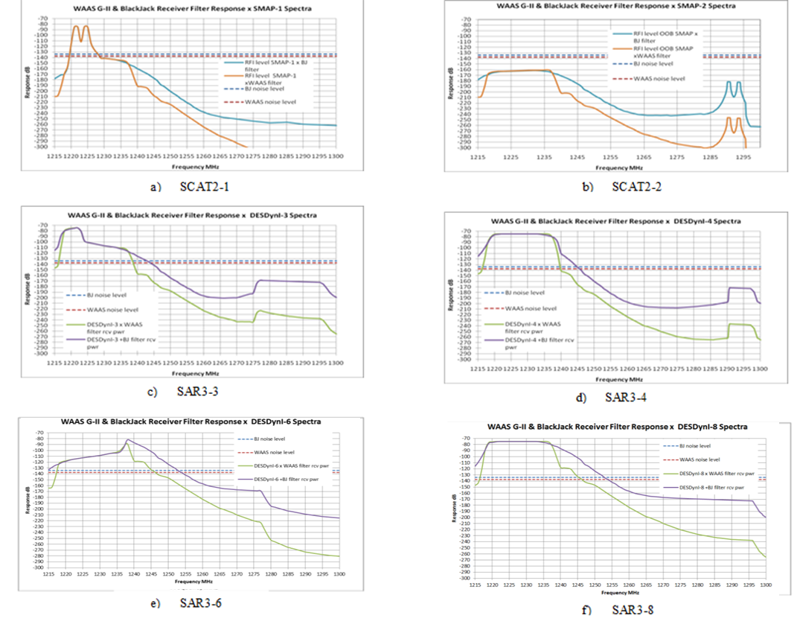

### 4.4.2 RNSS receiver *C/N*0 pulsed RFI impact equations

To assess the pulsed RFI impact from the EESS signals (§ 4.1), this Report uses the pulsed RFI impact equation (1) for the GPS receivers (§ 4.3 above) taken from Recommendation ITU‑R M.2030[4]. Additional parameters defined in equations (2) to (4) are taken from Report ITU‑R M.2220, §§ 2.3.2 and 4.1.3.

 (1)

 (2)

 (3)

where:

*PDCLIM*: fractional duty cycle of the saturating pulses (unitless ratio)

τ*PW,EFF*: the effective pulse width (s)

τ*RT*: the RNSS recovery time (s)

*PRFEFF*: the effective pulse repetition frequency (Hz) (= *PRF* for standard SARs)

τ*PW*: the transmit pulse width (s)

*PRF*:the transmit pulse repetition frequency (Hz) (e.g. *PRF* = 3 500 Hz)

*BWoverlap*: the portion of the transmit chirp bandwidth (MHz) which overlaps the RNSS receiver pre-correlator RF/IF band (centred at 1 227.6 MHz for GPS)

*BWChirp*: the full transmit chirp bandwidth (MHz).

Note in equation (2) that whenever τ*PW,EFF* = 0, *PDCLIM* is identically zero.

For some EESS (active) scatterometers operating in sun-synchronous orbit with a fast azimuth‑scanning beam, an additional correction to the transmit *PRF* is modeled by the following equation for the two semi-codeless RNSS receivers tested:

 (4)

where:

*τobs*: the observation time (s) per cycle that the received peak power is above the RNSS input compression point (e.g. 100-300 ms for Scatterometer2), and

*TTC*: the scatterometer scan cycle time (s) (beam rotation period)[5].

The correction factor in equation (4) was used to model the *C/N*0 degradation of the two specific   
semi-codeless RNSS receivers tested for this portion of the Report. It should be noted that this correction factor applies to these receivers and, as previously mentioned, should not be assumed to apply to other receivers without further study.

### 4.4.3 Measured SNR or *C/N*0 degradation versus effective duty cycle

The measured SNR or *C/N*0 degradation is plotted versus the calculated effective duty cycle *PDCLIM* in Fig. 6. Regions of measured values of degradation can be distinguished between that for gating “ON” and gating “OFF”. The measured degradation values are clustered around the trendline curve of 20 log10(1–*PDCLIM*).

Test results for all the tests conducted are listed in Table 3. This table represents as-run test parameters and test results. Explanation of the entries in Table 3 is as follows:

Col. 1 Contains the test number in the format (day number)-(sequence number). Day 1 is 22 June 2010, and day 4 is June 25. Also, “roof” or “sim” indicates whether the test was conducted using signals from an antenna on the roof or from the RNSS constellation simulator.

Col. 2 Gives the type of radar signal (SCAT2 or SAR3) and a configuration number (from 1 to 8). The configuration number is intended to refer to a specific set of the parameters in columns 3 through 6.

Col. 3 Gives the PRF (Hz) and the pulse width or duration of each pulse in µs. SAR3 waveforms often consist of split spectrum signals that are generated as “sequential chirps” whereby the first chirp bandwidth centred on a first frequency uses a pulse width of τ1 and the second chirp bandwidth centred at the second frequency uses a pulse width τ2. When two numbers are listed in col. 3 (e.g. “10 + 40”), they indicate the pulse widths of the chirps at the two centre frequencies in col. 4, respectively. Therefore the total transmission time is the sum of the two numbers τ1 + τ2. Chirp rate is kept the same on the two segments to insure a uniform power spectral density in the waveform.

Col. 4 Gives the chirp bandwidth and the RF centre frequency. The waveform consists of a signal whose instantaneous frequency changes linearly in time (a “chirp”). If there is a single number in this column, it is the bandwidth or the difference in frequency between the end and the beginning of the pulse. Using the pulse width (col. 3), frequency rate of change, i.e. chirp rate, can be computed.

In some cases radar system specific designations are used. For the SCAT2 tests, this column always says “2 × 1”, to designate that two 1-MHz bandwidth signals separated by 3 MHz were generated. SCAT2 testing was conducted in the so called “sequential chirp” mode where the waveform consisted of two sequential 15 µs wide pulses having chirp bandwidths of 1 MHz and a 3 MHz separation pulsed at a PRF of 1 750 Hz.

For the SAR3 tests there are several entries like “5 + 20”. This means a 5-MHz chirp bandwidth centred on the first frequency in col. 4 followed by a 20-MHz chirp bandwidth at the second frequency in col. 4.

Also given is the centre frequency of the pulses. For some systems, e.g. SAR3, there are two numbers corresponding to the centre frequencies of the two sequential chirps. For SCAT2 tests, the single number is the middle of the total frequency range spanned by the two pulses – that is, the mean of the lowest frequency transmitted in the lower‑frequency pulse and the highest frequency transmitted in the higher-frequency pulse.

Col. 5 Gives the power coupled into the receiver preamplifier during a pulse with the “gate” open and also indicates whether gating was on.

Col. 6 Provides the timing parameters for the gating circuit. It is specified by two numbers with the format: (time interval during which gate is open in seconds)/(total gating period in seconds). For example, “0.1/4.1” means that in a 4.1-second interval, the gate is open, and pulses are being transmitted, for 0.1 second. Then during the remaining 4.0 seconds the gate is closed, and the pulses are transmitted with 60 dB of attenuation.

Col. 7 Contains the observed Δ*C/N*0 for the RNSS1 receiver.

Col. 8 Contains the observed Δ*SNRP* for the RNSS2 receiver.

TABLE 3

Summary of L2 *C/N*0 and SNR degradation

|  |  |  |  |  |  |  |  |
| --- | --- | --- | --- | --- | --- | --- | --- |
| 1 | 2 | 3 | 4 | 5 | 6 | 7 | 8 |
| Run No. | Configuration | Pulse width (µs)/ PRF (Hz) | Bandwidth (MHz)/ Centre RF frequency (MHz) | Power (dBW)/ gating | Gating timing (s/s) | RNSS1 L2 (SBAS/WAAS) Δ(*C/N*o)-µ (dB) | RNSS2 L2 (Hi Precis. Semi-codeless) Δ (*S*/*N*)-µ (dB) |
| 2-2 (Roof) | SCAT2-1 | (2 × 15)/ 1 750 | (2 × 1)/  1 227.6 | −85/OFF |  | −0.61 | −0.43 |
| 3-6 (Sim.) | −0.36 | −0.51 |
| 4-1 (Sim.) | −0.38 | N/A |
| 4-8 (Roof) | −0.41 | −0.65 |
| 3-3 (Sim.) | −105/OFF |  | −0.32 | N/A |
| 4-5 (Sim.) | −125/OFF |  | −0.73 | −0.32 |
| 3-5 (Sim.) | −85/ON | 0.1/4.1 | 0.03 | −0.05 |
| 4-2 (Sim.) | 0.1/4.1 | 0.03 | N/A |
| 4-9 (Roof) | 0.1/4.1 | 0.04 | −0.05 |
| 3-2 (Sim.) | −105/ON | 0.1/4.1 | −0.02 | N/A |
| 3-4 (Sim.) | 0.2/4.1 | −0.02 | −0.04 |
| 3-7 (Sim) | SCAT2-2 | (2 × 15)/ 1 750 | (2 × 1)/ 1 295.5 | −85/OFF |  | N/A | −0.05 |
| 4-3 (Sim.) | 0.00 | N/A |
| 4-4 (Sim.) | −85/ON | 0.1/4.1 | 0.01 | N/A |
| 4-10 (Roof) | 0.1/4.1 | −0.01 | −0.10 |
| 3-9 (Sim.) | SAR3-3 | (10 + 40)/ 3 500 | (5 + 20)/ (1 220.0 + 1 287.5) | −75/OFF |  | −0.53 | −1.17 |
| 3-11 (Sim.) | SAR3-4 | (40 + 10)/ 3 500 | (20 + 5)/ (1 227.5 + 1 295.0) | −75/OFF |  | −1.41 | −1.43 |
| 3-13 (Sim.) | SAR3-6 | 40/3 500 | 40/1 257.5 | −75/OFF |  | −0.10 | −0.74 |
| 3-15 (Sim.) | SAR3-8 | 50/3 500 | 78/1 257.5 | −75/OFF |  | −0.56 | −1.05 |

Table 4 lists the parameters defined by § 4.2.1 equations (3) and (4), and the resulting fractional duty cycle *PDCLIM* computed by equation (2) for each test run in Table 3. The assumed receiver recovery times, τ*RT*, for the units under test, RNSS1 and RNSS2, are 0.3 µs and 0.05 µs, respectively.

Figure 6 contains the computed *PDCLIM* values for each run in Table 4 (non-zero values) plotted together with the associated measured *C/N*0 (or *S*/*N*) degradation values. The *C/N*0 degradation model equation (1) is also plotted for comparison.

TABLE 4

Calculation of fractional duty cycle *PDCLIM*

|  |  |  |  |  |  |  |
| --- | --- | --- | --- | --- | --- | --- |
| Run No. | τ*PW,EFF* (µs) [eq (3)] | | *PRFEFF*(Hz) [eq (4)] | | *PDCLIM* (%) [eq (2)] | |
| RNSS1 | RNSS2 | RNSS1 | RNSS2 | RNSS1 | RNSS2 |
| 2-2 | 30.000 | 30.000 | 1 750.000 | 1 750.000 | 5.3550 | 5.2680 |
| 3-6 | 30.000 | 30.000 | 1 750.000 | 1 750.000 | 5.3550 | 5.2680 |
| 4-1 | 30.000 | 30.000 | 1 750.000 | 1 750.000 | 5.3550 | 5.2680 |
| 4-8 | 30.000 | 30.000 | 1 750.000 | 1 750.000 | 5.3550 | 5.2680 |
| 3-3 | 30.000 | 30.000 | 1 750.000 | 1 750.000 | 5.355 | 5.268 |
| 4-5 | 30.000 | 30.000 | 1 750.000 | 1 750.000 | 5.355 | 5.268 |
| 3-5 | 30.000 | 30.000 | 42.683 | 42.683 | 0.1306 | 0.1285 |
| 4-2 | 30.000 | 30.000 | 42.683 | 42.683 | 0.1306 | 0.1285 |
| 4-9 | 30.000 | 30.000 | 42.683 | 42.683 | 0.1306 | 0.1285 |
| 3-2 | 30.000 | 30.000 | 42.683 | 42.683 | 0.1306 | 0.1285 |
| 3-4 | 30.000 | 30.000 | 85.366 | 85.366 | 0.2612 | 0.2570 |
| 3-7 | 0.000 | 0.000 | 1 750.000 | 1 750.000 | 0 | 0 |
| 4-3 | 0.000 | 0.000 | 1 750.000 | 1 750.000 | 0 | 0 |
| 4-4 | 0.000 | 0.000 | 42.683 | 42.683 | 0 | 0 |
| 4-10 | 0.000 | 0.000 | 42.683 | 42.683 | 0 | 0 |
| 3-9(1) | 17.000 | 31.0 | 3 500.000 | 3 500.000 | 6.055 | 10.87 |
| 3-11 | 40.000 | 40.000 | 3 500.000 | 3 500.000 | 14.105 | 14.0175 |
| 3-13(2) | 2.960 | 20.0 | 3 500.000 | 3 500.000 | 1.141 | 7.108 |
| 3-15(3) | 14.173 | 30.600 | 3 500.000 | 3 500.000 | 5.065 | 10.73 |

Notes:

(1) EESS generator spectral distortion and, for RNSS2, saturation effects in the auxiliary preamplifier caused energy in the 40 µs pulse width, 23.2 MHz (99%) wide upper split-chirp to broaden the effective received pulse width in RNSS1 and RNSS2 by 7 µs and 21 µs, respectively.

(2) EESS generator spectral distortion and saturation effects in the RNSS2 auxiliary preamplifier caused energy in the 40 µs pulse width, 42.7 MHz wide chirp (99%) to broaden the effective received pulse width in RNSS2 by about 17 µs more than in RNSS1.

(3) EESS generator spectral distortion and saturation effects in the RNSS2 auxiliary preamplifier caused energy in the 50 µs pulse width, 84 MHz wide (99%) chirp to broaden the effective received pulse width in RNSS2 by about 16.5 µs more than in RNSS1.

FIGURE 6

Measured *C*/*N*0 or *S*/*N* degradation versus effective pulse duty cycle (PDC)

NOTE – The measured data points in Fig. 6 with PDC values below 1% represent Scatterometer2 tests with simulated fast azimuth scanning beam illumination (“Gating On” condition in Table 3).

## 4.5 Possible mitigation techniques

In § 4.4.2, the degradation to the *S*/*N*, ∆*S*/*N*, or degradation to the *C*/*N* density, ∆*C/N*0, can be approximated by equations (1) to (4). There are possible mitigation techniques that would reduce the degradation by adjusting the parameter values in equations (1) to (4).

### 4.5.1 Reduction of the ratio of chirp bandwidth overlapping the pre-correlator band

In equation (3), the effective pulse width is reduced by the factor of the ratio of the portion of the chirp bandwidth which overlaps the pre-correlator band to the full EESS chirp bandwidth. As an example, SAR3 has the wideband mode (configuration SAR3-8 in Table 3) where only a portion of the 78 MHz wide (−3 dB bandwidth) overlaps the SBAS receiver pre-correlator filter response, such that the effective pulse width is reduced by a factor[6] of 0.28.

As a second example, SAR3 has a split-spectrum modes where there is a 5 MHz bandwidth with 10 μs pulse width component and a 20 MHz bandwidth with 40 μs pulse width component (SAR3‑3 and SAR3-4 in Table 3); the components are separated by the maximum possible within the 1 215-1 300 MHz band for optimum in SAR height accuracy. By placing the component with the lowest duty cycle (10 μs × 3 500 Hz) within the GPS L2 pre-correlator bandwidth, the PDC is reduced.

### 4.5.2 Reduction of the ratio of observation time per cycle

With equation (4), the effective PRF impacting the tested RNSS receivers is reduced by the factor of the ratio of the observation time per cycle to the cycle time period for certain types of scatterometers. As an example, Scatterometer2 rotates its antenna beam in azimuth 360 degrees each 4.1 seconds with a 14.6 rpm rate. For ground-based RNSS receivers, the azimuth beam footprint is observed for about 300 ms each 4.1 second period. For the two GPS receivers tested in this portion of the Report, the ratio would translate to a reduction to the PRF by a factor of 0.07 (0.3 s/4.1 s).

### 4.5.3 Reduction of potential for multiple EESS satellite illumination of RNSS receivers

Since the RNSS pulsed RFI degradation thresholds in Recommendation ITU-R M.2030 are, in essence, aggregate quantities, it is important to consider the possibility of multiple EESS active sensors simultaneously illuminating the same RNSS earth station receiver. To mitigate the possibility that the aggregate threshold is exceeded because of multiple EESS sensor illumination, one technique to be considered is coordination of the separate EESS sensor orbits. This coordination would involve consideration of both EESS antenna main-beam and sidelobe interactions due to the low levels of RNSS receiver pulsed RFI power impact thresholds. (See also Report ITU-R [M.2305](http://www.itu.int/pub/R-REP-M.2305-2014))

## 4.6 2010 U.S. study conclusions of EESS signal impact to GPS receivers

In conclusion, the overall results of this study based on two tested GPS semi-codeless RNSS receivers (described in § 4.3) and the pulsed RFI model in § 4.4.2 are:

1) The maximum pulsed RF interference from a single EESS (active) system for the two modeled spaceborne radars upon the two aforementioned GPS receivers results in a degradation of *S*/*N* or *C/N*0 of 0.47 dB for Scatterometer2 and 1.4 dB for SAR3. However, there may be certain measures which could reduce the amount of degradation.

2) Accounting for the dynamics and temporal aspects of the radar antenna beam coupling with the RNSS antenna beam by gating in the test setup reduces the effective duty cycle for RFI levels that are above the RNSS receiver input compression level from the transmit pulse duty cycle by a factor of up to 14 for Scatterometer2 (4.1/0.3). For the two RNSS receivers tested, these conditions resulted in degradations of *S*/*N*, and *C/N*0, of less than 0.1 dB.

3) The overlap of the EESS sensor transmit spectrum with the 20-MHz wide RNSS band segment 1 227.6 ± 10 MHz could be minimized to reduce the effective pulse duty cycle. The Scatterometer2 signal with dual 1-MHz wide frequencies is tunable and can be positioned within the 80-MHz band from 1 217.5 MHz to 1 297.5 MHz. The 4-MHz wide envelope of the dual chirp spectrum would then overlap the 20-MHz RNSS band segment, 1 227.6 ± 10 MHz, only when its centre is located close to the centre of the RNSS band segment at 1 227.6 MHz.

The SAR3 split spectrum signal with “5 MHz + 20 MHz” has the lower duty cycle 5‑MHz, 10-µs component located at the lower end of the 1 215-1 300 MHz band centred around 1 220 MHz such that the higher duty cycle 20-MHz, 40-µs component does not overlap with the RNSS band segment 1 227.6 ± 10 MHz. A SAR3 20 MHz wide signal could be centred at 1 275.5 MHz again with minimal overlap with the RNSS band segment 1 227.6 ± 10 MHz. The SAR3 78 MHz wide signal centred at 1 257.5 MHz has slightly over one-fourth of its bandwidth overlapping the RNSS band segment 1 227.6 ± 10 MHz.

NOTE – The conclusions in §§ 4.5.2 and 4.6 are based on results of tests done in 2010 for one example RNSS receiver from each of two types and the conclusions may be different for other RNSS receivers (e.g. CDMA receivers acquiring and tracking GPS L2C signals). Further study is required to determine if the conclusions apply to any other RNSS receivers.

# 5 2011 Japanese study of EESS SAR4, 5, 6 (ALOS-2) signal impact on QZSS receivers

To check the *S*/*N* degradation of QZSS L2C and LEX signals due to the pulsed interference from ALOS-2 signals, Japan conducted signal impact tests in 2011. Figure 7 shows the configuration of these tests.

The L2C and LEX signals transmitted from the QZSS satellite were received at a GPS antenna on the roof of the facility in Tsukuba Space Center, and mixed with the simulated ALOS-2 signals generated by an ALOS-2 Engineering Model (EM). The worst-case ALOS-2 signal characteristics (including the pulse width, PRF, bandwidth, and the RF duty cycle) with respect to the *S*/*N* degradation based on equations (1) to (4), were used in each observation mode of ALOS-2.

The test cases (including pulsed signal characteristics) and results (*S*/*N* degradations) of the signal impact tests are shown in Table 5. The *S*/*N* degradation typically ranges from –0.23 dB to   
–0.88 dB. Further study may be needed to characterize the QZSS receiver measured degradation in terms of the received pulse RFI parameters similar to those in the characterization in § 4.4.

Figure 7

The configuration of signal impact test between QZSS receiver and ALOS-2



The following supplementary information about the test configuration should be considered with Fig. 7:

– Active type GPS antenna “Trimble GNSS Choke ring antenna” was used.

TABLE 5

Static degradation measurements in QZSS/ALOS-2 signal impact demonstration test

|  |  |  |  |
| --- | --- | --- | --- |
| Demonstration test step configuration  The level into the QZSS receiver is the maximum level: –71.48 dBW for the worst case test | Lock/ No lock | LEX *S*/*N*  change (dB) | L2C *S*/*N* change (dB) |
| 84 MHz bandwidth, *PRF* = 1 960 Hz, Pulse width = 51 μs  Centre frequency: 1 257.5 MHz (SAR4) | Lock | –0.88 | –0.66 |
| 42 MHz bandwidth, *PRF* = 1 477 Hz, Pulse width = 46 μs  Centre frequency: 1 257.5 MHz | Lock | –0.72 | –0.35 |
| 28 MHz bandwidth, *PRF* = 2 637 Hz, Pulse width = 25 μs  Centre frequency: 1 257.5 MHz (SAR6) | Lock | –0.58 | –0.32 |
| 14 MHz bandwidth, *PRF* = 1 915 Hz, Pulse width = 36.6 μs  Centre frequency: 1 257.5 MHz (SAR5) | Lock | –0.67 | –0.32 |
| 42 MHz bandwidth, *PRF* = 2 900 Hz Pulse width = 23.4 μs  Centre frequency: 1 257.5 MHz | Lock | –0.60 | –0.27 |
| 28 MHz bandwidth, *PRF* = 4 400 Hz, Pulse width = 15 μs  Centre frequency: 1 257.5 MHz (SAR6) | Lock | –0.47 | –0.23 |
| 14 MHz bandwidth, *PRF* = 1 915 Hz Pulse width = 36.6 μs  Centre frequency: 1 236.5 MHz (SAR5) | Lock | –0.34 | –0.50 |
| 28 MHz bandwidth, *PRF* = 2 637 Hz, Pulse width = 25 μs  Centre frequency: 1 278.5 MHz (SAR6) | Lock | –0.65 | –0.40 |

# 6 Summary

This Report contains the results of two independent studies of pulsed RF signal impact of several spaceborne active sensors in the EESS (active) on certain types of RNSS receivers operating in the band 1 215‑1 300 MHz.

In the first signal impact study (c.f. § 4), the EESS (active) signal waveforms included those of Scatterometer2 with a chirp waveform contained within the RNSS receiver bandwidth and those of SAR3 with three different chirp waveforms, some of which had spectral components outside the receiver bandwidth. Certain possible waveform-related impact mitigation techniques were investigated. Two GPS RNSS receivers were tested: a simple 1-bit analog-to-digital converter (ADC) type of high-precision semi-codeless receiver and a multi-bit ADC SBAS ground reference semi-codeless receiver.

For each EESS (active) sensor waveform, degradation to the *C/N*0 ratio or *S*/*N* of the RNSS receivers from a pulsed RFI-free baseline was measured. Both GPS receivers were operated simultaneously in one of two GPS satellite signal configurations: 1) receiving live signals from GPS satellites with receivers on a rooftop in view of the satellites, and 2) receiving simulated signals from a RNSS constellation simulator in the laboratory. For the two GPS receivers tested, the values of the measured *S*/*N* degradation varied between less than 0.1 dB for Scatterometer2 (with simulated fast beam scanning applicable to the tested receivers) and up to 1.4 dB for SAR3. These pulsed signal impact measurement results compare favourably with the degradation model prediction for the tested receivers (c.f. § 4.4.3).

In the second independent study (c.f. § 5) the impact was measured of EESS (active) waveforms for SAR4, SAR5, and SAR6 on two QZSS receivers. The *S/N* degradation to these RNSS receivers was measured while receiving live signals from RNSS satellites. The values of the measured *S*/*N* degradation for QZSS varied between 0.34 dB to 0.88 dB for the QZSS LEX receiver and between 0.23 dB to 0.66 dB for the QZSS L2C receiver.

The results in this Report reflect pulsed RFI impact from a single EESS (active) sensor but did not consider the aggregate impact from multiple EESS sensor signals.

1. The carrier-to-noise density ratio, *C/N*0, with units of Hz or dB-Hz, is a common RNSS signal quality measure. See Report [ITU-R M.2220](http://www.itu.int/pub/R-REP-M.2220) for more details. Note that *C/N*0 is not used as an RNSS receiver protection criterion.
2. These two pulsed effects categories are described further in Report ITU-R M.2220.
3. Since it has a 1-bit ADC, this receiver has a unity *NLIM* value rather than the standard value of 2 from Recommendation ITU-R M.2030.
4. The simple logarithmic version in equation (1) here (essentially Recommendation ITU-R M.2030 equation (7a)) is appropriate for the particular GPS receivers in this Report since they both have a unity value for the *NLIM* parameter. For RNSS receivers with an *NLIM* value greater than 1, equation (8) from Recommendation ITU‑R M.2030 should be used.
5. For this Report the actual test value of *TTC* is 4.1 seconds.
6. This factor can be determined experimentally by convolution of the chirp spectrum with the receiver front-end filter and allows for some growth from finite receiver filter response roll-off.