**Report ITU-R RS.2535-0**

**(09/2023)**

RS Series: Remote sensing systems

**Studies related to possible EESS (passive) allocations in the frequency range 231.5-252 GHz**

**Foreword**

The role of the Radiocommunication Sector is to ensure the rational, equitable, efficient and economical use of the radio-frequency spectrum by all radiocommunication services, including satellite services, and carry out studies without limit of frequency range on the basis of which Recommendations are adopted.

The regulatory and policy functions of the Radiocommunication Sector are performed by World and Regional Radiocommunication Conferences and Radiocommunication Assemblies supported by Study Groups.

**Policy on Intellectual Property Right (IPR)**

ITU-R policy on IPR is described in the Common Patent Policy for ITU-T/ITU-R/ISO/IEC referenced in Resolution ITU‑R 1. Forms to be used for the submission of patent statements and licensing declarations by patent holders are available from <http://www.itu.int/ITU-R/go/patents/en> where the Guidelines for Implementation of the Common Patent Policy for ITU‑T/ITU‑R/ISO/IEC and the ITU-R patent information database can also be found.

|  |  |
| --- | --- |
| **Series of ITU-R Reports**  (Also available online at <https://www.itu.int/publ/R-REP/en>) | |
| **Series** | **Title** |
| **BO** | Satellite delivery |
| **BR** | Recording for production, archival and play-out; film for television |
| **BS** | Broadcasting service (sound) |
| **BT** | Broadcasting service (television) |
| **F** | Fixed service |
| **M** | Mobile, radiodetermination, amateur and related satellite services |
| **P** | Radiowave propagation |
| **RA** | Radio astronomy |
| **RS** | **Remote sensing systems** |
| **S** | Fixed-satellite service |
| **SA** | Space applications and meteorology |
| **SF** | Frequency sharing and coordination between fixed-satellite and fixed service systems |
| **SM** | Spectrum management |
| **TF** | Time signals and frequency standards emissions |

|  |
| --- |
|  |

|  |
| --- |
| ***Note****: This ITU-R Report was approved in English by the Study Group under the procedure detailed in Resolution ITU‑R 1.* |

*Electronic Publication*

Geneva, 2023

© ITU 2023

All rights reserved. No part of this publication may be reproduced, by any means whatsoever, without written permission of ITU.

REPORT ITU-R RS.2535-0

Studies related to possible EESS (passive) allocations   
in the frequency range 231.5-252 GHz

WRC-23 agenda item 1.14

(2023)

TABLE OF CONTENTS

Page

1 Introduction 2

2 Radiocommunication services having allocations in the frequency range 231.5-252 GHz 2

3 EESS (passive) service and applications within 231.5-252 GHz frequency range 4

3.1 Background 4

3.2 Information on the Ice Cloud Imager (ICI) instrument 6

3.3 Information on the Microwave Limb Sounder (MLS) instrument 8

3.4 Protection criteria 9

3.5 Technical characteristics of the EESS (passive) systems 10

4 Technical characteristics of the active services in relevant frequency bands 13

4.1 Fixed service 13

4.2 Fixed-satellite service (space-to-Earth) in the frequency band 232-240 GHz 14

4.3 Amateur and amateur-satellite services 14

5 Propagation aspects of Earth-to-space paths in the frequency range 231.5-252 GHz 14

6 Sharing and compatibility studies 15

6.1 Sharing between EESS (passive) (Conical scan) and Fixed service 15

6.2 Sharing between EESS (passive) (Limb sounding) and Fixed service 19

6.3 Sharing between EESS (passive) and GSO FSS (space-to-Earth) 28

6.4 Sharing between EESS (active) and FS in the 237.9-238 GHz band 32

6.5 Adjacent band compatibility between EESS (passive) and FS/MS at around 239.2 GHz 37

Annex 1 – Methodology used to derive number of FS links on a population based deployment 39

# 1 Introduction

The purpose of WRC-23 agenda item 1.14, Resolution **662 (WRC-19)**, is to review and consider possible adjustments of the existing or possible new primary frequency allocations to Earth exploration satellite service (EESS) (passive) in the frequency range 231.5-252 GHz to ensure alignment with remote-sensing observation requirements.

# 2 Radiocommunication services having allocations in the frequency range 231.5-252 GHz

Based on the Radio Regulations, Article **5**, Section IV, Table of Frequency Allocations, the frequency bands 235-238 GHz and 250-252 GHz are allocated to EESS (passive) on a primary basis. The frequency allocations within the frequency range 231.5-252 GHz are listed as below.

|  |
| --- |
| 231.5-232 FIXED  MOBILE  Radiolocation |
| 232-235 FIXED  FIXED-SATELLITE (space-to-Earth)  MOBILE  Radiolocation |
| 235-238 EARTH EXPLORATION-SATELLITE (passive)  FIXED-SATELLITE (space-to-Earth)  SPACE RESEARCH (passive)  5.563A 5.563B |
| 238-240 FIXED  FIXED-SATELLITE (space-to-Earth)  MOBILE  RADIOLOCATION  RADIONAVIGATION  RADIONAVIGATION-SATELLITE |
| 240-241 FIXED  MOBILE  RADIOLOCATION |
| 241-248 RADIO ASTRONOMY  RADIOLOCATION  Amateur  Amateur-satellite  5.138 5.149 |
| 248-250 AMATEUR  AMATEUR-SATELLITE  Radio astronomy  5.149 |
| 250-252 EARTH EXPLORATION-SATELLITE (passive)  RADIO ASTRONOMY  SPACE RESEARCH (passive)  5.340 5.563A |

5.563AIn the bands 200-209 GHz, 235-238 GHz, 250-252 GHz and 265-275 GHz, ground‑based passive atmospheric sensing is carried out to monitor atmospheric constituents.     (WRC-2000)

5.563BThe band 237.9-238 GHz is also allocated to the Earth exploration-satellite service (active) and the space research service (active) for spaceborne cloud radars only.     (WRC-2000)

5.138The following bands:

6 765-6 795 kHz (centre frequency 6 780 kHz),

433.05-434.79 MHz (centre frequency 433.92 MHz) in Region 1,

except in the countries mentioned in No. **5.280**,

61-61.5 GHz (centre frequency 61.25 GHz),

122-123 GHz (centre frequency 122.5 GHz), and

244-246 GHz (centre frequency 245 GHz)

are designated for industrial, scientific and medical (ISM) applications. The use of these frequency bands for ISM applications shall be subject to special authorization by the administration concerned, in agreement with other administrations whose radiocommunication services might be affected. In applying this provision, administrations shall have due regard to the latest relevant ITU‑R Recommendations.

5.149In making assignments to stations of other services to which the bands:

13 360-13 410 kHz, 4 950-4 990 MHz, 102-109.5 GHz,

25 550-25 670 kHz, 4 990-5 000 MHz, 111.8-114.25 GHz,

37.5-38.25 MHz, 6 650-6 675.2 MHz, 128.33-128.59 GHz,

73-74.6 MHz in Regions 1 and 3, 10.6-10.68 GHz, 129.23-129.49 GHz,

150.05-153 MHz in Region 1, 14.47-14.5 GHz, 130-134 GHz,

322-328.6 MHz, 22.01-22.21 GHz, 136-148.5 GHz,

406.1-410 MHz, 22.21-22.5 GHz, 151.5-158.5 GHz,

608-614 MHz in Regions 1 and 3, 22.81-22.86 GHz, 168.59-168.93 GHz,

1 330-1 400 MHz, 23.07-23.12 GHz, 171.11-171.45 GHz,

1 610.6-1 613.8 MHz, 31.2-31.3 GHz, 172.31-172.65 GHz,

1 660-1 670 MHz, 31.5-31.8 GHz in Regions 1 and 3, 173.52-173.85 GHz,

1 718.8-1 722.2 MHz, 36.43-36.5 GHz, 195.75-196.15 GHz,

2 655-2 690 MHz, 42.5-43.5 GHz, 209-226 GHz,

3 260-3 267 MHz, 48.94-49.04 GHz, 241-250 GHz,

3 332-3 339 MHz, 76-86 GHz, 252-275 GHz

3 345.8-3 352.5 MHz, 92-94 GHz,

4 825-4 835 MHz, 94.1-100 GHz,

are allocated, administrations are urged to take all practicable steps to protect the radio astronomy service from harmful interference. Emissions from spaceborne or airborne stations can be particularly serious sources of interference to the radio astronomy service (see Nos. **4.5** and **4.6** and Article **29**).     (WRC-07)

5.340All emissions are prohibited in the following bands:

1 400-1 427 MHz,

2 690-2 700 MHz, except those provided for by No. **5.422**,

10.68-10.7 GHz, except those provided for by No. **5.483**,

15.35-15.4 GHz, except those provided for by No. **5.511**,

23.6-24 GHz,

31.3-31.5 GHz,

31.5-31.8 GHz, in Region 2,

48.94-49.04 GHz, from airborne stations

50.2-50.4 GHz2,

52.6-54.25 GHz,

86-92 GHz,

100-102 GHz,

109.5-111.8 GHz,

114.25-116 GHz,

148.5-151.5 GHz,

164-167 GHz,

182-185 GHz,

190-191.8 GHz,

200-209 GHz,

226-231.5 GHz,

250-252 GHz. (WRC-03)

# 3 EESS (passive) and applications within 231.5-252 GHz frequency range

## 3.1 Background

### 3.1.1 Ice cloud measurements

Ice clouds, covering more than 33% of Earth’s surface, have important effects on Earth’s climate and hydrological cycle by affecting precipitation, atmospheric structure, and cloud processes. Global measures of ice cloud properties including ice water path, ice particle size distribution, are critically needed.

The ability of passive microwave remote sensing instruments to measure ice clouds depends on specific microwave frequencies where this important atmospheric component for weather forecasting can be best observed. The current operational microwave sensors, which typically have instruments observing frequencies of less than 200 GHz, are sensitive only to relatively thick ice clouds because the interaction of millimetre-wave radiation with cloud ice particles is not very strong. At higher frequencies, however, the interaction of submillimetre-wave (greater than 300 GHz) radiation is significantly stronger. Intermediate microwave frequencies, such as the frequency band 231.5‑252 GHz, exhibit significantly more sensitivity to ice clouds than do lower frequencies.

The frequency band 231.5-252 GHz, centrally placed between the 183 and 325 GHz water vapour transitions, provides the optimal sensitivity to ice particles, which can be used to measure the hydrometeor properties of cirrus clouds, higher altitude convective, and anvil clouds. Sub‑bands inside 231.5-252 GHz (specifically centred on 240.7 GHz) are adept at detecting ice particles around 700 micrometres in size.

Figure 1 compares brightness temperature relative to a clear sky over an ice cloud, with bars indicating the positions of the potential Ice Cloud channels.

Figure 1

Sensitivity of brightness temperature to clear sky and Ice Cloud

The 243.2 GHz band (2 × 3000 MHz bandwidth) is being considered for future ice cloud imaging passive sensors. The sensors will utilize a conical scanning submillimetre-wave imaging radiometer acquiring noise-like signals from the Earth through the atmosphere. The main objective is measuring ice cloud properties to improve the current Numerical Weather Prediction (NWP) models.

### 3.1.2 Measurement of gases in the atmosphere

Furthermore, various portions of this frequency range play an important role in the measurement of chemical processes and compounds within Earth’s atmosphere. Nitric acid (HNO3) is observable in this range and is a primary reservoir for reactive nitrogen, serving as a key component to upper tropospheric processes that maintain ozone abundances and clouds. Additionally, spectral lines emitted from ozone (O3) molecules are observable in this frequency range, and tracking the stability of this greenhouse gas in the layer from 15 to 50 km above the Earth’s surface is vitally important. Sulphur dioxide (SO2), emitted into the atmosphere by volcanic eruptions, ultimately results in sulphate aerosols, which are observable in this frequency range and are important from the perspective of understanding climatological impact. Lastly, isotopic oxygen (18OO) generates spectral lines in this frequency range and may be used to derive temperature/pressure information for the troposphere, which is fundamentally important to atmospheric science due to its impact on many atmospheric processes. The specific frequencies at which the various compounds can be observed are given in Table 1.

TABLE 1

Spectral Lines for Atmospheric Molecules

| Observable product | Spectroscopic line frequencies (GHz)[1] |
| --- | --- |
| Nitric Acid (HNO3) | 231.6273893  231.6610236  231.6943465  244.1428721  244.1763432  244.2091804  244.2440666 |
| Ozone (O3) | 235.7098550  237.1461160  239.0932790  242.3186880  243.4537760  248.1833900  249.7885520  249.9619600 |
| Sulphur Dioxide (SO2) | 234.1870526  236.2166848  237.0688700  244.2542177  245.5634226  248.0574013  251.1996753  251.2105857 |
| Oxygen (18OO) | 233.9460983 |
|  | Further spectroscopic lines  frequencies (GHz) |
| Nitric Oxide (NO) | 250.8 |
| Nitrous Oxide (N2O) | 251.21 |

## 3.2 Information on the Ice Cloud Imager (ICI) instrument

The Ice Cloud Imager (ICI) instrument is a conically scanning millimetre/sub-millimetre wave radiometer serving climate monitoring and operational meteorology by providing information to the weather and climate models on ice clouds, especially cirrus clouds, cloud ice water path, cloud ice effective radius and cloud altitude. It will also provide vertical humidity profile and vertical profiles of hydrometeors (cloud ice, graupel and snowfall distribution), as well as water vapour, all in support of NWP and nowcasting.

ICI data will enhance the ability of NWP centres to initialise global and regional models with information on ice clouds, which is today not well represented in these weather and climate models. Also, observations of this type are not currently available to improve the initialisation of three-dimensional cloud fields.

Numerical weather and climate models today are not fully able to represent the radiative and thermodynamic effects of ice clouds, which is especially problematic because these effects couple to the circulation in various ways that are still poorly understood. Clouds and their interaction with the circulation are therefore one of the biggest sources of uncertainty in climate predictions. But it is not only model understanding that is lacking, there is also a lack of ice cloud data with global coverage.

ICI is therefore very important to provide these underrepresented and missing data to the regional and global weather and climate models.

In short, the following weather and climate monitoring products will be provided by the ICI instrument:

– Cloud-ice content (total column and gross profile)

– Snowfall detection

– Precipitation content (frozen; total column and gross profile)

– Snowfall rate near the surface

– Water-vapour profiles.

The ICI instrument performs measurements in 11 channels. The frequency coverage is from 183 GHz up to 664 GHz, with two window channels (243 GHz and 664 GHz). The ICI spectral bands are presented in Table 2 below together with information on the utilisation of each channel. The channels, each consist of two symmetric spectral bands around the channel central frequency as shown in Table 2, must be understood as a set, because observations from multiple frequency channels are needed to retrieve the physical parameters listed above. Also, the frequencies have been carefully selected based on the atmospheric components to be observed. For example, ice retrieval algorithms require the use of all ICI channels.

Channels ICI-1 to ICI-3 provide information on water vapour profiles and the possibility of performing precipitation retrievals.

Channel ICI-4 is within the 231.5-252 GHz frequency range that is under consideration of WRC-23 agenda item 1.14. The two symmetric spectral bands of ICI-4 occur at 239.2-242.2 GHz and 244.2‑247.2 GHz, which is used for measuring cloud ice water paths and cirrus clouds. This channel at 243 GHz is key to estimate the cloud ice content, centrally placed between 183 and 325 GHz water vapour transitions and providing an optimal range of sensitivity to the ice phase in this frequency domain. It is a quasi-window channel which allows measuring radiances at both horizontal and vertical polarisations through the atmosphere due to minimum atmospheric absorption compared to the neighbouring channels. This allows retrieving information on different ice crystal habits in comparison with the other window channel 11 where the effect of polarisation has increased with the frequency. The ICI-4 channel of Table 2 is shaded in grey.

TABLE 2

ICI spectral bands with information on the utilization

| Channel | Frequency (GHz) | Bandwidth (MHz) | Stability (MHz) | Polarisation | Utilisation |
| --- | --- | --- | --- | --- | --- |
| ICI-1 | 183.31 ± 7.0 | 2 × 2 000 | 100 | V | Water vapour profile, Cloud ice water path |
| ICI-2 | 183.31 ± 3.4 | 2 × 1 500 | 100 | V |
| ICI-3 | 183.31 ± 2.0 | 2 × 1 500 | 100 | V |
| ICI-4 | 243.2 ± 2.5 | 2 × 3 000 | 100 | V, H | Quasi-window, cloud ice water path, cirrus clouds |
| ICI-5 | 325.15 ± 9.5 | 2 × 3 000 | 200 | V | Cloud ice effective radius |
| ICI-6 | 325.15 ± 3.5 | 2 × 2 400 | 200 | V |
| ICI-7 | 325.15 ± 1.5 | 2 × 1 600 | 200 | V |
| ICI-8 | 448 ± 7.2 | 2 × 3 000 | 200 | V | Cloud ice water path and cirrus |
| ICI-9 | 448 ± 3.0 | 2 × 2 000 | 200 | V |
| ICI-10 | 448 ± 1.4 | 2 × 1 200 | 200 | V |
| ICI-11 | 664 ± 4.2 | 2 × 5 000 | 400 | V, H | Cirrus clouds, cloud ice water path |

## 3.3 Information on the Microwave Limb Sounder (MLS) instrument

The Microwave Limb Sounder (MLS) instrument is currently on-board NASA’s Aura satellite, which was launched in mid-2004, and studies the chemistry and dynamics of the atmosphere, from the upper troposphere to the lower mesosphere. MLS utilizes a microwave heterodyne technique to observe thermal microwave emission from the Earth’s limb in a number of frequency bands and characterizes emission from O2 (used to obtain temperature/pressure information), O3, H2O, and a large number of other chemical compounds. MLS’ overall scientific objective is to advance competency in the following domains: ozone depletion in the stratosphere, climate change as seen through impacts to atmospheric processes, the distribution of tropospheric ozone, and the effect of volcanic events on each of these areas.

The MLS instrument continuously observes thermal emission from numerous channels near 118, 190, 240, 640 and 2 500 GHz, utilizing spectrometers of various bandwidths. The limb-viewing geometry is designed to maximize signal intensity and vertical resolution of measurements. Within the frequency range 231.5-252 GHz, MLS specifically targets the following measurements:

– The full O3 lineshape (two dominant lines plus background absorption) by a number of wideband spectrometers. In this spectral region, upper tropospheric absorption (mainly by water vapour) is sufficiently small to allow measurements of O3.

– Isotopic 18OO, which serves as the primary source of temperature/pressure information in the troposphere.

– Strong HNO3 lines for use in a variety of atmospheric chemistry studies.

The MLS spectral bands are presented in Table 3 below together with information on the utilisation of each channel. The various MLS bands that fall within the 231.5-252 GHz frequency range that is under consideration of WRC-23 agenda item 1.14 are shaded in grey in Table 3.

Table 3

MLS spectral bands with information on the utilization

| Channel | Centre Frequency (GHz) | Bandwidth (MHz) | Polarisation | Primary Utilisation |  | Channel | Centre Frequency (GHz) | Bandwidth (MHz) | Polarisation | Primary Utilisation |
| --- | --- | --- | --- | --- | --- | --- | --- | --- | --- | --- |
| MLS-32/1 | 115.3 | 500 | H/V | O2 wing |  | **MLS-33/2** | **234.86** | **500** | **H** | **O3 wing** |
| MLS-32/2 | 117.0 | 500 | H/V | O2 wing |  | **244.46** |
| MLS-1 | 118.753 | 1250 | H/V | O2 |  | **MLS-7** | **235.7151** | **1250** | **H** | **O3** |
| MLS-22 | 10 |  | **MLS-24** | **10** |
| MLS-32/3 | 120.5 | 500 | H/V | O2 wing |  | **MLS-33/1** | **236.66** | **500** | **H** | **O3 wing** |
| MLS-32/4 | 122.0 | 500 | H/V | O2 wing |  | **242.66** |
| MLS-27 | 177.2652 | 190 | V | HCN |  | MLS-31 | 624.7821 | 190 | H | 81BrO |
| MLS-4 | 181.5987 | 1250 | V | HNO3 |  | MLS-14 | 625.3856 | 1250 | H | O3 |
| MLS-2 | 183.3142 | 1250 | V | H2O |  | MLS-13 | 625.9327 | 1250 | H | HCl |
| MLS-23 | 10 |  | MLS-29 | 635.8844 | 190 | H | HOCl |
| MLS-3 | 200.9798 | 1250 | V | N2O |  | MLS-10 | 649.4659 | 1250 | H | ClO |
| MLS-5 | 204.3566 | 1250 | V | ClO |  | MLS-28 | 649.7162 | 190 | H | HO2 |
| MLS-6 | 206.1367 | 1250 | V | O3 |  | MLS-11 | 650.1937 | 1250 | H | 81BrO |
| MLS-9 | 230.5432 | 1250 | H | CO |  | MLS-12 | 652.8485 | 1250 | H | N2O |
| MLS-25 | 10 |  | MLS-30 | 660.5006 | 190 | H | HO2 |
| **MLS-33/4** | **231.86** | **500** | **H** | **O3 wing** |  | MLS-17 | 2502.3804 | 1250 | H | O2 |
| **247.46** |  | MLS-16 | 2510.0057 | 1250 | H | OH |
| **MLS-33/3** | **232.46** | **500** | **H** | **O3 wing** |  | MLS-19 | V |
| **246.86** |  | MLS-15 | 2514.3735 | 1250 | H | OH |
| **MLS-8** | **233.9515** | **1250** | **H** | **18OO** |  | MLS-18 | V |

## 3.4 Protection criteria

The current version of Recommendation [ITU-R RS.2017](https://www.itu.int/rec/R-REC-RS.2017/en) provides protection criteria for the bands 235-238 GHz and 250-252 GHz only applicable for limb sounding instruments. It does not provide any protection criteria for conical or nadir scanning instruments in the range 231.5-252 GHz.

For conical and nadir scanning instruments observing in frequency range 231.5-252 GHz it is proposed to consider the same protection criteria from the band 226-231.5 GHz; i.e. −160 dB(W/200 MHz) at a 0.01%. The protection criteria would be applicable to instruments like ICI for ice cloud measurements in the bands 239.2-242.2 GHz and 244.2-247.2 GHz.

For limb sounding instruments like MLS for measuring atmospheric gases it is proposed to consider the protection criteria from the band 235-238 GHz, i.e. −194 dB(W/3 MHz) at a 1% level for the entire frequency range 231.5-252 GHz.

Table 4 provides a summary of the protection criteria for the ICI and MLS sensors.

TABLE 4

Proposed protection criteria for passive sensors observing   
in the frequency range 231.5-252 GHz

|  |  |  |
| --- | --- | --- |
| Sensor protection criteria | | |
| Frequency range (GHz) | 231.5-252 | |
| Reference bandwidth (MHz) | 200 | 3 |
| Maximum interference level (dBW) | −160 | −194 |
| Percentage of area or time permissible interference level may be exceeded (%)* | 0.01 | 1 |
| Scan mode | N, C | L |
| * For a 0.01% level, the measurement area is a square on the Earth of 2 000 000 km2, unless otherwise justified; for a 1% level, the measurement time is 24 h, unless otherwise justified. | | |

Relevant revision to Recommendation [ITU-R RS.2017](https://www.itu.int/rec/R-REC-RS.2017/en) will need to be addressed once WRC-23 concluded upon agenda item 1.14.

## 3.5 Technical characteristics of the EESS (passive) systems

Recommendation [ITU-R RS.1861](https://www.itu.int/rec/R-REC-RS.1861/en) – Typical technical and operational characteristics of Earth exploration-satellite service (passive) systems using allocations between 1.4 and 275 GHz, includes, among others, characteristics of passive sensors that are or will be operating between 231.5 and 252 GHz.

These characteristics are summarized in Tables 5 and 6.

TABLE 5

EESS (passive) sensor characteristics operating between 231.5 and 252 GHz

|  | Sensor T1 (ICI) | Sensor T2  (MLS) |
| --- | --- | --- |
| Sensor type | Conical scan | Limb sounder |
| **Orbit parameters** |  |  |
| Altitude (km) | 830 | 705 |
| Inclination (degree) | 98.7 | 98.2 |
| Eccentricity | 0.001 | 0 |
| Repeat period (days) | 29 | 16 |
| **Sensor antenna parameters** |  |  |
| Number of beams | 1 | 1 |
| Antenna size (m) | 0.255 | 1.6 (V) × 0.8 (H) |
| Maximum beam gain (dBi) | 52 | 67.5 |
| Polarization | V and H | H |
| −3 dB beamwidth | 0.5° | 0.060° × 0.123° |
| Instantaneous field of view | 11 km × 18 km 155 km² | 3.2 km × 6.4 km |

TABLE 5 *(end)*

|  | Sensor T1 (ICI) | Sensor T2  (MLS) |
| --- | --- | --- |
| Off-nadir pointing angle (degree) | 44.7 | N/A |
| Incidence angle at Earth (degree) | 52.7 | N/A |
| Swath width (km) | 1 700 | N/A |
| Antenna efficiency | 0.64 | 0.69 |
| Beam dynamics | 45 rpm (1.33 s) | Scans continuously in tangent height from the surface to ~92 km in 24.7 s, 240 scans/orbit |
| Sensor antenna pattern | See Rec. ITU‑R [RS.1813](http://www.itu.int/rec/R-REC-RS.1813/en) | See § 3.5.1 |
| Cold calibration ant. Gain | 47 dBi | N/A |
| Cold calibration angle (degrees re. satellite track) | 130° to 135° | N/A |
| Cold calibration angle (degrees re. nadir direction) |  | N/A |
| **Sensor receiver parameters** |  |  |
| Sensor integration time | 2 to 3 ms | 0.166 s |
| Channel bandwidth | See Table 6 | See Table 7 |
| **Measurement spatial resolution** |  |  |
| Horizontal resolution |  | 6.4 km |
| Vertical resolution |  | 3.2 km |

TABLE 6

Sensor T1 passive sensor characteristics for channels between 239 and 248 GHz

|  |  |  |
| --- | --- | --- |
| **Centre frequency  (GHz)** | **Frequency range (GHz)** | **Channel bandwidth  (MHz)** |
| 243.2 ± 2.5 | 239.2-242.2 244.2-247.2 | 2 × 3 000 |

In Table 6, the centre frequencies of the two channels of Sensor T1 are at 240.7 GHz (243.2-2.5 = 240.7) and 245.7 GHz (243.2+2.5 = 245.7). To visualise this point, a simplified frequency diagram for Sensor T1 is illustrated in Fig. 2.

Figure 2

Simplified frequency diagram for sensor T1

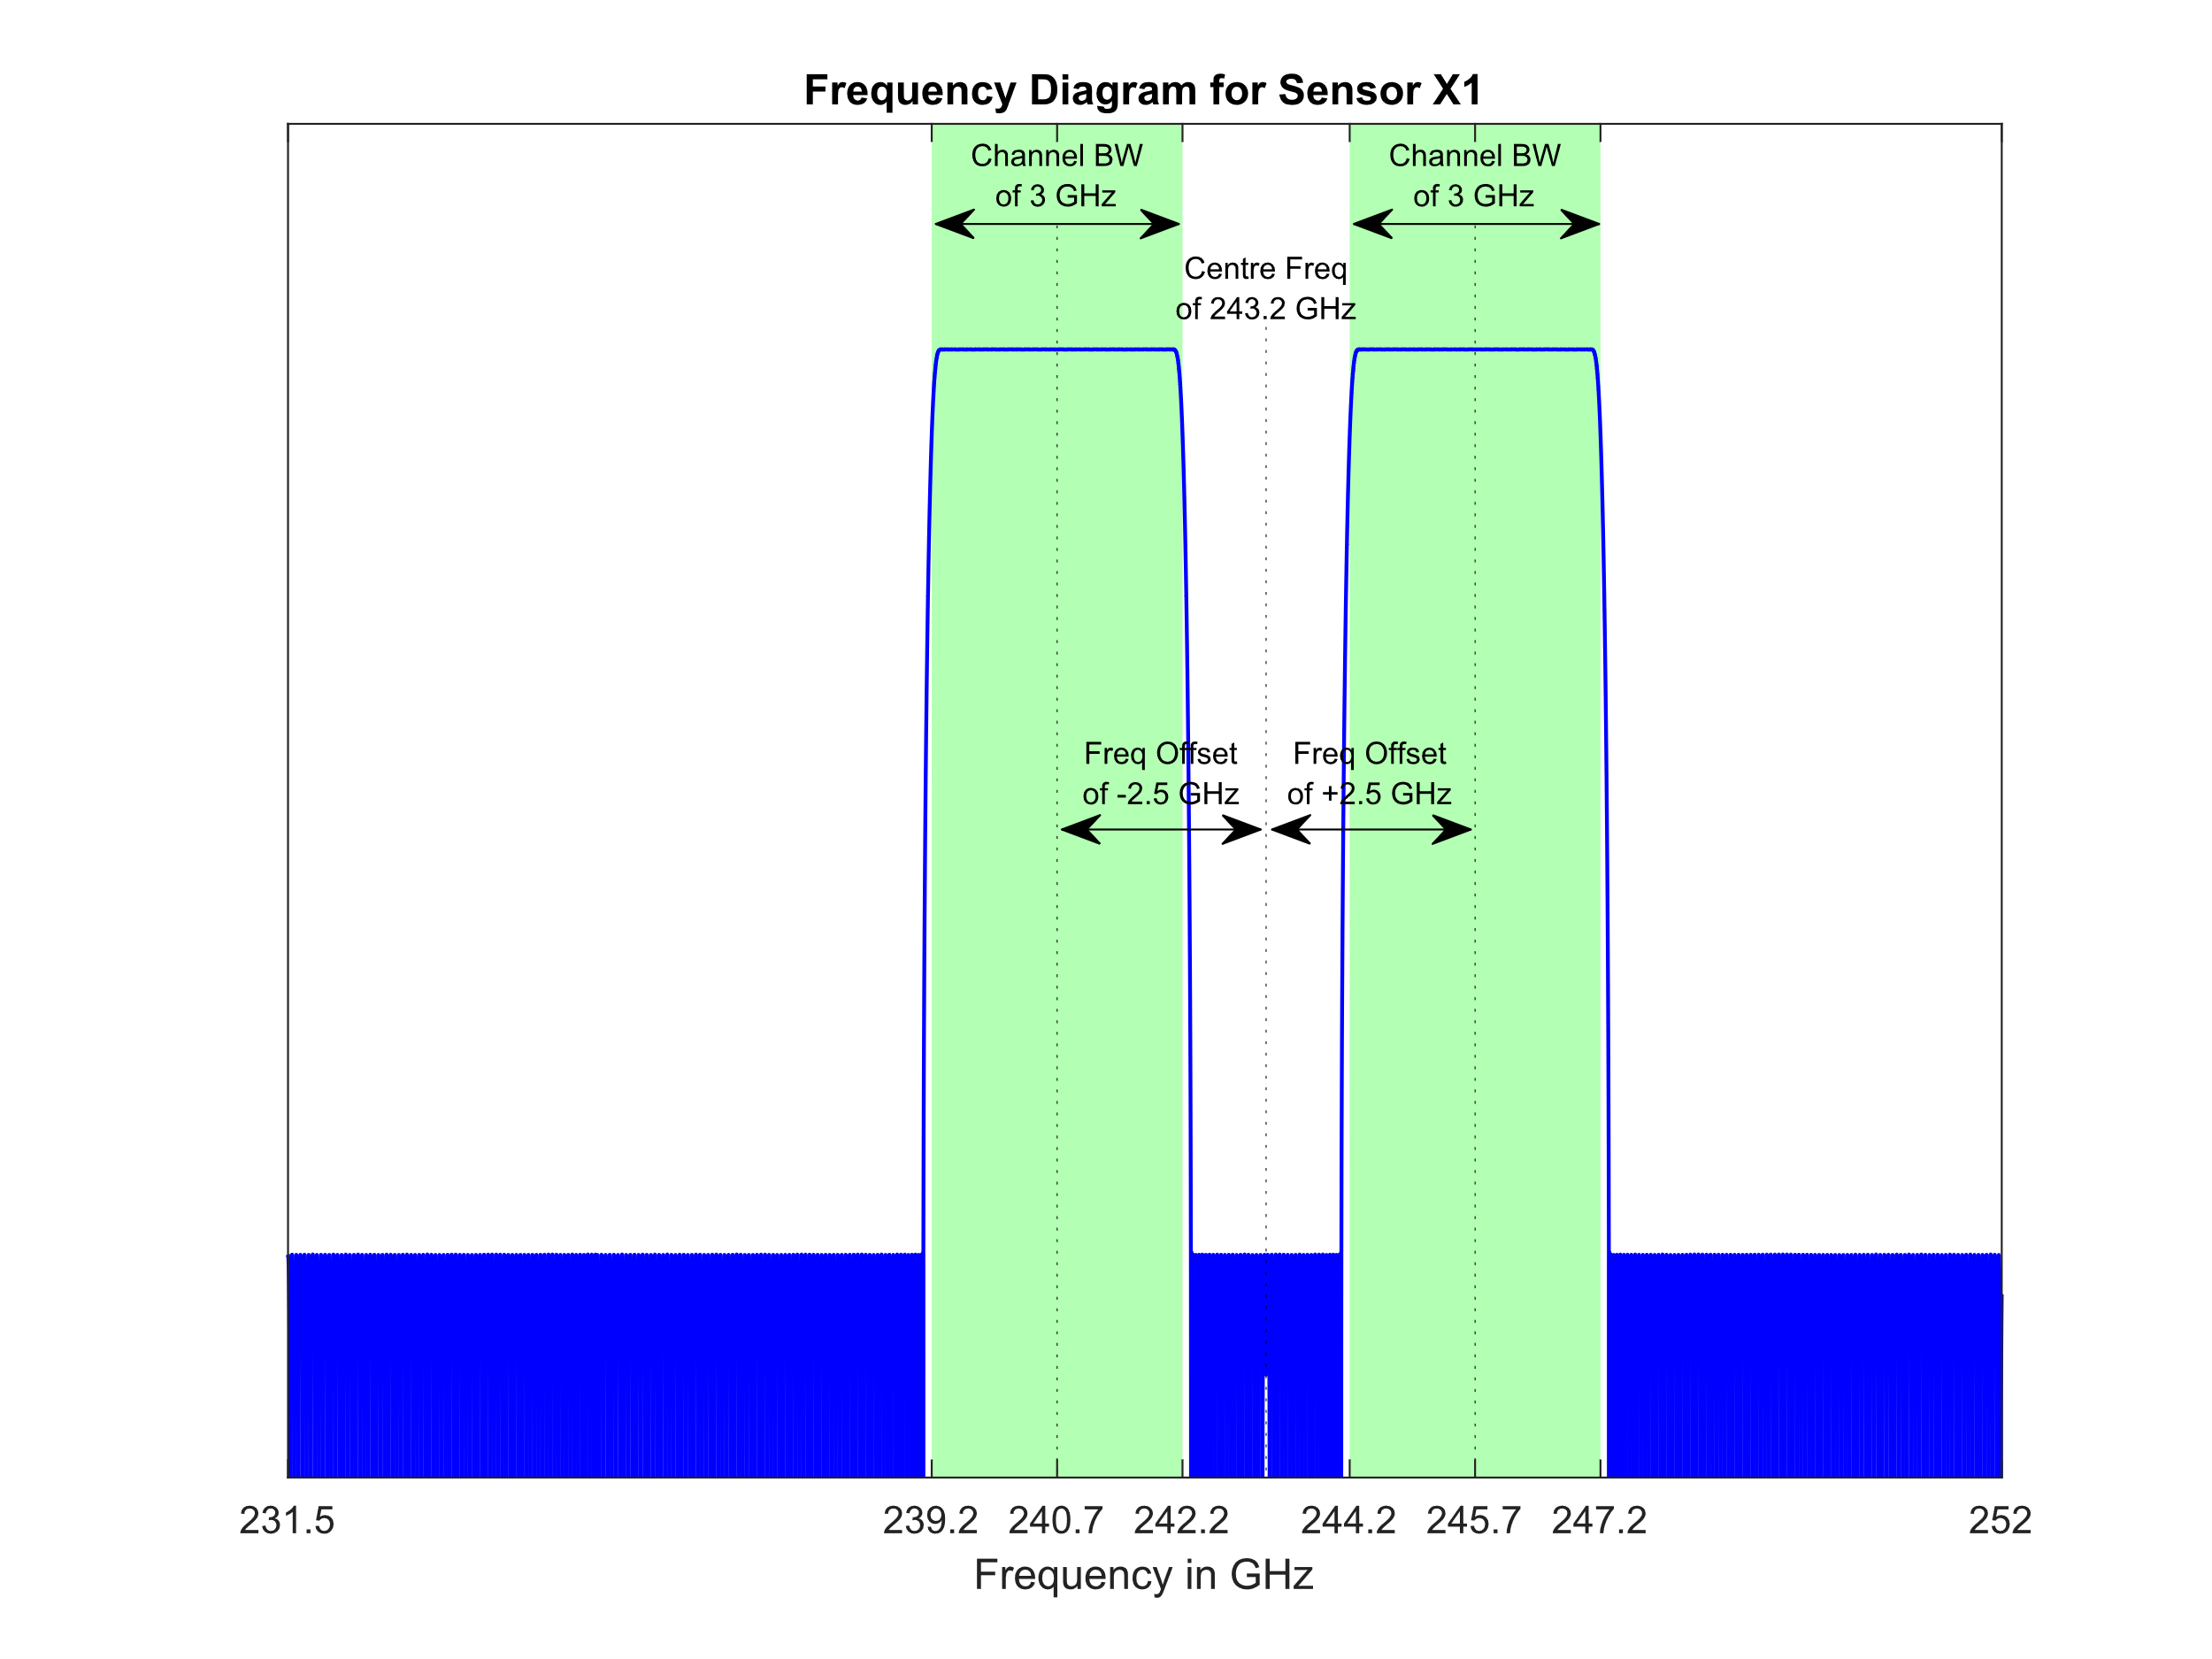

TABLE 7

Sensor T2 passive sensor characteristics for channels between 231.5 and 248 GHz

| Centre frequency  (GHz) | Channel bandwidth  (MHz) |
| --- | --- |
| 233.9515 | 1 250 |
| 235.7151 | 10  1 250 |
| 231.86  232.46  234.86  236.66  242.66  244.46  246.86  247.46 | 500 |

### 3.5.1 Representative antenna pattern for MLS

While Recommendation [ITU-R RS.1813](https://www.itu.int/rec/R-REC-RS.1813/en) provides a reference antenna pattern for EESS (passive) sensors in the frequency range 1.4-100 GHz, MLS operates at higher frequencies and its antenna is not rotationally symmetric around its boresight, so it cannot solely be parameterized as a function of off-axis angle. Therefore, this section seeks to adjust the Recommendation [ITU-R RS.1813](https://www.itu.int/rec/R-REC-RS.1813/en) antenna model to support modelling elliptically-shaped reflectors as is needed for MLS. With that in mind, the following modifications should be made:

– The maximum antenna gain be defined as: $G_{max}=10\log_{10}\left(ηπ^{2}\frac{D_{max}D_{min}}{λ^{2}}\right)$.

– The antenna diameter be defined as: $D=\sqrt{D_{max}^{2}\cos^{2}\left(α\right)+ D_{min}^{2}\sin^{2}\left(α\right)}$. Therefore, the antenna diameter becomes a function of the angle (α ϵ [0°, 90°]) in the plane that is perpendicular to the antenna boresight vector and between the intended direction of emission and the antenna beam’s major axis: See Fig. 3 for additional clarity on the use of these parameters.

– The existing functions for *G*(φ) and φ*m* should be evaluated for each point in the alpha/phi space.

Figure 3

Definition of coordinate system for elliptically-shaped reflectors

Lastly, it should be noted that *Dmax* = *Dmin* for circularly-shaped reflectors, and the proposed modifications simplify into the equations currently contained within Recommendation [ITU-R RS.1813](https://www.itu.int/rec/R-REC-RS.1813/en).

# 4 Technical characteristics of the active services in relevant frequency bands

## 4.1 Fixed service

In the absence of specific reference for fixed service systems in bands around 230 GHz, the fixed service characteristics considered in this Report are those provided by Report ITU-R [F.2416](https://www.itu.int/pub/R-REP-F/publications.aspx?lang=en&parent=R-REP-F.2416) on “Technical and operational characteristics and applications of the point-to-point fixed service applications operating in the frequency band 275-450 GHz”.

The values of *I*/*N* are those guided by Recommendation ITU-R [F.758-7](https://www.itu.int/rec/R-REC-F/recommendation.asp?lang=en&parent=R-REC-F.758) and the antenna patterns given in Recommendation [ITU‑R F.699](https://www.itu.int/rec/R-REC-F.699/en).

## 4.2 Fixed-satellite service (space-to-Earth) in the frequency band 232-240 GHz

Table 8 provides geostationary-satellite orbit (GSO) fixed-satellite service (FSS) systems parameters relevant for the band 232-240 GHz.

TABLE 8

GSO FSS downlink parameters

|  |  |  |  |
| --- | --- | --- | --- |
| Frequency range (GHz) | 232-240 | | |
| SPACE STATION CARRIER | Carrier 1 | Carrier 2 | Carrier 3 |
| Peak transmit antenna gain (dBi) | 65 | 60 | 55 |
| Peak satellite e.i.r.p. spectral density (dBW/Hz) | 8 | 3 | -8 |
| Transmit antenna gain pattern | Rec. ITU-R 672-4 (*LN* = −25) | Rec. ITU-R 672-4 (*LN* = −25) | Rec. ITU-R 672-4 (*LN* = −25) |
| Other |  |  |  |
| Additional notes | 100 cm diameter reflector, oriented at any point on the surface of the Earth | 50 cm diameter reflector, oriented at any point on the surface of the Earth | 30 cm diameter reflector, oriented at any point on the surface of the Earth |

## 4.3 Amateur and amateur-satellite services

The following Recommendations provide the frequency sharing criteria and technical characteristics of the amateur and amateur-satellite services, including the allocations to those services at 241‑250 GHz:

– Recommendation [ITU-R M.1044](https://www.itu.int/rec/R-REC-M.1044/en) – Frequency sharing criteria in the amateur and amateur-satellite services

– Recommendation [ITU-R M.1732](https://www.itu.int/rec/R-REC-M.1732/en) – Characteristics of systems operating in the amateur and amateur-satellite services for use in sharing studies.

# 5 Propagation aspects of Earth-to-space paths in the frequency range 231.5-252 GHz

Assumptions that affect the atmospheric attenuation calculation will play a critical role in the analysis of Earth-to-space paths under WRC-23 agenda item 1.14.

Figure 4 provides the predicted atmospheric attenuation due to oxygen and water vapour, as given in Recommendation [ITU-R P.676](https://www.itu.int/rec/R-REC-P.676/en), for an Earth-to-space path across the possible values of frequency, local elevation angle, and reference atmospheres given in Recommendation [ITU-R P.835](https://www.itu.int/rec/R-REC-P.835/en). Based on Fig. 4, the frequency range 231.5‑252 GHz exhibits minimal variation in atmospheric attenuation with respect to frequency. Most elevation angles experience low amounts of atmospheric attenuation, with an overall minima of 1.62 dB at 231.5 GHz, 90-degree elevation, and use of the winter high-latitude reference atmosphere.

Figure 4

Total atmospheric attenuation for Earth-to-space paths across elevation angle, frequency,  
and reference atmosphere



It should be noted that free-space path loss, which is not shown within Fig. 4, is calculated based off of slant range which is dependent upon spacecraft orbital altitude. However, the FSPL will be no less than approximately 198.1 dB for Sensor T1 (231.5 GHz at 830 km) and no less than approximately 196.7 dB for Sensor T2 (231.5 GHz at 705 km).

It should also be noted that choice of the appropriate reference atmosphere is situationally dependent. For instance, in cases when simulating Sensor T1 and utilizing a two million km2 MAI, it is appropriate to choose the most transparent model for which deployment of that active service may be plausible. Based on the above plot, that suggests analysis of an MAI in a winter high-latitude region. In cases when simulating Sensor T2 and utilizing a global active service deployment, then each active station within the simulation should individually apply the appropriate atmosphere model based its specific latitude.

# 6 Sharing and compatibility studies

## 6.1 Sharing between EESS (passive) (Conical scan) and fixed service

### 6.1.1 EESS (passive) characteristics

Technical characteristics of EESS (passive) systems in the 231.5-252 GHz are given in § 3.5 above describing a conical scan instrument (ICI) and a Limb sounding instrument (MLS).

It should be noted that updated characteristics of these sensors have been included in ITU-R Recommendation RS.1861-1 recently adopted (see sensors T1 and T2 in § 6.20 of this Recommendation).

For the specific conical scan ICI system, the following parameters in Table 9 are necessary to undertake the sharing analysis:

TABLE 9

ICI characteristics

|  |  |
| --- | --- |
|  | ICI sensor |
| Orbit type | NGSO |
| Altitude (km) | 830 |
| Off-nadir pointing angle (degree) | 44.7 |
| elevation at ground (degree) | 37.3 |
| IFOV (km²) | 155 |
| Antenna gain (dBi) | 52 |

ICI passive sensor characteristics for channels between 239 and 248 GHz are presented in Table 9.

### 6.1.2 Fixed service characteristics

FS systems in the 230 GHz range are assumed to be rather similar to the one described in the 275‑450 GHz in Report [ITU-R F.2416](https://www.itu.int/pub/R-REP-F.2416).

The following technical parameters are necessary to undertake sharing analysis between FS and EESS (passive) systems:

– E.i.r.p. ranging 30 to 67 dBm/GHz

– Antenna gain ranging 24 to 50 dBi

– FS antenna pattern F.1245.

With regards to the number of FS links, the following assumptions are considered:

– Link density scenario = 4.2 links/km²

– Population scenario = 0.00035 link/inhab.

Finally, for the FS link elevation distributions, the baseline case provided by WP5C has been used, i.e. 20° typical (Case 1), which is not saying that higher elevations will not occur.

Under the assumption that the maximum elevation of FS links in the range 230 GHz will not be regulated, it is also necessary to consider the impact of a certain percentage of FS links operated at higher elevation. To this respect, the example of Report [ITU-R M.2292](https://www.itu.int/pub/R-REP-M.2292) has been taken as a reference, depicting for the FS links in the 81-86 GHz the following elevation cases:

TABLE 10

FS elevation scenarios from Report [ITU-R M.2292](https://www.itu.int/pub/R-REP-M.2292)

|  |  |  |  |  |
| --- | --- | --- | --- | --- |
|  | Case 2 | Case 3 | Case 4 | Case 5 |
| High elevation links | 0.39% of links with elevation higher than 20° | 0.5% of links with elevation between 30° and 45° | ±30° (normally distributed) | Less than 2% of links with elevation between 20° and 65° |
| *Note*: It should be noted that since FS links hop lengths are more than likely being longer in the 81-86 GHz band than in the 230 GHz band, the FS elevation angles in the 230 GHz band will be more than likely higher. | | | | |

In order to calculate the aggregate impact of an FS deployment on EESS (passive) sensors, the following methodology has been applied:

*1st step*: Determine the number of FS links in the EESS footprint:

– Option 1: density based (4.2 links / km²), i.e. a number of 651 links within the ICI footprint

– Option 2: population based (0.00035 links / inhab.) (see methodology in Annex 1, leading to a number of 1051 links within the ICI footprint)

*2nd step*: Random deployment of the number of FS links with the following parameters randomly chosen:

– Azimuth (0 to 360°)

– Elevation (based on above distributions Cases 1 to 5)

– E.i.r.p. (30 to 67 dBm/GHz)

– Antenna gain (24 to 50 dBi)

*3rd step*: For each case, run 10 000 different random deployments to determine the distribution of maximum e.i.r.p. in the direction of the EESS (passive) sensor.

### 6.1.3 Maximum FS e.i.r.p. in direction of the EESS (passive) satellite

The following sections present the maximum FS e.i.r.p. at the ground in direction of the EESS (passive) satellites (expressed in dBm/200 MHz).

a) Single entry

The maximum FS e.i.r.p. is given as 67 dBm/GHz. Therefore, expressed in dBm/200 MHz, the maximum single entry FS e.i.r.p. at the ground in direction of the EESS (passive) satellites is:

Max e.i.r.p. = 67 + 10 × log (200/1 000) = 60 dBm/200 MHz

b) Aggregate case for the ICI type sensor

Figure 5

FS e.i.r.p. at the ground for ICI type sensor (density based)

Figure 6

FS e.i.r.p. at the ground for ICI type sensor (population based)

c) Sharing studies with specific EESS (passive) system (ICI)

Table 11 provides the maximum e.i.r.p. at the ground in direction of the EESS (passive) satellites (expressed in dBm/200 MHz) in order to ensure protection of the ICI sensor in the 230 GHz band.

It is to be noted that over the range 231.5 to 252 GHz, the free space and atmospheric attenuations are pretty constant. On this basis, it is proposed to consider calculation at a single frequency (243.2 GHz) being valid over the range.

TABLE 11

Maximum interference at the ground for ICI system

|  |  |
| --- | --- |
| EESS system | ICI |
| Frequency (GHz) | 243.2 |
| Orbit altitude (km) | 830 |
| Nadir angle (degree) | 44.7 |
| Slant path distance (km) | 1254 |
| Free Space losses (dB) | 202.1 |
| Elevation at ground (degree) | 37.3 |
| Atmospheric losses (dB) | 3 |
| Antenna gain (dBi) | 52 |
| Protection criteria (dBW/200 MHz) | −160 |
| Apportionment (dB) | 3 |
| Maximum interference at the ground (dBm/200 MHz) | 20.1 |

According to the analysis in § 4 above, the following maximum FS e.i.r.p. at the ground are expected:

1) single entry = 60 dBm/200 MHz (i.e. 60 – 20.1 = 39.9 dB negative margin)

2) aggregate = 54 dBm/200 MHz (i.e. 54 – 20.1 = 33.9 dB negative margin)

### 6.1.4 Conclusions for ICI vs fixed service

The above results show that FS deployment will not be compatible with ICI operation in any portion of the 231.5-252 GHz band, with a negative margin of around 34 dB (for aggregate scenario).

## 6.2 Sharing between EESS (passive) (Limb sounding) and fixed service

Two different studies (A and B) have been addressing the sharing between EESS (passive) (Limb sounding) and Fixed service.

### 6.2.1 Study A

#### 6.2.1.1 EESS (passive) characteristics

Technical characteristics of EESS (passive) systems in the 231.5-252 GHz are given in § 3.5 above describing a conical scan instrument (ICI) and a Limb sounding instrument (MLS).

It should be noted that updated characteristics of these sensors have been included in Recommendation [ITU-R RS.1861](https://www.itu.int/rec/R-REC-RS.1861/en)-1 recently adopted (see sensors T1 and T2 in section 6.20 of this Recommendation).

For the specific MLS system (i.e. T2), the following parameters in Table 12 are necessary to undertake the sharing analysis:

TABLE 12

MLS characteristics

|  |  |
| --- | --- |
|  | MLS sensor |
| Orbit type | NGSO |
| Altitude (km) | 705 |
| Antenna gain (dBi) | 67.5 |
| Beam dynamics | Scans continuously in tangent height from the surface to ~92 km in 24.7 s, 240 scans/orbit |

The position C in Fig. 7 (Figure 1 of Recommendation RS.1861-1) gives an overview of the geometry of a Limb sounder.

Figure 7

Limb sounder geometry (Figure 1 of Recommendation RS.1861-1)

#### 6.2.1.2 Consideration of EESS (passive) Limb sounders systems

Unlike for Nadir/Conical scan for which interference is created within the sensor main beam pointing to the Earth at quite high elevation angle, this situation does not exist for Limb sounders which main beam is never reaching the ground.

a) Geometry makes that the maximum EESS (passive) off-axis gain at ground is limited to the pointing direction of the instrument at the visibility distance (more than 3 000 km in the case of MLS). Depending on where the measurement is performed (tangent to ground or 92 km altitude) the off-axis gain can range 11 to 61 dBi.

However, in such situation, the EESS (passive) sensor is seen from the ground at very low elevation, hence presenting very high levels of atmospheric attenuation (see Fig. 8) as well as high level of Free Space attenuation (about 10 dB more compared to nadir).

Figure 8

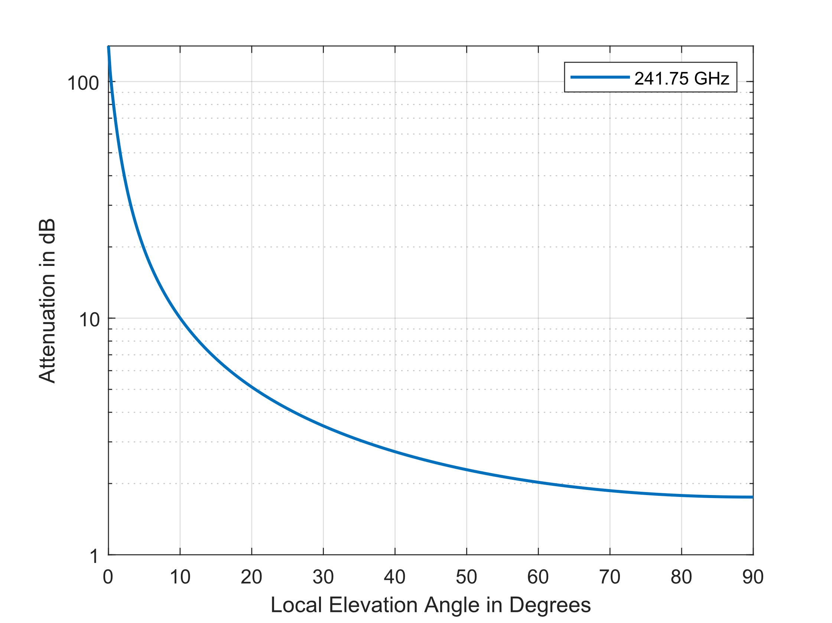

These levels of attenuation will make that these “high off-axis gain scenario” will not be representative in the sharing analysis.

b) Looking at the steep shape of the MLS instrument antenna pattern (with a 67.5 dBi max gain), the off-axis gain at ground will rapidly evolve to negative values within few degrees of pointing (see Fig. 9).

Figure 9

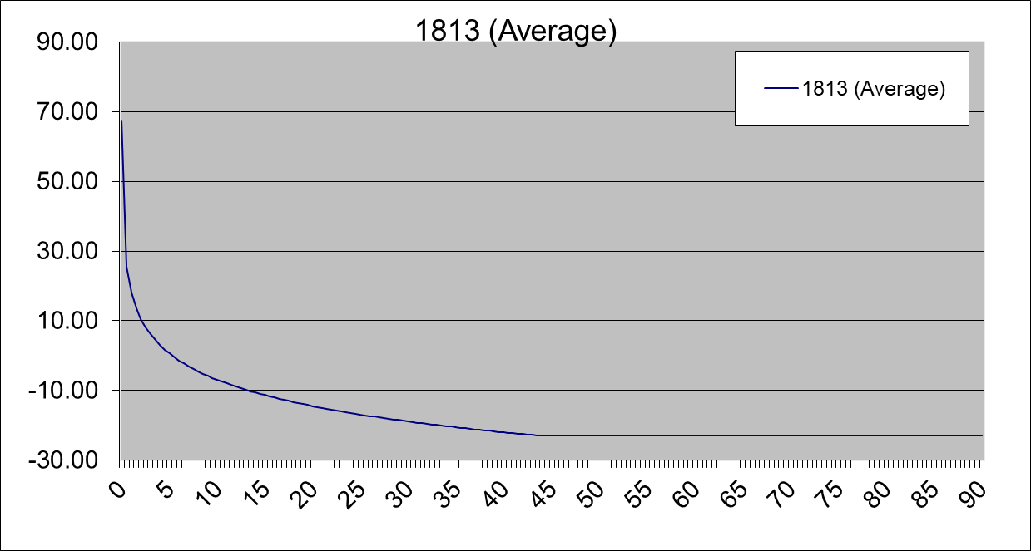

c) Within the visibility area of the satellite, places on the ground that will be seen with positive off axis gains will be limited to geometric situation in the pointing direction of the sensor (see Fig. 10).

Figure 10

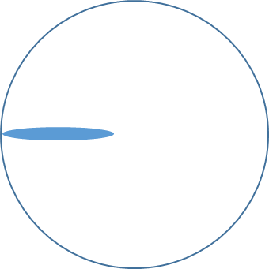

As expressed in a), these cases will at first experience high levels of atmospheric attenuation and higher Free Space attenuation levels. In addition, considering that the EESS (passive) protection criteria is associated with a percentage of 1% of time that the permissible interference level may be exceeded, one can assume that these cases will not be representative for the sharing analysis. Finally, for the vast majority of other geometric situations, it is more than likely that off-axis gains will be within side/back lobes values (i.e. down to −23 dBi).

It is hence proposed to limit the current analysis to a 10 dB range from back lobe value, i.e. off-axis gains ranging −13 to −23 dBi and to consider aggregation of multiple FS deployments (in urban area) within the whole satellite visibility (about 28 M km²).

#### 6.2.1.3 Fixed service characteristics

FS systems in the 230 GHz range are assumed to be rather similar to the one described in the 275‑450 GHz in Report [ITU-R F.2416](https://www.itu.int/pub/R-REP-F.2416).

The following technical parameters are necessary to undertake sharing analysis between FS and EESS (passive) systems.

– E.i.r.p. ranging 30 to 67 dBm/GHz

– Antenna gain ranging 24 to 50 dBi

– FS antenna pattern F.1245.

With regards to the number of FS links, the following assumptions are considered:

– Population scenario = 0.00035 link / inhab.

Finally, for the FS link elevation distributions, the baseline case provided by WP5C has been used, i.e. 20° typical (Case 1).

In order to calculate the aggregate impact of an FS deployment on EESS (passive) sensors, the following methodology has been applied:

*1st step*: Determine the number of FS links in the EESS footprint:

– population based (0.00035 link / inhab.) (see methodology in Annex 1, leading to a number of 1 051 links within an area of 155 km² corresponding to the ICI footprint).

*2nd step*: Random deployment of the number of FS links with the following parameters randomly chosen:

– Azimuth (0 to 360°)

– Elevation (based on above distributions Cases 1 to 5)

– E.i.r.p. (30 to 67 dBm/GHz)

– Antenna gain (24 to 50 dBi).

*3rd step*: For each case, run 1000 different random deployments to determine the distribution of maximum e.i.r.p. in the direction of the EESS (passive) sensor:

– Calculation is made for EESS (passive) sensor seen at different elevations (with a 10° step)

#### 6.2.1.4 Maximum FS e.i.r.p. in direction of the EESS (passive) satellite

The following sections present the maximum FS e.i.r.p. at the ground in direction of the EESS (passive) satellites (expressed in dBm/3 MHz).

a) Single entry

The maximum FS e.i.r.p. is given as 67 dBm/GHz. Therefore, expressed in dBm/3 MHz, the maximum single entry FS e.i.r.p. at the ground in direction of the EESS (passive) satellites is:

Max e.i.r.p. = 67 + 10 × log (3/1 000) = 41.8 dBm/3 MHz

b) Aggregate case

Figure 11

FS e.i.r.p. at the ground for Limb sounder (density based)

Table 13 provides the summary of these calculations for the median, the 10% and 1% values (in dBm/3 MHz).

TABLE 13

summary of FS deployment e.i.r.p. at the ground

|  |  |  |  |  |  |  |  |  |
| --- | --- | --- | --- | --- | --- | --- | --- | --- |
|  | Elevation | | | | | | | |
|  | 10° | 20° | 30° | 40° | 50° | 60° | 70° | 80° |
| Median (50%) | 34.7 | 31.5 | 25.6 | 24.4 | 23.9 | 23.7 | 23.7 | 23.7 |
| 10% | 38.9 | 36.7 | 26.7 | 25.1 | 24.5 | 24.4 | 24.4 | 24.4 |
| 1% | 40.9 | 39.5 | 27.9 | 25.7 | 25.1 | 24.9 | 24.9 | 24.9 |

c) Sharing studies with specific EESS (passive) system (MLS)

Table 14 provides the maximum e.i.r.p. at the ground in direction of the EESS (passive) satellites (expressed in dBm/3 MHz) in order to ensure protection of the MLS Limb sounder sensor in the 230 GHz band.

It is to be noted that over the range 231.5 to 252 GHz, the free space and atmospheric attenuations are fairly constant. On this basis, it is proposed to consider calculation at a single frequency (243.2 GHz) being valid over the range.

TABLE 14

Maximum interference at the ground for Limb sounder sensor

|  |  |  |  |  |  |  |  |  |  |
| --- | --- | --- | --- | --- | --- | --- | --- | --- | --- |
|  |  | Elevation | | | | | | | |
| EESS system | MLS | 10° | 20° | 30° | 40° | 50° | 60° | 70° | 80° |
| Frequency | GHz | 243.2 | 243.2 | 243.2 | 243.2 | 243.2 | 243.2 | 243.2 | 243.2 |
| Orbit altitude | km | 705 | 705 | 705 | 705 | 705 | 705 | 705 | 705 |
| Slant path distance | km | 2165 | 1593 | 1245 | 1028 | 890 | 801 | 745 | 715 |
| Free Space losses | dB | 206.6 | 204 | 201.8 | 200.2 | 198.9 | 198 | 197.4 | 197 |
| Atmospheric losses | dB | 10 | 5 | 3.5 | 3 | 2.5 | 2 | 2 | 2 |
| Antenna gain (upper) | dBi | −13 | −13 | −13 | −13 | −13 | −13 | −13 | −13 |
| Antenna gain (lower) | dBi | −23 | −23 | −23 | −23 | −23 | −23 | −23 | −23 |
| Protection criteria | dBW/3 MHz | −194 | −194 | −194 | −194 | −194 | −194 | −194 | −194 |
| Apportionment | dB | 3 | 3 | 3 | 3 | 3 | 3 | 3 | 3 |
| **Maximum interference at the ground (upper case)** | **dBm/3 MHz** | **62.6** | **55** | **51.3** | **49.2** | **47.4** | **46** | **45.4** | **45** |
| **Maximum interference at the ground (lower case)** | **dBm/3 MHz** | **72.6** | **65** | **61.3** | **59.2** | **57.4** | **56** | **55.4** | **55** |

According to the analysis above, the following conclusions can be drawn:

a) single entry

The maximum FS e.i.r.p. in direction of EESS (passive) sensor is calculated as 41.8 dBm/3 MHz.

It is compatible with all values above, further noting that above 30/40° elevation, the probability of having an FS link at these elevations and pointing in the direction of the EESS sensor is likely being null.

b) Aggregate

Comparing values in Tables 13 and 14 shows that for all elevation, there is a large margin from the potential interference created by a single FS deployment (1051 links) to the EESS (passive) protection (15.5 to 37.9 dB).

When considering the aggregation of multiple FS deployments (i.e. several large urban areas) within the EESS (passive) visibility area, it would not be realistic to consider all cases aggregating at the maximum e.i.r.p. but, on the contrary, one could expect that median values would be more appropriate.

On this basis, the margin from the potential interference created by a single FS deployment (1 051 links) to the EESS (passive) protection would range 21.3 to 37.9 dB.

This means that that to reach the EESS (passive) protection, there would be a need for a scenario in which hundreds different FS deployments within the EESS (passive) visibility area would occur. Considering that the 1 051 links deployment corresponds to a scenario over Paris region, such a scenario is more than likely being not realistic.

#### 6.2.1.5 Conclusions of Study A for MLS vs fixed service

The above results show that FS deployment will be compatible with Limb sounding operations (using MLS system) in any portion of the 231.5-252 GHz band.

### 6.2.2 Study B

The FS is not currently allocated in 235-238 GHz, and the only EESS (passive) systems in this band are limb-sounding applications. Study B evaluates the potential effect of in-band fixed service stations on the limb sounders that operate in 235-238 GHz.

#### 6.2.2.1 Simulation assumptions

The results in Study B are generated by a dynamic analysis that propagates the limb sounding satellite according to its orbital characteristics as listed in Table 5. The 2.5 arcmin [Gridded Population of the World](https://sedac.ciesin.columbia.edu/data/set/gpw-v4-population-count-adjusted-to-2015-unwpp-country-totals-rev11/data-download) data is used to determine the number of inhabitant in each ~5 km pixel on the Earth. The number of FS transmitters per pixel is determined by multiplying the population per pixel by a link density of 3.5e-04 links/inhabitant and rounding to the nearest integer. Therefore, after applying this approach, the resulting effective FS link density is 3.1436e-04 links/inhabitant. Figure 12 shows the locations of the pixel centres in the Western Hemisphere that contain a non‑zero number of FS stations.

Figure 12

Pixels containing a non-zero number of FS stations



Below are the remaining assumptions that have been incorporated into the simulation:

– The analysis is conducted at the lowest portion of the allocation (235 GHz) since that is where the local minima are observed from Recommendation [ITU-R P.676](https://www.itu.int/rec/R-REC-P.676/en).

– Orbital elements other than apogee, perigee, and inclination angle are randomized on a run-to-run basis since Recommendation [ITU-R RS.1861](https://www.itu.int/rec/R-REC-RS.1861/en) provides representative sensor information.

– FS stations are randomly placed within the ~5 km pixel. The FS station height is determined based on an assumed hop length of 300 m and the (negative) sine of the elevation angle.

– Free-space path loss, atmospheric attenuation, transmit gain, and receive gain are calculated on a per-FS station basis.

– On a per-timestep basis, interference from FS stations that do not have line-of-sight to the limb-sounding sensor are ignored, and all interference from visible FS stations is aggregated.

– The atmospheric model is chosen based on the latitude of the station. It is assumed to be summer in the Northern Hemisphere.

– It is assumed that all FS stations operate at the maximum power density of 17 dBm/GHz, and this level is scaled down to the 3 MHz IPC reference bandwidth.

– This analysis considers both a 24 dBi and 50 dBi FS antenna. The pattern from the 70‑86 GHz portion of Recommendation [ITU-R F.699](https://www.itu.int/rec/R-REC-F.699/en) is being used (see Fig. 13). In many directions, the 50 dBi antenna has less gain than the 24 dBi antenna, and this is apparent in the results shown below.

– The FS pointing azimuth comes from a uniform random distribution in 0 to 360°, and the FS pointing elevation comes from those used in Reports [ITU-R F.2239](https://www.itu.int/pub/R-REP-F.2239) and [ITU-R F.2416](https://www.itu.int/pub/R-REP-F.2416).

Figure 13

Comparison of fixed service antenna patterns for 24 and 50 dBi gain



#### 6.2.2.2 Simulation results

The interference results and margins are given in Fig. 14 and Table 15, respectively. It is worth noting that the observed interference level at the 1% point is very consistent between each run. Since the CCDF does not approach 100%, this indicates that there are portions of the satellite’s orbit where it does not have LOS with any pixels with a non-zero number of interferers.

TABLE 15

Summary of interference margins at various cases of FS links elevation angles

|  |  |  |  |  |  |  |
| --- | --- | --- | --- | --- | --- | --- |
| Margin (dB) | Case 0:  Uniform Random between −20°  and 20° | Case 1:  −20 and 20° Equiprobable | Case 2: Case 1 + 0.39% of links 20-90° | Case 3:  Case 1 + 0.5% of links 30-45° | Case 4: Normal (μ=0, σ=10) with truncation at ±30° | Case 5: Case 1 + 2% of links 20‑65° |
| **24 dBi** | 15.850 | 14.225 | 14.243 | 14.256 | 16.387 | 14.246 |
| **50 dBi** | 18.305 | 15.658 | 16.018 | 16.026 | 20.421 | 15.456 |

Figure 14

Interference CCDFs for in-band sharing between FS and EESS (passive) in 235-238 GHz



In both, it appears that high elevation angle FS links do not affect the 1% interference exceedance point to a noticeable extent, and that seems to make sense based on the overall geometry of the interference situation. Further, low elevation angle links (with certain azimuths) pose the biggest interference issue, but those signals seem to be adequately attenuated by Recommendation [ITU-R P.676](https://www.itu.int/rec/R-REC-P.676/en).

#### 6.2.2.3 Study B summary

All FS pointing and gain scenarios exhibit sizeable positive margin of at least 14 dB when evaluated against the EESS (passive) protection criteria. Therefore, for these reasons, it can be concluded that potential FS operations in the 235-238 GHz would not adversely impact limb sounding applications of the EESS (passive), and sharing between these two sets of systems is feasible throughout the entire frequency range of 235-238 GHz.

### 6.2.3 Conclusions for EESS (passive) (Limb sounding) vs fixed service

Both studies A and B lead to similar conclusion that FS deployment will be compatible with EESS (passive) Limb sounding operations in any portion of the 231.5-252 GHz band with a sizeable positive margin (at least 14 dB in Study B).

## 6.3 Sharing between EESS (passive) and GSO FSS (space-to-Earth)

### 6.3.1 Simulation assumptions

A dynamic simulation propagates the EESS (passive) sensor according to its orbital parameters and assumes operation within a passive sensor reference bandwidth centred at 236 GHz, which is the middle of the FSS frequency range; for the same propagation distance, a difference of 0.295 dB in free-space path loss is observed over the 232 to 240 GHz range. In the case of the conical-scan sensor, only the snapshots are retained where the EESS (passive) sensor antenna boresight intersects a defined Measurement Area of Interest (MAI); since the limb-sounding sensor does not have a spatial component to its protection criteria, all snapshots are retained. A sufficiently large number of snapshots are used such that the interference levels at 0.01% or 1% exceedance, depending on the sensor type, can be accurately estimated. Within each snapshot of the dynamic simulation, all position vectors are updated and all pointing angles between the space station antennas are calculated and used for evaluation within their respective gain pattern. Due to the desire to capture peak interference values within the analysis, *recommends* 2 of Recommendation [ITU-R RS.1813](https://www.itu.int/rec/R-REC-RS.1813/en) is implemented. Lastly, only free-space path loss is considered for interference paths between space stations that have line-of-sight; non-line-of-sight interference is completely ignored.

The following factors lead to additional simulation complexity (i.e. more discrete combinations that must be evaluated):

– To account for worst-case conditions, FSS space stations are placed every two degrees on the geostationary arc with 100% duty cycle. Time-series data for each of the potential 180 individual interferers, as well as the aggregate interference vector, is used to generate complementary cumulative distribution functions (CCDFs) for evaluation against the protection criteria.

– Square MAIs centred at latitudes of 0°, 40°, and 80° are evaluated for conical-scan sensor T1. The choice of MAI latitude has a significant impact on interference geometries between the FSS space stations and conical sensor.

– All three FSS downlink e.i.r.p. densities are evaluated. To appropriately bound the results, all space stations within a given simulation assume the same e.i.r.p. density.

The following factors are uniquely determined during each simulation run and, to ensure that any run-to-run variability is appropriately observed, each discrete combination of simulation parameters is run a total of ten times:

– While the EESS (passive) orbital altitude and inclination angle are given in Table 5 above and are fixed, the remaining Keplerian elements (right ascension of the ascending node, argument of perigee, and true anomaly) are randomized during each simulation run to allow for all potential orbital planes and positions to be considered.

– The intersection point of the Earth’s surface and each GSO’s antenna boresight vector is randomized at the start of each simulation to account for differences in FSS operations. The latitude of the intersection point is uniformly distributed between −45° and 45°, and the longitude of the intersection point is uniformly distributed between −10° and 10° from the longitude of the GSO orbital slot.

### 6.3.2 Simulation results

Simulation results are given in Table 16, and the scenario letters should be interpreted as the following:

– A: Sensor T2, max FSS e.i.r.p.

– B: Sensor T2, mid FSS e.i.r.p.

– C: Sensor T2, min FSS e.i.r.p.

– D: Sensor T1, MAI centred at Lat = 0°, max FSS e.i.r.p.

– E: Sensor T1, MAI centred at Lat = 0°, mid FSS e.i.r.p.

– F: Sensor T1, MAI centred at Lat = 0°, min FSS e.i.r.p.

– G: Sensor T1, MAI centred at Lat = 40°, max FSS e.i.r.p.

– H: Sensor T1, MAI centred at Lat = 40°, mid FSS e.i.r.p.

– I: Sensor T1, MAI centred at Lat = 40°, min FSS e.i.r.p.

– J: Sensor T1, MAI centred at Lat = 80°, max FSS e.i.r.p.

– K: Sensor T1, MAI centred at Lat = 80°, mid FSS e.i.r.p.

– L: Sensor T1, MAI centred at Lat = 80°, min FSS e.i.r.p.

TABLE 16

Simulation results

|  |  |  |  |  |  |  |  |  |  |  |  |  |
| --- | --- | --- | --- | --- | --- | --- | --- | --- | --- | --- | --- | --- |
| Scenario: | A | B | C | D | E | F | G | H | I | J | K | L |
| **Average worst single interferer margin for 10 Runs (dB)** | 30.404 | 28.090 | 33.760 | 1.445 | 3.191 | 13.744 | 18.225 | 31.169 | 29.043 | 38.833 | 36.484 | 41.662 |
| **Worst overall single interferer margin for 10 runs (dB)** | 30.102 | 27.912 | 33.470 | 0.151 | 2.974 | 13.555 | −0.350 | 3.241 | 13.853 | 37.909 | 35.302 | 40.592 |
| **Average aggregate margin for 10 runs (dB)** | 2.074 | 0.299 | 5.773 | −1.018 | 2.577 | 13.572 | 17.854 | 28.625 | 28.446 | 32.699 | 30.727 | 35.831 |
| **Worst-case aggregate margin for 10 runs (dB)** | 1.700 | −0.031 | 5.467 | −1.880 | 2.450 | 13.368 | −1.621 | 2.839 | 13.697 | 31.995 | 28.771 | 34.600 |

As indicated by the values in Table 16, almost all entries exhibit positive margin against the EESS (passive) protection criteria. Scenarios that do not have positive margin only have very modest exceedance and generally relate to worst-case assumptions (e.g. aggregation from up to 180 FSS space stations, or maximum FSS e.i.r.p. density). It is worth noting that the relevant margins in Table 16 are obtained by finding the average of the dB values in the linear domain, then transforming the result back to the logarithmic domain.

In all subsequent plots, the red X denotes the protection criteria, the blue curve is the aggregate CCDF, and the green through black lines represent the individual FSS interferer CCDFs. In the case of conical-scan sensors, a light green CCDF corresponds to interference from a GSO whose longitude slot is close to the MAI’s midpoint longitude; the colour of the CCDF darkens as the GSO slot becomes further away from the MAI’s midpoint. Additionally, Figs 15 through 18 are sample plots that show results at the maximum FSS e.i.r.p. density level. Plots at the medium and minimum FSS e.i.r.p. levels show similar, yet slightly different, behaviour.

#### 6.3.2.1 Interpretation of Sensor T2 results

Since simulations for Sensor T2 do not involve the concept of an MAI, all FSS space stations are visible to the passive sensor, and Fig. 15 has exactly 180 individual CCDFs. The spread of the individual CCDFs starting at approximately 30% is due to the random nature of the FSS antenna pointing on the interference calculation.

It is worth noting that using the medium FSS e.i.r.p. density level (Scenario B) produces less margin than using the maximum FSS e.i.r.p. density level (Scenario A), and this trend does not occur with Sensor T1’s data. However, this can be explained by the fact that the protection criteria have an allowable exceedance of 1%, and reduced antenna gain results in increased antenna beamwidth.

Figure 15

Sample Interference CCDFs for single run of Scenario A

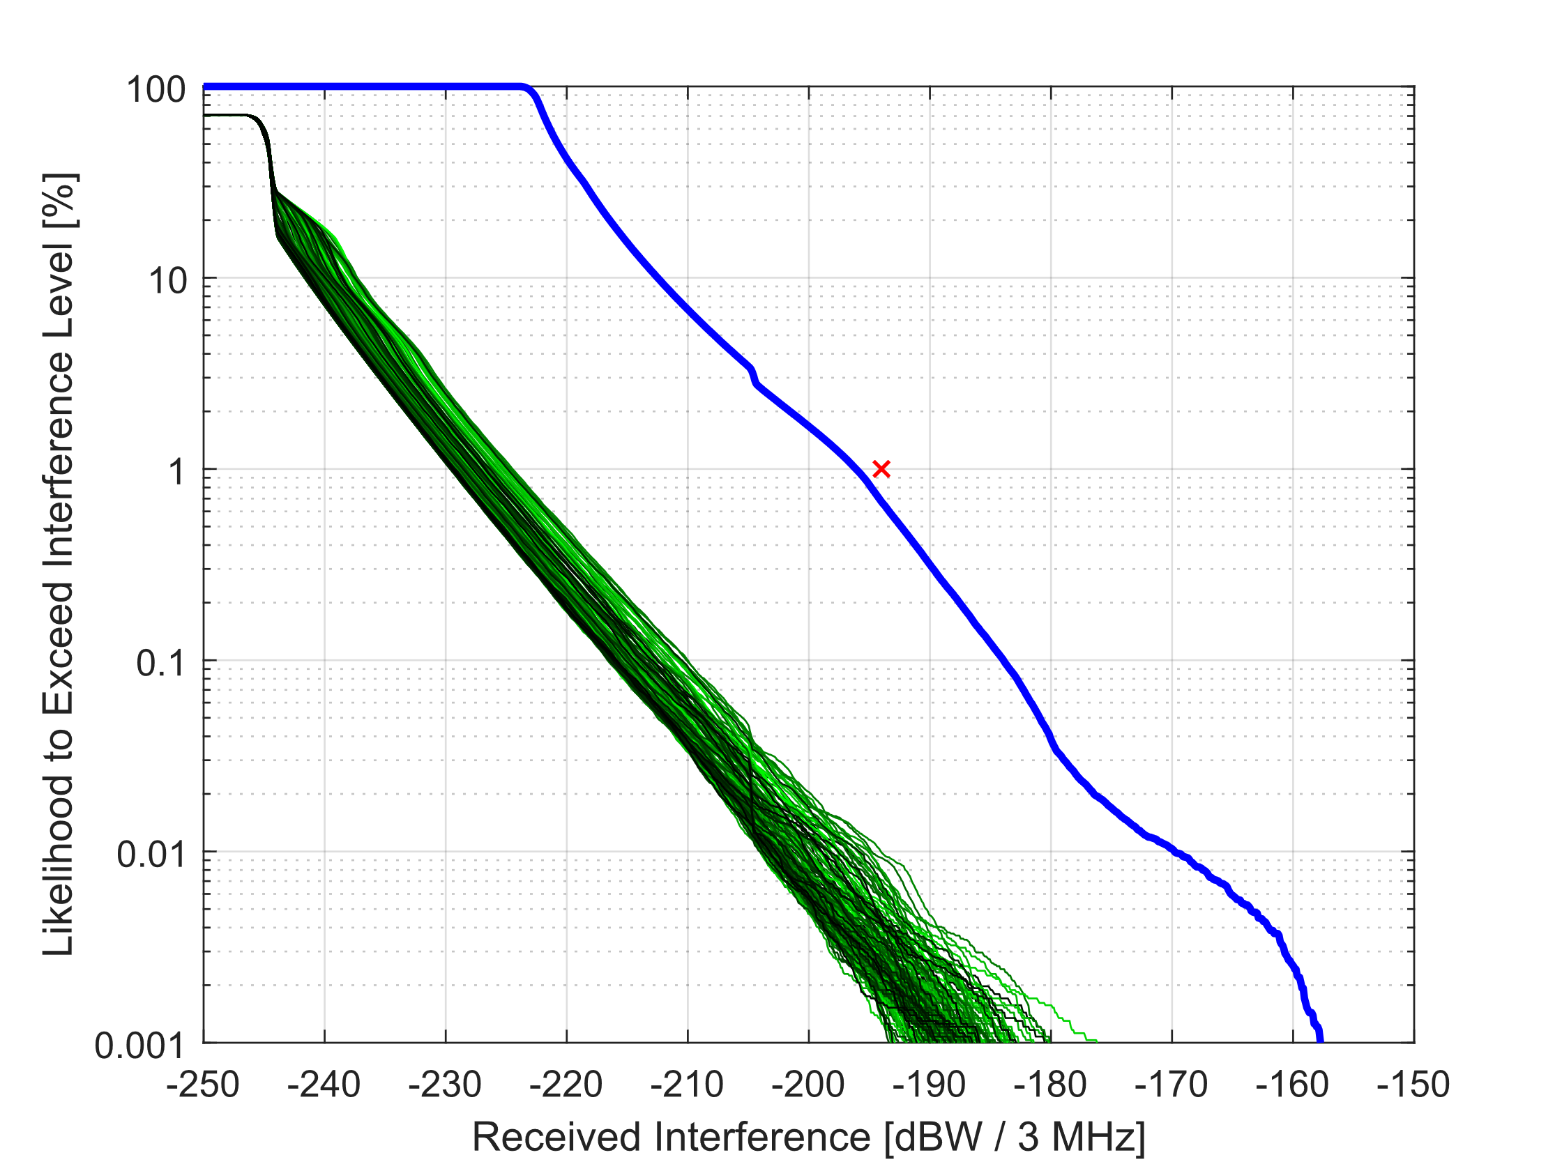

#### 6.3.2.2 Interpretation of Sensor T1 results

In the case of Sensor T1, more individual CCDF curves can be found in Fig. 18 (MAI centred at 80° latitude) than in Fig. 17 (MAI centred at 40° latitude), which has more than Fig. 16 (MAI centred at 0°). This is because more GSO slots are visible as the MAI is moved from the Earth’s equator to its poles.

However, the highest observed levels of interference occur when the EESS (passive) backlobe is illuminated by the main-beam of the FSS downlink. When comparing the assumptions for FSS antenna pointing and the MAI midpoints, main-beam illumination from the FSS downlink is not possible in Scenarios J, K, and L, and this has a noticeable impact on the simulation results. In maximum/medium e.i.r.p. density cases and situations where the MAI is within the area where the FSS antenna may be pointed (Scenarios D, E, G, and H), even a single interferer may produce interference levels that are on the order of the EESS (passive) protection criteria, as evidenced by the second row of Table 16. However, this does not occur in all runs due to differences in FSS antenna pointing.

Lastly, darker CCDFs have the highest interference levels in Scenarios J, K, and L because the GSOs that are positioned on the opposite side of the Earth as the MAI (between 90° and 180° difference in longitude) have a geometry that produces higher antenna gain values than those GSOs that are positioned on the same side of the Earth as the MAI (between 0° and 90° difference in longitude).

Figure 16

Sample Interference CCDFs for single run of Scenario D

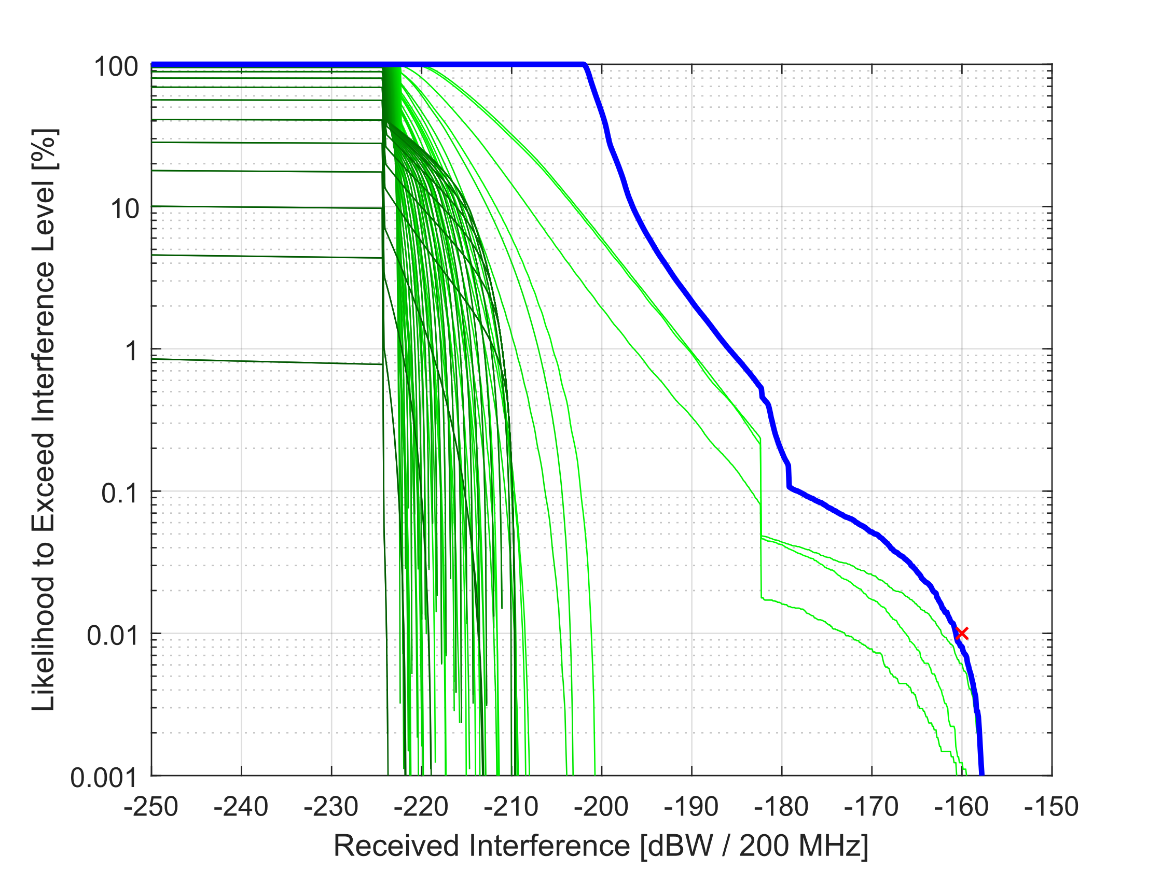

Figure 17

Sample Interference CCDFs for single run of Scenario G

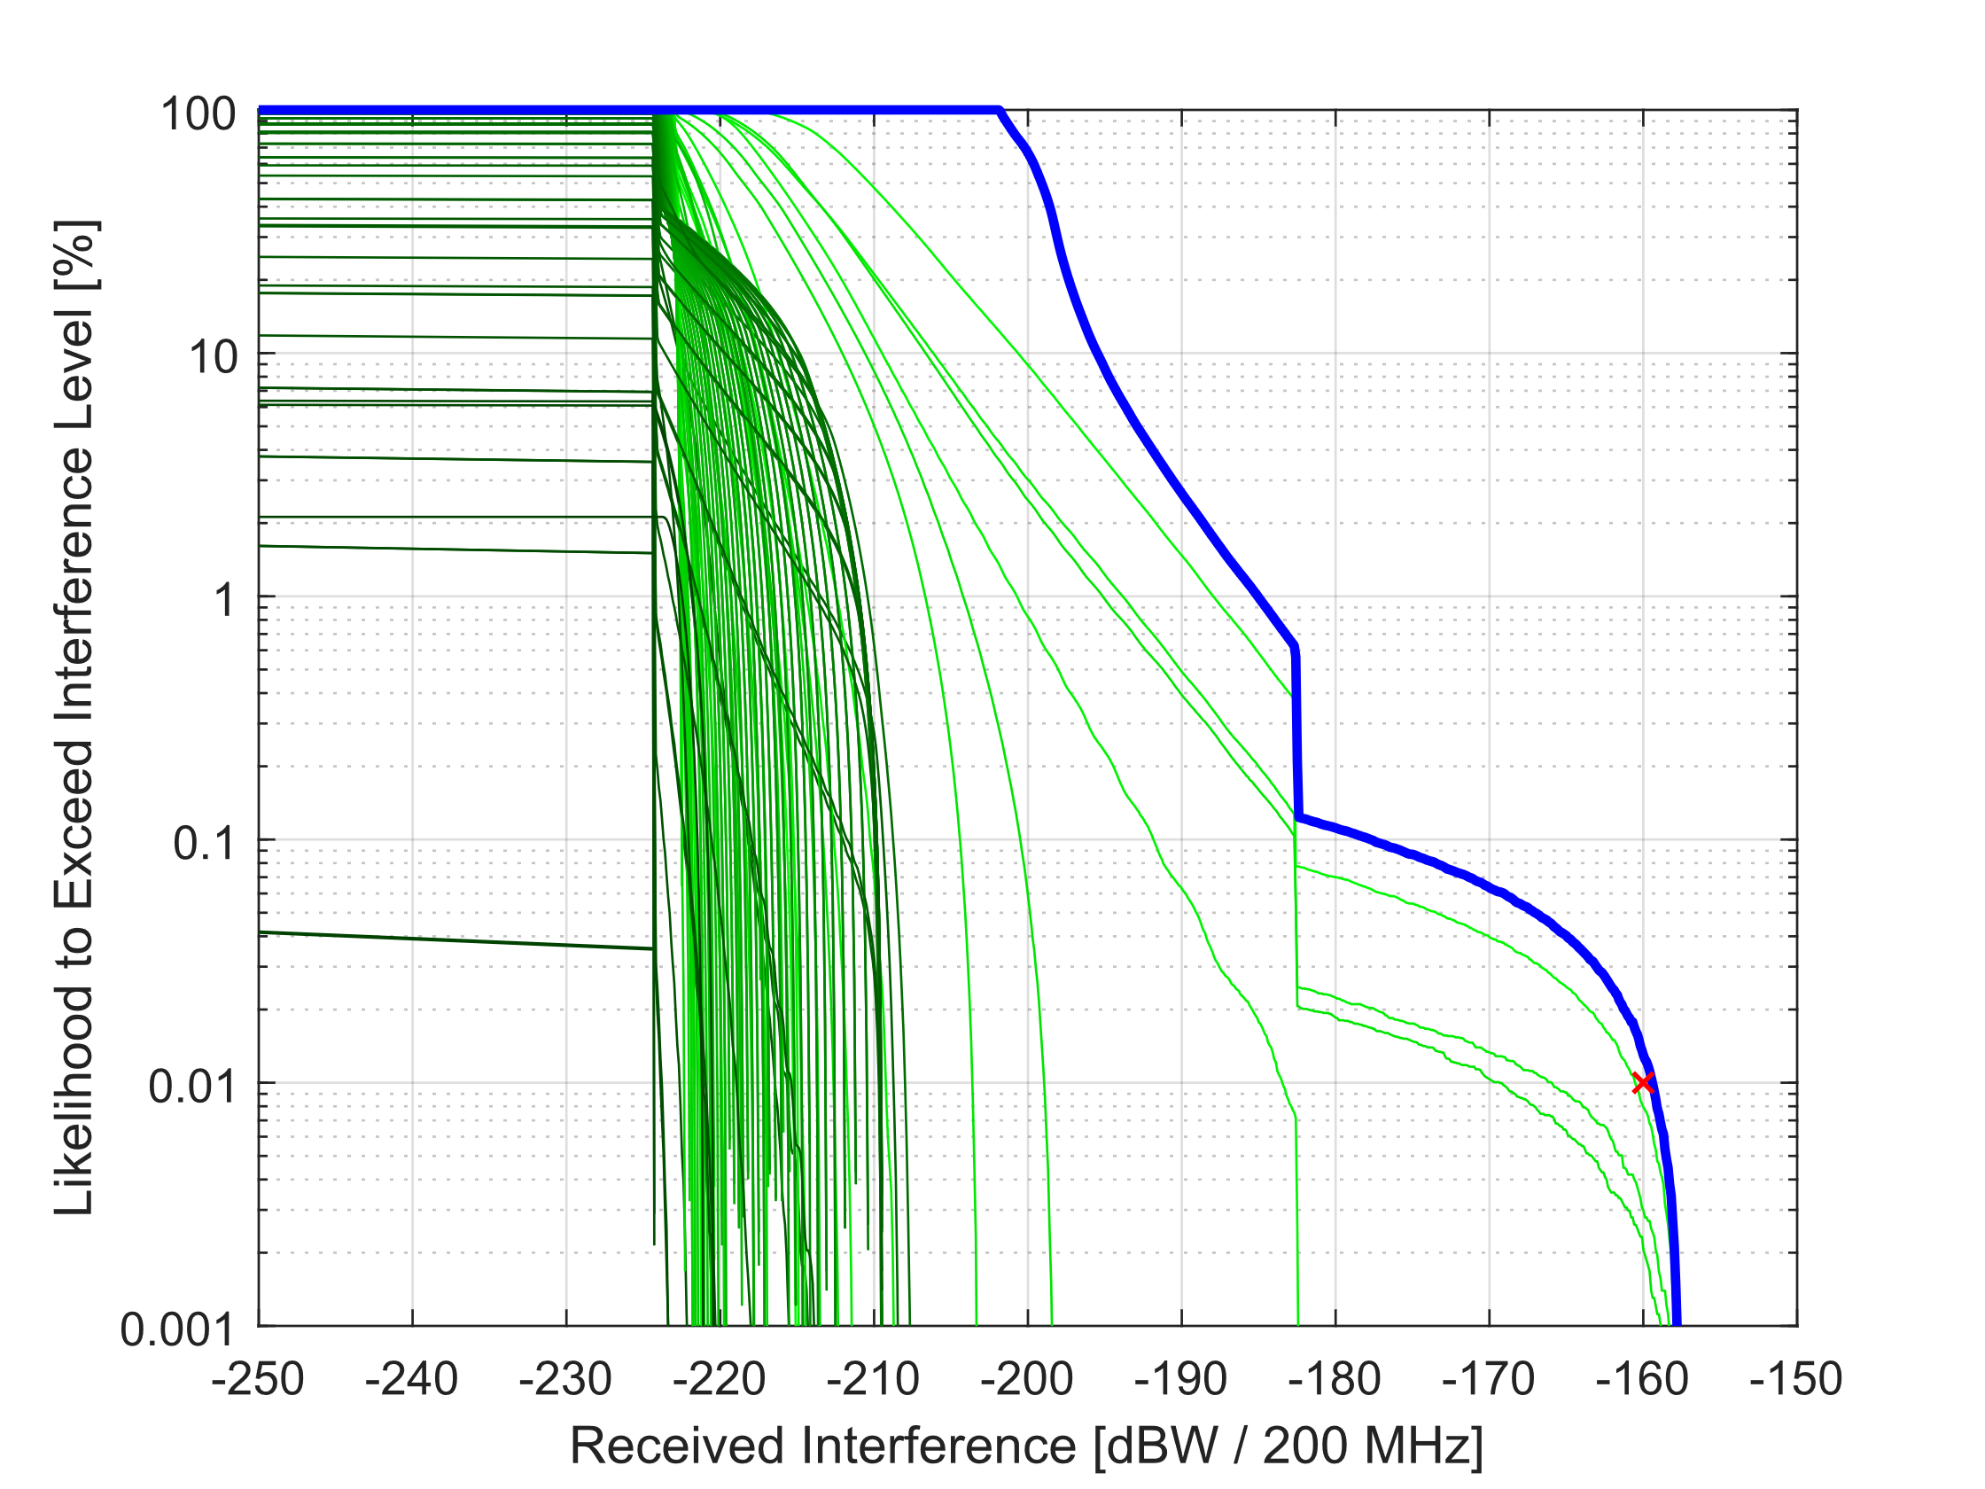

Figure 18

Sample Interference CCDFs for single run of Scenario J

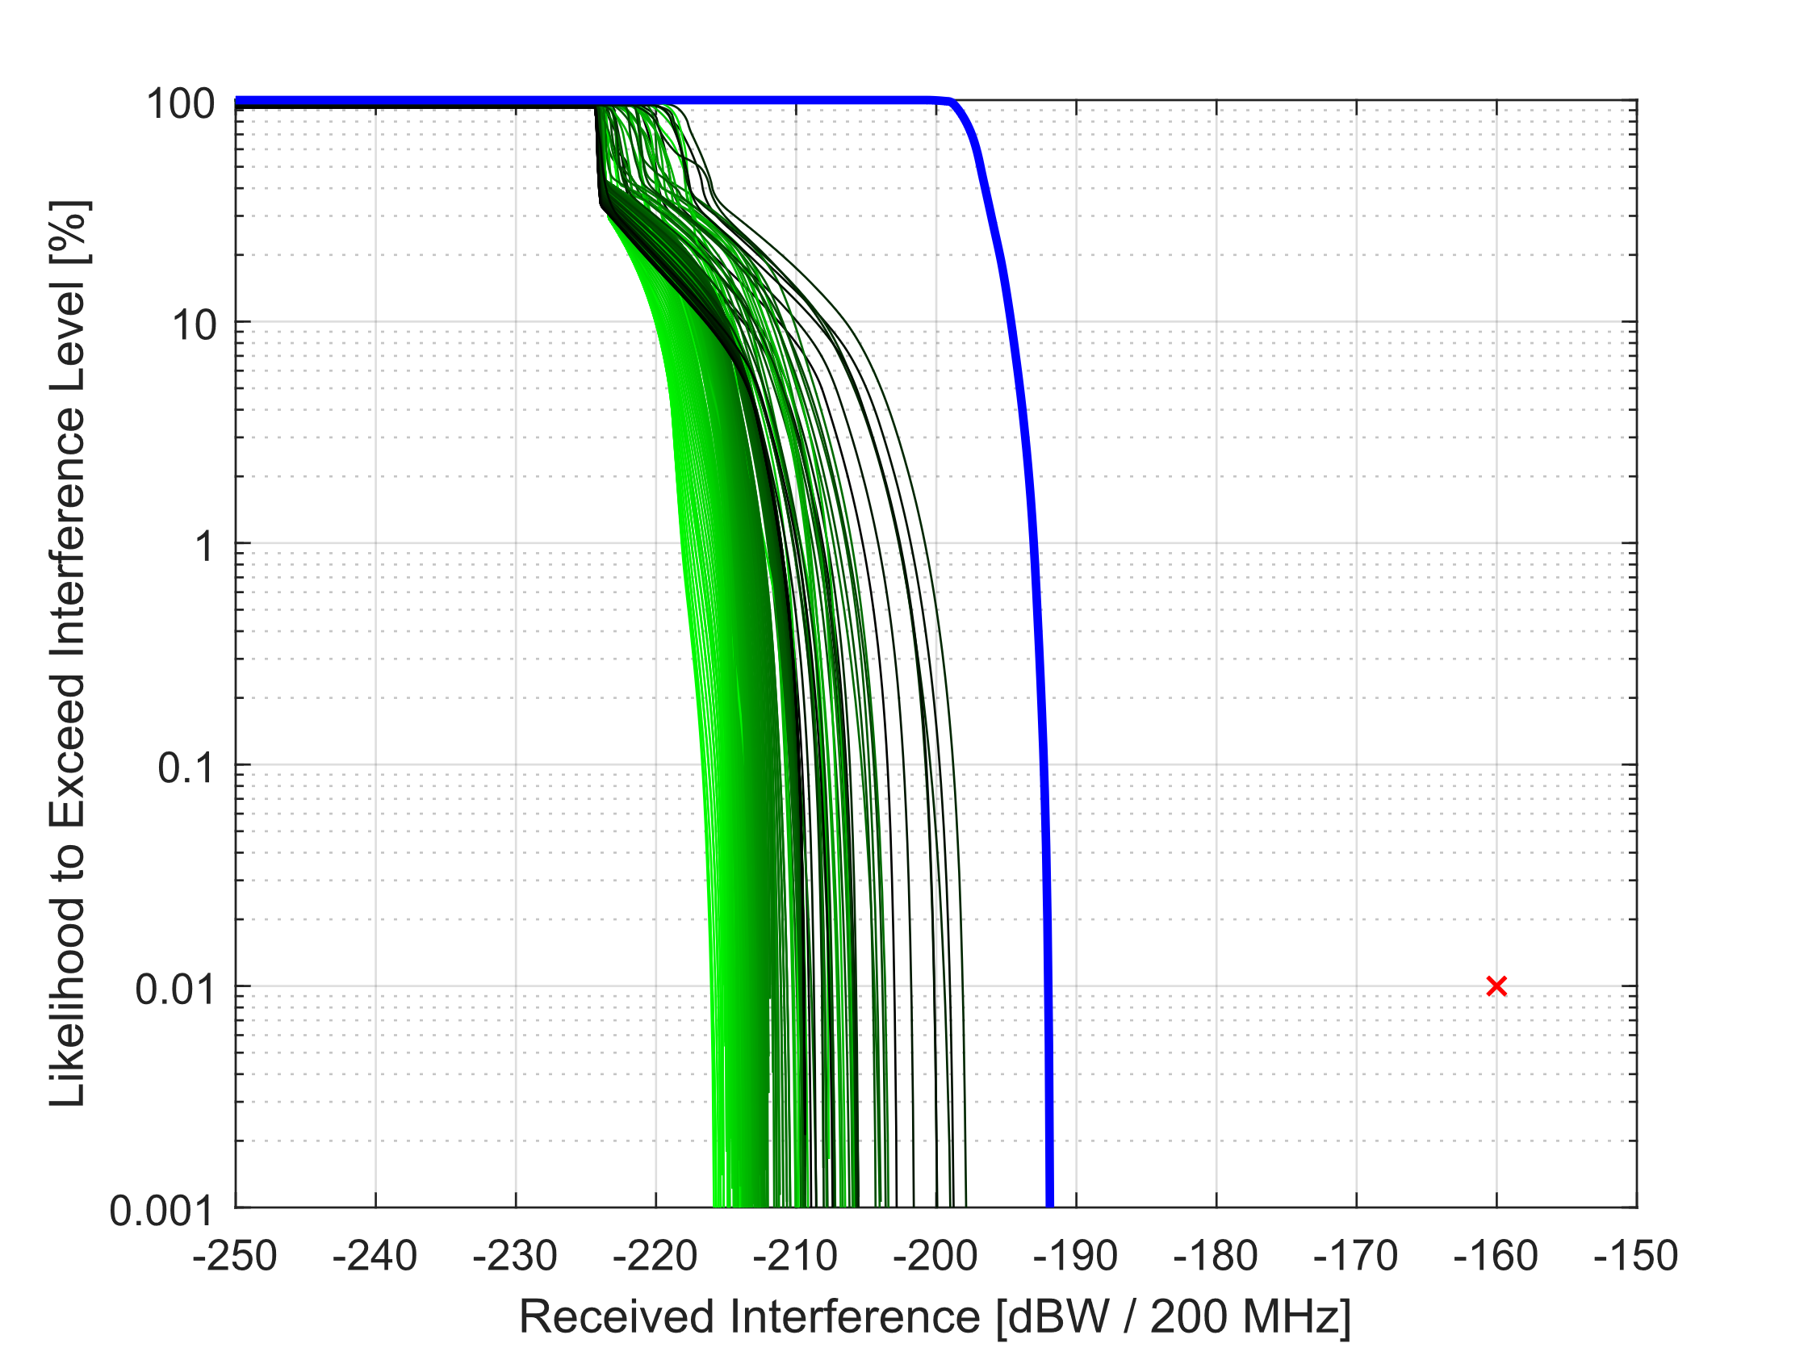

### 6.3.3 Study summary

Almost all scenarios exhibit positive margin when evaluated against the EESS (passive) protection criteria for worst-case assumptions. Scenarios that result in negative margin have only minor exceedance and are due, in large part, to the effects from aggregation from an exhaustive FSS deployment. Therefore, for these reasons, it can be concluded that current FSS (GSO, space-to-Earth) operations would not adversely impact potential EESS (passive) operations, and sharing between these two services is feasible throughout the entire frequency range of 232-240 GHz.

## 6.4 Sharing between EESS (active) and FS in the 237.9-238 GHz band

### 6.4.1 Context

One of the possible Method under WRC-23 agenda item 1.14 consists in shifting the existing FS and MS allocations in the band 239.2-241 GHz to the band 235-238 GHz. In this frequency range, an allocation to EESS (active), limited to Cloud Profiler Radars, is made in the 237.9-238 GHz band through RR Footnote No. **5.563B**.

The present section addresses the sharing between FS/MS and EESS (active) is feasible and addresses both relevant scenarios (i.e. FS receiving and EESS (active) receiving).

### 6.4.2 EESS (active) characteristics

Description of EESS (active) systems in the 237.9-238 GHz is given in § 7.14 of current Recommendation ITU-R RS.2105-1.

For the corresponding CPR-N1 system, the parameters in Table 17 are necessary to undertake the sharing analysis.

TABLE 17

CPR-N1 characteristics

|  |  |
| --- | --- |
| Parameter | CPR-N1 (Cloud profiling radar) |
| Type of orbit | NGSO |
| Altitude (km) | 705 |
| Repeat period (days) | 16 |
| Antenna diameter (m) | 3 |
| Antenna gain (dBi) | 78 |
| Polarization | Linear |
| Antenna beamwidth (degrees) | 0.024 |
| RF centre frequency (GHz) | 237.95 |
| RF bandwidth (MHz) | 0.65 |
| Transmit Pk power (W) | 80 |
| Pulsewidth (μs) | 1.6 |
| Pulse repetition frequency (PRF) (Hz) | 4 000 |
| System noise figure (dB) | 11 |

Cloud profiling radars are nadir instruments meaning that they are pointing downward with a nadir angle of 0°.

With a 78 dBi antenna gain of the instrument, the main beam trace on the ground is very limited with a diameter of 0.3 km and hence an area of less than 0.1 km².

This has the following consequences for the present studies:

– It is more than likely that the interference scenario will only be related to a single terrestrial station.

– With a satellite speed on its orbit of about 7 km/s, the possible interference situations will only last a very short period of time (lower than 0.3/7 = 43 ms) and with a repeat period of 16 days, this represents a percentage of time of 0.000003%, i.e. in the extreme short-term domain.

Finally, the EESS (active) protection criteria is given in Recommendation [ITU-R RS.1166](https://www.itu.int/rec/R-REC-RS.1166/en). For cloud profiling radars, it is expressed as *I*/*N* = −10 dB with a data availability of 99% (systematic) or 95% (random).

### 6.4.3 Fixed service characteristics

FS systems in the 230 GHz range are assumed to be rather similar to the one described in the 275‑450 GHz in Report [ITU-R F.2416](https://www.itu.int/pub/R-REP-F.2416).

The following technical parameters are necessary to undertake sharing analysis between FS and EESS (active) systems:

– E.i.r.p. ranging 30 to 67 dBm/GHz

– Antenna gain ranging 24 to 50 dBi

– FS antenna pattern F.1245.

With regards to the number of FS links, Report [ITU-R F.2416](https://www.itu.int/pub/R-REP-F.2416) provides two different scenarios, either in area (4.2 link /km²) or in population (0.00035 link / inhab).

In both cases it will lead to a figure of less than 1 FS link in the main beam on the EESS (active) sensor (about 0.1 km²).

For the present studies, only one FS link has been considered in the sharing analysis. Considering the small bandwidth of the EESS (active) sensor, it is more than likely that only one of the two transmitters from the FS link will be transmitting in the EESS (active) band.

In addition, since the corresponding FS band would be of about 8 GHz, a typical FS bandwidth of 4 GHz has been assumed.

Finally, for the FS link elevation distributions, the baseline case provided by WP5C has been used, i.e. 20° typical (Case 1). In addition, the example elevation scenario of Report [ITU-R M.2292](https://www.itu.int/pub/R-REP-M.2292) has been taken as a reference, depicting for the FS links in the 81-86 GHz the following elevation cases:

|  |  |  |  |  |
| --- | --- | --- | --- | --- |
|  | Case 2 | Case 3 | Case 4 | Case 5 |
| High elevation links | 0.39% of links with elevation higher than 20° | 0.5% of links with elevation between 30° and 45° | ±30° (normally distributed) | Less than 2% of links with elevation between 20° and 65° |

### 6.4.4 Interference from FS to EESS (active)

Table 18 provides the maximum e.i.r.p. at the ground in direction of the EESS (active) satellites (expressed in dBm/0.65 MHz) in order to ensure protection of the CPR-N1 sensor in the 237‑238 GHz band.

TABLE 18

Maximum e.i.r.p. at the ground for CPR-N1 system

|  |  |
| --- | --- |
| EESS system | CPR-N1 |
| Frequency (GHz) | 237.95 |
| Orbit altitude (km) | 705 |
| Nadir angle (degree) | 0 |
| Slant path distance (km) | 705 |
| Free space losses (dB) | 196.9 |
| Elevation at ground (degree) | 90 |
| Atmospheric losses (P.676) (dB) | 5 |
| EESS antenna gain (dBi) | 78 |
| Protection criteria (dBm/0.65 MHz) | −114.9 |
| **Maximum e.i.r.p. at the ground (dBm/0.65 MHz)** | **9.1** |

When considering a single FS transmitter, the maximum e.i.r.p. in the direction of the EESS (active) is calculated considering the power and the antenna gain in the direction of the EESS (active) sensor.

In order to have a general overview of the situation, 200 000 calculation samples have been considered for which the FS transmitter characteristics have been randomly chosen.

– Azimuth (0 to 360°)

– Elevation (based on above distributions Cases 1 to 5) (since only one transmitter is considered, the elevation can be either positive or negative)

– e.i.r.p. (30 to 67 dBm/GHz), i.e. a maximum e.i.r.p. level of −1.9 to 35.1 dBm/0.65 MHz

– Antenna gain (24 to 50 dBi) (pattern F.1245)

Figure 19 provides the corresponding results for the FS elevation distributions Cases 1 to 5 and a static situation of the EESS (active) sensor pointing to the location of the FS link.

Figure 19

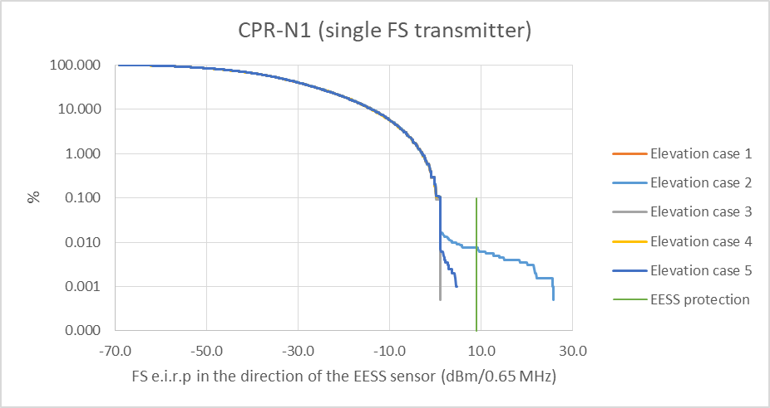

This Figure shows that for elevation distribution Cases 1 (typical), 3, 4 and 5, the interference distributions are similar and the EESS protection level is never exceeded.

Only calculations related to elevation Case 2 depict some exceeding levels for less than 0.01% of the cases. These cases relate to FS links with very high elevations. When comparing the results with Case 5 (with elevations up to 65° and no exceeding) and these calculations, one can hence show that such FS links would have very high elevation, but would be very rare.

Since the EESS (active) protection criteria is given for a data availability of 99% (systematic) or 95% (random), one can conclude that the EESS (active) will be fully protected from a potential FS deployment in the 235-238 GHz band.

#### 6.4.5 Interference from EESS (active) to FS

Using a static analysis for which the EESS (active) is pointing to the FS location (noting that it corresponds to 0.000003% of the time (and probability), the interference level from EESS (active) to FS can be calculated as follows:

$I=P_{EESS}+G_{EESS}-L_{FreeSpace}+G_{FS relative}-{Att}_{atmos}$

where:

*PEESS* : EESS mean power

*GEESS* : EESS max gain

*LFreeSpace* : Free space losses

*GFS relative* : FS antenna gain in the direction of the EESS sensor

*Attatmos* : atmospheric attenuation.

Table 19 provides the corresponding calculation.

TABLE 19

Interference from CPR-N1 system to FS

|  |  |
| --- | --- |
| EESS peak power (W) | 80 |
| Pulse width (μs) | 1.6 |
| PRF | 4 000 |
| EESS mean power (dBW) | −2.9 |
| EESS antenna gain (dBi) | 78 |
| Slant path distance (km) | 705 |
| Free Space losses (dB) | 196.9 |
| Elevation at ground (degree) | 90 |
| Atmospheric losses (P.676) (dB) | 5 |
| FS bandwidth (GHz) | 4 |
| FS noise figure (dB) | 15 |
| kTBF (dBW) | −93 |
| FS antenna gain (dBi) | See below |

In order to have a general overview of the FS antenna gain, 200 000 calculation samples have been considered for which the FS receiver characteristics have been randomly chosen.

– Azimuth (0 to 360°)

– Elevation (based on above distributions Cases 1 to 5) (since only one transmitter is considered, the elevation can be either positive or negative)

– Antenna gain (24 to 50 dBi) (pattern F.1245).

On this basis, Fig. 20 provides the corresponding resulting interference levels (in *I*/*N*) from CPR-N1 to FS receivers.

Figure 20

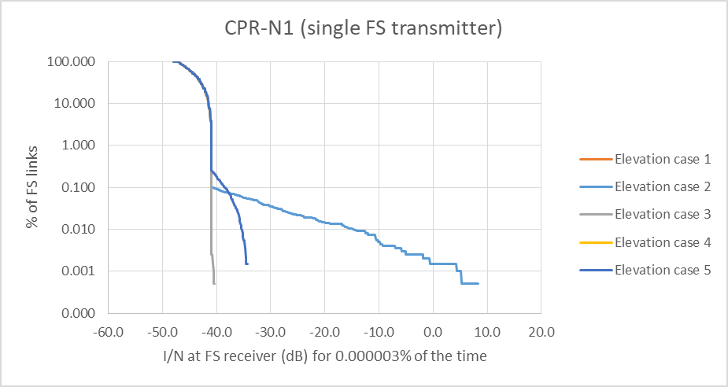

The Figure shows that for elevation distribution Cases 1 (typical), 3, 4 and 5, the interference received by all FS links is below −30 dB *I*/*N*.

For elevation Case 2, less than 0.01% of the FS links would experience *I/N* higher than −10 dB, noting that such *I*/*N* value is the long-term protection criteria for FS (20% of the time) whereas the calculation above relates to a very low percentage of 0.000003%.

Even the highest *I*/*N* calculated of 8 dB is quite low when considering short-term protection of FS, further noting that it would be experienced by FS links with elevation close to 90 degrees that would be very rare. In particular, at this frequency, FS link margins will be large to overcome high rain fade and will hence easily digest a maximum *I*/*N* = 8 dB for 0.000003% of the time.

One can conclude that the potential FS deployment in the 235-238 GHz band will be fully protected from the EESS (active) systems in the 237.9-238 GHz band.

### 6.4.6 Summary

The above studies address the possible sharing between FS/MS and EESS (active) and shows that both services will be fully protected.

One can hence conclude that a new FS/MS allocation in the 235-238 GHz band can be made in full compatibility with EESS (active) in the 237.9-238 GHz band.

## 6.5 Adjacent band compatibility between EESS (passive) and FS/MS at around 239.2 GHz

### 6.5.1 Context

Under agenda item 1.14, a new primary allocation to the EESS (passive) is proposed in the frequency bands 239.2-242.2 GHz that will be adjacent to the existing FS and MS allocations below 239.2 GHz.

Annex 1 proposes to address the adjacent band compatibility between EESS (passive) and Fixed/Mobile service at around 239.2 GHz.

### 6.5.2 Sharing between EESS (passive) (Conical scan) and FS

The sharing between EESS (passive) (Conical scan) and Fixed service is currently addressed in § 6.1 above showing that FS deployment will not be compatible with ICI operation in any portion of the 231.5-252 GHz band, with a negative margin of around 34 dB (for aggregate scenario).

One can therefore consider that, in an adjacent band scenario around 239.2 GHz, FS and EESS (passive) would be compatible if the unwanted emissions in the 239.2-242.2 GHz of FS stations operating below 239.2 GHz would be about 34 dB below their in-band emissions.

### 6.5.3 FS emissions masks

The FS emissions masks at around 239.2 GHz may be assessed based on existing information in close-by frequency bands, namely:

– Annex 2 to Report ITU-R [F.2416](https://www.itu.int/pub/R-REP-F/publications.aspx?lang=en&parent=R-REP-F.2416) – Technical and operational characteristics and applications of the point-to-point fixed service applications operating in the frequency band 275-450 GHz.

– Elements recently discussed in ITU-R Working Party 5C related to FS systems operating in bands from 94.1 GHz to 174.8 GHz, considering the annex to Document [5C/276](https://www.itu.int/md/R19-WP5C-C-0276/en).

The first reference provides the following FS spectrum mask taken from IEEE Std 802.15.3dTM-2017.

Figure 21

Generic transmit spectral mask

**PSD [dBr]**

**0**

**-20**

**-25**

**-f4**

**-f3**

**-f2**

**-f1**

**f1**

**f2**

**f3**

**f4**

**f-fc (GHz)**

**0**

It can be assumed that FS systems that may operate in the range 231.5-239.2 GHz in the future would make use of a maximum bandwidth of 2 GHz, hence leading to a quite rapid roll-off of 30 dB within less than 1 GHz as given in Table 20 (Table 4 of Report [ITU-R F.2416](https://www.itu.int/pub/R-REP-F.2416)).

TABLE 20

Transmit spectrum mask parameters (Table 4 of Report [ITU-R F.2416](https://www.itu.int/pub/R-REP-F.2416))

|  |  |  |  |  |
| --- | --- | --- | --- | --- |
| Channel bandwidth  (GHz) | $$f_{1}(GHz)$$ | $$f_{2}(GHz)$$ | $$f_{3}(GHz)$$ | $$f_{4}(GHz)$$ |
| 2.160 | 0.94 | 1.10 | 1.60 | 2.20 |

In addition, this mask being a standardisation mask, real emissions will more than likely be lower than the mask values, allowing to assume that FS emissions above 239.2 GHz would be compatible with EESS (passive) protection requirements.

Similarly, the second reference also addresses the emissions masks of FS stations above 100 GHz, depicting “ETSI relative spectral power density masks” as follows for lower and higher modulation schemes.

Figure 22

|  |  |
| --- | --- |
|  |  |
| (a) Lower modulation formats | (b) Higher modulation formats |

These Figures show a rapid roll-off of 30 to 45 dB of the FS emission masks. In this case also, considering their standardisation nature, real emissions will more than likely be lower than the mask values and allow to assume that FS emissions above 239.2 GHz would be compatible with EESS (passive) protection requirements.

### 6.5.4 Summary

Based on FS characteristics in bands above 100 GHz, the present annex allow to assume that FS emissions above 239.2 GHz would be compatible with EESS (passive) protection requirements.

Annex 1  
  
Methodology used to derive number of FS links   
on a population based deployment

1) Specific area of study

The area of study has been specified as follows:

– Centred on Paris (France)

– 340 km East to West

– 161 km South to North

– Total area of 5 4740 km²

This area is described in Fig. A-1.

Figure A-1

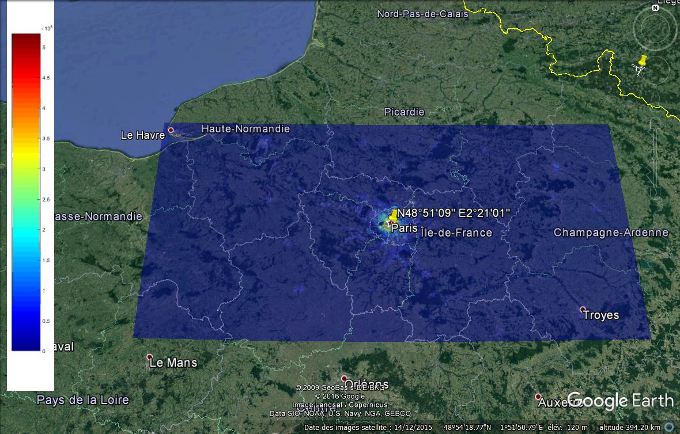

2) Spatial distribution of FS links

Taking into account the above elements, the FS links are distributed in the study area.

For each km², the number of FS links is determined by multiplying the number of inhabitants by the FS density/inhabitant (i.e. 0.000351), the final figure being rounded to the closest integer.

In total, 4 415 FS links are distributed in the study area. Figure A-2 depicts the spatial distribution of these FS links over the study area.

Figure A-2

Distribution of FS links over the study area

3) Distribution of FS links in the EESS (passive) footprints

For each of the EESS (passive) sensor, the number of FS links in the footprint is determined by placing the footprint at the centre of the study area.

Figure A-3 depicts the spatial distribution of the FS links over the EESS (passive) footprint, taking the example of ICI System (11 × 18 km IFOV, 155 km²). It leads to a number of 1 051 FS links deployed over its footprint.

Figure A-3

Distribution of FS links in the EESS (passive) footprint

1. Data retrieved from <https://spec.jpl.nasa.gov/>. Spectral line lists are not fully exhaustive, and only list those with the strongest intensities.