|  |
| --- |
| **Report ITU-R S.2222**  **(10/2011)** |
| **Cross-layer QoS for IP-based hybrid satellite-terrestrial networks** |
| **S Series**  **Fixed satellite service** |

Foreword

The role of the Radiocommunication Sector is to ensure the rational, equitable, efficient and economical use of the radio-frequency spectrum by all radiocommunication services, including satellite services, and carry out studies without limit of frequency range on the basis of which Recommendations are adopted.

The regulatory and policy functions of the Radiocommunication Sector are performed by World and Regional Radiocommunication Conferences and Radiocommunication Assemblies supported by Study Groups.

# Policy on Intellectual Property Right (IPR)

ITU-R policy on IPR is described in the Common Patent Policy for ITU-T/ITU-R/ISO/IEC referenced in Annex 1 of Resolution ITU-R 1. Forms to be used for the submission of patent statements and licensing declarations by patent holders are available from <http://www.itu.int/ITU-R/go/patents/en> where the Guidelines for Implementation of the Common Patent Policy for ITU‑T/ITU‑R/ISO/IEC and the ITU-R patent information database can also be found.

|  |  |
| --- | --- |
| Series of ITU-R Reports  (Also available online at <http://www.itu.int/publ/R-REP/en>) | |
| **Series** | Title |
| **BO** | Satellite delivery |
| **BR** | Recording for production, archival and play-out; film for television |
| **BS** | Broadcasting service (sound) |
| **BT** | Broadcasting service (television) |
| **F** | Fixed service |
| **M** | Mobile, radiodetermination, amateur and related satellite services |
| **P** | Radiowave propagation |
| **RA** | Radio astronomy |
| **RS** | Remote sensing systems |
| **S** | **Fixed-satellite service** |
| **SA** | Space applications and meteorology |
| **SF** | Frequency sharing and coordination between fixed-satellite and fixed service systems |
| **SM** | Spectrum management |

|  |
| --- |
|  |

|  |
| --- |
| ***Note****: This ITU-R Report was approved in English by the Study Group under the procedure detailed in Resolution ITU-R 1.* |

*Electronic Publication*

Geneva, 2011

© ITU 2011

All rights reserved. No part of this publication may be reproduced, by any means whatsoever, without written permission of ITU.

REPORT ITU-R S.2222

Cross-layer QoS for IP-based hybrid satellite-terrestrial networks

(Question ITU-R 287/4)

(2011)

TABLE OF CONTENTS

Page

1 Introduction 5

2 Hybrid network reference architecture 5

2.1 Hybrid satellite-WiFi network architecture 6

2.2 Hybrid satellite-WiMAX network architecture 7

2.2.1 Hybrid satellite-WiMAX network protocol architecture 7

3 IP-based satellite networks 8

3.1 DVB-S2 system description 9

3.2 DVB-RCS system 9

3.3 DVB-RCS+M reference model 10

4 Cross-layer design methodologies 10

4.1 Satellite protocol stack: Example 12

4.2 Cross layer protocol model 12

4.3 Cross layer design approaches 13

4.3.1 Explicit cross layer design 14

4.4 Cross layer protocol interactions 15

4.4.1 PHY and MAC layer interactions 15

4.4.2 PHY and network layer interactions 16

4.4.3 MAC and network layer interactions 16

4.4.4 MAC and transport layer interactions 16

4.4.5 Interactions among PHY, MAC and higher-layers 17

5 Cross-layer design of IP-based satellite networks subject to rain fading 17

5.1 Rain fading impact on IP-based satellite networks 17

Page

6 Satellite-cellular network 19

6.1 Description of satellite connection in support of cellular system 19

6.2 Circuit-based cellular system 20

6.3 IP-based cellular system 21

7 Conclusions 23

8 References 23

List of acronyms

3G Third Generation

4G Fourth Generation

AAL ATM adaptation layer

ACK Acknowledgment

ACM Adaptive coding and modulation

AMR-WB Adaptive multirate wideband

APP Application

APSK Amplitude phase shift keying

ARQ Automotive repeat request

ASN Access service network

ATM Asynchronous transfer mode

AVBDC Absolute volume base dynamic capacity

AWGN Additive white Gaussian noise

BDP Bandwidth delay product

BPSK Binary phase-shift keying

BSC Base station control

BTS Base transceiver station

CBM Centralized bandwidth manager

CCM Constant coding and modulation

CIR Committed information rate

CRA Continuous-rate assignment

CS Cell station

DAMA Demand assignment multiple access

DBRA Dynamic bandwidth and resource allocation

DVB Digital video broadcast

DVB-RCS Digital video broadcast – Return channel by satellite

DVB-RCS+M DVB-RCS extension to mobile broadband

DVB-S Digital video broadcast by satellite

DVB-S2 Digital video broadcast – Satellite transmission 2nd generation

ETH Ethernet

ETSI European Telecommunications Standards Institute

FCA Free capacity assignment

FEC Forward error correction

FSS Fixed satellite service

FTP File transfer protocol

GEO Geostationary Earth orbit

GSM Global System for Mobile Communications

GT Gateway terminal

GW Gateway

HDTV High definition TV

HTTP Hyper text transfer protocol

ICMP Internet control message protocol

IEEE Institute of Electrical and Electronics Engineers

IMS IP multimedia subsystem

IMSI International mobile subscriber identity

IP Internet Protocol

ISO International Standards Organization

ITU-R ITU Radiocommunication Sector

ITU-T ITU Telecommunication Standardization Sector

LDPC Low density parity check

LoS Line of Sight

MAC- CS MAC convergence sublayer

MAC Medium access control

MAC-CPS MAC Common Part Sublayer

MES Mobile Earth Station

MF-TDMA Multiple-frequency time-division multiple access

MMD Multi media domain

MPDU MAC packet data unit

MPEG Moving Picture Experts Group

MSC Mobile switching center

MSS Mobile satellite service

NCC Network control center

OFDM Orthogonal frequency division multiplexing

PER Packet error rate

PES Personal Earth station

PHY Physical layer

PS Personal station

PSK Phase shift keying

PSTN Public switched telephone network

QoS Quality of Service

QPSK Quadrature phase-shift keying

RBDC Rate base dynamic capacity

RCST Return channel satellite terminal

RRA Radio resource allocation

RRC Radio resource control

RRM Radio Resource Management

RT Real time

RTO Retransmission on time out

RTP Real time protocol

RTT Roundtrip time

SIP Session initiation protocol

SI-SAP Satellite independent service access point

SLA Service level agreement

SLC Satellite link control

SMAC Satellite medium access control

SNIR Signal to noise interference ratio

SPHY Satellite physical

TCP Transmission control protocol

TDM Time division multiplexing

TDMA Time-division multiple access

ToS Type of Service

TV Television

UDP User datagram protocol

UE User equipment

UHF Ultra high frequency

VBDC Volume base dynamic capacity

VCM Variable coding and modulation

VHF Very high frequency

VoIP Voice over internet protocol

WAP Wireless access point

WiFi Wireless fidelity (products based on IEEE 802.11 standards)

WiMAX Worldwide interoperability for microwave access

# 1 Introduction

This Report presents hybrid network reference architecture including satellite segment of DVB‑S2/RCS links and terrestrial WiFi/WiMAX segments followed by discussions of DVB satellite network protocols. The cross-layer design approaches and protocol layer interactions including rain fading mitigation techniques are described. A description of satellite connection supporting circuit based as well as IP-based cellular system is provided.

# 2 Hybrid network reference architecture

Figure 1 shows a hybrid satellite-wireless network operating at Ka band to support multimedia applications. Various scenarios could include a Geostationary Earth Orbit (GEO) satellite system with DVB-S2/RCS air interface connected with either a WiFi and/or a WiMAX terrestrial segment. As shown in this figure DVB‑Return channel satellite terminals (RCST’s) could also directly support applications such as VoIP, streaming multimedia, video conferencing, and bulk data transfer. The system is composed of gateway terminals (GTs), RCST’s and network control and management center. The forward link, i.e. from the gateway to user terminal (solid blue arrows) follows DVB-S2 with adaptive coding and modulation (ACM). The return link from terminal to gateways (dashed red arrows) is based on DVB-RCS.

FIGURE 1

DVB-S2/RCS and WiFi/WiMAX Network

**HUB/GT**



**WiMAX**

**RCST2**

**RCST1**

**WAP**

Internet

**DVB‐S2** Satellite Transmission 2nd Generation

**DVB‐RCS**: DVB Return Channel by Satellite

**WAP**: Wireless Access Point

**RCST**: Return Channel Satellite Terminal **WAP**: Wireless Access Point; **RCST**: Return Channel Satellite Terminal

The DVB-S2 features two main enhancements compared with its predecessor, DVB-S. First, it introduces an improved physical layer, offering several higher order modulation waveforms with more powerful forward error correction (FEC). Secondly, it supports real-time adaptation to link and propagation conditions. It supports 28 combinations of modulation format and coding schemes to guarantee a low packet error rate across a wide range of signaled noise plus interference ratio (SNIR). The three operational modes supported include (a) constant coding and modulation (CCM) (b) variable coding and modulation (VCM) and (c) adaptive coding and modulation (ACM).

DVB-RCS used on the return link implements multi-frequency time division multiple access (MF‑TDMA) and adaptive coding. The return link MF‑TDMA enables it to have bi-dimensional framing in which every time-frequency window is portioned into carriers, super frames, frames and slots. The MF-TDMA return link is coded with concatenated Convolution and Reed Solomon codes. The data may be encapsulated in Asynchronous Transfer Mode (ATM) cells using ATM Adaptation layer 5 or it may use native IP encapsulation over MPEG-2. These protocols allow IP traffic transmission over the physical layer which is used in simulation experiments. Rain becomes the most affecting atmospheric event for transmission in the Ka band. Therefore, the effect of fading on various MAC and application layer parameters using cross-layer design approach must be evaluated. The differentiated services (DiffServ) model is assumed to prioritise IP based networks interfacing with WiFi and WIMAX segments.

## 2.1 Hybrid satellite-WiFi network architecture

To provide broadband connectivity to areas of both low population density network (i.e. rural areas) and high population density (i.e. suburban and urban areas) hybrid networks composed of both satellite and terrestrial radio access technologies.

Figure 2 shows satellite-terrestrial wireless network protocol architecture. The wireless segment can use the protocols such as GSM, 3G, WiFi, WiMAX, and 4G. Both the satellite segment and the terrestrial network will provide resource allocation algorithms and a control management system.

FIGURE 2

Satellite – Wireless network protocol architecture

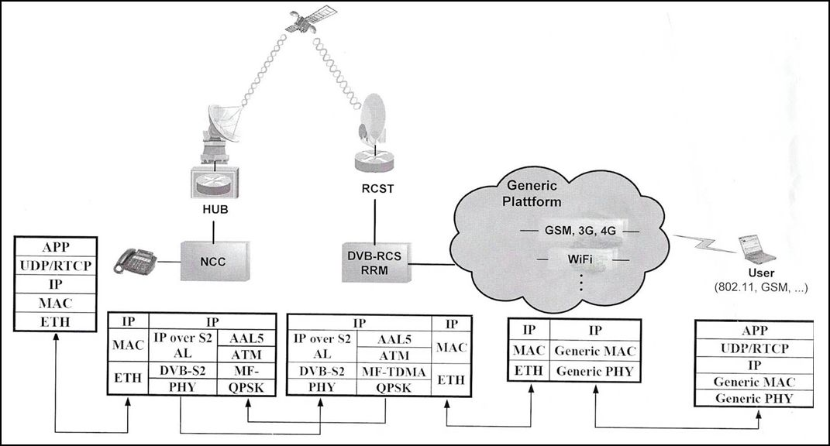

Other components in the network architecture include the access service network gateway, and the DVB-RCS Radio Resource Management (RRM). The RRM of the satellite terminal check if enough resources are available to enable admission of new user equipment requesting services from the gateway to the satellite link. The RCST communicates with the Hub, which is associated to a network control center (NCC). The NCC controls the interactive network, user service request via satellite access and manages the satellite spectrum depending on the satellite terminals requests.

## 2.2 Hybrid satellite-WiMAX network architecture

Figure 3 shows hybrid satellite network using DVB-S2/RCS terminals connected with a WiMAX network.

FIGURE 3

Hybrid DVB-S2/RCS satellite-WiMAX network

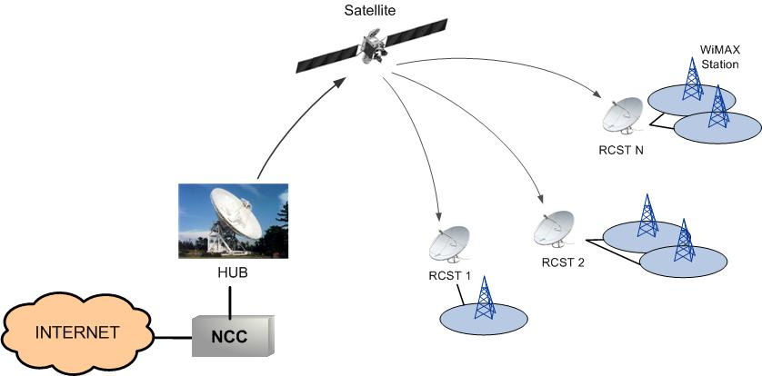

### 2.2.1 Hybrid satellite-WiMAX network protocol architecture

Figure 4 shows the hybrid satellite-WiMAX network protocol architecture. The terrestrial link is based on IEEE 802.16, where a user in the core network directs traffic (e.g. VoIP conversation) to a mobile user, called user equipment (UE). The UE is placed in an area serviced by WiMAX network. The Base Station (BS) is responsible of the IEEE.802.16 connectivity through the radio link to UE located inside its coverage area. An adaptive physical layer maximizes the data rate by adjusting transmission modes to channel variations while maintaining a prescribed packet error rate (PER). The WiMAX RRM is in charge of utilizing the limited radio spectrum resources and radio network infrastructure of its associated BS efficiently using strategies and algorithms for controlling parameters. Figure 4 includes the Access Service Network (ASN) gateway, and the DVB-RCS RRM. The RRM of the satellite terminal checks if enough resources are available to enable admission of new UEs requesting services from the gateway to the satellite link. The RCST communicates with the Hub, which is associated with a NCC. The NCC controls the interactive network, user service requests via satellite access and manages the satellite spectrum depending on the satellite terminals requests. The protocol stack of the WiMAX RRM consists of three sub layers forming the whole MAC layer. The Convergence Sublayer (MAC-CS) provides the transformation or mapping of external network data (e.g. Ethernet, IP.). The Common Part Sublayer (MAC-CPS) performs packing into MAC packet data unit (MPDU) of information coming from MAC-CS, and the Privacy Sub layer, provides authentication, key exchange and data encryption. Main features of the IEEE 802.16 Physical layer are the utilization of orthogonal frequency division multiplexing (OFDM), time division multiplexing (TDM) and power control in the S-Band (principally around 3.5 GHz). MAC-CPS is the core of MAC layer. It provides QoS, manages bandwidth, multiplex VoIP flows directed to the BS, establishes and maintains the connection, performs FEC, and enables automatic repeat request (ARQ) mechanisms.

Figure 4

Reference architecture and protocol stack for IEEE 802.16e-2005 / DVB-RCS network

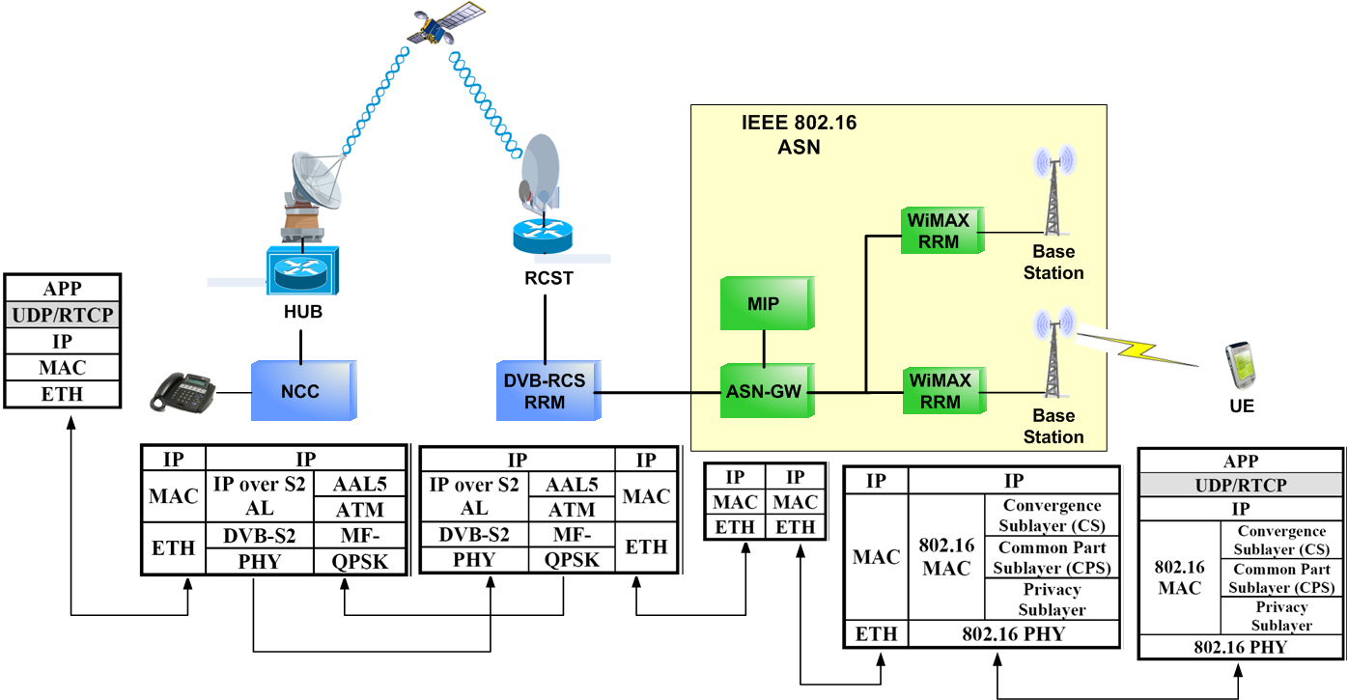

Several ASN profiles have been specified in WiMAX as a tool to manage diversity node usage and implementation:

– Profile A: Centralized ASN model with ASN-GW and BS in separate platforms with split RRM. Radio resource allocation (RRA) in BS and radio resource control (RRC) in the gateway.

– Profile B: BS and ASN-GW functionalities implemented in a single platform.

– Profile C: Separate platforms, with the RRM controlled by the BS.

Profile A is suitable for soft handover, used in high speed mobiles, where the typical users are mobiles inside a rural area. Although profile B is the most simple, operators prefer separate platforms, as it is easier to customize IP and wireless functions. Profile C includes, the ASN-GW between the two RRM, i.e. in the satellite terminal and the WiMAX network. It allows an interaction between both and manages the resources in a friendly way. This option allows each BS to manage the IEEE 802.16 service within its area, while the RCST carries out the resource assignment of all ASNs. The ASN-GW incorporates the mobile IP, to provide an efficient and scalable mechanism for roaming within the Internet.

# 3 IP-based satellite networks

Figure 5 shows an IP-based DVB-S2/RCS network in which user data is multiplex and broadcast over satellite in MPEG packets. The end-user’s return channel satellite terminal (RCST) receives the data. User requests for communications towards the terrestrial network are sent via satellite to the DVB-RCS gateway. The DVB-RCS system is based on an asymmetry in bandwidth for the broadcasting and the return channel.

FIGURE 5

IP-based satellite DVB network

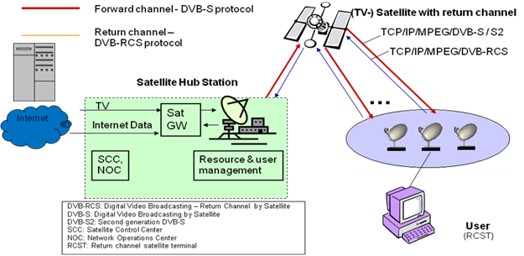

## 3.1 DVB-S2 system description

DVB-S2 is the second-generation DVB specification for broadband satellite application, developed to improve the performance of DVB-S developed for broadcasting and DVB-DSNG for satellite news gathering. It has been developed for services; a) broadcast service for standard definition TV and HDTV, b) interactive service including Internet Access for consumer applications, c) professional applications, such as Digital TV contribution and News Gathering, TV distribution to terrestrial VHF/UHF transmitters, Data Content distribution and Internet Trunking.

The DVB-S2 standard has been specified to provide best transmission performance, flexibility and less receiver complexity. To achieve the best performance-complexity trade-off, DVB-S2 adopts low density parity check codes (LDPC) for channel coding and modulations of QPSK, 8PSK, 16 APSK and 32 APSK. The results are typically a 30% capacity increase over DVB-S under the same transmission conditions. In addition, for broadcasting applications, DVB-S2 is not constrained to the use of QPSK and therefore it can deliver significantly higher bit rates over high power satellites, thus still increasing capacity gain with respect to DVB-S. Furthermore, for interactive point-to-point applications like IP unicasting, the gain of DVB-S2 over DVB-S is even greater: VCM functionality allows different modulation and error protection level to be used and changed on a frame-by-frame basis. This may combined with use of a return channel to achieve closed-loop ACM, thus allowing the transmission parameters to be optimized for each individual user, dependant on its own link conditions.

DVB-S2 is so flexible that it can cope with any existing satellite transponder characteristics, with large variety of spectrum efficiencies and associate *C*/*N* requirements. DVB-S2 accommodates any input stream format, including continuous bit-streams, single or multiple MPEG Transport Streams, IP as well as ATM packets.

## 3.2 DVB-RCS system

The DVB return channel via satellite (DVB-RCS) specifies RCST supporting a two way DVB satellite system. DVB-RCS uses MF-TDMA access scheme to share the capacity available for transmission by the user terminal. Two coding schemes are provided i.e. Turbo codes and concatenated code. In the case of the concatenated coding, the outer code is a Reed-Solomon (RS) code and the inner code is non-systematic convolutional code. The RCST implements both schemes. The DVB-RCS employs different resource allocation schemes depending on the traffic profiles. These are a) continuous rate assignment (CRA), b) rate based dynamic capacity (RBDC), c) volume based dynamic capacity (VBDC), d) absolute volume based dynamic capacity (AVBDC), and e) free capacity assignment (FCA).

## 3.3 DVB-RCS+M reference model

DVB-RCS+M is the mobility version of DVB-RCS to serve application environments such as maritime, aeronautical, railway and land vehicular. Figure 6 shows DVB-RCS+M model. DVB‑RCS+M has been developed to improve the system performance in mobile scenarios including re-transmissions for the return link, ACM/VCM under mobile conditions and signalling protection.

FIGURE 6

DVB-RCS+M model

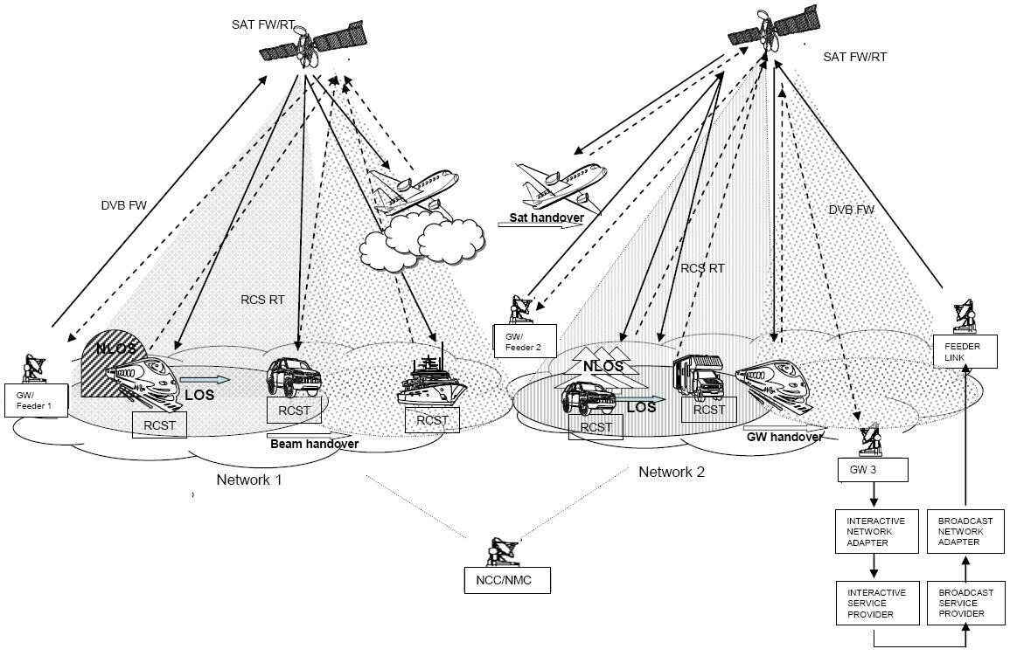

# 4 Cross-layer design methodologies

Satellites play a significant role in developing fully IP-based hybrid network architectures. The increasing demand for multimedia broadband services and high-speed internet services via satellite dictates development of new networking infrastructure and full understanding of protocols at each layer and their interactions. Satellite resources are expensive and satellite communications impose special constraints with respect to terrestrial systems in terms of attenuation, propagation delays, fading, etc., and whose behaviour becomes a very critical factor in supporting user service level agreements and Quality of Service (QoS) levels. To make the upcoming satellite network systems fully realizable, meeting new services and applications requirements, many technical challenges have to be addressed. For example, adaptive resource management advanced coding techniques and routing algorithms must be developed. To support end-to-end QoS, satellite IP QoS models and cross-layer interaction designs must be investigated.

To deploy state-of-the-art satellite technologies supporting media-rich applications, efficient utilization of radio resources and end-to-end QoS support are mandatory requirements. The need of efficiently utilizing satellite radio resources calls for innovative approaches that are based on a full-scale optimization of the satellite radio interface. A possible solution is represented by the cross-layer design where interactions among different protocol layers, even non-adjacent ones, are considered to improve the capacity of the air interface. The joint design of different protocol layers optimized for suitable operating conditions or the dynamic adaptation of different (even non-adjacent) layers allowing the direct communication between protocols at non‑adjacent layers or sharing state variables between layers known as cross-layer design. It is a design procedure actively exploiting the dependence between protocol layers to obtain performance gains. The cross-layer design of the air interface entails the possibility to exchange information even between non-adjacent layers. Such an approach can be particularly important to optimize the efficiency of resource management protocols in wireless networks including hybrid satellite- terrestrial environments.

Many satellite system architectures are being envisaged to be fully IP-based. The ISO/OSI reference model and the Internet protocol suite (i.e. transmission control protocol (TCP)/IP) are based on a layering paradigm. Each layer protocol solves a specific problem by using the services provided by modules below it and giving a new service to upper layers. The main disadvantages of the layered approach can be detailed as follows:

– User service requirements are provided by the communication system at the top-level. The hierarchy and the overall performance of the system is however dependent upon the lower‑layers.

– Lower-layer protocols have to interact with application layers. Information is lost during this layer by layer top-down conversion, which is particularly critical in the satellite scenario where packet loss occurs due to the error-prone radio channel.

– Layers are independently optimized. However, in many cases, close interaction among them should be considered. For instance, transport layer protocols need to take into account large propagation delays, link impairments, and bandwidth asymmetry.

A strict modularity and layer independence may lead to non-optimal performance in IP-based satellite communication systems. Furthermore, the growth of hybrid networks entails the need of adaptive actions. Finally, since both radio resources and power are strongly constrained, a network optimization is needed. Such an optimization is not guaranteed by the current layered protocol stack, where, for instance, error correction schemes are implemented at physical, link and (in some cases) transport layers. In this framework, an optimized cross-layer approach is required where interactions even between non-adjacent protocol layers are conceived to achieve a better adaptation to system dynamics.

Without a cross-layer design of the air interface a loss of system efficiency can occur due to the following issues:

– IP packets lost due to errors induced by wireless channel are interpreted as signals of congestion at the TCP level, thus lowering the bit-rate (congestion window, *cwnd*). A long time is needed to recover after a loss event especially when multiple losses occur that may cause a TCP timeout. This is particularly critical in a satellite scenario where it takes several Roundtrip times (RTT) before recovering the TCP output at the same level as before the loss event.

– Radio resources can be also allocated to mobile users that have bad channel conditions.

– Intra-and inter-satellite handoff procedures (with consequent re-routing) in non‑geostationary satellite constellations can take a long time which can lead to IP connection interruption with the risk of higher layer timeouts.

System efficiency is an important requirement for operators of satellite communications to provide services at competitive costs, allowing a mass-market penetration of satellite communications. Whereas, QoS support is mandatory for end users who do not care about resource utilization, but expect a good service level. System optimization and QoS support are typically conflicting needs. For instance, the best QoS condition for delay-intolerant variable bit-rate traffic is to have permanently allocated bandwidth corresponding to the peak traffic, thus causing significant system inefficiency. These conflicting needs can be solved by means of a suitable system design and by exploiting the multiplexing effect of packet data traffic.

In cross-layer design, for example, source compression at the application layer can improve with knowledge of the transmission rate being used at the link layer or the performance at network layer can be improved by looking both up and down the stack. The routing algorithm might add redundant links if the link layer provides an unreliable channel or if the QoS constraints from the application layer are particularly tight.

## 4.1 Satellite protocol stack: Example

Figure 7 shows an example of satellite network architecture in which lower layers depend on satellite system implementation (satellite-dependent layers) and higher layers are those typical of the internet protocol stack (satellite-independent layers). These two blocks of protocols are interconnected through the SI-SAP (satellite independent – service access point) Interface. Only a small number of generic functions need to cross the SI-SAP; in particular: address resolution, resource management, traffic classes QoS.

Figure 7

Satellite protocol stack architecture



## 4.2 Cross layer protocol model

This section provides cross-layer protocol modelling approaches to provision an end-to-end QoS in an IP-based satellite network.

Satellite communication system optimization calls for a vertical design of the air interface protocol stack. Such cross-layer approach requires interfaces across the layers, which exchange control information beyond the standard TCP/IP structure. Cross-layer interfaces can be within, between or beyond adjacent abstraction layers. Although interfaces between adjacent layers are in general preferable, there can be the need for efficient and direct interaction between non-adjacent layers; in general, a layer should be aware of the other layers of the protocol stack: cross-layer management/optimization. As shown in Fig. 8, Cross-layer information can be exchanged from higher to lower layers (top-down approach) or from lower to higher layers (bottom-up approach). To notify lower layer status (get function) and to control lower layer behaviour (set function) may improve the system performance.

Figure 8

Cross-layer exchange of control commands (signalling)



The exchange of information is performed through “send” and “receive” primitives. In a classic layered approach such exchange of information can be exerted only among adjacent layers. Non adjacent layers can communicate only involving intermediate layers. The novelty of the cross‑layer approach is to allow the exchange of control information (signalling) among non‑adjacent layers as shown in Figure 8. In particular, a “get function” can be used by lower layer protocols to notify their internal state to higher layer protocols; moreover, a “set function” can be adopted by higher layer protocols to change the state of lower layer protocols. Different solutions have been proposed to support the cross-layer exchange of signalling information. Some of the methods include where a “global coordinator” of the different layers is considered allowing to acquire status information from the different protocols to store it in a shared memory and to set the internal state of the protocols on the basis of suitable events (see § 4.3.1).

## 4.3 Cross layer design approaches

The cross-layer approaches can be distinguished in several typologies (a) creation of new interfaces beyond those between adjacent layers; (b) merging of adjacent layers; (c) joint design of protocols at different layers; (d) vertical calibration of the whole protocol stack. The different cross-layer schemes can be also classified according to the presence or absence of cross-layer signalling. Correspondingly, three different methods can be envisaged as follows:

– **Implicit cross-layer design** (above cases a, cand d): there is no exchange of signalling among different layers during operation, but in the design phase all the layers and interactions are taken into consideration in order to perform a joint protocol optimization.

– **Explicit cross-layer design** (above case a): signalling among (non-)adjacent protocol levels is used to achieve dynamic adaptations, involving together all (or many of) the protocol layers.

– **Combined approach**: an implicit approach is used to optimize the system in the normal operating conditions and the explicit method is adopted to perform adaptation according to system dynamics.

The joint protocol design of the implicit approach is a relatively simple task, requiring the optimization of the protocol stack in the design phase; no cross-layer signalling is involved and no violation to the OSI layering principia is required. The explicit cross-layer method is to allow the direct exchange of control information (signalling) among non-adjacent layers as shown in Fig. 1.

Two signalling directions are, one that is from higher to lower layers (top-down approach) and the other from lower to higher layers (bottom-up approach). Signalling can be realized with different approaches that are outlined below:

– *Packet headers*: This method makes use of packet headers as in-band message carriers. Since, a packet normally can only be processed layer-by-layer, this method can only be used in the top-down approach. This approach can be visualized like a “signalling pipe”.

– *ICMP messages*: Internet control message protocol (ICMP) is a widely-deployed signalling protocol in IP-based networks. Compared to the pipe described above, this method tries to “punch holes in the protocol stack” and propagates information across layers by using ICMP messages. A new ICMP message is generated only when a parameter changes beyond a given threshold. Since cross-layer communications are carried out through selected “holes” (not a general “pipe”), this method seems more flexible and efficient. However, an ICMP message is always encapsulated in an IP packet, and this indicates that the message has to pass by the network layer even if the signalling is only between link and application layers. This method is well suited for the bottom-up cross‑layer approach.

– *Network service*: In this scheme, channel and link states are collected, abstracted and managed by third parties, i.e. distributed servers. Interested applications then access the servers for their required parameters from the lowest two layers. Although there is not a cross-layer signalling scheme within a terminal, we can deem this scheme as complementary to the two above techniques. However, any intensive use of such method would introduce considerable signalling overhead and delays across a radio access network.

– *Local profiles*: In this method, local profiles are used to store periodically updated information. Cross-layer information is abstracted from each necessary layer and stored in separate ‘profiles’ within the hosts. Other interested layer(s) can then select the profile(s) to fetch the desired information.

### 4.3.1 Explicit cross layer design

Figure 9 shows an explicit cross-layer design methodology. The use of a global coordinator of the different layers is assumed to acquire internal state information from the different protocols and can set the internal state of the protocols as a response to suitable events e.g. buffer overflow, signal-to-noise ratio (SNR) variations, packet losses, timers expirations, selection of a new modulation and coding level, etc. A possible solution to implement the global coordinator is to use the management plane, which has interfaces with all the protocol layers. Hence, the management plane functionalities that are supported by current protocol stacks can be used to support cross-layering; this technique can be based on MAC layer needs (MAC-centric approach) or application layer needs (application-centric approach). Control plane signalling could be used to support the explicit notifications among protocol layers.

Figure 9

A *conceptual* cross-layer realization using a global coordinator



## 4.4 Cross layer protocol interactions

This section describes some of the layer interactions between PHY and MAC, MAC and network and PHY, MAC, TCP and application layers. Figure 10 shows the exchange of information between different layers through the signalling.

Figure 10

Cross-layer interactions



### 4.4.1 PHY and MAC layer interactions

It is important that resource allocation scheme be aware of the physical layer behavior and the related adoption of ACM. Access protocol parameters as well as scheduling techniques should have knowledge of the available transmission mode and radio channel conditions to select optimal choice. For example these considerations can be well suited to the DVB-S2 scenario for satellite broadcasting. DVB-S2 benefits from recent developments in channel coding such as LDPC codes combined with a variety of modulation formats, e.g. QPSK, 8PSK, 16APSK and 32APSK. For interactive applications, such as Internet navigation, adoption of the ACM allows optimization of the transmission parameters for each user on a frame-by-frame basis, depending on path conditions, under closed-loop control via a return channel (terrestrial or by satellite). During rain fades, more conservative transmission modes are employed (i.e. a lower order modulation level and a lower coding rate) thus reducing the information bit-rate available for users.

### 4.4.2 PHY and network layer interactions

In an IP network traffic management, user mobility should be adequately taken into account. For non-geostationary constellations, where a conversation incurs in many handoffs during its lifetime, intra- and inter-handoffs need to be properly managed to avoid high delay experienced by IP traffic. Hence, layer 2 protocol should provide a prioritized traffic management during user handoff phases. Moreover, efficient mobility management protocols have to be employed at layer 3 to prevent excessive delays in redirecting the data flows during handoff phases. Such delays would have a negative impact at the transport level with the risk of timeouts and significant TCP output reduction. Mobility management protocols could use motion prediction algorithms to define in advance the cell where user is moving to, which reduces the handoff delays.

### 4.4.3 MAC and network layer interactions

In IP-based networks QoS provisioning can be archived using according to two approaches: Integrated Services (IntServ) and Differentiated Services (DiffServ). It is important that resource allocation scheme at layer 2 manages traffic in a way that is compatible with that adopted at layer 3 using either IntServ or DiffServ. Following IntServ reserve resources are reserved through the RSVP protocol for each flow through the network. Current implementations of IntServ allow a choice of guaranteed service or controlled-load service. Whereas, the DiffServ approach achieves scalability by aggregating traffic into classes that are conveyed by means of IP-layer packet marking using the type of service (ToS) field in the IPv4 header or the Differentiated Service (DS) field in the IPv6 header. DiffServ prescribes treatment for aggregated traffic rather than for micro‑flows and forces much of the complexity out of the core network into edge devices, which process lower volumes of traffic and lower numbers of flows. Assured forwarding (AF), expedited forwarding (EF) and *background* traffic flows of the DiffServ scheme should have an adequate mapping at layer 2.

### 4.4.4 MAC and transport layer interactions

TCP is the prominent transport layer protocol. Used for assuring a reliable end-to-end data delivery over the internet. TCP controls at least 85% of all Internet traffic and runs only at the end-hosts. It is designed to utilize the available bandwidth for the source-destination pair in a fair and efficient way. However, the standard TCP congestion control mechanism is known to perform poorly over satellite links, due to both the large round-trip time and the possibly high packet error rates. Several enhancements of TCP were proposed to improve the performance over satellite links or network with larger bandwidth-delay product (BDP).

To improve TCP performance in an error-prone channel, we can consider TCP Reno that detects the loss of one segment as a consequence of three received duplicated ACKs. When three duplicated ACKs are received, TCP Reno halves the cwnd value and employs two phases namely fast retransmit and fast recovery to retransmit the lost data.

Different cross-layer mechanisms can be used in a satellite IP network to improve the performance at the TCP level. For example, let us refer to a DVB-S/DVB-RCS scenario: when a group of terminals, using TCP as transport protocol, are connected to the system gateway acting as network control centre (NCC), a capacity allocation strategy which does not take into account the TCP window fluctuating behavior may lead to an inefficient and unfair sharing of resources. An interesting approach is to synchronize the resource requests with the TCP window trend in order assign/remove dynamically capacity to terminals on the basis of the actual needs. This approach calls for a TCP-driven dynamic bandwidth and resource allocation (DBRA) to be operated at layer 2 so as to reduce the queuing delay at layer 2 and congestion phenomena with RTO expirations.

### 4.4.5 Interactions among PHY, MAC and higher-layers

Different traffic flows (e.g. real-time traffic and non-real-time traffic) produced by the application layer need to have specific service level Agreements (SLAs). A monitoring action should be jointly performed by application and MAC layers in order to control adaptively the service priority (top‑down approach). Conversely, the adaptation of modulation and coding levels employed at the PHY level should be back to the application layer to change dynamically the source generation bit‑rate (bottom-up approach). This adaptation in the source coding is important to avoid buffer overflow and loss of information at the source during a fade period.

# 5 Cross-layer design of IP-based satellite networks subject to rain fading

IP-based Hybrid networks designed for emerging broadband and mobile applications must provision QoS with parameters, such as guaranteed bandwidth, delay and delay jitter. The performance of applications such as video conferencing, VoIP, media streaming, web browsing, email and content distribution will be impacted by the rain fading. For example mitigation techniques using Architectures second generation DVB by satellite (DVB-S2) for the forward link and (DVB-RCS) on the return link must be considered.

## 5.1 Rain fading impact on IP-based satellite networks

One of the prominent features of DVB-S2 is its coding and modulation. It provides for normal (64 800 bits) and short (16 200 bits) FEC block lengths. Before a block of data can be transferred over the satellite link it must arrive at the staging station and be encapsulated in a FEC code block. This results in some delay, depending on the FEC frame length, the arrival rate of the data to be encoded and the allocated link bandwidth. Another interesting aspect of the coding and modulation is that it can be adaptively changed on a frame by frame basis for certain types of transport streams. The adaptation depends on receiving signal to noise + interference information at the sending station from the destination station(s). This feature is intended to help mitigate the effects of rain induced fading, especially for Ka and higher frequency bands.

Figure 11 shows exchange of information between the user satellite gateway and information provider during an Internet session by satellite forward link. IP using DVB-S2 using ACM adapts error protection on a user per user bases. The ACM routing manager employs the polling strategies and dynamically varies according to the traffic statistics, fading characteristics and the traffic policy of the service provider to appropriately provisioning the user QoS.

The rain fade mitigation involves cross layer interaction between the physical layer at the ground terminals whose received signal is affected by the rain fade and the MAC layer in the gateway which controls the coding and modulation of the forward stream of traffic directed to the affected ground terminal(s). During a rain fade event as the received *Es*/(*N*0 + *I*0) changes at a ground terminal which is noted by the physical layer and reported to the gateway MAC by sending special messages in the reverse direction. The gateway MAC responds by changing the coding and modulation of the traffic stream directed to the affected ground terminals in such a manner as to maintain the ground terminal’s bit error rate at an acceptable level. This is possible because at a given *Es*/(*N*0 + *I*0), within a suitable range, it is known that a certain FEC code rate and modulation will result in a certain bit error rate at the ground terminal(s). This relationship shown in Table 1 is designed to give an MPEG packet error rate of less than 1.0E-7. Also of interest is the user data rate efficiency versus *Es*/(*N*0 + *I*0) shown in Table 1.

FIGURE 11

IP service using a DVB-ACM link

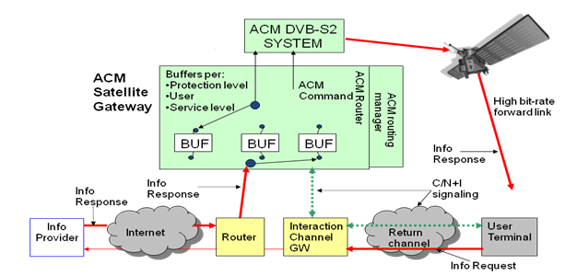

TABLE 1

Coding and modulation versus *Es* /(*N*0 + *I*0)

|  |  |  |  |
| --- | --- | --- | --- |
| Coding and Modulation | | | |
| *Es* /(*N*0 + *I*0) (dB) | DRu/N (bits/s)/(Symbols/s) | FEC_rate | Modulation |
| −2.5 | 0.50 | 1/4 | QPSK |
| −1.5 | 0.67 | 1/3 | QPSK |
| 0.0 | 0.80 | 2/5 | QPSK |
| 1.0 | 1.0 | 1/2 | QPSK |
| 2.2 | 1.20 | 3/5 | QPSK |
| 3.1 | 1.33 | 2/3 | QPSK |
| 4.0 | 1.50 | 3/4 | QPSK |
| 4.7 | 1.60 | 4/5 | QPSK |
| 5.2 | 1.67 | 5/6 | QPSK |
| 5.5 | 1.8 | 3/5 | 8PSK |
| 6.6 | 2.00 | 2/3 | 8PSK |
| 7.8 | 2.25 | 3/4 | 8PSK |
| 9.3 | 2.67 | 2/3 | 16APSK |
| 10.2 | 3.00 | 3/4 | 16APSK |
| 11.0 | 3,20 | 4/5 | 16APSK |
| 11.6 | 3.33 | 5/6 | 16APSK |
| 12.75 | 3.75 | 3/4 | 32APSK |
| 13.6 | 4.00 | 4/5 | 32APSK |
| 14.4 | 4.17 | 5/6 | 32APSK |
| 15.7 | 4.375 | 7/8 | 32APSK |
| 17.0 | 4.50 | 9/10 | 32APSK |

# 6 Satellite-cellular network

A cellular system has become one of the major telecommunication systems worldwide with user-friendly mobile terminals and its penetration speed exceeds a rate of terrestrial fixed-line system in some countries. The interworking system composed of satellite backhauling and cellular access network can provide communication services with merging the benefits of both systems. Some satellite systems have been already used or planned for transmission of the cellular network. The system architecture design and the parameters employed by the existing and/or planned satellite systems would be quite useful as the design examples or references in satellite systems providing transmission of the cellular network.

The satellite is in geostationary orbit with a star topology, assuming transmission in the Ku-band (12-18 GHz). A TDM broadcast downstream channel from a central hub location is shared by a number of remote nodes. The upstream transmission implements a TDMA by which the remote nodes transmit to the hub on one or more shared carriers. The air-interface for the cellular system is one of standardized systems such as GSM, CDMA2000, WCDMA, etc.

Recommendation ITU-R M.818 describes a satellite component within International Mobile Telecommunication-2000 (IMT-2000) that includes mobile links, distribution services links and FSS connections in support of IMT-2000 as shown in Figure 12. Although a mobile-satellite service (MSS) is included in Figure 9, the major emphasis of this contribution is to address the use of a fixed-satellite service (FSS) connection.

FIGURE 12

Examples for satellite operation involved with IMT-2000



## 6.1 Description of satellite connection in support of cellular system

The following diagram shows a simplified architecture in a cellular system, which consists of three sub-systems of an access network, a cellular core network, and a public network. The cellular core network includes a base transceiver station (BTS), a base station controller (BSC), a mobile switching center (MSC), and a satellite system as a backhaul line. BTS provides an air interface for mobile handsets, BSC controls BTSs and the call processing, and MSC handles the call processing to the public switched telephone network (PSTN). The mobile handset will be placed in underserved areas by a terrestrial mobile network (remote and rural areas, islands, vessels, etc.).

The satellite systems including both FSS and MSS will be used as a backhaul link among these nodes. Figures 13 and 14 show satellite links connecting BTS and BSC (case 1), and BSC and MSC (case 2), respectively.

Case 1 will be suitable for controlling a small number of dispersed BTSs at the same BSC. It should be noted that a satellite terminal is required for each BTS. When several BTSs are deployed at a short distance, case 2 will be used, in which all traffic is concatenated at a single BSC and then forwarded to the satellite portion. The advantage of case 2 is to reduce the number of satellite terminals even if the same number of BTSs are deployed as in case 1. The system model to be used would depend on an operational policy of the telecommunication company.

FIGURE 13

Satellite connecting BTS and BSC (case 1)



FIGURE 14

Satellite connecting BSC and MSC (case 2)



## 6.2 Circuit-based cellular system

The conventional cellular system has been designed to adopt the circuit-based protocol with a physical layer of T1/E1. The cellular system based on the circuit switched scheme requires an always-connected satellite link in order to transmit all slots in the physical layer, in which user or signalling traffic is included. Once the satellite links are established, the satellite bandwidth is unchanged for both cases 1 and 2.

When the circuit-based cellular system is partly combined with the IP-based satellite system, satellite resources can be efficiently used considering effective slots in the physical layer.

All slots in T1/E1 are not always occupied when a limited number of mobile handsets are originating their calls. If all slots including idle slots are converted into IP packets, unnecessary IP packets are emerged, which results in the waste of the satellite resource.

A dedicated equipment such as a T1/E1-IP protocol converter can detect idle slots and encapsulate effective slots into IP packets and vice versa, leading to efficient use of the satellite resource.

## 6.3 IP-based cellular system

The transmission protocol in the cellular core network has been gradually migrated from the circuit‑based one to the IP-based one. Although the conventional signalling protocol requires the full-time connection to frequently transmit signalling messages, the session initiation protocol (SIP) signalling – an application-layer signalling protocol used in the IP-telephony system – is capable of greatly reducing the signalling traffic and efficiently utilizing the satellite resource. It is also adopted for a signalling protocol for next-generation cellular systems including IP multimedia subsystem (IMS) and multimedia domain (MMD). In the packet-based system, TCP/UDP/IP is used to transmit data traffic, messaging and signalling. Real‑time transport protocol (RTP) streams along with a voice encoding are used to carry voice traffic. When no active handsets connect to BTS, there is no traffic towards the cellular core network, excluding a periodic keep-alive reporting once every ten minutes, for example.

Figure 15 shows the architecture of the IP-based system with a protocol stack for the case 1. The IP‑based cellular system allows delivering voice traffic as IP packets as well as data traffic together with a SIP signalling in the IP network. It should be noted that the protocol used in the access network is the cellular-specific one, which is implemented in current mobile handsets and ensures the voice quality between a mobile handset and a BTS.

Voice stream and the cellular-specific signalling are converted into VoIP packets and the SIP messages at BSC, respectively. Also converted is the address of the mobile handset. Each mobile handset has its own telephone number or the international mobile subscriber identity (IMSI), but actually a SIP – uniform resource locator (SIP-URL) is used in the IP-based cellular system. Both user and signalling traffic are transmitted in the satellite link, then forwarded to the MSC. The protocol is again converted from the IP-based one to the cellular-specific one at MSC.

FIGURE 15

Architecture of IP-based system with protocol stack



The satellite system employing a bandwidth assignment on a demand basis is the best combination with the IP-based cellular system. Such system always keeps a certain satellite resource (for example, 8 kbit/s) to manage remote terminals or to ensure the committed information rate (CIR) for users. Note that not considered is a demand assignment multiple access (DAMA) system with call setup based on the multiple access scheme. In combination with the cellular system, the satellite system with the demand-basis bandwidth assignment can also keep connecting the signalling traffic in cellular system by assuring the minimum resource in the satellite system.

The bandwidth assignment in the satellite system is controlled by the centralized bandwidth manager (CBM). Downlink bandwidth is determined by continuously evaluating network traffic flow to remote terminals. The CBM assigns bandwidth and controls the transmission of packets for each remote terminal according to the QoS parameters defined for each remote downlink.

Uplink bandwidth is requested continuously with each TDMA burst from each remote terminal (remote bandwidth manager). The CBM integrates the information contained in each request and produces a TDMA burst time plan which assigns individual bursts to specific remote terminals. The burst time plan is produced once per TDMA frame.

Some satellite system implements a packet scheduling to support time-sensitive and non-critical applications on an instantaneous basis, because the satellite bandwidth is not sufficient. The packet scheduling is achieved by transmitting queued packets in a pre-determined order. The queue types are a priority queue, a class-based weighted queue, and a best-effort queue, for example. A QoS class is defined as a set of a queue type and a priority level in each queue. For example, a QoS class of VoIP implements the priority queue with the highest level priority, since VoIP traffic is time‑sensitive. A signalling message will be transmitted with a QoS class of a middle-level priority. Best effort queues are only served if there are no packets waiting in the priority queue and the class‑based weighted queue.

When an outgoing or incoming call is originating, the remote or centralized bandwidth manager in the satellite system requests a bandwidth expansion to transmit both the signalling and user traffic together with appropriate QoS parameters. The QoS class of voice traffic should be VoIP in order to ensure the voice quality in the satellite links, which enables the satellite modem to process voice traffic at the highest priority.

Figure 16 shows an example of the bandwidth allocation depending on the originating traffic. The minimum bandwidth of 8 kbit/s is allocated in idle states, while much bandwidth is allocated with increasing voice channels.

FIGURE 16

Bandwidth allocation with QoS parameter in satellite system depending on originating traffic



# 7 Conclusions

Hybrid networks composed of satellite and terrestrial segments provide broadband connectivity to low densely populated areas such as suburban and rural areas. Supporting multi service transport such as VoIP, video conferencing, video streaming and data on a converged IP-based networks require compliance with the stringent QoS requirements e.g. bandwidth, delay, and delay variations. This becomes more vital in the case of systems operations under fading conditions. The current protocol suites for ISO/OSI and TCP/IP are based on a layering paradigm. These protocols are based on a strict modularity and layer independence which leads to non-optimal performance in an IP-based satellite networks. As radio resources and power are strongly constrained a satellite network optimization is required. Therefore an optimized cross layer approach must be used in systems design for QoS provisioning.

# 8 References

[1] ETSI EN 300 421 V1.1.2 (1997-08), ”Digital Video Broadcasting (DVB): Framing structure, Channel coding and modulation for 11/12 GHz satellite services.

[2] ETSI EN 302 307 V1.1.2, ”Digital Video Broadcasting (DVB); Second generation framing structure, Channel coding and modulation systems for broadcasting Inter active services, News gathering and other broadband satellite applications” European Telecommunication Standards Institute (ETSI), June 2006.

[3] ETSI EN 301,790 V1.4.1, ”Digital Video Broadcasting (DVB): Interaction Channel for Satellite distribution Systems”, European Telecommunication Standards Instruction (ETSI), September 2005.

[4] ETSI EN 301, 790 V1.5.1, ”Digital Video Broadcasting (DVB): Interaction Channel for Satellite distribution Systems”, European Telecommunication Standards Instruction (ETSI), July 2008.

[5] Recommendation ITU-R M.818, “Satellite operation within International Mobile Telecommunications‑2000 (IMT-2000)”.

[6] Recommendation ITU-R M.1073, “Digital cellular land mobile telecommunication systems”.

[7] Recommendation ITU-R M.1167, “Framework for the satellite component of International Mobile Telecommunications-2000 (IMT-2000)”.

[8] Recommendation ITU-R M.1457, “Detailed specifications of the terrestrial radio interfaces of International Mobile Telecommunications-2000 (IMT-2000)”.

[9] Recommendation ITU-R M.1741, “Methodology for deriving performance objectives and its optimization for IP packet applications in the mobile-satellite service”.

[10] Recommendation ITU-R S.1711, “Performance enhancements of transmission control protocol over satellite networks”.

[11] ITU-T Recommendation Y.1540, “Internet protocol data communication service – IP packet transfer and availability performance parameters”.

[12] ITU-T Recommendation Y.1541, “Network performance objectives for IP-based services”.

[13] 3GPP2 A.S0003-A, “BTS-BSC inter-operability (Abis interface)”.