Report ITU-R S.2461-0
(07/2019)
Spectrum needs for the fixed-satellite service in the 51.4-52.4 GHz band

S Series
Fixed-satellite service

Foreword
The role of the Radiocommunication Sector is to ensure the rational, equitable, efficient and economical use of the radio-frequency spectrum by all radiocommunication services, including satellite services, and carry out studies without limit of frequency range on the basis of which Recommendations are adopted.
The regulatory and policy functions of the Radiocommunication Sector are performed by World and Regional Radiocommunication Conferences and Radiocommunication Assemblies supported by Study Groups.

Policy on Intellectual Property Right (IPR)
ITU-R policy on IPR is described in the Common Patent Policy for ITU-T/ITU-R/ISO/IEC referenced in Resolution ITU-R 1. Forms to be used for the submission of patent statements and licensing declarations by patent holders are available from http://www.itu.int/ITU-R/go/patents/en where the Guidelines for Implementation of the Common Patent Policy for ITU-T/ITU-R/ISO/IEC and the ITU-R patent information database can also be found.

Series of ITU-R Reports
(Also available online at http://www.itu.int/publ/R-REP/en)
Series | Title
BO | Satellite delivery
BR | Recording for production, archival and play-out; film for television
BS | Broadcasting service (sound)
BT | Broadcasting service (television)
F | Fixed service
M | Mobile, radiodetermination, amateur and related satellite services
P | Radiowave propagation
RA | Radio astronomy
RS | Remote sensing systems
S | Fixed-satellite service
SA | Space applications and meteorology
SF | Frequency sharing and coordination between fixed-satellite and fixed service systems
SM | Spectrum management

Note: This ITU-R Report was approved in English by the Study Group under the procedure detailed in Resolution ITU-R 1.

Electronic Publication
Geneva, 2019
© ITU 2019
All rights reserved. No part of this publication may be reproduced, by any means whatsoever, without written permission of ITU.

REPORT ITU-R S.2461-0
Spectrum needs for the fixed-satellite service in the 51.4-52.4 GHz band
(2019)

1 Introduction
This Report presents studies in response to resolves to invite ITU-R 1 of Resolution 162 (WRC-15), to conduct “studies considering additional spectrum needs for development of the fixed-satellite service, taking into account the frequency bands currently allocated to the fixed-satellite service, the technical conditions of their use, and the possibility of optimizing the use of these frequency bands with a view to increasing spectrum efficiency”.
The Report contains background information on the concepts of frequency re-use and spot beam technologies considered in Resolution 162 (WRC-15). The Report presents also the current status of fixed-satellite service (FSS) allocations in the 50/40 GHz bands and explains the need for the proposed new 1 GHz FSS allocation. Two examples of applications that can be envisaged to implement broadband FSS systems in the 50/40 GHz allocations if the frequency band 51.4-52.4 GHz is effectively allocated to this service. In addition, a comparative assessment of signal propagation loss in the FSS (Earth-to-space) radio links in the frequency range 50/40 GHz is presented.

2 Background
Resolution 162 (WRC-15) considers in a) “that satellite systems are increasingly being used to deliver broadband services and can help enable universal broadband access” and in c) “that technological developments such as spot-beam technologies and frequency reuse are used by the fixed-satellite service in spectrum above 30 GHz to increase the efficient use of spectrum”.
This section provides an overview of such FSS satellite systems, including examples of operational networks already providing similar broadband access services in Ka-band.
According to the State of Broadband report from 2015, 57 per cent of the world’s population remain offline. The report specifically highlights the discrepancy of coverage in rural areas and notes that “the latest advances in satellite technology are playing a key role in helping deliver broadband to rural and isolated areas”. The report notes that satellites enable the immediate connection of many subscribers to broadband and Internet backbone networks with just one launch, rather than a point-by-point roll-out.

2.1 Frequency re-use and spot beam technologies: technological basis of High Throughput Satellites
High throughput satellites (HTS) are satellites that have many times the throughput of traditional FSS satellites using the same amount of allocated spectrum, leading to a reduction in the Gbit/s (Gigabits per second) cost, as explained in Report ITU-R S.2361. This is achieved through frequency re-use by covering a given geographical area with a number of spot beams instead of using traditional wide beams. See Fig. 1 for a comparison of a traditional satellite beam coverage area versus one where a HTS utilizes spot beam technology and frequency re-use.
Figure 1
Illustration of HTS spot beam technology and frequency re-use
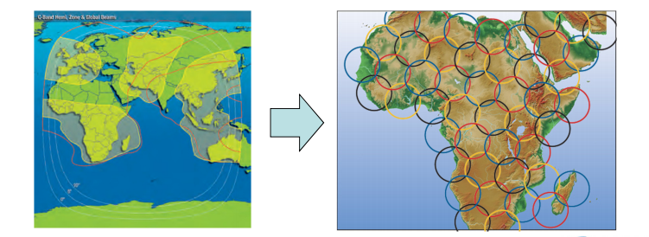
If a bandwidth of B (Hz) is used by a FSS link and the concerned satellite is equipped with a single-beam antenna covering a surface of S km², the allocated spectrum can be used only once when a single polarization is used. On the other hand, if the satellite is equipped with a N-cluster antenna, each cluster (made of M beams) covering its own fraction 1/N of the total service area S (km²), then any part of the allocated spectrum can be reused N times and the equivalent available bandwidth is N × B (Hz).
In order to avoid unacceptable intra-system interference between adjacent fractional service areas (S/N km²), when a satellite is equipped with a multi-beam antenna, it is necessary to create enough frequency discrimination between them. For doing so, each cluster with a total bandwidth of B (Hz) is divided into M beams and each beam is assigned with an equal fraction of the total bandwidth B. Such fraction of spectrum is associated to a specific polarization is known as “colour”. As a result, each fraction of the bandwidth is transmitted by only one beam of every cluster and two adjacent spot beams of different clusters cannot use the same frequency and polarization (colour).
Figure 2 represents six clusters, each of them uses three colours and so, it is constituted by M=3 adjacent beams. The set of six clusters makes it possible to reuse 6 times the total spectrum bandwidth B (Hz) allocated to the considered link. It shows also that the number of gateways can be reduced if the allocated bandwidth to this link is widened.
In order to provide the same total throughput, the use of a single-beam antenna would have required either a much larger bandwidth (i.e. B × 6) or the use of six satellites (i.e. six orbital positions), each of them using the same bandwidth B with an angular separation enabling a terrestrial receiver pointing one satellite not to be interfered by the others.
Conventionally, the satellite throughput is considered high (HTS) when N ranges from 5 to 10, and very high (VHTS) when N > 10.
The limiting factor of a satellite network of the HTS kind is the amount of spectrum allocated for the feeder links, which is the Earth-to-space segment from the gateway to the satellite.
Such feeder links are located within the service area of the satellite. They typically use antennas with diameters of 3 m or larger in the frequency bands 40/50 GHz and are subject to individual coordination.
Figure 2
Overview of HTS systems
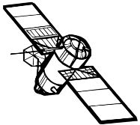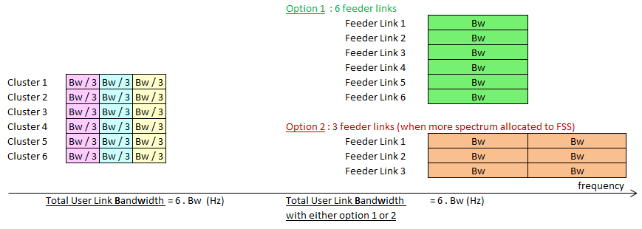
Cluster 1
Beam 3

Cluster 1
Beam 2

Cluster 1
Beam 1
C. 3
B. 3

C. 3
B. 2

C. 3
B. 1
C. 2
B. 3

C. 2
B. 2

C. 2
B. 1

C. 4
B. 3

C. 4
B. 2

C. 4
B. 1

C. 5
B. 3

C. 5
B. 2

C.5
B. 1

C. 6
B. 3

C. 6
B. 2

C. 6
B. 1

2.2 Examples of HTS in operation
Currently, a number of satellite systems are using the technology described in the previous section, in particular frequency re-use and spot beam antennas. Some examples of launched and scheduled for launching satellites are provided in Table 1.
TABLE 1
Example of launched and scheduled for launching HTS satellites
Name | Band | Capacity (Gbit/s) | Status
Thaicom 4 | Ku and Ka band | 45 | Launched
Ka-sat | Ka band | > 90 | Launched
NBN Co1A/1B | Ka band | 80 | Launched
Viasat 1 | Ka band | > 140 | Launched
Intelsat 29e | C, Ku and Ka bands | Reconfigurable | Launched
Shi Jian 13,  ChinaSat 16 | Ka band | > 20 | Launched
Jupiter 1 / EchoStar 17 | Ka band | 100 | Launched
AMOS-17 | C, Ku and Ka bands |  | To be launched in 2019

3 Current status of the 50/40 GHz frequency range for the FSS
Figure 3 shows the current primary allocations to the unplanned FSS Earth-to-space and space-to-Earth.
Figure 3
Current FSS allocations in the 50/40 GHz range
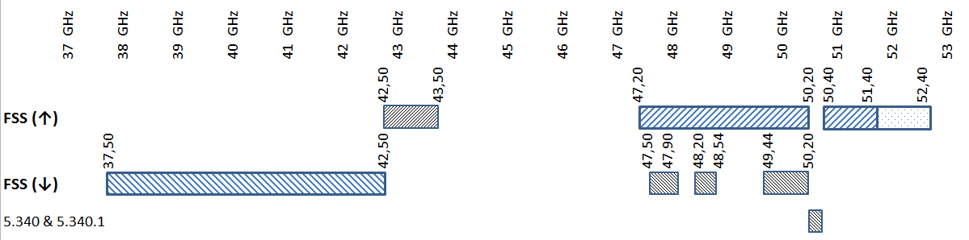
The total bandwidth of primary allocations to unplanned FSS (Earth-to-space) in the bands 40 GHz and 50 GHz in Regions 1, 2 and 3 reaches 5 GHz. In addition, RR No. 5.552 specifies that “Administrations are urged to take all practicable steps to reserve the band 47.2-49.2 GHz for feeder links for the broadcasting-satellite service operating in the band 40.5-42.5 GHz”.
The frequency bands 47.5-47.9 GHz, 48.2-48.54 GHz and 49.44-50.2 GHz (total bandwidth 1 500 MHz) are allocated to unplanned FSS (space-to-Earth) in Region 1 only for high-density fixed-satellite service applications, limited to geostationary satellites under RR Nos. 5.516В and 5.554А.
The frequency bands 47.2-47.5 GHz and 47.9-48.2 GHz are allocated on a primary basis to the fixed service (FS) for use by high altitude platform stations (HAPS) under provisions of Resolution 122 (Rev.WRC-07), see RR No. 5.552A.

4 Justification of the additional 1 GHz FSS allocation (Earth-to-space)
FSS networks with HTS makes it possible to provide wide band connectivity with a substantial reduction of the Gbit/s cost as explained in § 2.1; consequently, the spectrum needs are daily increasing. In fact, industry watcher NSR states that high throughput satellites (HTS) are expected to supply at least 1.34 Tbit/s of capacity by 2020. In order to satisfy these increasing capacity requirements, the most likely solution is to migrate the feeder links to higher frequency bands, in particular the 50/40 GHz bands.
As shown in Fig. 3, three allocations to the FSS (Earth-to-space) can be noted: the 42.5-43.5 GHz band, the 47.2-50.2 GHz band and the 50.4-51.4 GHz band.
47.2-50.2 GHz band: The 3 GHz allocation in the 47.2-50.2 GHz band could be suitable for the operation of wideband carriers with a view to address the current and future HTS spectrum needs, optimizing cost of on board equipment. The complexity and amount of RF components in systems using wide-band carriers may be reduced in comparison to the cases in which satellites are constrained to operate over narrower bandwidths. Such is the situation of the 42.5-43.5 GHz, described below.
42.5-43.5 GHz band: The 42.5-43.5 GHz FSS allocation (Earth-to-space) presents the condition of being adjacent to the FSS allocation in the opposite direction in the 37.5-42.5 GHz band. Over the years, advancements in technology and signal processing have allowed managing these adjacent-band situations on board satellites; nevertheless, the very high frequency range of the bands under consideration imposes material and technological limitations on the satellite components when analogue technologies are used. The operation of satellite links in opposite directions using adjacent allocations by the same satellites is challenging but may be possible using digital technologies in the future.
The required guard band B1, between the adjacent allocations should provide the proper reception of the uplink signal at the satellite while it is transmitting with high power in the adjacent allocation (space-to-Earth). This is illustrated in Fig. 4.
Figure 4
Guard band between adjacent allocations dedicated to uplink and downlink transmissions on board the satellite
42.5
43.5
C/N ≥ min level (typ around 16 dB)
B1
Levels in dBW/Hz at the feed point of the GW antenna
Uplink / signal transmitted
Downlink / signal received
Limit of protection of services in the band above
Downlink / signal transmitted
C/N ≥ min level
(typ around 16 dB)

Uplink / signal received
Freq. (GHz)
Freq. (GHz)
Levels in dBW/Hz at the feed point of the Satellite antenna
The two uplink allocations to the FSS in the 42.5-43.5 GHz and 47.2-50.2 GHz frequency bands are separated by almost 4 GHz, which leads to the need of an additional frequency conversion, which creates additional intermodulation products, requiring complex filtering systems.
50.4-51.4 GHz band: The current allocation to the FSS in the 50.4-51.4 GHz band offers an opportunity to mitigate the technical and operational difficulties explained in the paragraphs above. Indeed, the proposed allocation to the FSS in the 51.4-52.4 GHz band would be adjacent and in the same direction as the current allocation, making it possible to have 2 GHz of continuous spectrum for the FSS uplink operation. This situation could facilitate the development of satellite systems.

5 Examples of FSS applications relating to the additional spectrum needs to provide broadband services

5.1 Application case 1: Use of very high throughput satellites feeder links in the 50/40 GHz band
The amount of spectrum allocated to the forward link in the Earth-to-space segment (gateway to satellite link) is considered to be the limiting factor of an HTS satellite network.
Current HTS systems operating in Ka-band use the Earth-to-space allocations for both, user links and feeder links. In order to achieve higher data rates and improve the services provided to end-users, this application proposes to use the allocations in the 50/40 GHz range for gateway-to-satellite communications. In this way, all the Ka-band allocations to FSS (Earth-to-space) can be made available for the links from the users to the space station.
As an example, link availability analysis was carried out for a proposed network with a V-band feeder-link, implemented with a gateway diversity configuration of 6 for 4. The gateways were located at six locations within the United States of America. The target is a system level availability of 99.75% in clear sky, with each gateway link having a link availability of 95%. A nominal uplink C/N objective of 13 dB was considered based on actual system requirements. It was then assumed that the feeder-link earth stations were operating either in the 42.5-43.5 GHz or in the 51.4-52.4 GHz band. The results are presented in Table 2 and described below. It should be noted that the Table also contains data for a similar assessment carried out at the centre frequencies of 47.2 GHz, 49.3 GHz and 50.4 GHz for completeness.
In order to improve the V-band feeder link availability, gateway diversity is used where alternate sites can be selected in the event that primary sites are impaired by weather. In this case, four gateways are required to provide services and two additional gateways are used as alternative sites. It is important that rain events be un-correlated between gateways, therefore the selection of gateway locations will directly impact the link availability. For the analysis above, gateway sites were separated by 1.3° or 800 to 900 km to maximize de-correlation. It is necessary to use two independent satellite beams for organizing back-up feeder links with alternative gateways along with switching matrix.
TABLE 2
Feeder link availabilities based on uplink C/N objective of 13.0 dB at six gateway sites
(the 95% availability objective is always met)
Gateways locations/sites | #1 | #2 | #3 | #4 | #5 | #6
42.5-43.5 GHz (evaluated at 42.5 GHz) | 99.80% | 99.46% | 99.07% | 99.80% | 99.62% | 99.46%
50.4-51.4 GHz (evaluated at 50.4 GHz) | 99.48% | 98.68% | 97.15% | 99.43% | 98.35% | 97.98%
51.4-52.4 GHz (evaluated at 51.4 GHz) | 99.23% | 98.03% | 95.14% | 99.04% | 95.31% | 95.59%
47.2 GHz | 99.71% | 99.23% | 98.58% | 99.71% | 99.38% | 99.14%
49.3 GHz | 99.64% | 99.07% | 98.18% | 99.63% | 99.15% | 98.85%

This availability analysis clearly shows that the 51.4-52.4 GHz band can be gainfully used for an uplink feeder link requiring a very high availability (99.75%), when using Gateway diversity. Due to high propagation impairment above 40 GHz, Gateway diversity will be essential to achieve high availability requirements for HTS.
The following possibilities may be considered to make the transition or add the VHTS feeder links from the Ka-band towards the Q/V band.
Frequency band for space-to-Earth communication
The frequency band 37.5-42.5 GHz band is currently allocated to the FSS (space-to-Earth) and provides 5 GHz for communications from the satellites to the Earth stations.
Frequency band for Earth-to-space communication
There are three options as contained in Fig. 5 below.
Figure 5
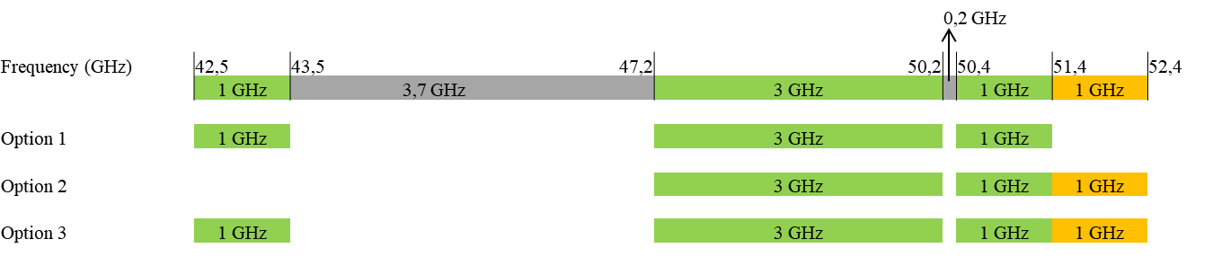
Option 1
This frequency plan represents the existing allocation. To achieve the necessary rejection between the FSS adjacent allocations 37.5-42.5 GHz (space-to-Earth) and 42.5-43.5 GHz (Earth-to-space), additional guard band must be implemented, reducing the actual available spectrum.
Option 2
This option uses the upper frequency bands allocated to the FSS (Earth-to-space) and also the potential new allocation in the 51.4-52.4 GHz band. The availability analysis above shows that the 51.4-52.4 GHz band can be gainfully used with Gateway diversity, allowing for high availability feeder link satellite systems. There is no increase in feeder link spectrum compared to Option 1 apart from the required guard band for analogue systems in Option 1.
Option 3
This option retains the existing allocations as indicated in Option 1, plus adds the 51.4-52.4 GHz band. It provides maximum spectrum on the feeder link uplink, which is a major design driver of any HTS systems, allowing considerable increase in capacity or a reduction in the number of gateways. Once again, the availability analysis above shows that 51.4-52.4 GHz band can be gainfully used with gateway diversity, allowing for high availability feeder link satellite systems.

5.1.1 Example of a GSO FSS network (VHTS) using allocations in the Ka band (user links) and Q/V band (feeder links)
Figure 6 illustrates the envisaged application with an example frequency plan.
Figure 6
Application of a GSO FSS in a VHTS system using Ka and Q/V bands
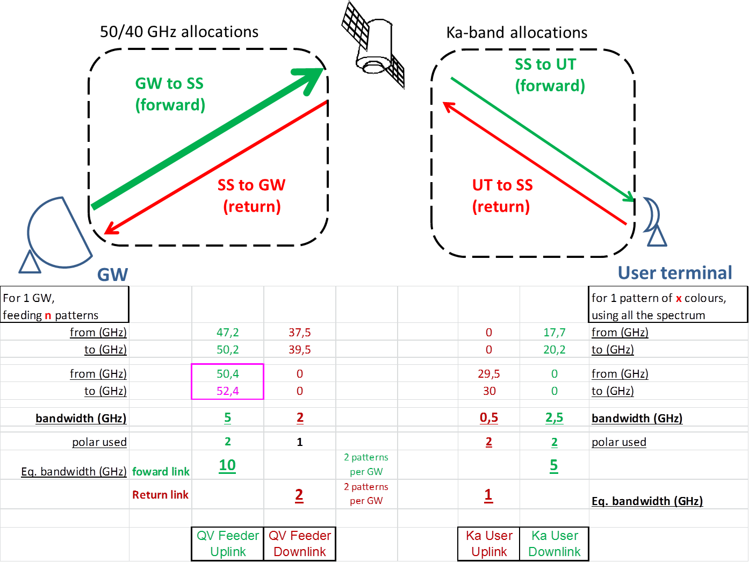
Note that the gateway would use the FSS Earth-to-space allocations from 47.2 GHz to 50.2 GHz and 50.4 to 51.4 GHz, plus the possible new allocation in the 51.4-52.4 GHz. In addition, two orthogonal polarizations would be used, which would lead to 10 GHz of spectrum in the Earth-to-space segment of the forward link. In the space-to-earth segment (forward link) 5 GHz are available in the Ka-band, which means that a single gateway would be able to provide the capacity for two clusters, independently of the frequency reuse factor (number of spot beams per cluster).
The return link would use the current FSS allocations in the Ka-band (Earth-to-space) and the 37.5 to 39.5 GHz range (space-to-Earth) with the amount of available spectrum being 1 GHz and 2 GHz respectively.

5.2 Application case 2: Non-GSO FSS satellite constellation

5.2.1 Assessment of the spectrum needs
For the case of non-GSO FSS, the existing uplink spectrum needs at 42.5-43.5 GHz are not considered under WRC-19 agenda item 1.6 which considers the establishment of regulatory provisions to allow sharing of 50/40 GHz spectrum between NGSO and GSO FSS services. This leaves an imbalance between downlink and uplink spectrum in the 50/40 GHz frequency ranges with 5 GHz of spectrum currently allocated to FSS (space-to-Earth) direction. Additionally, if access to these frequency bands were available for NGSO FSS services, the use of these frequency bands would be subject to the same limitations as described in § 4. Access to an equal amount of uplink and downlink spectrum would facilitate the opportunity for NGSO FSS networks to provide high data rate services worldwide.
GSO and non-GSO FSS networks are currently being developed utilizing high throughput technology that could provide high-capacity broadband connectivity to all regions of the world, with non-GSO networks also providing coverage of remote and polar areas. These new FSS satellite networks are able to deliver high data rate communication services on a global basis with increased capacity due to high-gain narrow spot beams, frequency re-use, and other advanced communication techniques such as phased-array antenna designs. Further, due to the low-Earth orbit altitude in which non-GSO networks can operate, they are able to deliver these high-capacity services with low latency – a key factor for real-time broadband communications.
Next generation satellite networks can employ dynamic beam-forming technology to provide broadband, multi-Gbit/s service which interconnects the network gateways to the widely-deployed user terminals across each satellite’s coverage footprint. Because of this design, all satellite data originates and terminates with either user or gateway terminals on or near the surface of the Earth and therefore, it is desirable that FSS networks have access to an equal amount of downlink and uplink spectrum. Each satellite uplink or downlink beam carries the amount of aggregate capacity needed by the cell being served by that communications beam. Any uplink channel can generally be connected to any downlink beam in a satellite communications network.

5.2.2 FSS broadband traffic delivery forecast
This section describes the traffic forecast and needs of providing a global broadband network by satellite by simulating the served load broadband capacities of a range of large non-GSO FSS satellite constellations. Such a model can be used to estimate the amount of spectrum that would enable FSS networks to satisfy the portion of the global demand for broadband Internet access services that is most likely to be served by satellites. This amount of spectrum would enable FSS to help bridge the broadband gap between those who have sufficient access to broadband services and those who do not. It should be noted that the model presented below assumes an optimal spectrum balance, i.e. 5 GHz available for the uplink and 5 GHz available for the downlink. As explained above, the current imbalance of usable spectrum for FSS services in the 50/40 GHz band would not allow for the spectrum efficiencies and potential worldwide offering as presented in the model.

5.2.2.1 FSS served broadband capacity model
To determine the potential FSS served broadband capacity, a model of the geographic distribution of offered capacity that FSS networks might expect in the year 2020 is established. The term “offered capacity” here refers to the demand for capacity within a given area, which is a function of population distribution and projections of broadband usage per person.
The geographic distribution of the offered capacity is based on version 3 of the Socioeconomic Data and Application Center (SEDAC) estimate of the gridded population of the world for the year 2015. This database provides a gridded population estimate with an output resolution of 2.5 arc-minutes in both latitude and longitude as shown in Fig. 7.
For modelling purposes, this source data was processed into fixed size and shape planning regions (PRs) that correspond to the frequency reuse area of the candidate non-GSO FSS networks. These regions are scaled accordingly and projected onto the surface of the Earth to produce equal area tiles, representing frequency reuse areas, on the Earth’s surface. A similar approach could also be used for high throughput GSO FSS networks using spot beams.
Figure 7
2015 Population distribution used for non-GSO served capacity estimates
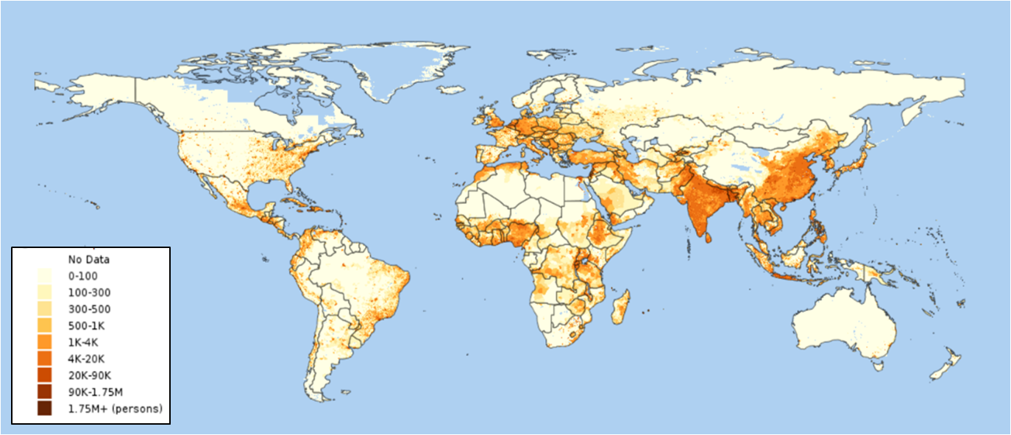
The demand of every frequency reuse tile is determined by multiplying its percentage of the global population by the projected global offered capacity. It should be noted that this is a simplified assumption as it assumes that in the year 2020 the population distribution will be the same as in 2015. Also, it assumes that the penetration rate of non-GSO FSS services will be equal throughout the world.

5.2.2.2 FSS offered capacity traffic forecast
The first step for determining the offered capacity model is determining the peak global offered capacity for the year of interest. For illustrative purposes, this analysis estimated the peak global offered capacity using the latest release of the Cisco Visual Networking Index (VNI). This is Cisco’s ongoing initiative to track and forecast to the year 2020 the impact of the networking applications such as the combination of video, social media, and advanced collaboration applications that will dominate broadband traffic.
The Cisco analysis indicates that in 2020 the global average traffic for fixed internet consumer users will be 331 Tbit/s. It should be noted that the forecast tool utilized by Cisco only estimates a global Internet user population of 52% in the year 2020. To capture and account for the additional unserved or underserved broadband traffic that can be accounted for by a FSS network, an additional factor taken into account is the percentage of this global traffic that could be expected to be served by non-GSO networks operating in the 50/40 GHz bands. The term “Capture Rate” is used for this parameter in this analysis. This analysis has conservatively assumed a Capture Rate of 10% (i.e. only 10% of the total unserved/ underserved areas would be met by non-GSO FSS networks), which corresponds to a peak global offered capacity of 33.1 Tbit/s for the 2020 timeframe.

5.2.2.3 Non-GSO FSS served broadband capacity forecast
The particular model used in this analysis is a representative non-GSO FSS model that uses low-Earth Orbit (LEO) non-GSO space vehicle (SV) design parameters, earth station (ES) design parameters and link design parameters appropriate for 50/40 GHz operations assuming 5 GHz total uplink spectrum and 5 GHz total downlink spectrum. These inputs are used to determine the aggregate constellation capabilities to provide communications on a per-frequency reuse area and per SV basis. The total frequency reuse and SV capacity is then applied to the geographic capacity model to determine the served broadband capacity capabilities of the representative non-GSO constellations. It is important to note that each representative non-GSO constellation could be comprised of any number of sub-constellations, each operated by a different satellite operator. This simplifying assumption is just intended to provide an estimate of the broadband capacity that could be delivered on a global basis by the total number of non-GSO satellites that could be simultaneously operating co-frequency in the 50/40 GHz bands.

5.2.2.4 Representative non-GSO constellation parameters
The representative LEO constellation parameters used in the study are shown in Table 3. All orbits are assumed circular, with an altitude of 1 200-km and 45 degrees inclination angle. The SV coverage area is defined by an ES minimum operation elevation angle of 45 degrees. The SV coverage is also constrained by the use of a 10 degrees geosynchronous arc avoidance (α) and a 2.5 degrees self-avoidance angle.
TABLE 3
Representative constellation parameters
LEO altitude | 1 200-km
LEO inclination | 45°
ES minimum operational elevation angle | 45°
Number of LEO SVs | Number of  LEO planes | SVs per plane
1 000 | 20 | 50
2 000 | 20 | 100
3 000 | 30 | 100
4 000 | 40 | 100

The design space of possible non-GSO networks is extremely large. To reduce the design space to something manageable for this analysis most of the parameters were set to fixed representative values for each simulation run. Table 4 lists the most important of these model parameters and their values.
TABLE 4
Network/model parameters
Network/model parameter | Value | Units | Note/Description
SV antenna diameter | 1.1 | m | This determines the SV antenna gain as well as the frequency reuse area
ES antenna diameter | 25 | cm | User terminal
SV total RF power | 500 | W | This constrains the maximum total transmit power across all active beams
Total bandwidth | 5 | GHz | Uplink and Downlink
Excess bandwidth | 10% |  | Assumption to account for intra-system adjacent channel interference
Non-GSO ES antenna pattern | N/A | N/A | ITU-R S.1428-1
Non-GSO SV antenna pattern | N/A | N/A | ITU-R S.1528-0 recommends 1.3L=3, Ls=−25 dB
System noise temperature (T_{sys}) | 350 | K | For user terminal receiver
Colour reuse | 7 | N/A | The number of SV beams that make up a reuse area on the Earth's surface
Maximum number of SV frequency reuses | 400 | reuses | This is the number of times a frequency can be simultaneously used in different beams by a given SV
Capacity Lien | 50% |  | Total communications overhead including packet headers, resource management, network operations and inter-system inefficiencies to allow for sharing between non-GSO networks

To compute the FSS served broadband capacity forecast based on a non-GSO service model, the first step is to generate the served capacity distribution based on the SV antenna size, the non-GSO SV altitude and link parameters. To simplify the model, a single nominal RF link is used to determine the beam coverage footprint size. For the purposes of this study, it was assumed that the nominal link was based on a beam scanned to 42.5 degrees, which corresponds to a user elevation angle of 50 degrees. The beam coverage footprint on the Earth’s surface was estimated using an analytical formula that is very accurate for beams not pointed to the edge of the Earth. An adjustment factor of 82.7% that accounts for beam overlap is multiplied by the beam footprint area to compute a cell area. This cell area is then multiplied by the colour reuse number (the number of beams that make up a reuse) to compute the size of a reuse area. For the parameters in this study, the reuse area is approximately 1 200 km².
The next step is to compute each candidate representative non-GSO constellationʼs total capacity per frequency reuse area and the capacity per single non-GSO SV. This starts with standard link budget equations that are employed to compute the RF power per beam based on the power flux-density (pfd), SV antenna size and other parameters. The RF power per beam, along with the total RF power per SV, determines how many intra-SV frequency reuses are possible. The inter-service interference is then calculated, using the conservative assumption that all the non-GSO SV’s are spaced exactly the minimum angular distance, the self-separation angle of 2.5 degrees, from each other and that the SV of interest is in the centre of this formation.
Using knowledge of the single SV capacity and the previous calculations of global served capacity, the total global served broadband capacity for each of the representative non-GSO constellations can be calculated. The model estimates the offered capacity of the geographically distributed tiles by identifying which offered capacity tiles exceed the total frequency reuse capacity of the representative non-GSO constellation and reducing the offered load from those tiles to the frequency reuse capacity limit. Satellite capacity limitations are also accounted for by determining if a specific geographic tile’s offered capacity can be served by an SV in the non-GSO constellation with available capacity. Once the offered broadband capacity of each geographic frequency reuse tile is processed, the total global served load is then just the sum of the served capacity of all the individual frequency reuse tiles. Figure 8 shows the calculated served capacity as a function of the number of representative SV in a non-GSO constellation.
Figure 8
Total global served capacity for four different non-GSO constellations sizes
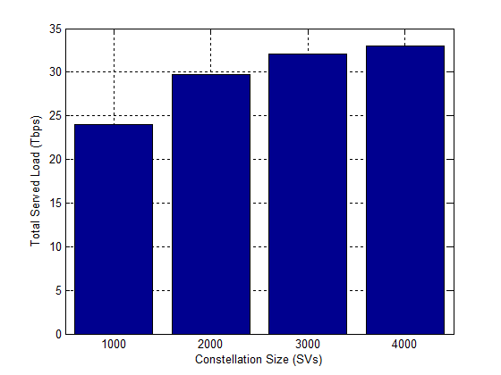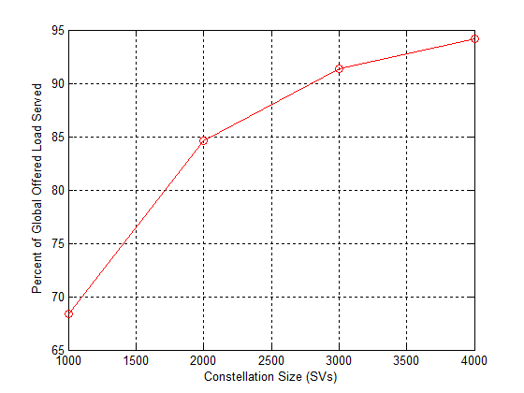
As can be seen by Fig. 8, a non-GSO network operating with a full 5 GHz of spectrum available for both the uplink and downlink could provide global broadband capacity to service unserved and underserved regions of the world. Satellite services can be used to provide this service and to help bridge the broadband digital divide within the next decade.

6 Estimation of propagation loss in a feeder link (Earth-to-space) in the bands 40 GHz and 50 GHz

6.1 Analysis 1
FSS (Earth-to-space) allocations already exist in the 40/50 GHz bands and their characteristics are specified in several ITU Recommendations such as Recommendations ITU-R S.1328 and ITU-R S.1557.
Tables 5 to 8 in Annex 1 present the results of comparing the propagation loss for four earth stations located in areas with different rainfall rates (Moscow, Madrid, Rome and Athens).
All the parameters used, come either from the characteristics of 50/40 GHz band systems referenced in Recommendations ITU-R S.1328 or ITU-R S.1557. Two elevation angles are compared; the maximum for the ES to point towards the GSO arc and one that is close to the minimum referenced in the aforementioned Recommendations: 10 degrees or 15 degrees.
The link availability of 99.9% corresponds to that given in Recommendation ITU-R S.1557 for feeder links, which is higher than the one referenced for user links of 99.7%. The frequency values used in the calculations are those of the central frequencies in the 42.5-43.5 GHz and 50.4-51.4 GHz bands.
The tool used to calculate the gaseous, rain, clouds and scintillation attenuations is the ITU-R software “Dynamic Link Library (DLL)” developed by CNES (France) in its version 20100917.
From Tables 5 to 8 in Annex 1, small variations of the propagation loss, ranging between 1.9 dB and 6.6 dB, are observed when comparing the proposed frequency band and the current allocation in 50.4-51.4 GHz, even for elevation angles as low as 10 degrees.
Making a similar comparison between the proposed band and the 43 GHz allocation (frequency difference of 8.9 GHz), the results range from 9.4 dB to 26.1 dB; the first corresponding to an elevation angle of 43.3 degrees and the second to an elevation of 10 degrees. As expected, it is observed that the most significant differences are obtained for the low elevation angles (10 to 15 degrees).
On the other hand, the most significant differences are not obtained for the area with the highest rainfall rate (Rome). This indicates that the rainfall rate is a very important factor but that it will not necessarily lead to insurmountable propagation conditions when it is relatively high. For instance, observe that less than 2 dB differences are obtained between the results for Madrid (rainfall rate of 27.27 mm/h exceeded for 0.01% of the average year) and Rome (rainfall rate of 56.48 mm/h) when elevation angles are in the order of 42 degrees.
Given the order of magnitude obtained for the loss variations between the proposed and the current allocations to the FSS (Earth-to-space), it can be anticipated that such differences are manageable. Therefore, no significant difficulty is expected for the operation of feeder links in the proposed 51.4-52.4 GHz frequency band.

6.2 Analysis 2
Additional calculations for signal propagation losses in feeder links (Earth-to-space) at frequencies 52 GHz and 43 GHz for eight countries in Asia, Africa and Europe, located in Region 1 at latitudes from 56° North (ES₁, Moscow, RUS) to 0° North (the equator) (ES₈, Kampala, UGA) with Earth station antenna elevation angles from 26° to 90° correspondingly, are given in Tables 9 and 10 in Annex 2. Typical availability for links in this frequency range (99.9%) and a higher value (99.97%) were used. It is to be noted that due to propagation impairments, such higher availabilities are typically achieved with site diversity in the studied frequency bands 50/40 GHz.
Summary of § 6
The analysis above has shown that propagation affects caused by geographical and climate factors can have a significant impact on FSS communications in the 50/40 GHz frequency bands. However, recent advances in satellite technology enable the use of precise beam-forming, high-gain antennas, highly-efficient modulation and coding techniques, and other capabilities including sophisticated power control to allow for the successful performance of communication signals for FSS networks in these frequency bands.
Implementing FSS systems in the frequency bands 51.4-52.4 GHz is not substantially different than doing so in the current allocations to the FSS (Earth-to-space) in the 50/40 GHz bands. This is shown by taking into account the propagation impairments in the relevant frequency bands for Earth stations located in zones subject to different rainfall rates. The analysis considered the maximum and minimum elevation angles of the FSS ES antenna towards the GSO arc from every location.

7 Conclusion
This Report responds to resolves to invite ITU-R 1 of Resolution 162 (WRC-15), which calls for studies on additional spectrum needs for development of the fixed-satellite service in the frequency band 51.4-52.4 GHz.
In line with such resolves, this Report contains technical details on the concepts of frequency re-use and spot beam technologies considered for the operation of high throughput satellite (HTS) networks to substantially increase spectrum efficiency with respect to the satellite networks operating in lower frequency bands.
The analyses provided in this Report take into account the frequency bands currently allocated to the fixed-satellite service in the 50/40 GHz bands and explains how the proposed new allocation of 1 GHz has the potential to address the high throughput satellite spectrum needs optimizing the cost of on board equipment and facilitating the achievement of availability requirements for HTS networks that are difficult to obtain in these bands due to the high propagation impairment.
Examples of applications that can be envisaged to implement broadband FSS systems in the 50/40 GHz allocations are provided if the frequency band 51.4-52.4 GHz is allocated to this service. It can be concluded that the additional allocation to FSS being considered is beneficial to make broadband connections more accessible to communities regardless of their geographical location and with more affordable costs as achieved by HTS (High Throughput Satellite) systems.

Annex 1
TABLE 5
Station localisation | Madrid (ESP) |  |  | Madrid (ESP)
Rain intensity (mm/h) | 27.27 |  |  | 27.27
TX & RX stations
Satellite longitude (degree) | -3.7 |  |  | 61
ES latitude (degree) | 40.41 |  |  | 40.41
ES longitude (degree) | −3.7 |  |  | −3.7
ES height (m) | 0 |  |  | 0
Satellite elevation (degree) | 43.3 |  |  | 10.0
Distance (km) | 37 533.8 |  |  | 44 018.6
Frequency (GHz) | 43 | 50.9 | 51.9 | 43 | 50.9 | 51.9
Link availability (%) | 99.9 | 99.9 | 99.9 | 99.9 | 99.9 | 99.9
Propagation losses
Free space losses (dB) | 216.6 | 218.0 | 218.19 | 217.9 | 219.4 | 219.6
Atmospheric gas attenuation (dB) | 0.7 | 3.0 | 4.3 | 2.9 | 11.7 | 16.8
Rain attenuation (dB) | 15.7 | 19.3 | 19.7 | 32.7 | 39.6 | 40.5
Clouds attenuation (dB) | 0.8 | 1.0 | 1.0 | 3.0 | 3.9 | 4.1
Scintillation (dB) | 0.3 | 0.3 | 0.3 | 2.1 | 2.3 | 2.3
Total propagation losses (dB) | 234.1 | 241.6 | 243.5 | 258.6 | 276.9 | 283.2
Losses variation 51.9-43 GHz (dB) | 9.4 |  |  | 24.6
Losses variation 51.9-50.9 GHz (dB) | 1.9 |  |  | 6.3

TABLE 6
Station localisation | Моscow (RUS) |  |  | Моscow (RUS)
Rain intensity (mm/h) | 31.74 |  |  | 31.74
TX & RX stations
Satellite longitude (degree) | 37.62 |  |  | −17
ES latitude (degree) | 55.71 |  |  | 55.71
ES longitude (degree) | 37.62 |  |  | 37.62
ES height (m) | 0 |  |  | 0
Satellite elevation (degree) | 26.5 |  |  | 10.0
Distance (km) | 38 925.2 |  |  | 43 861.2
Frequency (GHz) | 43 | 50.9 | 51.9 | 43 | 50.9 | 51.9
Link availability (%) | 99.9 | 99.9 | 99.9 | 99.9 | 99.9 | 99.9
Propagation losses
Free space losses (dB) | 216.9 | 218.3 | 218.5 | 217.9 | 219.4 | 219.5
Atmospheric gas attenuation (dB) | 1.2 | 4.7 | 6.8 | 3.0 | 12.2 | 17.5
Rain attenuation (dB) | 19.5 | 23.7 | 24.2 | 33.4 | 40.4 | 41.2
Clouds attenuation (dB) | 2.0 | 2.7 | 2.8 | 5.2 | 7.0 | 7.2
Scintillation (dB) | 0.6 | 0.6 | 0.6 | 2.0 | 2.1 | 2.2
Total propagation losses (dB) | 240.1 | 250.0 | 252.9 | 261.5 | 281.0 | 287.6
Losses variation 51.9-43 GHz (dB) | 12.8 |  |  | 26.1
Losses variation 51.9-50.9 GHz (dB) | 2.8 |  |  | 6.6

TABLE 7
Station localisation | Athens (GRC) |  |  | Athens (GRC)
Rain intensity (mm/h) | 47.10 |  |  | 47.10
TX & RX stations
Satellite longitude (degree) | 23.72 |  |  | −36
ES latitude (degree) | 37.97 |  |  | 37.97
ES longitude (degree) | 23.72 |  |  | 23.72
ES height (m) | 0 |  |  | 0
Satellite elevation (degree) | 46.0 |  |  | 15.0
Distance (km) | 37 340.8 |  |  | 47 340.0
Frequency (GHz) | 43 | 50.9 | 51.9 | 43 | 50.9 | 51.9
Link availability (%) | 99.9 | 99.9 | 99.9 | 99.9 | 99.9 | 99.9
Propagation losses
Free space losses (dB) | 216.5 | 218.0 | 218.1 | 218.6 | 220.0 | 220.2
Atmospheric gas attenuation (dB) | 0.8 | 2.9 | 4.1 | 2.2 | 8.0 | 11.4
Rain attenuation (dB) | 18.9 | 22.8 | 23.2 | 30.8 | 36.9 | 37.6

TABLE 7 (end)
Station localisation | Athens (GRC) |  |  | Athens (GRC)
Clouds attenuation (dB) | 0.7 | 0.9 | 0.9 | 1.9 | 2.5 | 2.6
Scintillation (dB) | 0.4 | 0.4 | 0.4 | 1.6 | 1.8 | 1.8
Total propagation losses (dB) | 237.2 | 244.9 | 246.8 | 255.1 | 269.2 | 273.5
Losses variation 51.9-43 GHz (dB) | 9.5 |  |  | 18.4
Losses variation 51.9-50.9 GHz (dB) | 1.9 |  |  | 4.3

TABLE 8
Station localisation | Roma (ITA) |  |  | Roma (ITA)
Rain intensity (mm/h) | 56.48 |  |  | 56.48
TX & RX stations
Satellite longitude (degree) | 12.49 |  |  | 70
ES latitude (degree) | 41.89 |  |  | 41.89
ES longitude (degree) | 12.49 |  |  | 12.49
ES height (m) | 0 |  |  | 0
Satellite elevation (degree) | 41.6 |  |  | 15.0
Distance (km) | 37 655.3 |  |  | 39 861.0
Frequency (GHz) | 43 | 50.9 | 51.9 | 43 | 50.9 | 51.9
Link availability (%) | 99.9 | 99.9 | 99.9 | 99.9 | 99.9 | 99.9
Propagation losses
Free space losses (dB) | 216.6 | 218.1 | 218.2 | 217.0 | 218.5 | 218.7
Atmospheric gas attenuation (dB) | 0.6 | 2.7 | 3.9 | 1.7 | 6.9 | 10.0
Rain attenuation (dB) | 21.7 | 26.8 | 27.4 | 47.5 | 57.8 | 59.0
Clouds attenuation (dB) | 1.7 | 2.2 | 2.3 | 4.2 | 5.6 | 5.8
Scintillation (dB) | 0.3 | 0.3 | 0.3 | 1.2 | 1.3 | 1.3
Total propagation losses (dB) | 240.9 | 250.1 | 252.2 | 271.5 | 290.1 | 294.8
Losses variation 51.9-43 GHz (dB) | 11.2 |  |  | 23.3
Losses variation 51.9-50.9 GHz (dB) | 2.1 |  |  | 4.8

Annex 2
TABLE 9
Calculation of propagation losses in the GSO FSS feeder link (Earth-to-space) in the frequency ranges 52 GHz and 43 GHz
for feeder link Earth stations (ES₁ – ES₄) in Region 1
ES feeder link, city | ES₁, Moscow (RUS) |  |  |  | ES₂, Luxemburg (LUX) |  |  |  | ES₃, Atyrau (KAZ) |  |  |  | ES₄, Toulouse (F)
Geographic coordinates  ES feeder link (º) | ES latitude – 55.746º North |  |  |  | ES latitude – 49.604º North |  |  |  | ES latitude – 47.167º North |  |  |  | ES latitude – 43.552º North
 | ES longitude – 37.864º East |  |  |  | ES longitude – 6.127º East |  |  |  | ES longitude – 52.377º East |  |  |  | ES longitude – 1.45º East
Frequency band (GHz) | 43 |  | 52 |  | 43 |  | 52 |  | 43 |  | 52 |  | 43 |  | 52
Elevation angle of ES antenna (degree) | 26 |  |  |  | 33 |  |  |  | 36 |  |  |  | 40
Radio link availability (%) | 99.97 | 99.9 | 99.97 | 99.9 | 99.97 | 99.9 | 99.97 | 99.9 | 99.97 | 99.9 | 99.97 | 99.9 | 99.97 | 99.9 | 99.97 | 99.9
Free-space loss (dB) | 216.7 | 216.7 | 218.6 | 218.6 | 216.6 | 216.6 | 218.4 | 218.4 | 216.5 | 216.5 | 218.4 | 218.4 | 216.5 | 216.5 | 218.3 | 218.3
Attenuation by atmospheric gases (dB) | 1.71 | 1.71 | 7.99 | 7.99 | 1.31 | 1.31 | 6.18 | 6.18 | 1.29 | 1.29 | 5.81 | 5.81 | 1.12 | 1.12 | 5.15 | 5.15
Attenuation by clouds (dB) | 2.08 | 2.08 | 2.86 | 2.86 | 1.88 | 1.88 | 2.59 | 2.59 | 1.26 | 1.26 | 1.73 | 1.73 | 1.17 | 1.17 | 1.61 | 1.61
Attenuation by rain (dB) | 32.16 | 18.91 | 39.48 | 23.46 | 30.78 | 18.06 | 37.63 | 22.3 | 17.21 | 9.8 | 21.77 | 12.55 | 37.47 | 22.21 | 45.9 | 27.49
Total loss, dB | 252.7 | 239.4 | 268.9 | 252.9 | 250.6 | 237.9 | 264.8 | 249.5 | 236.3 | 228.9 | 247.7 | 238.5 | 256.3 | 241.0 | 271.0 | 252.6
Increase in total loss (52/43 GHz) (dB) | - | - | 16.2 | 13.5 | - | - | 14.2 | 11.6 | - | - | 11.4 | 9.6 | - | - | 14.7 | 11.6
Required increase in feeder link budget at frequency 52 GHz ⁽¹⁾ (dB) |  |  | 12.9 | 10.2 |  |  | 10.9 | 8.3 |  |  | 8.1 | 6.3 |  |  | 11.4 | 8.3
⁽¹⁾ Total gain of transmitting earth station feeder link antenna and receiving space station antenna at frequency 52 GHz is 2 × 20lg(52/43) = 3.3 dB higher compared to the gain at 43 GHz.

TABLE 10
Calculation of propagation losses in the GSO FSS feeder link (Earth-to-space) in the frequency ranges 52 GHz
and 43 GHz for feeder link Earth stations (ES₅ – ES₈) in Region 1
ES feeder link, city | ES₅, Ankara (TUR) |  |  |  | ES₆, Cairo (EGY) |  |  |  | ES₇, Abu Dhabi (UAE) |  |  |  | ES₈, Kampala (UGA)
Geographic coordinates  ES feeder link (degree) | ES latitude – 39.741º North |  |  |  | ES latitude – 29.669º North |  |  |  | ES latitude – 24.287º North |  |  |  | ES latitude – 0º North
 | ES longitude – 33.03º East |  |  |  | ES longitude – 31.599º East |  |  |  | ES longitude – 54.698º East |  |  |  | ES longitude – 31.892º East
Frequency band (GHz) | 43 |  | 52 |  | 43 |  | 52 |  | 43 |  | 52 |  | 43 |  | 52
Elevation angle of ES antenna (degree) | 44 |  |  |  | 55 |  |  |  | 62 |  |  |  | 90
Radio link availability (%) | 99.97 | 99.9 | 99.97 | 99.9 | 99.97 | 99.9 | 99.97 | 99.9 | 99.97 | 99.9 | 99.97 | 99.9 | 99.97 | 99.9 | 99.97 | 99.9
Free-space loss (dB) | 216.4 | 216.4 | 218.2 | 218.2 | 216.2 | 216.2 | 218.1 | 218.1 | 216.1 | 216.1 | 218.0 | 218.0 | 216.0 | 216.0 | 217.8 | 217.8
Attenuation by atmospheric gases (dB) | 0.9 | 0.9 | 4.68 | 4.68 | 0.83 | 0.83 | 3.86 | 3.86 | 0.92 | 0.92 | 3.69 | 3.69 | 0.78 | 0.78 | 3.31 | 3.31
Attenuation by clouds (dB) | 0.53 | 0.53 | 0.73 | 0.73 | 0.31 | 0.31 | 0.43 | 0.43 | 0.34 | 0.34 | 0.46 | 0.46 | 1.3 | 1.3 | 1.79 | 1.79
Attenuation by rain (dB) | 20.81 | 11.96 | 25.55 | 14.94 | 8.93 | 5.04 | 11.7 | 6.69 | 17.63 | 10.56 | 22.24 | 13.48 | 87.05 | 63.95 | 105.0 | 77.89
Total loss (dB) | 238.6 | 229.8 | 249.2 | 238.6 | 226.3 | 222.4 | 234.1 | 229.1 | 235.0 | 227.9 | 244.4 | 235.6 | 305.1 | 282.0 | 327.9 | 300.8
Increase in total loss (52/43 GHz) (dB) | - | - | 10.6 | 8.8 | - | - | 7.8 | 6.7 | - | - | 9.4 | 7.7 | - | - | 22.8 | 18.8
Required increase in feeder link budget at frequency 52 GHz ⁽¹⁾ (dB) |  |  | 7.3 | 5.5 |  |  | 4.5 | 3.4 |  |  | 6.1 | 4.4 |  |  | 19.5 | 15.5
⁽¹⁾ Total gain of transmitting earth station feeder link antenna and receiving space station antenna at frequency 52 GHz is 2 × 20lg(52/43) = 3.3 dB higher compared to the gain at 43 GHz.

ITU and United Nations Educational, Scientific and Cultural Organization. State of Broadband 2015. Available at: http://www.broadbandcommission.org/documents/reports/bb-annualreport2015.pdf.
David Bettinger. “Virtual Partner Series – HTS and VSAT: New Implications, New Opportunities”.
Socioeconomic Data and Application Center (SEDAC). Population Density, v4, Gridded population of the world. Available at: http://sedac.ciesin.columbia.edu/data/set/gpw-v3.
Cisco Visual Networking Index: Forecast and Methodology, 2015-2020 White Paper; Available at http://www.cisco.com/c/en/us/solutions/service-provider/visual-networking-index-vni/index.html.

