REPORT ITU-R SA.2065
Protection of the space VLBI telemetry link

CONTENTS
Page
1 Introduction 2
2 Space VLBI system 2
2.1 Space VLBI telemetry signal, noise and interference 2
2.1.1 Signal 3
2.1.2 Noise and interference 3
3 Space VLBI telemetry detection 3
3.1 Telemetry receiver 3
3.1.1 Matched filter 4
3.2 Telemetry bit error rate (BER) 5
4 Space VLBI cross-correlation 5
4.1 Cross-correlation of digitized observation record 6
4.1.1 Mean value of cross-correlation product 7
4.1.2 Evaluation of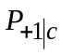 8
4.2 Cross-correlation SNR (XSNR) 9
5 Derivation of space VLBI telemetry interference criteria 10
5.1 Degradations in XSNR due to noise and interference in the telemetry link 10
5.2 Tolerable degradation due to interference 11
5.3 Calculation of interference criteria 12
References 14

1 Introduction
Very long baseline interferometry (VLBI) is used to achieve very high resolution of observed radio sources. VLBI has many scientific and engineering uses, from observing extragalactic radio sources to navigating and tracking of spacecraft [Thompson et al., 2001].

2 Space VLBI system
Space VLBI pairs a space-borne observatory with a ground-based observatory to form an interferometer as shown in Fig. 1.

figure 1
Space VLBI system
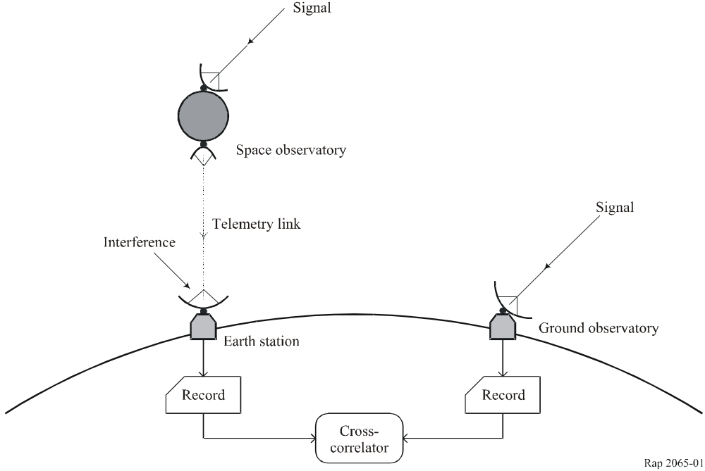

A telemetry link returns the signal record from the spaceborne observatory-to-Earth. This signal record is degraded by thermal and other internal noise sources in the space-to-Earth telemetry link and by external interference from other radio stations into the receiving earth station. An appropriate figure-of-merit for the overall space VLBI telemetry link is the degradation in the cross-correlation SNR ([Thompson et al., 2001] and Recommendation ITU-R SA.1344 – Preferred frequency bands and bandwiths for the transmission of space VLBI data). This Report characterizes the degradation to the cross-correlation SNR by the interference present on the telemetry link.

2.1 Space VLBI telemetry signal, noise and interference
In the telemetry link analysis, we assume that signal s(t) and noise n(t) plus an interfering signal I(t) are present, the received signal being s(t)+n(t)+I(t).

2.1.1 Signal
The signal is a carrier with power P and frequency f_{c}. It is data modulated using differentially encoded quadriphase-shift keying (DQPSK) and rectangular data pulses. This data modulation suppresses the carrier. The signal is of the form:

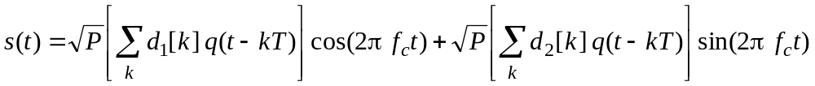 (1)

where T is the quaternary symbol period, and

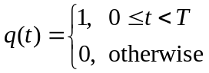 (2)

is the rectangular data pulse. The quaternary symbol period, T, is the reciprocal of the quaternary symbol rate (R = 1/T), which equals one-half the binary symbol rate at the input to the DQPSK modulator. The sequences d₁[k] and d₂[k] are binary valued: d₁[k] = ±1 and d₂[k] = ±1, which are related to the data bits by a four-phase differential encoding.

2.1.2 Noise and interference
The noise n(t) is, as always, assumed zero-mean, Gaussian, and white within the passband of the receiver. Its one-sided power spectral density in the receiver passband is N₀.
The interfering signal is characterized by a one-sided power spectral density S_{i}(f). This power spectral density is bandpass and its peak value is presumably located at a frequency near f_{c}, otherwise it would not be an interference threat. Since this power spectral density is one-sided, the integral 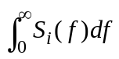 accounts for all of the interfering signal power.
The noise spectral density, N₀, and the interference power spectral density, S_{i}(f), are referenced to the same point in the receiver chain as the signal power, P. Normally, the receiver reference point is the input terminal of the low-noise amplifier (LNA). The noise spectral density is based on the equivalent noise temperature at this point. The equivalent noise temperature accounts for antenna noise temperature and all noise that enters the receiver chain after the antenna.

3 Space VLBI telemetry detection

3.1 Telemetry receiver
The receiver multiplies s(t)+n(t)+I(t) by a local oscillator signal ∙cos(2π f_{c}t+φ) and, in parallel, by ∙sin(2π f_{c}t+φ) to create in-phase and quadrature channels as shown in Fig. 2.
To simplify the analysis, we assume here that the carrier tracking phase φ = 0. In actual processing, the QPSK carrier synchronization loop can only reduce φ to one of four values. The differential encoding, however, ensures that this four-fold phase ambiguity does not affect data recovery. In the present analysis, the φ = 0 assumption is fair because the effect of interference and noise on telemetry detection is same for all four possible values of φ.
figure 2
Space VLBI telemetry receiver
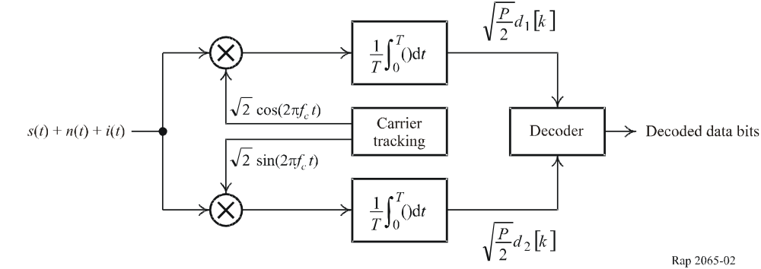
The desired signals that appear at baseband within the in-phase and quadrature receiver channels are (with φ = 0):
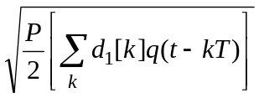, and 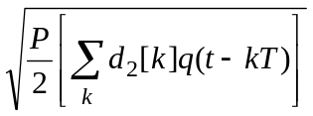

3.1.1 Matched filter
The in-phase and quadrature receiver channels each have a matched filter, modelled simply as time-average over T seconds (see Fig. 2). The discrete-time signals available from these matched filters are therefore:
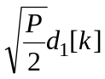, and 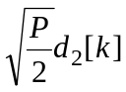
The thermal noise, which contributes a term to each receiver channel output, is calculated as follows. The baseband noise in each channel, prior to matched filtering, is Gaussian with a one-sided noise spectral density N₀ within the baseband bandwidth. The unity power of the local oscillator signal ensures that the N₀ of the baseband noise is numerically equal to the N₀ of the pre-detection bandpass noise. The additive noise is modelled as a sequence of zero-mean, Gaussian random variables, each statistically independent of every other. The noise at the output of the second receiver channel has the same statistics. The noises of the two receiver channels are statistically independent because the local oscillator signals are orthogonal. The variance of the Gaussian random variables equals the noise power within the bandwidth of the matched filter as referenced to the input terminal of the low noise amplifier. This thermal noise variance 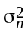 equals to the total thermal noise power N and is given by:

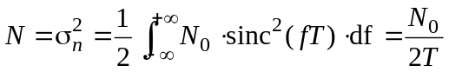 (3)

Within the bandwidth of the matched filter, the interference variance 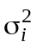 equals to the interference power, I, as referenced to the input terminal of the low-noise amplifier. It can be calculated from:
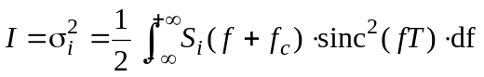 (4)
The sinc() function in equations (3) and (4) is defined by sinc(x) = sinc(πx)/(πx).

3.2 Telemetry bit error rate (BER)
When only thermal noise is present, the probability P_{ε} that a differentially encoded bit (symbol) is incorrectly detected is:

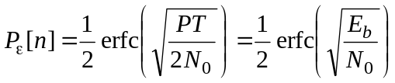 (5)

where 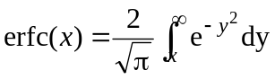 is the complementary error function. Here, we used that:

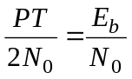 (6)

since T is the quaternary symbol period.
The presence of interference changes the total variance at the output of each matched filter from 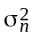 to 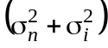. This raises the effective noise spectral density N₀ to 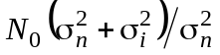; thus, the effective energy-per-bit-to-noise-spectral-density ratio decreases by 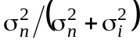. In the presence of interference, the probability of symbol error now becomes:

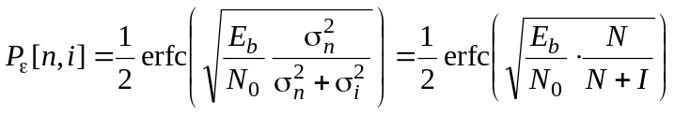 (7)

since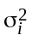 is the total interference power, I, and 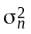 is the total noise power, N.
In the differential decoding process, the error probability of detecting a differentially encoded bit (symbol), P_{ε}, and the error probability of a message bit, P_{e}, are related as:

BER = P_{e} = 2P_{ε}(1 –P_{ε}) (8)

Note that telemetry BER equals P_{e}. From equation (8) we see that for DQPSK, when P_{ε} is small, 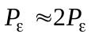; that is, an error in one differentially encoded bit typically leads to two errors in the message bits.

4 Space VLBI cross-correlation
Figure 3 below shows the space VLBI signal processing. The space observatory digitizes the observed signal record and transmits it to the earth station using the space-to-Earth telemetry link. The ground observatory also digitizes its observed signal record and cross-correlates it with the record received from the space observatory.
Figure 3
Space VLBI signal processing
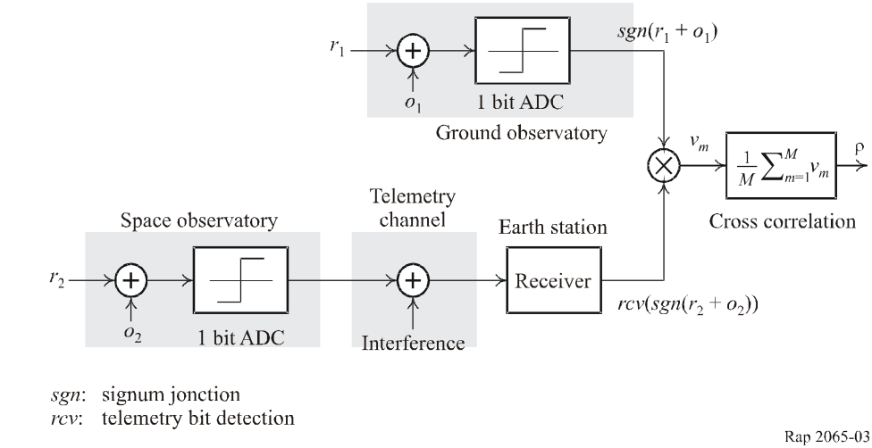

4.1 Cross-correlation of digitized observation record
The following analysis assumes one-bit quantization, which is presently used for the recording of signal plus noise at both observatories in a space VLBI system. Here, we model these one bit quantized recordings as having values ±1 and define the product of these recordings from the two observatories as:
v = sgn(r₁ + o₁) ⋅ rcv(sgn(r₂ + o₂) (9)

The desired radio source signals at the two VLBI observatories are denoted by r₁ and r₂. All other noise in the two VLBI observatories are denoted by o₁ and o₂. In the equation above, sgn() is the signum function, which has the value +1 when its argument is positive and –1 when its argument is negative. The operator rcv() represents the telemetry bit detection.
The telemetry link from the space observatory to earth station occasionally inverts the sign of the telemetry bit. Therefore, ν can be written as:
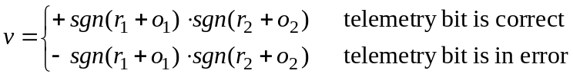 (10)
The two random variables r₁ and r₂ have zero mean, and their variances before one-bit quantization are denoted 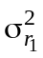 and 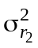. In this analysis, we assume that a compensating delay perfectly time-aligns the two radio source signals before the recordings from the two VLBI observatories are multiplied. In other words, r₂ is identical to r₁ but scaled; i.e. r₂ = αr₁. In this case,

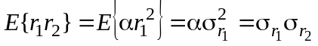 (11)
where E{} is the expectation operator.
The random variables o₁ and o₂ are zero-mean and Gaussian; their variances before one-bit quantization are denoted 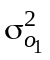 and 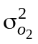. Normally:
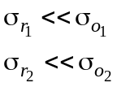 (12)
The cross-correlation, denoted by ρ, is defined as:

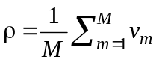 (13)

where ν_{m} (= ν) is a sequence of the statistically independent binary values of equation (9) and the number of binary values in the sum, M, is proportional to the measurement integration time. The mean value of ρ is given by:
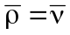 (14)

and the mean-square value of ρ is by equation (15):
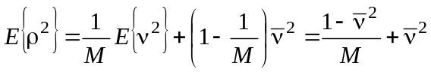 (15)
since ν² = 1. Using equations (14) and (15), the variance of ρ can be written as:
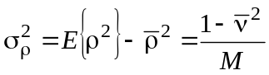 (16)
To compute the mean and the variance of the cross-correlator output, ρ, we need to evaluate the mean value of the cross-correlation product, ν.

4.1.1 Mean value of cross-correlation product
The mean is given by:
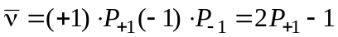 (17)
where P₊₁ is the probability that ν = +1. This probability, in turn, is related to the conditional probability that ν = +1 given the telemetry bit is correct, 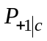, and the conditional probability that ν ν = +1 given the telemetry bit is in error, 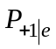, by:
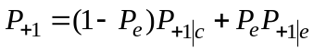 (18)
where P_{e} is the probability that the telemetry bit is in error (and P_{e} is the probability that it is correct).
The conditional probability 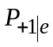 can be written in terms of . From equation (10), we notice that 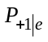 equals the probability that sgn(r₁+o₁)·sgn(r₂+o₂) = –1. But 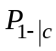 equals this same probability since the telemetry channel is binary symmetric; so 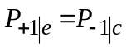. Furthermore, 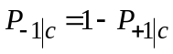. Therefore:
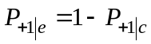 (19)
Using equation (19) we get:
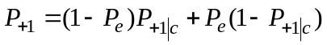 (20)
Substituting equation (20) in equation (17) gives:
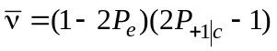 (21)
Equation (21) indicates that the cross-correlation product is proportional to (1 – 2P_{e}). As it turns out, the standard deviation of ν is approximately constant. So, before the derivation of the XSNR degradation is complete, it is already possible to see that the XSNR degradation will be proportional to (1 – 2P_{e}).
To complete the derivation of the mean value of ν an equation for is required.

4.1.2 Evaluation of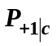
To evaluate , we define two useful conditional probabilities. Let the symbol p₁ denote the conditional probability that r₁+o₁ is positive, given r₁. Similarly, let p₂ denote the conditional probability that r₂ + o₂ is positive, given r₂. Note that p₁ is a function of r₁ and that p₂ is a function of r₂, expressed as:

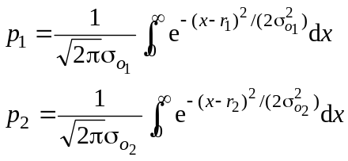 (22)

The unconditional probability that r₁+o₁ and r₂+o₂ are simultaneously both positive is obtained by taking the exception of (p₁p₂) over the random variables r₁ and r₂, that is: 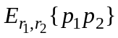.
It is also necessary to consider the possibility that r₁ + o₁ and r₂+o₂ are negative. The expression (1 – p₁) represents the conditional probability that r₁ + o₁ is negative, given r₁. Similarly, (1 – p₂) represents the conditional probability that r₂ + o₂ is negative, given r₂. The unconditional probability that r₁ + o₁ and r₂ + o₂ are simultaneously both negative is obtained by taking the expectation of (1 – p₁)(1 – p₂) over the random variables r₁ and r₂; that is:

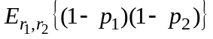

When the telemetry bit is correct, from equation (10) we see that ν will equal +1 if r₁ + o₁ and r₂ + o₂ are both positive, or they are both negative. Therefore, the conditional probability that ν = +1, given that the telemetry bit is correct, is calculated as the sum of and ; that is:

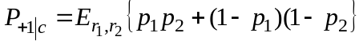 (23)

Because of the Inequalities (12), it is appropriate to approximate p₁ and p₂ under the assumptions that 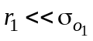 and 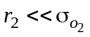. Expanding each probability density function in equation (22) in a Taylor’s series expansion, while keeping only the first two terms of each series, results in the following approximations:
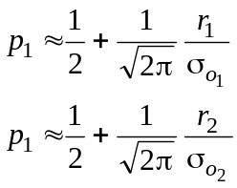 (24)
Using equation (24) in equation (23) gives:

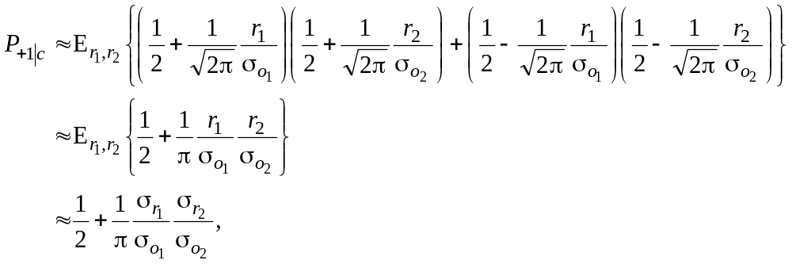 (25)

where we used equation (11) in the last step.

4.2 Cross-correlation SNR (XSNR)
The following ratio defines the XSNR:

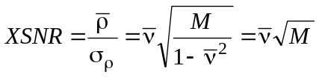 (26)

since 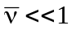. Note that XSNR is not defined as the ratio of powers, but simply as the ratio of the mean to the standard deviation of ρ. Here, this definition is reasonable, since ρ itself has units of power, being the product of the two voltage (or current) signals. Now, by combining equations (21) and (25), we get a simple, approximate expression for as:

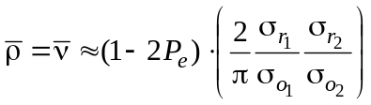 (27)

Therefore, XSNR is approximated as:

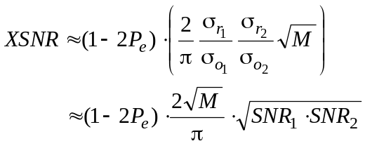 (28)

where 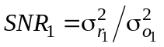 and 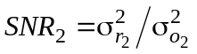are the SNRs at the observatories. Note that if the telemetry bit error rate is zero, the XSNR becomes:

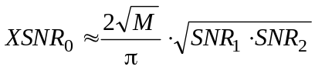 (29)

which can be considered as the nominal value of the XSNR. Thus, the telemetry channel can only introduce bit errors and degrade the XSNR to:
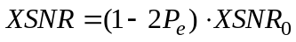 (30)
Note that this is an exact expression for XSNR, where XSNR₀ represents the XSNR with no bit errors. Equation (29) gives an approximation for XSNR₀. In the space VLBI system, the thermal noise and interference in the telemetry link affect the XSNR. In particular, we showed here that the XSNR is proportional to (1 – 2P_{e}), with P_{e} being the probability of bit error for the telemetry link.
Also note that, using equation (8):

1 – 2P_{e} = (1 – 2P_{ε})² (31)

Therefore, the XSNR will be proportional to the square of (1 – 2P_{ε}), i.e.

XSNR = (1 – 2P_{ε})² ⋅ XSNR₀ (32)

5 Derivation of space VLBI telemetry interference criteria

5.1 Degradations in XSNR due to noise and interference in the telemetry link
When interference is absent, the XSNR degradation due to thermal and other internal noise sources on the telemetry link is defined by:

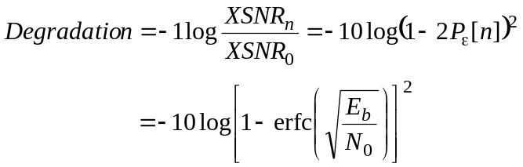 (33)

When interference is present, the XSNR degradation due to thermal noise and interference together on the telemetry link is given by:

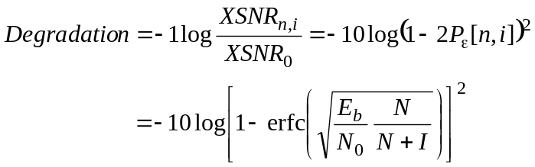 (34)

where N represents the total noise power and I represents the total interference power. Now, combining the above equations, we obtain the additional degradation that telemetry interference causes with respect to thermal noise only case as given by the ratio:

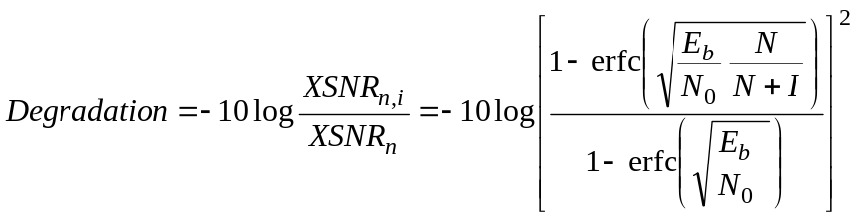 (35)
The ratio E_{b}/N₀ is 5.2 dB in the baseline Space VLBI telemetry link design, corresponding to a BER of 10^{–2} using DQPSK with coherent detection. At this BER using equation (33) the XSNR degradation due to thermal noise on the telemetry link is 0.09 dB. Higher E_{b}/N₀ is very difficult to achieve on the Space VLBI spacecraft because of the stringent requirement of an extremely high data rate in the midst of other difficult challenges unique to such spacecraft. These challenges include a phase stable link, transporting the clock frequency of the ground station to the spacecraft, and a 15 m observatory antenna receiving galactic signals.
The XSNR degradation of equation (35) at an E_{b}/N₀ of 5.2 dB is plotted in Fig. 4 as a function of the I/N. Both interference power and thermal noise power are referred at the input of the receiver LNA, weighted by a 1 GHz matched filter as defined in § 3.1.1, equations (3) and (4).

Figure 4
XSNR degradation vs I/N at E_{b}/N₀ = 5.2 dB
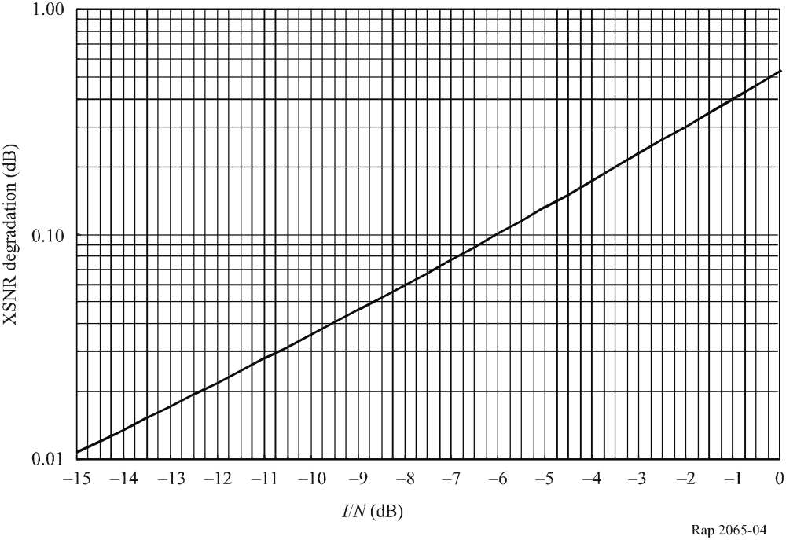
The ratio of total powers, I/N, is in general different from the ratio of power spectral densities, I₀/N₀, since the interfering signal and the matched filter in the receiver will not ordinarily have equal bandwidths. In cases where the spectral properties of the interfering signals can be characterized, the corresponding I₀/N₀ may be derived.

5.2 Tolerable degradation due to interference
The impact of interference on VLBI observation is discussed in [Thompson et al., 2001], which considers the final product of a VLBI observation the image of the signal source. It defines harmful interference as the ratio of interference rms value to the noise rms value in the radio map, called the brightness distribution. It states that 1% error in the visibility function, which is proportional to the cross-correlation function, introduces a 1% error in the rms value over the brightness distribution compared to the corresponding rms value of the true brightness distribution. Therefore, a 1% error in the cross-correlation function is tolerable. The cross-correlation function, however, is proportional to the square root of the product of the SNRs at the two observatories (see § 4.2, equation (28)). Therefore, distributing the error equally between the two observatories, we get 1% error in SNR₁ and 1% error in SNR₂ as tolerable.
Recommendation ITU-R RA.769 considers the science objectives of VLBI as discussed above and establishes a tolerable level of cross-correlation degradation. In addressing two VLBI antennas on the ground, Recommendation ITU-R RA.769 Protection criteria used for radioastronomincal measurements, says that the “tolerable interference level is determined by the requirement that the power level of the interfering signal should be no more than 1% of the receiver noise power to prevent serious errors in the measurement of the amplitude of the cosmic signals”. When interference with 1% of the receiver noise power is present at one of the observatories but not the other, the effective SNR at this observatory decreases by the fractional factor 1/1.01 = 0.99. Since the XSNR is proportional to the square-root of the product of the SNRs at the two observatories, and the standard deviation is the square-root of variance, the cross-correlation SNR decreases by a fractional factor 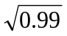 = 0.995, which is –10 log(0.995) = 0.02 dB.
In a space VLBI system, Recommendation ITU-R RA.769, thus, limits the cross-correlation degradation to 0.02 dB due to interference in the ground-based observatory. To achieve the same performance objective in the space-borne observatory link, it is sufficient to limit the cross correlation degradation due to interference in the telemetry link to 0.02 dB.
From Fig. 4, we determine that the XSNR degradation is limited to 0.02 dB when the I/N at the telemetry receiver does not exceed –12.5 dB.
In the space-to-Earth telemetry link, two sources degrade the XSNR (figure-of-merit): internal system impairments (thermal noise) and external interference. The degradation of 0.09 dB due to thermal noise is equivalent to a 2.06% degradation of the link figure of merit. The degradation of 0.02 dB due to interference is equivalent to a 0.46% degradation of the same figure of merit. Relative to the sum of the two degradations, 82% is therefore due to internal system impairments (thermal noise), and 18% is due to external interference. These percentages are consistent with such allocations in other active services.

5.3 Calculation of interference criteria
In the band defined by the matched filter, the interfering power at the input terminal of the LNA is calculated using equation (4). Its value that corresponds to a XSNR degradation of 0.02 dB, however, can be calculated using:

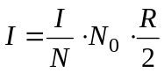 (36)

where I/N = –12.5 dB, N₀ is the one-sided power spectral density of the thermal noise, and R is the quaternary symbol rate (see equation (3)). Note that the one-sided power spectral density of the thermal noise in the telemetry receiver is given by:

N₀ =kT_{sys} (37)

where k = –228.6 dB(W/(Hz ∙ K)) is Boltzmann’s constant, and T_{sys} is the system noise temperature referenced to the input terminal of the LNA. This noise temperature is a strong function of antenna elevation angle as shown in Fig. 5 for weather condition corresponding to 90% cumulative-distribution.
Figure 5
T_{sys} in the 37-38 GHz band with 90% weather
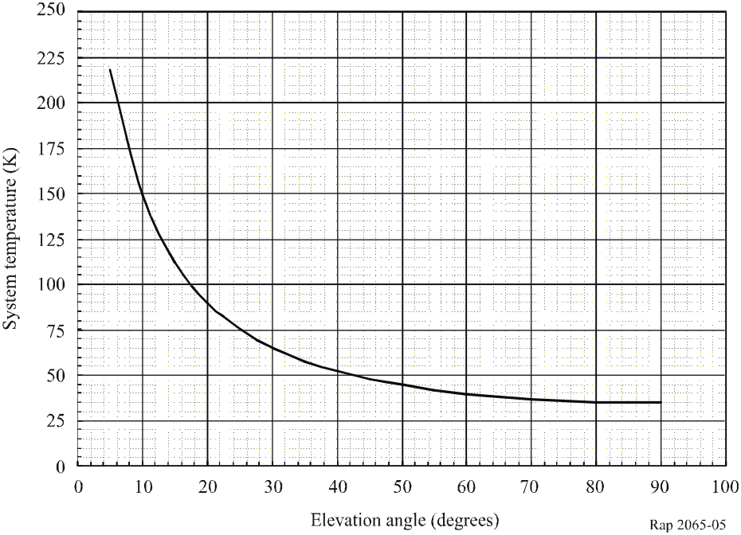
For an equivalent system noise temperature T_{sys} of 150 K (90% weather at 10° elevation angle) and a quaternary symbol rate of 500 Msymbol/s, the interfering power is approximately –135.5 dB(W) based on equations (36) and (37), as shown in Table 1, below:

TABLE 1
Interference power calculation
Parameter | Unit | Value
I/N | dB | –12.5 | Space VLBI design
N₀ | dB(W/Hz) | –206.84 | N₀ = kT_{sys} with T_{sys} = 150 K
R/2 | dB(symbol/s) | 84 | R = 500 Msymbol/s
I | dBW | –135.34

It is important to note that the interfering power, as calculated by equation (36), is also referenced to the input terminal of the LNA. This is the same reference point within the receiver chain as for the noise spectral density N₀, but only includes that portion of the total interfering signal power that lies within the band defined by the telemetry-matched filter. Note also that in order for the interfering power at the input to the low-noise amplifier defined by the 1 GHz matched filter to be below it is sufficient to restrict the interfering power at the input to the LNA across the 37.0 to 38.0 GHz band to be below –135.5 dB(W).
The carrier-tracking loop performance of the Space VLBI telemetry is also protected adequately when I/N ≤ –12.5 dB. Consider the extreme case when the interference power is concentrated in a continuous wave (CW) interfering signal. Then the CW interference power I is defined as in equation (36). The effective carrier power P_{c} equals the total signal power P determined from the requirement E_{b}/N₀ ≥ 5.2 dB, as:

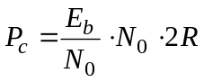 (38)

since E_{b} = P/(2R) where R is the same symbol rate as in equation (36). Now, using the design values, we get:

TABLE 2
Carrier power calculation
Parameter | Unit | Value
E_{b}/N₀ | dB | 5.2 | Space VLBI design
N₀ | dB(W/Hz) | –206.84 | N₀ = kT_{sys} with T_{sys} = 150 K
2R | dB(symbol/s) | 90 | R = 500 Msymbol/s
P_{c} | dBW | –111.64

Thus, from Tables 1 and 2 we have P_{c}/I = 23.7 dB in the carrier-tracking loop. Such a ratio is high enough that degradation in carrier synchronization and in telemetry detection will be insignificant. In normal cases when the interference spectrum is spread over a bandwidth of several Megahertz, P_{c}/I >> 23.7 dB, and its effect on the carrier tracking loop will be even less.

References

THOMPSON. A.R., MORAN J.M. and SWENSON G.W. [2001] Interferometry and synthesis in radio astronomy, 2nd Ed., J. Wiley & Sons.

