|  |
| --- |
| **Report ITU-R SA.2275**  **(09/2013)** |
| **Sharing between the Earth exploration-satellite service (Earth-to-space) and  the fixed service in the 7-8 GHz range** |
| **SA Series**  **Space applications and meteorology** |

Foreword

The role of the Radiocommunication Sector is to ensure the rational, equitable, efficient and economical use of the radio-frequency spectrum by all radiocommunication services, including satellite services, and carry out studies without limit of frequency range on the basis of which Recommendations are adopted.

The regulatory and policy functions of the Radiocommunication Sector are performed by World and Regional Radiocommunication Conferences and Radiocommunication Assemblies supported by Study Groups.

# Policy on Intellectual Property Right (IPR)

ITU-R policy on IPR is described in the Common Patent Policy for ITU-T/ITU-R/ISO/IEC referenced in Annex 1 of Resolution ITU-R 1. Forms to be used for the submission of patent statements and licensing declarations by patent holders are available from <http://www.itu.int/ITU-R/go/patents/en> where the Guidelines for Implementation of the Common Patent Policy for ITU‑T/ITU‑R/ISO/IEC and the ITU-R patent information database can also be found.

|  |  |
| --- | --- |
| Series of ITU-R Reports  (Also available online at <http://www.itu.int/publ/R-REP/en>) | |
| **Series** | Title |
| **BO** | Satellite delivery |
| **BR** | Recording for production, archival and play-out; film for television |
| **BS** | Broadcasting service (sound) |
| **BT** | Broadcasting service (television) |
| **F** | Fixed service |
| **M** | Mobile, radiodetermination, amateur and related satellite services |
| **P** | Radiowave propagation |
| **RA** | Radio astronomy |
| **RS** | Remote sensing systems |
| **S** | Fixed-satellite service |
| **SA** | **Space applications and meteorology** |
| **SF** | Frequency sharing and coordination between fixed-satellite and fixed service systems |
| **SM** | Spectrum management |

|  |
| --- |
|  |

|  |
| --- |
| ***Note****: This ITU-R Report was approved in English by the Study Group under the procedure detailed in Resolution ITU-R 1.* |

*Electronic Publication*

Geneva, 2013

© ITU 2013

All rights reserved. No part of this publication may be reproduced, by any means whatsoever, without written permission of ITU.

REPORT ITU-R SA.2275

Sharing between the Earth exploration-satellite service (Earth-to-space)  
and the fixed service in the 7-8 GHz range

(2013)

# 1 Introduction

WRC-15 agenda item 1.11 deals with the consideration of a primary allocation to the Earth exploration-satellite service (Earth-to-space) in the 7-8 GHz range in accordance with Resolution **650 (WRC‑12)**,with priority to the band 7 145-7 235 MHz.

This Report examines the sharing between such EESS (Earth-to-space) earth stations and the fixed service (FS).

The methodology applied consists in determining the size of a coordination area around the EESS earth station which will depend on the characteristics of both the EESS as well as the FS. It should be noted that the space operation service (SOS) and space research service (SRS) are already allocated in this frequency range and that provisions exist in RR Appendix **7** with regard to coordination between SRS and SOS on one side and FS on the other side, including the characteristics of the reference FS system to be taken into account in the determination of the coordination area.

This Report also studies the impact of a deployment of FS stations on an EESS low Earth orbit (LEO) satellite receiver.

# 2 Fixed service characteristics

The characteristics of fixed service links as shown in Table 1 were taken from Table 7b of RR Appendix **7** in the band 7 100-7 235 MHz shared between the FS and the SOS in Russia and the SRS worldwide. The sharing situation is similar. Only the digital FS system was considered here, since most of the analogue systems are no longer in operation and no longer appear in Recommendation ITU-R F.758-5.

TABLE 1

FS characteristics from Table 7b of RR Appendix 7

|  |  |  |  |
| --- | --- | --- | --- |
| Frequency bands (MHz) | | 7 100-7 235 | |
| Receiving terrestrial service designations | | Fixed, mobile | |
| Method to be used | | § 2.2 | |
| Modulation at terrestrial station | | N | |
| Terrestrial station interference parameters and criteria | *p*0 (%) | 0.005 | |
| *N* | 2 |
| *p* (%) | 0.0025 |
| *NL* (dB) | 0 |
| *Ms* (dB) | 37 |
| *W* (dB) | 0 |
| Terrestrial station parameters | *Gx* (dBi)4 | 46 | |
| *Te* (K) | 750 |
| Reference bandwidth | *B* (Hz) | 106 | |
| Permissible interference power | *Pr*( *p*) (dBW) in *B* | –103 | |
| 4 Feeder losses are not included. | | | |

This reference system used for the determination of coordination contours may be compared to the characteristics of FS systems contained in Recommendation ITU-R F.758-5 for the same frequency bands, which are reproduced in Table 2.

TABLE 2

FS characteristics from Recommendation ITU-R F.758-5

|  |  |  |  |  |
| --- | --- | --- | --- | --- |
| Frequency range (GHz) | 7.110-7.900 | | 7.725-8.500 | |
| Reference ITU‑R Recommendation | F.385 | | F.386 | |
| Modulation | 16-QAM | 128-QAM | 16-QAM | 128-QAM |
| Channel spacing and receiver noise bandwidth (MHz) | 3.5, 5, 7, **10**, 14, **20**, **28**, **30**(3), **40**(3), **60**(3), **80**(3) | 3.5, 5, 7, **10**, 14, **20**, **28**, **30**(3), **40**(3), **60**(3), **80**(3) | 1.25, 2.5, 5, 7, **10**, 11.662, 14, **20**, **28**, 29.65, **30**, **40**, **60**(3), **80**(3) | 1.25, 2.5, 5, 7, **10**, 11.662, 14, **20**, **28**, 29.65, **30**, **40**, **60**(3), **80**(3) |
| Tx output power range (dBW) | −6.5…20.0 | −6.5…20.0 | −6.5…20.0 | −6.5…20.0 |
| Tx output power density range (dBW/MHz)(1) | −25.5…10.0 | −25.5…10.0 | −25.5…10.0 | −25.5…10.0 |
| Feeder/multiplexer loss range (dB) | 0…3.0 | 0…3.0 | 0…3.0 | 0…3.0 |
| Antenna gain range (dBi) | 12…48.6 | 12…48.6 | 12…48.6 | 12…48.6 |

TABLE 2 (*end*)

|  |  |  |  |  |
| --- | --- | --- | --- | --- |
| Frequency range (GHz) | 7.110-7.900 | | 7.725-8.500 | |
| e.i.r.p. range (dBW) | 5.5…65.5 | 5.5…65.5 | 5.5…65.5 | 5.5…65.5 |
| e.i.r.p. density range (dBW/MHz)(1) | −13.5…55.5 | −13.5…55.5 | −13.5…55.5 | −13.5…55.5 |
| Receiver noise figure typical (dB) | 2.5…6 | 2.5…6 | 2.5…6 | 2.5…8 |
| Receiver noise power density typical (=*NRX*) (dBW/MHz) | −141.5… −138.0 | −141.5… −138.0 | −141.5…−138.0 | −141.5…−136 |
| Normalized Rx input level for 1 × 10−6 BER (dBW/MHz) | −121.0… −117.5 | −112.5… −115.0 | −121.0…−117.5 | −111.3…−106.5 |
| Nominal long-term interference power density (dBW/MHz)(2) | −141.5… −138.0 + *I*/*N* | −141.5… −138.0 + *I*/*N* | −141.5… −138.0 + *I*/*N* | −141.5… −136+ *I*/*N* |
| (1) To calculate the values for the Tx/e.i.r.p. densities, channel spacing/bandwidth needs to be identified. In these tables, the channel spacing indicated in the **bold** letter is used. Where a modal value (Mode) is provided, it is to be taken as indicative within the range specified and further sensitivity analysis may be required on a case-by-case basis to assess a given interference potential due to the variations within the range specified.  (2) Nominal long-term interference power density is defined by “Receiver noise power density + (required *I*/*N*)” as described in § 4.13 in Annex 2 (see also § 4.1 in Annex 1).  (3) This channel spacing value is not specified in the reference Recommendation. | | | | |

The characteristics given in RR Appendix **7** are quite consistent with the characteristics contained in Recommendation ITU-R F.758-5. Since the determination of coordination contour with regard to space research and space operation is currently done with the characteristics of Table 1, it is proposed to use them also with regard to EESS.

# 3 EESS (Earth-to-space) earth station characteristics

The technical characteristics of potential new EESS (Earth-to-space) systems operating in the 7‑8 GHz frequency range would be similar to those of SRS near-Earth systems, which operate today in the same frequency range, but with lower transmit power requirements and antenna size limited to 12‑15 metre diameter. The assumptions considered in the simulations presented in the following sections are based on Table 3.

TABLE 3

Technical characteristics representative of potential EESS missions with uplinks in 7-8 GHz

|  |  |  |
| --- | --- | --- |
|  | Representative parameters | Remarks |
| **Orbit description** |  |  |
| Type of orbit | Circular LEO | Typically circular or near-circular polar orbit |
| Orbit altitude | 700 km | 400-900 km |
| Inclination | 98 degrees | Typically 97-99 degrees |
| **Earth station** |  |  |
| Location | Typically high latitudes | High latitudes preferable to maximize the satellite contact times |
| RF transmit power level | 16 dBW (40 W) | At antenna interface |
| Antenna type | 15 m parabolic reflector | Typically 12-15 m |
| Antenna gain | 56.5 dBi |  |
| Antenna pattern | Recommendation ITU-R F.1245 | Representative of average side lobes as the antenna is tracking the satellite |
| Minimum elevation angle | 5 degrees | Also depends on the terrain shielding surrounding the earth station |
| e.i.r.p. | 72.5 dBW max | Maximum e.i.r.p. |
| Uplink signal: | Telecommand and ranging |  |
| – Telecommand | Low rate: *Rb* = 4 kbit/s | Up to 4 kbit/s  Modulation: PCM (NRZ-L)/PSK/PM (*)  Max BW 99% ≈ 100 kHz |
| Medium rate: *Rb* = 64 kbit/s | 8 to 256 kbit/s  Modulation PCM (SPL)/PM (*)  Max BW 99% ≈ 780 kHz (for 64 kbit/s) to 3 MHz (for 256 kbit/s) with filtering |
| High rate: *Rb* = 1.024 Mbit/s | 1 to 2 048 kbit/s  Modulation BPSK (*)  Not compatible with simultaneous ranging  Max BW 99% ≈ 2 MHz (for 1 Mbit/s), 4 MHz (for 2 Mbit/s) with filtering |
| – Ranging | Tone ranging or PN code ranging systems | Max BW ≈ 2.5 * Ft  250 kHz (for 100 kHz tone) to 3.75 MHz (for 1.5 MHz tone) (*) |
| **Satellite** |  |  |
| Antenna type 1: Low gain antenna (LGA) | *G* = –2 dBi @ 90 degrees (nom)  *G* = +7 dBi (±10 degrees peak gain) | Hemispherical coverage by using two or more LGAs.  Dynamic simulations: *G* = 0 dBi considered |

TABLE 3 (*end*)

|  |  |  |
| --- | --- | --- |
|  | Representative parameters | Remarks |
| Antenna type 2: Shaped isoflux antenna | *G* = +6 dBi max at ±60 degrees  *G* = –4 dBi min at 0 degree | Antenna pointing to Earth centre. Pattern assumed as currently used for many EESS downlink in the 8 025-8 400 MHz frequency band |
| Noise temperature at the receiver input | 800 K | Antenna noise Tant ≈ 300 K  Receiver noise figure *F* ≈ 2.5 dB |
| Protection criteria | –161 dBW/kHz, 0.1% of the time | Recommendation ITU-R SA.514-3 |
| (*) CCSDS Recommendations for radio frequency and modulation systems (CCSDS 401.0-B). | | |

In view of the characteristics of the modulation schemes used by the earth station, it has been considered in the following paragraphs that the EESS earth station emission power falls completely into the FS reference bandwidth of 1 MHz.

The number of EESS earth stations operating Earth-to-space in this new allocated band is expected to be limited to a few tens. At the moment all the EESS satellites are commanded using the band 2 025-2 110 MHz. The number of these S-band stations used for EESS commanding is estimated to be in the order of ~30. These stations are typically located at high latitudes, to achieve longer visibility of the polar-orbiting EESS satellites. These stations are often shared by users from many different space agencies.

Assuming the new allocation is agreed at WRC-15, some of the future EESS satellites requiring large bandwidth on the uplink are likely to be controlled using this new allocated band. This is not to be expected to happen in the short-term but rather in the medium-/long-term period.

For operating cost reasons, it is expected that any new earth station with EESS Earth-to-space capability in the new band will be co-located with the existing S-band earth stations.

It can be estimated that roughly two thirds of the stations operating in the S band will be equipped with an additional EESS (Earth-to-space) capability, leading to an estimated number of ~20 EESS stations that will be operating in the new EESS (Earth-to-space) band in the 7/8 GHz range in the long period.

# 4 TIG methodology (from RR Appendix 7)

This is the general methodology to derive the coordination contour. However, it has to be noticed that this general methodology will overestimate the coordination distance in case of non-GSO satellites, and in particular EESS satellites which are on LEO. The time-variant gain (TVG) methodology described in § 5 would give a better evaluation of the coordination distance for this specific case. Therefore, the results provided in § 4 are for information only.

## 4.1 Description

The attenuation required to limit the level of interference between a transmitting terrestrial station or earth station and a receiving terrestrial station or earth station to the permissible interference power for *p*% of the time is represented by the “minimum required loss”, which is the loss that needs to be equalled or exceeded by the predicted path loss for all but *p*% of the time.

For propagation mode (1) the following equation applies:

*Lb*( *p* ) = *Pt* + *Gt* + *Gr* – *Pr*( *p* )                    dB (1)

where:

*p*: maximum percentage of time for which the permissible interference power may be exceeded

*Lb*(*p* ): propagation mode (1) minimum required loss (dB) for *p*% of the time; this value must be exceeded by the propagation mode (1) predicted path loss for all but *p*% of the time

*Pt*:maximum available transmitting power level (dBW) in the reference bandwidth at the terminals of the antenna of a transmitting terrestrial station or earth station

*Pr*( *p* ): permissible interference power of an interfering emission (dBW) in the reference bandwidth to be exceeded for no more than *p*% of the time at the terminals of the antenna of a receiving terrestrial station or earth station that may be subject to interference, where the interfering emission originates from a single source

*Gt*: gain (dB relative to isotropic) of the antenna of the transmitting terrestrial station or earth station. For a transmitting earth station, this is the antenna gain towards the physical horizon on a given azimuth; for a transmitting terrestrial station, the maximum main beam axis antenna gain is to be used

*Gr*: gain (dB relative to isotropic) of the antenna of the receiving terrestrial or earth station that may be subject to interference. For a receiving earth station, this is the gain towards the physical horizon on a given azimuth; for a receiving terrestrial station, the maximum main beam axis antenna gain is to be used.

## 4.2 Determination of the coordination distance for the worst case azimuth

Using the pattern provided in Recommendation ITU-R F.1245 for the EESS earth station antenna, it is possible to obtain the maximum EESS earth station antenna gain *Gt* towards the horizon at an elevation angle of 5°, which is 11.5 dBi, as well as the minimum antenna gain, which is –13 dBi (see § 5.2).

The value for *Gt* is determined by the difference in the maximum and minimum gain of the antenna along the azimuth angle under consideration in accordance with equation (2) from RR Appendix **7** paragraph 2.2.

   (2)

*Gt* is therefore equal to 7 dBi.

In this section, the FS station is assumed to be pointing towards the direction of the EESS earth station, which is a worst case assumption. *Gr* is therefore the FS maximum antenna gain, 46 dBi.

The propagation loss is then calculated for separation distances ranging from 200 m to 300 km using the complete clear air methodology in Recommendation ITU-R P.452-14 for the percentages of time 0.005 (short-term) and 20 (long-term). The location was considered in Kiruna (Sweden) where an EESS earth station receiving data from satellites in the band 8 025-8 400 MHz is already implemented.

An antenna height of 11 m above the ground was considered for the EESS station, and 20 m for the FS station (station on top of a building).

TABLE 4

TIG maximum coordination distance

|  |  |  |  |  |  |  |
| --- | --- | --- | --- | --- | --- | --- |
| *p* (%) | *Pt* (dBW) | *Gt* (dBi) | *Gr* (dBi) | *Pr* (dBW) | *Lb* (dB) | *D* (km) |
| 20 | 16 | 7 | 46 | –150 | 219 | 201 |
| 0.005 | –103 | 172 | 271 |

The results of the TIG methodology when considering a worst case situation with the FS station pointing straight at the EESS earth station and no shielding give a rather high coordination distance. As usual, the worst case separation distance is given by the short-term criterion.

## 4.3 Relevance of the long-term criterion and the TIG methodology

As shown in Fig. 1, the EESS earth station would be active less than 10% of the time, since the number and duration of LEO EESS passages are limited, even when considering an earth station tracking several satellites during the day. Therefore, the 20% of the time associated with the long‑term criterion would never be reached. For this reason, in the following sections, only the short-term criterion is considered.

The TIG methodology may overestimate the coordination distances for non-GSO satellites, particularly on LEOs such as polar orbits often used for Earth observation. When considering an earth station tracking non-GSO satellites, Annex 6 to RR Appendix **7** gives an alternative method that takes into account the movement of the earth station antenna and the associated statistics on the antenna gain of the earth station towards the horizon. This is depicted and applied in § 5.

# 5 TVG methodology (from Annex 6 to RR Appendix 7)

The TVG methodology is fully relevant for EESS satellites which operate on LEOs and gives a more realistic coordination distance for this particular case.

## 5.1 Description

The TVG method described in section 4 of Annex 6 to RR Appendix **7** is used. Indeed the situation is similar as WRC-12 agenda item 1.11 (allocation of SRS (Earth-to-space) at 22 GHz) in the previous study cycle, where sharing with FS was also studied, using this methodology.

The TVG method closely approximates the convolution of the distribution of the horizon gain of the earth station antenna and the propagation loss. This method may produce slightly smaller distances than those obtained by an ideal convolution. An ideal convolution cannot be implemented due to the limitations of the current model for propagation loss. The propagation loss required distance, at the azimuth under consideration, may be rewritten for the *n*-th calculation in the following form:

                    dB (3)

with the constraint:



where:

*Pt*: maximum available transmitting power level (dBW) in the reference bandwidth at the terminals of the antenna of a transmitting terrestrial station for earth station

*Pr*( *p* ): permissible interference power of an interfering emission (dBW) in the reference bandwidth to be exceeded for no more than *p*% of the time at the terminals of the antenna of a receiving terrestrial station or earth station that may be subject to interference, where the interfering emission originates from a single source

*Gx*: maximum antenna gain assumed for the terrestrial station (dBi)

*Ge*( *pn*): the horizon gain of the coordinating earth station antenna (dBi) that is exceeded for *pn*%of the time on the azimuth under consideration

*Lb*( *pv*): the minimum required propagation loss (dB) for *pv*% of the time.

The values of the percentages of time, *pn*, to be used in equation (3) are determined in the context of the cumulative distribution of the horizon antenna gain. This distribution needs to be developed for a predetermined set of values of horizon antenna gain spanning the range from the minimum to the maximum values for the azimuth under consideration. The notation *Ge*( *pn*) denotes the value of horizon antenna gain for which the complement of the cumulative distribution of the horizon antenna gain has the value corresponding to the percentage of time *pn*. The *pn* value is the percentage of time that the horizon antenna gain exceeds the *n*-th horizon antenna gain value.

For each value of *pn*, the value of horizon antenna gain for this time percentage, *Ge*( *pn*), is used in equation (3) to determine a minimum required propagation loss. The propagation loss is to be lower than this required propagation loss for no more than *pv*% of the time, as specified by the constraint associated with equation (3). A series of distances are then determined using Recommendation ITU‑R P.452-14.

## 5.2 Determination of the coordination distance for the worst case azimuth

Using the pattern provided in Recommendation ITU-R F.1245 for the EESS earth station antenna, it is possible to derive the cumulative distribution function (cdf) of the EESS earth station antenna gain towards the horizon for a station tracking an EESS satellite on polar orbit at elevation angles greater than 5°. Figure 1 gives this cdf for a station located in Kiruna in the North of Sweden. The cdf is derived over 1 month assuming 36 different directions in azimuth for the FS station (from 0 to 360° with a step of 10°). The worst case appears in red.

Figure 1

EESS earth station antenna gain towards the FS station



For all the antenna gains *Ge* from –13 dBi to 11 dBi with a step of 1 dB, the percentage of time *pn* used in equation (3) is taken from the red curve on the cdf. Then the percentage of time *pv* associated with the propagation loss is derived using the constraint in equation (3), considering the percentage of time, *p*, associated with the short‑term protection criterion (0.005%).

In this section, the FS station is assumed to be pointing towards the direction of the EESS earth station, which is a worst case assumption. *Gx* is therefore the FS maximum antenna gain, 46 dBi.

The propagation loss is then calculated for separation distances ranging from 200 m to 300 km using the complete dry air methodology in Recommendation ITU-R P.452-14 for the percentage of time *pv*. An antenna height of 11 m above the ground was considered for the EESS station, and 20 m for the FS station (station on top of a building).

Table 5 gives the result of calculation of coordination distances for all the EESS earth station antenna gains.

TABLE 5

Results of the TVG methodology for an EESS earth station located in Kiruna

|  |  |  |  |  |  |
| --- | --- | --- | --- | --- | --- |
| *Ge* (dBi) | *pn* (%) | *p* (%) | *pv* (%) | *Lb* (dB) | Distance (km) |
| **–13** | **7.172** | **0.005** | **0.070** | **152** | **74** |
| –12 | 2.266 | 0.005 | 0.221 | 153 | 52 |
| –11 | 2.054 | 0.005 | 0.243 | 154 | 54 |
| –10 | 1.863 | 0.005 | 0.268 | 155 | 56 |
| –9 | 1.689 | 0.005 | 0.296 | 156 | 57 |
| –8 | 1.529 | 0.005 | 0.327 | 157 | 59 |
| –7 | 1.378 | 0.005 | 0.363 | 158 | 60 |
| –6 | 1.237 | 0.005 | 0.404 | 159 | 61 |
| –5 | 1.106 | 0.005 | 0.452 | 160 | 62 |

TABLE 5 (*end*)

|  |  |  |  |  |  |
| --- | --- | --- | --- | --- | --- |
| *Ge* (dBi) | *pn* (%) | *p* (%) | *pv* (%) | *Lb* (dB) | Distance (km) |
| –4 | 0.985 | 0.005 | 0.508 | 161 | 62 |
| –3 | 0.870 | 0.005 | 0.575 | 162 | 63 |
| –2 | 0.764 | 0.005 | 0.654 | 163 | 62 |
| –1 | 0.663 | 0.005 | 0.754 | 164 | 61 |
| 0 | 0.569 | 0.005 | 0.879 | 165 | 60 |
| 1 | 0.483 | 0.005 | 1.034 | 166 | 58 |
| 2 | 0.401 | 0.005 | 1.246 | 167 | 55 |
| 3 | 0.324 | 0.005 | 1.545 | 168 | 51 |
| 4 | 0.248 | 0.005 | 2.013 | 169 | 50 |
| 5 | 0.169 | 0.005 | 2.960 | 170 | 49 |
| 6 | 0.113 | 0.005 | 4.407 | 171 | 49 |
| 7 | 0.075 | 0.005 | 6.662 | 172 | 48 |
| 8 | 0.045 | 0.005 | 11.002 | 173 | 46 |
| 9 | 0.025 | 0.005 | 20.375 | 174 | 44 |
| 10 | 0.011 | 0.005 | 47.048 | 175 | 40 |
| 11 | 0.002 | 0.005 | 50.000 | 176 | 40 |

The final distance should be the maximum distance derived for all transmitter antenna gains. This leads to a maximum coordination distance of 74 km. This corresponds to an antenna gain of   
–13 dBi, and an e.i.r.p. of 3 dBW towards the horizon for the EESS earth station, and a percentage of time of 0.07% for the propagation model (Recommendation ITU-R P.452-14).

# 6 Application for different pointing angles for the FS station

The TVG methodology was also applied to the case of a FS station which is not pointing towards the EESS earth station. As an example, when an offset angle of 2° is applied to the FS station, the FS antenna gain decreases to 25 dBi assuming the FS antenna pattern follows Recommendation ITU-R F.699, and the coordination distance decreases to about 34 km. For an offset angle greater than 50°, the FS antenna gain drops to –9 dBi and the coordination distance required drops to 3 km for all azimuths. Table 6 gives the results for different offset angles for Kiruna.

For 80% of FS stations, the coordination distance would therefore reduce to less than 5 km. For 90% of FS stations, it would be below 10 km.

TABLE 6

Coordination distance vs FS offset pointing angle for Kiruna

|  |  |  |  |
| --- | --- | --- | --- |
| Percentage of FS stations concerned (%) | FS offset pointing angle (°) | FS antenna gain towards the EESS earth station (dBi) | Coordination distance  (km) |
| 100 | 0 | 46 | 74 |
| 99 | 2 | 25 | 34 |
| 97 | 5 | 15 | 28 |
| 94 | 10 | 8 | 20 |
| 89 | 20 | 0 | 10 |
| 83 | 30 | –4 | 6 |
| 78 | 40 | –7 | 4 |
| 72 | 50 | –9 | 3 |

Using the same approach, Tables 7 to 10 give the results for Villafranca, Kourou, Wallops and Poker Flat for diverse offset angles for the FS station. It should be noted that the coordination distances around Kourou and Wallops are larger due to more favourable propagation conditions in this area. However, the first station is surrounded by tropical jungle with more than 20 dB of tree attenuation except in the direction of the sea.

TABLE 7

Coordination distance vs FS offset pointing angle for Villafranca

|  |  |  |  |
| --- | --- | --- | --- |
| Percentage of FS stations concerned (%) | FS offset pointing angle (°) | FS antenna gain towards the EESS earth station (dBi) | Coordination distance  (km) |
| 100 | 0 | 46 | 103 |
| 99 | 2 | 25 | 33 |
| 97 | 5 | 15 | 25 |
| 94 | 10 | 8 | 22 |
| 89 | 20 | 0 | 10 |
| 83 | 30 | –4 | 6 |
| 78 | 40 | –7 | 4 |
| 72 | 50 | –9 | 3 |

TABLE 8

Coordination distance vs FS offset pointing angle for Kourou

|  |  |  |  |
| --- | --- | --- | --- |
| Percentage of FS stations concerned (%) | FS offset pointing angle (°) | FS antenna gain towards the EESS earth station (dBi) | Coordination distance  (km) |
| 100 | 0 | 46 | 156 |
| 99 | 2 | 25 | 40 |
| 97 | 5 | 15 | 29 |
| 94 | 10 | 8 | 22 |
| 89 | 20 | 0 | 10 |
| 83 | 30 | –4 | 6 |
| 78 | 40 | –7 | 4 |
| 72 | 50 | –9 | 3 |

TABLE 9

Coordination distance vs FS offset pointing angle for Wallops

|  |  |  |  |
| --- | --- | --- | --- |
| Percentage of FS stations concerned  (%) | FS offset pointing angle (°) | FS antenna gain towards the EESS earth station (dBi) | Coordination distance  (km) |
| 100 | 0 | 46 | 178 |
| 99 | 2 | 25 | 57 |
| 97 | 5 | 15 | 34 |
| 94 | 10 | 8 | 29 |
| 89 | 20 | 0 | 14 |
| 83 | 30 | –4 | 9 |
| 78 | 40 | –7 | 6 |
| 72 | 50 | –9 | 5 |

TABLE 10

Coordination distance vs FS offset pointing angle for Poker Flat

|  |  |  |  |
| --- | --- | --- | --- |
| Percentage of FS stations concerned  (%) | FS offset pointing angle (°) | FS antenna gain towards the EESS earth station (dBi) | Coordination distance  (km) |
| 100 | 0 | 46 | 135 |
| 99 | 2 | 25 | 38 |
| 97 | 5 | 15 | 31 |
| 94 | 10 | 8 | 17 |
| 89 | 20 | 0 | 6 |
| 83 | 30 | –4 | 3 |
| 78 | 40 | –7 | 2 |
| 72 | 50 | –9 | 2 |

# 7 Terrain elevation

The terrain elevation around the EESS earth station constitutes an important factor that may considerably reduce the coordination distance. For example Fig. 2 shows the area around the ESA earth station of Villafranca in Spain where coordination with fixed service stations will be required (considering a worst case where the FS station points towards the EESS earth station). This area is considerably reduced compared to the maximum 103 km radius circle previously determined and constitutes basically an area of ±40 km in latitude and 5 km in longitude. The colour gives the level by which the FS interference protection criterion would be exceeded. In this example, it may be seen that the city of Madrid is not impacted by this earth station.

Figure 2

Coordination contour around the EESS earth station in Villafranca with terrain elevation

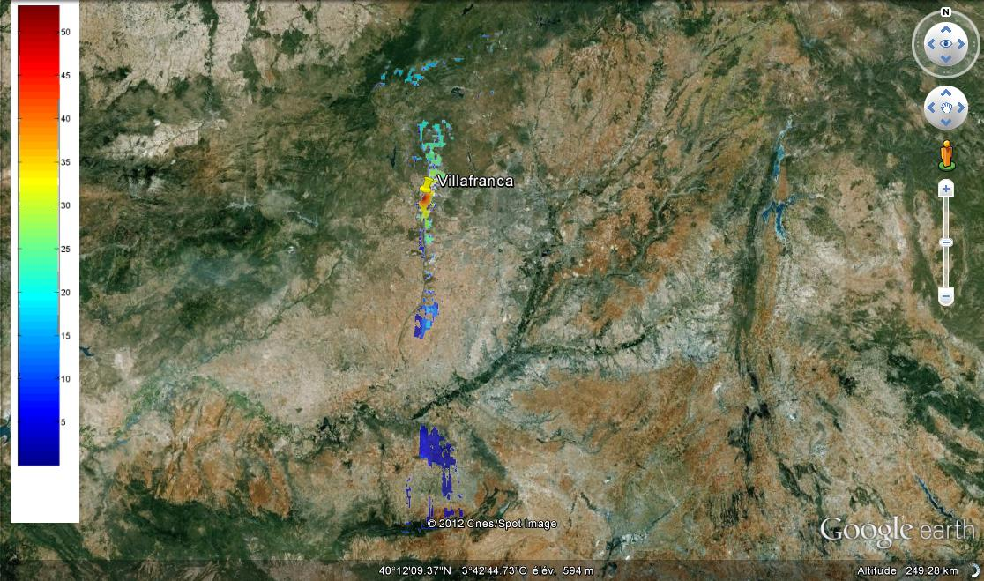

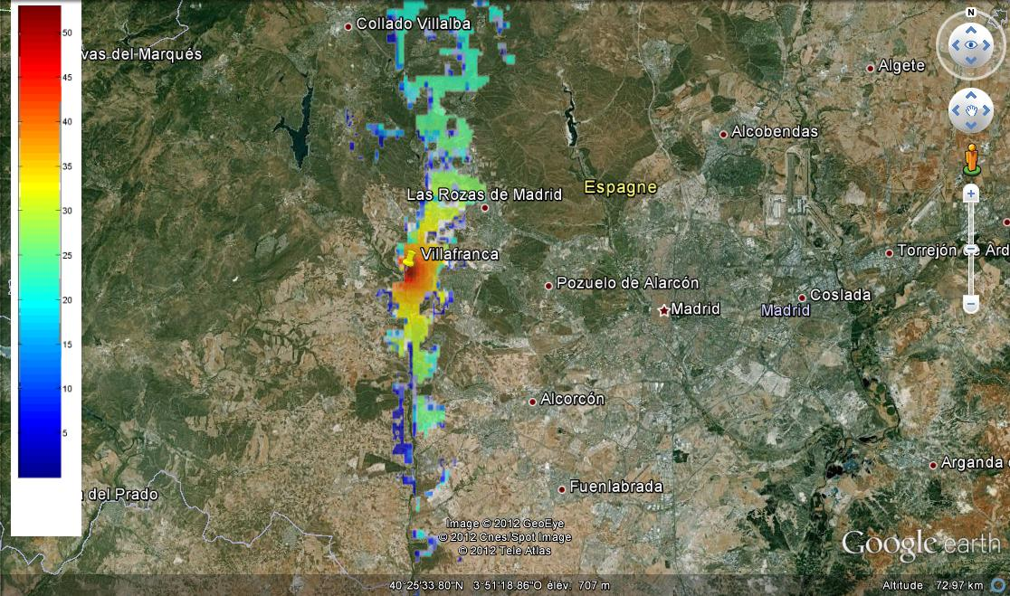

Figure 3 gives the same result for Kourou in French Guyana, still for a FS station pointing right at the EESS earth station. The large coordination distances are limited to the sea, where of course no FS station would be deployed, and to some land portions to the south east of the EESS earth station. The distances in the other directions are more around 12 km. As mentioned above, this station is surrounded by tropical jungle with more than 20 dB of tree attenuation except in the direction of the sea.

Figure 3

Coordination contour around the EESS earth station in Kourou with terrain elevation

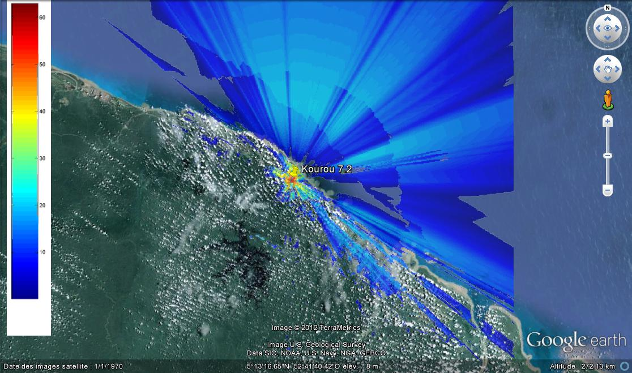

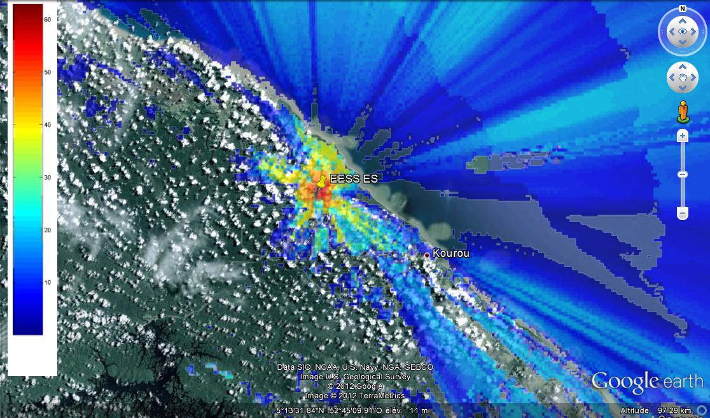

Figure 4 gives the same result for Wallops in the USA, still for a FS station pointing right at the EESS earth station. The large coordination distances are limited to the sea, where of course no FS station would be deployed. As in the two examples above, coordination areas inland are limited to specific directions, here to the littoral.

Figure 4

Coordination contour around the EESS earth station in Wallops with terrain elevation

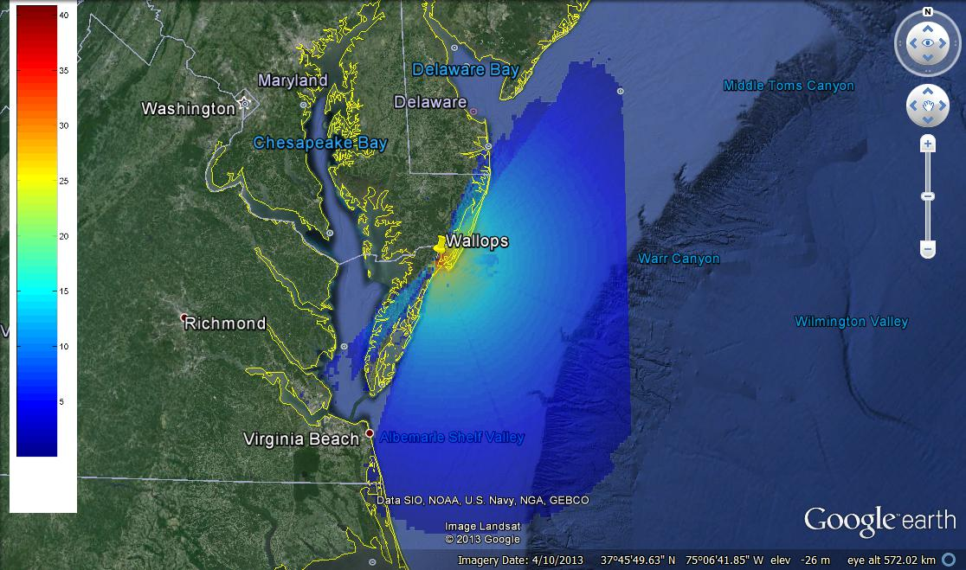

Figure 5 gives the same result for Poker Flat in the USA, still for a FS station pointing right at the EESS earth station. The separation distances are quite reduced due to terrain elevation, down to 30 km.

Figure 5

Coordination contour around the EESS earth station in Poker Flat with terrain elevation

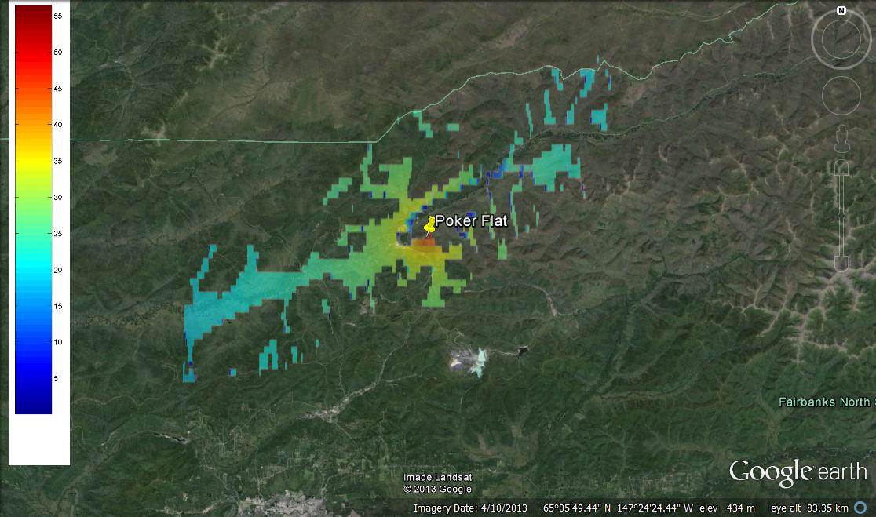

# 8 Impact of a deployment of FS links into EESS spaceborne receivers

This section analyses the impact of a deployment of 10 000 FS stations in Europe over an EESS receiver embarked on board a LEO EESS satellite.

## 8.1 FS and EESS deployment assumptions

The 10 000 stations are assumed to be transmitting over the same frequency, so that they all fall into the 1 kHz reference bandwidth given for the EESS protection criterion. They have been deployed over 100 hot spots of 1 000 km2 over Europe, with a density of 0.1 FS/km2.

The distribution of emission power density per MHz, antenna gain and elevation angles has been assumed to follow a normal distribution, with minimum and maximum values based on Table 2. The distributions are reproduced in Figs 6 to 8.

Figure 6

Distribution of FS elevation angles (°)

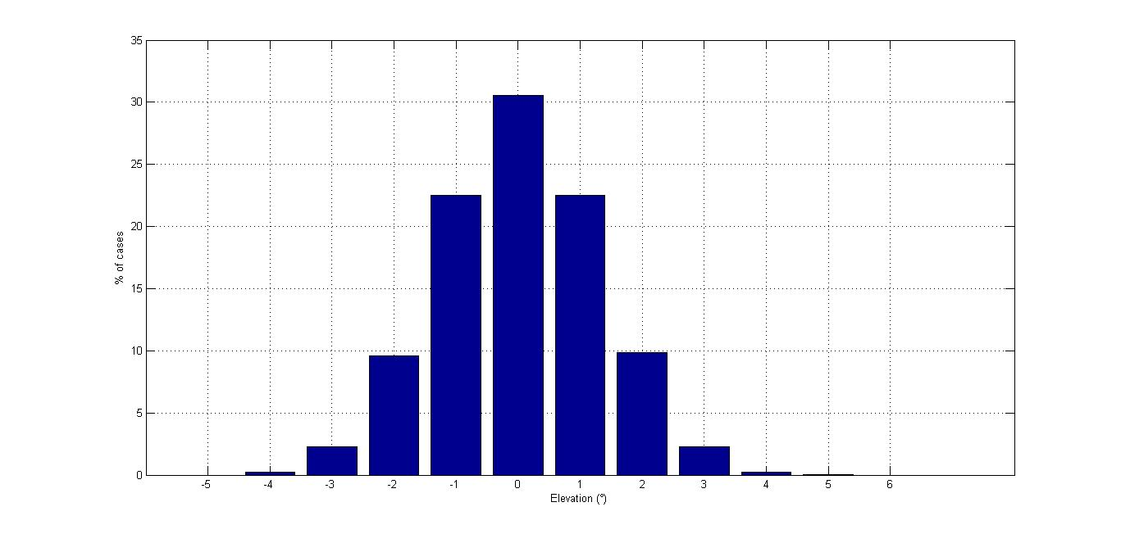

Figure 7

Distribution of power spectral densities (including feeder losses) (dBW/MHz)

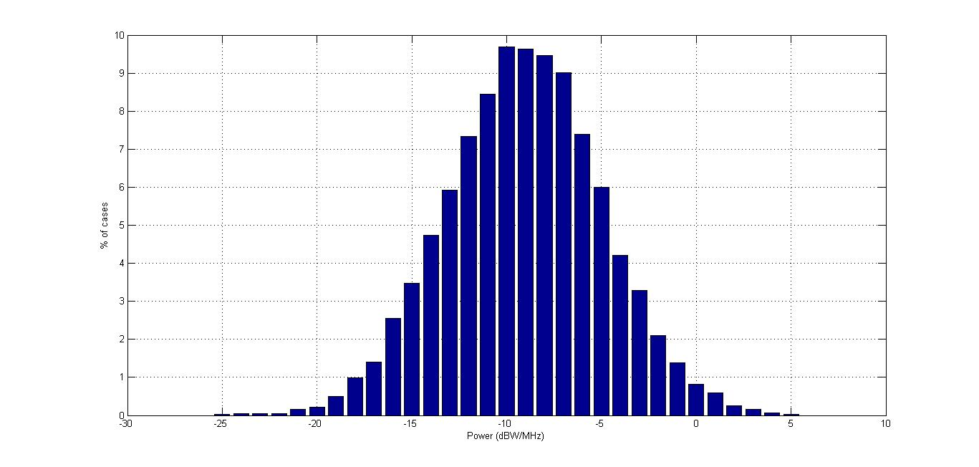

Figure 8

Distribution of maximum antenna gains (dBi)

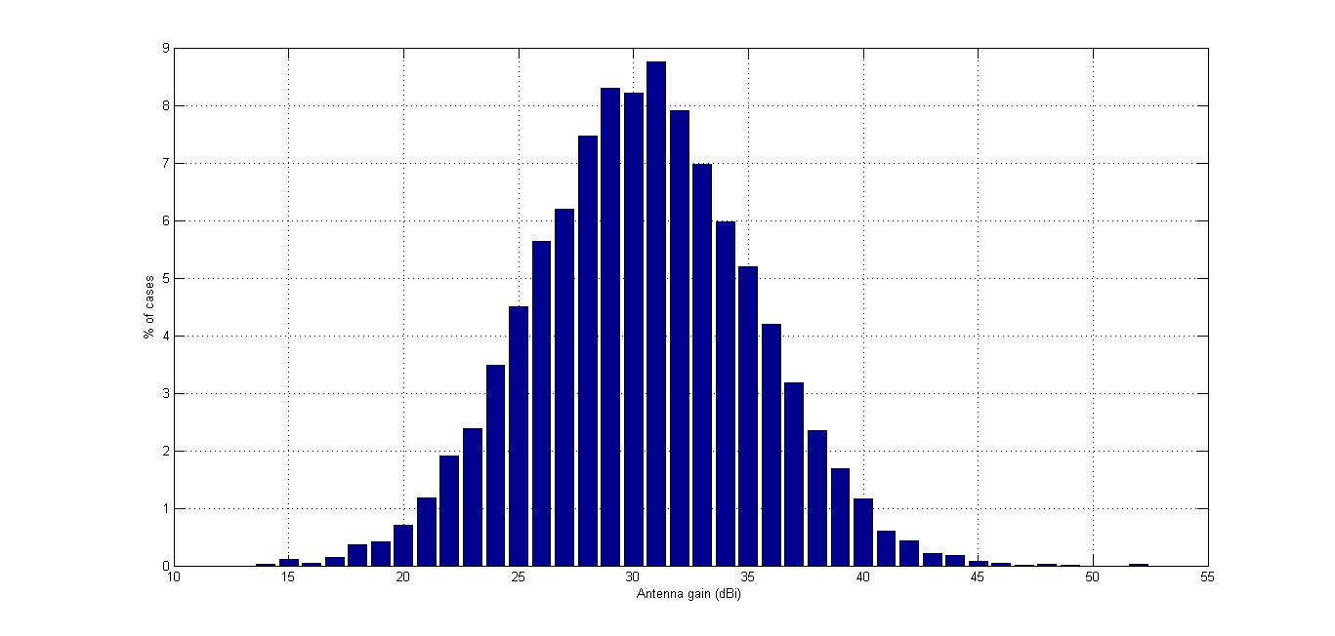

The EESS earth station is located at different latitudes from 35 to 65°. The satellite is at 700 km altitude, and for simplification, the antenna gain of the receiver antenna on board the satellite has been assumed to be omnidirectional with a 0 dBi gain.

Figure 9

Distribution of FS links and satellite orbits in visibility of the EESS earth station

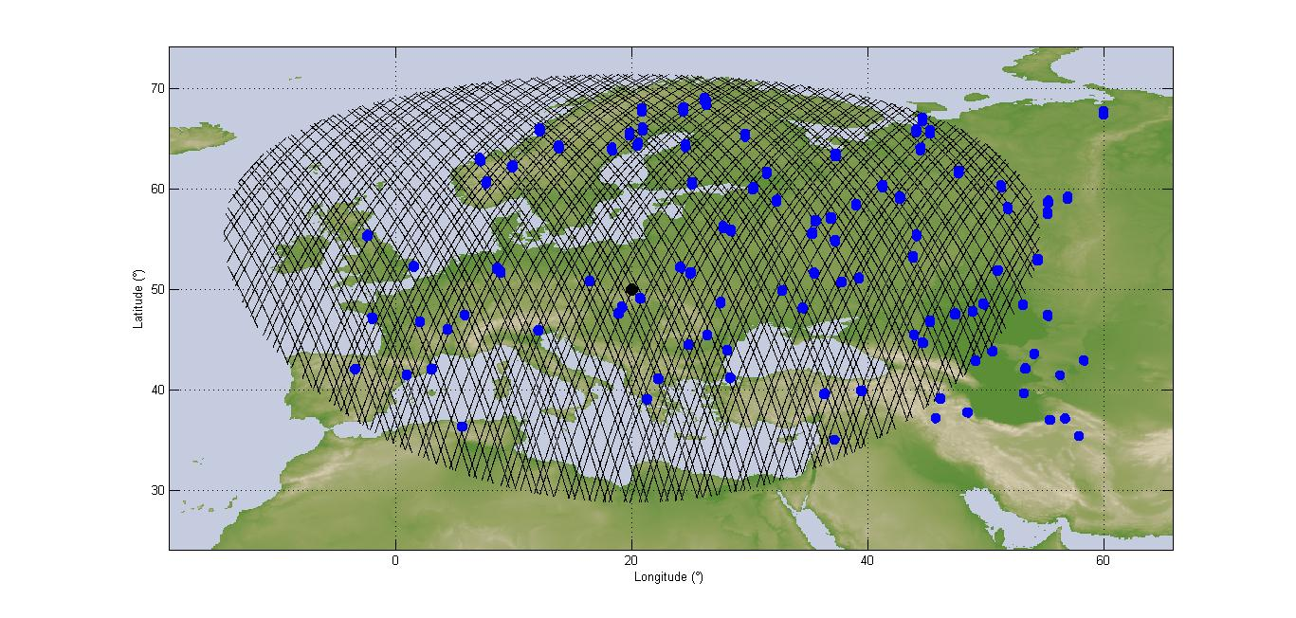

## 8.2 Simulation results and discussion

The simulation has been run over one month. The percentage of time of interference is calculated over the periods when the satellite is in visibility of the EESS earth station, with a minimum elevation angle of 5°. The results are given in Fig. 10.

Figure 10

cdf of interference depending on the latitude of the EESS earth station

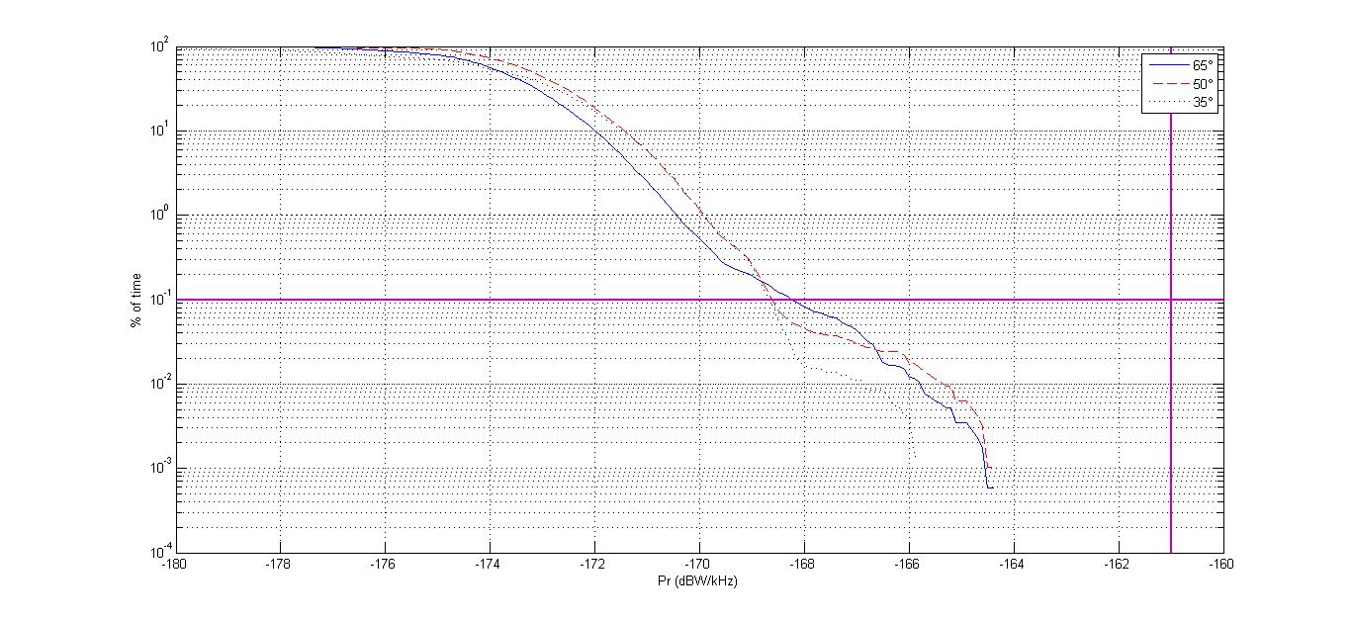

There is a 7 dB margin compare to the protection criterion of –161 dBW/kHz of the EESS not to be exceeded more than 0.1% of the time. The total number of links deployed in this area on the same frequency could therefore be 5 times higher than the 10 000 links considered here, with no harmful interference being created on board the EESS satellite. Noting that, according to Recommendation ITU-R F.385 giving the channel arrangements in the range 7 128-7 268 MHz, there would be between 5 channels (28 MHz bandwidth) and 80 channels (1.75 MHz bandwidth), this would lead to a total of 50 000 × 5 = 250 000 links to 50 000 × 80 = 4 000 000 links being deployed in this area and this frequency range without any harmful interference being noticed on the EESS. It should be noted that ECC Report 173 indicates that the total number of FS links active in Europe for the whole band 7.1-8.5 GHz is 38 500, much lower than these numbers.

The distribution of power spectral densities given in Fig. 7 may be over pessimistic, as administrations and operators will try to reduce as much as possible the output power of FS stations. In addition, it is expected that ATPC would be used on such links, so that the FS stations would transmit at their maximum output power only for a fraction of time. In particular, the hop length of FS links deployed in cities is expected to be shorter than in rural areas, thus requiring less output power. A distribution with a peak on the low power spectral densities would therefore be expected instead of a normal distribution as considered here. Though, this would have to be confirmed by data provided by Administrations.

No polarization discrimination has been considered. However since most of the interference would be generated through the sidelobes of the FS antenna, it is not expected that this parameter would have a great influence on the results.

# 9 Conclusions

The TIG and TVG methodologies described in RR Appendix **7** were applied to assess the coordination area around EESS earth stations where coordination would be required with FS. However, the TVG gives a more realistic coordination distance for this particular case, as the TIG methodology may overestimate the coordination distances for non-GSO satellites, particularly on LEOs such as polar orbits often used for Earth observation. The TVG contour leads to a maximum coordination distance of 74 km for an EESS earth station located in Kiruna in Sweden, 103 km for an EESS earth station located in Villafranca in Spain, 135 km for a station located in Poker Flat in the USA, 156 km for a station located in Kourou in French Guyana, and 178 km for a station located in Wallops in the USA, and this considering that the FS station is pointing directly towards the EESS earth station.

This coordination distance drops rapidly down to 3 km when the FS station does not point directly towards the EESS earth station, which would likely be the case when dealing with cross border coordination. The 3 km distance is obtained for offset angles greater than 50°. For 80% of FS stations, the coordination distance would be lower than 5 km. For 90% of FS stations, it would be lower than 10 km.

It should also be noted that these findings take into account a flat terrain but, when taking into account the actual terrain elevation, on a site-by-site basis, the coordination distance would be much more reduced. Examples of such calculations are provided in this Report.

The actual TVG coordination distance will depend on the location of the station, its characteristics and the orbit of the EESS satellite.

It should be pointed out that a number of SRS earth stations operating today in the band 7 145‑7 235 MHz have been successfully coordinated with the FS, although they use a much higher emission power than EESS earth stations, leading to larger coordination areas.

Similarly to what is happening for these SRS earth stations, for each individual EESS satellite mission and earth station, a specific uplink licence will have to be obtained from the relevant administration. This implies that the compatibility with the FS systems operating within the coordination area will always have to be analysed (in a few cases this could involve the neighbouring administrations). Only when and if the administration(s) will have verified that there will be no impact to the FS systems the individual licences for operating the uplinks will be given. In other words, the FS systems will always be fully protected.

For the sharing compatibility in the other direction, no harmful interference is expected in the EESS satellite receivers based on the studies presented here and the number of links deployed in the whole range 7-8 7.1-8.5 GHz.