Report ITU-R SA.2277
(09/2013)
Sharing studies between mobile-satellite
service (MSS) and space research service
(SRS) in the 22-26 GHz range
SA Series
Space applications and meteorology

Foreword
The role of the Radiocommunication Sector is to ensure the rational, equitable, efficient and economical use of the radio-frequency spectrum by all radiocommunication services, including satellite services, and carry out studies without limit of frequency range on the basis of which Recommendations are adopted.
The regulatory and policy functions of the Radiocommunication Sector are performed by World and Regional Radiocommunication Conferences and Radiocommunication Assemblies supported by Study Groups.

Policy on Intellectual Property Right (IPR)
ITU-R policy on IPR is described in the Common Patent Policy for ITU-T/ITU-R/ISO/IEC referenced in Annex 1 of Resolution ITU-R 1. Forms to be used for the submission of patent statements and licensing declarations by patent holders are available from http://www.itu.int/ITU-R/go/patents/en where the Guidelines for Implementation of the Common Patent Policy for ITU-T/ITU-R/ISO/IEC and the ITU-R patent information database can also be found.

Series of ITU-R Reports
(Also available online at http://www.itu.int/publ/R-REP/en)
Series | Title
BO | Satellite delivery
BR | Recording for production, archival and play-out; film for television
BS | Broadcasting service (sound)
BT | Broadcasting service (television)
F | Fixed service
M | Mobile, radiodetermination, amateur and related satellite services
P | Radiowave propagation
RA | Radio astronomy
RS | Remote sensing systems
S | Fixed-satellite service
SA | Space applications and meteorology
SF | Frequency sharing and coordination between fixed-satellite and fixed service systems
SM | Spectrum management

Note: This ITU-R Report was approved in English by the Study Group under the procedure detailed in Resolution ITU-R 1.

Electronic Publication
Geneva, 2013
© ITU 2013
All rights reserved. No part of this publication may be reproduced, by any means whatsoever, without written permission of ITU.

REPORT ITU-R SA.2277
Sharing studies between mobile-satellite service (MSS) and
space research service (SRS) in the 22-26 GHz range

(2013)

TABLE OF CONTENTS
Page
1 Introduction 2
2 MSS satellite system characteristics 3
3 SRS satellite system characteristics 4
4 Protection of space research service links from proposed MSS Earth-to-space and space-to-Earth links 5
4.1 Proposed MSS (Earth-to-space) links 6
4.2 Proposed MSS (space-to-Earth) links 13
5 Sharing considerations with the proposed MSS links with incumbent SRS links 17
5.1 Incumbent SRS (Earth-to-space) links 18
6 Conclusions 20

1 Introduction
WRC-15 agenda item 1.10, Resolution 234 (WRC-12) calls for conducting sharing and compatibility studies between mobile-satellite service (MSS) in the Earth-to-space and space-to-Earth directions, within portions of the bands between 22 GHz to 26 GHz, while ensuring protection of existing services within these bands.
Table 1 presents the frequency allocations in the 22-26 GHz range. As shown in Table 1, a number of frequency bands in the range considered under WRC-15 agenda item 1.10 are allocated to the space research service (SRS), Earth exploration-satellite service, and inter-satellite service used in space research operations. This Report describes the SRS services in the bands presented in Table 1, and discusses sharing feasibility from the proposed new MSS allocations in the 22-26 GHz range with these incumbent services. This contribution introduces the system characteristics of both SRS and MSS systems, interference study parameters, and study results of potential MSS allocations interference into SRS services.
TABLE 1
Frequency allocations for the bands addressed in this contribution
Allocation to services
Region 1 | Region 2 | Region 3
22.21-22.5 EARTH EXPLORATION-SATELLITE (passive)

SPACE RESEARCH (passive)
5.149 5.532
22.5-22.55 …

22.55-23.15 INTER-SATELLITE 5.338A

SPACE RESEARCH (Earth-to-space) 5.532A
23.15-23.55 INTER-SATELLITE 5.338A

23.55-23.6 …

23.6-24 EARTH EXPLORATION-SATELLITE (passive)

SPACE RESEARCH (passive)
5.340
24-24.05 …

24.05-24.2
Earth exploration-satellite (active)

24.2-25.25 …

25.25-25.5
INTER-SATELLITE 5.536
25.5-27 EARTH EXPLORATION-SATELLITE (space-to Earth) 5.536B

INTER-SATELLITE 5.536
SPACE RESEARCH (space-to-Earth) 5.536C

2 MSS satellite system characteristics
WRC-12 agenda item 1.25 considered studies for sharing of incumbent services with the MSS in the bands between 4 GHz and 16 GHz. During the course of the work under WRC-12 agenda item 1.25, Report ITU-R M.2221 was produced summarizing the results of the studies and the feasibility of MSS operations in certain frequency bands. This Report also contains agreed upon MSS technical characteristics as used in the studies under WRC-12 agenda item 1.25 for MSS systems then proposed for operation in the 4-16 GHz range.
Table 2 provides an overview of the technical characteristics for MSS system user terminals and Table 3 provides an overview of MSS satellite parameters as used in this sharing analysis, as well as the source of the information.
TABLE 2
MSS user terminal technical characteristics
Environment type | Estimated user terminal distribution density  (user/square km)
Land – All types | 8
 | User terminal 1
Transmit centre frequency | 22-26 GHz
Transmit antenna diameter | 1.8 m
Transmit e.i.r.p. per carrier | 45 dBW
Transmit antenna pattern | Rec. ITU-R S.580
Transmit antenna minimum elevation angle | 5-10 degrees
Receiver noise temperature | 650 K
Interference threshold | I/N > –12.2 dB  (from Report ITU-R M.2221)

TABLE 3
MSS GSO satellite technical characteristics
Environment type | Estimated user terminal distribution density  (user/square km)
Transmit centre frequency | 22-26 GHz
Modulation type | QPSK
Uplink occupied bandwidth per carrier | 4.05 MHz
Downlink occupied bandwidth per carrier | 16.2 MHz
Transmit antenna pattern | Rec. ITU-R S.672
Antenna coverage area | The coverage area of the satellite is divided into about 200 spot beams generated on demand.  (from Report ITU-R M.2221)
Transmit e.i.r.p. per carrier | 42.05 dBW

3 SRS satellite system characteristics
The SRS technical system characteristics used in this analysis are indicated in Table 4 below.
TABLE 4
SRS technical characteristics
Interference threshold  (Earth-space and space-Earth) | I/N > –6 dB for 0.1% of the time  (Rec. ITU-R SA.609)
Interference threshold (space-space) | I/N > –10 dB for 0.1% of the time  (Rec. ITU-R SA.1155)
SRS GSO parameters
Parameter | Value
Orbit type | GSO
Longitude | 46 West
RF receive parameters
Antenna pattern | Rec. ITU-R S.672-4
Antenna gain | 57.9 dBi
Reference bandwidth | 25 MHz
Noise temperature | 572 K
SRS NGSO parameters
Orbit type | NGSO
Height | 350 km
Inclination | 51.6 degrees
RF receive parameters
Antenna pattern | See Fig. 1
Antenna gain | 39.7 dBi
Reference bandwidth | 25 MHz
Noise temperature (space-to-space) | 290 k
Noise temperature (space-to-Earth, Earth-to-space) | 570 k
Interference threshold | I/N > –6 dB  (Rec. ITU-R SA.609)
SRS earth station parameters
Goldstone SRS earth station
Latitude | 35.34
Longitude | –116.89
WSGT SRS earth station
Latitude | 35.51
Longitude | –106.61

TABLE 4 (end)
Wallops SRS earth station
Latitude | 37.93
Longitude | –75.48
RF receive parameters
Antenna pattern | Rec. ITU-R S.465
Antenna gain | 49.7
Reference bandwidth | 25 MHz
Noise temperature | 190

Figure 1
SRS NGSO antenna pattern
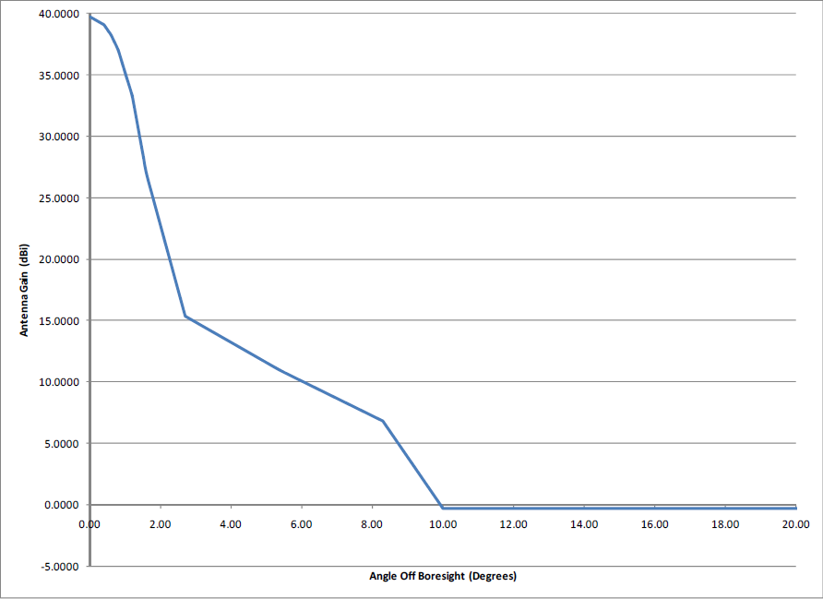

4 Protection of space research service links from proposed MSS Earth-to-space and space-to-Earth links
For a complete set of sharing studies and compatibility between the MSS and the services indicated in Table 1, several sharing scenarios including interference assessments of MSS GSO transmissions and high density MSS user terminal transmissions into SRS space-to-Earth, space-to-space, and Earth-to-space need to be studied. Table 5 presents a listing of sharing scenarios to be considered in §§ 4.1 and 4.2. All sharing scenarios are assumed to be co-frequency and were conducted using a commercially available software.
TABLE 5
Sharing analysis considered for protection of space research service links from proposed
MSS operations in 22-26 GHz
Scenario number | Description of sharing analysis | Protection Criteria  used
Scenario 1 | MSS ground station uplink into SRS GEO receiver (space-to-space) from SRS LEO transmitter in 25.25-26 GHz | I/N > –10 dB
Scenario 2 | MSS ground station uplink into SRS ground station receiver (space-to-Earth) from SRS LEO transmitter in 25.5-26 GHz | I/N > –6 dB
Scenario 3 | MSS ground station uplink into SRS LEO receiver (space-to-space) from SRS GEO transmitter in 22.55-23.55 GHz | I/N > –10 dB
Scenario 4 | MSS ground station uplink into SRS LEO receiver (Earth-to-space) from SRS earth station transmitter in 22.55-23.15 GHz | I/N > –6 dB
Scenario 5 | MSS ground station uplink into SRS GEO receiver (Earth-to-space) from SRS earth station transmitter in 22.55-23.15 | I/N > –6 dB
Scenario 6 | MSS GEO satellite downlink into SRS LEO receiver (space-to-space) from SRS GEO transmitter in 22.55-23.55 GHz | I/N > –10 dB
Scenario 7 | MSS GEO satellite downlink into SRS GEO receiver (space-to-space) from an SRS LEO transmitter in 25.25-26 GHz | I/N > –10 dB
Scenario 8 | MSS GEO satellite downlink into SRS earth station (space-to-Earth) from SRS LEO transmitter in 25.5-26 GHz | I/N > –6 dB
Scenario 9 | MSS GEO satellite downlink into SRS earth station (space-to-Earth) from SRS GEO transmitter in 25.5-26 GHz | I/N > –6 dB

4.1 Proposed MSS (Earth-to-space) links
Scenario 1
As shown in Fig. 2, this analysis will consider interference from MSS user terminals into an SRS satellite in GSO receiving a transmission from a LEO SRS satellite, in the bands 25.25-26 GHz, taking into account the protection levels identified in Recommendation ITU-R SA.1155 of
I/N > –10 dB for 0.1% of the time.
FIGURE 2
Representative interference scenario of MSS transmissions into SRS satellite
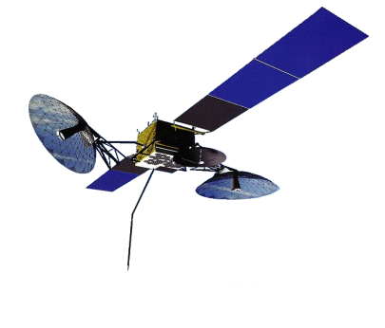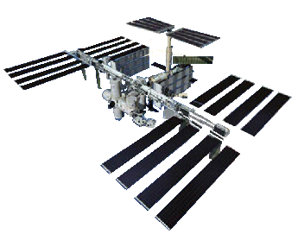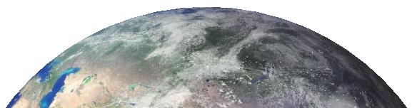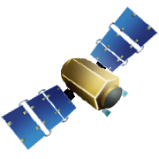

This analysis assumes a distribution of MSS user terminals transmitting to an MSS GSO satellite located at 48 West. The modelled MSS GSO satellite has multiple antenna beams available for use within the satellite coverage area. It is assumed that each MSS user terminal selects which antenna beam to transmit based on the antenna beam with the highest gain within view of the user terminal. In order to reduce computational complexity in this scenario, there are 20,165 MSS user terminals uniformly distributed over a 1,785,916 km² area on the surface of the Earth. This corresponds to a density of 0.01 users/square km. Figure 3 shows the dynamic simulation results of this interference scenario.
FIGURE 3
I/N results of interference from MSS user terminals into an SRS GSO return link
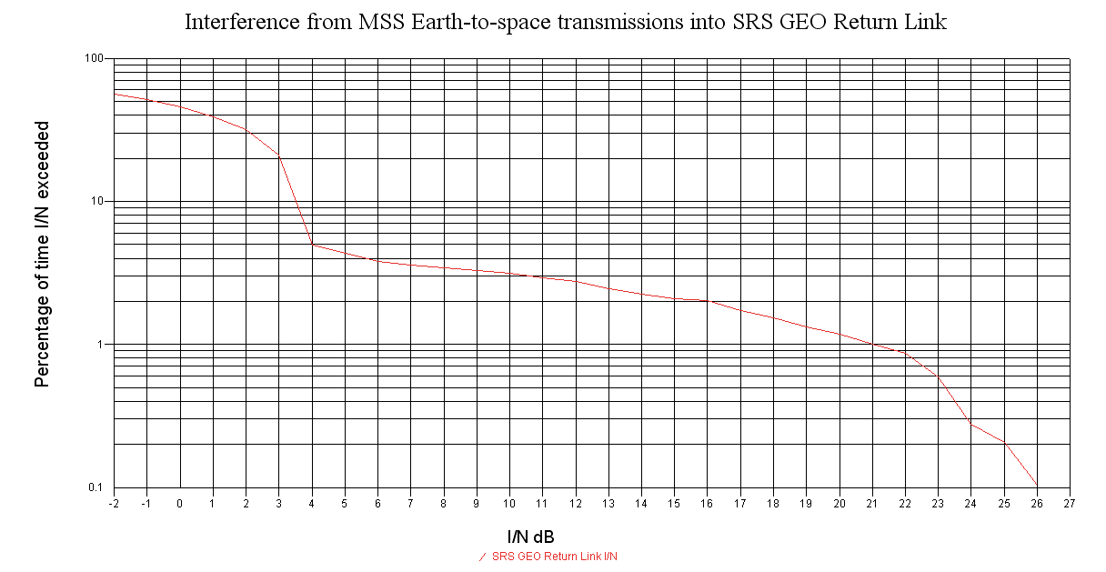

Protection Criterion I/N >–10

In this scenario, the orbital separation of the MSS GSO satellite from the SRS GSO satellite influences the amount of interference experienced by the SRS GSO satellite. If the SRS GSO is located at 46° West and the MSS GSO is located at 48° West, then a maximum I/N of 26 dB for 0.1% of the time is experienced by the SRS GSO. If there is proper orbital separation, in the order of 50 degrees, between the SRS GSO and the MSS GSO, exceedance of the interference criterion given in Recommendation ITU-R SA.1155 to the SRS GSO can be avoided.
Scenario 2
As shown in Fig. 4, this analysis will consider interference from MSS user terminals transmission into a receiving SRS earth station in the 25.5-26 GHz band, taking into account the protection levels identified in Recommendation ITU-R SA.609 of I/N > –6 dB for 0.1% of the time.
FIGURE 4
Representative interference scenario of MSS transmissions into SRS earth stations

This scenario assumes a random distribution of 8 MSS user terminals transmitting to an MSS GSO satellite located at 48 West. The modelled MSS GSO satellite has multiple antenna beams available for use within the satellite coverage area. It is assumed that each MSS user terminal selects which antenna beam to transmit based on the antenna beam with the highest gain within view of the user terminal. In order to reduce computational complexity in this scenario, there are 8 MSS user terminals randomly distributed over a 64 km² area around the WSGT SRS earth station. This corresponds to an average density of 0.1 users/square km around the SRS earth station. Figure 5 shows the dynamic simulation results of this interference scenario.
FIGURE 5
I/N results of interference from MSS user terminals into an SRS earth station
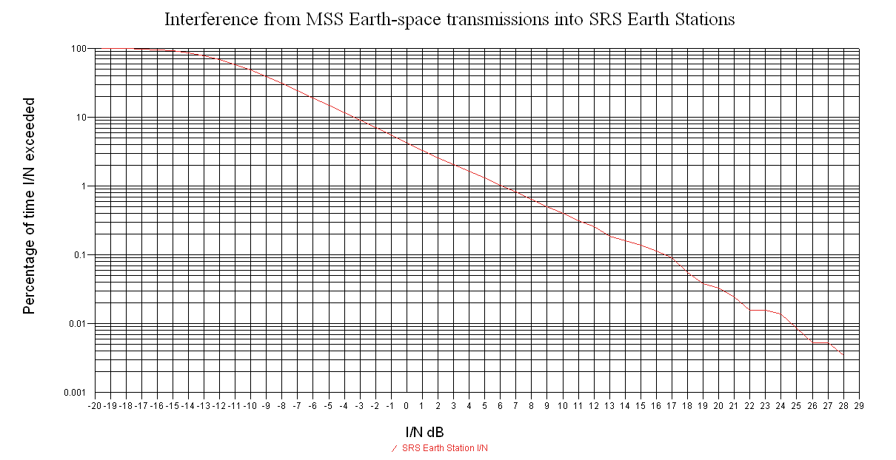

Protection Criterion I/N >-6

This scenario involves interference from one earth station into another. In such a case, a coordination zone can be calculated to determine the minimum required separation distance between the MSS user terminal and the SRS earth station to avoid interference. Using a generic path calculating with Recommendation ITU-R P.452-14 and assuming a maximum sidelobe gain consistent with Recommendation ITU-R S.580 and an orbital separation of two degrees, a coordination distance of over 330 km would be needed to avoid interference from a MSS user terminal communicating with an SRS earth station.
Scenario 3
As shown in Fig. 6, this analysis will consider interference from transmission of MSS user terminals into an SRS satellite in LEO receiving a transmission from a GSO SRS satellite in the band 22.55-23.55 GHz, taking into account the protection levels identified in Recommendation ITU-R SA.1155.
FIGURE 6
Representative interference scenario of MSS transmissions into SRS satellite

This scenario assumes a uniform distribution of MSS user terminals transmitting to an MSS GSO satellite located at 60º West. The modelled MSS GSO satellite has multiple antenna beams available for coverage within the satellite coverage area. It is assumed that each MSS user terminal selects which antenna beam to transmit based on the antenna beam with the highest gain within view of the user terminal. In order to reduce computational complexity in this simulation, there are 10,000 aggregate clusters of MSS user terminals uniformly distributed over a 26,458,207 km² area on the surface of the Earth. Thus, each MSS user cluster terminal is spread over an area of approximately 2,645 km². The aggregate power of 264 MSS user terminals is then modelled for each MSS user terminal cluster coverage area of 2,645 km². This corresponds to an aggregate approximation of 2,640,000 MSS user terminals modelled over a 26,458,207 km² area on the surface of the Earth for a total aggregate user terminal density of 0.1 users/square km. Figure 8 shows the dynamic simulation results of this interference scenario. Figure 7 illustrates the modelling of MSS terminal clusters for this scenario.
FIGURE 7
Modelled MSS user terminal distribution including aggregate effects: 2,640,000 MSS user terminals
(10,000 clusters of 264 terminals per cluster) over a coverage area of 26,458,207 km² area on
the surface of the Earth for a distribution of 0.1 MSS users per square km
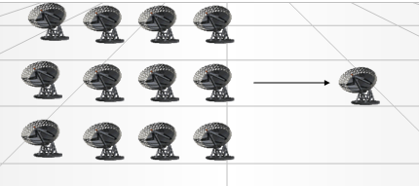

FIGURE 8
I/N results of interference from MSS user terminals into an SRS LEO return link
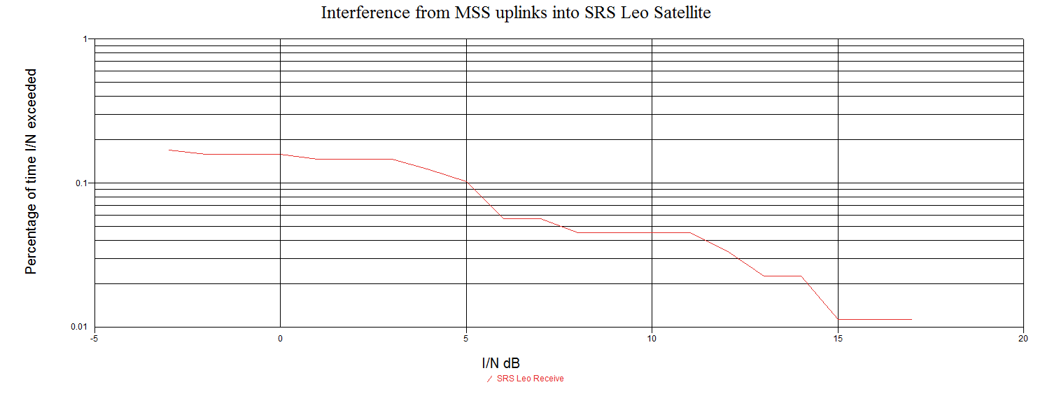
Protection Criterion I/N >-10
Scenario 4
As shown in Fig. 9, this analysis will consider interference from MSS user terminal transmissions into an SRS satellite in LEO receiving a transmission from SRS earth stations located at three locations throughout the United States of America, in the bands 22.55-23.15 GHz, taking into account the protection levels in Recommendation ITU-R SA.609.
FIGURE 9
Representative interference scenario of MSS user terminal transmissions into SRS satellite

This scenario assumes a uniform distribution of MSS user terminals transmitting to an MSS GSO satellite located at 60° West. The modelled MSS GSO satellite has multiple antenna beams available for coverage within the satellite coverage area. It is assumed that each MSS user terminal selects which antenna beam to transmit based on the antenna beam with the highest gain within view of the user terminal. In this simulation, there are 10,000 MSS user terminal clusters uniformly distributed over a 26,458,207 km² area on the surface of the Earth. Thus, each MSS user terminal cluster is spread over an area of approximately 2,645 km². The aggregate power of 264 MSS user terminals is then modelled for each MSS user terminal cluster coverage area of 2,645 km². This corresponds to approximately 2,640,000 MSS user terminal clusters modelled over a 26,458,207 km² area on the surface of the Earth for a total user terminal density of 0.1 users/square km. Figure 10 shows the dynamic simulation results of this interference scenario.
FIGURE 10
I/N results of interference from MSS user terminals into an SRS LEO receive link
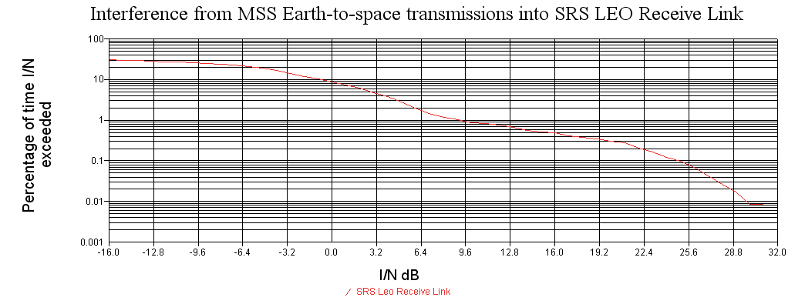
Protection Criterion I/N >-6

Scenario 5
As shown in Fig. 11, this analysis will consider interference transmissions from MSS user terminals into an SRS satellite in GSO receiving a transmission from SRS earth stations located at three locations throughout the United States of America, in the bands 22.55-23.15 GHz, taking into account the protection levels in Recommendation ITU-R SA.609.
FIGURE 11
Representative interference scenario of MSS user terminal transmissions into SRS GSO satellite
MSS GEO
INTERFERENCE
SRS GEO satellite
SRS Earth Station

This analysis assumes 10,000 MSS user terminal clusters uniformly distributed over a 26,458,207 km² area on the surface of the Earth transmitting to a MSS GSO satellite. Thus, each MSS user terminal cluster is spread over an area of approximately 2,645 km². The aggregate power of 264 MSS user terminals is then modelled for each MSS user terminal cluster coverage area of 2,645 km². This corresponds to approximately 2,640,000 MSS user terminals modelled over a 26,458,207 km² area on the surface of the Earth for a total user terminal density of 0.1 users/square km. In this scenario, the orbital separation of the MSS GSO satellite from the SRS GSO satellite influences the amount of interference experienced by the SRS GSO satellite. If the SRS GSO is located at 46º West and the MSS GSO is located at 48° West, then a maximum I/N of 22 dB is experienced by the SRS GSO. If there is proper orbital separation, in the order of 26 degrees, between the SRS GSO and the MSS GSO, exceedance of the interference criterion given in Recommendation ITU-R SA.1155 to the SRS GSO can be avoided.

4.2 Proposed MSS (space-to-Earth) links
Scenario 6
As shown in Fig. 12, this analysis will consider interference from MSS GSO satellite transmissions into an SRS satellite in LEO receiving a transmission from a GSO SRS satellite in the band 22.55-23.55, taking into account the protection levels identified in Recommendation ITU-R SA.1155.
FIGURE 12
Representative interference scenario of MSS transmissions into SRS satellite
Protection Criterion I/N >-12.2
MSS user terminal

To reduce computational complexity, this analysis assumes a MSS GSO satellite transmitting to 1,600 user terminals uniformly distributed over a 7,825,783 km² area on the surface of the Earth. This corresponds to a density of 0.0002 users/square km. 1,600 worldwide user terminals were chosen for this simulation since this corresponds to a value of 8 user terminals supported by 200 possible antenna spot beams produced by any one MSS GSO satellite or a worldwide system of MSS GSO satellites. Figure 13 shows the dynamic simulation results of this interference scenario.
FIGURE 13
I/N results of interference from MSS GSO downlinks into an SRS LEO return link
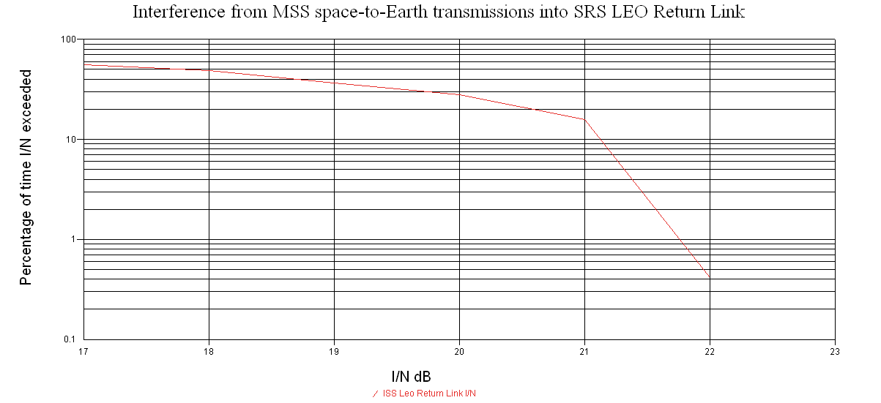
Protection Criterion I/N >-10
Scenario 7
As shown in Fig. 14, this analysis will consider interference from MSS GSO satellite transmissions into an SRS satellite in GSO receiving a transmission from a LEO SRS satellite in the band 25.25-26 GHz, taking into account the protection levels identified in Recommendation ITU-R SA.1155.
FIGURE 14
Representative interference scenario of MSS transmissions into SRS GSO satellite

To reduce computational complexity, this analysis assumes a MSS GSO satellite transmitting to 1,600 user terminals uniformly distributed over a 7,825,783 km² area on the surface of the Earth. This corresponds to a density of 0.0002 users/square km. In this scenario, the orbital separation of the MSS GSO satellite from the SRS GSO satellite influences the amount of interference experienced by the SRS GSO satellite. If the SRS GSO is located at 46° West and the MSS GSO is located at 48° West, then a maximum I/N of 18.17 dB is experienced by the SRS GSO. If there is proper orbital separation, in the order of 28 degrees, between the SRS GSO and the MSS GSO, exceedance of the interference criterion given in Recommendation ITU-R SA.1155 to the SRS GSO can be avoided.
Scenario 8
As shown in Fig. 15, this analysis will consider interference from MSS GSO satellite transmissions into an SRS earth station receiving from an SRS LEO satellite in the band 25.5-26.0 GHz, taking into account the protection levels identified in Recommendation ITU-R SA.609.
FIGURE 15
Representative interference scenario of MSS GSO transmissions into SRS earth station
receiving from SRS LEO
MSS GEO
SRS NGSO
SRS ES
INTERFERENCE

This analysis examines the interference between a MSS GSO satellite located at 60 West transmitting to a uniform distribution of MSS user terminals to a SRS earth station receiving a transmission from a SRS LEO satellite. To reduce computational complexity in this simulation, there are 10,000 MSS user terminals uniformly distributed over a 26,458,207 km² area on the surface of the Earth. This corresponds to a total user terminal density of 0.0004 users/square km. Figure 16 shows the dynamic simulation results of this interference scenario.
FIGURE 16
Representative interference scenario of MSS transmissions into SRS earth station
receiving a transmission from an SRS LEO satellite
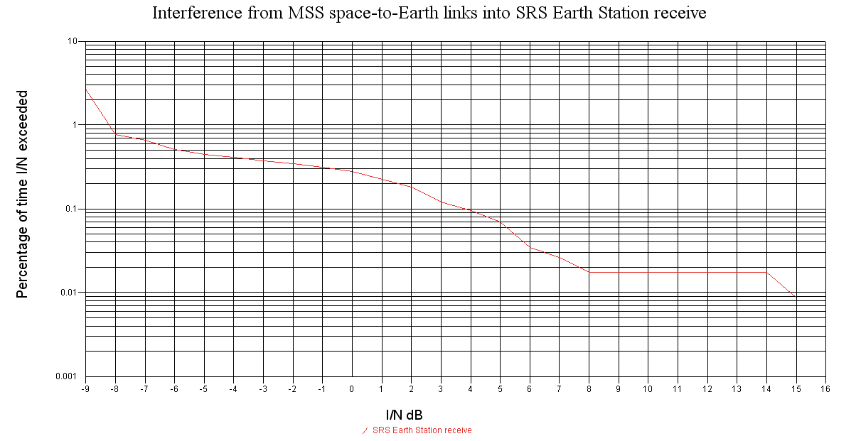

Protection Criterion I/N >-6

Scenario 9
As shown in Fig. 17, this analysis will consider interference from MSS GSO satellite transmissions into an SRS earth station receiving from an SRS GSO in the bands 25.5-26.0 GHz, taking into account the protection levels identified in Recommendation ITU-R SA.609.
FIGURE 17
Representative interference scenario of MSS GSO transmissions into SRS earth station
receiving from SRS GSO

MSS user terminal
SRS Earth Station
SRS LEO satellite
INTERFERENCE

This analysis assumes a MSS GSO satellite transmitting to 10,000 user terminals uniformly distributed over a 26,458,207 km² area on the surface of the Earth. This corresponds to a density of 0.0004 users/square km. In this scenario, the orbital separation of the MSS GSO satellite from the SRS GSO satellite influences the amount of interference experienced by the SRS GSO satellite. If the SRS GSO is located at 46° West and the MSS GSO is located at 48° West, then a maximum I/N of 24 dB is experienced by the SRS GSO. If there is proper orbital separation, in the order of 31 degrees, between the SRS GSO and the MSS GSO, exceedance of the interference criterion given in Recommendation ITU-R SA.1155 to the SRS GSO can be avoided.

5 Sharing considerations with the proposed MSS links with incumbent SRS links
To examine the feasibility of proposed MSS operations in the bands 22-26 GHz, interference assessments from incumbent SRS systems and the proposed MSS allocations should be considered. Table 6 presents a listing of sharing scenarios concerning interference between operations of incumbent SRS operations and proposed MSS Earth-to-space and space-to-Earth links as presented in § 5.1. All sharing scenarios are assumed to be co-frequency and were conducted using a commercially available software.
TABLE 6
Sharing analysis considered for protection of proposed MSS operations from
incumbent SRS operations in 22-26 GHz
Scenario  number | Description of sharing analysis | Protection  Criteria used
Scenario 10 | SRS ground station uplink to SRS NGSO satellite into MSS user terminal receiver at 22.55-23.15 GHz | I/N > –12.2 dB
Scenario 11 | SRS ground station uplink to SRS GSO into MSS GEO satellite at 22.55-23.15 GHz | I/N > –12.2 dB

5.1 Incumbent SRS (Earth-to-space) links
Scenario 10
As shown in Fig. 18, this analysis will consider interference from SRS earth station transmissions into an MSS user terminal receiving a transmission from an MSS GSO located at 60 West in the band 22.55-23.15 GHz.
FIGURE 18
Representative interference scenario of SRS ES transmissions into MSS user terminal
MSS GEO

Protection Criterion I/N >-10
Each MSS user terminal cluster Represents the aggregate power effect of 264 terminals over an area of approximately 2,645 square km

This analysis evaluates the interference from a SRS earth station transmitting to a SRS LEO into a MSS user terminal transmitting to a MSS GSO satellite located at 60° West. In this simulation, there are 10,000 MSS user terminals uniformly distributed over a 26,458,207 km² area on the surface of the Earth. This corresponds to a total user terminal density of 0.0004 users/square km.
Figure 19 shows the dynamic simulation results of this interference scenario over all the MSS user terminal links. The worst value of interference received to any one MSS user terminal is I/N = 45 dB.
FIGURE 19
Representative interference scenario of SRS earth station transmission into MSS user terminal receive links
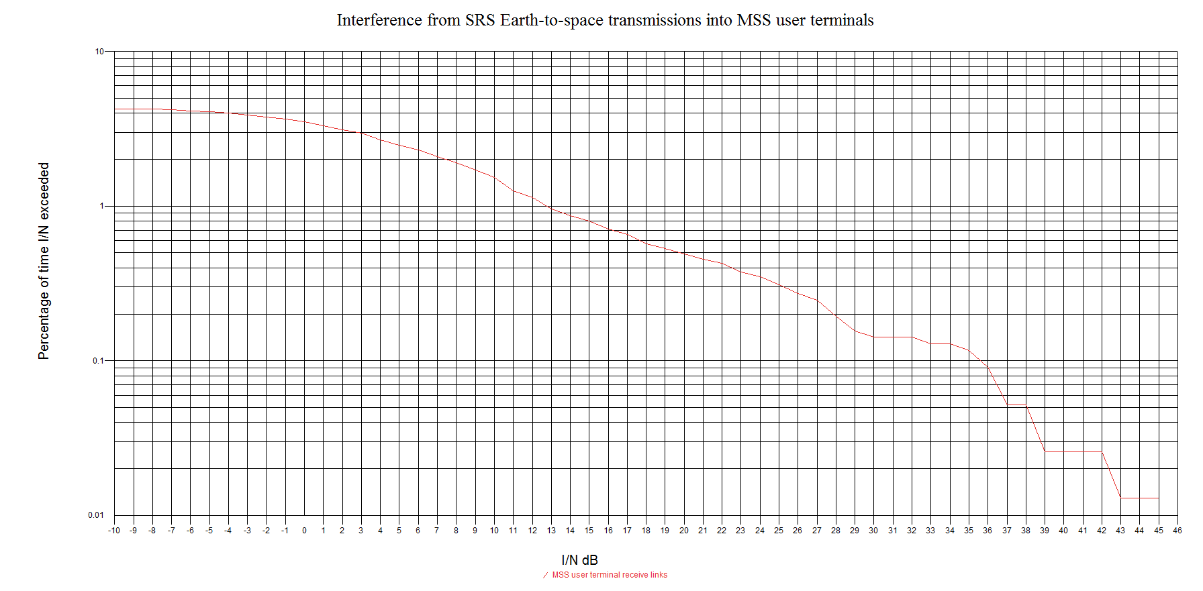
Protection Criterion I/N >-12.2
26,458,207 square km area on the surface of the Earth with 10,000 clusters of MSS user terminals
This scenario involves interference from one earth station into another. In such a case, a coordination zone can be calculated to determine the minimum required separation distance between the MSS user terminal and the SRS earth station to avoid interference. Using a generic path calculating with Recommendation ITU-R P.452-14 and assuming a maximum sidelobe gain consistent with Recommendation ITU-R S.580, a coordination distance of over 330 km would be needed to avoid interference from an SRS earth station.
Scenario 11
As shown in Fig. 20, this analysis will consider interference from SRS earth station transmissions into an MSS GSO satellite in the band 22.55-23.15 GHz.
FIGURE 20
Representative interference scenario of SRS ES transmissions into MSS GSO satellite
MSS GEO
SRS GSO
SRS ES
INTERFERENCE
MSS user terminal

This analysis examines the interference caused by the transmission of three SRS earth stations throughout the United States to a SRS GSO satellite into a MSS GSO satellite. In this scenario, the orbital separation of the MSS GSO satellite from the SRS GSO satellite influences the amount of interference experienced by the SRS GSO satellite. If the SRS GSO is located at 46° West and the MSS GSO is located at 48° West, then a maximum I/N of 2 dB is experienced by the MSS GSO. If there is proper orbital separation, in the order of 3 degrees, between the SRS GSO and the MSS GSO, exceedance of the interference to the MSS GSO link can be avoided.

6 Conclusions
This Report presents study results of sharing between SRS operations in the 22-26 GHz range with available characteristics of planned MSS operations. Several interference scenarios were considered between proposed MSS user terminal Earth-to-space links and MSS GSO space-to-Earth links and incumbent SRS space-Earth, Earth-space, and space-to-space links used in space research operations in the bands 22-26 GHz. The assumptions and parameters used for proposed MSS operations in the bands 22-26 GHz considered in these sharing scenarios can be considered conservative. If the full deployment scenario of 8 MSS user terminals per square km was considered in these sharing analyses, the resulting interference to the incumbent SRS service would be increased drastically compared to the results presented in this Report. For example, in the majority of sharing scenarios considered in this Report, where the distribution was modelled as 0.1 users per square kilometre, an approximation of total interference if 8 users/km² was modelled would be an additional 19 dB of interference. For sharing scenarios with an even lower user terminal density, the interference levels would be higher than an additional 19 dB.
However, even with the conservative assumptions used in these analyses, the aggregate criterion given for protection of SRS services is exceeded by as much as 30 dB for Earth-space, space-Earth, and space-space incumbent operational links of the space research service in 22-26 GHz. Further, the interference criterion for protection of MSS user terminals of I/N of –12.2 dB can be exceeded by over 40 dB by interference from the space research service.
Table 7 presents a summary of the aggregate interference found in each of the sharing scenarios considered in this Report and the results obtained from the analysis. If the scenarios were considered with a larger deployment of MSS terminals, the results presented below would be drastically increased. Further scenarios considering different MSS terminal deployments may be considered in further revisions of this Report.
TABLE 7
Sharing analysis considered for protection of space research service links from
proposed MSS operations in 22-26 GHz
Scenario  number | Description of  sharing analysis | Aggregate I/N  criteria | I/N value found  in analysis | Aggregate  I/N  exceedance  amount | MSS  Distribution  considered in  analysis
Scenario 1 | MSS ground station uplink into SRS GEO receiver (space-to-space) from SRS LEO transmitter in 25.25-26 GHz | I/N > –10 dB | 26 dB* | 36 dB | 0.01 users/km²
Scenario 2 | MSS ground station uplink into SRS ground station receiver (space-to-Earth) from SRS LEO transmitter in 25.5-26 GHz | I/N > –6 dB | 17 dB | 23 dB | 0.1 users/km²
Scenario 3 | MSS ground station uplink into SRS LEO receiver (space-to-space) from SRS GEO transmitter in 22.55-23.55 GHz | I/N > –10 dB | 5 dB | 15 dB | 0.1 users/km²
Scenario 4 | MSS ground station uplink into SRS LEO receiver (Earth-to-space) from SRS earth station transmitter in 22.55-23.15 GHz | I/N > –6 dB | 25.6 dB | 31.6 dB | 0.1 users/km²
Scenario 5 | MSS ground station uplink into SRS GEO receiver (Earth-to-space) from SRS earth station transmitter in 22.55-23.15 GHz | I/N > –6 dB | 22 dB* | 28 dB | 0.1 users/km²
Scenario 6 | MSS GEO satellite downlink into SRS LEO receiver (space-to-space) from SRS GEO transmitter in 22.55-23.55 GHz | I/N > –10 dB | 22 dB | 32 dB | 0.0002 users/km²
Scenario 7 | MSS GEO satellite downlink into SRS GEO receiver (space-to-space) from an SRS LEO transmitter in 25.25-26 GHz | I/N > –10 dB | 18.17 dB* | 19.17 dB | 0.0002 users/km²
TABLE 7 (end)
Scenario  number | Description of  sharing analysis | Aggregate I/N  criteria | I/N value found  in analysis | Aggregate  I/N  exceedance  amount | MSS  Distribution  considered in  analysis
Scenario 8 | MSS GEO satellite downlink into SRS earth station (space-to-Earth) from SRS LEO transmitter in 25.5-26 GHz | I/N > –6 dB | 4 dB | 10 dB | 0.0004 users/km²
Scenario 9 | MSS GEO satellite downlink into SRS earth station (space-to-Earth) from SRS GEO transmitter in 25.5-26 GHz | I/N > –6 dB | 24 dB* | 30 dB | 0.0004 users/km²
Scenario 10 | SRS ground station uplink to SRS NGSO satellite into MSS user terminal receiver at 22.55-23.15 GHz | I/N > –12.2 dB | 36 dB | 48.2 dB | 0.0004 users/km²
Scenario 11 | SRS ground station uplink to SRS GSO into MSS GEO satellite at 22.55-23.15 GHz | I/N > –12.2 dB | 2 dB* | 14.4 dB | N/A
* Interference mitigation techniques could be considered in these scenarios..

Based on the results presented in Table 5, the proposed MSS operations in the band 22-26 GHz are not compatible with incumbent SRS space-to-space, Earth-to-space, and space-to-Earth systems.

