|  |
| --- |
| **Report ITU-R SA.2425-0**  **(09/2018)** |
| **Studies to accommodate spectrum requirements in the space operation service for non-geostationary satellites with short duration missions** |
| **SA Series**  **Space applications and meteorology** |

Foreword

The role of the Radiocommunication Sector is to ensure the rational, equitable, efficient and economical use of the radio-frequency spectrum by all radiocommunication services, including satellite services, and carry out studies without limit of frequency range on the basis of which Recommendations are adopted.

The regulatory and policy functions of the Radiocommunication Sector are performed by World and Regional Radiocommunication Conferences and Radiocommunication Assemblies supported by Study Groups.

# Policy on Intellectual Property Right (IPR)

ITU-R policy on IPR is described in the Common Patent Policy for ITU-T/ITU-R/ISO/IEC referenced in Annex 1 of Resolution ITU-R 1. Forms to be used for the submission of patent statements and licensing declarations by patent holders are available from <http://www.itu.int/ITU-R/go/patents/en> where the Guidelines for Implementation of the Common Patent Policy for ITU‑T/ITU‑R/ISO/IEC and the ITU-R patent information database can also be found.

|  |  |
| --- | --- |
| Series of ITU-R Reports  (Also available online at <http://www.itu.int/publ/R-REP/en>) | |
| **Series** | Title |
| **BO** | Satellite delivery |
| **BR** | Recording for production, archival and play-out; film for television |
| **BS** | Broadcasting service (sound) |
| **BT** | Broadcasting service (television) |
| **F** | Fixed service |
| **M** | Mobile, radiodetermination, amateur and related satellite services |
| **P** | Radiowave propagation |
| **RA** | Radio astronomy |
| **RS** | Remote sensing systems |
| **S** | Fixed-satellite service |
| **SA** | **Space applications and meteorology** |
| **SF** | Frequency sharing and coordination between fixed-satellite and fixed service systems |
| **SM** | Spectrum management |

|  |
| --- |
|  |

|  |
| --- |
| ***Note****: This ITU-R Report was approved in English by the Study Group under the procedure detailed in Resolution ITU-R 1.* |

*Electronic Publication*

Geneva, 2018

© ITU 2018

All rights reserved. No part of this publication may be reproduced, by any means whatsoever, without written permission of ITU.

REPORT ITU-R SA.2425-0

Studies to accommodate spectrum requirements in the space operation service for non-geostationary satellites with short duration missions

(2018)

# 1 Introduction

This Report responds to *invites* 1 in Resolution **659 (WRC-15)** described below and studies the spectrum requirements for telemetry, tracking and command in the space operations service for non-GSO (NGSO) satellites with short duration missions. The companion Report ITU-R SA.2426-0 was used as a source of technical characteristics of such missions.

Resolution **659 (WRC-15)** calls to study the spectrum needs for telemetry, tracking and command in the space operation service for NGSO satellites with short duration missions, to assess the suitability of existing allocations to the space operation service and, if necessary, to consider new allocations.

Resolution **659** **(WRC-15)** *invites ITU-R*:

1 to study the spectrum requirements for telemetry, tracking and command in the space operation service for the growing number of non-GSO satellites with short duration missions, taking into account No. **1.23**;

2 to assess the suitability of existing allocations to the space operation service in the frequency range below 1 GHz, taking into account *recognizing a)* and current use;

3 if studies of the current allocations to the space operations service indicate that requirements cannot be met under *invites ITU-R* 1 and 2, to conduct sharing and compatibility studies, and study mitigation techniques to protect the incumbent services, both in-band as well as in adjacent bands, in order to consider possible new allocations or an upgrade of the existing allocations to the space operation service within the frequency ranges 150.05-174 MHz and 400.15‑420 MHz.

Resolution **659 (WRC-15)** considering *a)* states “that the term “short duration mission” used in this Resolution refers to a mission having a limited period of validity of not more than typically three years”. Therefore, the term “short duration mission” is not directly tied to the lifetime of the spacecraft. For example, a single spacecraft with a lifetime of less than typically three years, where the operator does not launch a replenishment or replacement spacecraft, is a short duration mission. However, in the case of a (or multiple) spacecraft with a lifetime of less than typically three years, where the operator launches a (or multiple) replenishment or replacement spacecraft(s) such that the operator has a persistent frequency assignments longer than typically three years, is not a short duration mission.

To assist in determining the requirements for short duration NGSO operations, the Technical University of Berlin (TU Berlin) compiled information, both space and ground segments, of existing and planned small satellite systems (i.e. nanosatellites and picosatellites as discussed in Report ITU-R SA.2312). Spreadsheets (one for the ground segment and one for the space segment) containing this data are attached in Annex 2 and Annex 3 respectively. Therefore, it is noted that some of the systems contained in the database represent satellites with missions exceeding the three‑year period of validity criterion established in Resolution **659 (WRC-15)**.

# 2 Technical and operational characteristics of NGSO satellites with short duration missions

Technical and operational characteristics of NGSO satellites with short duration missions are described in Report ITU-R SA.2426-0.

# 3 Assessment of spectrum requirements

*Invites* 1 of Resolution **659** **(WRC-15)** calls for the study of the spectrum requirements of Telemetry, Tracking and Command (TT&C) of NGSO satellites with short duration missions, taking into account the definition of the space operation service under RR No. **1.23** which states that the space operation service is “A radio communication service concerned exclusively with the operation of spacecraft, in particular space tracking, space telemetry and space telecommand.”

It should be noted that theseTT&C functions will normally be provided within the service in which the space station is operating.

According to a questionnaire, 93% of the responding participants who plan short duration missions have indicated that they plan to perform TT&C operations in bands below 1 GHz. The questionnaire does not identify the radiocommunication service in which the service links of these space stations operate in and if TT&C could be performed in this radiocommunication service.

Statistics contained in the questionnaire contained in Annex 1 to this Report only represent the actual use of the bands by short duration NGSO systems in a certain region, since there were only a limited number of responses received on this matter from other regions.

## 3.1 Expected number of NGSO satellites with short duration missions

Future trends of short duration missions may be assumed to, at a minimum, maintain launch numbers following historical trends.

### 3.1.1 Short duration mission satellites launched between 2000 and July 2017

An analysis of satellite launches over the period of 2000 to July 2017 shows that the number of satellites launched over this period has increased.

Table 1 of Report ITU-R SA.2312 provides the typical mass for nanosatellites to be less than 10 kg and a mission duration (which is directly linked to the period of validity) of less than three years. A study was performed to determine the amount of satellites with a mass between 1 kg and 10 kg launched over the period from the year 2000 up to July 2017 in order to validate the assumed number of satellites. This study is based on data available in the public domain.

It has to be noted that some of the satellites in the mass range considered are part of coordinated constellations, therefore the study has made an attempt to distinguish between satellites part of constellations and satellites that are not part of a constellation. Figures 1 and 2 show the study results, presenting the number of satellites launched per year within the mass range of 1 to 10 kg. Figure 1 presents these statistics for “single” satellites and Fig. 2 presents these statistics for satellites which are part of constellations.

Figure 1

Number of satellites launched per year, mass range 1 to 10 kg – single satellites

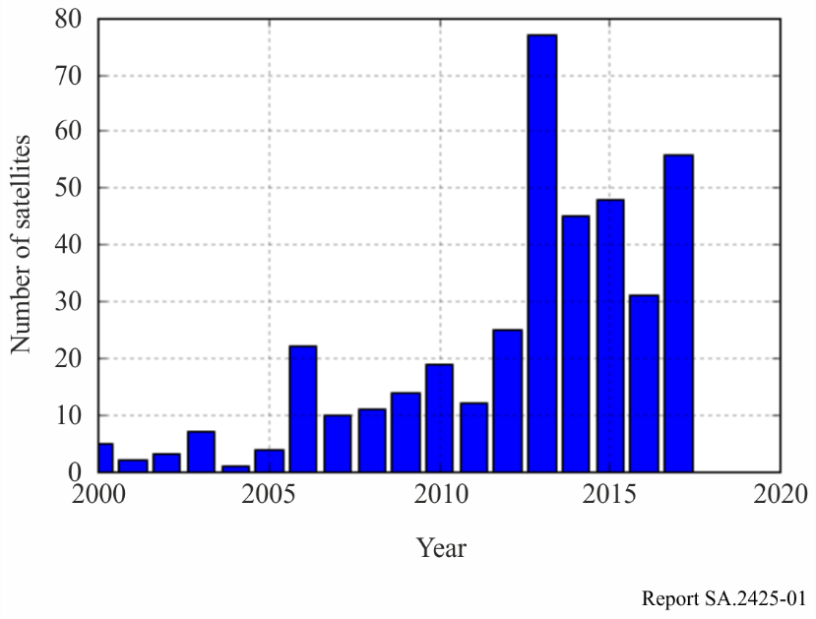

Figure 2

Number of satellites launched per year, mass range 1 to 10 kg – satellites part of constellations

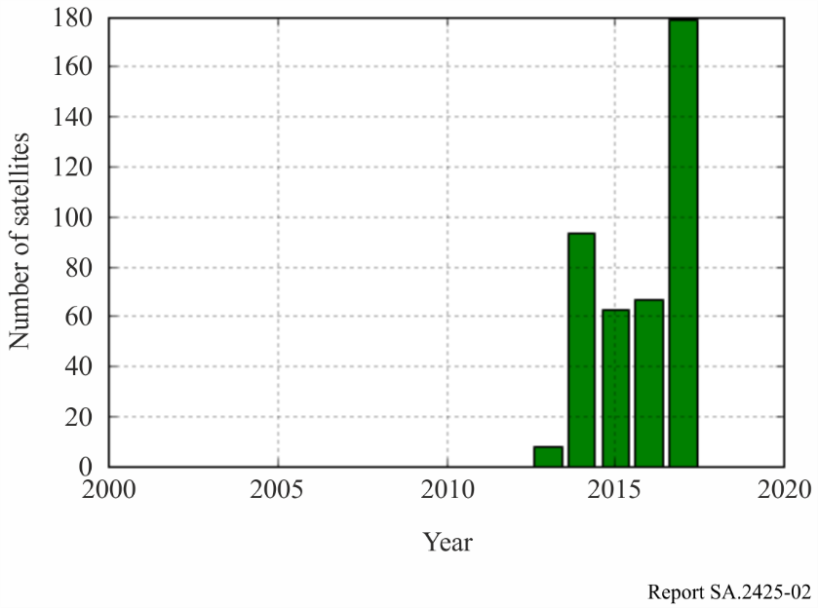

A number of observations can be made when analysing these statistics:

1 The number of satellites with short duration missions launched into non-GSO orbits has increased significantly over the time period 2010 to July 2017.

2 Constellations of satellites in the mass range considered in the study have only appeared since 2013.

3 Of the single satellites, on average approximately 60 satellites have been launched per year since 2013.

Commercial constellations of small satellites typically have a period of validity of the associated filing which is much longer than three years since the operator files a system once and then replenishes the satellite hardware in space. Therefore, it is not realistic to assume that satellites part of these constellations fall under the short duration NGSO category.

On the basis of this recent trend, it could be reasonably anticipated to expect new launches for any given year in the near future to at least maintain levels seen in the previous three years and total active satellite missions maintain on the order of at least 300 satellites.

### 3.1.2 Expected number of short duration mission satellites in operation (per year) between 2017 and 2030

Based on the observations in the previous section, it could be reasonably anticipated to expect new launches for any given year in the near future to at least maintain levels seen in the previous three years. This means that a total number of at least 3*60 = 180 short duration NGSO satellites must be sustained during any time window spanning three years. However, it is expected that the number of short duration mission satellites will grow in the near future. Therefore, it would be appropriate to assume that a worst case number of 300 satellites would need to be accommodated simultaneously. This accounts for an average population growth of 60 new satellites per year and also provides sufficient margin to take variations of the number of satellites launched into account.

## 3.2 Spectrum requirements analysis

A set of general input simulation parameters used for spectrum requirements analysis are given in Table 1 below.

NOTE ‒ There are no SOS Earth-to-space allocations below 1 GHz that are not subject to RR No. **9.21** and therefore the uplink frequency parameters of 149 MHz and 450 MHz have been used as input simulation parameters.

TABLE 1

Input simulation parameters

| Characteristic group | Parameter | Value |
| --- | --- | --- |
| Frequency | Downlink frequency | 137.5 MHz and 401 MHz |
| Uplink frequency | 149 MHz and 450 MHz |
| Orbit | Orbital altitude | 300-1000 km, using the following distribution: (300-500): 59%; (500-750): 38%; (750-1000): 3%, uniform distribution inside each bin  (Source: TU Berlin Satellite Database, see Annex 2) |
| Inclination | 0-100 degrees, using the following distribution: (0-40): 5% (40-60): 45%; (60-90): 5%; (90-100) 45%, uniform distribution inside each bin  (Source: TU Berlin Satellite Database, see Annex 2) |
| Mean anomaly | 0-360 degrees, using a uniform distribution |
| Argument of periapsis | 0-360 degrees, using a uniform distribution |
| Right ascension of the ascending node (with respect to the prime meridian) | 0-360 degrees, using a uniform distribution |
| Eccentricity | 0 |

TABLE 1 (*end*)

| Characteristic group | Parameter | Value |
| --- | --- | --- |
| Transmission scheme | Earth-to-space direction (uplink) | Once a day during the largest time in which the satellite is in the earth station visibility cone |
| Space-to-Earth direction (downlink) | 1 Continuous while the satellite is in the earth station visibility cone  and  2 Once a day during the largest time in which the satellite is in the earth station visibility cone that day |
| Earth station antenna radiation pattern |  | Per Rec. ITU-R F.699-7 (tracking antenna) |
| Earth station antenna gain |  | 12 dBi at VHF, 16 dBi at UHF |
| Earth station system noise temperature |  | 500 K max at UHF; 1500 K max at VHF |
| Space station antenna type |  | Omnidirectional |
| Space station antenna gain |  | ≤ 3 dBi |
| Space station antenna pattern |  | ND-SPACE |
| Space station system noise temperature |  | 500 to 1 000 K |
| Protection criteria |  | Per Rec. ITU-R SA.363-5 |
| Simulation duration |  | 7 days |
| Time step |  | 10 s |
| Number of satellites considered |  | 300 |
| Earth station deployment |  | To be taken from TU Berlin small satellite database (see Annex 3) |
| Number of earth stations per satellite |  | 1 |
| Number of satellites per earth station |  | 1 |

### 3.2.1 Method for selection of system parameters for use in simulations

The system parameters used in the simulations are based in the majority on the latest values (agreed at the time of this Report) in Table 1 above and also additional parameters as necessary from Report [ITU-R SA.2312](http://www.itu.int/pub/R-REP-SA.2312) ‒ Characteristics, definitions and spectrum requirements of nanosatellites and picosatellites, as well as systems composed of such satellites. For some technical parameters that are not specified in these two sources, examples of real existing systems, systematically compiled, are used to determine general trends for those parameters.

An example of a supplementary source of system parameter information, consulted to develop the tables, was a database developed by the Technical University of Berlin’s Department of Aeronautics and Astronautics. The table contains 568 small satellites launched from the year 2000 to 2016. Out of these systems, more than 500 use or used links below 1 GHz. The table is a useful compilation of orbital parameters, however, there still exist many gaps on the transmission parameters which are required for a comprehensive interference analysis with the objective of this section’s undertaking. However, the data can be used for assumptions on the distribution of orbital parameters.

Spectrum needs for a single system can be determined from specific operational technical requirements through link budget analysis. Moreover, multiple systems utilizing overlapping co‑channel frequency bandwidths have the potential to interfere with each other. Therefore, this set of co-channel operations imposes a limitation on total supportable systems operational within a given bandwidth. The saturation of the given bandwidth can be determined by comparing the statistics of interference signal levels with relevant regulatory protection criteria. Specifically, a method to determine the amount of TT&C spectrum required for a volume of short duration NGSO missions is to determine how many simultaneous operations may be sustained in co-channel operational bandwidth of spectrum (BW) on a non-coordinated basis and to multiply that ratio (BW(kHz) divided by the number of satellites) times the number of such satellites which might be expected to operate simultaneously in a given region. This will be called the baseline sustainability factor.

It is important to note that spectrum efficiency engineering/management techniques such as code-division and time-division multiple access (TDMA, CDMA), as well as orbit planning, and ground segment coordination should substantially increase the maximum supportable number of satellites for the given bandwidth. A new sustainability factor may be determined by incorporating such techniques.

That factor may reasonably be expected to exceed the baseline factor. However, it is noted that there does not appear to exist any ITU-R guidance specifically available for achieving satellite load capacities using these techniques. There does however exist ITU-R regulatory guidance for limiting interference power for space operations service as discussed below.

Recommendation [ITU-R SA.363-5](http://www.itu.int/rec/R-REC-SA.363/en) contains guidance on frequencies, bandwidths and protection criteria for space operation systems. Section 5.5 of that Recommendation specifies the following criteria:

Uplinks:

*“For space stations carrying out space operation functions, the ratio of signal power to total interference power in any 1 kHz band should not fall below 20 dB for a period exceeding 1% of the time each day.”*

Hence, for the uplink direction, the guidance indicates that the C/I should not fall below 20 dB for a period exceeding 1% of the link time each day.

Downlinks:

“*For earth stations carrying out space operation functions, above 1 GHz, the total interference power at the receiver input in any 1 kHz band should not exceed −184 dBW for more than 1% of the time each day; below 1 GHz, this value may be increased by 20 dB per decreasing frequency decade*.”

Table 2 lists the actual values of the protection criteria used in the downlink direction at the simulation frequencies of 137 and 401 MHz taking into account the 20 dB per decade increase of the interference power spectral density (PSD) threshold. The PSD values in Table 2 are determined by linear interpolation between 1 GHz and 100 MHz (one frequency decade).

TABLE 2

Downlink threshold interference PSD levels calculated   
using Recommendation ITU-R SA.363-5 at 137 MHz and 401 MHz

|  |  |  |
| --- | --- | --- |
| Frequency (MHz) | 137 | 401 |
| PSD threshold (dBW/kHz) | −166.7 | −176 |
| PSD threshold (dBW/Hz) | −196.7 | −206 |

### 3.2.2 Simulation approach for populating the satellite and earth station sample set

A dynamic simulation environment was developed taking into account the parameters listed in Table 1 as well as the RF characteristics as agreed in the Report ITU-R SA.2426-0. This simulation assumes 300 uncoordinated satellite-earth station combinations, and serves to determine the amount of satellite-earth station combinations which can operate co-frequency while not violating the protection criteria given by Recommendation [ITU‑R SA.363-5](http://www.itu.int/rec/R-REC-SA.363/en).

Based on the distribution in the Table, a set of 300 satellites and their corresponding orbits are created. Second, 300 earth stations are distributed. The distribution is based on the actual distribution of small satellite earth stations according to the TU Berlin database and the ITU SNS database. Out of these databases, for each satellite only one filing per location was selected. For example, when for a given satellite there were earth station assignments for two or more different services or multiple frequencies, the earth station was nevertheless only inserted once in the distribution. This method allows simulation of a currently realistic environment, since most existing earth stations are distributed over the United States of America, Europe and parts of Asia rather than uniformly over the whole world. Rather than population density weighting as initially agreed, the actual earth station locations from the TU Berlin database were taken as inputs as this was understood to be the most realistic. Figure 3 shows the earth station distribution.

Figure 3

Earth station distribution for simulation

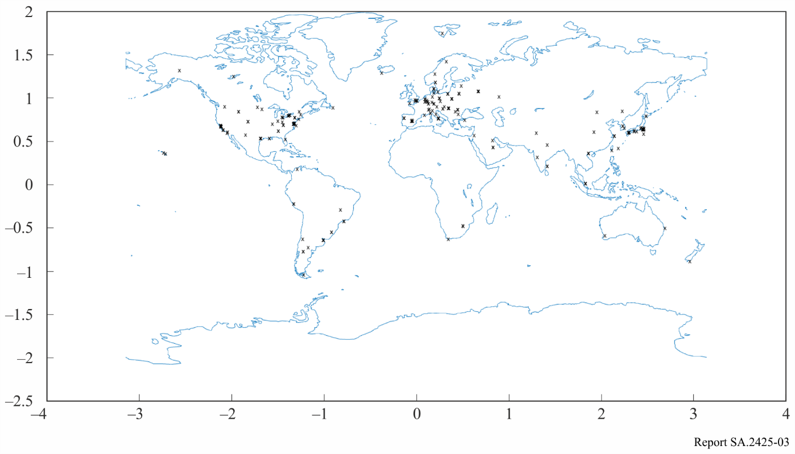

After creating the earth station distribution, the 300 satellites are linked to the 300 earth stations from the TU Berlin database by means of random permutation pairs.

Finally, the RF characteristics as contained in the Report ITU-R SA.2426-0 are attributed to each satellite and earth station. For the earth station antenna gain pattern, a pattern according to Recommendation [ITU-R F.699](http://www.itu.int/rec/R-REC-F.699/en) is assumed, furthermore assuming that the antenna is tracking such that the maximum gain is always directed at the satellite associated with that respective earth station. Figure 4 shows the earth station antenna gain as a function of the off-axis angle, assuming a 12 dBi maximum gain on VHF frequencies, and 16 dBi maximum gain on UHF frequencies.

Figure 4

Earth station antenna gain patterns at 137 MHz (12 dBi maximum gain) and 401 MHz (16 dBi maximum gain)

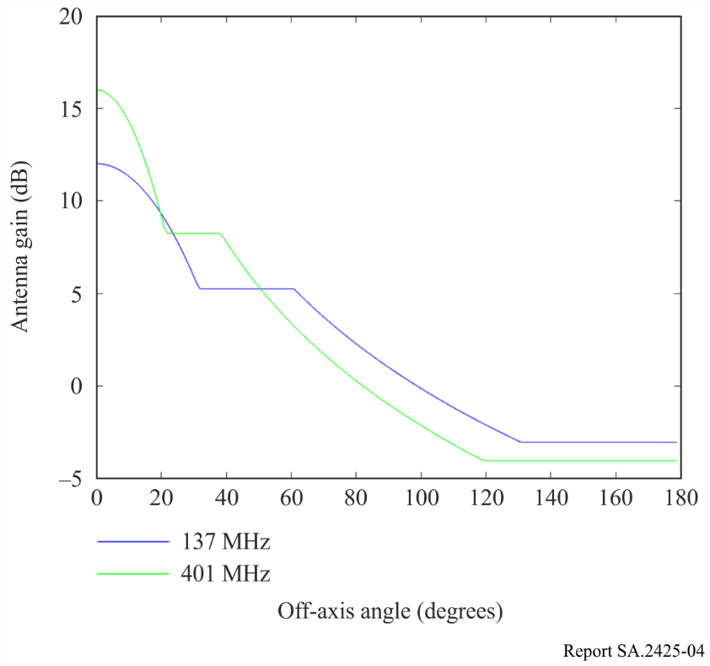

### 3.2.3 Simulation approach in the space-to-Earth direction

An orbit propagator based on a Keplerian orbit model propagates the satellite orbits. When the satellite is above the minimum elevation angle of 5 degrees the range of each satellite to the earth station is determined. The angle of the satellite-earth station vector for the satellite associated with a particular earth station (the wanted link) is set to 0 degrees, assuming a tracking earth station antenna and no pointing error. If other satellites have co-visibility to the earth station under consideration, andhave visibility to their own associated earth station, the range of these satellites to this earth station is determined. The (off-axis) angle of the satellite-earth station vector for each of these satellites is determined as well and stored for later use in the interference calculations.

Based on the above calculation of the range and off-axis angle of the satellite-earth station vectors, the aggregate received interference PSD (denoted by the symbol I0) received by each earth station is calculated for each time step. After that, the cumulative distribution function (CDF) of the interference PSD is calculated. CDF calculations are performed for two emission scheduling scenarios as outlined in Table 1:

1 Continuous while the satellite is in the earth station visibility cone.

In this case, the aggregate interference power spectral density statistics are determined over the total active link time.

2 Once a day during the largest time in which the satellite is in the earth station visibility cone that day.

In this case, the aggregate interference power spectral density statistics are determined over the largest time in which the satellite is above the minimum elevation of 5 degrees for each day in the simulation out of the total of seven simulation days.

An example for the space-to-Earth direction considering 10 satellite-earth station combinations can be found in Fig. 5. The red dotted lines indicate the interference PSD threshold as specified by Recommendation [ITU-R SA.363-5](http://www.itu.int/rec/R-REC-SA.363/en), in this case for a frequency of 401 MHz. Finally, for each earth station in the simulation, it is determined whether the threshold is exceeded. This data is then passed on for further statistics processing.

Figure 5

Example of aggregate interference PSD statistics from emissions of NGSO SD satellites at the earth station   
(space-to-Earth direction)

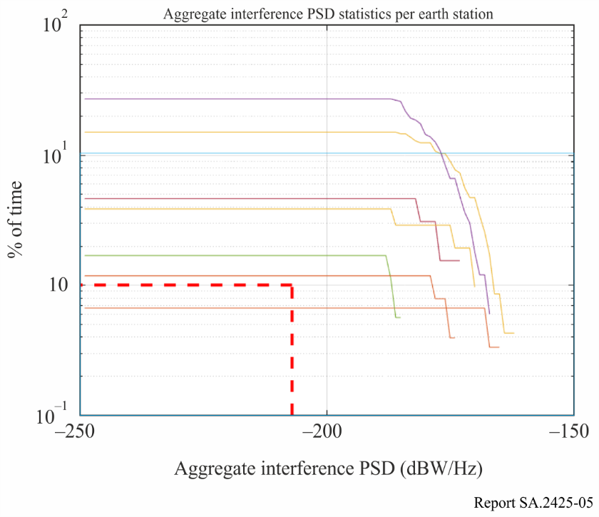

### 3.2.4 Simulation approach in the Earth-to-space direction

A similar calculation as in the space-to-Earth direction is performed, but this time, the received carrier power (denoted by the symbol C) at the output of each satellite antenna is calculated for the wanted links. Furthermore, the aggregate interference power (denoted by the symbol I) at the output of each satellite antenna is determined.

CDF calculations are performed for one emission scheduling scenario as outlined in Table 1:

1 Once a day during the largest time in which the satellite is in the earth station visibility cone that day.

In this case, the aggregate interference PSD statistics are determined over the largest time in which the satellite is above the minimum elevation of 5 degrees for each day in the simulation out of the total of seven simulation days.

An example plot of the cumulative distribution of the *C*/*I* for a simulation with 10 satellite-earth station combinations is given in Fig. 6 for the Earth-to-space direction.

Figure 6

Example of *C*/*I* statistics at NGSO SD satellite from emissions of earth stations (Earth-to-space direction)

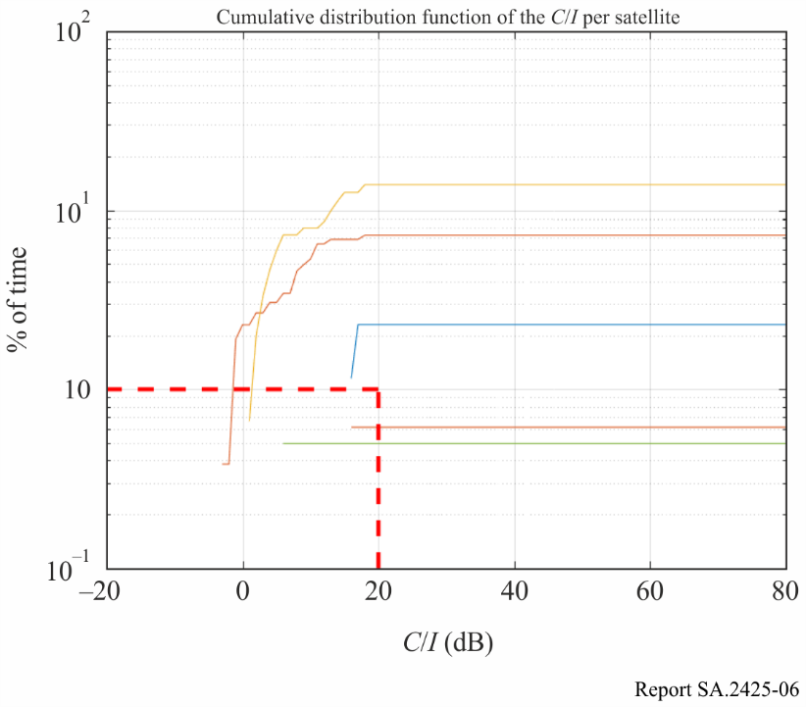

### 3.2.5 Processing of simulation results

A single simulation run consists of a number n of satellite-earth station pairs. For each value of n ranging from 2 to 40, a total of 100 simulation runs is performed, each run taking a new random selection from the sample set of 300 pairs.

For each simulation run, the amount of earth stations or satellites (depending on the link direction simulated) at which the protection criteria of Recommendation [ITU-R SA.363-5](http://www.itu.int/rec/R-REC-SA.363/en) are exceeded is calculated and stored. Upon completion of the simulation for a particular value of *n*, the number of runs in which the protection criteria is exceeded for at least one satellite-earth station pair is determined and subsequently stored.

### 3.2.6 Simulation results

A total of six overall simulations were performed in accordance with the simulation parameters contained in Table 1. Table 3 lists the simulations which have been run.

TABLE 3

Simulation overview

|  |  |  |  |
| --- | --- | --- | --- |
| Simulation | Direction | Frequency band | Wanted link active during |
| 1 | s-E | 137 MHz | All passes |
| 2 | s-E | 401 MHz | All passes |
| 3 | s-E | 137 MHz | Longest pass per day |
| 4 | s-E | 401 MHz | Longest pass per day |
| 5 | E-s | 148 MHz | Longest pass per day |
| 6 | E-s | 450 MHz | Longest pass per day |

Simulation results can be found in Figs 7, 8 and 9.

Figure 7

Simulation results for simulations 1 and 2

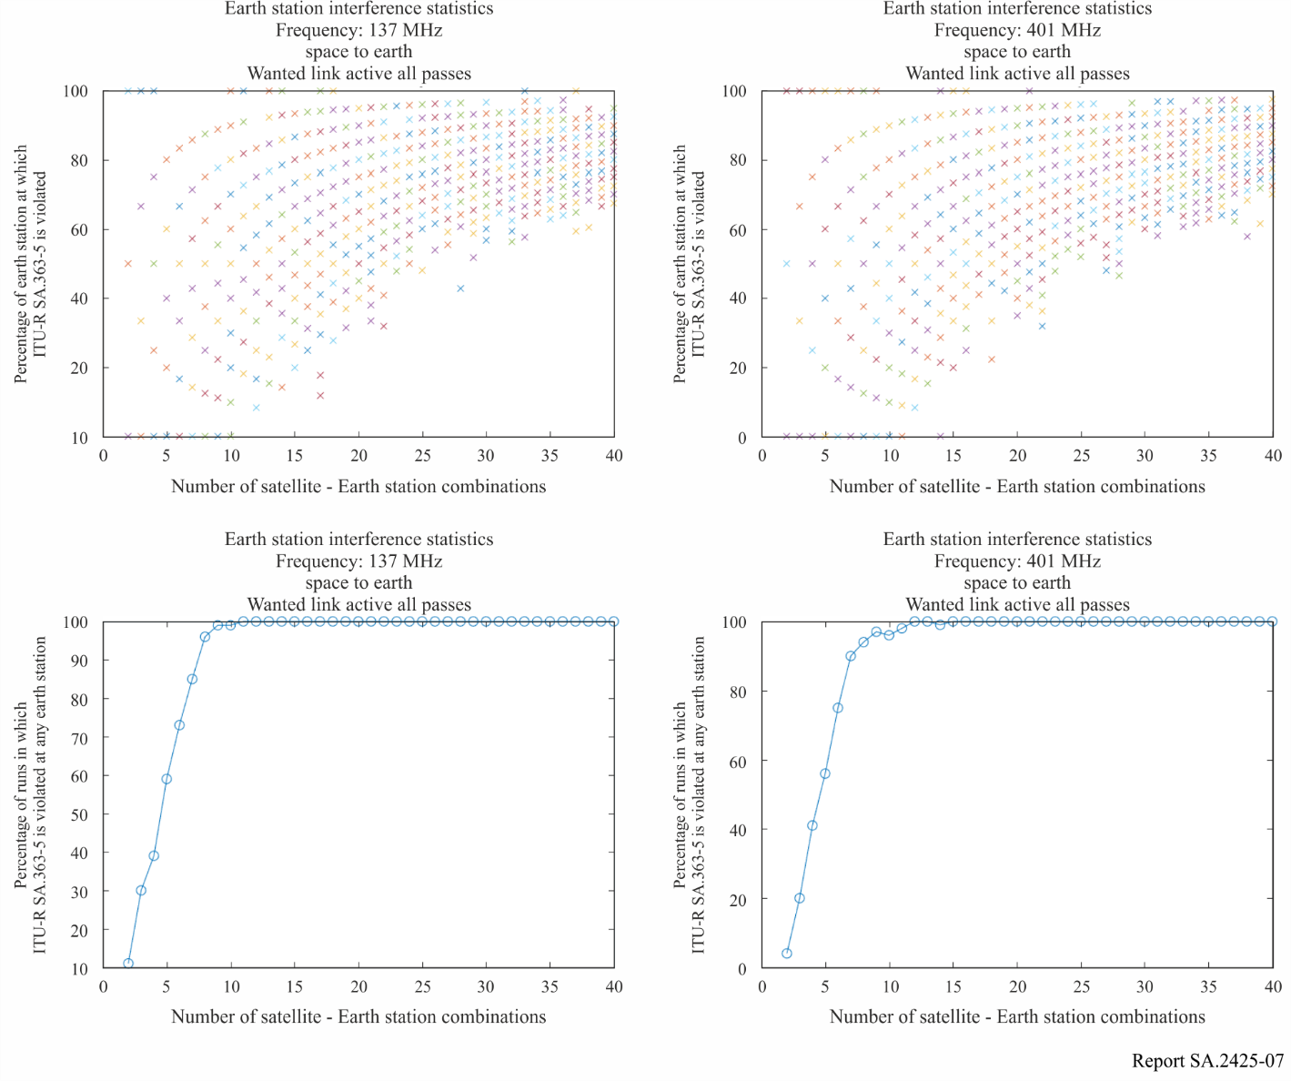

Figure 8

Simulation results for simulations 3 and 4

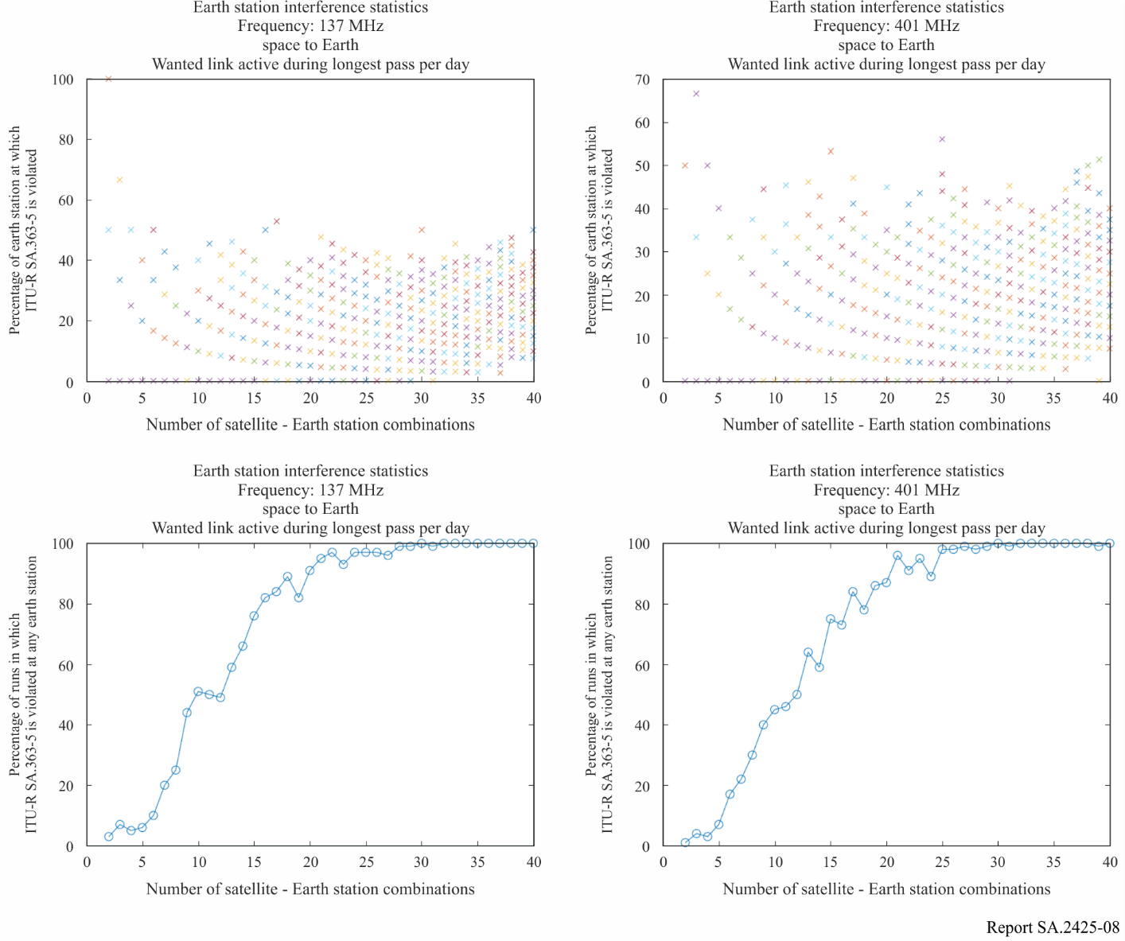

Figure 9

Simulation results for simulations 5 and 6

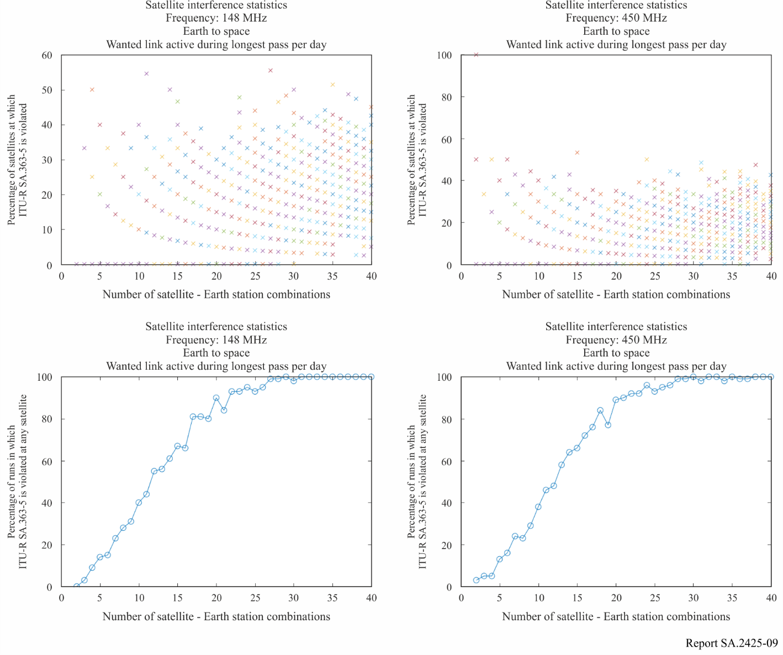

For each Figure, the upper plots show the percentage of earth stations or satellites at which the protection criteria are exceeded as a function of the number of satellite-earth station combinations.

As indicated before, there are 100 runs for every n pairs of satellite-earth station combinations. The vertical axis in these plots indicates the percentage of pairs for which the protection criteria are exceeded for each run, represented by a cross. Note that some of the 100 crosses can be on top of each other, which is not visible in the plot.

The lower plots show the percentage of simulation runs out of the total of 100 runs in which the protection criteria are exceeded for at least one satellite-earth station pair.

Two observations can be made:

1 The simulation results show only a small difference in the results between the VHF and UHF frequency ranges.

2 The protection criteria could be exceeded for the case of two satellite-earth station pairs, for example in Simulation 1. On the other hand, for eight satellite-earth station combinations in Simulation 1 there are still runs showing no violation of the protection criteria, although the vast majority of runs do give a violation of the protection criteria for this number of satellite-earth station combinations. If the visibility of the randomly picked earth stations overlap, violation of the protection criteria is almost certain. If the distribution is such that there is little overlap, there can also be cases where the protection criteria are not exceeded. In practice, due to coordination, the actual value of co-existing satellite-earth station combinations could be somewhere between these values, since interference issues can at least partially be resolved by means of coordination. Furthermore, it is expected that some of the 300 satellite-earth station combinations will be in centrally-controlled multi-satellite (and earth station) systems, in which spectrum use is coordinated and thus efficiencies are gained.

Taking Simulation 2 into account, a reasonable assumption could be that the protection criteria may be exceeded in between 30 to 50% of the simulation runs. This means that 70 to 50% of the simulation runs had no interference events that exceed the protection criteria.

Table 4 summarizes the spectrum requirements for a set of 300 satellite-earth station combinations assuming that the protection criteria may be exceeded in 30% of the simulation runs, and Table 5 summarizes the spectrum requirements for a set of 300 systems assuming that the protection criteria may be exceeded in 50% of the simulation runs. In these tables, the spectrum requirement value is determined by dividing the total number of satellite-earth station combinations (300) by the number of satellites which can operate co-frequency, and multiplying the result by the necessary bandwidth per satellite (25 kHz).

As an example of how to calculate the spectrum requirement based on the simulations results one could consider the example where for 30% of the simulation runs the protection criteria was exceeded for the 137 MHz space-to-Earth scenario and emission schedule such that the satellite transmits during the total time it is in the earth station visibility cone. Then from Fig. 7 lower left the number of pairs which can operate co-frequency is determined to be equal to 3. This translates to a spectrum requirement of 300/3 times 25 kHz equals 2.5 MHz.

TABLE 4

Spectrum requirements for 300 short duration NGSO satellite-earth station combinations,  
violation of 30% of simulation runs

|  |  |  |  |  |  |  |
| --- | --- | --- | --- | --- | --- | --- |
| Simulation | 1 | 2 | 3 | 4 | 5 | 6 |
| Frequency (MHz) | 137 | 401 | 137 | 401 | 148 | 450 |
| Direction | space-to-Earth | space-to-Earth | space-to-Earth | space-to-Earth | Earth-to-space | Earth-to-space |
| Time criterion | Total time in visibility cone | Total time in visibility cone | Longest time in visibility cone per day | Longest time in visibility cone per day | Longest time in visibility cone per day | Longest time in visibility cone per day |
| Amount of satellite – earth station combinations which can operate co-frequency (baseline sustainability factor) | 3 | 3 | 8 | 8 | 8 | 9 |
| **Spectrum requirement (MHz)** | **2.5** | **2.5** | **0.938** | **0.938** | **0.938** | **0.834** |

TABLE 5

Spectrum requirements for 300 short duration NGSO satellite-earth station combinations,  
violation of 50% of simulation runs

|  |  |  |  |  |  |  |
| --- | --- | --- | --- | --- | --- | --- |
| Simulation | 1 | 2 | 3 | 4 | 5 | 6 |
| Frequency (MHz) | 137 | 401 | 137 | 401 | 148 | 450 |
| Direction | space-to-Earth | space-to-Earth | space-to-Earth | space-to-Earth | Earth-to-space | Earth-to-space |
| Time criterion | Total time in visibility cone | Total time in visibility cone | Longest time in visibility cone per day | Longest time in visibility cone per day | Longest time in visibility cone per day | Longest time in visibility cone per day |
| Amount of satellite-earth station combinations which can operate co‑frequency (baseline sustainability factor) | 4 | 4 | 12 | 12 | 11 | 11 |
| **Spectrum requirement (MHz)** | **1.875** | **1.875** | **0.625** | **0.625** | **0.682** | **0.682** |

### 3.2.7 Validation of simulation results in the Space-to-Earth direction

An additional analysis, using the same input parameters but a different, independent simulation environment was performed to validate the simulation results.

Out of the 300 satellite-earth station combinations, a number of m = 2 satellite-earth station combinations are randomly chosen. One system is the wanted satellite-earth station link, the other one is a possibly interfering link. According to the protection criteria in Recommendation [ITU-R SA.363‑5](http://www.itu.int/rec/R-REC-SA.363/en), the interference of the system for a frequency of 401 MHz should not exceed   
−176 dBW/kHz during more than 1% of the link time (−166.76 dBW/kHz for 137.5 MHz). Therefore, the percentage of time in which this threshold is exceeded is calculated. Since the calculation highly depends on the random pick of satellites and earth stations, the simulation is repeated 300 times for both VHF and UHF.

After the simulation was performed for two satellite-earth station combinations, it is repeated for m = 3 combinations (1 wanted link and 2 interferers) up to m = 8 combinations. The results are presented in Table 6.

TABLE 6

Average period of time in which the protection criteria of −176 dBW/kHz (UHF) / −166.76 dBW/kHz (VHF) is exceeded for *m* satellite-earth station combinations

|  |  |  |  |  |  |  |  |
| --- | --- | --- | --- | --- | --- | --- | --- |
| **Number of satellite-earth station combinations (m)** | 2 | 3 | 4 | 5 | 6 | 7 | 8 |
| **Exceedance of protection criteria in UHF (in %)** | 0.42 | 1.17 | 1.53 | 2.29 | 2.36 | 3.64 | 3.85 |
| **Exceedance of protection criteria in VHF (in %)** | 0.51 | 0.99 | 1.52 | 1.87 | 2.45 | 3.16 | 3.77 |

Table 6 shows that in the UHF frequency region, not more than two satellite-earth station combinations can use the same frequency in the same geographical area (three systems for VHF). Obviously, this depends on the distribution of earth stations and there are many possible distributions where more than two satellite-earth station combinations can share the same frequency (e.g. three systems with earth stations in Europe, the United States of America and Japan). To include this circumstance in the simulation, a further analysis is performed. In this analysis, the maximum number of coexisting satellite-earth station combinations in which none of the earth stations is interfered with more than 1% of the link time is calculated. Since this case is more favourable for sharing studies, it is named “best case for sharing” in the following.

*Example:* Seven earth stations are randomly distributed (Fig. 10). For each of the seven earth stations, an interference analysis is performed. If all analyses state that the protection criteria is not exceeded more than 1% of the time, the distribution is considered to be feasible.

Figure 10

Example of feasible distribution of seven satellites and seven earth stations using  
the same frequency without harmful interference

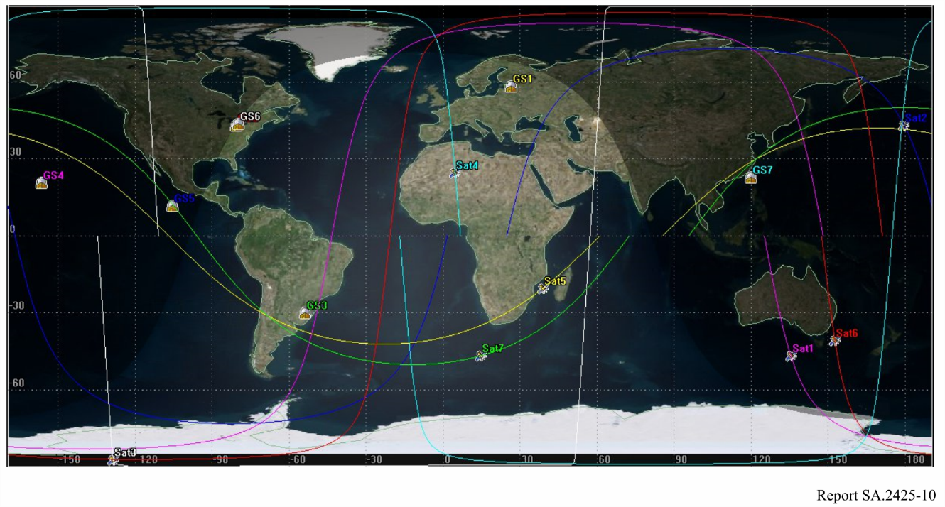

The simulation is performed for each number of coexisting satellite-earth station combinations up to 300 times and results in the maximum number of seven coexisting satellite-earth station combination that do not harmfully interfere with each other (Fig. 10) for a frequency of 401 MHz. For a frequency of 137.5 MHz, the critical number is five satellite-earth station combinations.

It should be noted that this represents the maximum number of systems per frequency. Since many earth stations are in the same region, the average number of non-interfering stations will be lower.

The results of the validation for the space-to-Earth direction are summarized in Table 7. According to this analysis, the maximum number of satellite-earth station combinations per frequency varies between two and seven for UHF and between three and five in VHF. Accordingly, the spectrum needs vary between 3.75 MHz (random distribution case) and 1.07 MHz (best case for sharing) for UHF and between 2.5 MHz (random distribution case) and 1.5 MHz (best case for sharing) for VHF.

As can be seen, the results obtained in the space-to-Earth direction for the case where the satellite link is active during all passes over the associated earth station in § 3.4.6 fall within the minimum and maximum spectrum requirements bounds obtained in the validation.

TABLE 7

Validation results in the space-to-Earth direction – total time in visibility cone

|  |  |  |
| --- | --- | --- |
| Frequency (MHz) | 137 | 401 |
| Direction | space-to-Earth | space-to-Earth |
| Time criterion | Total time in visibility cone | Total time in visibility cone |
| Amount of satellite-earth station combinations which can operate co-frequency (baseline sustainability factor) – random distribution case | 3 | 2 |
| **Spectrum requirement (MHz) (random distribution)** | **2.5** | **3.75** |
| Amount of satellite-earth station combinations which can operate co-frequency (baseline sustainability factor) – best case for sharing | 5 | 7 |
| **Spectrum requirement (MHz) (best case for sharing)** | **1.5** | **1.07** |

# 4 Summary

This study determines the amount of TT&C spectrum required for short duration NGSO missions, based on the protection criteria as outlined in Recommendation [ITU-R SA.363-5](http://www.itu.int/rec/R-REC-SA.363/en).

Simulations have shown that the protection criteria could be exceeded for the case of two satellite-earth station pairs, for example in simulation 1. On the other hand, for eight satellite-earth station pairs in simulation 1 there are still simulation runs showing no violation of the protection criteria, although the vast majority of simulation runs do give a violation of the protection criteria for this number of satellite-earth station pairs. If the visibility cones of the randomly picked earth stations overlap, violation of the protection criteria is almost certain. If the distribution is such that there is little overlap, there can also be cases where the protection criteria are not exceeded. Therefore, in practice, some inter-operator coordination may be necessary. Furthermore such coordination may be necessary to account for the fact the satellite population is dynamic, i.e. satellites are added over time, while other satellites have reached end of mission. Finally, it is expected that some of the 300 satellite-earth station combinations will be in centrally-controlled multi-satellite (and earth station) systems, in which spectrum use is coordinated and thus efficiencies are gained.

Taking the above observations into account, the spectrum requirements for short duration NGSO systems range from 0.625 MHz to 2.5 MHz in the space-to-Earth direction, and from 0.682 MHz to 0.938 MHz in the Earth-to-space direction, depending on the operational scenario.

Annex 1  
  
Results of a small satellite frequency use questionnaire

In 2016, a questionnaire was created to analyse the expected increase of satellites with short duration missions. The questionnaire was sent to various representatives of the small satellite community and 58 responses were sent back. The summary of the results is attached below. As can be seen, the questions aimed to find out whether there is a need for TT&C spectrum below 1 GHz. Also, it should identify whether small satellite developers consider their missions to last not more than the above mentioned three years. One question was to state the planned satellites for the upcoming five years. In total, the 58 participants stated that they plan up to 747 satellites in the upcoming five years from which 721 plan to use spectrum below 1 GHz.

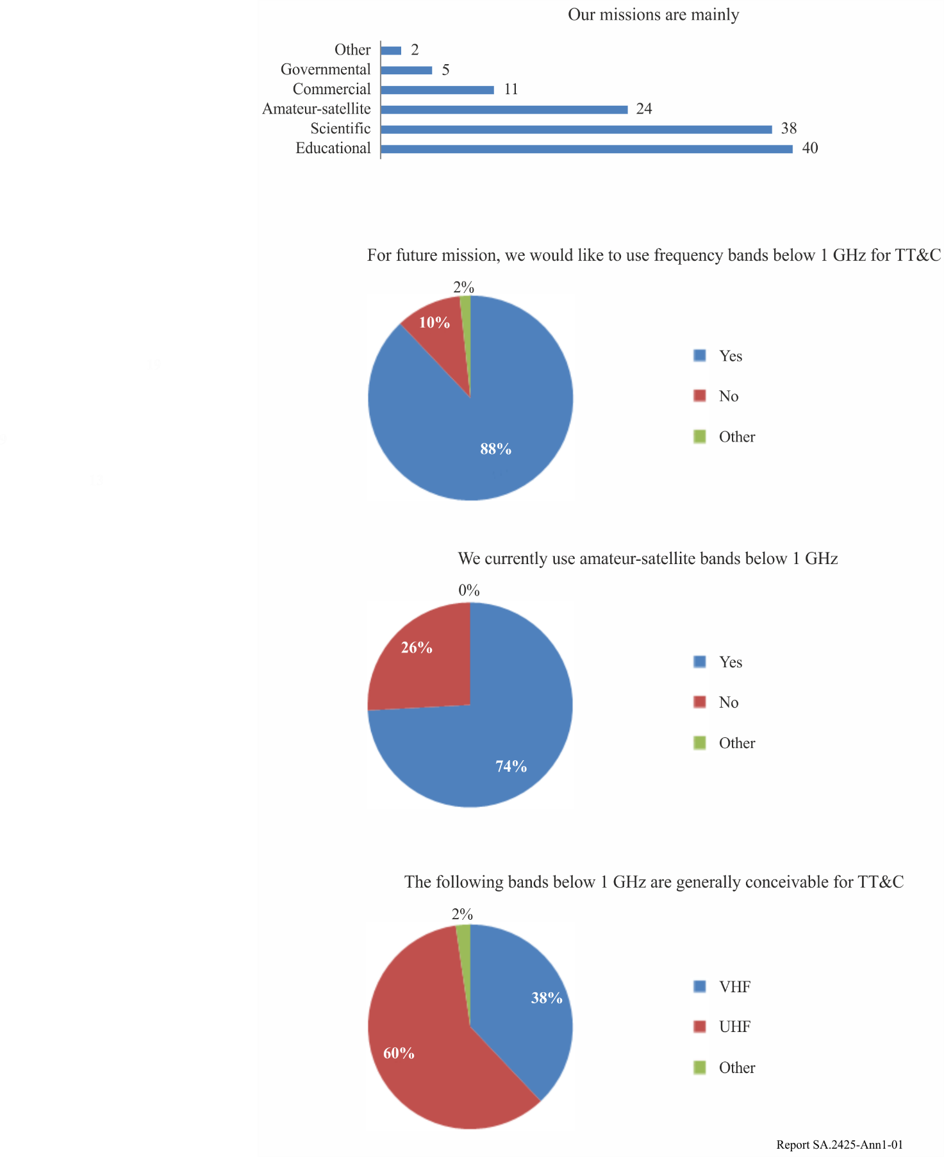

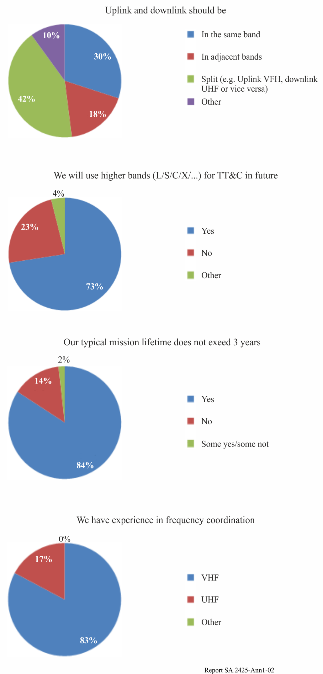

Annex 2  
  
Excel file containing orbit parameters of satellites based   
on the TU Berlin Small Satellite Database



Annex 3  
  
Excel file containing ground stations of satellites based   
on the TU Berlin Small Satellite Database

