|  |
| --- |
| **Report ITU-R SM.2424-0**  **(06/2018)** |
| Measurement techniques and new technologies for satellite monitoring |
| **SM Series**  **Spectrum management** |

Foreword

The role of the Radiocommunication Sector is to ensure the rational, equitable, efficient and economical use of the radio-frequency spectrum by all radiocommunication services, including satellite services, and carry out studies without limit of frequency range on the basis of which Recommendations are adopted.

The regulatory and policy functions of the Radiocommunication Sector are performed by World and Regional Radiocommunication Conferences and Radiocommunication Assemblies supported by Study Groups.

# Policy on Intellectual Property Right (IPR)

ITU-R policy on IPR is described in the Common Patent Policy for ITU-T/ITU-R/ISO/IEC referenced in Annex 1 of Resolution ITU-R 1. Forms to be used for the submission of patent statements and licensing declarations by patent holders are available from <http://www.itu.int/ITU-R/go/patents/en> where the Guidelines for Implementation of the Common Patent Policy for ITU‑T/ITU‑R/ISO/IEC and the ITU-R patent information database can also be found.

|  |  |
| --- | --- |
| Series of ITU-R Reports  (Also available online at <http://www.itu.int/publ/R-REP/en>) | |
| **Series** | Title |
| **BO** | Satellite delivery |
| **BR** | Recording for production, archival and play-out; film for television |
| **BS** | Broadcasting service (sound) |
| **BT** | Broadcasting service (television) |
| **F** | Fixed service |
| **M** | Mobile, radiodetermination, amateur and related satellite services |
| **P** | Radiowave propagation |
| **RA** | Radio astronomy |
| **RS** | Remote sensing systems |
| **S** | Fixed-satellite service |
| **SA** | Space applications and meteorology |
| **SF** | Frequency sharing and coordination between fixed-satellite and fixed service systems |
| **SM** | **Spectrum management** |

|  |
| --- |
|  |

|  |
| --- |
| ***Note****: This ITU-R Report was approved in English by the Study Group under the procedure detailed in Resolution ITU-R 1.* |

*Electronic Publication*

Geneva, 2018

© ITU 2018

All rights reserved. No part of this publication may be reproduced, by any means whatsoever, without written permission of ITU.

REPORT ITU-R SM.2424-0

Measurement techniques and new technologies for satellite monitoring

(2018)

# 1 Introduction

The ITU Handbook on Spectrum Monitoring provides detailed information on signal parameter measurement and basic procedures for spectrum monitoring, but lacks descriptions of advanced measurement techniques and new technologies for satellite monitoring. The purpose of this Report is to provide a comprehensive description of the necessary functions of satellite monitoring stations, and related technical requirements for new monitoring solutions, as systematic and intuitive guidance for administrations that wish to establish satellite monitoring capabilities.

The following ITU documentation concerning spectrum monitoring has been taken into account when developing this Report:

– Recommendation ITU-R RA.769 – Protection criteria used for radio astronomical measurements

– Recommendation ITU-R SM.1600 – Technical Identification of Digital Signals

– ERC Report 171: “Impact of Unwanted Emissions of IRIDIUM Satellites on Radio Astronomy Operations in the Band 1610.6-1613.8 MHz”

– ITU Handbook Spectrum Monitoring edition 2011.

Other documents:

Reconstruction of the Satellite Orbit via Orientation Angles (Journal for Geometry and Graphics, Volume 4 (2000), by A. M. Farag and Gunter Weiss

# 2 Terms and definitions

8PSK Eight state phase shift keying

16 QAM Sixteen state quadrature amplitude modulation

AOA Angle of arrival

BPSK Binary phase shift keying – two state phase shift keying

CDMA Code division multiple access

CW Continuous wave

DVB-CID DVB Carrier-Identification

e.i.r.p. equivalent isotropic radiated power

EVM Error vector magnitude

FDMA Frequency division multiple access

FDOA Frequency difference of arrival

LDPC Low density parity check – a linear error correcting code

pfd Power flux density, dBW/m2 in the applicable bandwidth

POA Power of arrival

RS Reed Solomon coding

SDMA Space-division multiple access

SOA Service oriented architecture

spfd Spectral power flux density, dBW/m2 /Hz

TCA Time of closest approach

TDMA Time division multiple access

TDOA Time difference of arrival

Turbo High-performance forward error correction codes

QPSK Quadrature phase shift keying – four state phase shift keying

# 3 Goals of satellite monitoring

The goal of spectrum management is to maximize spectrum efficiency, minimize interference and eliminate unauthorised and improper use of the spectrum. Spectrum monitoring supports the spectrum management process. Monitoring of space radio services requires different approaches and techniques compared to terrestrial radio monitoring. For this reason, it is important for administrations to establish fully functional satellite monitoring stations.

Satellite monitoring has two primary goals, which are:

– Goal 1: Evaluation of satellite resource utilization:

• Carrier and transponder level;

• Orbit position occupancy;

• Frequency occupancy;

• Orbit position and frequency assignment (over long-term usage);

• Power flux-density (pfd) and other technical parameters compliance;

• Beam coverage.

– Goal 2: Detection and resolution of interference:

• Geolocation of interfering transmitters on the surface of the earth;

• Determination if the interfering transmitters are mobile or fixed;

• Detection and technical analysis of interfering satellite communication networks;

• Determination of the exact position of terrestrial interferers;

• Investigation and verification of emission parameters with license conditions;

• Elimination of the interference.

# 4 Functions of monitoring systems

This section describes the basic functions of a satellite monitoring station. The structure of a typical fixed monitoring station is shown in Fig. 1.

Figure 1

Structure of a typical fixed monitoring station

Signal

Measurement

Transmitter

Geolocation

Signal

Transmission

Orbit

Determination

Signal

Identification

Monitoring database

## 4.1 Signal reception

For monitoring signals from satellites, the most commonly used antenna type is the parabolic antenna because it can be pointed to the satellite of interest and may be used to track satellites. The size of the antenna determines the gain of the antenna, so it should be sufficiently large to allow for proper signal reception. Higher order modulation schemes require higher *C*/*N* ratios. The satellite orbit position can be approximate calculated using azimuth angle and elevation angle of the antenna. A spectrum analyser connected to the antenna will display the received spectrum.

Phased array antennas change the shape of their radiation patterns by adjusting the phase of the signal feeding of the radiating elements in the array. This facilitates scanning multiple satellites within a large spatial arc almost simultaneously. Therefore, phased array antennas may be a good choice for monitoring multiple GSO satellite signals.

The requirements of antenna systems used for both GSO and non-GSO are described in more detail in the ITU-R Spectrum Monitoring Handbook §§ 5.1.3.3 to 5.1.3.6, and the examples of antenna usage are presented in § 5.1.6.1.1.

The GSO satellite frequency bands that a satellite monitoring station typically monitors are UHF, L, S, C, X, Ku and Ka bands. The non-GSO satellite frequency bands that a satellite monitoring station typically monitors are UHF, L, S, X, Ku and Ka bands. With the increasing use of broadband Internet satellite communications, bandwidth demand continues to expand, the monitoring frequency bands will expand to Q band and above.

## 4.2 Signal measurement

Modern receiving systems should have the ability to perform real-time, non-real-time (data is analysed later, known as post processing), and fixed time measurements. The system should have a measurement bandwidth wider than the typical satellite carriers being evaluated. As a minimum, however, the system should support measurement bandwidths greater than 100 MHz. The system should also be able to record IQ data at the full bandwidth of the signal. The IQ recordings support post processing and analysis of the signal.

The following RF parameters should be measured in real time by the receiving system:

– Centre frequency;

– Doppler frequency;

– pfd in reference bandwidth and total pfd;

– Equivalent Isotropic Radiated Power (e.i.r.p.);

– Carrier-to-noise ratio, *C/N*0;

– Transponder bandwidth and carrier bandwidth;

– Out-of-band spectrum;

– Received signal to noise ratio.

## 4.3 Signal identification

As stated above, the IQ data from the receiving system can support post processing and analysis of the signal parameters. With the proper triggering, the receiving system can record a signal once it is detected so that the characteristics of the signal can be preserved for future analysis. Refer to Recommendation ITU-R SM.1600 – Technical Identification of Digital Signals, for guidance regarding the process of making and analysing IQ recordings. The receiving system should have the ability to determine the following signal properties:

– Code rate and symbol rate.

– Modulation type, i.e. QPSK, 8PSK, BPSK, 16QAM.

– Source coding and channel coding type (i.e. RS, Turbo, LDPC).

– Multiplex Access, i.e. TDMA, FDMA, SDMA, CDMA.

– DVB Carrier-Identification (DVB-CID). DVB-CID is a unique identifier to identify the owner of a satellite signal according to ETSI TS 103 129.

Additional parameters show below could be used to identify the communication system:

– Communication protocol type, i.e. IP, DCME.

– Communication system, i.e. SNG, DVB-S, DVB-S2, COMTECH.

– Communication network type, i.e. SkyWAN, iDirect, LinkWay/LinkStar.

## 4.4 Signal surveillance and alarming

In order to detect unauthorised transmitters and identify anomalies on a transponder or in a given bandwidth, signal surveillance should be performed. The deviation between the measured and the nominal (expected) parameters should be continuously compared.

The monitoring system may generate an alarm to notify the operator when a given threshold is exceeded. Examples of a low and high signal power alarm levels are shown in Fig. 2. Modern satellite monitoring systems are capable of setting high and low power level thresholds. When a level violation occurs, the software can automatically take an action to provide useful information to satellite operations. In the Figure, two signals are shown along with the associated high and low power levels (shaded).

Similar limits can be established for different parametric measurements providing the operator with real-time alerts to changing operating conditions.

Figure 2

An example of a low signal power alarm level

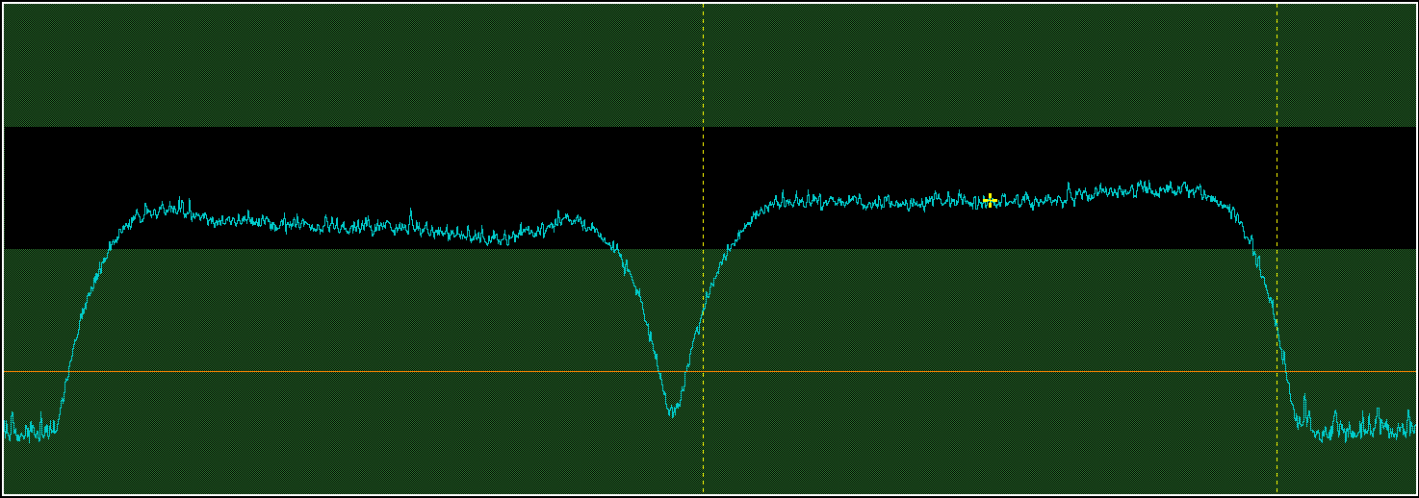

This can be done manually (for only a few carriers) or automatically (for multiple carriers) providing 24/7-hour monitoring. Tasks such as IQ recording, modulation classification and notification of the monitoring operator could be initiated automatically to aid in the identification of anomalies. Additionally, the geolocation system could be setup and started whenever an interference event or unauthorised emission is detected.

The following parameters can be used to detect an anomaly or unauthorised transmission and set an alarm:

– Centre frequency

– Bandwidth

– e.i.r.p.

– *S*/*N* ratio

– Guard band noise level changes

– Modulation characteristics (symbol rate, EVM).

– Spectrograms can be used by the operator to visualize short duration interference, fast time slot drift, and sweeping signals.

## 4.5 Geolocation of transmitters on earth

Geolocation of transmitters on earth should be accomplished with cross-correlation algorithms using one, two or three satellites.

Due to the limitations of the algorithms and numerous factors that affect the accuracy of the geolocation measurement, the geolocation result is an area, where the interfering transmitter is most likely located, rather than an exact position.

The result is usually presented in the form of an area with parameters as indicated below:

– Longitude and latitude of the centre point of the area

– Geolocation accuracy which could be represented by ellipse with major axis, minor axis and angle of the area relative to North

– Whether the transmitter is stationary or moving.

## 4.6 Signal transmission

The signal transmission system of a space radio monitoring station is mainly used for transmitting a reference signal from a known remote location to help improving geolocation accuracy. The reference signal is usually a spread spectrum signal. Because of the spectral characteristics of the spread spectrum signal, it is difficult to detect and causes no interference to the signals on the satellite transponder.

## 4.7 Orbit determination

The precision of satellite ephemeris data greatly affects the geolocation accuracy. It is strongly recommended to use satellite ephemeris with accuracy better than 5 km for geolocation.

There are three ways to get satellite ephemeris. The first way is to obtain the satellite ephemeris from the Internet or satellite operators. Ephemeris from operators is up to date and accurate. The second way is to measure the satellite ephemeris using active methods. The third way is to measure the satellite ephemeris using passive methods.

The active ephemeris determination methods using radio measurement usually based on Doppler shift, Interferometry or Radar, it is usually required several transmitters distributed in different locations to continuously emit signal to satellite and receive the same signal from satellite synchronously for several hours, and then calculate the orbital elements of the satellite as well as the satellite ephemeris. Optical orbital determination can also be used.

However, in comparing active ephemeris determination methods, the passive satellite ephemeris determination method does not require transmitting signals to the satellite, therefore it reduces the possibility of interfering with the satellite by the signals themselves. It uses time-difference-of-arrival (TDOA) lines of at least three distant receiving stations. The receiving stations are dispatched in a triangle of hundreds of kilometres, and are accurately time synchronized on GPS signal. The TDOA values are computed by performing an Orbital model regression integrating the TDOA values over the time.

## 4.8 Signal homing

Signal homing uses mobile monitoring stations to identify the location and operator of a ground-based transmitter or other interfering source that interferes with authorized satellite communication signals. Commonly used techniques for interference investigation include the use of angle of arrival (AOA), power of arrival (POA) and TDOA cross-correlation algorithms. Signal homing starts with the results of a satellite geolocation measurement that describes an area from which the interference most likely originates. An iterative process using mobile assets results in the successful location of the ground-based transmitter. The results of ground search and confirmation are shown below:

– Longitude and latitude of target transmitter (location).

– Operator of the target transmitter (identification).

## 4.9 Documentation and database

Monitoring procedures and results could be recorded in a database automatically to support long term trend analysis and documentation of the impact of scheduled changes, and interference events. The database contains records of data recorded from different types of operations and facilities in the monitoring stations across the region or country. Besides, it could also support generation of regular (daily, weekly) reports to support normal operations and maintenance. The following main parameters could be stored:

– Spectrogram data, I/Q data.

– Signal measurement data.

– Signal identification data.

– Geolocation data.

– Interference investigation data.

– Audio and video data.

– Equipment configuration parameters while monitoring.

– Operation documentation.

– Work log.

## 4.10 Monitoring data visualization

To build an understanding of the performance of a satellite system over time, the monitoring database can be visualized by displaying data in different formats including traditional spectrum analysis, spectrograms, waterfall plots, constellation diagrams (for demodulated signals), as well as digital maps for location referenced data. Periodic measurements show parametric changes over short or long time periods and provide insight into trends and the impact of other factors associated with system performance (such as weather, local events, equipment changes, etc.).

The monitoring data could be observed in the following formats:

– Audio and video display (for previously decoded data).

– Graphic display of signal data in spatial domain, time domain, frequency domain and modulation domain, i.e. spectrogram, waterfall plot, and constellation diagram.

– Map display on geolocation result.

– Driving route display of monitoring vehicle.

### 4.11 Statistics and analysis

To manage the spectrum usage of satellites and earth stations, a highly integrated database is used to compare the measurement data as listed in §§ 4.2 and 4.3 with historical data for the purpose of both understanding normal operations and identifying the origin of anomalous transmissions. The data allow for example the following analyses:

– Identification of unauthorised emissions and anomalies

– Deployment of interferences and unauthorised satellite communication network (i.e. VSAT) including interference frequencies, modulation types, the number of interferences, geographical distribution of the interference sources

– Satellite orbit position

– Frequency occupancy.

### 4.12 Equipment control

Computerised monitoring equipment can perform many automated measurement functions and facilitate the building of the database. It can also aid operators in performing manual operations and check and maintain the station. Remote control of the station can provide a similar functionality. In addition, real-time communication between monitoring vehicles and fixed monitoring facilities can be established through audio or video via wide-area network connections. It can also provide monitoring data from remote/mobile stations to fixed facilities.

Due to the large variety of monitoring devices and manufactures, there are different Application Programming Interface (API) standards and data formats for those monitoring devices. Because of this automated and intelligent control of devices may not be possible. In order to solve the problems, satellite monitoring could be divided according to functions rather than devices. Devices providing the same function should have the same API. To facilitate efficient use of monitoring functions, administrations should consider adopting a Service Oriented Architecture (SOA) in the control software.

SOA is a component model that links the different functional units of monitoring devices (called services) through well-defined interfaces between these services. The interface should be independent of the hardware platform, operating system, and programming languages that implement the service. This allows services built on a variety of systems to interact in a unified and universal way.

# 5 Evaluation of satellite resource utilization

The number of GSO satellite orbit positions is limited. It is important to verify whether the satellite orbit positions and frequencies are properly used and whether the actual monitoring parameters are in compliance within its nominal value, to support the selection of new satellite orbit positions and coordination between satellites.

In addition, with the increasing use of micro-satellites, interference between non-GSO satellites and terrestrial equipment is more likely to occur. It is important to monitor parameters of non-GSO satellites for maintaining normal use of both satellite communication and terrestrial communication.

## 5.1 System composition

A block diagram for a typical satellite monitoring system is shown in Fig. 3.

Figure 3

Block diagram for a typical satellite monitoring system



## 5.2 Measurement technique of GSO satellite monitoring

### 5.2.1 Satellite orbit position accuracy measurement

According to Radio Regulations (RR) Article **22** Section III and RR Appendix **30**, space stations on board GSO satellites which use any frequency band allocated to the fixed-satellite service or the broadcasting-satellite service shall have the capability of maintaining their positions within ±0.1° of the longitude of their nominal positions. However, space stations in the broadcasting-satellite service on geostationary satellites operating in the band 11.7-12.7 GHz must maintain their positions within ±0.5° of longitude of their nominal positions.

Therefore, it is necessary to measure the current orbit position over at least 12 hours and compare it with the nominal orbit position of the satellite. Differences greater stated above should be recorded.

### 5.2.2 Spectrum occupancy measurement

Spectrum occupancy indicates the actual usage of a transponder or in a given bandwidth. The following procedure should be performed.

– Steer the antenna to a GSO satellite or an orbit position;

– Perform signal measurement in a given bandwidth, see § 4.2. Signal measurements should be performed automatically by GSO satellite monitoring systems;

– Record signal measurement result in database;

– By querying the database, the spectrum occupancy of different frequency bands in different time durations could be calculated as needed. Besides, if the spectrum occupancy of an orbit location is near zero in the long term, the orbit location can be identified as an idle orbit position which could be used to file for registration with the ITU.

If there are several satellites sharing one orbit position, it is hard to distinguish the spectrum from satellite to satellite, unless the polarisation and transponder plan of each satellite is known.

### 5.2.3 Detection of unauthorised emissions

To detect unauthorised and anomalies emissions on a transponder or in a given bandwidth, signal parameters (as described in § 4.2) should be automatically measured and continuously compared with the nominal (expected) parameters.

In the case of unauthorised emissions efforts should be made to identify the characteristics of the internal parameters of the signal, see § 4.3.

In addition, according to RR Article **21** Section V, the measured pfd of an improper emission should be compared to the ITU limit and the nominal pfd limit applied by the satellite operator.

## 5.3 Measurement techniques of non-GSO satellite monitoring

### 5.3.1 Identification of non-GSO satellites

The identification of non-GSO satellites is necessary during frequency band occupancy measurements, pre-launch monitoring, and for the mitigation of interference.

Due to different preconditions, there are different methods for the identification. Possible scenarios could be:

– The time of the appearance of the interference is known. An indication of non-GSO satellites is the Doppler shift; another is the repeated occurrence at a similar time of day. Example: customer has protocol of interference cases. The directivity / radiation pattern of the antenna which receives the interference has to be taken into account.

– The monitoring station is able to track the unknown satellite and record time, azimuth, elevation.

– The monitoring station is able to record the frequency band of interest, using an omnidirectional antenna.

Methods of identification

Keep in mind that a satellite does not necessarily transmit continuously.

Method A: Orbital elements are available

– Precondition: a complete set of orbital elements for all satellites is available

– Software predicts visibility (and observation angles) in real time mode

– Comparison with observed object

– Reduce number of possible satellites by repetition of measurements

– Use orbital elements to steer antenna for further measurements

Method B: Orbital elements from observation angles

– Precondition: antenna in auto tracking mode on a suitable signal

– Record azimuth and elevation angles

– Calculate orbital elements (see literature)

– Predict overflights for further measurements

Method C: Comparison of observation times

– Precondition: spectrum recording on an omnidirectional antenna

– Measure time difference between times of closest approach (TCAs)

– Search matching period in database

– Get TLEs of satellites with this period

– Calculate visibility and compare visibility times with observation times

– Use orbital elements to steer antenna for further measurements

Some remarks on method C

Non-GSO satellites circle the globe while earth is rotating on its axis. Thus the observer (unless situated near earthʼs rotation axis) passes twice under the satellite orbit, one time the satellite comes from north, the second time from south. To get a more precise measurement it is recommended to determine the time difference between overflights that are approximately 24 (48, 72 …) hours apart and divide by the number of revolutions. The best result is achieved when the satellite moves in the same direction (north/south) and is received with similar observation angles.

As most of the non-GSO satellites have a low orbit with heights of 160 to 2000 km (low earth orbit (LEO)) their period is between 84 and 127 minutes. Therefore, they are visible multiple times when the observer passes under the orbit. This results in a series of overflights. Depending on the latitude of the observer both series (satellite coming from north, satellite coming from south) are visible with equal (observer close to equator) or different time intervals. The change of the time interval gives an indication of the satelliteʼs inclination. For example, if the observer is in the northern hemisphere and the time interval during a series of overflights is first decreasing, then increasing, then the inclination of the satellite is more than 90 degrees.

There are frequencies which are shared by a number of satellites, mostly of the same constellation. The overflights have to be associated to single satellites. This can be achieved by identifying groups of overflights with nearly equal time differences.

Some definitions

Overflight:One passing of a satellite over the receiving station from horizon to horizon.

Series of overflights: Consecutive revolutions (orbits) of a satellite that can be observed.

TCA: Time of closest approach. The Doppler shift makes the overflights visible as s-shaped curves. At the time of closest approach the velocity of the satellite relative to the monitoring station is zero. This is the inflection point of the curve. At this time, the received frequency corresponds to the transmitted frequency.

Δ*t*: time difference between two overflights

~12 hours after a series of overflights the satellite passes the observer from the opposite direction (north/south)

~24 hours after a series of overflights the satellite passes the observer from the same direction (north/south)

Figure 4

Recording of a satellite during 30 hours

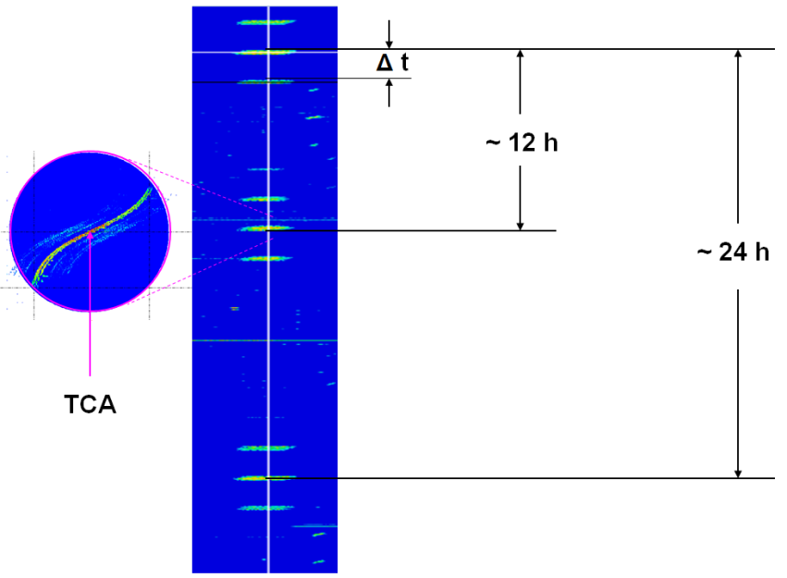

Spectrum Recording(Frequency Band Recording): A recording system that is capable to display spectra over time (spectrogram or waterfall display) with a storage time of at least 48 hours, a time resolution in the range of seconds, and a frequency resolution good enough to identify the TCA in Doppler curves.

Figure 5

Example of a spectrum recording

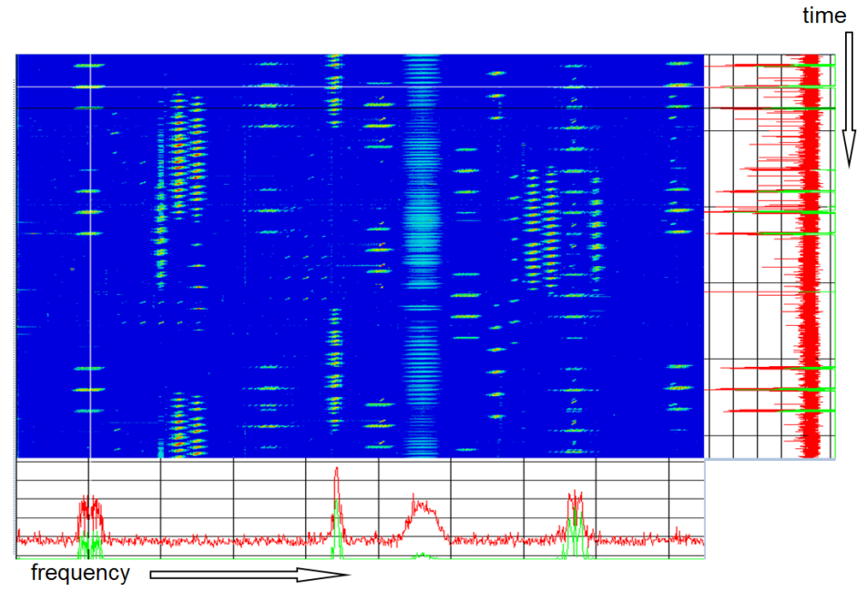

### 5.3.2 Orbit position measurement

The track of a non-GSO satellite should be calculated and provided in geographical coordinates (the sub-satellite point and altitude – can also be define in xyz coordinates reference to the Earth’s centre) or in a celestial grid. This can be accomplished through monopulse-tracking over a 24-hour period or through the use of optical means.

### 5.3.3 Carrier pfd curve measurement

The reception time of a non-GSO satellite can be predicted by using the satellite ephemeris. With this data, the earth station antenna can track the satellite and measure the pfd curve automatically. The measurement results should be stored in the database and displayed graphically.

# 6 Interference resolution

Transparent satellite transponders are susceptible to intentional and unintentional uplink and downlink interferers. Unintentional interference is typically caused by one of the following reasons:

– Improper operation of a licensed satellite service:

• Operator error;

• Equipment malfunction;

• Cross-polarisation interference;

– Adjacent satellite interference.

Intentional interference can be caused by deliberate jamming for political or criminal purposes, as well as unlicensed earth stations that illegally occupy idle satellite frequencies, which cause harmful degradation or interruption of licensed services. Therefore, geolocation and investigation of satellite interference is very important.

## 6.1 Interference types

Each type of interference has its preferred measurement techniques due to the different signal characteristics. Therefore, a satellite geolocation system must work on various types of interference signals:

– Continuous Wave (CW)

– Digital modulated signal

– Analog modulated signal

– TDMA/FDMA/CDMA

– Burst type signal

– Pulsed signal

– Sweeping signal

– Spread spectrum signal

– Radar pulse.

For example, in order to implement geolocation on a CW signal, only FDOA measurements are needed. However, in the case of TDMA interference, additional parametric measurements must be completed to determine how many stations are online and the time slot of each station in advance before geolocation can begin.

## 6.2 Geolocation principles

### 6.2.1 Geolocation of transmitters on Earth using two GSO satellites

#### 6.2.1.1 Measurement principle

The most widely used method of geolocating transmitters on Earth is based on TDOA and FDOA measurements with two GSO satellites. The concept of this method is shown in Fig. 6.

Figure 6

Main-adjacent satellite angular separation versus uplink frequency band and antenna size

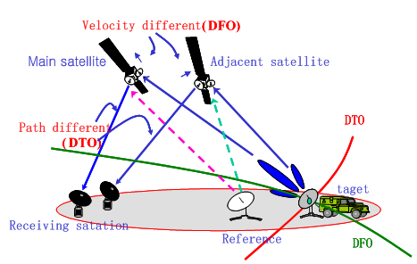

In this example, the main satellite is the satellite receiving the interference, also known as the “victim” satellite. The adjacent satellite is located near the main satellite, where its transponders can be used to measure the side lobe of the interference. A TDOA measurement yields the time difference of the interfering signal arriving at two ground-based receivers monitoring through the main satellite and the adjacent satellite. A FDOA measurement yields the frequency difference of the interfering signal which separately arrives at the two receivers through the two satellites. The intersection of TDOA and FDOA lines is typically presented in the form of an elliptical area which defines the area that the unauthorised transmitter is most likely to be.

#### 6.2.1.2 Typical geolocation system using two GSO satellites

A typical geolocation system configuration using two GSO satellites consists of two RF receiving chains, signal digitizers and geolocation application server. The RF chain may use a low noise amplifier (LNA)+down-converter or low noise block down-converter (LNB) which is shown in Fig. 7.

Figure 7

Example of a two satellite geolocation system diagram



### 6.2.2 Geolocation of transmitters on Earth using three GSO satellites

#### 6.2.2.1 Problem description

One limitation of the geolocation method using two GSO satellites is the uncertainty of the FDOA line which can fluctuate up and down especially in the case of imprecise ephemeris. This fluctuation results in poor accuracy. Using measurement data from multiple known reference stations will decrease the influence of imprecise ephemeris, however it cannot completely eliminate it.

To achieve a more accurate result, a geolocation method using three GSO satellites based on TDOA measurements has been developed. However, in reality it may be difficult to find two suitable adjacent satellites to support this method. The concept of this method is shown in Fig. 8.

Figure 8

Concept of three satellite geolocation systems using TDOA/TDOA algorithm

**Main satellite**

**Adjacent**

**satellite1**

**Receiving**

**station**

**(DTO1)**

**Reference**

**Transmitter**

**（DTO2）**

**Adjacent**

**satellite2**

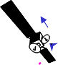

**Target**

#### 6.2.2.2 Typical geolocation system using three GSO satellites

A typical geolocation system configuration using three GSO satellites is quite similar to the geolocation system using two GSO satellites. This system consists of three RF receiving chains, signal digitizers and geolocation application server. The RF chain may use a low noise amplifier (LNA)+down-converter or low noise block down-converter (LNB), which is shown in Fig. 9.

FIGURE 9

Example of a three satellite geolocation system diagram



### 6.2.3 Geolocation of transmitters on earth using a single GSO satellite

#### 6.2.3.1 Problem description

As already outlined in §§ 6.2.1 and 6.2.2, there are commercial geolocation systems currently available from different manufacturers. The main drawback of these geolocation principles is the necessity of having at least one adjacent satellite which is close enough to have useful crosstalk energy to support the calculation.

Even though several hundred GSO satellites are in operation from the main satellite operators, some are still “isolated”, meaning the next adjacent satellite is separated by more than 10 degrees. In this case the crosstalk is very likely too small to be measurable.

In case an adjacent satellite is available, it still may not be useful for geolocation if precise ephemeris are not available. One of the main parameters which must be known by geolocation systems is the precise position and velocity of both, the main and the adjacent satellite. The quality of these parameters has a significant impact on the accuracy of geolocation systems. Further, if the adjacent satellite is under control by a different satellite operator, the ephemeris data are often not known or only with coarse accuracy, which makes any geolocation result unusable.

With the help of an orbit determination system, satellite ephemeris can be calculated. That stated, one of the preconditions for successful measurement is the availability of reference stations. At least three to four reference stations are needed to calculate the ephemeris data with sufficient accuracy. While that seems easily achievable, in reality this presents a real challenge and in many cases geolocation cannot be done because operators often do not know which reference signal is emitted from which station.

If both conditions are satisfied, the next hurdle is related to the crosstalk signal on the adjacent satellite. The crosstalk signal needs to be in the same frequency band and polarisation as the interference signal on the main (affected) satellite. Taking all three conditions into account, there are many scenarios in which a successful geolocation measurement is not possible with currently available tools and algorithms. Therefore, it would be a big advantage to have a geolocation method that used the interference signal and reference signal from a single satellite.

#### 6.2.3.2 Geolocation method using single GSO satellite and inverse Doppler shift

Section 5.1.2.8 of the ITU Handbook Spectrum Monitoring (edition 2011) already describes a possible method for geolocation of an unauthorised transmitter on earth by using a single GSO satellite. The drawback of this approach is the inherent sensitivity to frequency variations caused by the uplink station monitoring equipment hardware itself (e.g. frequency sources and phase locked loop (PLL)-based equipment affected by temperature variations, etc.) which can reach or exceed the typical range of the Doppler shift in GSO satellites.

In reality, commercial geolocation systems using this method have shown that the best achievable geolocation accuracy is greater than 100 km, and therefore it is not really useful to identify the uplink station of an unauthorised transmitter. They may work with acceptable accuracy when the interference signal is received via an inclined orbit satellite, which shows greater movements compared to regular GSO satellites, resulting in a larger Doppler shift.

#### 6.2.3.3 Geolocation method using single GSO satellite and correlation against known transmitters on Earth

This technique relies on the fact that the power of a satellite signal, which transmitted from a certain uplink station on the earth to the satellite and down to a receiving station, varies with time due to a number of factors as shown in Fig. 10:

– Movement of the satellite;

– Atmospheric and weather conditions (on the uplink and downlink side);

– Changes in power amplifier gain and antenna alignment at the uplink station.

Figure 10

Concept of a single satellite geolocation system using correlation against known transmitters

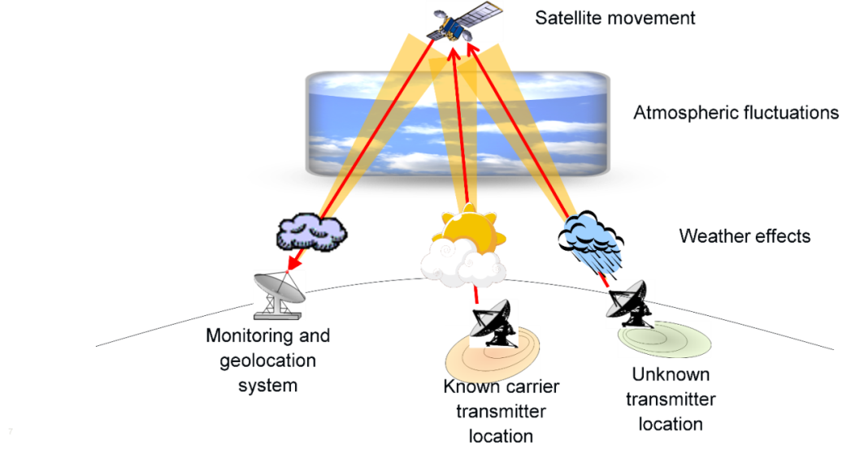

It can be assumed that signals transmitted from the same uplink station or from the same geographical area will show the same power variations during the same time frame, whereas signals transmitted from different geographical areas will show different power variations during the same timeframe.

Figure 11 shows power variations of two signals (red and blue) transmitted from the same uplink station over a period of four days. A 24-hour cyclical variation resulting from the satellite movement can be clearly identified. Figure 12 shows power variations caused by weather effects (big spikes in the data). In both cases, the power variations are almost identical since both signals are transmitted from the same uplink antenna.

|  |  |
| --- | --- |
| Figure 11  24h power variation caused by satellite movement  Spectra_24h_variation.PNG | FIGURE 12  Power variations caused by weather effects  Spectra_weather_variation.PNG |

With this method, to locate an interfering signal, the similarities between the interfering signal and other known signals must be calculated. This is usually done in the frequency domain by correlating the signals or parts of them. Therefore, the correlation algorithm is most crucial to this method in terms of geolocation accuracy, efficiency and success.

This concept is applicable where many different signals are transmitted from the same uplink station or in the same geographical area as the source of interference. All signals (including the interferer) from that area could be monitored long-term by a carrier monitoring system and measured changes to the interfering signal in power, frequency or bandwidth (e.g. caused by weather influences) could be correlated with those of the other (assumed) local transmitters. In the case of a positive correlation, it could be determined that the location of the uplink interference transmitter is identical or close to the correlating transmitter location.

The challenge in this method lies in the correlation approach and monitoring strategy, since the measurements are typically not performed at exactly the same time (for example, synchronous versus “round robin” measurements). This will significantly affect the ability to get meaningful correlation results which require more synchronous parametric measurements. For correlation of non-synchronous measurements, the effects of time delta dependent weighting, plausibility checks, ambiguity mitigation, etc. must be investigated. Furthermore, the method could be enhanced by considering factors such as information related to hardware belonging to the known transmit stations, third-party weather information, etc. For example, weather information could be used for additional ambiguity mitigation by identifying and eliminating cases which are in conflict with certain weather situations.

## 6.3 Geolocation system requirements

### 6.3.1 Satellite

For geolocation methods using more than one satellite, the main and the adjacent satellites should not be too close (causing TDOA measurement to be difficult) nor too far (causing the signal level in the adjacent satellite to be too low to be detected), and the crosstalk signal on the adjacent satellite needs to be in the same frequency band and polarisation as the interference signal on the main satellite. The ephemeris data of these satellites are indispensable for accurate geolocation. The recommended main-to-adjacent satellite angular separation is shown in Table 1.

TABLE 1

Main-to-adjacent satellite angular separation versus uplink frequency band and antenna size

|  |  |  |  |  |  |
| --- | --- | --- | --- | --- | --- |
| Antenna Size (m) | C Band 6 GHz | X band 8 GHz | Ku Band 14 GHz | Ka Band 27.5 GHz | Ka Band 31 GHz |
| 1.2 | <15° | <15° | <15° | <10° | <9° |
| 3 | <15° | <15° | <15° | <10° | <8° |
| 4.5 | <13° | <13° | <12° | <8° | <7° |
| 7.3 | <12° | <11° | <10° | <7° | <5° |
| 9 | <10° | <10° | <10° | <6° | <3° |
| 16 | <10° | <9° | <8° | <3° |  |
| 32 | <10° | <7° | <3° |  |  |

The main and adjacent satellite should not be in the same orbit, unless very accurate ephemeris is available.

### 6.3.2 Receiving station

The beam coverage of the transponders in both main satellite and adjacent satellites should cover both transmitting station and receiving station simultaneously. In addition, sufficient performance of the geolocation system, such as RF front-end, data acquisition and software is required.

### 6.3.3 Reference transmitter

A reference uplink transmitter is used to emit a reference signal at a known position (accurate latitude, longitude and altitude), and with known parameters (frequency, bandwidth, polarisation) to the main or adjacent satellites. The reference signal is usually a modulated signal but preferably a spread spectrum signal.

The reference signal can be used to eliminate the inherent errors while measuring TDOA and FDOA, such as the drift error of the local oscillator of transponder and satellite ephemeris error. If the satellite ephemeris is not accurate enough (download from Internet), it is recommended to use three to five reference signals so as to get an accurate geolocation result.

## 6.4 Techniques for geolocation of transmitter on the Earth

In order to handle difficult measurement scenarios, it is recommended to improve geolocation system performance, and techniques mentioned below.

### 6.4.1 Carrier cancellation technique

In certain cases, strong signal in the adjacent satellite may overwhelm the side lobe of interference, geolocation measurements may not be successful or the geolocation result may be wrong. Carrier cancellation technology can eliminate the influence of such strong signals in the adjacent satellite. The technology can be applied in the following manner:

– Measure and analyse parameters of the original carrier in the adjacent satellite, i.e. frequency, bandwidth, modulation type, symbol rate.

– Reconstruct a carrier similar to the original carrier.

– Subtract the original carrier from the reconstructed carrier, and then remove the original carrier from the sampling data to the largest extent.

This process can also be achieved using Vector Signal Analysis software and its ability to compute the Error Vector Magnitude time waveform by using an IQ recording of the strong signal in the adjacent channel. Load the recording into the VSA software and enter the modulation parameters of the strong signal including the modulation format, symbol rate and filter type as shown in Fig. 13. The EVM spectrum may then be used to view the interfering signal spectrum and the time domain EVM waveform used to reconstruct the signal.

Figure 13

One application using carrier cancellation technique

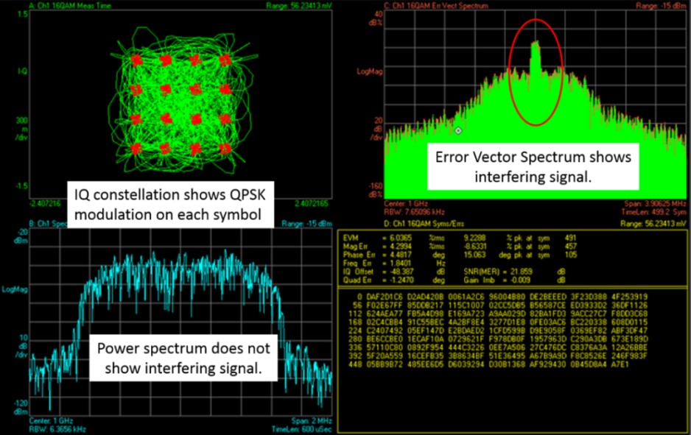

### 6.4.2 High gain processing technique

If the adjacent satellite is far from the main satellite, the crosstalk energy will be too weak to detect, which will result in a failure of geolocation. The solution to this situation is to improve the system processing gain, and therefore improve weak signal extraction ability of the system, and increase the distance between main and adjacent satellites.

This technology can be implemented by increasing the integration time and measurement bandwidth of the geolocation system.

### 6.4.3 Mobility determination technique

The TDOA line is related to the distance from the transmitter to the main satellite and the adjacent satellite. If the transmitter is moving on the ground, the TDOA line will change considerably. If the transmitter is stationary, the TDOA line only varies within a few kilometres. Therefore, the TDOA line can be used to estimate the mobility of the transmitters by observing it over a long period of time.

## 6.5 Factors affecting geolocation accuracy

The accuracy of geolocation result is highly dependent on the following aspects:

– Satellite ephemeris accuracy:

The three-dimensional position and velocity information of the satellite is regarded as a known factor in geolocation algorithms and relevant equations. The satellite ephemeris error directly affects the location accuracy and it is the main factor cause error.

– Reference location accuracy:

The reference stations play an important role in error correction of ephemeris and inherent errors, the precision of the position of reference station will affect the accuracy of the geolocation result to a large extent.

– Reference station layout:

The geographic configuration of the reference stations will also impact the error corrections needed for ephemeris and inherent errors. Typically, one of the reference stations should be close to the unauthorised transmitter, while the rest are distributed around it at wide separation distances.

– Time of geolocation:

Due to perturbation of the satellite position, it is difficult to accurately measure the slightly radial speed difference from the satellites to each uplink station, so the location accuracy will be poor during two periods each day.

– Time delay:

Since the satellite signal is transmitted through the troposphere, ionosphere, receiving channel and the equipment, variations in the time delay corrections will impact the accuracy of the geolocation result.

# 7 Identification of unauthorised transmitters

The satellite-based geolocation measurement results in an estimation of the emitter location with an area that can cover tens to hundreds of square kilometres. The mobile monitoring station(s) should be deployed to identify and locate an unauthorised transmitter inside this area. This section describes these mobile systems and approaches to identify and mitigate the interference.

## 7.1 Mobile monitoring system composition

For the purpose of identifying and locating unauthorised transmitters using mobile monitoring systems, the following portable equipment should be considered.

– Monitoring platforms:

• ground monitoring platform such as monitoring vehicle;

• aerial monitoring platform such as UAV, airship, captive balloon or aerostat.

– Portable spectrum analyser.

– Directional and omni-directional antenna.

– LNA, LNB, appropriate bandpass filters.

– Low loss RF cables.

– GPS receiver, compass.

– Data transmission device and remote control device, if data transmission is needed.

## 7.2 Ground search methods

### 7.2.1 Conventional approaches based on amplitude comparison

The conventional approach to search for ground-based transmitters start with the area determined by geolocation system, involves in signal homing and is achieved by making several POA measurements from multiple sites to gradually narrow down the area till the exact unauthorised transmitter is found. The disadvantage of this method is that the radio wave propagation path can be greatly affected by complex electromagnetic environment, and therefore additional time may be needed to find the best sites to support line of sight reception for signal homing. In addition, the complexity in identifying the location of unauthorised transmitters significantly increases with the use of higher frequency bands. This part is elaborated in § 5.4.5.3.2 of the ITU Handbook Spectrum Monitoring edition 2011. Conventional approach based on amplitude comparison is shown in Fig. 14.

Figure 14

Interferer search method based on amplitude comparison



### 7.2.2 Using cross-correlation algorithm for improving system sensitivity

A cooperative satellite-ground location method using a cross-correlation algorithm is shown in Fig. 15. The fixed antenna or vehicle-mounted receiving antenna, which both point to the satellite being interfered, is established to receive the main lobe of the interference in the downlink frequency. At the same time, the side lobe of the interference in the uplink frequency is received by a portable or vehicle-mounted directional antenna. The two signals are collected synchronously and transmitted through a wireless network for cross correlation measurements based on the cross ambiguity function. If a correlation peak is presented in the result, it means the target emitter is relatively near, and the maximum peak represents the direction of the interference source. This part is elaborated in § 5.4.5.3.3 of the ITU Handbook Spectrum Monitoring edition 2011.

FIGURE 15

Ground search using cross-correlation algorithms in a satellite-ground joining location system



### 7.3.3 Using aerial monitoring approach for quick detecting of the interference

The transmitter antenna is pointed to the satellite, while signal receiver is laid on the ground, so the side lobe signal is quite weak and hard to detect. Besides, most of the interfering emitters are in the urban area, the signal is likely to be blocked by buildings. Therefore, the ground search methods mentioned in §§ 7.3.1 and 7.3.2 are time consuming.

To address the “last mile” searching problem, satellite interferers search with UAV is proposed, which leverages the height advantage of UAV to increase visible horizon, clear obstacles or buildings, and improve the received power (the receiving antenna is close to the main lobe of interfering signal), and therefore to improve the probability to perform direction finding. The combination of geolocation result and direction finding can be an effective and practical way to approach the interferers, as shown in Fig. 16.

The geolocation result can be used as *a priori* information. The TDOA line can be held because it is quite stable and accurate. The UAV makes direction finding of the interfering signal through mechanical scanning, which yields the DF line. The intersection of the TDOA line and the DF line is the interfering emitter’s position. The payload in UAV performs direction finding through amplitude comparison by using a direction antenna.

Figure 16

Interferer search method with UAV based on TDOA line and DF line



Based on the facts that, TDOA line is accurate and in north-south direction, and larger angle between TDOA line and DF line provides higher location accuracy, the search procedure can be designed as follows:

After completing geolocation, arrive at the area given by the geolocation result, and deploy the UAV at the east or west of the TDOA line. Apply direction finding and obtain the possible position of interferer from the intersection of DF line and TDOA line. Then adjust the position of UAV to get another DF line to reduce error caused by direction finding. Then adjust the position of UAV for several times, gradually approach the real position of interfering emitter.

The search procedure is shown in Fig. 17. The ellipse area is the geolocation result which shows the area that the interfering emitter is possibly in, the green line is TDOA line held in the geolocation result, the red stars are the position of UAV, the red lines are DF lines results got from UAV, and the red point in the centre is the position of interfering emitter.

Figure 17

Interferer search procedure

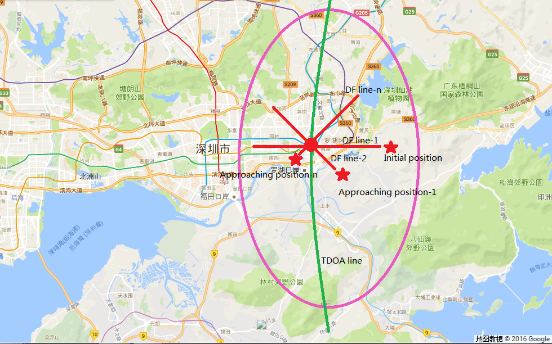

Annex 1  
  
Categories of satellite monitoring stations

When considering different monitoring scenarios, the flexible operation and deployment of various types of monitoring systems should be considered.

The fixed monitoring systems are vital for a monitoring station, especially for global beam satellite and regional beam satellite monitoring and geolocation of transmitters on earth. The non-fixed monitoring systems are requisite approaches for spot-beam satellite monitoring, direction-finding and electromagnetic environment test, as well as act as auxiliary facilities of geolocation system.

## A1.1 Fixed monitoring station

In order to meet the measurement requirement of the Radio Regulations, fixed monitoring system is essential for satellite monitoring stations. It is recommended that a fixed monitoring system should be installed in a location that complies with requirements of “clean” electromagnetic environment, so as to achieve optimal performance during satellite signal reception, as well as conducive to further measurement and analysis.

The size of the antenna determines the gain of the antenna, so it should be sufficiently large to allow for proper signal reception. Higher order modulation schemes require higher *C*/*N* ratios. In order to ensure the consistency of measurement results in a long term, the transmission loss should be checked regularly as one important work of system maintenance.

## A1.2 Transportable monitoring station

The transportable monitoring system is an auxiliary system to the fixed monitoring system. It can be carried in monitoring vehicles, or installed temporarily in wherever outside the beam coverage of the fixed monitoring system. This system is usually used to conduct satellite signal measurement along national boundaries, near harbours and around important regions during major events.

In addition, spot-beam satellites have small beam coverage (for only hundreds of kilometres), the transportable monitoring system will definitely be indispensable.

## A1.3 Mobile monitoring station

The mobile monitoring system can be installed and operated in monitoring vehicle while in motion or at fixed locations. It is used to perform spectrum monitoring, signal homing and direction-finding of interferences sources or the other transmitters of interest, as well as electromagnetic environment test in specific areas during major events.

## A1.4 Aerial monitoring station

The aerial monitoring system is an auxiliary system to the mobile monitoring system, and is used to implement spectrum monitoring and direction-finding in a fast way through the use of an UAV or an airship. The system can easily avoid undesirable propagation losses by objects on the ground, and only have to deal with propagation loss in line of sight. Nonetheless, the improper operation of UAV may cause security concerns to flying objects such as airplanes, so we strongly encourage to comply with relevant law and regulations on UAV operation.

## A1.5 Portable monitoring station

The portable monitoring system is convenient and useful in direction-finding of interference sources or transmitters of interest in the last-mile monitoring. The system is composed of at least an omni‑directional antenna, directional antenna, LNA (or LNB), and spectrum analyser.

Annex 2  
  
Formats of satellite ephemeris data

## A2.1 TLE format

The TLE is a set of two data lines listing orbital elements that describes the time, coordination, position and velocity of an Earth-orbiting object with six Kepler elements. The TLE data representation is specific to the Simplified perturbations models (SGP, SGP4, SDP4, SGP8 and SDP8), so any algorithm using a TLE as a data source should implement one of the simplified perturbation models to correctly compute the state of an object at a time of interest.

The United States Space Surveillance Network tracks all detectable objects in earth orbit, and creates a corresponding TLE for each object, and makes TLEs of non-classified objects public from a sponsored web site, which is Space Track. The TLE format is a de facto standard for distribution of an Earth-orbiting object's orbital elements.

The TLE set may include a title line proceeding the element data. The title is not required as each data line includes a unique object identifier code.

The format of TLE is as follows:

ISS (ZARYA)

1 25544U98067A 08264.51782528 -.00002182 00000-0 -11606-4 0 2927

2 25544 51.6416 247.4627 0006703 130.5360 325.0288 15.72125391563537

TABLE A2-1

Description of the TLE

| Serial No | Char No. | Description | Example |
| --- | --- | --- | --- |
| **Line 1** | | | |
| 1-1 | 1 | Line Number of Element Data | 1 |
| 1-2 | 2 | Space |  |
| 1-3 | 3~7 | Satellite Number | 25544 |
| 1-4 | 8 | Classification (U=Unclassified) | U |
| 1-5 | 9 | Space |  |
| 1-6 | 10~11 | International Designator(Last two digits of launch year) | 98 |
| 1-7 | 12~14 | International Designator (Launch number of the year) | 067 |
| 1-8 | 15~17 | International Designator (Piece of the launch) | A |
| 1-9 | 18 | Space |  |

TABLE A2-1 (*end*)

| Serial No | Char No. | Description | Example |
| --- | --- | --- | --- |
| 1-10 | 19~20 | Epoch Year (Last two digits of year) | 08 |
| 1-11 | 21~32 | Epoch (Day of the year and fractional portion of the day) | 264.51782528 |
| 1-12 | 33 | Space |  |
| 1-13 | 34~43 | First Time Derivative of the Mean Motion divided by two | −.00002182 |
| 1-14 | 44 | Space |  |
| 1-15 | 45~52 | Second Time Derivative of Mean Motion divided by six (decimal point assumed) | 00000-0 |
| 1-16 | 53 | Space |  |
| 1-17 | 54~61 | BSTAR drag term (decimal point assumed) | −11606-4 |
| 1-18 | 62 | Space |  |
| 1-19 | 63 | The number 0 (Originally this should have been “Ephemeris type”) | 0 |
| 1-20 | 64 | Space |  |
| 1-21 | 65~68 | Element set number. incremented when a new TLE is generated for this object | 292 |
| 1-22 | 69 | Checksum (Modulo 10) (Letters, blank, periods, plus signs=0,minus signs=1) | 7 |
| **Line 2** | | | |
| 2-1 | 1 | Line number | 2 |
| 2-2 | 2 | Space |  |
| 2-3 | 3~7 | Satellite number | 25544 |
| 2-4 | 8 | Space |  |
| 2-5 | 9~16 | Inclination (degrees) | 51.6416 |
| 2-6 | 17 | Space |  |
| 2-7 | 18~25 | Right Ascension of the Ascending Node (degrees) | 247.4627 |
| 2-8 | 26 | Space |  |
| 2-9 | 27~33 | Eccentricity (decimal point assumed) | 0006703 |
| 2-10 | 34 | Space |  |
| 2-11 | 35~42 | Argument of Perigee (degrees) | 130.5360 |
| 2-12 | 43 | Space |  |
| 2-13 | 44~51 | Mean Anomaly (degrees) | 325.0288 |
| 2-14 | 52 | Space |  |
| 2-15 | 53~63 | Mean Motion [Revs per day] | 15.72125391 |
| 2-16 | 64~68 | Revolution number at epoch [Revs] | 56353 |
| 2-17 | 69 | Checksum (Modulo 10) | 7 |

Annex 3  
  
Monitoring of satellite generated interference in bands allocated   
to the radio astronomy service on a primary basis

## A3.1 Introduction

The antenna to be used for post-launch interference measurements requires satellite tracking capability, gain (typically 40 dBi), and relatively low noise receivers. Since the threshold values in Recommendation ITU-R RA.769 are determined for 0 dBi side lobe entry and not for main beam entry, a monitoring system with these specifications can achieve rapid detection of interfering signals with an adequate interference‑to‑noise ratio. To avoid introducing unwanted artefacts, the receiver signal path must be highly linear.

Data acquisition is described in § A3.2. The required signal levels and thresholds are described in § A3.3. The monitoring antenna needs to be well calibrated, using strong celestial radio sources of known SPDF. This procedure is described in § A3.4. Finally, the procedure to identify RFIs is described in § A3.5.

## A3.2 Data acquisition

Measurements for the determination of data loss are made as a time series of *N* measurements with a time interval Δ*t* covering *M* frequency channels with bandwidth Δ*f*.

Data acquisition is best accomplished with a multichannel spectrum analyser, such as a digital filter bank, with hundreds to thousands of simultaneous, well-isolated frequency channels. This should provide simultaneous coverage of the full radio astronomy band. In practice, typical data rates are about one spectrum per second, though higher rates may be required in some instances, to capture the full range of interference time scales.

A typical display of observed data following calibration is shown in Fig. 18 below. In this case the Recommendation ITU-R RA.769 spectral line detrimental threshold is −238 dB(W/m2/Hz), or   
+22 dBJy (1Jy = 10−26 (W/m2/Hz)). The band in this example is not used for continuum observations.

Figure 18

Time-frequency occupancy diagram in the RAS band 1 610.6-1 613.8 MHz

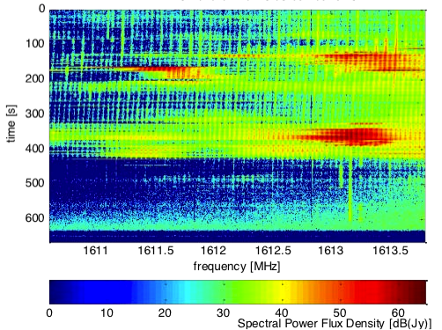

The measurement interval is 1 second and the measurement channel bandwidth is 6.1 kHz. This diagram contains *N* = 630 data records and *M* = 420 spectral channels within the Radio Astronomy Service (RAS) band.

Acknowledgement: These data have been obtained at the Satellite-Monitoring Station in Leeheim/Germany operated by the Federal Network Agency (Bundesnetzagentur) using a spectrometer of the German Max Planck Institut für Radioastronomie.

During processing the individual data records may be averaged (stacked) in order to achieve higher sensitivity. Similarly, the monitoring system may have spectral channel widths that are narrower than the reference spectral bandwidths presented in Recommendation ITU-R RA.769, which range from 10 kHz below 1 GHz to 1 MHz above 60 GHz, as long as the proper bandwidth conversion is done during the analysis to determine the interference level.

## A3.3 Signal levels and thresholds

The signals received by the monitoring station from calibration radio sources and from the satellite’s unwanted emissions are often hidden within the noise of individual short observations, but can be recognized after summing multiple observations. Because of the white noise characteristics of both the receiver system and the sky, the use of longer integrations reduces the rms noise level Δ*T* for a measurement as:

$ΔT=T_{sys} /\sqrt{(ΔtΔf)}$ (1)

where, for the purposes of equation (1), *Tsys* is the noise temperature of the system, Δ*t* is the total time over which individual observations are averaged, and Δ*f* is the bandwidth over which individual spectrometer channels are averaged.

A quantitative evaluation of the percentage data loss in RAS bands is based on the identification of interference signals in the data records that are in excess of the levels of detrimental interference listed in Recommendation ITU-R RA.769. These are based on a well-defined reference time interval of 2 000 seconds (about 33 minutes) and a well-defined reference channel width(*Δfref*) orreference continuum bandwidth (Δ*fb*).

The flux density levels *Tspec* and *Tcont* to be used during the evaluation of data loss in RAS bands are derived respectively from the narrow band *spfd* spectral line (subscript spec) values or the *spfd* values from broadband continuum (subscript cont) observations.These are adjusted to match the relevant bandwidth and duration parameters listed in Recommendation ITU-R RA.769:

*Tspec*(Δ*t,* Δ*f*) = *spfdspec*(RA.769, table 2) + 5 log ((Δ*fref* /Δ*f*) (2000/Δ*t*)) (dB(W/m2/Hz)) (2a)

*Tcont*(Δ*t*, Δ*f*) = *spfdcont*(RA.769, table 1) + 5 log ((Δ*fb* /Δ*f*) (2000/Δ*t*)) (dB(W/m2/Hz)) (2b)

where 2 000 sec is the reference time interval. For spectral line observations the value to be used for Δ*fref* equals the channel bandwidth given in Recommendation ITU-R RA.769. For continuum observations the reference bandwidth Δ*fb* is the allocated RAS bandwidth for bands up to 60 GHz, and 8 GHz for all higher frequency bands (see Recommendation ITU-R RA.769).

The threshold levels of Recommendation ITU-R RA.769 are based on signals that are 10% of the integrated noise fluctuations in the detection system using 0 dBi gain and the radio astronomy system temperatures listed in the Recommendation. These detection thresholds need to be corrected for the gain of the monitoring antenna above 0 dBi, and for the ratio of the two system temperatures (see equation (1)), as follows.

The levels for main beam entry with the monitoring antenna for an interfering signal equal to the Recommendation ITU-R RA.769 threshold levels are:

*Sspec*(Δ*t,* Δ*f*) = −(*G*+10) + [10 log (*Tsys,ref*/*Tsys*,mon)] + *Tspec*(Δ*t,* Δ*f*) (dB(W/m2/Hz)) (3a)

*Scont*(Δ*t,* Δ*f*) = −(*G*+10) + [10 log (*Tsys,ref*/*Tsys*,mon)] + *Tcont*(Δ*t,* Δ*f*) (dB(W/m2/Hz)) (3b)

The levels *Tspec*(Δ*t*, Δ*f*) and *Tcont*(Δ*t*, Δ*f*) from Recommendation ITU-R RA.769 are derived from equations (2a) and (2b), and the forward gain *G* of the monitoring antenna is expressed in dB. The terms in equations (3a) and (3b) reflect the difference between the system temperature quoted in Recommendation ITU‑R RA.769 (*Tsys,ref*) and the system temperature of the monitoring system (*Tsys*,mon).

## A3.4 Calibration of the system

The monitoring antenna measurements produce data in units of antenna temperature (*TA*).These are converted to spectral power-flux density units of spfd (dB(W/m2/Hz)) or Janskys (10−26 (W/m2/Hz)). These conversion factors must be accurately known as a function of frequency. The procedure to establish the calibration is to:

1) perform ON observations in the desired frequency band of a few strong celestial continuum sources, each with a known flux density (in Janskys), such as Centaurus A, Virgo A, or other strong calibrators; and

2) perform OFF observations for each calibrator on a nearby piece of ‘blank’ sky to determine the zero signal baseline.

The conversion factor, in Janskys/K, is obtained by dividing the source strength in Janskys, by the measured signal difference (*TA*(ON) − *TA*(OFF)). This sensitivity parameter gives the number of Janskys required to produce one Kelvin of signal at the monitoring station. Both radio source strength and detrimental levels can be given in Janskys.

## A3.5 Identification of the RFI

Average and peak interference levels inside the RAS band should lie below the continuum and spectral line levels respectively given in Recommendation ITU-R RA.769. If not, it is counted as data loss. Note that the RAS bands in this Report are labelled as spectral line only, continuum only, or both.

In the case of spectral line use, all channels of bandwidth Δ*f* located within the RAS band should be evaluated independently for the presence of interference above the spectral line detrimental threshold using equation (2a). The peak must lie below the detrimental level in every channel. In the case of continuum use, the average interference level over the entire band should be evaluated using equation (2b).

After calibration of the data records and conversion from antenna temperature (K) to flux density units, the data record for each measurement interval should be evaluated for the presence of interference that exceeds the corresponding detrimental threshold levels for spectral line or continuum (see equations (2a) and (2b)). This procedure produces a time‑frequency occupancy diagram of the measurements (waterfall plot) with dimensions of *N* records and *M* spectral channels. Figure 18 is an example of such a calibrated measurement of rapidly varying interference during the passage of a satellite.

Spread spectrum interferers emit low power levels across a large bandwidth. ON-OFF measurements of spread spectrum interference need to cover sufficient bandwidth in order to detect the spfd enhancement.

In general, the measurement time interval should be short enough to reveal time variability and intermittence characteristics of the interfering signal. However, when the interferer is persistent and using frequency variability or frequency sweeping, the use of a short time interval may leave interference signals below the detection threshold. In this case an integrated measurement with a time interval covering the period of the variability or the sweep cycle is needed.