Report ITU-R SM.2454-1
(06/2023)
SM Series: Spectrum management
Spatial assessment of radio signals in different frequency bands

Foreword
The role of the Radiocommunication Sector is to ensure the rational, equitable, efficient and economical use of the radio-frequency spectrum by all radiocommunication services, including satellite services, and carry out studies without limit of frequency range on the basis of which Recommendations are adopted.
The regulatory and policy functions of the Radiocommunication Sector are performed by World and Regional Radiocommunication Conferences and Radiocommunication Assemblies supported by Study Groups.

Policy on Intellectual Property Right (IPR)
ITU-R policy on IPR is described in the Common Patent Policy for ITU-T/ITU-R/ISO/IEC referenced in Resolution ITU-R 1. Forms to be used for the submission of patent statements and licensing declarations by patent holders are available from http://www.itu.int/ITU-R/go/patents/en where the Guidelines for Implementation of the Common Patent Policy for ITU-T/ITU-R/ISO/IEC and the ITU-R patent information database can also be found.

Series of ITU-R Reports
(Also available online at https://www.itu.int/publ/R-REP/en)
Series | Title
BO | Satellite delivery
BR | Recording for production, archival and play-out; film for television
BS | Broadcasting service (sound)
BT | Broadcasting service (television)
F | Fixed service
M | Mobile, radiodetermination, amateur and related satellite services
P | Radiowave propagation
RA | Radio astronomy
RS | Remote sensing systems
S | Fixed-satellite service
SA | Space applications and meteorology
SF | Frequency sharing and coordination between fixed-satellite and fixed service systems
SM | Spectrum management
TF | Time signals and frequency standards emissions

Note: This ITU-R Report was approved in English by the Study Group under the procedure detailed in Resolution ITU-R 1.

Electronic Publication
Geneva, 2023
© ITU 2023
All rights reserved. No part of this publication may be reproduced, by any means whatsoever, without written permission of ITU.

REPORT ITU-R SM.2454-1
Spatial assessment of radio signals in different frequency bands
(2019-2023)
TABLE OF CONTENTS
Page
Policy on Intellectual Property Right (IPR) ii
1 Introduction 1
2 Major steps in measurement and spatial analysis of emissions 2
3 Measurements for the purpose of assessing the electromagnetic and interference environment 2
4 Determining aggregate parameters from the spectrum emissions 4
4.1 Calculation of noise power 5
4.2 Calculation of peak power 5
4.3 Calculation of mean power 6
5 Constructing the spatial emission distribution diagram 6
6 Determination of emission level norms 7
6.1 Emission level norm for general monitoring purposes 7
6.2 Emission level norm for radio planning purposes 7
7 Overlay of directional level distribution and other information on a digital map 8
8 Result analysis 8
9 Examples of measurements and spatial analysis of emissions 8
Annex 1 – Example of measurements and spatial analysis of emissions from terrestrial emission sources in the frequency range of 900 MHz 8
Annex 2 – Example of measurements and analysis of emissions from aerial and space sources in the RNSS frequency band 1 559-1 610 MHz 11

1 Introduction
Radio signal receiving conditions can have an adverse effect on the quality of radio communications. Radio signal receiving conditions include background noise and emissions of spatially distributed radio stations. This Report describes a spectrum monitoring technique that records and rates the signals along with the noise level at a specific location along with the assorted spatial distribution in the frequency band of interest.

2 Major steps in measurement and spatial analysis of emissions
The method for measurement and spatial analysis of emissions involves the following major steps:
1) Acquisition and recording of spectra for analysis of emissions:
• for analysis of terrestrial sources, the azimuth plane in different directions is taken into account;
• for aerial and space sources, different directions defined by a combination of azimuths and elevations are taken into account.
2) Determination of the aggregate parameters of the recorded spectra.
3) Construction of a diagram showing the spatial distribution of emissions in relation to the measurement point.
4) Calculation of the emission level norms for each data sample.
5) Additional overlays on the geographical map.
6) Result analysis.

3 Measurements for the purpose of assessing the electromagnetic and interference environment
The measurement system used to conduct measurements in a particular frequency band should include the following instruments and accessories:
– directional measurement antenna, mounted on tripod with a rotary table;
– omnidirectional antenna;
– antenna switch;
– low noise amplifier;
– measurement receiver or spectrum analyser;
– navigation receiver;
– computer with remote control interface.
The operating band of the measuring equipment must correspond to the frequency band of the analysis. The polarization of the measuring antenna must correspond to that of the signals to be measured.
The measuring system may be mobile, stationary, portable or transportable as needed. The block schematic is shown in Fig. 1 below.
Figure 1
Block diagram of measurement equipment
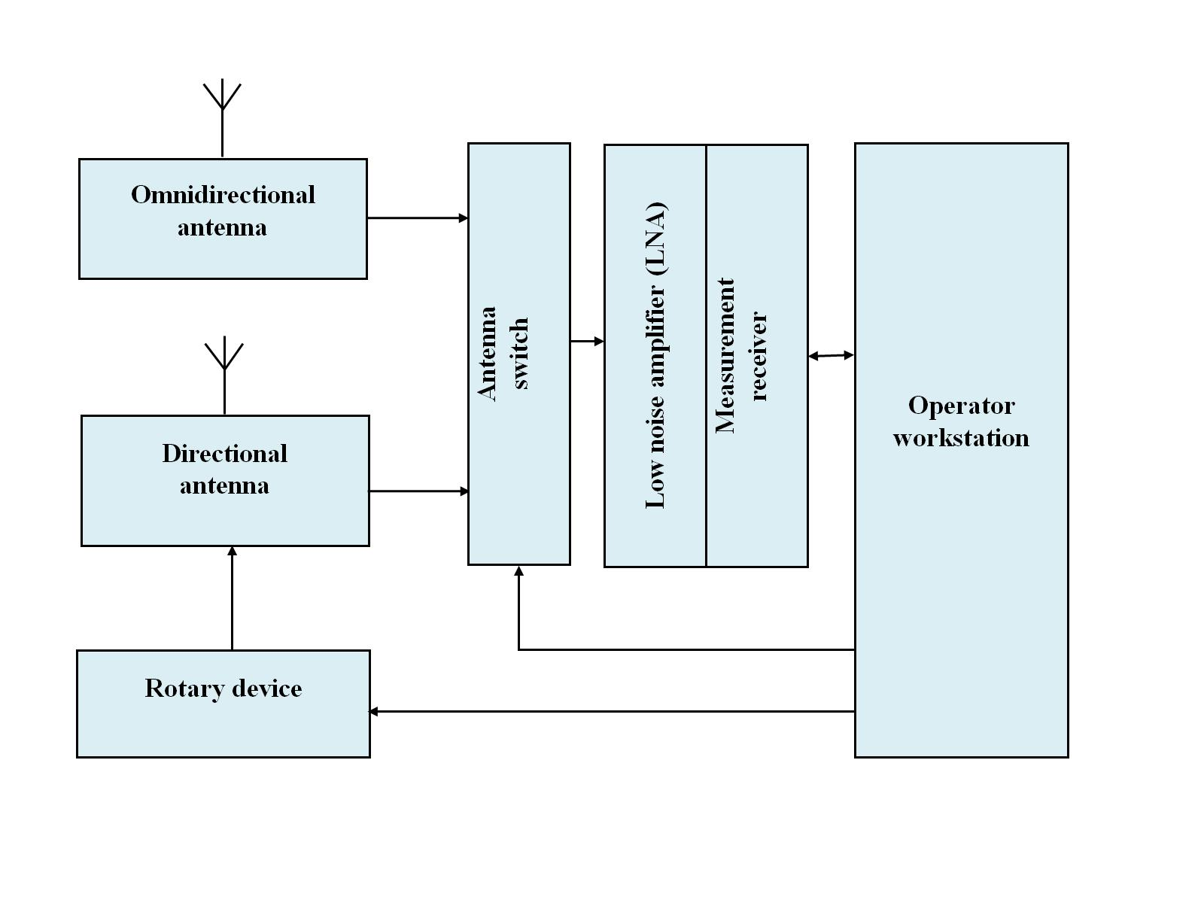
As part of the measurement process, the geographical coordinates of the measurement point, the time of measurement, antenna height, as well as the measurements antennas azimuth and elevation are recorded.
To perform the measurements, the directional antenna rotates stepwise, sweeping the surrounding area. At each step, the spectrum and antenna orientation (azimuth, elevation) in the monitored frequency band is recorded. Depending on the monitoring target, following sweep patterns can be applied:
– analysis of terrestrial sources: azimuth sweep with constant elevation;
– analysis of aerial and space sources: azimuth and elevation sweep, covering the upper hemisphere;
– complex analysis of terrestrial, aerial and space sources: Combination of both scans described above.
The scanning step size is determined by the directional antennas half-power beamwidth as well as the desired spatial resolution.
For complex emissions analysis, the data and assessments of terrestrial emission sources are separated from those of aerial and space sources by dividing the measurement results into groups based on the elevation of the measuring antenna.
Figure 2 illustrates the process of an azimuth sweep to analyse emissions from terrestrial sources.
Figure 2
Azimuth sweep
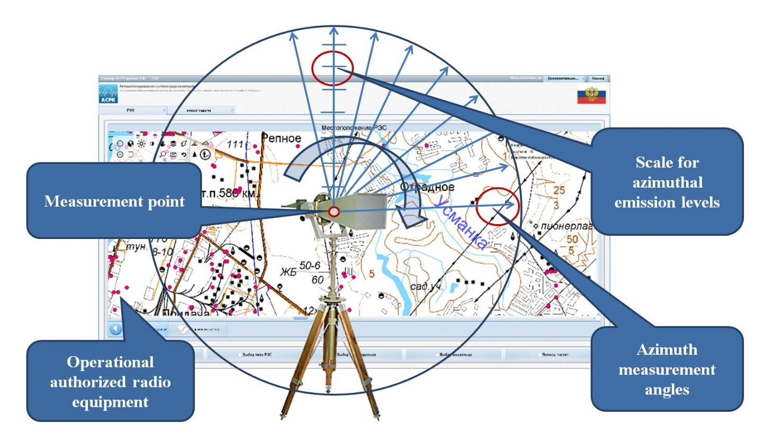

4 Determining aggregate parameters from the spectrum emissions
Aggregate emission parameters include background noise, peak level and mean level for each spectrum in the given frequency band.
Aggregate emission parameters are determined for each recorded spectrum. They are used for constructing the diagram showing the spatial distribution of emissions. An example is illustrated in Fig. 3.
Figure 3
Estimation of aggregated parameters of spectrum emissions
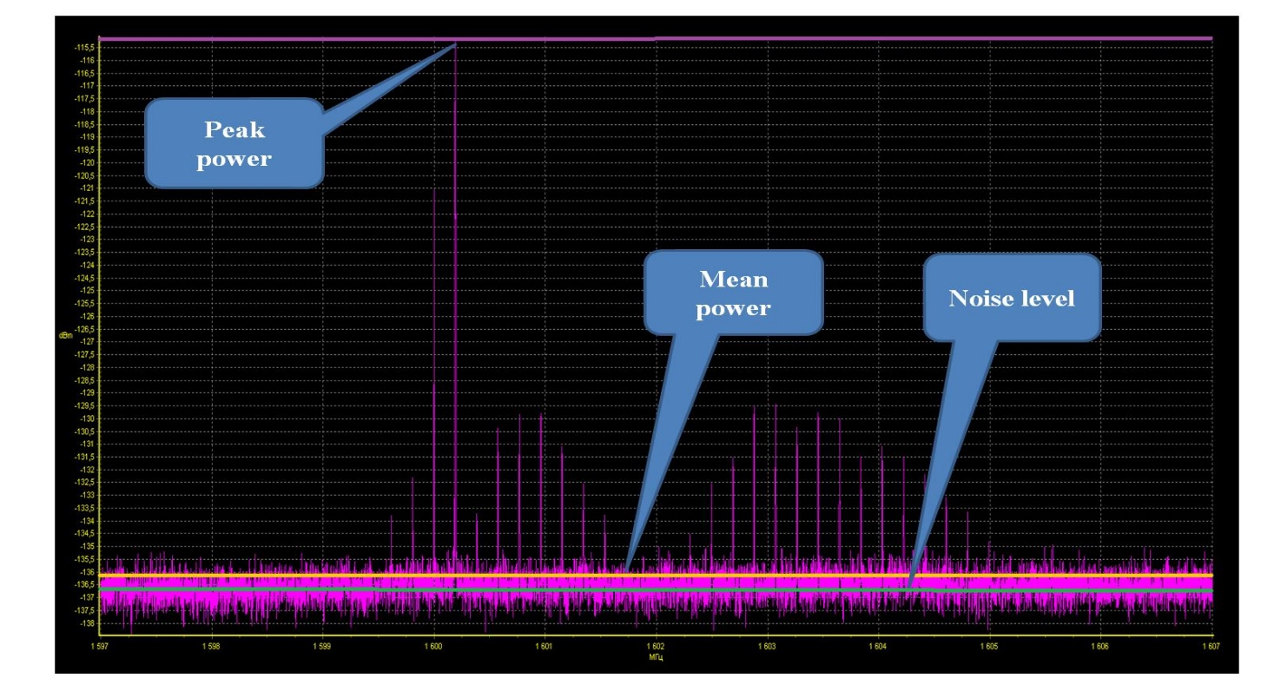

4.1 Calculation of noise power
The noise power in the whole monitored frequency band is determined for each recorded spectrum as described Recommendation ITU-R SM.1753.
For calculation, the power spectrum samples are sorted in ascending order. Next, only the first 20% of samples above the minimum power level of that recording are selected and used for calculation of average value of the noise level:
$P_{n}=10\log\left(\frac{1}{C}\sum_{i=1}^{C}{{10}^{\frac{P_{i}}{10}}}\right)$ (1)
where:
$P_{n}$: average noise power level, in dBm
C: number of elements in the first 20% of samples
$P_{i}$: value of i-th sample, in dBm.

4.2 Calculation of peak power
The peak power in the whole monitored frequency band is calculated for each recorded spectrum by taking the maximum value:
$P_{peak}=MAX\left(P_{i}\right)$, i=1,…, N (2)
where:
$P_{peak}$: peak receive power level in dBm
$P_{i}$: value of the i-th sample in dBm
$N$: total number of samples recorded.

4.3 Calculation of mean power
The mean power in the whole monitored frequency band is calculated for each recorded spectrum by averaging all power spectrum samples:
$P_{mean}=10\log\left(\frac{1}{N}\sum_{i=1}^{N}{{10}^{\frac{P_{i}}{10}}}\right)⁡$ (3)
where:
$P_{mean}$: frequency band’s mean received power level in dBm
$N$: total number of samples recorded
$P_{i}$: power of i-th measured spectrum sample, dBm.

5 Constructing the spatial emission distribution diagram
The directions of arrival of measured emissions are depicted in the form of a spatial distribution diagram.
The measurement point is the diagrams origin. Its system of coordinates has rays spaced by azimuth and elevation according to the step size to be used for the sweep with the directional antenna. The length of the directional rays is graduated according to the received level.
If emissions from aerial and space sources are the aim of the measurement, then the 2D-plot becomes a 3D-plot.
To construct the diagram, each graduated ray is marked with points to show the value of the aggregate parameters calculated for the emission spectrum acquired by the directional antenna at that azimuth and elevation. Both point types are connected with a straight, colour-coded line. This gives separate plots on the diagram for each of the aggregate emission parameters.
It is also possible to depict a specified radio signal detection threshold (colour-coded for clarity). For 2D-plots, the threshold can be shown as a circular line centred at the plot’s origin. For 3D-plots, the threshold indicator lines become a hemisphere.
Figure 4 illustrates the construction and final presentation of a 2D-plot.
Figure 4
Constructing a spatial emission distribution diagram in the azimuth plane
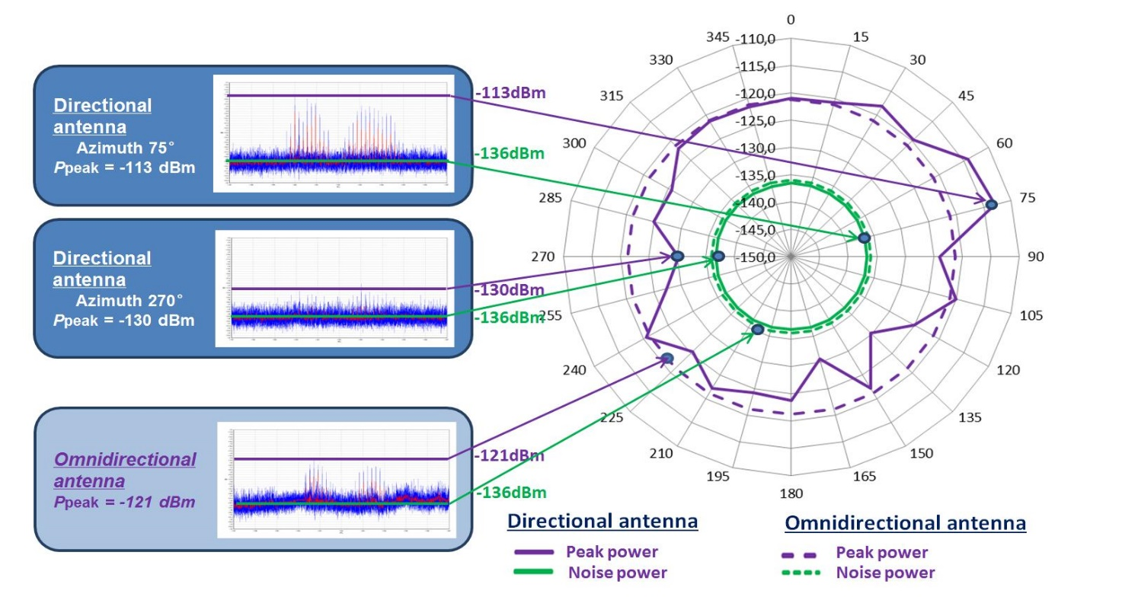

6 Determination of emission level norms
The sectors at which the directional antenna is pointed to is called the directional sector. For each of these sampling points, emission level norms are determined.
For each individual directional sector, the norm for the emissions level is determined by the emission level limit for radio facilities within the sector in the frequency band being analysed.
How the emission level norm is determined depends on the purpose of the measurements, as described in the following sections.

6.1 Emission level norm for general monitoring purposes
This option is used for a general assessment of the radio environment, including interfering signals.
The emissions level norm is calculated based on the assigned radiated power to the transmitters in the individual directional sectors. For all those stations, the received power level at the measurement point is estimated using a propagation model suited to the frequency range and signal type of interest. The maximum expected power level is considered to be the emission level norm for that specific directional sector.

6.2 Emission level norm for radio planning purposes
This option is used to check if a certain radio application could be operated interference free at the measurement location.
For this, the emission level norm is calculated as given in § 6.1 above. Additionally, the required RF protection ratio is added to the level norm.

7 Overlay of directional level distribution and other information on a digital map
To conduct a spatial analysis of emission, the diagram constructed in § 5 is overlaid on a digital map. The locations of known emission sources can be marked on the map as well, e.g. with a dot. Those locations can be connected to the measurement point by a straight line or curve, depending on the maps’ projection.
Furthermore, the radio visibility of the measuring equipment can be shown on the map. For this, the height of the measurement antenna and a representative radio station in the area has to be known.
For greater clarity, the different elements of the diagram (plots of values of the same type, identified violations and cases of interference) can be colour-coded.

8 Result analysis
The resulting diagrams provide a summary of the signals present at the measurement location in various domains.
Signals above the specified signal detection threshold can be seen easily along with their direction as well the mean and peak levels. The difference to the individual emission level norms is visualized for each direction, along with the assorted signal-to-noise ratio.
If the measured levels are not in the magnitude of the expected norm levels, then the reception conditions could be different than assumed. This mismatch could also call for a detailed investigation, even if the license conditions are met. It also could indicate the overlay of an unwanted, interfering signal, the presence of an unauthorized transmitter or otherwise simply a bad reception site.

9 Examples of measurements and spatial analysis of emissions
An example of the presented procedure for terrestrial emission sources in the frequency range of 900 MHz is described in Annex 1.
An example of complex measurements and analysis of aerial and space emissions in an RNSS frequency band is described in Annex 2.

Annex 1
Example of measurements and spatial analysis of emissions
from terrestrial emission sources in the frequency range of 900 MHz
This Annex presents an example of the technique described in the frequency range of 900 MHz. The measurement point was in an urban area with high-rise buildings.
Within the analysed bandwidth of 10 MHz, 925 authorized radio stations located on 115 sites are operated in the vicinity of the measurement point. The authorized emitter power levels of the stations are in the range of 1.5 to 20 W.
Measurement setup and parameters:
– horn antenna;
– azimuth step size 10 degrees;
– antenna height was 10 metres above ground level;
– signal detection threshold was specified as 40 dBµV/m.
The calculated zone of radio visibility for the measurement system with a standard radio station developing 3 W at 900 MHz was 6.12 km.
Figure 5 shows the measurement point (green dot) and the authorized radio stations in the vicinity of the measurement point that are assumed to be receivable according to the propagation prediction using Recommendation ITU-R P.1546-5 (red dots). The radio visibility range is shown as a black circle.
FIGURE 5
Measurement point, radio stations including angle of arrival and calculated zone of radio visibility
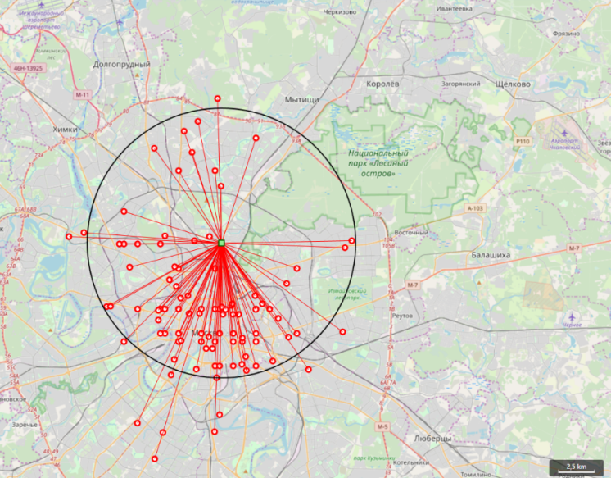
All transmitters shown in Fig. 5 are used for the calculation of the level norms for the target azimuths. The measurements are taken after those preparatory steps.
The values of the level norms by azimuth are marked on Fig. 6 as black points and overlaid with the measurement results. The green plot marks the background noise level, the yellow line the mean power levels and the purple line the peak power levels. In azimuths where no transmitter is expected, the black dot has been set to the signal detection threshold of approximately −65 dBm.
FIGURE 6
Measurement result diagram by azimuth overlaid with emission norms
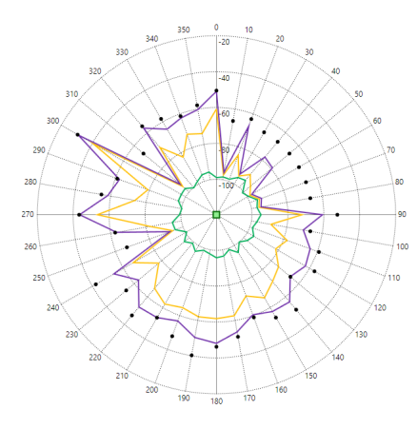
Figure 6 indicates no violation of the authorized transmitter power levels. In azimuth steps where no transmitter was expected, no signal above the signal detection threshold was recorded.
The procedure resulted in Fig. 7 on a different occasion. In this Figure, the plot in azimuth 50 degrees goes beyond the emission norm. This indicates a potential source of interference by a transmitter operated with a higher power than authorized or simply the influence of propagation conditions.
FIGURE 7
Directions to emission sources, based on measurement data (red lines)
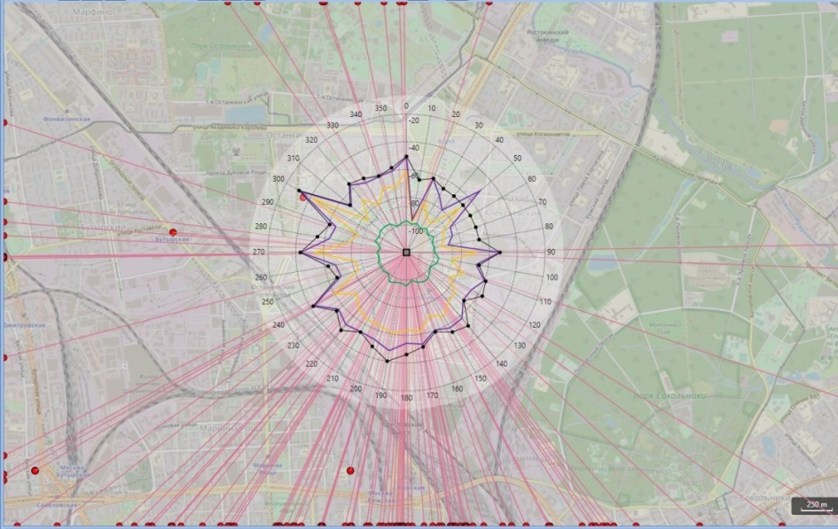

Annex 2
Example of measurements and analysis of emissions from aerial and
space sources in the RNSS frequency band 1 559-1 610 MHz
This Annex presents an example of complex measurements and spatial analysis of emissions from aerial and space sources.
The monitored service is the RNSS service GLONASS, where parts are allocated in the frequency range 1 597-1 607 MHz. During the measurement process, GLONASS satellite Cosmos-2434 (721) was tracked using its trajectory data.
The example used real-time spectrum analysers to easily monitor fast, pulsed events. A parabolic antenna with a diameter of 2 metres was used.
Figure 8 shows the trajectories of all GLONASS satellites with radio visibility during the measurements, using an azimuth/elevation coordinate system centred at the measurement point. The black points represent the start and end of the satellites radio visibility during the measurement time.
FIGURE 8
Trajectories of the GLONASS satellites during measurements
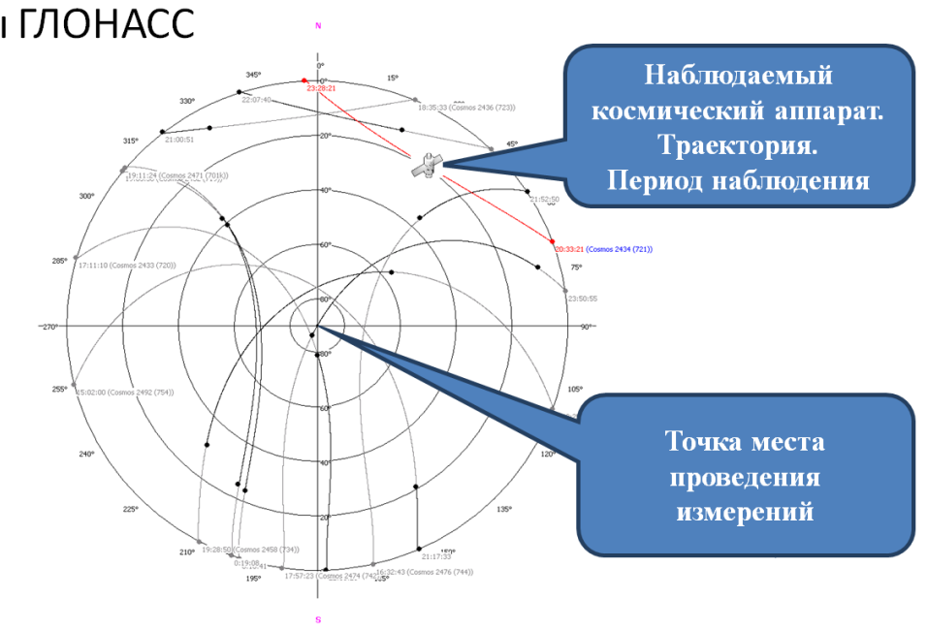

Monitored satellite: trajectory and observation period
Measurement
point
Figure 9 shows the spectra in the measurement frequency band 1 597-1 607 MHz (GLONASS L1) for three measurement azimuth angles to the GLONASS satellite. The signal from the monitored GLONASS satellite in the plotted spectra is marked with blue circle. Figure 9 also shows that spectra of possible interference signals marked with red circles at low elevation angles.
FIGURE 9
Spectra in the measurement GLONASS L1 frequency band 1 597-1 607 MHz
for three azimuth angles to the GLONASS satellite
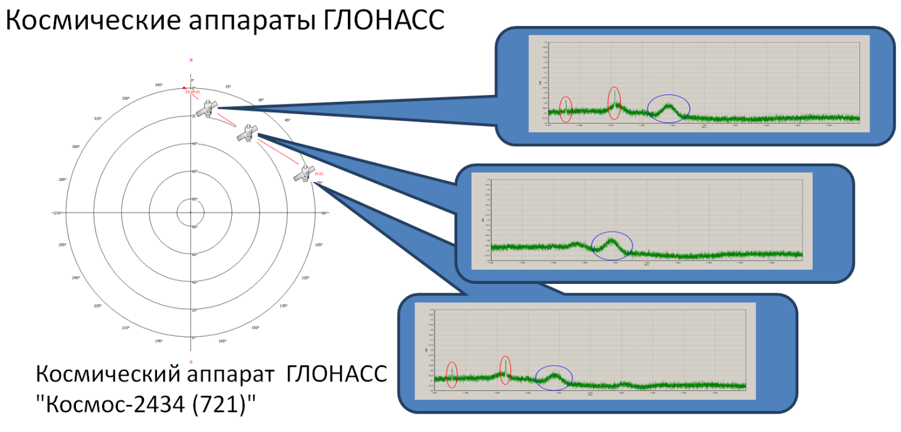
GLONASS Cosmos-2434 (721) satellite

GLONASS spacecrafts
Figure 10 sketches a combination of recorded emission values in the monitored frequency band in the direction to the monitored satellite in two coordinate systems:
– 3D hemisphere diagram centred at the measurement point. Emission levels are shown in green colour;
– 2D diagram of the emission levels in the band vs. the time during observation period where each time value corresponds to certain azimuth and elevation angle towards the monitored satellite.
The increased levels in the diagrams indicate possible sources of interference, or to an increase in the level of background noise with the parabolic antenna pointed towards horizon.
FIGURE 10
Emission mean values in the measurement frequency band 1 597-1 607 MHz (GLONASS L1)
in the direction of the GLONASS satellite
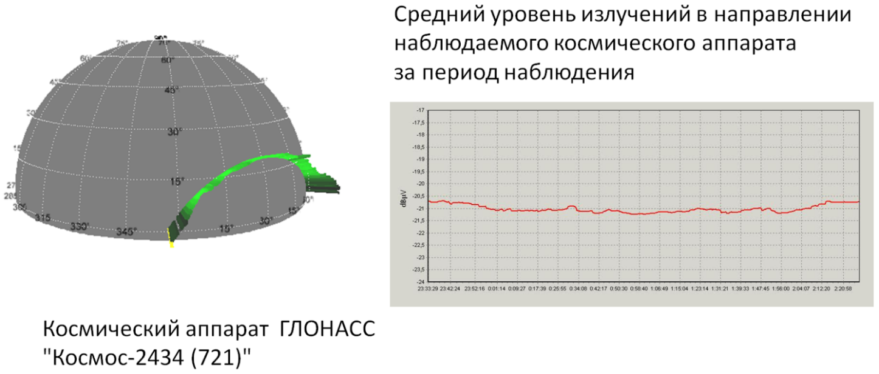
GLONASS Cosmos-2434 (721) satellite
Mean level of emission from the monitored satellite vs time during observation period
The increased emission levels in the diagrams above indicate possible sources of emissions and interference as well as possible high levels of background noise in the directions towards horizon.
Figure 11 shows two diagrams of received power levels in the monitored frequency band:
− 3D hemisphere diagram with received power levels in green colour. The hemisphere is centred at the measurement point (left hand side of Fig. 11).
− 3D diagram of azimuth and elevation, where the receive levels are colour-coded. Intense red colour indicates high levels, low intensity green colours indicate low levels (right hand side of Fig. 11).
FIGURE 11
Spatial diagrams of monitored levels at the measurement point
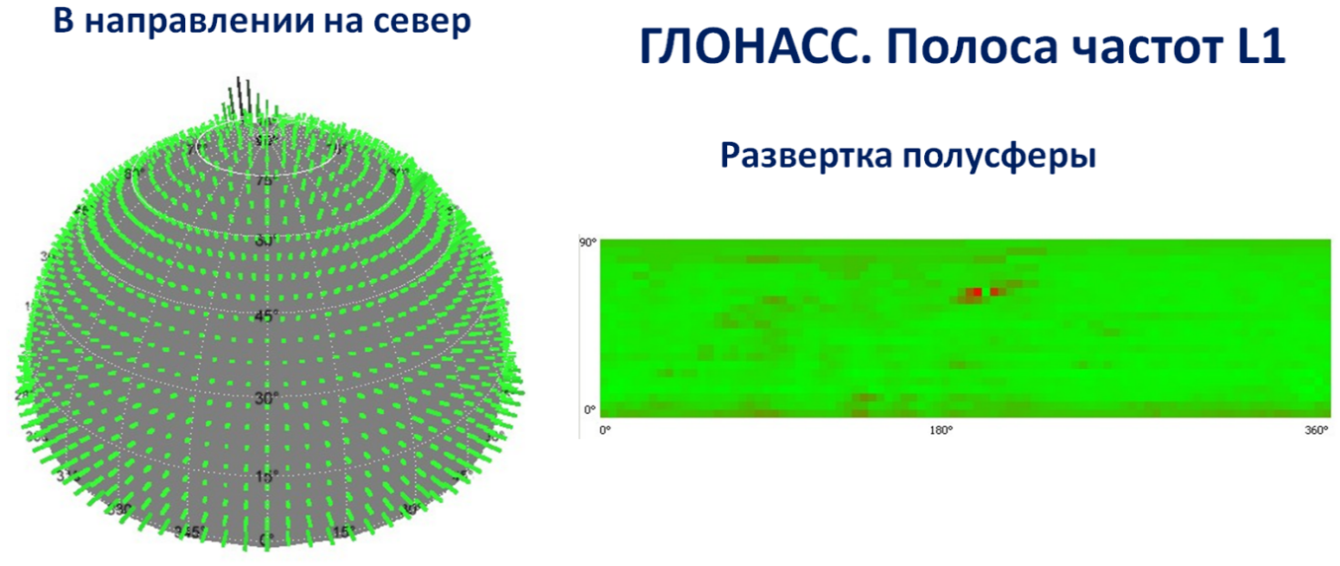
Hemisphere sweep
GLONASS L1 frequency band
Direction to North
The diagram in Fig. 11 shows high received power levels from airspace or space at certain azimuth and elevation angles during the measurement period.

