|  |
| --- |
| **Report ITU-R SM.2486-0**  **(06/2021)** |
| Use of commercial drones for ITU-R spectrum monitoring tasks |
| **SM Series**  **Spectrum management** |

Foreword

The role of the Radiocommunication Sector is to ensure the rational, equitable, efficient and economical use of the radio-frequency spectrum by all radiocommunication services, including satellite services, and carry out studies without limit of frequency range on the basis of which Recommendations are adopted.

The regulatory and policy functions of the Radiocommunication Sector are performed by World and Regional Radiocommunication Conferences and Radiocommunication Assemblies supported by Study Groups.

# Policy on Intellectual Property Right (IPR)

ITU-R policy on IPR is described in the Common Patent Policy for ITU-T/ITU-R/ISO/IEC referenced in Resolution ITU-R 1. Forms to be used for the submission of patent statements and licensing declarations by patent holders are available from <http://www.itu.int/ITU-R/go/patents/en> where the Guidelines for Implementation of the Common Patent Policy for ITU‑T/ITU‑R/ISO/IEC and the ITU-R patent information database can also be found.

|  |  |
| --- | --- |
| Series of ITU-R Reports  (Also available online at <http://www.itu.int/publ/R-REP/en>) | |
| **Series** | Title |
| **BO** | Satellite delivery |
| **BR** | Recording for production, archival and play-out; film for television |
| **BS** | Broadcasting service (sound) |
| **BT** | Broadcasting service (television) |
| **F** | Fixed service |
| **M** | Mobile, radiodetermination, amateur and related satellite services |
| **P** | Radiowave propagation |
| **RA** | Radio astronomy |
| **RS** | Remote sensing systems |
| **S** | Fixed-satellite service |
| **SA** | Space applications and meteorology |
| **SF** | Frequency sharing and coordination between fixed-satellite and fixed service systems |
| **SM** | **Spectrum management** |

|  |
| --- |
|  |

|  |
| --- |
| ***Note****: This ITU-R Report was approved in English by the Study Group under the procedure detailed in Resolution ITU-R 1.* |

*Electronic Publication*

Geneva, 2021

© ITU 2021

All rights reserved. No part of this publication may be reproduced, by any means whatsoever, without written permission of ITU.

REPORT ITU-R SM.2486-0

Use of commercial drones for ITU-R spectrum monitoring tasks

(2021)

TABLE OF CONTENTS

Page

Policy on Intellectual Property Right (IPR) ii

1 Introduction 1

2 Functional components of commercial drone-based monitoring systems 2

2.1 The drone flight system 3

2.2 Radio monitoring and measurement systems 3

2.3 Radio mission control 4

2.4 Radio mission remote control 4

3 Other considerations 4

3.1 Prerequisites to operation 4

3.2 Measurement uncertainty factors 5

3.3 Current limitations of commercial drones 6

4 Experiment and use cases 7

4.1 Radio field strength measurement: DTV broadcasting signal 7

4.2 Locating VSAT uplink satellite signal 10

5 Abbreviations 12

Summary

Commercial droneswhich are similar to legacy airborne monitoring stations can assist in regulatory spectrum monitoring and measurement procedures. Radio monitoring utilizing commercial drones can be appropriate for use in difficult situations where the traditional ground-based measurements and transmissions are unable to overcome geographical barriers or to ensure the safety of operations. The application of commercial drones in this Report is understood to be conducted within visible line of sight by ground operations and is for use within the country of the authorities operating the drone.

This Report details the common elements, considerations on the uncertainty, possible missions as well as use cases of spectrum monitoring and measurement procedures that are assisted by commercial drones.

# 1 Introduction

The International Civil Aviation Organization (ICAO) defines unmanned aircraft systems (UAS), which is commonly well known as unmanned aerial vehicle (UAV), as an aircraft and its associated elements which are operated with no pilot on board. Commercial drones fall into this general category. As such, they are able to overcome geographical limitations and provide relatively low cost of flight compared to manned aircraft. Commercial drones can perform reception or transmission at locations inaccessible by ground equipment, and at multiple locations in a short time similar to legacy manned airborne stations. Because conventional stationary or mobile radio monitoring systems carry out measurements and transmissions on the ground or at a limited height from the ground, they may experience reduced accuracy due to the site environment such as surrounding urban buildings, mountains, antennas at high elevation, and coastal areas.

Potential measurement and transmission tasks using commercial drones can include:

– radio field strength measurements;

– three-dimensional antenna pattern measurement;

– radio coverage measurements;

– inspection of radio monitoring stations on site;

– inspection of radio stations on site;

– maintenance and calibration of radio monitoring stations and equipment;

– investigating of interference;

– direction finding of a emitter source;

– technical and scientific studies.

The advantage presented by drone-based spectrum monitoring is the ability to observe the spectrum and make signal specific measurements or recordings at an elevation far above that possible with a ground-based monitoring system. The additional elevation may prove extremely beneficial in any of the applications mentioned above. Additionally, the cost of purchasing a drone platform for spectrum monitoring purposes is far below that of the most basic mobile platform.

# 2 Functional components of commercial drone-based monitoring systems

The functional components of radio monitoring and measurements using commercial drones can be described as having four parts, as shown in Fig. 1:

• the drone flight system,

• radio monitoring and measurement system,

• the radio mission control, and

• radio mission remote control.

Figure 2 shows the example of a drone-based radio monitoring station.

FIGURE 1

Functional architecture of drone-based radio monitoring and measurement station

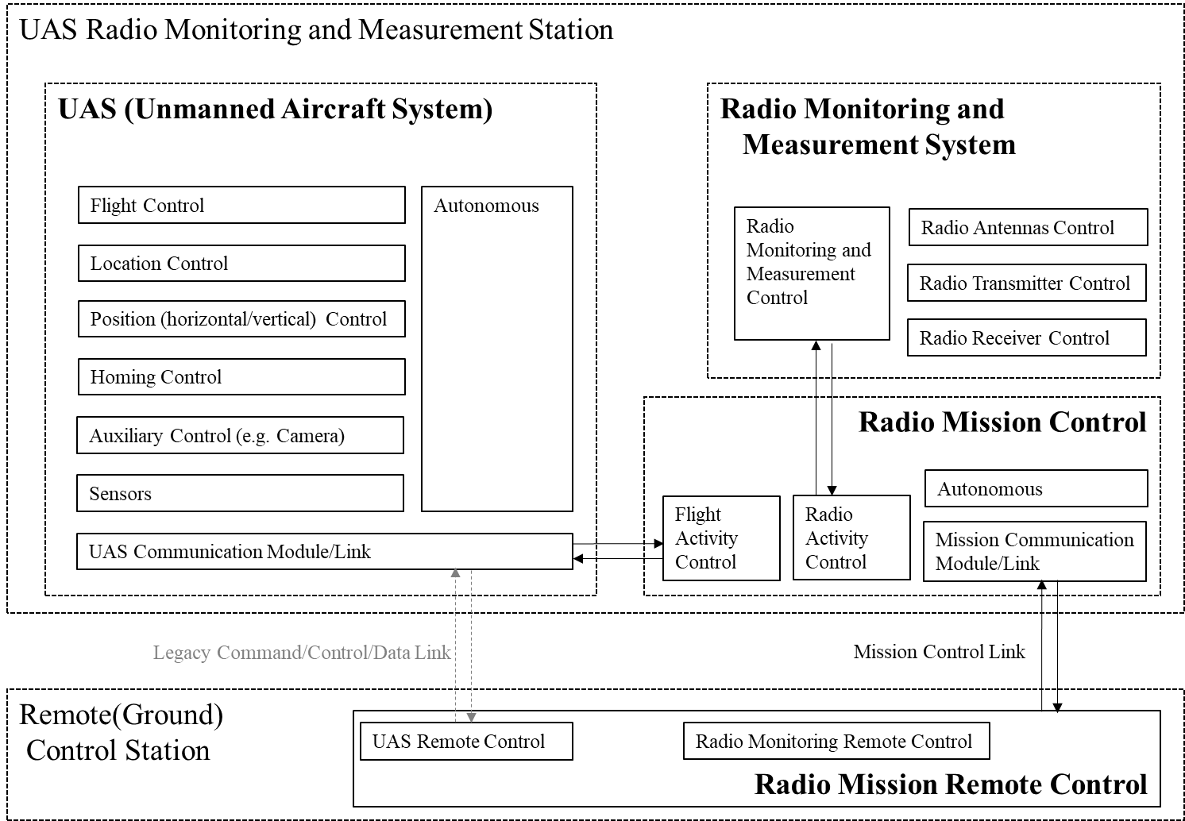

## 2.1 The drone flight system

Commercial drones have control components similar to manned aircraft, and the major functions required for radio monitoring in either autonomous or manual mode are as follows:

• flight control with/without collision avoidance;

• location and altitude control;

• horizontal and vertical position control (hovering);

• homing (origin) control.

Commercial drones are typically able to be remotely and fully controlled from a distant location, or pre-programmed to conduct its flight autonomously without intervention. The accuracy of each method of control depends on the flight performance of the drone.

## 2.2 Radio monitoring and measurement systems

The radio monitoring and measurement system can include both equipment for receiving and measuring radio waves and equipment capable of transmitting signals. It is conceptually identical to existing radio monitoring and test equipment, but the type, size and weight are limited by the drone capacity (e.g. maximum payload, power consumption, dimensions and shape). For example, the size of the antenna or antenna array that determines the frequency range is affected by the drone size, and the size and weight of the receiver, signal generator, or power amplifier is directly limited by the payload capability. In addition, the possible radio monitoring and measurement tasks depend on the precision of position control. For instance, if the drone is used to measure a near-field three‑dimensional antenna pattern, the location accuracy and precision of position-keeping control must be ensured.

## 2.3 Radio mission control

Radio mission control coordinates the drone as well as the radio monitoring and measurement system to perform one or more tasks. The radio mission control can move the drone to a precise location, perform radio measurements or transmissions, collect and transfer the results. The radio mission control has a communication link for transferring telemetry and other data to the remote (ground) control station and uses some or all the links depending on the mode of flight and the measurement tasking. Depending on the situation, the drone can use dedicated legacy communication links, and radio monitoring-related missions can be operated through the mission control link.

## 2.4 Radio mission remote control

Commercial drone radio monitoring and measurement stations can be fully controlled by the radio mission remote control during the process of radio monitoring. The radio mission remote control communicates with the radio mission control via the mission control link. The use of the link depends on the level of automation of the radio monitoring and measurement procedures and the drone flight control mode.

FIGURE 2

Example of drone-based radio monitoring and measurement system

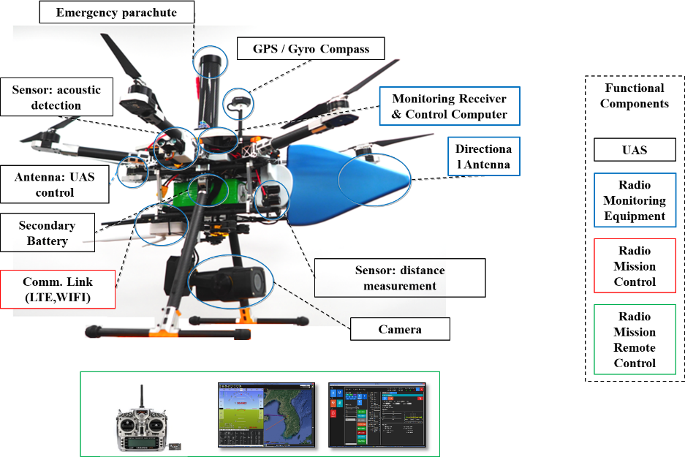

# 3 Other considerations

## 3.1 Prerequisites to operation

### 3.1.1 Size, weight and power impacts on performance

Since a relatively small drone body limits the installation space, it is necessary to select components based on their size, weight, and power consumption. They must be installed in a very space-efficient, but functional configuration that enables both flight and measurement operations. Unlike traditional radio measurement systems, RF components able to fit on a drone (antennas, receivers, and transmitters) may exhibit poor performance, and narrow operating bandwidth, or range characteristics. Therefore, when deploying a monitoring system on a drone, it is recommended to measure, calibrate, and verify the overall system performance with all monitoring equipment installed.

### 3.1.2 Antenna patterns

Commercial drones use a relatively small amount of metal to make it light, but there are many structures around the antenna that may interfere with signal reception. Landing legs, propellers as well as their arms, and mounts for attachment of peripheral equipment such as cameras, may interfere with signal reception from certain directions. The pattern of an antenna mounted on a UAV will affect the measurement results. During flight, while the UAV is in continuous motion, some systems may use a laser reflector to obtain accurate three-dimensional position data to point the antenna in the correct direction. To make accurate antenna pattern of UAV, the pattern is typically measured in an anechoic chamber. During the chamber measurements, all the equipment needed for the operation should be mounted (such as laser reflector) to accurately determine the pattern.

### 3.1.3 Noise floor

Commercial drones have a number of radio frequency devices on board for:

• legacy remote control and data transmission,

• communication links for the radio monitoring mission, and

• components that can be sources of EMI, such as electric motors and power supplies.

Therefore, noise levels may be abnormally high in certain frequency bands. Some of these may need to be turned off to create a better measurement environment.

### 3.1.4 Safety and protection features

Commercial drones travel through the air like any aircraft, so the operator must ensure the safety of other airspace users and the safety of persons and property on the ground. In addition, a drone equipped with a radio monitoring system is an expensive asset for an agency but can be prone to crashing and the subsequent costly repairs. Therefore, it may be necessary to install an acoustic detection sensor capable of detecting and avoiding a collision during a flight, a parachute in case of an emergency drop, a backup communication link, and a backup location tracking system.

### 3.1.5 Local flight regulations

Because there are national regulations limiting flight regions, time of day, flight controls for each type of drone, it is necessary to contact the appropriate national regulatory authority in advance.

## 3.2 Measurement uncertainty factors

Since drones are not firmly attached to the ground, it is trying to keep at a target position using various sensors and algorithms. Therefore, any volatility or sudden movement during the signal acquisition time can result in measurement uncertainty, and variation of the results. For example, if a measurement is performed at the same location and a different time, the measurement results for a single tone signal may be different. While drones are controlled to maintain the same position, in actual measurements it can be assumed that volatility in the operating environment will impact the measurement.

The main sources of uncertainty that contribute to measurement volatility include the following.

### 3.2.1 Flight control by single operator

When the drone is remotely controlled by an operator, flying to the target coordinates and performing measurements or transmissions at the same time is a very difficult task. If the position of the drone is suddenly changed due to weather conditions, wind, or inaccurate position readings, it is almost impossible for a single operator to visually confirm and maintain the fixed position.

### 3.2.2 Location control by global navigation satellite system (GNSS)

Drones typically use GNSS for navigation, including GPS, GLONASS, Galileo, Beidou, and uses an inertial navigation system (INS) for short-term accuracy. These signals are also susceptible to interference or jamming and can suddenly weaken or disappear in some environments during drone flight. The performance of GNSS reception can be degraded by EMI from various peripherals of the drone itself, and by weather conditions such as strong winds or thick clouds. This can cause unstable hovering, which is a problem for measurement or transmission accuracy. Multiple GNSS receivers or multi-frequency receivers, EMI enhancements, etc. can be used to improve reception performance of the navigation signals and therefore, the stability of the drone platform.

GPS has horizontal plane errors of metres under normal conditions, and vertical plane errors are 1~2 times that of the horizontal. In order to increase the position accuracy, real-time kinematic (RTK) GPS technology like that used in surveying etc. can be used, and as a result, position error range of several centimetres can be obtained.

### 3.2.3 Horizontal and vertical position control (hovering) and homing

Drones remain at the target position with high accuracy but can still be tilted and rotated, which can cause large errors in near field measurements.

### 3.2.4 Measurement and transmission antenna characteristics

Drones can be equipped with directional, omnidirectional antennas, or antenna arrays depending on the mission. Even if an antenna with a known radiation pattern is installed, it is necessary to check the radiation pattern in the mounted condition considering the influence with the drone body or peripheral devices. The altitude and attitude/tilt of the drone can also be changed during measurement or transmission, so it may be necessary to measure the 3D antenna pattern of the target frequency band. When using a directional antenna, the drone homing status and antenna pattern have a bigger effect on the measurement results. In general, it is more important to know the antenna pattern in near-field missions, where calibration becomes more important in the case of source reconstruction using near-field measurements and converting them to far-field measurements.

### 3.2.5 Influence of wind

Even if the location accuracy is improved using RTK or the like, wind can constantly disturb the drone to suddenly move from its position. Most of the recreational drones sold in the real world do not guarantee safe or stable operation in windy environments, and there have been many accidents reported due to wind in wireless monitoring tests using drones. In order to have a successful monitoring mission, it may be necessary to monitor, and record the speed of wind on every flight, or every measurement. This may help to better understand measurement results.

## 3.3 Current limitations of commercial drones

Despite its many advantages, the drones have many of the limitations of conventional aircraft.

### 3.3.1 Location positioning, homing

There are limits to controlling attitudes where exist both/either the inaccuracy of the sensors’ detection and/or atmospheric flow. For example, the drone may not be reporting the direction of the actual origin at the same moment the motion sensor of the drone detects the pointing to the origin. If the drone is used without additional compensation for rotation and tilt, such as laser equipment, the measurement angle can easily vary by several degrees resulting in measurement error.

### 3.3.2 Dependency on weather condition

Mission planning relies on weather forecasts but is a factor that must be verified in-situ and is the biggest influence on drone activities. High or low temperatures can also have an adverse effect on batteries, sensors, motors and radio monitoring equipment. Drones are also difficult to operate in high humidity, on foggy, rainy, or snowy days, and their use can be limited by local climate in the measurement area. In addition, high winds make drones difficult to fly, and can adversely affect the measurement results.

### 3.3.3 Short operating time

With limited power supplies, drone flight times are typically less than a few tens of minutes in duration, and spare batteries and charging stations are required for repeated use.

### 3.3.4 Size, weight, and power

Commercial drones, which can be easily purchased, are relatively small and lightweight, so there is a great limitation on the payload weight including power supply, mountable peripherals, antennas, and radio monitoring receivers.

### 3.3.5 Risk of accident

The systems have many constraints, and present certain risks of accident. Drones, when in flight, always present risk of accident that can include injury to people, damage to property, and damage to on-board systems during operation.

### 3.3.6 Cost and regulations

Since there are many limitations in the operating environment and method, and the risk of accidents, it is necessary to evaluate the cost effectiveness when using drone-based spectrum monitoring for special purposes.

# 4 Experiment and use cases

## 4.1 Radio field strength measurement: DTV broadcasting signal

This subsection describes the measurement of radio signals for terrestrial broadcasting from a UAV platform and compares the results with measurements made with a traditional fixed monitoring system.

Figure 3 shows the UAV remote radio monitoring system.

FIGURE 3

UAV remote radio monitoring system

|  |  |
| --- | --- |
| Radio monitoring scope using a UAV | Radio monitoring system using a UAV |
|  |  |

### 4.1.1 Technical considerations

Handheld three-axis gimbals are used in stabilization systems designed to give the camera operator the independence of handheld shooting without camera vibration or shake in order to remove measurement errors due to blurring while flying.

Consideration should be given to visual cognition technology for correct landing position. The programmed landing point of the UAV may have a three-metre variance. To overcome this potential offset, the UAV should be visually monitored during the landing process.

In case of measurements in the HF band, the potential radio noise caused by the UAV motors should be documented and measured.

Operators must consider the size, weight, payload, and operating time of the UAV since measurement equipment will be carried on the UAV.

Factors to consider in the selection of the monitoring equipment for use with the UAV should include the size, weight, power supply, and performance.

When selecting a control computer, relevant specifications (OS, CPU, memory size, etc.) are needed dependent on requirements of the monitoring equipment.

The monitoring equipment is controlled by the remote controller’s ten available communication channels. Five of the channels are used for controlling the UAV and the remaining five channels are for controlling the computer programme and operation of the on-board equipment.

FIGURE 4

Block diagram of radio monitoring system using a UAV

|  |  |
| --- | --- |
| Channel plan of controlling a UAV | Radio monitoring system architecture for control computer |
|  |  |

### 4.1.2 Experiment of DTV terrestrial broadcasting signal measurement by UAV

The comparison of measurement results for DTV broadcasting is described between fixed radio monitoring and drone remote radio monitoring.

FIGURE 5

Radio monitoring DTV transmission station

|  |  |
| --- | --- |
| Fixed radio monitoring | Drone remote radio monitoring |
| EMB000049145ac9 | EMB000049145aca |

For DTV broadcasting signals, the antenna height for measurement is 9 metres above the ground. The existing method (fixed radio monitoring) requires installation of an antenna mast to the vehicle and takes more time, and more budget for measurements and results in a limited number of measurement sites. However, if a drone is used in the monitoring process, it could monitor at a height of 9 metres with stable position and monitor from locations hard for vehicles to access.

Measurements were taken using both methods on five DTV channels transmitting from Mt. Moak in Jeonju City. The comparison of results between the two methods ranges from 1 to 2 dB, which is negligible since it corresponds to the measurement error that occurs in the existing method. The left side of Fig. 6 shows the measurement spectrum from the fixed radio wave measurement method using the antenna mast, and the right side shows the remote radio measurement spectrum using drones. Table 1 shows the measurement results of all broadcast channels transmitted from Mt. Moak. This Report shows the feasibility of using a drone as a remote radio monitoring system, since the measurement result of the conventional fixed radio monitoring using the antenna mast is comparable to the result using UAVs.

FIGURE 6

Spectrum monitoring result of DTV terrestrial broadcasting station

|  |  |
| --- | --- |
| Using fixed spectrum monitoring system | Using drone spectrum monitoring system |
| EMB000049145acb | EMB000049145acc |

TABLE 1

Spectrum monitoring details of DTV terrestrial broadcasting station

|  |  |  |  |  |
| --- | --- | --- | --- | --- |
| DTV Ch. (Mt. Moak) | Frequency | Fixed station | Using drone | Difference |
| 27 | 551 MHz | −46 dBm | −48 dBm | 2 dB |
| 33 | 587 MHz | −51 dBm | −49 dBm | 2 dB |
| 41 | 635 MHz | −48 dBm | −49 dBm | 1 dB |
| 44 | 653 MHz | −48 dBm | −47 dBm | 1 dB |
| 46 | 665 MHz | −47 dBm | −46 dBm | 1d B |

## 4.2 Locating VSAT uplink satellite signal

### 4.2.1 Introduction

This section provides an example of using UAV platform to detect and locate VSAT uplink satellite signal.

### 4.2.2 System information

#### 4.2.2.1 UAV

The UAV platform includes 6 Rotors copter and support vertical take-off and landing. It is equipped with high definition (HD) camera and two payloads covering the frequency band 2-40 GHz. Figure 7 shows the components of the UAV.

FIGURE 7

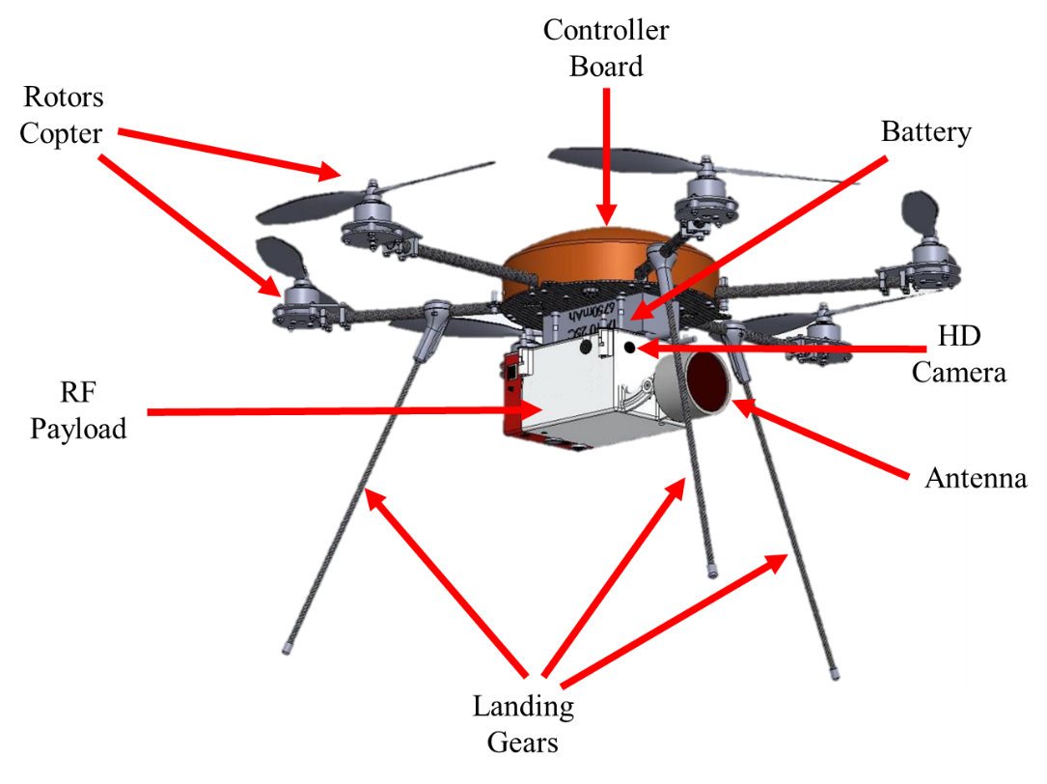

The ground station of the UAV includes Gamepad, laptop, telemetry module and anemometer.

#### 4.2.2.2 Radio monitoring system (RF payload)

The UAV platform can monitor the frequency band from 2 to 40 GHz using two payloads as mentioned below:

| Parameters | L, C, X, Ku bands payload | Ka band payload |
| --- | --- | --- |
| Frequency band | 2-18 GHz receive antenna | 18-40 GHz receive antenna |
| Polarization | LCHP and RCHP | LCHP and RCHP |

The communication between the ground station and UAV is done via wireless link in the 2.4 GHz frequency band.

#### 4.2.2.3 Control and operations

The UAV supports two modes of operation: manual and automatic. It can be manually controlled via Gamepad by an operator to fly in any desired direction. Alternatively, the flight route can be decided and programmed ahead of flight via using the software to load a flight plan into the UAV. For the sake of safety, UAV is equipped with safety landing feature to home position in case of battery drainage.

### 4.2.3 Measurements and results

To carry out such measurement, consideration needs to be taken before performing the mission in a specified large area, such as identifying the measurement location and flying points to locate the target antenna, besides the direction of the suspected target location.

Figure 8 shows the measurement results of UAV mission. During the mission, the UAV measured the target frequency from two measurement points and at different specified degrees. With the use of power threshold metre, the result of the measurements can be filtered on the map to view only the direction with high power received (left-side picture). The UAV system can then provide an optimized result that shows the best direction of measurement calculated based on all received power from all directions. The intersection of optimized results circled in yellow from two measurement flying points shows the location of VSAT transmitter (right-side picture).

FIGURE 8

UAV measurement results and analysis

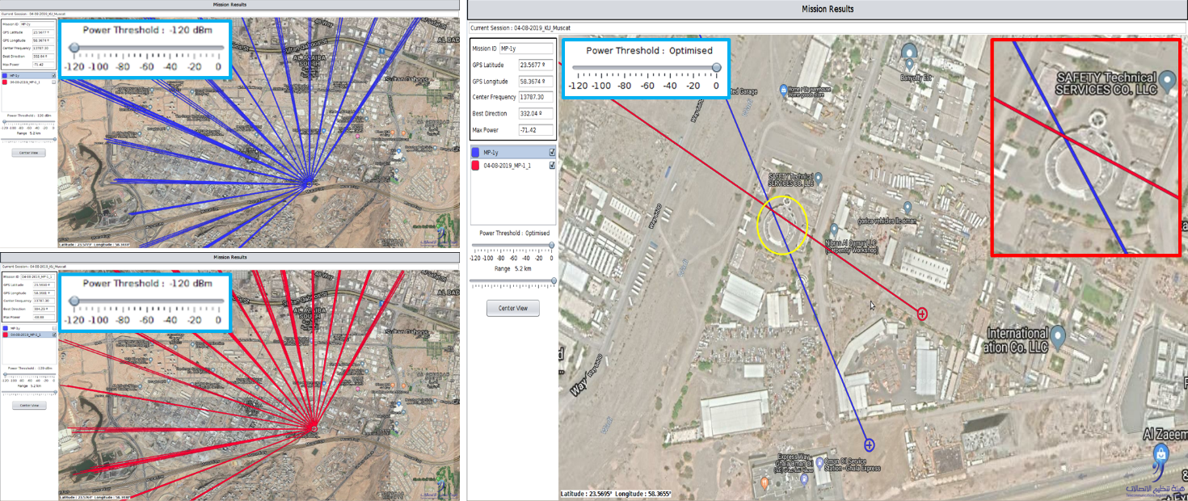

Based on the above measurement, the UAV built-in camera helps in identifying any antenna placed on high altitude, where photos are taken in each degree to check if there is an antenna that can be seen in the direction of maximum received power. Figure 9 shows the captured photo of VSAT transmitter.

FIGURE 9

UAV camera photos

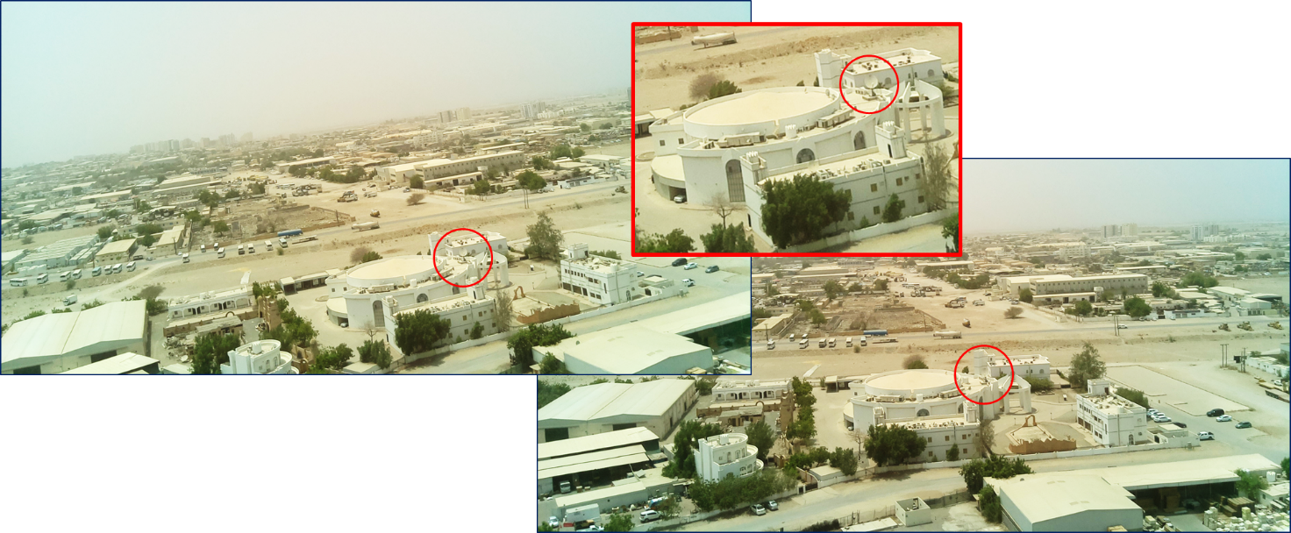

# 5 Acronyms

3D Three-dimensional

DTV Digital television

EMI Electromagnetic interference

GNSS Global navigation satellite system

GPS Global positioning system

ICAO International Civil Aviation Organization

INS Inertial navigation system

RTK Real-time kinematic

UAS Unmanned aircraft system

UAV Unmanned aerial vehicle

VSAT Very small aperture terminal