Report ITU-R SM.2504-0
(07/2022)
Methods for the estimation of coverage
for terrestrial radio services
based on population

SM Series
Spectrum management

Foreword
The role of the Radiocommunication Sector is to ensure the rational, equitable, efficient and economical use of the radio-frequency spectrum by all radiocommunication services, including satellite services, and carry out studies without limit of frequency range on the basis of which Recommendations are adopted.
The regulatory and policy functions of the Radiocommunication Sector are performed by World and Regional Radiocommunication Conferences and Radiocommunication Assemblies supported by Study Groups.

Policy on Intellectual Property Right (IPR)
ITU-R policy on IPR is described in the Common Patent Policy for ITU-T/ITU-R/ISO/IEC referenced in Resolution ITU-R 1. Forms to be used for the submission of patent statements and licensing declarations by patent holders are available from http://www.itu.int/ITU-R/go/patents/en where the Guidelines for Implementation of the Common Patent Policy for ITU-T/ITU-R/ISO/IEC and the ITU-R patent information database can also be found.

Series of ITU-R Reports
(Also available online at http://www.itu.int/publ/R-REP/en)
Series | Title
BO | Satellite delivery
BR | Recording for production, archival and play-out; film for television
BS | Broadcasting service (sound)
BT | Broadcasting service (television)
F | Fixed service
M | Mobile, radiodetermination, amateur and related satellite services
P | Radiowave propagation
RA | Radio astronomy
RS | Remote sensing systems
S | Fixed-satellite service
SA | Space applications and meteorology
SF | Frequency sharing and coordination between fixed-satellite and fixed service systems
SM | Spectrum management

Note: This ITU-R Report was approved in English by the Study Group under the procedure detailed in Resolution ITU-R 1.

Electronic Publication
Geneva, 2022
© ITU 2022
All rights reserved. No part of this publication may be reproduced, by any means whatsoever, without written permission of ITU.

REPORT ITU-R SM.2504-0
Methods for the estimation of coverage for terrestrial radio services
based on population
(2022)
Summary
One of the primary responsibilities of radio service operators is to provide quality service to the population within a certain territory. In some countries, a condition for obtaining an operator’s licence is to provide a predefined minimum coverage, which may include a certain percentage of the population.
This Report describes methods and techniques for the estimation of population coverage as applied to terrestrial radio services.

1 Scope
One objective when planning the topology of a terrestrial radio service is to cover the largest possible territory. Radio operators make efforts to cover the maximum number of people with the respective services. There are several reasons why it is beneficial to estimate population coverage of a radio service. For example:
– it provides a national regulatory authority (NRA) with independent and reliable information on population coverage of different radio technologies in the country;
– such information is often made available by the NRA to consumers and government organizations.
Different countries apply different policies to verify coverage, and for that reason it would be difficult to harmonise one approach across all the countries. In some cases, coverage requirements are included in the rights of use (or licence conditions) for the radio network operators, but not population coverage. Further, there is no harmonisation for the estimation of coverage based on both area and population. Different countries use different coverage requirements and criteria.
NRAs, telecommunication network operators (TNOs) and research agencies often use different approaches and methods for estimating population coverage, and measurement results can be different based on the approach, making comparison of the measurements results impractical.
Generally, two types of coverage criteria are used:
– Area coverage: the operator needs to cover a percentage of the territory,
– Population coverage: the operator needs to cover a percentage of the population.
These methods and procedures may be applied broadly to the estimation of population coverage for many types of terrestrial radio networks.

2 Terms, definitions and abbreviations
Coverage area (of a terrestrial transmitting station) is the area associated with a given service and a specified frequency within which, under specified technical conditions, radiocommunications may be established with one or several receiving stations [1].
Service area is the area within which a mobile station can access the radio service. A service area may contain several networks. One service area may consist of one country, be a part of a country, or comprised of several countries [1].
In some cases, the term ‘geographic coverage’ instead of the term ‘area coverage’ is used. The geographic coverage is defined as the percentage of the territorial area where the service is available.
The term ‘population coverage’ is defined as the percentage of the population to which the service is available.
The term ‘covered population’ is defined in the context of a specific terrestrial radio service and network as follows:
“The ‘covered population’ is the number of ‘objects’ located in the covered area which have availability to use the service provided by a terrestrial radio network”. The definition of the term ‘object’ is addressed in § 3 of this Report.
Abbreviations
DPSA Digital preferred service area
DTBN Digital terrestrial broadcasting network
DVB-T Digital video broadcast – terrestrial
DVB-T2 Digital video broadcasting – second generation terrestrial
EU European Union
NRA National Regulatory Authority
NUTS Nomenclature of territorial units for statistics (Nomenclature des unités territoriales statistiques (fr.))
QoS Quality of service
RF Radio frequencies
TNO Telecommunication network operator

3 Objects and metrics of population coverage estimation
Estimation of population coverage must be performed with the understanding that classification of the population based on different radio technologies varies from country to country. Classes of population used in the estimation of population coverage are referred to as ‘objects’, and are described below:
– inhabitants
– householders
– homes
– users
– subscribers.
The population coverage measurement can be performed with the following service characteristics:
– RF properties
– Quality of Service (QoS).
RF properties typically relate to the received signal power at a specific measurement location. In most cases, the received signal power determines the coverage area. However, QoS determines the service area.
Quantitatively, the population coverage within a test area can be estimated using the following parameters:
– total number of objects, $N_{cov.}$, registered in the test area with radio services
– total number of objects within the test area, $N_{tot.}$
– coverage parameter, $C_{\%}$, the percentage of objects within the covered area.
The parameter $C_{\%}$ is calculated by dividing $N_{cov.}$ by $N_{tot.}$ within the test area:
$C_{\%}=\frac{N_{cov.}}{N_{tot.}}∙100\%$ (1)
In practice, it is a very complicated problem to estimate the number of objects in large territories. In these cases, the population coverage, $C_{\%}$, can be calculated with equation (2):
$C_{\%}=\frac{DP⋅S_{cov.}}{N_{tot.}}⋅100\%$ (2)
where:
DP : population density (density of objects) in the territory $S_{tot.}$
$S_{cov.}$ : coverage area within the territory $S_{tot.}$.
To define the parameter DP, population density data is needed. Fortunately, this information is generally available from national authorities.
The methods to estimate the coverage area for rural and urban (or suburban) territories are different. For example, one new methodology was developed to classify land types across Europe. An area with households representing a population less than one hundred contained in one square kilometre is classified as ‘rural’. The use of these different classifications will produce different results.

4 Background

4.1 Different approaches
Approaches to estimation of population coverage are very different in different countries. The main differences lie in the application of:
– radio technologies
– objects
– parameters and metrics.
Different approaches are also needed considering the size of the coverage area of different services (based on the radius of coverage from a single transmitter). For example, a broadcasting network may transmit over 100 km, while broadband networks may transmit less than a few kilometres. Different measurement parameters or class of objects may be needed to determine coverage calling for a different approach.
In any case, two considerations are essential to the process of measuring, estimating and reporting on population coverage:
– radio service performance metrics
– presentation of population coverage.
Population coverage estimations should always be performed by an experienced research team using the most current available data.

4.2 Global and local basis
Population coverage can be estimated using two different bases:
– global basis
– local basis.
Global basis assesses the penetration of certain radio technologies into the infrastructure of the entire world (or a specific country) and identifies the territories not yet covered.
The estimation of population coverage on a global basis is used to determine:
– the population coverage per technology (technological population coverage)
– the population coverage in a certain region (regional population coverage).
In most cases, estimations of global technological and regional population coverage are based on surveys of operators and the appropriate NRA.
For example, in the EU and the UK, the NUTS classification (Nomenclature of territorial units for statistics) was established as a hierarchical system for dividing up the economic territory for the purpose of:
– collection, development and harmonisation of European regional statistics,
– socio-economic analyses of the regions
NUTS 1: major socio-economic regions
NUTS 2: basic regions for the application of regional policies
NUTS 3: small regions for specific diagnoses
Preliminary population coverage from a global basis is determined at the NUTS 3 level. Annually, Eurostat publishes data on the average number of households for each country together with population data. This approach allows a research team to maintain a consistent population coverage methodology across all tested countries using one source of data. To make determining the number of homes processed in each NUTS 3 region easier for respondents, the research team provides guidance by including the total number of households in each area.
Estimations of population coverage are performed on a local basis to verify the match between radio service obligations and real coverage areas. They are also performed to determine differences between rural and urban population coverage, the uncovered areas, and main directions of population expansion at the country level.

5 Methods for estimation of population coverage
The primary methods used to estimate population coverage are:
– prediction based on mathematical modelling
– measurement
– polling (by survey).

5.1 Prediction
Prediction of population coverage is based on modelling of the coverage area. Methods to predict covered areas are described in ITU-R Recommendations and Reports, for example:
– Recommendation ITU-R P.1546 [2] describes the method for calculation of predicted field strength for point-to-area terrestrial services in the frequency range from 30 MHz to 3 GHz.
– Recommendation ITU-R P.1812 [3] describes the prediction method for calculation of a path-specific propagation for point-to-area terrestrial services in the VHF and UHF bands.
– Recommendation ITU-R P.525 [4] describes the method for calculation of free-space attenuation.

5.2 Measurement
The measurement of population coverage is based on a specific coverage area and is applied on a local basis. For example, the term ‘covered’ is defined for DVB-T/T2 networks as follows: “A certain area is regarded as being ‘covered’ by DVB-T/T2, when the median field strength for the particular receiving situation in a specified height above ground (often 10m) and protection ratio reach or exceed the values given in relevant planning documents” [5].
The main principles and procedures for estimating fixed and mobile area coverage of the standards DVB-T/T2 using measurement data, are described in Recommendation ITU-R SM.1875 [5].

5.3 Polling
Polling is widely used for estimation of population coverage on a global basis.

6 Calculation of the population coverage metrics
Metrics used to calculate the coverage area and population coverage include:
– technological population coverage
– regional population coverage
– rural/urban population coverage
– speed of service or data rate coverage.
Technological population coverage is estimated by the number of objects per certain technology in use by all operators in that country.
Regional population coverage is the number of objects per each region covered with a single technology or combination of certain technologies by one or all operators.
The speed of service coverage is estimated by the number of objects served by certain technologies with speed of service no less than the threshold of performance.
In all cases, the population coverage is determined by the number of objects within the coverage area.
The population coverage can be determined by:
– careful calculation of the number of objects within the coverage area;
– estimation of the number of objects within the coverage area.

6.1 Calculation of the number of objects
In the first case, the following procedures are applied to estimate the population coverage through calculation of the number of objects:
1) In the tested territory, the coverage area with a certain radio technology is determined.
2) The number of objects N_{i} in each i-th settlement in the tested territory is determined using an authoritative population or statistical reference.
3) The total number of objects $N_{tot.}$ registered in the tested territory in n settlements is determined as follows:
$N_{tot.}=\sum_{i=1}^{n}{N_{i}}$ (3)
4) The determined (calculated or measured) coverage area is plotted on a digital map and the settlements which are completely inside this coverage area, i.e. completely ‘covered’ with certain radio service, are determined.
5) The total number of objects $N_{tot.cov.}$ registered within the coverage area is determined with the equation:
$N_{tot.cov.}=\sum_{j=1}^{m}{N_{j}}$ (4)
where:
m : number of completely covered settlements
N_{j} : number of objects registered in j-th completely covered settlement.
6) If only a part of a settlement is covered, the approximate number of objects $N_{obj.cov.}$ in the ‘covered’ territory with area $S_{cov.}$ is calculated with the equation:
$N_{obj.cov.}=N_{obj.}∙\frac{S_{cov.}}{S_{settl.}}$ (5)
where:
$N_{obj.}$ : total number of objects within tested settlement
$S_{settl.}$ : total area of the tested settlement.
7) The total number of objects $N_{part.cov.}$, registered within l partly ‘covered’ settlements is calculated with the equation:
$N_{part.cov.}=\sum_{j=1}^{l}{N_{obj.cov.j}}$ (6)
8) The total number of objects $N_{cov.}$ registered in the covered area is determined with the following equation:
$N_{cov.}=N_{tot.cov.}+N_{part.cov.}$ (7)
The coverage parameter $C_{\%}$ is calculated with equation (1).

6.2 Estimation of the number of objects
In the second case, the population coverage estimation is based on the covered urban and rural populations separately.
After determination of the coverage area within tested territory, it is plotted on a digital map and the following procedures are applied:
1) The number of objects $N_{urb.}$ which are registered in m big cities inside the coverage area is estimated using an authoritative population or statistical reference for each city and summed as following:
$N_{urb.}=\sum_{j=1}^{m}{N_{urb. j}}$ (8)
2) The total area of covered rural territory (excluding big cities area) $S_{cov.rur.}$ is determined.
3) The total number of objects $N_{rur.cov.}$, registered in the covered rural area within the tested territory is estimated with the equation:
$N_{rur.cov.}={DP}_{rur.}×S_{cov.rur.}$ (9)
4) The approximated number of objects, $N_{cov.}$, registered in the covered area is determined with following equation:
$N_{cov.}=N_{rur.cov.}+N_{urb.cov.}$ (10)
The coverage parameter $C_{\%}$ is calculated with equation (1).
Annex 1 provides an example of population coverage estimations using the steps outlined above for different areas and for cases where only part of the tested territory is covered.

7 Other considerations

7.1 Broadcasting services
Considering that in most cases it is impossible to estimate the actual number of terrestrial broadcasting service users, the term ‘covered population’ is defined as following: “Covered population is the number of objects registered in the covered area and able to use the services of the digital terrestrial broadcasting network (DTBN)”. Typically, the population coverage of a DTBN is estimated by the number of objects within the certain covered area.
The estimation of population coverage of a DTBN can be performed using following classes of objects:
– inhabitants;
– households;
– homes.
The term ‘registered’ above refers to:
– all inhabitants living within the covered area;
– all households/homes located within the covered area.
In most cases, it is not possible to provide an exact figure for the number of households that receive broadcasting services from a specific transmitter, and therefore difficult to be precise about how many households receive the local services. To address this situation, two measures can be considered [6]:
– Gross population;
– Digital Preferred Service Area (DPSA).
Gross population represents the total number of households that would receive the local services if their aerials are pointing towards the appropriate transmitter. In practice, the gross coverage of adjacent transmitters overlaps to some extent, which means that households have a choice of which direction to point their aerials. Gross coverage is therefore almost always an overestimate of the number of households using a particular transmitter as some households within the gross coverage area can be expected to be watching a different transmitter. For areas where two adjacent transmitters are proposed, the gross population figure is based on the gross coverage of the larger transmitter only.
DPSA attempts to provide a more realistic estimate of the number of households that could receive the local services as compared to the gross population. The DPSA is a prediction of the areas where a specific transmitter is likely to provide better signals than other transmitters. In those areas, it is reasonable to expect that households with aerials pointing at the transmitter in question could therefore receive the local services broadcast from that transmitter. The DPSA method is a numerical prediction and cannot, however, account for viewer preferences where households may choose services from a different transmitter. In locations where two transmitters are positioned, the DPSA coverage figure is the sum of the contribution of both transmitters.
The population coverage of a DTBN can be determined by either prediction or measurement.
The predicted covered area can be calculated with different methods described in Recommendation ITU-R P.1546 [2], and Recommendation ITU-R P.1812 [3].
The following procedures for estimating the population coverage are applied:
1) The calculated coverage area is plotted on digital map of the tested territory.
2) Within the tested territory, the settlements located completely within the coverage area are determined and in each i-th settlement the number of objects is determined.
3) The settlements located partly within the coverage area are determined, and the number of covered objects within these areas is calculated in accordance with item 6) of § 6.1.
4) The total number of covered objects and the coverage parameter $C_{\%}$ are calculated.
The number of objects (inhabitants, households, homes) can be determined from an authoritative population or statistical reference. However, since tested territories of broadcasting networks are very large, the calculation of the total number, and number of covered inhabitants is a complicated problem for both the NRA and service operators.

7.2 Effects of terrain
Terrain is a significant factor in the coverage of terrestrial services. Because of terrain, only parts of some settlements may be covered even though they lie well within the calculated covered area. To verify the actual coverage area, measurements in tested settlements can be applied.
The following measurement procedures for estimating the population coverage can be applied when dealing with terrain that may result in areas where the service is blocked:
1) The calculated coverage area is plotted on a digital map of the tested (small) territory. The uncovered areas also known as ‘white spots’ within the calculated coverage area are determined and highlighted.
2) The total number of objects (households, homes, or inhabitants) $N_{tot.}$ within the tested settlements is determined from an appropriate reference. Consideration must be given to the fact that rural and urban areas (cities, districts etc.) have different population densities, and the total number of objects for different territories will vary significantly.
3) Suitable measurement points in the designated territory based on a grid of 500 metres are plotted over the settlements. The territory bounded by each grid cell is referred to as ‘small area’.
4) The field strength of the service is measured in each small area.
5) A small area is considered ‘covered’ when the measured field strength is equal to or exceeds the minimum median equivalent field strength value.
6) The small areas with uninhabited buildings are not considered for calculation.
7) The total number of covered objects $N_{cov.}$ is determined and the coverage parameter $C_{\%}$ is calculated.
Annex 1 provides an example of the estimation of population coverage where only parts of some of the settlements are covered (within the covered area) with a digital terrestrial television broadcasting service.

8 Presentation of results
The population coverage is determined by quantitative parameters: by the total number of objects covered $N_{cov.}$, and the coverage parameter $C_{\%}$. Both are applied for a certain territory.
In practice, the population coverage data can be presented with:
– tables (see Table 1 below);
– diagrams;
– coverage area maps.
TABLE 1
Population coverage measurement results
Tested country/territory | Technology | Total number of objects | Total number of objects covered | Population coverage, C%

The population coverage estimation results can be presented as a parity plot to provide the year-on-year trends of the data. Figure 1 shows a parity plot of population coverage by different technologies as an example.
FIGURE 1
Population coverage by technologies in rural area in 28 EU countries
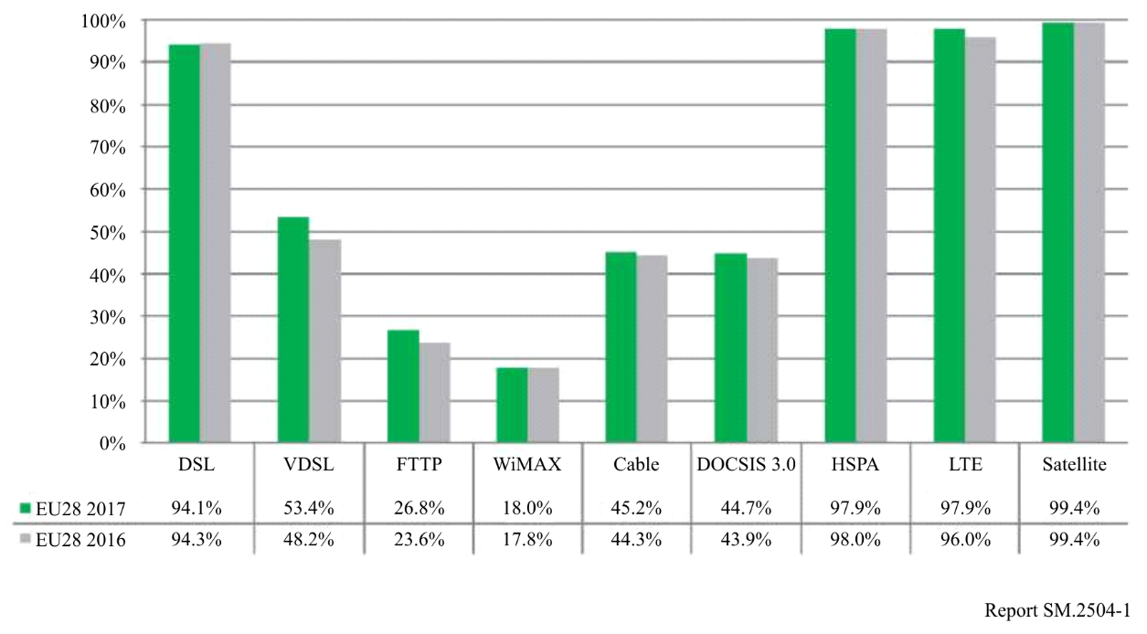
References
[1] Recommendation ITU-R V.573 – Radiocommunication vocabulary
[2] Recommendation ITU-R P.1546 – Method for point-to-area predictions for terrestrial services in the frequency range 30 MHz to 3 000 MHz
[3] Recommendation ITU-R P.1812 – A path-specific propagation prediction method for point-to-area terrestrial services in the frequency range 30 MHz to 6 000 MHz
[4] Recommendation ITU-R P.525 – Calculation of free-space attenuation
[5] Recommendation ITU-R SM.1875 – DVB-T/T2 coverage measurements and verification of planning criteria
[6] Note for Applicants on Coverage of Local Television. Minimum coverage requirements and transmission arrangements. OFCOM. 10 May 2012

Annex 1
Case study

1 Estimation in the case of partially covered territory
FIGURE 2
DVB-T2 coverage areas based on measurements
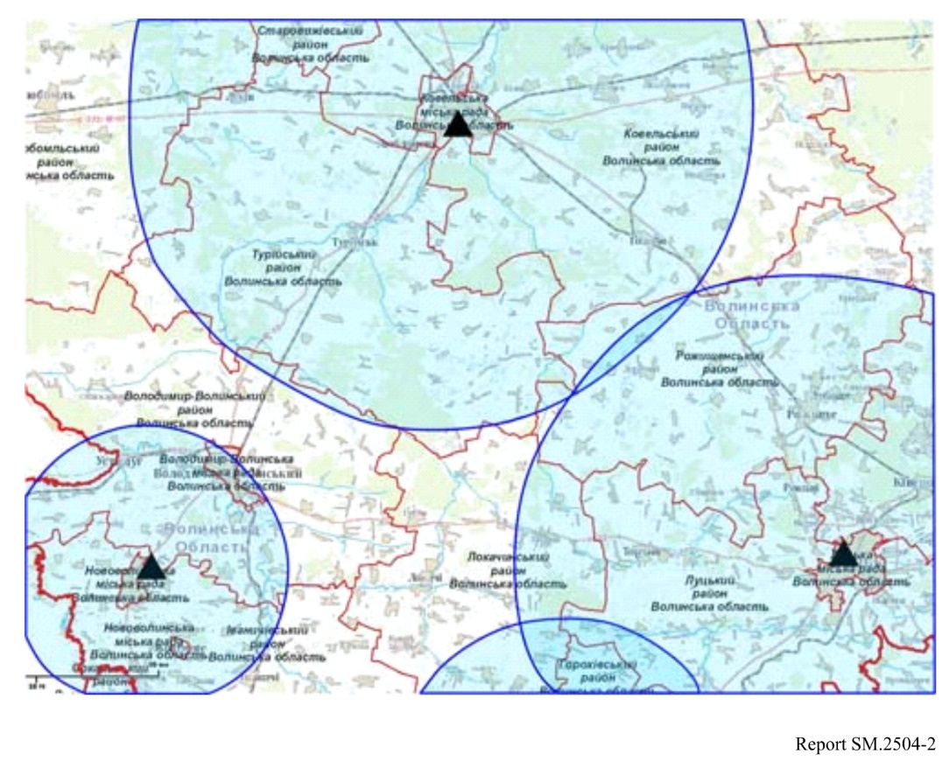
According to the Vital Statistics Reference Book, the entire tested territory covers 543 settlements with total population of about 682 350 inhabitants.
There are 328 settlements where 562 600 inhabitants reside that are covered with DVB-T2 service; and 215 settlements with population of 119 750 inhabitants that are not covered. Accordingly, the population coverage in the appointed territory $C_{\%}$ is equal to:
$C_{\%}=\frac{562 600}{682 350}∙100\%≈82.45\%$

2 Estimation in the case of partially covered settlements
In cases where terrain blocks radio coverage, some settlements may not receive broadcast service even though they lie well within the calculated covered area. To verify the real coverage area, measurements across a grid in such settlements can be applied.
The following procedures for estimating the population coverage in this case are applied:
1) The calculated coverage area is plotted on digital map of the small territory. Figure 3 represents the calculated coverage area of a small territory, where three small settlements are located. The covered area is highlighted in blue; the residential buildings are denoted by brown geometric figures. The coverage area can be calculated with a propagation model according to Recommendation ITU-R P.1546. The uncovered areas within the calculated coverage area are highlighted in white.
2) The total number of objects (households, homes, or inhabitants) $N_{tot.}$ within the tested settlements is determined. The number of objects can be determined with the reference source. It should be taken into consideration that different rural regions and urban areas (cities, districts and others) have different density of population, and values $N_{tot.}$ and $N_{cov.}$ for different territories may vary significantly.
3) To find suitable measurement locations in the designated territory, a grid of 500 metres length is placed over these settlements. The measuring locations within each small area are denoted by the yellow squares. The field strength of the service under test is measured in each small area.
FIGURE 3
Determination of small areas and receiving locations
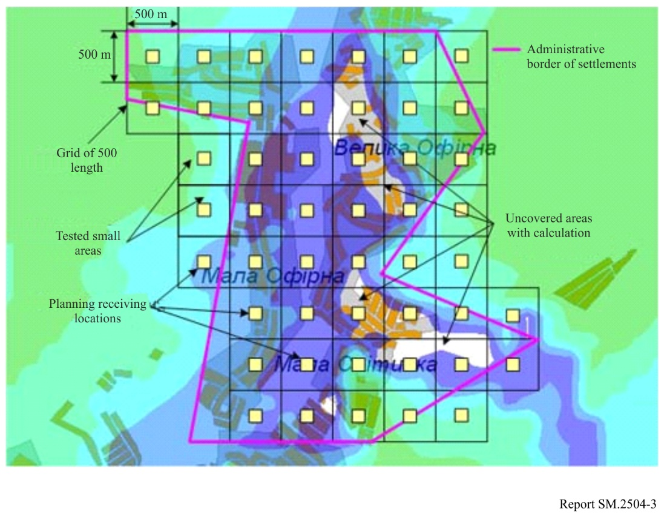
4) Whenever the measured value exceeds the minimum median equivalent field strength value, a small area is denoted by a green square. If this is not the case, an area is denoted by a red square (Fig. 4).
FIGURE 4
Coverage area measurement results
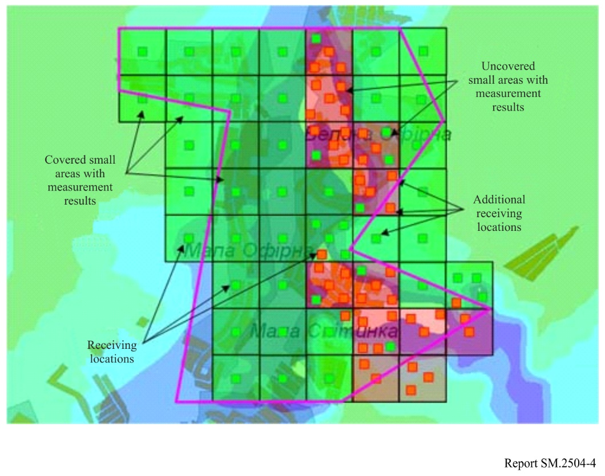
5) Small areas without any residential buildings are not taken into consideration in the calculation (Fig. 5).
FIGURE 5
Population coverage measurement results
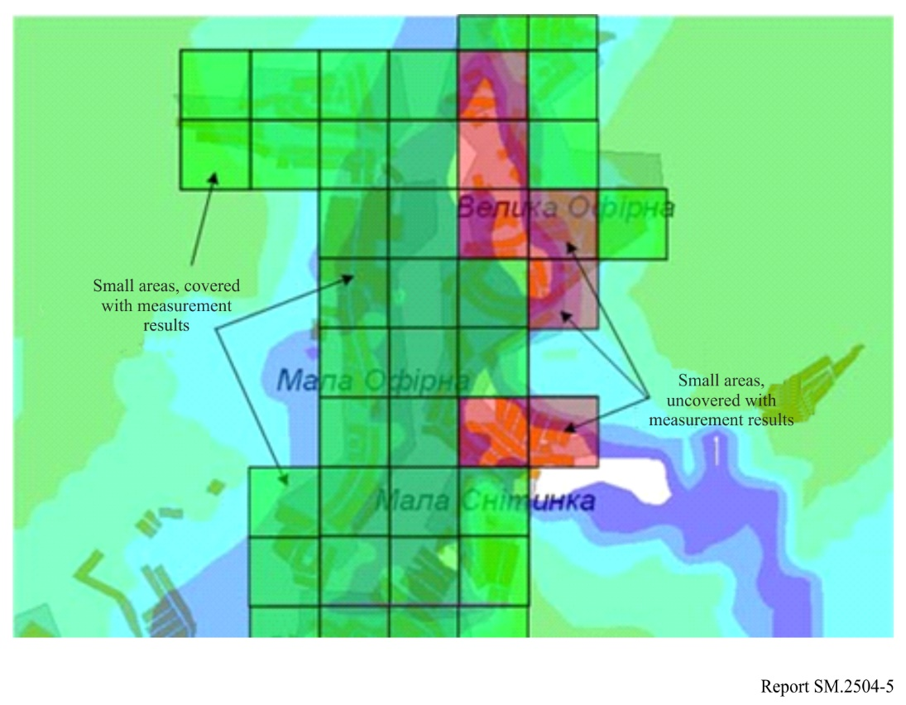
6) The total number of covered objects $N_{cov.}$ is determined and coverage parameter $C_{\%}$ is calculated.
In this example, the population coverage is estimated for the number of inhabitants. The total population residing in the designated settlements is 2 060. The total number of tested small areas in the designated territory (Fig. 3) is 42, and the density of population is 49.05 inhabitants per small area. To determine the total number of the inhabitants residing in the 35 covered small areas (Fig. 4), use 35 for the variable $m_{cov.}$:
$N_{cov.}=m_{cov.}∙49.05=35∙49.05≈1 716$ inhabitants.
Population coverage $C_{\%}$ is equal to:
$C_{\%}=\frac{1 716}{2 060}∙100\%≈83.3\%$

